Student Name: Imtiaz Begum.
Student Number: 2128130.
Module Code: LCHS4004.
Module: Introduction to Public Health.
Lecturers Name: Robert Ashford
Assignment Title: Major Health Issues, Diabetes.

Major Health Issues, Diabetes Mellitus
Introduction.
Diabetes mellitus is a non-communicable chronic disease, it is a long-term condition and one of the world's most common diseases, with millions of people suffering from the condition worldwide. As well as diabetes is one the most predominant diseases and a primary cause of mortality, placing diabetes among the top 10 killers worldwide. One in ten people have diabetes globally, this figure is expected to rise from 537 million adults to 748 million adults by 2030 and 2045. Diabetes occurs when the body produces insufficient insulin, when it is not utilised as well as it should be, when there is an excessive amount of blood sugar present in the bloodstream, or when cells cease reacting to insulin, serious health issues like heart disease, stroke, kidney failure, nerve damage, diabetes, foot disease, and visual problems can result from this. This report will examine and critically evaluate the, public health measures available and the short-term and long-term impact of diabetes on individuals and public health.

Key risk factors
The most common type of diabetes is Type 1 and Type 2, this section will investigate the health concerns associated with them both. Type 1: Type 1 diabetes occurs when the body does not produce enough insulin in body, and the immune system targets and kills the insulin, producing cells in the pancreas. Although type 1 diabetes can occur at any age it is most commonly diagnosed in children and young people. To stay alive people with type 1 diabetes must take insulin every day. (StatPearls, 2022). Type 2: Type 2 diabetes can develop when the body fails to produce or use insulin effectively. It can occur at any age even in childhood, but it is most common in adults and elder people. Type 2 diabetes is the most prevalent, most people that develop type 2 diabetes are over 45 and are overweight, have certain health issues such as high blood pressure and have a family history of diabetes. (DeFronzo et al, 2015).
Having too much sugar in the blood is known as hyperglycaemia, it can be toxic to the body, and can cause major complications, these complications will be discussed below.
Heart disease: Diabetes can damage blood arteries, which can result in heart attacks and strokes, and heart disease is the main cause of mortality in diabetics, according to the Centres for Disease Control and Prevention (CDC, 2022)).
Neuropathy: Diabetic neuropathy can be brought on by high blood sugar (nerve damage). (Centre of Disease Control and Prevention, 2022).
Kidney disease: According to estimates, 33% of diabetics have renal disease, and diabetes can harm the vessels in the kidneys, which are in charge of maintaining fluid balance and eliminating waste from the body. So, the condition of the kidneys is crucial to general health. (Myhhre, Sifris, 2022)
Hypoglycaemia: When diabetics who take insulin consume too much for their current needs, low blood sugars can result to this, it can be treated by eating or drinking something sweet. If left untreated, it could lead to a diabetic coma, which is potentially fatal. (John Hopkins Medicine, 2021).
Infections: Diabetes increases the chances of infection, which can also cause longer healing times, more severe symptoms, and sepsis. Additionally, diabetes's propensity for high blood pressure and high cholesterol might make the situation worse. (Diabetes - Infections, 2022).
Vision problems: High blood sugar levels can harm the eyes and result in vision loss. Retinopathy affects blood vessels in the retina, which is located behind the eye. (John Hopkins Medicine, 2021).
Symptoms, Increased hunger and thirst, frequent urination, high blood pressure, high cholesterol, sores or cuts that don't heal, exhaustion, blurred vision, and unexplained weight loss are all signs of diabetes. There is a high chance of having type 2 diabetes if you are over 40 (or 25 if you are of south Asian heritage), obese, overweight, or have a family history of the disease (Bragato, 2021).

Both in the UK and around the world, the number of cases of diabetes has dramatically increased in recent years. High intakes of sugar, carbs, and calories, together with a lack of exercise, are the main causes of this increase. By 2035, according to the International Diabetes Foundation, 1 in 10 people worldwide will have diabetes. Since 1996, there have been an increase in cases of diabetes in the UK from 1.4 million to 3.5 million; currently, it is believed that over 4 million individuals in the country have the disease. (British Heart Foundation, 2022).
According to estimates from Diabetes UK, there are around 549,000 undiagnosed cases of diabetes in the UK. The vast majority of these cases are type 2 diabetes, which has been strongly associated with the nation's rising obesity rates. (Diabetes UK, 2022)
By 2030, the prevalence in the UK is projected to be 5.5 million. 422 million people worldwide have diabetes, the majority of whom reside in low- and middle-income nations. People from underdeveloped nations and regions as well as members of ethnic minorities are more likely to get diabetes. Every year, diabetes directly causes 1.5 million fatalities. Over the past few decades, diabetes cases and prevalence have risen. By 2040, the number is projected to increase to 642 million globally (WHO, 2022).
Type 2 diabetes is the most common type of diabetes in the UK, accounting for 90% of cases, and type 1 diabetes for 10%, according to the International Diabetes Federation (IDF, 2022). Although type 1 diabetes is less common than type 2 diabetes which is growing more common in most countries, type 1 diabetes will affect the great majority of children. More than 542,000 children globally had type 1 diabetes in 2015. According to the International Diabetes Federation, these countries have a high prevalence of diabetes, 109 million in China, 69 million in India, America with 29 million, 12 million in Brazil and 12 million in the Russian Federation. (IDF, 2022)
Prevalence increases are influenced by factors such as GDP growth rates in addition to genetic predisposition, which presents a specific problem for Middle Eastern nations. The United Arab Emirates, Oman, and Qatar will experience the biggest increases in diabetes prevalence between 2013 and 2035, (NICE, 2022)

Public health measures available
By eating a healthy, nutritious diet free of sugar and saturated fats, exercising frequently, maintaining a healthy weight, abstaining from alcohol and tobacco, reducing salt intake, daily monitoring of blood sugar levels, managing blood pressure and cholesterol levels, taking care of feet, and scheduling routine check-ups with the GP, many cases of type 2 diabetes can be prevented or delayed. According to new research, the NHS Diabetes Prevention Programme (NHS DPP) has helped prevent type 2 diabetes in thousands of people. As well as the Healthy Living Programme which may have prevented 18,000 people suffering from the disease's severe repercussions by causing a 7% decline in the United Kingdom between 2018 and.(NHS UK, 2022).

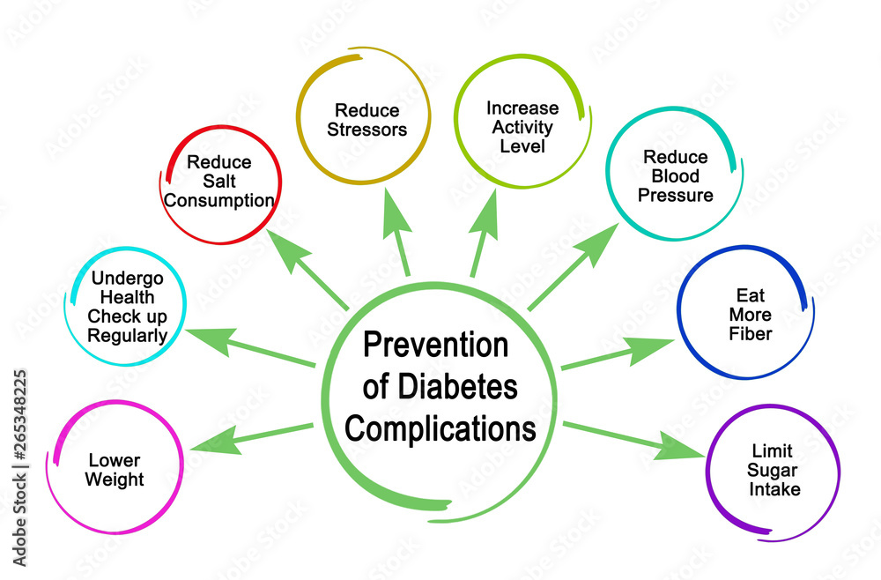

A diagnosis of diabetes is always confirmed by laboratory results, there are variety of tests to diagnose diabetes, A1C test, glucose tolerance test (GTT), retinopathy (eye screening), genetic testing. A home testing kit is available it may show high blood sugars but won't confirm you have diabetes. (Diabetes UK, 2022).

Short-term public health factors & long-term public health factors
According to estimates, the NHS spends £10 billion a year on diabetes, with the majority of this money going toward its complications. Diabetes increases a person's risk of stroke, heart attack, and heart failure it causes long-term damage to the heart and blood arteries. The number of persons with complications will increase along with the number of people living with diabetes. According to the NHS, 50,000 people will get a stroke and 185,000 people with diabetes will experience heart attacks or heart failure by 2035. Statistics show that each week, diabetes causes over 2,000 episodes of heart failure, 530 heart attacks, 680 strokes, and more than 169 amputations. This is a huge long-term negative impact on the health service provision. (Department of Health & Human Services, 2004).
Short term complications of type 2 diabetes can cause, retinopathy (eye problems), hypoglycaemia (low blood glucose levels), hyperglycaemic (very high blood sugar levels), gum disease and other mouth infections, high blood pressure and high cholesterol. Regular check-ups and diabetic screening are essential to detect any problems early and avoid any further complications. (Di Martino et al, 2021).
The purpose of the NHS health check programme, which launched in England in 2009, is to find early indicators of diabetes, stroke, kidney disease, heart disease, and dementia. It offers a five-yearly check-up for everyone between the ages of 40 and 74. (SCIE, 2022).
Type 2 diabetes and obesity are closely related; 66% of men and 57% of women are overweight or obese; 10% of children between the ages of 4 and 5 and 20% of those between the ages of 10 and 11. In June 2018, the government published Chapter 2018 of the action plan to combat childhood obesity. By 2030, the government wants to considerably reduce the obesity disparity between children from the most and least impoverished communities. The NHS Diabetes Prevention Program was introduced in 2018 by Diabetes UK, NHS England, and Public Health department. This nine-month programme aimed to assist patients to lose weight and gain a more active lifestyle, which would potentially lower their risk of developing type 2 diabetes. The Diabetes Prevention Program has received 280,000 referrals, and those who finished it on average dropped 3.7 kg (NHS diabetes prevention programme, 2022).

Treatment
There are few treatments to help manage and treat diabetes, treatment will vary depending on the individual as everyone is different. Type 1 diabetic patients must use insulin to manage their condition, insulin can be used by a pump or by injection. Islet cell transplant is also available for type 1 diabetics. (NHS choices, 2022).
Type 2 diabetes can be treated by medications (Metformin), or insulin may be needed if not controlled. Initially healthy eating, good exercise, losing weight, can help treat diabetes. Managing blood sugars effectively is very important in reducing the risk of further complications. (Centre, 2016).

Conclusion
To conclude it is evidence diabetes has a huge impact nationally and internationally on individuals and the public health, and social care services. With an enormous amount of money spent annually dealing and coping with the effect of diabetes on individual health. Although the NHS has introduced a number of programmes to reduce diabetes nationally, it still evidently remains a huge issue within society. Although statistics presented within the report demonstrate a positive influence of these NHS initiatives, it still is not enough to have a noticeable impact on strain caused by diabetes on the health service. Evidence shows England is not alone with the international concern, however as discussed England have demonstrated better management than other countries in very similar position. Clearly there is no overnight fix, although it seems impossible for diabetes to be eradicated.

References

Admin (no date) Our prevention work, Diabetes UK. Diabetes UK. Available at: https://www.diabetes.org.uk/preventing-type-2-diabetes/prevention (Accessed: November 2, 2022).
(no date) Behind closed doors? the hidden impact of diabetes in social care - social care online. Available at: https://www.scie-socialcareonline.org.uk/behind-closed-doors-the-hidden-impact-of-diabetes-in-social-care/r/a11G0000005W8lMIAS (Accessed: November 6, 2022).
British Heart Foundation (2022) Diabetes patients set to benefit from heart disease Data Investment, BHF. British Heart Foundation. Available at: https://www.bhf.org.uk/what-we-do/news-from-the-bhf/news-archive/2022/july/diabetes-patients-set-to-benefit-from-heart-disease-data-investment (Accessed: November 8, 2022).

Centre, D.H.M. (2016) New treatment aimed at halting type 1 diabetes trialled, Department of Health and Social Care Media Centre. Available at: https://healthmedia.blog.gov.uk/2016/03/24/diabetes/ (Accessed: November 8, 2022).

CKS is only available in the UK (no date) NICE. Available at: https://cks.nice.org.uk/topics/diabetes-type-1/background-information/incidence-prevalence/ (Accessed: November 2, 2022).
Daniela.bragato (no date) Diabetes diagnoses double in the last 15 years, Diabetes UK. Diabetes UK. Available at: https://www.diabetes.org.uk/about_us/news/diabetes-diagnoses-doubled-prevalence-2021 (Accessed: November 2, 2022).
Department of Health & Human Services (2004) Diabetes - long-term effects, Better Health Channel. Department of Health & Human Services. Available at: https://www.betterhealth.vic.gov.au/health/conditionsandtreatments/diabetes-long-term-effects# (Accessed: November 8, 2022).
DeFronzo, R.A. et al. (2015) Type 2 diabetes mellitus, Nature News. Nature Publishing Group. Available at: https://www.nature.com/articles/nrdp201519 (Accessed: November 9, 2022).

Diabetes and your eyes: What you need to know (2021) Diabetes and Your Eyes: What You Need to Know | Johns Hopkins Medicine. Available at: https://www.hopkinsmedicine.org/health/conditions-and-diseases/diabetes-and-your-eyes-what-you-need-to-know (Accessed: November 9, 2022).
Diabetes, infections, and you (no date) APIC. Available at: https://apic.org/monthly_alerts/diabetes-infections-and-you/ (Accessed: November 9, 2022).

Diabetes (2022) NCD Alliance. Available at: https://ncdalliance.org/why-ncds/ncds/diabetes (Accessed: November 2, 2022).
Diabetes (no date) World Health Organization. World Health Organization. Available at: https://www.who.int/health-topics/diabetes#tab=tab_1 (Accessed: November 2, 2022).
Diabetes (no date) World Health Organization. World Health Organization. Available at: https://www.who.int/news-room/fact-sheets/detail/diabetes (Accessed: November 2, 2022).
Diabetes UK (no date) Number of people with diabetes reaches 4.7 million, Diabetes UK. Diabetes UK. Available at: https://www.diabetes.org.uk/about_us/news/new-stats-people-living-with-diabetes (Accessed: November 2, 2022).
Di Martino, G. et al. (2021) Hospitalization for short-term diabetes-related complications: Focus on patients aged over 85 years, Healthcare (Basel, Switzerland). MDPI. Available at: https://www.ncbi.nlm.nih.gov/pmc/articles/PMC8070693/ (Accessed: November 8, 2022).
Hypoglycemia (low blood sugar) (2021) Hypoglycemia (Low Blood Sugar) | Johns Hopkins Medicine. Available at: https://www.hopkinsmedicine.org/health/conditions-and-diseases/diabetes/hypoglycemia-low-blood-sugar (Accessed: November 9, 2022).

International diabetes federation - home (no date) International Diabetes Federation - Home. Available at: https://idf.org/ (Accessed: November 2, 2022).
James Myhre & Dennis Sifris, M.D. (no date) Diabetes and chronic kidney disease: What is the relationship?, Verywell Health. Available at: https://www.verywellhealth.com/diabetes-and-chronic-kidney-disease-6748952 (Accessed: November 9, 2022).

(no date) NHS choices. NHS. Available at: https://www.england.nhs.uk/2022/03/nhs-prevention-programme-cuts-chances-of-type-2-diabetes-for-thousands/ (Accessed: November 2, 2022).
(no date) NHS choices. NHS. Available at: https://www.rlbuht.nhs.uk/departments/medical-specialisms/diabetes/managing-your-diabetes-with-tablets/ (Accessed: November 9, 2022).

StatPearls (2022) Diabetes mellitus, StatPearls. StatPearls Publishing. Available at: https://www.statpearls.com/ArticleLibrary/viewarticle/20429 (Accessed: November 9, 2022).

What is diabetes? (2022) Centers for Disease Control and Prevention. Centers for Disease Control and Prevention. Available at: https://www.cdc.gov/diabetes/basics/diabetes.html (Accessed: November 2, 2022).
What is the rate of diabetes by country? (no date) Medical News Today. MediLexicon International. Available at: https://www.medicalnewstoday.com/articles/diabetes-rates-by-country (Accessed: November 2, 2022).
Your local healthier you: NHS diabetes prevention programme (no date) Health & Wellbeing - Healthier You Diabetes prevention. Available at: https://preventing-diabetes.co.uk/ (Accessed: November 4, 2022).

