ADHD Awareness through Drama in Education
By
Lowri Wilson

Introduction
The purpose of my project is to determine if students with ADHD would benefit from learning drama. Both imagination and play are inherent parts of effective education. Drama is a vital part of education in schools according to Ustundag (1988, p11). Students learning drama gain self-confidence by thinking outside the box and learning to trust their ideas and abilities through play and improvisation.
Students can be creative and imaginative and can explore the world as they see it while building on new ideas. This gives those the chance to express themselves more effectivity in everyday situations, which is evidenced by McGregor (1976, p106).
Students can experience real life situations through play and improvisation understanding human experience through meaning and collaboration according to Courtney (1980) p33. Drama encourages empathy and compassion (Jigsaw Arts, 2022) by allowing us to connect more deeply and authentically (LinkedIn, 2023). Moreover, allowing ourselves to do this it gives us a physical, visual, and immediate experience (Medical News Today, 2022).
However, another way of achieving this is through Drama Therapy which is a form of Psychotherapy. Art Therapy is used to improve cognitive and sensory-motor functions, foster self-esteem and self-awareness, cultivate emotional resilience, promote insight, enhance social skills, reduce, and resolve conflicts and distress, and advance societal and ecological change (American Art Therapy Association, 2017).
By applying drama techniques this allows individuals to develop self-awareness, express emotions and help to improve relationships (Medical News Today, 2022).
Drama is a social activity, enabling people to have fun, which can help to alleviate symptoms of stress, anxiety, depression. Playing games and performing allows those to move around freely (SCIPS, 2004) as well as improve fitness (Kishon, 2021) and improve motivation, focus and coordination.
Performing and being a part of a company can help to improve a person’s self-esteem, acceptance, and confidence through teamwork, collaboration, and performance. Learning lines/scripts can help to improve memory as well as help stay focussed and improve concentration (Theatre folk, 2021).
There are a lot of benefits for everyone studying drama, but for those with ADHD there are even more. Students with ADHD may respond to a less formally structured learning environment, according to Brown (2013) and Barkley (2016), where they can express themselves more freely. Introducing drama to those with ADHD can help alleviate those symptoms for those of the disorder through movement, play, and performing.
A structured environment where there is no moving around or play can be extremely difficult for those with ADHD as this can make them feel restricted and start to feel restless, fidgety, lose focus and attention (Biederman, 2018; Barkley, 2016; Brown, 1998). However, drama provides freedom, creativity, movement and play which can be extremally beneficial for those with ADHD, as their symptoms can aid having a more positive impact on their wellbeing.
Dramatic play teaches self-regulation; those with ADHD are known for acting on impulse (ADHD Foundation, 2023). Dramatic play is a great way for those to learn how to self-regulate their emotions and actions. Coming up with their own rules through play can help those develop their ability to coordinate and plan with others as well as control their impulses (Sharp, 2023).
Having had 35 years of my own personal history, experience, and knowledge of ADHD combined with my acting skills, my aim is to set up workshops on raising awareness of the neurodevelopment condition. As part of my wellbeing officer role, I can collaborate with the student union and make a difference to provide better support for student’s wellbeing.
I was a student rep in my first year (level 4) and I was voted in again by my group to be their student representative once again in my final year (level 6). Course & Class Reps as a conduit for student voice and in their roles on Staff-Student Committees and within the Students' Union provide feedback on all aspects of the educational experience, such as curriculum development, feedback and assessment, course structure, facilities and resources, teaching/learning approaches, and the general academic experience of their fellow students evidenced by UWTSD Student Union.
The skills I have developed as an actor include collaboration, communication, presenting, performing, and delivering, all of which will allow me to reach out to those at the workshop confidently and efficiently. I will be collaborating with Taya Gibbons (Carmarthen President) and Bronwyn Morsy (coordination manager, student union) and Euan Morriston Advocate Manager at Students Union to set up an ADHD awareness workshop (pilot) on the Carmarthen campus.
I aim to collaborate with the students to improve their mental health and wellbeing. I know that I am the best person for this. I am well placed to deliver these workshops, because of the personal experience I have of living with ADHD. I know the struggles, frustration, stress this can all have on a person.
I know what strategies have helped me over my university experience and what things to avoid. I know that a person with ADHD can be hugely successful but at the same time I know that a person can really struggle (Mayberg, 1999; Simpson, 2001) Before attending the university, I did not have any awareness. I struggled through my first year in university. It was only after my diagnosis in my second year that I was able to reframe my brain and develop new skills and strategies to enable me to put on my workshop. I have compassion and empathy. I can relate to those who are struggling on a much deeper level through my own past experiences growing up. I will interview two people of both genders, Danny Sheppard who is a professional actor and Tallulah who is an ADHD Campion from ITV`s documentary Tanya Bardsley’s, Me and ADHD.I want to find out how living with undiagnosed ADHD impacted their lives and the struggles they face daily.
I want to find out how their lives have changed since after having the diagnosis. Both were diagnosed in adulthood. I will interview Jo Kelleher who is a SPLD and specialist tutor and find out what she thinks about the high rises of ADHD and the impact this has on waiting lists and student screenings.
Throughout this dissertation I aim to collect all my research from the internet, interviews, students and personal experience and history of ADHD.I aim to find out how the process works to be eligible for an ESA, I will investigate how the process works, medical letter, cost and how long the processing takes for registry.
The specific modules I have studied which are useful to my project are Theatre in Education (TIE), Contemporary Challenges, and Building your own Brand for Substantial Employment (websites, blogs, vlogs, forums). I aim to do this by building my own website for ADHD Awareness with regular updated blogs and vlogs to help those after the workshop. This will allow a follow on once the workshops have ended.
By setting up my website this gives students a place to go if they want to find out more information about ADHD and living with the condition. Moreover, by accessing the website students may find their missing piece of their puzzle like I did when I found out I had dyslexia and ADHD. This gives students a piece of mind and a feeling that they are not on their own with the condition. I will apply skills from my ADHD project from my Value and Creation module, presentations, and slideshows. I aim to demonstrate the importance of raising awareness of ADHD through drama in Education, by setting up workshops and by incorporating all these skills mentioned above. To see my personal history and Experience of ADHD (Appendix 1).

In the following section, an outline of ADHD is given, focussing on how it is defined and how its symptoms affect those who have been diagnosed with the condition. It is important to understand current thinking on ADHD and how it has come to be understood by clinicians.
This will help to support those who work with young people to understand the behaviours associated with ADHD.

Research & Investigation - What is ADHD?
Many more people have become more aware of the neurodevelopment condition known as ADHD. According to Faraone (2005) “the disorder is now firmly established as highly inheritable.” Barkley (2016) states that if a parent has the diagnosis, children are 6-8 times more likely to have the disorder.
Another explanation for the presence of ADHD is certain environmental factors or learnt behaviours, such as growing up with a parent who has ADHD. Barkley (2016) says that “the different versions of the genes lead to different proteins and chemicals in the brain.” Psychiatrists classify ADHD as neurodevelopmental because it is primarily the result of a delay or lag in specific mental abilities (Brown, 1998).
Attention Deficit Hyperactivity Disorder (ADHD) is a lifelong condition. Life can feel overwhelming for the individual to know that this is a condition they must learn to live with. Therefore, it is important to get a diagnosis as early as possible. Barkley (1990, page number) says that “those deficits are largely due to delays and/or dysfunction in the maturation of the brain areas that underlie those abilities.”
This is the reason people with ADHD may struggle with other learning differences, such as Dyslexia. Moreover, ADHD can impact a person’s ability to regulate and impact a person’s organisation skills. It can also impact their working memory, time-management, and self-awareness (High-Speed Training, 2023). Research has shown.
(Biederman, 2005, page number) that “There is strong evidence that there are neurochemical differences in regions that support vital cognitive functions”. People with ADHD suffer from cognitive impairments which can make it more difficult to process and digest information (Brown, 2013). A lot of information that is out there can be misleading, an example of this would be claiming that ADHD is a mental health disorder, which it is certainly not. ADHD Aware (2022) supports this by saying “ADHD is a Neurodiversity disorder and is NOT a mental health illness.” There are similarities in behaviours which means that it could be linked to symptoms consistent with bipolar, autism, anxiety, and depression.
High Speed Training (2023) also supports this by saying “with ADHD you will have least one other condition symptoms such as Social and communication difficulties, learning disorders, autism, Insomnia, epilepsy, and sleep problems.” These changes are very real, neurodevelopment differences, changing brain functioning and structure according to Barkley (2016).
ADHD is similar to Autism in the way that Autism is also a neurological disorder. ADHD and Autism (ASD) both disorders affect the central nervous system, which is responsible for focusing, language, social, memory and movement. Those with these conditions will struggle to process information and have trouble communicating with others.
High Speed Training (2023) states that “Autism is a neurological condition that effects how someone communicates and understands the world”. Learning drama encourages those with the disorder to explore their creativity through movement and performance, or to think outside the box and come up with new concepts and ideas. Although ADHD is not the same as Autism, they do have some of the same symptoms and often happen comorbidly. A Comorbidity is the presence of two or more diseases that present themselves at the same time in one person (Kessler, 2006, page number). In addition, Kessler states that “ADHD is further complicated by comorbidities with one or more additional psychiatric disorders. Comorbidity means the simple addition of two diseases that independently follow their usual trajectories.”
If ADHD is overlooked and the two illnesses worsen this could lead to significant complications in later in life, according to the National Institute of Mental Health (NIMH, date, page number). Therefore, it is extremely important to get the right diagnosis as early as possible. ADHD Aware (2022) says that “secondary mental health problems will abate when ADHD is treated.
These impairments affect a person daily, at home, at university and at a workplace significantly. Having a solid structure and routine is extremally important for those with ADHD (Brown, 2013). Learning drama and exploring different characters through role play, improvisation, and script work challenges students to think and act differently.
Brown (2013) says that “Impairments can also be considered in terms of cognitive impairments which underlie and play an essential role in various aspects of these role performances.” The disorder is a neurodevelopmental condition that consists of developmental delays or deficiencies in at least two types of neuropsychological abilities (Brown, 1998). The two types of ADHD are the hyperactivity type and the inattentive (ADD) type (Biederman, 1999; Barkley, 2016; Brow, 1998). However, you can have both types, hyperactivity and inattentive, this is known as the combined type as mentioned in, the diagnostic and statistical Manual of Mental Disorders 4th Edition DSM-IV.
These key traits of hyperactivity are combined with inattention traits such as difficulty sustaining attention in tasks, being distracted by noises, not following through on instructions and failing to complete homework, disliking tasks that require sustained mental effort, not understanding instructions and not seeming to listen when spoken to directly supported by Brown (2013).
Peers can sometimes be put off by these traits of a person with ADHD and at times can be overwhelming. Therefore, this could be one of the main reasons why that person would struggle to fit in and maintain friendships Very Well Mind (2023) supports this. Drama would help encourage and support those who struggle to fit in by playing games and collaborating with one another.
Learning drama, you’re always learning and working on something new. This can help those who struggle to engage in activities, get bored of things easily, fail to complete tasks which is another common trait of ADHD. By exploring new concepts and bouncing ideas off one another and developing new skills, or collaborating on tasks and putting on performances, these are all ways to develop skills in creativity, problem-solving and teamwork.
Furthermore, drama can boost attention and help to improve focus concentration, and coordination. Moreover, can help boost self-esteem and confidence (McGregor, 1976, p106). Drama can help with the traits of ADHD by performing and releasing excess energy which they may have through movement, performance, and dance. Furthermore, this could be an advantage for the person with ADHD as this can help with those feelings of restlessness, fidgeting and impulsive behaviour (Brown, 2013; Barkley, 2016).
Drama would encourage those to get up and move around rather than get reprimanded for being disruptive or not staying in their seat. ADHD brains are motivated by their search for optimal stimulation according to ADHD Foundation (2023). Furthermore, drama can encourage creative thinking (McGregor, 1976) and come up with new ideas, concepts and strategies while maintaining new friendships along creating opportunities to meet me people (Hishon, 2021). Maintaining new friendships alleviates symptoms of loneliness, self-esteem, confidence, and self-worth. The ADHD Foundation (2023) states that internal motivations are intrinsically more meaningful to their brains and, as a result, more dopamine becomes available. This means that a person’s mood is improved. Rewarding a person with ADHD gives that person a sense of accomplishment and achievement. After all a person with ADHD can feel hurt by their peers when they are teased or targeted because of their apparent academic delay (Shattell, 2008). This links back to the stigma that surrounds the disorder.
Learning drama helps stimulate those with ADHD by learning skills in time management, organizing, and prioritizing tasks, focusing and active listening skills. Coping with all these issues daily can cause huge stress amongst other mental health conditions such as anxiety and depression for the individual. A person with ADHD may tend to face even more struggles growing up, especially into adolescence. These setbacks of feelings of prolonged rejection and isolation from their peers. People with Rejection sensitivity dysphoria (RSD) struggle with letting go of past hurts and/or rejections and experience heightened emotional sensitivity (Phycology Today, 2023).
Those who suffer with ADHD say that they often don’t feel accepted and that they could be in a room full of people and still feel extremely lonely and feel completely isolated (Brown, 2009; Barkley, 2016). Several studies such as these have focused on examining the experience described by individuals with ADHD.
It is important to understand the emotional and psychological burden of this diagnosis and its impact in a child or youth’s quality of life and well-being (Frontiers, 2015). Other individuals report having the diagnosis of ADHD lead them to feel as though they were different and isolated (Shattell, 2008). Rewarding those with ADHD gives those a sense of hope, positivity, drive, ambition, and a purpose. It can give those something to focus on that is positive and not negative. An example of rewarding positive behaviour is having an applause at the end of a performance. Having an applause at the end of a performance is a good feeling of accomplishment, an achievement which can make all the difference to the person with ADHD. ADHD brains search for stimulation that can increase dopamine more quickly and intensely compared to those non-ADHD (Edge Foundation, 2023).
Moreover, this would encourage the person into wanting to take part in other performances in the future. Drama can provide laughter and humour which can help alleviate symptoms of stress, anxiety, and depression, through performing and playing games with one another (Mental Health Foundation, 2022).
This is why raising awareness of the disorder is so important. If others were more aware of ADHD this could help reduce the stigma that surrounds the disorder. This would help those with the condition find acceptance amongst their peers and would help to reduce feelings of constant rejection for those individuals. Moreover, raising awareness would help support those with the condition by having a deeper understanding of ADHD, which could help to prevent feelings of anxiety and depression later into adolescence. Learning drama would help with being accepted as actors are from all different walks of life and their own quirks and character. Everyone is accepted for who they are., which leads to feeling a sense of belonging in drama, you instantly become part of a team, and a company.
Actors are known for their compassion and empathy mainly form portraying many characters from previous plays and stepping into their shoes (Jigsaw Arts, 2022). Those with ADHD say that they experience greater highs and lows compared to a person without the disorder, similar to a person who has BI-Polar (ADHD Aware, 2022).
The role of therapy dogs
Over recent years therapy dogs have been on the rise for assisting those who have medical health issues. Therapy dogs are dogs are trained to provide comfort, support, and affection to those in hospitals, nursing homes, universities, schools, retirement homes. libraries and so many more. Therapy dogs support patients with emotional and mental health benefits by reducing anxiety and depression. Dogs can provide laughter in a classroom lifting students mood (Alliance of Therapy Dogs, 2022). Previous research has demonstrated that positive interactions between humans and dogs can stimulate individual and mutual positive effects, confirmed by hormonal changes that emerge in both humans and dogs (POP, 2014, p71 (2).
University students tend to suffer higher levels of mental illnesses such as anxiety and depression compared to non-students (Eisenberg, 2007). Mental health and social connection contribute to university student success in terms of academic performance (Eisenberg, 2009). Having a therapy dog can help those with anxiety, grief, loneliness, and depression (Therapy Dogs, 2022).
Many students agree that by having a dog in the classroom improves their mental health and wellbeing as well as many benefits for students (Alliance of Therapy Dogs, 2022). The benefits of having a dog in a classroom include a reduction in blood pressure, providing stimulation and assisting with pain management (Alliance of Therapy Dogs, 2022). A person may have a neurological condition such as Autism or ADD/ADHD, previous research shows problems with comorbidities which surrounds these disorders. Providing a companion can help to alleviate those symptoms for many students, as well as to be a friendly face within the group.
The Emotional Support Animal (ESA) UK registry was established to support those with ongoing mental health conditions. The ESA UK was set up to help those that meet the criteria to go out to public spaces with their ESA animal. ESA animals have special limitations into schools, universities, and have special permissions from the council and housing associations under the Equality Act 2010, Mental Health Act 1983, and the Disability Discrimination Act, 1995.
According to ESA UK (2023), all domesticated animals of any age may qualify as Emotional Support Animal and they do not need any specific task-training like a service dog or assistance animal because their very presence alleviates the symptoms associated with the person’s psychological or emotional disability. These animals are different to those of assistance and service dogs in the way that emotional support animals do not require any additional training. ESA`s are there to bring comfort and support to the individual. Based on my research, I decided to include a therapy dog (ESA) in my workshop. Having the Therapy dog (ESA) with them will help individuals through companionship alone.
Just by the animals there by the side of their owners can help reduce feelings of anxiety and depression (Eisenberg, 2007), as well as building up the person’s confidence and self-esteem. Helping a person gain their independence and helping those who struggle to fit in with feelings acceptance and loneliness which was mentioned and supported earlier by Therapy Dogs (2022).
In a documentary called Me and ADHD, the narrator Tanya Bardsley talks about her experiences of having ADHD (ITV Tanya Bardsley`s Me & ADHD (2023). Tanya found out that she had ADHD at the age of thirty-nine. Tanya is an ambassador of the charity ADHD UK (2023) and a footballer’s wife. Tallulah Syron who is an ADHD Champion was on the documentary speaking with Tanya. Tallulah also slipped through the net and found out she had ADHD when she was twenty-four years old. While interviewing Tallulah (See Appendix 2) she mentioned the difficulties she faced daily, growing up without a diagnosis. Parents of those from the Stockport Group (2022) in the documentary say that their children were being bullied and teased in school.
Henry (2023) from ADHD UK who was on the Me & ADHD documentary supports this and claims, “ADHD itself was only recognised in the UK in the 2000s so if you were in school before then, you were just a naughty kid as you were not picked up” (ITV Tanya Bardsley`s Me & ADHD). Biederman (1999) says “although efforts to investigate ADHD in females are increasing, this could account for many more girls and women seeking a diagnosis, which therefore impacts on waiting times for assessment.”
This could also be one of the reasons for long waiting times with psychiatrists and GP`s. Henry (2023) from ADHD UK, “If I could wave a magic wand waiting lists are another one and getting people and waiting lists are another one and getting people an assessment, the knowledge and awareness that access to support and help is absolutely number one.” Henry also believes that we are missing the opportunity to diagnose thousands of people with ADHD. Students who have been flagged up in the screening process at the university have reported to be on a two-year waiting list with their GP. The ADHD Foundation (2023) can help to support those who do require a diagnostic screening to help cut back waiting times for those needing support.

Workshop Planning – Collaboration.
I began looking for an ADHD training course to further my knowledge into ADHD. I found a High-Speed Training website where I could do an online CPD course in ADHD Awareness. After the completion of the course, I would receive a certificate in the post, and this would allow me to work with children with ADHD. Furthermore, this allowed me to further my knowledge on ADHD. This gave me clarity on my knowledge on ADHD (see appendix 3).
I met up with representatives from the SU on Teams to discuss what equipment I would need, the room that I would use, how many students would I like to attend and what I would need in preparation for my ADHD Awareness workshop. They suggested writing up a detailed workshop plan (see appendix 4) so she could see what I was planning to do, and how I was going to run the workshop.
I decided to collaborate with the SU as I already had connections with them as part of my wellbeing officer role at the Union. I wanted to try an experiment, a ‘pilot’ to see if I could combine all the different elements from my research into a workshop for those with ADHD. The workshop would be open to a limited number of staff and students as this is a pilot. As I know from my research that especially in schools and in education need to be aware of all the key traits and symptoms the key traits of ADHD (Tayna Bardsley, Me and ADHD (2023).
Raising awareness will enable students to be more supported as staff will have more understanding of those who are displaying symptoms. For those students the workshop will be a great way to obtain a deeper understanding of themselves and to show them that they are not on their own with the condition. “Raising awareness lets people know that they are not alone with the condition.” Henry (date) from ADHD UK believes that we are still missing the opportunity to diagnose thousands of people (ITV Tanya Bardsley, Me & ADHD 2023). “Raising ADHD awareness improves quality of life for people with the condition and those close to them”.
Using a presentation on ADHD (appendix 5) will help students to relate to the different symptoms and learn about the different strategies and techniques that will help them strive, both academically and in their personal lives. Having Jo Kelleher at the workshop allowed students to find out how they could get support at university.

I know from my own experience and the research undertaken, the workshop needs to be fun, engaging, and educational at the same time. Brown (2013) says “students with cognitive impairments may not have the ability to regulate alertness and focus, the ability to sustain effort, to inhibit impulsive behaviour, and to utilize working memory for keeping several items in mind simultaneously and for retrieving needed information efficiently from the files of memory”. According to Barkley (2016) “People with ADHD can seem restless, may have trouble concentrating and may act on impulse”. I need to
make sure that I have a solid timeline and structure put in place for both the presentation and the different games/activities in my workshop.

For the first part of my workshop, I wanted to create a colourful presentation full of bright colours, visuals with different eye-catching designs for each slide. The reason behind this is that my research suggests that those with ADHD struggle to stay focused and struggle to engage in things that are not that interesting.
Barkley (2016) states that “people who have the inattention type often avoid/dislike or are reluctant to engage in tasks that require sustained mental effort; they often have difficulty sustaining attention in tasks and are often very easily distracted.” By having plenty of visuals this will encourage those with ADHD to stay engaged during the presentation. Including visuals would also help those who struggle with learning difficulties to process the information more effectively. The presentation would include colourful and different layout slides on defining ADHD, the different types of ADHD, as well as symptoms, comorbidities, and strategies. My research suggests that these are the most important topics to highlight (Barkley, 2016; Brown, 2013; Biederman, 2018).

I want to use bright colours with different slide layouts to keep students engaged. I know myself how difficult it is to stay engaged during presentations so by mixing things up this could help aid with this issue. I know first-hand what living with ADHD is like and the daily struggles that I face (Appendix). My research along with the interviews of those diagnosed with ADHD supports this (Appendix).

Introducing Floppy- Joe to the students will help those students who struggle with other comorbidities as mentioned in my research. Eisenberg (2007) claims “University students also tend to suffer higher levels of mental illnesses such as anxiety and depression.” Having a therapy dog present will help and support those who struggle with their emotions and has problems engaging in activities (Barkley, 2016). Introducing a therapy dog/ emotional support dog helps reduce symptoms associated with anxiety, self-esteem, and confidence (Alliance of Therapy Dogs, 2022) as well as being a friendly face within the group. Mental health and social connection contribute to university student success in terms of academic performance (Eisenberg, 2009).

I began the process into ESA registration. Forty-eight hours later I had been accepted and fully registered (see appendix 6).

I started looking into having a variety of different games and activities as this will help keep those who have ADHD/ADD stay focused and engaged throughout the workshop. This would also be a great way for students to move around and to release energy. Furthermore, this could help those who struggle to engage in activities to collaborate with one another and move around freely. I want to find a way to show non-ADHD students what it is like living inside of the head of someone living with ADHD. Lots of people who are living with ADHD including Bardsley (2023), Henry (2023), ADHD UK (date), compare having ADHD with having 15 TV/Radio stations on at once and only tune in to the most interesting channel at that time. Henry (2023), ADHD UK mentioned on the documentary about his own experience with this. Henry says, “I’ve got three slots in my head that can be occupied at any time, so if something comes up it has to knock one of my three out”.

The first thing that sprung to my mind was a sound machine from my Theatre in Education (TIE) workshop module with Ally Franks last year. I knew that this could be the best way for students to fully understand what this is like for a person living with ADHD/ADD. Introducing a sound machine those at the workshop would provide a sense of drama therapy in the way that they can put themselves in the mind of a person with ADHD through a visual physical, and immediate experience (Medical News, 2022). Through combining creative storytelling, play acting, improvisation, and games, we can put ourselves in other people’s shoes by fostering empathy and improving emotional intelligence and awareness. Barkley (1997a) says, “Children with ADHD have problems with use, with and without music, with and without vocalization, and with and without physical contact among students.” By adding sounds this allows the machine to lift in energy and allows the participants to have fun while being creative, imaginative, as well as to collaborate with all the participants in the group while allowing them to project their voice and engage in their bodies (Bright Hub Education, 2022).

As mentioned in, the diagnostic and statistical Manual of Mental Disorders 4th Edition DSM-IV the main hyperactivity symptoms are, often subjected to feelings of restlessness, often talking excessively, often leaving their seat when remaining seated is expected and often fidgeting with hands and by moving their feet when sitting still (The diagnostic and statistical Manual of Mental Disorders 4th Edition DSM-IV) (2000).
Creating a sound machine would allow those students who struggle with their hyperactivity to project their voices and allow them to move their bodies freely. For Impulsive ADHD students a sound machine will help them with their difficulty waiting their turn and interrupting and intruding on others and well as all the benefits from movement, collaboration, teamwork, and projection skills. As Barkley (2016) says, “people with ADHD can seem restless, may have trouble concentrating and may act on impulse”.

This activity could help ADHD students who do have this difficulty gain confidence and self-esteem as this exercise involves a lot of projection and constant movements over a prolonged period, which is often something prohibited to do in a classroom setting. It is important to make special adjustments for those with ADHD to take regular breaks.

This would help gain back focus on the subject or burn off energy if need be. ADHD Centre (2009) supports this statement by saying “Exercise can help aid concentration and focus.” Those in the workshop may have never done drama before, therefore there could be people there who have low confidence and self-esteem and anxiety. Warm-ups are a great way to build connections, release any tension or anxiety and physically prepare students (Trinity College, 2022). Moreover, warmups help encourage creativity and stretch the limits of the imagination (Backstage, 2023).

I will be collaborating with a dance student, Natalie Partridge to take a ten-minute warm up. Trinity College London (2020) says “warm-ups are a great way to build connections, release any tension or anxiety and physically prepare students for the tasks ahead.” I have decided to have music throughout this activity as music as many benefits such as can help with anxiety, memory, focus, communication, as well build confidence and boost self-esteem (Performing Arts Music, 2023).

These symptoms have been reported by many physicians (Brown, 2013; Barkley, 2016; Biederman, 2005) as common traits in a person with ADHD. For a person with ADHD their minds are constantly thinking, of a million different thoughts at a time and they struggle to ever switch off.

I wanted to apply skills such as collaboration, teamwork, compassion, empathy, psychotherapy, projection, movement and combine them all together. My aim for this exercise would be to put those inside the mind of a person with ADHD. A sound machine is a game where students can explore vocal and movement by connecting in a line to make simple repetitive body motions/gestures by using their voices to represent a certain theme, idea, and process. The machine allows those to explore theatre skills like projection, articulation, motion, and tempo (DBI Network, 2023). By introducing the sound machine those who have symptoms of ADHD, especially the hyperactive/combined type, can get up and move about and not feel confined to their seat (Munden & Arcelus, 1999; Brown, 2013; Barkley; 2016). This activity could help encourage those to think outside the box and to be creative. Those with ADHD see the world differently (High-Speed Training, 2023). Moreover, this activity can help support those who lack in confidence and self-esteem by collaborating and working as a team (Jigsaw Arts, 2022).

The success of any collaborative drama activity relies on levels of energy, interaction, and communication with the group (Trinity College London, 2020). Next, I decided to include drama games which I played throughout my time on my acting module in university. Drama activities and games allow people to have fun and help aid with confidence, self-esteem, and anxiety (Jigsaw Arts, 2022; Trinity College, 2022).
One of the games I choose for my workshop was called Topics. This game we play a lot on my acting module. This game involves focus, quick thinking, movement, and communication. Everyone stands in a circle. 1 person will start by thinking of a topic. A topic can be anything from colours, animals, countries, or sweets.
For example, when someone starts with a topic of sweets, that person will walk towards another person. Before that person gets to the other person they must think of a sweet and so on.If the person cannot think of a sweet by the time the person got to them then they are out and so on. If you get a person out, then you can think of a brand-new topic. Repeat this until there are 2 people left. At the end of the game the two people left will stand back-to-back and a chosen word will be suggested from the rest of the group. Similar sounding words will be shouted out. When the correct word is shouted out whoever shouts ‘bang’ first wins. I chose this game as it allows those to move around whilst using their knowledge of certain topics. This game allows those to think and act quickly.

My reason for choosing this game was to allow those who have constant thoughts running through their head to remain focussed and engaged as it involves thinking on your feet. Furthermore, the game could help those with concentration as you must stay alert throughout the game otherwise you will be out. I began working on my poster on Canva (ND) for my workshop (Appendix 7).

I investigated setting up my own website on ADHD Awareness. The website would include regular blogs and updates from myself which I learnt in my two previous modules: Contemporary challenges and Digital Era. It would be like a diary of what my life is like and what strategies I use to try and get over the obstacles which I face daily.

I wanted those who attended to have a place to visit afterwards, to find out more information on ADHD and explore different strategies which could help support their condition. This would allow me to reach out to many more people and help support those in any way I could by raising awareness of ADHD and by sharing my stories. To see my website please see (Appendix 8).

I thought of the name Highz & Lowz as this was mentioned in my research as one of the comorbidities that is connected to ADHD and Bi-Polar (ADHD Aware, 2023). My nickname is Lowz so together I thought it worked quite well as people with ADHD do get greater highs and lows than a person without the disorder. I thought of using a head with a puzzle as my logo, the reason behind this was, when I found out that I had ADHD it was like finding the missing piece of the puzzle. By raising awareness of ADHD, it could help others find their missing piece of their puzzle.
Applying my skills from two previous modules: Learning in a Digital Era and Contemporary Challenges, I wanted to set up a blog section on the website to share my stories, strategies, and things that have helped me reframe my understanding of having ADHD.

Reflection

Description
As set out in the previous section, the workshop was trialled as a pilot to establish whether combining drama activities with information sharing about ADHD would help raise awareness and understanding of the condition. The elements of the workshop were outlined and explained in the previous section.
On the day, there were some concerns raised by the Student Union reps about the presence of the dog, even though the correct procedure to bring the dog on campus had been followed and agreed by the university. The Union reps raised the issues whilst the workshop was up and running, which was difficult to manage at the time and interfered with the flow of the workshop.
The workshop was a pilot an experiment to find out if combining ADHD awareness, Therapy dog/ESA, Drama games and Activities if it could benefit those with ADHD from learning drama.

Feelings
Before the experiment I felt that I could put on the workshop confidently although I had feelings of anxiety as I have not taken a workshop on my own before. I felt passionate, committed, focused, engaged. I felt that I could make a difference to people`s life with ADHD.
During the workshop I felt disappointed, raged, distressed, anxious, depressed, and deeply annoyed from the ‘issues’ that I faced in my workshop.

Evaluation
In brief, the elements of the workshop that had been planned and supported by research and study in drama went well. Those who attended the workshop engaged with the activities which were fun and met the objective of improving people`s understanding of having ADHD.

Things that went well was the presentation on ADHD and the talk on the diagnostic screening with Jo Kelleher.
The sound machine activity went well everyone seemed to have picked it up quickly with the use of different sounds and gestures.
However, the best response was the therapy dog/ESA. Everyone was happy and Floppy-Joe provided plenty of laughter in the activities and drama games.
The drama games went well everyone took part and joined in.
What didn’t work so well was the breakdown in communication with other collaborations. The interruption by the SU reps during the workshop was unhelpful and had the potential to undo the hard work that had been put into setting up the workshop. However, with the support of fellow students I was able to continue and complete the activities I had planned.
On reflection, the presentation at the beginning could have been shorter, leaving more time for the drama games and activities. I was also made aware of an error on my poster regarding the use of the word ‘therapy’ firstly in relation to the dog secondly in relation to the drama activities. This caused some confusion about the purpose of the workshop which I had to rectify both during and after the workshop.

Analysis
The experiment was positive despite the ‘issues’ that I faced on the day. My personal history and experience of ADHD gave me the confidence to talk about what is ADHD in my presentation more efficiently.
Having Jo Kelleher at the workshop was helpful as Jo was able to answer questions the students had after the presentation and was able to talk with students about the support available at the university. Having Floppy-Joe at the workshop was great. Everyone very much enjoyed having him there. Floppy-Joe enjoyed getting involved in the drama games and activities with everyone. Those felt relaxed, engaged, less anxious and more motivated and focused on the day. The feedback I received from attendees at the workshop confirms this, for example, “I enjoyed Floppy-Joe the most. I thought his presence at the workshop was great and he was friendly and sociable to everyone there. He is a brilliant therapy dog.”
The sound machine activity went well everyone seemed to have picked it up quickly and those commented saying “the sound machine was a brilliant way to understand the busyness of an ADHD mind, it got the idea across really well.” However, having more people at the workshop would have heightened the sounds and conversations of the machine.
Whilst the content of the presentation was well received, it did seem quite long. Having a shorter presentation would have allowed more time for the drama games and activities later. Moreover, this would help with those who struggle to sit and listen for a sustained period. The drama games went well although due to the ‘issues’ raised during the workshop, there was less time available for the activities. I would have liked to have had more time for more games and activities as it is important for those with ADHD to move around freely and to have plenty of interaction.
I had ‘issues’ with my poster. I mentioned Drama Therapy and Therapy dog. I now know that this was a big mistake to use those words as to be a drama therapist you need to have a master’s degree. The same for a therapy dog, where the dog would have to have undergone extensive training to be officially registered as a therapy dog.
The concerns around the use of the word ‘therapy’ in relation to the dog, and also in relation to the drama activities was an error on my part. However, this has enabled me to learn from this experience that in the planning stage, issues around the use of language to promote an activity really do matter, this has been an important lesson for me.
The biggest issue for me was the breakdown of communication with other collaborations which was beyond my control. If there had been better communication throughout the collaboration phase there would have been no ‘issues’ with my poster as I would have had that knowledge and understanding and would have known that I couldn’t use the words ‘therapy’ unless I was a trained therapist, or my dog had undergone the necessary training. Moreover, there also would have been no ‘issues’ at break time either.
Conclusion
From implementing my pilot workshop, I have learnt that I cannot use the words ‘Therapy’ as using that word can seem very misleading to others. The reason behind using this word was that I thought what I was doing regarding the sound machine was related to a form of drama therapy. In the same way I thought that as my Floppy-Joe provides myself and family friends outside the university comfort for their medical issues, to me he was a therapy dog. Moving forward I have learnt something valuable, and I now know not to make that mistake again for any future workshops.
I have learnt how important it is to have strong communication throughout the building of a workshop and how the lack of communication can cause series ‘issues.’ The workshop gave me more confidence that I can, in future, develop a workshop of my own. Furthermore, the workshop has made me believe in myself more. At times I struggle with my dyslexia which often impacts my self-esteem and confidence which can sometimes hold me back. However, I do feel more confident now in my ability to set up any future workshops on ADHD.
I have learnt that having a therapy dog/ESA in a workshop can be rewarding and beneficial for those with ADHD. Having a dog in a classroom has proven to be the biggest hit in my experiment that is supported in my feedback. Those seemed to be less anxious, engaged, focused, confident, and felt at ease having Floppy-Joe there with them. Everyone at the workshop said that Floppy-Joe was their favourite activity from their feedback.
There were other comments from university students on campus, for example, “I would love to have a dog in my class to help me feel more motivated in my academic studies.” Floppy-Joe provided plenty of laughter throughout the workshop which helped to lift people`s mood as soon as the workshop began and put people at ease right from the start.

Action Plan
The specific actions that I will take moving forward will be to upload regular blogs onto my website, continuing to raise awareness of ADHD through my Highz & Lowz website and through my social media. I aim to start working with Leanne Maskell on an ADHD coach training course which will help me gain further knowledge on how to best support those with ADHD. After the completion of the course. I aim to become an official ADHD coach.
I am currently going through the therapy dog's assessment with Therapy Dogs Nationwide (2023) for my ESA dog to become an official member of the charity. This will allow me to further my own career as an ADHD coach in the future, by teaming up with Floppy-Joe.
I am extremely passionate about reaching out to people to raise awareness of ADHD. Because of this, I will be planning to meet with my local MP Jamie Wallis to discuss how we can go about setting up regular talks in schools, prisons, hospitals. I am currently in talks with the Childrens Commissioner of Wales 2023 to help change the way ADHD is supported in education.
Once I have become an official ADHD coach, I could use elements of the pilot to further develop a workshop that will benefit staff and students at university. It would be an engaging way to make staff and students aware of the different traits and symptoms of ADHD so that in turn, they may be more supportive of people with ADHD.

My Personal Experience with Living with ADHD. (Personal Statement - Appendix 1)
Growing up I always knew that I was different from a lot of the other children. I was always mischievous, I struggled to sit still, my mind kept wondering and I was very talkative and easily distracted. I didn’t have many friends as a child, I found it very hard to make and keep my friendships with the other children. I only had 1 or 2 close friends in school, and I found it easier to hang out with children that were very much like myself who were also quite destructive and mischievous and talkative. During my secondary school years, I found life incredibly tuff, as I really struggled to engage in subjects that didn’t interest me such as, Maths, Science, RE, Geography, French and History. I found it almost impossible to be able to engage in these lessons as my mind kept being distracted by anything other than the lesson, I day-dreamed a lot in my classes. Although these lessons were tough for me to engage in, I found that I thoroughly enjoyed subjects such as, Cooking, English, PE, Art, Music, German, and Drama. I found that I excelled in these subjects as I had an interest to them, so I was able to concentrate and engage with them more effectively. During my time in year 7, I can say I was named as the “naughty child” as I kept distracting the class by talking, joking around and being hyperactive. I was known as the “class clown” by the students in my year, and I struggled to fit in with other friendship groups. I was a risk taker to the point where I liked to skive off school with my friend and I never cared about the consequences of my actions by the school or my parents. One time I went to town with my friend, used my lunch money to buy some hair dye from one of the shops in town. My and my friend went to the local church where we used the shower facilities to dye our hair. I found doing things like this exciting and fun, I just couldn’t help myself! I found myself in detention a lot after school due to not being able to hand my homework in on time or from being constantly late before the start of school. I was put on report for my behaviour, and I was kept on report all the way through to year 8. I had very poor time-management and planning skills, which resulted me falling behind academically. This was around the time that I started getting bullied for my behaviour by the other students at my school and then soon after I moved to a different school for a fresh start, in hope that things would be different there. In my new school in year 9 nothing much changed. I still struggled to make new friends and the only friends that I did make were known as the “troublemakers”. I found it easier to make new friends with people that were very much like myself. I felt like that they understood me as a person, and they liked taking risks like skiving off school and getting up to mischief. One time in year 9 myself and my friend decided to run away from home we went missing for 4 days. Broke into my dad’s flat only to find out that it wasn’t his flat, he hadn’t lived there for years! The police and our parents were looking for us, but we didn’t care about the consequences we felt free, and we could do what we wanted to, life was exciting and fun. During my time at the school, I still found that I was struggling academically, and as the subjects started getting harder and harder, I struggled to focus. I found myself gazing out of the window a lot of the time and daydreaming in my lessons. I was very easily distracted by noises around me, and my brain could think of 15 different things at all the same time. It was like having fifteen tv channels on at once and it was only when someone had something interesting to say that I would tune it to that channel, as it sounded the most interesting and exciting. I would completely zone out otherwise. I fell massively behind in year 9 and decided that school wasn’t for me. I did not sit my GCSES, and I had no other qualifications. Out of school life wasn’t much easier, I still hung out with the wrong crowd and when I was 16, I fell pregnant, and I left home. I had many part-time jobs, but I struggled to keep them as I found myself being late on many occasions and then they let me go. Growing up into adulthood, nothing really changed, well apart from my jobs and relationships. I found in my relationships that I get bored quite easily and I need to have a lot of things going on at once to keep my brain occupied and stimulated. My emotions are very up and down, and I have much greater highs and lows than someone who does not have ADHD. All my life until I was in my early 30`s I my jobs and relationships. I found in my relationships that I get bored quite easily and I need to have a lot of things going on at once to keep my brain occupied and stimulated. My emotions are very up and down, and I have much greater highs and lows than someone who does not have ADHD. All my life until I was in my early 30`s I have had history of anxiety and depression; the doctors would prescribe me anti-depressants. I always knew it was something more but back then I didn’t know what ADHD was nor did I know anyone else who had it. I later took myself back to education when I was 30 years old. I wanted to create a better life for myself and now my 4 children. I started in Bridgend Campus and studied a A-level Preforming Arts course. I excelled in the course. I found a place of belonging. I wasn’t told off for fidgeting or being hyperactive. It was encouraged to think outside the box and to be creative. I found a great use for my over thinking brain. I liked being part of a small company I felt like an equal, I felt valued not just by my peers but an audience too. I felt like this was my place of belonging, I could be anyone I wanted to be, and my ideas were valued, and I felt like I was being appreciated and not dismissed. I was encouraged and not shut down. During my time studying performing arts at my collage, I found that I had new skills such as being able hyper-focus on tasks that really excited me, and I found tackling the tasks that least excited me, by breaking them down and giving myself rewards when I completed them. My time-management, and planning skills improved greatly, along with my friendships. I found something that I was good at, putting on shows gave me the fulfilment and excitement that I needed, as it was packed with new topics and games daily. I didn’t feel board or distracted. I finished on a merit, and I started studying at the UWTSD Carmarthen. That’s when my life changed forever. During my first year I was offered a student screening to see where I was academically. A lady called Jo took my screening for me she was very nice and made me feel at ease straight away. I had to undergo a series of different tasks such as puzzles, etc. The screening took a few hours and by the end Jo, said that I have Dyslexia and ADHD/ADD. I was quite shocked by the diagnosis, but I knew all this time that I was different, and I felt like I just had the closure that I always needed/wanted. As soon as I got home, I began research on ADHD/ADD as I didn’t know what it was, I only knew what Jo had said to me. When I started researching my hyper-focus started coming into effect at its highest peak. I had this massive passion for mental health and not only was I finding out a lot more about myself I knew I wanted to help more people that are in or have been in my situation. I knew how hard it was for myself growing up and feeling like an outcast and being called “thick” because I had problems focusing and digesting the information in a school setting. Being on this acting course has completely changed my life for the better. I have so many new skills that I never knew I had all this time such as, creativity, hyperfocus, passion, drive, and time-management and planning.

Appendix 2 – Tallulah Interview

Appendix 3 – ADHD Awareness Certificate.

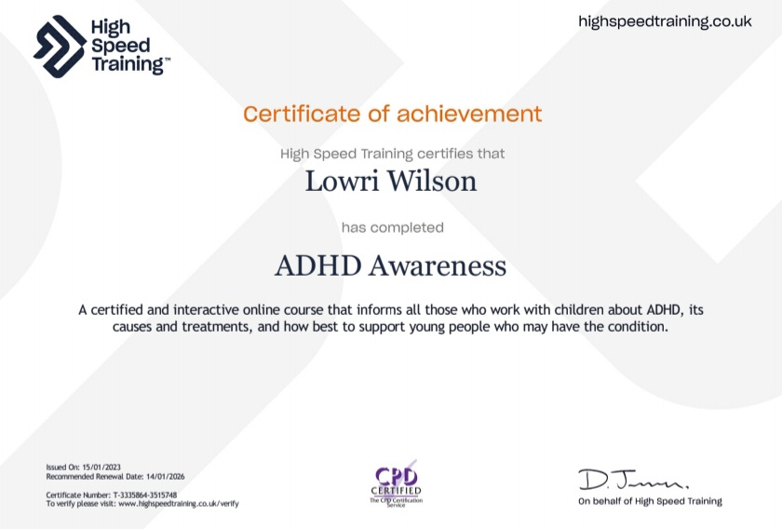

Appendix 4 – Workshop Plan

Workshop/experiment plan
ADHD Awareness
By
Lowri Wilson
In Collaboration with Taya Gibbons, Bronwyn Mosey, Euan Morriston, Natalie Partridge, SLS Creative and Jo Kelleher and students at the Carmarthen Campus University.
- 2 Hours 11am-1pm
- 8 students minimum
- Chairs x15
- Projector screen
- Mobility user Friendly
- Quad, Room 1, and Parry 3.
- Floppy-Joe (Therapy Dog) – Water bowl, lead, treats, therapy dog harness, ESA documents and ID card.
- Jo Kelleher, SpLD and Specialist Tutor – Diagnostic Screening Talk (Special Guest)
- -Natalie Partridge – Third year dance student – Warm up session
- SLS Creative – website – Highz & Lowz
ADHD workshop is an educational program that allows staff and students to fully engage in.
ADHD awareness will allow staff and students to understand the symptoms and to have a deeper understanding of how a person with ADHD must overcome many daily challenges.
The workshop will educate and help to motivate individuals through engagement and a range of activities that are fun but also useful in terms of managing and recognising symptoms of ADHD.

- Talk on ADHD
What is ADHD?
Symptoms, and strategies.
15/20MINS

Raising awareness of ADHD will allow students to have a better understanding of the symptoms and the problems that are associated with it.
Students will have a deeper awareness of what ADHD is.
ADHD awareness allows students to recognise and relate to the symptoms and when necessary to seek a screening at the university or if already done so, to get a referral from their local GP. For the students who have recently diagnosed at the university, these students will learn more about themselves and develop a deeper understanding of how their brains function differently from their non-ADHD peers.
Students will learn about different strategies on how to manage their ADHD. As well as learning and understanding different techniques that can help students strive during their education and in their personal lives.

- Meet and Greet Floppy-Joe (Therapy Dog) (10/15 MINS)
The benefits of having therapy dogs in the classroom include:
Physical benefits. Interaction with therapy dogs has been shown to reduce blood pressure, provide physical stimulation and assist with pain management.
Social benefits. A visiting therapy dog promotes greater self-esteem and focused interaction with other students and teachers.
Cognitive benefits. It has been empirically proven that therapy dogs stimulate memory and problem-solving skills.

showing off his dancing skills. Floppy will be checking in on their wellbeing (having fuss) and participating in all the activities Alliance of Therapy Dogs (2020).

- Jo Kelleher
Talk on diagnostic screenings and any extra support at the university.
Students will be able to chat with Jo about seeking a diagnostic screening at the university. Or to seek any extra support that they feel they may need to help them with their academic studies. 15/20 MINS
BREAK – 20 MINS – COSTA COFFEE.
PARRY 3 – GAMES
Music has many benefits. It can help with anxiety, memory, focus, communication, as well build confidence and boost self-esteem supported by Performing Arts Music (2023). These symptoms have been reported by many physicians Brown (2013), Barkley (2016) and Biederman (2005) as common traits in a person with ADHD.
Warm Up exercise session with Natalie Partridge (Third year dance student) 10 mins
Warm-ups are a great way to build connections, release any tension or anxiety and physically prepare students for the tasks ahead Trinity Collage London (2020).
The success of any collaborative drama activity relies on levels of energy, interaction, and communication with the group.
- Sound Machine 5/10 minutes
- Whole class
- Distanced
- Inclusive mobility
Projection, Collaboration, Teamwork, focus, movement
The purpose of the sound machine is a great way to understand what it is like for people living with ADHD and how our minds function differently compared to those non-ADHD.
A lot of people who has ADHD say that living with ADHD is like having 15 TV/Radio channels on at once, and their brains will only tune in to the most interesting channel at that time.
The sound machine exercise will allow students to have a deeper understanding of their peers as well has having a deeper understanding of themselves.
A person would go up and come up with a sound and gesture and then someone else would follow on with a different sound and gesture, for example clapping your hands while bending your knees repeatedly and so on until the machine is built. When I tap someone on the shoulder that person would stop what they were doing while everyone else would be carrying on. Introducing the volume dial from 1-10. 10 being the highest, 1 being the lowest. This allows the machine to lift in energy and allows the participants to have fun while being creative, imaginative, as well as to collaborate with all the participants in the group while allowing them to project their voice and engage in their bodies.
- Games – Time depending, which games I will be using from the list below. No more than 30 mins for all games.
Drama games and activities allow students to have fun whilst growing in confidence and learning valuable theatrical skills. Within the structure of Drama, drama games can be used to focus students’ attention, facilitate team building, deployed as a tool for developing communication and receptive skills, or simply to foster enjoyment of drama Trinity Collage London (2020).
Topics – 10 mins
Everyone will stand in a circle. 1 person will start by thinking of a topic. A topic can be anything from colours, animals, countries, sweets. For example, when someone starts with a topic for example sweets, that person will walk towards another person. Before that person gets to the other person they must think of a sweet and so on. If the person cannot think of a sweet by the time the person got to them then they are out and so on. If you get a person out, then you can think of a brand-new topic. Repeat this until there are 2 people left. At
The purpose of the sound machine is a great way to understand what it is like for people living with ADHD and how our minds function differently compared to those non-ADHD.
A lot of people who has ADHD say that living with ADHD is like having 15 TV/Radio channels on at once, and their brains will only tune in to the most interesting channel at that time.
The sound machine exercise will allow students to have a deeper understanding of their peers as well has having a deeper understanding of themselves.
A person would go up and come up with a sound and gesture and then someone else would follow on with a different sound and gesture, for example clapping your hands while bending your knees repeatedly and so on until the machine is built. When I tap someone on the shoulder that person would stop what they were doing while everyone else would be carrying on. Introducing the volume dial from 1-10. 10 being the highest, 1 being the lowest. This allows the machine to lift in energy and allows the participants to have fun while being creative, imaginative, as well as to collaborate with all the participants in the group while allowing them to project their voice and engage in their bodies.
- Games – Time depending, which games I will be using from the list below. No more than 30 mins for all games.
Drama games and activities allow students to have fun whilst growing in confidence and learning valuable theatrical skills. Within the structure of Drama, drama games can be used to focus students’ attention, facilitate team building, deployed as a tool for developing communication and receptive skills, or simply to foster enjoyment of drama Trinity Collage London (2020).
Topics – 10 mins
Everyone will stand in a circle. 1 person will start by thinking of a topic. A topic can be anything from colours, animals, countries, sweets. For example, when someone starts with a topic for example sweets, that person will walk towards another person. Before that person gets to the other person they must think of a sweet and so on. If the person cannot think of a sweet by the time the person got to them then they are out and so on. If you get a person out, then you can think of a brand-new topic. Repeat this until there are 2 people left. At the end of the game the two people left will do back-to-back and a chosen word will be suggested from the rest of the group. Similar sounding words will be shouted out. When the correct word is shouted out whoever shouts bang first wins.
Spy – Game 15mins
Learning outcomes – Mind game, problem solving, concentration, communication.
You are all villagers, apart from one of you. I will go around and when I tap you on the shoulder you will open your eyes and look on the phone to see if you are a villager or a spy. If you are a spy, on the screen it will say “you’re a spy” and nothing else. If you are a villager, you will have a topic. Villagers will all have the same topic. The aim of the game is for everyone to ask questions to one another by only questions which only have a yes/no response. The villagers will have to guess who the spy is by the end of the game. If the villagers guess right, they win. However, if the spy can guess what the topic is, the spy will win. This is a mind game. Who is telling the truth amongst the group? Time to find out. Please close your eyes.

Learning Outcomes: coordination, teamwork, movement, concentration, quick thinking, focus.
Zombie Tag 10/15mins - Instructions by Stage Milk (2023).
This is a popular warm-up game, even for students who know each other’s names and have worked together before! For new groups, Zombie Tag is a great way of incentivising the learning of names: if you want to survive, you better know who everybody is!

- Everyone walks randomly around the space. To begin, name a student who will be the first zombie. They must pick one person in the space to walk towards and try to tap them on the shoulder.
- To escape, the chosen student must yell out another student’s name in the room. That new person becomes the zombie and picks another victim, and the game continues from there.
- If a person is tapped by the zombie, they become the next one. After another name is said, they wait on the side-lines.

Tip: With smaller classes, you might want to restrict the playing space. One way to do this is have students who get out become “The Wall”: they stand at the edge of the space and can tap people out who get too close!
Instructions by Stage Milk (2023).

Zip Zap Boing 10 mins
- 5 minutes
- Inclusive Mobility
- Distanced
- Whole Class

Collaboration, focus, Projection
This classic game is quick and easy and involves quick thinking and concentration to stay in the game.
Rules – Instructions by Icebreakers (2023).
- The first player claps their hands, says “Zip”, and points at another player in the circle.
- The player that was pointed to must immediately clap and point at someone else in the circle (including the previous player), saying “Zap”.
- The third player continues the pattern, this time using the word “Zop”.
- The pattern of words repeats, going: “Zip”, “Zap”, Zop”, “Zip”, “Zap” etc.
- If anyone hesitates or says the wrong word, they take a strike.
- Three strikes and a player lose, which ends the round.
- Try to play the game with some speed to increase the chances of a mistake.

Rules
- If a player wants to choose the player to their left, they point and say Zip.
- If they want to choose the player on their right, the point and say Zap.
- If they want to choose the person that just pointed at them, they say Boing without pointing.
- Each time another player is selected in this way, it is their turn to quickly Zip, Zap, or Boing.
- If a player hesitates or doesn’t respond when it is their turn, they get a strike. If a player’s word doesn’t match where they are pointing, they get a strike. The first player to three strikes loses, and the game ends.
After a round or two, mix things around and up the confusion by changing the rules: now, when a player Zips or Zaps, they DON’T point, and when the Boing, they DO point. Everyone’s brain will get twisted into knots trying to relearn when to point and when not to, and the players to either side of the current player will have to be really paying attention because they have to rely on the words rather than the motions to know when it is their turn.

Appendix 5

Presentation - ADHD Awareness, Workshop Lowri Wilson final draft 1 [Autosaved].pptx

Appendix 6– ESA Documents

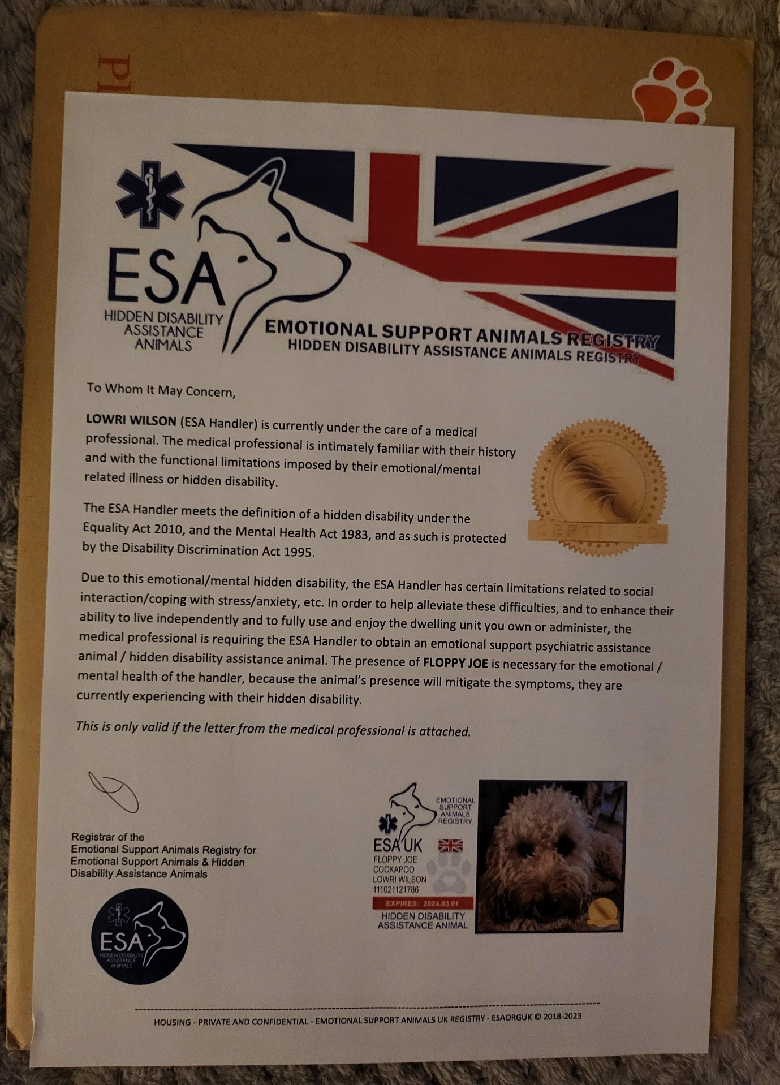
Official ESA Registration card.



Appendix 7 - Poster

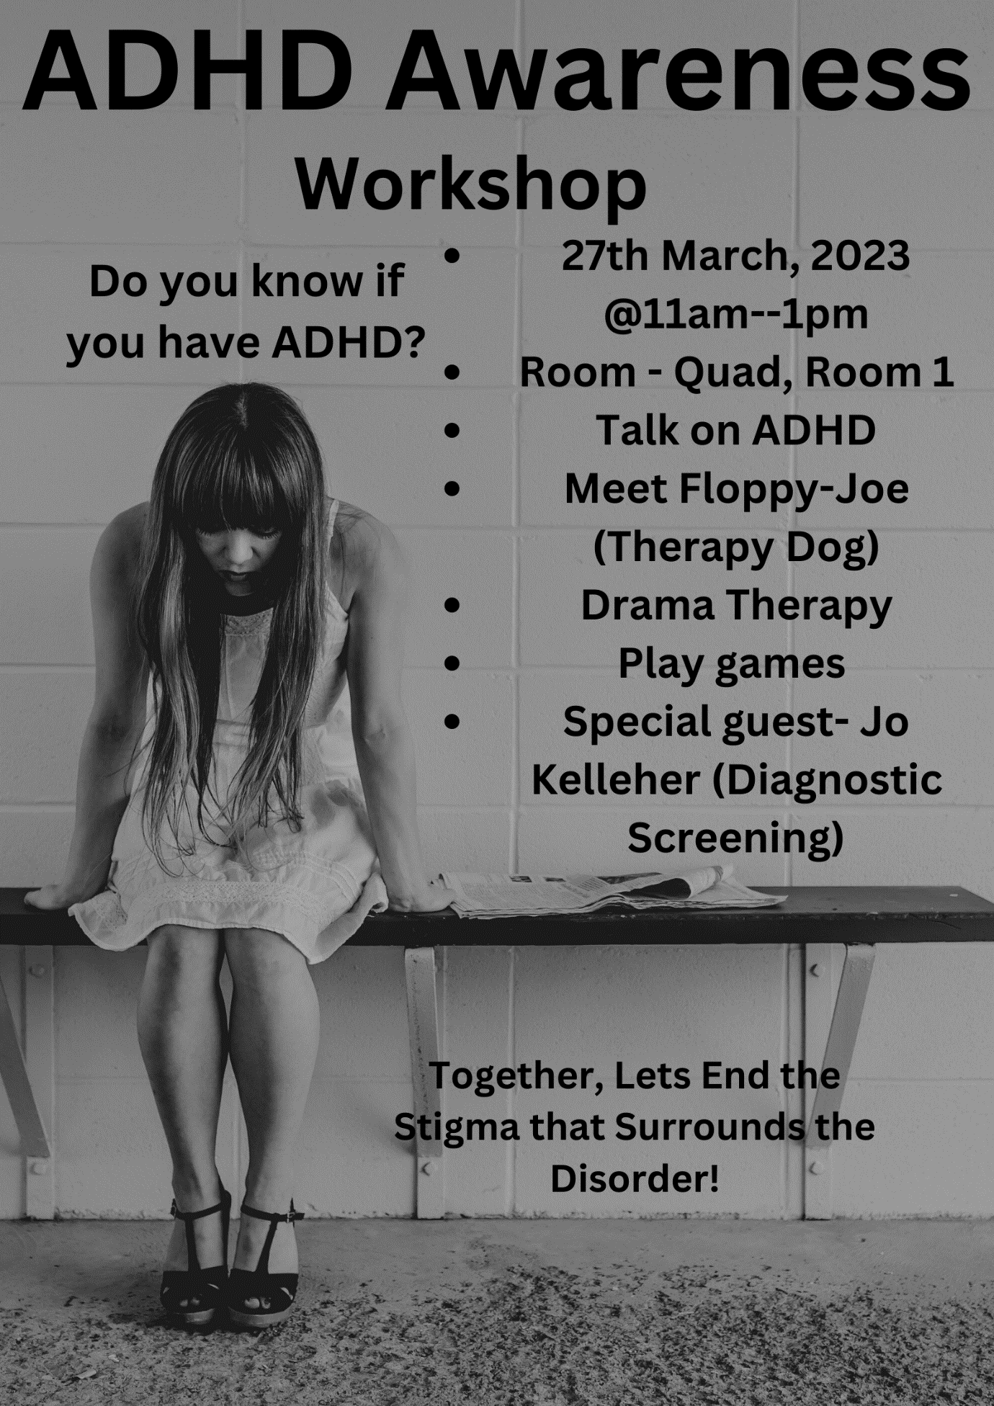
Appendix 8 – Highz & Lowz Website link and logo.

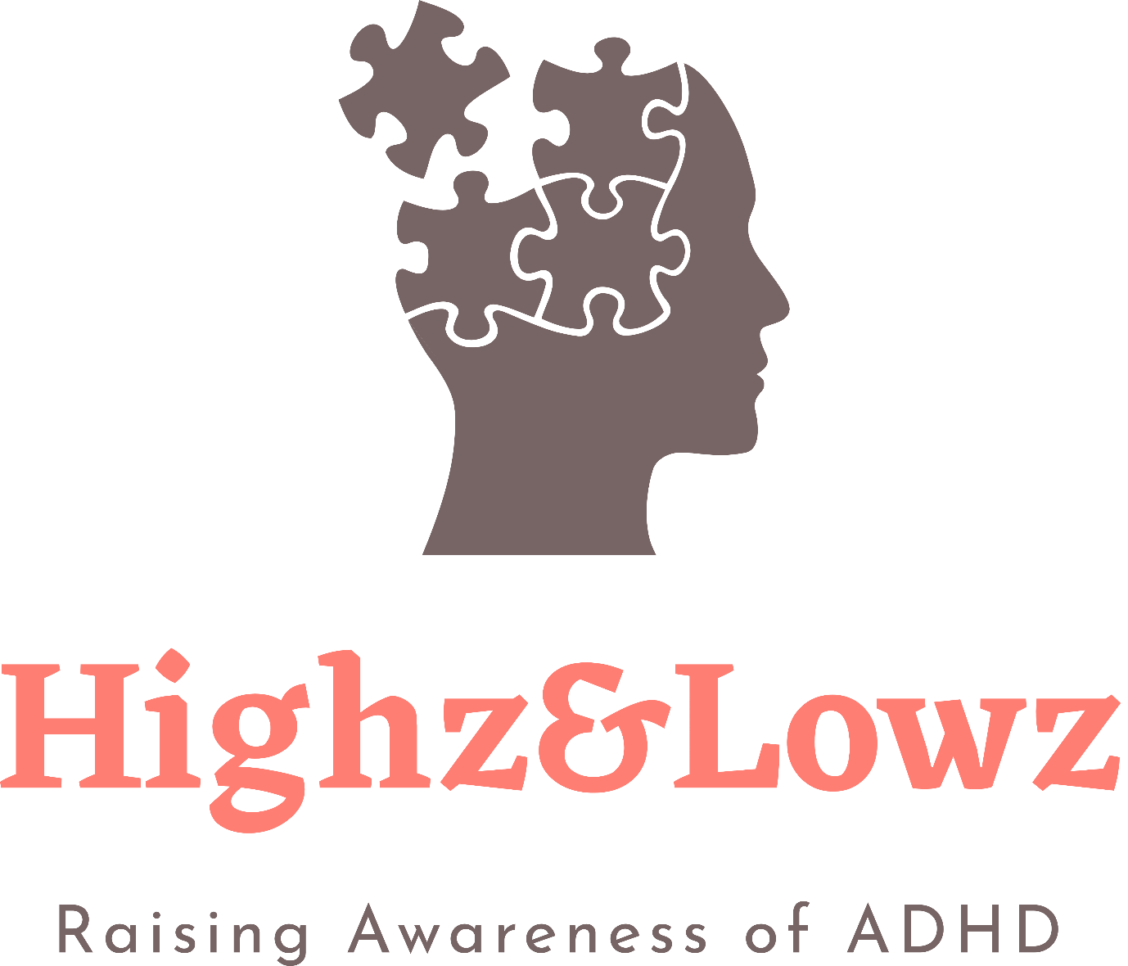

Bibliology
American Psychiatric Association Staff (2022). Diagnostic and Statistical Manual of Mental Disorders, 4th Edition, (2000). American Psychiatric Association Publishing.
(Accessed: 10th January 2023).

Arnold. E. (1996) Child & Adolescent Disorders Research Branch. National of Mental Health: Rockville: USA.

Barkley, R. A. (1990) attention deficit hyperactivity disorder: A Handbook for Diagnosis and Treatment. Fourth Edition.: New York: Gilford Press.

Barkley, R. A. (1997a). Behavioural inhibition, sustained attention, and executive functions: Constructing a unifying theory of AD/HD: Psychological Bulletin.

Barkley. R.A. (2016) Treating ADHD in Children and Adolescents: Guilford Press.

Banks, M. R., & Banks, W. A. (2002). The effects of animal-assisted therapy on loneliness.

Biederman. J. (1999) Child Adolescence: Psychiatry

Biederman. J. Attention (2005) attention deficit hyperactivity disorder. A selective overview: BIOL Psychiatry.

Bradley, C., 1937. The behaviour of children receiving Benzedrine. American journal of Psychiatry.

Brown. E.T. (2013) A New Understanding of ADHD in Children and Adults: New York: Yale University.

Brown. E.T. (2009) ADHD Comorbidities: A Handbook for ADHD Complications in Children and Adults: American Psychiatric Publishing Inc: Washington. D.C.

Brown. W. A (1998) Charles Bradley, M.D: Am J Psychiatry

Bustad, L. (1980). Animals, aging and the aged. Minneapolis: University of Minnesota Press.

Courtney, R (1980). The Dramatic Curriculum. London: Heinemann.p.33.
Douglas VI. (1988) Cognitive Defects in Children with Attention Deficit Disorder with Hyperactivity in Attention Disorder. Criteria, Cognition, Intervention: Pergamon: New York.

Eisenberg, D., Golberstein, E. and Hunt, J.B., 2009. Mental health and academic success in college. The BE Journal of Economic Analysis & Policy, 9(1).

Eisenberg, D., Gollust, S.E., Golberstein, E. and Hefner, J.L., 2007. Prevalence and correlates of depression, anxiety, and suicidality among university students. American journal of orthopsychiatry, 77(4), pp.534-542.

Faraone. S.V., Perlis. R.H, Doyle. A.E. (2005). Molecular genetics of attention deficit hyperactivity disorder: Biology Psychiatry.

Gordan M. (1995). How to operate an ADHD Clinic or Subspecialty Practice: New York: GSI Publications.

Henry. C. (2008) Affective lability and affect as core dimensions of bipolar disorders during euthymic period: Psychiatry Res.
Kesser. R. C, Adler. L, Barkley. R. (2006) The Prevalence and correlates of Adult ADHD in the United States. Results from the National Comorbidity Survey Replication: AM J Psychiatry.

Kooij, S.J., Bejerot, S., Blackwell, A. European consensus statement on diagnosis and treatment of adult ADHD: The European Network Adult ADHD. BMC Psychiatry.

Kooji.J. S., 2012. Adult ADHD: Diagnostic assessment and treatment. Springer Science & Business Media.

Kramer, F. and Pollnow, H., (1932). Über eine hyperkinetische Erkrankung im Kindesalter: European Neurology.
(Accessed 9th January 2023).

Ohan. J. L, Johnson. C. (2005) Gender Appropriateness of Symptom Criteria for Attention, Deficit, Hyperactivity Disorder- Oppositional Defiant Disorder, and Conduct Disorder. Child Psychiatry Hum.

Mayberg. H.S. Liotti. M, Brannan. S.K. Reciprocal limbic-cortical Function and Negative Mood. Converging PF. T Findings in Depression and Normal Sadness: Am J Psychiatry.

Martinussen R, Hayden J. Hogg-Johnson. Tannock R. (2005) Meta analysis of working memory impairments in children with attention-deficit/hyperactivity disorder: Journal of the American Academy of Child and Adolescent Psychiatry.

McGregor. (1976). Developments in Drama Teaching. London: open Books.p106.
Munden. M; Arcelus. J. (1999) A Guide for Parents and Professionals on Attention, Deficit, / Hyperactivity Disorder: ADHD Handbook: England: London.

POP, D., POP-VANCIA, V., CONSTANTINESCU, R., MIRESAN, V., RUSU, A.S. and PAPUC, I., 2014. Physiological Effects of Human-Animal Positive Interaction in Dogs-Review of the Literature. Bulletin of the University of Agricultural Sciences & Veterinary Medicine Cluj-Napoca. Animal Science & Biotechnologies, 71(2).

Sayal K, Goodman R, Ford T. (2006). Barriers to the identification of children with attention deficit/hyperactivity disorder: J Child Psychology: Psychiatry.

Shattell, M.M., Bartlett, R. and Rowe, T., 2008. “I have always felt different”: The experience of attention-deficit/hyperactivity disorder in childhood. Journal of Paediatric Nursing, 23(1), pp.49-57.

Simpson. J.R., Drevets. W.C, Synder. A.C. Emotion Included Changes in Human Medical Prefrontal Cortex. During Anticipatory Anxiety: Proc Natl Acad Sci: USA.

Spolin. V. (1999) Improvisation for the Theatre. A Teachers Handbook: Northwestern: University Press.

Spolin. V. (1986) Theatre Games for the Classroom. A Teachers Handbook: Northwestern: University Press.

Taylor. M, Lichtenstein, H. Larsson, H. Anchkarsater (2016) Child Adolescence: Psychiatry.

The Diagnostic and Statistical Manual of Mental Disorders 4th Edition DSM-IV (1994): American Psychiatric Association: Washington. D.C.

Travell, C. and Visser, J., 2006. ‘ADHD does bad stuff to you’: young people's and parents' experiences and perceptions of attention deficit hyperactivity disorder (ADHD). Emotional and Behavioural Difficulties, 11(3), pp.205-216.

Ustundag, T., 1988. The efficacy of drama in education in the primary school as a teaching method. Unpublished Master Thesis. Hachette University, institute of Social Sciences, p. ll.

Weitzman C, Wegner L, Section D, Behavioural P. (2015). Committee on Psychosocial Aspects of C, Family H, et al. Promoting optimal development: screening for behavioural and emotional problems: Paediatrics.

World Health Organization (1992) The ICD-10 Classification of Mental and Behavioural Disorders. Clinical Descriptions and Diagnostic Guidelines: Geneva: WHO

Young, S., Bramham, J., Gray, K. and Rose, E., 2008. The experience of receiving a diagnosis and treatment of ADHD in adulthood: a qualitative study of clinically referred patients using interpretative phenomenological analysis. Journal of attention disorders, 11(4), pp.493-503.

References

ADHD and mental health - Mind
(Accessed: 2nd October 2022).

ADHD and Mental Health – Co-occurring primary mental health conditions (2021)
ADHD and mental health - ADHD Aware
(Accessed 14th October 2022).

Acting Games | Drama Exercises and Games for Kids and Adults (stagemilk.com) (2022)
(Accessed: 14th February 2023).

Akgun, S. and Ciarrochi, J., 2003. Learned resourcefulness moderates the relationship between academic stress and academic performance. Educational Psychology, 23(3), pp.287-294.

Arkow, P. (2004). Animal-assisted therapy and activities: A study, resource guide and bib lipography for the use of companion animals in selected therapies 9th ed: Stratford: NJ: Phil Arkow

Attention-Deficit / Hyperactivity Disorder (ADHD) in Children (2022)
https://www.hopkinsmedicine.org/health/conditions-and-diseases/adhdadd
(Accessed: 17th October 2022).

ADHD Treatment and Behaviour Therapies (2022)
ADHD Treatment Options for Children: Medication, Natural Remedies (additudemag.com)
(Accessed: 19th October 2022).

Banks, M. R., & Banks, W. A. (2002). The effects of animal-assisted therapy on loneliness.

Can Drama Classes Teach Children about Empathy? (2022)
Can Drama Classes Teach Children About Empathy? (jigsaw-arts.co.uk)
(Accessed: 7th March 2023).

Canva (2023)
www.Canva.com
(Accessed: 3rd March 2023).

Casey, B. J., Castellanos, F. X., Giedd, J. N., Marsh, W. L., Hamburger, S. D., Schubert, A. B., Vauss, Y. C., Vaituzis, A. C., Dickstein, D. P., Sarfatti, S. E., & Rapoport, J. L. (1997). Implication of right.

Comorbidity of Mental Health and Physical Diseases (2013)
Comorbidity of mental and physical diseases: a main challenge for medicine of the 21st century - PMC (nih.gov)
(Accessed 20th January 2023).

Conners, C.K., (2000). Attention-deficit/hyperactivity disorder. Historical Development and Overview: Journal of Attention Disorders.

Course & Class Reps @ UWTSD Students' Union (uwtsdunion.co.uk)
(Accessed: 12th March 2023).

Dance Drama and Singing (2022)
Jigsaw Performing Arts Schools | Dance Drama & Singing For Children (jigsaw-arts.co.uk)
(Accessed: 10th March 2023).

Diagnostic Issues and Gender Differences of Attention Deficit Hyperactivity Disorder (escholarship.org)
(Accessed: 17th January 2023).
Emotional Support Animals UK
Emotional Support Animals UK Registration (esaorguk.com)
(Accessed 2nd March. 2023).

Fitness Tips for Drama Students (2022)
https://www.theatrefolk.com/blog/3-fitness-tips-for-drama-students/
(Accessed 18th March 2023).

Fun Icebreakers, Ideas and Activities (N.D)
Zip, Zap, Boing - Fun Icebreaker Ideas & Activities (icebreakers.ws)
(Accessed: 22nd January 2023).

Health benefits of Animal Assisted Interventions (N.D).
Health Benefits of Animal-Assisted Interventions (sagepub.com)
(Accessed 17th February 2023).

How To Play Mafia (2013)
How to Play Mafia: An In-Depth Guide to the Perfect Party Game - KQED Pop
(Accessed: 22nd January 2023).

High Speed Training (2023).
ADHD Awareness v4 (highspeedtraining.co.uk)
(Accessed: 15th October 2022).

Reflections on Play (2023)
Reflections on Play: Dramatic Play and the Home Corner – Alice Sharp
(Accessed: 7th March 2023).

Resolved: Mania Is Mistaken for ADHD in Prepubertal Children - ScienceDirect
(Accessed:15th February 2023)

Rising Above the Drama Triangle: Embracing Empathy and Authentic Connections (linkedin.com) (2023)
(Accessed: 5th February 2023).

Serpell, J. A. (2006). Animal-assisted interventions in historical perspectiveHandbook on animal-assisted therapy: Theoretical foundations and guidelines for practice (2nd ed., chap. 1). New York: Academic Press. Sobo, E. J., Eng, B., & Kassity-Krich, N. (2006). Canine visitation (pet)
Scan you brain and find the secrets (2005)
Scan your Brain and Find its Secrets - Connecting the Dots (iconnectdots.com)
(Accessed: 18th October 2022).

Stimulation, Rewards, and the ADHD Brain (2023)
Stimulation, Rewards and the ADHD Brain - Edge Foundation
(Accessed 7th March 2023).

Tanya Bardsley Me and ADHD (2023)
Celebrity Health Stories - ITVX
(Accessed: January 12th, 2023).

The Benefits of Therapy Dogs in Classrooms and on College Campuses (2022)
Benefits of Therapy Dogs in Classrooms and on College Campuses
(Accessed: 23rd January 2023).

The Experience of Having the Diagnosis of ADHD (2015)
Frontiers | Why the Diagnosis of Attention Deficit Hyperactivity Disorder Matters (frontiersin.org)
(Accessed: 16th February 2023).

The Machine Drama Game and Walm up for Music and Movement (2022)
The Machine Drama Game and Warm Up for Music and Movement - Bright Hub Education
(Accessed 12th February 2023).

There is Hope (2017)
https://youtu.be/Se0_hYKJyqA
(Accessed 11th February 2023).

Weitzman C, Wegner L, Section D, Behavioural P. (2015). Committee on Psychosocial Aspects of C, Family H, et al. Promoting optimal development: screening for behavioural and emotional problems: Paediatrics.

What are the different types of ADHD? (2022)
Attention-Deficit / Hyperactivity Disorder (ADHD) in Children | Johns Hopkins Medicine
(Accessed: 17th October 2022).

What is ADHD? (2021)
ADHD and Mental Health | Signs and Symptoms of ADHD | Young Minds
(Accessed: 18th October 2022).

Why are Drama Games Important? (2020)
Drama games - A resource for teachers (trinitycollege.com)
(Accessed: 22nd January 2023).

Stimulation, Rewards and the ADHD Brain - Edge Foundation (2023)
(Accessed: 13th March 2023).

Zombie Game (2023)
Acting Games | Drama Exercises and Games for Kids and Adults (stagemilk.com)
(Accessed: 15th February 2023).

