University of Wales Trinity Saint David London
Programme: BSc Cloud Computing
Module: ACCC4004 Information Engineering
Name: Celdwan Bandeira
ID:1812407

Table of Contents
Introduction 3
Task 1: Database design 3
ER Diagram 3
Entities 4
Relationships 5
Degree of Relationships 5
Normalization 6
Membership Class 6
Task 2 8
Table Design 8
Creation of Forms 12
Running SQL Queries 18
Creating Reports 21
Relationships 23
Macros 23
Brief user Guide 25
Conclusion 25

Introduction
Database implementation has become a popular activity of organization to improvement managing, accessing and controlling of company. It enables the business owners to migrate to online business and improves customer service through better information management (Jukic et al. 2016). In this paper, a database using MS Access software has been developed for a company named Home from Home. The company Home from Home is a real estate firm that operates sales of properties in South Wales. Due to increased customer, the company is facing challenges to manage large amount of data and need a database system. The developer has provided detailed documentation for ERD design, database design, and creation of forms, reports and macros.

Task 1: Database design

ER Diagram
Design of an ER diagram is the initial stage of implementing a database. ERD or Entity relationship diagrams are useful to identify the key entities of a database and create a relationship between them (Hingorani et al. 2017). It also enables developers to design a relational database system. The following figure shows the ERD for Home from Home database.
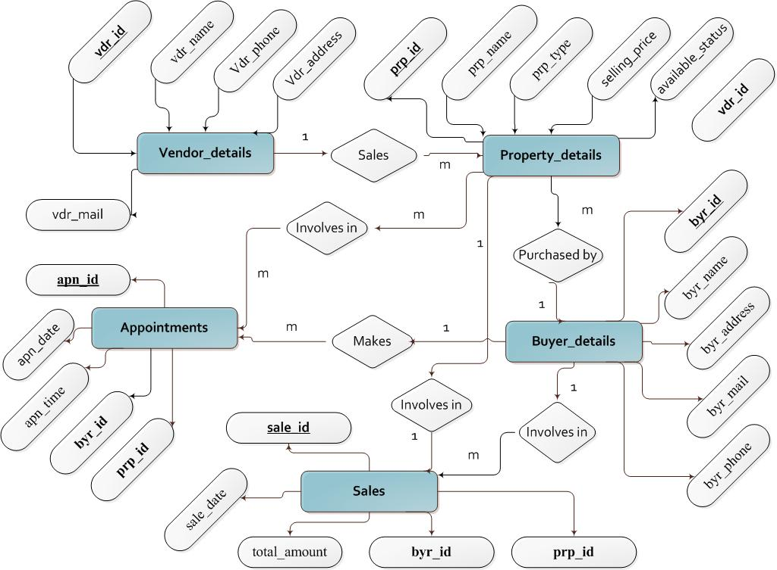
Figure 1: Entity Relationship Diagram for Home from Home
(Source: Created in MS Visio)

Entities
It is identified that; the database requires at least the following five entities as per the case scenario of Home from Home.
A vendor details entity to store the details of all vendors associated with Home from Home Company. The company can add id, name, address, phone and email of each vendor which are the main attributes of this entity. As shown in the ERD, vdr_id will work as the primary key to uniquely identify each row in this table.
A buyer details entity to store Home from Home's clients detail interested in buying property. This entity may include attributes such as byr_id, byr_name, byr, address, byr_phone and byr_mail. The byr_id is the primary key of this table which will be unique in each row.
A property_details entity in order to store details of properties managed by Home from Home. The database users can store id, name, property type, selling price, location of properties. Another attribute vdr_id is added as foreign key to store the vendor information who is selling the property.
An appointments entity is required to store the details of appointments. As customer base is increasing, Home from Home may face difficulties to access information related to upcoming appointments. This database can help to easily access client appointment details such as appointment date, time, concerned property and client details.
A sales entity is required to record the details of sold properties. As shown in the ERD, it may involve the attributes such as id, sold date, amount paid, buyer details and property details. byr_id and prp_id are used as foreign key of this table to retrieve the details from buyer and property related entities.

Relationships
In a relational database system, it is important to create a linkup between different entities and tables. According to Eckstein and Schultz (2018), use of foreign key is the main way to create relationship. Foreign keys are helpful to create referenced of one table for another. The current database of Home from Home is developed using relational database design. As identified in the ERD, property_details, appointments and sales entities include foreign keys. For example – the vdr_id is the primary key of vendor_details entity which is used as the foreign key of property_details entity. Thus a relationship between property_details is created to access records of vender from the property table.

Degree of Relationships
Relationship between two tables also involves degree which is called cardinality in database context. There can three types of relationship degree including one-to-one, one-to-many and many-to-many (Jukic et al. 2016). As per the business rules of Home from Home, relationships has been created. For example- the company received property details from many vendors; however a particular property may belong to only one vendor. Though, one vendor may wish to sale many properties. For this reason, one-to-many relationship (1: m) is created between client_details and property_details entity. In similar manner, the developer has developed the following degree of relationships.
Buyer_details to Property_details: one-to-many relationship
Buyer_details to Appointments: one-to-many relationship
Property_details to Appointments: one-to-one relationship
Buyer_details to Sales: one-to-many relationship

Normalization
In relational database development, a database must be normalized to better organize datasets. Albarak and Bahsoon (2016) defined; normalization is the process of minimizing redundancy from a set of database relations. There are mainly five types of normalization including 1NF, 2NF, 3NF, BCNF and 4NF. In the database of Home from Home, normalization up to 3NF is achieved. The developer has used the following procedure to achieve 3NF.
- As per 1NF rule, at tributes should contain only atomic values. In this database, each attribute are single-valued attributes which ensures 1NF.
- As per 2NF rule, all non-key attributes must dependent on the primary key only. In each table, primary key is developed and there is no dependency between non-key attributes.
- As per 3NF rule, there should be no transitive dependency between non-prime attributes (Eckstein and Schultz, 2018). The tables of this database do not include any composite key which reduces the possibility of transitive dependency. Moreover, all the non-prime attributes are considered in such manner, that these are only dependent to the primary key. Thus, the database achieves 3NF and reduces data duplications.

Membership Class
Membership Classes | Attributes and Data types
Properties Class | prp_id: Integer  prp_name: String  prp_type: String  selling_price: Float  available_status: String
Vendor Class | vdr_id: Integer  vdr_id: Integer  vdr_name: String  vdr_phone: Integer  vdr_email: String  vdr_address: String
Buyers Class | byr_id: Integer  byr_name: String  byr_phone: Integer  byr_address: String  byr_mail: String
Sales Class | sale_id: Integer  prp_id:Integer  byr_id: Integer  sale_date: Date  sale_amount: Float
Appointments Class | apn_id: Integer  apn_date: Date  apn_time: Date  byr_id: Integer  prp_id: Integer

Table 1: Membership Class
(Source: Developed by the author)

Task 2

Table Design
Based on the previously created ERD, the following tables are designed. Screenshots from MS Access database are also given.
Property_details table
Attributes | Data type | Primary/ foreign key | Foreign key table name
prp_id | TEXT | Primary key
prp_name | TEXT
prp_type | TEXT
Selling_price | CURRENCY
Available_status | YES/NO
vdr_id | TEXT | Foreign key | Vendor table

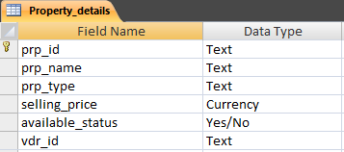
Figure 2: Tables design and MS Access Screenshot
(Source: Created by the author)
Vendor_details table
Attributes | Data type | Primary/ foreign key | Foreign key table name
vdr_id | TEXT | Primary key
vdr_name | TEXT
vdr_phone | TEXT
vdr_email | TEXT
vdr_address | TEXT

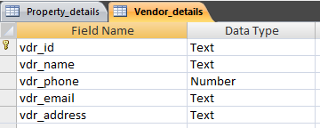
Figure 3: Tables design and MS Access Screenshot
(Source: Created by the author)
Buyer_details table
Attributes | Data type | Primary/ foreign key | Foreign key table name
byr_id | TEXT | Primary key
byr_name | TEXT
byr_phone | NUMBER
byr_address | TEXT
byr_mail | TEXT

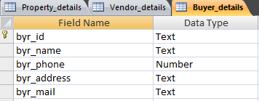
Figure 4: Tables design and MS Access Screenshot
(Source: Created by the author)
Appointments table
Attributes | Data type | Primary/ foreign key | Foreign key table name
apn_id | TEXT | Primary key
byr_id | TEXT | Foreign key | Buyers table
prp_id | TEXT | Foreign key | Properties table
apn_date | DATE/TIME
apn_date | DATE/TIME

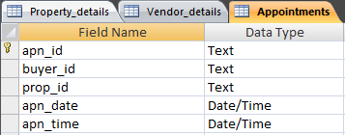
Figure 5: Tables design and MS Access Screenshot
(Source: Created by the author)
Sales table
Attributes | Data type | Primary/ foreign key | Foreign key table name
sale_id | TEXT | Primary key
prp_id | TEXT | Foreign key | Properties table
byr_id | TEXT | Foreign key | Buyers table
sale_date | DATE
sale_amount | CURRENCY

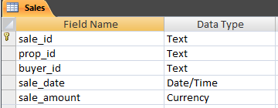
Figure 6: Tables design and MS Access Screenshot
(Source: Created by the author)

Creation of Forms
MS Access allows database designers to create forms based on created tables for the database (Ganchev and Kutseva, 2017). In this database system, template forms are used to create five different forms. Each form includes button for adding item, navigating to records, and searching a particular item from the database tables. In addition a main menu form is created to help the users to access all forms simultaneously.
1. Main Menu Form
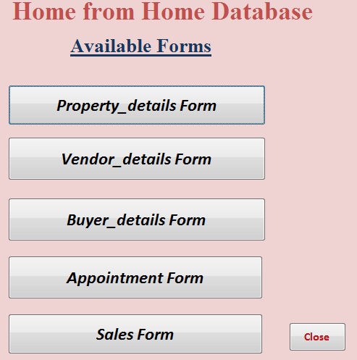
Figure 7: Screenshot of Main Menu Form
(Source: Developed in MS Access)

2. Property detailsForm
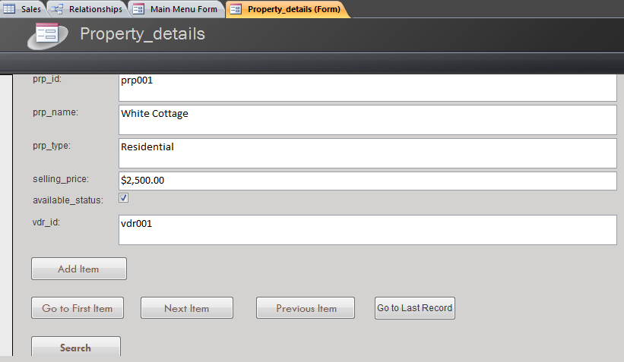

Figure 8: Property_details Form Screenshot
(Source: Developed in MS Access)
3. Vendor detailsForm
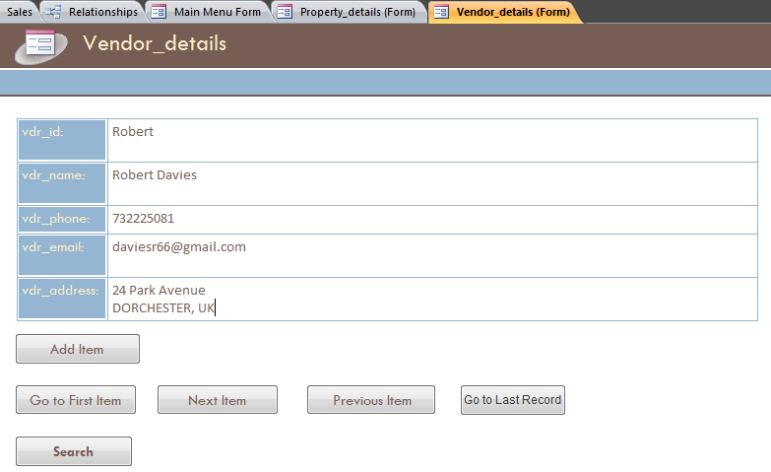

Figure 9: Vendor_details Form Sceenshot
(Source: Developed in MS Access)
4. Buyer details Form
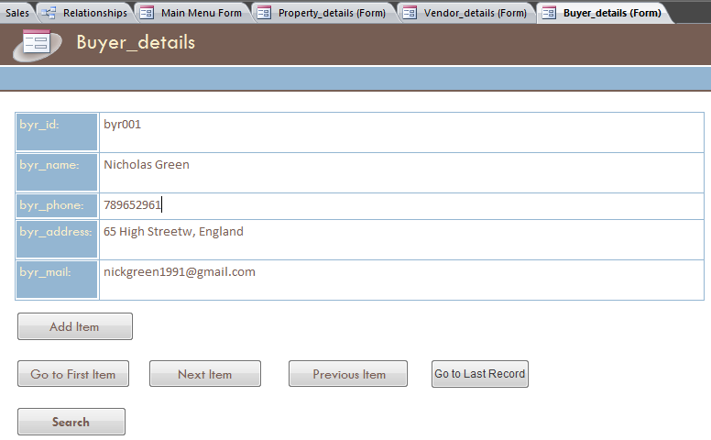

Figure 10: Buyer_details Form Screenshot
(Source: Developed in MS Access)
5. Appointments Form
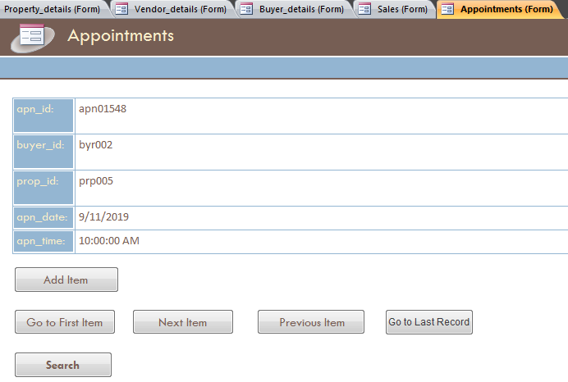

Figure 11: Appointments Form Screenshot
(Source: Developed in MS Access)
6. Sales Form
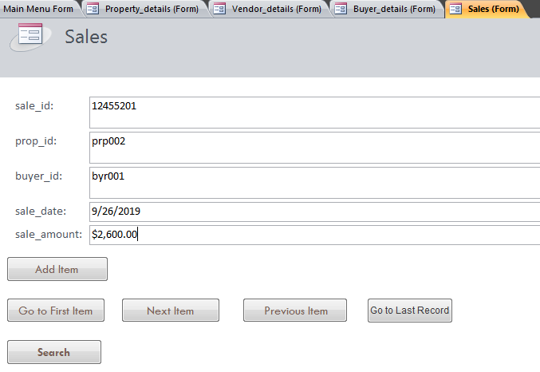

Figure 12: Sales Form Screenshot
(Source: Developed in MS Access)

Running SQL Queries
In database context, SQL queries are used to return values from the database tables based on end user requirements or criteria (Batory and Azanza, 2017). It also allows the database designers to test the database by providing different conditions. In this section different user criteria are developed to run SQL queries and return required results. Using the ‘Query Design’ functionality of MS Access, the following queries are designed to test data.
1. Retrieving property details whose available status is “Yes”
Query:
SELECT Property_details.prp_id, Property_details.prp_name, Property_details.prp_type, Property_details.selling_price, Property_details.available_status, Property_details.vdr_id
FROM Property_details
WHERE (((Property_details.available_status)=Yes));
Output:
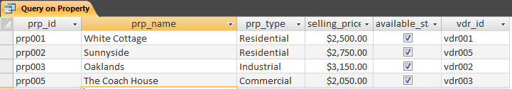
2. Retrieving name, address and phone number of all vendors
Query:
SELECT Vendor_details.vdr_name, Vendor_details.vdr_phone, Vendor_details.vdr_address
FROM Vendor_details;
Output:
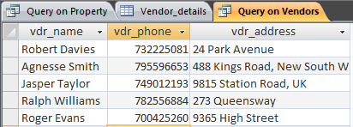
3. Retrieving name, address and phone number of all buyers
Query: SELECT Buyer_details.byr_name, Buyer_details.byr_phone, Buyer_details.byr_address
FROM Buyer_details;
Output
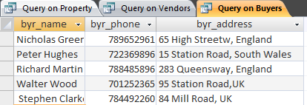
4. Retrieving the appointment details of September month.
Query:
SELECT Appointments.apn_id, Appointments.apn_date, Appointments.apn_time, Appointments.buyer_id, Appointments.prop_id, Appointments.buyer_id, Appointments.prop_id
FROM Appointments
WHERE (((Appointments.apn_date) Between #1/9/2019# And #9/30/2019#));
Output
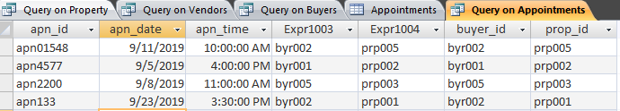

Creating Reports
In MS Access database, Reports can be considered as printable dataset produced by the user on specific criteria. In MS Access, the ‘Report Wizard’ function is used to generate reports as per end user requirements. In this section, reports for each table’s details are created.
1. Report on Property details
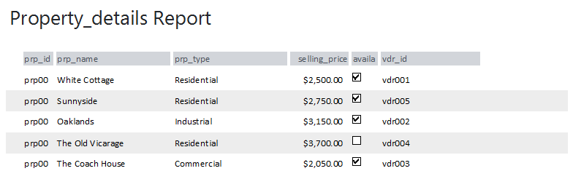
2. Report on vendor details
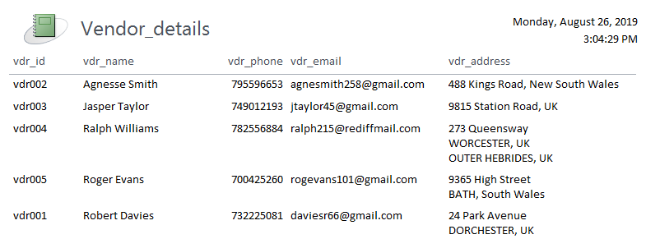
- Report on Buyer details
- 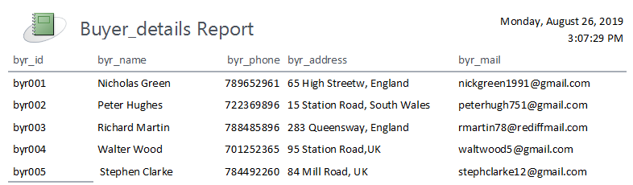

4. Report on Appointment details
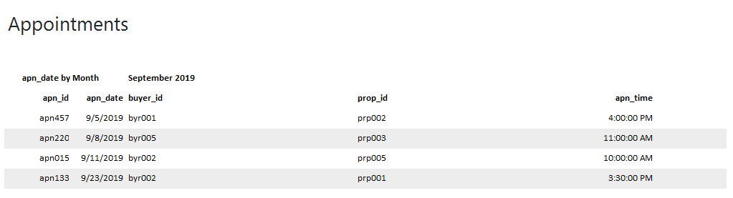
- Report on Sales data
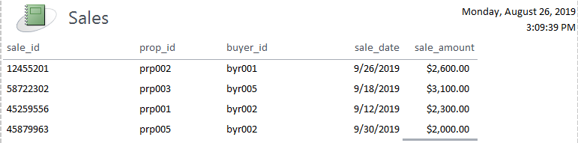
Figure 14: Sample reports
(Source: Created in MS Access)

Relationships
Relationships between different tables can be designed in MS Access. From the ‘Database tools’ tab, the ‘Relationship’ function can be accessed to create relationships. Based on the five tables of Home from Home database the following relationships are created. As shown in the figure below, each foreign key is connected to the primary key of its parent table. For example – Vendor_details and property_details are connected through vdr_id.
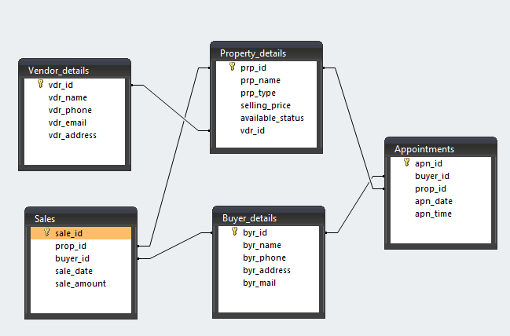
Figure 15: Relationships between different tables
(Source: Created in MS Access)

Macros
Macros in MS access can be considered as a tool to include different functionality to the forms (Chang et al. 2017). MS Access facilitates a range of Actions such as ‘AddMenu’, ‘ApplyFilter’, ‘FindRecord’ ‘FindNext’ to run macros. In the database of Home from Home, there are five different forms and each form includes macros. The buttons such as ‘Add item’, ‘Search’ perform different functionality based on macro operations. For example the ‘Next Item’ button in each form performs the ‘GoToRecord’ actions. Another evidence of macro can be seen in the Main Menu Form of this database. The close button also performs a macro operation called ‘Close Form’.

Brief user Guide

Accessing tables design and data
- Open the ‘Home from Home database’ files in MS Access.
- From the ‘All tables’, navigate to particular table.
- View and edit data from the records
- To access the table design, go to ‘View’ in the right hand corner from ‘Design’ tab and select ‘Design view’.
Accessing forms
- Navigate to Main Menu Form in bottom of ‘All tables’ panel.
- Select a particular form to add, update or find records
Insert, navigate or search an item
- Navigate to the form in which data to be inserted
- Insert records in the provided data fields and Click 'Add item button
- To view the first record click on 'Go to first record' button.
- To update a record, find the target record by clicking ‘Search’. Then update the data fields and click ‘Add Item’.

Conclusion
It can be concluded from this technical document, data that the new database can be useful to increase data management efficiency of Home from Home. The company can notice faster data access from a large set of data. Appropriate relationships are created to enables the database users to connect one business entity to another. Apart from that forms are design through which end users can add, navigate and search items from the database. The database involves macros which are used to perform these form operations. A brief user guide is also provided for a better understanding of this database functionality.

Reference List
Albarak, M. and Bahsoon, R., 2018, May. Prioritizing technical debt in database normalization using portfolio theory and data quality metrics. In Proceedings of the 2018 International Conference on Technical Debt (pp. 31-40). ACM.
Batory, D. and Azanza, M., 2017. Teaching model-driven engineering from a relational database perspective. Software & Systems Modeling, 16(2), pp.443-467.
Chang, S., Knauth, A. and Greenman, B., 2017, January. Type systems as macros. In ACM SIGPLAN Notices (Vol. 52, No. 1, pp. 694-705). ACM.
Eckstein, J. and Schultz, B.R., 2018. Introductory Relational Database Design for Business, with Microsoft Access. Newark: Wiley.
Ganchev, D. and Kutseva, A., 2017. Application of Microsoft Access Relational Database for Pesticide Decision Taking and Selection. MAYFEB Journal of Agricultural Science, 4, pp.12-19.
Hingorani, K., Gittens, D. and Edwards, N., 2017. REINFORCING DATABASE CONCEPTS BY USING ENTITY RELATIONSHIPS DIAGRAMS (ERD) AND NORMALIZATION TOGETHER FOR DESIGNING ROBUST DATABASES. Issues in Information Systems, 18(1), pp.148-155.
Jukic, N., Vrbsky, S. and Nestorov, S., 2016. Database systems: Introduction to databases and data warehouses. Prospect Press.

