

Certificate of Higher Education in Employability Skills LEVEL 4
Module Name: Digital Skills for Personal and
Professional Growth
Module Code: BMSW4008
Assessment: Evidence of Learning (E-Portfolio) Task 1 and Task 2
Student Name: Roksana Gizynska
Student Number: 2422919
Lecturer: Muhammad Cassamo

AI Acknowledgement
I acknowledge the use of Grammarly (https://www.grammarly.com/) on 11.12.2025 to check my work using the prompt(s):
1. Please check the following text for readability, grammar, and syntax.
I confirm that I have not presented any AI generated text as my own work. I confirm that I have copies of my drafts, notes, and other resources I used before, and after the use of AI tools which I may be asked to provide in evidence.

Task 1
Analysis Report: Market Research Results and The Impact on the RhythmFit Dance Fitness Studio Idea

Introduction
This analysis report outlines how the questionnaire results and secondary research shaped RhythmFit. The report investigates four primary research enquiries: demand for family-friendly dancing fitness, preferred formats and schedules, impact of pricing and convenience on attendance (Kimola, 2025). How segmentation and SEO data outcomes created business plan, marketing, website layout, advertising materials, and the long-term strategy (Sport England, 2025).

Demand for dance-fitness services
Primary research (Appendix 4–11) demonstrated a strong interest in Zumba, particularly family-focused sessions, and after-school Zumba Kids, proving a local deficiency in joint adult-child activities (Zumba Fitness, LLC, 2025). Parents mentioned that there are not many physical activities, which is in line with Sport England's (2025) finding that youngsters activity levels are below national recommendations.
The second trend is flexibility, and various fitness experiences. Many individuals require a mix of in-person sessions and online access that works for busy lifestyle and family routines (Sandahu,2020; Soltanifar et al., 2021). Competitor investigation showed that no local providers offer adult, kid, plus livestreaming and on-demand sessions all in one. The RhythmFit meets this expectation and makes people more resilient because of health issue, childcare, or venue access concerns (Exercise.com, 2025). Sources state that dance-fitness is increasing faster than regular gyms, so plan mix of Zumba reflects wider trends towards enjoyable, music-based group training (IMARC Group, 2024).

Effect on the business concept
The choice to start out as a sole trader is based on small businesses guidance which keep costs low, flexible, and full control during the early stages of development (Barringer and Ireland, 2022).
The participants agreed that prices between £5-£6 is reasonable, and affordable. Williams (2022) says that matching costs with local competitors makes it easier for businesses to get started, which is beneficial for RhythmFit's target audience.
Customers prefer venue close to residential areas, schools, and public transport. This inspired RhythmFit to use community centres and school halls at the beginning because low-cost facilities reduce financial risk for new businesses.
Expectations for the delivery format showed a clear preference for adaptability. While parents preferred early nights and weekends, busy adults preferred evening sessions. Work and childcare obligations make it difficult for some of them to attend for classes, which makes the hybrid model and livestreaming or on-demand sessions necessary.
Trainerize (2025) argues that hybrid fitness enterprises attract larger audience and keep them longer. Easy booking, a visible class calendar, simple payment options, and clear links to online sessions are make these insights improved the usability and accessibility of the website (Exercise.com, 2025).

Audience segmentation
Market segmentation is necessary for successful marketing (Kotler and Keller, 2022). Reflecting popular fitness sectors like "families" and "social exercisers," RhythmFit aims parents between 25-45 with school-age children and young adults who enjoy active, music-based workouts (PerfectGym, 2025).
According to ActiveEntities (2021), psychographic segmentation focusses on those that value enjoyment, community, and mental health. Responses to questionnaires indicating a preference for dancing over gym equipment points that "social group exerciser" profile drive more fun, confidence, and stress relief that competition (Sport England, 2025). While Zumba Fitness (2024) increase energy, positive mood, and mental well-being, group-based activities also boost motivation (Appendix 12), belonging, and long-term adherence (Carron and Spink, 1995).
Geographically, RhythmFit focusses on people who live within a mile of the local schools in Llanelli. After-school and early-evening time slots are feasible due to public transport and nearby halls (Future Fit Training, 2022). Community facilities and school halls are the first selected locations, which organically connects to school collaborations, local festivals, and charitable activities (Kimola, 2025).
Solomon et al. (2019) contend that targeting precision is increased by segmenting lifestyle, habits, and psychographics. These findings are used by RhythmFit to customise social media posts, schedule classes, and marketing materials.

Influence on website design and marketing materials
Effective marketing requires functional and emotional benefits, according to Kotler and Keller (2022). RhythmFit emphasises both confidence, social satisfaction, and health (fitness, well-being) advantages.
Recognising these motivators influenced RhythmFit's marketing strategy:
- The brand's messaging priority inclusivity, joy, and positivity.
- Bright colours and dynamic pictures are used in visual design.
- The class format places a high value on group atmosphere and simple choreography.

Preferences for ease of use, simple booking, and rapid access to information are the direct source of the website concept (Reedy and Parker, 2017). Clear navigation and conspicuous calls to action, like "Join a Class Today," are highlighted in research on fitness websites and digital literacy (Xplor Gym, 2025). In response, the proposed RhythmFit website (Appendix 13) has a straightforward homepage that displays the several class schedule, and costs, along with an obvious booking button that connects to the livestream platform. Segmentation findings and digital media guidelines that authenticity and storytelling build a trust reflected in instructor profiles and community stories (Burgess et al., 2018; Byrd,2021).
Professional advice says that marketing materials should have bright colours, testimonials, and clear calls to action (FounderPal, 2025). Flyers, posters, and business cards (Appendix 1-3) displayed in shops, salons, schools, and community centres (Future Fit Training, 2022).

SEO strategy and digital visibility
SEO became crucial since most participants used Google, Facebook, and Instagram to find fitness providers. Kotler and Keller (2022) stress that having a digital presence is an important part of the marketing.
RhythmFit's SEO plan includes
- Optimising keywords: "Zumba Llanelli," "family fitness," "dance fitness classes," and "Zumba Kids" are all results of consumer searches.
- Local SEO: Moz (2024) says that using location terms makes community services easier to find. RhythmFit incorporates venue details and area keywords.
- Social media alignment: connecting material from TikTok, Instagram, and Facebook can help with search ranking (Dadwal,2020).
- Blog and video content: Updates on local events, wellness advice, and quick routines increase website traffic and engagement.
The fact that clients mostly use search engines and social media to find local fitness services completely changed SEO decision.
Conclusion
The analysis of questionnaire data and secondary research directly influenced RhythmFit's business plan, target audience definition, website, and promotion, ensuring that the concept is evidence-based and closely aligned with the needs and behaviours of local families (Sport England, 2025; Office for Health Improvement and Disparities, 2025). The business model is even stronger by using segmentation, SEO, and marketing strategies. RhythmFit is in a great position to be a hybrid fitness supplier that is open to everyone and has outstanding long-term potential.

Words count: 1062

References
ActiveEntities (2021) Psychographic segmentation in fitness markets. Available at: https://activeentities.com (Accessed: 10 December 2025).
Barringer, B.R. and Ireland, R.D. (2022) Entrepreneurship: Successfully launching new ventures. 7th edn. Harlow: Pearson.
Burgess, J., Marwick, A. and Poell, T. (2018) The SAGE handbook of social media. London: SAGE Publications Ltd. Available at: http://www.doi.org/10.4135/9781473984066 (Accessed: 10 December 2025)
Byrd, L.S. (ed.) (2021) Cultivating entrepreneurial changemakers through digital media education. Hershey, PA: IGI Global. Available at: https://doi.org/10.4018/978-1-7998-5808-9 (Accessed: 10 December 2025).
Carron, A.V. and Spink, K.S. (1995) ‘The group size–cohesion relationship in minimal groups’, Small Group Research, 26(1), pp. 86–105. Available at: https://journals.sagepub.com (Accessed: 10 December 2025).
Dadwal, S.S. (ed.) (2020) Handbook of research on innovations in technology and marketing for the connected consumer. Hershey, PA: IGI Global. Available at: https://doi.org/10.4018/978-1-7998-0131-3 (Accessed: 10 December 2025).
Exercise.com (2025) How to build a hybrid fitness business online. Available at: https://www.exercise.com (Accessed: 10 December 2025).
FounderPal (2025) Fitness marketing ideas and examples. Available at: https://founderpal.com (Accessed: 10 December 2025).
Future Fit Training (2022) Starting a fitness business: Guide to venues and facilities. Available at: https://www.futurefit.co.uk (Accessed: 10 December 2025).
IMARC Group (2024) Zumba business plan and project report 2025: Industry trends, business setup, revenue model, investment opportunities, income, expenses, and profitability. Available at: https://www.imarcgroup.com/zumba-business-plan-project-report (Accessed: 10 December 2025).
Kimola (2025) Complete market research guide for fitness centers. Available at: https://kimola.com/blog/complete-market-research-guide-for-fitness-centers (Accessed: 10 December 2025).
Kotler, P. and Keller, K.L. (2022) Marketing management. 16th edn. Harlow: Pearson.
Moz (2024) Beginner’s guide to local SEO. Available at: https://moz.com/learn/seo/local (Accessed: 10 December 2025).
Office for Health Improvement and Disparities (2025) Physical activity data for children and families in England. Available at: https://www.gov.uk/government/organisations/office-for-health-improvement-and-disparities (Accessed: 10 December 2025).
PerfectGym (2025) Gym member profiles and segmentation strategies. Available at: https://www.perfectgym.com (Accessed: 10 December 2025).
Reedy, K. and Parker, J. (eds) (2017) Digital literacy unpacked. London: Facet Publishing. Available at: https://ebookcentral.proquest.com/lib/trinity/detail.action?docID=5490897 (Accessed: 10 December 2025).
Sandhu, K. (ed.) (2020) Digital transformation and innovative services for business and learning. Hershey, PA: IGI Global. Available at: https://doi.org/10.4018/978-1-7998-5175-2 (Accessed: 10 December 2025).
Solomon, M.R., Marshall, G.W. and Stuart, E.W. (2019) Marketing: Real people, real choices. 10th edn. Harlow: Pearson.
Soltanifar, M., Hughes, M. and Göcke, L. (eds) (2021) Digital entrepreneurship: Impact on business and society. Cham: Springer. Available at: https://doi.org/10.1007/978-3-030-53914-6 (Accessed: 10 December 2025)
Sport England (2025) Active Lives Children and Young People Survey: Academic year 2023–24. Available at: https://www.sportengland.org (Accessed: 10 December 2025).
Trainerize (2025) ‘The top exercise trends in 2025’, ABC Trainerize Blog, 23 June. Available at: https://www.trainerize.com/blog/exercise-trends (Accessed: 10 December 2025).
Williams, S. (2022) Start your own small business in the UK. London: Kogan Page.
Xplor Gym (2025) Gym website best practices: Design, UX and conversion. Available at: https://xplorgym.co.uk (Accessed: 10 December 2025).
Zumba Fitness, LLC (2024) Health benefits of Zumba: Research summary. Available at: https://www.zumba.com/en-US/about (Accessed: 10 December 2025).
Zumba Fitness, LLC (2025) Benefits of dance fitness for adults and children. Available at: https://www.zumba.com (Accessed: 10 December 2025).

Appendix
Appendix 1 RythmFit Business Card - Canva
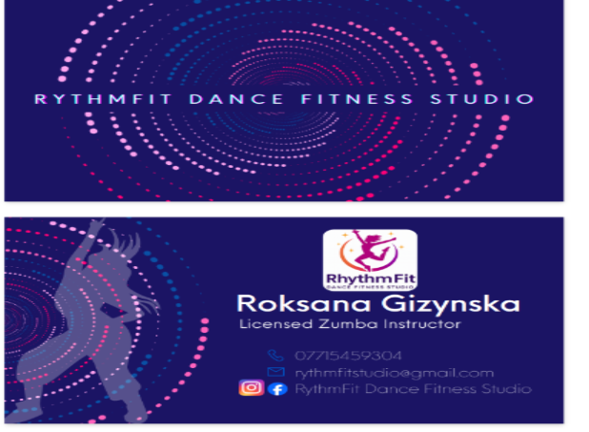
Appendix 2 RythmFit Poster - Canva
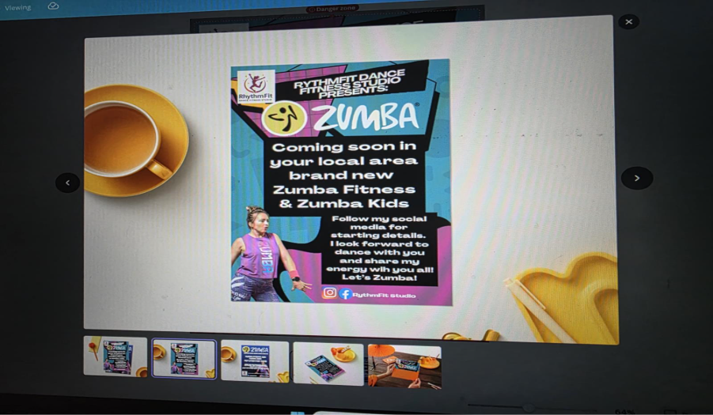

Appendix 3 RhythmFit Poster - Canva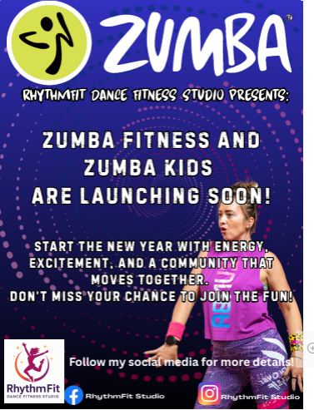
Appendix 4 Microsoft Form Questionaries
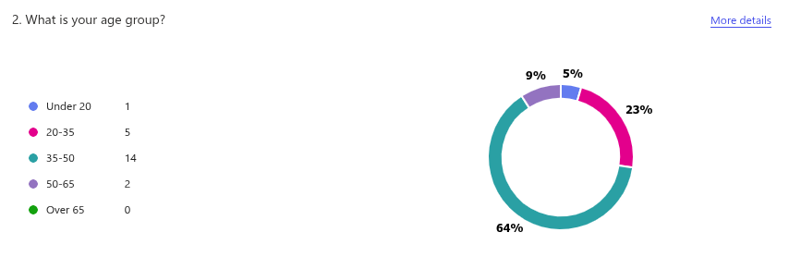Appendix 5 Microsoft Form Questionaries
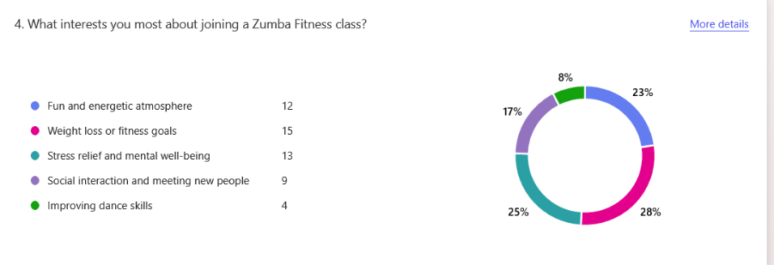Appendix 6 Microsoft Form Questionnaire
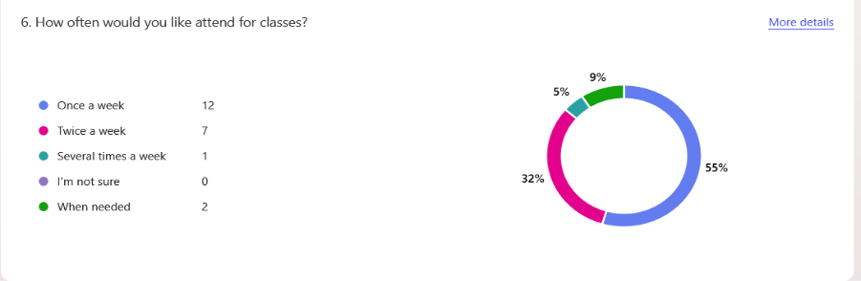Appendix 7 Microsoft Form Questionnaire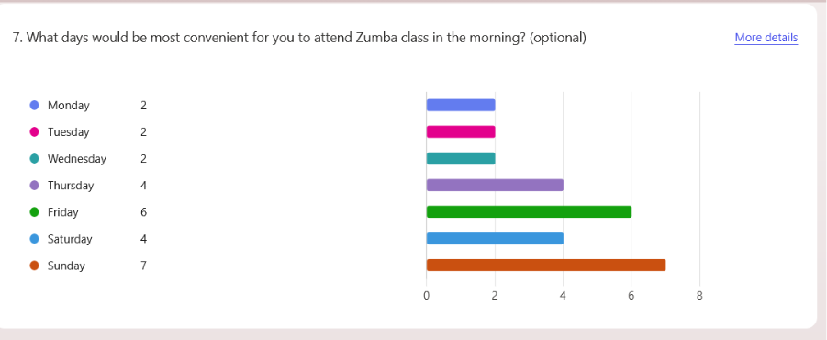Appendix 8 Microsoft Form Questionnaire
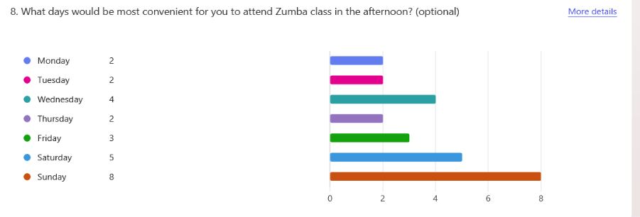Appendix 9 Microsoft Form Questionnaire
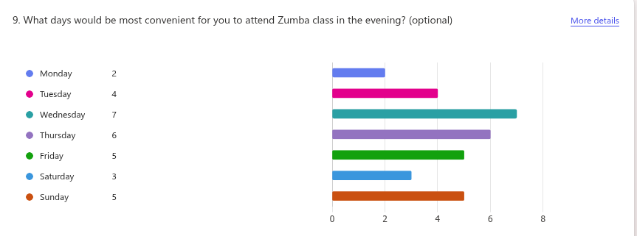
Appendix 10 Microsoft Form Questionaries
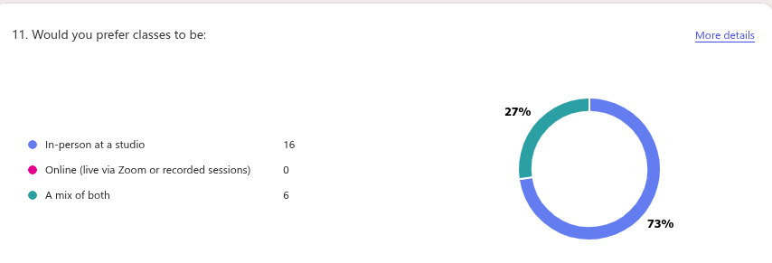Appendix 11 Microsoft Form Questionaries
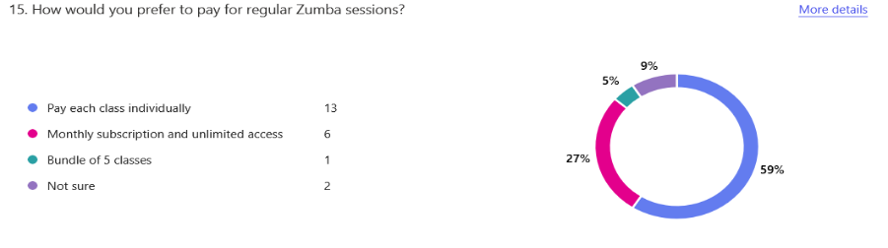
Appendix 12 Microsoft Form Questionaries
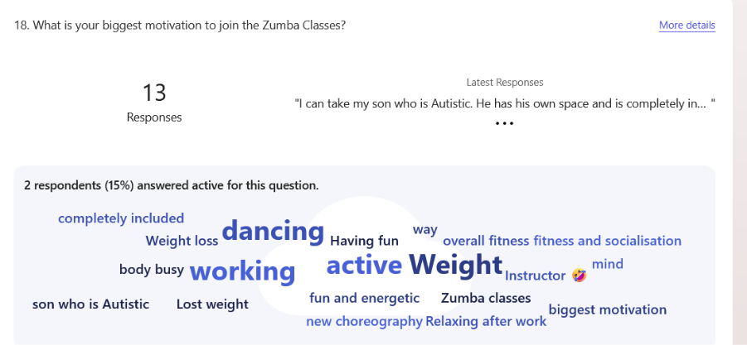

Appendix 13 Website 4 pages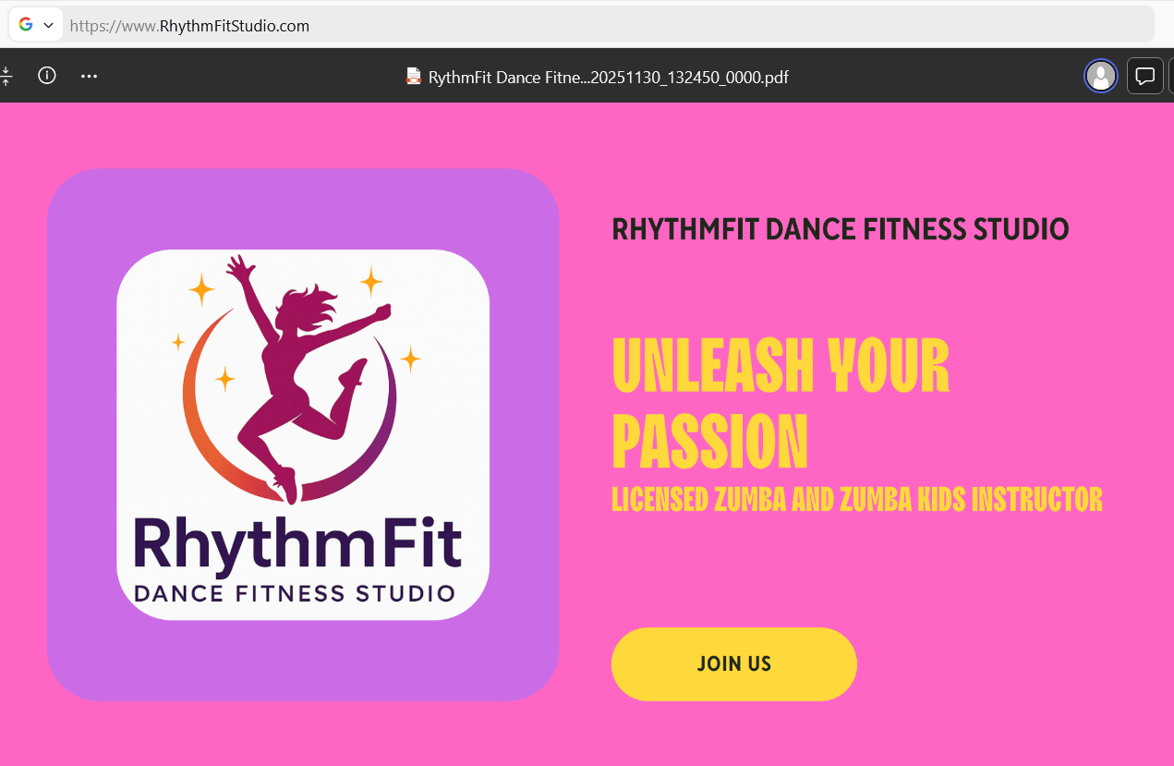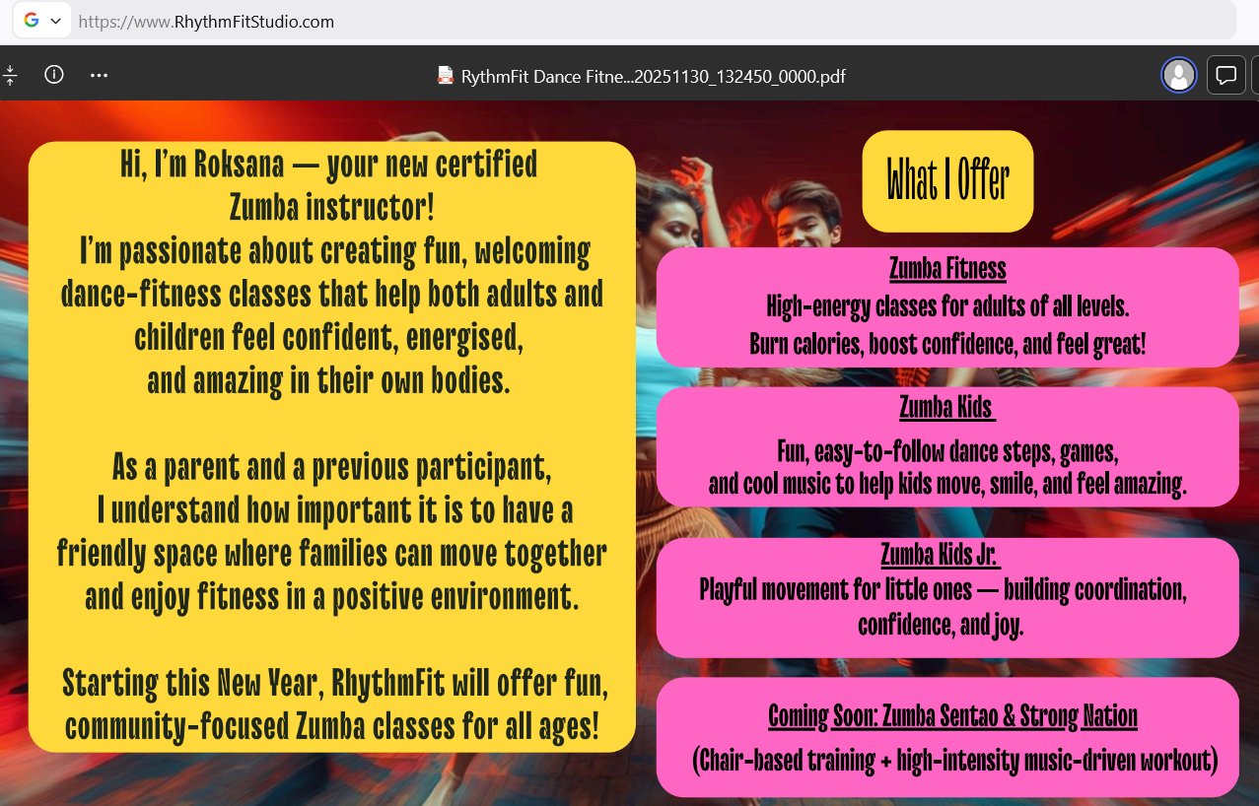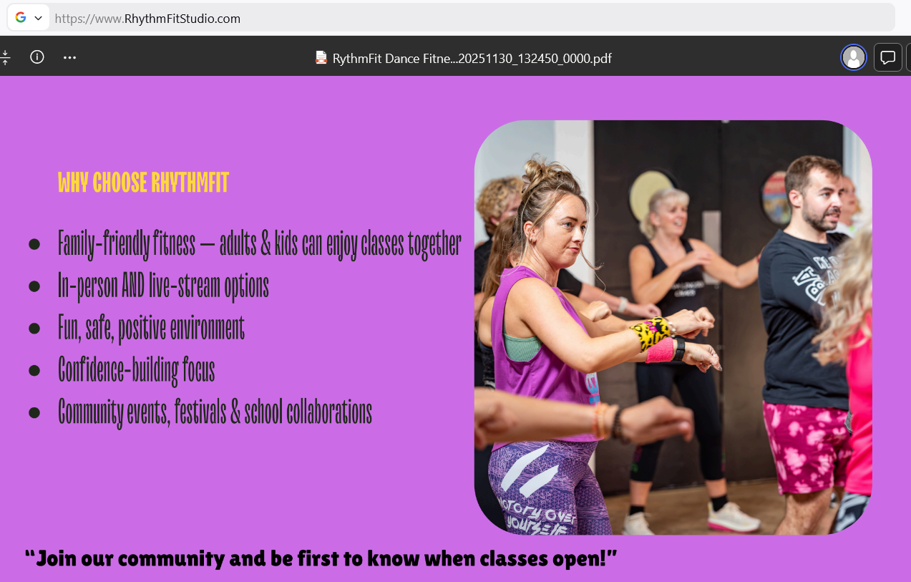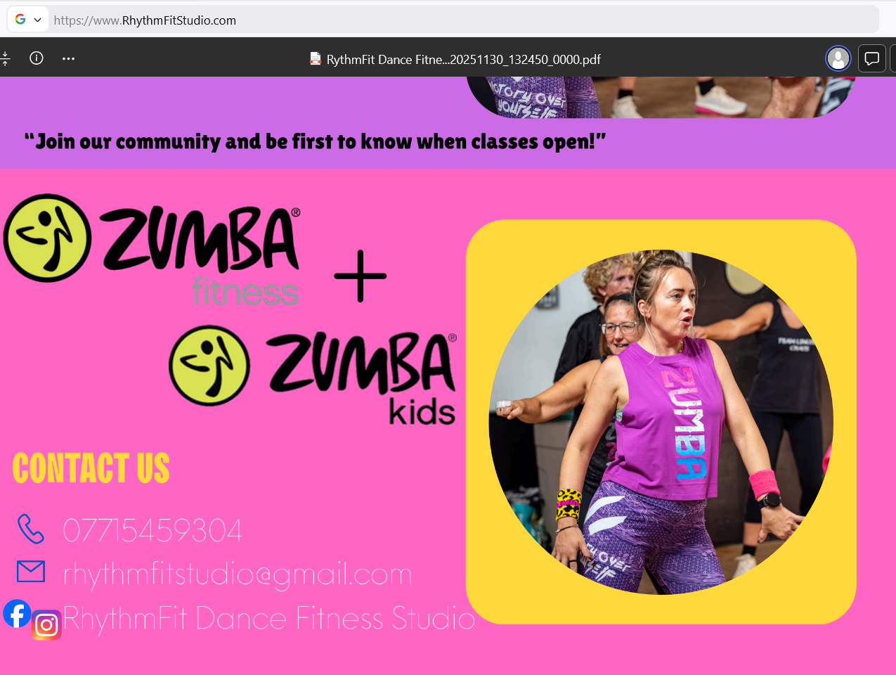

Task 2

The Importance of Excel in the Digital Era and Its Application to RhythmFit Dance Fitness Studio

Introduction
In the digital age, Microsoft Excel is becoming one of the most significant tools for individuals and companies (Kaplan, 2024). Even though automated technologies have come a long way, people still use Excel a lot for data analysis, financial planning, forecasting, strategic decision-making, and visual communication. Nowadays, digital literacy is seen as a fundamental employability skill, and Excel is crucial in helping companies manage and interpret data efficiently (Williams, 2022). It can immediately assist with operations, marketing, financing, and strategic planning for a small business like RhythmFit Dance Fitness Studio.

Excel's core strength is its capacity for organising data, analysing it, and displaying it clearly. Large volumes of data are produced by modern companies, and tools like pivot charts, tables, and algorithms enable users to transform unprocessed data into insightful knowledge (Kotler and Keller, 2022). Also, can help identify patterns in attendance, revenue, and customer behaviour (Microsoft, 2025). RhythmFit used Excel to look at survey data, find out what class schedules people liked best, and figure out that there is a significant need for family-friendly Zumba sessions. Cash-flow tables can be kept in organised worksheets, and then categorise them by day, age group, or class type to show which sessions and time slots work best (Velixo, 2024).
Financial management is another area where Excel is essential for entrepreneurs. According to guidance for small firms, Excel can support basic profit and loss accounting, keeping track of monthly expenses, and cash-flow predictions that test alternative situations (Wisdify, 2024; ICAEW, 2025). Efficient planning helps businesses run more smoothly and keeps costs down, especially for solo traders. RhythmFit already has a 12-month forecast, and Excel makes it easier to recalculate if online live streams will be added or new classes like Zumba Sentao and Strong Nation will launch with a new schedule (Williams, 2022). A simple function can indicate how changes in the average class size affect income or cover the costs of renting a venue, insurance, and marketing (ActionCOACH, 2024; Government, 2025). This financial modelling helped find the break-even point and showed that the business might have a positive cumulative cash flow by the fourth month.
Data, social media analytics, and consumer insights are key components of marketing in the digital age. Excel can keep track of engagement data from Facebook, Instagram, TikTok, and YouTube, which helps organisations determine what kinds of content receive the greatest attention (UKActive, 2025). With Excel, RhythmFit can generate basic dashboards that display customer feedback, video views, and post reach. These insights support the customer segmentation techniques outlined by Kotler and Keller (2022). According to IMARC Group (2024), the dance-fitness sector is growing quickly, and businesses that track performance using data technologies respond to customer requests faster.
Additionally, Excel improves daily operational effectiveness. While businesses must follow GDPR guidelines, Excel can safely store non-sensitive information such as attendance lists, loyalty tracking, or general feedback themes (Exercises, 2025). Spreadsheets can be used to schedule sessions, track bookings, and monitor attendance or cancellations. RhythmFit analyses attendance data to find out which types of classes are most popular, when they are most likely to be full, and when additional sessions can be added. Keep a content calendar in line with local events and class schedules to guarantee Zumba Kids is consistently promoted during the summer community festivals and school terms (Burgess et al., 2018; Dadwal, 2020).
Lastly, Excel is essential for digital literacy and employability. Digital tools are initially difficult for many students, particularly those who must balance work, school, and family obligations. Nevertheless, exploring Excel helps build useful abilities like digital communication, organising, and problem-solving (Williams, 2022). Excel continues to be one of the most popular digital skills in business, financial, and marketing professions, according to training providers and labour market reports (Coursera, 2017; Skillset Group, 2023). Gaining proficiency with Excel has helped RhythmFit make better decisions, plan more effectively, and handle financial tasks with less stress. It is now simpler to interact with accountants, comprehend financial reports, and obtain evidence for grants or loans (Williams, 2022; ICAEW, 2025). These abilities also function with other digital tools that RhythmFit uses, like website analytics and booking software, which typically export data directly into Excel for further research (Sandhu, 2020; Soltanifar et al., 2021).
Conclusion
In conclusion, Excel is a crucial tool in the digital era because it connects raw facts and smart choices in a flexible way (Kaplan, 2024). Excel plays an important role for RhythmFit with handling the costs, customer analysis, marketing evaluation, and operational planning. This helps to create a long-lasting, expandable, and family-focused fitness business (Robin Waite, 2024). To be successful in the current fitness sector, it is necessary to know how to use Excel effectively; it helps businesses run more smoothly and gives business owners more confidence.

Word count: 807

References
ActionCOACH (2024) 10 ways to excel in 2024’s business landscape. Available at: https://burystedmunds.actioncoach.co.uk/ (Accessed 10 December 2025).
Burgess, J., Marwick, A. and Poell, T. (2018) The SAGE handbook of social media. London: SAGE Publications Ltd. Available at: http://www.doi.org/10.4135/9781473984066 (Accessed: 10 December 2025)
Coursera (2017) Excel skills for business specialization. Available at: https://www.coursera.org/specializations/excel (Accessed 10 December 2025).
Dadwal, S.S. (ed.) (2020) Handbook of research on innovations in technology and marketing for the connected consumer. Hershey, PA: IGI Global. Available at: https://doi.org/10.4018/978-1-7998-0131-3 (Accessed: 10 December 2025).
Exercise.com (2025) Best gym software with attendance tracking in 2025. Available at: https://www.exercise.com/grow/best-gym-software-with-attendance-tracking/ (Accessed: 11 December 2025)
Government (2025) Support for self‑employed fitness professionals. UK Government. Available at: https://www.gov.uk (Accessed: 11 December 2025).
ICAEW (2025) Cashflow forecasting and budgeting for small businesses. Institute of Chartered Accountants in England and Wales. Available at: https://www.icaew.com (Accessed: 11 December 2025).
IMARC Group (2024) Virtual fitness market: global industry trends, share, size, growth and forecast 2025–2034. Available at: https://www.imarcgroup.com/virtual-fitness-market (Accessed: 11 December 2025).
Kaplan, R.S. (2024) What is Microsoft Excel used for and is it still relevant?, Kaplan UK Blog, 6 November. Available at: https://kaplan.co.uk/blog/features/is-microsoft-excel-still-relevant (Accessed: 11 December 2025).
Kotler, P. and Keller, K.L. (2022) Marketing management. 16th edn. Harlow: Pearson.
Microsoft (2025) Overview of Excel for the web. Microsoft Support. Available at: https://support.microsoft.com/excel (Accessed: 11 December 2025).
Robin Waite (2024) Pricing and profitability for fitness businesses. Available at: https://www.robinwaite.com (Accessed: 11 December 2025).
Sandhu, K. (ed.) (2020) Digital transformation and innovative services for business and learning. Hershey, PA: IGI Global. Available at: https://doi.org/10.4018/978-1-7998-5175-2 (Accessed: 10 December 2025).
Skillset Group (2023) Top digital skills employers want in 2023. Available at: https://www.skillsetgroup.com (Accessed: 11 December 2025).
Soltanifar, M., Hughes, M. and Göcke, L. (eds) (2021) Digital entrepreneurship: Impact on business and society. Cham: Springer. Available at: https://doi.org/10.1007/978-3-030-53914-6 (Accessed: 10 December 2025)
UKActive (2023) The importance of data and insight for the future physical activity sector. Available at: https://www.ukactive.com/blog/the-importance-of-data-and-insight-for-the-future-physical-activity-sector/ (Accessed: 11 December 2025).
UKActive (2025) UK health and fitness market report 2025. London: UKActive. Available at: https://www.ukactive.com/ukactive-reports/ (Accessed: 11 December 2025).
Velixo (2024) Using Excel for cash flow forecasting. Available at: https://www.velixo.com (Accessed: 11 December 2025).
Williams, J. (2022) Excel skills for business: essentials for work and study. 2nd edn. London: Kogan Page.
Wisdify (2024) Beginner’s guide to financial modelling in Excel. Available at: https://www.wisdify.com (Accessed: 11 December 2025).

Microsoft Exel Spreadsheet Available at Below Link
Book 1.xlsx

