The term social exclusion could be defined and referenced in two different ways; narrowly, where it can be referred to as meaning exactly the same as income poverty and can make reference directly to members of society who are not attached to the paid labour market or people who are employed in low wage work. This narrow definition of social exclusion is commonly used in conjunction with the term social cohesion. As a cohesive society is where economic, political and social stability is sustained and managed by members of society participating in the paid workforce.

Or, the term social exclusion can be defined broadly, where in which case, it will acknowledge more than income inequality, poverty, lack of employment and deprivation, this is according to the conclusive reports complied by the European Union Poverty Programme (Andersen et al, Conroy 1994). This set of twelve reports found that exclusion was multidimensional, and it more often than not involved a shortage of resources and refusal of social rights and human rights, as well as the refusal that exclusion is a changing process. The dynamic process of exclusion can often result in multiple deprivations, loss of identity and purpose and the breakdown of family and friendship relationships (Silver, 1995).

The United Kingdom Exclusion Unit, which is active in England, in its earlier display, seemed to focus more on individuals and defining exclusion as normal poverty discourse. Although the complexity was mentioned by terms, such as; ‘linked problems’. Social Exclusion is a label, a category; individuals and families can get put into. Often members of society find themselves being labeled ‘excluded’ from experiencing a combination of interlinked problems, for example; low level skills, poor health, unemployment, homophobic abuse, high levels of crime within the area, low incomes, racism, inadequate housing or the breakdown of family and friendships. (Social Exclusion Unit 1999)

There are separate perspectives on family and different ways to attempt to understand differing families in the 21st century, one being; anthropology. According to the University of Manchester anthropology is the study of a humankind society, including societal constructions, norms and values. As an anthropologist it would be your aim to understand how humans live in society and the ways in which they create a meaningful life for themselves. They will raise questions, such as; how societies are organsied, relationships between morals, behavior and values, as well as why humans do whatever it is they do. Another perspective on family is the developmental psychology theory.
Developmental Psychology is a theory that was not acknowledged until after the industrial revolution when there was high demand for an educated workforce, which therefore resulted in the social construction of ‘childhood’ becoming a very well defined phase in somebody’s life. The first ever standardised study of developmental psychology was conducted by Charles Darwin. He published a report in 1877, based off the development of unlearnt ways of communicating with his own son.
Although the disclosure of developmental psychology can date back to 1882 when a German physiologist, William Preyer created a book called The Mind of a Child. Within this book, William Preyer studied the development of his own daughter from when she was born up until she was two and a half years old.
Developmental Psychology is a theory which has the main goal of explaining changes, growth and consistency throughout somebody’s lifespan. It focuses on how thinking, behavior change and feeling can change through life, for various different reasons. The three main goals of the theory are to explain, optimize and describe (Baltes, Reese, & Lipsitt, 1980).

Family has been defined as a social group which is distinctive by living together, sharing finances, cooperation and reproduction. As well as including two adults, male and female. These two adults must be a part of and maintain a socially approved sexual relationship, along with one or more children of the cohabiting couple (Murdock, 1949). This definition of family is claiming that to be a family you must live, together, have a children, share finances and be a man and women, although this definition is outdated in the current 21st century. In 2009 family was defined as anybody related by marriage or blood (Lawson and Garrod, 2009). The term ‘family’ has changed and will continue to keep changing over the years to come. For example ‘family’ is a much looser term, a group of close friends may refer to themselves as family, a single mother and her only child, a same-sex couples who have adopted a child, or a group of people who have no blood related family that live together and share morals, values and goals. Discrimination over not being a typical heterosexual, white, two children family is becoming less common than it ever was. Although the perception on what constitutes as a family is changing for the better, people in same-sex relationships, marriages and often their children can still face exclusion and being stereotyped in daily life.

In 1958 The Homosexual Law Reform Society was founded to enable them to campaign for the legalization of same-sex relationships within the United Kingdom. The Sexual Offences Act 1967 decriminalized sex between two consenting males, both over the age of 21 and in private. Although this decriminalisation did not count for the Merchant Navy or the Armed Forces, Ireland, Channel Islands, Isle of Man or Scotland. Although this was to be later legalised everywhere and the age limit brought down to the same as a heterosexual couple.

In 1972 the first ever Pride was organsied and held in London, which attracted approximately 2,000 members of the public. Britain’s first ever gay newspaper was also published, Gay News.

The first ever Black Gay and Lesbian Group were created in the United Kingdom in 1980. Denmark, in 1988 became the first ever country in the world to legally acknowledge any same- sex partnerships.

In 2002 the same rights were given to same-sex couples, as there are for straight couples trying to adopt a child.

The Civil Partnership Act 2004 is approved, which therefore grants civil partnership in the United Kingdom. This Act will allow same-sex couples exactly the same rights and duties as a heterosexual married couple, within; Wales, England, Ireland and Scotland.

The Adoption and Children Act 2002 came into action, which therefore allowed unmarried, same-sex couples to still apply for joint adoption, this was in 2005. In 2008 The Human Fertilization and Embryology Act 2008 acknowledges same-sex couples as the legal parents of a child that is conceived through the use of donated sperm.

In 2013 the Same-Sex Couples Marriage Act is successfully passed in both Wales and England. Following that Act passing, the first same-sex marriage, successfully took place on the 29th March 2014.

All three pictures are aiming to positively represent same-sex parents within their families, although members of society can/will interpret them all differently, based on potential biases, stereotypes or preconceived ideas.

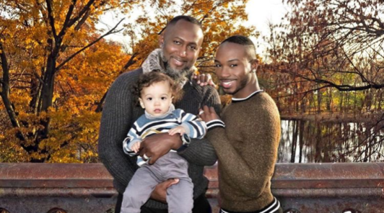
Image 1:

(Gays with Kids).

Image 1 is displaying two black men in a same-sex relationship, smiling, making physical contact and holding a white child. This picture is attempting to display the family in a positive way. The child looks healthy, the couple are wearing smart clothes; they are both smiling and are all outdoors, in a park like setting. All of these factors therefore mean this picture is more likely to get a positive reaction from society. As the media portraying something as positive, means society are more likely to accept this relatively new and dynamic concept.

Although there are various ways this family could get discriminated against. Often people assume that children that are either born into, or adopted by same-sex couples will be disadvantaged in one way or another, whether that be, growing up with different gender role modeling, a higher chance of being bullied at school and more likely to suffer with worse emotional well-being than other children their age. People in same-sex relationships may become parents if they wish too in many different ways, for example by former heterosexual relationships, sperm donor, foster, adoption or step parenting. Artificial insemination and surrogacy services are also becoming increasingly popular. This therefore shows being in a same-sex relationship and wanting a child is becoming a reality for many couples and therefore becoming more common and normalized in today’s society.

In the United Kingdom, Black History Month is every October, which is a crucial time, as it pays tribute to black role models whose various different contributions to society are often marginalised.

Black History Month can help to allow barriers amongst communities to be broken down and encourage, acknowledge and celebrate differences between people. This event also educates and commemorates past and current black figures in society who have made substantial contributions to fighting the exclusion of black members of society.

Often, for people who can face duel discrimination, these positive accomplishments can have no positive effect on them or their daily lives.

Stonewall is an organisation which aims to fight for gay people’s rights. Their main aims are to empower individuals, transform institutions, reform laws and promote positivity regarding people’s decisions on sexual preference.

Stonewall try to always ensure they use the Black History Month to celebrate the successes of black gay, lesbian, bisexual and transvestite members of society, who constantly continue to try and rewrite the possible futures of the communities they live in, often this is done by daily activism.

Stonewall encourages people in this period to challenge and acknowledge racism within communities in all its forms, this can therefore lead to people becoming more accepted and respected by members of society.

By this organisation celebrating Black History Month, as well as celebrating people who are black, as well as gay, lesbian or bisexual, it will lead to normalisation and members of society would be more inclined not discriminate and view this as normal within the 21st century.

By various organisations promoting positivity it in turn creates a more positive view around images like, image one. It is becoming more and more normalised and therefore more and

Image 2:
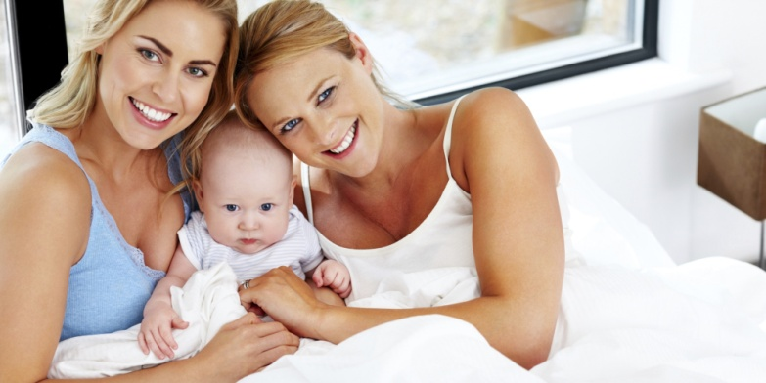

(The Health Site).

Image 2 is displaying a white, female, same-sex couple sat in bed cuddling a baby.

There is argument to suggest that members of society may have a negative reaction to this picture, due to them thinking the child is going to be negatively affected. There are four different ways to develop gender roles: sex; gender; gender role and gender identity. Sex, is being biologically, male or female. Gender focuses on anything that society or individuals relate to being male or female. Gender roles are the societal expectations for the differences in behavior, depending on if you are male or female. Gender identity is defined as how somebody might psychologically see themselves as a male or female.

From age three to five children feel sexually attached to their other-sex parent. Between the ages of five to six years old, children can experience anxiety over the attraction they felt towards one of their parents. A connection with the same-sex parent is also key in ensuring the child has good mental health and healthy sex drive (Fraud, 1936). Therefore many members of the public, according to this theory, will believe that having two parents of the same-sex will affect the child’s long term mental health and sex drive when they get older, as they will not be receiving the support they need from both genders. Although many people raise a child on their own, without any other partner involved, and these single parent families often receive less discrimination than a family with two same-sex parents and a child, even though that family has a second parent to provide that child with love and support. There have been various arguments that a child having two of the same gender parents is overall worse for the child’s short term and long term mental health and well-being. Although there have also been various studies that argue against this, and say it makes no difference to the child, as long as it’s a part of a loving, supportive, caring family. According to an Australian study conducted at the University of Melbourne and published by the BMC Public Health, the study included an investigation of approximately 500 children below the age of eighteen who all have same-sex parents. The research found that children with gay, lesbian or bisexual parents had the same levels of self-esteem and spent just as much time with their families as children with two different sex parents. The researchers actually found that children with same-sex parents tended to be healthier and have stronger family values and an overall stronger family unit. Children that are raised by lesbian parents tend to show a much higher level of academic and social abilities, as well as showing less signs of various behavior problems and less aggression than a large amount of their peers with different sex parents. According to research the sexual orientation of a child’s parents has no effect on the child’s development; the relationship between the child and parents is what will have the largest effect on the child’s mental health and well-being.

With increasing research stating that it doesn’t matter if a child is raised by two men, two women or a man and women and this has no effect on the child’s ability to succeed in school, make friends or have a normal life. But the child’s mental health and well-being is more likely to be defined by how the child is raised how much support they receive and how much time they spend with their family. Society is more likely to accept this as normal, especially if research states that it has no negative effect on the child.

Image 3:
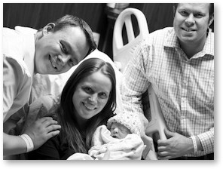

(ABC News).

This image shows a gay couple, with their surrogate mother and their child.

This image is trying to portray same-sex couples using a surrogate mother as a positive and happy event. Gay surrogacy has become increasing common over the past five years, as more and more people believe that gay people have as much right to have a child as a same sex-couple. The majority of people believe that it is anybody’s right to have a child, no matter what sexual orientation, colour or background, as long as that child is born into a loving and supportive family. This picture is displaying a loving and happy family, and therefore the general public is more likely to interpret this picture in a positive way.

Although many people may not actually agree with gay marriage or same-sex relationships for religious reasons, and will therefore not agree with these people having children, even though there is no evidence to suggest that children being born this way will have any more limitations throughout life as a child born into a heterosexual family. Others may also believe that surrogacy is complicated and un-ethical due to the potential confusion of identity for the child, and the identity of their biological parents as they get older.

Members of society could interpret this picture negatively as surrogacy can be a largely emotional process for the women carrying the child, as well as physically challenging. A minority of people would feel sorry for the women as she would then have to detach herself from the child once it has been born. Although others would argue that, ethically if the woman agrees and the process is carried out in a sensitive manner, then it gives the couple the gift of a child, which is therefore worth it.

In conclusion, it is clear that views on same-sex relationships and families have changed drastically, and become significantly more socially accepted. Members of society in the 21st century are now more open to same-sex couples having children, for example. The more positive portrayal by the media will have a large overall affect on people’s views of same-sex families. “The achievements of the lesbian and gay movement have opened up possibilities for broader claims for validating a wide range of life experiences” (Weeks et al, 2001). Another positive of the normalization of same-sex couples having children is that it creates role models for younger members of society who might be gay and worrying about not being able to have children, or disappointing their parents by possibly not being able to provide a grandchild. By same-sex couples having children becoming more and more common, it therefore enables younger people the hope and vision to be able to have their own child.

Reference List

Modern Family surrogacy centre. (2016) The ethical issues of surrogacy. http://www.modernfamilysurrogacy.com/page/surrogacy_ethical_issues (Accessed: 24/03/2018).
Peace, R. (2001) Social Exclusion: A concept in need of definition? http://citeseerx.ist.psu.edu/viewdoc/download?doi=10.1.1.627.6786&rep=rep1&type=pdf (Accessed: 25/03/2018).
University of Manchester. (Unknown) What is social anthropology?
https://www.socialsciences.manchester.ac.uk/social-anthropology/study/what-is-social-anthropology/ (Accessed: 20/03/2018).
McLeod, S. (2017) Developmental Psychology. https://www.simplypsychology.org/developmental-psychology.html (Accessed: 26/03/2018). Oxford Dictionary. (2018). Family. https://en.oxforddictionaries.com/definition/family (Accessed: 25/03/2018).
Revise Sociology. (2014). The functionalist perspective on the family.
https://revisesociology.com/2014/02/09/functionalist-perspective-family/ Accessed: 20/03/2018).
Stonewall. (2016). Key dates for gay, lesbian, bi and trans equality.
http://www.stonewall.org.uk/about-us/key-dates-lesbian-gay-bi-and-trans-equality (Accessed: 21/03/2018).
Power, J. (2015). In families with same-sex parents, the kids are all right.
http://theconversation.com/in-families-with-same-sex-parents-the-kids-are-all-right-42605 (Accessed: 22/03/2018).
Wynter, S. (2017). Celebrating black history month. https://www.stonewall.org.uk/our-work/blog/celebrating-black-history-month (Accessed: 26/03/2018).
McLeod, S. (2016). Psychodynamic Approach. https://www.simplypsychology.org/psychodynamic.html (Accessed: 27/03/2018).

