Taster Session
Computer Games Development


2017/2018


Faculty of Architecture, Computing and Engineering
University of Wales Trinity Saint David
Swansea Campus, Mount Pleasant
Swansea, SA1 6ED
SA1 6ED

The Amazing Racer Game

Objective
Your objective is to put together a simple game in Unity, a development platform for creating multiplatform 3D and 2D games and interactive experiences.

Game Concept
The player character starts at one end of an area and runs quickly to the other side. There will be hills, trees and obstacles along the path it takes to reach the other side. The goal of the game is for the player character to try and make it to the finish zone as quickly as he/she can.

Game Rules
- The game ends when the player enters the finish zone.
- The player will always spawn (the process by which the player character enters the game) in the same spot and the finish zone will always be in the same spot.
- There will be water hazards present and whenever the player character falls into a water hazard, the player is moved back to the spawn point.
- The objective of the game is for the player to get the fastest time possible.

Game Requirements
Your game will have:
- A first person character controller
- A water hazard
- A spawn point
- A finish zone

Step 1: Creating the Game World
- You should have been assigned a PC with Unity.
  - Create a new project and save it to the desktop or my documents.
- Look on the desktop, there should be a Unity package called AmazingRacer (or download from Moodle as instructed).
- Drag/copy this file into the Assets window.
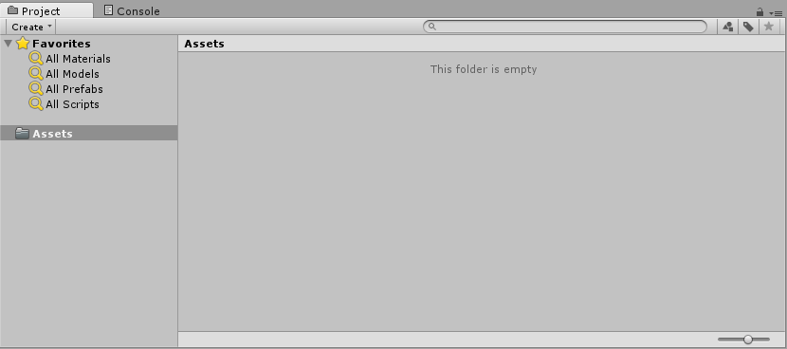
- You should get another window asking you to Import the files. Click the import button.
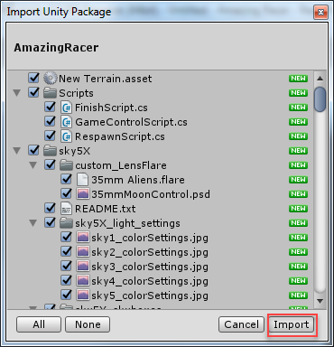
- This should load a number of default assets for you to use to build the game.
- You should have a default scene window where you are going to build your game.
- From the menu, select File Save scenes and save your scene – give it a name of your choice e.g. Scene1.
- Now you can start building your game world.
- Drag the New Terrain asset from the Asset Window into the Hierarchy Window.
- Double-click on the terrain to bring it into focus.
- If there is no directional light in the scene, add one to brighten up your scene from the Game Object Light Directional Light menu.
- Rotate and position the added light from the Inspector window (should be on the left side) using the following settings (note the minus symbols):
  - Position X: -90 Y: -113 Z: 35
  - Rotation X: 39 Y: 340 Z: 6
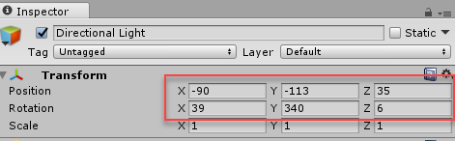
- Select your terrain in the hierarchy window and add a skybox to it using the menu option Component Rendering Skybox
- From the inspector window, set the Custom Skybox property to sky5X3 as shown below by clicking the little circle – you can choose a different sky if you wish.
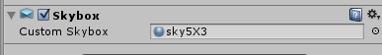
- In the asset window, go to Standard Assets Environment Water (Basic) Prefabs add drag the WaterBasicDaytime into your game scene (you can also try the night time one if you wish).
- From the inspector window, adjust the water’s settings as follows:
  - Position X: 88 Y: 29 Z: 49
  - Scale X: 50 Y: 1 Z: 50
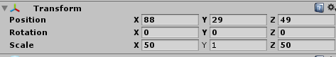
- Save your scene. You can play it, but there is not much to see yet

Step 2: The Character Controller
- In the asset window, go to Standard Assets Characters FirstPersonCharacter Prefabs and drag the FPSController prefab into the hierarchy window of your game scene.
- Rename the FPSController to Player in the hierarchy window.
- In the properties window, adjust the player’s settings as follows:
  - Position X: 160 Y: 32 Z: 64
  - Rotation X: 0 Y: 260 Z: 0
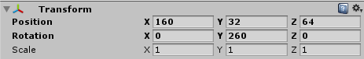
- You may notice that in the status bar window, Unity is warning you that: “There are 2 audio listeners in the scene. …” – you can have only one.
  - Select the Main Camera game object from the hierarchy window
  - From the Inspector window, uncheck the Audio Listener box (see below)
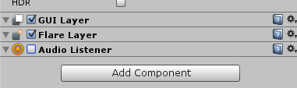
- Save your scene and then hit the Play button and test your environment. See if you can have a wonder around – you can use wither the arrow keys or W, A, S, D.
- Important: Hit the play button to Exit play mode! The Scene tab should be highlighted.
- If you didn’t have the Audio listeners warning previously, check now. If you have it, go back to step 21 to fix.s

Step 3: Adding the Game Control Objects

The Spawn Point
The spawn point is the point the player restarts the game from, either when initially starting or whenever the player falls into the water hazard.
- From the top menu, add an empty game object: Game Object Create Empty
- Rename the new game object to SpawnPoint and adjust its position in the hierarchy window to:
  - Position X: 160 Y: 32 Z: 64
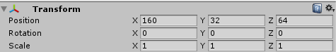

The Water Hazard Detector
The water hazard detector is a simple plane positioned just below the water created earlier.
- Add a plane to the scene from Game Object 3D Object Plane
- Rename the plane in the hierarchy window to WaterHazardDetector
- From the Inspector window, adjust the settings as follows:
  - Position X:86 Y:27 Z:51
  - Scale X:10 Y:1 Z:10
  - Check the Convex and Is Trigger checkboxes so that the plane will detect and trigger an action when the player collides with it (this is called collision detection in development).
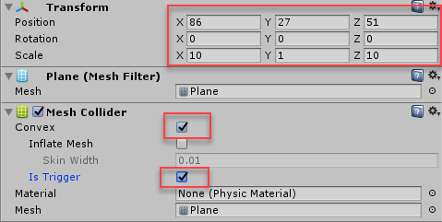

The Finish Zone
The finish zone is the target destination for the player. It will be a shining point light so the player knows where to head to.
- Add another empty game object to the scene: Game Object Create Empty
- Rename the new game object to Finish
- From the hierarchy window adjust its settings as follows:
  - Position X: 26 Y: 32 Z: 24
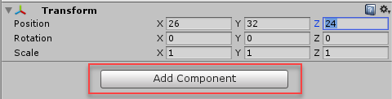
- Click the Add Component button and select Rendering Light
- You should see a new light component, adjust its settings as follows (also shown below):
  - Type: Point
  - Range: 35
  - Intensity: 3
  - Colour: whatever you wish – click the little pen by the side to select
  - Mode: Baked
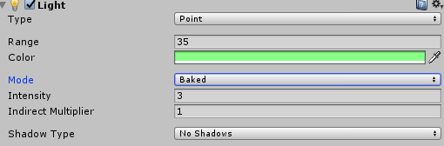
- Next to detect when the player reaches the finish zone, we need more collision detection. Click the Component button and select Physics Capsule Collider. This will detect when the player collides with the finish zone.
- Adjust the settings of the capsule collider as follows:
  - Radius: 9
  - Check the Is Trigger box
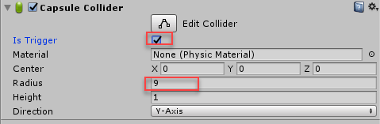

The Game Control Object
The game control object controls the mechanics of the game.
- Add another empty game object to the scene: Game Object Create Empty
- Rename the new game object to GameControl
- Save your changes. Hopefully you have something similar to the screen shots below .
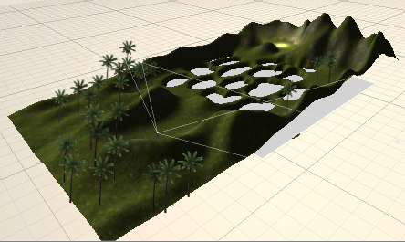
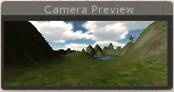

Step 4: Adding Scripts
Your game still does not do anything much at this stage as the program code to implement the game play and rules (game mechanics) does not exist.
Luckily we are not making you write any scripts today, we will be giving them to you, but if you come on one of our development courses then you will learn how to write such scripts!
- Double –click the assets folder in the project window towards the bottom of the screen.
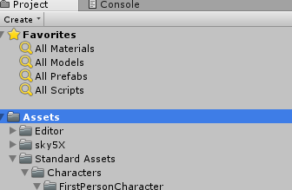

- You should see a file called AmazingRacerClassLibrary – expand it as shown below (click the little arrow):
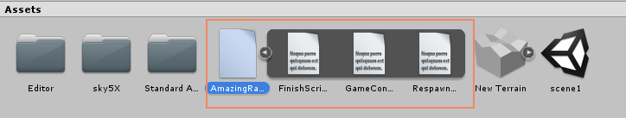
- From the expanded file:
  - Drag the FinishScript onto the Finish game object in the hierarchy window
  - Drag the GameControlScript onto the GameControl object
  - Drag the RespawnScript onto the WaterHazardDetector object
- To finish off, you need to set a few script properties.
- Select the WaterHazardDetector game object from the Hierarchy window.
  - In the Inspector window, you should see the RespawnScript component that you dragged onto it in the last step.
  - It requires a Respawn Point property, drag the Spawn Point object from the hierarchy window onto it or if you click the little circle by the side, you should be able to select it.
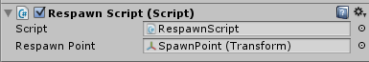
- Next select the Finish object from the hierarchy window and from the Inspector window, locate the Finish script component – it requires the Game control object – attach as you did in the last step.
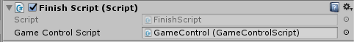
- Finally, for the game control object, set the following properties for the Game Control script:
  - Player – player object
  - Spawn Point – spawn point object
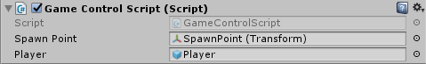
- That’s all! Save your changes and play your game
P.S.:
- You may want to adjust the player’s speed (make the character move faster). Exit play mode. Click on the Player object in the Hierarchy view and locate the First Person Controller script in the Inspector view. You can change the player’s speed by adjusting the Walk Speed. Change this as you wish.
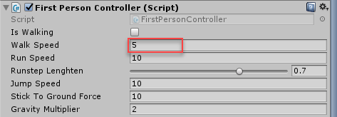
- How far did you get? What was your time?

Game adapted from Sams Teach Yourself Unity Game Development in 24 Hours, Sams (2014) By Mike Geig

