Name: Radu Andreescu
Student Number: 2026729
Module: Leading and Implementing Workplace Change
Module Code: BMSW_6103
Professor: dr. Dennis Pepple

Royal Mail
Implementing Change
-case study-

Table of Contents
1.1 Introduction 3
2.1 Interview 3
Annex1 10

Introduction
Organisation is a social system designed to attain regulated effectiveness in the pursuit of common objectives (Buchanan and Huczynski, 2013). There are other definitions of organisations some of them referring to a business organisation some to political organisations, but we will work with this one with the purpose to have an insight view in Royal Mail. The purpose of Royal Mail is to connect companies, people and countries. Values are to be positive, brilliant and to share responsibility (RoyalMail.com, 2023)

The Royal Mail, a prominent postal service organization in the United Kingdom, is currently grappling with a significant challenge—a strike initiated by its employees demanding increased wages. This strike has caused disruptions in operations and strained relationships with stakeholders, necessitating effective conflict resolution and swift resolution. To gain deeper insights into the root causes and complexities of the strike, this report begins with an interview with a colleague, Sabrina Reis (Annex1) offering a fresh and unbiased perspective on the situation. The interview aims to enrich our understanding of the strike's implications and potential solutions, serving as a crucial foundation for the subsequent analysis.

Following the interview, the report delves into a comprehensive stakeholder analysis to identify all parties involved in the strike and understand their respective interests, concerns, and influence over the resolution process. The analysis encompasses not only the striking employees but also Royal Mail's management, customers, shareholders, regulatory bodies, and any other relevant stakeholders (Reeds at al., 2009). By exploring their viewpoints, this report aims to develop a holistic understanding of the complexities of the strike and its impact on various stakeholders.

Additionally, this report evaluates the power dynamics and politics at play within the organization and its external context. It is important power and politics to be analysed if change must be effective (Burnes, 2004). The analysis seeks to identify potential challenges and opportunities for successful resolution by closely examining power struggles, influence, and decision-making processes. Furthermore, the impact of Royal Mail's culture, characterized as "achievement informal," on power distribution and communication channels is assessed to determine how it influences conflict management and resolution strategies.

To address the strike effectively, the report considers the possibility of employing either an internal or external agent of change consultant. The decision is informed by their respective capabilities in navigating power dynamics, politics, and cultural influences, as well as their potential to engage with external authorities. Through a critical analysis of pros and cons for both types of consultants, this report will provide recommendations on the most suitable approach to resolve the strike and achieve a mutually beneficial outcome for all stakeholders involved.

2.1 Interview

In the today’s dynamic business environment and technological development change is a factor more and more defined as being of high importance in the market. Surviving as business and being able to change are deeply connected. Management of change, organisational change is a process of events of various degrees from fine tuning to corporate change, that can be triggered internally or externally, a response to a crisis or a step forward in fulfilling the needs of the market or of the internal factors of the business (Todnem, 2007). In our case Royal Mail obviously has some problems as the workers were for many days in strike and with the help of a colleague, Sabrina Reid, will try to discover the nature of the problem and what approach, either internal or external consultant will be appropriate to identify the solutions necessarily for the process of change. This process is developed through an interview as it is shown in Annex 1. Step by step fallowing the interview question will try to identify the right solution using critical thinking and the tools that we could learn in different modules in the university courses.
In first question from Annex 1, my colleague Sabrina introduce herself and we start the interview.
As we go further to the next question now we identify the problem to deal with. The strikes are caused by low wages (Interview Annex1), employees are not happy with the income they have. To have a better view over the problem lets position it in an internal context and external context. A good tool for a macro view of the company is PESTEL (Yuksel, 2012).

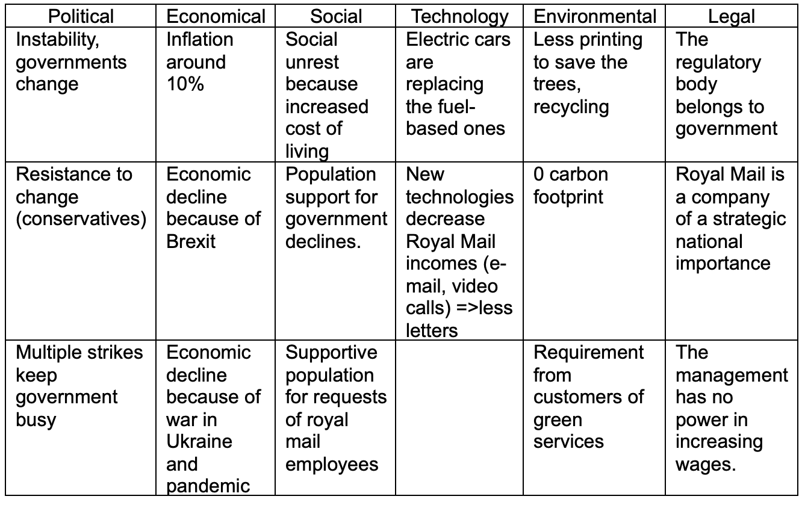
From PESTLE analysis it is clear that company is facing major financial issues due the economical struggle because of inflation as well workers may surely feel the pressure because of increased cost of living due the war in Ukraine that raised the energy costs and all costs associated with energy, lower incomes because economy shrinks and not only because of the war but also Brexit and pandemic. A big pressure on company like the need to change the fleet and to make investments for changing to fit the requirements for being carbon 0 neutral, to adapt to new technological changes to lower demand of sending letters. Finding a solution it may not be easy, the problem is obviously complex. For a better internal view we will use a tool that gives a comprehensive approach that helps assess an organization's internal factors (Gurl, 2017)
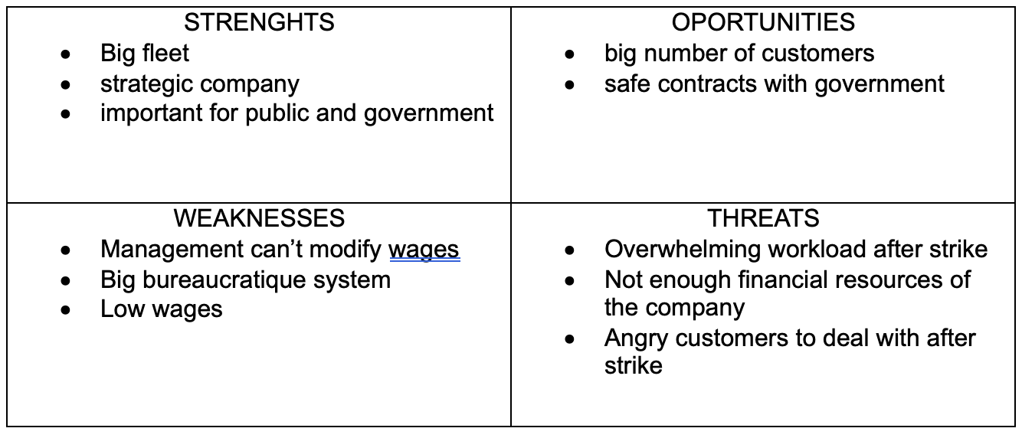
As the problem was identified and positioned in a macro and micro context, low wages and strike with Sabrina’s help back to interview question number 3 (Annex 1), it is clear is needed an agent of change either internal or external. After examining existing literature and empirical research on change agency, a novel categorization of change agents is put forward, which includes four distinct types: leadership, management, consultancy, and team models (Caldwell, 2003)
For consultancy process we will use a model in 8 steps introduced to us by Cheung-Judge and Holbeche in 2011 (Cheung-Judge and Holbeche, 2011). Sabrina in the answer number 4 (Annex 1) has proposing two solutions an internal and an external consultant to be considered for first step of consultancy process.
- Entry level initial contact – Internal consultant have a better chance to create a better impact and influence, better in building trust and confidence among his colleagues, better personal skills and in touch with workers feelings. He is not as good as an external consultant in strategic and analytical skills, in playing politics with all stakeholders specially with external ones.
- External consultant it is a better option for entry level and
initial contact when it is about analytical skills, change readiness management as it should be his expertise, pragmatism. External consultant may not be as good as the internal one in building personal relationships with employees and having the insight knowledge of people and processes.
- Data collection as it was explained in interview with Sabrina (Annex 1) in question 5 it is a very important process, success or failure of the consultancy it is strictly connected to the quality of this step (Kuipers at al., 2014).
- Internal consultant have a faster access to data from internal sources like departments inside Royal Mail, faster feedback from colleagues and he intimately knows the nature of the problem. He doesn’t have a good access to data regarding external stakeholders and availability of founding for increasing wages.
- External consultant has a better access to governmental data as external stakeholder, he may have a better data analyse management and he may not have the closeness with the employees that an internal consultant has at ease. Feedback he receives and the speed of collecting data may be slower.
- Data analysis is the next step in the management of change, and it uses accurate tools and methods to generate further options (Allen et al., 2007).
- Internal consultant as Sabrina answered in question number 6 (Annex 1) has access to a smaller quantity of data to analyse mostly internal and probably solution proposed will be an internal one. As the wages of the employees can only be increased with external funding from a governmental body that can approve it the internal consultant will focus on availability of funding inside the company to identify the chance of a one-time payment to ease the living struggle of the employees.
- External consultant analyse a bigger quantity of data including the availability of funding a wage increase from government. As expert and focused on providing consultancy in this kind of situation the external consultant has better knowledge and use of analysing tools and methods.
- Feedback process it is approached in question seven from interview (Anenx1) and in our case even internal consultant may have faster feedback and more honest from employees than external consultant if the nature of the solution will be a one-time payment vs increased wages may favour the external consultant.
- Action planning: Both internal and external consultant has same objective, to find a solution to make employees get back to work and to stop strike. Action planning is an European concept that means planning every move, every stage or step and taking actions in reaching the objective (Orlikowski and Hofman, 1997) It derives from the way European navigators were planning their journeys. Micronesians navigators were just focusing on the objective and did whatever was needed to reach it. In our case external consultant as Sabrina pointed in question eight form interview (Annex 1) will probably plan the steps to approach the regulatory body and initiate political negotiations to rise wages, a long-term solution adjusting the plan on the “course” aiming the objective of easing employees’ hardship on a long term. Internal consultant will be more like a Micronesian navigator trying to find in its limited options the resources and the solutions for maybe one-time payment. For first time in the process internal consultant is obviously at bias planning a solution that he will benefit of.
- Action taking it fallows the planning and as Sabrina point it out in the interview -question nine (Annex 1) – internal consultant will probably make agreements with management for one-time payment, being at bias and negotiating with unions the end of the strike while external consultant negotiate with government and unions an exit of the problem with an increase of the wage, hence a long term solution maybe more satisfactory than one-time payment and definitely not being on bias. Taking action is a necessary step in any model of consultancy and is the necessary step after analysing and planning (Cameron and Green, 2019)
- Evaluation – internal consultant will have a biased evaluation as any action taking will be something that he will benefit, he also may not have the managerial background and ability to co-design, implement a monitor evaluation methods and metrics as an external expert may have. The bias Sabrina pointed out in the interview it is a major minus.
- External consultant has a bigger expertise in evaluating post process as this is his main job and expertise. He is not at bias.
- Termination Internal consultant, as my colleague Sabrina points out in the interview attached in Annex 1, will terminate the process of change probably with a solution of a one-time payment that he will benefit of and he will be at bias.
External consultant will have a termination with a result of an increased wages, solution valid for a longer term, with the process added to the portfolio of successful cases.
Last question from interview shows Sabrina’s preference for an external consultant.

My conclusion based on the interview and the process of change is that external consultant will have a better solution, long term, it will lead the process not being at bias, having a larger base of data to analyse and being able to approach government and the regulatory body with a bigger experience in this kind of work. Internal consultant may have some certain advantages having a better understanding of the employees as they are his colleagues, but his pros are limited to microenvironment of Royal Mail while the best solution is outside. Being at bias is a big negative that won’t recommend him.

2.1. Stakeholder analysis

It is important to take note that several research studies conducted in recent times emphasize that a significant majority of large restructuring projects, more than half, experience failure to some extent. Even reviews conducted at different times consistently reach the same conclusion. Although a reasonable number of projects do succeed entirely due to clearly identifiable factors, the lessons from these successes don't seem to be adequately learned. This pattern is also observed in numerous smaller projects. The reasons for failure vary, but a major contributing factor to many of these costly failures is the inadequate or complete absence of stakeholder analysis during the planning and execution stages (Finlay-Robinson, 2009).
In case of Royal Mail, we can identify those stakeholders:

Trade Unions: Labour unions representing the interests of Royal Mail's employees are important stakeholders in labour negotiations, work conditions, and employee welfare.

Government Departments: Various government departments and agencies, such as the Department for Business, Energy & Industrial Strategy (BEIS), Ofcom (the UK's communications regulator), and HM Revenue and Customs (HMRC), have interests in Royal Mail's operations, regulation, and tax compliance.

Environmental Groups: Environmental organizations and advocacy groups are stakeholders concerned with Royal Mail's environmental impact, sustainability practices, and efforts to reduce carbon emissions.

Shareholders: are individuals or groups who hold shares in Royal Mail and may actively seek to influence the company's strategies, policies, or governance practices.

Media and Press: Media outlets and journalists are stakeholders with an interest in reporting on Royal Mail's activities, performance, and any significant developments related to the company.

Local Authorities: Local councils and authorities in areas where Royal Mail operates play a role in granting permits, zoning regulations, and addressing community concerns related to the company's facilities and operations.
Pension Trustees: Given Royal Mail's status as a former government-owned entity, pension trustees are responsible for managing the pension funds and ensuring the welfare of pensioners associated with the company.

Regulatory Bodies: Apart from government departments, other regulatory bodies and industry watchdogs might have oversight on various aspects of Royal Mail's services, pricing, and customer protection. One of the regulatory bodies it is the authority that can approve an increase of wages.

Charities and Non-Profit Organizations: Royal Mail's corporate social responsibility initiatives and charitable contributions make charities and non-profit organizations stakeholders with an interest in the company's social impact.

Customers, as stakeholders of Royal Mail, are individuals or organizations who utilize the company's postal and courier services and have a vested interest in the quality, reliability, and affordability of those services.

Employees, as stakeholders of Royal Mail, are the workforce and personnel of the company who contribute their skills and efforts to its operations, and they have a vested interest in fair treatment, job security, work conditions, and career growth opportunities. They are in strike causing the issue that is to be fixed by an internal or an external consultant.

Competitors, as stakeholders of Royal Mail, are other postal and courier companies operating in the same market, and they have an interest in the company's strategies, performance, and market share dynamics as it impacts their own business operations and competitiveness.

Suppliers, as stakeholders of Royal Mail, are companies or individuals that provide goods, services, or resources to the company, and they have an interest in the company's stability, growth, and fulfilment of contractual agreements, as their business is directly linked to Royal Mail's operations and success.

Identifying the position of the stakeholders and their influence on Royal Mail it can be crucial for a better understanding of how an internal or external consultant can have access to them (Derakhshan, Turner and Mancini, 2019).

Internal Stakeholders | External Stakeholders
Shareholders  Employees | Trade Unions  Government Departments  Environmental Groups  Media and Press  Local Authorities  Pension Trustees  Regulatory Bodies  Charities and Non-Profit Organisations  Customers  Competitors  Suppliers

Stakeholders can be classified into primary and secondary categories based on their level of direct influence and involvement in the organization or project (Stocker at al., 2020)

We will analyse the potential pros and cons for both internal and external consultants in their interactions with each category of stakeholders concerning the issue of ending a strike that requires a wage increase at Royal Mail:

Primary Stakeholders:

1. Employees (Striking Workers):

Pros for Internal Consultant:
Familiarity with the organization's culture and internal dynamics.
Direct access to employees, which may facilitate trust and open communication.
Cons for Internal Consultant:
Potential bias or perception of being aligned with management, leading to distrust from striking workers.
May face challenges in maintaining neutrality and objectivity.
Pros for External Consultant:
Perceived as an impartial third party, which can enhance trust from striking workers.
Brings fresh perspectives and external expertise to resolve the dispute.
Cons for External Consultant:
May require time to understand the organization's culture and dynamics fully.
Could face resistance from employees who may prefer someone internal to represent their interests.

2. Top Management and HR Department:

Pros for Internal Consultant:
In-depth knowledge of the organization's policies, history, and practices.
Easy accessibility to management and HR personnel for collaboration.
Cons for Internal Consultant:
Potential conflicts of interest if perceived to favour management's perspective.
Might face challenges in challenging existing management decisions or practices.
Pros for External Consultant:
Independent perspective to objectively assess the situation.
May bring specialized expertise in labour disputes and negotiations.
Cons for External Consultant:
Limited understanding of the organization's unique internal dynamics and culture.
May require time to build rapport and gain management's trust.

3. Government Regulatory Bodies:

Pros for External Consultant (Internal consultants may not directly interact with regulatory bodies):
Expertise in labour laws and regulations relevant to wage negotiations.
Experience in working with regulatory bodies, facilitating communication and negotiation.
Cons for External Consultant (Internal consultants may not directly interact with regulatory bodies):
Might face challenges in understanding the specific regulatory environment.
May need to coordinate closely with internal teams to align strategies.

Secondary Stakeholders:

1. Customers:

Pros and Cons are generally similar for both internal and external consultants. Both can benefit from understanding customer feedback but may face challenges in representing customer interests while remaining focused on resolving the labour dispute.

2. Suppliers:

Pros and Cons are generally similar for both internal and external consultants. Both can assist in maintaining supplier relationships during the strike but may face challenges in balancing supplier interests with resolving the labour dispute.

3. Competitors:

Pros and Cons are generally similar for both internal and external consultants. Both can help analyse competitor behaviour but may face challenges in staying impartial and not prioritizing competitive interests over resolving the strike.

4. Media and Press:

Pros and Cons are generally similar for both internal and external consultants. Both can assist in crafting effective communication strategies but may face challenges in managing public perception and balancing transparency with confidentiality during negotiations.

5. Local Authorities:

Pros and Cons are generally similar for both internal and external consultants. Both can facilitate communication with local authorities but may face challenges in understanding local regulations and managing community concerns effectively.
In conclusion, both internal and external consultants bring unique strengths and face potential challenges when interacting with different stakeholders. The choice between internal and external consultants will depend on factors such as the specific expertise required, the level of impartiality needed, and the existing relationships between stakeholders and the consulting parties. Effective stakeholder management and engagement are critical for consultants to navigate through the complexities of ending a strike and achieving a resolution that satisfies the interests of all stakeholders involved.

Stakeholder Map for Royal Mail

HIGH POWER – LOW INTEREST  Trade Unions  Media and Press | HIGH POWER – HIGH INTEREST  Shareholders  Customers  Employees  Government  Regulators
LOW POWER - LOW INTEREST  Competitors | LOW POWER – HIGH INTEREST  Environmental Groups  Local Authorities  Pension Trustees  Charities and Non-Profit Organizations  Suppliers

The stakeholders in the "High Power, High Interest" quadrant are the most critical for Royal Mail, as they have both significant powers to impact the company and a high level of interest in its activities.

Those in the "High Power, Low Interest" quadrant have substantial influence but may not be directly affected by Royal Mail's operations. Engaging with them strategically can still be important for the company's reputation and regulatory matters.

Stakeholders in the "Low Power, High Interest" quadrant may not have much direct power, but they are interested in the company's actions. Addressing their concerns can lead to positive outcomes for Royal Mail's image and social responsibility.

Lastly, stakeholders in the "Low Power, Low Interest" quadrant have minimal impact on the company and are not highly invested in its affairs.

Another perspective of analysing stakeholders is possible fallowing some academical research regarding social equity and economical interest (Sarkki, Heikkinen, and Löf, 2021). It was developed in early 1984 while researching how an organisation can interact socially and economically and how the boundaries of an organisation influence socioeconomical environment (Harrison et al., 2019). Fallowing this perspective equity stakes usually defines the shareholders and top management, economic or market stakes for employees, competitors, etc. and influencer stakes organisations and governmental agencies etc.

Equity stakes | Shareholders
Economic/market stakes | Competitors  Suppliers  Pension Trustees  Employees  Customers
Influencer stakes | Charities and Non-Profit organisations  Local Authorities  Environmental Organisations  Regulators  Government  Media and Press  Trade Unions

Royal Mail bears diverse responsibilities to its stakeholders.
- Customers benefit from reliable services and data privacy.
- Employees receive fair wages, a safe work environment, and opportunities for growth.
- Shareholders gain from sustainable profitability and transparent reporting.
- The company adheres to legal regulations and fosters an ethical culture of diversity and inclusion.
- Philanthropic commitments include supporting communities and charitable causes.
- With government and regulators, Royal Mail demonstrates social responsibility and cooperation.
- Suppliers are treated fairly and responsibly.
- Competitors experience fair competition and industry initiatives.
- The media receive timely and accurate information.
- Environmental groups witness sustainable practices and engagement.
- Local authorities benefit from economic support and compliance.
By fulfilling these responsibilities, Royal Mail strives to build trust and value for all stakeholders.

COMMUNICATION STRATEGY

A good communication is essential part of stakeholder management (Eskerod and Jepsen, 2016). Planning and analysing the internal and external approaches of communication should be dynamic and adjust as the priorities changes in a very competitive market and new technologies occurs (Welch and Jackson, 2007). Royal Mail can effectively communicate with and respond to each stakeholder group through the following types of communication:

Customers:
Type of Communication: Online Surveys, Customer Feedback Forms, Social Media Engagement
Approach: Regularly conduct online surveys to gather feedback on service quality, delivery times, and customer satisfaction. Provide easily accessible customer feedback forms on the website to address specific concerns. Engage with customers through social media platforms, promptly responding to inquiries and comments.
Employees:
Type of Communication: Town Hall Meetings, Employee Forums, Internal Newsletters
Approach: Conduct town hall meetings with senior leadership to communicate company updates, future plans, and address employee questions. Establish employee forums for open discussions and suggestions. Share regular updates through internal newsletters, highlighting achievements and recognizing employee contributions.
Shareholders:
Type of Communication: Shareholder Meetings, Investor Relations Website, Annual Reports
Approach: Organize shareholder meetings where senior management presents financial performance, strategic direction, and answers questions. Maintain an investor relations website with updated financial data and company information. Publish comprehensive annual reports to provide a detailed overview of the company's performance and prospects.

Government and Regulators:
Type of Communication: Industry Conferences, Formal Letters and Reports, Regulatory Filings
Approach: Participate in industry conferences and events to engage with regulatory authorities and discuss policy matters. Submit formal letters and reports to regulators detailing compliance efforts and contributions to the industry. Submit regulatory filings as required by relevant authorities.

Suppliers:
Type of Communication: Supplier Meetings, Vendor Portal, Regular Email Updates
Approach: Conduct supplier meetings to discuss business performance, address concerns, and explore collaboration opportunities. Set up a vendor portal to streamline communication and provide updates on procurement processes. Send regular email updates on payment schedules and supply chain initiatives.

Competitors:
Type of Communication: Industry Associations, Networking Events, Collaborative Projects
Approach: Engage in industry associations and attend networking events to exchange insights and best practices with competitors. Seek opportunities for collaborative projects that benefit the industry and foster positive relationships.

Media and Press:
Type of Communication: Press Releases, Media Interviews, Media Briefings
Approach: Issue timely and accurate press releases to provide updates on significant developments and company initiatives. Make spokespersons available for media interviews to answer questions and address concerns. Conduct media briefings to provide in-depth information on specific topics or events.

Environmental Groups:
Type of Communication: Environmental Impact Reports, Collaborative Meetings, Sustainability Webinars
Approach: Publish regular environmental impact reports to demonstrate progress and commitment to sustainability. Arrange collaborative meetings with environmental groups to understand their concerns and explore joint initiatives. Conduct sustainability webinars to showcase efforts and engage with stakeholders.

Local Authorities:
Type of Communication: Community Outreach Programs, Local Council Meetings, Public Consultations
Approach: Organize community outreach programs to connect with local residents and understand community needs. Attend local council meetings to discuss plans, projects, and address any local concerns. Conduct public consultations to gather feedback on proposed initiatives and assess community impact.
By adopting these tailored communication approaches, Royal Mail can build strong relationships with stakeholders, address their challenges and opportunities, and foster a collaborative and supportive environment for sustainable growth and positive impact.

3.1 Power and politics in conflict solving at Royal Mail

Critical evaluation of power and politics in assisting internal and external change agent consultants to resolve the Royal Mail strike for higher wages.

Every organisation has a political component and change process jut winds up the political process. It happens because humans, departments are competing for resources, money, influence, and this is how the politics appear (Buchanan and Badham, 2020).

The Royal Mail strike for higher wages presents a complex challenge for the organization, impacting its operations and stakeholder relationships. The success of resolving the strike lies in the hands of change agent consultants who possess the ability to navigate power dynamics and political influences within the organization. This critical evaluation analyses the different ways that power and politics can aid internal and external change agents in finding a resolution to the strike. Considering Royal Mail's achievement-oriented culture, the Thomas-Kilmann conflict mode instrument, and its positive, brilliant, and responsibility-assuming values, we explore the pros and cons of each consultant's approach. Additionally, since the power to increase wages resides with a regulatory body in the government, this evaluation considers the consultants' roles in engaging with external authorities to achieve their objectives.

Institutional and cultural factors influence organisational culture (Oseghale at al.,2023). The Royal Mail culture is achievement informal, meaning it emphasizes results and accomplishments in an environment that promotes open communication and collaboration. It has also elements of ascription formal culture in top management and some of the departments creating in the end a cultural mix for the purpose of efficiency.

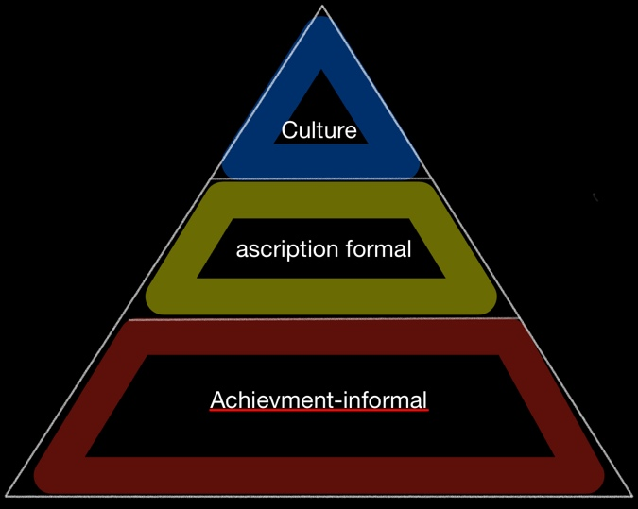

The Thomas-Kilmann Conflict Instrument is a widely used assessment tool that helps individuals understand their preferred approaches to handling conflicts. It classifies conflict resolution styles into five modes: competing (assertive, uncooperative), collaborating (assertive, cooperative), compromising (moderately assertive and cooperative), avoiding (unassertive, uncooperative), and accommodating (unassertive, cooperative). By identifying their dominant style, individuals can better navigate conflicts and adopt more effective strategies for resolving them (Thomas, 2008).
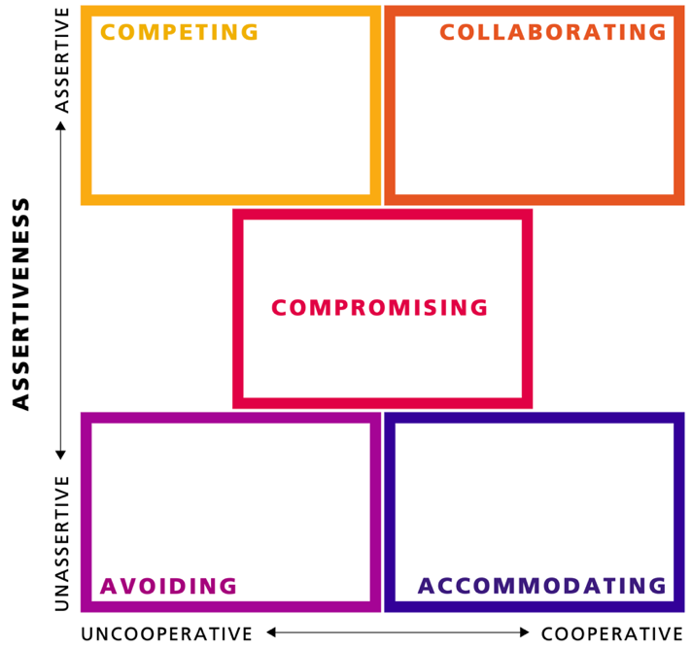

- Internal change agent consultant:

Pros:

Familiarity with organizational culture: An internal consultant possesses an in-depth understanding of Royal Mail's values, norms, and communication channels. This familiarity can expedite the resolution process by streamlining communication and establishing trust among stakeholders.
Promotion of a one-time payment solution: Given the organization's achievement-oriented culture, the internal consultant may emphasize a one-time payment solution as a way to recognize and appreciate employees' efforts during the strike.
Collaborative conflict resolution: an internal consultant can leverage the Thomas-Kilmann conflict mode instrument to encourage collaboration and encourage stakeholders to work towards a mutually beneficial resolution.

Cons:

Limited influence on regulatory decision: the internal consultant's scope of influence may not extend to the external regulatory body responsible for wage increases. This limitation could hinder their ability to secure a permanent wage increase for the striking employees.
Perceived bias: employees engaged in the strike may perceive the internal consultant as being aligned with management's interests, leading to doubts about their impartiality and advocacy for employee demands.

- External change agent consultant:

Pros:

Impartiality and external perspective: external consultants bring an unbiased and neutral perspective, free from internal biases and politics. This impartiality can facilitate open communication and build trust among stakeholders, including striking employees and management.
Expertise in engaging with external authorities: an external consultant can effectively engage with the regulatory body in the government, presenting the striking employees' demands persuasively and negotiating for a wage increase on their behalf.
Utilization of achievement-informal culture orientation: the external consultant's focus on results and achievements can resonate with Royal Mail's achievement-informal culture, fostering a positive work environment and motivating employees during the resolution process.

Cons:

Limited knowledge of organizational culture: the external consultant may require time to familiarize themselves with Royal Mail's culture and values, potentially delaying the initial progress of the resolution process.
Challenges in influencing external authorities: while an external consultant may possess expertise in engaging with external authorities, securing a wage increase from the regulatory body could be a challenging and time-consuming process.
Linking power and politics to culture orientation:
Royal Mail's achievement-informal culture orientation links power dynamics and politics to individual achievements and informal communication. The distribution of power may be influenced by employees' contributions to the organization's success, while informal communication channels may play a crucial role in decision-making processes. An effective consultant would acknowledge and utilize these dynamics, encouraging cooperation and engagement among employees to reach a resolution. Additionally, the consultant must navigate the organization's internal politics and power structures to identify key decision-makers and stakeholders who can support the resolution efforts.

Conclusion:
The resolution of the Royal Mail strike for higher wages requires skilful navigation of power dynamics and political influences. Internal and external change agent consultants offer distinct approaches, each with its pros and cons. While internal consultants may benefit from their familiarity with the organization's culture, external consultants can leverage their impartiality and expertise in engaging with external authorities. However, the power to increase wages lies with the regulatory body in the government, impacting both consultants' abilities to secure a permanent wage increase for striking employees. To maximize success, Royal Mail should consider an external consultant who can effectively engage with external authorities while understanding and integrating into the achievement-informal culture orientation. The selected consultant must foster cooperation, open communication, and trust among stakeholders, aligning their approach with Royal Mail's positive, brilliant, and responsibility-assuming values. By employing an inclusive and strategic approach, the chosen consultant can drive a successful resolution to the strike, benefiting both Royal Mail and its employees in the long run.
In the context of the Royal Mail strike for higher wages, considering the decision on wage increases lies with a regulatory body within the UK government, it is recommended to hire an external change agent consultant to lead the strike resolution process. While both internal and external consultants have their strengths and limitations, the external consultant's impartiality, external perspective, and expertise in navigating external regulatory processes make them better suited to handle the situation effectively.

4.1 Recommendation

To ensure the success of the external change agent consultant, the following steps are recommended:

In-Depth Familiarization with Royal Mail: The external consultant should conduct thorough research and interact extensively with key stakeholders within Royal Mail to understand the organization's culture, values, and the dynamics of the ongoing strike. This will facilitate a deeper understanding of the organization's challenges and help in crafting effective strategies.
Collaborative Approach: Engage in open communication and collaboration with both striking employees and management. The consultant should act as a bridge between the two parties, ensuring that their concerns are adequately addressed and facilitating a constructive dialogue.
Influence the Regulatory Decision: The external consultant should use their expertise in engaging with the regulatory body from the UK government. They must present the employees' demands persuasively, providing compelling arguments and data to support the case for a fair wage increase.
Advocate for Long-Term Solutions: While the immediate goal is to resolve the strike, the consultant should advocate for sustainable, long-term solutions that address the wage demands in a manner that aligns with Royal Mail's financial capabilities and ensures employee satisfaction and motivation.
Stay Adaptable and Flexible: The external consultant should be prepared to adapt their strategies and approaches based on the evolving situation and feedback received from stakeholders. Flexibility is essential in addressing unexpected challenges and seizing new opportunities.
Focus on Cultural Integration: As an external consultant, it is crucial to respect and integrate into Royal Mail's achievement-informal culture orientation. Building rapport and trust with employees will require sensitivity to the organization's values and the way employees perceive success and achievements.
Advocate for Positive Organizational Values: The consultant should align their proposals with Royal Mail's positive, brilliant, and responsibility-assuming values. Emphasizing the importance of valuing employees and recognizing their contributions can foster a positive work environment and improve employee morale.
Monitor and Evaluate Progress: Continuously monitor the progress of the strike resolution process and evaluate the effectiveness of proposed solutions. Feedback from stakeholders should be considered and used to make necessary adjustments to the consultant's approach.
By following these recommendations, the external change agent consultant can effectively navigate power dynamics, politics, and cultural influences within Royal Mail while influencing the regulatory body to make a fair wage increase decision. This collaborative and strategic approach will increase the likelihood of reaching a successful resolution to the strike, benefiting both the organization and its employees in the long run.

5.1 References

Allen, J., Jimmieson, N.L., Bordia, P. and Irmer, B.E., 2007. Uncertainty during organizational change: Managing perceptions through communication. Journal of change management, 7(2), pp.187-210.

Buchanan, D. and Badham, R., 2020. Power, politics, and organizational change. Sage.

Buchanan, D.A. and Huczynski, A.A., 2019. Organizational behaviour. Pearson UK.

Burnes, B., 2004. Managing change: A strategic approach to organisational dynamics. Pearson Education.

Caldwell, R., 2003. Models of change agency: a fourfold classification. British Journal of Management, 14(2), pp.131-142.

Cameron, E. and Green, M., 2019. Making sense of change management: A complete guide to the models, tools and techniques of organizational change. Kogan Page Publishers.

Cheung-Judge, M.Y. and Holbeche, L., 2011. Organization development: A practitioner's guide for OD and HR. London: Kogan Page.

Derakhshan, R., Turner, R. and Mancini, M., 2019. Project governance and stakeholders: a literature review. International Journal of Project Management, 37(1), pp.98-116.

Eskerod, P. and Jepsen, A.L., 2016. Project stakeholder management. Routledge.

Finlay‐Robinson, D., 2009. What's in it for me? The fundamental importance of stakeholder evaluation. Journal of Management Development, 28(4), pp.380-388.

Gurl, E., 2017. SWOT analysis: A theoretical review.

Harrison, J.S., Barney, J.B., Freeman, R.E. and Phillips, R.A. eds., 2019. The Cambridge handbook of stakeholder theory. Cambridge University Press.

Kuipers, B.S., Higgs, M., Kickert, W., Tummers, L., Grandia, J. and Van der Voet, J., 2014. The management of change in public organizations: A literature review. Public administration, 92(1), pp.1-20.

Orlikowski, W.J. and Hofman, J.D., 1997. An improvisational model for change management: The case of groupware technologies. Sloan management review, 38, pp.11-22.

Oseghale, R.O., Pepple, D., Ifere, S.E. and Amaugo, A.N., 2023. Organization culture types and the replication of transferred human resource management practices in multinational subsidiaries in Nigeria. Employee Relations: The International Journal, 45(3), pp.565-584.

Reed, M.S., Graves, A., Dandy, N., Posthumus, H., Hubacek, K., Morris, J., Prell, C., Quinn, C.H. and Stringer, L.C., 2009. Who's in and why? A typology of stakeholder analysis methods for natural resource management. Journal of environmental management, 90(5), pp.1933-1949.

Sarkki, S., Heikkinen, H.I. and Löf, A., 2021. Reindeer herders as stakeholders or rights-holders? Introducing a social equity-based conceptualization relevant for Indigenous and local communities. Nordic perspectives on the responsible development of the Arctic: Pathways to action, pp.271-292.

Stocker, F., de Arruda, M.P., de Mascena, K.M. and Boaventura, J.M., 2020. Stakeholder engagement in sustainability reporting: a classification model. Corporate Social Responsibility and Environmental Management, 27(5), pp.2071-2080.

Thomas, K.W., 2008. Thomas-Kilmann conflict mode. TKI Profile and Interpretive Report, 1(11).

Todnem R., 2005. Organisational change management: A critical review. Journal of change management, 5(4), pp.369-380.

RoyalMail.com (2023) Royal Mail About Us. Available at: https://business.help.royalmail.com (Accessed: 22 July 2023).

Welch, M. and Jackson, P.R., 2007. Rethinking internal communication: a stakeholder approach. Corporate communications: An international journal, 12(2), pp.177-198.

Yüksel, I., 2012. Developing a multi-criteria decision making model for PESTEL analysis. International Journal of Business and Management, 7(24), p.52.

Annex1


