University of Wales Trinity Saint David, School of Engineering BEng Motorcycle Engineering

Jason Sorg
Student Number: 1700589
Real World Powertrain Analysis
Powertrain and Sustainability, (M6X01206)

Contents

Introduction - 2 -
Raw Data Analysis - 3 -
Vehicle Comparison - 4 -
Optimal Drive Cycle Vehicle - 7 -
Project Proposal - 9 -
Conclusion - 10 -
Bibliography - 11 -

Introduction

This report will explore what the optimal vehicle would look like in 2028 for the specific drive cycle data that has been provided by a third party source. The first step will be to determine how accurate the given data is which would then allow for a direct comparison of all three different vehicle types. Also the drive cycle data will be extrapolated into Simulink in order to determine what the optimal fully electric motorcycle would be in 2028 to complete the drive cycle. Furthermore, this report will describe the benefits of switching from an ICE powertrain to a fully electric one, along with what the overall power generation solution would have to be to.

Raw Data Analysis

In order to correctly analyse the raw data from the supplied sources the first step was to determine the validity of all provided channels. The key problem found when sorting through the data was that the data logger automatically calculated most of the channels based on user inputs and basic input channels such as RPM and vehicle position, which is why the assumption was made to discredit all these calculated channels due to the unknow starting variables. This decision resulted in the following useable channels (RPM, time, GPS speed, MAP sensor and GPS coordinates). These channels would then be used later in this report to manually calculate other channels along with the OEM specifications to correctly determine the characteristics of each vehicle type. The consequences of choosing to analyse the data this way meant more manually calculations and thus more time to do acquire specific output channels but guaranteed that all further assumptions and results are accurate. The next step was to create an average drive cycle between all three vehicles in one second intervals which would then be used to determine the optimal vehicle for this specific drive cycle. This was achieved by filtering out the noise from each channel and then creating an average speed and altitude for the drive cycle in question, figure 1.
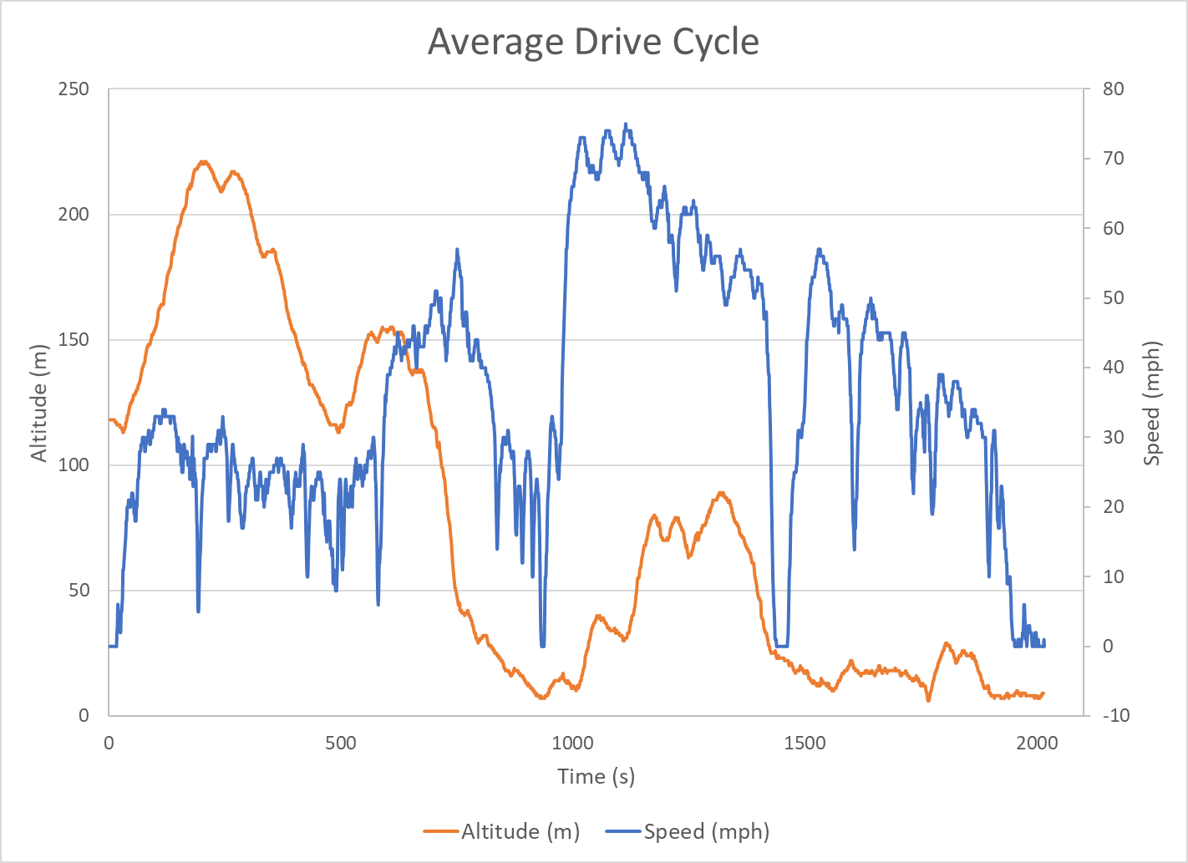
Figure 1: Average Drive Cycle
It is also important to note that the accuracy of the chosen channels cannot be verified with a third party source and thus all calculations and results throughout this report can potentially contain slight errors due to the initial starting data.

Vehicle Comparison

Based on given parameters, all three vehicles achieve around the same fuel consumption rate of 50 mpg for this specific drive cycle. At first glance this is very surprising since all three vehicles are targeted to very different consumer groups and you would expect different fuel consumption rates, which is why the first comparison was to determine how each vehicle uses the fuel during the drive cycle. The first step taken was to transpose the manifold absolute pressure readings for all three vehicles into mass air flow outputs because they can then be translated into fuel flow and thus into the average mpg. The equations below outline how this was done (Meseguer, 2015).

Figure 2: MAP to IMAP Figure 3: IMAP to MAF Transposition
Creating a synthetic variable IMAP allows an estimation of what the mass air flow sensor would be outputting in real time. IMAP was calculated by using the intake air temperature supplied from the data and converting into kelvin and using the corresponding RPM output channel. The next step was calculating the estimated MAF output by using the volumetric efficiency, air properties and engine displacement for each vehicle. The volumetric efficiency used for each vehicle is as follows, Triumph – 85%, Toyota – 85%, Volvo – 90%. The final step was to calculate the fuel flow from the following equation.
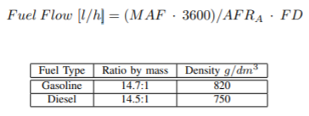
Figure 4: MAF to Fuel Flow
The next calculation was to convert the fuel flow into instantaneous fuel consumption quasi statically and then summing the total amount of fuel used for each supplied data set and then divide by the total miles travelled for the drive cycle, results in figure 5 and 6.

Figure 5: Calculated MPG

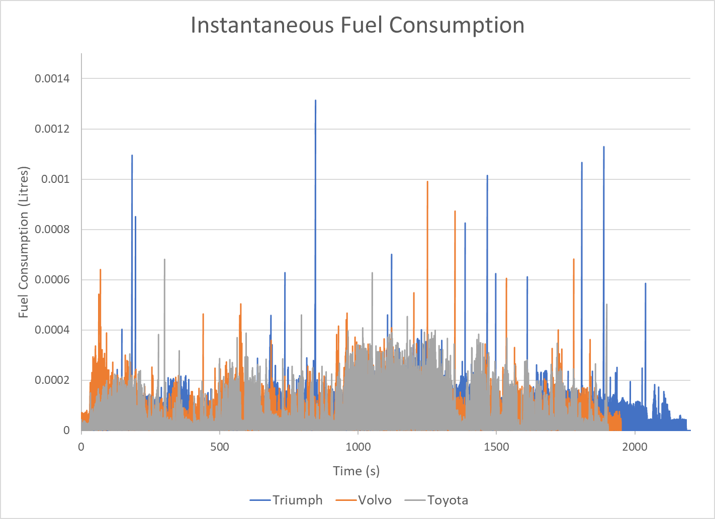
Figure 6: Fuel Consumption
The above graph was produced by using the supplied time scale and not by one second increments which is why the fuel consumption values have outliers and are not consistent throughout the drive cycle. This was deemed suitable since the absolute values were not as important as the overall trends. The RPM trace shown below was also used to make educated assumption about the drive characteristics of each vehicle.
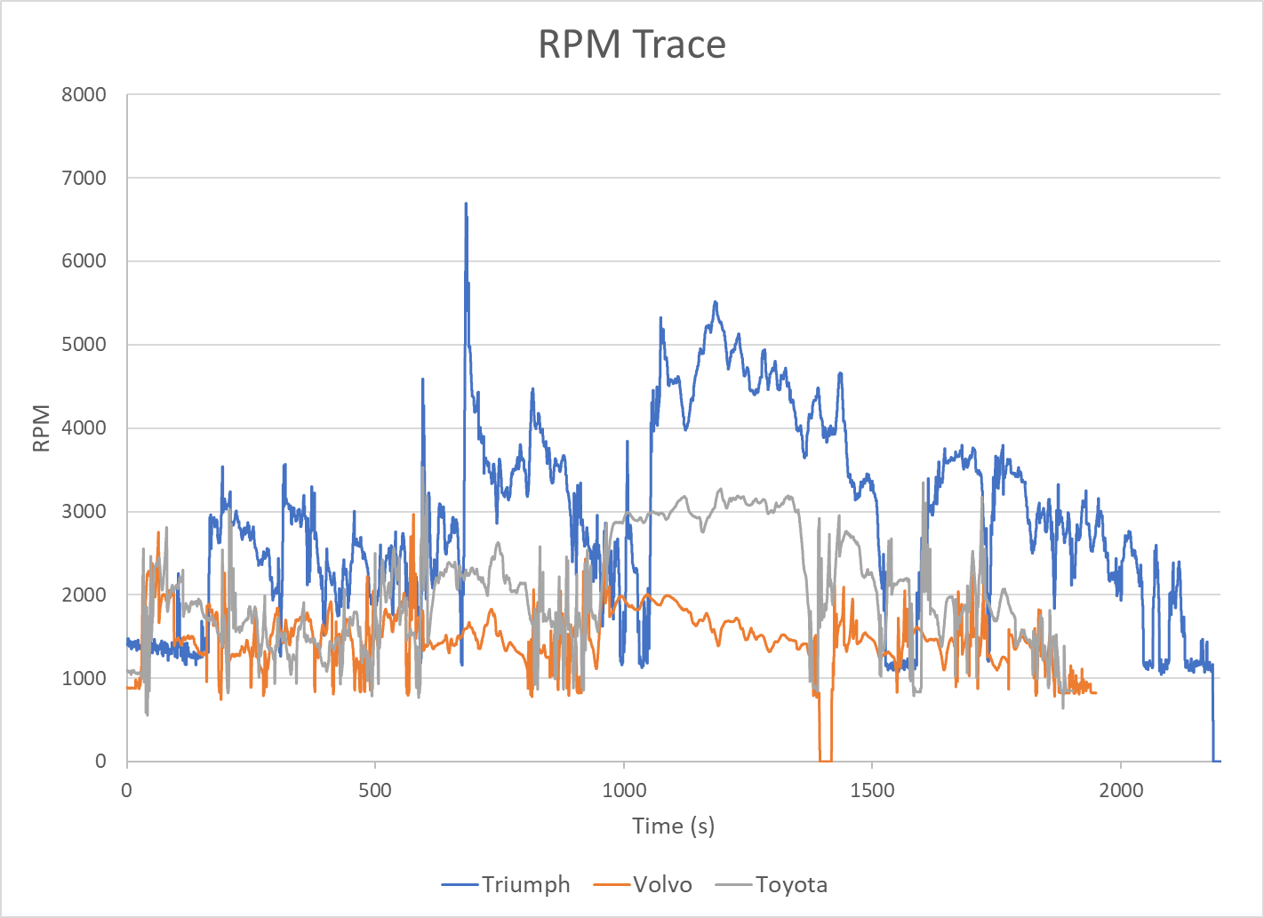
Figure 7: Drive Cycle RPM
The following list outlines the assumptions taken from figure 6 and 7.
- The Volvo consumes a large amount of fuel when starting and stopping but when normal cruising operation is occurring the Volvo is much more efficient. This is validated due to the fact that the Volvo is much heavier than the other vehicles.
- The Toyota does not use as much fuel from a standstill but uses quite a bit of more fuel at higher driving speeds due to the small capacity engine and lower gear ratio.
- The Triumph is much more consistent with its fuel consumption over the drive cycle but when compared to the overall weight of the other vehicles it falls short in efficiency which is due to the performance and high operating RPM of the engine.
It is important to note that although all three vehicles achieve the same real world fuel consumption the Volvo is much more efficient due to higher weight and larger user capacity.

Optimal Drive Cycle Vehicle

In order to determine the optimal vehicle that should be implemented for this specific drive cycle the average drive cycle (figure 8) that was extrapolated earlier in this report were implemented into a dynamic Simulink program.
Figure 8: Average Drive Cycle
The initial decision to optimize a motorcycle as the starting platform was due to the smaller carbon footprint needed to manufacture them when compared to cars if scaled correctly. To simplify the initial starting conditions, all the specifications from the Triumph Tiger 800XC were used. The few assumptions made was that the frontal area was 0.75m² and the centre of gravity was 0.746m from the rear axle and 0.544m horizontally from the ground, which was assumed to be reasonably when compared to other adventure type motorcycles.
The first step taken was to run a baseline simulation with the standard engine setup for the Triumph Tiger and try to mimic what is occurring in real life. This was achieved by comparing the amount of fuel used in the Simulink program with the actual real world results. The findings from the comparison resulted in a higher fuel consumption rate of 4% when using the Simulink program, see appendix for further detail. These finding were deemed suitable for further use of the Simulink program with the specific drive cycle, which meant the next step was to explore how a fully electric powertrain conversion of the Triumph would handle the drive cycle. In order to determine if the program was accurately mimicking the 60km drive cycle, the percent error between the drive cycle mph and the simulation mph was adjusted via the throttle inputs until the error produced was under 1%, see appendix for further clarification.
The next step was to determine the amount of power needed to complete the drive cycle with 10% extra to account for traffic and environmental variables. This was achieved by first using an overpowered motor to make sure it was not the weak link in the system and thus making the battery pack (power needed) the variable in question. The battery pack composition used was based of Zero Motorcycles 14.4kW pack which uses Farasis 32Ah cells in a 28s4p configuration, along with a starting battery charge of 114ah, maximum cell charge of 4.22V and minimum cell charge of 2.4V. Through trial and error the optimal battery pack contained twelve Farasis 32Ah cells in series and four in parallel with the same battery cell composition, figure 9.
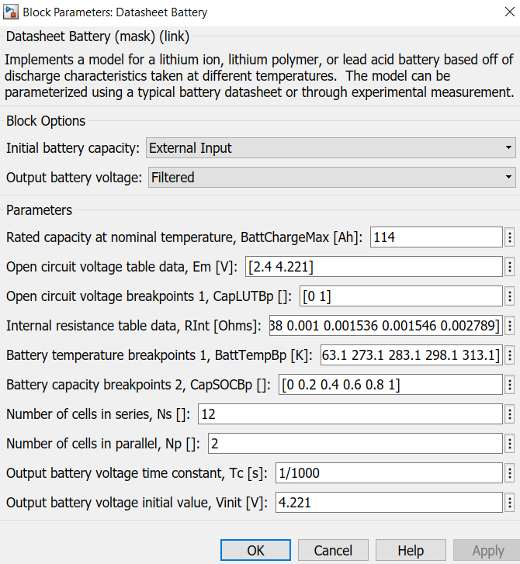
Figure 9: Battery Specifications
This resulted in a total voltage drop of 20.03V over the drive cycle due to the useable cell voltage drop of 1. 821 with 11 cells which was just able to complete the drive cycle, which is why another cell was added to allow for 9% extra power capabilities. The next step was to implement a suitable motor to pair with the battery pack in order to decrease overall weight and increase the power consumption efficiency. The chosen motor was a Parker GVM210-100-200 with a power rating of 65.1kW and a rated torque of 104Nm which proved enough power to staying within the 1% throttle response error. The results achieved from the simulations can be seen below, and in figure 11 (appendices).
- Total kWh used during the drive cycle = 20.03V (voltage drop) x 114Ah (cell capacity) = 2.28 kWh
- “Fuel Consumption” = 37.38 miles / 2.28 kWh = 16.37 miles/kWh
- Battery Pack Size = 12 – Farasis 32Ah cells. Total Weight = 12 x 0.485kg = 5.82kg
- It is important to note that the voltage drop is much more significant during the return journey because the vehicle needs to overcome a large altitude change.
When compared to real world results achieved from current fully electric production motorcycles the “fuel consumption” is roughly 20% lower due to the majority of data for Zero motorcycles comes from California and the drive cycle is roughly 40% more stop and go traffic (Motorcycles, 2019), which is why the results achieved from the simulation have been deemed suitable for further results.
Based on this specific drive cycle the yearly mileage would be 10846 miles assuming a 253 day work year and a 15% addition to account for drive cycle deviation. Assuming the average electrical cost to homeowners living in this specific drive cycle area is 18.076p per kWh (British Gas Standard Tariff), the added yearly electrical cost of owning this specific motorcycle would be £119.76. But would then result in a yearly savings of £865.59 in fuel costs assuming a fuel price of £1.20 per litre.

Project Proposal

In order to realistically utilize the above results in a real world application the infrastructure must be upgraded to cope with the increased demand in electricity due to the increase of fully electric motorcycles. Since the drive cycle in question is conveniently located near one of the largest tidal changes in the world with the difference between low and high tide being around 8 meters the perfect solution to generate the extra power demand is to construct a Tidal Lagoon in the Swansea Bay. Based off past project proposals for the Tidal Lagoon, the overall yearly output would be around 572.00 GWh (Lagoon, 2017), which would allow for the addition of 863,327 fully electric motorcycles in the Swansea area. This means that every Swansea resident would be able to own and charge 3.58 fully electric motorcycles every year for this specific drive cycle. The obvious limitation of this power solution is the delivery of the electricity since most councils and towns surrounding Swansea would need a total revamp to allow for the amount of electricity to reach every individual house. Assuming that the power delivery problem could be solved by the government and individual enterprises, the switch from using the Triumph Tiger 800XC to a fully electric Triumph Tiger would be a viable solution is all assumptions used are accurate.
The two key objectives for this specific project are as follows:
- Full conversion of the Triumph Tiger 800XC to an electric powertrain which would consist of a Parker GVM210-100-200 motor and a battery pack with 12 Farasis 32Ah cells.
- Tidal Lagoon project would need to be constructed in the Swansea bay in order to cope with the additional electricity demand and the power supply system must be also upgraded.
If all previous assumptions are correct for this specific drive cycle the total fuel cost savings would be £865.59 and would result in 1.81 metric tons of CO₂ reduction. Meaning that instead of paying £0.09 per mile for the original Triumph Tiger the newly designed electric bike would result in £0.011 per mile, thus generating an increase of cost per mile by 718%. Considering that the current cost difference between a Triumph Tiger 800XC and a current production electric motorcycle (ZERO) is on average to be £6500, thus making the fully electric pay for itself in 7.5 years and with the current proposal of a much cheaper motor and battery pack the number of years to pay it self off over the ICE Triumph would be much better than 7.5 years. Not to mention the need for extra electrical demands would mean that the Tidal Lagoon project would not only generate the needed electricity to charge the motorcycle it would also result in cheaper rates for housing and create a sustainable power generation for the area. It is important to note that these results are specific to this drive cycle and will not scale linearly for other drive cycles around the world.

Conclusion
By implementing a Tidal Lagoon power station along with utilizing a fully electric motorcycle for this specific drive cycle, the results have proven to be very advantageous over the current solution due to the increase of 718% for the cost per mile by converting the ICE powertrain to an electric one. The addition of a Tidal Lagoon power station for the city of Swansea would also generate more than enough power to charge the additional motorcycles along with providing a cheaper and greener solution when compared to other power generation stations within the UK.

Bibliography

Lagoon, T., 2017. Tidal Technology. [Online]
Available at: http://www.tidallagoonpower.com/
Meseguer, J. E., 2015. Assessing the Impact of Driving Behavior on, Spain: Department of Computer Engineering Universitat Politècnica de València.
Motorcycles, Z., 2019. Unofficial Service Manual, California: Zero.

Appendix
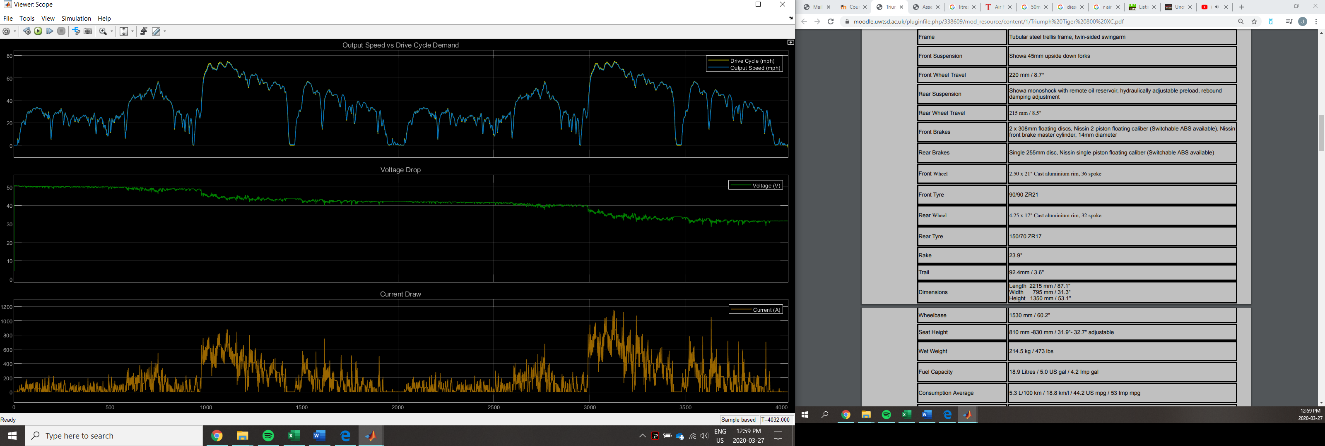
Figure 10: Drive Cycle Percent Error
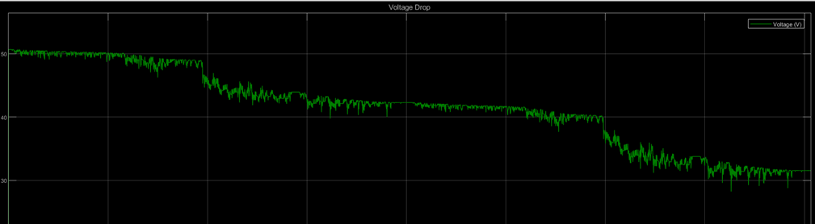
Figure 11: Voltage Drop

