Tabs in a Single View Application

1. Set up a project as Single Application

2. Select your View Controller.

Go to Editor – Embed in – Tabbed View Controller
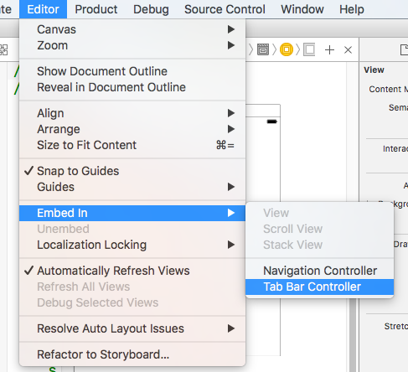

3. To add another tab, drag another View Controller on to Main.storyboard, and then CTRL/drag from the Tab Bar Controller to the new View Controller. A menu will appear. Choose "view controllers" under Relationship Segue.

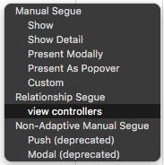

4. Click on item in the destination screen. Under Attributes, change System Item to something in the System Item menu (it doesn’t matter what)

5. Add a third tab in the same way as the previous instructions (drag another View Controller into the storyboard, and then click and drag mouse to connect it)
Select a System Item.

We now have three tabs:

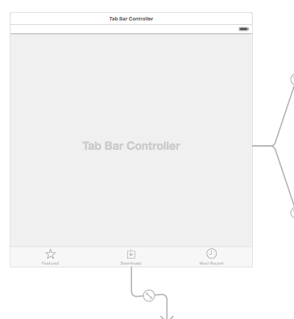

6. Make sure that the Tab Bar Controller is set as “Is Initial View Controller” (tick)

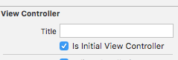

7. Add a few labels to each tab as required and then run the simulator. You should now have a Tabbed Single Application.
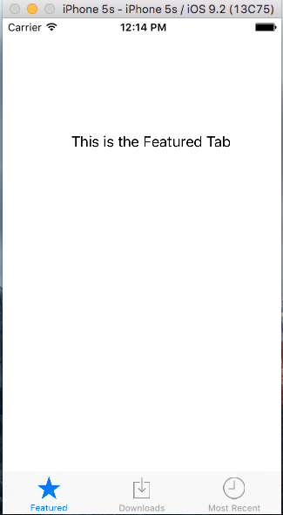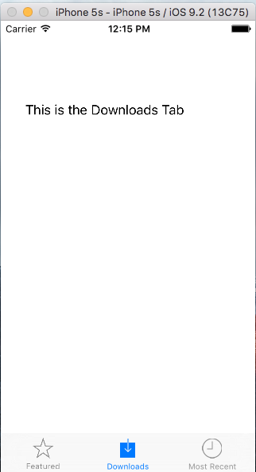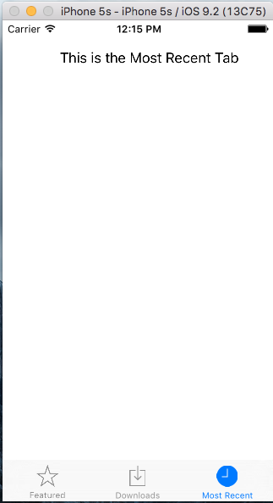
NOTE: Make sure your Tab Bar is set to "Enabled"
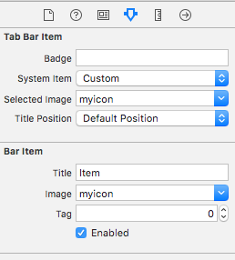

Customising tab images

Apple will not let you put just anything as an icon. For example, I cannot add my banana image as an icon.

Icons should be in PNG format and 29x29 max for a small icon.

(Guidelines here: https://developer.apple.com/library/content/qa/qa1686/_index.html)

1. I've created a very basic icon in Photoshop with a transparent background:



2. Add it to your Assets:

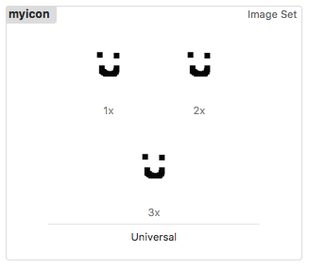

3. Select your new icon in both "Tab Bar Item" (the tab itself) and "Bar Item" (the tab controller)

NOTE:
You may find that your new icon is not rendering properly.

For example, I used this image set: (From https://icons8.com/ )

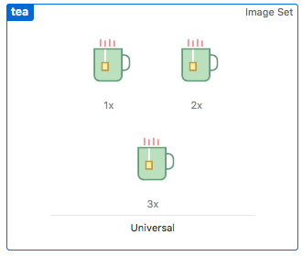

But it renders as follows:

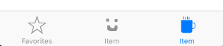

Click on the item itself in your Assets folder and make sure that Render As in the Attributes Inspector is set to Original Image

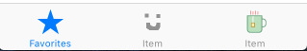

Start on a different page other than the Tab Bar Controller:

- Make a new View Controller
- Drag the “initial arrow” to it.

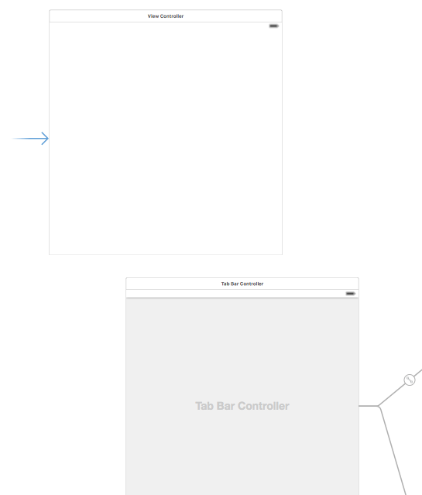
Add a label and a button, then CTRL/drag the button to the Tab Bar Controller and select “Show”
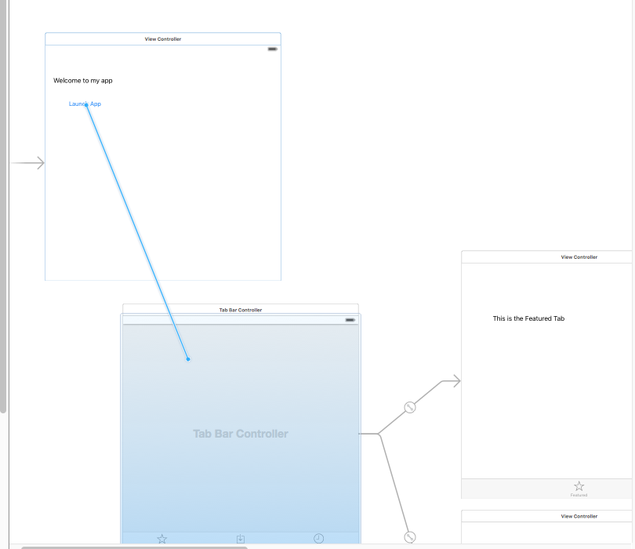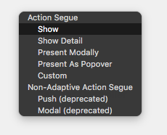

Run the app in the simulator, and click the button to launch the page with the Tabs on it.

