Programme:BA Business Management
Module: The Global Business Environment
Module code:LCCB4005
Contribution to Overall Module Assessment (%): 50%
Assignment 2 Title: Environmental Analysis of an industry
Module Coordinator/ Lecturer: Dr John Malagila

Student ID: 2020524
Student Name: Irina Bulgar

Table of Contents
Introduction 3
Background of the organization 3
Concerns raised by the different stakeholders of the organization 4
Critical analysis of the changes the organization has made in the last few years to its business model 5
Critical explanation of the changes that can give the company some form of competitive advantage position 6
Recommendations to the management of the organization 9
Conclusion 11
References 12

Introduction
The main purpose of the report is to understand that Zara is one of the most successful businesses in the fashion industry. SWOT-analysis helps in analyzing the strengths, weaknesses, threats, and opportunities. The different stakeholders' concerns are analyzed and work on it in the company. With the help of pestle analysis, the business model of the company is analyzed by identifying different external factors. With the help of a new product launch, Zara plays a smart role in the market that helps in achieving a competitive position in the market.

Background of the organization
Zara is one of the renowned brands in the clothing industry. It has run its business in the industry for the past many years and launched different products and services for its customers. The main objectives of the company are to deliver quality services to their customers and increase their satisfaction level. According to Abalkhail, (2019, p. 30) the company is planning to develop its brand image in the competitive market and set the high-quality standard at a reasonable price which is unable to be touched by its competitors like H&M.
Swot analysis

Strengths  - A unique model is followed by Zara which helps in maintaining a balance between demand and supply.  - The company is using advanced IT technologies for managing its supply chain and logistics.  - Skilled designers work under Zara who designs the clothes as per the fashion, and with good finishing.  - The company runs its business through online and offline channels which help in increasing its sales by reaching mass audiences. | Weaknesses  - The company did not give more focus on their marketing activities which creates hurdles for competing with competitors.  - The collection of the company is focused on all sectors like party wear, formal, informal, and so on. Their focus on particular designs is less (Achinas et al., 2019, p. 5981).
Opportunities  - For a better customer experience, the company can use AI technology and increase the values of customer services by providing virtual reality concepts.  - The company can focus on marketing by promoting its products through different marketing channels.  - Although the company can give more focus on e-commerce business for stabilizing their business. | Threats  - Different competitors give tough competition to Zara in this industry line.  - Changes in regulations and legislation impact the company’s productivity.  - The increment of prices of raw materials can hamper sales and profits.

Concerns raised by the different stakeholders of the organization
Zara distributes its products in different stores from where the end-users make their final purchases. According to Aftab et al., (2018, p. 212), while ordering stocks for the different stores for different countries, HQ managers need to first collect data from the store manager to understand the actual requirements of customers. Even they can involve store managers in the meetings so that they can provide the right product details which are higher in demand in their particular stores. But in Zara during the meeting store manager’s concerns are involved which directly affects the sales of the company. According to Allam et al., (2020, p. 200), it is evident that if any customers cannot receive their choice of clothing they switch to another and it also affects the sales and brand reputation of the company. Another concern raised by customers who believe that the company needs to give more focus on sustainability. The company's one of the key policies to attract customers is to change the collection in every store every 15 days. This might attract the attention of mass audiences but it also raises CSR factors. It is the responsibility of Zara to not waste the clothes and maintain sustainability in business.

Critical analysis of the changes the organization has made in the last few years to its business model
Pestle analysis
Political: The financial regulations mostly affected the business of Zara. According to da Silva Oliveira et al., (2021, p. 10), the government has limited Foreign Direct Investment in different countries due to which the company faced challenges. In that case, Zara can run this business by adopting partnering concepts or strategies with local brands. Instability in the political ground can also affect the business of Zara.
Economic: Affordable pricing strategy is used by Zara so that instability in the economy may not affect its business. It means even if the economy falls the people still can purchase the products from Zara at a reasonable price. Due to the economic turmoil, the company did not suffer any loss. The low economic activity might not impact business as compared to its competitors.
Social: Zara needs to take care of recent trends demanded by youth, customer’s attitudes, and behaviours. According to Düerkop and Huth, (2017, p. 14), it helps the company to remain in touch with their customers and develop a sense of loyalty and trust. Prior market research is done by Zara so that they can easily enter into new territory. The company ensures research effectively on new territory cultural and social factors before setting its business.
Technology: in supply chain management Zara implements advanced technology and increases the customer's demand responsiveness. Also, with the help of technology the order tracking inventory checking and logistics management become simpler for the company. Even for manufacturing the products the company uses advanced machinery and equipment and develops quality and cost-effective products.
Legal: in every business environment companies need to follow certain laws. According to Duoyan, (2021, p. 200), ethics and sustainability are needed to be followed by the company strictly. In the external systems, the compliance policy is followed by the company. While operating its business in certain locations the company ensures to follow the law of that particular location. In this way, the company gains the advantage to maintain its ethical brand image.
Environmental: for any business sustainable development is essential because it helps in surviving in the market. In sustainability, the company invests in a larger context. Inditex is the parent company of Zara who is planning to make every store efficient. In this way, the company can save energy and focus on recycling. From manufacturing hazardous or waste products are removed. However, they focus on producing quality products that maintain sustainability.
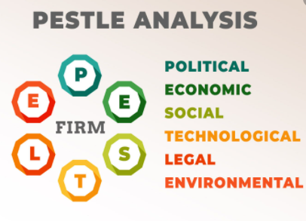
Figure1: Pestle analysis
Source: (Zara et al., 2020, p. 042030)

Critical explanation of the changes that can give the company some form of competitive advantage position
Product life cycle
In the competitive market, Zara plans to launch a new product line apart from men’s wear; women's wear and kids' collection are home accessories and fragrances. It helps increase the chance of the company gaining a competitive position in the market. Major competitors of Zara are H & M, Primark, and URBN. According to Hu et al., (2019, p. 70), the strategy of launching a completely new collection is different from the clothing line and helps in increasing the chance of sales and profits in the business. With the help of the product life cycle strategy, Zara launched this new product line of home accessories and attracted the attention of mass audiences in the country. Also, the company plans to launch this product in the market in a unique style in which they decorate the coffee shop by using classic products and inspire individuals to purchase the product through an online website. In this way, the company introduces its product to target audiences. According to Islam and Mamun, (2017, p. 10), for moving the growth stage, Zara analyzes whether the demand for the product is equal to the supply of the product and analyzes the profit margin. In this, the company also ensures that the quoted price is accepted by target audiences or not. According to the feedback of consumers Zara plans to develop changes for continuous improvement. The third stage is maturity in which the company has sold enough products in the market and now it's time to develop innovation in the existing product line before it moves towards the decline stage. Lastly, in the decline stage, the products are no longer required by customers.
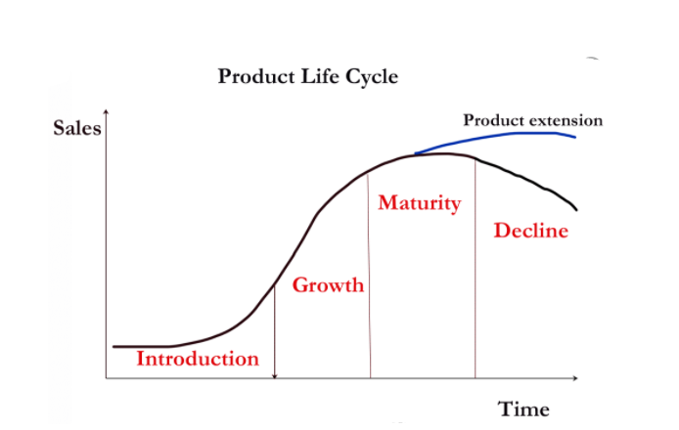
Figure 2: Product life cycle
Source: (Rejeb and Keogh, 2021, p. 1580)
Porter’s five forces
Threats of new entrants: According to KAPUSTINA et al., (2018, p. 779), the new players' force is high because of the retail and apparel industry. In this industry due to the involvement of big players the prices are fluctuated by different brands to attract customers' attention. Also, setting business involves higher distribution cost, business setting cost, marketing cost, and so on. New entrants must have strong resources to develop a new business in the fashion industry. Zara already has the benefits of selling products at cost-effective prices and has a reputable image in the market which does not effect because of new entrants.
The threat of substitute: home accessories are not considered as a necessity for individuals but it also represents the identity of the individuals. According to Potnis and Mallary, (2021, p. 0165551520984719), substitute threats are high because different competitors like H&M, Primark, and URBN. in the several markets many companies can easily imitate the product, and due to which buyers can easily switch to buy the product at a lower cost. But Zara ensures to produce its home accessories and fragrance at a reasonable cost and maintain the high-quality standard which motivates their buyers to purchase from the same brand.
Buyer power: in the retail and fashion industry the buyer power is high. The major target audience of the company is middle to upper-class people. The company launched its new home accessories range at a reasonable cost and maintained the unique design, colour palette which attracted the attention of mass audiences. It helps Zara to maintain its relationship with its buyers and increase the chance to stay for a longer period. The company ensures to sell its products at a lower price which increases the difficulty for competitors to sell its products in the market.
Supplier power: According to Rejeb and Keogh, (2021, p. 1580), it is noticed that in the industry the power of suppliers is high. The reason is that it requires a lot of time to maintain a stable partnership with different suppliers. Suppliers charge higher costs against raw materials when the company expects a higher quality standard. Also, suppliers have complete knowledge of the profits of the company so they charged prices accordingly. To mitigate such issues Zara plans to develop a contract and work with suppliers on a contract basis. According to Selwyn and Leyden, (2021, p. 1024529421995351), due to this, suppliers’ power gets weekends and under the regulations of the contract, suppliers cannot fluctuate their prices even if the company earns a higher profit margin.
Rivalry: in the industry, Zara has direct competitors like H&M, Primark, and URBN. Even due to the higher competition the company maintains its sales and profits because of its loyalty towards its customers. The company launches its new product line with a variety of designs and ensures to update the product portfolio on a regular interval which cannot be maintained by other brands. It increases the power of Zara over its competitors and allows the company to enjoy a higher profit.
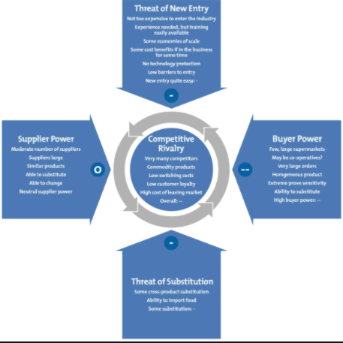
Figure 3: Porter’s five forces
Source: (Wanyonyi et al., 2021, p. 1865595)

Recommendations to the management of the organization
Porter’s value chain
With the help of Porter's value chain framework, Zara understands that all functions do not involve the same efforts.
Primary activities: In this, to the target customers the products are produced and sold directly by Zara. It includes different functions like:
Inbound logistics: according to Seo and Suh, (2019, p. 90), Zara ensures to develop a strong relationship with suppliers so that they can provide effective raw materials with the business can develop the quality finished product. The company ensures to maintain their stock of raw materials which help in productivity.
Operations: Service operations and manufacturing are involved in operations. The operational activities are analyzed effectively that help in higher productivity, efficiency is maximized, and gain competitive advantage.
Outbound logistics: According to Vallati and Grassi, (2019, p. 70), Zara outbound activities are needed to be managed effectively because it helps in delivering the final products to end-users effectively. The company can maintain advanced logistics functions so that final products reach customers at a lower cost without affecting the quality.
Marketing and sales: It is another primary activity that Zara needs to concentrate on. Marketing helps the brand to communicate with mass audiences directly and increase its sales overnight. Different activities like social media campaigning, digital apps, and so on help in promoting the brand effectively.
Services: After-sales services help Zara to set its loyalty among customers. The company should maintain the relationship with their customers by providing services even after purchasing like repairing damaged products.
Secondary activities:
Firm infrastructure: According to Wanyonyi et al., (2021, p. 1865595), the infrastructure activities can be controlled by Zara which helps the company to stand apart from its competitors in the market. It involves the overhead cost.
Human resource management: Zara ensures to hire skilled employees and trains them so that they can increase its products’ quality. While hiring the company analyzes the talent of each candidate effectively.
Technology development: According to Wurst, (2021, p. 40), automation software, customer services based on technology, technology-based research design, and data analytics can be done and develop technology in the workplace that helps in finishing the work in minimal time at cost-effective prices.
Procurement: inbound, operational, and outbound value chain activities can be optimized with the help of procurement activities in Zara. The company needs to ensure to purchase raw materials, equipment, and other resources carefully.
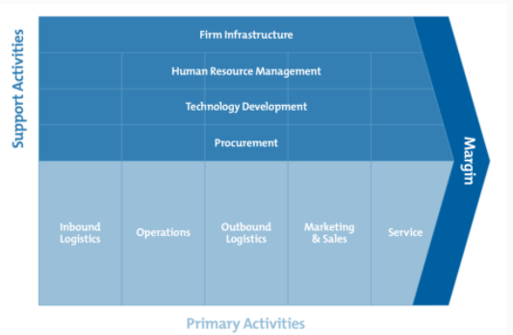
Figure 4: Porter’s Value Chain
Source: (Zara et al., 2020, p. 042030)

Conclusion
Based on the above discussion, it can be concluded different marketing activities help Zara to achieve its competitive position in the market. Different stakeholders' concerts have raised concerns that need to be improved by the company. Also, with the help of Pestle analysis and Porter's five forces, the company analyzes its competitive move, and in this way, the company focuses on launching its new product line. It is recommended that porter's value chain helps Zara to understand its different activities scrutiny.

References
Abalkhail, T.S., 2019. Entry and Expansion Strategies for Burberry in Oman by Applying Porter's Five Forces Model. Indian Journal of Marketing, 49(1), pp.25-35.
Achinas, S., Horjus, J., Achinas, V. and Euverink, G.J.W., 2019. A PESTLE analysis of biofuels energy industry in Europe. Sustainability, 11(21), p.5981.
Aftab, M.A., Yuanjian, Q., Kabir, N. and Barua, Z., 2018. Super responsive supply chain: The case of Spanish fast-fashion retailer Inditex-Zara. International Journal of Business and Management, 13(5), p.212.
Allam, I., Scagnelli, S. and Corazza, L., 2020. Sustainability Reporting, a New Type of Companies’ Hypocrisy: Zara and Volkswagen Cases. In Responsible Business in a Changing World (pp. 195-211). Springer, Cham.
da Silva Oliveira, C.A., Kasper, D., Junior, É.S., Bolson, M.A., Torrezani, L. and Zara, L.F., 2021. Influence of environmental conditions on the mercury levels of the sediment along the Balbina Reservoir, Brazilian Amazon. Environmental Monitoring and Assessment, 193(1), pp.1-12.
Düerkop, S. and Huth, M., 2017. Transportation under Threat–A PESTLE Analysis for Critical Logistical Infrastructures. ICTA2017, p.14.
Duoyan, H., 2021, April. Research on ZARA Strategy from the Perspective of SWOT Analysis Method. In 2021 6th International Conference on Social Sciences and Economic Development (ICSSED 2021) (pp. 201-205). Atlantis Press.
Hu, K., Acimovic, J., Erize, F., Thomas, D.J. and Van Mieghem, J.A., 2019. Forecasting new product life cycle curves: Practical approach and empirical analysis: Finalist–2017 m&som practice-based research competition. Manufacturing & Service Operations Management, 21(1), pp.66-85.
Islam, F.R. and Mamun, K.A., 2017. Possibilities and challenges of implementing renewable energy in the light of PESTLE & SWOT analyses for island countries. In Smart Energy Grid Design for Island Countries (pp. 1-19). Springer, Cham.
KAPUSTINA, L., AGABABAEV, M. and DREVALEV, A., COMPETITIVE POSITION OF THE ZARA BRAND IN THE CLOTHING MARKET. Challenging the Status Quo in Management and Economics, p.779.
Potnis, D. and Mallary, K., Proposing an information value chain to improve information services to disabled library patrons using assistive technologies. Journal of Information Science, p.0165551520984719.
Rejeb, A. and Keogh, J.G., 2021. 5G Networks in the Value Chain. Wireless Personal Communications, 117(2), pp.1577-1599.
Selwyn, B. and Leyden, D., 2021. Oligopoly-driven development: The Word Bank’s Trading for Development in the Age of Global Value Chains in perspective. Competition & Change, p.1024529421995351.
Seo, K. and Suh, S., 2019. A study on the characteristics and social values of vegan fashion in H&M and Zara. Journal of Fashion Business, 23(6), pp.86-100.
Vallati, M. and Grassi, A., 2019, July. AI to Facilitate Legal Analysis in the PESTLE Context. In Emerging Technology Conference (pp. 66-68). The Emerging Technology (EMiT) Conference.
Wanyonyi, E.I., Gathungu, E.W., Bett, H.K. and Okello, D.O., 2021. Determinants of Porter’s competitive strategy utilization among agro-dealers in Kenya. Cogent Food & Agriculture, 7(1), p.1865595.
Wurst, C., 2021. How Freight Forwarders Are Challenged by and Respond to the Digital Disruption. In Disrupting Logistics (pp. 235-249). Springer, Cham.
Zara, O., Guimarães, G., Zibetti, M., Pompermayer, K., Leite, I. and Gomes, V., 2020, November. Balancing data requirement and modelling quality in neighbourhood life cycle assessments. In IOP Conference Series: Earth and Environmental Science (Vol. 588, No. 4, p. 042030). IOP Publishing.

