Handout 13 - Notes on Testing the Assumptions of Liner Regression
Regression Analysis – Basic Concepts
- Regression is an attempt to explain movements in a dependent variable by reference to movements in one or other independent variables. If the independent variable(s) sufficiently explain the variation in the dependent variable, we can estimate the relative influence of each independent variable on the dependent variable (derived importance).
Independent variable (x)
Dependent variable (y)

- When we perform a simple linear regression (or any other type of regression analysis), we get a line of best fit. The data points usually don’t fall exactly on this regression equation line; they are scattered around. A residual is the vertical distance between a data point and the regression line. Each data point has one residual. They are:
- Positive if they are above the regression line
- Negative if they are below the regression line
- Zero if the regression line actually passes through the point
Simple Linear Regression
Independent variable (x)
Dependent variable (y)
y’ = β₀ + β₁ X ± є
Β₀ (y intercept)
β₁ = slope= ∆y/ ∆x
є

As residuals are the difference between any data point and the regression line, they are sometimes called “errors.” Error in this context doesn’t mean that there’s something wrong with the analysis; it just means that there is some unexplained difference. In other words, the residual is the error that isn’t explained by the regression line.
A residual plot is a graph that shows the residuals on the vertical axis and another variable (e.g., independent variable, dependent variable, fitted values) on the horizontal axis.

Assumptions of Regression
We make a few assumptions when we use linear regression to model the relationship between a response and a predictor. These assumptions are essentially conditions that should be met before we draw inferences regarding the model estimates or before we use a model to make a prediction.
- Independence of the observations (uncorrelated predictors) (Collinearity Statistics)
- Residuals are independent of each other (no autocorrelation) (Durbin-Watson test)
- Homoscedasticity of errors (or, equal variance around the line) (visual inspection)
- No “bad” outliers. (Cook’s distance)
- Errors are normally distributed (visual inspection and Shapiro-Wilk test)
- The true relationship is linear (visual inspection)
1) Correlated predictors

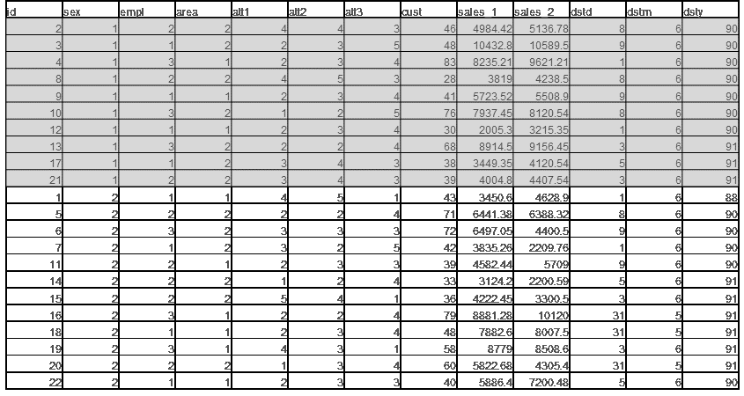
2) Autocorrelation
How do we check regression assumptions? We examine the variability left over after we fit the regression line. We simply graph the residuals and look for any unusual patterns. If a linear model makes sense, the residuals will
- have a constant variance
- be approximately normally distributed (with a mean of zero), and
- be independent of one another.
The most useful graph for analysing residuals is a residual by predicted plot. This is a graph of each residual value plotted against the corresponding predicted value. If the assumptions are met, the residuals will be randomly scattered around the centre line of zero, with no obvious pattern. The residuals will look like an unstructured cloud of points, centred at zero.
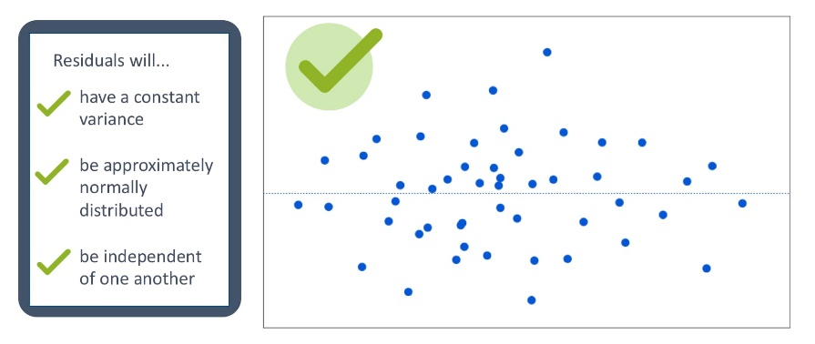
Residuals
ŷ
If there is a non-random pattern, the nature of the pattern can pinpoint potential issues with the model. For example, if curvature is present in the residuals, then it is likely that there is curvature in the relationship between the response and the predictor that is not explained by our model. A linear model does not adequately describe the relationship between the predictor and the response. In this example, the linear model systematically over-predicts some values (the residuals are negative), and under-predict others (the residuals are positive).
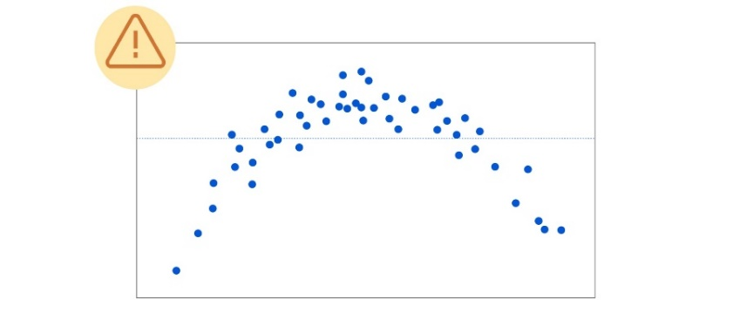
Residuals
ŷ
Residual vs fitted value plot
If the residuals fan out as the predicted values increase, then we have what is known as heteroscedasticity. This means that the variability in the response is changing as the predicted value increases. This is a problem, in part, because the observations with larger errors will have more pull or influence on the fitted model.
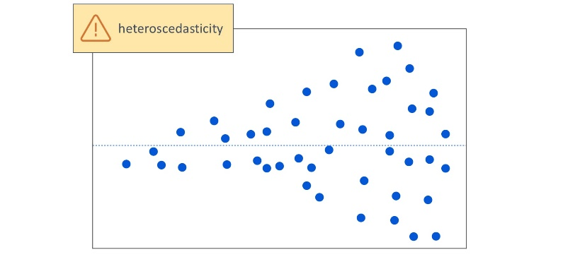
Residuals
ŷ
An unusual pattern might also be caused by an outlier. Outliers can have a big influence on the fit of the regression line.
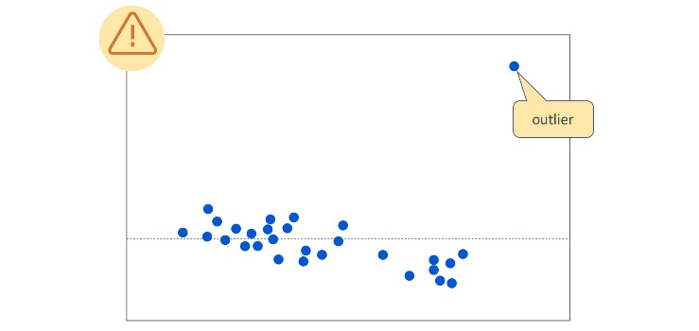
Residuals
ŷ
In this example, we have one obvious outlier. Many of the residuals with lower predicted values are positive (these are above the centre line of zero), whereas many of the residuals for higher predicted values are negative. The one extreme outlier is essentially tilting the regression line. As a result, the model will not predict well for many of the observations.
In addition to the residual versus predicted plot, there are other residual plots we can use to check regression assumptions. A histogram of residuals and a normal probability plot of residuals can be used to evaluate whether our residuals are approximately normally distributed. However, unless the residuals are far from normal or have an obvious pattern, we generally don’t need to be overly concerned about normality.
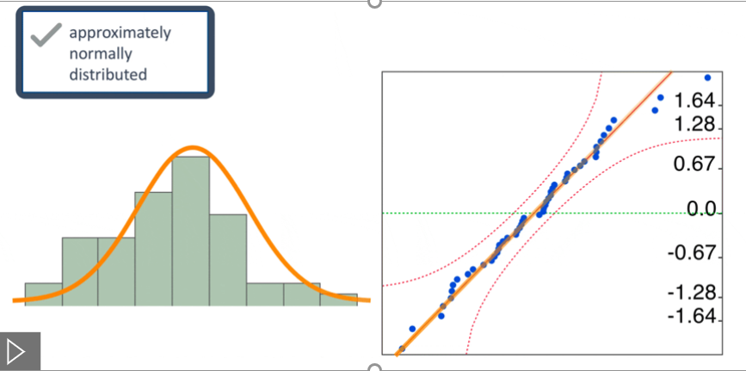
Q-Q Plot
Note that we check the residuals for normality. We don’t need to check for normality of the raw data. Our response and predictor variables do not need to be normally distributed in order to fit a linear regression model.
If the data are time series data, collected sequentially over time, a plot of the residuals over time can be used to determine whether the independence assumption has been met. But this generally isn’t needed unless your data are time-ordered.
How do we address these issues? We can use different strategies depending on the nature of the problem. For example, we might build a more complex model, such as a polynomial model, to address curvature. Or we might apply a transformation to our data to address issues with normality. Or we might analyse potential outliers, and then determine how to best handle these outliers.
https://www.jmp.com/en_hk/statistics-knowledge-portal/what-is-regression/simple-linear-regression-assumptions.html

The following analyses are based on a data set of 103 frequent customers (see Handout 12)
- Uncorrelated predictors
To see if the data meets the assumption of collinearity, we need to run the regression in jamovi. To do this, OPEN the data set “Relational Benefits”. CLICK the Analyses menu and select Regression and then select Linger Regression.
This opens the main Linger Regression dialog box. Run the regression by SPECIFYING the outcome variable (satisfaction) as the Dependent Variable box and the predictors (Social Benefit and Confidence Benefit) as the variable entered in the Covariates box.
To test whether the predictors (Social Benefit and Confidence Benefit) are highly correlated, CLICK the Assumption Checks tab and select the Collinearity Statistics checkbox.
This gives the results shown below:
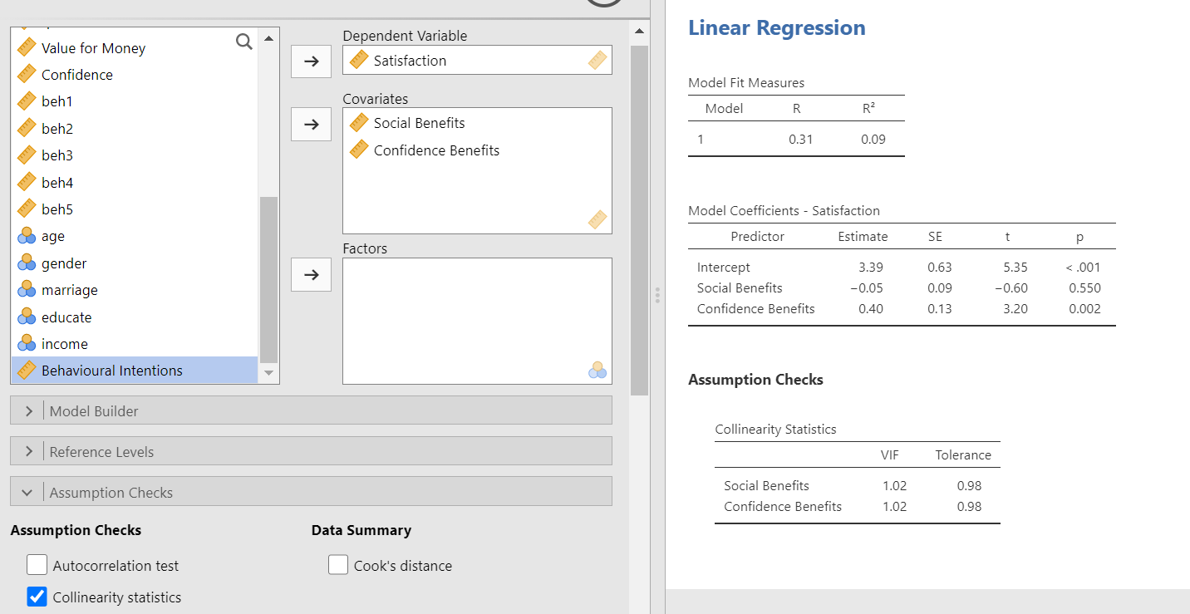
Decision rule | If the Tolerance is less than 0.1 or the VIF value is greater than 10, then you have concerns over multicollinearity. Otherwise, the data has met the assumption of collinearity
How to write it up | Collinearity statistics indicate that multicollinearity is not a major concern (all tolerance values are greater than 0.1 and VIF-scores are smaller than 10) (Hair et al., 2010).

- Residuals are independent of each other
To see if the residual terms are uncorrelated, Click the Autocorrelation Test checkbox in the Assumption Checks tab
Durbin–Watson Test for Autocorrelation
Autocorrelation |  | DW Statistic |  | p
0.01 |  | 1.90 |  | 0.580

Decision rule | Durbin-Watson values can be anywhere between 0 and 4. Researchers often look for is a value as close to 2 in order to meet the assumption of uncorrelated residuals. As a rule of thumb if the Durbin-Watson value is less than 1 or over 3 then it is considered as being significantly different from 2, and thus the assumption has not been met.
How to write it up | The Durbin–Watson value was 1.9, indicating that there was no autocorrelation.  or  The Durbin Watson test shows absence of auto-correlation (Durbin-Watson value = 1.90).
3. Homogeneity of variance
To see if the error term (the “noise” or random disturbance in the relationship between the independent variables and the dependent variable) is the same across all values of the independent variables, we need to examine the residual plots. Click the Residual Plots checkbox in the Assumption Checks tab

The scatterplot of each predictor variable, the outcome variable, and the fitted values against residuals are shown below:
- The first graph plots the predicted values against the residuals (Figure 1)
- The second graph plots the Y values against the residuals (Figure 2_
- The third and the fourth graphs plot the Xi values against the residuals (Figures 3 & 4)

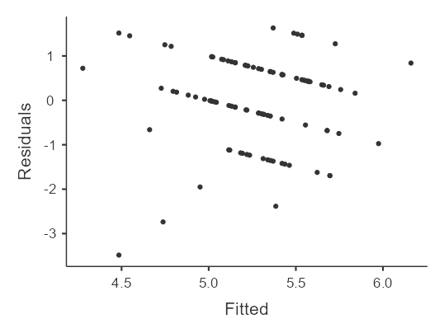1 | 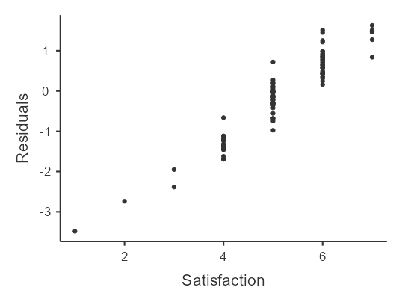2
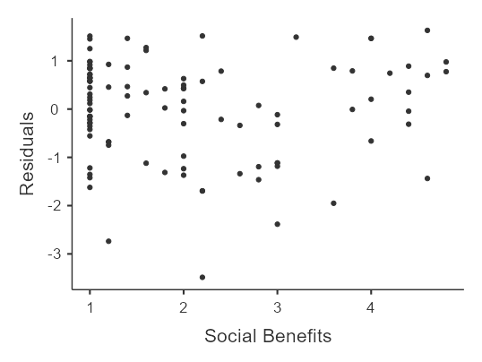3 | 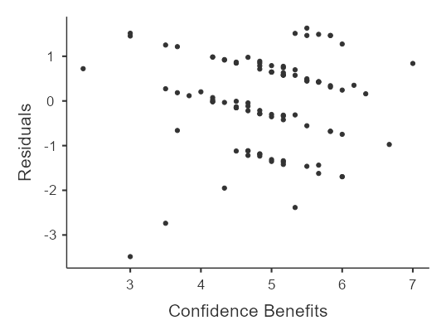4
If the graph has a funnel shape as seen in the right figure, you are probably dealing with heteroscedasticity (assumption net met). The opposite is homoscedasticity (assumption met).
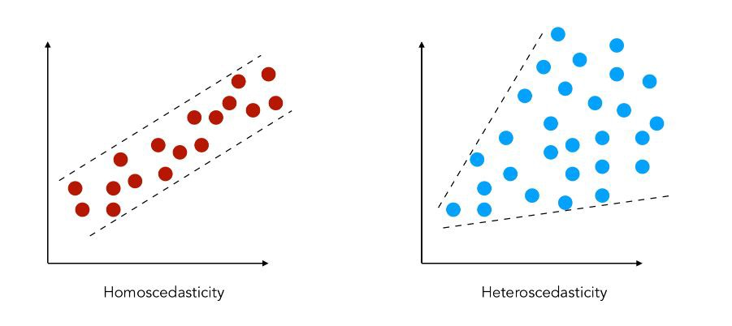

Decision rule | In general, as the values increase (along the X-axis), the variation in the residuals should be roughly similar. If everything is ok, this should look like a random array of dots. If the graph looks like a funnel shape, then it is likely that this assumption has been violated.
How to write it up | The plot of residuals versus predicted values showed no apparent signs of funnelling, suggesting that the assumption of homoscedasticity has been met.

4. Outliners
Significant outliers can place undue influence on the regression model, making it less representative of the data as a whole. Cook's distance is used to detect the influential observations, which is a measure of the difference in the coefficient of regression with and without an individual observation. In order to have a large Cook’s distance an observation must be a fairly substantial outlier and have high leverage. To calculate the Cook’s distance values, CLICK the Cook’s Distance checkbox in the Assumption Checks tab
Cook's Distance
 |  |  |  |  |  | Range
Mean |  | Median |  | SD |  | Min |  | Max
0.01 |  | 0.00 |  | 0.03 |  | 0.00 |  | 0.29

Decision rule | A Cook's distance greater than 1 is a sign that an observation is having an unusual influence on the regression model and should be looked into.
How to write it up | Cook’s Distance values were all under 1 (no Cook's distance greater  than 0.29), suggesting that no observations had disproportionate influence on the model.

5. Normality (The residuals are normally distributed)
The normality assumption can be tested by looking at the histogram or Q-Q plot.
In order to create a histogram of the residuals and observe whether or not the distribution follows a bell-shape, we need to save the residuals into the data file. This can be done by Clicking the Residuals checkbox in the Save tab
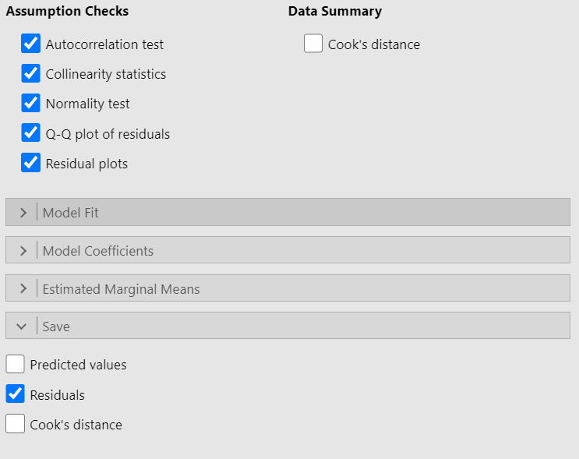
Click the Exploration sub-menu and select Descriptives
Find “Residuals” in the source variable list and drag and drop it into the target variable list.
Click the Plots tab and then Click the Histogram checkbox
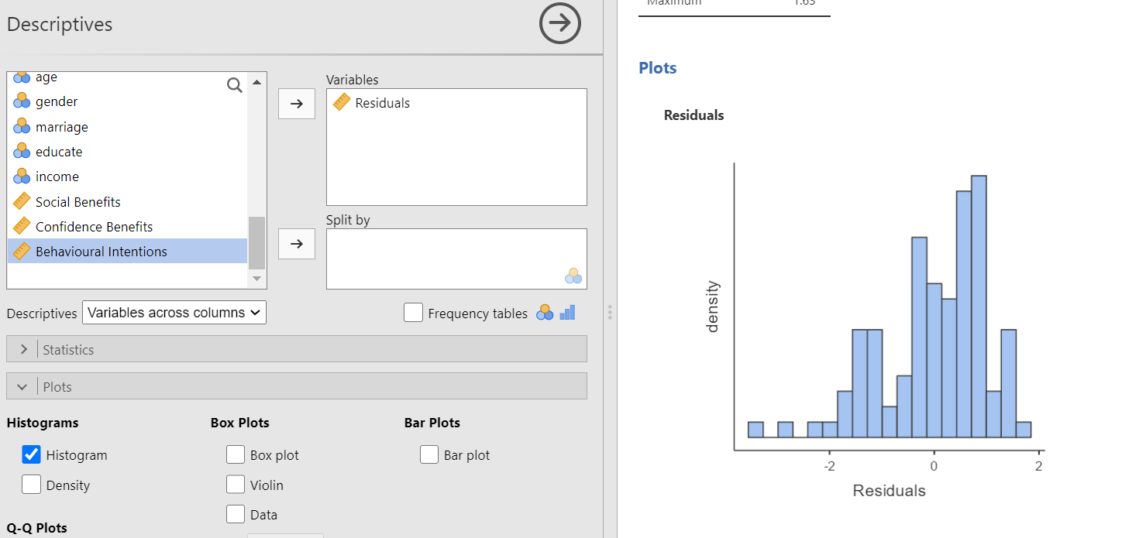
The graph clearly shows a left skewed distribution (or a negatively skewed distribution because it's long tail is on the negative direction on a number line).
Decision rule | The histogram of the residuals should be approximately normal or bell-shaped.
How to write it up | The histogram of residuals does not look normal.  or  The histogram of the residuals appears to be distributed normally.
Q-Q Plot
The quantile-quantile or q-q plot is an exploratory graphical device used to check the validity of a distributional assumption for a data set. In general, the basic idea is to compute the theoretically expected value for each data point based on the distribution in question. If the data indeed follow the assumed distribution, then the points on the q-q plot will fall approximately on a straight line.
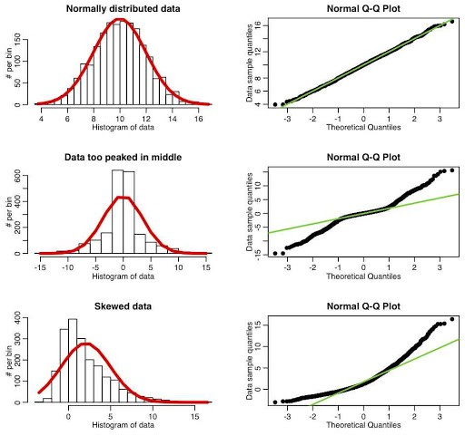
CLICK the Q-Q Plot checkbox in the Assumption Checks tab

Q-Q Plot
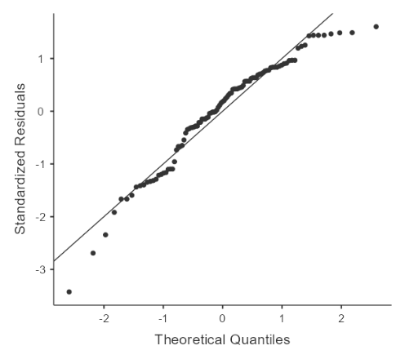

Decision rule | - The closer the dots lie to the diagonal line, the closer to normal the residuals are distributed.  - For further information on Q-Q plot, you may refer to the notes on “Understanding the Concept of Q-Q plots”.
How to write it up | The P-P plot for the model suggested that the assumption of normality of the residuals may have been violated.

Normality Test
The Shapiro-Wilk test assesses whether a sample of data comes from a normal distribution. CLICK the Normality Test checkbox in the Assumption Checks tab
Normality Test (Shapiro-Wilk)
Statistic |  | p
0.95 |  | < .001

Decision rule | If the P-Value of the Shapiro Wilk Test is larger than 0.05, we assume a normal distribution.
How to write it up | Shapiro-Wilk test indicated that model residuals were not normally distributed. However, as only extreme deviations from normality are likely to have a significant impact on your findings, the results are probably still valid.

6. Linear Relationship
If you fit a linear model to a non-linear data set, the residual plot will show a curved pattern.
How to writ it up: The residual plot shows a fairly random pattern indicating a linear model is appropriate. (see figure 1 on page 5)

Exact of a thesis
Preliminary analyses
Before the data can be analyzed, some preparation is needed. The first step was screening and cleaning the dataset for outliers or errors. There were no errors or outliers in the data, only some missing data in the variables involvement and firm profitability. As a result, the total organization-year combinations is 95.
After checking the data, the normality of the distribution of the dependent variable is assessed, because many statistical techniques assume a normal distribution of scores of the dependent variable (Pallant, 2013). Results are provided in figure 2 in appendix 2. First, a histogram is made to see if the distribution shows a bell curve. It appears that the values are reasonably normal distributed. Furthermore, the Kolmogorov-Smirnov statistic¹ is used. A non-significant result (more than 0.05) indicates normality (Pallant, 2013). The significance value in this study is 0.000 suggesting a violation of the assumption of normality. Third, the normal probability plots are observed (normal Q-Q plot). A reasonably straight line against the expected value suggests a normal distribution. In this case, the values are all close around the line, suggesting a normal distribution. All three measures taken together, it can be assumed that there is no violation of the normality assumption. Although, the Kolmogorov-Smirnov test shows significance, normal distribution is clearly visible in the histogram and Q-Q plot. Therefore, the variable is not transformed.
The relationship between two variables has to be linear (Pallant, 2013). Therefore, linearity is the next assumption that is checked for. The linearity assumption is met when there is not a curve in the scores when you look at the scatterplot, but roughly a straight line (Pallant, 2013). The scatterplot in figure 3 appendix 2 shows that this assumption is also met.
The homoscedasticity assumption is checked. The scores are roughly rectangular distributed and most scores are concentrated around the zero point. This means that this assumption is also not violated (see figure 4 in appendix 2).
Source: de Grauw, S. (2018). Corporate social responsibility, job satisfaction and the role of employee involvement (Master's thesis, Tilburg University, Tilburg, Netherlands). Retrieved from http://arno.uvt.nl/show.cgi?fid=145880
- Kolmogorov-Smirnov test is an alternative to Shapiro-Wilk test.

