

NAME: ARUN TEJA GOUD RANGA
STUDENT NUMBER: 2212572

MODULE: Human Resource Management
MODULE CODE: LCBM7000

TITLE: Assessment 1 Human Resource Management

LECTURER: Mushfiqur Rahman

Submission Date: 04/01/2023

Executive summary
This specific study assessed the present labour market situation in the UK. To check the trend, analysis was made from various viewpoints like the unemployment rate in the UK, government standpoint, preference of job choice after the pandemic, etc. After Brexit and the covid-19 pandemic, the work process was changed. It was discussed with the relevant points along with theories applicable to the process for further knowledge.

Table of Contents
1.0 Introduction 4
2.0 Main body 4
a) The current state of the labour market in the UK 4
b) The emerging changes in Human Resourcing Strategies in the post-Covid, post-Brexit external environment. 7
3.0 Tools and theories 9
4.0 Conclusion 11
References 13

1.0 Introduction
This study aims to ascertain the current labour trend in the UK market after the covid and Brexit and the HR strategies to manage the situation. HRM is working with people in an organisation in a structured manner. The UK labour market is appropriately addressed by the government as well as the HR department of companies. The trend of the UK labour market is analysed in respect of the unemployment rate, people's preference to select a job, government steps towards the fixation of wages, etc. The pandemic situation and Brexit changes the whole labour market situation. The working culture of the UK is changed due to various rules and regulations. The HR department initiates different steps to manage the business in the post-Brexit and post-Covid-19 situations. The different approaches adopted by the HR department are stated here to understand the current labour market situation in the UK. Sources of information are also declared to authenticate the statement. The application of different theories is also needed to understand the subject matter better. The labour market trend in the UK and the initiatives adopted by the HR department are also analysed by different theories to authenticate the applications.

2.0 Main body

a) The current state of the labour market in the UK
A labour market can be defined as where employers and employees interact with each other. Employers try to find the best skill in the labour market, and the job-seekers compete for the best job. The international labour market can be defined as an informal place to meet the global skill requirement of multinational corporations.
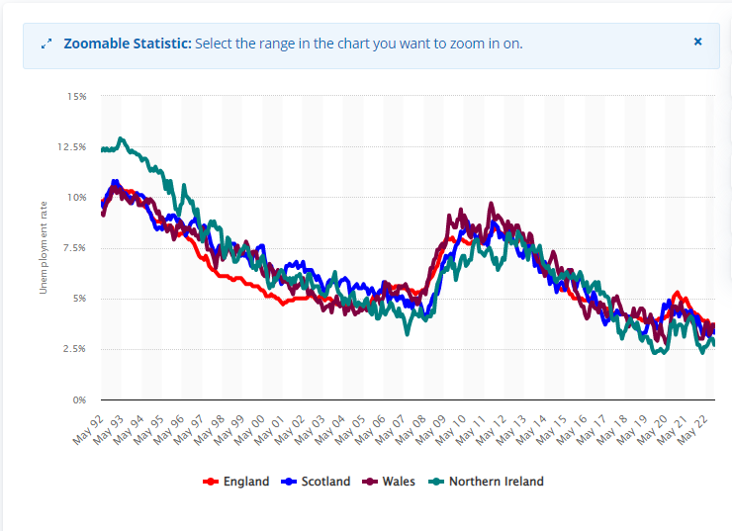
Figure 1: The unemployment rate in the UK from May 1992 to October 2022
Source: (Clark, 2022)
After the pandemic, the UK economy is recovering steadily. As a result, the scope of employment is also increasing, and employment confidence remains at a positive trend. The resurgence of the UK economy creates a massive demand for labour. Therefore, the need for workers overtakes the labour supply in the market. From the above diagram, it is evident that unemployment increased during the pandemic on May 20 and May 21 but gradually decreased on May 22. The highest unemployment rate in the UK is in England, at 3.7%, followed by Wales at 3.6%, 3.3% in Scotland and 2.7% in Northern Ireland (Clark, 2022). It is the lowest unemployment rate in the UK since 1974. During the pandemic times, the rate of unemployment increased due to the closure of industries, but the situation is reversed due to the furlough policy adopted by the UK industries. The employment rate has increased in the public sector of the UK. Public sector employment has increased by 307,000 between March 2020 and September 2022 (Powell and Francis-Devine, 2022). On the contrary, the employment scope has been reduced by 313,000 posts in the private sector (Powell and Francis-Devine, 2022).
The labour market of the UK is heading towards the tightest situation in decades where demand outstrips supply. The reopened industrial sectors recruit a large number of workers, and the requirements are also high, like the pre-pandemic level. The maximum requirement of workers in low-paid sectors where the demand for labour overtakes the supply. The low-paid workers are mostly under-23 people and are heavily affected during the pandemic. But the situation is reversed rapidly during 2021 and 2022. The demand for the young workforce has increased due to the tight position in the labour market and the increasing demand for youth-friendly jobs (Government of UK, 2022). The tense market situations and the need for young workers also help to increase the wage rate of the 16-17and 18-20 age groups of workers. The UK government recommends a 9.7% increase in the National Living wages index. As a result, the minimum wages in these two groups are fixed at £ 5.28 and £ 7.49, respectively (Government of UK, 2022). Since the minimum wages in the lower-paid job have been increased, the absorption rate is also high. As a result, the unemployment rate in the UK is decreasing. On the other hand, the average wage level has been reduced. The average real wage has been reduced by -3.9% annually in the three months before October 2022 (Powell and Francis-Devine, 2022).
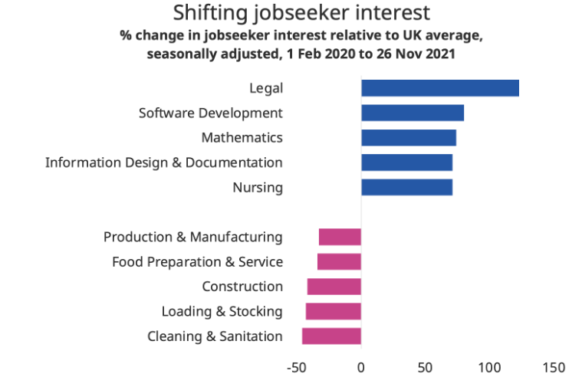
Figure 2: Shifting of job interest
Source: (Kennedy, 2021)
In the UK labour market, people are opting for higher-paid jobs. During the pandemic, lower-paid jobs are affected more. Around 2 million people are paid below minimum wages during the pandemic (Partington, 2020). As a result, people opt for high-paying jobs rather than concentrating on low pay jobs for job security. Consequently, much demand is created for lower-paid jobs compared to higher-paid jobs in the market. It has been observed that more people prefer to switch their job preference to legal, software development, educational facilities, etc. From the above diagram, it is evident that maximum clicks made on the job posting which has security regarding wages payment, further career progression, etc. These jobs are also preferred since it has been observed that high-paying categories are safe during the pandemic compared to other types regarding working from home, flexible working hours, etc.
On the contrary, low-paid jobs, like construction, house cleaning, etc., do not attract much preference since these jobs are affected most during the pandemic (Mayhew and Anand, 2020). Therefore, from the above discussion, it has been understood that there is enormous scope for lowly paid work in the UK market. It is also observed that due to different policies of the UK government, the unemployment rate is also reducing, which is a positive sign for the labour trend.

b) The emerging changes in Human Resourcing Strategies in the post-Covid, post-Brexit external environment.
The covid-19 pandemic and Brexit changes the working scenarios in the UK. Therefore, human resources (HR) have formulated new strategies to match the new external environment. The HR policies regarding new situations are discussed below.
Post-Covid external situation
Hybrid work culture: One of the HR strategies is introducing hybrid culture in the business concern. The hybrid work culture can be defined as a combined approach to facilitate working from the office as well as from home. Due to travel restrictions, employees must work from home instead of the office. Around 57% of UK employees prefer to work in the hybrid system due to more autonomy, flexible working hours, etc. (Adams-Prassl et al., 2020). On the other hand, an estimated 39% workforce will be separated if an enterprise goes on a complete hybrid system. Therefore, HR has introduced a policy regarding schedule flexibility and good leadership to maintain a hybrid environment.
Developing critical talent: Since the movement is restricted during the pandemic period, HR is facing the problem of attracting global talent to UK companies. HR is under pressure to meet the critical need of business and organisational change. HR adopts strategies according to the market conditions to bridge the skill gap. The HR of UK companies develop the skill of employees by imparting training. In the post-pandemic period, TCS arranged 100 hours of accessible training facilities for the staff in 2020 to enhance their working skill in the post-covid-19 situation (Burki, 2020). They also encourage employees to accept newly created job roles within the business enterprises so that in the post covid situation, business performance cannot be affected. It is called internal labour market creation within the organisation. The business enterprises also improve the infrastructure and training facilities within the organisation so that employee improves their output. It also helps the employees to move on without exiting companies.
The well-being of the staff: During the pandemic, the team worked remotely without keeping in touch with teammates. As a result, people suffer from depression, agony, etc., since they miss the office's physical atmosphere. It is observed that the number of psychological patients increased to 29.5% in 2020 compared to 20.8% in 2019 in the UK (Mansfield et al., 2021). The activities of HR in the post-covid situation also include the wellness of employees. It has regular communication with employees regarding the office so that employees can feel they are not isolated, which is effective in reducing work-related tension. HR also formulates a plan to check the health of family and employees. Therefore, the employee will feel that he is supported.
Post-Brexit external situation
After Brexit, the UK is outside of the European Union (EU) and they cannot enjoy facilities provided by the EU. The HR of the UK companies adopt specific strategies to manage the business in the post-Brexit situation.
Recruitment: Before Brexit, people could move anywhere in Europe by obtaining a single passport. After Brexit, one needs a separate work permit to enter the UK. Around 81.6% of people born in other EU countries are employed in the UK (Magennis et al., 2022). As a result, they need a separate work permit for work in the UK. To mitigate the problem, the HR of the UK company looks into developing local talent. They also give importance to the existing employees' skills, so that dependency upon other EU countries' skilled staff will be reduced. The HR strategy also includes recruiting university students. Therefore, students can be trained to bridge the skill gap. The HR of Aldi, a renowned retail brand in the UK, arranges to recruit students from Loughborough University to meet their skill gap (McFadden et al., 2022).
Gig economy: Gig economy can be defined as a labour market with a focus on short-term employment. The workers are primarily freelancers or independent contractors. HR has taken these steps because, after Brexit, many workers faced uncertainties regarding financial stability. The initiative is made for short-term gain so people can meet their immediate needs. The gig economy is initiated by UK companies for better service at the cheapest cost since skilled labour in the UK is abundant. After Brexit, the gig economy is essential in the UK labour sector. The gig economy contributes around £ 20 billion to the UK economy, which is almost equal to the contribution from the aerospace industry of the UK (Popan, 2021).
Workforce planning: Since Brexit affects the inflow of global talent to the UK, HR arranges workforce planning beforehand. The planning includes skill requirements in the future, existing skills available in the company, maintaining diversity to attract talent, etc. (Tucker, 2021). Meanwhile, the HR department also checks the bye-laws associated with Brexit. So, HR can arrange to grant UK citizenship to the ex-pat workers for availing their technical excellence.

3.0 Tools and theories
The information collected regarding the UK labour trend and HR strategies changes is from secondary sources. Since the data volume is large and it is challenging to manage the primary data, dependence is made on the secondary data. The information sources are research work, academic journals, government statistics, blogs, newspapers and others. Reliable literature is taken for the authenticity of the information. Since the secondary data contain many irrelevant details, proper care has been taken to filter unnecessary information.
The theories applied to the UK labour market trend can be explained by macroeconomics's demand and supply theory. When wage growth decreases but production increases, it implies that the supply of labour has increased (Kumar et al., 2022). When this occurs, there will be pressure on the wage rate of workers. In this situation, workers chase the job, and employers select the labour force according to their preferences. On the contrary, when the demand increases over the supply, the wage rate increases, and the labour can switch over the job for better wages.
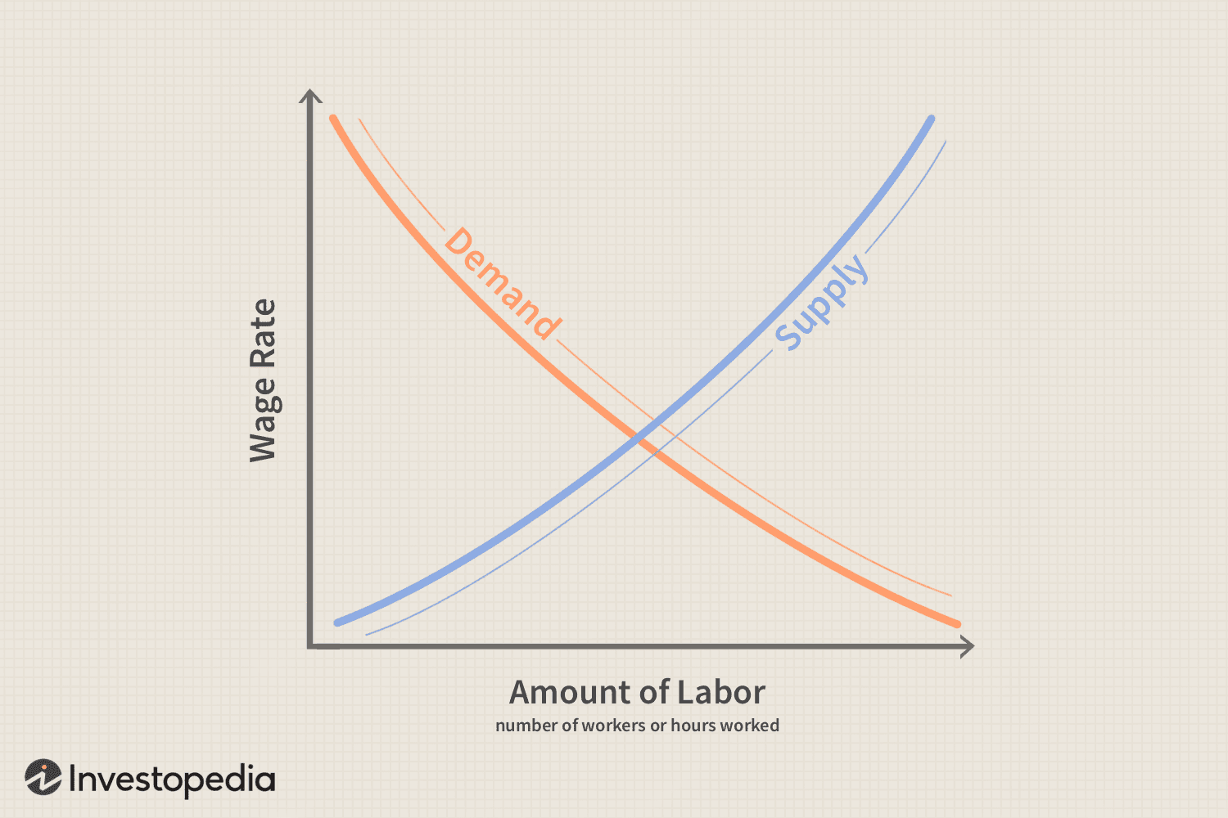
Figure 3: Labour market demand and supply
Source: (Kenton, 2022)
In the UK labour market, the demand for menial jobs has increased. Since people are not willing to do the lower category job, the wage rate has increased. On the other hand, workers rush to high-paying jobs because of job security, but the wages stay the same due to excess labour supply.
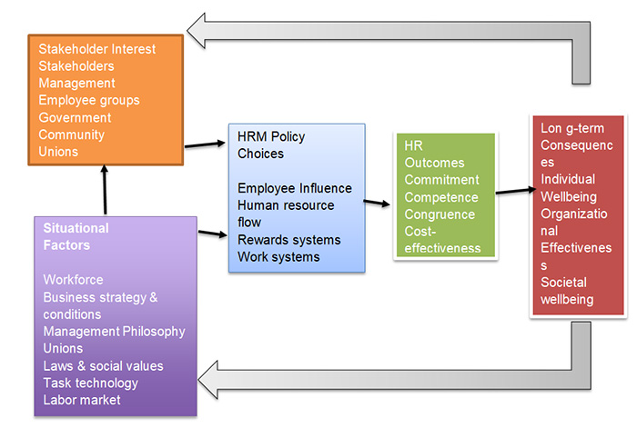
Figure 4: Harvard model
Source: (Green and Henseke, 2021)
The Harvard model is ideal for analysing strategic human resource management regarding the post-covid period. The model is based on stakeholders' interests, situational factors, HRM policies for sustainability, etc. In the post-pandemic time, employees' preference for flexible working hours compels the HR of the UK Company to adopt a hybrid functional approach. Otherwise, they cannot retain the talent (Green and Henseke, 2021). On the other hand, to cope with external situations, HR has to formulate to development of the critical skill of the employees because talent search is difficult due to restrictions in the movement. The well-being of the staff is also getting important because the employee is the backbone of the business. If wellness is not considered, the employee receives sick, and business performance will be affected. On the other hand, the employee may leave the organisation for a better option where staff welfare measures are higher.
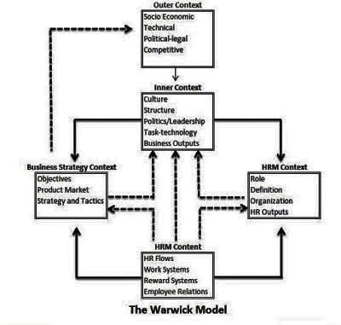
Figure 5: The Warwick model
Source: (García-García et al., 2020)
The Warwick model of human resources is used to balance internal and external factors. In the Brexit situation, HR has to balance between external factors like the business situation in the UK and internal situations like the hurdles in the recruitment process, workforce planning, increasing motivations, etc. it is helpful to apply when both factors are at odd. In the post-Brexit situation, the UK is separated from the rest of Europe, but they have to manage its labour market to run the business. The Warwick model helps the HR to build the labour-management policy by recruiting local talent and workforce planning after considering all the future effects, etc., for the proper running of the business (García-García et al., 2020).

4.0 Conclusion
From the above discussion, it has been observed that the labour market trend has changed in the UK. Due to several initiatives taken by the government, the unemployment rate is falling. People opt for more white-collar jobs like a lawyer, teaching, etc., for more job security, flexible working times, etc. As a result, there is a tight market situation for menial jobs like construction, home cleaning, etc. The average income in the position where young persons are required has increased compared to the high-paying job in the UK labour market due to the short labour supply. The labour market trend has changed after the pandemic and Brexit. The HR of the UK companies initiated different measures to match the market situation. The steps that have been taken included the hybrid working culture, developing homegrown talent, etc., in case of a post-pandemic situation. On the other hand, the methods like the gig economy, recruiting of local talents, etc., have been adopted by HR to manage post-Brexit situations. It has been observed that the decision taken by the HR of UK companies are well supported by the theories so that its implementation is successful.

References
Adams-Prassl, A., Boneva, T., Golin, M. and Rauh, C. (2020) Inequality in the impact of the coronavirus shock: new survey evidence for the UK.
Burki, T.K. (2020) COVID-19: consequences for higher education. The Lancet Oncology, 21(6), p.758.
Clark, D. (2022) UK unemployment rate by country 2022, Statista. Available at: https://www.statista.com/statistics/279990/unemployment-rate-in-the-uk-by-country/ (Accessed: December 22, 2022).
García-García, P., Carpintero, Ó. and Buendía, L. (2020) Just energy transitions to low carbon economies: A review of the concept and its effects on labour and income. Energy Research & Social Science, 70, p.101664.
Government of UK (2022) Low pay commission summary of findings 2022, GOV.UK. Available at: https://www.gov.uk/government/publications/minimum-wage-rates-for-2023/low-pay-commission-summary-of-findings-2022 (Accessed: December 22, 2022).
Green, F. and Henseke, G. (2021) Europe’s evolving graduate labour markets: supply, demand, underemployment and pay. Journal for Labour Market Research, 55(1), pp.1-13.
Kennedy, J. (2021) UK labour market 2021 review and 2022 outlook: How long can the job market keep roaring back?, Indeed Hiring Lab. Available at: https://www.hiringlab.org/uk/blog/2021/12/15/labour-market-2021-review-2022-outlook/ (Accessed: December 22, 2022).
Kenton, W. (2022) Labor Market explained: Theories and who is included, Investopedia. Investopedia. Available at: https://www.investopedia.com/terms/l/labor-market.asp (Accessed: December 22, 2022).
Kumar, A., Kumar, A., Prasad, A., Burch, M., Cheng, S. and Mueller, K. (2022) An Open Source Interactive Visual Analytics Tool for Comparative Programming Comprehension. arXiv preprint arXiv:2208.00102.
Magennis, P., Begley, A., Dhariwal, D.K., Smith, A. and Hutchison, I. (2022) Oral and Maxillofacial Surgery (OMFS) Consultant Workforce in the UK: reducing consultant numbers resulting from recruitment issues, pension pressures, changing job-plans, and demographics when combined with the COVID backlog in elective surgery, requires urgent action. British Journal of Oral and Maxillofacial Surgery, 60(1), pp.14-19.
Mansfield, K.E., Mathur, R., Tazare, J., Henderson, A.D., Mulick, A.R., Carreira, H., Matthews, A.A., Bidulka, P., Gayle, A., Forbes, H. and Cook, S. (2021) Indirect acute effects of the COVID-19 pandemic on physical and mental health in the UK: a population-based study. The Lancet Digital Health, 3(4), pp.e217-e230.
Mayhew, K. and Anand, P. (2020) COVID-19 and the UK labour market. Oxford Review of Economic Policy, 36(Supplement_1), pp.S215-S224.
McFadden, P., Neill, R.D., Mallett, J., Manthorpe, J., Gillen, P., Moriarty, J., Currie, D., Schroder, H., Ravalier, J., Nicholl, P. and Ross, J. (2022) Mental well-being and quality of working life in UK social workers before and during the COVID-19 pandemic: A propensity score matching study. The British Journal of Social Work, 52(5), pp.2814-2833.
Partington, R. (2020) Two million in UK paid below minimum wage since Covid pandemic began, The Guardian. Guardian News and Media. Available at: https://www.theguardian.com/uk-news/2020/nov/03/two-million-in-uk-paid-paid-below-minimum-wage-since-covid-pandemic-began (Accessed: December 22, 2022).
Popan, C. (2021) Embodied Precariat and Digital Control in the “Gig Economy”: The Mobile Labor of Food Delivery Workers. Journal of Urban Technology, pp.1-20.
Powell, A. and Francis-Devine, B. (2022) UK labour market statistics. Available at: https://researchbriefings.files.parliament.uk/documents/CBP-9366/CBP-9366.pdf (Accessed: December 22, 2022).
Tucker, E. (2021) Strategic workforce planning: from closing skills gaps to optimising talent. Strategic HR Review.

