MARKETING FUNDAMENTALS (LCBB4004)
ASSESSMENT 1: Individual Blog Marketing Fundamentals Analysis and Evolution

Submission date:28/03/2023
Name of the Lecture: TUSHARA BALENDRAN
Student ID: 2236845
Student name: SLAVI SINAPOV


Background
History

King C. Gillette created the first safety razor in 1901, revolutionizing the shaving process. The patent was issued on November 15th, 1904. A man didn't have to take his shaving blade to the barber to be sharpened using the new shaving razor. King C. Gillette built his business on the tenet that “There is a better way to shave and we will find it”.
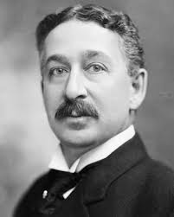

Men's safety razors are what Gillette is recognized for us a brand. The Gillette corporation, its former parent firm, is referenced in its name. Later, it amalgamated with P&G, and as result, is now a part of the P&G company. https://simconblog.wordpress.com/2015/07/04/gillette-brand-analysis/?fbclid=IwAR1XoXqWIlQuCH4NPJgqQ0pl7JP17jPWhUSCbz1WZ8wjfAReyczUw8hrTKQ

Timeline
1932 Gillette introduces Gillette Blue Blade
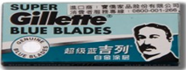
1938 Gillette introduces Gillette Thin Blade
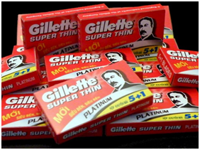
1957 Gillette launches a three-setting adjustable razor. It developed a commercial to demonstrate the functionality of its distinctive product.
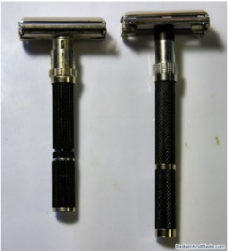

Mission
“The Gillette Company is a worldwide oriented consumer products marketer that seek a competitive advantage in quality, value-added personal care and personal use products,” reads company's mission statement. In addition to being inspiring, Gillette's mission statement is also concise and practical. This claim market it clear that they must be aware of their clients' satisfaction with their offering(quality). It’s a smart marketing move for Gillette to highlight the fact that it markets consumer good globally since it gives consumer the impression that it would be difficult to discover a product that is superior. Also, the mission statement makes it obvious what the organization offers. By doing this, Gillette raises societal awareness of its actions.
https://thesocialgrabber.com/marketing-strategy-and-swot-analysis-of-gillette/

Vision
The Gillette Company's vision is to outperform the competition by inventing to give consumer value and customer leadership more quickly, more effectively, and more completely. Organizational Excellence and Core Values, two guiding principles that serve as the cornerstone for all of our efforts, complement this vision. In order to achieve the mining vision, it is necessary to achieve high results on all levels. Each business unit's clear and succinct strategic and a continual quest for excellence across all operational and staff activities will serve as the foundation for their performance. A varied staff of the greatest level is required for this Quest for Excellence in order to be successful.
The Gillette Company Mission, Vision & Values | Comparably





Marketing segmentation
P&G market segmentation strategies are designed to divide the stabilize market it has available into submarkets depending on the various needs and product preferences of its customers. Under these shared traits, the business can standardize its market mix for its clients inside a certain market sector (Ailawadi et.al, 2001). Consequently, segmenting Gillette products serves a variety of goals, such a fostering innovation, fostering long-lasting customers relationships, bringing about larger profits, enabling better satisfaction of consumer desires and needs, and so on. The segmentation strategy used by Gillette is known as "Geo-Clustering," and it comprises combining a few characteristics with the goal of having a more clearly defined target client category. This might be referred to as a multi-attribute segmentation technique. Age, gender, occupation, income, generation, and lifestyle are the main segmentation characteristics of Gillette products, all of which allow the business to precisely identify the market groups at its disposal. To meet the needs of the male personal grooming industry, a variety of Gillette products are manufactured. For example, shaving gel is created for men who place a high importance on skin care and grooming. Customers in this market are willing to pay higher amounts for product used for personal grooming.

Demographic segmentation:
- Men and Women
- Born between 1950-2005
- Multicultural
- Low income
- High income
Geographic segmentation:
In general, the Gillette products are all around the world.
- Europe
- Asia
- USA
- Australia
- Africa
Physiographic segmentation:
This group typically targets those who are conscious that they have high standards for personal grooming. These are the people who, for example, always make sure they look good before going to work. A large portion of the population identifies with this way of life. A significant market for Gillette also includes wealthy people and people in the middle class. The brad often asks a premium price in exchange for extremely high-quality goods therefore this is essential. So, it is designed to help people who work and have money to spare.

Advantages and disadvantages:
- Increases the concentration and intensity of marketing efforts with market segmentation, companies can now identify their target audience and target their marketing efforts specifically to that segment.
- Psychographic segmentation plays an important role because the same demographic group may have different characteristic due to different life experience.
- Demographic segmentation is the most frequently use farmwork at Gillette, it divides customers according to the income of the customers and according to their stage at the time of purchasing a certain product.
- The company could also use the cross-market segmentation method.
- Due to intense rivalry in the area, market share growth is constrained.
- In the past, the brand has suffered legal challenges and disputes that have impeded its operations.



https://embapro.com/frontpage/marketingstpcoanalysis/10697-gillette-india

https://www.youtube.com/watch?v=eof9eSyfr4Y

Targeting
According to the geographic distribution, people who live in cities are their target market. This is because people who usually live in big cities use hygiene and care products every day. The company wants to cover a large part of the world, and for this purpose, it should aim for the countries of the Middle East, because in some countries there is an increase in the standard of living (Schlegelmilch, 2016). Gillette use differentiated targeting strategy to distinguish between the products attributes.
Positioning
Marketers are currently facing difficult times.

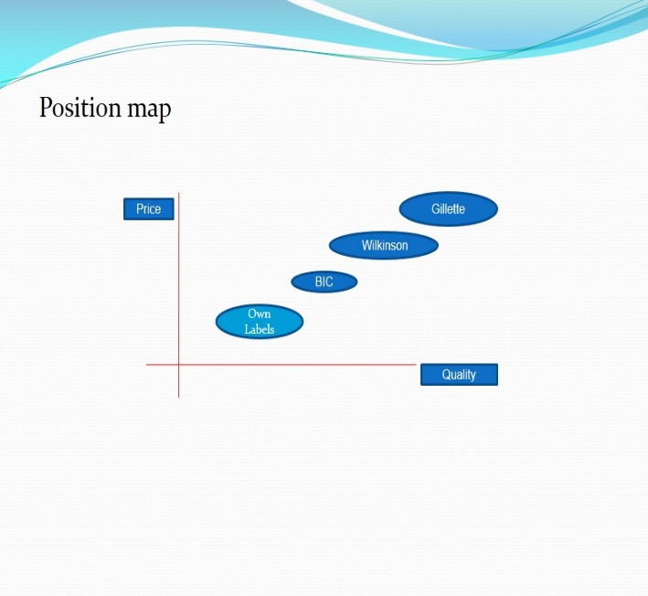

The company has the highest market share in the world with approximately 70% market shares and is the absolute dominant in this category. This is result of huge and constant advertising campaigns and ceaselessly innovative products. This is a good example of a subsidiary company such a Gillette as part of P&G to increase the value of its shares.
https://www.forbes.com/companies/gillette/?sh=5ba0cf1510a0

Marketing mix
The Gillette corporation Procter and Gamble's marketing mix enables and aids it in achieving its marketing goals and favorably affecting the target audience. The company often use the components of the marketing mix when marketing its good and services as well as engaging in brand-building initiatives. These components are crucially important for the formation and implementation of marketing plans and strategy by the corporation, particularly for creating and maintaining competitive advantage. (Chernev, 2018).
Product
In the area of men's personal care, Gillette is one of the top brands. They are strives to meet all needs and search the market by offering quality products from customers who will always be satisfied(M. Goldberg, M. Fishbein,2013).
Gillette offer almost every possible face and body product to the male audience. For this company’s marketing mix, several elements are included:

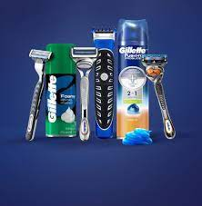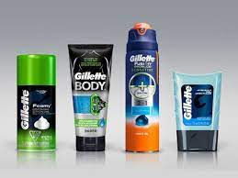
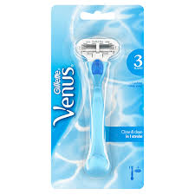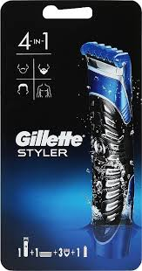

Razors, trimmers, and blades: Some of the brands in this area are Gillette Fusion, Gillette Mach 3, and Gillette Flex ball. A Mach 3 variation made specifically for women is Gillette Venus. A variety of deodorants, antiperspirants, shaving creams, gels, foams, skin care products, aftershaves, and body washes.
The packaging of the product and the service enables Gillette Company P&G to emphasize the product's function while also making it simple to transport, allowing for a longer shelf life, and fostering a distinctive and pleasurable customer experience.
https://www.forbes.com/sites/forbesagencycouncil/2018/01/03/evolution-of-the-four-ps-revisiting-the-marketing-mix/?sh=7d0b47ee1120

Price
The value that customers pay for the service of the product provided by P&G is referred to as the element of price in the marketing mix, The pricing strategy and the price of the products are crucial since they have a direct impact on the revenue and profit margins for the Gillette company.
https://www.gillette.co.uk/all-products.list?gclid=CjwKCAiA3pugBhAwEiwAWFzwdczIrPbKEU5pEYU1opyNdbNRsv0FWx8Dqv2v1dWdyWF53kDDqPdm0BoCk1YQAvD_BwE
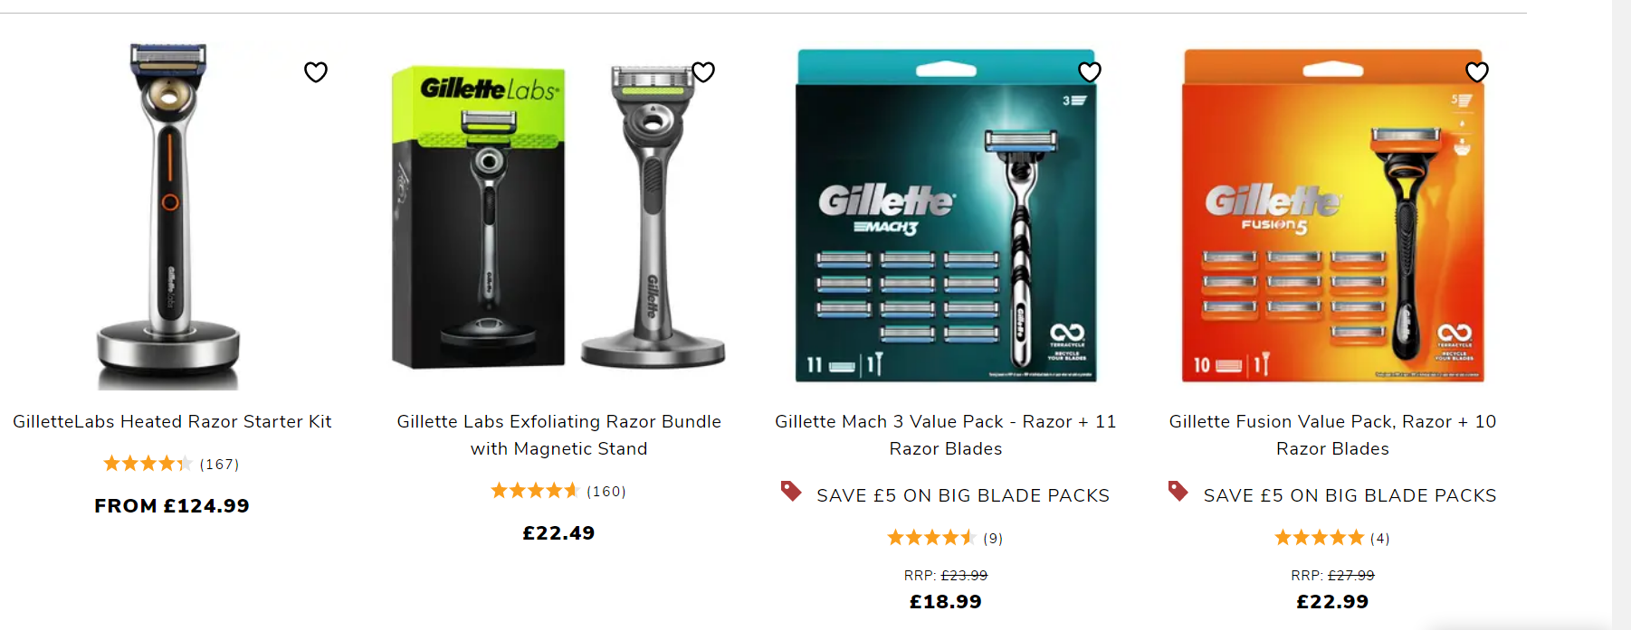

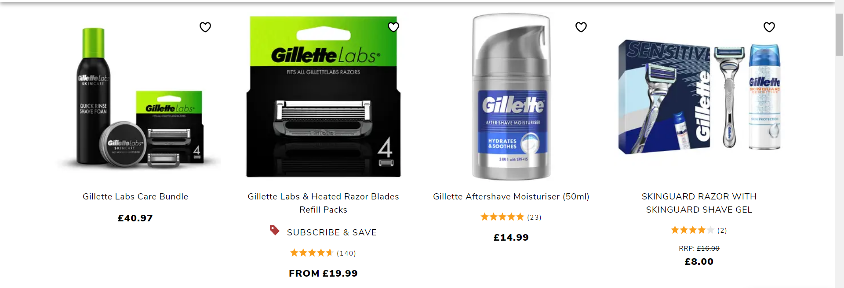
https://www.gillette.co.uk/all-products.list?gclid=CjwKCAiA3pugBhAwEiwAWFzwdczIrPbKEU5pEYU1opyNdbNRsv0FWx8Dqv2v1dWdyWF53kDDqPdm0BoCk1YQAvD_BwE
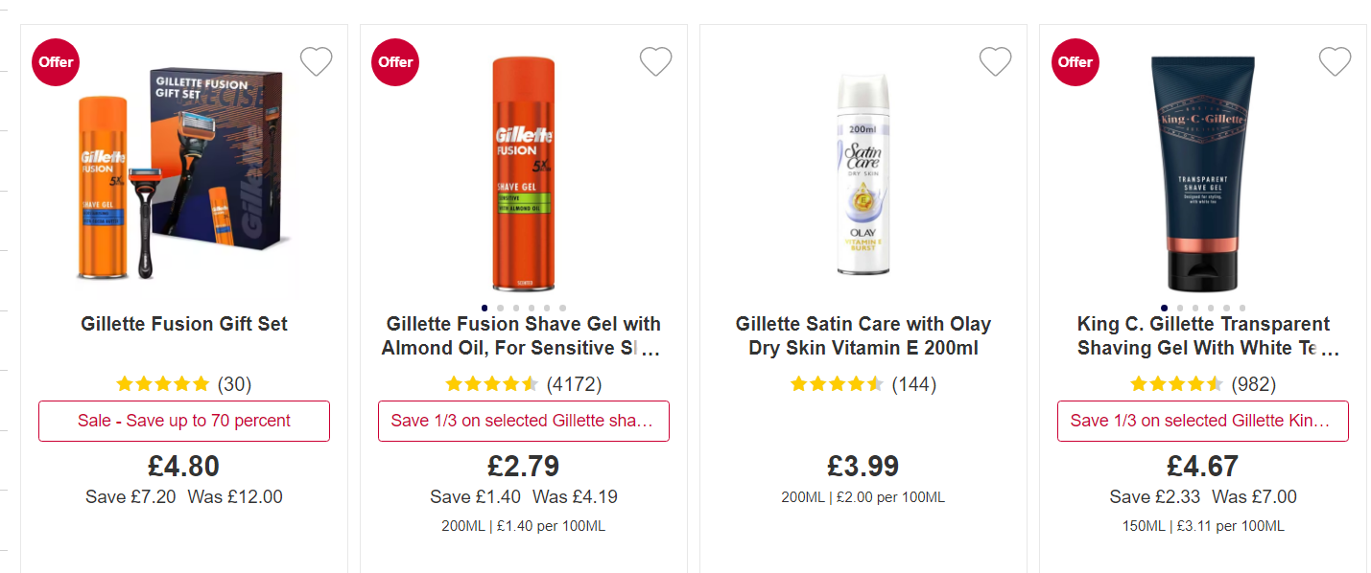
https://www.boots.com/gillette-full-range#facet:-70000000000001356051151049711810511010332103101108,-7000000000000135605115104971181051101033210211197109115,-7000000000000135605115104971181051101033210211197109&productBeginIndex:0&orderBy:&pageView:grid&minPrice:&maxPrice:&pageSize:&

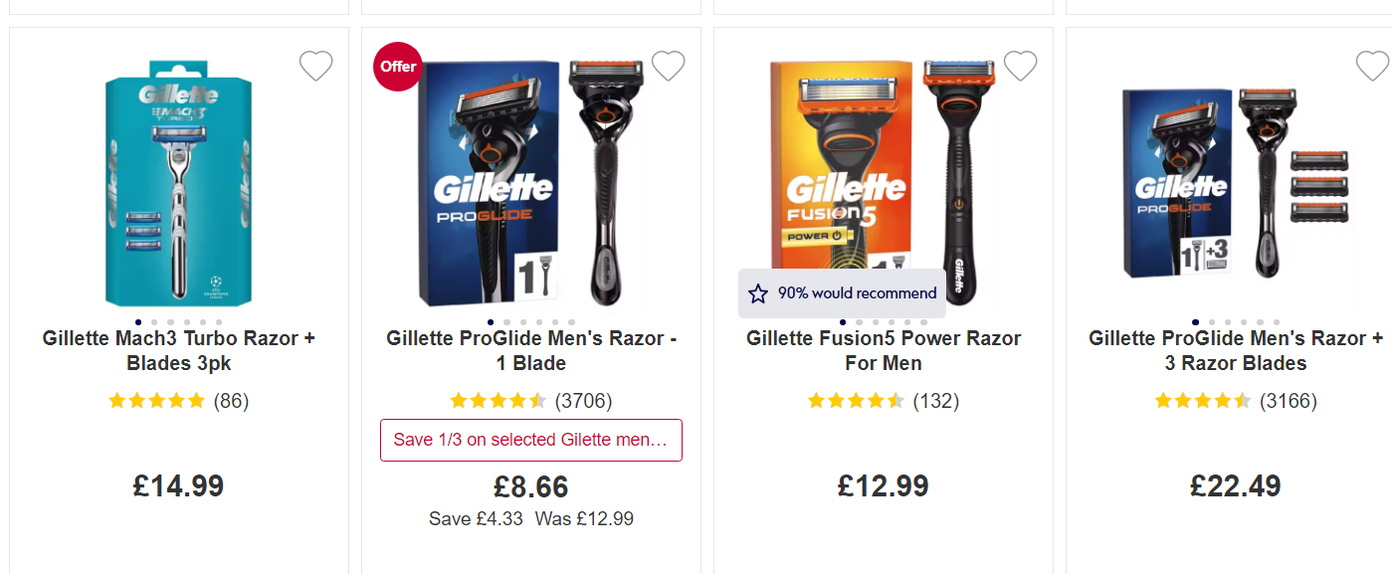
https://www.boots.com/gillette-full-range#facet:-700000000000013560511497122111114,-700000000000013560511497122111114115&productBeginIndex:0&orderBy:&pageView:grid&minPrice:&maxPrice:&pageSize:&
Place
The company’s customers are on almost all continents and are all over the world. So far there are more than 200 countries, and their production is located in several of them, including the United Kingdom. It uses different distribution systems and for this the products are available both in large chains and in small towns.
. https://www.forbes.com/companies/gillette/?sh=56f85af910a0
Within the 4Ps model of marketing mix, the element of place refers to the sites where the firm inventories its products and service offers for customers to access and purchase. P&G takes care to include all places that are easily accessible to the company’s target audiences. Because of technological advancements, Gillette can now sell its goods on current Omni channel retail platforms in addition to conventional brick-and-mortar retail sites (Iacobucci, 2018). Gillette use an indirect channel of distribution to make their products available.

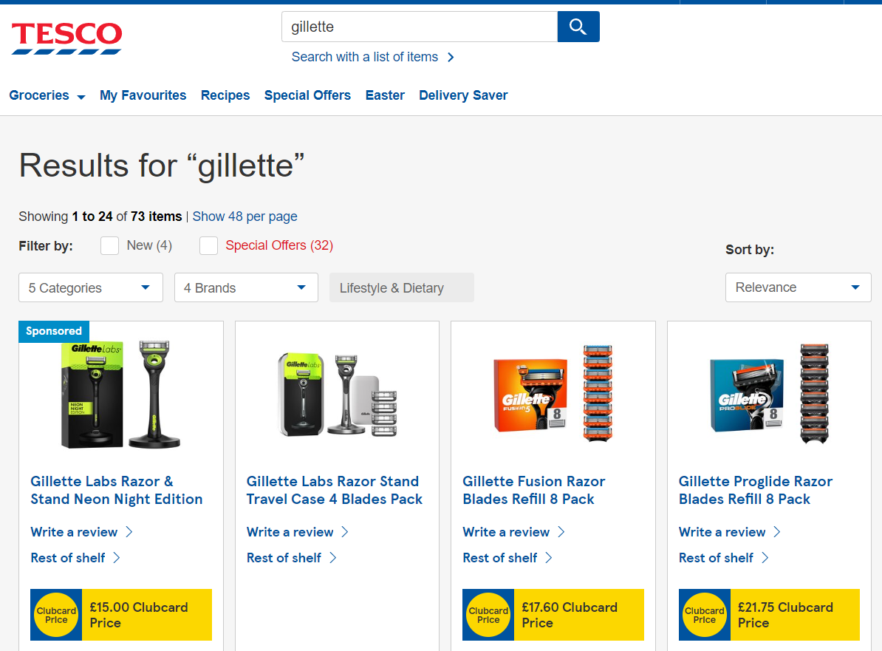
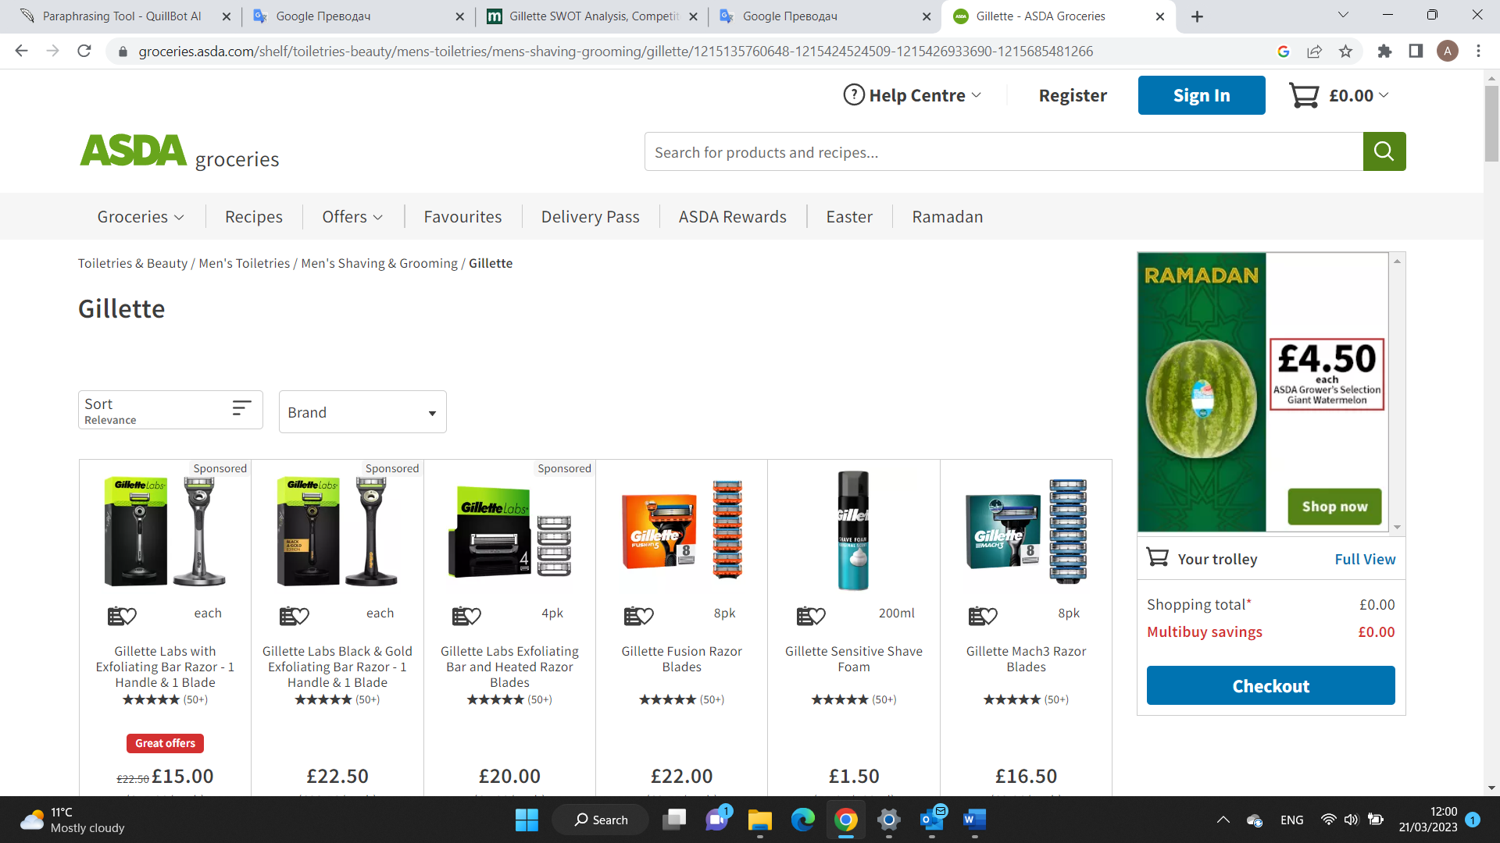

Promotion
The expenses of Gillette's marketing strategy are in the billions. They used unemotional marketing strategy to promote their goods. The ads have an unstoppable vibe thanks to their fluidity and coolness. Businesses use a variety of tactics to retain their customers and also attract new ones. Good advertising gives confidence and a feeling that customers have made the best choice using Gillette products. Creating their advertising the company, on the one hand, they bet more on emotions than focusing on the advertising product. Some of the famous people who have participated in their advertising campaigns include tennis player Roger Federer, golf champion Tiger Woods, football stars David Beckham and Thierry Henry.
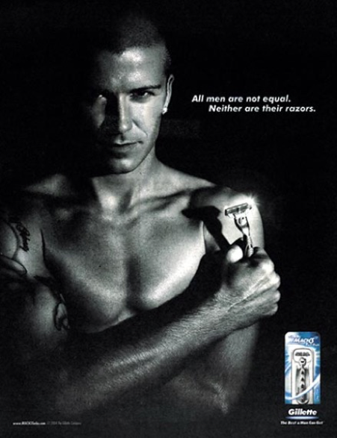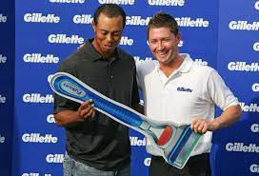


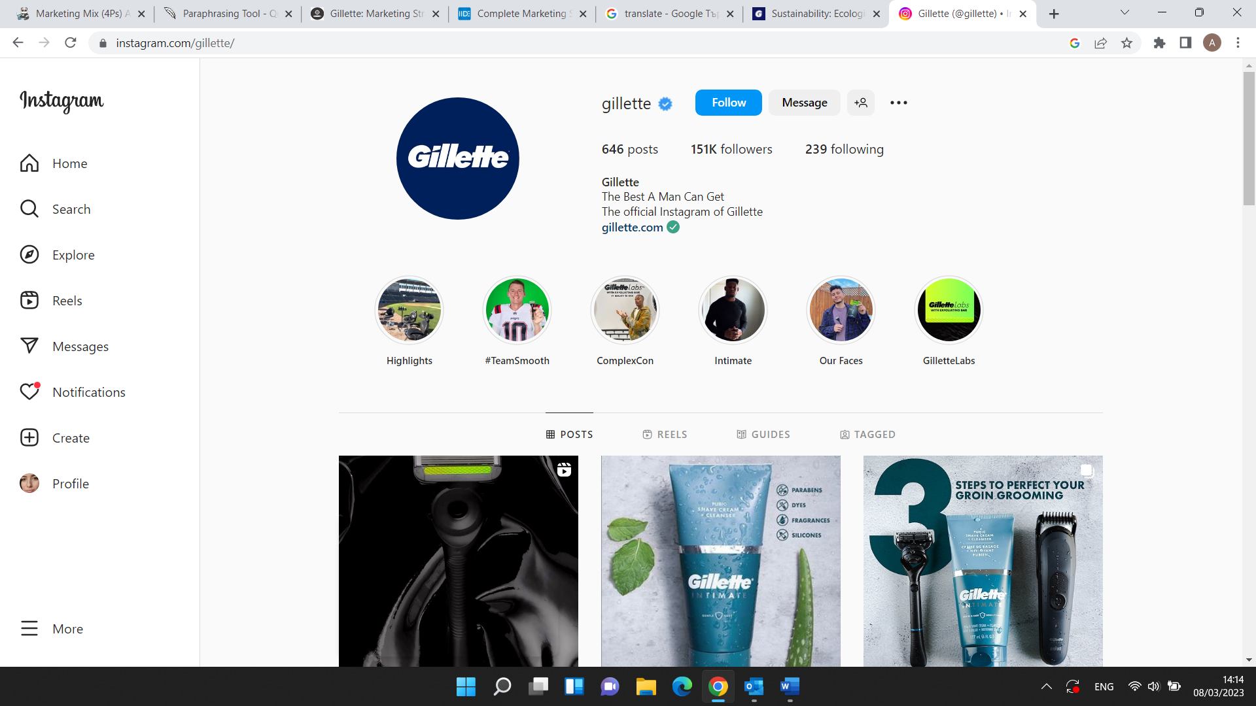 https://www.instagram.com/gillette/
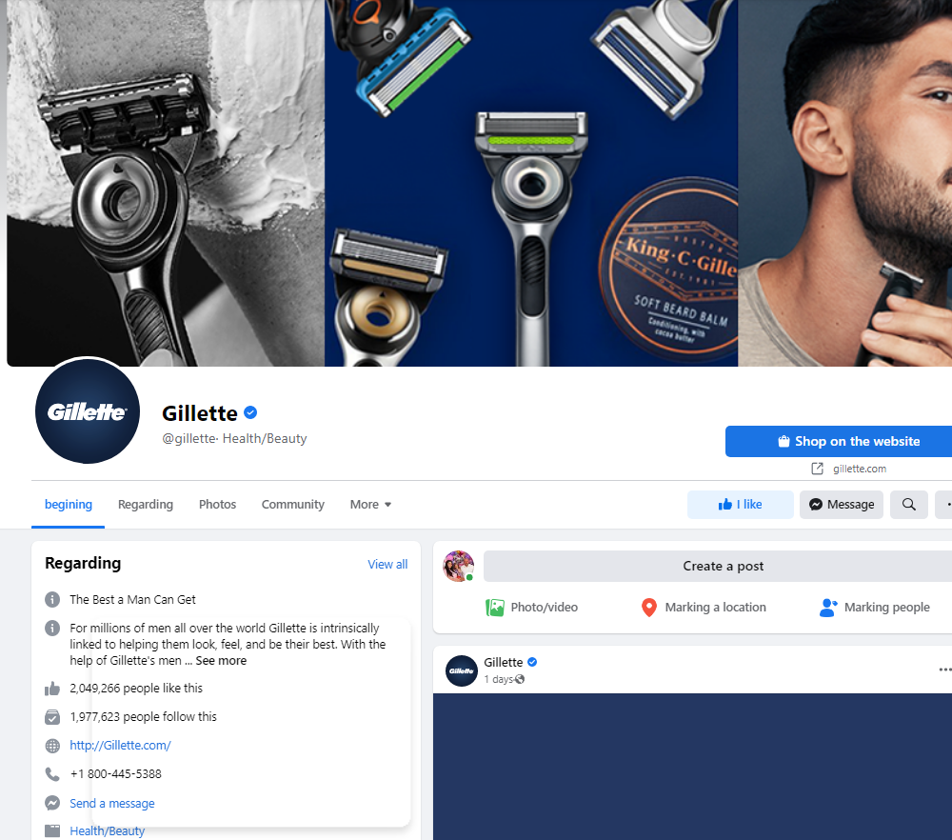 https://www.facebook.com/gillette/

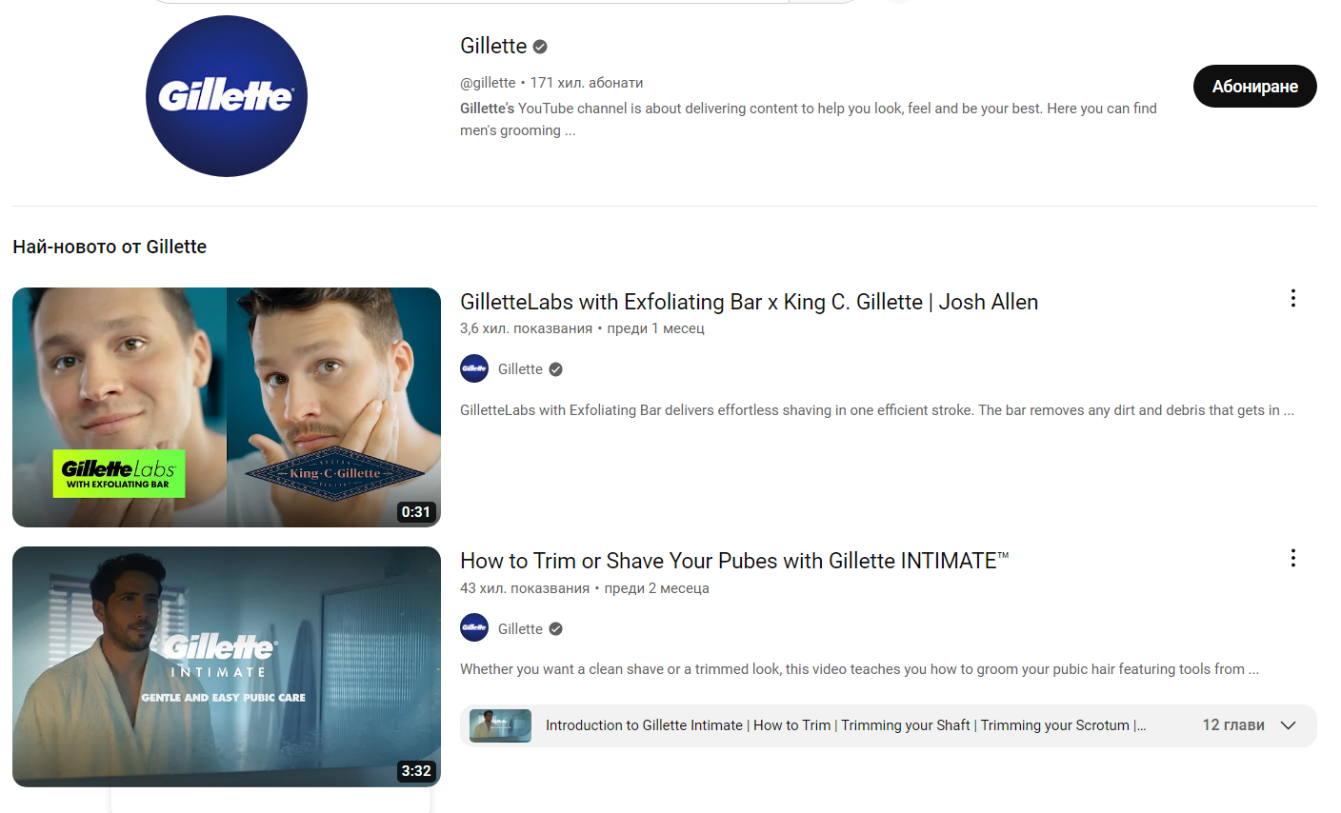
https://www.youtube.com/results?search_query=gillete

References:
- A. Chernev, (2018) "Strategic Marketing Management".
- A. Kusum L., Lehmann Donald R., and N. Scott A., (2001), "Market Response to a Major Policy Change in the Marketing Mix: Learning from P&G's Value Pricing Strategy”.
- B. Schlegelmilch, (2016) " Segmentation Targeting and Positioning in Global Market".
- Iacobucci, D. (2018) Marketing management. Boston, MA: Cengage Learning.
- "Social Marketing Theoretical and Practical Perspectives" Edited by Marvin E. Goldberg, Martin Fishbein, Susan E., (2013).
- Simconblog (2015) Gillette brand analysis, SIMCON Blog. Available at: https://simconblog.wordpress.com/2015/07/04/gillette-brand-analysis/?fbclid=IwAR1XoXqWIlQuCH4NPJgqQ0pl7JP17jPWhUSCbz1WZ8wjfAReyczUw8hrTKQ [Accessed: March 22, 2023].
- Darbinyan, M., Perch, D. and Avetisian, S. (2021) Marketing strategy and SWOT analysis of Gillette, The Social Grabber. Available at: https://thesocialgrabber.com/marketing-strategy-and-swot-analysis-of-gillette/ [Accessed: March 22, 2023].
- The Gillette Company Mission, Vision & Values. Available at: The Gillette Company Mission, Vision & Values | Comparably [Accessed on 06/03/23].
- Pro, E.M.B.A. (no date) Gillette India (India) marketing segmentation, targeting, differentiation, positioning solution, embapro.com. Available at: https://embapro.com/frontpage/marketingstpcoanalysis/10697-gillette-india [Accessed: March 22, 2023].
- (1) 10 Must Know Tips to Not Destroy Your Straight Razor - YouTube [Accessed on 07/03/23].
- Gillette Available at: Gillette | Company Overview & News (forbes.com) [Accessed on 08/03/23].
- Gillette Shaving and Body Products for Men | Gillette UK [Accessed on 08/03/23].
- Full Range | Gillette - Boots [Accessed on 08/03/23].
- Gillette (@gillette) • Instagram photos and videos [Accessed on 08/03/23].
- https://www.facebook.com/gillette/ [Accessed on 08/03/23].
- (1) Gillette - YouTube [Accessed on 08/03/23].

