UWTSD CAMPUS CRISIS
Full colored High Fidelity Story board design and Evaluation Report
ACCB6017 Usability Engineering
BSc Applied Computing
Md Gulam Hafiz Student ID:2232603
University of Wales Trinity Saint David London

Contents
1. Introduction: 2
2. Full-color story board design: 3
Fig 1: Welcome screen 4
3. Logic behind graphics, color, and interaction: 6
4. Changes from the low-fidelity wireframe: 7
5. Feedback collection and usability evaluation: 9
6.Data for effective and published version: 12
7. Usability, user experience, and design conflict: 13
8. Reflective summary & conclusion: 14
9.Reference: 15
Appendix A: 17
Appendix B: 23
Appendix d: 25
Survey Question 1 25
Feedback 1: 28
Feedback 2: 29
Feedback 3: 30
Appendix E: 32

1. Introduction:
This report represents the 2nd Fase of the UWTSD Campus Crisis Interface design.
This is a mobile-first cooperative strategy game inspired by a Pandemic strategy cooperative disease control board game but did not copy the virtual identity. A maximum of six players will be playing the role of a Student Representative, Lecturer, IT service specialist, Wellbeing advisor, and Library & Resource Officer. They will be moving to Swansea, Carmarthen, Cardiff, London, and Birmingham campus and int an imaginary learning hub. Instead of disease, the main threats here are cyber failure, resource shortage, wellbeing pressures, and transport disruption. Before the crisis reaches its pick, the team needs to remove the disruption marker and complete four resilience plans.
This design is a continuation of the low fidelity wireframe design that has been submitted in the first assignment. In that work four persona (Farah Ahmed, David Morgan, Mrs. Rehman Siddique, and M Islam) functional requirement and six experience requirements were fixed: clarity, inclusion, competence, teamwork, manageable tension, and trust. In this task, the previous story board has been turned into a full-colored storyboard, reserved wireframe feedback has been evaluated, and a logical process has been proposed for the final storyboard testing and necessary data has been taken into consideration for the published system. The proposal highlights the importance of iterative user centered[1] and follows the human centered approach where during the development period user, task and context evaluate constantly[2],[3]

2. Full-color story board design:
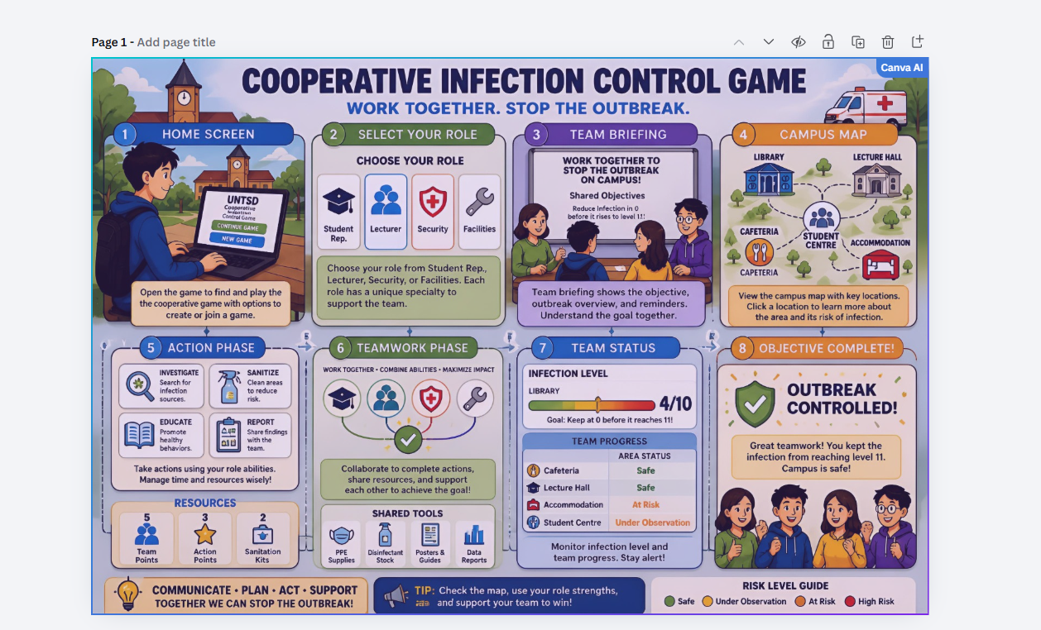
In the completed story board, there are eleven mobile screens and a navigation overview. The main sequence is accessibility, and welcome; create or join; progressive tutorial; specialist selection; campus map; valid action selection; team proposal; unexpected event; pause and reconnect; collective outcome; and optional post-game feedback. This sequence includes the main functionality of assignment task 1: joining the game, understanding the shared objectives, role selection, campus network checking, completing the valid action, exchanging help, communicating with the teammate, observing the team status, returning from the interruptions and understanding the win or loss.
In the welcome screen the accessibility choice has been given before starting the game, that's why text size, reduced motion and time pace are not hidden at any secondary menu. This is kept for mature learners, casual gamers, and assistive technology users and supports the inclusive requirements.
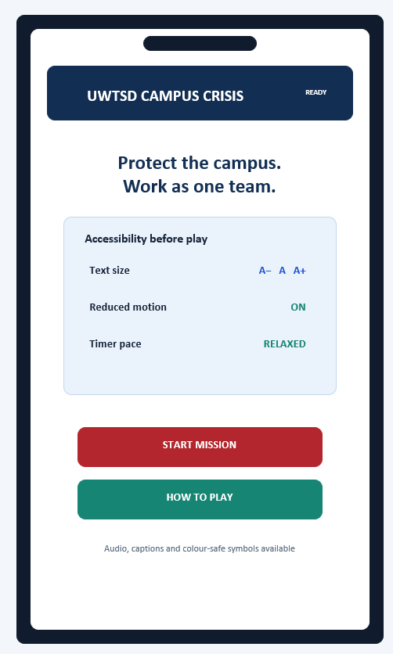
Fig 1: Welcome screen
The join/creation screen limits the first decision in two clear routes after that the tutorial uses the three brief progressive cards rather than a long rule book. Progressive disclosure mitigates the conflict between David and Farah Islam’s needs. All the important things are always open, and extra instructions can be open or skipped. Recognition given more importance instead of recall because role power, action cost and explanation of locked state have been shown during the time of decision making[4],[5]
In the main campus screen, active player banner, crisis track, team connection status, and big campus target have been put together. Those who cannot select the campus easily for those who have a list-view alternative has been kept. It is the visible solution for the problems of selection of campus target’s severity three findings. At the same time, it follows the WCGA principle where the alternative of precise gesture running the functionality should have been advised [6]
The action screen shows the cost availability of four big choices. Locked resilience-plan action makes clear the need for four research cards; users need not remember or discover failure.
Collaboration has not been considered an extra benefit as a main activity. In the previous review, it was hard to find the collaboration panel; that is why the Team item is kept fixed at the bottom of navigation.
In the Proposal screen-player you can propose a coordinated plan, agree, change, or use briefed predefined message that ensure the individual control and make visible the aim of the team. Event screens by hierarchy, amber warning and clear symbol create tension but avoid flashing effects, visual chaos, and blame. The reconnect screen confirms the interrupted player that mission state has been saved. In the Outcome screen instead of individual leaderboard, it shows collective contribution and protects the cooperative objective of the previous Assignment.

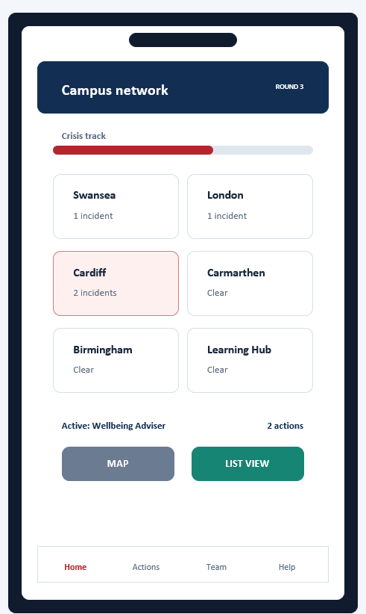
Fig 2: Campus map with status, big target, and Team navigation.

3. Logic behind graphics, color, and interaction:
The color system is designed in such a way that hierarchy and emotional state can be explained and at the same time clearly related to the university context. Dark navy has been used in global header and shared status because it creates visual stability and supports trust. UWTSD-inspired red is only kept for primary mission action and critical condition. Teal and green recovery, agreement, and successful teamwork. Amber explains such a warning that demands attention but still not failure. Off-white and pale blue background reduces glare and separates the information without extra border.
Color is never a carrier of meaning; every crisis is indicated by name crisis, symbol, and status text; success and warning message also has unambiguous language. It is color-only crisis identification related and solves the severity-four wireframe issue. The design follows the perceivable and operable content related to WCAG 2.2 guidance [6] Primary control is big, separated from each other label by using verbs. Navigation terms are permanently visible on every screen; consistent; and in system state. These decisions reflect visibility, feedback, consistency, error prevention, and recovery’s usability principle [4] [5]
The graphics are intentionally functional. Rounded mobile surface, simple line symbol & campus label has been created without following Pandemic artwork as a contemporary interface. Skipping is possible because the Game has already got enough strategic information and can hide extra imagery crisis state for this reason it is possible to avoid the decorative illustration. In the Typography a clear sans-serif hierarchy has been used; big screen heading, medium action label and limited supporting text. Overall, emotional intention is deep but helpful. Unexpected events should be mean as important but pausing the interface, explain what changes have happened and what action still can be taken. Game Flow clear goal, feedback, control, appropriate challenge, and social interaction considered as important part of enjoyment [7], that's why crates tension decision and shared consequence, unreadable motion or arbitrary is not solved by time pressure.

4. Changes from the low-fidelity wireframe:
Low-fidelity wireframe intentionally removes branding, color, and final typography so that the player can give more attention to the movement within early evaluation layout, information hierarchy screen. Low-fidelity wireframe intentionally removes branding, color, and final typography so that attention can be given on movement within early evaluation layout, information hierarchy screen. It is relevant with the paper prototyping practice where structural problems are exposed before the low-cost representation of visual investment changes become [8] Full-color design keeps the main journey but does some changes based on the interface evidence. Full-color design keeps the main journey but does bring changes based on the interface evidence.
The feedback saved was effective, though it is limited in number Participant 1 said the storyboard was understandable, did not want any features and thought people would play the game.
The second participant has said that though the sequence seems right, the low-fidelity version could not be understood, and interface needs to be clearer. Assignment-1 also recorded. peer review issue: small campus node, unclear active player, and extremely hard to find out the color-only crisis state, irrelevant individual leaderboard proposal with team panel and cooperation.
Five visible revisions have identified from these findings. Campus target has been increased, and list alternative has been added; persistent turn banner shows active role and remaining action, in crisis information; name, symbol, pattern and color have been combined; Team communication has been fixed in the bottom navigation and leader board has been changed to collective contribution summary. Location sheets have been divided conceptually between status and so that at a specific time, relevant information can be collected. At a time, one event is shown. Back and close control stay in a consistent place. Disabled action explains its’ condition and pauses/reconnect have been shown as a full recovery path.
These changes solve conflict among people. Experienced players can skip tutorials and quickly can see the action preview. New or less confident players find limited explanations in the context. Tap alternative, reduced motion and adjustable pacing are for the user who has problems with small target, dragging animation or timing. For this high-fidelity design is not only a wireframe’s-colored version, but also a revised requirements model, whose presentation makes requirement more visible.

Wireframe evidence | High-fidelity changes | Logics.
Campus node selection is hard (severity 3) | Big target and list alternatives. | Motor accessibility and error reduction
Active players unclear (severity 3) | Persistent turn/action banner | Makes system status visible
Crisis is indicated only by color (severity 4) | Name, symbol and color | Perceivable without depending on the color
Finding team plans is extremely hard (severity 2) | The team is on Bottom navigation. | Support collaboration.
Individual leaderboard proposed. | Team contribution summary | Save the cooperative purpose.

5. Feedback collection and usability evaluation:
UWTSD module does not depend only on the design judgement design; encourage to evaluate based on the representative user’s realistic task [1].in the previous research plan there were 6-8 participants and student, staff, commuter, international and mature learner, experienced and casual gamer and accessibility adjustment users was proposed purposive coverage, but in the Assignment 1-seved evidence have only two brief participant response. Presenting plan sample task as a completed testing would be academically inappropriate because the two recorded responses have been treated as formative wireframe feedback and the below process has been given as necessary for final story board evaluation.
Every participant should be selected to map the four personas and role, game experience, study pattern, and variation on the accessibility need. Everybody should be giving same introductions, and same task needs to be done, joining in existing game, identifying shared objective, specialist role selection and giving explain, using map or list finding campus, solve the disruption sending team proposal, explain unexpected event and after the simulated interruption reconnect the game again. Using moderator neutral think-aloud protocol listing and recording the completion, wrong choice, help request, hesitation, and emotional language. Think-aloud evidence can expose the user’s mental model and intend sequence of designer mismatch[9]
After the task, by using a brief questionnaire, five-point scale, clarity, confidence, pressure, enjoyment, and perceived teamwork should be measured. In an interactive prototype, a System Usability Scale can be used: but SUS is a global measure and in a small sample should be explained carefully [10] [11]. In a short interview, which subject is encouraging, confusing or stressful, needs to be known. Because successful task completion does not prove that cooperative experience was fair or enjoyable. Hornbæk-review warns that usability measurements most of the time become too narrow, so that we need a couple of complementary measures [12].
Positive feedback should be coded under the clarity, role identity, shared progress, communication, and accessibility of emotional engagement. Negative feedback should be coded under navigation, information density, symbol comprehension, pressure, and loss of control. Current defensible positive finding is one participant who has understood concepts and accepted. The negative finding is that the other person has understood the sequence but did not understand the low fidelity interface correctly. Results need to be added after the revised storyboard test. This limitation should not be hidden rather than need to be reported.
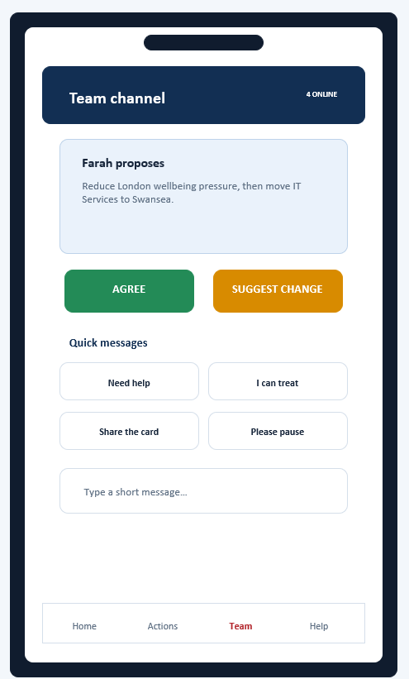
Fig 3: Structured team proposal and quick-message control.

6.Data for effective and published version:
In released version of the game, it needs a clear difference among operational data, usage analytics, and self-reported experience. In operational data, there will be anonymous session identifier, game version, selected campus, role, difficulty, connection status, action sequence, crisis state, completion outcome, and technical error. After disconnecting, this record-restoration and failed action diagnosis helps with crisis problems. Usage analytics screen transition, tutorial completion or skipping, selecting again unavailable action, use of map VS list, communication tool and enabled accessibility setting can be recorded. Aggregated patterns can show users repeatedly opening resource-sharing screens or leaving session after specific event.
Emotional response cannot be predicted reliably from clickstream data. Long time might mean confusion, thoughtful strategy, or interruption. For this reason, a system should have confidence, pressure, enjoyment, trust and teamwork’s optional post-game scale supported by occasional interview or moderate study. Hassenzahl and Tracinski say user experience is beyond task performance and includes affective experiential quality [13] Hassenzahl, Diefenbach, and Görlitz add interactive products with psychological need and affect [14]. So, usage and emotion should analyse together but should not be taken as equivalent.
In data collection, minimisation rules should be followed. Real health information, emergency record, precise GPS, stranger chat, payment detail, or individual performance ranking are not needed in Game. Player names can be changed by temporary alias and, in research, participant code. Optional research consent should be separated from basic service operation. According to UK GDPR responsibility, retention period, deletion route, access control, and breach procedure need to be recorded [15].
In future, final analysis will show where users leave the flow; error frequency will expose unclear rules; accessibility-feature usage will identify testing priority without disability diagnosis. Qualitative comments will explain why these patterns happen. Decisions should be made by converging evidence.

7. Usability, user experience, and design conflict:
If the game was designed from the usability point of view, then the interfaces become more neutral, less animated and speed accuracy and error reduction centric. Instead of campus maps; plain list can be used, narrative events would be removed, celebratory feedback could be reduced, and character identity would be limited. Sush a design would be efficient, but make teamwork, competence, manageable tension, and trust experience requirement weaker. User experience is not only a decorative usability but created by interaction, meaning, & feeling would be the part of it [13],[14]
So that couple of conflicts have been solved. Firstly, map immersion support shared spatial reasoning, but small nodes created motor-accessibility problems. As for the solution, it did not remove the problems targets have been increased and offered list view. Secondly, timed turn creates strategic tension, but compulsory countdown may give pressure to novice users or those needing more time. So that timer adjustable and important event screen progression status paused until the user does not get ready. Thirdly, status information may help the experienced player but may overload the newcomer. Progressive disclosure supports an essential state, and forecasts or explanations stay behind the optional control.
Fourthly, individual statistics can recognise competence but may weaken the collective responsibility so in outcome screen instead of player ranking shows team contribution and shared resilience plan. Finally unexpected events can make the game emotionally engaged, but aggressive warning can create anxiety. In the event, controlled color and at a time one message, non-flashing symbol and what still can be done has been explained, constructive language has been used so challenge and agency stays as it is. According to Flow theory, enjoyment depends on the effective relationship between challenge and skill [16]. Game Flow adds clear goals, feedback, control, and social interaction [7]. Final design tries to keep this relationship without removing those who need more time and explanation.

8. Reflective summary & conclusion:
The overall process moves from cooperative game structure adaptation to persona, requirements, low-fidelity flow, formative feedback, and revised full-colour storyboard. The most important learning is that visual polish can never compensate the damage of unclear interaction model. Second Participant’s problem of understanding the wireframe has made clarity more important; peer finding has turned general accessibility intention into specific changes: larger target, persistent turn information, non-colour coding, permanent Team navigation and complete reconnect support.
Persona was effective because they presented realistic conflicts instead of creating an average user. Progressive disclosure, skippable guidance, adjustable pacing, and alternative interaction methods have come from this conflict. Clear signifier, mapping, feedback and recoverability of Norman [4]Usability principle of Nielsen,[5] and iterative evaluation approach of UWTSD module [17] have provided practical criteria. UX and game research prevented the design from becoming merely efficient, supporting role identity, shared achievement, controlled tension and social connection.
The main limitation is evidence. The first assignment has only two recorded participant responses, and the final full-colour storyboard needs representative testing. Therefore, this report provides an ethical test protocol without inventing results.
In conclusion, UWTSD Campus Crisis presents a coherent mobile journey for six university roles, with accessible alternatives, structured communication, supportive recovery and collective outcomes.
(NB: All the UI designs of the story board in Appendix A, Usability test Instrument in appendix B, Appendix C. Evidence Statement, Feedback is in the Appendix D, interactive prototype link Appendix E)

9.Reference:
[1] J. Nielsen. J. Nielsen. World leaders in research-based user experience log in to UX certification home articles training & events consulting reports & books about NN/g. World leaders in research-based user experience log in to UX certification home articles training & events consulting reports & books about NN/g. 1994.
[2] Y. Rogers, H. Sharp and J. Preece, Interaction Design: Beyond Human–Computer Interaction, 6th ed. Hoboken, NJ, USA: Wiley, 2023.
[3] International Organization for Standardization, “Ergonomics of human-system interaction—Part 210: Human-centered design for interactive systems,” ISO 9241-210:2019, 2019.
[4] D. A. Norman, The Design of Everyday Things, revised and expanded ed. New York, NY, USA: Basic Books, 2013.
[5] J. Nielsen, Usability Engineering. San Francisco, CA, USA: Morgan Kaufmann, 1994.
[6] C. Snyder, Paper Prototyping: The Fast and Easy Way to Design and Refine User Interfaces. San Francisco, CA, USA: Morgan Kaufmann, 2003.
[7] J. Pruitt and J. Grudin, “Personas: Practice and theory,” in Proc. Designing for User Experiences, 2003, pp. 1–15, doi: 10.1145/997078.997089.
[8] M. W. Jaspers, T. Steen, C. van den Bos and M. Geenen, “The think aloud method: A guide to user interface design,” Int. J. Med. Inform., vol. 73, nos. 11–12, pp. 781–795, 2004, doi: 10.1016/j.ijmedinf.2004.08.003.
[9] K. Hornbæk, “Current practice in measuring usability: Challenges to usability studies and research,” Int. J. Human–Computer Studies, vol. 64, no. 2, pp. 79–102, 2006, doi: 10.1016/j.ijhcs.2005.06.002. Md Gulam Hafiz • ACCB6017 Usability Engineering UWTSD CAMPUS CRISIS | FULL-COLOUR STORYBOARD REPORT
[10] M. Hassenzahl and N. Tractinsky, “User experience—A research agenda,” Behav. Inf. Technol., vol. 25, no. 2, pp. 91–97, 2006, doi: 10.1080/01449290500330331.
[11] M. Hassenzahl, S. Diefenbach and A. Göritz, “Needs, affect, and interactive products—Facets of user experience,” Interact. Comput., vol. 22, no. 5, pp. 353–362, 2010, doi: 10.1016/j.intcom.2010.04.002.
[12] P. Sweetser and P. Wyeth, “GameFlow: A model for evaluating player enjoyment in games,” Comput. Entertain., vol. 3, no. 3, p. 3, 2005, doi: 10.1145/1077246.1077253.
[13] J. Brooke, “SUS: A quick and dirty usability scale,” in Usability Evaluation in Industry, P. W. Jordan et al., Eds. London, UK: Taylor & Francis, 1996, pp. 189–194.
[14] A. Bangor, P. T. Kortum and J. T. Miller, “An empirical evaluation of the System Usability Scale,” Int. J. Human–Computer Interaction, vol. 24, no. 6, pp. 574–594, 2008, doi: 10.1080/10447310802205776.
[15] World Wide Web Consortium, “Web Content Accessibility Guidelines (WCAG) 2.2,” W3C Recommendation, 2024. [Online]. Available: https://www.w3.org/TR/WCAG22/
[16] J. Lazar, J. H. Feng and H. Hochheiser, Research Methods in Human–Computer Interaction, 2nd ed. Cambridge, MA, USA: Morgan Kaufmann, 2017. [17] H. Desurvire, M. Caplan and J. A. Toth, “Using heuristics to evaluate the playability of games,” in CHI ’04 Extended Abstracts, 2004, pp. 1509–1512, doi: 10.1145/985921.986102.
[18] K. Isbister, How Games Move Us: Emotion by Design. Cambridge, MA, USA: MIT Press, 2016.

Appendix A:
Completed high-fidelity Colorful storyboard and UI design set:
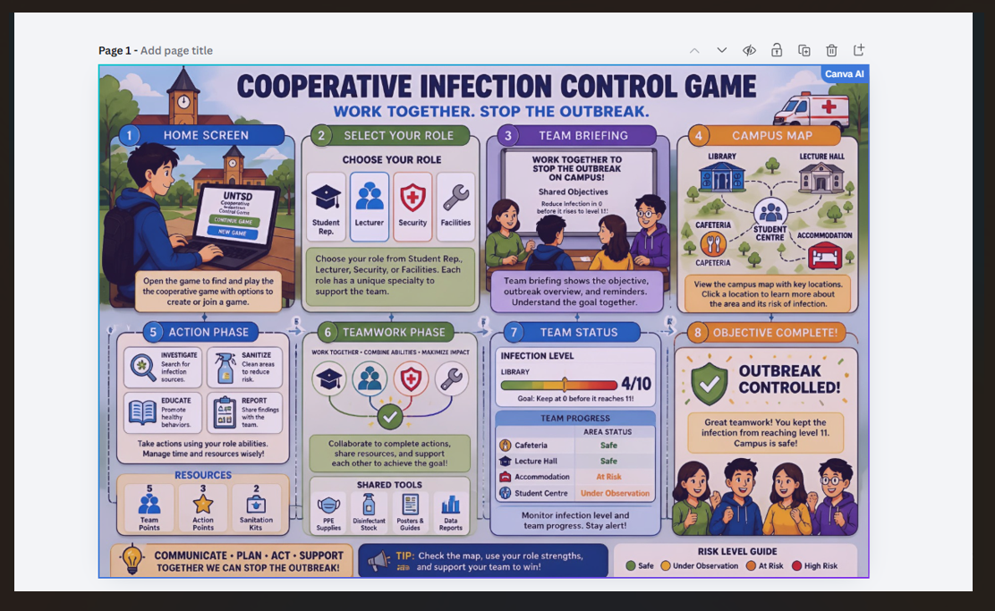

UI:1
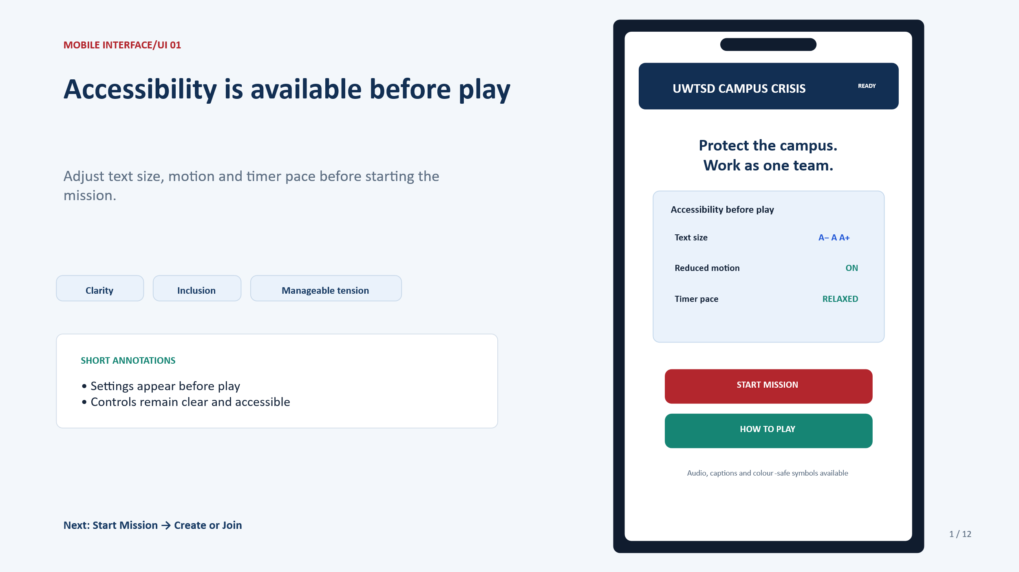

UI: 2
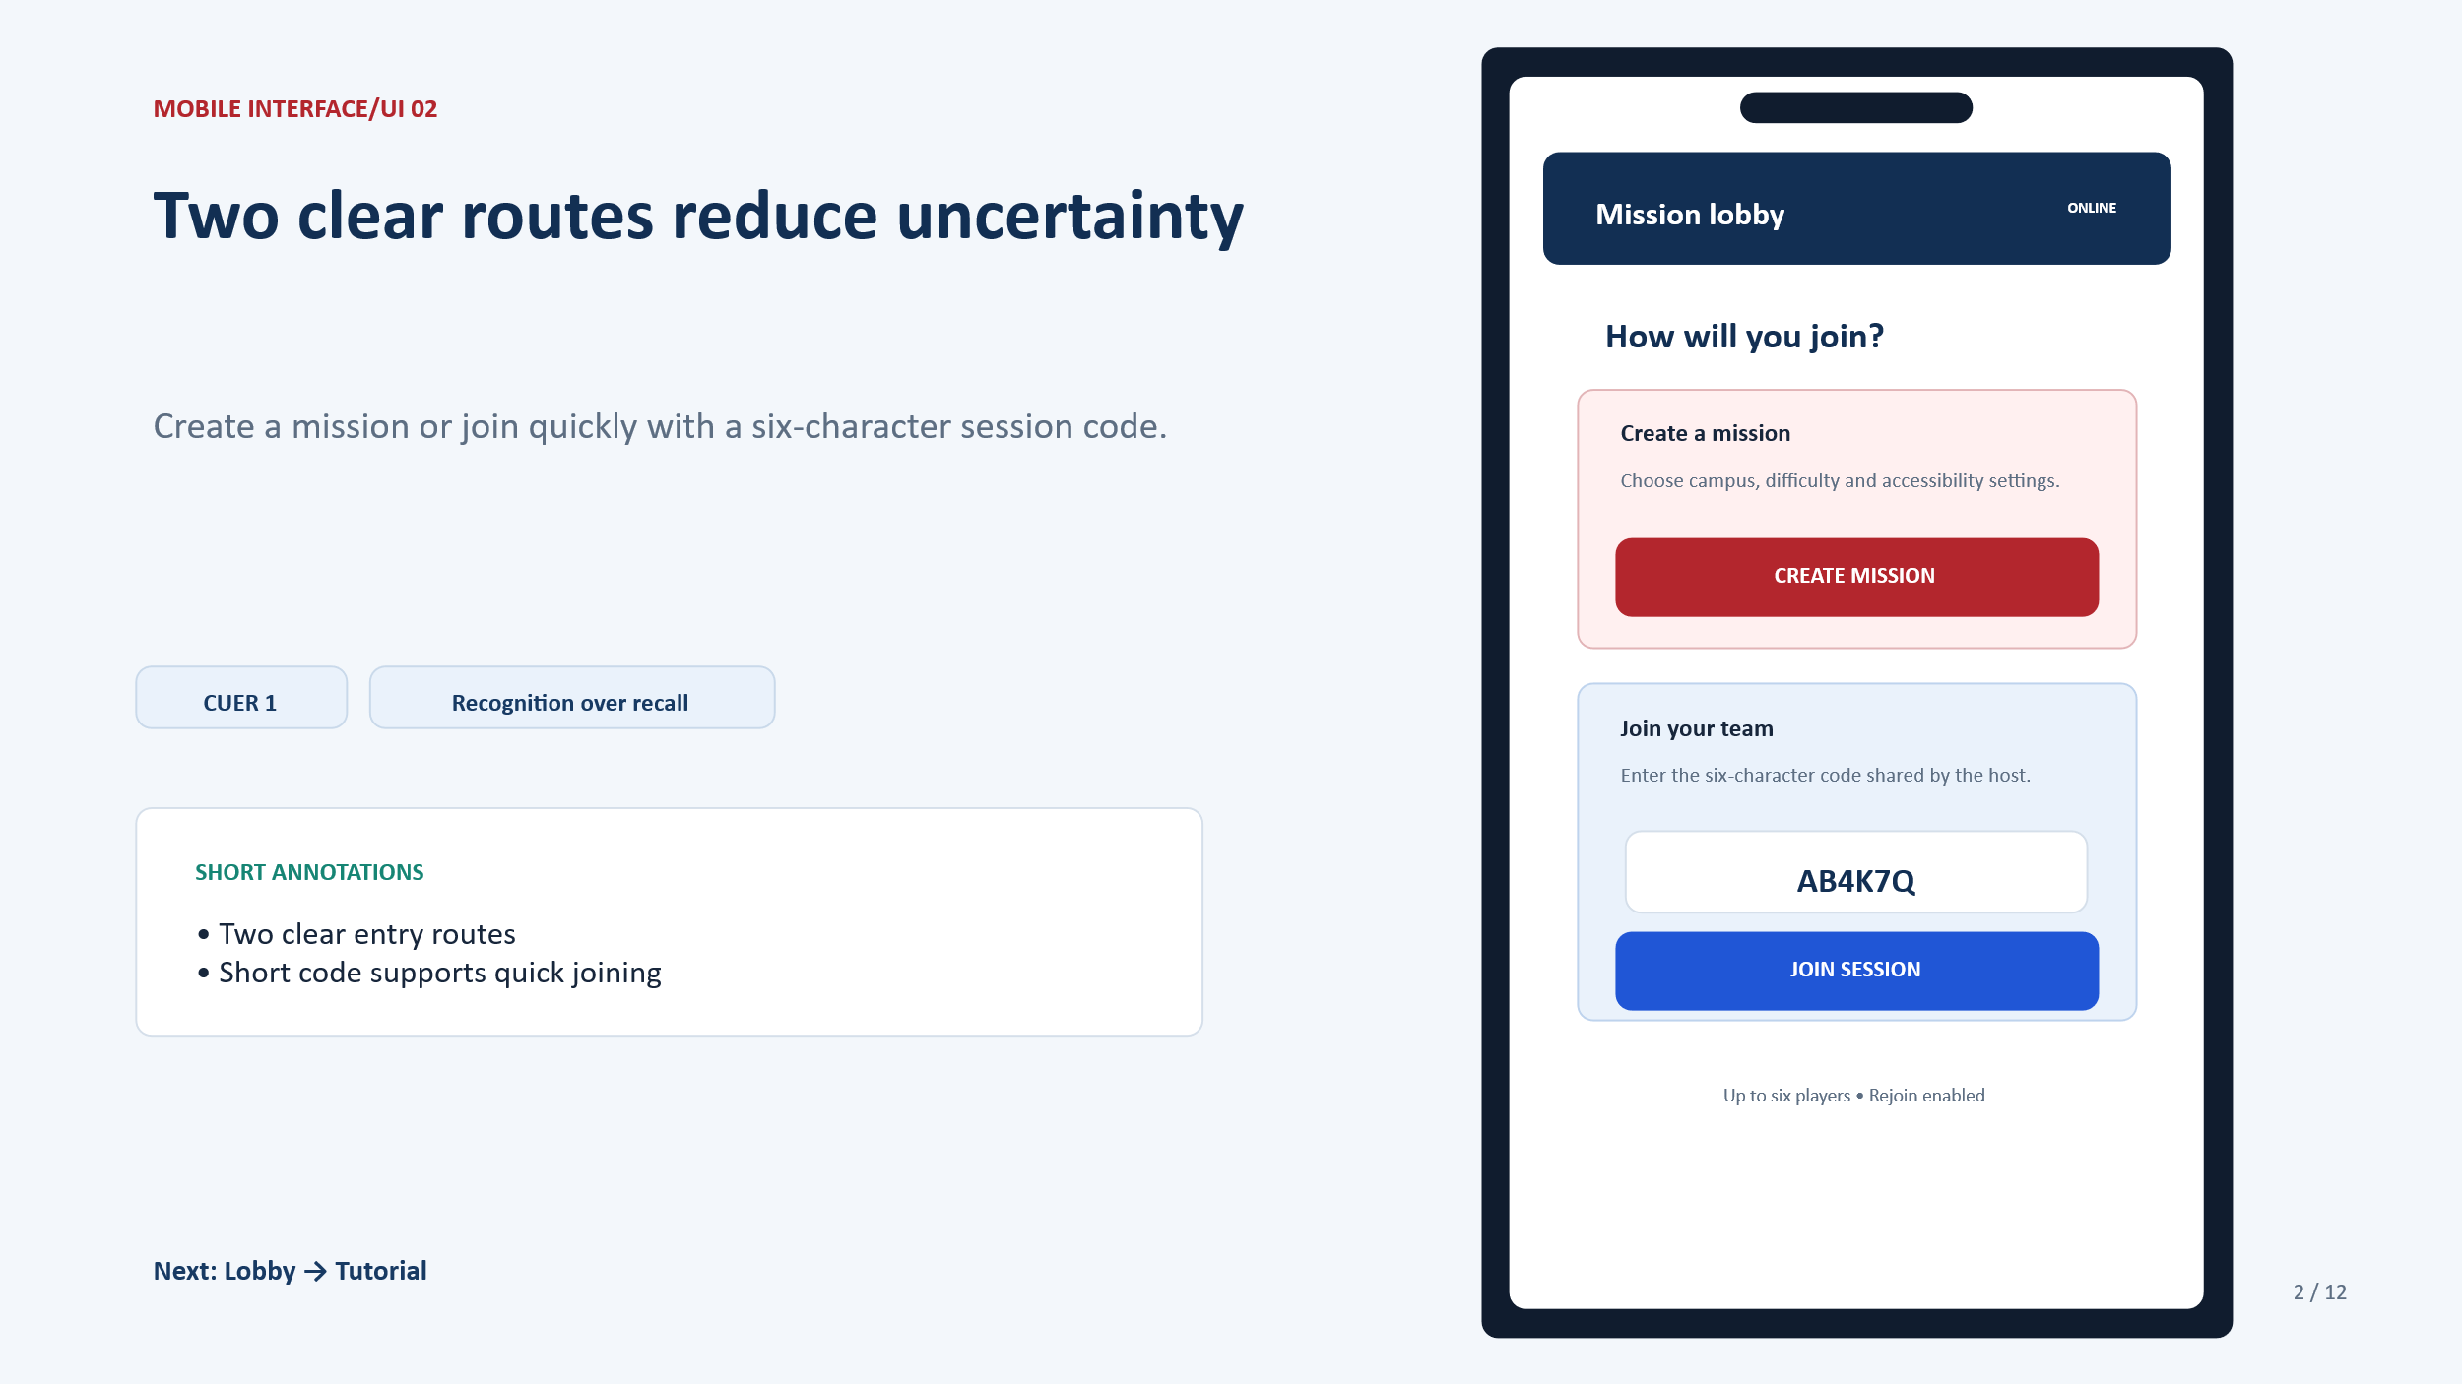
UI: 3
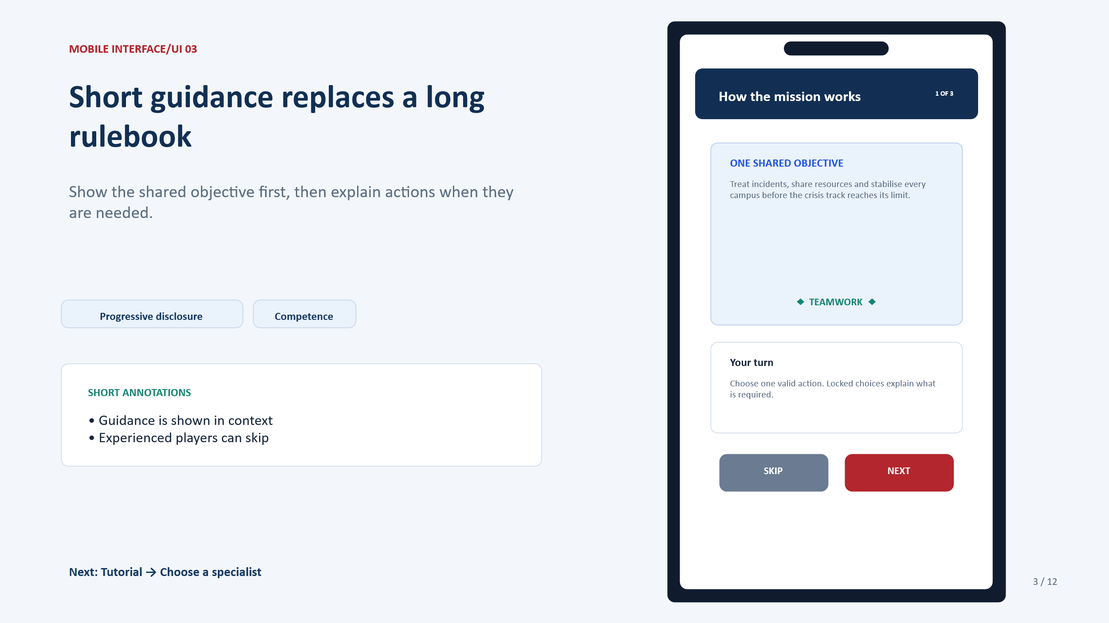

UI: 4
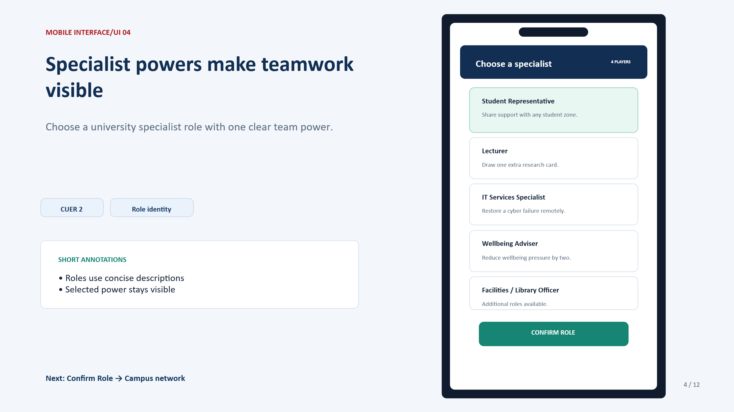
UI: 5
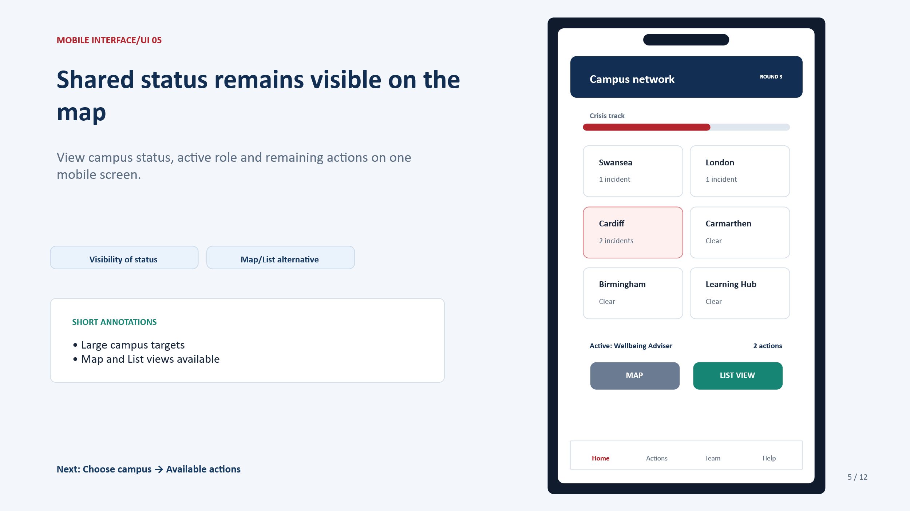

UI: 6
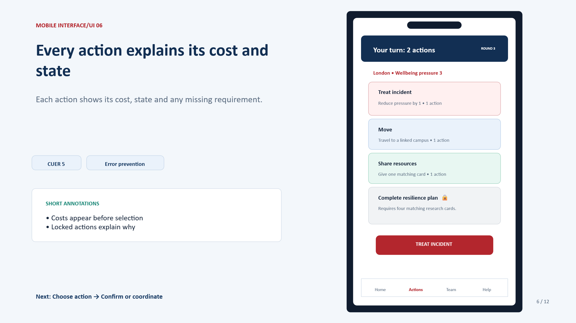
UI: 7
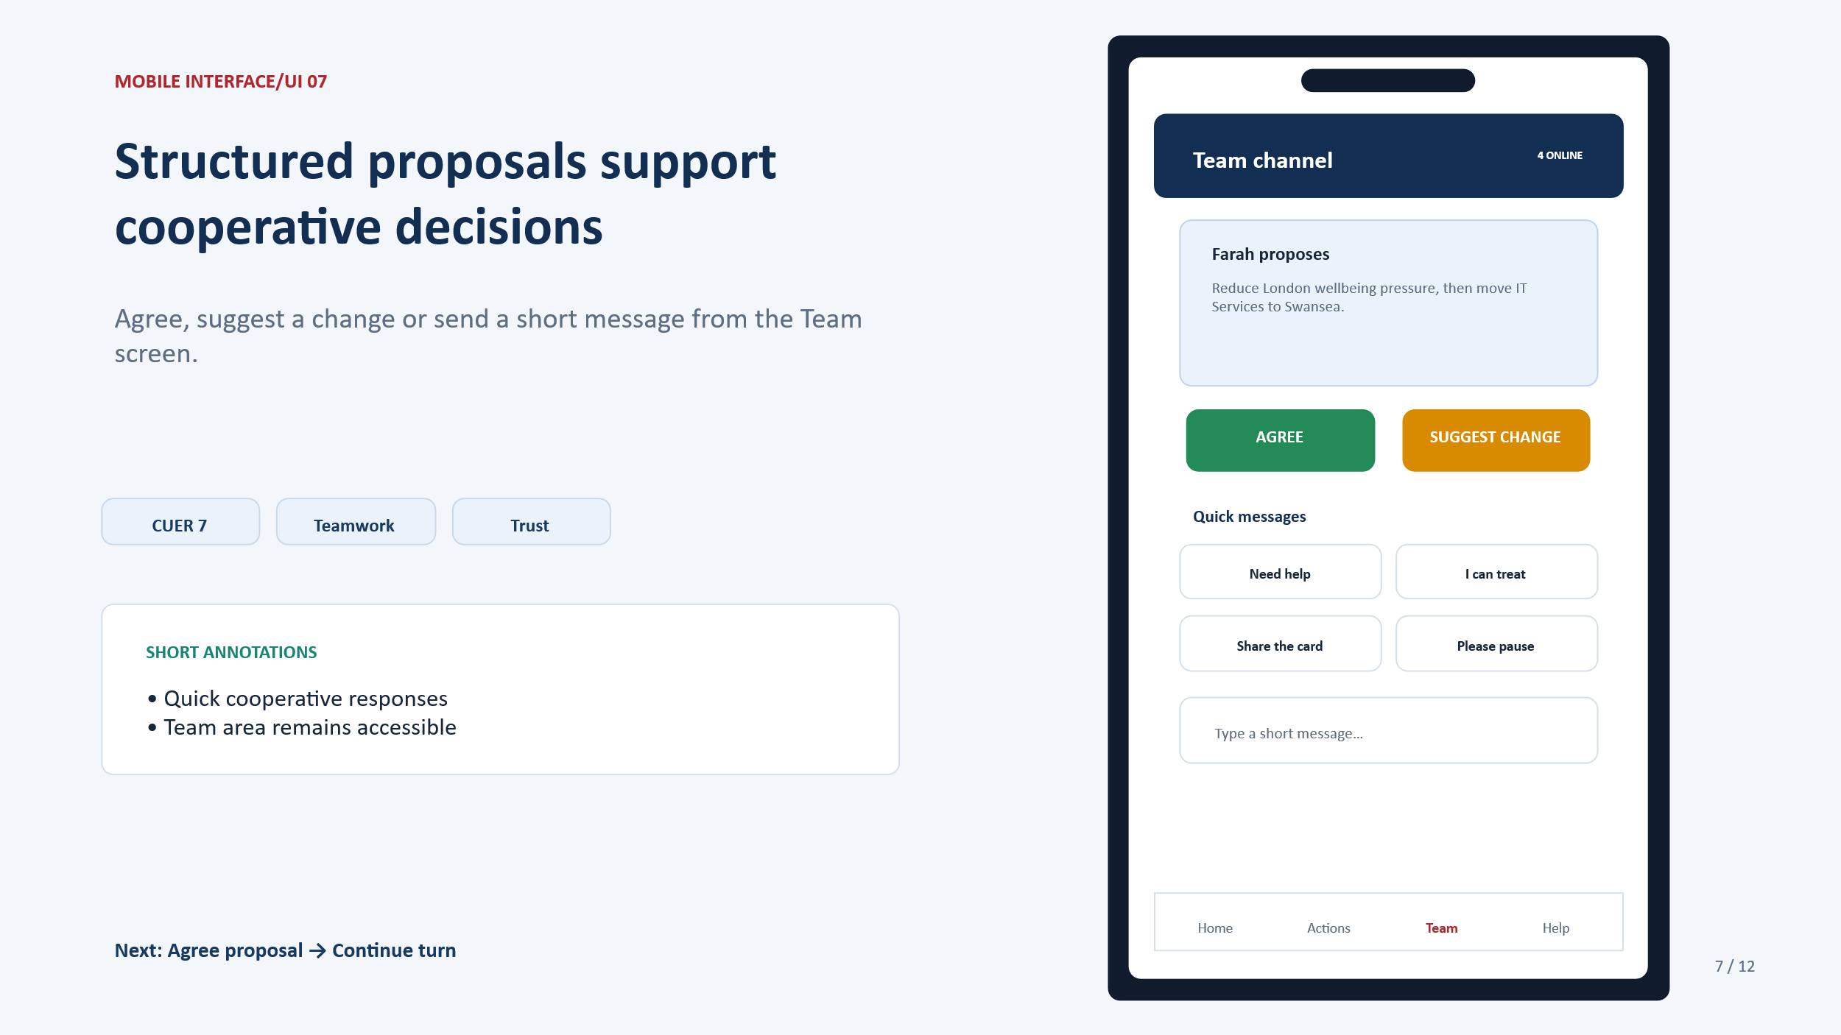

UI: 8
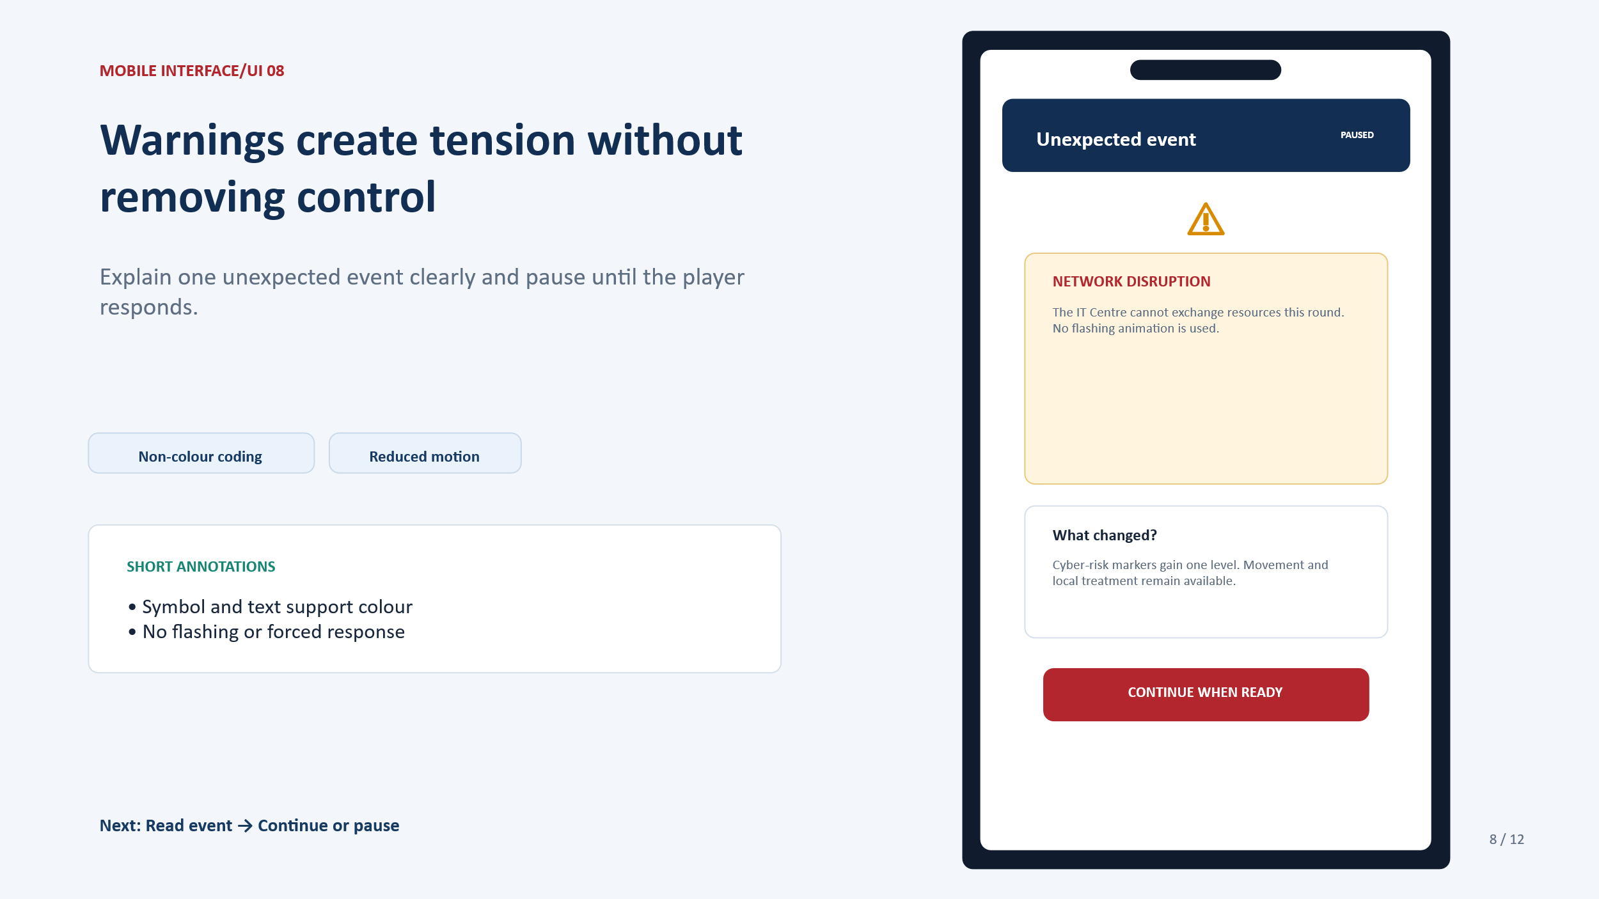
UI: 9
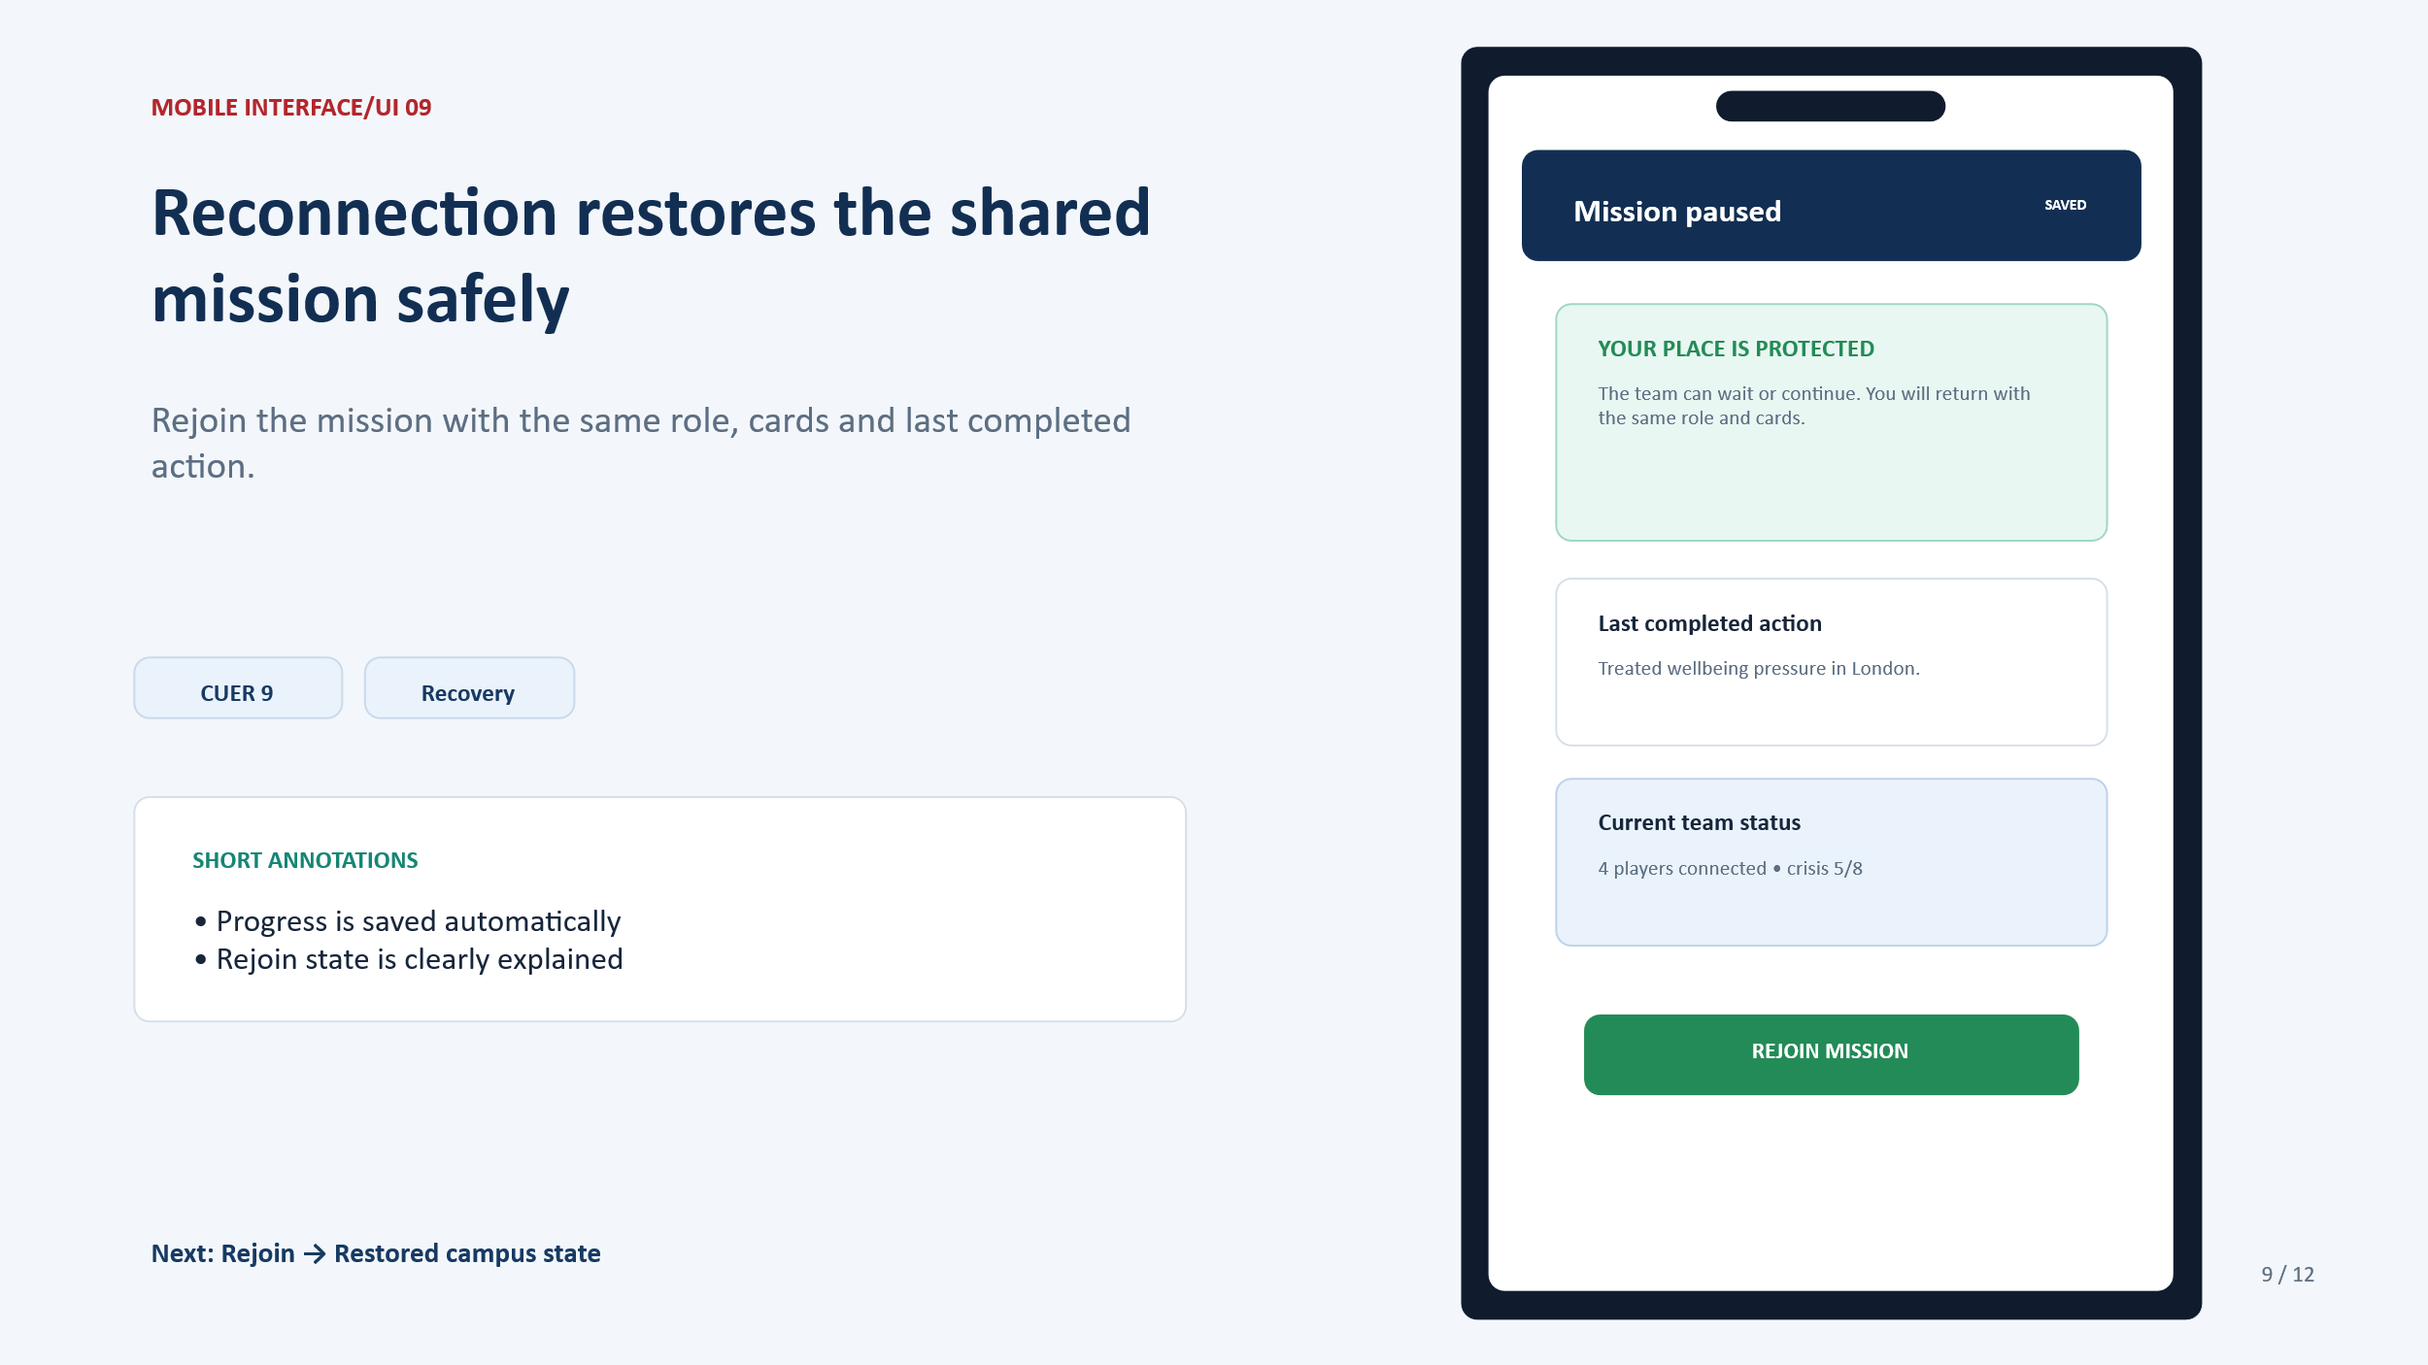

UI: 10
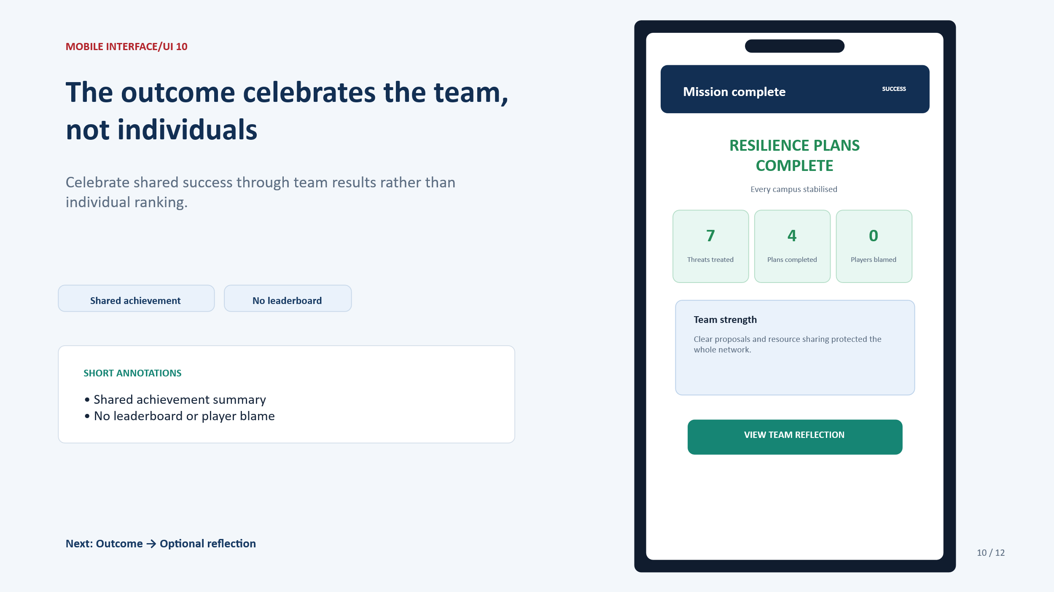
UI: 11
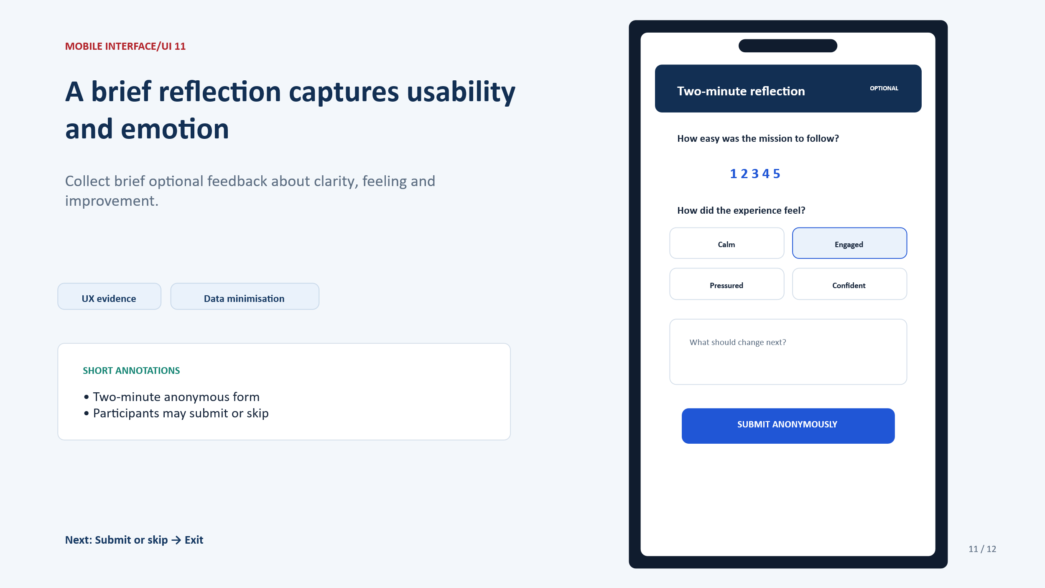

UI 12: Navigation overview
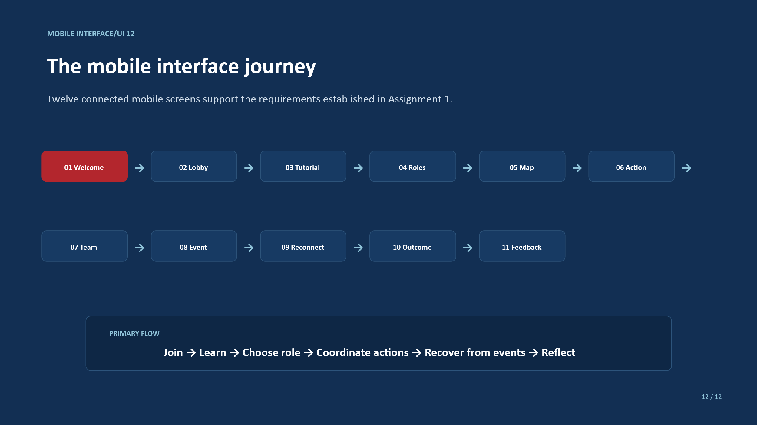

Appendix B:
Final storyboard usability test instrument:
Participant code ______ Persona coverage______ Device ______ Date______
Task | Success criterion | Completion/error/help | Emotional observation
Join Using Code | Enter lobby without help
Fixing Shared objective | Correct Explanation
Role selection and Explanation | Role power understood
Searching location using Map or list | Select correct campus
Wellbeing pressure solving | Valid action completed
Sending Proposal | Team tool has been found
Event explain and reconnect | State understanding and restoration have done

Post-task rating (1 = fully disagree; 5 = fully agree): clarity, confidence, manageable pressure, enjoyment, teamwork, and trust. What is good and what is bad and what should be changed?

Appendix C.
Evidence Statement:
Assignment 1 got two recorded participant responses. In this report the same participant and one new participant have given feedback on the full color story board and that has can be found appendix D. Final storyboard that describes the evaluation sections gives a protocol that needs to be completed before claiming the final usability testing and also need to be updated by anonymised evidence.

Appendix d:
Evidence of survey feedback:
Survey Question 1:
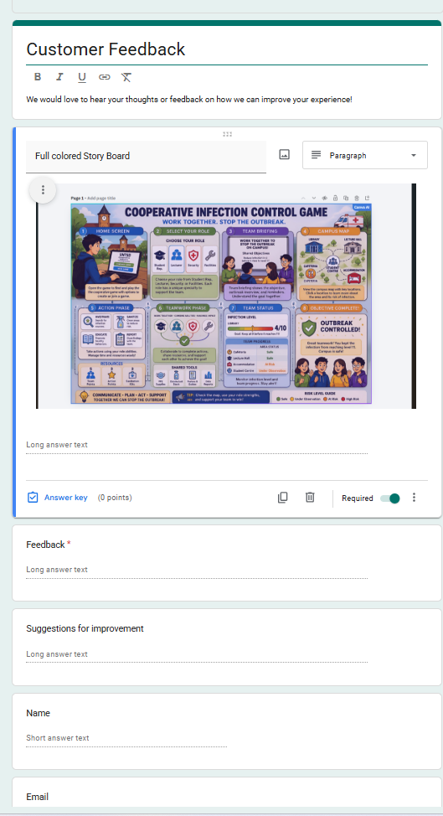

Survey Question 2:
SURVEY 2: EVALUATION OF FULL-COLOUR STORYBOARD AND GAME INTERFACES
UWTSD Cooperative Infection Control Game
Date: ______________________________
Previous experience of digital/cooperative games: ☐ None ☐ A little ☐ Moderate ☐ Extensive
Role/connection to UWTSD: ☐ Student ☐ Staff ☐ Other: __________________
Age group: ☐ 18–24 ☐ 25–34 ☐ 35–44 ☐ 45–54 ☐ 55+
Participant ID/Number (optional): ______________________________
Participant Details
Participant instructions: Please review the full-colour storyboard and interfaces, then answer the questions below. Tick or mark the option that best represents your opinion. Your feedback will be used to evaluate and improve the interface design.
Q1. Overall, how easy is it to understand the sequence of the game from the storyboard?
Please select one response:
☐ 1 - Very difficult ☐ 2 - Difficult ☐ 3 - Neutral ☐ 4 - Easy ☐ 5 - Very easy
Q2. Which part of the interface is easiest for you to understand?
Please select one option:
☐ Home Screen ☐ Select Your Role ☐ Team Briefing ☐ Campus Map
☐ Action Phase ☐ Teamwork Phase ☐ Team Status ☐ Objective Complete
Q3. How suitable do you find the colors, icons, text and graphics used in the interface?
Please mark one response for each design element:
Design element | Poor | Fair | Good | Very Good | Excellent
Color scheme | ☐ | ☐ | ☐ | ☐ | ☐
Icons | ☐ | ☐ | ☐ | ☐ | ☐
Text readability | ☐ | ☐ | ☐ | ☐ | ☐
Graphics | ☐ | ☐ | ☐ | ☐ | ☐
Q4. Which features would help you most when playing the game?
Select all that apply:
☐ Campus map ☐ Team status display ☐ Role selection ☐ Shared tools
☐ Communication options ☐ Action choices ☐ Risk-level indicator ☐ Objective/progress information
Q5. After looking at the storyboard, how confident would you feel about knowing what to do during your turn?
Please select one response:
☐ 1 - Not confident at all ☐ 2 ☐ 3 - Neutral ☐ 4 ☐ 5 - Very confident
Q6. If you could improve ONE part of this interface, what would you change and why?
Please write your answer below:
________________________________________________________________________________
________________________________________________________________________________
________________________________________________________________________________
Q7. Would you be interested in using this interface to play the complete UWTSD cooperative game?
Please select one option:
☐ Yes ☐ Maybe ☐ No

Thank you for your participation and feedback.

Feedback 1:
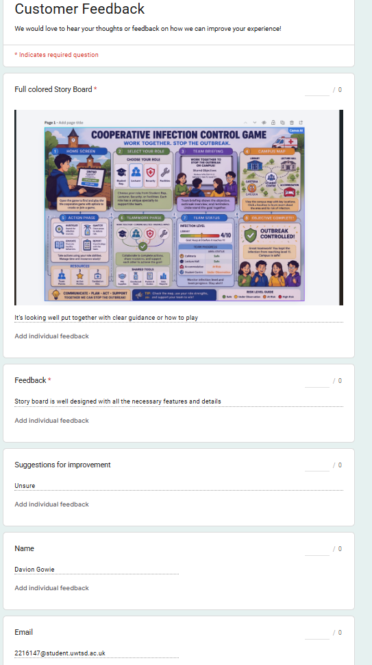

Feedback 2:
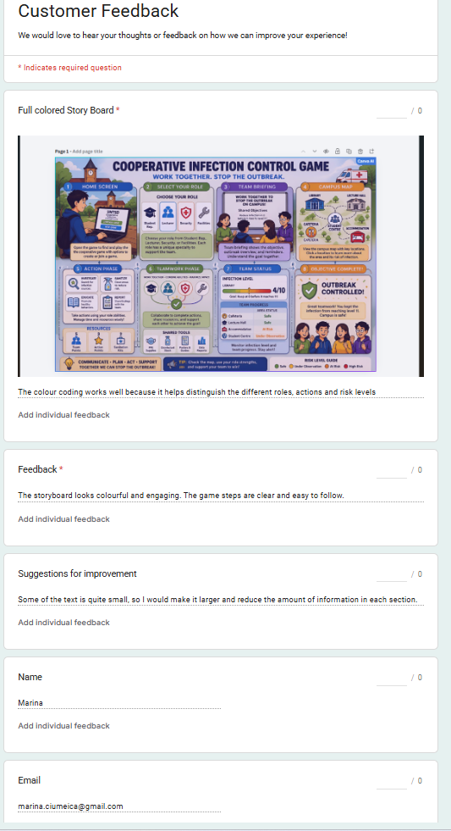

Feedback 3:
SURVEY 2: EVALUATION OF FULL-COLOUR STORYBOARD AND GAME INTERFACES
UWTSD Cooperative Infection Control Game
Date: ____16/08/2026__________________________
Previous experience of digital/cooperative games: ☐ None ☐ A little ☐ Moderate ☐ Extensive
Role/connection to UWTSD: ☐ Student ☐ Staff ☐ Other: __________________
Age group: ☐ 18–24 ☐ 25–34 ☐ 35–44 ☐ 45–54 ☐ 55+
Participant ID/Number (optional): ______________________________
Participant Details
Participant instructions: Please review the full-color storyboard and interfaces, then answer the questions below. Tick or mark the option that best represents your opinion. Your feedback will be used to evaluate and improve the interface design.
Q1. Overall, how easy is it to understand the sequence of the game from the storyboard?
Please select one response:
☐ 1 - Very difficult ☐ 2 - Difficult ☐ 3 - Neutral ☐ 4 - Easy ☐ 5 - Very easy
Q2. Which part of the interface is easiest for you to understand?
Please select one option: Overall is very good.
☐ Home Screen ☐ Select Your Role ☐ Team Briefing ☐ Campus Map
☐ Action Phase ☐ Teamwork Phase ☐ Team Status ☐ Objective Complete
Q3. How suitable do you find the colors, icons, text and graphics used in the interface?
Please mark one response for each design element:
Design element | Poor | Fair | Good | Very Good | Excellent
Color scheme | ☐ | ☐ | ☐ | ☐ | ☐
Icons | ☐ | ☐ | ☐ | ☐ | ☐
Text readability | ☐ | ☐ | ☐ | ☐ | ☐
Graphics | ☐ | ☐ | ☐ | ☐ | ☐
Q4. Which features would help you most when playing the game?
Select all that apply:
☐ Campus map ☐ Team status display ☐ Role selection ☐ Shared tools
☐ Communication options ☐ Action choices ☐ Risk-level indicator ☐ Objective/progress information
Q5. After looking at the storyboard, how confident would you feel about knowing what to do during your turn?
Please select one response:
☐ 1 - Not confident at all ☐ 2 ☐ 3 - Neutral ☐ 4 ☐ 5 - Very confident
Q6. If you could improve ONE part of this interface, what would you change and why?
Please write your answer below:
_____Nothing to be changed. ___________________________________________________________________________
________________________________________________________________________________
________________________________________________________________________________
Q7. Would you be interested in using this interface to play the complete UWTSD cooperative game?
Please select one option:
- ☐ Yes ☐ Maybe ☐ No

Appendix E:
The interactive prototype of the UWTSD Campus Crisis Game created in Figma.
https://www.figma.com/make/usBPdzPvKeZHHrkA1dLqoS/Interactive-Campus-Crisis-Game--Copy-?t=oLN940CW4brczSU4-1
Mobile UI.pptx

