Name
Student number
E-portfolio report
Learning in the Digital Era – BMPL4007/BMPS4009

Table of Contents

Task 1 – Written summary 2
Task 2 – Mind map 3
Task 3 – Presentation 4
Task 4 – Reflection 5
Reference list 6

Task 1 – Written summary
In higher education, it is expected that students will take on increasing levels of responsibility for education and that, as a responsible student, they are prepared for and capable of conducting their own independent research (Cottrell, 2019, p.5). It’s important to ensure that sources are reliable, especially when conducting research online. A reliable source is one that provides the most accurate and comprehensive information possible (Godfrey, 2018, p.8). Resources provided by lecturers, as well as search engines such as Google Scholar can be useful, however it’s also important to ensure that the information being used is relevant to the subject and the question being asked. When sourcing information, whether online or from books, it’s important for students to reference any ideas that aren’t their own, in order to credit the original author and avoid plagiarism. According to Cite Them Right (2022), referencing is the technique of stating that someone else's work has been used in an assignment or research. In order to study these sources for themselves and confirm the veracity of your arguments, it enables the reader to discover source material as fast and readily as feasible. The connection between what is written and the supporting evidence is made possible through referencing.
When writing assignments, it’s important for students to evaluate, analyse, compare and differentiate. This involves using critical thinking throughout the process. Critical thinking's main point of interest is frequently referred to as the "argument." The argument can be viewed as the message being delivered, whether it is done so in writing, or through another type of media (Cottrell, 2017, p.2).
An issue than many students run into during higher education is procrastination. As the poet, Edward Young, wrote: ‘Procrastination is the thief of time’ (McMillan & Weyers, 2021, p.4). This can be avoided when time is managed effectively, such as using "high energy" time for focused study; and "low energy" time for basic administrative tasks like writing up and filing notes (McMillan & Weyers, 2021, p.40). To avoid procrastination, the right study environment should be used, removing distractions and creating a comfortable and motivational environment. Although it’s important to ensure that enough time is devoted to studying, it’s also important to maintain a balance. This can be done by keeping a planner or timetable, to plan set times to studying, so that students allow themselves time to socialise or spend time with family. Activities can be ranked from important to not important, allowing students to decide what has priority, and what needs to be done first (McMillan & Weyers, 2021, p.27).

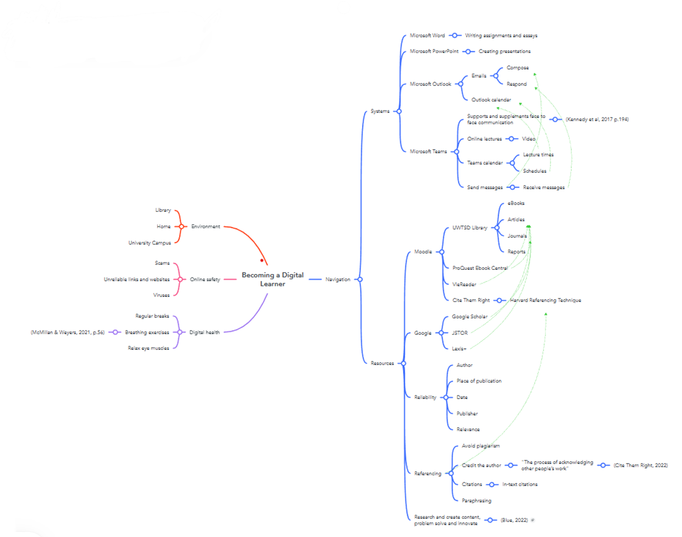
Task 2 – Mind map

Task 3 – Presentation
Please follow this link to view my presentation: Presentation Assignment 1.pptx

Task 4 – Reflection
In January 2023 I began studying Law and Legal Practice at University of Wales Trinity Saint David (UWTSD). This started with an induction day at the Swansea Business Campus where I met lecturers and other students and got an idea of what the course would entail.
The course is delivered through a virtual learning environment (VLE) and face-to-face sessions on campus (UWTSD, 2023). So far, lectures have been carried out via Teams and written content with audio recordings. The course has introduced me to the education system Moodle, where I am able to access the written content uploaded by lecturers, as well as a wide range of resources to assist me with my studies and write my assignments. I have attended each lecture and used all of the resources provided to me in order to prepare for my assignments. Because of this, I have been able to write my assignments with confidence as I am able to ask questions during lectures that may not have been clear to me when reading the assignment brief. My experience so far has been positive, as I have received much support from my lecturers, as well as guidance with navigating through the resources and systems I have been provided with. Initially, the experience was daunting, as I hadn’t used VLE in an educational setting before, and many of the systems I had been introduced to were new to me. I had also been introduced to the Harvard Referencing Technique, which is something I wasn’t familiar with, and had to learn through the resource Cite them Right, which is also accessible through Moodle. Since then, I have gained confidence in navigating the many systems and resources and have found it easy with the help of my lecturers and other students. This has allowed me to develop confidence when writing assignments and completing tasks relating to the course.
My aim in this experience is to gain knowledge and work my way towards a degree in Law and Legal Practice. I am confident that I can achieve this if I continue to attend lectures and take full advantage of the resources provided on Moodle to assist me with my studies (Janse, 2022).

Reference list
Blue, J. (2022) More than just using computers: understanding and developing Digital Literacy with our new guide. Available at: https://www.cambridge.org/elt/blog/2022/04/07/understanding-developing-digital-literacy/ (Accessed: 23 February 2023).

Cambridge Dictionary (2023) Meaning of belief in English. Available at: https://dictionary.cambridge.org/dictionary/english/belief (Accessed: 27 February 2023).
Cottrell, S. (2019) The Study Skills Handbook. 5th edn. London: Red Globe Press.
Cottrell, S. (2017) Critical Thinking Skills: Effective Analysis, Argument and Reflection. 3rd edn. London: Palgrave.
Cite Them Right (2022) What is referencing? Available at: https://www-citethemrightonline-com.ezproxy.uwtsd.ac.uk/article?docid=b-9781350928060&tocid=b-9781350928060-what-is-referencing (Accessed: 22 February 2023).
Godfrey, J. (2018) How to use your reading in your essays. 3rd edn. London: Palgrave.
Janse, B. (2022) Borton’s Model of Reflection. Available at: https://www.toolshero.com/personal-development/borton-model-of-reflection/ (Accessed: 27 February 2023).
Kennedy, E. Neumann, T. Rowett, S. Strawbridge, F. (2017) Digital Education and the Connected Curriculum: Towards a Connected Learning Environment. UCL Press.

Mayhew, S. (2001) A Dictionary of Geography. 5th edn. Oxford: University Press.
McMillan, K. Weyers, J. (2021) The Study Skills Book. 4th edn. Harlow: Pearson.
Mind Tools (2022) What are your values? Available at: https://www.mindtools.com/a5eygum/what-are-your-values (Accessed: 27 February 2023).
Olson, Eric T. (2022) Personal Identity, The Stanford Encyclopedia of Philosophy. Available at: https://plato.stanford.edu/archives/sum2022/entries/identity-personal/ (Accessed: 27 February 2023).

