DS 1 Template
ERIC FLOCEA
Student number 2535547

My Screenshots/Photos
- Please add 4–6 screenshots or photos of your digital life.
- You can use your phone or laptop.
- For each screenshot, write one or two sentences explaining what it shows.

Screenshot/Photo 1
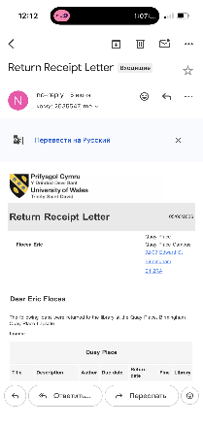
This screenshot shows that I use email and online documents for university work .

Screenshot/Photo 2

This screenshot shows that I use online business news websites to stay informed about current events and business topics .

Screenshot/Photo 3
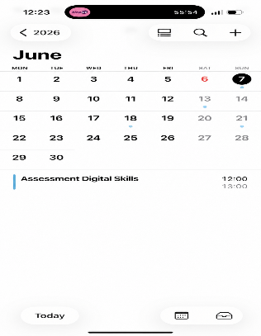
This screenshot shows that I use digital tools to organise my study time.

Screenshot/Photo 4
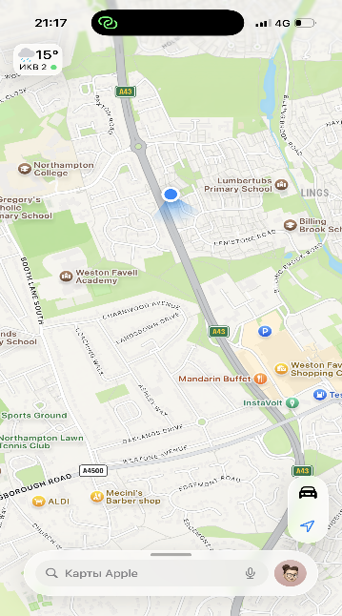
This screenshot shows that I use digital maps to find directions and travel to different places .

Screenshot/Photo 5
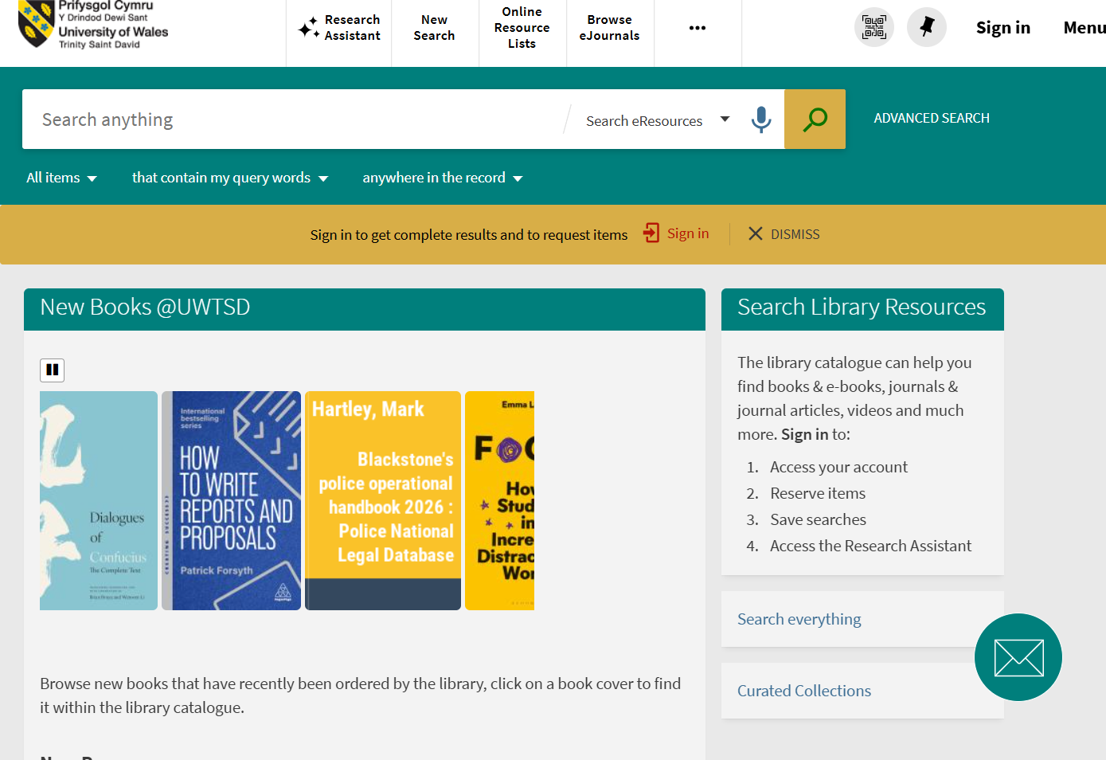
This screenshot shows that I use online library resources for my university studies .

Screenshot/Photo 6
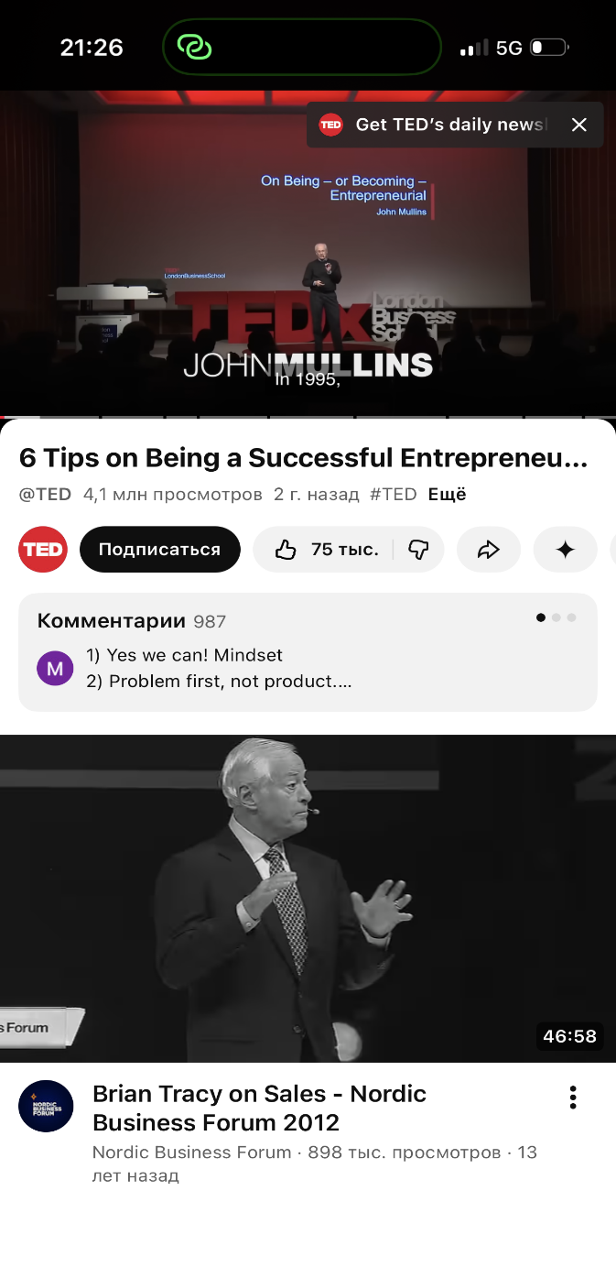
This screenshot shows that I use YouTube to learn business skills and new ideas .

My Short Reflection
- Write 5–8 simple sentences about your digital life.
- You can use the sentence starters below if helpful.
I use digital tools to learn new things on the internet .
I often use my phone to stay in contact with my family.
I fell more confident when I use technology for my study.
I want to get better at using computers and online programs.
I hope this course will teach me more useful digital skills.
Digital skills are important because they help me in everyday life .

Sentence starters
- I use digital tools to …
- I feel confident when I …
- I want to improve …
- I often use these tools: …
- I sometimes feel nervous about …
- I hope this module will help me …
- Digital skills are important for me because …
You can write more if you want.

Submission Checklist
Before you submit, please check:
​​​ ☒ I added 4–6 screenshots
☒ I wrote short sentences for each screenshot
☒ I wrote my short reflection
☒ My work is my own
☒ My file opens correctly
​​☒ My file opens correctly

