University of Wales trinity saint David

Wales institute of science and art
Potential and Kinetic Energy in a Flywheel
Motor vehicle Engineering Science (ACHA4036)

Gabriel Jenkins-Handy
2501670
(03/2026)

Contents
1 Introduction 1
2 Experimental Procedure 2
2.1 Equipment 2
2.2 ES9 Kit Assembly 3
2.3 Carrying out the experiment 3
3 Results 4
4 Analysis 5
4.1 Results and calculations 5
4.2 Torque against angular acceleration graph 6
5 Conclusion 7
6 Evaluation 8
7 Further Work 9
8 References 10

Figure 1: fully assembled ES9 Kit. 2
Figure 2: Torque against Angular Acceleration 6

Introduction
The Purpose of this report is to prove the theory for energy in a flywheel. The data gathered in this report has been collected from a practical experiment using weights and a flywheel. The data has then been put into an Excel spreadsheet to use provided formulae to calculate the different values.
Flywheels play an integral part in the automotive industry. They are used at the end of crankshafts in engines and can also be found in some hybrid systems (Śliwiński, C. 2016). These systems are still in an early development stage and have mostly just been seen in motorsports such as formula one.

Experimental Procedure

Equipment
The equipment used to conduct the experiment was the Potential and Kinetic Energy Kit ES9 provided by TecQuipment Ltd (2012). The kit includes a flywheel connected to a shaft mounted in a bearing. The flywheel assembly can be mounted to a backing plate via screws in the back. The kit also includes 10g weights and a weight holder with hook on one end which weighs an additional 10g. a length of string and a magnetic 30cm ruler were also provided in the kit box.
The enclosed bearing has an adjustable screw which can be adjusted for resistance. For the purposes of the conducted experiment, the resistance screw was removed. Below (Fig.1) shows the fully assembled kit.

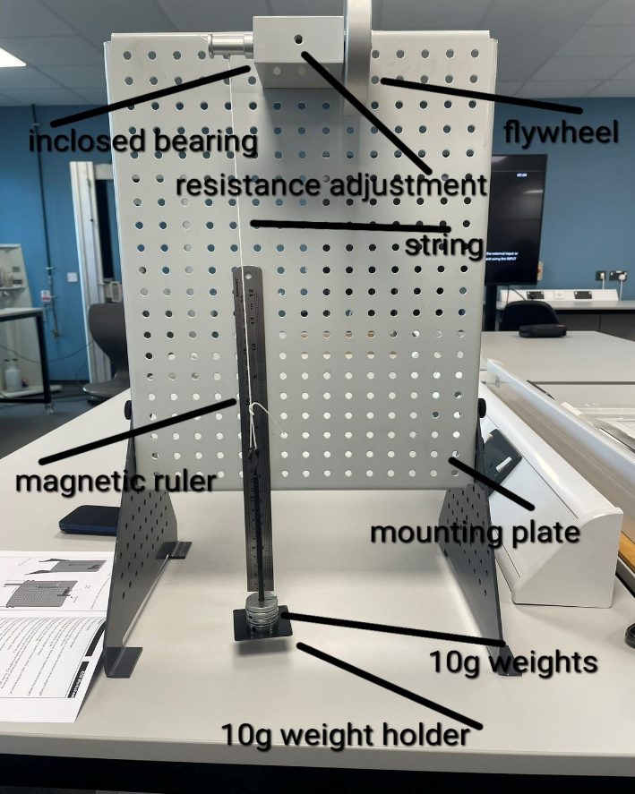
Figure 1: fully assembled ES9 Kit.

ES9 Kit Assembly
When presented with the ES9 kit, the assembly is crucial to gain accurate data when carrying out the experiment. Screwing the flywheel and bearing assembly at the top of the backing plate, it gives the mass enough room to fall and rise without hitting the surface below. Cutting the string to size and tying a loop at one end allows the weight hanger to attach; if the string is too long the hanger will hit the surface below meaning no data can be gathered. With the hanger and string attached to the bearing assembly, the magnetic ruler can be placed on the backing plate with the lowest value (0cm) being at the bottom at the exact same height as the weight carrier at its lowest point of travel. This assures the height travelled measurement can be carried out accurately. This can be seen in figure 1.

Carrying out the experiment
The starting weight for the experiment is 0.1kg. Nine 10g weights must be added to the hanger to achieve this. The string must be wound up the shaft connected to the flywheel to a height of 0.28m (h₁). The time then can be measured for the mass to fall and then rise. The height the weight rises to after falling needs to be measured; this is h₂. The time it takes for the mass to start at h₁ and then reach h₂ must be measured also. For this report, each mass was recorded three times to improve accuracy. The experiment is repeated with increasing weight of 0.1kg each time. The data gathered in this report was capped at 0.5kg.

Results
In the table below is the raw data collected from the experiment. The average for H₂ was calculated using the equation, $average=\frac{sume of the value}{number of values}$ .

Table 1: results
Mass (kg) | H₁ (m) | H₂(m) | H₂ (m) | H₂ (m) | Tt (s) | Tt (s) | Tt (s) | H₂ Average (m)
0.1 | 0.28 | 24.7 | 24.6 | 24.8 | 4.77 | 4.19 | 4.19 | 24.7
0.2 | 0.28 | 24.5 | 24.9 | 24.6 | 2.5 | 2.99 | 2.59 | 24.67
0.3 | 0.28 | 24.6 | 24.6 | 24.6 | 2.59 | 2.32 | 2.27 | 24.6
0.4 | 0.28 | 24.6 | 24 | 24.1 | 2.17 | 2.1 | 2.06 | 24.23
0.5 | 0.28 | 22.3 | 22.2 | 22.4 | 1.87 | 1.92 | 1.89 | 22.3

Analysis

Results and calculations
Using certain equations, the table on Excel could be created. The first step in calculating the data was converting all the measurements into base units as some of the given measurements were in millimetres or centimetres and the weights were in grams. These measurements had to be changed to metres and kilograms. Using the raw data that was gathered, the initial parameters needed to be calculated. The first thing to calculate was $mg$ (Mass × Gravity), with gravity having the standard value of 9.81m/s². After $mg$ was calculated, the potential energy had to be worked out using the equation $PE=mgh_{1}$, with h₁ being the original height (0.28m) the next calculation that had to be done was for the $PE$ loss, using the equation ${PE}_{loss}=mg(h_{1}-h_{2}$), with h₂ being the height after the mass had travelled a full cycle. After calculating this, the $PE$ loss could then be used to calculate the $PE$ loss adjusted value using the equation ${PE}_{loss}×\frac{h_{1}}{h_{1}+h_{2}}$ . $T_{f}$(falling time) could then be calculated. This needed was to calculate the maximum acceleration (A_{max}) of the mass. To get a value for $t_{f}$, the equation $t_{f=t_{t}×\frac{h_{1}}{h_{1+h_{2}}}}$ had to be used. When the previous calculations were complete, they could be used to calculate acceleration. The equation used was $a=\frac{h_{1}}{tf^{2}}$. With acceleration calculated, maximum velocity (V_{max}) could be calculated using the equation $V_{max}=at_{f}$. The next part to calculate was angular velocity ($ω$), this was achieved by using the equation $c.ω=\frac{2πv}{c}$, this equation shows converting the linear velocity using the circumference of the pully. The given force acting upon the string connecting the weights to the flywheel is equal to the difference between gravity (9.81m/s²) acting on the mass $(mg)$ and the acceleration of the mass $(ma)$; $F=mg-ma$. For these calculations it is assumed that the string doesn’t stretch, torque is force times the radius of the pully; $T=\left(mg-ma\right)r$. With this complete, angular acceleration can then be calculated using $a=\frac{a}{r}$. All the values logged for these calculations can be found on the Excel spreadsheet.

Torque against angular acceleration graph
Because the flywheel was moving, the torque was equal to the angular acceleration time. The equation for the moment of inertia in the flywheel is $T=Ia$, using this equation, the previous equations can be substituted in creating $\left(mg-ma\right)r=I\frac{a}{r}$. From these calculations a graph could be made showing torque against angular acceleration (Fig.2) which gave a reliable average for $I$ based on the data gathered.
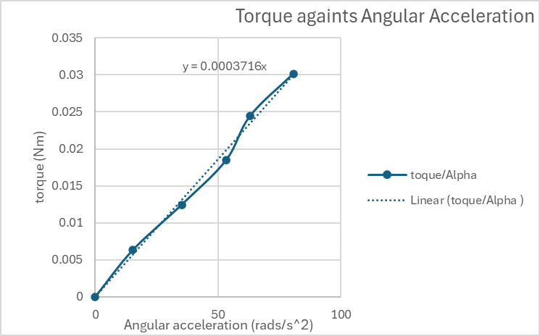
Figure 2: Torque against Angular Acceleration

Conclusion
The purpose of this experiment was to prove the theory behind energy stored in a flywheel and to use kinetic energy calculations to find the moment of inertia “$I$”. However, there is a difference between the nominal inertia value $(4.696×{10}^{-4}kgm^{2})$ and the calculated inertia value being $3.72×{10}^{-4}kgm^{2}$. This is roughly a 23.2% difference. With all the variables considered when collecting the data, things such as human error or drag in the bearing, a 23.2% difference proves moderate correlation between the nominal value and the calculated or “experimental” values for inertia.
As seen in the data collected, the kinetic energy calculated using $PE+{PE}_{loss}$ Adjusted and the kinetic energy using the calculated inertia have similar values. However, these values do not perfectly match, this can be attributed to variables not considered in the calculations such as elasticity in the string or drag from the bearing (Suh, N.P., Et, Al. 1994). Both of these variables can hinder kinetic energy. While air resistance could also hinder the results if not accounted for, the experiment was completed at a small scale and in a controlled lab with no wind pushing up against the mass.
The results obtained through this experiment also support the theory for potential energy; this can be seen through the gathered data. As the mass increased, the value for potential energy also increased, therefore showing the equation $PE=mgh$ to be correct. However, the added mass increases the frictional losses in the bearing which explains why the values for $PE$ and ${PE}_{loss }$Adjusted are slightly different with the ${PE}_{loss}$ Adjusted value being slightly lower than the initial $PE$ value.
Overall, the experiment succeeded in proving the theory of energy stored in a flywheel by showing the transfer from potential energy to kinetic energy.

Evaluation
To minimise errors, each time the measurements were taken, there was always at least four people watching/conducting the experiment. Two people would take times; a third person would operate the experiment with a fourth person saying when to release the weight and start the clock. The experiment was also filmed in slow motion to capture more accurate times however due to only having a phone camera, the videos taken proved to be useless. Each weight had the experiment conducted three times to gain the most accurate data.

Further Work
If the experiment was to be repeated on an unlimited budget with more time being dedicated to it, the key areas to improve would be: the string, the bearing, the measuring equipment and reduction of horizontal movement of the mass.
For the timing equipment, the best and easiest solution would be to use a high-speed camera, this would mean the experiment could just be filmed and then by going over each frame retrospectively, a precise time for the mass to hit h₂ could be found and a precise height could be taken.
With more budget an ultra-low friction bearing could be used, or a zero-friction bearing could be developed which would remove any inconsistencies due to drag.
The string having slight elasticity caused slight inaccuracy in some of the measurements especially when comparing calculated values to the initial values, if this elasticity could be reduced there would be a further improvement in continuity between values. In addition to this, a system to reduce the horizontal motion of the mass as it travels would improve the values of both kinetic and potential energy as some energy will be used for swinging horizontally.

References
Potential and Kinetic Energy Kit . (2012). TecQuipment Ltd, ES9.
Śliwiński, C. (2016). Kinetic Energy Recovery Systems in Motor Vehicles. IOP Conference Series: Materials Science and Engineering, 148, p.012056. doi:https://doi.org/10.1088/1757-899x/148/1/012056.
Suh, N.P., Mosleh, M. and Howard, P.S. (1994). Control of Friction. Wear, 175(1-2), pp.151–158. doi: https://doi.org/10.1016/0043-1648(94)90178-3.

