

Contemporary Themes in the Hotel and Hospitality Sector

Sustainability in the Hotel and Hospitality Sector: Innovations in Waste Reduction and Resource Management

Module code: BMIH6001
Student name :Frentusca Ana-Maria
Student number : 2120534
Module tutor: Dr. Ernest Balutie Wavei

Abstract
This report explores sustainability in the hotel and hospitality industry with special attention to minimizing waste, resource conservation, and approaches that lead to energy-efficient operations. The study emphasizes important areas of impact such as government regulation, social pressure and environmental pressures through a PESTEL analysis. By examining some of the most notable examples provided by industry leaders such as Marriott and Hilton, the analysis details current efforts in these areas along with their pros and cons. In its closing, Sustainable management recommends key policies for the future including effective waste disposal regulations and renewable energy subsidies as well as management practices like employee training and resident participation. Highlighting the importance of maintaining dedication and creativity to achieve sustainable hospitality in the long run.
Contents
Abstract 2
Introduction 4
Literature Review 5
Waste Reduction Strategies 5
Resource Management: Energy and Water Conservation 6
Theoretical and Practical Impacts of Sustainable Practices 8
Application to the Hotel and Hospitality Sector 9
PESTEL Analysis on Sustainability in the UK Hotel and Hospitality Sector 9
Energy and Resource Efficiency: IHG’s “Green Engage” Program 11
Food Waste Reduction: Accor’s Partnership with Winnow Technology 11
Water and Carbon Emissions Reduction: Marriott’s “Serve 360” Goals 11
Future Policy and Management Options for Sustainability in Hospitality 12
Stricter Waste Management Policies 12
Incentives for Renewable Energy Adoption 12
Recommended Management Practices for Sustainability 13
Conclusion 14
References 15

Introduction
The hotel and hospitality sector are a resource-consumptive industry that drives sustainability across sectors. As major energy and water consumers using the latter for everything from HVAC operations to lighting to their extensive laundry and cleaning needs hotels are also significant contributors to greenhouse gas emissions. The same applies to the huge waste that is created from food, single-use plastics and used furniture and appliance disposal. With these environmental pressures, sustainability involvements are crucial to limit the footprint of the sector. Key initiatives around sustainability in the industry are mainly focused on waste and resource management. Waste reduction methods may be recycling, composting, and reducing single-use plastics; resource management encompasses building design for energy efficiency and water conservation. These sustainability practices not only contribute to environmentally friendly measures but also improve brand building and guest satisfaction because more travellers support accommodations with eco-friendly tourism strategies. The combination of the two components therefore encourages hotels to invest in sustainability as it aids both the component (environment) and outcome (profitability), especially with expectations from consumers and an increasingly profitable process within their operations.

Literature Review

Waste Reduction Strategies
The hospitality industry is challenged with delivering unique guest experiences while remaining committed to sustainability. The industry has helped significantly in advocating waste reduction and resource management, which have now emerged as key pillars of sustainable operations (Njoroge, Anderson and Mbura, 2019). Waste reduction strategies focus on reducing unnecessary waste generation and resource use, while resource management enhances operational efficiency. By using these methods, hotels are playing a part in both a greener industry and customer satisfaction.
Due to their large waste production, especially related to food services and disposable guest products, hotels have made reducing waste a priority (Brotherton, 2015). These initiatives range from recycling to composting and minimizing single-use plastic items. Multiple hotels use glass, metal and paper recycling programs to ensure recyclables are staying out of landfills. In addition to this, many hotels compost food waste and turn their food scraps into nutrient-rich soil that can be given to nearby farmers or used in landscaping (Clegg., 2021). Composting not only reduces landfill waste but also connects the hotel with local agricultural groups allowing for a win-win circular economy for both the organisation and the location​.
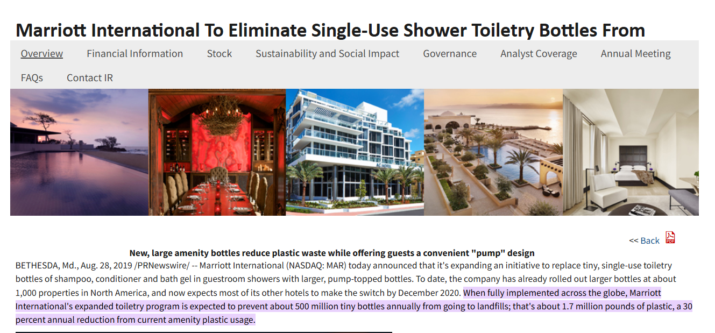
Figure 1: Marriott International To Eliminate Single-Use Shower Toiletry Bottles (Perkumienė et al., 2023)

Hotels have likewise ditched plastic water bottles with filtering stations and delivering glass or metallic water bottles for guests. Backed by increasing consumer awareness about sustainability, these steps are in line with global movements and legislation advocating for plastic reduction, which ultimately benefits brand image as guests enjoy tangible environmental efforts; practices may also involve collaborations between waste management firms and regional recyclers (Costa and Costa, 2022). In doing so, hotels make sure that their waste management practices are in line with what the region is capable of handling and comply with regulations that shift over time. It is well noted by research that guests appreciate sustainability while staying at hotels and this will provide the backbone of hotel loyalty as well as assurance of guest satisfaction. According to a recent study in the Journal of Sustainable Tourism, 70 % of visitors surveyed prefer hotels that disclose sustainable waste reduction strategies, revealing consumers come out over 3 times as eco-conscious choices in regards to lodging.

Resource Management: Energy and Water Conservation
The second area of focus is resource management, which aims to lower the usage of energy and water in hotels. Energy Management is a huge challenge because, unlike other businesses, the hotel never stops operating. LED lights, energy-efficient devices, and automated climate control systems are now more prevalent than ever (Darcy, Ambrose and Bulhalis, 2012). For instance, smart thermostats automatically modify the temperatures of rooms based on occupancy, thus eliminating any waste of energy. InterContinental Hotels Group (IHG) is one of the hotel chains that has adopted such technologies, resulting in massive energy and carbon emission savings. For example, LEED certification is the most widely used green building rating system in the world and among hospitality it has become a coveted credential; LEED-certified hotels save an average of 30% more energy than non-LEED buildings (Robaina and Madaleno, 2018). These seals boost the guests who care about sustainability to be in turn eco-friendly hotel guests’ sustainability and brand appeal.
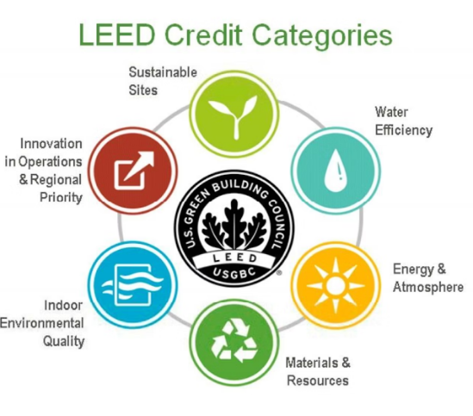
Figure 2: LEED certification (Robaina and Madaleno, 2018)
Hotel customers in water-scarce places are also large consumers. Hilton uses LightStay to measure resource use and reduce its water footprint across its hotels by identifying high-consumption areas and implementing adjustments (Dawson, Lemelin and Stewart, 2012). Low-flow showerheads and faucets, dual-flush toilets, and linen and towel reuse are common water-saving measures. Guest rooms use less water, while efficient irrigation systems and xeriscaping cut water use. By installing water-efficient fixtures, hotels can save 20–30% on water and save money.
The Ritz-Carlton in San Francisco recycles greywater, irrigates with treated wastewater, and flushes toilets with it. This reduces the hotel's dependence on municipal water, especially in water-scarce locations. Many hotels gather rainwater for gardening and other non-potable uses. These methods comply with UN SDG 6, which promotes water conservation for sustainable development and climate resilience.
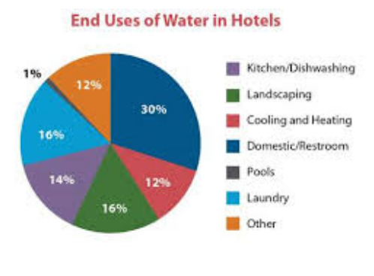
Figure 3: Saving Water in Hotels (Ford and Sturman, 2020)

Theoretical and Practical Impacts of Sustainable Practices
Sustainable hospitality stems from corporate social responsibility (CSR), specifically a triple-bottom-line approach to people, earth, and profit. Reducing resource use and waste can save hotel costs and attract environmentally conscious guests (Faulkner, Moscardo and Laws, 2001). Studies in Tourism Management found that hotels with effective environmental programs had more bookings and customer loyalty. Recent industry surveys indicated that 73% of Millennial and Gen Z travellers favour eco-friendly hotels, proving that sustainability gives a competitive edge.
It provides hotels with sustainable solutions and helps them comply with policies like the EU Single-Use Plastics Directive, which requires a significant decrease in plastic litter and requires EU hotels to find alternatives to plastic products. In strict states like California, environmental restrictions encourage resource efficiency and waste minimisation in U.S. hotels. These best practices help hotels plan for legislation, avoid fines and penalties, and take advantage of government incentives for sustainable hot goblet operations (Ford and Sturman, 2020).
Sustainable methods pay out financially and reputationally, proving the obvious (Ivanov and Webster, 2019). Resource optimisation has helped several large hotel chains offer cheaper and better services. Green hotels with visible practices enhance client satisfaction by 18%, according to Ecolab. Such methods build client trust and boost the hotel's brand image, which attracts investors seeking an eco-friendly, ethical business.

Application to the Hotel and Hospitality Sector

PESTEL Analysis on Sustainability in the UK Hotel and Hospitality Sector
Political
The political environment plays a huge role in sustainability for the hospitality industry with different areas having their own set of regulations and rules that aim to compel hotels to minimize their footprint on earth. With initiatives such as the Green Tourism Business Scheme, the UK government encourages businesses to be more eco-friendly by rewarding those that fulfil low-impact standards with an environmental badge (Krippendorf, 2011). The Environment Act 2021 for example, specifically calls for waste management improvements to ensure that hotels move away from landfilling. UK hotel chains such as Hilton have moved in line with these initiatives, planning to halve food waste by introducing time-saver menu options across flagship locations. This is part of a wider drive by the government to help hospitality businesses achieve net zero by 2050.
Economic
Sustainability links economics in two different ways; first, the solutions offered when it comes to sustainability are often expensive upfront as new technologies appear but ultimately end up saving money over time. Implementing energy-efficient practices such as harnessing renewable sources, however, might prove to have significant initial investments, saving up to a quarter of their overall energy costs over the long run (Laws, Prideaux and Chon, 2007). For example, Marriott International has used energy-efficient installations such as LED lighting and smart thermostats across many of its properties in the UK to help it see big savings on energy. Practices of this kind attract cost-sensitive customers who would select a hotel based on best economic practices in environmental issues that provide them with a better competitive advantage.
Social
From the guest's view, consumer expectations regarding eco-friendly environments are transforming the hospitality sector where travellers want to stay in sustainable places. New research shows that six in ten travellers in the UK are more likely to choose hotels where sustainability is apparent. This trend has led to some hotels (including Accor) following suit with sustainable alternatives that include accessing options like getting rid of disposable plastics, as well as a system of water savings (Mill, 201). To meet these expectations, Marriott’s “Serve 360” initiative takes on issues such as Water conservation and Waste minimization. Not only does this raise the profile of the hotels by aligning with consumer values, but it prompts more repeat stays from environmentally conscious guests.
Technological
The sector uses the advancement of technology on its sustainability path, which helps in minimizing waste and energy consumption (Morrison, 2021). AI-powered waste management programs, as seen in hotels such as the Hilton, can monitor patterns of food waste to inform purchasing and preparation decisions. Hilton has partnered with AI company Winnow, which has helped the chain reduce food waste in some locations by as much as half, and they even built a massive organization plan to control trash. Above that, smart energy systems like the ones used by IHG (InterContinental Hotels Group) can control heating, cooling and lighting depending on the areas of occupancy making it a solution to reduce energy use.
Environmental
Sustainability places a major emphasis on the environmental impact in hospitality operations from creating waste and carbon footprints. UK hotels already produce a large amount of waste and emissions, with approximately 79% of emissions from energy use. Chains such as IHG implement environmental stewardship strategies to address this, including the use of sustainable materials in construction and operations (Robson, 2014). In one example, Marriott has committed to a 50% reduction of its water and carbon footprint by the year 2030 sustainability goals are directly aligned with those of the United Nations. In addition, these initiatives address the surrounding ecological effects on local communities due to hotels, especially in heavily touristic areas.
Legal
UK hotels must adhere strictly to environmental regulations and legislation, such as the UK’s Energy Savings Opportunity Scheme (ESOS) which requires large businesses to carry out energy audits and implement efficient practices. Such noncompliance could incur hefty penalties, which is why hotels have taken the initiative to incorporate sustainable measures into their operations. Titled “Travel with Purpose,” Hilton’s sustainability framework focuses on regulatory compliance and seeks to decrease its environmental footprint at every UK location (Santos and Silva, 2019). UK hotels that follow legal compliance not only fulfil their responsibility towards the environment but also avoid penalties that could hurt their profits.

Energy and Resource Efficiency: IHG’s “Green Engage” Program
Under its “Green Engage” program, IHG Hotels & Resorts has emphasized sustainability with a focus on energy, water and waste management across its UK portfolio. They see measurable environmental benefits and a significant reduction in operational costs of 30% less energy use. However, it has an outsize footprint that requires extensive staff training and a large upfront investment in ancillary monitoring technology, which tends to scare away the adoption of smaller hotels (Tribe, 2009).
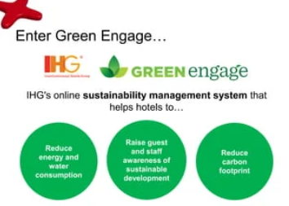
Figure 4: IHG’s “Green Engage” Program (IHG Green EngageTM system | IHG, 2024)

Food Waste Reduction: Accor’s Partnership with Winnow Technology
Accor Hotels has reduced food waste by implementing AI-powered technology in UK properties with Winnow. It has reduced food wastage by 50%, which in turn meets environmental targets and cost savings. Unfortunately, the dependency on high-tech solutions like Winnow does restrict it from smaller or independent hotels due to costs.

Water and Carbon Emissions Reduction: Marriott’s “Serve 360” Goals
HILTON DoubleTree by Hilton Birmingham 2019 Average score: 80% Sustainability feature: A Serve 360 program out of the UK that aims for a 50% decrease in water use and carbon emissions between now and 2030, aligning with Marriott’s global sustainability goals While this initiative enhances Marriott's platform among eco-friendly travellers, it also illuminates hurdles to widespread adoption (Wahab and Cooper, 2005). The scale of sustainability these places aimed for may prove too tall an order for small hotels, which won't have the resource logistics or financial capabilities to line up such changes.

Figure 5: Marriott’s “Serve 360” Goals (Martin-Rios, Hofmann and Mackenzie, 2020)

Future Policy and Management Options for Sustainability in Hospitality

Stricter Waste Management Policies
Tightened waste management policies need to accompany the sector to diminish its environmental footprint. Reduced Landfill Hotels contribute to landfills and governments can always help hotels with the implementation of stricter guidelines for waste segregation, recycling and composting. In the UK, local councils could even offer financial rewards (for instance through tax rebates) for hotels that exceed waste reduction, or if they introduce green certifications such as Green Key. In addition, it could be mandatory for hotels to monitor and report the waste they produce so that transparency and accountability are achieved. For example, Marriott has some ambitious waste goals such as a single-use plastics reduction plan to introduce refillable bathroom amenities in its UK properties can catalyse all sorts of initiatives throughout an industry (Eco-hotels as an example of environmental responsibility and innovation in savings in the hotel industry, 2019).

Incentives for Renewable Energy Adoption
Policies designed to encourage renewable energy adoption can speed up sustainability efforts, largely by providing financial incentives often critical to offset high initial investment costs. UK hotels could be set to benefit from grants, low-interest loans or tax cuts to encourage them to install solar panels or use other green technologies such as geothermal heating (Ioannidis et al., 2021). Such as The Scarlet Hotel in Cornwall a solar-powered and biomass boiler-powered establishment for properties which are interested in renewable energy investment. It may also encourage additory providers to offer lower prices for businesses who wish to transition over to green energy, allowing hotels to more easily secure a carbon-neutral status.

Recommended Management Practices for Sustainability
Training staff in sustainable practices
Staff training is key to angling sustainability into day-to-day operations. Possible training programs might include energy and water conservation, waste reduction, and guest engagement on environmental issues. For example, the IHG Green Engage program trains employees on environmentally friendly practices that relate to their jobs in particular (Martin-Rios, Hofmann and Mackenzie, 2020). This type of training allows staff to ensure they can play their part in achieving the property's environmental objectives which adopt a common sustainability approach. Collaborations with Green Vendors
Partnerships with Eco-Friendly Suppliers
By partnering with more sustainable suppliers, a hotel can massively lower its environmental footprint. Hotels can reduce transportation emissions and benefit the local economy by sourcing sustainable, locally produced goods. Chains such as Accor UK have started sourcing ingredients locally for their restaurants within their hotel chains, lowering carbon emissions and enhancing sustainable farming. Accommodations​EHL Hospitality Insights prohibits suppliers and suppliers from doing business to be environmentally- friendly by possessing Fair Trade, Rainforest Alliance or Organic certification (Sloan, Legrand and Chen, 2022).
Guest Engagement Initiatives
Involving the guests in the sustainability efforts, not only does it strengthen environmental responsibility but also customer loyalty. Such as soliciting guests to join in any green initiatives, like towel and linen reuse programs to maximize usage before washing, digital check-ins to minimal use of paper or recycling bins placed in rooms. For example, Hilton introduced the Green Stay initiative to encourage guests to cut back on room servicing by rewarding them with loyalty points (Bitter, 2019). Initiatives like these will not only help lower operational expenses but also instil a mindset of environmental consciousness in all travellers, answering the rising demand for quality green practices.

Conclusion
To sum up, sustainability is becoming an essential element of the hotel and hospitality industry it helps mitigate the environmental and social impact created by its presence Hotels like Marriot and Hilton show how sustainable practices can be beneficial with cost savings, guest loyalty etc. by practising waste reduction, resource management & renewable energy initiatives. However, permanent sustainability will necessitate continual innovation; from new technologies implemented, to a higher standard in waste and resource regulations.

References
Bitter, K. (2019) Guest engagement in the environmental management of private hotels in Germany. https://www.theseus.fi/handle/10024/172184.
Brotherton, B. (2015) Researching hospitality and tourism. 2nd ed. New Delhi, India: SAGE.
Clegg., S.R. (ed.) (2021) Project Management: A Value Creation Approach. Sage, London.
Cooper, C. and Hall, M. (2019) Contemporary Tourism: An International Approach. Oxford.
Costa, V. and Costa, C. (2022) Sustainability and competitiveness in the hospitality industry. Hershey, Pennsylvania: Business Science Reference.
Darcy, S., Ambrose, J. and Bulhalis, D. (2012) Best Practice in Accessible Tourism: Inclusion, Disability, Ageing Population and Tourism. Channel View, London.
Dawson, J., Lemelin, H. and Stewart, E. (2012) Last Chance Tourism: Adapting Tourism Opportunities in a Changing World. Routledge, London.
Eco-hotels as an example of environmental responsibility and innovation in savings in the hotel industry (2019). https://www.ceeol.com/search/article-detail?id=826442.
Faulkner, B., Moscardo, G. and Laws, E. (2001) “Tourism in 21st Century. Reflections on Experience,” Reflections on Experience. Continuum [Preprint].
Ford, R.C. and Sturman, M. (2020) Managing Hospitality Organizations 2nd Edn. Sage, London.
IHG Green EngageTM system | IHG (2024). https://www.ihg.com/content/gb/en/support/green-engage.
Ioannidis, A., Chalvatzis, K.J., Leonidou, L.C. and Feng, Z., 2021. Applying the reduce, reuse, and recycle principle in the hospitality sector: Its antecedents and performance implications. Business Strategy and the Environment, 30(7), pp.3394-3410. https://doi.org/10.1002/bse.2809.
Ivanov, S. and Webster, C. (2019) “Economic fundamentals of the use of robots, artificial intelligence, and service automation in travel, tourism, and hospitality,” in Robots, Artificial Intelligence, and Service Automation in Travel, Tourism and Hospitality. Emerald Publishing Limited, pp. 39–55.
Krippendorf, J. (2011) The Holiday Makers: Understanding the Impact of Leisure & Travel.
Laws, E., Prideaux, B. and Chon, K. (2007) “Crisis Management in,” Crisis Management in Tourism [Preprint].
Martin-Rios, C., Hofmann, A. and Mackenzie, N. (2020) 'Sustainability-Oriented innovations in food waste management technology,' Sustainability, 13(1), p. 210. https://doi.org/10.3390/su13010210.
Mill, R.C. (2012) Resorts: Management and Operation. Wiley.
Morrison, A.M. (2021) “Reflections on trends and issues in global tourism,” in Tourism in development: reflective essays. UK: CABI, pp. 218–232.
Njoroge, M., Anderson, W. and Mbura, O. (2019) 'Innovation strategy and economic sustainability in the hospitality industry,' The Bottom Line Managing Library Finances, 32(4), pp. 253–268. https://doi.org/10.1108/bl-03-2019-0080.
Perkumienė, D., Atalay, A., Safaa, L. and Grigienė, J., 2023. Sustainable waste management for clean and safe environments in the recreation and tourism sector: a case study of Lithuania, Turkey and Morocco. Recycling, 8(4), p.56. https://doi.org/10.3390/recycling8040056.
Robaina, M. and Madaleno, M. (2018) 'Resources: Eco-efficiency, sustainability and Innovation in tourism,' in Springer eBooks, pp. 19–41. https://doi.org/10.1007/978-3-319-89941-1_2.
Robson, C. (2014) Real World Research, 3rd edition | Wiley.
Santos, J.D. and Silva, Ó.L. (2019) Digital Marketing Strategies for Tourism, Hospitality, and Airline Industries. Hershey: IGI Global.
Sloan, P., Legrand, W. and Chen, J.S. (2022) Sustainability in the hospitality industry. https://doi.org/10.4324/9781003081128.
Tribe, J. (2009) “Philosophical issues in Tourism (Aspects of Page 4 of 24 Tourism),” Channel View [Preprint].
Wahab, S. and Cooper, C. (2005) Tourism in the Age of Globalisation. Routledge, Abingdon.

