

Postgraduate/Distance Learning
Assignment coversheet & feedback form

THIS SHEET MUST BE THE FIRST PAGE OF THE ASSIGNMENT YOU ARE SUBMITTING (DO NOT SEND AS A SEPARATE FILE)

For completion by the student:

Student Name:
Danielle Lisa Casling Alexander
Module code:  HPCA7019  Module title:  Sacred Skies | Student ID number:  1600109 |  |  | Educational support needs:  Yes/No
Module tutor:
Dr Bernadette Brady, Dr Darrelyn Gunzburg, Dr Nick Campion

Assignment due date:
19th March 2021
If your module has multiple submissions please indicate which piece of work this is.

1st 2nd 3rd 4th 5th 6th
I confirm that this is my original work and that I have adhered to the University policy on plagiarism.
Signed ……………………………………………………………
Email submission: if you are submitting this form via email, please tick this box
(as a substitute for your signature) to confirm that you agree to the above declaration.
Assignment Mark
Final Mark | WILL BE GIVEN ON TURNITIN

NB. All marks are provisional until confirmed by the Final Examination Board.

PLEASE NOTE: ALL COMMENTS WIL BE POSTED ON TURNITIN

For completion by Marker 1 :
Comments:

Marker’s signature: |  |  | Date:
For completion by Marker 2/Moderator:

Comments:

Marker’s Signature: |  | Date:
AGREED INTERNAL MARK (where necessary):

Comment on process of arriving at agreed mark:

External Examiner’s comments (if relevant)

External Examiner’s Signature: |  | Date:

When a black cloud is a bear with a balloon: Discussing a sky journal to understand the psychological effect of clouds.

Introduction
This paper examines my sky journal to identify whether the meteorological phenomenon of clouds can influence psychological well-being. Previous studies from Martin Heusser and Alexandra Harris indicate that cloudscapes affect the perceiver's mood and provide examples spanning humankind’s history, yet both works employ secondary sources to illustrate their theories. This information could be unreliable due to secondary sources being interpretations of primary sources. This project utilises a primary source recorded by myself; a sky focused journal that was then used as a tool to determine whether the clouds affected my mood or psychological wellness. This qualitative research was recorded in a notebook at my family home in Bulgaria over a lunar month period. I employed a phenomenological approach, as favoured by Carla Dahl and Pauline Boss in therapeutic contexts centred on certain phenomenon. Extracts from the journal are then used to contextualise any phenomenological and emotionally reflexive encounters with the meteorological phenomena of clouds into the wider literature of experiences of the same events. The themes that will be discussed centre on creativity that was inspired by the journal and the cathartic influence of clouds.

Literature Review
This is not the first study of clouds in a phenomenological format; the work of Ada Blair also followed the emotions evoked through the observation of clouds. However, Blair focused on contextualising their cloud-watching findings as a cultural resource. Blair did use primary sources, which were appropriate for her phenomenological study because secondary sources aided in the interpretation of her primary source material. However, Blair was not the inspiration for this project. The research that influenced my journal most is the work of Martin Heusser, which sought to identify the psychological effect induced by cloud symbolism within English literary texts. According to Heusser, cloud symbolism reveals two seemingly polar associations; on one hand, destruction and despair while on the other, fecundity and sexuality. In The Book of Symbols, the connection to fertility is explained through a link to life-giving rain and cosmic revival. A third association is related to the notion of a cloud as 'in-between', or a symbol of the imagination, reflecting ideals concerning the spiritual and the material. This definition is also promoted within symbol compendiums. Heusser concluded that ‘a cloud is not a cloud, but what we think it should be[.]’ This implies that it is the perceiving mind that interprets the cloud, rather than the cloud causing a certain response. Additionally, within Weatherland: Writers and Artists under English Skies, Alexandra Harris reveals instances in which cloudscapes have psychologically affected the perceiver. Additionally, Harris argued that Shakespeare emphasises the relationship between weather and mood within A Midsummer Night’s Dream. The work of trauma-specialist Bessel van der Kolk encourages the re-connection with somatic sensations and the exploration of how these sensations feel. This work asserts the requirement of a connection between the Self and the outside world, which is dominated by the sky, to encourage healing and therefore, psychological changes. Similarly, Tim Ingold stresses the bond between the sky and humans in ‘Earth, Sky, Wind and Weather’, a study that introduces the concept of living with, rather than under, the sky and acknowledges the agency of meteorological phenomena.

Methodology
I am a 25-year-old white British female, staying with family in rural Bulgaria during the COVID-19 pandemic. I am also a neuro-divergent post-graduate student with a research interest in archaeology, ancient civilizations, cultural astronomy, and mythography.
My sky journal was recorded for a lunar month (starting on the New Moon of February 11th, 2021). I wrote at least one observation per day from my garden in Gradishte, Pleven Province, Bulgaria. The house faces south, but a panoramic view of the sky from east-south-west is visible. The journal was constructed via the handwriting of any phenomenological sensations in a prescribed notebook and included the date, time, moon phase and visibility, a 'mood before' and 'mood after' evaluator ranging from 1 (depressed/dissociated) to 5 (positive/productive). This method ensured my qualitative data was built on a quantitative foundation. According to Judith Bell, this ensures a comprehensive understanding of the data. The views of others were not taken into consideration or noted down. Rather, this is a personal journal that is then situated into the wider contexts of meteorological observations. My sky journal documented subjective experiences such as sensations or invoked memories. A phenomenological perspective allows me to focus on my experiences and understanding of the world. Additionally, it challenging ‘the assumption that the scientific method is the one way to accumulate truth and knowledge', finding usefulness in probabilistic conclusions. Selected extracts from the journal, which were chosen due to their potency in revealing how the sky impacted my mood, are then used to contextualise my phenomenological and emotionally reflexive encounters with meteorological phenomena into the wider literature of experiences of the same events.

Selected Extracts
Date: | 15th February 2021 | Moon Phase: | Waxing Crescent [in Aries]
Time: | 1:30 pm | Moon Visibility: | Not visible
Before: | 1 | After: | 3 - 4
Observations:
It’s super bright out today, despite the biting chill – it’s actually quite hard to open my eyes and look at the sky. I’m outside, with a cup of tea. I can only look west and peek through my fingers. The clouds look fluffy, featuring many shades from white to the darkest of greys. There is plenty of cloud cover, but still lots of blue too. I can actually see some shapes in the clouds directly in front of me (I’m still peeking through my fingers), they look like a mumma and baby bear. It’s the anniversary of her death tomorrow. I am suddenly overwhelmed with a wave of emotion, I cannot help but think of memories – so I shut my eyes and allow them in […] I remember being happy and peaceful and I can feel that creeping in now […] I spot the dark clouds looming to the south. They look ominous but strikingly gorgeous, (a little captivating) – but I bet those standing under them would not agree. I look up – my zenith is bright blue. Hmm. Maybe, next time my skies are grey, I will remember the beauty I saw in them today.

Date: | 24th February 2021 | Moon Phase: | Waxing Gibbous [in Cancer]
Time: | Noon | Moon Visibility: | Not visible
Before: | 4 | After: | 1
Observations:
It’s cool today, refreshingly so. Inside is stifling, both atmosphere and heat. There’s lots of birds today and I can hear their songs and, if I really listen, the beat of wings when they fly by. The cloud covering has a blue tinge to it, which tells me that it isn’t too thick. […] I can hear a woodpec- I SEE IT! Awesome!! There’s the sounds of chickens and chainsaws, cattle and chatty dogs; the world is so alive. The animals have joined me. I’m not really observing the clouds today, but rather whole sky, land and taskscape before me. I feel connected. […] Oh no, the taskscape has turned sour and I hear angry voices. I feel uncomfortable. I did feel okay, and it is lovely out here, but I must go inside now.
Date: | 28th February 2021 | Moon Phase: | Full (99%) [in Virgo]
Time: | 5:25 pm | Moon Visibility: | Not visible
Before: | 1.5 | After: | 4
Observations:
The first thing I saw today was beautifully terrifying grey stratocumulus clouds, with blazing orange visible in the gaps. It was enthralling and reminiscent of a forge – not as warm as one though!! Now, the sky is dotted with dark cumulus clouds, their white patches reflecting pale pinks and oranges of sunset. On the southern horizon, a dark mauve cloud skims along the tree line. I wouldn’t be able to see that if it was summer. There’s no wind, but that cloud is moving quickly. […] The clouds are vivid purple now. Beautiful and striking and mesmerizing.
Date: | 10th March 2021 | Moon Phase: | Waning crescent [in Aquarius]
Time: | Noon | Moon Visibility: | Not visible
Before: | 1 | After: | 4
Observations:
Today it rains. It rarely rains. It’s a little foggy and there is a dark blue tinge to the world. I don’t feel so good today, physically not mentally. The rain and air is really refreshing and feels wonderful. The grey clouds are quite comforting, the world is not too bright. I feel more alive after watching the rain run down my window, so I go outside. My page gets a little wet, but that’s okay. I feel energized after sitting with the sky, mentally not physically.

Discussion
Creative Clouds
Unfortunately, the way I wrote the journal could have been affected by the research aim and reading that occurred during the journals’ creation. The quest for meaning and phenomenological emphasis synthesized into a more creative, poetic writing style within my sky journal which is comparatively different from previous journals I have kept. However, this could also be representative of the sensations and overall mental wellness evoked by regular sky-watching, inviting me to be more creative. Clouds slowly became the dominating feature of digital drawings I created (Figure 1). Additional creative energy manifested in a cross-stitch bookmark that was inspired by the quote ‘Maybe, next time my skies are grey, I will remember the beauty I saw in them today’. The creation of a bookmark ensures that the sky journal remains with me and its psychological impact is reaffirmed with each use of the bookmark and with each stitch sowed in its creation. Even my social media became inundated with cloud imagery, as I followed several artists on Instagram who focused on cloudscapes, such as @cathycamilleart (located in the Netherlands) and @gizembozkurt_art (located in Turkey). I was also inspired to investigate cloudscape artist John Constable (11 June 1776 - 31 March 1837, Suffolk, England), who fused meteorological knowledge into his artwork. One of his artworks was even like my own (Figure 2). These actions reveal how deeply the sky affected my psychology and how I wanted it to continue being a part of my everyday experience due to the benefits I was seeing.
Additionally, I used a ‘word cloud’ to creatively express the different words that were used during the sky journal (Figure 3). The words ‘magnificent’, ‘enthralling’ and ‘terrifying’ were the most used words regarding clouds. This reveals a wide spectrum of feelings invoked by cloud-watching and would imply negative connotations. For example, the entry for 24th February saw my mood dip drastically after sky-observations. However, it was more common to feel happier, or more productive, after observations; 22 / 28 entries saw a boost in my mood. This indicates that cloud-watching, or at least sky-watching, generally improved my mood. Quite possibly, the dip on the 24th was caused by the taskscape, rather than the cloudscape, and other lower scores were similarly influenced by the human activity present in observations. It is also significant that cloud-watching frequently invoked memories and this is represented within the word-cloud.
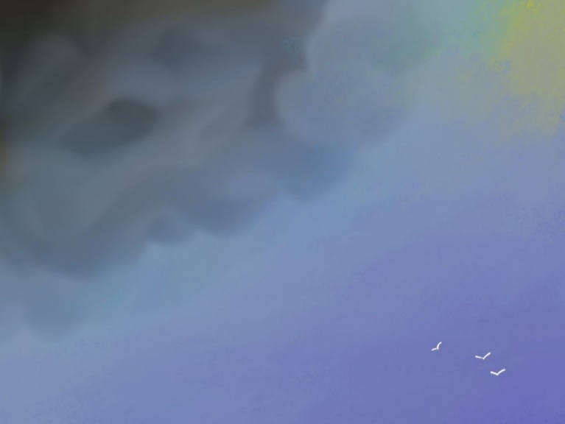
The theme of creative clouds that arose from the sky journal confirms Heusser’s notion of a cloud as a ‘threshold’ or symbolic representations of the imagination. Furthermore, the employment of cloud-inspired art would be an action encouraged by van der Kolk, who states that art therapy has many benefits although scientists still do not know why.

Figure 1: A digital drawing composed by me on the 2nd of March, inspired by watching the clouds and seeking to express their complexity and depth.
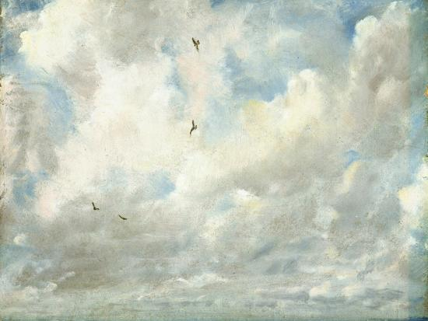
Figure 2: John Constable, Cloud Study, 1821 [Oil on canvas]
<https://www.independent.co.uk/arts-entertainment/art/great-works/great-works-cloud-study-1821-24-8cm-x-30-2cm-john-constable-2362942.html> [accessed 2021].

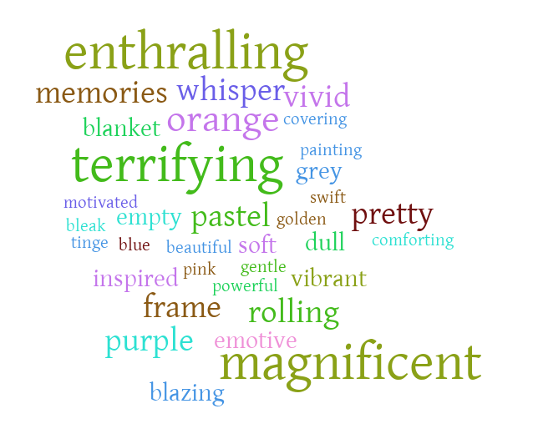
Figure 3: A ‘word cloud’ created by me using words that had featured in the sky journal entries.
Cathartic Clouds
The wider literature regarding clouds, their symbolism and psychological impact on the observer are often contradictory. As noted by Heusser, clouds can be representative of despair, sexuality, or imagination. Throughout the journal, each entry could be categorized into one of Heusser’s proposed notions. For example, the extract from the 10^{th of} March 2021 reveals how the grey cloud no longer designated misery for me, but rather, could be revitalizing. Whereas other days, the cloud appeared to reflect any unhappiness or unconscious processing, almost like a dream. This also connects to Heusser’s notion of thresholds and imagination and reminiscent of the work of Maurice Merleau-Ponty, who states that the sky is a ‘homeland of our thoughts’. This is exemplified by the grey cloudscape that I observed on the 15^{th of} February 2021, which became a cathartic tool aiding in processing grief and trauma. This entry revealed a shift in my perception of what it means to view a grey cloud and the impact it had on my psyche. Previous assumptions I had about grey clouds included a bleak feeling, miserable and drab, a notion enforced in dream and symbol dictionaries. However, after this observation, the grey cloud proved to be a comfort and a tool for processing grief; I had realized the magnificent beauty that a grey cloud incited and encouraged myself to remember that transformative moment. This extract reveals how the mind shapes the perception of the cloud and how the perception can be manipulated to suit the psychological requirement of the perceiver. Thus, this extract affirms Heusser’s theory that the cloud is what the perceiver denotes it to be, rather than having agency itself. It is also reminiscent of A. A Milne’s Winnie the Pooh, who pretends to be a black cloud to harvest honey, armed with his trusty balloon. This book was a favourite in childhood, and it is only after completing the sky journal that I understand Winne the Pooh when he says ‘How sweet to be a cloud, floating in the blue, it makes him very proud, to be a little cloud’. On the 15^{th of} February 2021, I saw a big black cloud, but it was also a bear, albeit with a baby in tow, rather than a balloon.
Further changes in perception were identifiable in the entry of 26th February, which stated that I ‘sat with the sky’ rather than an outsider observing it. This indicates that there was an acknowledgement that the sky, and clouds, have agency and that I am within the weather-world, just as Tim Ingold suggested. This provides a connection between myself, nature and people of the past who have also felt connected to the sky. For example, on occasions with minimal coverage, the clouds often act as frames of the skyscape, highlighting other celestial phenomena such as ‘sparkling’ Sirius on the 12^{th of} February, or the epic golden arch of a waning crescent moon on the 7th of March. The connection to these phenomena is particularly potent regarding my academic journey due to their dominance in some ancient cultures; for example, the Babylonians started the month on the new moon, even if cloud cover obscured the sight and the ancient Egyptians used the rising of Sirius, which was seen as Isis and coincided with the annual flooding of the Nile, to determine whether they required an intercalary month before the start of the year. In Inuit cosmology, traditionally the Moon has greater importance than the Sun, revered as a 'benevolent and approachable spirit' and Sirius is known as the Fox Star; representing a white and red fox fighting for the same hole. This connection to the ancient world was particularly evident on 28th February when the blazing orange sky was reminiscent of a forge, making me think of Hephaestus, the Greek blacksmith god. Additionally, the Aztecs worshipped a cloud-serpent god of hunting named Mixcoatl. The connection to ancient cultures is motivating and inspiring, positively affecting my psychology. This theme, therefore, connects strongly to Heusser’s notions and Harris’ statement that clouds affect the perceiver, even if indirectly in this latter instance.

Conclusion:
This paper aimed to discuss my sky journal, which had been focused on understanding the psychological impact of clouds. Previous studies from Heusser and Harris indicated that the perceiving mind influenced how the cloud is interpreted, while Ingold stressed the agency of the cloud. Cloud-watching encouraged me to create artworks, such as a bookmark and digital drawings, while also motivating me to locate artists specialising in cloudscape paintings. The 'word cloud' displays the lexicon used to describe clouds that would imply a negative impact, but the journal reveals that cloud watching persistently improved my psychological wellness. Further evidence for this includes clouds as an affective cathartic tool acting similarly to dreams, implying my mental state impacted how I viewed the clouds. These experiences removed previous assumptions about grey clouds, which developed into an acknowledgement that I am within the sky and intricately bound to it, rather than being an outside observer. The psychological impact was amplified when the clouds acted as frames for other celestial phenomena such as Sirius and the Moon, creating a link between my experiences and those of the ancient world. To conclude, my sky journal confirms notions presented by previous scholars; that clouds can influence the psyche of the perceiver. However, the perceiving mind similarly manipulates the perception of a cloud to suit the requirements of the perceiver, particularly regarding the cloud as reflecting or representing the imagination.

Bibliography
Dream Encyclopedia, Clouds, (2020) <https://www.dreamencyclopedia.net/clouds> [accessed 16/03/2021].
A. A. Milne, The Complete Winnie-the-Pooh (Bath: Chancellor Press, 1989).
Bell, Judith, Doing Your Research Project: A Guide for First-Time Researchers, 7th edn (London: McGraw-Hill Education, 2018), Kindle Edition.
Blair, Ada, 'The Meaning of Clouds: A Phenomenological Study', Spica, 2 (2014), 20-43.
Brady, Bernadette, 'The Egyptian Ascension Mythology of the Old Kingdom and the Phenomenon of Star Phases', Current Research in Egyptology, (2011), 40-47.
Chetwynd, Tom, Dictionary of Symbols (London: Aquarian Press; Harper Collins Press, 1982).
Clarke, Martha, The Big Dictionary of Dreams (China: Skyhorse, 2015), Kindle edition.
Coleman, J. A, The Dictionary of Mythology (London: Arcturus Publishing Ltd., 2018).
Dahl, Carla and Pauline Boss, 'The use of Phenomenology for Family Therapy Research: The Search for Meaning', in Research Methods in Family Therapy, ed. by Douglas H. Sprenkle and Fred P. Piercy, 2nd edn (New York: Guilford Press, 2005) Chap. 4, pp. 63-84.
Glover, Micheal, Great Works: Cloud Study, 1821 (24.8cm X 30.2cm), John Constable, (2011). <https://www.independent.co.uk/arts-entertainment/art/great-works/great-works-cloud-study-1821-24-8cm-x-30-2cm-john-constable-2362942.html> [accessed 16 March 2021].
Harris, Alexandra, Weatherland: Writers and Artists Under English Skies (London: Thames & Hudson, 2015), Kindle Edition.
Heusser, Martin, 'Camel, Weasel Or Whale Cloud Symbolism in English Literary Texts', Variations, 2004 (2004), 225-241.
Ingold, Tim, 'Earth, Sky, Wind, and Weather', Journal of the Royal Anthropological Institute, 13 (2007), S19-S38.
Merleau-Ponty, Maurice, Phenomenology of Perception, trans. C. Smith, (London: Routledge).
Ronnberg, Ami and Kathleen Martin, The Book of Symbols (Latvia: Taschen, 2010) (Archive for Research in Archetypal Symbolism).
Ruggles, Clive, Ancient Astronomy: An Encyclopedia of Cosmologies and Myth, (Santa Barbara: ABC-CLIO, 2005).
Stern, Sacha, 'The Babylonian Month and the New Moon: Sighting and Prediction', Journal for the History of Astronomy, 39 (2008), 19-42.
Thornes, John E. and John Constable, John Constable's Skies: A Fusion of Art and Science (A&C Black, 1999).
Tilley, Christopher, A Phenomenology of Landscape : Places, Paths and Monuments (Oxford; Providence: Berg, 1997).
van der Kolk, Bessel, The Body Keeps the Score (East Rutherford: Penguin Publishing Group, 2014).

Martin Heusser, "Camel, Weasel Or Whale Cloud Symbolism In English Literary Texts." Variations, 2004.12 (2004): 225-241; Alexandra Harris, Weatherland: Writers And Artists Under English Skies (London: Thames & Hudson, 2015).
Bell, Judith, Doing Your Research Project: A Guide For First-Time Researchers, 7th edn, (London: McGraw-Hill Education, 2018), location 3069, Kindle Edition.
Carla Dahl and Pauline Boss, 'The Use of Phenomenology for Family Therapy Research: The Search For Meaning' in Research Methods In Family Therapy, edited by Douglas H. Sprenkle and Fred P. Piercy, 2nd ed., (New York: Guilford Press 2005).
Ada Blair, 'The Meaning Of Clouds: A Phenomenological Study' in SPICA: Postgraduate Journal for Cosmology in Culture, 2.1, (2014), pp. 20-43.
Bell, Doing Your Research Project, location 3069.
Heusser, ‘Cloud Symbolism In English Literary Texts’.
Heusser, Cloud Symbolism In English Literary Texts, p. 226-7, 230-2.
Ami Ronnberg, and Kathleen Martin, The Book Of Symbols (Latvia: Taschen, 2010) (Archive for Research in Archetypal Symbolism), p. 58.
Heusser, Cloud Symbolism In English Literary Texts, p. 234-5.
Chetwynd, Tom, Dictionary Of Symbols (London: Aquarian Press; Harper Collins Press, 1982), p. 91-92; Ronnberg, and Martin, The Book Of Symbols, p. 58.
Heusser, Cloud Symbolism In English Literary Texts, p. 237.
Harris, Weatherland.
Harris, Weatherland, p. 122.
Bessel van der Kolk, The Body Keeps The Score (East Rutherford: Penguin Publishing Group, 2014).
Ingold, Tim, 'Earth, Sky, Wind, and Weather', Journal of the Royal Anthropological Institute, 13 (2007), S19-S38.
Bell, Doing Your Research Project, location 696.
Christopher Tilley, A Phenomenology Of Landscape: Places, Paths And Monuments (Oxford; Providence: Berg, 1997), p. 11.
Dahl and Boss, 'Phenomenology for Family Therapy Research, p. 63, 65.
Permission attained on 11th March 2021 to reference these artists.
Thornes, John E. and John Constable, John Constable's Skies: A Fusion of Art And Science (A&C Black, 1999).
Glover, Micheal, Great Works: Cloud Study, 1821 (24.8cm X 30.2cm), John Constable, https://www.independent.co.uk/arts-entertainment/art/great-works/great-works-cloud-study-1821-24-8cm-x-30-2cm-john-constable-2362942.html (2011) [accessed 2021].
Heusser, Cloud Symbolism In English Literary Texts, p. 234-5.
van der Kolk, Bessel, The Body Keeps The Score (East Rutherford: Penguin Publishing Group, 2014) p.242-3.
Heusser, Cloud Symbolism In English Literary Texts, p. 226-7, 230-2, 234-5.
Maurice Merleau-Ponty, Phenemenology of Perception, trans. C. Smith, (London: Routledge), p. 24.
Ronnberg, and Martin, The Book Of Symbols, p. 58; Martha Clarke, The Big Dictionary Of Dreams (China: Skyhorse, 2015), p. 182, Kindle Edition; Dream Encyclopedia, Clouds, (2020) <https://www.dreamencyclopedia.net/clouds> [accessed 16/03/2021].
Heusser, Cloud Symbolism In English Literary Texts, p. 237.
A. A. Milne, The Complete Winnie-The-Pooh (Bath: Chancellor Press, 1989), pp.25-30.
A strange coincidence occurred upon grabbing my copy of this book to confirm this reference; the book opened due to a bookmark cross-stitched by my grandmother. The page it opened on was the one I had been planning to look for, the page which this quote came from. A. A. Milne, The Complete Winnie-The-Pooh, p.28.
Ingold, 'Earth, Sky, Wind, and Weather', pp. S31-3.
Sacha Stern, 'The Babylonian Month And The New Moon: Sighting And Prediction', Journal for the History of Astronomy, 39 (2008), pp. 19-20; Bernadette Brady, 'The Egyptian Ascension Mythology Of The Old Kingdom And The Phenomenon Of Star Phases', Current Research in Egyptology, (2011), p. 41, 46; Clive Ruggles, Ancient Astronomy: An Encyclopedia Of Cosmologies And Myth, (Santa Barbara: ABC-CLIO, 2005), pp. 9, 229.
Ruggles, Ancient Astronomy, p. 194.
J. A. Coleman, The Dictionary Of Mythology (London: Arcturus Publishing Ltd., 2018), pp. 223-224.
Coleman, Dictionary Of Mythology, p. 319.

