A Critical Analysis of the Global Competitiveness of India’s Passenger-Automobile Industry and the Factors Affecting Hyundai Motor India’s Success

Student Name
Student ID

Table of contents
Section 1: International Business Report 4
1. Introduction 4
2. Industry and Country Overview 4
2.1 Scope and Development of India’s Passenger-Automobile Industry 4
2.2 Economic Importance and the Automotive Value Chain 5
2.3 Competitive Structure and Relative Positioning 6
3. Application of Porter’s Diamond Model to India’s Passenger-Automobile Industry 7
3.1 Relevance and Limitations of the Model 7
3.2 Factor Conditions 8
3.3 Demand Conditions 8
3.4 Related and Supporting Industries 9
3.5 Firm Strategy, Structure and Rivalry 9
3.6 Government and External Influences 9
4. Factors Affecting Hyundai Motor Company’s Success in India 10
4.1 Hyundai’s Position and the OLI Framework 10
4.2 Political and Institutional Factors 10
4.3 Economic Factors 11
4.4 Legal and Regulatory Factors 12
4.5 Social and Cultural Factors 13
4.6 Technological and Environmental Factors 14
4.7 Integration, Local Responsiveness and Strategic Fit 15
5. Conclusion 15
Section 2: Reflective Account Using Gibbs’ Reflective Cycle 17
6.1 Description 17
6.2 Feelings 17
6.3 Evaluation 18
6.4 Analysis 18
6.5 Conclusion 18
6.6 Action Plan 19
7. References 20

Section 1: International Business Report

1. Introduction
The passenger-automobile industry is now a large business and an increasing manufacturing and export base in India (Vyas, 2024). India's competitiveness is largely attributable to a strong domestic market, cost-efficient production, a mature component-supplier network and the fact of some competition between companies that are based in the country, and those that are multinational (Abraham, 2025). The market is changing, though, because of new trends like getting a lot more SUVs, new safety and environmental laws, digital connectivity and electric mobility. The study of Hyundai Motor Company is a suitable multinational company since the company has made significant strides in manufacturing, distribution and export activities, especially in the premium mass-market and SUV segments in India (Thanh and Surender Rangaraju, 2024). This report uses the Porter's Diamond Model, OLI Paradigm, PESTLE analysis and institutional perspectives to critically evaluate how competitive India is and what issues would impact the ongoing success of Hyundai.

2. Industry and Country Overview

2.1 Scope and Development of India’s Passenger-Automobile Industry
The passenger-automobile industry in India includes passenger vehicles, utility vehicles and vans which are designed, made, assembled, distributed, exported and serviced in India (Ruchika Pharswan, Negi and Basak, 2023). Two-wheelers and commercial vehicles are not included in the central analysis as their demand and regulatory environment differ from that of the central analysis and they are not relevant for the analysis of the localization of components, however they are relevant for the analysis of production costs and technological capability. The industry is part of a greater value chain that includes steel, aluminium, tyres, electronics, batteries, software, logistics, vehicle finance, dealerships and after-sales. The domestic sales of passenger-vehicles stood at around 4.3 million units in FY2024–25, which grew by about 2 percent (Vasanthkumar B, 2025). This was a relatively small drop but came on the heels of a very strong year. More importantly, sales of the entry level hatchbacks were being replaced by SUVs that provided more room, safety, road presence and technology, accounting for approximately 65 per cent of all sales. With this growth, India is becoming more of a competitive global production hub for automobiles, both domestic and international, further.

2.2 Economic Importance and the Automotive Value Chain
The relevance of the industry is more than simply manufacturing of vehicles. Passenger-vehicle manufacturing creates jobs, investment, tax revenues, exports, and technological learning through materials and engineering, financial services, insurance, retail distribution and maintenance. While the contribution of the broader automotive industry to the gross domestic product (GDP) is estimated to be around 7.1 per cent of the Indian GDP, it is not entirely passenger cars but also two-wheelers and commercial vehicles and parts (Tejaswini et al., 2026). The component manufacturing industry is one of the strong sectors of India. This scale facilitates the creation of more local opportunities, specialization and economies of agglomeration around existing automotive clusters. However, the approximate equality of imports and exports suggests that there is a lack of technological independence. India still depends on imports of semiconductors, advanced battery cells, and power electronics and special production equipment (Goel, Moerenhout and Bollini, 2024). Its current edge is therefore greater in terms of cost-effective, value-engineered manufacturing, versus any other aspect of the frontier automotive technologies.

2.3 Competitive Structure and Relative Positioning
The passenger-vehicle market in India is made up of Indian manufacturers as well as subsidiaries of multinational companies. Maruti Suzuki continues to be the main volume player, this has been achieved through scale, affordability, fuel efficiency and a huge network of sales and service (Rai, 2025). While it is considered an easy replicator in terms of cost leadership, its small-car appeal is threatened by the changing demand for SUVs, and premiumization and electrification are posing a challenge. One of Hyundai Motor India's strategies is premium mass market differentiation. For the current financial year (FY2024–25), it has sold a total of 598,666 vehicles in India and exported 163,386 units during the same period (Reddy et al., 2021). This provides a competitive advantage to its design, perceived quality, technology, safety features and wide range of hatchbacks, sedan, SUVs, CNG and electric models. Hyundai is heading into the SUV segment as well as those of the Creta, Venue and Exeter models. However, this selling strategy puts it at risk from the competition of Maruti and its growing number of specialist competitors which are getting better.
Table 1. Strategic Positioning of Major Passenger Vehicle Manufacturers
Company | Strategy | Strength | Weakness
Maruti Suzuki | Cost Leadership | Dealer Network | Weak EV
Hyundai | Differentiation | Technology & SUVs | Premium pricing
Tata | EV Focus | Domestic Brand | Export Scale
Mahindra | SUV Specialist | Lifestyle Brand | Limited Global Reach
Kia | Feature Rich | Modern Design | Smaller Network
Toyota | Reliability | Hybrid Technology | Premium Price

Tata Motors has gained an early edge in the EV segment for low cost, whereas Mahindra has carved out a niche SUV market which has a performance, rugged and lifestyle element. Toyota differentiates in the reliability and hybrid features, and multipurpose vehicles, while Kia offers a design challenge to Hyundai with connectivity and feature rich SUVs (Ezugwu et al., 2025). The market is thus concentrated but also is a diverse one strategically. Sustainably maintaining its differentiated brand, enhancing the degree of localisation and increasing the range of electrified products while maintaining affordability will be Hyundai's continued success. While India is a large market and has considerable export potential, there is also a lot of competition, so that a company may not have an advantage in the market. Thus, the ability to be flexible is a key factor in success as well as being a manufacturer on a large scale.

3. Application of Porter’s Diamond Model to India’s Passenger-Automobile Industry
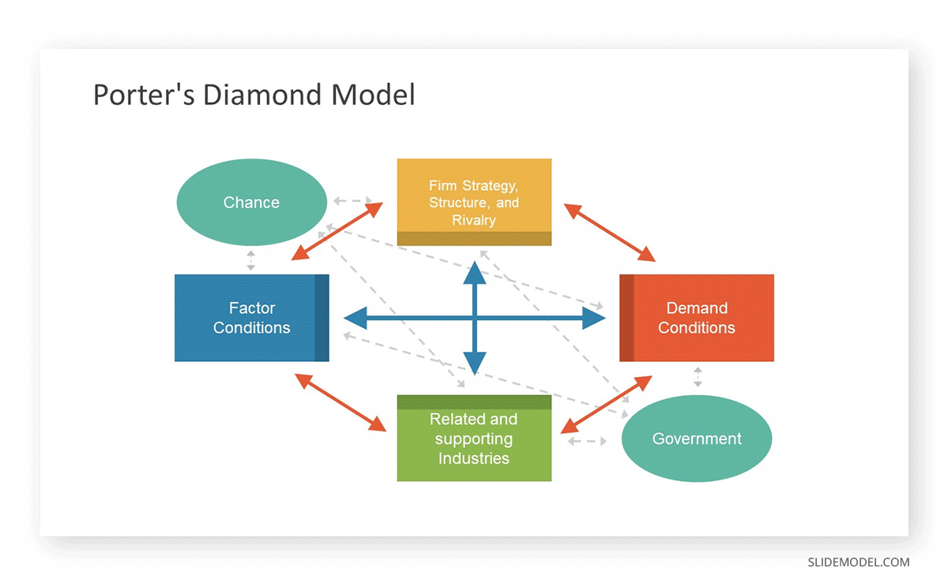
Fig 1: Porter’s Diamond Model, source:(Lopez, 2023)

3.1 Relevance and Limitations of the Model
Porter's Diamond Model is a model that helps to understand national competitiveness based on four determinants of competitiveness which reinforce one another: factor conditions, demand conditions, related and supporting industries and firm strategy, structure and rivalry (Yovka Bankova and Tsvetelina Tsvetanova, 2024). The system is impacted by chance and government. The framework is relevant as it connects the resources, home market, suppliers and competition of India with industrial upgrading (Ningsih et al., 2026). Its national focus is limited, however, in a business which is dominated by multinational corporations. South Korea's research, platform and capital and managerial skills are utilized in the development of the Hyundai model; India's competitiveness is a result of the interaction between the local and international benefits. Multinational companies have to create competitiveness (Kumar et al., 2025), a feature which the double-diamond perspective highlights.

3.2 Factor Conditions
The factor conditions in India come with cost benefits and high levels of capabilities. Industrialization and scale economies are enabled by a large workforce, engineering skill, existing industrial facilities and clusters in Chennai, Pune, Gujarat and NCR. Being close to the component makers, port facilities, etc., in Chennai, helps in strengthening distribution for Hyundai products. However, the benefits of these are not equal. India remains competitive in high volume production with value engineering but is yet to make an impact in the semiconductors, battery cells, power electronics and specialized equipment space. The PLI scheme seeks to encourage localization of advanced automotive technologies with an approved outlay of ₹25938 crore (Kapoor et al., 2024). This helps Hyundai localize and fortify its supply chain, which means bolstering its manufacturing competitiveness. However, these incentives are not enough to maintain a competitive edge over the years, as the continued dependence on imported semiconductors and battery technologies deprives India of technological capability.

3.3 Demand Conditions
Scale and pressure for adaptation is provided by demand conditions. As of FY2024-25, the passenger-vehicle sales amounted to 4.3 million units, enough to fuel the production and network of dealerships in the country (Hyundai, 2024). However, market size does not necessarily reflect sophisticated consumer demand. Safety, connectivity, comfort and SUV styling are all customer expectations that have been gaining traction among Indian consumers, while price, fuel efficiency, finance costs, maintenance, and resale value are all factors that are of concern. This mix promotes the creation of low-cost innovations, instead of premiumization. Manufacturers need to be able to implement the sophisticated functionality without becoming uneconomic, a feature which is needed for exports to emerging markets (Omer et al., 2022). But EV demand is still limited by the cost of buying an EV, charging stations and battery reliability. India's demand conditions are therefore, complex with regard to value-for-money requirements, and less developed about supporting their quick adoption of costly technologies.

3.4 Related and Supporting Industries
There are also other significant strengths, such as related and supportive industries. It makes local procurement easier, supplier specialization possible and it reduces costs; India's software industry has the potential to bring benefits as vehicles become connected and digital (Achal and Vijaya, 2024). This is further supported by the financial institutions, insurance providers, logistics companies and dealership networks. It is nonetheless interesting to observe the almost equal sizes of exports and imports of components, indicating limited domestic depth. Supply chains for conventional vehicles are stronger, but batteries, semiconductors, charging infrastructure and power electronics are not as strong (Jagani, Marsillac and Hong, 2024). India might then be able to compete in the field of assembly but not be able to reap the value of next generation technologies.

3.5 Firm Strategy, Structure and Rivalry
Firm strategy, firm structure and competition are one of the best components of India's Diamond. Maruti Suzuki bucks the trend with scale and affordability, Hyundai with mass-market positioning and differentiation; Tata Motors with positioning and electric mobility in the home market, Mahindra with SUV specialisation, Kia with design and features, while Toyota plays reliability and hybrid technology. This competition drives companies to decentralise, reinvent their models, enhance their safety and cut costs. The exports of passenger-vehicles were 0.77 million units in FY2024–25, which rose by 14.6%, indicating transferability of capabilities created through the competition in the domestic market (ChiniMandi, 2025). But competitive rivalry also leads to discounting, low product life cycles and high marketing spending and can boost sales numbers at the expense of profit.

3.6 Government and External Influences
The government supports the Diamond by investing in the diamond, building infrastructure, ensuring safety and enforcing environmental standards and manufacturing incentives. However, interventions can have both positive and negative impacts. Incentives can stimulate localisation but they can also help the competitors of Hyundai and can lead to policies becoming a substitute for productivity. The regulatory burden may be greater due to differences between central and state institutions. The global supply chain disruptions, such as semiconductor shortages, commodity price fluctuations, currency fluctuations and geopolitical disruptions, further highlight India's reliance on global supply chains (Mishra, 2025).

4. Factors Affecting Hyundai Motor Company’s Success in India

4.1 Hyundai’s Position and the OLI Framework
Hyundai Motor India Limited is a suitable multinational case study for assessing the attractiveness of the Indian market as it has been running for almost 30 years and has become proficient in manufacturing, distribution and export. The company sold 598,666 vehicles in FY2024–25 and exported 163,386 units, to boost sales with a 14-model portfolio that included hatchbacks, sedans, SUVs, CNG vehicles and electric models (Hyundai, 2024a). However, with scale alone, success in the future is not guaranteed. Hyundai's success is increasingly reliant on the transformation of global resources into locally relevant and economically viable products at a competitive price. The OLI Paradigm of Dunning can be used to help. The advantages enjoyed by Hyundai are its brand, product platforms, manufacturing systems, engineering resources and its export connections. Market size, talent in engineering, clusters of suppliers and port access are some of the location advantages that India offers. Internalization enables Hyundai to safeguard its technology, manage its production and ensure quality. However, price sensitive demand, regulation, imported components and underutilized capacity could temper these benefits. Great localization and continued domestic demand and export will be the keys to Hyundai's success.

4.2 Political and Institutional Factors
In general, India's political climate is favorable towards foreign automotive investment. The automobile industry has 100 per cent foreign direct investment (automatic) permission so that Hyundai can retain strategic and managerial control over their Indian business. The Production-Linked Incentive (PLI) scheme for automobiles and automotive components with an approved outlay of ₹25,938 crore is also aimed at encouraging the use of advanced automotive technologies and increasing the value addition in the country (Wandhe, 2024). These incentives, though, are offered to all such manufacturers and thus don't give Hyundai any sort of edge. Rather, competitiveness is reliant on the ability of Hyundai to leverage policy support to increase localization, efficiency and product innovation.
Institutional theory separates the formal institutions that define foreign investment rules, taxation, safety regulations and environment and regulations from the informal institutions, such as trust, legitimacy, expectations of consumers, and business relationships (Mirza, 2023). Hyundai has come in to minimize its foreignness by engaging in long-term manufacturing operations, providing jobs, sourcing locally and having a large dealer network. The company is no longer seen as an importer but rather is closely identified with Indian manufacturing and exports of automobiles. However, domestic companies, like Tata Motors and Mahindra, might still have more national cred than the foreign companies. To ensure institutional legitimacy, therefore, Hyundai has to invest in the local market, nurture local suppliers, train its staff, and make it visible that it is catering to India's mobility and manufacturing goals (Bolton and Park, 2026). However, institutional complexity is still a risk operated as it involves central ministries, State governments, regulatory and local administration bodies in automobile investment. Even though the quality of the land, infrastructure, Labour management, and incentives differ between states, the coordination costs could rise as the business of Hyundai grows to include more than one state. Although the political environment is generally favorable, challenges remain. The foundations of long-term competitiveness should be based on productivity, innovation and customer demand, and not overly reliant on incentives which are subject to periodic changes in fiscal and/or political policy.

4.3 Economic Factors
The long-term growth potential is huge for India, due to the increasing income, urbanisation, finance of cars and relatively lesser number of cars. Hyundai's models offer a good balance of design, road presence, interior space and technological features, like the Hyundai Creta, Hyundai Venue, Hyundai Exeter, and Hyundai Alcazar fit the utility trend well (India, 2026). However, don't mistake size of population with the purchasing power of that population. Passenger vehicles are a discretionary purchase and demand is income sensitive, as is interest rates and fuel costs and credit availability. Although sales volumes can be maintained through promotional discounts and financing offers, it can also have a negative impact on profitability and brand premiums. India could thus present a strong opportunity with respect to the size of its market yet prove to be hard to value. Hyundai has to think about two things: differentiation and affordability, over the entire ownership journey from the price, fuel efficiency, maintenance cost, vehicle financing and resale value.

Another significant impediment to economics is input costs. Production economics is directly impacted by the steel, aluminium, electronics, energy, logistics, batteries and imported components. While these can help to lower transport costs, tariffs and exposure to exchange rates, advanced semiconductors, battery cells and other specialised electronic systems continue to rely on international supply chains (Yücesan, 2025). The rupee depreciation thus has counteracting effects: one is the rise in the cost of imported inputs to the vehicle sector in India and the second is that the price of the vehicles exported from India becomes competitive in the international market. While exporting provides a range of benefits for Hyundai, it also introduces variability in revenue and challenges factory capacity utilization, and can be influenced by global demand and supply fluctuations, trade constraints, currency fluctuations and geopolitical events (Tak, 2025). The same strategic dilemma exists with regards to capacity expansion. An increase in the production volume will lead to a decrease in unit cost, better export capability and supplier economies of scale. It also raises the depreciation expense and labour expenses and fixed cost exposure. Underutilised capacity may result in lower financial returns in the event of a fall in domestic demand or decline in overseas demand (Artica Pérez, 2022). Expansion, then, is only good if it is accompanied by competitive products and export market diversification as well as by a capacity management system which is disciplined.

4.4 Legal and Regulatory Factors
The legal landscape is becoming tough and complex for India with regards to safety, emissions, fuel efficiency, competition and digital data (Zhang and Bilawal Khaskheli, 2025). The more stringent safety standards could benefit Hyundai's premium mass market image, as its engineering prowess enables it to include airbags, driver-assistance and structural protection technologies. But extra safety features will also add to the price of production and could lead to higher retail prices, which is a key consideration in a market where price is a key concern. Regulation is thus both a compliance cost and a selection cost: larger and better-engineered firms are likely to be able to cope with compliance costs better than their less competitive counterparts (Littman et al., 2022). There are also various technologies that are required for environmental and fuel-efficiency standards, driving Hyundai's investment. Its range of petrol, diesel, CNG and electric products ensures it has a multitechnological approach which decreases reliance on a single technology, but adds complexity to operations. Hyundai could find its transition costs to be significant, if environmental regulations tighten faster than demand by consumers shifts.

Competition law has particular importance for the dealership and parts network, as well as Hyundai's relationships with them. The Competition Commission of India has previously studied the practices of Hyundai and how the company has too much influence on pricing, distribution or aftersale arrangements by its dealers, creating a legal and reputational risk for the firm (Rai et al., 2024). A strategic asset, Hyundai's distribution system needs to be managed, while there shouldn't be any restricting practices that would impact the dealers and consumer choices. Adverse regulation consequences of connected vehicles. The digital services of Hyundai can be used for the processing of data regarding customers, vehicle use, diagnostics and location. The Digital Personal Data Protection Act lays down the guidelines for the lawful and responsible use of personal data in India. Privacy and cybersecurity therefore should not be just about compliance, but also be embedded in product design and supplier governance methodology and become part of the customer communication (Aarland, 2024). The data leakage may lose consumers' trust and impact the technological edge that Hyundai is leaning on as a crucial part of its brand.

4.5 Social and Cultural Factors
Functional and symbolic influences are involved in vehicle purchases in India. Customers consider things like price, fuel consumption, maintenance costs, safety, reliability, resale value and after-sales service, and cars can also be a symbol of the family's progress, personal success and social standing (KANKANAMAGE, 2025). This blend is the reason why compact SUVs are so popular: They're both appealing to consumers and stylish, making them appealing to drivers who are not only looking for a sense of scale but also enjoy the family life of an SUV. Hyundai's premium mass-market strategy is well-centred on these tastes, as the car's design and technology are coupled with its (relatively) entry-level price.

Indian consumers are not a single non-diverse group, however. Connectivity and automatic transmissions, advanced safety and convenience features may be more important for metro buyers while fuel economy, durability, service access, finance and resale value may be more important for smaller city buyers (Gruyer et al., 2021). Language, income, climate and road conditions are regional and product, communication and distribution strategies need to be differentiated. While Hofstede's dimensions can give us general information about the organisational culture in South Korea and India, the national score may overlook the wide variations that exist within the respective nations. Therefore, Hyundai needs to increasingly take into account local managerial input, dealer feedback and consumer research in lieu of static cultural classifications.

4.6 Technological and Environmental Factors
The challenges and opportunities of technological change for Hyundai include connected services, advanced safety, manufacturing automation and electric mobility (Lee et al., 2023). It has a wide range of research facilities across the globe which can help differentiate, and its development of the Creta Electric is a response to a demand from India for electric-vehicle technology. Hyundai has said that they will be making a gradual shift from high-end electric vehicle products to more mainstream markets once the ecosystem supporting the EVs is developed. This progressive approach takes a different view on the "when" of exposure, but leads to a timing dilemma. Coming in too late may mean that Tata Motors and their competitors (Tata Motors and Mahindra and now others) will have greater brand loyalty, supplier relationships and economies of scale. Too fast could lead to putting Hyundai at risk of high battery costs, inadequate charging stations, and consumer demand.

The gradual investment in the charging infrastructure by the government through the PM E-DRIVE programme will help decrease range anxiety and make EVs more attractive (Kumbhare, 2025). However, questions of charging availability and battery life, along with the reliability of the electricity and its resale value are still relevant consumer concerns. Hyundai cannot rely solely on technological superiority, it needs to out-finance it, out-warranty it, partner on charging stations and out-service it, too and it will have to do all that. Tailpipe emissions are not the only way to express environmental responsibility. The broader effects of EVs can be calculated by measuring the emissions from battery sourcing, manufacturing, EV recycling and emissions from the supply-chain. Thus, the environmental credibility of Hyundai will be linked to the use of renewable energy and responsible sourcing and circular economy practices with electrification. It is important to be careful of reputation risk if only focusing on their downstream environmental impacts are being managed.

4.7 Integration, Local Responsiveness and Strategic Fit
The integration responsiveness framework implies Hyundai should go for transnational strategy. Shared vehicle platforms, procurement economies, research, quality systems and brand consistency are just some of the benefits of global integration. Local responsiveness needed as Indians have different expectations on price, body style, powertrain, financing and the coverage of service, road suitability etc. Too much standardization would lead to too much standardization, and it could become too expensive to too less relevant, too local would become more complicated and less economies of scale. Hyundai has proved to be responsive in their local manufacturing, supplier development, CNG products, SUV-centric offerings and smooth sales and service network. To keep its competitiveness, Hyundai needs to boost the localization of batteries, electronics and electric drivetrains while maintaining quality to global standards. However, too much localization may undermine economies of scale and the advantages of global integration. So, the key for Hyundai's long-term competitiveness is not being focused on either global efficiencies or local responsiveness, but on a combination of both.

5. Conclusion
The passenger automobile industry has gained significant global competitiveness by virtue of the size of the domestic market, a wide spread of suppliers, low-cost production, increased exports and the high level of competition. The advantages in Porter's Diamond Model are mutually reinforcing and serve as a solid basis for manufacturing and global expansion. India's competitive edge, however, is still not even. The industry is very good at manufacturing cheap, locally appropriate vehicles, but is still reliant on imported technologies, such as semiconductors, batteries, advanced electronics etc. The infrastructure of electric vehicles and its local technological capability are still developing.

The brand has established an enviable position due to local production, differentiation of mass market products, leadership in the SUV market, brand recognition and exports. However, the past success it has enjoyed is not guaranteed in the future due to the competition that has been building up in the domestic market, and the technological advancement. The market size, manufacturing size, and export linkages make India an attractive market for Hyundai. The Company's future success will rely on the ability to enlarge the localisation, keep affordability, increase the electrified portfolio, take care of regulatory change and merge the global technological resources with a good responsiveness on the local level. Hyundai needs to be a foreign manufacturer that sells cars in India, but also a producer that's embedded and grounded in India, an innovator, and an international car export center.

Section 2: Reflective Account Using Gibbs’ Reflective Cycle
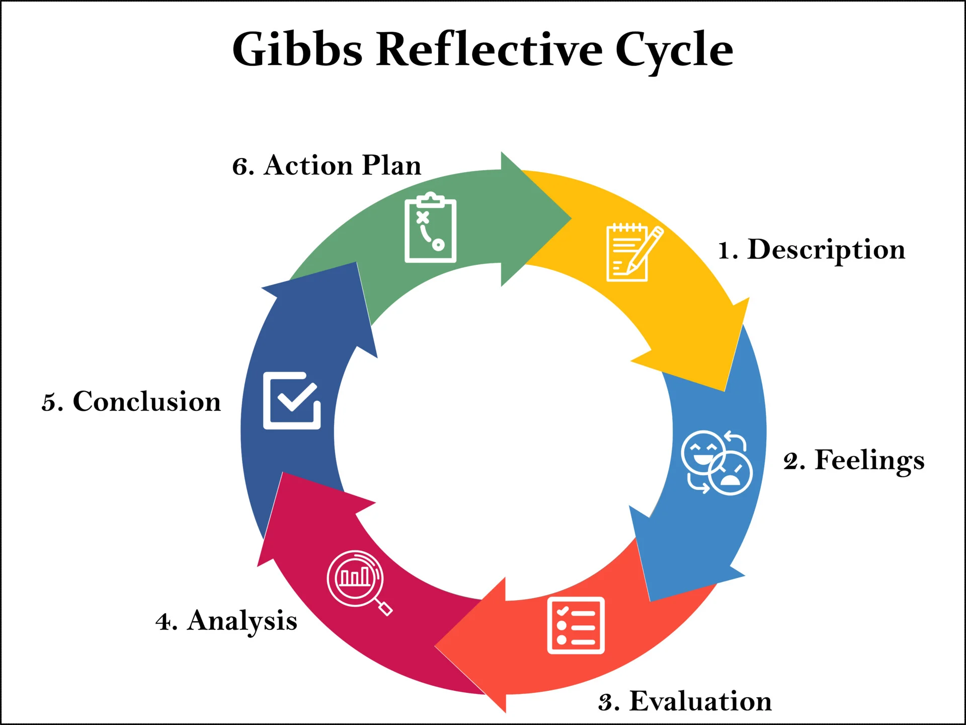
Fig 2: Gibbs Reflective Cycle, source: (McLeod, 2025)

6.1 Description
This is a reflective piece, which examines the process I undertook in conducting research and preparing the report on the Global competitiveness of the passenger-automobile industry in India and the factors that are aiding in the success of Hyundai Motor Company in India. Gibbs' Reflective Cycle was chosen to help organise the reflection. I started by examining the assessment specification, and looking for two tasks that are related. The first step towards assessing the passenger-automobile industry in India was to analyse the country based on Porter's Diamond Model. Secondly, I had to evaluate the political, economical, legal and cultural aspects that affect a foreign multinational. It was decided to choose Hyundai as the case as it had been manufacturing for a long time and has export and domestic operations. The statistics, government publications, Hyundai's annual reports and academic literature on Porter's Diamond, OLI, institutional theory and integration–responsiveness were used to gather data for my research. I also did a comparison of Hyundai with other brands like Maruti Suzuki, Tata Motors, Mahindra, Toyota and Kia. One difficulty was the use by the different sources of different measurement bases (wholesale sales and retail registrations).

6.2 Feelings
Initially, I felt confident as there was a lot of Public information available in the Indian Automotive Industry. However, when I found discrepancies in the numbers and coupled with the confusion in reporting the numbers for the financial year, my confidence dropped. At first, I thought that the more data that I could add, the better the report would be. Once you did too much you began to have descriptive stats instead of strengthening the report and clouding the argument. It is also challenging to do theoretical analysis. My initial line of thinking about Porter's Diamond and PESTLE was that they were both "checklists.I started thinking of Porter's Diamond and PESTLE as checklists. This was done in an organised way but was not critical. I gained increased confidence when I was able to identify that evidence should be tested and explained via models, and not held to control the discussion. Other issues included objectivity. While helpful, the annual report made by Hyundai was of course a positive spin. So I merged the claims made by the companies with SIAM, ACMA, government and competitor claims, so as to triangulate my way to the truth.

6.3 Evaluation
The following elements of the process worked well. The focus on passenger cars, utility vehicles and vans kept me from misinterpreting the whole-sector GDP and employment data and interpreting it for passenger vehicles only. The Hyundai comparison with the other brands substantiated analysis as the Hyundai has adopted a premium mass market approach as opposed to Maruti Suzuki's scale advantage, Tata Motors' electric-vehicle dominance and Mahindra's SUV specialisation. Porter's Diamond helped to assess the industry level and OLI explained the ownership, location and internalisation advantage of Hyundai. Regulation, legitimacy and local adaptation was explained using institutional theory and integration responsiveness framework. However, weaknesses remained. Too much information gathered and not enough developing central argument leads to repetition, too many frameworks and less depth. The evidence base was also not quite up to date, independent and interpreted.

6.4 Analysis
The main learning conclusion was that the discussion of advantages and disadvantages is not enough for critical analysis; it had to include an analysis of what evidence supports, what evidence does not support, and what alternative interpretation(s) are still possible. These initial sales data for passenger cars indicated competitiveness, but a more detailed analysis revealed that growth was not uniform and that SUVs were driving sales growth and maturity in hatchbacks. So I changed my perspective on the market, from a growth perspective to a structural transformation perspective. I also separated manufacturing scale from technological capability, as India has delved deep into the manufacturing of components, but its continued reliance on imports for semiconductors, batteries, and advanced electronics shows that there is still a long way to go. Porter's Diamond came in handy but it was a locally limited model, as Hyundai also uses South Korean technology and global platforms. This enhanced my market attractiveness, profitability, confirmation bias and competitive risk thinking.

6.5 Conclusion
Overall, I gained a better understanding of the process of research and writing, and developed the ability to differentiate description from critical evaluation and to evaluate evidence. I think the most important decisions that I made were specifying my industry very specifically, looking at other companies that I felt were similar to my industry, and triangulating three sources: official, corporate and academic. However, I also identified a few areas that needed improvement, mainly a lack of evidence gathering prior to developing a clear argument, a lack of frameworks and a lack of using too much company-provided resources. The experience was an eye-opener to theoretical models being most useful when they are used judiciously, their limitations are recognised and they can be used to assist, but not supplant, independent judgement. As a result, I am more disciplined in my research and evaluation of sources and in my argument construction and should make my academic writing more clear, balanced and analytical in the future.

6.6 Action Plan
The evidence matrix will be used as a starting point in future assignments that will link each requirement to the evidence, theory, counterarguments and provisional judgement. I will document the basis for each statistic, as well as the date each was used, and keep a record of the quality of the source; I will restrict the use of frameworks to those which help to develop the argument; I will also check to ensure that there is a claim, evidence, interpretation and critical qualification in each of the paragraphs with the reverse outline strategy. Finally, I will leave time aside to practice and learn Harvard referencing, word count checking and verifying tables and figures. Through these activities, my future work should be focused, transparent and in a critical manner.

7. References
Aarland, M. (2024). Cybersecurity in digital supply chains in the procurement process: Introducing the digital supply chain management framework. Information & Computer Security. doi:10.1108/ics-10-2023-0198.
Abraham, B. (2025). Foreign Giants Under Fire: Strategic Responses of Chinese Telecom Firms Navigating U.S. Regulatory and Political Hostility. [online] Utexas.edu. Available at: https://repositories.lib.utexas.edu/items/64712cff-9dce-4cad-94be-c2309e2c5634 [Accessed 11 July 2026].
Achal, D.K. and Vijaya, G.S. (2024). Vendor Partnerships in Sustainable Supply Chains in the Indian Electric Two-Wheeler Industry—A Systematic Review of the Literature. Sustainability, 16(15), pp.6603–6603. doi:10.3390/su16156603.
Artica Pérez (2022). The impact of excess capacity on the investment falloff. Panoeconomicus, [online] 70(3), pp.403–428. doi:10.2298/pan180301017p.
Bolton, B. and Park, J. (2026). Advancing Corporate Governance Research. Edward Elgar Publishing.
ChiniMandi (2025). India’s passenger vehicle sales hit record high at 43 lakh units in FY24-25, utility vehicles driver of growth. [online] ChiniMandi. Available at: https://www.chinimandi.com/indias-passenger-vehicle-sales-hit-record-high-at-43-lakh-units-in-fy24-25-utility-vehicles-driver-of-growth-siam/ [Accessed 11 July 2026].
Ezugwu, E.O., Bhattacharya, I., Ayomide, A.I., Antony Dhason, M.V., Soyoye, B.D. and Banik, T. (2025). Powertrain in Battery Electric Vehicles (BEVs): Comprehensive Review of Current Technologies and Future Trends Among Automakers. World Electric Vehicle Journal, 16(10), p.573. doi:10.3390/wevj16100573.
Goel, S., Moerenhout, T. and Bollini, R. (2024). Unlocking Supply Chains for Localizing Electric Vehicle Battery Production in India IISD REPORT. [online] Available at: https://www.iisd.org/system/files/2024-11/electric-vehicle-battery-production-india.pdf [Accessed 11 July 2026].
Gruyer, D., Orfila, O., Glaser, S., Hedhli, A., Hautière, N. and Rakotonirainy, A. (2021). Are Connected and Automated Vehicles the Silver Bullet for Future Transportation Challenges? Benefits and Weaknesses on Safety, Consumption, and Traffic Congestion. Frontiers in Sustainable Cities, 2. doi:10.3389/frsc.2020.607054.
Hyundai (2024a). Hyundai Motor India Limited - Integrated Annual Report 2024-25. [online] Hyundai.com. Available at: https://www.hyundai.com/in/en/investor-relations/financial-information/reports/annual-report-digital-summary [Accessed 11 July 2026a].
Hyundai (2024b). Industry Report on the Passenger Vehicle Industry in India. [online] Available at: https://www.hyundai.com/content/dam/hyundai/in/en/data/investor-relations/HyundaiIndustryReportFinalReport.pdf [Accessed 11 July 2026b].
India, H. (2026). Hyundai car interiors: Features that enhance every journey. [online] Hyundai motors. Available at: https://www.hyundai.com/in/en/blog/hyundai-car-interiors-features-comfort-technology [Accessed 23 July 2026].
Jagani, S., Marsillac, E. and Hong, P. (2024). The Electric Vehicle Supply Chain Ecosystem: Changing Roles of Automotive Suppliers. Sustainability, [online] 16(4), p.1570. doi:https://doi.org/10.3390/su16041570.
KANKANAMAGE, K. (2025). Investigating the Factors Affecting the High Resale Value of Toyota Vehicles in Sri Lanka. Theseus.fi. [online] doi:https://www.theseus.fi/handle/10024/896297.
Kapoor, A., Puri, P., Joshi, N. and Zutshi, S. (2024). #TheIndiaDialog Working Paper Series Assessment of PLI Scheme on EV Manufacturing in India. [online] Available at: https://competitiveness.in/wp-content/uploads/2024/04/TID_WP_27_Assessment_of_PLI_Scheme_on_EV_Manufacturing.pdf [Accessed 11 July 2026].
Kumar, R., Sinha, K., Fernandes, M., Kumar, A. and Kumar, A. (2025). Open Innovation: Reshaping Industrial Capabilities. SSRN Electronic Journal. [online] doi:10.2139/ssrn.5671911.
Kumbhare, P. (2025). System thinking to analyze the Market penetration of Two-Wheeled vs Four-Wheeled EVs in India. [online] Mit.edu. Available at: https://dspace.mit.edu/entities/publication/f716e19f-a655-4432-9068-2e331c75d956 [Accessed 11 July 2026].
Lee, J., Chua, P.C., Chen, L., Ng, P.H.N., Kim, Y., Wu, Q., Jeon, S., Jung, J., Chang, S. and Moon, S.K. (2023). Key Enabling Technologies for Smart Factory in Automotive Industry : Status and Applications. International Journal of Precision Engineering and Manufacturing-Smart Technology, 1(1), pp.93–105. doi:10.57062/ijpem-st.2022.0017.
Littman, M.L., Ajunwa, I., Berger, G., Boutilier, C., Currie, M., Doshi-Velez, F., Hadfield, G., Horowitz, M.C., Isbell, C., Kitano, H., Levy, K., Lyons, T., Mitchell, M., Shah, J., Sloman, S., Vallor, S. and Walsh, T. (2022). Gathering Strength, Gathering Storms: The One Hundred Year Study on Artificial Intelligence (AI100) 2021 Study Panel Report. arXiv:2210.15767 [cs]. [online] Available at: https://arxiv.org/abs/2210.15767 [Accessed 11 July 2026].
Lopez, P. (2023). Porter’s Diamond Model: An Essential Guide for Global Achievement. [online] SlideModel. Available at: https://slidemodel.com/porters-diamond-model/ [Accessed 11 July 2026].
McLeod, S. (2025). Gibbs Reflective Cycle. [online] Simply Psychology. Available at: https://www.simplypsychology.org/gibbs-reflective-cycle.html [Accessed 11 July 2026].
Mirza, A. (2023). The association of formal and informal institutions with total entrepreneurial activity: A neo-institutional theory approach - Enlighten Theses. Gla.ac.uk. [online] doi:https://theses.gla.ac.uk/83453/1/2022MirzaPhD.pdf.
Mishra,, V. (2025). Global Supply Chain Shocks and Trade Resilience: A Review Post-Covid and Ukraine Crisis. Journal of Marketing & Social Research, [online] 2(5), pp.336–348. doi:https://doi.org/10.61336/jmsr/25-05-38.
Ningsih, E.A., Diawati, L., Sari, H. and Irianto, D. (2026). Sustainability of Industrial competitiveness of the textile and apparel industry in asian Countries—A systematic review. Sustainability, 18(7), p.3400. doi:10.3390/su18073400.
Omer, M., Kaiser, M., Moritz, M., Buxbaum-Conradi, S., Redlich, T. and Jens P, W. (2022). Democratizing Manufacturing – Conceptualizing the Potential of Open Source Machine Tools as Drivers of Sustainable Industrial Development in Resource Constrained Contexts. Institutional Repository of Leibniz Universität Hannover (Leibniz Universität Hannover). [online] doi:10.15488/12154.
Rai, R., Murali, S.A., Sharma, S. and Ramesh, K. (2024). Legal &amp; Economic Standards used in Vertical Restraint and Abuse of Dominance Cases by the Competition Commission of India. SSRN Electronic Journal. [online] doi:10.2139/ssrn.4836113.
Rai, S. (2025). Customer satisfaction and loyalty in a multi-powertrain environment : An analysis of service quality, product innovation, and demographic factors among Maruti Suzuki consumers in India. Theseus.fi. [online] doi:http://www.theseus.fi/handle/10024/903501.
Reddy, L.S., V, R.P., Sabnis, S., Ganatra, V., Shastry, K., Elviona, A., Sin, L.G., Chee, Y.N., Kee, D.M.H., Kerof, C.A.P.P., Qianya, W. and Jiaze, W. (2021). Advertising Strategies of Hyundai Motors In Indian Market. International Journal of Accounting & Finance in Asia Pasific (IJAFAP), [online] 4(1), pp.104–115. doi:10.32535/ijafap.v4i1.1037.
Ruchika Pharswan, Negi, A. and Basak, T. (2023). Impact of Suppliers Network on SCM of Indian Auto Industry. WILEY. online Library, pp.289–314. doi:10.1002/9781119879862.ch14.
Tak, Y.H. (2025). The Complexity-Simplicity Trade-Off: Strategic Fit and Firm Viability in the Security-First Economy. [online] Jhu.edu. Available at: https://jscholarship.library.jhu.edu/items/f5ffa45b-802b-4c72-a46b-38c3e860408a [Accessed 11 July 2026].
Tejaswini, K., J Yadunandh, G Uma and Shruthika S (2026). Driving India&#039;s Growth: A Statistical Assessment of the Automotive Industry&#039;s Socio-Economic Impact. Journal of Industrial Engineering and Technology, [online] Volume79(Jan-March 2026), pp.118–132. Available at: https://www.researchgate.net/publication/400593476_Driving_India [Accessed 11 July 2026].
Thanh, T. and Surender Rangaraju (2024). How Hyundai Expanded Its Automotive Footprint in Vietnam Market. [online] Www.researchgat.org. doi:10.13140/RG.2.2.23357.99044.
Vasanthkumar B (2025). <P><span>Impact of Electric Vehicles in Current Automobile Component Sector</span><span> </span></p>. SSRN. [online] doi:10.2139/ssrn.5267978.
Vyas, C.A.S.D.D. (2024). THE IMPACT OF MACROECONOMIC CONDITIONS ON INDIAN AUTOMAKERS INCLUDED IN THE S&P BSE MANUFACTURING INDEX LIST. International Soil and Water Conservation Research, [online] 12(3), pp.14–25. Available at: https://iswcr.com/index.php/iswcr/article/view/39 [Accessed 11 July 2026].
Wandhe, P. (2024). An Overview on Production Linked Incentive (PLI) Scheme by The Government of India. Social Science Research Network. doi:10.2139/ssrn.4693578.
Yovka Bankova and Tsvetelina Tsvetanova (2024). The Diamond Model of Porter to Measure Rural Regions” Competitiveness: A Case from Bulgaria. Annals of Dunarea de Jos University of Galati Fascicle I Economics and Applied Informatics, 30(3), pp.379–385. doi:10.35219/eai15840409465.
Yücesan, E. (2025). Does deglobalization imply the end of global supply chains? International Business Review, p.102398. doi:10.1016/j.ibusrev.2025.102398.
Zhang, Y. and Bilawal Khaskheli, M. (2025). The Role of Digital Technologies in Advancing Sustainable Economic Development into Intersections of Policy, Law, Environmental Economics, and a Comparative Study of China, the EU, and the USA. Sustainability, [online] 17(19), p.8666. doi:10.3390/su17198666.

