Workplace Culture and its impact on Organisational



BA(Hons) Leadership and Management Skills for the Workplace
BMSW5101
Workplace culture and its Impact on Organisational Efficacy

Student name- Jesica Mora Mera

Student No- 2010296

Module Name- Developing workplace critical thinking

Module Tutor- Md Kalan

Executive summary (150-200 words - but it will not count towards your report)

Table of contents
Contents
Executive summary 2
Introduction 4
Organization Culture 7
Ethical Dilemma 8
Conclusion 8
Recommendations 8
Task 2 Individual Reflective 9

Purpose of the report

Introduction
The purpose of this report is analysis the culture and context of an organisation, critically evaluation culture and ethical behaviour in the organisation. Environmental and organisational analysis techniques will use.
Reiss is the organisation I choose in this assessment because in the future I want to be part of Hed office.
It was launched by David Reiss in 1971 and proved a design philosophy focused on creating modern menswear, womenswear, accessories, and childrenswear. style house and offers affordable luxury collections of uncompromising elegance. Over 5 decades, Reiss has developed a totally unique fashion vocabulary and has garnered a loyal following of discerning individuals, stylish celebrities, and royalty. "This is our story," tells the history and highlights of the logo from 1971 to today. The brand, which has its roots in menswear, launched its women's collection in 2000. Known for its contemporary take on formal and workwear, the brand has garnered a following from both the Duchess of Sussex and the Duchess of Cambridge. Reiss is a UK-based fashion brand and retail chain with around 225 stores worldwide.

REISS LIMITED
Company number 02655347

Company status
Active
Company type
Private limited Company
Incorporated on
18 October 1991
ANGELIDES, Christos
Company Director
Correspondence address
Reiss Building, 12 Picton Place, London, England, W1U 1BW
Role
Active Director

Appointed on
9 August 2018

Country of residence
United Kingdom
Company size (No of Employs)
1077
Key stockists:
Concessions in John Lewis, Selfridges, Hoopers, Fenwick
UK Concessions
Approx. 25
Payment Methods
Debit card, Credit card, America Express, PayPal, gift card
Delivery options
Standard delivery, Nex day delivery, in store collection
Head office
Reiss Building, 12 Picton Place London W1U 1BW

Instagram
Instagram https://www.instagram.com/reissfashion 86700 Followers.
Facebook
https://www.facebook.com/Reiss/?id=web 205,604 Followers

Twitter
https://twitter.com/reiss/ 67,600 Followers

Printers
https://www.printers.com/reissfashion/ 21,000 Followers

Brand
Reiss

International websites in the US, Australia, France, Germany, Ireland and Hong Kong, Reiss will be adding a local site in the Netherlands and implementing an upgraded international site that will run in 60 markets.

Macro environment

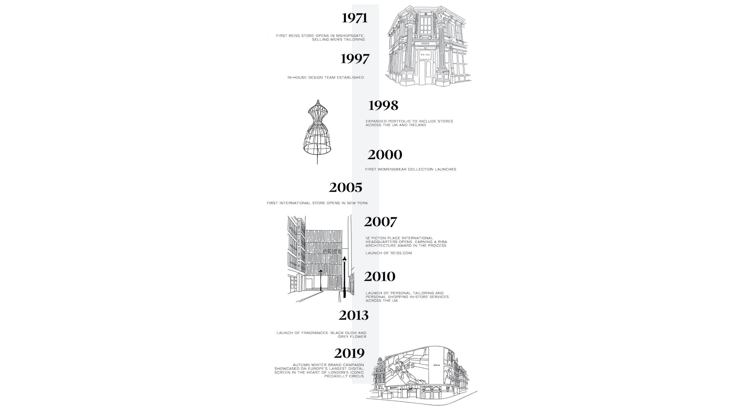

1971 – The son of a city tailor, David Reiss Opens the first Reiss Store in Bishopsgate selling Men’s tailoring
1980 – Reiss branches out from the city opening a store on The Kings Road with Head Office above it
1997 – Reiss begins to design in house
1999 – Reiss branches out across the UK
2000 – Womenswear is launched
2005 - First international store opens in New York
2007 – 12 Picton Place our Head Office opens, we also launch Reiss.com
2010 – The Royal connection! Kate Middleton wears Reiss for official engagement photo’s
2017 – Reiss is sold to Warburg Pincus – David Reiss still retains a % of the business and becomes Chairman. Christos is appointed as CEO
2021 – Next acquire 25% of Reiss from Warburg. Lord Simon Wolfson replaces Chairman of the Board
2021 – Reiss Childrenswear is launched

Organization Culture

Reiss Culture

- Teamwork - Trust and support each other
- Specialist Skills - Use and keep improving your unique skills
- Ambitious winners - each of us needs to be better than our counterparts in other brands
- Leadership - It is not restricted to management. Advance, move forward and improve a situation
- Resilience - There are more tough times ahead
- Positive mindset - Be part of the solution, not the problem
- Fun - more fun comes from success

Significant growth in the last years specially during covid
The global pandemic Covid 19, ended 30 January 2021 forced store closure, lockdown, and other restrictions on social activity as government sought to suppress infection rates. Follow a record year in the 52 weeks ended 1 February 2020, Reiss began the period in very strong position as one of the best performing affordable luxury brands in the UK. I inevitably, the COVID 19 pandemic has had a profound impact on the groups revenue and profit this year. Sales for the 52 week ended 30 January 2021 totalled £133.4 m (52 week ended 1 February 2020 restated: £174.8 m)
Key actions:
- Investment in the warehouse and warehouse staff to ensure the website could continue to trade.
- Focus on cash management.
- Negotiating with landlords.
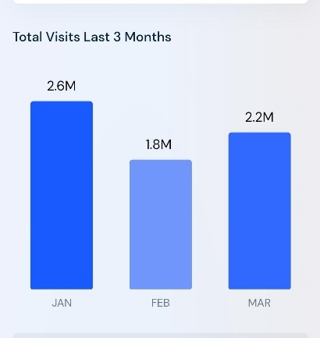
Similar web (2022) https://www.similarweb.com/website/reiss.com/#geography

Marketing Share

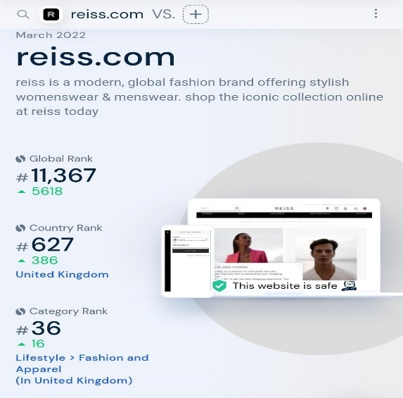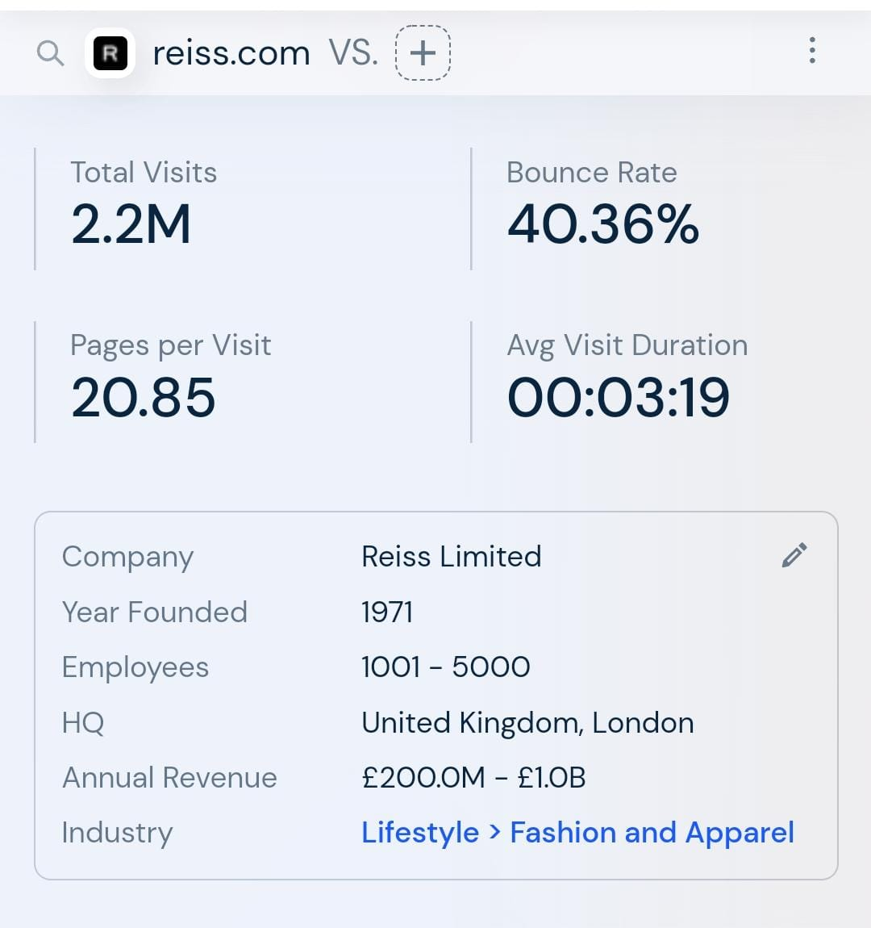
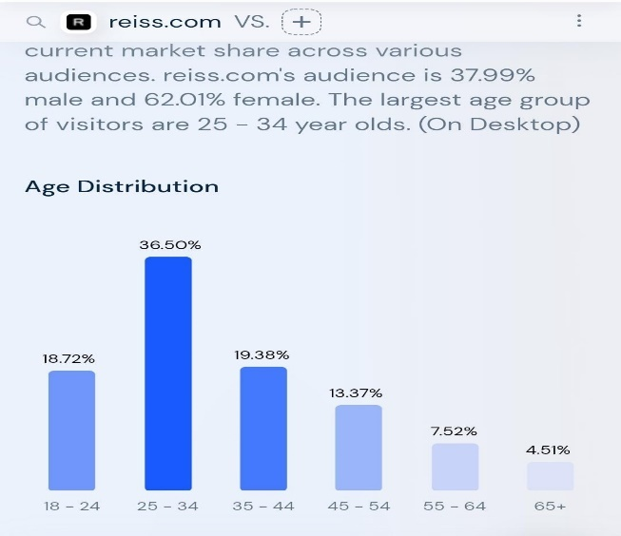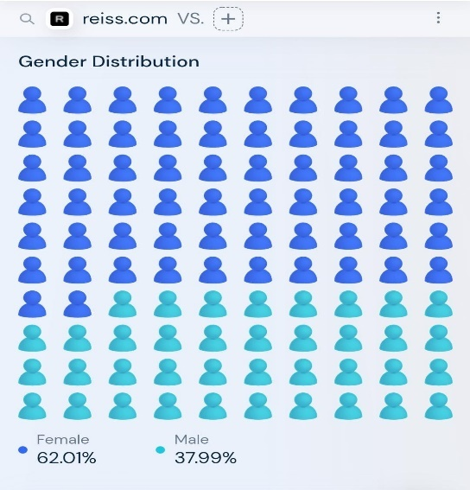
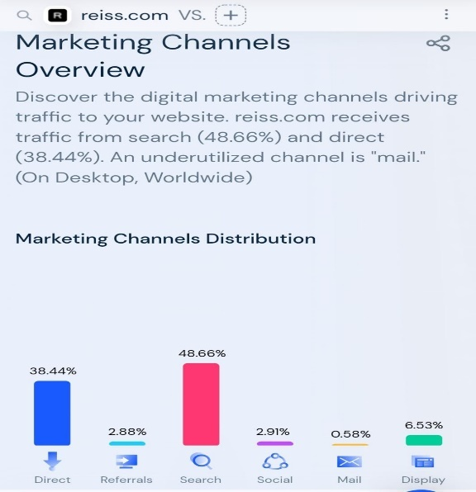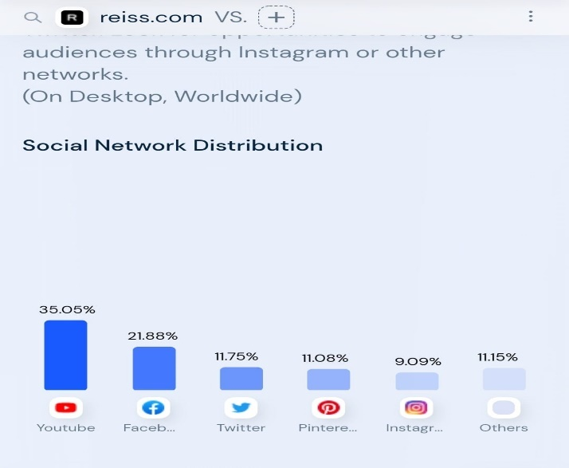
Similar web (2022) https://www.similarweb.com/website/reiss.com/#geography

Reiss limited company number 02655347
Reiss the enterpriser David Reiss was born in London in the 1950s. He took over his father' business (wholesaling menswear) in the early Nineteen Seventies and for a few times in hand a factory in Yorkshire where he made his own collection. Reiss designs retails high quality men’s, women’s, children’s fashion clothing and accessories. These are sold exclusively under Reiss brand in the UK and overseas. Reiss promise of “affordable luxury “position it between mainstream high street retailers and international luxury designer brands. Established in the UK as a menswear retailer in 1971 and first entering the womenswear market in 2000, tailored for modern childrenswear in 2020. New collection Petite is now trading online. Reiss is one of the UKs best known fashion brands and has an established global presence. We are focus on delivery the high-quality clothing and good customer services. Reiss and Next are partnership, Reiss online operations will be contracted to next via Next’s total platform. Also supply warehouse and distribution services for Reiss business. Reiss and Next, they are confident to serving our customers efficiency customer services.
Reiss was founded in 1971 by David Reiss, originally merchandising men’s suits. Since 2000, Reiss began to sell womenswear. products lie at the heart of the retailer’s strategy because it seeks to embody David Reiss' belief in beingness instead of fast fashion. All vestures} is its own brand and not overtly branded. The focus is on high-quality clothes clips with a little design stubbornness. Women's clothing costs up to £1,500, giving Reiss the highest ranking in the high street market. In the UK, Reiss works in around 20 dealerships, mostly John Lewis, as well as around sixty independent stores. The company is focused on international growth and last year opened 40 new stores around the world. The company recently opened 12 concessions for Nordstrom stores in the United States.
Reiss Environmental
- Reiss are committed to reduce carbon emissions to Zero or less by 2040.
- Reducing our waste to zero by 2025.
- Reducing the use of energy and water in all activities,
- Better Cotton (2022) https://bettercotton.org/
- Leather Working group (2022) https://www.leatherworkinggroup.com/who-we-are/about-us
- The reduction and reuse of paper and packaging is of paramount precedence for the safety of the world’s constrained forest assets and has a clean and useful effect on decreased costs.
- Reusable / refillable transport containers to lessen corrugated paper and paperboard.
- Design and enforce e-commerce, transport, show, and wrapping structures that decrease using paper.
- Utilize re-useable packaging structures for intra commercial enterprise applications.
- Increase using virtual communication, advertising, and accounting structures.
- Adopt first-class practices inclusive of learning and making use of rising and round financial system innovations.

- https://www.greenamerica.org/report-skip-the-slip



Reiss PESTLE Analysis

Political
- Personal
Economic Factors
- Personal Disposable Income increased by 11%
- Further increase up 13 % project
- Consumer expenditures grew by 16% between 1997 & 2001
- Consumer orientation towards spending than saving
- Interest rate
- Inflection rate

Culture factors
- Changing trends towards quiet and casual article of clothing.
- Fashion promotion through media & fashion magazines.
- Shift from goods garments to fashion wear.
- Huge and straightforward convenience of fashion wear.
- Accrued range of operating women

Technologies
- Intelligent cloths expected be launched in the future and gain popularity
- Development of cloth fibres with moisturizing creams coating of Teflon.
Legal
Privacy policy
Next and Reiss control data protection
Environment
Reiss commitment to protecting the worlds forest through our paper, packing and fabric choices.

5 forces model

Competitiveness
Reiss | Ted Baker | Jack Wills | AllSaints | Ralph Lauren
Reiss is a fashion brand and retail store chain offering menswear, womenswear, and accessories. | Ted Baker is a designer brand offering menswear, womenswear, and accessories. | Jack Wills operates as a textile apparel manufacturer and designer of menswear and womenswear. | AllSaints is a fashion house creating clothing and accessories for men and women. | Ralph Lauren is a company engaged in the design, marketing, and distribution of lifestyle products.
Founding Date 1972 | Founding Date 1988 | Founding Date 1999 | Founding Date 1994 | Founding Date 1967
Type  Subsidiary | Type  Public | Type  Subsidiary | Type  Private | Type  Public
Tags: Retail, accessories, clotting, Fashion | Tags: Retail, accessories, clotting, fashion | Tags: Manufacturing &Industrial Retail, accessories, clothing, consumer goods, textiles | Tags: Retail, accessories, clothing, ecommerce, fashion | Tags: Manufacturing &Industrial Retail, accessories, clothing, interior design
Employees  1133 | Employees  2596  28% decrease | Employees  2592 28 % decreased | Employees  548  2% decrease | Employees  1756
Valuation ($)  N/A | Valuation ($) | Valuation ($) | Valuation ($) | Valuation ($)
Twitter followers 64.1 K | Twitter followers | Twitter followers | Twitter followers | Twitter followers
Number of tweets (last 30 days)  53 | Number of tweets (last 30 days) | Number of tweets (last 30 days) | Number of tweets (last 30 days) | Number of tweets (last 30 days)
Average likes per tweet (last 30 days)  1.2 | Average likes per tweet (last 30 days) | Average likes per tweet (last 30 days) | Average likes per tweet (last 30 days) | Average likes per tweet (last 30 days)
Percentage of tweets with engagement (last 30 days) 50.94 | Percentage of tweets with engagement (last 30 days) | Percentage of tweets with engagement (last 30 days) | Percentage of tweets with engagement (last 30 days) | Percentage of tweets with engagement (last 30 days)
Alexa Website Rank 29957 | Alexa Website Rank | Alexa Website Rank | Alexa Website Rank | Alexa Website Rank
Employee Rating 3.1 | Employee Rating | Employee Rating | Employee Rating | Employee Rating

Threat of New Entrants
Reiss competitors in Masch 2022 is Ted Baker, Karen Miller, Allsaints, French connection.

Bargaining Power of Suppliers

Bargaining Power of Suppliers

Bargaining Power of Buyers

Threat of Substitutes
Democratic Treats

Competitor Analysis
https://www.similarweb.com/website/reiss.com/competitors/

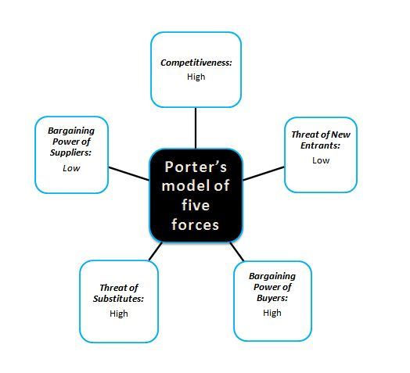

Organisational Culture

At Reiss our culture is based Upton having a standard goal and propose to grow the company year on year while guaranteeing we still are a good place to work. we tend to do that through teamwork; trusting and supporting every other, while recognising we are all specialists in our own areas. we tend to encourage our team member to be ambitious and invariably move into the shoes of the customer. thinking commercially and sanely once creating decisions. everyone seems to be chargeable for their success and results Reiss success, and that we believe that to keep up the company moment and achievements, we should all out perform our counterparts in alternative brands. everyone seems to be a leader at Reiss, not simply our manager, we tend to recreate out team to hunt opportunities for improvement, recommend and implement solutions, and help as to continually move factor forward. If mistakes happen, we believe it's better to say them hide them as that's however we will all learn and become better at what we do. Most of all we believe workers ought to get pleasure from what they're doing and celebrate while work. Fun comes from being successful however being successful also comes from having a happy workforce.

  - File downloaded and (you may need to use the checklist)
Define the organisational culture and critically investigate the culture of your chosen organisation using a cultural WEB model
- Organisational Culture and External Factors –
BREXIT
COVID

Next New technology
Next been trading to Reiss employees, managers, and the staff to working with the new technology sharing technical information. This technology comes into everyday use in the organisation, and hence the managers and employees who use the technology on a day-to-day basis. This gives the opportunity to the employees to practices. The new technology benefit to the organisation and customers.

- Organisational Culture and Performance
  - Find this info on the annal report WEBSITE
Briefly explain the impact of organisational culture on organisational performance and critically investigate the relationship between your chosen case study's present organisational culture and its financial and non-financial performance with illustrated examples
Promotion
Discount to move old stock twice a year. Now there are sales and offers in store at least six times a year: January and July, mid-season, and special events.
Uniforms
Recluting
Discounts
Ethical Dilemma
Low motivation and morale
At Reiss score is no good enough. It is a member of the Ethical Trading Initiative - ETI. The employee has said is lack of communication and insufficient delegation of decision-making. which includes rights to make a complaint, lack of clarity in job definition, excessive of labour abuse. The employees proof it the fee of a residing salary in its delivery chain. It audits several its delivery chain. It does now no longer divulge any rules or safeguards to shield providers and employees in its delivery chain from the influences of COVID-19.
Late and inappropriate decisions
Reiss Customer services decisions they are poor co-ordination in different units, insufficient delegations.
Conflict and lack of co-ordination
In the stores in Reiss people working at cross purpose, because of lack of motivation, lack of clarity on goals and priorities. They are not team work skills,

Conclusion
Minimum wage. Rare opportunity to grow professionally.
Unfortunately
Most important
Whilst evaluation is important for business reason it also has a human implications and so we should be looking for measures in both areas. Moral, attitudes, satisfaction., progress, support

Recommendations: suggested action choices that can be used to overcome the identified challenges and potential benefits of applying recommended suggestion

References
Case Marathon (1994), Bob Reiss and Valdawn Exhibit B: Porter’s Five Forces Model https://casemarathon.com/harvard/bob-reiss-and-valdawn-a-november-1994/porters-analysis.php
https://fashionbi.com/brands/reiss/financials

https://find-and-update.company-information.service.gov.uk/company/02655347/officers

Compare countries - Hofstede Insights (hofstede-insights.com)
Compare countries - Hofstede Insights (hofstede-insights.com)

(14) Charles Handy's Model of Organisational Culture - YouTube

https://www.youtube.com/watch?v=wd1bsxWeM6Q

Task 2 Individual Reflective

Outline learning with example:
- What was your understanding about workplace Culture before taking this module?
- What have your learned during this module?
- What is your understanding about workplace culture after taking the module?
- What useful Skills at the workplace you learned during this module?
You must outline your learning and acquired skills from this module with examples which can be used for employment requiring the exercise of personal responsibility and decision making by understanding the organisational workplace culture (1000 words +/- 10% words) - 25% of overall marks

Workplace Culture and Organisational Efficiency BMSW_5105 Weekly schedule Week No. Topics Notes Week 1 Introduction to the of the Module. General topics to be discussed the organisation and its environment - Part I PESTEL Analysis Activities: Case Study – Highways Agencies; Real Estate Report. PPT slides Case Study

Week 2 The organisation and its environment - Part II Porter’s FIVE Forces Activities: Case Study – Reserve; costa-coffee PPT slides Case Study

Week 3 Organisational Structures Review of Assignment Brief Activities: Case Study – Specsavers PPT slides Case Study – Specsavers
Week 4 Organisational culture Additional notes on understanding organisational culture Activities: • Activity 4.2 Identifying the elements of the organisational culture • Activity 4.3 Understanding organisational cultures PPT slides Case Studies
Week 5 Creating an ethical and sustainable culture in an organisation Reflection • What can employees do to facilitate the socialisation process? • What can organisation do to facilitate socialisation? Reminder- Submission of Assignment Plan – 500 words PPT slides
Week 6 Determinants of a successful organisational culture and culture change. Video - Do you want to know how to lead change management? PPT slides & Videos
Week 7 Barriers to effective functioning of an organisation • Article - The Silent Killers of strategy – Beer • Organisational Healthcheck Questionnaire Activity Case Study – Siemens Formative Feedback PPT slides Video - Do you know about the "Silent killers"?
Week 8 Global implication of organisational culture Formative Feedback PPT slides & videos Video - Cultural differences in doing business
Week 9 Business Ethics and Ethical Dilemmas Discussion of Assignment Brief Video- Ethical Dilemmas and Decisions
Week 10 Workshop Discussion of Assignment Brief Recommended Structure and Checklist

Appendices (if

