

Assessment Component 1

Case study - Written Report

Student name: Achiaa Boakye
Student ID: 1916597
Module name: Children, Young People and Families
Module code: (BMHP5004_LON)
Lecturer name: Bianca Sanfilippo
Date 19/08/21

Table of contents
- Introduction ……………………. P1
- Case Study ……………………………. P1
- Child Vulnerability ……………………… p2
- Factors of child vulnerability …………… p3
- Interventions …………………………… p4
- Evaluation ………………………………. P6
- Conclusion ……………………………. P7
- References ……………………………. p10

Introduction
For the past decades, children’s inequalities in UK have come to question to accept by society most vulnerable groups. Mostly children certainly face the outcome. This report will look at vulnerable child and the factors that contribute to the vulnerability of a child and the needs to combine flexibility formular outline the policies. The report will evaluate the relationship between vulnerable and a child in need and the situation that build up children flexibility. Finally, the report will outline a lay down procedure through direct from OECD countries that support child development and welfare planned with special focus on vulnerability child.

Case study
This case study consists of four family who are in their early thirties and late twenties with their two children Jayden and Erin lived in Sheffield. The father (John) is now serving two years jail term due to his constant alcoholic and temperament behaviour that made him leave school early without any qualification. Their son (Jayden) also had attention deficit hyperactivity disorder (ADHD). Their daughter Erin in primary school were placed on high-risk registrar due to social service involvement with them almost a year that believed as a suspect physical abuse with the father who has a history of domestic violence and involved with social service since he was a teenager. John considered to be violence person as he has anti-social behaviour due to repeated offending family attitude.
Child vulnerability
This case study shows family were facing a lot of difficulties when compared to average family as the father was serving two jail term and the children being place on high risk of registrate due absence from school and suspected physical abuse going on in the family that made the children vulnerable and different from average family. Vulnerability of child can be described as a result of action of a different separate surrounding factor that composite changing over time. Different types of child vulnerability extend as these elements continuous to progress, (NSPCC,2019) for example, age shapes children need and expose them to possible high risk. The infant who are totally dependent on the needs reactively and expected care given, are expective tactful to parent’s well-being and material hardship. Young children between the ages of three are also affected drastically through parents’ difficulties and other forms of hardship since, their continuous growth of brain developing stage according to neuroscience child brain develop as early stage. Vulnerable defined as frequently expose to harm and abuse, being neglect. According to children Act 1989, children are well catered for within their own families and parents make every necessary effort to help them where practicable. This shows child’s needs or wellbeing are paramount in a family, and it should put in consideration when making decision about their welfare, feelings and their desires, so a child need happened when child without intervention of social service cannot effort a good living or when a child is unable to reach or attain, any appropriate quality of health or circumstances without providing of social services.
There are most of factors that contributed to children’s vulnerabilities, mostly individuals’ factors that influence child vulnerability comes from psychological, emotional and physical competence of potential situations. Example, disability and age, a children own positioning or inner state or special education needs like Jayden with (ADHD) becomes vulnerable. they are variable that can make someone vulnerable such as belonging to ethic minority group or experiencing maltreatment from institutional background.
Disability: according to NSPCC,2019, children with disability or development difficulties including mental health state and special education needs turns to be vulnerable due to lack of communication and are more likely to be at risk of maltreatment or neglect when compared to average child without disabilities.
Mental health State
Evidence has proving that a lot of children mental health state or difficulties has become more rampant. Most OECD countries, such as England, mostly experience growth over the last ten years according to survey (NSPCC 2017) Explaining being emotional welfare and high academic pleasure and weaken family support play significant part. Inequalities also play part in children inner being. Children from low-income background are higher to develop mental health issues than children from high social-economic background, for example logistic deprivation, inferior social stigmatization and strong parents’ child transmission also play part. Well elite parents are more likely to approach quicker interventions or specialist services for their child support.

Parental substance misuse
(NSPCC 2018) stated that parental substance misuse has impacted on the children due to parent long term substance misuse. For example, parents who consume too much alcohol leads to alcohol related health issues such as depression, physical sickness and accident that impacted the supervision of their children and unpredictable lifestyle that may struggle to identify and meet their children needs, this act may result putting their child at high risk of harm. In this case study the father John, who because of alcohol substance misuse put their family at risk of abuse. because when someone dependant on alcohol, they are likely to crave for more alcohol and continuous to drink although it is causing them danger. Heavy alcohol drinking associate with domestic abuse and other forms of criminal activities. (NICE 2011) that impacted on their children.
Emotional and physical Abuse
The influence of parental substance misuse is emotional, or physical abuse on their children. Typically, example of the case study above. Because john was alcoholic, he was always abusing the family, and this put Bridget in emotional stress that impacted on the children for school authority to put them on risk- register. According to NSPCC, 2019) Parents who drink heavily, or misuse drug turned to be emotionally unapproachable to their child and like mother who have drug issues becomes less responsible to their child needs, refuse to engage with their children and response to their children in a distasteful manner that may frighten their children. Parents who also misuse substances/ alcohol also have difficulties in controlling their emotions. Typically, excessive drinking contributed to physical abuse (Clever, Unell and Aldgate, 2011). This case study present multiple risk factors as seen above such as physical abuse, domestic abuse and alcohol misuse/ substance misuse
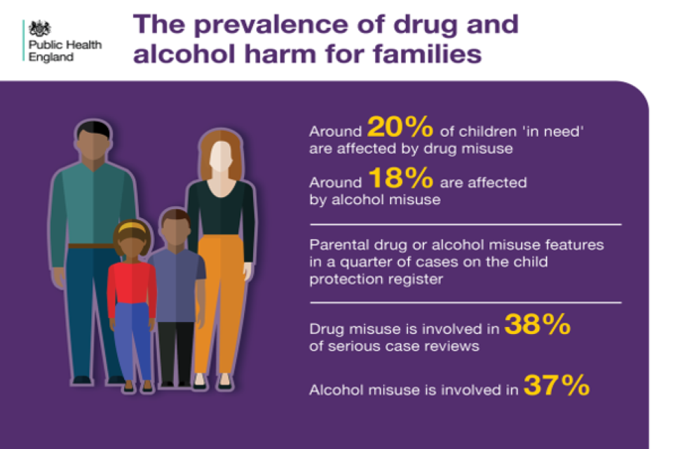
Image 1: Source:

According to (NSPCC 2019) parental alcohol misuse that affected children in need over the year was around 37% and about 84% referral were made for children living with families facing diversity that led to other forms of abuse such as neglect.
Neglect: can be describe as mistreatment from individuals resulting from inadequate Attention such as not getting necessity and support deserved, example, ignoring medical needs, food, shelter and clothing.
Rgards to the above case study one of the factors of vulnerability was domestic abuse:
In United Kingdom this factor is increasing recently among most families
Domestic abuse
According to survey in England and Wales about 2.3 million adult experience domestic abuse over the last year. While 1.6 million were women and 757000 were men. Its data shows women are more prone to domestic abuse more than men as it happened in the case study above. In this case the children become subject of assessment as according to Children Act 1989 every child have the right to protection from abuse and exploitation and the right to safe environment, so the assessment was based on children as the guideline highlighted the procedure in considering a child at risk practitioners should focus on questions such as
Is this child in need? According to Children Act 1989 Section 17 that says” He/she is unlikely to reach or maintain, or have golden opportunity of reaching a quality healthcare of service or expansion without the provision form local authority”
A child developing is obviously to be outstandingly damage, or crucially harm, without the support of such services; He/she has disabilities. If there is any doubly there is believed that the child is vulnerable or presumably to bear remarkable harm under the section 47 of Children Act 1989 what authority should or can be done to take action to safeguard these children by single assessment.
Is this child in need of Accommodation? Again, under section 20 of the children Act 1989 explain how local authority should come up with a shelter for children whose don’t have a home or accommodation to stay to safeguard any unforeseen danger and this can be done through child and family assessment.
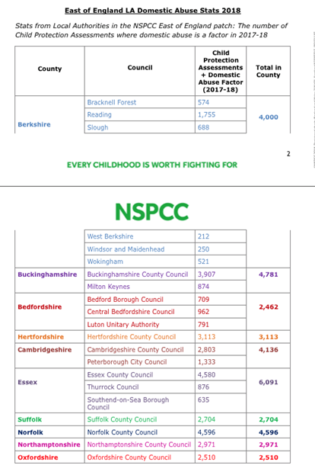
Analysis: The assessment, intervention of multi-agency and results

The practitioner in this case study implemented a particular intervention as the family was at risk and specific assessment was needed.
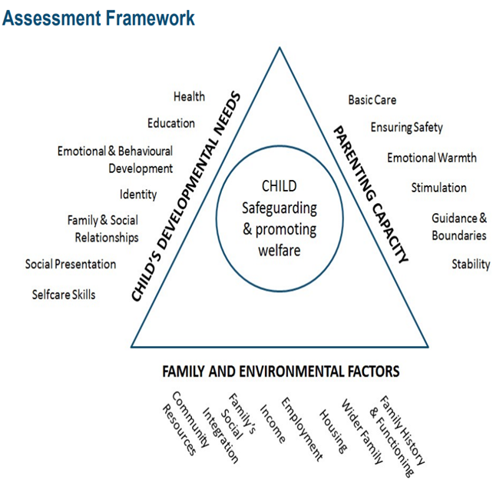

Interventions
This intervention made in accordance with Children Act 2004 that hold the local authorises responsible and other working agencies working with children and young adult to protect them from harm, Neglect and abuse. The social worker according to the Children act 2004 and the statutory guidance ‘Working Together to Safeguard Children A guide to inter-agency working to safeguard and promote the welfare of children’ (2018)”, they have responsible to work in partnership with other multi-agency. The organization that sees the needs of all children service both private and public such as NHS and private healthcare providers, Police Officers, Probationers, rehabilitation Offices and Offending Team. In this case study there was multiples agencies involved for example John was sent to attend programme and one to one session to manage his domestic violence, anger management and alcohol awareness, while the social worker also taught both John and Bridget on their parental responsibilities before John returns home from prison. The social worker was able to support this family for almost ten months and until there was positive result, John behaviour was changed through one-to one counselling session, was able to complete NVQ level two that gave him permanent job, and finally John became mentor for other people who are in similar difficulty situations. Bridget also become confidence and remained in employment and the children stays in school full time. In this scenario, the social worker intervention was based on “United Nations Convention on the Rights of the Child (UNCRC, 1991), and another Article like 24, 26. (Article 24 that place responsibilities of United Kingdom government to support and ensured children welfare. Again Article 28 under Children Act 1989 also protect the right of education. In this case study because the children were place at risk-register due to low attendances, the social worker ensured the improvement of attendance according to (UNCRC,1991) that states “every child has a right to an education”
Article 24 that stated every child includes received best health care is related to (UNCRC 1991) “every child has the right to the best possible health’. Article 26 that also states that government should provide financial support and other benefit such as child benefit, child tax to support families who are in need off.
Article 27, every child has a right to live basic good standard of living that meet their physical and social development’. The Quality Act 2010 was also in line with this case study as the social worker demonstrated professionalism in this case, that involved all the family and the children and asses them fairly without any discrimination whatsoever as the Act ensured that professionals removed any barriers that may hinder the processor of fairness.

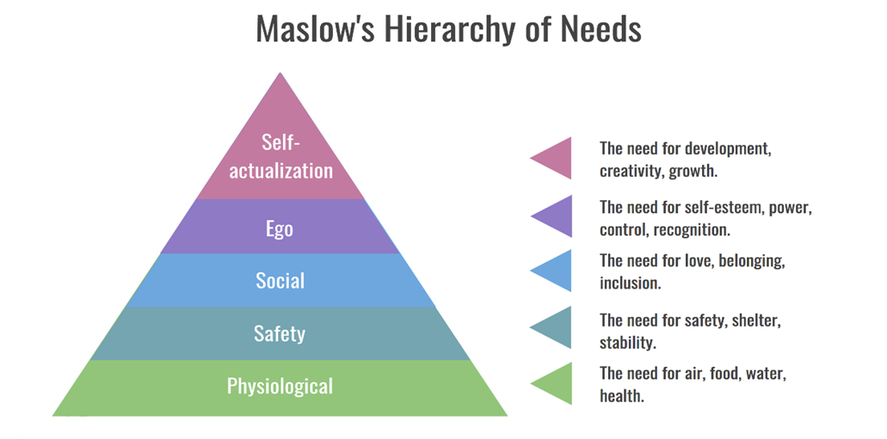
Evaluation
According to Maslow Theory, 1958, to be able to achieve full potentials there are basic thing that needs to be fulfilled in structure form firstly, physiological needs as food, water, and toilet. Secondly, safety needs, Home, health and health plan and thirdly, love and society which includes, relationship, family members, friends and other peers. Fourthly, esteem needs that includes self-esteem, self-confidence and respect for others. Lastly, self-actualisation. In order to be able to achieve this self-actualisation, able to meet the above needs before can be achieved. To this end, the social worker in this case study was able to achieve these goals by working hand in hand with the family, and the children along using most effective intervention without prejudice to safeguard the family.
Conclusion
There is a need to provide better and inclusive services for all children, together with services that prevent struggling and support families that surface diversity. It is also vital that vulnerable children received relevant support. This can also relate to Bronfenbrenner ecological theory that talks about a child environment affected by his/her development. According to Bronfenbrenner, a child is not only influences by family rather healthcare practitioners, community and social workers. Similar example was the practitioners in involved in this case scenario. They were able to make impact in the family, school attendance improvement, behaviour changed, Bridget getting self-confidence, John stays in permanent job was a big positive influence.

References
Bronfenbrenner, U. (2005) Making human beings human: Bioecological perspectives on human development. Thousand Oaks, CA: Sage
Center of the Developing Child – Harvard University (2021) Three Core Concepts in Early Development https://developingchild.harvard.edu/resources/three-core-concepts-in-early-development/(date accessed: 02/08/2021) Estonia: Towards a Single Government Approach, OECD Public Governance Reviews,
OECD Publishing, Paris, https://dx.doi.org/10.1787/9789264104860-en
OECD (2018), Equity in Education: Breaking Down Barriers to Social Mobility, PISA, OECD Publishing, Paris, https://dx.doi.org/10.1787/9789264073234-en.
[1] OECD (2018), Opportunities for All: A Framework for Policy Action on Inclusive Growth, OECD Publishing, Paris, https://dx.doi.org/10.1787/9789264301665-en.
PCC (2019) Children living in families facing adversity. (online) Available at: https://learning.nspcc.org.uk/media/1432/nspcc-families-facing-adversity-helplines-report.pdf (Accessed: 19/08/2021).
NSPCC (2018) Safeguarding children and child protection. (online) Available athttps://learning.nspcc.org.uk/safeguarding-child-protection (Accessed: 12/07/2021).
Children’s Commissioner (2018) Vulnerability Report. (online) Available at: 2018https://www.childrenscommissioner.gov.uk/wp-content/uploads/2018/07/Childrens-Commissioner-Vulnerability-Report-2018-Overview-Document-1.pdf (Accessed: 19/08/2021).

