

A Management Information System for the University of Wales Trinity Saint David’s Student Services Department
By
Cerys Bethan Nickels

Supervisors: Beverley Holland, Sue Maw

Project submitted as part of the requirements for the award of MComp (Hons) Software Engineering

May 2019

Declaration
I, Cerys Bethan Nickels, declare that I am the sole author of this project; that all references cited have been consulted; that I have conducted all work of which this is a record, and that the finished work lies within the prescribed word limits.

This work has not previously been accepted as part of any other degree submission.

Signed: C. Nickels
Date: 24th May 2019

Form of Consent
I, Cerys Bethan Nickels, hereby consent that my project, submitted in candidature for the MComp Software Engineering degree, if successful, may be made available for inter-library loan or photocopying (subject to the law of copyright), and that the title and abstract may be made available to outside organisations.

Signed: C. Nickels
Date: 24th May 2019

Abstract
The aim of this project is to develop a management information system (MIS) for the University’s Student Services that alerts Valerie Harding and the member of staff that their qualifications/ checks and professional body memberships are due for renewal. To achieve this, the project must achieve the following objectives:
- A literature review to determine key aspects of management information systems
- Research usability and accessibility and create a set of criteria to which to evaluate the Student Services MIS.
- Research compatible programming languages and integrated development environments (IDE’s) to develop the system
- To design, create and test the MIS
- Analyse and evaluate the system against a list of criteria.
The design and implementation of the project follows an agile methodology, known as feature driven development (FDD), which uses timeboxes to organise the design and development of the application. The application works as expected, with the exception of exporting data to csv file format. The application design has a system usability score of 83%, which higher than the mean score of mid 60’s.
This project could be expanded, by fixing the issues with the data export feature, in addition to additional testing on the email feature to ensure it works as expected. Additionally, there are many recommendations for improvements, including web capability for the system, with a link on the staff MyDay portal, monitoring staff hours by incorporating a calendar feature, and the creation of a splash screen for increased professionalism.

Table of Contents
Declaration 1
Form of Consent 1
Abstract 2
Table of Figures 10
Tables 13
Project Introduction 14
Aims and Objectives 14
Report Structure 14
Background Research 15
Introduction to Usability & Accessibility 15
System Usability, Accessibility and UI 15
Usability Guidelines & Principles 16
Shneiderman's 8 Golden Rules of Interface Design 16
Nielson’s Usability Heuristics 17
Dix Design Principles 18
Analysis & Comparison 19
Usability Evaluation Tools & Techniques 20
Eye Tracker & Heat Maps Introduction 20
Heat Map Viewing Patterns 22
Heat Map Data Quality Factors 23
System Walkthrough 24
System Usability Scale 24
Summary 25
Management Information Systems 25
Definition 25
Characteristics 26
Role Within Organisations 27
Formal & Informal Systems 28
Existing Solution Issues 28
Design Influences 28
Summary 29
Chapter Summary 29
Methodologies 30
Research Methodology 30
Development Methodologies 31
Development Languages & Tools 32
Justification 32
Alternatives 32
Sustainability Considerations 33
Ethical Considerations 34
Legal Considerations - GDPR 35
Risk Analysis 36
System Development 42
Timebox 1 42
Timebox Aims 42
System Components 42
System Stakeholders 42
Initial Feature List (System Requirements Analysis) 43
Constraints 44
Assumptions 44
Initial System Database Design 45
Initial User Interface Designs 45
Timebox 1 Analysis 46
Timebox 2 47
Timebox Aims 47
User Interface Designs 47
System Usability & Accessibility Guidelines 48
Database Table Design 49
Entity Relationship Diagram 51
Database Implementation 51
Updated Feature List 52
Timebox 2 Analysis 53
Timebox 3 54
Timebox Aims 54
Updated Database Table Design 54
Updated Entity Relationship Diagram 56
Updated Database Implementation 57
User Interface Designs 57
User Interface Implementation 63
Code Implementation 65
Timebox 4 67
Timebox Aims 67
User Interface Implementation 68
Code Implementation 69
Class & Package Diagrams 71
Timebox 5 74
Timebox Aims 74
Final User Interfaces 74
Final Database Entity Relationship Diagram 86
Final Logic Layer 87
Final Code Functionality 89
Final Class & Package Diagrams 91
Final Testing & Deployment 94
Analysis 95
System Usability Score 95
System Usability & Accessibility Guidelines 96
Evaluation 98
Conclusion & Future Improvements 99
Conclusion 99
Suggestions for Future Improvements 99
Reflection 100
References 101
Appendix 1: Code 109
DatabaseConnection Class 109
Email Class 149
AddExternalTemporaryStaffClass 153
EditDeleteExternalTemporaryStaffClass 168
ViewExternalTemporaryStaffClass 188
Login Class 195
HeadMainMenu Class 207
StaffMainMenu Class 242
AddRole Class 255
EditDeleteRole Class 266
ViewRoles Class 277
AddRoleRequirements Class 287
EditDeleteRoleRequirements Class 302
ViewRoleRequirements Class 317
AddStaffMember Class 327
EditDeleteStaffMember Class 343
ViewStaffInformation Class 362
StaffProfile Class 369
AddStaffRecord Class 385
EditDeleteStaffRecord Class 400
ViewStaffRecords Class 419
AddStaffAppraisals Class 431
EditDeleteStaffAppraisals Class 443
ViewStaffAppraisals Class 458
AddWarningsReminders Class 468
EditDeleteWarningsReminders Class 484
ViewWarningsReminders Class 502
User Class 512
Appendix 2: Management User Guide 514
Introduction 517
Minimum System Requirements 517
Login Page 518
Password Resets 518
Main Menu 519
Staff Profile 520
Exporting Staff Record Data 520
Staff/ Users 521
Add Staff/ User 521
View Staff/ User 522
Edit/ Delete Staff/ User 523
Staff Records 524
Add Staff Records 524
View Staff Records 525
Edit/ Delete Staff Record 525
Roles 526
Add Role 526
View Roles 527
Edit/ Delete Role 527
Role Requirements 528
Add Role Requirements 528
View Role Requirements 529
Edit/ Delete Role Requirements 529
Warnings/ Reminders 530
Add Warnings/ Reminders 530
View Warnings/ Reminders 531
Edit/ Delete Warnings/ Reminders 531
Staff Appraisals 532
Add Staff Appraisals 532
View Staff Appraisals 533
Edit/ Delete Staff Appraisals 534
External/ Temporary Staff 535
Add External/ Temporary Staff 535
View External/ Temporary Staff 535
Edit/ Delete External/ Temporary Staff 536
Appendix 3: Staff User Guide 537
Introduction 539
Minimum System Requirements 539
Login Page 540
Password Resets 540
Main Menu 541
Staff Profile 542
Staff Records 542
Add Staff Records 542
View Staff Records 543
Edit/ Delete Staff Record 544
Warnings/ Reminders 545
Add Warnings/ Reminders 545
View Warnings/ Reminders 546
Edit/ Delete Warnings/ Reminders 546
Appendix 4: Questionnaire 548

Table of Figures
Figure 1: Eye Tracker for Peripheral Devices [30] 21
Figure 2: Eye Tracking Glasses [30] 21
Figure 3: Heat Map Example [35] 22
Figure 4: F Shaped Heat Map [39] 22
Figure 5: Z Shaped Heat Map [40] 23
Figure 6: Management Information System Components [46] 26
Figure 7: Organisational Functions [49, Sec. 1.2] 27
Figure 8: Management Information System Design Influences [45, pp. 238–9] 28
Figure 9: Timebox 1 - Initial Database Design 45
Figure 10: Timebox 1 - Initial Login System User Interface Design 45
Figure 11: Timebox 1 - Initial Design for Valerie Harding’s Main Menu 46
Figure 12: Timebox 1 - Initial Design for Staff Main Menu 46
Figure 13: Timebox 2 - Login Page Design 47
Figure 14: Timebox 2 - Valerie Harding's Main Menu Design 48
Figure 15: Timebox 2 - Staff Main Menu Design 48
Figure 16: Timebox 2 - Entity Relationship Diagram 51
Figure 17: Timebox 2 - Database Implementation 52
Figure 18: Timebox 3 - Entity Relationship Diagram 56
Figure 19: Timebox 3 - Updated Database Implementation 57
Figure 20: Timebox 3 - Login Page Design 58
Figure 21: Timebox 3 - Management Main Menu Page Design 58
Figure 22: Timebox 3 - Staff Main Menu Page Design 59
Figure 23: Timebox 3 - Add Staff Page Design 59
Figure 24: Timebox 3 - Edit/ Delete Staff Member Page Design 59
Figure 25: Timebox 3 - Add Role Page Design 60
Figure 26: Timebox 3 - Edit/ Delete Roles Page Design 60
Figure 27: Timebox 3 - Add Role Requirements Page Design 61
Figure 28: Timebox 3 - Edit/ Delete Role Requirements Page Design 61
Figure 29: Timebox 3 - Add Staff Appraisals Page Design 61
Figure 30: Timebox 3 - Edit/ Delete Staff Appraisals Page Design 62
Figure 31: Timebox 3 - Add Warnings/ Reminders Page Design 62
Figure 32: Timebox 3 - Edit/ Delete Warnings/ Reminders Page Design 63
Figure 33: Timebox 3 - Login UI Implementation 63
Figure 34: Timebox 3 - Add Staff UI Implementation 63
Figure 35: Timebox 3 – Edit/ Delete Staff UI Implementation 64
Figure 36: Timebox 3 - Add Role UI Implementation 64
Figure 37: Timebox 3 - Edit/ Delete Role UI Implementation 64
Figure 38: Timebox 3 - Database Connection Code 65
Figure 39: Timebox 3 – Role Class Database Code 66
Figure 40: Timebox 3 - Login Code 67
Figure 41: Timebox 4 - Management Main Menu UI Implementation 68
Figure 42: Timebox 4 - Add Role Requirements UI Implementation 68
Figure 43: Timebox 4 – Edit/ Delete Role Requirements UI Implementation 68
Figure 44: Timebox 4 - Add Staff Appraisals UI Implementation 69
Figure 45: Timebox 4 – Clear & Back to Main Menu Button Code 69
Figure 46: Timebox 4 – Main Menu Button Code 70
Figure 47: Timebox 4 – RoleRequirements Class Database Code 71
Figure 48: Timebox 4 - Class & Package Diagram - Part 1 72
Figure 49: Timebox 4 - Class & Package Diagram - Part 2 73
Figure 50: Timebox 5 - Final Login Menu 74
Figure 51: Timebox 5 - Final Management Main Menu 75
Figure 52: Timebox 5 - Final Staff Main Menu 75
Figure 53: Timebox 5 - Final Staff Profile Menu 76
Figure 54: Timebox 5 - Final Add Staff Member Menu 76
Figure 55: Timebox 5 - Final View Staff Information Menu 77
Figure 56: Timebox 5 - Final Edit/Delete Staff Member Menu 77
Figure 57: Timebox 5 - Final Add Staff Record Menu 78
Figure 58: Timebox 5 - Final View Staff Records Menu 78
Figure 59: Timebox 5 - Final Edit/Delete Staff Record Menu 79
Figure 60: Timebox 5 - Final Add Role Menu 79
Figure 61: Timebox 5 - Final View Roles Menu 80
Figure 62: Timebox 5 - Final Edit/Delete Role Menu 80
Figure 63: Timebox 5 - Final Add Role Requirements Menu 81
Figure 64: Timebox 5 - Final View Role Requirements Menu 81
Figure 65: Timebox 5 - Final Edit/Delete Role Requirements Menu 82
Figure 66: Timebox 5 - Final Add Warnings/Reminders Menu 82
Figure 67: Timebox 5 - Final View Warnings/Reminders Menu 83
Figure 68: Timebox 5 - Final Edit/Delete Warnings/Reminders Menu 83
Figure 69: Timebox 5 - Final Add Staff Appraisals Menu 84
Figure 70: Timebox 5 - Final View Staff Appraisals Menu 84
Figure 71: Timebox 5 - Final Edit/Delete Staff Appraisals Menu 85
Figure 72: Timebox 5 - Final Add External/Temporary Staff Menu 85
Figure 73: Timebox 5 - Final View External/Temporary Staff Menu 86
Figure 74: Timebox 5 - Final Edit/Delete External/Temporary Staff Menu 86
Figure 75: Timebox 5 - Final Entity Relationship Diagram 87
Figure 76: Timebox 5 - Email Code Snippet 88
Figure 77: Timebox 5 - User Class Code 88
Figure 78: Timebox 5 - DatabaseConnection Class Code: Populating Tables 89
Figure 79: Timebox 5 - EditDeleteRole Class Code Section 90
Figure 80: Timebox 5 - ViewRoleRequirements Class Code Section 91
Figure 81: Timebox 5 - Final Class & Package Diagram - Part 1 92
Figure 82: Timebox 5 - Final Class & Package Diagram - Part 2 93
Figure 83: System Usability Scale Step 1 95
Figure 84: System Usability Scale Step 2 95
Figure 85: System Usability Scale Step 3 96
Figure 86: System Usability Scale Chart 96
Figure 87: System Usability & Accessibility Guidelines Results 96
Figure 88: System Usability & Accessibility Guidelines Chart 97

Tables
Table 1: Usability Guidelines Comparison Table 20
Table 2: The Research Wall Adapted From Saunders Research Onion [58] 30
Table 3: Development Languages & Tools Comparison Table 32
Table 4: Project Sustainability Utilising Lami’s Sustainability Framework [67] 33
Table 5: Risk Register - Risk 1 37
Table 6: Risk Register - Risk 2 38
Table 7: Risk Register - Risk 3 39
Table 8: Risk Register - Risk 4 40
Table 9: Risk Register - Risk 5 41
Table 10: Timebox 2 Database Table Design - Staff Table 49
Table 11: Timebox 2 Database Table Design - Appraisals Table 50
Table 12: Timebox 2 Database Table Design - RoleRequirements Table 50
Table 13: Timebox 2 Database Table Design - WarningList Table 50
Table 14: Timebox 2 Database Table Design - StaffRecords Table 50
Table 15: Timebox 2 Database Table Design - ExternalFractionalStaff Table 50
Table 16: Timebox 3 Database Table Design - Role Table 54
Table 17: Timebox 3 Database Table Design - Staff Table 54
Table 18: Timebox 3 Database Table Design - Appraisals Table 55
Table 19: Timebox 3 Database Table Design - RoleRequirements Table 55
Table 20: Timebox 3 Database Table Design - WarningList Table 55
Table 21: Timebox 3 Database Table Design - StaffRecords Table 55
Table 22: Timebox 3 Database Table Design - ExternalFractionalStaff Table 55

Project Introduction

Aims and Objectives
The aim of this project is to develop a management information system (MIS) for the University’s Student Services that alerts Valerie Harding and the member of staff that their qualifications/ checks and professional body memberships are due for renewal.
The objectives are as follows:
- A literature review to determine key aspects of management information systems
- Research usability and accessibility and create a set of criteria to which to evaluate the Student Services MIS.
- Research compatible programming languages and integrated development environments (IDE’s) to develop the system
- To design, create and test the MIS
- Analyse and evaluate the system against a list of criteria.

Report Structure
This report is organised into three sections. The first section focuses on the theoretical concepts and work which underpins this project. The second section details the practical element of the project, including the design, implementation, testing and analysis of the application. Finally, the third section focuses on the evaluation, conclusion and recommendations for future developments of the system, and an overall reflection of the project.

Background Research

Introduction to Usability & Accessibility
Usability is defined by ISO 9241-11 as: “the extent to which a product can be used by specified users to achieve specified goals with effectiveness, efficiency and satisfaction in a specified context of use” [1, Ch. 3.1.1]. Simply, it is the ease of accessing and/or using a product, and a component of user experience (UX). Therefore, three objectives have been identified:
- Become familiar and competent with the system
- Achieve their objective
- Recall the user interface (UI) and how to use it for future use [2].
Accessibility is defined by the Oxford Dictionary as: “The quality of being easily reached, entered, or used by people who have a disability” [3]. Therefore, for technology it is the way the user can access, interact and benefit from a site, system, application or device. This includes design (sight or colour perception), hearing textual content, literacy, movement capabilities, speech or neurological. Accessibility is also important with the use of mobile devices, smart watches and TV’s, different input modes (braille devices or speech-to-text), slow or limited internet connection, or the environment (bright sunlight) [4]–[6]. This includes:
- Text alternatives for non-text content
- Captions and other alternatives for multimedia
- Presenting content using alternative methods
- Enabling content to be easier to understand
- Increasing device functionality, providing compatibility with current and future user tools
- Providing sufficient time for users to read and use the content
- Ease of navigation, finding content, and determining page position
- Content appears and operates in predictable ways, thus aiding users to avoid and correct mistakes [7]

System Usability, Accessibility and UI
Effective design can improve the usability and accessibility of a system. It must be incorporated from the beginning of the process to minimise potential future issues and forgetfulness. The aesthetics can have an important aspect in system use and enjoyment, even if it has major usability issues, and is known as the ‘halo effect’, or ‘confirmation bias’ [8], [9].
Important aspects of a system are arranged in a ‘visual hierarchy’, which are six factors that influence the point of entry to a site or system. These are:
- Motion (use of animated elements over any other elements)
- Size (larger objects attract more attention)
- Images (images receive more attention than text)
- Colour (brighter colours over darker colours)
- Text style (typographical variations serve as effective non-verbal cueing systems for attracting attention)
- Position (elements located on the top over those located on the bottom) [8], [10]
A famous quote by Sir Tim Berners-Lee regarding web accessibility is: “The power of the Web is in its universality. Access by everyone regardless of disability is an essential aspect” [11]. Accessibility, usability and inclusive design are closely related, with their goals, approaches and guidelines significantly overlapping. Thus, when designing and implementing applications, websites or systems, they are incorporated from the beginning [12].

Usability Guidelines & Principles
The classic usability guidelines have been around since the late 1980’s, such as Shneiderman, Nielson and Dix. Modern guidelines and principles have either expanded upon these guidelines or have used a selection from the classic guidelines, adding in more accessibility concepts as laws have developed.

Shneiderman's 8 Golden Rules of Interface Design
Ben Shneiderman created a set of rules in 1987, known as the golden rules of interface design, which can be used for most interactive systems. These are [13]–[16]:
- Strive for consistency – Action processes and commands should be consistent for similar situations, using identical language for prompts, menus, and help screens. This can also include templates and conventions for greater goal achievement.
- Enable frequent users to use shortcuts – This can include the use of menus and shortcuts, abbreviations, function keys, hidden commands, and macro facilities to reduce the number of interactions needed.
- Offer informative feedback – Appropriate feedback should be provided for each action. This can be in the form of easily understandable dialogue boxes, messages, progress bars, loading screens or another view.
- Design dialogue to yield closure – This is linked to point three, but ensuring that sequences are organised with a beginning, middle, and end. Feedback should give the user a sense of satisfaction and relief, clearly and concisely indicating the next set of actions, or a completion message (such as when ordering online).
- Offer simple error handling – When possible, the system design should ensure the user cannot make a serious error. If an error occurs, the system should detect this and offer simple and understandable mechanisms for error handling.
- Permit easy reversal of actions – This allows the user to reverse their actions to relieve anxiety, or to encourage exploration of unfamiliar options. This can include a single action (such as delete), data entry, or a series of actions. This should be as easy as possible.
- Support internal locus of control – This provides frequent users more control in their experiences, such as giving them more control of their experiences, or that it responds to their actions. This can include menu/page navigation and safety in their usage.
- Reduce short-term memory load – This ensures that user views are kept simple. This can include consolidating multiple page displays, reducing scroll bars, and providing training time for codes, mnemonics, and action sequences.

Nielson’s Usability Heuristics
Jakob Neilson originally created a set of 10 general principles for interaction design, known as the usability heuristics. These were refined in 1994 to the following [17]:
- The visibility of system status – This refers to informing users of progress and feedback using appropriate means of communication within a reasonable time. This improves decision making and can be visual, audio or through other means [18].
- The match between system and the real world – This involves speaking the same language as the user. This includes words, phrases and concepts they are familiar with, and placing them in a natural and logical order, thus demonstrating user empathy and acknowledgement [19].
- User control and freedom – This is the addition of buttons/ options to undo or redo actions without going through an extended dialogue.
- Consistency and standards – This can include the careful use of language, such as words, phrases or situations, or actions, such as the use of a template or standards inspections. The use of a consistent standard throughout reflecting the user’s thoughts and actions can achieve a level of consistency [20].
- Error prevention – This is the ability to reduce or eliminate errors (slips or mistakes) before they occur by identifying them, and either remove them, or providing users with confirmation options, formats, suggestions, or examples [21].
- Recognition rather than recall – This is the ability for the developer to reduce the number of instructions users need to remember by making information, objects, actions and options easily available, accessible or retrievable by the user. Recognising a menu, or location of data greatly benefits all [22].
- Flexibility and efficiency of use – This is the ability for the user to tailor common actions to speed up the interaction for common users using accelerators.
- Aesthetic and minimalist design – Reducing irrelevant or rarely needed information for users improves dialogues by reducing competition with the visibility of relevant information.
- Help users recognise, diagnose, and recover from errors – The use of error messages aids usability, providing the user can understand them. This includes simple language indicating the issue and providing a solution to it, if it is possible to do so. This should be highly visible, clear, concise and polite [23].
- Help and documentation – Providing help and support, such as documentation, can benefit users with a system, especially if it is new or complex. Ideally, even a simple system should provide this, and should be in simple language and providing step-by-step instructions to complete the task.

Dix Design Principles
Alan Dix’s design principles are split into three main categories: learnability (points 1-5), flexibility (points 6-10), and robustness (points 11-14) [24, Sec. 7]. These principles are:
- “Predictability - Support for the user to determine the effect of future action based on past interaction history
- Synthesisability - Support for the user to assess the effect of past operations on the current state
- Familiarity - The extent to which a user’s knowledge and experience in other real world or computer based domains can be applied when interacting with a new system
- Generalisability - Support for the user to extend knowledge of specific interaction within and across applications to other similar situations
- Consistency - Likeness in input-output behaviour arising from similar situations or similar task objectives
- Dialogue initiative - Allowing the user freedom from artificial constraints on the input dialogue imposed by the system
- Multi-threading - Ability of the system to support user interaction pertaining to more than one task at a time
- Task migratability - The ability to pass control for the execution of a given task so that it becomes either internalised by the user or the system or shared between the two
- Substitutivity - Allowing equivalent values of input and output to be arbitrarily substituted for each other
- Customisability - Modifiability of the user interface by the user or the system
- Observability - Ability of the user to evaluate the internal state of the system from its perceivable representation
- Recoverability - Ability of the user to take corrective action once an error has been recognised
- Responsiveness - How the user perceives the rate of communication with the system
- Task conformance - The degree to which the system services support all of the tasks the user wishes to perform and in the way that the user understands them” [24, Sec. 7]

Analysis & Comparison
These guidelines are just as important today, if not more so, than when these were developed. With the increase of legislation, such as the Equality Act 2010 [25], and standards and guidance, such as the BS 8878 Web Accessibility Code of Practice [26], W3C Web Standards [27] and Web Content Accessibility Guidelines (WCAG) [28]. Below is a comparison table of the usability guideline by Shneiderman, Nielson and Dix:

Shneiderman | Nielson | Dix
Strive for consistency | Consistency and standards | Consistency
Enable frequent users to use shortcuts | Flexibility and efficiency of use | Recoverability
Offer informative feedback | The visibility of system status | Observability  Responsiveness
Design dialog to yield closure |  | Observability  Responsiveness
Offer simple error handling | Error prevention  Help users recognise, diagnose, and recover from errors | Observability  Recoverability
Permit easy reversal of actions | User control and freedom | Dialog initiative  Recoverability
Support internal locus of control | User control and freedom | Dialog initiative
Reduce short-term memory load | Recognition rather than recall
 | The match between system and the real world | Familiarity  Generalisability
 | Aesthetic and minimalist design
 | Help and documentation
 |  | Predictability
 |  | Synthesisability
 |  | Multi-threading
 |  | Task migratability
 |  | Substitutivity
 |  | Customisability
 |  | Task conformance
Table 1: Usability Guidelines Comparison Table
This table shows that nine of the guidelines are not shared by any of the other two authors. Dix is more comprehensive in the list, with additional principles that Shneiderman and Nielson have not mentioned. This comparison table suggests that usability design is more complex than one set of usability principles or guidelines can explain, and therefore careful research and consideration is required for a fully usable system. Organisations often develop their own system or use a standardised set, such as those set by professional bodies, e.g. the British Computer Society (BCS) or the Association for Computing Machinery (ACM).

Usability Evaluation Tools & Techniques
The following tools would be useful to evaluate the system’s usability.

Eye Tracker & Heat Maps Introduction
An eye tracker consists of cameras, sensors (including infrared) and projectors, and is used with software for image processing using mathematical algorithms to interact with the device or software [29]. Eye tracking technology can be used for a multitude of scenarios, such as marketing, usability testing, understanding behaviour in real world scenarios [30] for psychology and medical purposes, gaming and simulations [31], linguistics [32], and in business, such as store displays, advertisements and commercials [33].

Figure 1: Eye Tracker for Peripheral Devices [30]

Figure 2: Eye Tracking Glasses [30]
The eye movements and empirical data, such as fixation and gaze pattern are collected to create heat maps, which use colour to represent the duration of time, or intensity when viewing an area of a screen, or page. Red is used to represent high levels of fixation, whilst yellow and green representing lower levels of fixation, and blue and grey represent minimal levels [8], [34].
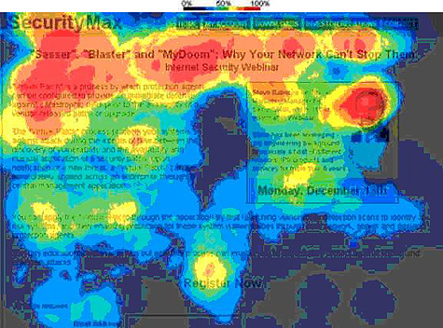
Figure 3: Heat Map Example [35]

Heat Map Viewing Patterns
A common heat map viewing pattern is the F shape for text-based pages and screens [36]. Users most commonly follow the same pattern: 1. Horizontal movement across the top of the screen, 2. Horizontal movement across the middle of the screen, and 3. Vertical movement along the left-hand side of the screen [37], [38]. This pattern can be seen below:
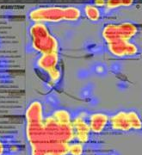
Figure 4: F Shaped Heat Map [39]
Another common pattern is the z-shaped pattern, also known as the reverse s-pattern, and can be seen on menus and login pages, or for media heavy screens. Users most commonly follow the same pattern: 1. Start in the top left, moving horizontally to the top right, 2. Then diagonally to the bottom right, and 3. Moving horizontally to the bottom right. This can often repeat, creating more of a zig-zag pattern [40].
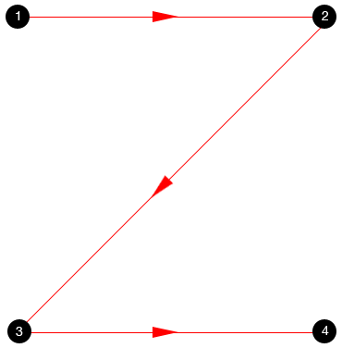
Figure 5: Z Shaped Heat Map [40]
A layer cake pattern occurs when only the headings and subheadings are scanned, and the normal text is skipped. A heat map produced by this type of pattern will show horizontal lines, reminiscent of a cake with alternating layers of cake and frosting [38].
A spotted pattern occurs when the user skips large sections of text and scans for something specific, such as a link, digits, a particular word or phrase with a distinctive shape, such as an address or signature [38].
A marking pattern occurs when the eyes are focused upon one place as the content changes, like a dancer fixating on an object to keep balance. This occurs more frequently on mobile and tablet devices [38].
A bypassing pattern occurs when users deliberately skip the first words of lines when multiple lines of text all with the same words [38].
A commitment pattern occurs when users fixate on most of the content, such as when users are highly motivated and interested in the content and will read all the text in a paragraph or page [38].

Heat Map Data Quality Factors
Some of the factors that influence data quality include:
- Differences in varying neurology, psychology and ability to follow instructions
- Wearing glasses, contact lenses, mascara or long or droopy eyelids
- Operators level of skill with the camera positioning and monitoring the results to determine whether it needs recalibrating
- Participants moving around or blinking more frequently than usual
- Recording environment conditions, such as lighting and small vibrations
- The geometry, including relative positions of the eye camera, participant and head, and stimulus
- Collecting the right sort of data and producing the right type of heat map
- Eye tracker design and the algorithms used to process the data [41], [42]

System Walkthrough
A system or structured walkthrough is defined as: “a static testing technique performed in an organised manner between a group of peers to review and discuss the technical aspects of the software development process” [43]. This involves system users trying out the system, and explaining their actions, thoughts and feelings regarding the system. These can be used to find weaknesses in the system early in the system development process. This improves the overall end result, as these findings can be fixed by the developer, reducing costs and saving time [43].

System Usability Scale
The system usability scale (SUS) was developed by John Brooke, in 1986, as a quick method of measuring the usability of products or services, such as a system. It consists of 10 questions with five response options for respondents; ranging from strongly agree to strongly disagree. These questions are as follows:
- I think that I would like to use this system frequently.
- I found the system unnecessarily complex.
- I thought the system was easy to use.
- I think that I would need the support of a technical person to be able to use this system.
- I found the various functions in this system were well integrated.
- I thought there was too much inconsistency in this system.
- I would imagine that most people would learn to use this system very quickly.
- I found the system very cumbersome to use.
- I felt very confident using the system.
- I needed to learn a lot of things before I could get going with this system.
Interpreting these results are complex, as it involves creating a score for each question to calculate the end score for each respondent. The score is between 0 and 100 and research suggests a score above 68 would be considered above average [44]. These elements will be factored into the system design and development.

Summary
Eye trackers are a series of cameras and sensors used as a method of measuring the usability of a system. These trackers can be used to produce heat maps, such as the F and Z shaped patterns. A system walkthrough is often used in addition to eye trackers and involves the participant talking through the system as they are using it. The system usability scale is a quick method of measuring the usability of products or services using a series of 10 questions. These tools would be useful during system testing and analysis stage to monitor eye positions by system users, and to identify issues regarding the system, so these can be resolved.

Management Information Systems

Definition
There is no set definition for a management information system (MIS), each author has their own interpretation on what these are. The following definitions are the closest to the system that will be developed. A MIS is defined by Kelly [45, p. 1] as: “The combination of human and computer-based resources that results in the collection, storage, retrieval, communication and use of data for the purpose of efficient management of operations and for business planning”.
However, Lucey [45, p. 2] defines MIS as: “A system to convert data from internal and external sources into information and to communicate that information, in an appropriate form, to managers at all levels in all functions, to enable them to make timely and effective decisions for planning, directing and controlling the activities for which they are responsible”.
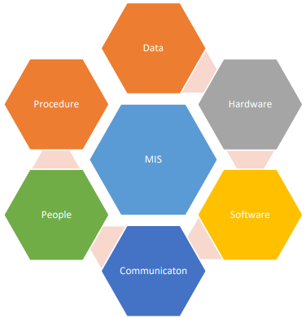
Figure 6: Management Information System Components [46]

Characteristics
There are several important and generic characteristics of MIS that have remained the same, despite technological changes [46]–[48]. These sources are in agreement with the following characteristics:
- Management oriented: MIS is designed as a top-down system; therefore, it is designed to suit the information needs of all managerial levels.
- Management directed: MIS is designed by the management, by becoming involved in its design and continuous reviews to remain with the evolving needs of the business, management and technology.
- Integrated: MIS is an integrated system involved with access to all the operational and functional management activities, and its data.
- Common data flows: This ensures that data duplication and redundancy is avoided, helping to simplify operations.
- Strategic planning: MIS require very high levels of planning to ensure effective organisations. This incorporates planning not for just the present needs, but its needs for the next 5-10 with only minor modifications as to not become obsolete.
- Bias towards centralisation: MIS must supply the correct and latest information, which can only be achieved by centralised data repositories. This ensures that data is not obsolete and is communicated to all departments.
- Information and communication technology enabled: This requires that the MIS remains up to date, using the latest technology to remain competitive. Management requires accurate data to ensure the right decisions are made at the right time.

Role Within Organisations
Within an organisation, MIS are required to perform a multitude of tasks, including feedback and performing analysis on data to support managerial decision making, such as enterprise-wide resource planning systems or customer relationship management systems, often in the form of reports or communications across departments. These tasks are dependent on the nature and purpose of the organisation and its needs, although many of the core departments are the same. This reduces costs and increases the chance of organisational success by providing a competitive edge, reducing costs and increasing the chances of survival [46], [49, Sec. 1.1], [50, pp. 4–5].

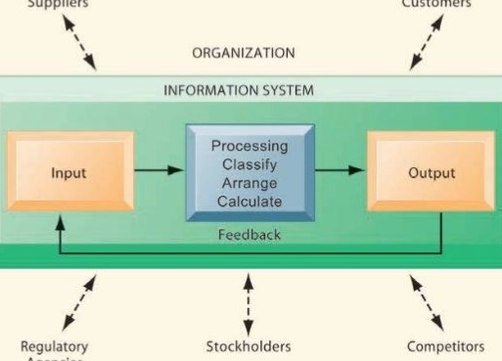
Figure 7: Organisational Functions [49, Sec. 1.2]
The use of a web dashboard modernises the use of MIS within organisations. Web dashboards are a method of transforming data into information in real time, providing summaries of several systems, such as emails, status, and activity durations [51]. A study by Vodafone in 2016 involving 8000 global employees found that three-quarters of companies worldwide have adopted flexible working policies, including teleworking [52]. The improvements in technology has enabled the number of people working from home to increase, with the Office for National Statistics (ONS) estimating that in 2015, 4.2 million people worked from home, and is expected to rise to 50% of the population in 2020 [53]. However, these figures are disputed by the Trades Union Congress (TUC), who estimated that 1.6 million employees regularly worked from home in 2017, and the numbers have stalled [54]. This revolution in the workplace means that companies must be able to provide web alternatives to allow their employees to perform their jobs as if they were in the office. A solution to this is the use of a web dashboard or a mobile/ web application [49, Ch. 15], [55], [56], which provides a portal to the organisations intranet, providing them with the access to the systems they need. These do not change the characteristics of MIS, but instead reinforce the ‘information and communication technology enabled’ characteristic by remaining up to date with not only technology but working practices as well.

Formal & Informal Systems
MIS can be formal, such as a system, or informal, such as a conversation or uncommon sets of data found on a memo or email, complementing each other. Informal systems can often achieve greater levels of flexibility and adaptability but may result in bias and noise [45, p. 240], which is defined as external and unwanted information [57].

Existing Solution Issues
There are several issues that occur with existing MIS solutions:
- Lack of management involvement and support during system analysis & design
- Limited or inappropriate emphasis of the system
- Excessive emphasis on low-level data processing
- Poor computer knowledge by management
- Lack of understanding and knowledge of management’s information requirements and organisational issues [45, pp. 2–3]

Design Influences
When designing a MIS, the following influences must be taken into consideration:
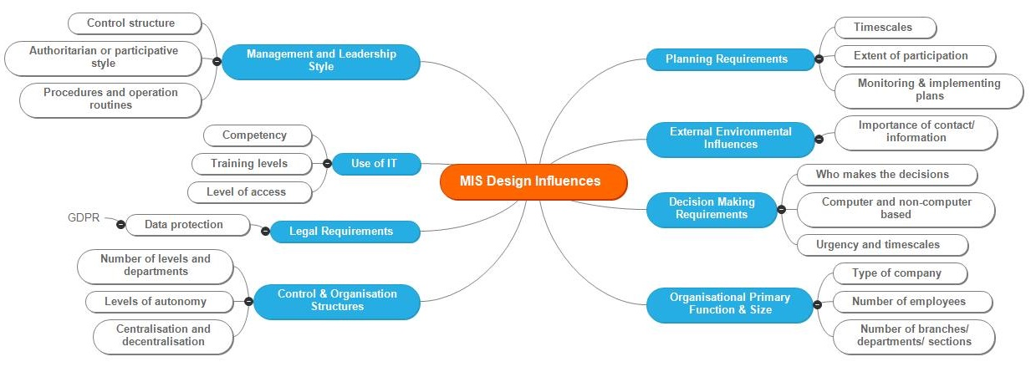
Figure 8: Management Information System Design Influences [45, pp. 238–9]
MIS systems are relational database management systems that utilise business rules or logic to produce an interface in which to interact with. It is these business rules and flows of information that provide security within the system, providing data on a ‘need to know’ basis only, providing reports, menus and views to display the stored data and available options.

Summary
A management information system is a collection of stored data, which can easily be retrieved for effective communication, decision making and management or organisational activities. They have several characteristics, including integrating individual systems to reduce data duplication and redundancy. MIS can be formal or informal, but encounter issues unless they are effectively designed, approved and reviewed by management.

Chapter Summary
This section covered usability and accessibility in regards to system design, focussing on user interface design and user experience. There are numerous usability guidelines and principles available for use, however, they vary in their depth and purpose, with many designed for a particular type of system. System usability can be evaluated using eye trackers that produce heat maps, and conducting system walkthroughs, both of which can be conducted together. This section also covered management information systems, focusing on their characteristics, role within organisations and their design influences. This information will be used and considered when designing and developing the system.

Methodologies
This report section describes the research and development methodologies used during this project.

Research Methodology
This project’s research methodology is an adaptation of Saunders research onion [58]. The research wall (Table 2), is adapted for applied computing projects:
Philosophy: | Positivism |  |  | Phenomenology
Approach: | Deductive |  |  | Inductive
Strategies: | Experiment | Software Development | Document Review |  | Case Study | Survey
Table 2: The Research Wall Adapted From Saunders Research Onion [58]
Initially, a document review strategy is used, as it allows research to be conducted regarding usability, accessibility and management information systems. This can be used to aid the understanding of similar systems to achieve the objectives. Additionally, it can help identify any pre-existing issues, identifying strategies to resolve them, should they occur. This strategy is both a positivist and a phenomenological philosophical approach.
However, predominantly, this project centres upon a positivism philosophy, and a deductive approach, since the main aim of this project is to develop a management information system for the Student Services department. Many of the issues that can and will arise within the system development can be resolved with additional research and design time.
An alternative to this project is a survey, which is a phenomenological approach, into the issues with the existing system, identifying areas and methods in which to solve these issues. The research undertaken and responses received would be used to recommend suggested solutions. However, this would not result in a developed solution for student services.
The usability testing and analysis of the system will follow a phenomenological philosophy, with an inductive approach. A survey/questionnaire and system walkthroughs will be conducted using willing participants to identify problems or bugs. The questionnaires will involve qualitative questions, examining the user’s views and opinions, allowing for comments and suggestions for improvements, such as glitches and bugs that can be easily fixed or to provide additional information about the system. The eye tracking will provide heat maps, which would identify the key areas of the software.
It is estimated that 5 users will be suitable to test the application. This includes Valerie Harding and at least 2 members of student services staff with different computer literacies. However, time constraints of the staff members and the developer may limit this possibility. This is a good representative of the student services staff as it may not be possible to ask them all for such a detailed analysis. However, this does not account for the abilities of all staff members.

Development Methodologies
A wide range of development methodologies are used within system development. This project will utilise an agile approach, which is a method of minimising risks through timeboxing elements, such as the planning, requirements analysis, design, coding, testing, and documentation to develop new functions by using the feature driven development (FDD) methodology. This allows the developer to design and build one feature at a time in an iterative approach [59], [60]. This approach permits easier system design, development and testing to ensure the system works, before additional features, such as additional features, are added in later timeboxes. Timeboxing supports the achievement of the feature list because each iteration is designed around the project aims and objectives, prioritised according to the given time constraints.
This is a small to medium sized project, which must be delivered within a short time frame. Therefore, each iteration, or timebox, will aim to last two weeks, allowing for time to design, gain feedback when required, build and test each feature individually and as part of the larger integrated application. This supports the handling of issues that arise, by using the available time to conduct further research and conduct additional testing, minimising the risk of failure, or future issues with integration of the next feature [61].
Data will be collected for analysis by:
- Log files (if there are any) created by the system during testing for faults/ errors (debugging).
- Data from secondary sources to develop the system, with a possibility of benchmarking at a later stage.
- Test data provided by questionnaires/surveys from users regarding its usability and functionality. The questionnaire asks the participant to identify issues with the system, such as missing data, features and options. These will be prototyped with several colleagues to identify missing or misleading questions.
- Eye tracking and system walkthroughs are excellent methods to test the usability of the system. The heat maps produced from the eye tracker and software, and the notes/ recordings made will form the basis for the analysis. The eye trackers will be set up beforehand and tested to minimise the margins for error and to familiarise with the device and technology.

Development Languages & Tools
The MIS could be developed using a wide variety of tools and languages, including the following:
Language | Python | C++ | Java
Tools/ Libraries | Tkinter or PyQt | Qt, Windows Forms, or a combination | JavaFX and inbuilt file handling system
IDE | Python IDLE | Visual Studio | NetBeans/ Eclipse
Notes | Tools would require installation on all desktops the system is used on. | Ability to integrate the database and user interface into the system. | Java and the required libraries are already installed.
Table 3: Development Languages & Tools Comparison Table

Justification
Java is the language of choice to develop the management information system, due to Java already running on the desktops, and its in-built libraries for UI, email capabilities, file handling and database communication with SQLite3.
SQLite3 will be used for the database, as it is encompassed within 1 file, and can be kept within the system for easy portability between machines or servers. Therefore, if the PC or server is changed, the system can be copied alongside the application, with little effort from the non-technical users. This provides a degree of portability with the system for when the hardware changes.

Alternatives
There are several alternatives to a MIS, including a diary or calendar system. This could be online (such as Google or Microsoft Calendar, Doodle, MyOffice or MyDiary), stored locally (such as Microsoft Excel or Access), or a traditional paper-based system. The online is more suited to their needs, as you can share certain details with selected users.

Sustainability Considerations
Sustainability is defined as: ‘patterns of economic, environmental, and social progress that meets the needs of the present day, without reducing the capacity to meet future needs’ [62, Ch. 1]. This has led to the creation of ‘Green IT’, which is defined as: ‘a collection of strategic and tactical initiatives that directly reduces the carbon footprint of an organisations computing operation’ [63, Ch. 2]. “While the sector plans to significantly step up the energy efficiency of its products and services, ICT’s largest influence will be by enabling energy efficiencies in other sectors, an opportunity that could deliver carbon savings five times larger than the total emissions from the entire ICT sector in 2020” [64, p. 10].
There are several frameworks used to get managers/ organisations to identify the impacts of the use of technology on the environment. These include first, second and third order impacts [65], in addition to Lago et al. [66], and Lami et al. [67]. Below is the use of Lami’s framework on this project:
Green Drivers | Power | Effort/Time | Paper | Fuel
People
System Users | More electricity | Less time | Less paper | Less fuel
Managers | More electricity | Less time | Less paper | Less fuel
Developers | More electricity | More time | N/A | N/A
Project Content
Resources | More electricity | N/A | Less paper | N/A
Technology | More electricity | N/A | N/A | N/A
Development
Project Methodology | N/A | N/A | N/A | N/A
Table 4: Project Sustainability Utilising Lami’s Sustainability Framework [67]

Ethical Considerations
The BCS code of conduct [68] is as follows:
- Public Interest
This project aims to ‘have due regard for public health, privacy, security and wellbeing of others and the environment’ (point 1) by incorporating security measures, such as a login system, password hashing and encryption where possible to protect the confidential nature of the system. Additionally, it aims to ‘promote equal access to the benefits of IT’ (point 4) by incorporating both usability and accessibility features into the developed system.
- Professional Competence and Integrity
This project addresses points 3 (developing professional knowledge, skills and competence) and 4 (ensuring your knowledge, understanding and compliance with legislation) by conducting research into the relevant legislation (GDPR), and understanding its relevance into the storage of sensitive data, such as personal data and qualifications. Point 5 (‘respect and value alternative viewpoints and, seek, accept and offer honest criticisms of work’) is also addressed by gaining feedback from clients, staff members and testers throughout the process, from which to act upon.
- Duty to Relevant Authority
This project meets points 1 (carrying out your professional responsibilities with due care and diligence) and 3 (accepting professional responsibility for your work) by the creation of this report, use of professional software and tools, and making notes/ comments during all stages of the system life cycle, and conducting research when required to solve problems. This is all documented within this report. Additionally, there is very limited confidential information provided by the client, which will be securely stored and accessed when this data is required, and destroyed when it is no longer required, thus meeting point 4 (disclose or authorise to be disclosed, or use for personal gain or to benefit a third party, confidential information).
- Duty to the Profession
This project includes elements of research throughout, such as gathering the required background information and during the system lifecycle, and this is an individual and group task, thus meeting points 2 (seek to improve professional standards) and 5 (encourage and support fellow members in their professional development). Point 4 (acting with integrity and respect in your professional relationships) is met via carefully thought out communications within the team and clients, whether this is face to face (such as interviews and team meetings), or via emails or group chats.

Legal Considerations - GDPR
The General Data Protection Regulation (GDPR) is Regulation (EU) 2016/679 and relates to the processing of personal data by individuals, companies or organisations within the EU [69]. This came into effect in May 2018 and strengthens the rules governing data protection [70], including specifying rights for all parties, including individuals [71] and businesses/ organisations [72]. Article 5 states the principles relating to the processing of personal data, and are as follows [73]: “
1. Personal data shall be:
(a) processed lawfully, fairly and in a transparent manner in relation to the data subject (‘lawfulness, fairness and transparency’);
(b) collected for specified, explicit and legitimate purposes and not further processed in a manner that is incompatible with those purposes; further processing for archiving purposes in the public interest, scientific or historical research purposes or statistical purposes shall, in accordance with Article 89(1), not be considered to be incompatible with the initial purposes (‘purpose limitation’);
(c) adequate, relevant and limited to what is necessary for relation to the purposes for which they are processed (‘data minimisation’);
(d) accurate and, where necessary, kept up to date; every reasonable step must be taken to ensure that personal data that are inaccurate, having regard to the purposes for which they are processed, are erased or rectified without delay (‘accuracy’);
(e) kept in a form which permits identification of data subjects for no longer than is necessary for the purposes for which the personal data are processed; personal data may be stored for longer periods insofar as the personal data will be processed solely for archiving purposes in the public interest, scientific or historical research purposes or statistical purposes in accordance with Article 89(1) subject to implementation of the appropriate technical and organisational measures required by this Regulation in order to safeguard the rights and freedoms of the data subject (‘storage limitation’);
(f) processed in a manner that ensures appropriate security of the personal data, including protection against unauthorised or unlawful processing and against accidental loss, destruction or damage, using appropriate technical or organisational measures (‘integrity and confidentiality’).
2. The controller shall be responsible for, and be able to demonstrate compliance with, paragraph 1 (‘accountability’).”
To comply with the GDPR legislation, the developed system will seek to minimise data collection where possible and allow users to access and edit their information, thus keeping the information easily accessible and up to date. The data is not processed, with the exception to send email notifications to staff and management to inform them of the need to renew their role requirements. Additionally, the system will also have user levels to limit data access, hash passwords, and allow for the ability to encrypt the database. Thus ensuring the integrity, confidentiality and security of the personal data collected.

Risk Analysis
The risk management procedure is based on the PRINCE2 system [74], and comprises of the following steps with the addition of communication through the escalation of risks to stakeholders:
- Identify: Assess and record threats and opportunities in the risk register
- Estimate: Assess the probability, impact and proximity of each risk and update the risk register
- Evaluate: Aggregate all risks to ascertain their combined impact on the project by plotting them against the probability impact grid
- Plan: Identifying responses to threats and opportunities using the response category examples and adding them to the register
- Implement: Allocate responsibilities for the execution and monitoring of the effectiveness of the responses and recording them in the register [74, Secs. 8.3.5, A24].
The following risk register format is taken from [74, Sec. A.25], and is continuously monitored and updated throughout the project:

Identifier | 1
Identify
Founder | Jennifer Ada
Date registered | 3/12/2018
Category (Threat or Opportunity) and (Human, Legal, Scheduling or Resource) | Threat, Human
Description (Cause of risk, consequent event and effect the event will have on the project) | Cause: Email notification service does not function correctly.  Event: Qualifications or certification are not renewed in time.  Effect: Staff cannot do their job. Loss of productivity.
Assess
Probability | <10%
Impact | Very High
Proximity | Beyond the project.
Plan
Response categories | Fallback
Response | Ensure alternative notification infrastructure or procedures are put in place.
Implement
Status | Unimplemented.
Owner | Cerys Nickels
Table 5: Risk Register - Risk 1

Identifier | 2
Identify
Founder | Jennifer Ada
Date registered | 3/12/2018
Category (Threat or Opportunity) and (Human, Legal, Scheduling or Resource) | Threat, Scheduling
Description (Cause of risk, consequent event and effect the event will have on the project) | Cause: Project not scheduled properly to fit the scope.  Event: Project does not meet milestones.  Effect: Delivery of a reduced scope or incomplete system by the delivery date. A system which does not provide the necessary functionality needed to ensure qualification documents are renewed in a timely manner and that paper usage is reduced leading to unnecessary complications in the processes used at student services.
Assess
Probability | 25%
Impact | Very High
Proximity | Within the project.
Plan
Response categories | Reduce
Response | Features are built incrementally in the rank of criticality to the proper functioning of the system.
Implement
Status | Implemented
Owner | Cerys Nickels
Table 6: Risk Register - Risk 2

Identifier | 3
Identify
Founder | Jennifer Ada
Date registered | 3/12/2018
Category (Threat or Opportunity) and (Human, Legal, Scheduling or Resource) | Threat, Scheduling
Description (Cause of risk, consequent event and effect the event will have on the project) | Cause: Prototype not scheduled properly to fit the scope.  Event: Prototype does not meet milestones.  Effect: Delivery of a reduced scope or incomplete system by the delivery date. A system which does not provide the necessary functionality needed to ensure that a representation of the project is not communicated effectively leading to insufficient feedback from student services.
Assess
Probability | 25%
Impact | Very High
Proximity | Within the project.
Plan
Response categories | Reduce
Response | Further sprints are only scheduled once the current sprint has been reviewed.
Implement
Status | Implemented
Owner | Jennifer Ada
Table 7: Risk Register - Risk 3

Identifier | 4
Identify
Founder | Jennifer Ada
Date registered | 3/12/2018
Category (Threat or Opportunity) and (Human, Legal, Scheduling or Resource) | Threat, Resource
Description (Cause of risk, consequent event and effect the event will have on the project) | Cause: Infrastructure not configured by the deadline and tested.  Event: Prototype does not meet milestones.  Effect: Delivery of a reduced scope or incomplete system by the delivery date.
Assess
Probability | 25%
Impact | Very High
Proximity | Within the project.
Plan
Response categories | Fallback
Response | An alternative process or software is identified to replace the resource which is not available. The whole pipeline is tested by the group prior to initiating the first sprint.
Implement
Status | Implemented
Owner | Cerys Nickels, Yan Zhang
Table 8: Risk Register - Risk 4

Identifier | 5
Identify
Founder | Jennifer Ada
Date registered | 21/2/2018
Category (Threat or Opportunity) and (Human, Legal, Scheduling or Resource) | Threat, Resource
Description (Cause of risk, consequent event and effect the event will have on the project) | Cause: Project team member ill or otherwise absent.  Event: Prototype does not meet milestones.  Effect: Delivery of a reduced scope or incomplete system by the delivery date.
Assess
Probability | 10%
Impact | Very High
Proximity | Within the project.
Plan
Response categories | Reduce
Response | Sprint meetings are scheduled twice a month.
Implement
Status | Implemented
Owner | Jennifer Ada
Table 9: Risk Register - Risk 5

System Development

Timebox 1
Start date: 14/01/2019
Duration: 2 weeks
Completion date: 27/01/2019

Timebox Aims
- Interview Valerie Harding & several student services staff members
- Identify the system components and stakeholders
- Develop the initial feature list
- Identify the system constraints and assumptions regarding the system
- Develop the initial database and UI designs

System Components
The system has three components:
- The UI (the presentation layer)
- The communications between the UI and the database (the logic layer)
- A database to store the data (the data store layer)

System Stakeholders
The primary stakeholder is Valerie Harding, who is the Learning Support Coordinator for the Faculty of Architecture, Computing & Engineering in UWTSD Swansea SA1 Campus. In addition to this, the secondary stakeholders are [75]:
- Directors & Principal Officers
- General Administration
- Careers Service & GO Wales Coordinators
- Counselling & Mental Health
- Student Finance
- International Services
- Disability Advisers
- Learning & Academic Support Staff
- Study Skills Support & PASS (Peer Assisted Study Skills)
- Student Wellbeing & Support for Students from Care
Most, if not all, the student services department staff will be using the developed system. It is important that they have their information stored, and they have the correct level of access to update their stored data and files. Although this will increase their workload slightly, it will benefit them in the long term, safeguarding that their qualifications, memberships and other necessary documentation do not expire without notification. This will benefit the primary stakeholder the most, as their workload reduces with their ability to monitor all their staff details at a glance.

Initial Feature List (System Requirements Analysis)
The feature list [76]–[80] for the project are listed below:
Staff records:
- To add, amend and delete staff records/ details securely
- To add, amend and delete checks/ qualifications/ certificates/ training/ professional body memberships
- To set the traffic light warnings (red, amber and green) for checks/ qualifications/training/ certificates/ professional body memberships
- Staff can add their checks/ qualifications/ certificates/ training/ professional body memberships
Files:
- Staff members can securely upload file records within the system of the checks/ qualifications/ certificates/ training/ professional body membership, and delete old files
- To link file records to staff members, and easily retrieve that file
Appraisals & Monitoring Hours:
- To allow Valerie Harding to add appraisal notes for each member of staff, with the restriction that the member of staff cannot view that information
- Valerie Harding can monitor hours of external/ fractional staff on a monthly basis
System:
- To have a graphical user interface (GUI)
- To login to the system and have a user level/ role to limit access
- For Valerie Harding to view all staff records simultaneously in a table format, using a traffic light system to easily identify expiration dates
- For each staff member to have a personalised menu, with relevant options
- To alert Valerie Harding and staff members via email notifications of when checks/ qualifications/ certificates/ professional body memberships are due to expire
Required documents:
- User guide (for Valerie Harding and Staff members)

Constraints
The constraints for the project are as follows:
- Portability (store it for easy retrieval) – It was requested during the initial interview that the application and its files will be stored using Microsoft OneDrive for portability and access from home. However, research into this capability shows that this is not possible. Hence, a desktop version will be created, with a shortcut on the desktop, and locating the application on the internal server/ shared location.
- Completion date is Easter holidays (Mid-April)
- There is only one person able to work on the project
- There is also a limited amount of time during the project duration due to other commitments
- There are limited resources available to the developer, including access to Valerie Harding and student services staff
- An increased scope during the project design and development will impact levels of priority over certain features to ensure delivery on time
- Quality assurance must be put in place to ensure users are comfortable with the security and functionality of the system

Assumptions
The assumptions for the project are as follows:
- The user already has the necessary hardware (desktops/ laptops) running Windows
- The user has limited computer knowledge
- The user will already have installed any required libraries upon delivery/ testing
- Feedback on designs will be provided within a reasonable timeframe, and before the end of the stage

Initial System Database Design
The initial system design was designed on a whiteboard, and can be seen below:
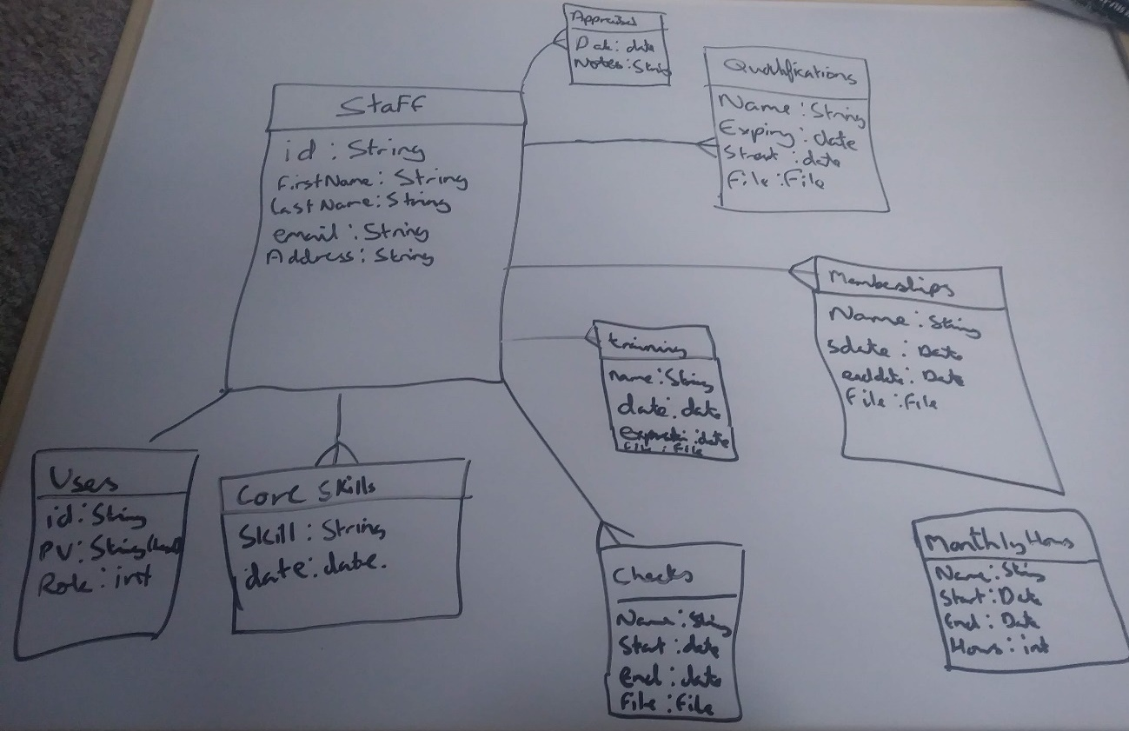
Figure 9: Timebox 1 - Initial Database Design

Initial User Interface Designs
The initial UI designs were designed on a whiteboard, and can be seen below:
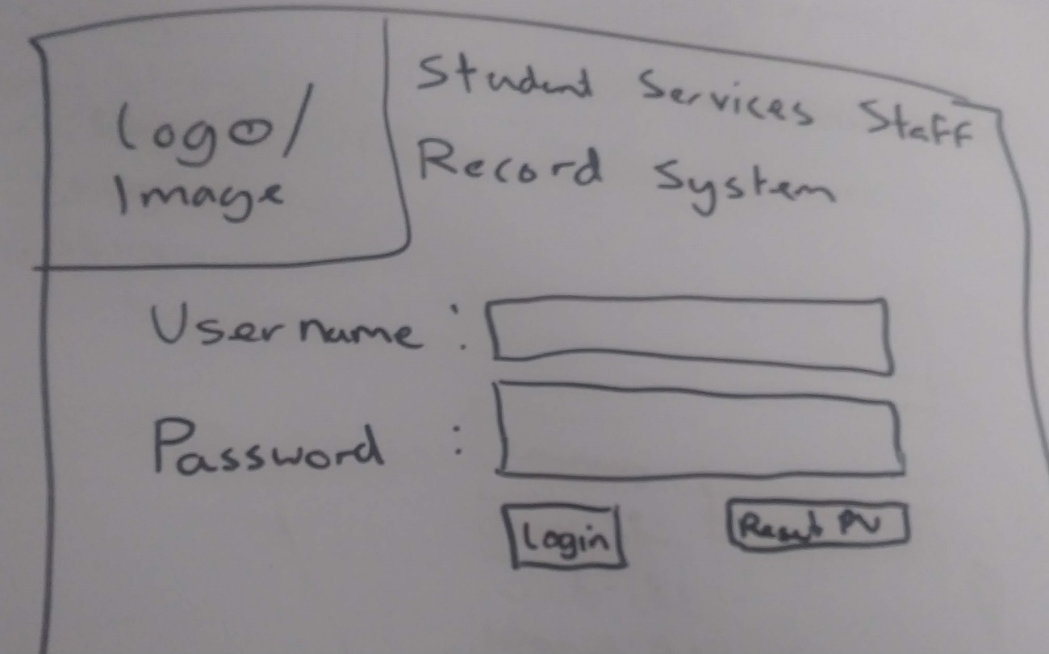
Figure 10: Timebox 1 - Initial Login System User Interface Design
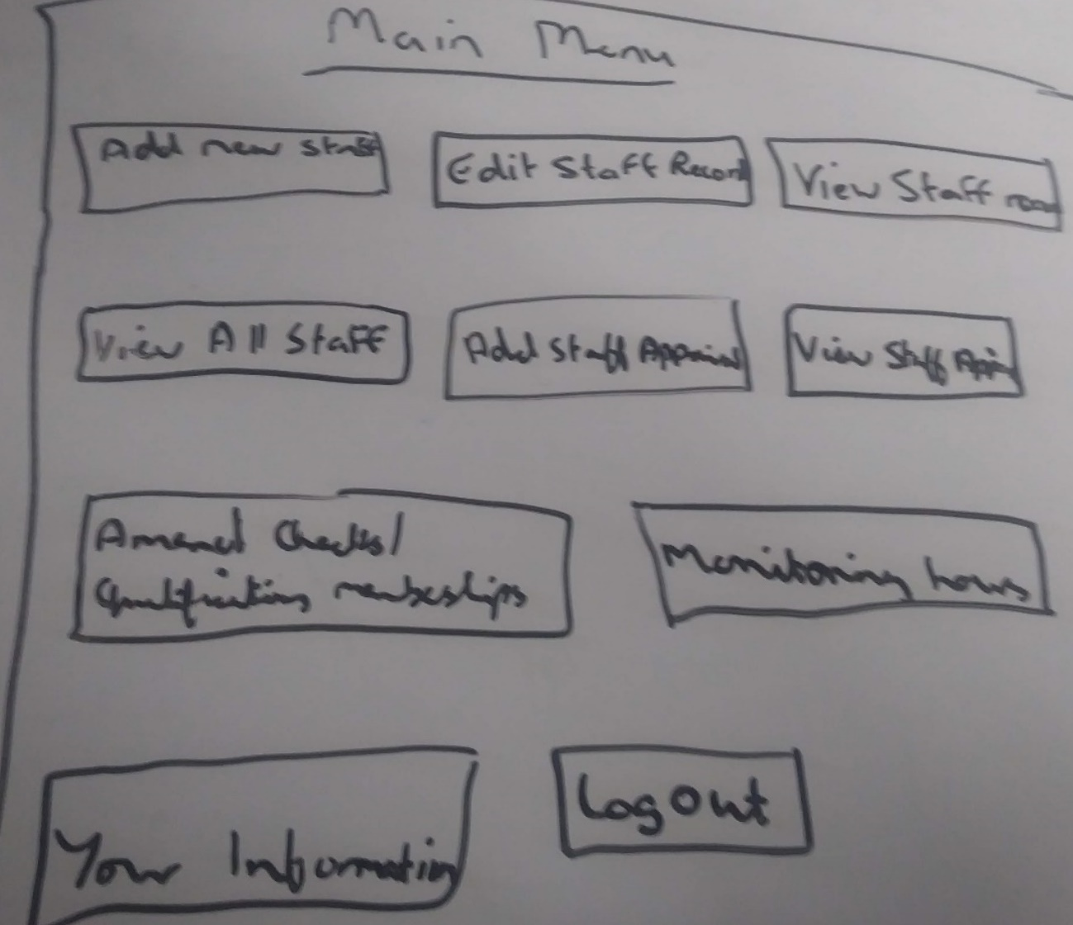
Figure 11: Timebox 1 - Initial Design for Valerie Harding’s Main Menu
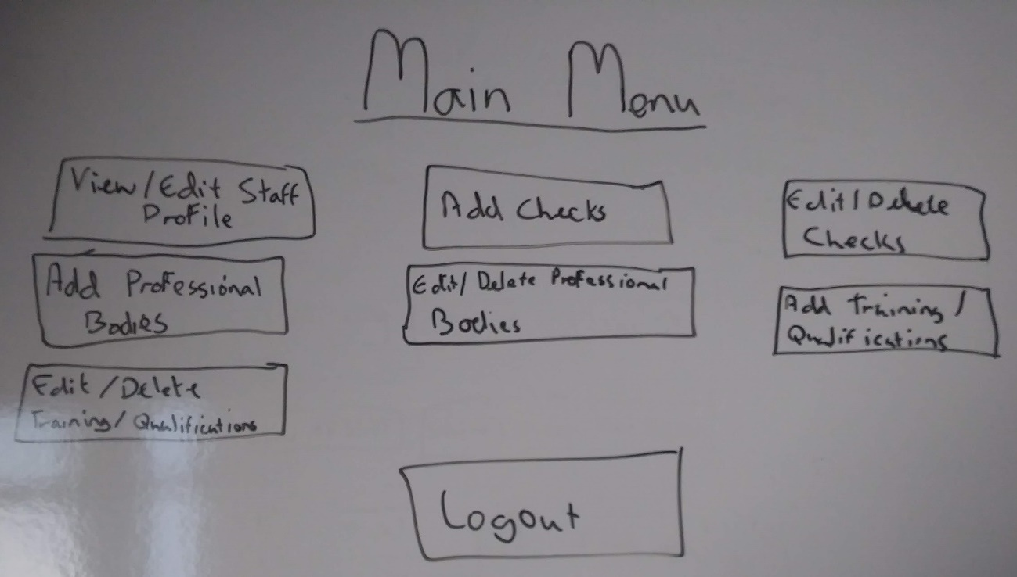
Figure 12: Timebox 1 - Initial Design for Staff Main Menu

Timebox 1 Analysis
The aims for this timebox were achieved within the stated 2 week duration. The designs are basic but will be digitalised in the next timebox. The initial feature list and designs have been developed and will be updated as more information is received from Valerie and the staff. This information will be requested in the next timebox.

Timebox 2
Start date: 28/01/2019
Duration: 2 weeks
Completion date: 10/02/2019

Timebox Aims
- Improve UI and system designs
- Develop the system usability and accessibility guidelines
- Start the database implementation
- Send UI designs to Valerie Harding and student services staff for feedback
- Request information regarding the feature list, and the database tables and fields

User Interface Designs
The following designs were improved from the initial designs using MS PowerPoint. This allows for the designs and colour scheme to be confirmed with Valerie Harding and the staff, before the interfaces are implemented. This is important that they are confirmed early on as to avoid changes at a later stage, and to allow time for feedback and refining.
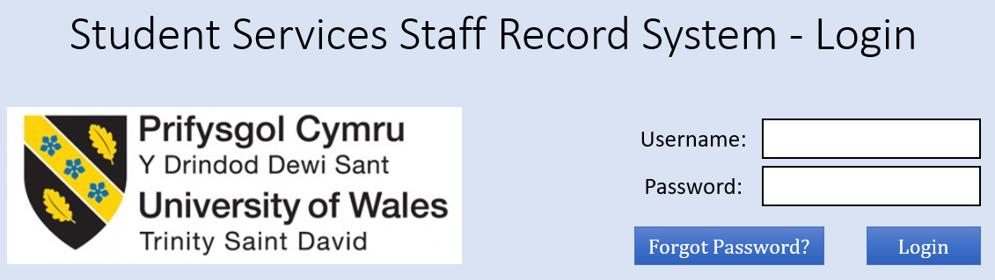
Figure 13: Timebox 2 - Login Page Design
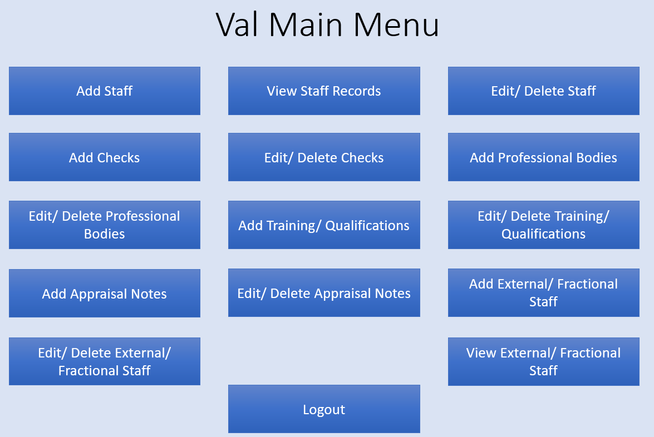
Figure 14: Timebox 2 - Valerie Harding's Main Menu Design
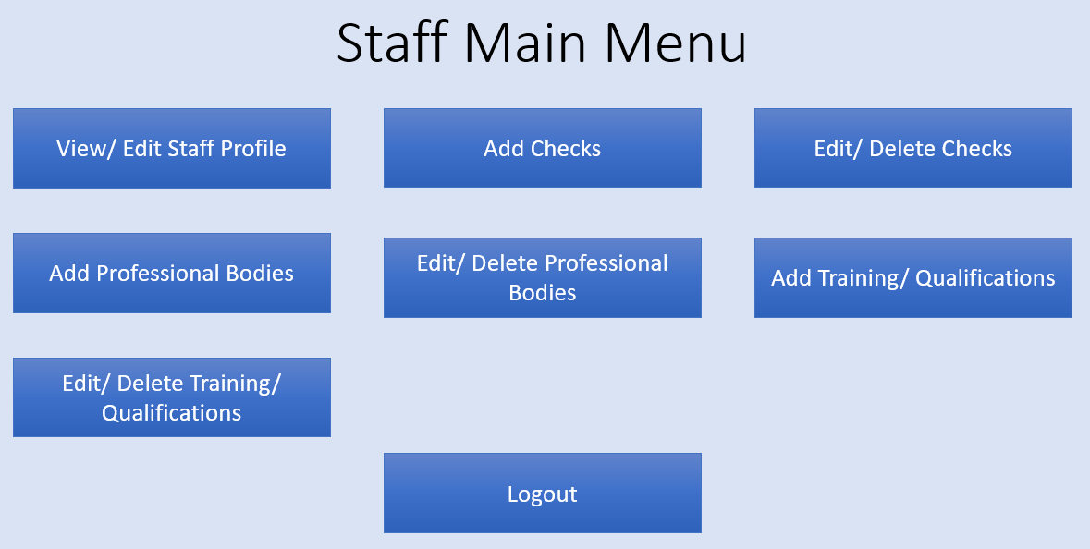
Figure 15: Timebox 2 - Staff Main Menu Design

System Usability & Accessibility Guidelines
The following system usability and accessibility guidelines for this system have been adapted from the background research for this system:
- Consistency – This is extremely important for system design to ensure familiarity and recognisability with the system. This is evidenced by the guidelines researched and can aid users in completing their desired goals.
- Efficiency – This is evidenced by the research and interviews conducted to reduce the time spent on human resource (HR) tasks within the department. The system must speed up the existing process for storing and retrieving staff records for all purposes.
- Feedback – It is important for all users to receive informative and relevant feedback to ensure knowledge of background tasks, such as loading screens, or saving data or files.
- Error handling and recoverability – It is important for users to be able to recover from errors with minimal effort, and either correcting or informing the users what caused the errors. The users must then be able to correct these errors. This guideline works alongside the feedback guideline but incorporates careful UI design.
- User control – Having buttons that allow the user to switch between menus is essential for users. This includes back, save and print buttons and links to menus.
- Help and documentation – This is detailed in the feature list as two user guides: one for staff, and one for Valerie Harding, indicating the steps to achieve set tasks.
- Aesthetic and minimal design – This is taken directly from Nielson, and this links back to consistency. A simply designed UI assists with staff training, and provides system recognition, as it may be several months between someone uses the system.
- Task conformance – This is taken from Dix, where the system must be able to complete all the tasks, and in a way that the user expects. For example, printing out all the staff information is best achieved in a report format for ease. The system must be able to produce this report when requested and print this report off accordingly.

Database Table Design
Field Name | Data Type | Additional Information
StaffID | CHAR(10) | PK
FirstName | VARCHAR(50)
LastName | VARCHAR(50)
EmailAddress | VARCHAR(100)
Role | VARCHAR(15)
PasswordHash | CHAR(30) | Hash
Table 10: Timebox 2 Database Table Design - Staff Table

Field Name | Data Type | Additional Information
AppraisalID | INTEGER | PK
StaffID | CHAR(10) | FK – Staff table
AppraisalDate | DATE
AppraisalNotes | VARCHAR(255)
ConductedBy | CHAR(10) | FK – Staff table
Table 11: Timebox 2 Database Table Design - Appraisals Table
Field Name | Data Type | Additional Information
Role | VARCHAR(15) | PK
ListName | VARCHAR(50) | PK, FK – WarningList table
Status | VARCHAR(20) | List: Needed, Desirable, Not Required
Table 12: Timebox 2 Database Table Design - RoleRequirements Table
Field Name | Data Type | Additional Information
ListName | VARCHAR(50) | PK
ListType | VARCHAR(25) | List: Qualification, Check, Training, Professional Body
Duration | INTEGER | Number of weeks (1,2,3,4,6,8,12,16,20,24)
AmberWarning | INTEGER | Number of weeks (1,2,3,4,6,8,12,16,20,24)
RedWarning | INTEGER | Number of weeks (1,2,3,4,6,8,12,16,20,24)
AdditionalNotes | VARCHAR(255)
Table 13: Timebox 2 Database Table Design - WarningList Table
Field Name | Data Type | Additional Information
StaffID | CHAR(10) | PK, FK – Staff table
ListName | VARCHAR(50) | PK, FK – RoleRequirements table
StartDate | DATE
ExpiryDate | DATE
FileAddress | FILE | File upload – Additional research required
Table 14: Timebox 2 Database Table Design - StaffRecords Table
Field Name | Data Type | Additional Information
StaffName | VARCHAR(100) | PK
MonthStartDate | DATE | PK
NoOfHours | INTEGER
Table 15: Timebox 2 Database Table Design - ExternalFractionalStaff Table

Entity Relationship Diagram
The diagram below was created in Microsoft Visio to aid the design of the database. This visual aid describes the relationships between the tables, highlighting any missing fields or potential many-to-many relationships that may occur.
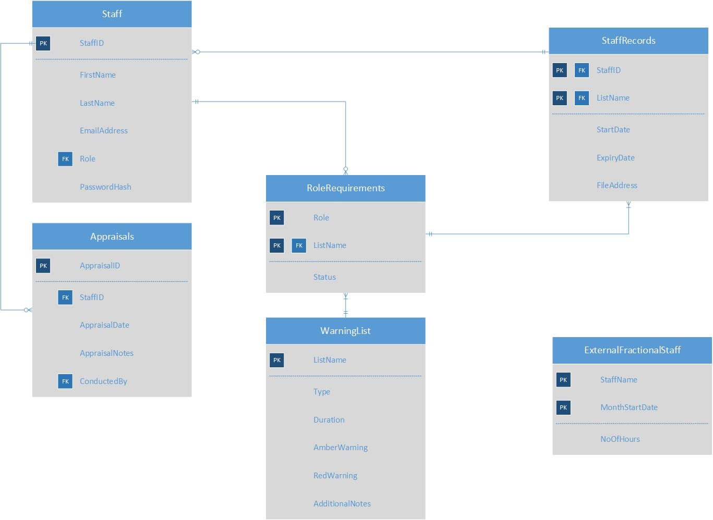
Figure 16: Timebox 2 - Entity Relationship Diagram

Database Implementation
Below are the SQL statements used to create the database:
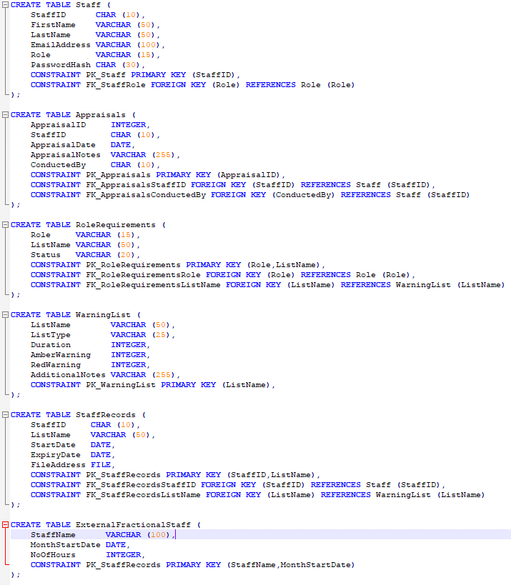
Figure 17: Timebox 2 - Database Implementation

Updated Feature List
Below is an updated feature list after speaking to the student services staff:
Staff records:
- To add, amend and delete staff records/ details securely
- To add, amend and delete checks/ qualifications/ certificates/ training/ professional body memberships
- To set the traffic light warnings (red, amber and green) for checks/ qualifications/ training/ certificates/ professional body memberships
- Staff can add their checks/ qualifications/ certificates/ training/ professional body memberships
- Add a needed, desirable or working towards, not necessary list of requirements for different staff roles
- The ability to add multiple staff from group staff training sessions.
Files:
- Staff members can securely upload file records within the system of the checks/ qualifications/ certificates/ training/ professional body membership, and delete old files
- To link file records to staff members, and easily retrieve that file
Appraisals & Monitoring Hours:
- To allow management to add appraisal notes for each member of staff, with the restriction that the member of staff cannot view that information
- Management can monitor hours of external/ fractional staff on a monthly basis
System:
- To have a graphical user interface (GUI)
- To login to the system and have a user level/ role to limit access
- For management to view all staff records simultaneously in a table format, using a traffic light system to easily identify expiration dates
- For each staff member to have a personalised menu, with relevant options
- To alert management and staff members via email notifications of when checks/ qualifications/ certificates/ professional body memberships are due to expire
Required documents:
- User guide (for management and staff members)

Timebox 2 Analysis
The aims for this timebox were achieved within the stated duration. The designs have been digitalised but will be refined in the next timebox, with additional designs made. The usability and accessibility guidelines have been created, and the feature list has been updated upon further analysis and development. The email has been sent asking for usable data for testing purposes and several questions that have arisen during the database design and implementation.

Timebox 3
Start date: 11/02/2019
Duration: 2 weeks
Completion date: 24/02/2019

Timebox Aims
- Resolve relationship issues with the database
- Complete UI designs
- Update database
- Start UI implementation and add functionality

Updated Database Table Design
Below are the updated table designs for the database:
Field Name | Data Type | Additional Information
Role | VARCHAR(15) | PK
LevelofAccess | INTEGER | Values: 1 for management, 2 for staff
Table 16: Timebox 3 Database Table Design - Role Table
Field Name | Data Type | Additional Information
StaffID | CHAR(10) | PK
FirstName | VARCHAR(50)
LastName | VARCHAR(50)
EmailAddress | VARCHAR(100)
Role | VARCHAR(15) | FK – Role table
PasswordHash | CHAR(30) | Hash
Table 17: Timebox 3 Database Table Design - Staff Table

Field Name | Data Type | Additional Information
AppraisalID | INTEGER | PK
StaffID | CHAR(10) | FK – Staff table
AppraisalDate | DATE
AppraisalNotes | VARCHAR(255)
ConductedBy | CHAR(10) | FK – Staff table
Table 18: Timebox 3 Database Table Design - Appraisals Table
Field Name | Data Type | Additional Information
Role | VARCHAR(15) | PK, FK – Role Table
ListName | VARCHAR(50) | PK, FK – WarningList table
Status | VARCHAR(20) | List: Needed, Desirable, Not Required
Table 19: Timebox 3 Database Table Design - RoleRequirements Table
Field Name | Data Type | Additional Information
ListName | VARCHAR(50) | PK
ListType | VARCHAR(25) | List: Qualification, Check, Training, Professional Body
Duration | INTEGER | Number of weeks (1,2,3,4,6,8,12,16,20,24)
AmberWarning | INTEGER | Number of weeks (1,2,3,4,6,8,12,16,20,24)
RedWarning | INTEGER | Number of weeks (1,2,3,4,6,8,12,16,20,24)
AdditionalNotes | VARCHAR(255)
Table 20: Timebox 3 Database Table Design - WarningList Table
Field Name | Data Type | Additional Information
StaffID | CHAR(10) | PK, FK – Staff table
ListName | VARCHAR(50) | PK, FK – RoleRequirements table
StartDate | DATE
ExpiryDate | DATE
FileAddress | FILE | File upload – Additional research required
Table 21: Timebox 3 Database Table Design - StaffRecords Table
Field Name | Data Type | Additional Information
StaffName | VARCHAR(100) | PK
MonthStartDate | DATE | PK
NoOfHours | INTEGER
Table 22: Timebox 3 Database Table Design - ExternalFractionalStaff Table

Updated Entity Relationship Diagram
Below is the updated entity relationship diagram fixing errors found during implementation:
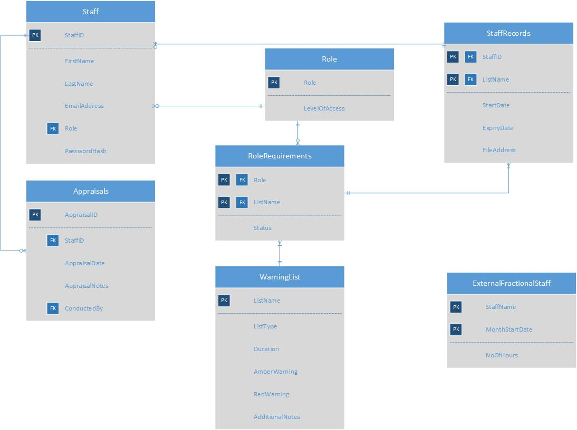
Figure 18: Timebox 3 - Entity Relationship Diagram

Updated Database Implementation
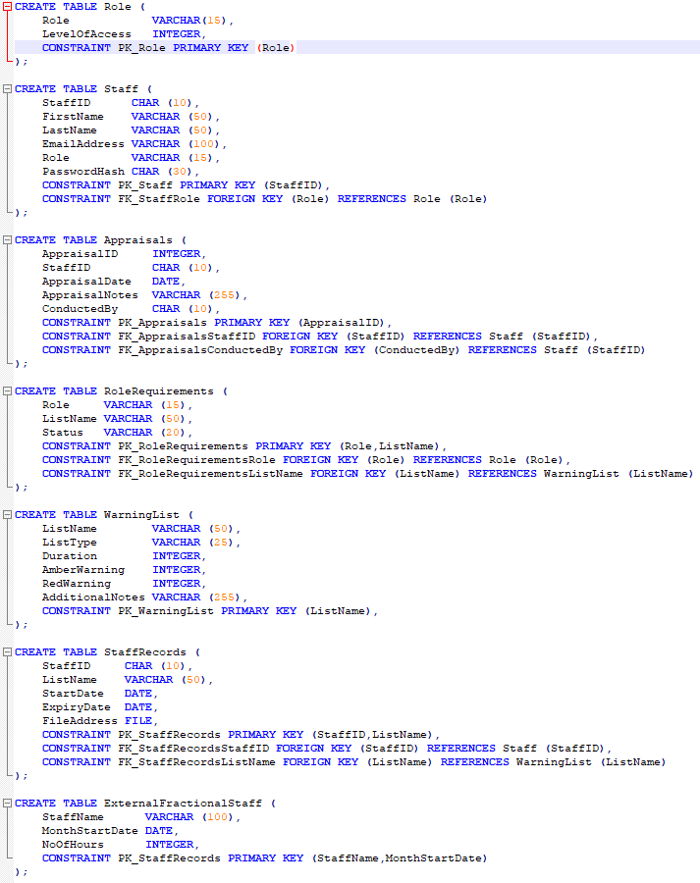
Figure 19: Timebox 3 - Updated Database Implementation

User Interface Designs
The number of buttons and options for the user have been reduced to consolidate the number of interfaces required, and to reflect the change in database designs. These changes are guided by the setting of the usability and accessibility guidelines within timebox 2. Below are the updated designs for the UI:
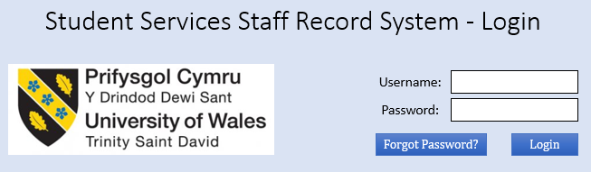
Figure 20: Timebox 3 - Login Page Design
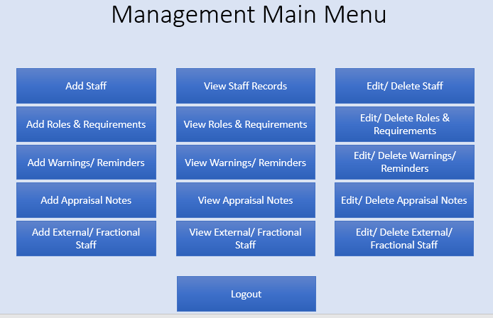
Figure 21: Timebox 3 - Management Main Menu Page Design
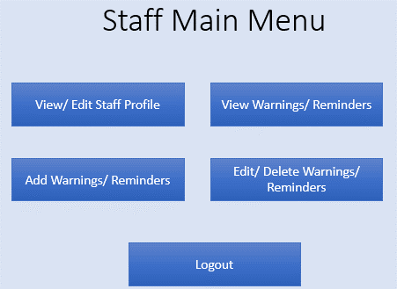
Figure 22: Timebox 3 - Staff Main Menu Page Design
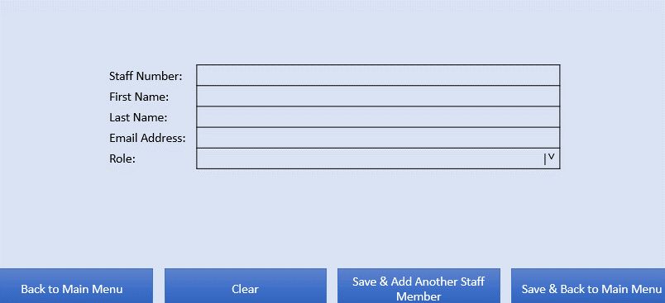
Figure 23: Timebox 3 - Add Staff Page Design
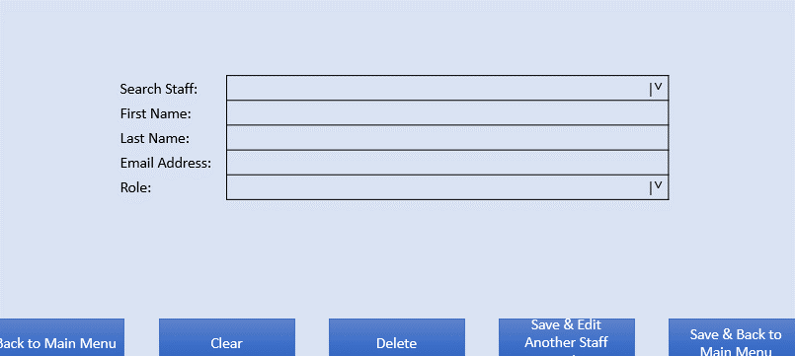
Figure 24: Timebox 3 - Edit/ Delete Staff Member Page Design
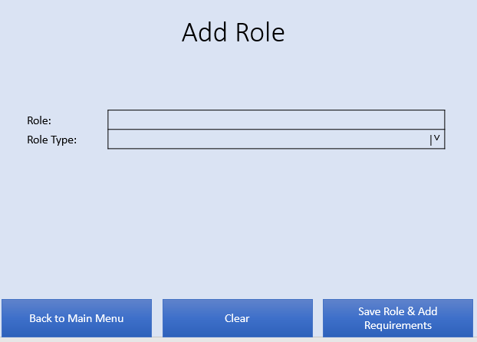
Figure 25: Timebox 3 - Add Role Page Design
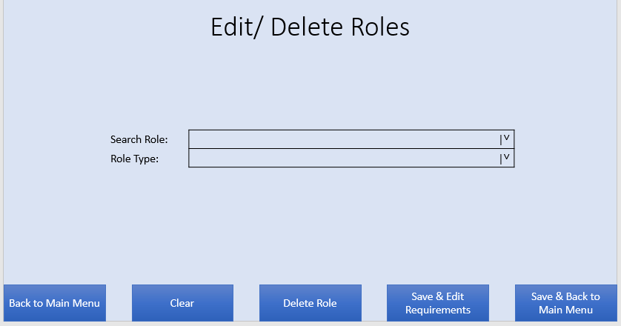
Figure 26: Timebox 3 - Edit/ Delete Roles Page Design
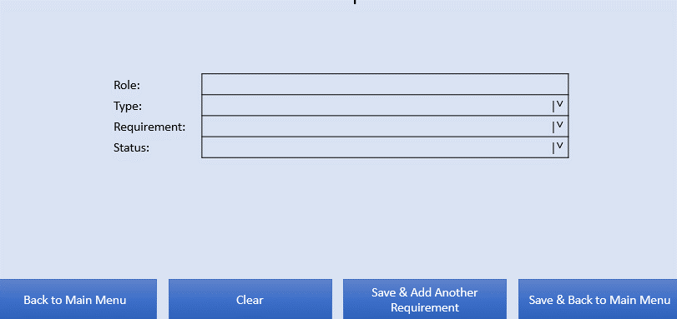
Figure 27: Timebox 3 - Add Role Requirements Page Design
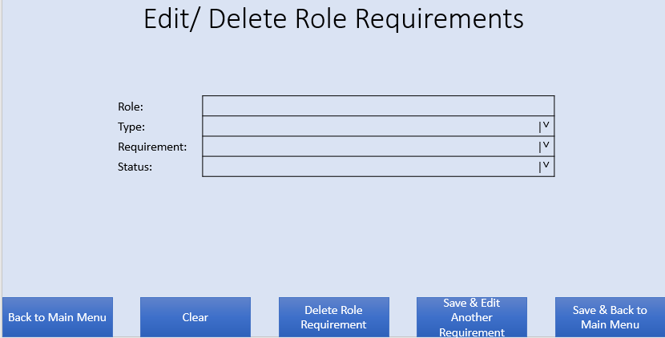
Figure 28: Timebox 3 - Edit/ Delete Role Requirements Page Design
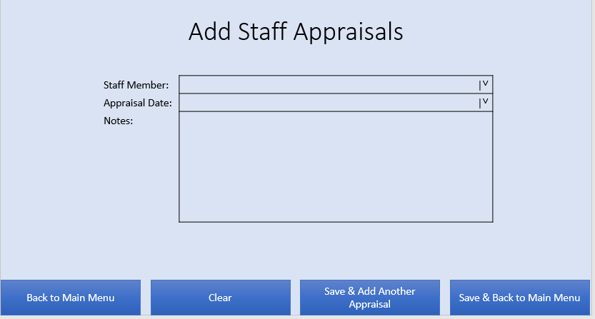
Figure 29: Timebox 3 - Add Staff Appraisals Page Design
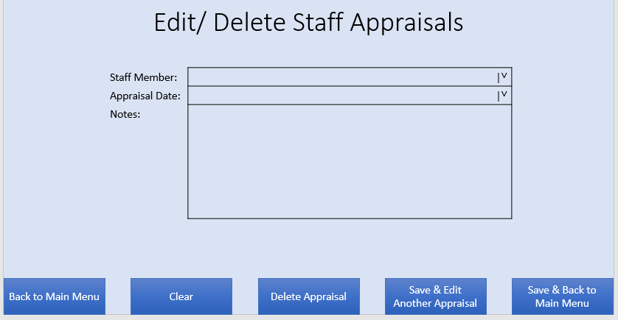
Figure 30: Timebox 3 - Edit/ Delete Staff Appraisals Page Design
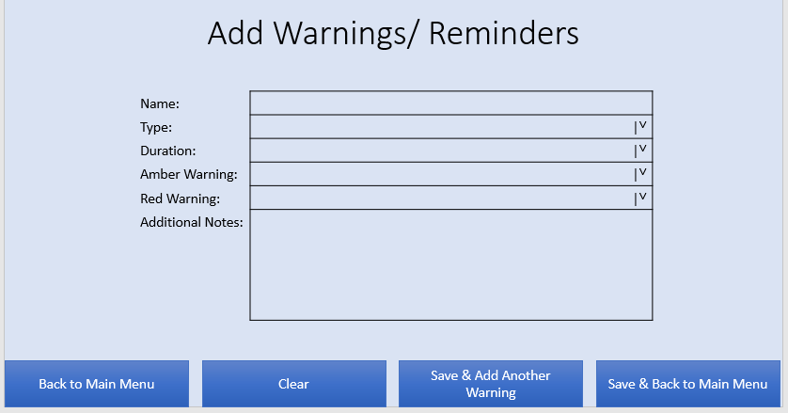
Figure 31: Timebox 3 - Add Warnings/ Reminders Page Design
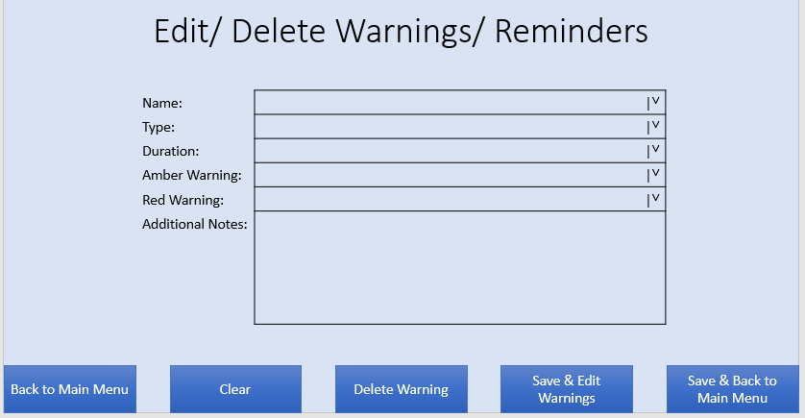
Figure 32: Timebox 3 - Edit/ Delete Warnings/ Reminders Page Design

User Interface Implementation
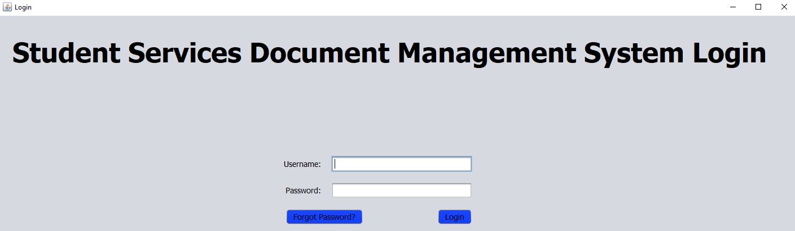
Figure 33: Timebox 3 - Login UI Implementation
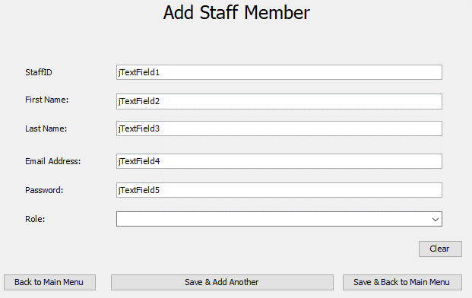
Figure 34: Timebox 3 - Add Staff UI Implementation
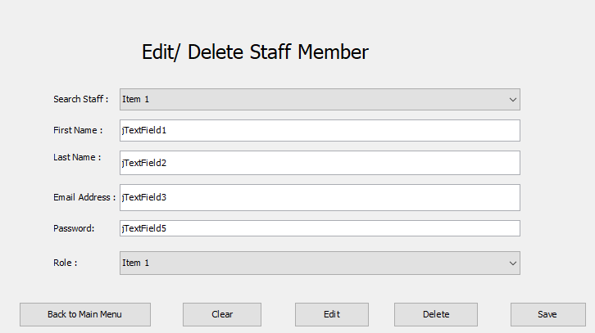
Figure 35: Timebox 3 – Edit/ Delete Staff UI Implementation
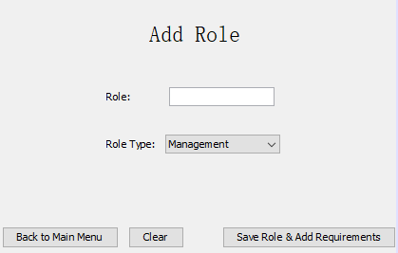
Figure 36: Timebox 3 - Add Role UI Implementation
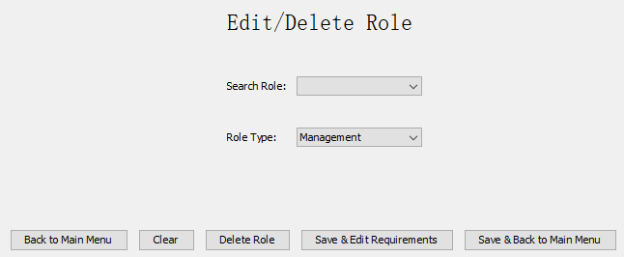
Figure 37: Timebox 3 - Edit/ Delete Role UI Implementation

Code Implementation
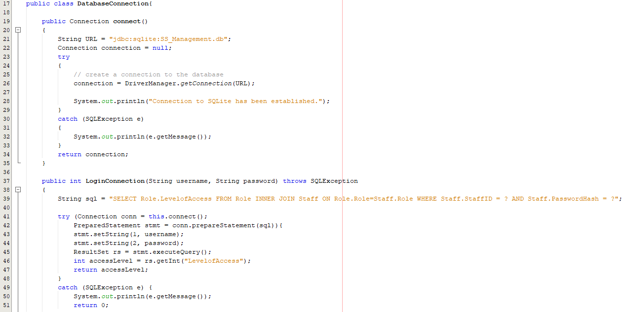
Figure 38: Timebox 3 - Database Connection Code
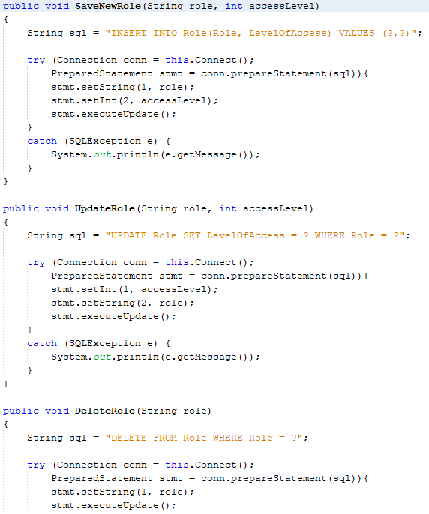
Figure 39: Timebox 3 – Role Class Database Code
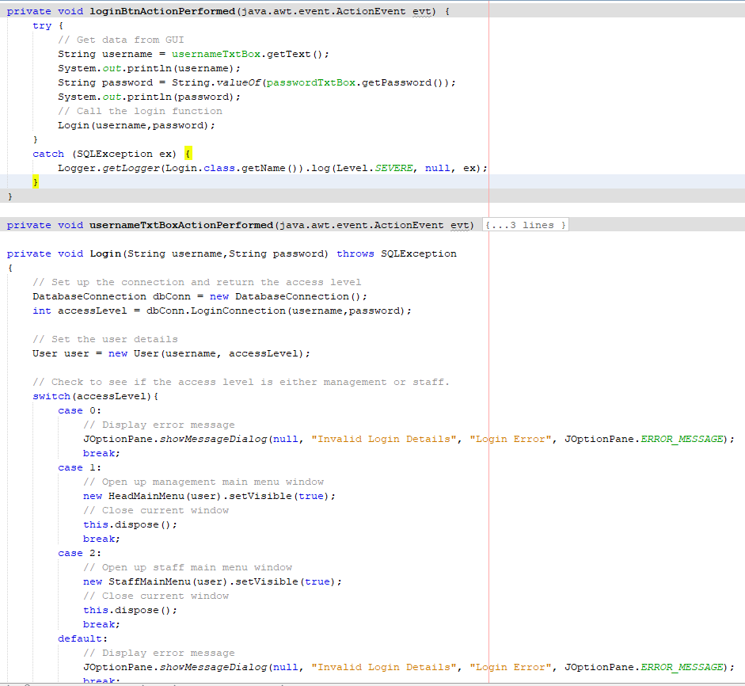
Figure 40: Timebox 3 - Login Code

Timebox 4
Start date: 25/02/2019
Duration: 2 weeks
Completion date: 11/03/2019

Timebox Aims
- UI implementation
- Code to add functionality
- Class & package diagrams

User Interface Implementation
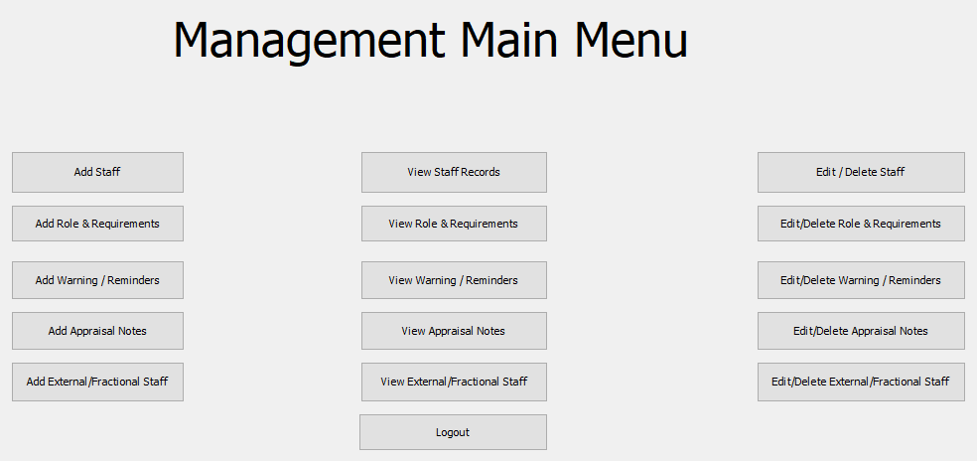
Figure 41: Timebox 4 - Management Main Menu UI Implementation
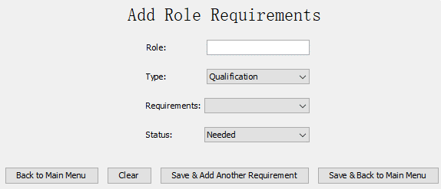
Figure 42: Timebox 4 - Add Role Requirements UI Implementation
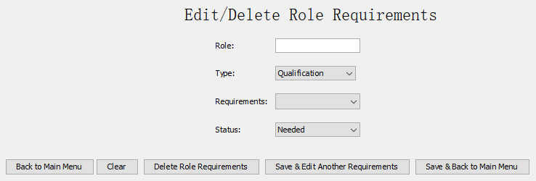
Figure 43: Timebox 4 – Edit/ Delete Role Requirements UI Implementation
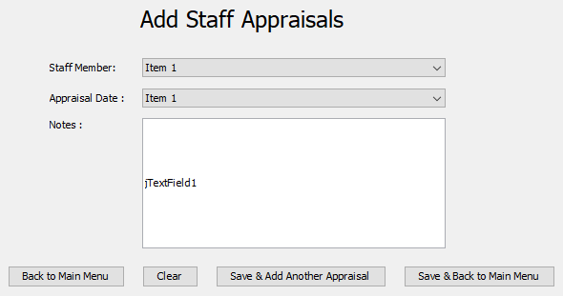
Figure 44: Timebox 4 - Add Staff Appraisals UI Implementation

Code Implementation
This involved creating all the code for the above user interfaces, including the functionality where possible. Some of the methods that required the database, such as add, update and delete functions were created.
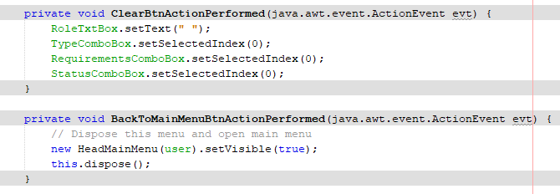
Figure 45: Timebox 4 – Clear & Back to Main Menu Button Code
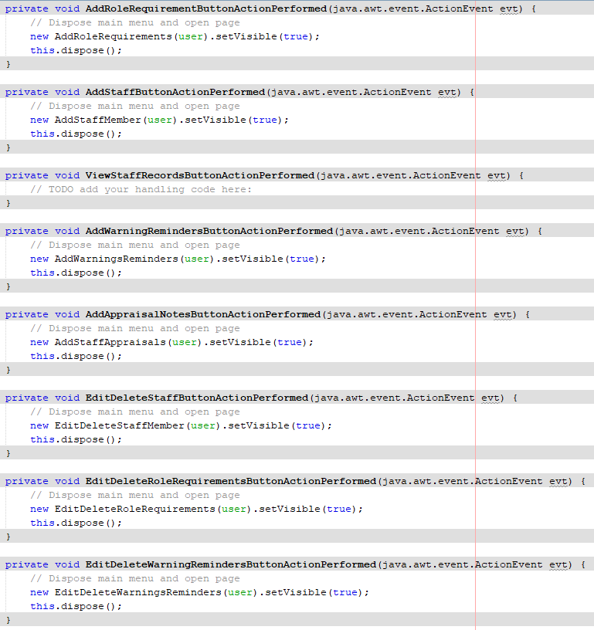
Figure 46: Timebox 4 – Main Menu Button Code
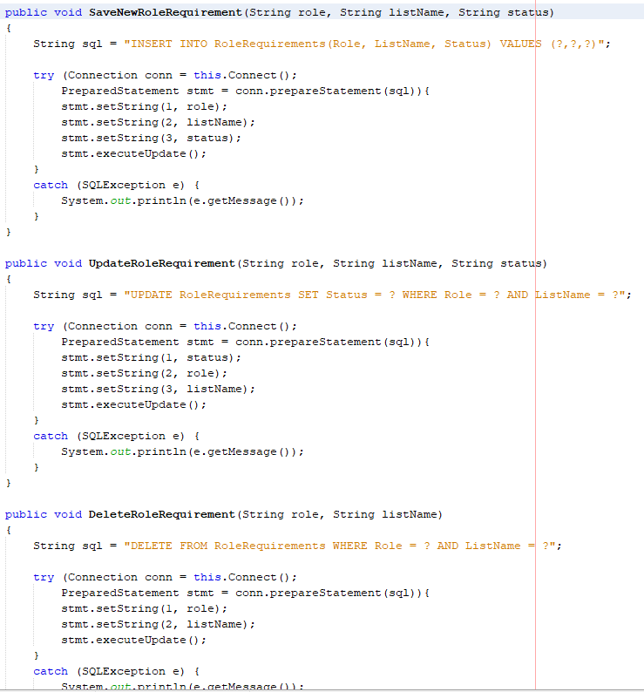
Figure 47: Timebox 4 – RoleRequirements Class Database Code

Class & Package Diagrams
The class and package diagram have been separated into two images for ease of reading.
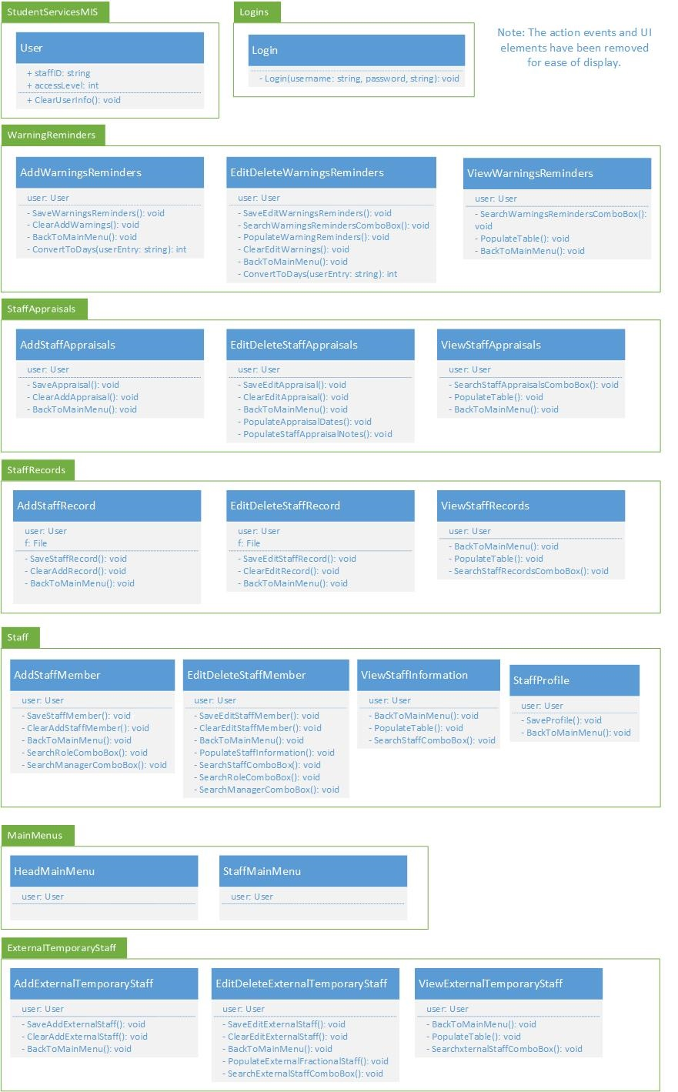
Figure 48: Timebox 4 - Class & Package Diagram - Part 1
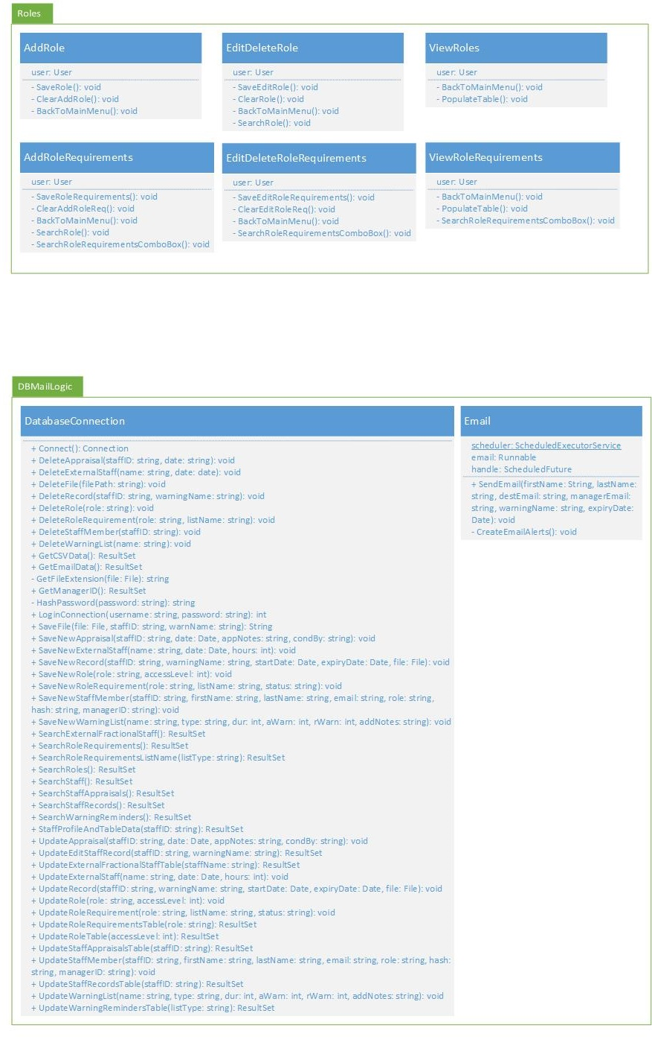
Figure 49: Timebox 4 - Class & Package Diagram - Part 2

Timebox 5
Start date: 12/03/2019
Duration: 2 weeks
Completion date: 26/03/2019

Timebox Aims
- Complete UI
- Complete SQL and logic layer
- Complete code functionality
- Unit and integration testing

Final User Interfaces
Below are the final user interfaces:
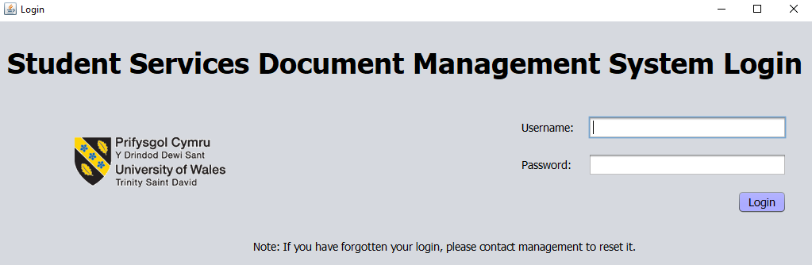
Figure 50: Timebox 5 - Final Login Menu
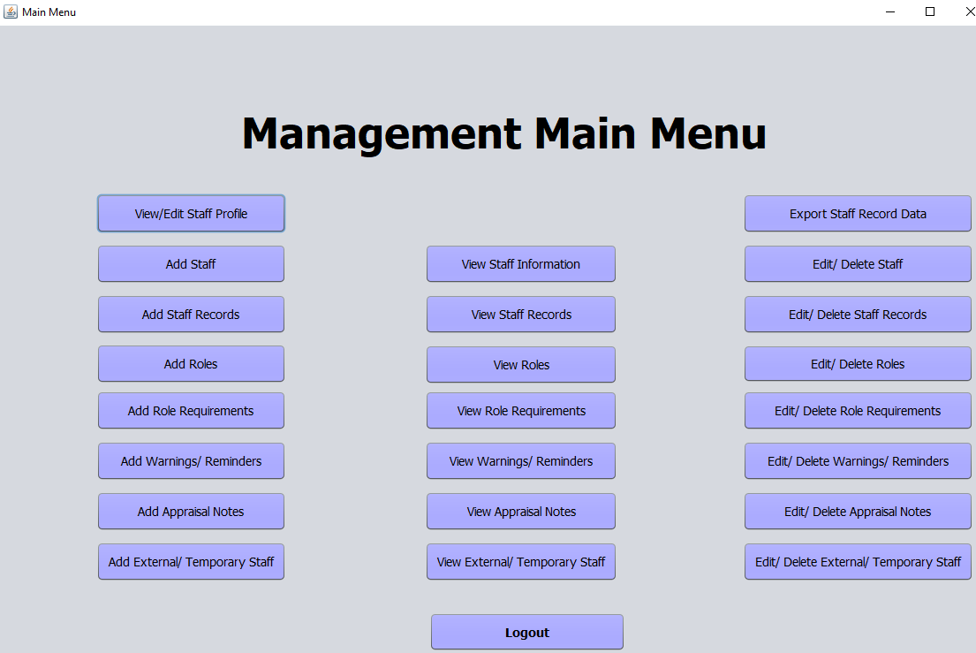
Figure 51: Timebox 5 - Final Management Main Menu
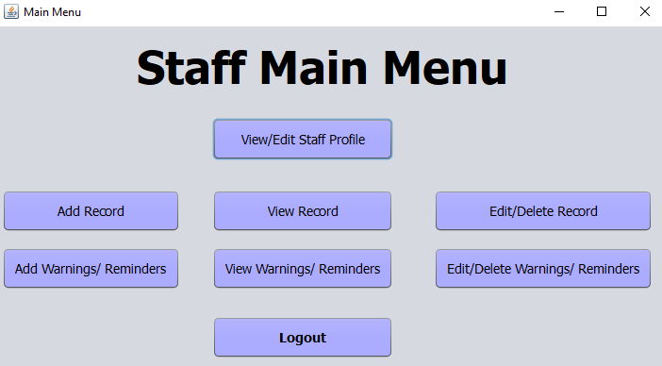
Figure 52: Timebox 5 - Final Staff Main Menu
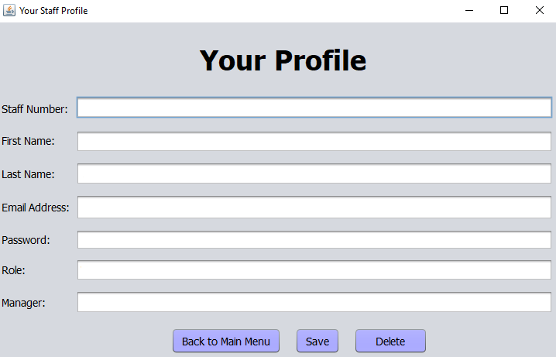
Figure 53: Timebox 5 - Final Staff Profile Menu
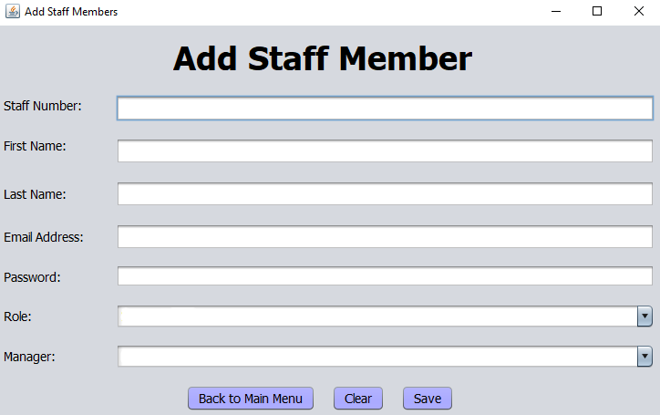
Figure 54: Timebox 5 - Final Add Staff Member Menu
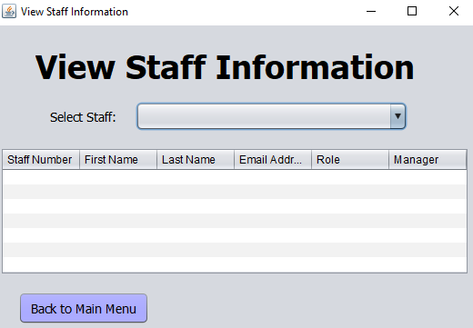
Figure 55: Timebox 5 - Final View Staff Information Menu
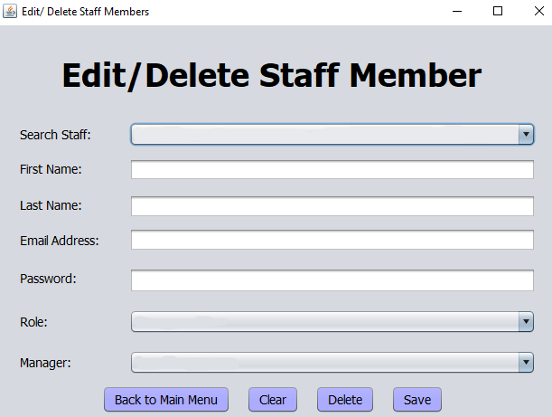
Figure 56: Timebox 5 - Final Edit/Delete Staff Member Menu
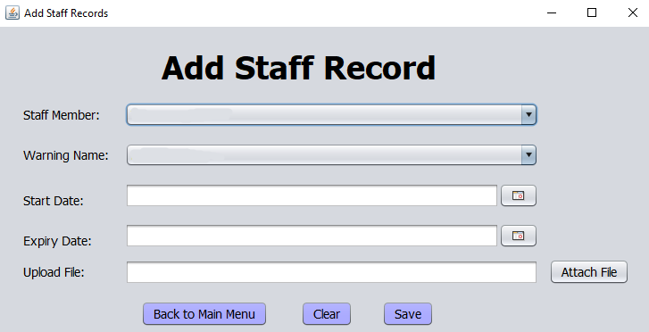
Figure 57: Timebox 5 - Final Add Staff Record Menu
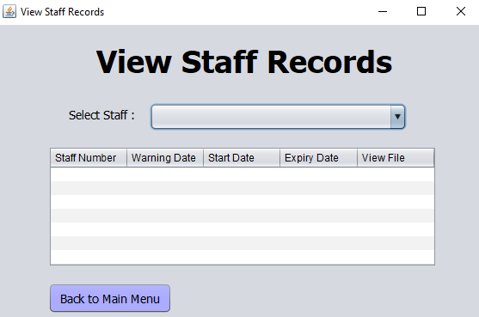
Figure 58: Timebox 5 - Final View Staff Records Menu
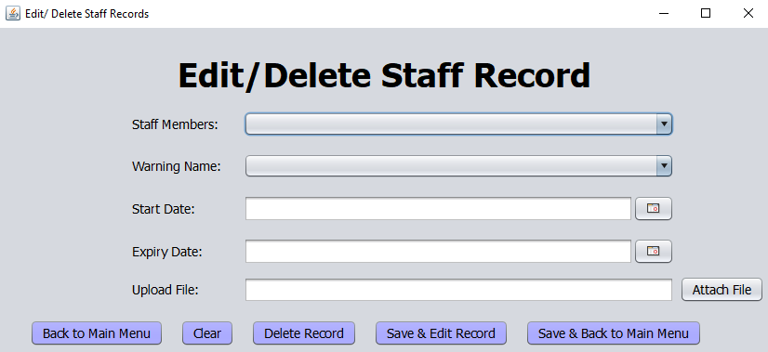
Figure 59: Timebox 5 - Final Edit/Delete Staff Record Menu
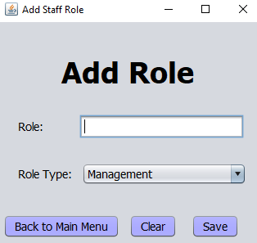
Figure 60: Timebox 5 - Final Add Role Menu
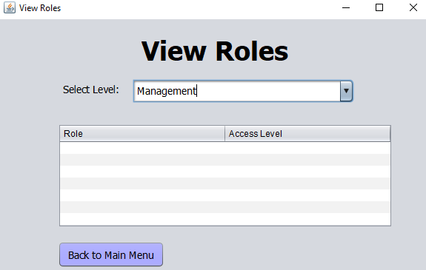
Figure 61: Timebox 5 - Final View Roles Menu
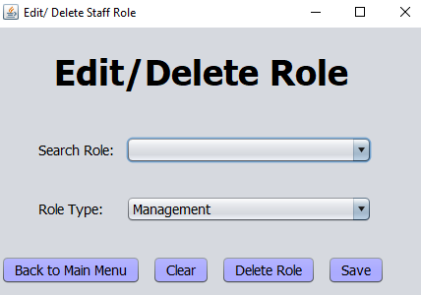
Figure 62: Timebox 5 - Final Edit/Delete Role Menu
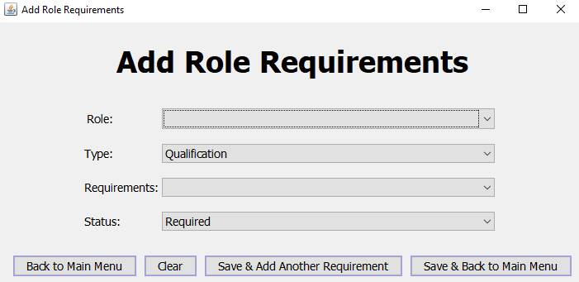
Figure 63: Timebox 5 - Final Add Role Requirements Menu
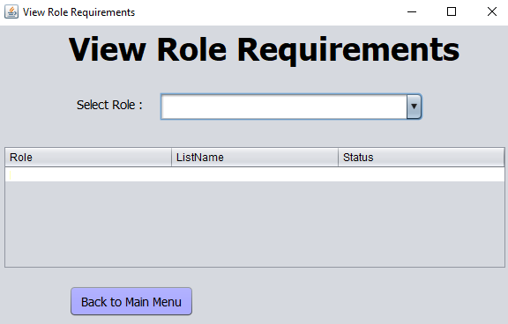
Figure 64: Timebox 5 - Final View Role Requirements Menu
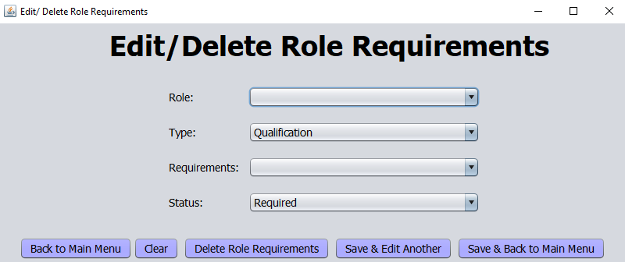
Figure 65: Timebox 5 - Final Edit/Delete Role Requirements Menu
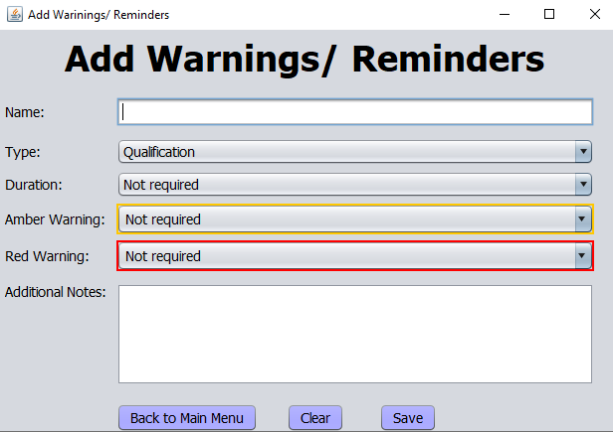
Figure 66: Timebox 5 - Final Add Warnings/Reminders Menu
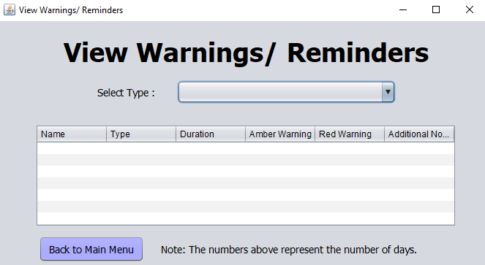
Figure 67: Timebox 5 - Final View Warnings/Reminders Menu
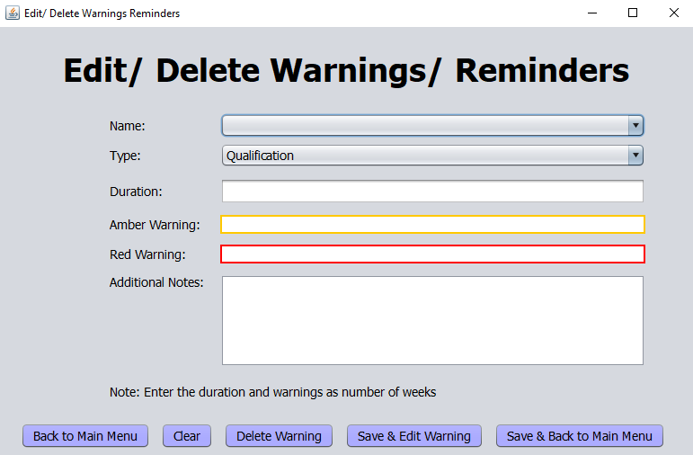
Figure 68: Timebox 5 - Final Edit/Delete Warnings/Reminders Menu
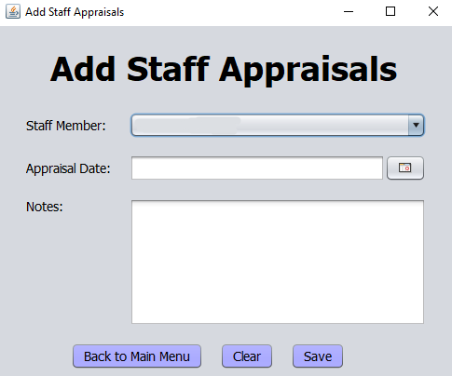
Figure 69: Timebox 5 - Final Add Staff Appraisals Menu
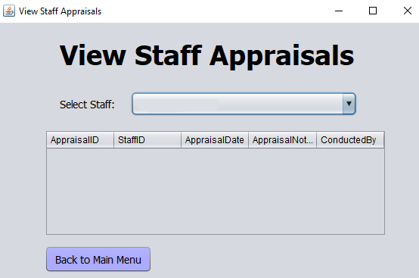
Figure 70: Timebox 5 - Final View Staff Appraisals Menu
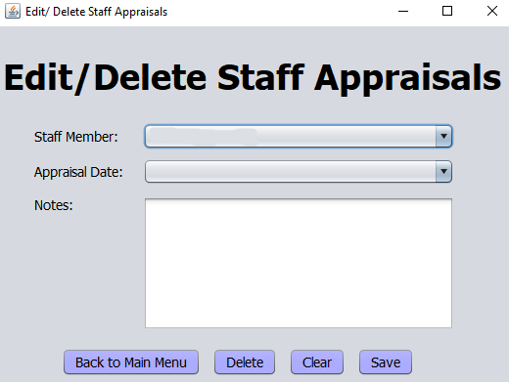
Figure 71: Timebox 5 - Final Edit/Delete Staff Appraisals Menu
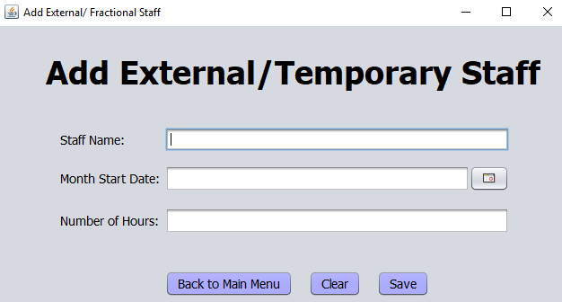
Figure 72: Timebox 5 - Final Add External/Temporary Staff Menu
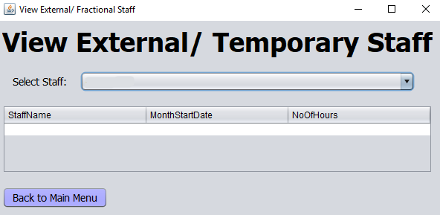
Figure 73: Timebox 5 - Final View External/Temporary Staff Menu
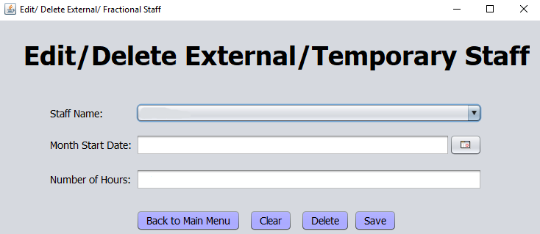
Figure 74: Timebox 5 - Final Edit/Delete External/Temporary Staff Menu

Final Database Entity Relationship Diagram
Below is the final entity relationship diagram for the MIS:
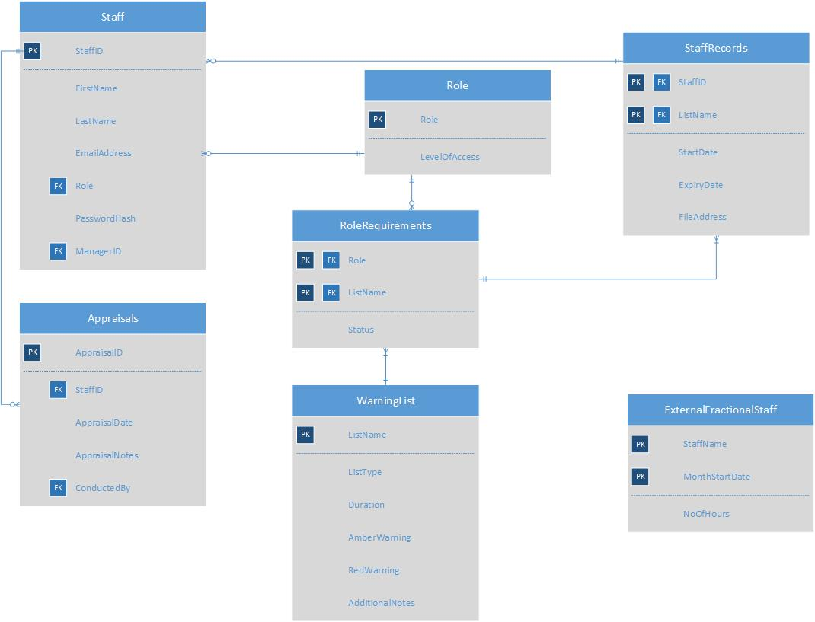
Figure 75: Timebox 5 - Final Entity Relationship Diagram

Final Logic Layer
These are the methods that interact between the database and the presentation layer (UI), which encompasses the DatabaseConnection, Email and User classes. This can be seen below:
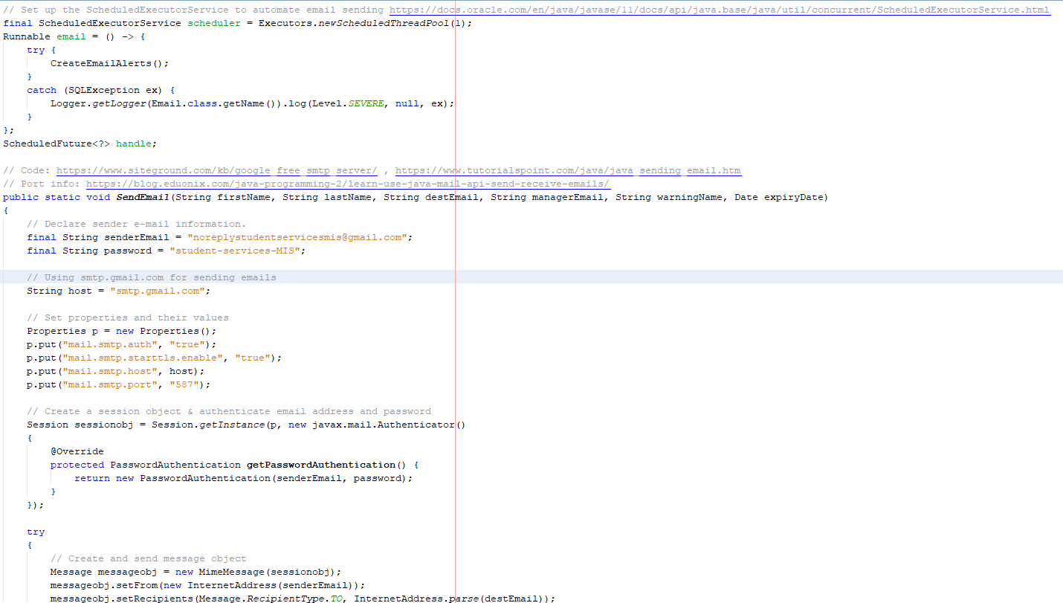
Figure 76: Timebox 5 - Email Code Snippet
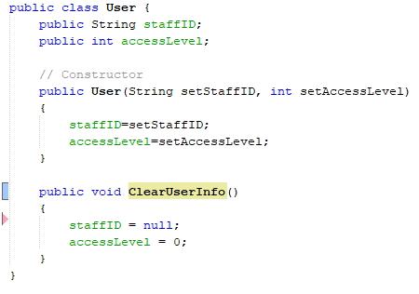
Figure 77: Timebox 5 - User Class Code
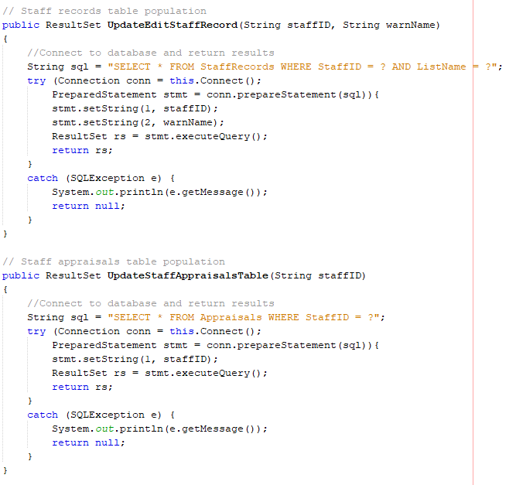
Figure 78: Timebox 5 - DatabaseConnection Class Code: Populating Tables

Final Code Functionality
This encompasses similar techniques across all the user interfaces, including populating tables and drop-down combo boxes. A selection of this functionality can be seen below:
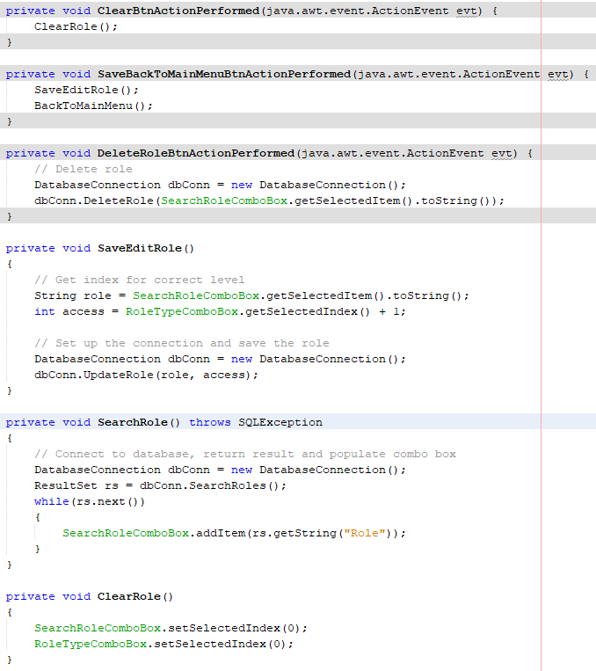
Figure 79: Timebox 5 - EditDeleteRole Class Code Section
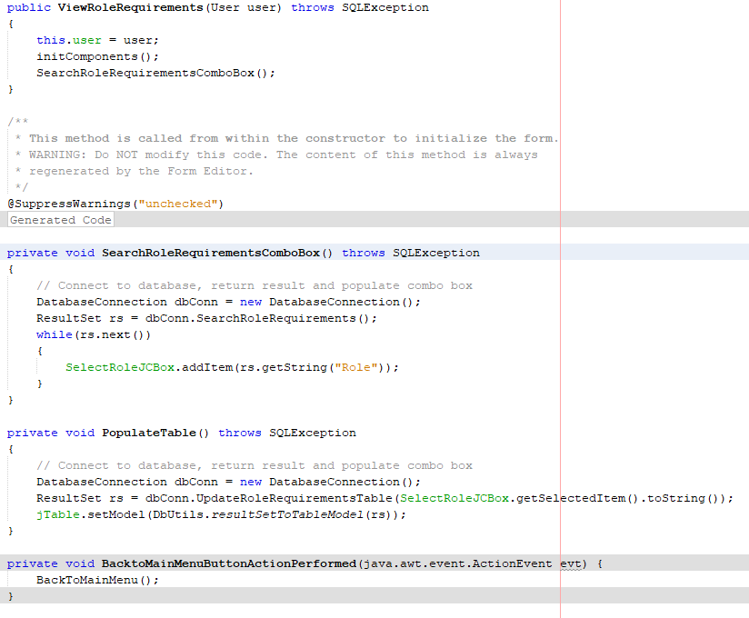
Figure 80: Timebox 5 - ViewRoleRequirements Class Code Section

Final Class & Package Diagrams
The class and package diagram have been separated into two images for ease of reading.
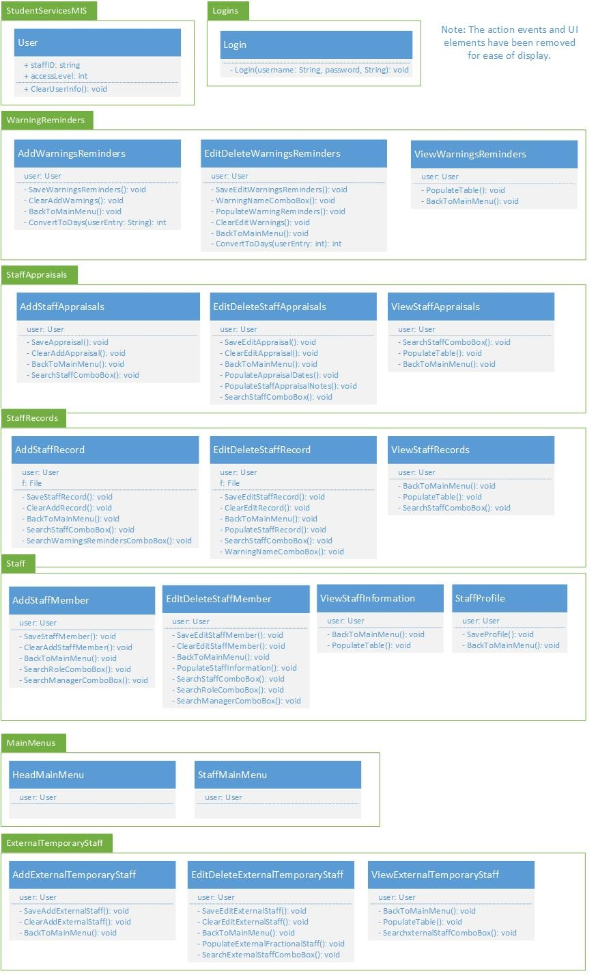
Figure 81: Timebox 5 - Final Class & Package Diagram - Part 1
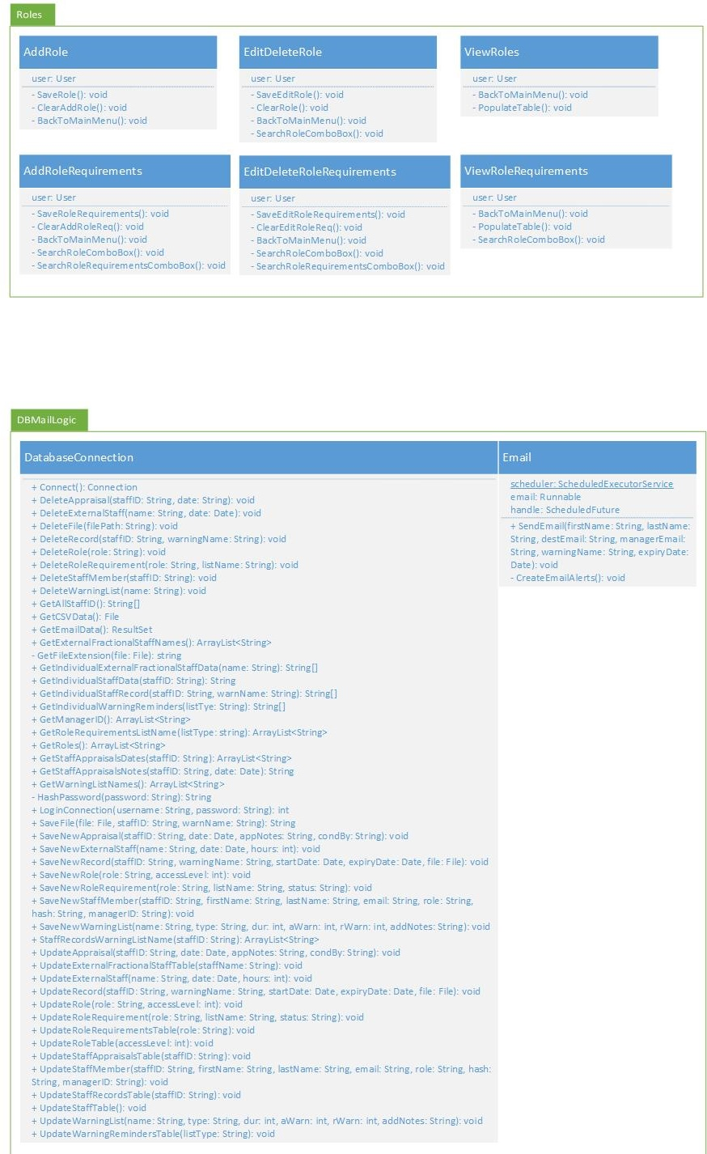
Figure 82: Timebox 5 - Final Class & Package Diagram - Part 2

Final Testing & Deployment
This stage incorporated four aspects:
- Unit and integration testing
- Exporting the application and database for deployment
- Creating the staff (see appendix 3) and management user guides (see appendix 2)
- User testing using the system usability scale and heuristics using the created system usability and accessibility guidelines (see Timebox 2: System Usability & Accessibility Guidelines)

Analysis
The data received was analysed using MS Excel for ease of analysing and displaying the results. Data was collected from the following sources:
- Software issues were collected via system generated logs, such as the command line via debugging and output files, and unit testing using JUnit version 4 for Java 8 compatibility, and version 5 for Java 9 and above.
- User interface issues were collected via regular user testing and system walkthroughs, taking notes when issues arose. These notes then became tasks within the next timebox, or after the full testing was completed.
- The questionnaire was comprised of 20 questions and included the system usability scale and the usability and accessibility guidelines created for this project. Additional notes/ comments were noted for future project expansion, or to be completed by the deadline. The questionnaire is located in appendix 4.

System Usability Score
The system usability score of 83 out of 100 is a very high score. It was calculated using the following steps:
1. Convert the responses to the corresponding number of points:
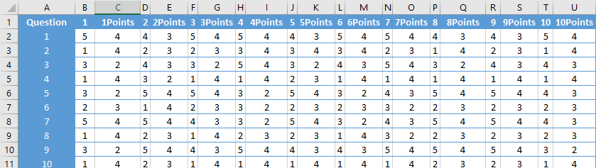
Figure 83: System Usability Scale Step 1
2. Sum these points and multiply by 2.5 to create the score for each respondent:
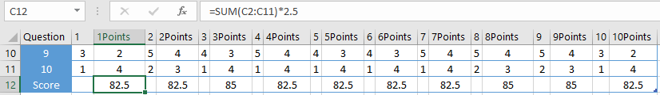
Figure 84: System Usability Scale Step 2

3. Average these scores to increase the accuracy of these results:
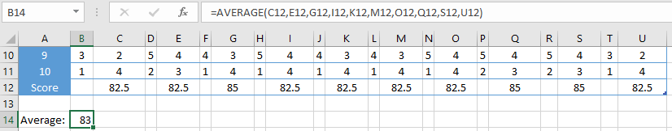
Figure 85: System Usability Scale Step 3
These are displayed in the chart below:

Figure 86: System Usability Scale Chart

System Usability & Accessibility Guidelines
This was tested using 10 questions to cover the 8 guidelines, separating the simplistic and aesthetically pleasing design question, with the addition of question 10. These results can be seen below:
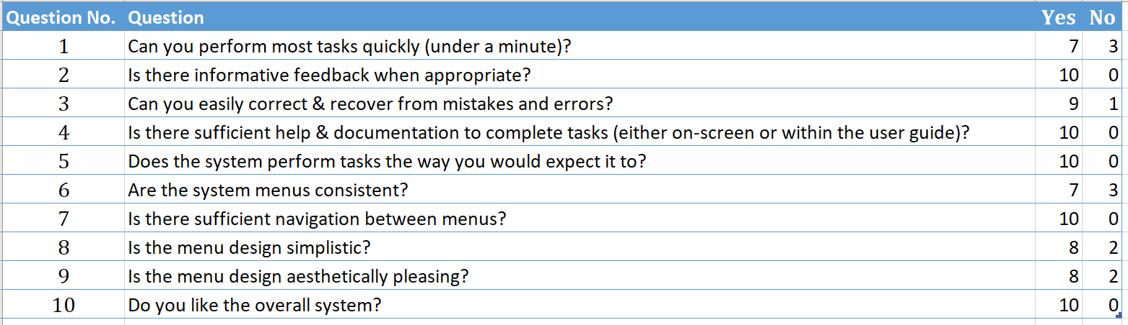
Figure 87: System Usability & Accessibility Guidelines Results
These results can be seen in the graph below:

Figure 88: System Usability & Accessibility Guidelines Chart
These results show that 100% of the respondents liked the system overall, with high scores across all 10 questions, of which half had 100% positive results. The lowest scores were questions 1 and 6 with 70% responding positively to the questions. The comments made regarding only one function per button were noted and was completed alongside the minor bugs found with the code. The exporting data to CSV file format button did not work, but due to time constraints, was made a suggestion for future improvements (see section) as it required additional time for research and development.

Evaluation
This system meets the original aims and objectives set out at the start of the project, with some of the additional objectives met. This is due to issues with successfully exporting the database data into CSV file format. The file is created, but none of the data is written to file.
The data resulting from the system testing is extensive and was easily monitored within the use of the JUnit test cases and their results, where these permits. Due to the extensive use of UI, user testing was required to complete the UI classes, although the majority of the UI code was auto generated by the use of NetBeans version 10 IDE. This permitted the ease of rapid UI development and made changes to the forms faster than would be possible using code alone.
The data from the questionnaire results was sufficient for the needs of this application and project, incorporating both the system usability score and questions generated based upon the usability and accessibility guidelines created for this project.
The SUS score of 83% is a high and expected score but would be slightly higher with the ability to successfully export to CSV file format. It can be deduced from this score that this application has a high level of usability, which could be due to the simple UI design.
If this project was redone, there would be an increased focus on planning out the development, setting out the aims of each timebox before any of the timeboxes commence. This would ensure increased focus to achieve the desired result. Additionally, increased support would have been beneficial to the system development, from both lecturers and student services, as a lack of response and access to crucial staff members has hindered development. Furthermore, additional research into Java GUI development would be conducted for alternatives to some of the chosen elements. This would have saved time during the development stages. This included the population of combo boxes and tables using data stored in a database. In addition to this, the use of an eye tracker may have improved the knowledge regarding the usability of the system, by developing a heat map for the main menus. This did not happen due to access to the eye tracker, and an inability to install the required software on a laptop.

Conclusion & Future Improvements

Conclusion
The aim of this project was to develop a management information system (MIS) for the University’s Student Services that alerts Valerie Harding and the member of staff that their qualifications/ checks and professional body memberships are due for renewal. These were used to create the feature list, initially created during timebox 1 and updated in timebox 2.
The literature review focused upon usability and accessibility, with an emphasis on the guidelines and principles developed by several eminent authors, including Shneiderman, Nielson, and Dix, in addition to researching evaluation tools and techniques, such as the eye tracker and heat maps, system walkthroughs, and the system usability scale. Additionally, research was conducted into management information systems, identifying their role within organisations, their characteristics, and design influences for the development of a system.
The development process (design and implementation) was conducted using an agile methodology called feature driven development, using timeboxes to design and develop the application. The application has a database back-end, a GUI front-end, and the logic layer interacts between both ends of the system. Despite the data export not working completely, the system is ready to use, with this function coming at a later date. This was tested using a combination of user testing (system walkthroughs and comments) and unit testing, due to the nature of this application, and its focus on usability and accessibility. This system could be further developed (see suggestions for future improvements section below).

Suggestions for Future Improvements
- Fix issues with exporting data to CSV file format in the user selected location.
- Web capability – perhaps a web application with a link on the MyDay dashboard for student services staff. This would directly link to the database and would require HTML and web (client and server-side) programming.
- Additional features to monitor current staff hours/ timetable by calendar.
- Log database activities within the system (what they add, update, delete etc.).
- Add an additional user level for admin staff, and additional testing on email sending.
- Increase user testing with end users – preferably the entire staff as to gain extensive feedback and improve the accuracy of results.
- Add a splash screen for added professionalism.

Reflection
A great amount of knowledge was accumulated whilst completing this project, enhancing the existing time management, research, report writing, planning and programming skills. The learning of Java was required to create this project. The main issues encountered were security, as the latest and most secure methods are not available in earlier versions of Java, the automatic sending of emails and the automatic updating of dropdown boxes and tables per user requests. These issues were resolved with a few hours of additional research but may need further research at a later date as Java versions are updated, as to ensure they do not become obsolete. This is where the time management and planning skills were utilised more, and the contingency time came into use. This was an excellent idea and is a crucial part of time management and project planning, especially when unexpected issues may occur, such as with programming, especially when a new programming language and additional tools must be learnt.
On reflection, if this project was done again, the development phase would be better planned from the start, planning each timebox before the process begins. Each timebox should only focus on a new feature, such as the security, database connectivity, data handling, and UI for that feature. This would ensure a faster system delivery, with additional time for testing and corrections. The research could have been more focused on the security features, or UI. The developer would start with the UI, with the aim to further understand data retrieval from the text fields, date pickers, file choosers and combo boxes.

References
[1] International Organization for Standardization, ISO 9241-11:2018(en), Ergonomics of human-system interaction — Part 11: Usability: Definitions and concepts, 2nd ed. ISO 9241-11:2018(en), Ergonomics of human-system interaction — Part 11: Usability: Definitions and concepts, 2018.
[2] Interaction Design Foundation, “What is Usability?,” Interaction Design Foundation, 2018. [Online]. Available: https://www.interaction-design.org/literature/topics/usability. [Accessed: 31-Oct-2018].
[3] Oxford Dictionaries, “Accessibility Definition,” Oxford Dictionaries, 2018. [Online]. Available: https://en.oxforddictionaries.com/definition/accessibility. [Accessed: 31-Oct-2018].
[4] Windows Development Center, “Accessibility overview,” Microsoft, 2017. [Online]. Available: https://docs.microsoft.com/en-us/windows/uwp/design/accessibility/accessibility-overview. [Accessed: 31-Oct-2018].
[5] Usability.gov, “Accessibility Basics,” Usability, 26-Feb-2015. [Online]. Available: https://www.usability.gov/what-and-why/accessibility.html. [Accessed: 31-Oct-2018].
[6] W3C, “Introduction to Web Accessibility,” Web Accessibility Initiative (WAI), 2018. [Online]. Available: https://www.w3.org/WAI/fundamentals/accessibility-intro/. [Accessed: 31-Oct-2018].
[7] W3C, “Accessibility Principles,” Web Accessibility Initiative (WAI), 2017. [Online]. Available: https://www.w3.org/WAI/fundamentals/accessibility-principles/. [Accessed: 31-Oct-2018].
[8] S. Djamasbi, M. Siegel, and T. Tullis, “Generation Y, web design, and eye tracking,” International Journal of Human-Computer Studies, vol. 68, no. 5, pp. 307–323, May 2010.
[9] G. Lindgaard, G. Fernandes, C. Dudek, and J. Browñ, “Attention web designers: You have 50 milliseconds to make a good first impression!,” Behaviour and Information Technology, vol. 25, no. 2, pp. 115–126, 2006.
[10] P. Faraday, “Visually Critiquing Web Page,” in 6th Conference on Human Factors and the Web, 2000, pp. 1–13.
[11] W3C, “Accessibility,” W3C, 2018. [Online]. Available: https://www.w3.org/standards/webdesign/accessibility. [Accessed: 31-Oct-2018].
[12] Web Accessibility Initiative (WAI), “Accessibility, Usability, and Inclusion,” W3C, 2016. [Online]. Available: https://www.w3.org/WAI/intro/usable. [Accessed: 31-Oct-2018].
[13] B. Shneiderman, “Shneiderman’s Eight Golden Rules of Interface Design,” Washington University. [Online]. Available: https://faculty.washington.edu/jtenenbg/courses/360/f04/sessions/schneidermanGoldenRules.html. [Accessed: 22-Nov-2018].
[14] E. Wong, “Shneiderman’s Eight Golden Rules Will Help You Design Better Interfaces,” Interactive Design Foundation, Nov-2018.
[15] Interactive Design Foundation, “Shneiderman’s 8 Golden Rules of Interface Design,” Interactive Design Foundation, 2018. [Online]. Available: https://public-media.interaction-design.org/pdf/Shneiderman.s.Eight.Golden.Rules.Worksheet.pdf. [Accessed: 22-Nov-2018].
[16] B. Scheiderman, “Shneiderman’s Eight Golden Rules of Interface Design,” Design Principles FTW, 2013. [Online]. Available: https://www.designprinciplesftw.com/collections/shneidermans-eight-golden-rules-of-interface-design. [Accessed: 21-Nov-2018].
[17] J. Nielsen, “10 Usability Heuristics for User Interface Design,” Nielsen Norman Group, 1995. [Online]. Available: https://www.nngroup.com/articles/ten-usability-heuristics/. [Accessed: 21-Nov-2018].
[18] A. Harley, “Visibility of System Status,” Nielsen Norman Group, 2018. [Online]. Available: https://www.nngroup.com/articles/visibility-system-status/. [Accessed: 21-Nov-2018].
[19] A. Kaley, “Match Between System and Real World: 2nd Usability Heuristic Explained,” Nielsen Norman Group, 2018. [Online]. Available: https://www.nngroup.com/articles/match-system-real-world/. [Accessed: 21-Nov-2018].
[20] J. Nielsen, “Do Interface Standards Stifle Design Creativity?,” Nielsen Norman Group, 1999. [Online]. Available: https://www.nngroup.com/articles/do-interface-standards-stifle-design-creativity/. [Accessed: 21-Nov-2018].
[21] P. Laubheimer, “Preventing User Errors: Avoiding Unconscious Slips,” Nielsen Norman Group, 2015. [Online]. Available: https://www.nngroup.com/articles/slips/. [Accessed: 21-Nov-2018].
[22] R. Budiu, “Memory Recognition and Recall in User Interfaces,” Nielsen Norman Group, 2014. [Online]. Available: https://www.nngroup.com/articles/recognition-and-recall/. [Accessed: 21-Nov-2018].
[23] J. Nielsen, “Error Message Guidelines,” Nielsen Norman Group, 2001. [Online]. Available: https://www.nngroup.com/articles/error-message-guidelines/. [Accessed: 21-Nov-2018].
[24] A. Dix, J. Finlay, G. D. Abowd, and R. Beale, Human Computer Interaction, 3rd ed. Harlow, Essex, UK: Pearson Education Limited, 2004.
[25] UK Government, “Making Your Service Accessible: An Introduction,” UK Government, 2018. [Online]. Available: https://www.gov.uk/service-manual/helping-people-to-use-your-service/making-your-service-accessible-an-introduction. [Accessed: 11-Jan-2019].
[26] M. Cooper, D. Sloan, B. Kelly, and S. Lewthwaite, “A Challenge to Web Accessibility Metrics and Guidelines,” in Proceedings of the International Cross-Disciplinary Conference on Web Accessibility - W4A ’12, 2012, p. 4.
[27] W3C, “Web Design and Applications,” W3C, 2016. [Online]. Available: https://www.w3.org/standards/webdesign/. [Accessed: 11-Jan-2019].
[28] A. Kirkpatrick, J. O Connor, A. Campbell, and M. Cooper, “Web Content Accessibility Guidelines (WCAG) 2.1,” W3C, 2018. [Online]. Available: https://www.w3.org/TR/WCAG21/. [Accessed: 11-Jan-2019].
[29] Tobii Tech, “What is eye tracking?,” Tobii Tech, 2015. [Online]. Available: https://www.tobii.com/tech/technology/what-is-eye-tracking/. [Accessed: 31-Oct-2018].
[30] Tobii, “This is Eye Tracking,” Tobii, 2015. [Online]. Available: https://www.tobii.com/group/about/this-is-eye-tracking/. [Accessed: 11-Jan-2019].
[31] iMotions, “Top 8 Eye Tracking Applications in Research,” iMotions, 2015. [Online]. Available: https://imotions.com/blog/top-8-applications-eye-tracking-research/. [Accessed: 12-Jan-2019].
[32] P. E. Dussias, “Uses of Eye-Tracking Data in Second Language Sentence Processing Research,” Annual Review of Applied Linguistics, vol. 30, pp. 149–166, 2010.
[33] B. Wąsikowska, “The Application of Eye Tracking in Business,” Szczecin, Poland, 2014.
[34] D. Miniotas and O. Špakov, “Visualization of Eye Gaze Data using Heat Maps,” Electronics and Electrical Engineering, pp. 55–58, 2007.
[35] T. Fazzini, “Use a Heat Map to Better Understand Your Web Conversion,” MoreVisibility, 2012. [Online]. Available: https://www.morevisibility.com/blogs/analytics/use-a-heat-map-to-better-understand-your-web-conversion.html. [Accessed: 11-Nov-2018].
[36] S. Djamasbi, M. Sigel, and T. Tullis, “Visual Hierarchy and Viewing Behavior: An Eye Tracking Study,” Human-Computer Interaction, Design and Development Approaches, vol. 6761, pp. 331–340, 2011.
[37] J. Nielson, “F-Shaped Pattern For Reading Web Content (Original Eyetracking Research),” Nielsen Norman Group, 2006. [Online]. Available: https://www.nngroup.com/articles/f-shaped-pattern-reading-web-content-discovered/. [Accessed: 11-Nov-2018].
[38] K. Pernice, “F-Shaped Pattern of Reading on the Web: Misunderstood, But Still Relevant (Even on Mobile),” Nielsen Norman Group, 2017. [Online]. Available: https://www.nngroup.com/articles/f-shaped-pattern-reading-web-content/. [Accessed: 11-Nov-2018].
[39] D. F. Nettleton and C. González-caro, “Successful Web Searches: What Makes the Difference? An Eye-Tracking Study,” pp. 53–72, 2012.
[40] S. Bradley, “3 Design Layouts: Gutenberg Diagram, Z-Pattern, And F-Pattern,” Vanseo Design, 2011. [Online]. Available: https://vanseodesign.com/web-design/3-design-layouts/. [Accessed: 12-Jan-2019].
[41] K. Holmqvist, M. Nyström, and F. Mulvey, “Eye tracker data quality,” in Proceedings of the Symposium on Eye Tracking Research and Applications - ETRA ’12, 2012, p. 45.
[42] A. Bojko, “Informative or Misleading? Heatmaps Deconstructed,” in Lecture Notes in Computer Science (including subseries Lecture Notes in Artificial Intelligence and Lecture Notes in Bioinformatics), vol. 5610 LNCS, no. PART 1, 2009, pp. 30–39.
[43] TutorialsPoint, “Structural Walkthrough,” Tutorials Point, 2018. [Online]. Available: https://www.tutorialspoint.com/software_testing_dictionary/structured_walkthrough.htm. [Accessed: 19-Nov-2018].
[44] Department of Health and Human Services, “System Usability Scale (SUS),” Department of Health and Human Services, 2019. [Online]. Available: https://www.usability.gov/how-to-and-tools/methods/system-usability-scale.html. [Accessed: 01-May-2019].
[45] T. Lucey, Management Information Systems, 8th ed. London: Continuum, 1997.
[46] D. Thakur, “What is MIS? Define the function and characteristics of MIS?,” EComputer Notes, 2016. [Online]. Available: http://ecomputernotes.com/mis/what-is-mis/functionandcharacteristicsofmis. [Accessed: 14-Jan-2019].
[47] A. Pratap, “Management Information System: Role, Characteristics and Advantages,” Cheshnotes, 19-May-2018.
[48] D. Das, “Characteristics of Management Information System,” CSE Tutor, Apr-2018.
[49] K. C. Laudon and J. P. Laudon, Management Information Systems: Managing the Digital Firm, 13th Globa. Harlow, Essex: Pearson Education, 2014.
[50] J. P. Princy, “Role of Management Information System in Business and Industry,” International Journal of Humanities and Social Science Invention, vol. 6, no. 7, pp. 1–6, 2017.
[51] A. Marcus, “Dashboards in your future,” Interactions - The art of prototyping, vol. 13, no. 1, pp. 48–60, 2006.
[52] O. Pickup, “A new era in the evolution of remote working,” The Telegraph, 23-Feb-2018.
[53] High Speed Office, “50% of UK workforce to work remotely by 2020,” High Speed Office, 2019. [Online]. Available: https://www.hso.co.uk/leased-lines/technology-news/homeworking-news/50-of-uk-workforce-to-work-remotely-by-2020. [Accessed: 30-Jan-2019].
[54] Trades Union Congress, “Growth in homeworking has stalled,” Trades Union Congress, London, May-2018.
[55] M. Olsha-Yehiav et al., “Quality Dashboards: technical and architectural considerations of an actionable reporting tool for population management.,” in AMIA Annual Symposium proceedings, 2006.
[56] D. M. West, “Big Data for Education: Data Mining, Data Analytics, and Web Dashboards,” 2012.
[57] Techopedia, “Noise Definition,” Techopedia. Techopedia, 2018.
[58] B. M. Saunders and P. Tosey, “The Layers of Research Design,” in Rapport: The Magazine for NLP Professionals, 2012, pp. 58–59.
[59] Association of Modern Technologies Professionals, “Software Development Methodologies,” Association of Modern Technologies Professionals, 2017. [Online]. Available: http://www.itinfo.am/eng/software-development-methodologies/. [Accessed: 13-Apr-2017].
[60] P. Abrahamsson, O. Salo, J. Ronkainen, and J. Warsta, “Agile software development methods review and analysis,” VTT Publications, no. 478, pp. 3–107, 2002.
[61] Wikidot, “FDD - Agile - Feature Driven Development,” Wikidot, 2011. [Online]. Available: http://sliitmscfdd.wikidot.com/introduction-to-fdd. [Accessed: 13-Apr-2017].
[62] J. Randolph and G. M. Masters, Energy for Sustainability: Technology, Planning, Policy, 1st ed. Washington D.C., USA: Island Press, 2008.
[63] M. G. O’Neill, Green IT for Sustainable Business Practice: An ISEB Foundation Guide, 1st ed. Swindon, UK: British Informatics Society, 2010.
[64] The Climate Group, “SMART 2020: Enabling the low carbon economy in the information age,” 2008.
[65] F. Berkhout and J. Hertin, “Impacts of Information and Communication Technologies on Environmental Sustainability: speculations and evidence,” Brighton, United Kingdom, 2001.
[66] P. Lago, S. A. Koçak, I. Crnkovic, and B. Penzenstadler, “Framing sustainability as a property of software quality,” Communications of the ACM, vol. 58, no. 10, pp. 70–78, Sep. 2015.
[67] G. Lami, F. Fabbrini, and M. Fusani, “A methodology to derive sustainability indicators for software development projects,” in Proceedings of the 2013 International Conference on Software and System Process - ICSSP 2013, 2013, pp. 70–77.
[68] British Computer Society, “Code Of Conduct,” Swindon, UK, 2019.
[69] European Commission, “Data Protection in the EU,” European Commission, 2019. [Online]. Available: https://ec.europa.eu/info/law/law-topic/data-protection/data-protection-eu_en. [Accessed: 06-Apr-2019].
[70] European Commission, “2018 Reform of EU Data Protection Rules,” European Commission, 2019. [Online]. Available: https://ec.europa.eu/commission/priorities/justice-and-fundamental-rights/data-protection/2018-reform-eu-data-protection-rules_en. [Accessed: 06-Apr-2019].
[71] European Commission, “What Are My Rights?,” European Commission, 2019. [Online]. Available: https://ec.europa.eu/info/law/law-topic/data-protection/reform/rights-citizens/my-rights/what-are-my-rights_en. [Accessed: 06-Apr-2019].
[72] European Commission, “What Data Can We Process & Under Which Conditions?,” European Commission, 2019. [Online]. Available: https://ec.europa.eu/info/law/law-topic/data-protection/reform/rules-business-and-organisations/principles-gdpr/what-data-can-we-process-and-under-which-conditions_en. [Accessed: 06-Apr-2019].
[73] European Union, Regulation (EU) 2016/679 of the European Parliament and of the Council of 27 April 2016 on the protection of natural persons with regard to the processing of personal data and on the free movement of such data, and repealing Directive 95/46/EC (General Da, vol. 2014. European Union, 2016, pp. 1–88.
[74] Office of Government Commerce, Managing Successful Projects with PRINCE2, 5th ed. Norwich, Norfolk: The Stationary Office, 2009.
[75] UWTSD, “Student Services - University of Wales Trinity Saint David,” UWTSD, 2019. [Online]. Available: https://www.uwtsd.ac.uk/student-services/. [Accessed: 20-Jan-2019].
[76] S. Palmer, “An Introduction to Feature-Driven Development,” DZone Agile Zone, Nov-2009.
[77] S. W. Ambler, “Feature Driven Development (FDD),” Agile Modeling, 2018. [Online]. Available: http://agilemodeling.com/essays/fdd.htm. [Accessed: 07-Dec-2018].
[78] S. Ambler, “Feature Driven Development (FDD) and Agile Modeling,” Agile Modeling, 2018. [Online]. Available: http://agilemodeling.com/essays/fdd.htm. [Accessed: 20-Jan-2019].
[79] B. Roseke, “25 Example Project Deliverables,” Project Engineer, May-2014.
[80] J. De Luca, “FDD Process,” Nebulon, 2004. [Online]. Available: http://www.nebulon.com/articles/fdd/download/fddprocessesA4.pdf. [Accessed: 12-Dec-2018].

Appendix 1: Code
Below is the code for each of the classes:

DatabaseConnection Class
package DBMailLogic;
import ExternalTemporaryStaff.ViewExternalTemporaryStaff;
import Roles.ViewRoles;
import Roles.ViewRoleRequirements;
import Staff.ViewStaffInformation;
import StaffAppraisals.ViewStaffAppraisals;
import StaffRecords.ViewStaffRecords;
import WarningReminders.ViewWarningsReminders;

import java.io.File;
import java.io.FileNotFoundException;
import java.io.IOException;
import java.io.PrintWriter;
import java.nio.charset.StandardCharsets;
import java.nio.file.Files;
import java.nio.file.Path;
import static java.nio.file.StandardCopyOption.REPLACE_EXISTING;
import java.security.MessageDigest;
import java.security.NoSuchAlgorithmException;
import java.sql.PreparedStatement;
import java.sql.Connection;
import java.sql.Date;
import java.sql.DriverManager;
import java.sql.SQLException;
import java.sql.ResultSet;
import java.sql.ResultSetMetaData;
import java.util.ArrayList;
import java.util.Arrays;
import java.util.Base64;
import net.proteanit.sql.DbUtils;
/**
*
* @author CerysNickels
*/
public class DatabaseConnection{

public Connection Connect()
{
String URL = "jdbc:sqlite:SS_Management.db";
try
{
// create a connection to the database
Connection connection = DriverManager.getConnection(URL);
System.out.println("Connection to SQLite has been established.");
return connection;
}
catch (SQLException e)
{
System.out.println(e.getMessage());
return null;
}
}

public int LoginConnection(String username, String password) throws SQLException, NoSuchAlgorithmException
{
String sql = "SELECT Role.LevelofAccess FROM Role INNER JOIN Staff ON Role.Role=Staff.Role WHERE Staff.StaffID = ? AND Staff.PasswordHash = ?";

try (Connection conn = this.Connect();
PreparedStatement stmt = conn.prepareStatement(sql)){
stmt.setString(1, username);
//stmt.setString(2, HashPassword(password));
stmt.setString(2, password);
ResultSet rs = stmt.executeQuery();
int accessLevel = rs.getInt("LevelofAccess");
return accessLevel;
}
catch (SQLException e) {
System.out.println(e.getMessage());
return 0;
}
}

// Role combo box population
public ArrayList<String> GetRoles()
{
//Connect to database and return results
String sql = "SELECT Role FROM Role";
try (Connection conn = this.Connect();
PreparedStatement stmt = conn.prepareStatement(sql)){
ResultSet rs = stmt.executeQuery();

//Stores properties of a ResultSet object, including column count
ResultSetMetaData rsmd = rs.getMetaData();
int colCount = rsmd.getColumnCount();

// Copy rs into array to return to interface
ArrayList<String> results = new ArrayList<>();
while (rs.next()) {
int i = 1;
while(i <= colCount) {
results.add(rs.getString(i++));
}
}
return results;
}
catch (SQLException e) {
System.out.println(e.getMessage());
return null;
}
}

// Staff appraisals table population
public ArrayList<String> GetStaffAppraisalsDates(String staffID)
{
//Connect to database and return results
String sql = "SELECT AppraisalDate FROM Appraisals WHERE StaffID = ?";
try (Connection conn = this.Connect();
PreparedStatement stmt = conn.prepareStatement(sql)){
stmt.setString(1, staffID);
ResultSet rs = stmt.executeQuery();

//Stores properties of a ResultSet object, including column count
ResultSetMetaData rsmd = rs.getMetaData();
int colCount = rsmd.getColumnCount();

// Copy rs into array to return to interface
ArrayList<String> results = new ArrayList<>();
while (rs.next()) {
int i = 1;
while(i <= colCount) {
results.add(rs.getString(i++));
}
}
return results;
}
catch (SQLException e) {
System.out.println(e.getMessage());
return null;
}
}

// Staff records warning list name combo box population
public ArrayList<String> StaffRecordsWarningListName(String staffID)
{
//Connect to database and return results
String sql = "SELECT * FROM StaffRecords WHERE StaffID = ?";
try (Connection conn = this.Connect();
PreparedStatement stmt = conn.prepareStatement(sql)){
stmt.setString(1, staffID);
ResultSet rs = stmt.executeQuery();

//Stores properties of a ResultSet object, including column count
ResultSetMetaData rsmd = rs.getMetaData();
int colCount = rsmd.getColumnCount();

// Copy rs into array to return to interface
ArrayList<String> results = new ArrayList<>();
while (rs.next()) {
int i = 1;
while(i <= colCount) {
results.add(rs.getString(i++));
}
}
return results;
}
catch (SQLException e) {
System.out.println(e.getMessage());
return null;
}
}

// External/fractional staff combo box population
public ArrayList<String> GetExternalFractionalStaffNames()
{
//Connect to database and return results
String sql = "SELECT StaffName FROM ExternalFractionalStaff";
try (Connection conn = this.Connect();
PreparedStatement stmt = conn.prepareStatement(sql)){
ResultSet rs = stmt.executeQuery();

//Stores properties of a ResultSet object, including column count
ResultSetMetaData rsmd = rs.getMetaData();
int colCount = rsmd.getColumnCount();

// Copy rs into array to return to interface
ArrayList<String> results = new ArrayList<>();
while (rs.next()) {
int i = 1;
while(i <= colCount) {
results.add(rs.getString(i++));
}
}
return results;
}
catch (SQLException e) {
System.out.println(e.getMessage());
return null;
}
}

// Staff appraisals table population
public String GetStaffAppraisalsNotes(String staffID, Date date)
{
//Connect to database and return results
String sql = "SELECT AppraisalNotes FROM Appraisals WHERE StaffID = ? AND AppraisalDate = ?";
try (Connection conn = this.Connect();
PreparedStatement stmt = conn.prepareStatement(sql)){
stmt.setString(1, staffID);
ResultSet rs = stmt.executeQuery();

// Copy rs into array to return to interface
String notes = rs.getString("AppraisalNotes");
return notes;
}
catch (SQLException e) {
System.out.println(e.getMessage());
return null;
}
}

// Role requirements combo box population
public ArrayList<String> GetRoleRequirementsListName(String listType)
{
//Connect to database and return results
String sql = "SELECT ListName FROM WarningList WHERE ListType = ?";
try (Connection conn = this.Connect();
PreparedStatement stmt = conn.prepareStatement(sql)){
stmt.setString(1, listType);
ResultSet rs = stmt.executeQuery();

//Stores properties of a ResultSet object, including column count
ResultSetMetaData rsmd = rs.getMetaData();
int colCount = rsmd.getColumnCount();

// Copy rs into array to return to interface
ArrayList<String> results = new ArrayList<>();
while (rs.next()) {
int i = 1;
while(i <= colCount) {
results.add(rs.getString(i++));
}
}
return results;
}
catch (SQLException e) {
System.out.println(e.getMessage());
return null;
}
}

// Warning/reminders combo box population
public ArrayList<String> GetWarningListNames()
{
//Connect to database and return results
String sql = "SELECT ListName FROM WarningList";
try (Connection conn = this.Connect();
PreparedStatement stmt = conn.prepareStatement(sql)){
ResultSet rs = stmt.executeQuery();

//Stores properties of a ResultSet object, including column count
ResultSetMetaData rsmd = rs.getMetaData();
int colCount = rsmd.getColumnCount();

// Copy rs into array to return to interface
ArrayList<String> results = new ArrayList<>();
while (rs.next()) {
int i = 1;
while(i <= colCount) {
results.add(rs.getString(i++));
}
}
return results;
}
catch (SQLException e) {
System.out.println(e.getMessage());
return null;
}
}

// Manager combo box population
public ArrayList<String> GetManagerID()
{
//Connect to database and return results
String sql = "SELECT S.StaffID AS ManagerID FROM Staff S INNER JOIN Role R ON S.Role = R.Role WHERE R.LevelOfAccess = 1";
try (Connection conn = this.Connect();
PreparedStatement stmt = conn.prepareStatement(sql)){
ResultSet rs = stmt.executeQuery();

//Stores properties of a ResultSet object, including column count
ResultSetMetaData rsmd = rs.getMetaData();
int colCount = rsmd.getColumnCount();

// Copy rs into array to return to interface
ArrayList<String> results = new ArrayList<>();
while (rs.next()) {
int i = 1;
while(i <= colCount) {
results.add(rs.getString(i++));
}
}
return results;
}
catch (SQLException e) {
System.out.println(e.getMessage());
return null;
}
}

// Staff table data
public void UpdateStaffTable()
{
//Connect to database and return results
String sql = "SELECT * FROM Staff";
try (Connection conn = this.Connect();
PreparedStatement stmt = conn.prepareStatement(sql)){
ResultSet rs = stmt.executeQuery();
// View results in table
ViewStaffInformation.staffInformationTable.setModel(DbUtils.resultSetToTableModel(rs));
}
catch (SQLException e) {
System.out.println(e.getMessage());
}
}

public String[] GetIndividualStaffData(String staffID)
{
//Connect to database and return results
String sql = "SELECT * FROM Staff WHERE StaffID = ?";
try (Connection conn = this.Connect();
PreparedStatement stmt = conn.prepareStatement(sql)){
stmt.setString(1, staffID);
ResultSet rs = stmt.executeQuery();

// Copy rs into array to return to interface
String[] results = new String[7];
for (int i=0; i<7; i++) {
results[i] = rs.getString(i+1);
}
return results;
}
catch (SQLException e) {
System.out.println(e.getMessage());
return null;
}
}

// External/fractional staff combo box population
public String[] GetIndividualExternalFractionalStaffData(String name)
{
//Connect to database and return results
String sql = "SELECT * FROM ExternalFractionalStaff WHERE StaffName = ?";
try (Connection conn = this.Connect();
PreparedStatement stmt = conn.prepareStatement(sql)){
stmt.setString(1, name);
ResultSet rs = stmt.executeQuery();

// Copy rs into array to return to interface
String[] results = new String[3];
for (int i=0; i<3; i++) {
results[i] = rs.getString(i+1);
}
return results;
}
catch (SQLException e) {
System.out.println(e.getMessage());
return null;
}
}

// Warning/reminders table population
public String[] GetIndividualWarningReminders(String listType)
{
//Connect to database and return results
String sql = "SELECT * FROM WarningList WHERE ListType = ?";
try (Connection conn = this.Connect();
PreparedStatement stmt = conn.prepareStatement(sql)){
stmt.setString(1, listType);
ResultSet rs = stmt.executeQuery();

// Copy rs into array to return to interface
String[] results = new String[6];
for (int i=0; i<7; i++) {
results[i] = rs.getString(i+1);
}
return results;
}
catch (SQLException e) {
System.out.println(e.getMessage());
return null;
}
}

// Get StaffID for combo boxes etc.
public String[] GetAllStaffID()
{
//Connect to database and return results
String sql = "SELECT StaffID FROM Staff";
try (Connection conn = this.Connect();
PreparedStatement stmt = conn.prepareStatement(sql)){
ResultSet rs = stmt.executeQuery();

// Copy rs into array to return to interface
String[] results = new String[7];
int i=0;
while (rs.next()) {
results[i] = rs.getString("StaffID");
i++;
}
return results;
}
catch (SQLException e) {
System.out.println(e.getMessage());
return null;
}
}

// External/fractional staff table population
public void UpdateExternalFractionalStaffTable(String staffName)
{
//Connect to database and return results
String sql = "SELECT * FROM ExternalFractionalStaff WHERE StaffName = ?";
try (Connection conn = this.Connect();
PreparedStatement stmt = conn.prepareStatement(sql)){
stmt.setString(1, staffName);
ResultSet rs = stmt.executeQuery();
ViewExternalTemporaryStaff.viewExternalStaffTable.setModel(DbUtils.resultSetToTableModel(rs));
}
catch (SQLException e) {
System.out.println(e.getMessage());
}
}

// Role table population
public void UpdateRoleTable(int accessLevel)
{
//Connect to database and return results
String sql = "SELECT * FROM Role WHERE LevelOfAccess = ?";
try (Connection conn = this.Connect();
PreparedStatement stmt = conn.prepareStatement(sql)){
stmt.setInt(1, accessLevel);
ResultSet rs = stmt.executeQuery();
ViewRoles.roleTable.setModel(DbUtils.resultSetToTableModel(rs));
}
catch (SQLException e) {
System.out.println(e.getMessage());
}
}

// Role requirements table population
public void UpdateRoleRequirementsTable(String role)
{
//Connect to database and return results
String sql = "SELECT * FROM RoleRequirements WHERE Role = ?";
try (Connection conn = this.Connect();
PreparedStatement stmt = conn.prepareStatement(sql)){
stmt.setString(1, role);
ResultSet rs = stmt.executeQuery();
ViewRoleRequirements.roleReqTable.setModel(DbUtils.resultSetToTableModel(rs));
}
catch (SQLException e) {
System.out.println(e.getMessage());
}
}

// Staff records table population
public void UpdateStaffRecordsTable(String staffID)
{
//Connect to database and return results
String sql = "SELECT * FROM StaffRecords WHERE StaffID = ?";
try (Connection conn = this.Connect();
PreparedStatement stmt = conn.prepareStatement(sql)){
stmt.setString(1, staffID);
ResultSet rs = stmt.executeQuery();
ViewStaffRecords.staffRecordsTable.setModel(DbUtils.resultSetToTableModel(rs));
}
catch (SQLException e) {
System.out.println(e.getMessage());
}
}

// Staff records table population
public String[] GetIndividualStaffRecord(String staffID, String warnName)
{
//Connect to database and return results
String sql = "SELECT * FROM StaffRecords WHERE StaffID = ? AND ListName = ?";
try (Connection conn = this.Connect();
PreparedStatement stmt = conn.prepareStatement(sql)){
stmt.setString(1, staffID);
stmt.setString(2, warnName);
ResultSet rs = stmt.executeQuery();

// Copy rs into array to return to interface
String[] results = new String[5];
for (int i=0; i<7; i++) {
results[i] = rs.getString(i+1);
}
return results;
}
catch (SQLException e) {
System.out.println(e.getMessage());
return null;
}
}

// Staff appraisals table population
public void UpdateStaffAppraisalsTable(String staffID)
{
//Connect to database and return results
String sql = "SELECT * FROM Appraisals WHERE StaffID = ?";
try (Connection conn = this.Connect();
PreparedStatement stmt = conn.prepareStatement(sql)){
stmt.setString(1, staffID);
ResultSet rs = stmt.executeQuery();
ViewStaffAppraisals.staffAppraisalTable.setModel(DbUtils.resultSetToTableModel(rs));
}
catch (SQLException e) {
System.out.println(e.getMessage());
}
}

// Warning/reminders table population
public void UpdateWarningRemindersTable(String listType)
{
//Connect to database and return results
String sql = "SELECT * FROM WarningList WHERE ListType = ?";
try (Connection conn = this.Connect();
PreparedStatement stmt = conn.prepareStatement(sql)){
stmt.setString(1, listType);
ResultSet rs = stmt.executeQuery();
ViewWarningsReminders.warningRemindersTable.setModel(DbUtils.resultSetToTableModel(rs));
}
catch (SQLException e) {
System.out.println(e.getMessage());
}
}

public void SaveNewRole(String role, int accessLevel)
{
String sql = "INSERT INTO Role(Role, LevelOfAccess) VALUES (?,?)";

try (Connection conn = this.Connect();
PreparedStatement stmt = conn.prepareStatement(sql)){
stmt.setString(1, role);
stmt.setInt(2, accessLevel);
stmt.executeUpdate();
}
catch (SQLException e) {
System.out.println(e.getMessage());
}
}

public void UpdateRole(String role, int accessLevel)
{
String sql = "UPDATE Role SET LevelOfAccess = ? WHERE Role = ?";

try (Connection conn = this.Connect();
PreparedStatement stmt = conn.prepareStatement(sql)){
stmt.setInt(1, accessLevel);
stmt.setString(2, role);
stmt.executeUpdate();
}
catch (SQLException e) {
System.out.println(e.getMessage());
}
}

public void DeleteRole(String role)
{
String sql = "DELETE FROM Role WHERE Role = ?";

try (Connection conn = this.Connect();
PreparedStatement stmt = conn.prepareStatement(sql)){
stmt.setString(1, role);
stmt.executeUpdate();
}
catch (SQLException e) {
System.out.println(e.getMessage());
}
}

public void SaveNewRoleRequirement(String role, String listName, String status)
{
String sql = "INSERT INTO RoleRequirements(Role, ListName, Status) VALUES (?,?,?)";

try (Connection conn = this.Connect();
PreparedStatement stmt = conn.prepareStatement(sql)){
stmt.setString(1, role);
stmt.setString(2, listName);
stmt.setString(3, status);
stmt.executeUpdate();
}
catch (SQLException e) {
System.out.println(e.getMessage());
}
}

public void UpdateRoleRequirement(String role, String listName, String status)
{
String sql = "UPDATE RoleRequirements SET Status = ? WHERE Role = ? AND ListName = ?";

try (Connection conn = this.Connect();
PreparedStatement stmt = conn.prepareStatement(sql)){
stmt.setString(1, status);
stmt.setString(2, role);
stmt.setString(3, listName);
stmt.executeUpdate();
}
catch (SQLException e) {
System.out.println(e.getMessage());
}
}

public void DeleteRoleRequirement(String role, String listName)
{
String sql = "DELETE FROM RoleRequirements WHERE Role = ? AND ListName = ?";

try (Connection conn = this.Connect();
PreparedStatement stmt = conn.prepareStatement(sql)){
stmt.setString(1, role);
stmt.setString(2, listName);
stmt.executeUpdate();
}
catch (SQLException e) {
System.out.println(e.getMessage());
}
}

public void SaveNewAppraisal(String staffID, Date date, String appNotes, String condBy)
{
String sql = "INSERT INTO Appraisals(StaffID, AppraisalDate, AppraisalNotes, ConductedBy) VALUES (?,?,?,?)";

try (Connection conn = this.Connect();
PreparedStatement stmt = conn.prepareStatement(sql)){
stmt.setString(1, staffID);
stmt.setDate(2, date);
stmt.setString(3, appNotes);
stmt.setString(4, condBy);
stmt.executeUpdate();
}
catch (SQLException e) {
System.out.println(e.getMessage());
}
}

public void UpdateAppraisal(String staffID, String date, String appNotes, String condBy)
{
String sql = "UPDATE Appraisals SET AppraisalDate = ?, AppraisalNotes = ?, ConductedBy = ? WHERE StaffID = ?";

try (Connection conn = this.Connect();
PreparedStatement stmt = conn.prepareStatement(sql)){
stmt.setString(1, date);
stmt.setString(2, appNotes);
stmt.setString(3, condBy);
stmt.setString(4, staffID);
stmt.executeUpdate();
}
catch (SQLException e) {
System.out.println(e.getMessage());
}
}

public void DeleteAppraisal(String staffID, String date)
{
String sql = "DELETE FROM Appraisals WHERE StaffID = ? AND AppraisalDate = ?";

try (Connection conn = this.Connect();
PreparedStatement stmt = conn.prepareStatement(sql)){
stmt.setString(1, staffID);
stmt.setString(2, date);
stmt.executeUpdate();
}
catch (SQLException e) {
System.out.println(e.getMessage());
}
}

public void SaveNewStaffMember(String staffID, String firstName, String lastName, String email, String role, String hash, String managerID) throws NoSuchAlgorithmException
{
String sql = "INSERT INTO Staff(StaffID, FirstName, LastName, EmailAddress, Role, PasswordHash, ManagerID) VALUES (?,?,?,?,?,?,?)";

try (Connection conn = this.Connect();
PreparedStatement stmt = conn.prepareStatement(sql)){
stmt.setString(1, staffID);
stmt.setString(2, firstName);
stmt.setString(3, lastName);
stmt.setString(4, email);
stmt.setString(5, role);
stmt.setString(6, HashPassword(hash));
stmt.setString(7, managerID);
stmt.executeUpdate();
}
catch (SQLException e) {
System.out.println(e.getMessage());
}
// Make folder for all files to be stored
File dir = new File(staffID);
dir.mkdir();
}

public void UpdateStaffMember(String staffID, String firstName, String lastName, String email, String role, String hash, String managerID) throws NoSuchAlgorithmException {
// Check to see if they have changed password
if (hash == null)
{
String sql = "UPDATE Staff SET FirstName = ?, LastName = ?, EmailAddress = ?, Role = ?, ManagerID = ? WHERE StaffID = ?";

try (Connection conn = this.Connect();
PreparedStatement stmt = conn.prepareStatement(sql)) {
stmt.setString(1, firstName);
stmt.setString(2, lastName);
stmt.setString(3, email);
stmt.setString(4, role);
stmt.setString(5, managerID);
stmt.setString(6, staffID);
stmt.executeUpdate();
}
catch (SQLException e) {
System.out.println(e.getMessage());
}
}
else
{
String sql = "UPDATE Staff SET FirstName = ?, LastName = ?, EmailAddress = ?, Role = ?, PasswordHash = ?, ManagerID = ? WHERE StaffID = ?";

try (Connection conn = this.Connect();
PreparedStatement stmt = conn.prepareStatement(sql)) {
stmt.setString(1, firstName);
stmt.setString(2, lastName);
stmt.setString(3, email);
stmt.setString(4, role);
stmt.setString(5, HashPassword(hash));
stmt.setString(6, managerID);
stmt.setString(7, staffID);
stmt.executeUpdate();
}
catch (SQLException e) {
System.out.println(e.getMessage());
}
}

}

public void DeleteStaffMember(String staffID)
{
String sql = "DELETE FROM Staff WHERE StaffID = ?";

try (Connection conn = this.Connect();
PreparedStatement stmt = conn.prepareStatement(sql)){
stmt.setString(1, staffID);
stmt.executeUpdate();
}
catch (SQLException e) {
System.out.println(e.getMessage());
}
}

public void SaveNewRecord(String staffID, String warningName, Date startDate, Date expiryDate, File file) throws IOException
{
String sql = "INSERT INTO StaffRecords(StaffID, ListName, StartDate, ExpiryDate, FileAddress) VALUES (?,?,?,?,?)";

try (Connection conn = this.Connect();
PreparedStatement stmt = conn.prepareStatement(sql)){
stmt.setString(1, staffID);
stmt.setString(2, warningName);
stmt.setDate(3, startDate);
stmt.setDate(4, expiryDate);
stmt.setString(5, SaveFile(file,staffID,warningName));
stmt.executeUpdate();
}
catch (SQLException e) {
System.out.println(e.getMessage());
}
}

public void UpdateRecord(String staffID, String warningName, Date startDate, Date expiryDate, File file) throws IOException
{
String sql = "UPDATE StaffRecords SET StartDate = ?, ExpiryDate = ?, FileAddress = ? WHERE StaffID = ? AND ListName = ?";

try (Connection conn = this.Connect();
PreparedStatement stmt = conn.prepareStatement(sql)){
stmt.setDate(1, startDate);
stmt.setDate(2, expiryDate);
stmt.setString(3, SaveFile(file,staffID,warningName));
stmt.setString(4, staffID);
stmt.setString(5, warningName);
stmt.executeUpdate();
}
catch (SQLException e) {
System.out.println(e.getMessage());
}
}

public void DeleteRecord(String staffID, String warningName)
{
String sql = "DELETE FROM StaffRecords WHERE StaffID = ? AND ListName = ?";

try (Connection conn = this.Connect();
PreparedStatement stmt = conn.prepareStatement(sql)){
stmt.setString(1, staffID);
stmt.setString(2, warningName);
stmt.executeUpdate();
}
catch (SQLException e) {
System.out.println(e.getMessage());
}
}

public void SaveNewWarningList(String name, String type, int dur, int aWarn, int rWarn, String addNotes)
{
String sql = "INSERT INTO WarningList(ListName, ListType, Duration, AmberWarning, RedWarning, AdditionalNotes) VALUES (?,?,?,?,?,?)";

try (Connection conn = this.Connect();
PreparedStatement stmt = conn.prepareStatement(sql)){
stmt.setString(1, name);
stmt.setString(2, type);
stmt.setInt(3, dur);
stmt.setInt(4, aWarn);
stmt.setInt(5, rWarn);
stmt.setString(6, addNotes);
stmt.executeUpdate();
}
catch (SQLException e) {
System.out.println(e.getMessage());
}
}

public void UpdateWarningList(String name, String type, int dur, int aWarn, int rWarn, String addNotes)
{
String sql = "UPDATE WarningList SET ListType = ?, Duration = ?, AmberWarning = ?, RedWarning = ?, AdditionalNotes = ? WHERE ListName = ?";

try (Connection conn = this.Connect();
PreparedStatement stmt = conn.prepareStatement(sql)){
stmt.setString(1, type);
stmt.setInt(2, dur);
stmt.setInt(3, aWarn);
stmt.setInt(4, rWarn);
stmt.setString(5, addNotes);
stmt.setString(6, name);
stmt.executeUpdate();
}
catch (SQLException e) {
System.out.println(e.getMessage());
}
}

public void DeleteWarningList(String name)
{
String sql = "DELETE FROM WarningList WHERE ListName = ?";

try (Connection conn = this.Connect();
PreparedStatement stmt = conn.prepareStatement(sql)){
stmt.setString(1, name);
stmt.executeUpdate();
}
catch (SQLException e) {
System.out.println(e.getMessage());
}
}

public void SaveNewExternalStaff(String name, Date date, int hours)
{
String sql = "INSERT INTO ExternalFractionalStaff(StaffName, MonthStartDate, NoOfHours) VALUES (?,?,?)";

try (Connection conn = this.Connect();
PreparedStatement stmt = conn.prepareStatement(sql)){
stmt.setString(1, name);
stmt.setDate(2, date);
stmt.setInt(3, hours);
stmt.executeUpdate();
}
catch (SQLException e) {
System.out.println(e.getMessage());
}
}

public void UpdateExternalStaff(String name, Date date, int hours)
{
String sql = "UPDATE ExternalFractionalStaff SET NoOfHours = ? WHERE StaffName = ? AND MonthStartDate = ?";

try (Connection conn = this.Connect();
PreparedStatement stmt = conn.prepareStatement(sql)){
stmt.setInt(1, hours);
stmt.setString(2, name);
stmt.setDate(3, date);
stmt.executeUpdate();
}
catch (SQLException e) {
System.out.println(e.getMessage());
}
}

public void DeleteExternalStaff(String name, Date date)
{
String sql = "DELETE FROM ExternalFractionalStaff WHERE StaffName = ? AND MonthStartDate = ?";

try (Connection conn = this.Connect();
PreparedStatement stmt = conn.prepareStatement(sql)){
stmt.setString(1, name);
stmt.setDate(2, date);
stmt.executeUpdate();
}
catch (SQLException e) {
System.out.println(e.getMessage());
}
}

public String SaveFile(File file, String staffID, String warnName) throws IOException
{
// Saves file in new location with new name and returns new file path
Path target = Path.class.cast("./" + staffID + "/" + warnName + "." + GetFileExtension(file));
Files.copy(file.toPath(),target,REPLACE_EXISTING);
return target.toString();
}

public void DeleteFile(String filePath) throws IOException
{
Path path = Path.class.cast(filePath);
Files.deleteIfExists(path);
}

// Adapted from https://www.journaldev.com/842/java-get-file-extension
private String GetFileExtension(File file) {
String fileName = file.getName();
if(fileName.lastIndexOf(".") != -1 && fileName.lastIndexOf(".") != 0)
{
return fileName.substring(fileName.lastIndexOf(".")+1);
}
else
{
return "";
}
}

public ResultSet GetEmailData()
{

//Connect to database and return results
String sql = "SELECT S.FirstName, S.LastName, S.EmailAddress, (SELECT m.EmailAddress FROM Staff s INNER JOIN Staff m ON m.StaffID = s.ManagerID) AS managerEmail, SR.ListName, SR.ExpiryDate "
+ "FROM Staff S, StaffRecords SR, WarningList WL "
+ "INNER JOIN StaffRecords ON SR.StaffID = S.StaffID"
+ "INNER JOIN WarningList ON SR.ListName = WL.ListName"
+ "WHERE (SR.ExpiryDate - WL.AmberWarning days) < date('now')";
try (Connection conn = this.Connect();
PreparedStatement stmt = conn.prepareStatement(sql)){
ResultSet rs = stmt.executeQuery();
return rs;
}
catch (SQLException e) {
System.out.println(e.getMessage());
return null;
}
}

public File GetCSVData() throws FileNotFoundException
{
// Connect to database and retrieve required information
String sql = "SELECT Staff.StaffID, Staff.FirstName, Staff.LastName, Staff.Role, StaffRecords.ListName, StaffRecords.ExpiryDate"
+ "FROM Staff, StaffRecords"
+ "INNER JOIN StaffRecords ON StaffRecords.StaffID = Staff.StaffID"
+ "ORDER BY Staff.StaffID";
try (Connection conn = this.Connect();
PreparedStatement stmt = conn.prepareStatement(sql)){
ResultSet rs = stmt.executeQuery();

// Create the csv file - store within application
File file = new File("StaffAuditData.csv");
try (PrintWriter pw = new PrintWriter(file)) {
StringBuilder sb = new StringBuilder();

// Write to StringBuilder
while(rs.next()){
sb.append(rs.getString("StaffID"));
sb.append(",");
sb.append(rs.getString("FirstName"));
sb.append(",");
sb.append(rs.getString("LastName"));
sb.append(",");
sb.append(rs.getString("Role"));
sb.append(",");
sb.append(rs.getString("ListName"));
sb.append(",");
sb.append(rs.getDate("ExpiryDate"));
sb.append("\r\n");
}
// Write to file and close before moving file
pw.write(sb.toString());
return file;// Create the csv file - store within application
}
}
catch (SQLException e) {
System.out.println(e.getMessage());
return null;
}
}

// Adapted from https://www.cryptoexamples.com/java_string_hash.html
private String HashPassword(String password) throws NoSuchAlgorithmException
{
// Get MessageDigest Instance
MessageDigest messageDigest = MessageDigest.getInstance("SHA-512");

// CREATE HASH
byte[] hashBytes = messageDigest.digest(password.getBytes(StandardCharsets.UTF_8));

// CONVERT/ENCODE IN BASE64
String hash = Base64.getEncoder().encodeToString(hashBytes);

return hash;
}
}

Email Class
package DBMailLogic;

import java.sql.ResultSet;
import java.sql.SQLException;
import java.util.Date;
import java.util.Properties;
import java.util.concurrent.Executors;
import java.util.concurrent.ScheduledExecutorService;
import java.util.concurrent.ScheduledFuture;
import static java.util.concurrent.TimeUnit.DAYS;
import java.util.logging.Level;
import java.util.logging.Logger;
import javax.mail.Message;
import javax.mail.MessagingException;
import javax.mail.PasswordAuthentication;
import javax.mail.Session;
import javax.mail.Transport;
import javax.mail.internet.InternetAddress;
import javax.mail.internet.MimeMessage;

/**
*
* @author Cerys
*/
public class Email {
// Set up the ScheduledExecutorService to automate email sending https://docs.oracle.com/en/java/javase/11/docs/api/java.base/java/util/concurrent/ScheduledExecutorService.html
final ScheduledExecutorService scheduler = Executors.newScheduledThreadPool(1);
Runnable email = () -> {
try {
CreateEmailAlerts();
}
catch (SQLException ex) {
Logger.getLogger(Email.class.getName()).log(Level.SEVERE, null, ex);
}
};
ScheduledFuture<?> handle;

// Code: https://www.siteground.com/kb/google_free_smtp_server/ , https://www.tutorialspoint.com/java/java_sending_email.htm
// Port info: https://blog.eduonix.com/java-programming-2/learn-use-java-mail-api-send-receive-emails/
public static void SendEmail(String firstName, String lastName, String destEmail, String managerEmail, String warningName, Date expiryDate)
{
// Declare sender e-mail information.
final String senderEmail = "noreplystudentservicesmis@gmail.com";
final String password = "student-services-MIS";

// Using smtp.gmail.com for sending emails
String host = "smtp.gmail.com";

// Set properties and their values
Properties p = new Properties();
p.put("mail.smtp.auth", "true");
p.put("mail.smtp.starttls.enable", "true");
p.put("mail.smtp.host", host);
p.put("mail.smtp.port", "587");

// Create a session object & authenticate email address and password
Session sessionobj = Session.getInstance(p, new javax.mail.Authenticator()
{
@Override
protected PasswordAuthentication getPasswordAuthentication() {
return new PasswordAuthentication(senderEmail, password);
}
});

try
{
// Create and send message object
Message messageobj = new MimeMessage(sessionobj);
messageobj.setFrom(new InternetAddress(senderEmail));
messageobj.setRecipients(Message.RecipientType.TO, InternetAddress.parse(destEmail));
messageobj.setRecipients(Message.RecipientType.CC, InternetAddress.parse(managerEmail));
messageobj.setSubject("Reminder: Your " + warningName + " will be expiring soon");
messageobj.setText("Please note that your " + warningName + " will be expiring on " + expiryDate + ". Please renew now to avoid complications with your employment.");
Transport.send(messageobj);
}
catch (MessagingException exp)
{
throw new RuntimeException(exp);
}
}

public Email() {
this.handle = scheduler.scheduleAtFixedRate(email, 10, 10, DAYS);
}

private void CreateEmailAlerts() throws SQLException
{
// Get the results from the database
DatabaseConnection dbConn = new DatabaseConnection();
ResultSet rs = dbConn.GetEmailData();

// Loop through all result sets and send email
while(rs.next())
{
SendEmail(rs.getString("FirstName"), rs.getString("LastName"), rs.getString("EmailAddress"), rs.getString("ManagerEmail"), rs.getString("ListName"), rs.getDate("ExpiryDate"));
}
}
}

AddExternalTemporaryStaffClass
package ExternalTemporaryStaff;

import DBMailLogic.DatabaseConnection;
import MainMenus.*;
import java.util.Date;
import javax.swing.JOptionPane;
import studentservicesmis.User;

/**
*
* @author CerysNickels
*/
public class AddExternalTemporaryStaff extends javax.swing.JFrame {

User user;

/**
* Creates new form ViewStaffInformation
*/
public AddExternalTemporaryStaff() {
initComponents();
}

public AddExternalTemporaryStaff(User user) {
this.user = user;
initComponents();
}

/**
* This method is called from within the constructor to initialize the form.
* WARNING: Do NOT modify this code. The content of this method is always
* regenerated by the Form Editor.
*/
@SuppressWarnings("unchecked")
// <editor-fold defaultstate="collapsed" desc="Generated Code">
private void initComponents() {

AddExternalTemporaryStaffLbl = new javax.swing.JLabel();
MonthStartDateLbl = new javax.swing.JLabel();
StaffNameLbl = new javax.swing.JLabel();
BackMainMenuButton = new javax.swing.JButton();
ClearButton = new javax.swing.JButton();
SaveButton = new javax.swing.JButton();
StaffNameTxt = new javax.swing.JTextField();
NumberHourLbl = new javax.swing.JLabel();
MonthStartDateChooser = new com.toedter.calendar.JDateChooser();
numberHoursTxtBox = new javax.swing.JTextField();

setDefaultCloseOperation(javax.swing.WindowConstants.EXIT_ON_CLOSE);
setTitle("Add External/ Fractional Staff");
setBackground(new java.awt.Color(0, 204, 204));
setIconImages(null);

AddExternalTemporaryStaffLbl.setFont(new java.awt.Font("Tahoma", 1, 36)); // NOI18N
AddExternalTemporaryStaffLbl.setHorizontalAlignment(javax.swing.SwingConstants.CENTER);
AddExternalTemporaryStaffLbl.setText("Add External/Temporary Staff");
AddExternalTemporaryStaffLbl.setHorizontalTextPosition(javax.swing.SwingConstants.CENTER);

MonthStartDateLbl.setFont(new java.awt.Font("Tahoma", 0, 14)); // NOI18N
MonthStartDateLbl.setText("Month Start Date:");

StaffNameLbl.setFont(new java.awt.Font("Tahoma", 0, 14)); // NOI18N
StaffNameLbl.setText("Staff Name: ");

BackMainMenuButton.setBackground(new java.awt.Color(153, 153, 255));
BackMainMenuButton.setFont(new java.awt.Font("Tahoma", 0, 14)); // NOI18N
BackMainMenuButton.setText("Back to Main Menu");
BackMainMenuButton.addActionListener(new java.awt.event.ActionListener() {
public void actionPerformed(java.awt.event.ActionEvent evt) {
BackMainMenuButtonActionPerformed(evt);
}
});

ClearButton.setBackground(new java.awt.Color(153, 153, 255));
ClearButton.setFont(new java.awt.Font("Tahoma", 0, 14)); // NOI18N
ClearButton.setText("Clear");
ClearButton.addActionListener(new java.awt.event.ActionListener() {
public void actionPerformed(java.awt.event.ActionEvent evt) {
ClearButtonActionPerformed(evt);
}
});

SaveButton.setBackground(new java.awt.Color(153, 153, 255));
SaveButton.setFont(new java.awt.Font("Tahoma", 0, 14)); // NOI18N
SaveButton.setText("Save");
SaveButton.addActionListener(new java.awt.event.ActionListener() {
public void actionPerformed(java.awt.event.ActionEvent evt) {
SaveButtonActionPerformed(evt);
}
});

StaffNameTxt.setFont(new java.awt.Font("Tahoma", 0, 14)); // NOI18N

NumberHourLbl.setFont(new java.awt.Font("Tahoma", 0, 14)); // NOI18N
NumberHourLbl.setText("Number of Hours:");

MonthStartDateChooser.setFont(new java.awt.Font("Tahoma", 0, 14)); // NOI18N
MonthStartDateChooser.setMinSelectableDate(new java.util.Date(-62135765925000L));

numberHoursTxtBox.setFont(new java.awt.Font("Tahoma", 0, 14)); // NOI18N

javax.swing.GroupLayout layout = new javax.swing.GroupLayout(getContentPane());
getContentPane().setLayout(layout);
layout.setHorizontalGroup(
layout.createParallelGroup(javax.swing.GroupLayout.Alignment.LEADING)
.addGroup(javax.swing.GroupLayout.Alignment.TRAILING, layout.createSequentialGroup()
.addContainerGap(54, Short.MAX_VALUE)
.addComponent(AddExternalTemporaryStaffLbl)
.addGap(31, 31, 31))
.addGroup(layout.createSequentialGroup()
.addGap(70, 70, 70)
.addGroup(layout.createParallelGroup(javax.swing.GroupLayout.Alignment.LEADING)
.addComponent(MonthStartDateLbl)
.addComponent(StaffNameLbl, javax.swing.GroupLayout.PREFERRED_SIZE, 88, javax.swing.GroupLayout.PREFERRED_SIZE)
.addComponent(NumberHourLbl))
.addPreferredGap(javax.swing.LayoutStyle.ComponentPlacement.RELATED)
.addGroup(layout.createParallelGroup(javax.swing.GroupLayout.Alignment.LEADING)
.addGroup(layout.createSequentialGroup()
.addComponent(BackMainMenuButton)
.addGap(18, 18, 18)
.addComponent(ClearButton)
.addGap(18, 18, 18)
.addComponent(SaveButton)
.addContainerGap(javax.swing.GroupLayout.DEFAULT_SIZE, Short.MAX_VALUE))
.addGroup(layout.createSequentialGroup()
.addGroup(layout.createParallelGroup(javax.swing.GroupLayout.Alignment.LEADING)
.addComponent(StaffNameTxt)
.addComponent(MonthStartDateChooser, javax.swing.GroupLayout.DEFAULT_SIZE, javax.swing.GroupLayout.DEFAULT_SIZE, Short.MAX_VALUE)
.addComponent(numberHoursTxtBox))
.addGap(66, 66, 66))))
);
layout.setVerticalGroup(
layout.createParallelGroup(javax.swing.GroupLayout.Alignment.LEADING)
.addGroup(layout.createSequentialGroup()
.addGap(31, 31, 31)
.addComponent(AddExternalTemporaryStaffLbl, javax.swing.GroupLayout.PREFERRED_SIZE, 41, javax.swing.GroupLayout.PREFERRED_SIZE)
.addGap(41, 41, 41)
.addGroup(layout.createParallelGroup(javax.swing.GroupLayout.Alignment.BASELINE)
.addComponent(StaffNameLbl, javax.swing.GroupLayout.PREFERRED_SIZE, 26, javax.swing.GroupLayout.PREFERRED_SIZE)
.addComponent(StaffNameTxt, javax.swing.GroupLayout.PREFERRED_SIZE, 26, javax.swing.GroupLayout.PREFERRED_SIZE))
.addGap(16, 16, 16)
.addGroup(layout.createParallelGroup(javax.swing.GroupLayout.Alignment.LEADING, false)
.addComponent(MonthStartDateLbl, javax.swing.GroupLayout.DEFAULT_SIZE, 26, Short.MAX_VALUE)
.addComponent(MonthStartDateChooser, javax.swing.GroupLayout.DEFAULT_SIZE, javax.swing.GroupLayout.DEFAULT_SIZE, Short.MAX_VALUE))
.addGap(18, 18, 18)
.addGroup(layout.createParallelGroup(javax.swing.GroupLayout.Alignment.BASELINE)
.addComponent(NumberHourLbl, javax.swing.GroupLayout.PREFERRED_SIZE, 26, javax.swing.GroupLayout.PREFERRED_SIZE)
.addComponent(numberHoursTxtBox, javax.swing.GroupLayout.PREFERRED_SIZE, javax.swing.GroupLayout.DEFAULT_SIZE, javax.swing.GroupLayout.PREFERRED_SIZE))
.addPreferredGap(javax.swing.LayoutStyle.ComponentPlacement.RELATED, 45, Short.MAX_VALUE)
.addGroup(layout.createParallelGroup(javax.swing.GroupLayout.Alignment.BASELINE)
.addComponent(BackMainMenuButton)
.addComponent(ClearButton)
.addComponent(SaveButton))
.addContainerGap())
);

setBounds(0, 0, 652, 346);
}// </editor-fold>

private void ClearButtonActionPerformed(java.awt.event.ActionEvent evt) {
ClearAddExternalStaff();
}

private void SaveButtonActionPerformed(java.awt.event.ActionEvent evt) {
SaveAddExternalStaff();
ClearAddExternalStaff();
JOptionPane.showMessageDialog(null, "Data saved.");
}

private void BackMainMenuButtonActionPerformed(java.awt.event.ActionEvent evt) {
BackToMainMenu();
}

private void SaveAddExternalStaff(){
// Get content from UI
String staffID = StaffNameTxt.getText();
Date date = MonthStartDateChooser.getDate();
int numberHours = Integer.parseInt(numberHoursTxtBox.getText());

// Save to database and back to main menu
DatabaseConnection dbConn = new DatabaseConnection();
dbConn.SaveNewExternalStaff(staffID, (java.sql.Date) date, numberHours);
}

private void ClearAddExternalStaff()
{
// Clear content
StaffNameTxt.setText("");
MonthStartDateChooser.setDate(new Date());
numberHoursTxtBox.setText("");
}

private void BackToMainMenu()
{
// Go back to access level main menu
switch(user.accessLevel)
{
case 1:
// Open up management main menu window
new HeadMainMenu(user).setVisible(true);
// Close current window
this.dispose();
break;
case 2:
// Open up staff main menu window
new StaffMainMenu(user).setVisible(true);
// Close current window
this.dispose();
break;
default:
break;
}
}

/**
* @param args the command line arguments
*/
public static void main(String args[]) {
/* Set the Nimbus look and feel */
//<editor-fold defaultstate="collapsed" desc=" Look and feel setting code (optional) ">
/* If Nimbus (introduced in Java SE 6) is not available, stay with the default look and feel.
* For details see http://download.oracle.com/javase/tutorial/uiswing/lookandfeel/plaf.html
*/
try {
for (javax.swing.UIManager.LookAndFeelInfo info : javax.swing.UIManager.getInstalledLookAndFeels()) {
if ("Nimbus".equals(info.getName())) {
javax.swing.UIManager.setLookAndFeel(info.getClassName());
break;
}
}
} catch (ClassNotFoundException | InstantiationException | IllegalAccessException | javax.swing.UnsupportedLookAndFeelException ex) {
java.util.logging.Logger.getLogger(AddExternalTemporaryStaff.class.getName()).log(java.util.logging.Level.SEVERE, null, ex);
}
//</editor-fold>
//</editor-fold>
//</editor-fold>
//</editor-fold>
//</editor-fold>
//</editor-fold>
//</editor-fold>
//</editor-fold>
//</editor-fold>
//</editor-fold>
//</editor-fold>
//</editor-fold>
//</editor-fold>
//</editor-fold>
//</editor-fold>
//</editor-fold>
//</editor-fold>
//</editor-fold>
//</editor-fold>
//</editor-fold>
//</editor-fold>
//</editor-fold>
//</editor-fold>
//</editor-fold>
//</editor-fold>
//</editor-fold>
//</editor-fold>
//</editor-fold>
//</editor-fold>
//</editor-fold>
//</editor-fold>
//</editor-fold>
//</editor-fold>
//</editor-fold>
//</editor-fold>
//</editor-fold>
//</editor-fold>
//</editor-fold>
//</editor-fold>
//</editor-fold>
//</editor-fold>
//</editor-fold>
//</editor-fold>
//</editor-fold>
//</editor-fold>
//</editor-fold>
//</editor-fold>
//</editor-fold>
//</editor-fold>
//</editor-fold>
//</editor-fold>
//</editor-fold>
//</editor-fold>
//</editor-fold>
//</editor-fold>
//</editor-fold>
//</editor-fold>
//</editor-fold>
//</editor-fold>
//</editor-fold>
//</editor-fold>
//</editor-fold>
//</editor-fold>
//</editor-fold>

//</editor-fold>
//</editor-fold>
//</editor-fold>
//</editor-fold>
//</editor-fold>
//</editor-fold>
//</editor-fold>
//</editor-fold>
//</editor-fold>
//</editor-fold>
//</editor-fold>
//</editor-fold>
//</editor-fold>
//</editor-fold>
//</editor-fold>
//</editor-fold>

/* Create and display the form */
java.awt.EventQueue.invokeLater(() -> {
new AddExternalTemporaryStaff().setVisible(true);
});
}

// Variables declaration - do not modify
private javax.swing.JLabel AddExternalTemporaryStaffLbl;
private javax.swing.JButton BackMainMenuButton;
private javax.swing.JButton ClearButton;
private com.toedter.calendar.JDateChooser MonthStartDateChooser;
private javax.swing.JLabel MonthStartDateLbl;
private javax.swing.JLabel NumberHourLbl;
private javax.swing.JButton SaveButton;
private javax.swing.JLabel StaffNameLbl;
private javax.swing.JTextField StaffNameTxt;
private javax.swing.JTextField numberHoursTxtBox;
// End of variables declaration
}

EditDeleteExternalTemporaryStaffClass
package ExternalTemporaryStaff;

import DBMailLogic.DatabaseConnection;
import MainMenus.*;
import java.sql.SQLException;
import java.util.ArrayList;
import java.util.Date;
import java.util.logging.Level;
import java.util.logging.Logger;
import javax.swing.JOptionPane;
import studentservicesmis.User;

/**
*
* @author CerysNickels
*/
public class EditDeleteExternalTemporaryStaff extends javax.swing.JFrame {

User user;

/**
* Creates new form ViewStaffInformation
*/
public EditDeleteExternalTemporaryStaff() {
initComponents();
}

public EditDeleteExternalTemporaryStaff(User user) throws SQLException {
this.user = user;
initComponents();
SearchExternalStaffComboBox();
}

/**
* This method is called from within the constructor to initialize the form.
* WARNING: Do NOT modify this code. The content of this method is always
* regenerated by the Form Editor.
*/
@SuppressWarnings("unchecked")
// <editor-fold defaultstate="collapsed" desc="Generated Code">
private void initComponents() {

ViewExternalTemporaryStaffLbl = new javax.swing.JLabel();
MonthStartDateLbl = new javax.swing.JLabel();
StaffNameLbl = new javax.swing.JLabel();
BackMainMenuButton = new javax.swing.JButton();
ClearButton = new javax.swing.JButton();
SaveButton = new javax.swing.JButton();
NumberHourLbl = new javax.swing.JLabel();
StaffNameJCBox = new javax.swing.JComboBox<>();
MonthStartDateChooser = new com.toedter.calendar.JDateChooser();
numberHoursTxtBox = new javax.swing.JTextField();
DeleteBtn = new javax.swing.JButton();

setDefaultCloseOperation(javax.swing.WindowConstants.EXIT_ON_CLOSE);
setTitle("Edit/ Delete External/ Fractional Staff");
setBackground(new java.awt.Color(0, 204, 204));
setIconImages(null);

ViewExternalTemporaryStaffLbl.setFont(new java.awt.Font("Tahoma", 1, 36)); // NOI18N
ViewExternalTemporaryStaffLbl.setHorizontalAlignment(javax.swing.SwingConstants.CENTER);
ViewExternalTemporaryStaffLbl.setText("Edit/Delete External/Temporary Staff");
ViewExternalTemporaryStaffLbl.setHorizontalTextPosition(javax.swing.SwingConstants.CENTER);

MonthStartDateLbl.setFont(new java.awt.Font("Tahoma", 0, 14)); // NOI18N
MonthStartDateLbl.setText("Month Start Date:");

StaffNameLbl.setFont(new java.awt.Font("Tahoma", 0, 14)); // NOI18N
StaffNameLbl.setText("Staff Name: ");

BackMainMenuButton.setBackground(new java.awt.Color(153, 153, 255));
BackMainMenuButton.setFont(new java.awt.Font("Tahoma", 0, 14)); // NOI18N
BackMainMenuButton.setText("Back to Main Menu");
BackMainMenuButton.addActionListener(new java.awt.event.ActionListener() {
public void actionPerformed(java.awt.event.ActionEvent evt) {
BackMainMenuButtonActionPerformed(evt);
}
});

ClearButton.setBackground(new java.awt.Color(153, 153, 255));
ClearButton.setFont(new java.awt.Font("Tahoma", 0, 14)); // NOI18N
ClearButton.setText("Clear");
ClearButton.addActionListener(new java.awt.event.ActionListener() {
public void actionPerformed(java.awt.event.ActionEvent evt) {
ClearButtonActionPerformed(evt);
}
});

SaveButton.setBackground(new java.awt.Color(153, 153, 255));
SaveButton.setFont(new java.awt.Font("Tahoma", 0, 14)); // NOI18N
SaveButton.setText("Save");
SaveButton.addActionListener(new java.awt.event.ActionListener() {
public void actionPerformed(java.awt.event.ActionEvent evt) {
SaveButtonActionPerformed(evt);
}
});

NumberHourLbl.setFont(new java.awt.Font("Tahoma", 0, 14)); // NOI18N
NumberHourLbl.setText("Number of Hours:");

StaffNameJCBox.setFont(new java.awt.Font("Tahoma", 0, 14)); // NOI18N
StaffNameJCBox.addActionListener(new java.awt.event.ActionListener() {
public void actionPerformed(java.awt.event.ActionEvent evt) {
StaffNameJCBoxActionPerformed(evt);
}
});

MonthStartDateChooser.setFont(new java.awt.Font("Tahoma", 0, 14)); // NOI18N

numberHoursTxtBox.setFont(new java.awt.Font("Tahoma", 0, 14)); // NOI18N

DeleteBtn.setBackground(new java.awt.Color(153, 153, 255));
DeleteBtn.setFont(new java.awt.Font("Tahoma", 0, 14)); // NOI18N
DeleteBtn.setText("Delete");
DeleteBtn.addActionListener(new java.awt.event.ActionListener() {
public void actionPerformed(java.awt.event.ActionEvent evt) {
DeleteBtnActionPerformed(evt);
}
});

javax.swing.GroupLayout layout = new javax.swing.GroupLayout(getContentPane());
getContentPane().setLayout(layout);
layout.setHorizontalGroup(
layout.createParallelGroup(javax.swing.GroupLayout.Alignment.LEADING)
.addGroup(layout.createSequentialGroup()
.addGroup(layout.createParallelGroup(javax.swing.GroupLayout.Alignment.LEADING)
.addGroup(layout.createSequentialGroup()
.addGap(34, 34, 34)
.addComponent(ViewExternalTemporaryStaffLbl))
.addGroup(layout.createSequentialGroup()
.addGap(70, 70, 70)
.addGroup(layout.createParallelGroup(javax.swing.GroupLayout.Alignment.LEADING)
.addComponent(MonthStartDateLbl)
.addComponent(StaffNameLbl, javax.swing.GroupLayout.PREFERRED_SIZE, 88, javax.swing.GroupLayout.PREFERRED_SIZE)
.addComponent(NumberHourLbl))
.addPreferredGap(javax.swing.LayoutStyle.ComponentPlacement.RELATED)
.addGroup(layout.createParallelGroup(javax.swing.GroupLayout.Alignment.LEADING)
.addGroup(layout.createSequentialGroup()
.addComponent(BackMainMenuButton)
.addPreferredGap(javax.swing.LayoutStyle.ComponentPlacement.UNRELATED)
.addComponent(ClearButton)
.addPreferredGap(javax.swing.LayoutStyle.ComponentPlacement.UNRELATED)
.addComponent(DeleteBtn)
.addPreferredGap(javax.swing.LayoutStyle.ComponentPlacement.RELATED)
.addComponent(SaveButton))
.addGroup(layout.createParallelGroup(javax.swing.GroupLayout.Alignment.TRAILING, false)
.addComponent(MonthStartDateChooser, javax.swing.GroupLayout.Alignment.LEADING, javax.swing.GroupLayout.DEFAULT_SIZE, 470, Short.MAX_VALUE)
.addComponent(StaffNameJCBox, javax.swing.GroupLayout.Alignment.LEADING, 0, javax.swing.GroupLayout.DEFAULT_SIZE, Short.MAX_VALUE)
.addComponent(numberHoursTxtBox)))))
.addContainerGap(15, Short.MAX_VALUE))
);
layout.setVerticalGroup(
layout.createParallelGroup(javax.swing.GroupLayout.Alignment.LEADING)
.addGroup(layout.createSequentialGroup()
.addGap(27, 27, 27)
.addComponent(ViewExternalTemporaryStaffLbl, javax.swing.GroupLayout.PREFERRED_SIZE, 41, javax.swing.GroupLayout.PREFERRED_SIZE)
.addGap(45, 45, 45)
.addGroup(layout.createParallelGroup(javax.swing.GroupLayout.Alignment.BASELINE)
.addComponent(StaffNameLbl, javax.swing.GroupLayout.PREFERRED_SIZE, 26, javax.swing.GroupLayout.PREFERRED_SIZE)
.addComponent(StaffNameJCBox, javax.swing.GroupLayout.PREFERRED_SIZE, 26, javax.swing.GroupLayout.PREFERRED_SIZE))
.addGap(16, 16, 16)
.addGroup(layout.createParallelGroup(javax.swing.GroupLayout.Alignment.LEADING, false)
.addComponent(MonthStartDateLbl, javax.swing.GroupLayout.DEFAULT_SIZE, 26, Short.MAX_VALUE)
.addComponent(MonthStartDateChooser, javax.swing.GroupLayout.DEFAULT_SIZE, javax.swing.GroupLayout.DEFAULT_SIZE, Short.MAX_VALUE))
.addGap(18, 18, 18)
.addGroup(layout.createParallelGroup(javax.swing.GroupLayout.Alignment.BASELINE)
.addComponent(NumberHourLbl, javax.swing.GroupLayout.PREFERRED_SIZE, 26, javax.swing.GroupLayout.PREFERRED_SIZE)
.addComponent(numberHoursTxtBox, javax.swing.GroupLayout.PREFERRED_SIZE, javax.swing.GroupLayout.DEFAULT_SIZE, javax.swing.GroupLayout.PREFERRED_SIZE))
.addGap(27, 27, 27)
.addGroup(layout.createParallelGroup(javax.swing.GroupLayout.Alignment.BASELINE)
.addComponent(BackMainMenuButton)
.addComponent(SaveButton)
.addComponent(ClearButton)
.addComponent(DeleteBtn))
.addContainerGap(25, Short.MAX_VALUE))
);

setBounds(0, 0, 753, 341);
}// </editor-fold>

private void ClearButtonActionPerformed(java.awt.event.ActionEvent evt) {
ClearEditExternalStaff();
}

private void SaveButtonActionPerformed(java.awt.event.ActionEvent evt) {
SaveEditExternalStaff();
ClearEditExternalStaff();
JOptionPane.showMessageDialog(null, "Data saved.");
}

private void BackMainMenuButtonActionPerformed(java.awt.event.ActionEvent evt) {
BackToMainMenu();
}

private void DeleteBtnActionPerformed(java.awt.event.ActionEvent evt) {
// Delete from database
DatabaseConnection dbConn = new DatabaseConnection();
dbConn.DeleteExternalStaff(StaffNameJCBox.getSelectedItem().toString(), (java.sql.Date) MonthStartDateChooser.getDate());
JOptionPane.showMessageDialog(null, "Data deleted from database.");
}

private void StaffNameJCBoxActionPerformed(java.awt.event.ActionEvent evt) {
try {
PopulateExternalFractionalStaff();
}
catch (SQLException ex) {
Logger.getLogger(EditDeleteExternalTemporaryStaff.class.getName()).log(Level.SEVERE, null, ex);
}
}

private void SearchExternalStaffComboBox() throws SQLException
{
// Connect to database, return result and populate combo box
DatabaseConnection dbConn = new DatabaseConnection();
ArrayList<String> rs = dbConn.GetExternalFractionalStaffNames();
rs.forEach((r) -> {
StaffNameJCBox.addItem(r);
});
}

private void PopulateExternalFractionalStaff() throws SQLException
{
// Connect to database, return result and populate combo box
DatabaseConnection dbConn = new DatabaseConnection();
String[] rs = dbConn.GetIndividualExternalFractionalStaffData(StaffNameJCBox.getSelectedItem().toString());

MonthStartDateChooser.setDateFormatString(rs[1]);
numberHoursTxtBox.setText(rs[2]);
}

private void SaveEditExternalStaff()
{
// Get content from UI
String staffID = StaffNameJCBox.getSelectedItem().toString();
Date date = MonthStartDateChooser.getDate();
int numberHours = Integer.parseInt(numberHoursTxtBox.getText());

// Save to database and back to main menu
DatabaseConnection dbConn = new DatabaseConnection();
dbConn.UpdateExternalStaff(staffID, (java.sql.Date) date, numberHours);
}

private void ClearEditExternalStaff()
{
// Clear content
StaffNameJCBox.setSelectedIndex(0);
MonthStartDateChooser.setDate(new Date());
numberHoursTxtBox.setText("");
}

private void BackToMainMenu()
{
// Go back to access level main menu
switch(user.accessLevel)
{
case 1:
// Open up management main menu window
new HeadMainMenu(user).setVisible(true);
// Close current window
this.dispose();
break;
case 2:
// Open up staff main menu window
new StaffMainMenu(user).setVisible(true);
// Close current window
this.dispose();
break;
default:
break;
}
}

/**
* @param args the command line arguments
*/
public static void main(String args[]) {
/* Set the Nimbus look and feel */
//<editor-fold defaultstate="collapsed" desc=" Look and feel setting code (optional) ">
/* If Nimbus (introduced in Java SE 6) is not available, stay with the default look and feel.
* For details see http://download.oracle.com/javase/tutorial/uiswing/lookandfeel/plaf.html
*/
try {
for (javax.swing.UIManager.LookAndFeelInfo info : javax.swing.UIManager.getInstalledLookAndFeels()) {
if ("Nimbus".equals(info.getName())) {
javax.swing.UIManager.setLookAndFeel(info.getClassName());
break;
}
}
} catch (ClassNotFoundException | InstantiationException | IllegalAccessException | javax.swing.UnsupportedLookAndFeelException ex) {
java.util.logging.Logger.getLogger(EditDeleteExternalTemporaryStaff.class.getName()).log(java.util.logging.Level.SEVERE, null, ex);
}
//</editor-fold>
//</editor-fold>
//</editor-fold>
//</editor-fold>
//</editor-fold>
//</editor-fold>
//</editor-fold>
//</editor-fold>
//</editor-fold>
//</editor-fold>
//</editor-fold>
//</editor-fold>
//</editor-fold>
//</editor-fold>
//</editor-fold>
//</editor-fold>
//</editor-fold>
//</editor-fold>
//</editor-fold>
//</editor-fold>
//</editor-fold>
//</editor-fold>
//</editor-fold>
//</editor-fold>
//</editor-fold>
//</editor-fold>
//</editor-fold>
//</editor-fold>
//</editor-fold>
//</editor-fold>
//</editor-fold>
//</editor-fold>
//</editor-fold>
//</editor-fold>
//</editor-fold>
//</editor-fold>
//</editor-fold>
//</editor-fold>
//</editor-fold>
//</editor-fold>
//</editor-fold>
//</editor-fold>
//</editor-fold>
//</editor-fold>
//</editor-fold>
//</editor-fold>
//</editor-fold>
//</editor-fold>
//</editor-fold>
//</editor-fold>
//</editor-fold>
//</editor-fold>
//</editor-fold>
//</editor-fold>
//</editor-fold>
//</editor-fold>
//</editor-fold>
//</editor-fold>
//</editor-fold>
//</editor-fold>
//</editor-fold>
//</editor-fold>
//</editor-fold>
//</editor-fold>
//</editor-fold>
//</editor-fold>
//</editor-fold>
//</editor-fold>
//</editor-fold>
//</editor-fold>
//</editor-fold>
//</editor-fold>
//</editor-fold>
//</editor-fold>
//</editor-fold>
//</editor-fold>
//</editor-fold>
//</editor-fold>
//</editor-fold>
//</editor-fold>
//</editor-fold>
//</editor-fold>
//</editor-fold>
//</editor-fold>
//</editor-fold>
//</editor-fold>
//</editor-fold>
//</editor-fold>
//</editor-fold>
//</editor-fold>
//</editor-fold>
//</editor-fold>
//</editor-fold>
//</editor-fold>
//</editor-fold>
//</editor-fold>
//</editor-fold>
//</editor-fold>
//</editor-fold>
//</editor-fold>
//</editor-fold>
//</editor-fold>
//</editor-fold>
//</editor-fold>
//</editor-fold>
//</editor-fold>
//</editor-fold>
//</editor-fold>
//</editor-fold>
//</editor-fold>
//</editor-fold>
//</editor-fold>
//</editor-fold>
//</editor-fold>
//</editor-fold>
//</editor-fold>
//</editor-fold>
//</editor-fold>
//</editor-fold>
//</editor-fold>
//</editor-fold>
//</editor-fold>
//</editor-fold>
//</editor-fold>
//</editor-fold>
//</editor-fold>
//</editor-fold>
//</editor-fold>

//</editor-fold>
//</editor-fold>
//</editor-fold>
//</editor-fold>
//</editor-fold>
//</editor-fold>
//</editor-fold>
//</editor-fold>
//</editor-fold>
//</editor-fold>
//</editor-fold>
//</editor-fold>
//</editor-fold>
//</editor-fold>
//</editor-fold>
//</editor-fold>
//</editor-fold>
//</editor-fold>
//</editor-fold>
//</editor-fold>
//</editor-fold>
//</editor-fold>
//</editor-fold>
//</editor-fold>
//</editor-fold>
//</editor-fold>
//</editor-fold>
//</editor-fold>
//</editor-fold>
//</editor-fold>
//</editor-fold>
//</editor-fold>

/* Create and display the form */
java.awt.EventQueue.invokeLater(() -> {
new EditDeleteExternalTemporaryStaff().setVisible(true);
});
}

// Variables declaration - do not modify
private javax.swing.JButton BackMainMenuButton;
private javax.swing.JButton ClearButton;
private javax.swing.JButton DeleteBtn;
private com.toedter.calendar.JDateChooser MonthStartDateChooser;
private javax.swing.JLabel MonthStartDateLbl;
private javax.swing.JLabel NumberHourLbl;
private javax.swing.JButton SaveButton;
private javax.swing.JComboBox<String> StaffNameJCBox;
private javax.swing.JLabel StaffNameLbl;
private javax.swing.JLabel ViewExternalTemporaryStaffLbl;
private javax.swing.JTextField numberHoursTxtBox;
// End of variables declaration
}

ViewExternalTemporaryStaffClass
package ExternalTemporaryStaff;

import DBMailLogic.DatabaseConnection;
import MainMenus.*;
import java.sql.SQLException;
import java.util.ArrayList;
import java.util.logging.Level;
import java.util.logging.Logger;
import studentservicesmis.User;

/**
*
* @author CerysNickels
*/
public class ViewExternalTemporaryStaff extends javax.swing.JFrame {

User user;

/**
* Creates new form ViewExternalFractionalStaff
*/
public ViewExternalTemporaryStaff() {
initComponents();
}

public ViewExternalTemporaryStaff(User user) throws SQLException
{
this.user = user;
initComponents();
SearchExternalStaffComboBox();
}

/**
* This method is called from within the constructor to initialize the form.
* WARNING: Do NOT modify this code. The content of this method is always
* regenerated by the Form Editor.
*/
@SuppressWarnings("unchecked")
// <editor-fold defaultstate="collapsed" desc="Generated Code">
private void initComponents() {

titleLbl = new javax.swing.JLabel();
selectStaffLbl = new javax.swing.JLabel();
SelectStaffJCBox = new javax.swing.JComboBox<>();
jScrollPane1 = new javax.swing.JScrollPane();
viewExternalStaffTable = new javax.swing.JTable();
BackToMainMenu = new javax.swing.JButton();

setDefaultCloseOperation(javax.swing.WindowConstants.EXIT_ON_CLOSE);
setTitle("View External/ Fractional Staff");
setBackground(new java.awt.Color(0, 204, 204));
setIconImages(null);

titleLbl.setFont(new java.awt.Font("Tahoma", 1, 36)); // NOI18N
titleLbl.setHorizontalAlignment(javax.swing.SwingConstants.CENTER);
titleLbl.setText("View External/ Temporary Staff");
titleLbl.setHorizontalTextPosition(javax.swing.SwingConstants.CENTER);

selectStaffLbl.setFont(new java.awt.Font("Tahoma", 0, 14)); // NOI18N
selectStaffLbl.setText("Select Staff:");

SelectStaffJCBox.setFont(new java.awt.Font("Tahoma", 0, 14)); // NOI18N
SelectStaffJCBox.addActionListener(new java.awt.event.ActionListener() {
public void actionPerformed(java.awt.event.ActionEvent evt) {
SelectStaffJCBoxActionPerformed(evt);
}
});

viewExternalStaffTable.setFont(new java.awt.Font("Tahoma", 0, 14)); // NOI18N
viewExternalStaffTable.setModel(new javax.swing.table.DefaultTableModel(
new Object [][] {
{null, null, null},
{null, null, null},
{null, null, null},
{null, null, null}
},
new String [] {
"Staff Number", "Month Start Date", "Number of Hours"
}
) {
boolean[] canEdit = new boolean [] {
false, false, false
};

public boolean isCellEditable(int rowIndex, int columnIndex) {
return canEdit [columnIndex];
}
});
jScrollPane1.setViewportView(viewExternalStaffTable);

BackToMainMenu.setBackground(new java.awt.Color(153, 153, 255));
BackToMainMenu.setFont(new java.awt.Font("Tahoma", 0, 14)); // NOI18N
BackToMainMenu.setText("Back to Main Menu");
BackToMainMenu.setToolTipText("");
BackToMainMenu.addActionListener(new java.awt.event.ActionListener() {
public void actionPerformed(java.awt.event.ActionEvent evt) {
BackToMainMenuActionPerformed(evt);
}
});

javax.swing.GroupLayout layout = new javax.swing.GroupLayout(getContentPane());
getContentPane().setLayout(layout);
layout.setHorizontalGroup(
layout.createParallelGroup(javax.swing.GroupLayout.Alignment.LEADING)
.addGroup(layout.createSequentialGroup()
.addContainerGap()
.addGroup(layout.createParallelGroup(javax.swing.GroupLayout.Alignment.LEADING, false)
.addComponent(titleLbl, javax.swing.GroupLayout.DEFAULT_SIZE, javax.swing.GroupLayout.DEFAULT_SIZE, Short.MAX_VALUE)
.addComponent(BackToMainMenu)
.addGroup(layout.createSequentialGroup()
.addGap(14, 14, 14)
.addComponent(selectStaffLbl)
.addGap(18, 18, 18)
.addComponent(SelectStaffJCBox, javax.swing.GroupLayout.PREFERRED_SIZE, 450, javax.swing.GroupLayout.PREFERRED_SIZE))
.addComponent(jScrollPane1, javax.swing.GroupLayout.PREFERRED_SIZE, 579, javax.swing.GroupLayout.PREFERRED_SIZE))
.addContainerGap(javax.swing.GroupLayout.DEFAULT_SIZE, Short.MAX_VALUE))
);
layout.setVerticalGroup(
layout.createParallelGroup(javax.swing.GroupLayout.Alignment.LEADING)
.addGroup(layout.createSequentialGroup()
.addContainerGap(javax.swing.GroupLayout.DEFAULT_SIZE, Short.MAX_VALUE)
.addComponent(titleLbl)
.addGap(18, 18, 18)
.addGroup(layout.createParallelGroup(javax.swing.GroupLayout.Alignment.BASELINE)
.addComponent(SelectStaffJCBox, javax.swing.GroupLayout.PREFERRED_SIZE, javax.swing.GroupLayout.DEFAULT_SIZE, javax.swing.GroupLayout.PREFERRED_SIZE)
.addComponent(selectStaffLbl, javax.swing.GroupLayout.PREFERRED_SIZE, 25, javax.swing.GroupLayout.PREFERRED_SIZE))
.addGap(18, 18, 18)
.addComponent(jScrollPane1, javax.swing.GroupLayout.PREFERRED_SIZE, 92, javax.swing.GroupLayout.PREFERRED_SIZE)
.addGap(18, 18, 18)
.addComponent(BackToMainMenu)
.addGap(68, 68, 68))
);

setBounds(0, 0, 615, 314);
}// </editor-fold>

private void SearchExternalStaffComboBox() throws SQLException
{
// Connect to database, return result and populate combo box
DatabaseConnection dbConn = new DatabaseConnection();
ArrayList<String> rs = dbConn.GetExternalFractionalStaffNames();
for(String r: rs) {
SelectStaffJCBox.addItem(r);
}
SelectStaffJCBox.setSelectedIndex(0);
}

private void PopulateTable() throws SQLException
{
// Connect to database and populate table
DatabaseConnection dbConn = new DatabaseConnection();
dbConn.UpdateExternalFractionalStaffTable(SelectStaffJCBox.getSelectedItem().toString());
}

private void BackToMainMenuActionPerformed(java.awt.event.ActionEvent evt) {
BackToMainMenu();
}

private void SelectStaffJCBoxActionPerformed(java.awt.event.ActionEvent evt) {
try {
PopulateTable();
}
catch (SQLException ex) {
Logger.getLogger(ViewExternalTemporaryStaff.class.getName()).log(Level.SEVERE, null, ex);
}
}

private void BackToMainMenu()
{
// Go back to access level main menu
switch(user.accessLevel)
{
case 1:
// Open up management main menu window
new HeadMainMenu(user).setVisible(true);
// Close current window
this.dispose();
break;
case 2:
// Open up staff main menu window
new StaffMainMenu(user).setVisible(true);
// Close current window
this.dispose();
break;
default:
break;
}
}

/**
* @param args the command line arguments
*/
public static void main(String args[]) {
/* Set the Nimbus look and feel */
//<editor-fold defaultstate="collapsed" desc=" Look and feel setting code (optional) ">
/* If Nimbus (introduced in Java SE 6) is not available, stay with the default look and feel.
* For details see http://download.oracle.com/javase/tutorial/uiswing/lookandfeel/plaf.html
*/
try {
for (javax.swing.UIManager.LookAndFeelInfo info : javax.swing.UIManager.getInstalledLookAndFeels()) {
if ("Nimbus".equals(info.getName())) {
javax.swing.UIManager.setLookAndFeel(info.getClassName());
break;
}
}
}
catch (ClassNotFoundException | InstantiationException | IllegalAccessException | javax.swing.UnsupportedLookAndFeelException ex) {
java.util.logging.Logger.getLogger(ViewExternalTemporaryStaff.class.getName()).log(java.util.logging.Level.SEVERE, null, ex);
}
//</editor-fold>
//</editor-fold>

//</editor-fold>

/* Create and display the form */
java.awt.EventQueue.invokeLater(() -> {
new ViewExternalTemporaryStaff().setVisible(true);
});
}

// Variables declaration - do not modify
private javax.swing.JButton BackToMainMenu;
private javax.swing.JComboBox<String> SelectStaffJCBox;
private javax.swing.JScrollPane jScrollPane1;
private javax.swing.JLabel selectStaffLbl;
private javax.swing.JLabel titleLbl;
public static javax.swing.JTable viewExternalStaffTable;
// End of variables declaration
}

Login Class
package Logins;

import MainMenus.HeadMainMenu;
import MainMenus.StaffMainMenu;
import studentservicesmis.User;
import DBMailLogic.DatabaseConnection;
import java.security.NoSuchAlgorithmException;
import java.sql.SQLException;
import java.util.logging.Level;
import java.util.logging.Logger;
import javax.swing.JFrame;
import javax.swing.JOptionPane;

/**
*
* @author CerysNickels
*/
public class Login extends JFrame {

/**
* Creates new form Login
*/
public Login() {
initComponents();
}

/**
* This method is called from within the constructor to initialize the form.
* WARNING: Do NOT modify this code. The content of this method is always
* regenerated by the Form Editor.
*/
@SuppressWarnings("unchecked")
// <editor-fold defaultstate="collapsed" desc="Generated
// <editor-fold defaultstate="collapsed" desc="Generated Code">
private void initComponents() {

loginTitlePnl = new javax.swing.JPanel();
systemTtleLbl = new javax.swing.JLabel();
LoginFormPnl = new javax.swing.JPanel();
loginBtn = new javax.swing.JButton();
usernameLbl = new javax.swing.JLabel();
passwordLbl = new javax.swing.JLabel();
usernameTxtBox = new javax.swing.JTextField();
passwordTxtBox = new javax.swing.JPasswordField();
ForgotPasswordLbl = new javax.swing.JLabel();
logoLbl = new javax.swing.JLabel();

setDefaultCloseOperation(javax.swing.WindowConstants.EXIT_ON_CLOSE);
setTitle("Login");
setBackground(new java.awt.Color(0, 204, 204));
setIconImages(null);

systemTtleLbl.setFont(new java.awt.Font("Tahoma", 1, 36)); // NOI18N
systemTtleLbl.setText("Student Services Document Management System Login");

loginBtn.setBackground(new java.awt.Color(153, 153, 255));
loginBtn.setFont(new java.awt.Font("Tahoma", 0, 14)); // NOI18N
loginBtn.setText("Login");
loginBtn.setName("loginButton"); // NOI18N
loginBtn.addActionListener(new java.awt.event.ActionListener() {
public void actionPerformed(java.awt.event.ActionEvent evt) {
loginBtnActionPerformed(evt);
}
});

usernameLbl.setFont(new java.awt.Font("Tahoma", 0, 14)); // NOI18N
usernameLbl.setText("Username:");

passwordLbl.setFont(new java.awt.Font("Tahoma", 0, 14)); // NOI18N
passwordLbl.setText("Password:");

usernameTxtBox.setFont(new java.awt.Font("Tahoma", 0, 14)); // NOI18N
usernameTxtBox.setName("usernameTxtBox"); // NOI18N

passwordTxtBox.setFont(new java.awt.Font("Tahoma", 0, 14)); // NOI18N
passwordTxtBox.setName("passwordTxtBox"); // NOI18N

javax.swing.GroupLayout LoginFormPnlLayout = new javax.swing.GroupLayout(LoginFormPnl);
LoginFormPnl.setLayout(LoginFormPnlLayout);
LoginFormPnlLayout.setHorizontalGroup(
LoginFormPnlLayout.createParallelGroup(javax.swing.GroupLayout.Alignment.LEADING)
.addGroup(LoginFormPnlLayout.createSequentialGroup()
.addGroup(LoginFormPnlLayout.createParallelGroup(javax.swing.GroupLayout.Alignment.LEADING)
.addGroup(javax.swing.GroupLayout.Alignment.TRAILING, LoginFormPnlLayout.createSequentialGroup()
.addGap(277, 277, 277)
.addComponent(loginBtn))
.addGroup(LoginFormPnlLayout.createSequentialGroup()
.addContainerGap()
.addGroup(LoginFormPnlLayout.createParallelGroup(javax.swing.GroupLayout.Alignment.LEADING)
.addComponent(usernameLbl)
.addComponent(passwordLbl))
.addGap(18, 18, 18)
.addGroup(LoginFormPnlLayout.createParallelGroup(javax.swing.GroupLayout.Alignment.LEADING, false)
.addComponent(usernameTxtBox)
.addComponent(passwordTxtBox, javax.swing.GroupLayout.PREFERRED_SIZE, 250, javax.swing.GroupLayout.PREFERRED_SIZE))))
.addContainerGap(javax.swing.GroupLayout.DEFAULT_SIZE, Short.MAX_VALUE))
);
LoginFormPnlLayout.setVerticalGroup(
LoginFormPnlLayout.createParallelGroup(javax.swing.GroupLayout.Alignment.LEADING)
.addGroup(LoginFormPnlLayout.createSequentialGroup()
.addContainerGap()
.addGroup(LoginFormPnlLayout.createParallelGroup(javax.swing.GroupLayout.Alignment.BASELINE)
.addComponent(usernameLbl)
.addComponent(usernameTxtBox, javax.swing.GroupLayout.PREFERRED_SIZE, javax.swing.GroupLayout.DEFAULT_SIZE, javax.swing.GroupLayout.PREFERRED_SIZE))
.addGap(18, 18, 18)
.addGroup(LoginFormPnlLayout.createParallelGroup(javax.swing.GroupLayout.Alignment.BASELINE)
.addComponent(passwordLbl)
.addComponent(passwordTxtBox, javax.swing.GroupLayout.PREFERRED_SIZE, javax.swing.GroupLayout.DEFAULT_SIZE, javax.swing.GroupLayout.PREFERRED_SIZE))
.addGap(18, 18, 18)
.addComponent(loginBtn)
.addContainerGap(22, Short.MAX_VALUE))
);

passwordTxtBox.getAccessibleContext().setAccessibleName("Password");

ForgotPasswordLbl.setFont(new java.awt.Font("Tahoma", 0, 14)); // NOI18N
ForgotPasswordLbl.setText("Note: If you have forgotten your login, please contact management to reset it.");

logoLbl.setIcon(new javax.swing.ImageIcon(getClass().getResource("/Logins/uwtsd-logo.png"))); // NOI18N

javax.swing.GroupLayout loginTitlePnlLayout = new javax.swing.GroupLayout(loginTitlePnl);
loginTitlePnl.setLayout(loginTitlePnlLayout);
loginTitlePnlLayout.setHorizontalGroup(
loginTitlePnlLayout.createParallelGroup(javax.swing.GroupLayout.Alignment.LEADING)
.addGroup(javax.swing.GroupLayout.Alignment.TRAILING, loginTitlePnlLayout.createSequentialGroup()
.addContainerGap(javax.swing.GroupLayout.DEFAULT_SIZE, Short.MAX_VALUE)
.addComponent(ForgotPasswordLbl, javax.swing.GroupLayout.PREFERRED_SIZE, 688, javax.swing.GroupLayout.PREFERRED_SIZE)
.addGap(10, 10, 10))
.addGroup(javax.swing.GroupLayout.Alignment.TRAILING, loginTitlePnlLayout.createSequentialGroup()
.addGap(91, 91, 91)
.addComponent(logoLbl, javax.swing.GroupLayout.PREFERRED_SIZE, 364, javax.swing.GroupLayout.PREFERRED_SIZE)
.addPreferredGap(javax.swing.LayoutStyle.ComponentPlacement.RELATED, javax.swing.GroupLayout.DEFAULT_SIZE, Short.MAX_VALUE)
.addComponent(LoginFormPnl, javax.swing.GroupLayout.PREFERRED_SIZE, javax.swing.GroupLayout.DEFAULT_SIZE, javax.swing.GroupLayout.PREFERRED_SIZE)
.addGap(20, 20, 20))
.addGroup(loginTitlePnlLayout.createSequentialGroup()
.addContainerGap()
.addComponent(systemTtleLbl)
.addContainerGap(javax.swing.GroupLayout.DEFAULT_SIZE, Short.MAX_VALUE))
);
loginTitlePnlLayout.setVerticalGroup(
loginTitlePnlLayout.createParallelGroup(javax.swing.GroupLayout.Alignment.LEADING)
.addGroup(javax.swing.GroupLayout.Alignment.TRAILING, loginTitlePnlLayout.createSequentialGroup()
.addComponent(systemTtleLbl, javax.swing.GroupLayout.PREFERRED_SIZE, 58, javax.swing.GroupLayout.PREFERRED_SIZE)
.addPreferredGap(javax.swing.LayoutStyle.ComponentPlacement.UNRELATED)
.addGroup(loginTitlePnlLayout.createParallelGroup(javax.swing.GroupLayout.Alignment.LEADING)
.addGroup(loginTitlePnlLayout.createSequentialGroup()
.addGap(0, 20, Short.MAX_VALUE)
.addComponent(LoginFormPnl, javax.swing.GroupLayout.PREFERRED_SIZE, javax.swing.GroupLayout.DEFAULT_SIZE, javax.swing.GroupLayout.PREFERRED_SIZE))
.addComponent(logoLbl, javax.swing.GroupLayout.DEFAULT_SIZE, javax.swing.GroupLayout.DEFAULT_SIZE, Short.MAX_VALUE))
.addPreferredGap(javax.swing.LayoutStyle.ComponentPlacement.RELATED)
.addComponent(ForgotPasswordLbl, javax.swing.GroupLayout.PREFERRED_SIZE, 27, javax.swing.GroupLayout.PREFERRED_SIZE)
.addGap(52, 52, 52))
);

javax.swing.GroupLayout layout = new javax.swing.GroupLayout(getContentPane());
getContentPane().setLayout(layout);
layout.setHorizontalGroup(
layout.createParallelGroup(javax.swing.GroupLayout.Alignment.LEADING)
.addGroup(layout.createSequentialGroup()
.addContainerGap(javax.swing.GroupLayout.DEFAULT_SIZE, Short.MAX_VALUE)
.addComponent(loginTitlePnl, javax.swing.GroupLayout.PREFERRED_SIZE, javax.swing.GroupLayout.DEFAULT_SIZE, javax.swing.GroupLayout.PREFERRED_SIZE)
.addContainerGap(javax.swing.GroupLayout.DEFAULT_SIZE, Short.MAX_VALUE))
);
layout.setVerticalGroup(
layout.createParallelGroup(javax.swing.GroupLayout.Alignment.LEADING)
.addGroup(layout.createSequentialGroup()
.addGap(23, 23, 23)
.addComponent(loginTitlePnl, javax.swing.GroupLayout.PREFERRED_SIZE, javax.swing.GroupLayout.DEFAULT_SIZE, javax.swing.GroupLayout.PREFERRED_SIZE)
.addContainerGap(27, Short.MAX_VALUE))
);

setBounds(0, 0, 1058, 403);
}// </editor-fold>

private void loginBtnActionPerformed(java.awt.event.ActionEvent evt) {// GEN-FIRST:event_loginBtnActionPerformed
try {
// Get data from GUI
String username = usernameTxtBox.getText();
//System.out.println(username);
String password = String.valueOf(passwordTxtBox.getPassword());
//System.out.println(password);
// Call the login function
Login(username, password);
} catch (SQLException ex) {
Logger.getLogger(Login.class.getName()).log(Level.SEVERE, null, ex);
}

}// GEN-LAST:event_loginBtnActionPerformed

private void Login(String username, String password) throws SQLException {
try {
// Set up the connection and return the access level
DatabaseConnection dbConn = new DatabaseConnection();
int accessLevel = dbConn.LoginConnection(username, password);

// Set the user details
User user = new User(username, accessLevel);

// Check to see if the access level is either management or staff.
switch (accessLevel) {
case 0:
// Display error message
JOptionPane.showMessageDialog(null, "Invalid Login Details", "Login Error", JOptionPane.ERROR_MESSAGE);
break;
case 1:
// Open up management main menu window
new HeadMainMenu(user).setVisible(true);
// Close current window
this.dispose();
break;
case 2:
// Open up staff main menu window
new StaffMainMenu(user).setVisible(true);
// Close current window
this.dispose();
break;
default:
// Display error message
JOptionPane.showMessageDialog(null, "Invalid Login Details", "Login Error", JOptionPane.ERROR_MESSAGE);
break;
}
} catch (NoSuchAlgorithmException ex) {
Logger.getLogger(Login.class.getName()).log(Level.SEVERE, null, ex);
}
}

/**
* @param args the command line arguments
*/
public static void main(String args[]) {
/* Set the Nimbus look and feel */
// <editor-fold defaultstate="collapsed" desc=" Look and feel setting code
// (optional) ">
/*
* If Nimbus (introduced in Java SE 6) is not available, stay with the default
* look and feel. For details see
* http://download.oracle.com/javase/tutorial/uiswing/lookandfeel/plaf.html
*/
try {
for (javax.swing.UIManager.LookAndFeelInfo info : javax.swing.UIManager.getInstalledLookAndFeels()) {
if ("Nimbus".equals(info.getName())) {
javax.swing.UIManager.setLookAndFeel(info.getClassName());
break;
}
}
}
catch (ClassNotFoundException | InstantiationException | IllegalAccessException
| javax.swing.UnsupportedLookAndFeelException ex) {
java.util.logging.Logger.getLogger(Login.class.getName()).log(java.util.logging.Level.SEVERE, null, ex);
}
// </editor-fold>

// </editor-fold>

/* Create and display the form */
java.awt.EventQueue.invokeLater(() -> {
new Login().setVisible(true);
});
}

// Variables declaration - do not modify
private javax.swing.JLabel ForgotPasswordLbl;
private javax.swing.JPanel LoginFormPnl;
private javax.swing.JButton loginBtn;
private javax.swing.JPanel loginTitlePnl;
private javax.swing.JLabel logoLbl;
private javax.swing.JLabel passwordLbl;
private javax.swing.JPasswordField passwordTxtBox;
private javax.swing.JLabel systemTtleLbl;
private javax.swing.JLabel usernameLbl;
private javax.swing.JTextField usernameTxtBox;
// End of variables declaration
}

HeadMainMenu Class
package MainMenus;

import StaffRecords.ViewStaffRecords;
import StaffRecords.EditDeleteStaffRecord;
import StaffRecords.AddStaffRecord;
import ExternalTemporaryStaff.ViewExternalTemporaryStaff;
import ExternalTemporaryStaff.EditDeleteExternalTemporaryStaff;
import ExternalTemporaryStaff.AddExternalTemporaryStaff;
import DBMailLogic.DatabaseConnection;
import Roles.ViewRoles;
import Roles.EditDeleteRoleRequirements;
import Roles.AddRoleRequirements;
import Roles.AddRole;
import Roles.ViewRoleRequirements;
import Roles.EditDeleteRole;
import StaffAppraisals.*;
import Logins.Login;
import Staff.*;
import WarningReminders.*;
import java.io.File;
import java.io.IOException;
import java.nio.file.Files;
import static java.nio.file.StandardCopyOption.REPLACE_EXISTING;
import java.sql.SQLException;
import java.util.logging.Level;
import java.util.logging.Logger;
import javax.swing.JFileChooser;
import javax.swing.JFrame;
import javax.swing.JOptionPane;
import studentservicesmis.User;

/**
*
* @author CerysNickels
*/
public class HeadMainMenu extends JFrame{
User user;
/**
* Creates new form
*/
public HeadMainMenu() {
initComponents();
}

public HeadMainMenu(User user) {
this.user = user;
initComponents();
}

/**
* This method is called from within the constructor to initialize the form.
* WARNING: Do NOT modify this code. The content of this method is always
* regenerated by the Form Editor.
*/
@SuppressWarnings("unchecked")
// <editor-fold defaultstate="collapsed" desc="Generated Code">
private void initComponents() {

mainMenuTitlePnl = new javax.swing.JPanel();
ManagementMainMenuTitleLbl = new javax.swing.JLabel();
HeadMainMenuButtonsPnl = new javax.swing.JPanel();
AddWarningRemindersButton = new javax.swing.JButton();
EditDeleteWarningRemindersButton = new javax.swing.JButton();
ViewWarningRemindersButton = new javax.swing.JButton();
AddAppraisalNotesButton = new javax.swing.JButton();
ViewAppraisalNotesButton = new javax.swing.JButton();
AddStaffButton = new javax.swing.JButton();
EditDeleteAppraisalNotesButton = new javax.swing.JButton();
ViewStaffInformationButton = new javax.swing.JButton();
AddExternalTemporaryStaffButton = new javax.swing.JButton();
EditDeleteStaffButton = new javax.swing.JButton();
AddRolesButton = new javax.swing.JButton();
EditDeleteExternalTemporaryStaffButton = new javax.swing.JButton();
ViewRoleRequirementsButton = new javax.swing.JButton();
EditDeleteRolesButton = new javax.swing.JButton();
ViewEditStaffProfileButton = new javax.swing.JButton();
ViewExternalTemporaryStaffButton = new javax.swing.JButton();
AddStaffRecords = new javax.swing.JButton();
ViewStaffRecords = new javax.swing.JButton();
EditDeleteStaffRecords = new javax.swing.JButton();
AddRoleRequirements = new javax.swing.JButton();
EditDeleteRoleRequirements = new javax.swing.JButton();
ViewRolesButton = new javax.swing.JButton();
ExportStaffButton = new javax.swing.JButton();
LogoutButton = new javax.swing.JButton();

setDefaultCloseOperation(javax.swing.WindowConstants.EXIT_ON_CLOSE);
setTitle("Main Menu");
setBackground(new java.awt.Color(0, 204, 204));
setIconImages(null);

mainMenuTitlePnl.setName("mainMenuTitlePnl"); // NOI18N

ManagementMainMenuTitleLbl.setFont(new java.awt.Font("Tahoma", 1, 48)); // NOI18N
ManagementMainMenuTitleLbl.setHorizontalAlignment(javax.swing.SwingConstants.CENTER);
ManagementMainMenuTitleLbl.setText("Management Main Menu");
ManagementMainMenuTitleLbl.setHorizontalTextPosition(javax.swing.SwingConstants.CENTER);

javax.swing.GroupLayout mainMenuTitlePnlLayout = new javax.swing.GroupLayout(mainMenuTitlePnl);
mainMenuTitlePnl.setLayout(mainMenuTitlePnlLayout);
mainMenuTitlePnlLayout.setHorizontalGroup(
mainMenuTitlePnlLayout.createParallelGroup(javax.swing.GroupLayout.Alignment.LEADING)
.addGroup(javax.swing.GroupLayout.Alignment.TRAILING, mainMenuTitlePnlLayout.createSequentialGroup()
.addContainerGap(254, Short.MAX_VALUE)
.addComponent(ManagementMainMenuTitleLbl)
.addGap(242, 242, 242))
);
mainMenuTitlePnlLayout.setVerticalGroup(
mainMenuTitlePnlLayout.createParallelGroup(javax.swing.GroupLayout.Alignment.LEADING)
.addGroup(javax.swing.GroupLayout.Alignment.TRAILING, mainMenuTitlePnlLayout.createSequentialGroup()
.addGap(0, 22, Short.MAX_VALUE)
.addComponent(ManagementMainMenuTitleLbl, javax.swing.GroupLayout.PREFERRED_SIZE, 115, javax.swing.GroupLayout.PREFERRED_SIZE))
);

AddWarningRemindersButton.setBackground(new java.awt.Color(153, 153, 255));
AddWarningRemindersButton.setFont(new java.awt.Font("Tahoma", 0, 14)); // NOI18N
AddWarningRemindersButton.setText("Add Warnings/ Reminders");
AddWarningRemindersButton.addActionListener(new java.awt.event.ActionListener() {
public void actionPerformed(java.awt.event.ActionEvent evt) {
AddWarningRemindersButtonActionPerformed(evt);
}
});

EditDeleteWarningRemindersButton.setBackground(new java.awt.Color(153, 153, 255));
EditDeleteWarningRemindersButton.setFont(new java.awt.Font("Tahoma", 0, 14)); // NOI18N
EditDeleteWarningRemindersButton.setText("Edit/ Delete Warnings/ Reminders");
EditDeleteWarningRemindersButton.addActionListener(new java.awt.event.ActionListener() {
public void actionPerformed(java.awt.event.ActionEvent evt) {
EditDeleteWarningRemindersButtonActionPerformed(evt);
}
});

ViewWarningRemindersButton.setBackground(new java.awt.Color(153, 153, 255));
ViewWarningRemindersButton.setFont(new java.awt.Font("Tahoma", 0, 14)); // NOI18N
ViewWarningRemindersButton.setText("View Warnings/ Reminders");
ViewWarningRemindersButton.addActionListener(new java.awt.event.ActionListener() {
public void actionPerformed(java.awt.event.ActionEvent evt) {
ViewWarningRemindersButtonActionPerformed(evt);
}
});

AddAppraisalNotesButton.setBackground(new java.awt.Color(153, 153, 255));
AddAppraisalNotesButton.setFont(new java.awt.Font("Tahoma", 0, 14)); // NOI18N
AddAppraisalNotesButton.setText("Add Appraisal Notes");
AddAppraisalNotesButton.addActionListener(new java.awt.event.ActionListener() {
public void actionPerformed(java.awt.event.ActionEvent evt) {
AddAppraisalNotesButtonActionPerformed(evt);
}
});

ViewAppraisalNotesButton.setBackground(new java.awt.Color(153, 153, 255));
ViewAppraisalNotesButton.setFont(new java.awt.Font("Tahoma", 0, 14)); // NOI18N
ViewAppraisalNotesButton.setText("View Appraisal Notes");
ViewAppraisalNotesButton.addActionListener(new java.awt.event.ActionListener() {
public void actionPerformed(java.awt.event.ActionEvent evt) {
ViewAppraisalNotesButtonActionPerformed(evt);
}
});

AddStaffButton.setBackground(new java.awt.Color(153, 153, 255));
AddStaffButton.setFont(new java.awt.Font("Tahoma", 0, 14)); // NOI18N
AddStaffButton.setText("Add Staff");
AddStaffButton.addActionListener(new java.awt.event.ActionListener() {
public void actionPerformed(java.awt.event.ActionEvent evt) {
AddStaffButtonActionPerformed(evt);
}
});

EditDeleteAppraisalNotesButton.setBackground(new java.awt.Color(153, 153, 255));
EditDeleteAppraisalNotesButton.setFont(new java.awt.Font("Tahoma", 0, 14)); // NOI18N
EditDeleteAppraisalNotesButton.setText("Edit/ Delete Appraisal Notes");
EditDeleteAppraisalNotesButton.addActionListener(new java.awt.event.ActionListener() {
public void actionPerformed(java.awt.event.ActionEvent evt) {
EditDeleteAppraisalNotesButtonActionPerformed(evt);
}
});

ViewStaffInformationButton.setBackground(new java.awt.Color(153, 153, 255));
ViewStaffInformationButton.setFont(new java.awt.Font("Tahoma", 0, 14)); // NOI18N
ViewStaffInformationButton.setText("View Staff Information");
ViewStaffInformationButton.addActionListener(new java.awt.event.ActionListener() {
public void actionPerformed(java.awt.event.ActionEvent evt) {
ViewStaffInformationButtonActionPerformed(evt);
}
});

AddExternalTemporaryStaffButton.setBackground(new java.awt.Color(153, 153, 255));
AddExternalTemporaryStaffButton.setFont(new java.awt.Font("Tahoma", 0, 14)); // NOI18N
AddExternalTemporaryStaffButton.setText("Add External/ Temporary Staff");
AddExternalTemporaryStaffButton.addActionListener(new java.awt.event.ActionListener() {
public void actionPerformed(java.awt.event.ActionEvent evt) {
AddExternalTemporaryStaffButtonActionPerformed(evt);
}
});

EditDeleteStaffButton.setBackground(new java.awt.Color(153, 153, 255));
EditDeleteStaffButton.setFont(new java.awt.Font("Tahoma", 0, 14)); // NOI18N
EditDeleteStaffButton.setText("Edit/ Delete Staff");
EditDeleteStaffButton.addActionListener(new java.awt.event.ActionListener() {
public void actionPerformed(java.awt.event.ActionEvent evt) {
EditDeleteStaffButtonActionPerformed(evt);
}
});

AddRolesButton.setBackground(new java.awt.Color(153, 153, 255));
AddRolesButton.setFont(new java.awt.Font("Tahoma", 0, 14)); // NOI18N
AddRolesButton.setText("Add Roles");
AddRolesButton.addActionListener(new java.awt.event.ActionListener() {
public void actionPerformed(java.awt.event.ActionEvent evt) {
AddRolesButtonActionPerformed(evt);
}
});

EditDeleteExternalTemporaryStaffButton.setBackground(new java.awt.Color(153, 153, 255));
EditDeleteExternalTemporaryStaffButton.setFont(new java.awt.Font("Tahoma", 0, 14)); // NOI18N
EditDeleteExternalTemporaryStaffButton.setText("Edit/ Delete External/ Temporary Staff");
EditDeleteExternalTemporaryStaffButton.addActionListener(new java.awt.event.ActionListener() {
public void actionPerformed(java.awt.event.ActionEvent evt) {
EditDeleteExternalTemporaryStaffButtonActionPerformed(evt);
}
});

ViewRoleRequirementsButton.setBackground(new java.awt.Color(153, 153, 255));
ViewRoleRequirementsButton.setFont(new java.awt.Font("Tahoma", 0, 14)); // NOI18N
ViewRoleRequirementsButton.setText("View Role Requirements");
ViewRoleRequirementsButton.addActionListener(new java.awt.event.ActionListener() {
public void actionPerformed(java.awt.event.ActionEvent evt) {
ViewRoleRequirementsButtonActionPerformed(evt);
}
});

EditDeleteRolesButton.setBackground(new java.awt.Color(153, 153, 255));
EditDeleteRolesButton.setFont(new java.awt.Font("Tahoma", 0, 14)); // NOI18N
EditDeleteRolesButton.setText("Edit/ Delete Roles");
EditDeleteRolesButton.addActionListener(new java.awt.event.ActionListener() {
public void actionPerformed(java.awt.event.ActionEvent evt) {
EditDeleteRolesButtonActionPerformed(evt);
}
});

ViewEditStaffProfileButton.setBackground(new java.awt.Color(153, 153, 255));
ViewEditStaffProfileButton.setFont(new java.awt.Font("Tahoma", 0, 14)); // NOI18N
ViewEditStaffProfileButton.setText("View/Edit Staff Profile");
ViewEditStaffProfileButton.addActionListener(new java.awt.event.ActionListener() {
public void actionPerformed(java.awt.event.ActionEvent evt) {
ViewEditStaffProfileButtonActionPerformed(evt);
}
});

ViewExternalTemporaryStaffButton.setBackground(new java.awt.Color(153, 153, 255));
ViewExternalTemporaryStaffButton.setFont(new java.awt.Font("Tahoma", 0, 14)); // NOI18N
ViewExternalTemporaryStaffButton.setText("View External/ Temporary Staff");
ViewExternalTemporaryStaffButton.addActionListener(new java.awt.event.ActionListener() {
public void actionPerformed(java.awt.event.ActionEvent evt) {
ViewExternalTemporaryStaffButtonActionPerformed(evt);
}
});

AddStaffRecords.setBackground(new java.awt.Color(153, 153, 255));
AddStaffRecords.setFont(new java.awt.Font("Tahoma", 0, 14)); // NOI18N
AddStaffRecords.setText("Add Staff Records");
AddStaffRecords.addActionListener(new java.awt.event.ActionListener() {
public void actionPerformed(java.awt.event.ActionEvent evt) {
AddStaffRecordsActionPerformed(evt);
}
});

ViewStaffRecords.setBackground(new java.awt.Color(153, 153, 255));
ViewStaffRecords.setFont(new java.awt.Font("Tahoma", 0, 14)); // NOI18N
ViewStaffRecords.setText("View Staff Records");
ViewStaffRecords.addActionListener(new java.awt.event.ActionListener() {
public void actionPerformed(java.awt.event.ActionEvent evt) {
ViewStaffRecordsActionPerformed(evt);
}
});

EditDeleteStaffRecords.setBackground(new java.awt.Color(153, 153, 255));
EditDeleteStaffRecords.setFont(new java.awt.Font("Tahoma", 0, 14)); // NOI18N
EditDeleteStaffRecords.setText("Edit/ Delete Staff Records");
EditDeleteStaffRecords.addActionListener(new java.awt.event.ActionListener() {
public void actionPerformed(java.awt.event.ActionEvent evt) {
EditDeleteStaffRecordsActionPerformed(evt);
}
});

AddRoleRequirements.setBackground(new java.awt.Color(153, 153, 255));
AddRoleRequirements.setFont(new java.awt.Font("Tahoma", 0, 14)); // NOI18N
AddRoleRequirements.setText("Add Role Requirements");
AddRoleRequirements.addActionListener(new java.awt.event.ActionListener() {
public void actionPerformed(java.awt.event.ActionEvent evt) {
AddRoleRequirementsActionPerformed(evt);
}
});

EditDeleteRoleRequirements.setBackground(new java.awt.Color(153, 153, 255));
EditDeleteRoleRequirements.setFont(new java.awt.Font("Tahoma", 0, 14)); // NOI18N
EditDeleteRoleRequirements.setText("Edit/ Delete Role Requirements");
EditDeleteRoleRequirements.addActionListener(new java.awt.event.ActionListener() {
public void actionPerformed(java.awt.event.ActionEvent evt) {
EditDeleteRoleRequirementsActionPerformed(evt);
}
});

ViewRolesButton.setBackground(new java.awt.Color(153, 153, 255));
ViewRolesButton.setFont(new java.awt.Font("Tahoma", 0, 14)); // NOI18N
ViewRolesButton.setText("View Roles");
ViewRolesButton.addActionListener(new java.awt.event.ActionListener() {
public void actionPerformed(java.awt.event.ActionEvent evt) {
ViewRolesButtonActionPerformed(evt);
}
});

ExportStaffButton.setBackground(new java.awt.Color(153, 153, 255));
ExportStaffButton.setFont(new java.awt.Font("Tahoma", 0, 14)); // NOI18N
ExportStaffButton.setText("Export Staff Record Data");
ExportStaffButton.addActionListener(new java.awt.event.ActionListener() {
public void actionPerformed(java.awt.event.ActionEvent evt) {
ExportStaffButtonActionPerformed(evt);
}
});

javax.swing.GroupLayout HeadMainMenuButtonsPnlLayout = new javax.swing.GroupLayout(HeadMainMenuButtonsPnl);
HeadMainMenuButtonsPnl.setLayout(HeadMainMenuButtonsPnlLayout);
HeadMainMenuButtonsPnlLayout.setHorizontalGroup(
HeadMainMenuButtonsPnlLayout.createParallelGroup(javax.swing.GroupLayout.Alignment.LEADING)
.addGroup(HeadMainMenuButtonsPnlLayout.createSequentialGroup()
.addGap(90, 90, 90)
.addGroup(HeadMainMenuButtonsPnlLayout.createParallelGroup(javax.swing.GroupLayout.Alignment.LEADING, false)
.addComponent(AddRoleRequirements, javax.swing.GroupLayout.DEFAULT_SIZE, javax.swing.GroupLayout.DEFAULT_SIZE, Short.MAX_VALUE)
.addComponent(AddExternalTemporaryStaffButton, javax.swing.GroupLayout.DEFAULT_SIZE, javax.swing.GroupLayout.DEFAULT_SIZE, Short.MAX_VALUE)
.addComponent(AddAppraisalNotesButton, javax.swing.GroupLayout.DEFAULT_SIZE, javax.swing.GroupLayout.DEFAULT_SIZE, Short.MAX_VALUE)
.addComponent(AddWarningRemindersButton, javax.swing.GroupLayout.DEFAULT_SIZE, javax.swing.GroupLayout.DEFAULT_SIZE, Short.MAX_VALUE)
.addComponent(AddRolesButton, javax.swing.GroupLayout.DEFAULT_SIZE, javax.swing.GroupLayout.DEFAULT_SIZE, Short.MAX_VALUE)
.addComponent(AddStaffButton, javax.swing.GroupLayout.DEFAULT_SIZE, javax.swing.GroupLayout.DEFAULT_SIZE, Short.MAX_VALUE)
.addComponent(AddStaffRecords, javax.swing.GroupLayout.DEFAULT_SIZE, javax.swing.GroupLayout.DEFAULT_SIZE, Short.MAX_VALUE)
.addComponent(ViewEditStaffProfileButton, javax.swing.GroupLayout.Alignment.TRAILING, javax.swing.GroupLayout.DEFAULT_SIZE, javax.swing.GroupLayout.DEFAULT_SIZE, Short.MAX_VALUE))
.addGap(157, 157, 157)
.addGroup(HeadMainMenuButtonsPnlLayout.createParallelGroup(javax.swing.GroupLayout.Alignment.LEADING, false)
.addComponent(ViewRoleRequirementsButton, javax.swing.GroupLayout.DEFAULT_SIZE, javax.swing.GroupLayout.DEFAULT_SIZE, Short.MAX_VALUE)
.addComponent(ViewStaffInformationButton, javax.swing.GroupLayout.DEFAULT_SIZE, javax.swing.GroupLayout.DEFAULT_SIZE, Short.MAX_VALUE)
.addComponent(ViewWarningRemindersButton, javax.swing.GroupLayout.DEFAULT_SIZE, javax.swing.GroupLayout.DEFAULT_SIZE, Short.MAX_VALUE)
.addComponent(ViewAppraisalNotesButton, javax.swing.GroupLayout.DEFAULT_SIZE, javax.swing.GroupLayout.DEFAULT_SIZE, Short.MAX_VALUE)
.addComponent(ViewExternalTemporaryStaffButton, javax.swing.GroupLayout.DEFAULT_SIZE, javax.swing.GroupLayout.DEFAULT_SIZE, Short.MAX_VALUE)
.addComponent(ViewStaffRecords, javax.swing.GroupLayout.DEFAULT_SIZE, javax.swing.GroupLayout.DEFAULT_SIZE, Short.MAX_VALUE)
.addComponent(ViewRolesButton, javax.swing.GroupLayout.Alignment.TRAILING, javax.swing.GroupLayout.DEFAULT_SIZE, javax.swing.GroupLayout.DEFAULT_SIZE, Short.MAX_VALUE))
.addGap(142, 142, 142)
.addGroup(HeadMainMenuButtonsPnlLayout.createParallelGroup(javax.swing.GroupLayout.Alignment.LEADING, false)
.addComponent(ExportStaffButton, javax.swing.GroupLayout.DEFAULT_SIZE, javax.swing.GroupLayout.DEFAULT_SIZE, Short.MAX_VALUE)
.addComponent(EditDeleteRoleRequirements, javax.swing.GroupLayout.DEFAULT_SIZE, javax.swing.GroupLayout.DEFAULT_SIZE, Short.MAX_VALUE)
.addComponent(EditDeleteExternalTemporaryStaffButton, javax.swing.GroupLayout.DEFAULT_SIZE, javax.swing.GroupLayout.DEFAULT_SIZE, Short.MAX_VALUE)
.addComponent(EditDeleteStaffButton, javax.swing.GroupLayout.DEFAULT_SIZE, javax.swing.GroupLayout.DEFAULT_SIZE, Short.MAX_VALUE)
.addComponent(EditDeleteRolesButton, javax.swing.GroupLayout.DEFAULT_SIZE, javax.swing.GroupLayout.DEFAULT_SIZE, Short.MAX_VALUE)
.addComponent(EditDeleteAppraisalNotesButton, javax.swing.GroupLayout.DEFAULT_SIZE, javax.swing.GroupLayout.DEFAULT_SIZE, Short.MAX_VALUE)
.addComponent(EditDeleteWarningRemindersButton, javax.swing.GroupLayout.DEFAULT_SIZE, javax.swing.GroupLayout.DEFAULT_SIZE, Short.MAX_VALUE)
.addComponent(EditDeleteStaffRecords, javax.swing.GroupLayout.DEFAULT_SIZE, javax.swing.GroupLayout.DEFAULT_SIZE, Short.MAX_VALUE))
.addContainerGap(20, Short.MAX_VALUE))
);
HeadMainMenuButtonsPnlLayout.setVerticalGroup(
HeadMainMenuButtonsPnlLayout.createParallelGroup(javax.swing.GroupLayout.Alignment.TRAILING)
.addGroup(javax.swing.GroupLayout.Alignment.LEADING, HeadMainMenuButtonsPnlLayout.createSequentialGroup()
.addContainerGap()
.addGroup(HeadMainMenuButtonsPnlLayout.createParallelGroup(javax.swing.GroupLayout.Alignment.BASELINE)
.addComponent(ViewEditStaffProfileButton, javax.swing.GroupLayout.PREFERRED_SIZE, 45, javax.swing.GroupLayout.PREFERRED_SIZE)
.addComponent(ExportStaffButton, javax.swing.GroupLayout.PREFERRED_SIZE, 45, javax.swing.GroupLayout.PREFERRED_SIZE))
.addPreferredGap(javax.swing.LayoutStyle.ComponentPlacement.UNRELATED)
.addGroup(HeadMainMenuButtonsPnlLayout.createParallelGroup(javax.swing.GroupLayout.Alignment.LEADING, false)
.addComponent(EditDeleteStaffButton, javax.swing.GroupLayout.DEFAULT_SIZE, javax.swing.GroupLayout.DEFAULT_SIZE, Short.MAX_VALUE)
.addComponent(ViewStaffInformationButton, javax.swing.GroupLayout.Alignment.TRAILING, javax.swing.GroupLayout.DEFAULT_SIZE, 45, Short.MAX_VALUE)
.addComponent(AddStaffButton, javax.swing.GroupLayout.Alignment.TRAILING, javax.swing.GroupLayout.DEFAULT_SIZE, 45, Short.MAX_VALUE))
.addPreferredGap(javax.swing.LayoutStyle.ComponentPlacement.UNRELATED)
.addGroup(HeadMainMenuButtonsPnlLayout.createParallelGroup(javax.swing.GroupLayout.Alignment.LEADING)
.addComponent(AddStaffRecords, javax.swing.GroupLayout.PREFERRED_SIZE, 45, javax.swing.GroupLayout.PREFERRED_SIZE)
.addGroup(HeadMainMenuButtonsPnlLayout.createParallelGroup(javax.swing.GroupLayout.Alignment.BASELINE)
.addComponent(ViewStaffRecords, javax.swing.GroupLayout.PREFERRED_SIZE, 45, javax.swing.GroupLayout.PREFERRED_SIZE)
.addComponent(EditDeleteStaffRecords, javax.swing.GroupLayout.PREFERRED_SIZE, 45, javax.swing.GroupLayout.PREFERRED_SIZE)))
.addGroup(HeadMainMenuButtonsPnlLayout.createParallelGroup(javax.swing.GroupLayout.Alignment.LEADING)
.addGroup(HeadMainMenuButtonsPnlLayout.createSequentialGroup()
.addPreferredGap(javax.swing.LayoutStyle.ComponentPlacement.RELATED, javax.swing.GroupLayout.DEFAULT_SIZE, Short.MAX_VALUE)
.addGroup(HeadMainMenuButtonsPnlLayout.createParallelGroup(javax.swing.GroupLayout.Alignment.BASELINE)
.addComponent(EditDeleteRolesButton, javax.swing.GroupLayout.PREFERRED_SIZE, 43, javax.swing.GroupLayout.PREFERRED_SIZE)
.addComponent(AddRolesButton, javax.swing.GroupLayout.PREFERRED_SIZE, 45, javax.swing.GroupLayout.PREFERRED_SIZE))
.addGap(8, 8, 8))
.addGroup(HeadMainMenuButtonsPnlLayout.createSequentialGroup()
.addPreferredGap(javax.swing.LayoutStyle.ComponentPlacement.UNRELATED)
.addComponent(ViewRolesButton, javax.swing.GroupLayout.PREFERRED_SIZE, 45, javax.swing.GroupLayout.PREFERRED_SIZE)
.addPreferredGap(javax.swing.LayoutStyle.ComponentPlacement.RELATED, 7, Short.MAX_VALUE)))
.addGroup(HeadMainMenuButtonsPnlLayout.createParallelGroup(javax.swing.GroupLayout.Alignment.BASELINE)
.addComponent(AddRoleRequirements, javax.swing.GroupLayout.PREFERRED_SIZE, 45, javax.swing.GroupLayout.PREFERRED_SIZE)
.addComponent(EditDeleteRoleRequirements, javax.swing.GroupLayout.PREFERRED_SIZE, 45, javax.swing.GroupLayout.PREFERRED_SIZE)
.addComponent(ViewRoleRequirementsButton, javax.swing.GroupLayout.PREFERRED_SIZE, 45, javax.swing.GroupLayout.PREFERRED_SIZE))
.addPreferredGap(javax.swing.LayoutStyle.ComponentPlacement.UNRELATED)
.addGroup(HeadMainMenuButtonsPnlLayout.createParallelGroup(javax.swing.GroupLayout.Alignment.LEADING)
.addComponent(AddWarningRemindersButton, javax.swing.GroupLayout.PREFERRED_SIZE, 45, javax.swing.GroupLayout.PREFERRED_SIZE)
.addComponent(ViewWarningRemindersButton, javax.swing.GroupLayout.PREFERRED_SIZE, 45, javax.swing.GroupLayout.PREFERRED_SIZE)
.addComponent(EditDeleteWarningRemindersButton, javax.swing.GroupLayout.PREFERRED_SIZE, 45, javax.swing.GroupLayout.PREFERRED_SIZE))
.addPreferredGap(javax.swing.LayoutStyle.ComponentPlacement.UNRELATED)
.addGroup(HeadMainMenuButtonsPnlLayout.createParallelGroup(javax.swing.GroupLayout.Alignment.LEADING)
.addComponent(EditDeleteAppraisalNotesButton, javax.swing.GroupLayout.PREFERRED_SIZE, 45, javax.swing.GroupLayout.PREFERRED_SIZE)
.addComponent(AddAppraisalNotesButton, javax.swing.GroupLayout.PREFERRED_SIZE, 45, javax.swing.GroupLayout.PREFERRED_SIZE)
.addComponent(ViewAppraisalNotesButton, javax.swing.GroupLayout.PREFERRED_SIZE, 45, javax.swing.GroupLayout.PREFERRED_SIZE))
.addPreferredGap(javax.swing.LayoutStyle.ComponentPlacement.UNRELATED)
.addGroup(HeadMainMenuButtonsPnlLayout.createParallelGroup(javax.swing.GroupLayout.Alignment.LEADING)
.addComponent(AddExternalTemporaryStaffButton, javax.swing.GroupLayout.PREFERRED_SIZE, 45, javax.swing.GroupLayout.PREFERRED_SIZE)
.addComponent(ViewExternalTemporaryStaffButton, javax.swing.GroupLayout.PREFERRED_SIZE, 45, javax.swing.GroupLayout.PREFERRED_SIZE)
.addComponent(EditDeleteExternalTemporaryStaffButton, javax.swing.GroupLayout.PREFERRED_SIZE, 45, javax.swing.GroupLayout.PREFERRED_SIZE))
.addGap(29, 29, 29))
);

ExportStaffButton.getAccessibleContext().setAccessibleDescription("");

LogoutButton.setBackground(new java.awt.Color(153, 153, 255));
LogoutButton.setFont(new java.awt.Font("Tahoma", 1, 14)); // NOI18N
LogoutButton.setText("Logout");
LogoutButton.setToolTipText("");
LogoutButton.addActionListener(new java.awt.event.ActionListener() {
public void actionPerformed(java.awt.event.ActionEvent evt) {
LogoutButtonActionPerformed(evt);
}
});

javax.swing.GroupLayout layout = new javax.swing.GroupLayout(getContentPane());
getContentPane().setLayout(layout);
layout.setHorizontalGroup(
layout.createParallelGroup(javax.swing.GroupLayout.Alignment.LEADING)
.addGroup(layout.createSequentialGroup()
.addGroup(layout.createParallelGroup(javax.swing.GroupLayout.Alignment.LEADING)
.addGroup(layout.createSequentialGroup()
.addGap(23, 23, 23)
.addGroup(layout.createParallelGroup(javax.swing.GroupLayout.Alignment.LEADING)
.addComponent(HeadMainMenuButtonsPnl, javax.swing.GroupLayout.PREFERRED_SIZE, javax.swing.GroupLayout.DEFAULT_SIZE, javax.swing.GroupLayout.PREFERRED_SIZE)
.addComponent(mainMenuTitlePnl, javax.swing.GroupLayout.PREFERRED_SIZE, javax.swing.GroupLayout.DEFAULT_SIZE, javax.swing.GroupLayout.PREFERRED_SIZE)))
.addGroup(layout.createSequentialGroup()
.addGap(490, 490, 490)
.addComponent(LogoutButton, javax.swing.GroupLayout.PREFERRED_SIZE, 222, javax.swing.GroupLayout.PREFERRED_SIZE)))
.addContainerGap(108, Short.MAX_VALUE))
);
layout.setVerticalGroup(
layout.createParallelGroup(javax.swing.GroupLayout.Alignment.LEADING)
.addGroup(layout.createSequentialGroup()
.addGap(41, 41, 41)
.addComponent(mainMenuTitlePnl, javax.swing.GroupLayout.PREFERRED_SIZE, javax.swing.GroupLayout.DEFAULT_SIZE, javax.swing.GroupLayout.PREFERRED_SIZE)
.addPreferredGap(javax.swing.LayoutStyle.ComponentPlacement.RELATED)
.addComponent(HeadMainMenuButtonsPnl, javax.swing.GroupLayout.PREFERRED_SIZE, javax.swing.GroupLayout.DEFAULT_SIZE, javax.swing.GroupLayout.PREFERRED_SIZE)
.addPreferredGap(javax.swing.LayoutStyle.ComponentPlacement.RELATED)
.addComponent(LogoutButton, javax.swing.GroupLayout.PREFERRED_SIZE, 44, javax.swing.GroupLayout.PREFERRED_SIZE)
.addContainerGap(58, Short.MAX_VALUE))
);

setBounds(0, 0, 1265, 804);
}// </editor-fold>

private void AddRolesButtonActionPerformed(java.awt.event.ActionEvent evt) {
// Dispose main menu and open page
new AddRole(user).setVisible(true);
this.dispose();
}

private void AddStaffButtonActionPerformed(java.awt.event.ActionEvent evt) {
try {
// Dispose main menu and open page
new AddStaffMember(user).setVisible(true);
this.dispose();
}
catch (SQLException ex) {
Logger.getLogger(HeadMainMenu.class.getName()).log(Level.SEVERE, null, ex);
}
}

private void ViewStaffInformationButtonActionPerformed(java.awt.event.ActionEvent evt) {
try {
// Dispose main menu and open page
new ViewStaffInformation(user).setVisible(true);
this.dispose();
}
catch (SQLException ex) {
Logger.getLogger(HeadMainMenu.class.getName()).log(Level.SEVERE, null, ex);
}
}

private void AddWarningRemindersButtonActionPerformed(java.awt.event.ActionEvent evt) {
// Dispose main menu and open page
new AddWarningsReminders(user).setVisible(true);
this.dispose();
}

private void AddAppraisalNotesButtonActionPerformed(java.awt.event.ActionEvent evt) {
try {
// Dispose main menu and open page
new AddStaffAppraisals(user).setVisible(true);
this.dispose();
}
catch (SQLException ex) {
Logger.getLogger(HeadMainMenu.class.getName()).log(Level.SEVERE, null, ex);
}
}

private void EditDeleteStaffButtonActionPerformed(java.awt.event.ActionEvent evt) {
try {
// Dispose main menu and open page
new EditDeleteStaffMember(user).setVisible(true);
this.dispose();
}
catch (SQLException ex) {
Logger.getLogger(HeadMainMenu.class.getName()).log(Level.SEVERE, null, ex);
}
}

private void EditDeleteRolesButtonActionPerformed(java.awt.event.ActionEvent evt) {
try {
// Dispose main menu and open page
new EditDeleteRole(user).setVisible(true);
this.dispose();
}
catch (SQLException ex) {
Logger.getLogger(HeadMainMenu.class.getName()).log(Level.SEVERE, null, ex);
}
}

private void EditDeleteWarningRemindersButtonActionPerformed(java.awt.event.ActionEvent evt) {
try {
// Dispose main menu and open page
new EditDeleteWarningsReminders(user).setVisible(true);
this.dispose();
}
catch (SQLException ex) {
Logger.getLogger(HeadMainMenu.class.getName()).log(Level.SEVERE, null, ex);
}
}

private void EditDeleteAppraisalNotesButtonActionPerformed(java.awt.event.ActionEvent evt) {
try {
// Dispose main menu and open page
new EditDeleteStaffAppraisals(user).setVisible(true);
this.dispose();
}
catch (SQLException ex) {
Logger.getLogger(HeadMainMenu.class.getName()).log(Level.SEVERE, null, ex);
}
}

private void LogoutButtonActionPerformed(java.awt.event.ActionEvent evt) {
// Clear user information
user.accessLevel = 0;
user.staffID = null;

// Dispose main menu and open login page
new Login().setVisible(true);
this.dispose();
}

private void AddExternalTemporaryStaffButtonActionPerformed(java.awt.event.ActionEvent evt) {
// Dispose main menu and open page
new AddExternalTemporaryStaff(user).setVisible(true);
this.dispose();
}

private void ViewRoleRequirementsButtonActionPerformed(java.awt.event.ActionEvent evt) {
try {
// Dispose main menu and open page
new ViewRoleRequirements(user).setVisible(true);
this.dispose();
} catch (SQLException ex) {
Logger.getLogger(HeadMainMenu.class.getName()).log(Level.SEVERE, null, ex);
}
}

private void ViewWarningRemindersButtonActionPerformed(java.awt.event.ActionEvent evt) {
try {
// Dispose main menu and open page
new ViewWarningsReminders(user).setVisible(true);
this.dispose();
}
catch (SQLException ex) {
Logger.getLogger(HeadMainMenu.class.getName()).log(Level.SEVERE, null, ex);
}
}

private void ViewAppraisalNotesButtonActionPerformed(java.awt.event.ActionEvent evt) {
try {
// Dispose main menu and open page
new ViewStaffAppraisals(user).setVisible(true);
this.dispose();
}
catch (SQLException ex) {
Logger.getLogger(HeadMainMenu.class.getName()).log(Level.SEVERE, null, ex);
}
}

private void ViewExternalTemporaryStaffButtonActionPerformed(java.awt.event.ActionEvent evt) {
try {
// Dispose main menu and open page
new ViewExternalTemporaryStaff(user).setVisible(true);
this.dispose();
}
catch (SQLException ex) {
Logger.getLogger(HeadMainMenu.class.getName()).log(Level.SEVERE, null, ex);
}
}

private void EditDeleteExternalTemporaryStaffButtonActionPerformed(java.awt.event.ActionEvent evt) {
try {
// Dispose main menu and open page
new EditDeleteExternalTemporaryStaff(user).setVisible(true);
this.dispose();
}
catch (SQLException ex) {
Logger.getLogger(HeadMainMenu.class.getName()).log(Level.SEVERE, null, ex);
}
}

private void ViewEditStaffProfileButtonActionPerformed(java.awt.event.ActionEvent evt) {
try {
new StaffProfile(user).setVisible(true);
this.dispose();
}
catch (SQLException ex) {
Logger.getLogger(HeadMainMenu.class.getName()).log(Level.SEVERE, null, ex);
}
}

private void AddStaffRecordsActionPerformed(java.awt.event.ActionEvent evt) {
try {
// Dispose main menu and open page
new AddStaffRecord(user).setVisible(true);
this.dispose();
}
catch (SQLException ex) {
Logger.getLogger(HeadMainMenu.class.getName()).log(Level.SEVERE, null, ex);
}
}

private void AddRoleRequirementsActionPerformed(java.awt.event.ActionEvent evt) {
try {
// Dispose main menu and open page
new AddRoleRequirements(user).setVisible(true);
this.dispose();
}
catch (SQLException ex) {
Logger.getLogger(HeadMainMenu.class.getName()).log(Level.SEVERE, null, ex);
}
}

private void ViewStaffRecordsActionPerformed(java.awt.event.ActionEvent evt) {
try {
// Dispose main menu and open page
new ViewStaffRecords(user).setVisible(true);
this.dispose();
}
catch (SQLException ex) {
Logger.getLogger(HeadMainMenu.class.getName()).log(Level.SEVERE, null, ex);
}
}

private void EditDeleteStaffRecordsActionPerformed(java.awt.event.ActionEvent evt) {
try {
// Dispose main menu and open page
new EditDeleteStaffRecord(user).setVisible(true);
this.dispose();
}
catch (SQLException ex) {
Logger.getLogger(HeadMainMenu.class.getName()).log(Level.SEVERE, null, ex);
}
}

private void EditDeleteRoleRequirementsActionPerformed(java.awt.event.ActionEvent evt) {
try {
// Dispose main menu and open page
new EditDeleteRoleRequirements(user).setVisible(true);
this.dispose();
}
catch (SQLException ex) {
Logger.getLogger(HeadMainMenu.class.getName()).log(Level.SEVERE, null, ex);
}
}

private void ViewRolesButtonActionPerformed(java.awt.event.ActionEvent evt) {
// Dispose main menu and open page
new ViewRoles(user).setVisible(true);
this.dispose();
}

private void ExportStaffButtonActionPerformed(java.awt.event.ActionEvent evt) {
try {
// Set up the connection and retrieve the created file
DatabaseConnection dbConn = new DatabaseConnection();
File file = dbConn.GetCSVData();

// Show JFileChooser for user to select file location
JFileChooser fileChooser = new JFileChooser();
fileChooser.setDialogTitle("Select where to save the file:");
fileChooser.setFileSelectionMode(JFileChooser.DIRECTORIES_ONLY);
fileChooser.showSaveDialog(null);

// Move file to user selected location
Files.move(file.toPath(), fileChooser.getCurrentDirectory().toPath(), REPLACE_EXISTING);

// Inform user of data export success
JOptionPane.showMessageDialog(null, "Successfully exported data to csv file format.");
}
catch (IOException ex) {
Logger.getLogger(HeadMainMenu.class.getName()).log(Level.SEVERE, null, ex);
}
}

/**
* @param args the command line arguments
*/
public static void main(String args[]) {
/* Set the Nimbus look and feel */
//<editor-fold defaultstate="collapsed" desc=" Look and feel setting code (optional) ">
/* If Nimbus (introduced in Java SE 6) is not available, stay with the default look and feel.
* For details see http://download.oracle.com/javase/tutorial/uiswing/lookandfeel/plaf.html
*/
try {
for (javax.swing.UIManager.LookAndFeelInfo info : javax.swing.UIManager.getInstalledLookAndFeels()) {
if ("Nimbus".equals(info.getName())) {
javax.swing.UIManager.setLookAndFeel(info.getClassName());
break;
}
}
}
catch (ClassNotFoundException | InstantiationException | IllegalAccessException | javax.swing.UnsupportedLookAndFeelException ex) {
java.util.logging.Logger.getLogger(HeadMainMenu.class.getName()).log(java.util.logging.Level.SEVERE, null, ex);
}
//</editor-fold>
//</editor-fold>

//</editor-fold>
//</editor-fold>

/* Create and display the form */
java.awt.EventQueue.invokeLater(() -> {
new HeadMainMenu().setVisible(true);
});
}

// Variables declaration - do not modify
private javax.swing.JButton AddAppraisalNotesButton;
private javax.swing.JButton AddExternalTemporaryStaffButton;
private javax.swing.JButton AddRoleRequirements;
private javax.swing.JButton AddRolesButton;
private javax.swing.JButton AddStaffButton;
private javax.swing.JButton AddStaffRecords;
private javax.swing.JButton AddWarningRemindersButton;
private javax.swing.JButton EditDeleteAppraisalNotesButton;
private javax.swing.JButton EditDeleteExternalTemporaryStaffButton;
private javax.swing.JButton EditDeleteRoleRequirements;
private javax.swing.JButton EditDeleteRolesButton;
private javax.swing.JButton EditDeleteStaffButton;
private javax.swing.JButton EditDeleteStaffRecords;
private javax.swing.JButton EditDeleteWarningRemindersButton;
private javax.swing.JButton ExportStaffButton;
private javax.swing.JPanel HeadMainMenuButtonsPnl;
private javax.swing.JButton LogoutButton;
private javax.swing.JLabel ManagementMainMenuTitleLbl;
private javax.swing.JButton ViewAppraisalNotesButton;
private javax.swing.JButton ViewEditStaffProfileButton;
private javax.swing.JButton ViewExternalTemporaryStaffButton;
private javax.swing.JButton ViewRoleRequirementsButton;
private javax.swing.JButton ViewRolesButton;
private javax.swing.JButton ViewStaffInformationButton;
private javax.swing.JButton ViewStaffRecords;
private javax.swing.JButton ViewWarningRemindersButton;
private javax.swing.JPanel mainMenuTitlePnl;
// End of variables declaration
}

StaffMainMenu Class
package MainMenus;

import StaffRecords.ViewStaffRecords;
import StaffRecords.EditDeleteStaffRecord;
import StaffRecords.AddStaffRecord;
import Logins.Login;
import Staff.*;
import WarningReminders.*;
import java.sql.SQLException;
import java.util.logging.Level;
import java.util.logging.Logger;
import studentservicesmis.User;

/**
*
* @author CerysNickels
*/
public class StaffMainMenu extends javax.swing.JFrame {
User user;
/**
* Creates new form StaffMainMeau
* @param user
*/
public StaffMainMenu(User user) {
this.user = user;
initComponents();
}

public StaffMainMenu() {
initComponents();
}

/**
* This method is called from within the constructor to initialize the form.
* WARNING: Do NOT modify this code. The content of this method is always
* regenerated by the Form Editor.
*/
@SuppressWarnings("unchecked")
// <editor-fold defaultstate="collapsed" desc="Generated Code">
private void initComponents() {

StaffMainMenuTitleLabel = new javax.swing.JLabel();
ViewEditStaffProfileButton = new javax.swing.JButton();
AddRecordButton = new javax.swing.JButton();
ViewRecordButton = new javax.swing.JButton();
EditDeleteRecordButton = new javax.swing.JButton();
AddWarningsRemindersButton = new javax.swing.JButton();
ViewWarningsRemindersBtn = new javax.swing.JButton();
EditDeleteWarningsRemindersButton = new javax.swing.JButton();
LogoutButton = new javax.swing.JButton();

setDefaultCloseOperation(javax.swing.WindowConstants.EXIT_ON_CLOSE);
setTitle("Main Menu");
setBackground(new java.awt.Color(0, 204, 204));
setIconImages(null);

StaffMainMenuTitleLabel.setFont(new java.awt.Font("Tahoma", 1, 48)); // NOI18N
StaffMainMenuTitleLabel.setHorizontalAlignment(javax.swing.SwingConstants.CENTER);
StaffMainMenuTitleLabel.setText("Staff Main Menu");
StaffMainMenuTitleLabel.setHorizontalTextPosition(javax.swing.SwingConstants.CENTER);

ViewEditStaffProfileButton.setBackground(new java.awt.Color(153, 153, 255));
ViewEditStaffProfileButton.setFont(new java.awt.Font("Tahoma", 0, 14)); // NOI18N
ViewEditStaffProfileButton.setText("View/Edit Staff Profile");
ViewEditStaffProfileButton.addActionListener(new java.awt.event.ActionListener() {
public void actionPerformed(java.awt.event.ActionEvent evt) {
ViewEditStaffProfileButtonActionPerformed(evt);
}
});

AddRecordButton.setBackground(new java.awt.Color(153, 153, 255));
AddRecordButton.setFont(new java.awt.Font("Tahoma", 0, 14)); // NOI18N
AddRecordButton.setText("Add Record");
AddRecordButton.addActionListener(new java.awt.event.ActionListener() {
public void actionPerformed(java.awt.event.ActionEvent evt) {
AddRecordButtonActionPerformed(evt);
}
});

ViewRecordButton.setBackground(new java.awt.Color(153, 153, 255));
ViewRecordButton.setFont(new java.awt.Font("Tahoma", 0, 14)); // NOI18N
ViewRecordButton.setText("View Record");
ViewRecordButton.addActionListener(new java.awt.event.ActionListener() {
public void actionPerformed(java.awt.event.ActionEvent evt) {
ViewRecordButtonActionPerformed(evt);
}
});

EditDeleteRecordButton.setBackground(new java.awt.Color(153, 153, 255));
EditDeleteRecordButton.setFont(new java.awt.Font("Tahoma", 0, 14)); // NOI18N
EditDeleteRecordButton.setText("Edit/Delete Record");
EditDeleteRecordButton.setToolTipText("");
EditDeleteRecordButton.addActionListener(new java.awt.event.ActionListener() {
public void actionPerformed(java.awt.event.ActionEvent evt) {
EditDeleteRecordButtonActionPerformed(evt);
}
});

AddWarningsRemindersButton.setBackground(new java.awt.Color(153, 153, 255));
AddWarningsRemindersButton.setFont(new java.awt.Font("Tahoma", 0, 14)); // NOI18N
AddWarningsRemindersButton.setText("Add Warnings/ Reminders");
AddWarningsRemindersButton.addActionListener(new java.awt.event.ActionListener() {
public void actionPerformed(java.awt.event.ActionEvent evt) {
AddWarningsRemindersButtonActionPerformed(evt);
}
});

ViewWarningsRemindersBtn.setBackground(new java.awt.Color(153, 153, 255));
ViewWarningsRemindersBtn.setFont(new java.awt.Font("Tahoma", 0, 14)); // NOI18N
ViewWarningsRemindersBtn.setText("View Warnings/ Reminders");
ViewWarningsRemindersBtn.addActionListener(new java.awt.event.ActionListener() {
public void actionPerformed(java.awt.event.ActionEvent evt) {
ViewWarningsRemindersBtnActionPerformed(evt);
}
});

EditDeleteWarningsRemindersButton.setBackground(new java.awt.Color(153, 153, 255));
EditDeleteWarningsRemindersButton.setFont(new java.awt.Font("Tahoma", 0, 14)); // NOI18N
EditDeleteWarningsRemindersButton.setText("Edit/Delete Warnings/ Reminders");
EditDeleteWarningsRemindersButton.addActionListener(new java.awt.event.ActionListener() {
public void actionPerformed(java.awt.event.ActionEvent evt) {
EditDeleteWarningsRemindersButtonActionPerformed(evt);
}
});

LogoutButton.setBackground(new java.awt.Color(153, 153, 255));
LogoutButton.setFont(new java.awt.Font("Tahoma", 1, 14)); // NOI18N
LogoutButton.setText("Logout");
LogoutButton.addActionListener(new java.awt.event.ActionListener() {
public void actionPerformed(java.awt.event.ActionEvent evt) {
LogoutButtonActionPerformed(evt);
}
});

javax.swing.GroupLayout layout = new javax.swing.GroupLayout(getContentPane());
getContentPane().setLayout(layout);
layout.setHorizontalGroup(
layout.createParallelGroup(javax.swing.GroupLayout.Alignment.LEADING)
.addGroup(javax.swing.GroupLayout.Alignment.TRAILING, layout.createSequentialGroup()
.addContainerGap()
.addGroup(layout.createParallelGroup(javax.swing.GroupLayout.Alignment.LEADING, false)
.addComponent(AddWarningsRemindersButton, javax.swing.GroupLayout.DEFAULT_SIZE, javax.swing.GroupLayout.DEFAULT_SIZE, Short.MAX_VALUE)
.addComponent(AddRecordButton, javax.swing.GroupLayout.PREFERRED_SIZE, 189, javax.swing.GroupLayout.PREFERRED_SIZE))
.addPreferredGap(javax.swing.LayoutStyle.ComponentPlacement.RELATED, 34, Short.MAX_VALUE)
.addGroup(layout.createParallelGroup(javax.swing.GroupLayout.Alignment.TRAILING, false)
.addComponent(ViewEditStaffProfileButton, javax.swing.GroupLayout.Alignment.LEADING, javax.swing.GroupLayout.DEFAULT_SIZE, javax.swing.GroupLayout.DEFAULT_SIZE, Short.MAX_VALUE)
.addComponent(LogoutButton, javax.swing.GroupLayout.Alignment.LEADING, javax.swing.GroupLayout.DEFAULT_SIZE, javax.swing.GroupLayout.DEFAULT_SIZE, Short.MAX_VALUE)
.addComponent(ViewWarningsRemindersBtn, javax.swing.GroupLayout.Alignment.LEADING, javax.swing.GroupLayout.DEFAULT_SIZE, javax.swing.GroupLayout.DEFAULT_SIZE, Short.MAX_VALUE)
.addComponent(ViewRecordButton, javax.swing.GroupLayout.Alignment.LEADING, javax.swing.GroupLayout.DEFAULT_SIZE, javax.swing.GroupLayout.DEFAULT_SIZE, Short.MAX_VALUE))
.addGap(43, 43, 43)
.addGroup(layout.createParallelGroup(javax.swing.GroupLayout.Alignment.LEADING, false)
.addComponent(EditDeleteWarningsRemindersButton, javax.swing.GroupLayout.DEFAULT_SIZE, javax.swing.GroupLayout.DEFAULT_SIZE, Short.MAX_VALUE)
.addComponent(EditDeleteRecordButton, javax.swing.GroupLayout.DEFAULT_SIZE, javax.swing.GroupLayout.DEFAULT_SIZE, Short.MAX_VALUE))
.addGap(15, 15, 15))
.addGroup(javax.swing.GroupLayout.Alignment.TRAILING, layout.createSequentialGroup()
.addContainerGap(javax.swing.GroupLayout.DEFAULT_SIZE, Short.MAX_VALUE)
.addComponent(StaffMainMenuTitleLabel, javax.swing.GroupLayout.PREFERRED_SIZE, 412, javax.swing.GroupLayout.PREFERRED_SIZE)
.addContainerGap(javax.swing.GroupLayout.DEFAULT_SIZE, Short.MAX_VALUE))
);
layout.setVerticalGroup(
layout.createParallelGroup(javax.swing.GroupLayout.Alignment.LEADING)
.addGroup(layout.createSequentialGroup()
.addGap(6, 6, 6)
.addComponent(StaffMainMenuTitleLabel, javax.swing.GroupLayout.PREFERRED_SIZE, 73, javax.swing.GroupLayout.PREFERRED_SIZE)
.addGap(18, 18, 18)
.addComponent(ViewEditStaffProfileButton, javax.swing.GroupLayout.PREFERRED_SIZE, 45, javax.swing.GroupLayout.PREFERRED_SIZE)
.addGap(31, 31, 31)
.addGroup(layout.createParallelGroup(javax.swing.GroupLayout.Alignment.BASELINE)
.addComponent(ViewRecordButton, javax.swing.GroupLayout.PREFERRED_SIZE, 45, javax.swing.GroupLayout.PREFERRED_SIZE)
.addComponent(AddRecordButton, javax.swing.GroupLayout.PREFERRED_SIZE, 45, javax.swing.GroupLayout.PREFERRED_SIZE)
.addComponent(EditDeleteRecordButton, javax.swing.GroupLayout.PREFERRED_SIZE, 45, javax.swing.GroupLayout.PREFERRED_SIZE))
.addGap(16, 16, 16)
.addGroup(layout.createParallelGroup(javax.swing.GroupLayout.Alignment.BASELINE)
.addComponent(ViewWarningsRemindersBtn, javax.swing.GroupLayout.PREFERRED_SIZE, 45, javax.swing.GroupLayout.PREFERRED_SIZE)
.addComponent(EditDeleteWarningsRemindersButton, javax.swing.GroupLayout.PREFERRED_SIZE, 45, javax.swing.GroupLayout.PREFERRED_SIZE)
.addComponent(AddWarningsRemindersButton, javax.swing.GroupLayout.PREFERRED_SIZE, 45, javax.swing.GroupLayout.PREFERRED_SIZE))
.addPreferredGap(javax.swing.LayoutStyle.ComponentPlacement.RELATED, 28, Short.MAX_VALUE)
.addComponent(LogoutButton, javax.swing.GroupLayout.PREFERRED_SIZE, 45, javax.swing.GroupLayout.PREFERRED_SIZE)
.addGap(27, 27, 27))
);

setBounds(0, 0, 745, 418);
}// </editor-fold>

private void ViewEditStaffProfileButtonActionPerformed(java.awt.event.ActionEvent evt) {
try {
new StaffProfile(user).setVisible(true);
this.dispose();
}
catch (SQLException ex) {
Logger.getLogger(StaffMainMenu.class.getName()).log(Level.SEVERE, null, ex);
}
}

private void AddRecordButtonActionPerformed(java.awt.event.ActionEvent evt) {
try {
// Dispose main menu and open page
new AddStaffRecord(user).setVisible(true);
this.dispose();
} catch (SQLException ex) {
Logger.getLogger(StaffMainMenu.class.getName()).log(Level.SEVERE, null, ex);
}
}

private void ViewRecordButtonActionPerformed(java.awt.event.ActionEvent evt) {
try {
// Dispose main menu and open page
new ViewStaffRecords(user).setVisible(true);
this.dispose();
}
catch (SQLException ex) {
Logger.getLogger(StaffMainMenu.class.getName()).log(Level.SEVERE, null, ex);
}
}

private void AddWarningsRemindersButtonActionPerformed(java.awt.event.ActionEvent evt) {
// Dispose main menu and open page
new AddWarningsReminders(user).setVisible(true);
this.dispose();
}

private void LogoutButtonActionPerformed(java.awt.event.ActionEvent evt) {
// Clear user information
user.accessLevel = 0;
user.staffID = null;

// Dispose main menu and open login page
new Login().setVisible(true);
this.dispose();
}

private void EditDeleteRecordButtonActionPerformed(java.awt.event.ActionEvent evt) {
try {
// Dispose main menu and open page
new EditDeleteStaffRecord(user).setVisible(true);
this.dispose();
}
catch (SQLException ex) {
Logger.getLogger(StaffMainMenu.class.getName()).log(Level.SEVERE, null, ex);
}
}

private void ViewWarningsRemindersBtnActionPerformed(java.awt.event.ActionEvent evt) {
try {
// Dispose main menu and open page
new ViewWarningsReminders(user).setVisible(true);
this.dispose();
}
catch (SQLException ex) {
Logger.getLogger(StaffMainMenu.class.getName()).log(Level.SEVERE, null, ex);
}
}

private void EditDeleteWarningsRemindersButtonActionPerformed(java.awt.event.ActionEvent evt) {
try {
// Dispose main menu and open page
new EditDeleteWarningsReminders(user).setVisible(true);
this.dispose();
} catch (SQLException ex) {
Logger.getLogger(StaffMainMenu.class.getName()).log(Level.SEVERE, null, ex);
}
}

/**
* @param args the command line arguments
*/
public static void main(String args[]) {
/* Set the Nimbus look and feel */
//<editor-fold defaultstate="collapsed" desc=" Look and feel setting code (optional) ">
/* If Nimbus (introduced in Java SE 6) is not available, stay with the default look and feel.
* For details see http://download.oracle.com/javase/tutorial/uiswing/lookandfeel/plaf.html
*/
try {
for (javax.swing.UIManager.LookAndFeelInfo info : javax.swing.UIManager.getInstalledLookAndFeels()) {
if ("Nimbus".equals(info.getName())) {
javax.swing.UIManager.setLookAndFeel(info.getClassName());
break;
}
}
} catch (ClassNotFoundException | InstantiationException | IllegalAccessException | javax.swing.UnsupportedLookAndFeelException ex) {
java.util.logging.Logger.getLogger(StaffMainMenu.class.getName()).log(java.util.logging.Level.SEVERE, null, ex);
}
//</editor-fold>
//</editor-fold>

//</editor-fold>
//</editor-fold>

/* Create and display the form */
java.awt.EventQueue.invokeLater(() -> {
new StaffMainMenu().setVisible(true);
});
}

// Variables declaration - do not modify
private javax.swing.JButton AddRecordButton;
private javax.swing.JButton AddWarningsRemindersButton;
private javax.swing.JButton EditDeleteRecordButton;
private javax.swing.JButton EditDeleteWarningsRemindersButton;
private javax.swing.JButton LogoutButton;
private javax.swing.JLabel StaffMainMenuTitleLabel;
private javax.swing.JButton ViewEditStaffProfileButton;
private javax.swing.JButton ViewRecordButton;
private javax.swing.JButton ViewWarningsRemindersBtn;
// End of variables declaration
}

AddRole Class
package Roles;

import DBMailLogic.DatabaseConnection;
import MainMenus.*;
import javax.swing.JOptionPane;
import studentservicesmis.User;

/**
*
* @author CerysNickels
*/
public class AddRole extends javax.swing.JFrame {

User user;

/**
* Creates new form AddRole
*/
public AddRole() {
initComponents();
}

public AddRole(User user) {
this.user = user;
initComponents();
}

/**
* This method is called from within the constructor to initialize the form.
* WARNING: Do NOT modify this code. The content of this method is always
* regenerated by the Form Editor.
*/
@SuppressWarnings("unchecked")
// <editor-fold defaultstate="collapsed" desc="Generated Code">
private void initComponents() {

jTabbedPane1 = new javax.swing.JTabbedPane();
RoleTxtBox = new javax.swing.JTextField();
RoleLbl = new javax.swing.JLabel();
RoleTypeLbl = new javax.swing.JLabel();
BackToMainMenuBtn = new javax.swing.JButton();
ClearBtn = new javax.swing.JButton();
SaveBtn = new javax.swing.JButton();
AddRoleTitle = new javax.swing.JLabel();
RoleTypeComboBox = new javax.swing.JComboBox<>();

setDefaultCloseOperation(javax.swing.WindowConstants.EXIT_ON_CLOSE);
setTitle("Add Staff Role");
setBackground(new java.awt.Color(0, 204, 204));
setIconImages(null);

RoleTxtBox.setFont(new java.awt.Font("Tahoma", 0, 14)); // NOI18N

RoleLbl.setFont(new java.awt.Font("Tahoma", 0, 14)); // NOI18N
RoleLbl.setText("Role:");

RoleTypeLbl.setFont(new java.awt.Font("Tahoma", 0, 14)); // NOI18N
RoleTypeLbl.setText("Role Type:");

BackToMainMenuBtn.setBackground(new java.awt.Color(153, 153, 255));
BackToMainMenuBtn.setFont(new java.awt.Font("Tahoma", 0, 14)); // NOI18N
BackToMainMenuBtn.setText("Back to Main Menu");
BackToMainMenuBtn.addActionListener(new java.awt.event.ActionListener() {
public void actionPerformed(java.awt.event.ActionEvent evt) {
BackToMainMenuBtnActionPerformed(evt);
}
});

ClearBtn.setBackground(new java.awt.Color(153, 153, 255));
ClearBtn.setFont(new java.awt.Font("Tahoma", 0, 14)); // NOI18N
ClearBtn.setText("Clear");
ClearBtn.addActionListener(new java.awt.event.ActionListener() {
public void actionPerformed(java.awt.event.ActionEvent evt) {
ClearBtnActionPerformed(evt);
}
});

SaveBtn.setBackground(new java.awt.Color(153, 153, 255));
SaveBtn.setFont(new java.awt.Font("Tahoma", 0, 14)); // NOI18N
SaveBtn.setText("Save");
SaveBtn.addActionListener(new java.awt.event.ActionListener() {
public void actionPerformed(java.awt.event.ActionEvent evt) {
SaveBtnActionPerformed(evt);
}
});

AddRoleTitle.setFont(new java.awt.Font("Tahoma", 1, 36)); // NOI18N
AddRoleTitle.setHorizontalAlignment(javax.swing.SwingConstants.CENTER);
AddRoleTitle.setText("Add Role");
AddRoleTitle.setHorizontalTextPosition(javax.swing.SwingConstants.CENTER);

RoleTypeComboBox.setFont(new java.awt.Font("Tahoma", 0, 14)); // NOI18N
RoleTypeComboBox.setModel(new javax.swing.DefaultComboBoxModel<>(new String[] { "Management", "General Staff" }));

javax.swing.GroupLayout layout = new javax.swing.GroupLayout(getContentPane());
getContentPane().setLayout(layout);
layout.setHorizontalGroup(
layout.createParallelGroup(javax.swing.GroupLayout.Alignment.LEADING)
.addGroup(layout.createSequentialGroup()
.addContainerGap()
.addComponent(BackToMainMenuBtn)
.addPreferredGap(javax.swing.LayoutStyle.ComponentPlacement.UNRELATED)
.addComponent(ClearBtn)
.addGap(18, 18, 18)
.addComponent(SaveBtn)
.addGap(0, 11, Short.MAX_VALUE))
.addGroup(layout.createSequentialGroup()
.addGroup(layout.createParallelGroup(javax.swing.GroupLayout.Alignment.LEADING)
.addGroup(layout.createSequentialGroup()
.addGap(24, 24, 24)
.addGroup(layout.createParallelGroup(javax.swing.GroupLayout.Alignment.LEADING)
.addGroup(layout.createSequentialGroup()
.addComponent(RoleLbl)
.addGap(44, 44, 44)
.addComponent(RoleTxtBox, javax.swing.GroupLayout.PREFERRED_SIZE, 201, javax.swing.GroupLayout.PREFERRED_SIZE))
.addGroup(layout.createSequentialGroup()
.addComponent(RoleTypeLbl)
.addPreferredGap(javax.swing.LayoutStyle.ComponentPlacement.UNRELATED)
.addComponent(RoleTypeComboBox, javax.swing.GroupLayout.PREFERRED_SIZE, 201, javax.swing.GroupLayout.PREFERRED_SIZE))))
.addGroup(layout.createSequentialGroup()
.addGap(73, 73, 73)
.addComponent(AddRoleTitle, javax.swing.GroupLayout.PREFERRED_SIZE, 171, javax.swing.GroupLayout.PREFERRED_SIZE)))
.addContainerGap(javax.swing.GroupLayout.DEFAULT_SIZE, Short.MAX_VALUE))
);
layout.setVerticalGroup(
layout.createParallelGroup(javax.swing.GroupLayout.Alignment.LEADING)
.addGroup(layout.createSequentialGroup()
.addGap(39, 39, 39)
.addComponent(AddRoleTitle)
.addPreferredGap(javax.swing.LayoutStyle.ComponentPlacement.RELATED, 44, Short.MAX_VALUE)
.addGroup(layout.createParallelGroup(javax.swing.GroupLayout.Alignment.BASELINE)
.addComponent(RoleTxtBox, javax.swing.GroupLayout.PREFERRED_SIZE, javax.swing.GroupLayout.DEFAULT_SIZE, javax.swing.GroupLayout.PREFERRED_SIZE)
.addComponent(RoleLbl))
.addGap(30, 30, 30)
.addGroup(layout.createParallelGroup(javax.swing.GroupLayout.Alignment.BASELINE)
.addComponent(RoleTypeLbl, javax.swing.GroupLayout.PREFERRED_SIZE, 21, javax.swing.GroupLayout.PREFERRED_SIZE)
.addComponent(RoleTypeComboBox, javax.swing.GroupLayout.PREFERRED_SIZE, javax.swing.GroupLayout.DEFAULT_SIZE, javax.swing.GroupLayout.PREFERRED_SIZE))
.addGap(36, 36, 36)
.addGroup(layout.createParallelGroup(javax.swing.GroupLayout.Alignment.BASELINE)
.addComponent(BackToMainMenuBtn)
.addComponent(ClearBtn)
.addComponent(SaveBtn))
.addGap(35, 35, 35))
);

BackToMainMenuBtn.getAccessibleContext().setAccessibleDescription("");

setBounds(0, 0, 338, 338);
}// </editor-fold>

private void BackToMainMenuBtnActionPerformed(java.awt.event.ActionEvent evt) {
BackToMainMenu();
}

private void ClearBtnActionPerformed(java.awt.event.ActionEvent evt) {
ClearAddRole();
}

private void SaveBtnActionPerformed(java.awt.event.ActionEvent evt) {
SaveRole();
ClearAddRole();
JOptionPane.showMessageDialog(null, "Data saved.");
}

private void SaveRole()
{
// Get index for correct level
int access = RoleTypeComboBox.getSelectedIndex() + 1;

// Set up the connection and save the role
DatabaseConnection dbConn = new DatabaseConnection();
dbConn.SaveNewRole(RoleTxtBox.getText(), access);
}

private void ClearAddRole()
{
// Clear contents
RoleTxtBox.setText("");
RoleTypeComboBox.setSelectedIndex(0);
}

private void BackToMainMenu()
{
// Go back to access level main menu
switch(user.accessLevel)
{
case 1:
// Open up management main menu window
new HeadMainMenu(user).setVisible(true);
// Close current window
this.dispose();
break;
case 2:
// Open up staff main menu window
new StaffMainMenu(user).setVisible(true);
// Close current window
this.dispose();
break;
default:
break;
}
}

/**
* @param args the command line arguments
*/
public static void main(String args[]) {
/* Set the Nimbus look and feel */
//<editor-fold defaultstate="collapsed" desc=" Look and feel setting code (optional) ">
/* If Nimbus (introduced in Java SE 6) is not available, stay with the default look and feel.
* For details see http://download.oracle.com/javase/tutorial/uiswing/lookandfeel/plaf.html
*/
try {
for (javax.swing.UIManager.LookAndFeelInfo info : javax.swing.UIManager.getInstalledLookAndFeels()) {
if ("Nimbus".equals(info.getName())) {
javax.swing.UIManager.setLookAndFeel(info.getClassName());
break;
}
}
}
catch (ClassNotFoundException | InstantiationException | IllegalAccessException | javax.swing.UnsupportedLookAndFeelException ex) {
java.util.logging.Logger.getLogger(AddRole.class.getName()).log(java.util.logging.Level.SEVERE, null, ex);
}
//</editor-fold>

//</editor-fold>

/* Create and display the form */
java.awt.EventQueue.invokeLater(() -> {
new AddRole().setVisible(true);
});
}

// Variables declaration - do not modify
private javax.swing.JLabel AddRoleTitle;
private javax.swing.JButton BackToMainMenuBtn;
private javax.swing.JButton ClearBtn;
private javax.swing.JLabel RoleLbl;
private javax.swing.JTextField RoleTxtBox;
private javax.swing.JComboBox<String> RoleTypeComboBox;
private javax.swing.JLabel RoleTypeLbl;
private javax.swing.JButton SaveBtn;
private javax.swing.JTabbedPane jTabbedPane1;
// End of variables declaration
}

EditDeleteRole Class
package Roles;

import DBMailLogic.DatabaseConnection;
import MainMenus.*;
import java.sql.SQLException;
import java.util.ArrayList;
import javax.swing.JOptionPane;
import studentservicesmis.User;

/**
*
* @author CerysNickels
*/
public class EditDeleteRole extends javax.swing.JFrame {

User user;

/**
* Creates new form EditDeleteRole
*/
public EditDeleteRole() {
initComponents();
}

public EditDeleteRole(User user) throws SQLException {
this.user = user;
initComponents();
SearchRoleComboBox();
}

/**
* This method is called from within the constructor to initialize the form.
* WARNING: Do NOT modify this code. The content of this method is always
* regenerated by the Form Editor.
*/
@SuppressWarnings("unchecked")
// <editor-fold defaultstate="collapsed" desc="Generated Code">
private void initComponents() {

jButton4 = new javax.swing.JButton();
EditDeleteRoleTitle = new javax.swing.JLabel();
SearchRoleLbl = new javax.swing.JLabel();
RoleTypeLbl = new javax.swing.JLabel();
SearchRoleComboBox = new javax.swing.JComboBox<>();
RoleTypeComboBox = new javax.swing.JComboBox<>();
BackToMainMenuBtn = new javax.swing.JButton();
ClearBtn = new javax.swing.JButton();
DeleteRoleBtn = new javax.swing.JButton();
SaveBtn = new javax.swing.JButton();

jButton4.setText("jButton4");

setDefaultCloseOperation(javax.swing.WindowConstants.EXIT_ON_CLOSE);
setTitle("Edit/ Delete Staff Role");
setBackground(new java.awt.Color(0, 204, 204));
setIconImages(null);

EditDeleteRoleTitle.setFont(new java.awt.Font("Tahoma", 1, 36)); // NOI18N
EditDeleteRoleTitle.setHorizontalAlignment(javax.swing.SwingConstants.CENTER);
EditDeleteRoleTitle.setText("Edit/Delete Role");
EditDeleteRoleTitle.setHorizontalTextPosition(javax.swing.SwingConstants.CENTER);

SearchRoleLbl.setFont(new java.awt.Font("Tahoma", 0, 14)); // NOI18N
SearchRoleLbl.setText("Search Role:");

RoleTypeLbl.setFont(new java.awt.Font("Tahoma", 0, 14)); // NOI18N
RoleTypeLbl.setText("Role Type:");

SearchRoleComboBox.setFont(new java.awt.Font("Tahoma", 0, 14)); // NOI18N
SearchRoleComboBox.setModel(new javax.swing.DefaultComboBoxModel<>(new String[] { "" }));

RoleTypeComboBox.setFont(new java.awt.Font("Tahoma", 0, 14)); // NOI18N
RoleTypeComboBox.setModel(new javax.swing.DefaultComboBoxModel<>(new String[] { "Management", "General Staff" }));

BackToMainMenuBtn.setBackground(new java.awt.Color(153, 153, 255));
BackToMainMenuBtn.setFont(new java.awt.Font("Tahoma", 0, 14)); // NOI18N
BackToMainMenuBtn.setText("Back to Main Menu");
BackToMainMenuBtn.addActionListener(new java.awt.event.ActionListener() {
public void actionPerformed(java.awt.event.ActionEvent evt) {
BackToMainMenuBtnActionPerformed(evt);
}
});

ClearBtn.setBackground(new java.awt.Color(153, 153, 255));
ClearBtn.setFont(new java.awt.Font("Tahoma", 0, 14)); // NOI18N
ClearBtn.setText("Clear");
ClearBtn.addActionListener(new java.awt.event.ActionListener() {
public void actionPerformed(java.awt.event.ActionEvent evt) {
ClearBtnActionPerformed(evt);
}
});

DeleteRoleBtn.setBackground(new java.awt.Color(153, 153, 255));
DeleteRoleBtn.setFont(new java.awt.Font("Tahoma", 0, 14)); // NOI18N
DeleteRoleBtn.setText("Delete Role");
DeleteRoleBtn.addActionListener(new java.awt.event.ActionListener() {
public void actionPerformed(java.awt.event.ActionEvent evt) {
DeleteRoleBtnActionPerformed(evt);
}
});

SaveBtn.setBackground(new java.awt.Color(153, 153, 255));
SaveBtn.setFont(new java.awt.Font("Tahoma", 0, 14)); // NOI18N
SaveBtn.setText("Save");
SaveBtn.addActionListener(new java.awt.event.ActionListener() {
public void actionPerformed(java.awt.event.ActionEvent evt) {
SaveBtnActionPerformed(evt);
}
});

javax.swing.GroupLayout layout = new javax.swing.GroupLayout(getContentPane());
getContentPane().setLayout(layout);
layout.setHorizontalGroup(
layout.createParallelGroup(javax.swing.GroupLayout.Alignment.LEADING)
.addGroup(layout.createSequentialGroup()
.addContainerGap()
.addComponent(BackToMainMenuBtn)
.addPreferredGap(javax.swing.LayoutStyle.ComponentPlacement.UNRELATED)
.addComponent(ClearBtn)
.addPreferredGap(javax.swing.LayoutStyle.ComponentPlacement.UNRELATED)
.addComponent(DeleteRoleBtn)
.addPreferredGap(javax.swing.LayoutStyle.ComponentPlacement.UNRELATED)
.addComponent(SaveBtn)
.addGap(0, 24, Short.MAX_VALUE))
.addGroup(layout.createSequentialGroup()
.addGroup(layout.createParallelGroup(javax.swing.GroupLayout.Alignment.LEADING)
.addGroup(layout.createSequentialGroup()
.addGap(44, 44, 44)
.addGroup(layout.createParallelGroup(javax.swing.GroupLayout.Alignment.LEADING)
.addComponent(SearchRoleLbl)
.addComponent(RoleTypeLbl))
.addPreferredGap(javax.swing.LayoutStyle.ComponentPlacement.UNRELATED)
.addGroup(layout.createParallelGroup(javax.swing.GroupLayout.Alignment.LEADING, false)
.addComponent(SearchRoleComboBox, 0, javax.swing.GroupLayout.DEFAULT_SIZE, Short.MAX_VALUE)
.addComponent(RoleTypeComboBox, javax.swing.GroupLayout.PREFERRED_SIZE, 250, javax.swing.GroupLayout.PREFERRED_SIZE)))
.addGroup(layout.createSequentialGroup()
.addGap(60, 60, 60)
.addComponent(EditDeleteRoleTitle)))
.addContainerGap(javax.swing.GroupLayout.DEFAULT_SIZE, Short.MAX_VALUE))
);
layout.setVerticalGroup(
layout.createParallelGroup(javax.swing.GroupLayout.Alignment.LEADING)
.addGroup(layout.createSequentialGroup()
.addGap(23, 23, 23)
.addComponent(EditDeleteRoleTitle)
.addGap(44, 44, 44)
.addGroup(layout.createParallelGroup(javax.swing.GroupLayout.Alignment.BASELINE)
.addComponent(SearchRoleLbl)
.addComponent(SearchRoleComboBox, javax.swing.GroupLayout.PREFERRED_SIZE, javax.swing.GroupLayout.DEFAULT_SIZE, javax.swing.GroupLayout.PREFERRED_SIZE))
.addGap(33, 33, 33)
.addGroup(layout.createParallelGroup(javax.swing.GroupLayout.Alignment.BASELINE)
.addComponent(RoleTypeLbl)
.addComponent(RoleTypeComboBox, javax.swing.GroupLayout.PREFERRED_SIZE, javax.swing.GroupLayout.DEFAULT_SIZE, javax.swing.GroupLayout.PREFERRED_SIZE))
.addPreferredGap(javax.swing.LayoutStyle.ComponentPlacement.RELATED, 46, Short.MAX_VALUE)
.addGroup(layout.createParallelGroup(javax.swing.GroupLayout.Alignment.BASELINE)
.addComponent(BackToMainMenuBtn)
.addComponent(ClearBtn)
.addComponent(DeleteRoleBtn)
.addComponent(SaveBtn))
.addGap(35, 35, 35))
);

setBounds(0, 0, 456, 335);
}// </editor-fold>

private void BackToMainMenuBtnActionPerformed(java.awt.event.ActionEvent evt) {
BackToMainMenu();
}

private void SaveBtnActionPerformed(java.awt.event.ActionEvent evt) {
SaveEditRole();
ClearRole();
JOptionPane.showMessageDialog(null, "Data saved.");
}

private void ClearBtnActionPerformed(java.awt.event.ActionEvent evt) {
ClearRole();
}

private void DeleteRoleBtnActionPerformed(java.awt.event.ActionEvent evt) {
// Delete role
DatabaseConnection dbConn = new DatabaseConnection();
dbConn.DeleteRole(SearchRoleComboBox.getSelectedItem().toString());
JOptionPane.showMessageDialog(null, "Data deleted from database.");
}

private void SaveEditRole()
{
// Get index for correct level
String role = SearchRoleComboBox.getSelectedItem().toString();
int access = RoleTypeComboBox.getSelectedIndex() + 1;

// Set up the connection and save the role
DatabaseConnection dbConn = new DatabaseConnection();
dbConn.UpdateRole(role, access);
}

private void SearchRoleComboBox() throws SQLException
{
// Connect to database, return result and populate combo box
DatabaseConnection dbConn = new DatabaseConnection();
ArrayList<String> roleResults = dbConn.GetRoles();
roleResults.forEach((r) -> {
SearchRoleComboBox.addItem(r);
});
}

private void ClearRole()
{
SearchRoleComboBox.setSelectedIndex(0);
RoleTypeComboBox.setSelectedIndex(0);
}

private void BackToMainMenu()
{
// Go back to access level main menu
switch(user.accessLevel)
{
case 1:
// Open up management main menu window
new HeadMainMenu(user).setVisible(true);
// Close current window
this.dispose();
break;
case 2:
// Open up staff main menu window
new StaffMainMenu(user).setVisible(true);
// Close current window
this.dispose();
break;
default:
break;
}
}

/**
* @param args the command line arguments
*/
public static void main(String args[]) {
/* Set the Nimbus look and feel */
//<editor-fold defaultstate="collapsed" desc=" Look and feel setting code (optional) ">
/* If Nimbus (introduced in Java SE 6) is not available, stay with the default look and feel.
* For details see http://download.oracle.com/javase/tutorial/uiswing/lookandfeel/plaf.html
*/
try {
for (javax.swing.UIManager.LookAndFeelInfo info : javax.swing.UIManager.getInstalledLookAndFeels()) {
if ("Nimbus".equals(info.getName())) {
javax.swing.UIManager.setLookAndFeel(info.getClassName());
break;
}
}
}
catch (ClassNotFoundException | InstantiationException | IllegalAccessException | javax.swing.UnsupportedLookAndFeelException ex) {
java.util.logging.Logger.getLogger(EditDeleteRole.class.getName()).log(java.util.logging.Level.SEVERE, null, ex);
}
//</editor-fold>

//</editor-fold>

/* Create and display the form */
java.awt.EventQueue.invokeLater(() -> {
new EditDeleteRole().setVisible(true);
});
}

// Variables declaration - do not modify
private javax.swing.JButton BackToMainMenuBtn;
private javax.swing.JButton ClearBtn;
private javax.swing.JButton DeleteRoleBtn;
private javax.swing.JLabel EditDeleteRoleTitle;
private javax.swing.JComboBox<String> RoleTypeComboBox;
private javax.swing.JLabel RoleTypeLbl;
private javax.swing.JButton SaveBtn;
private javax.swing.JComboBox<String> SearchRoleComboBox;
private javax.swing.JLabel SearchRoleLbl;
private javax.swing.JButton jButton4;
// End of variables declaration
}

ViewRoles Class
package Roles;

import DBMailLogic.DatabaseConnection;
import MainMenus.*;
import java.sql.SQLException;
import java.util.logging.Level;
import java.util.logging.Logger;
import studentservicesmis.User;

/**
*
* @author CerysNickels
*/
public class ViewRoles extends javax.swing.JFrame {

User user;

/**
* Creates new form ViewStaffInformation
*/
public ViewRoles() {
initComponents();
}

public ViewRoles(User user)
{
this.user = user;
initComponents();
}

/**
* This method is called from within the constructor to initialize the form.
* WARNING: Do NOT modify this code. The content of this method is always
* regenerated by the Form Editor.
*/
@SuppressWarnings("unchecked")
// <editor-fold defaultstate="collapsed" desc="Generated Code">
private void initComponents() {

ViewRoleRequirementLbl = new javax.swing.JLabel();
SelectLevelLbl = new javax.swing.JLabel();
SelectLevelJCBox = new javax.swing.JComboBox<>();
jScrollPane1 = new javax.swing.JScrollPane();
roleTable = new javax.swing.JTable();
BacktoMainMenuButton = new javax.swing.JButton();

setDefaultCloseOperation(javax.swing.WindowConstants.EXIT_ON_CLOSE);
setTitle("View Roles");
setBackground(new java.awt.Color(0, 204, 204));
setIconImages(null);

ViewRoleRequirementLbl.setFont(new java.awt.Font("Tahoma", 1, 36)); // NOI18N
ViewRoleRequirementLbl.setHorizontalAlignment(javax.swing.SwingConstants.CENTER);
ViewRoleRequirementLbl.setText("View Roles");
ViewRoleRequirementLbl.setHorizontalTextPosition(javax.swing.SwingConstants.CENTER);

SelectLevelLbl.setFont(new java.awt.Font("Tahoma", 0, 14)); // NOI18N
SelectLevelLbl.setText("Select Level: ");

SelectLevelJCBox.setEditable(true);
SelectLevelJCBox.setFont(new java.awt.Font("Tahoma", 0, 14)); // NOI18N
SelectLevelJCBox.setModel(new javax.swing.DefaultComboBoxModel<>(new String[] { "Management", "Staff" }));
SelectLevelJCBox.addActionListener(new java.awt.event.ActionListener() {
public void actionPerformed(java.awt.event.ActionEvent evt) {
SelectLevelJCBoxActionPerformed(evt);
}
});

roleTable.setFont(new java.awt.Font("Tahoma", 0, 14)); // NOI18N
roleTable.setModel(new javax.swing.table.DefaultTableModel(
new Object [][] {
{null, null},
{null, null},
{null, null},
{null, null},
{null, null},
{null, null},
{null, null}
},
new String [] {
"Role", "Access Level"
}
) {
boolean[] canEdit = new boolean [] {
false, false
};

public boolean isCellEditable(int rowIndex, int columnIndex) {
return canEdit [columnIndex];
}
});
jScrollPane1.setViewportView(roleTable);

BacktoMainMenuButton.setBackground(new java.awt.Color(153, 153, 255));
BacktoMainMenuButton.setFont(new java.awt.Font("Tahoma", 0, 14)); // NOI18N
BacktoMainMenuButton.setText("Back to Main Menu");
BacktoMainMenuButton.addActionListener(new java.awt.event.ActionListener() {
public void actionPerformed(java.awt.event.ActionEvent evt) {
BacktoMainMenuButtonActionPerformed(evt);
}
});

javax.swing.GroupLayout layout = new javax.swing.GroupLayout(getContentPane());
getContentPane().setLayout(layout);
layout.setHorizontalGroup(
layout.createParallelGroup(javax.swing.GroupLayout.Alignment.LEADING)
.addGroup(javax.swing.GroupLayout.Alignment.TRAILING, layout.createSequentialGroup()
.addContainerGap(81, Short.MAX_VALUE)
.addGroup(layout.createParallelGroup(javax.swing.GroupLayout.Alignment.LEADING)
.addGroup(layout.createParallelGroup(javax.swing.GroupLayout.Alignment.LEADING)
.addGroup(javax.swing.GroupLayout.Alignment.TRAILING, layout.createSequentialGroup()
.addComponent(SelectLevelLbl, javax.swing.GroupLayout.PREFERRED_SIZE, 88, javax.swing.GroupLayout.PREFERRED_SIZE)
.addPreferredGap(javax.swing.LayoutStyle.ComponentPlacement.RELATED)
.addComponent(SelectLevelJCBox, javax.swing.GroupLayout.PREFERRED_SIZE, 299, javax.swing.GroupLayout.PREFERRED_SIZE)
.addGap(103, 103, 103))
.addGroup(javax.swing.GroupLayout.Alignment.TRAILING, layout.createSequentialGroup()
.addComponent(jScrollPane1, javax.swing.GroupLayout.PREFERRED_SIZE, 452, javax.swing.GroupLayout.PREFERRED_SIZE)
.addGap(51, 51, 51)))
.addComponent(BacktoMainMenuButton)
.addGroup(javax.swing.GroupLayout.Alignment.TRAILING, layout.createSequentialGroup()
.addComponent(ViewRoleRequirementLbl)
.addGap(192, 192, 192))))
);
layout.setVerticalGroup(
layout.createParallelGroup(javax.swing.GroupLayout.Alignment.LEADING)
.addGroup(layout.createSequentialGroup()
.addGap(22, 22, 22)
.addComponent(ViewRoleRequirementLbl, javax.swing.GroupLayout.PREFERRED_SIZE, 41, javax.swing.GroupLayout.PREFERRED_SIZE)
.addGap(18, 18, 18)
.addGroup(layout.createParallelGroup(javax.swing.GroupLayout.Alignment.LEADING)
.addComponent(SelectLevelLbl, javax.swing.GroupLayout.PREFERRED_SIZE, 26, javax.swing.GroupLayout.PREFERRED_SIZE)
.addComponent(SelectLevelJCBox, javax.swing.GroupLayout.PREFERRED_SIZE, 32, javax.swing.GroupLayout.PREFERRED_SIZE))
.addGap(28, 28, 28)
.addComponent(jScrollPane1, javax.swing.GroupLayout.PREFERRED_SIZE, 141, javax.swing.GroupLayout.PREFERRED_SIZE)
.addGap(18, 18, 18)
.addComponent(BacktoMainMenuButton, javax.swing.GroupLayout.PREFERRED_SIZE, 36, javax.swing.GroupLayout.PREFERRED_SIZE)
.addContainerGap(javax.swing.GroupLayout.DEFAULT_SIZE, Short.MAX_VALUE))
);

SelectLevelJCBox.getAccessibleContext().setAccessibleName("Select level combo box");

setBounds(0, 0, 600, 386);
}// </editor-fold>

private void BacktoMainMenuButtonActionPerformed(java.awt.event.ActionEvent evt) {
BackToMainMenu();
}

private void BackToMainMenu()
{
// Go back to access level main menu
switch(user.accessLevel)
{
case 1:
// Open up management main menu window
new HeadMainMenu(user).setVisible(true);
// Close current window
this.dispose();
break;
case 2:
// Open up staff main menu window
new StaffMainMenu(user).setVisible(true);
// Close current window
this.dispose();
break;
default:
break;
}
}

private void PopulateTable() throws SQLException
{
// Connect to database and populate table
DatabaseConnection dbConn = new DatabaseConnection();
dbConn.UpdateRoleTable(SelectLevelJCBox.getSelectedIndex() + 1);
}

private void SelectLevelJCBoxActionPerformed(java.awt.event.ActionEvent evt) {
try {
PopulateTable();
}
catch (SQLException ex) {
Logger.getLogger(ViewRoles.class.getName()).log(Level.SEVERE, null, ex);
}
}

/**
* @param args the command line arguments
*/
public static void main(String args[]) {
/* Set the Nimbus look and feel */
//<editor-fold defaultstate="collapsed" desc=" Look and feel setting code (optional) ">
/* If Nimbus (introduced in Java SE 6) is not available, stay with the default look and feel.
* For details see http://download.oracle.com/javase/tutorial/uiswing/lookandfeel/plaf.html
*/
try {
for (javax.swing.UIManager.LookAndFeelInfo info : javax.swing.UIManager.getInstalledLookAndFeels()) {
if ("Nimbus".equals(info.getName())) {
javax.swing.UIManager.setLookAndFeel(info.getClassName());
break;
}
}
} catch (ClassNotFoundException | InstantiationException | IllegalAccessException | javax.swing.UnsupportedLookAndFeelException ex) {
java.util.logging.Logger.getLogger(ViewRoles.class.getName()).log(java.util.logging.Level.SEVERE, null, ex);
}
//</editor-fold>
//</editor-fold>
//</editor-fold>
//</editor-fold>

//</editor-fold>
//</editor-fold>

/* Create and display the form */
java.awt.EventQueue.invokeLater(() -> {
new ViewRoles().setVisible(true);
});
}

// Variables declaration - do not modify
private javax.swing.JButton BacktoMainMenuButton;
private javax.swing.JComboBox<String> SelectLevelJCBox;
private javax.swing.JLabel SelectLevelLbl;
private javax.swing.JLabel ViewRoleRequirementLbl;
private javax.swing.JScrollPane jScrollPane1;
public static javax.swing.JTable roleTable;
// End of variables declaration
}

AddRoleRequirements Class
package Roles;

import DBMailLogic.DatabaseConnection;
import MainMenus.*;
import java.sql.SQLException;
import java.util.ArrayList;
import java.util.logging.Level;
import java.util.logging.Logger;
import studentservicesmis.User;

/**
*
* @author CerysNickels
*/
public class AddRoleRequirements extends javax.swing.JFrame {

User user;

/**
* Creates new form EditDeleteRoleRequirements
*/
public AddRoleRequirements() {
initComponents();
}

public AddRoleRequirements(User user) throws SQLException {
this.user = user;
initComponents();
SearchRoleComboBox();
TypeComboBox.setSelectedIndex(1);
SearchRoleRequirementsComboBox();
}

/**
* This method is called from within the constructor to initialize the form.
* WARNING: Do NOT modify this code. The content of this method is always
* regenerated by the Form Editor.
*/
@SuppressWarnings("unchecked")
// <editor-fold defaultstate="collapsed" desc="Generated Code">
private void initComponents() {

AddRoleRequirementsTitle = new javax.swing.JLabel();
RoleLbl = new javax.swing.JLabel();
TypeLbl = new javax.swing.JLabel();
RequirementsLbl = new javax.swing.JLabel();
StatusLbl = new javax.swing.JLabel();
TypeComboBox = new javax.swing.JComboBox<>();
RequirementsComboBox = new javax.swing.JComboBox<>();
StatusComboBox = new javax.swing.JComboBox<>();
BackToMainMenuBtn = new javax.swing.JButton();
ClearBtn = new javax.swing.JButton();
SaveAddAnotherReBtn = new javax.swing.JButton();
SaveBackToMainMenuBtn = new javax.swing.JButton();
RoleComboBox = new javax.swing.JComboBox<>();

setDefaultCloseOperation(javax.swing.WindowConstants.EXIT_ON_CLOSE);
setTitle("Add Role Requirements");
setBackground(new java.awt.Color(0, 204, 204));
setIconImages(null);

AddRoleRequirementsTitle.setFont(new java.awt.Font("Tahoma", 1, 36)); // NOI18N
AddRoleRequirementsTitle.setHorizontalAlignment(javax.swing.SwingConstants.CENTER);
AddRoleRequirementsTitle.setText("Add Role Requirements");
AddRoleRequirementsTitle.setHorizontalTextPosition(javax.swing.SwingConstants.CENTER);

RoleLbl.setFont(new java.awt.Font("Tahoma", 0, 14)); // NOI18N
RoleLbl.setText("Role:");

TypeLbl.setFont(new java.awt.Font("Tahoma", 0, 14)); // NOI18N
TypeLbl.setText("Type:");

RequirementsLbl.setFont(new java.awt.Font("Tahoma", 0, 14)); // NOI18N
RequirementsLbl.setText("Requirements:");

StatusLbl.setFont(new java.awt.Font("Tahoma", 0, 14)); // NOI18N
StatusLbl.setText("Status:");

TypeComboBox.setFont(new java.awt.Font("Tahoma", 0, 14)); // NOI18N
TypeComboBox.setModel(new javax.swing.DefaultComboBoxModel<>(new String[] { "Qualification", "Check", "Training", "Professional Body" }));
TypeComboBox.addActionListener(new java.awt.event.ActionListener() {
public void actionPerformed(java.awt.event.ActionEvent evt) {
TypeComboBoxActionPerformed(evt);
}
});

RequirementsComboBox.setFont(new java.awt.Font("Tahoma", 0, 14)); // NOI18N
RequirementsComboBox.setModel(new javax.swing.DefaultComboBoxModel<>(new String[] { "" }));

StatusComboBox.setFont(new java.awt.Font("Tahoma", 0, 14)); // NOI18N
StatusComboBox.setModel(new javax.swing.DefaultComboBoxModel<>(new String[] { "Required", "Desirable", "Not Required" }));

BackToMainMenuBtn.setBackground(new java.awt.Color(153, 153, 255));
BackToMainMenuBtn.setFont(new java.awt.Font("Tahoma", 0, 14)); // NOI18N
BackToMainMenuBtn.setText("Back to Main Menu");
BackToMainMenuBtn.addActionListener(new java.awt.event.ActionListener() {
public void actionPerformed(java.awt.event.ActionEvent evt) {
BackToMainMenuBtnActionPerformed(evt);
}
});

ClearBtn.setBackground(new java.awt.Color(153, 153, 255));
ClearBtn.setFont(new java.awt.Font("Tahoma", 0, 14)); // NOI18N
ClearBtn.setText("Clear");
ClearBtn.addActionListener(new java.awt.event.ActionListener() {
public void actionPerformed(java.awt.event.ActionEvent evt) {
ClearBtnActionPerformed(evt);
}
});

SaveAddAnotherReBtn.setBackground(new java.awt.Color(153, 153, 255));
SaveAddAnotherReBtn.setFont(new java.awt.Font("Tahoma", 0, 14)); // NOI18N
SaveAddAnotherReBtn.setText("Save & Add Another Requirement");
SaveAddAnotherReBtn.setName(""); // NOI18N
SaveAddAnotherReBtn.addActionListener(new java.awt.event.ActionListener() {
public void actionPerformed(java.awt.event.ActionEvent evt) {
SaveAddAnotherReBtnActionPerformed(evt);
}
});

SaveBackToMainMenuBtn.setBackground(new java.awt.Color(153, 153, 255));
SaveBackToMainMenuBtn.setFont(new java.awt.Font("Tahoma", 0, 14)); // NOI18N
SaveBackToMainMenuBtn.setText("Save & Back to Main Menu");
SaveBackToMainMenuBtn.setToolTipText("");
SaveBackToMainMenuBtn.addActionListener(new java.awt.event.ActionListener() {
public void actionPerformed(java.awt.event.ActionEvent evt) {
SaveBackToMainMenuBtnActionPerformed(evt);
}
});

RoleComboBox.setFont(new java.awt.Font("Tahoma", 0, 14)); // NOI18N

javax.swing.GroupLayout layout = new javax.swing.GroupLayout(getContentPane());
getContentPane().setLayout(layout);
layout.setHorizontalGroup(
layout.createParallelGroup(javax.swing.GroupLayout.Alignment.LEADING)
.addGroup(layout.createSequentialGroup()
.addGap(19, 19, 19)
.addGroup(layout.createParallelGroup(javax.swing.GroupLayout.Alignment.LEADING)
.addGroup(layout.createSequentialGroup()
.addGap(86, 86, 86)
.addGroup(layout.createParallelGroup(javax.swing.GroupLayout.Alignment.LEADING)
.addGroup(layout.createSequentialGroup()
.addGroup(layout.createParallelGroup(javax.swing.GroupLayout.Alignment.LEADING)
.addComponent(RequirementsLbl)
.addComponent(StatusLbl))
.addPreferredGap(javax.swing.LayoutStyle.ComponentPlacement.RELATED)
.addGroup(layout.createParallelGroup(javax.swing.GroupLayout.Alignment.LEADING)
.addComponent(RequirementsComboBox, 0, javax.swing.GroupLayout.DEFAULT_SIZE, Short.MAX_VALUE)
.addComponent(StatusComboBox, 0, javax.swing.GroupLayout.DEFAULT_SIZE, Short.MAX_VALUE)))
.addGroup(layout.createSequentialGroup()
.addGroup(layout.createParallelGroup(javax.swing.GroupLayout.Alignment.LEADING)
.addComponent(TypeLbl)
.addComponent(RoleLbl))
.addGap(59, 59, 59)
.addGroup(layout.createParallelGroup(javax.swing.GroupLayout.Alignment.LEADING)
.addComponent(TypeComboBox, 0, javax.swing.GroupLayout.DEFAULT_SIZE, Short.MAX_VALUE)
.addComponent(RoleComboBox, 0, javax.swing.GroupLayout.DEFAULT_SIZE, Short.MAX_VALUE))))
.addGap(93, 93, 93))
.addGroup(javax.swing.GroupLayout.Alignment.TRAILING, layout.createSequentialGroup()
.addComponent(BackToMainMenuBtn)
.addPreferredGap(javax.swing.LayoutStyle.ComponentPlacement.UNRELATED)
.addComponent(ClearBtn)
.addPreferredGap(javax.swing.LayoutStyle.ComponentPlacement.UNRELATED)
.addComponent(SaveAddAnotherReBtn)
.addPreferredGap(javax.swing.LayoutStyle.ComponentPlacement.UNRELATED)
.addComponent(SaveBackToMainMenuBtn)))
.addContainerGap())
.addGroup(layout.createSequentialGroup()
.addGap(144, 144, 144)
.addComponent(AddRoleRequirementsTitle)
.addContainerGap(javax.swing.GroupLayout.DEFAULT_SIZE, Short.MAX_VALUE))
);
layout.setVerticalGroup(
layout.createParallelGroup(javax.swing.GroupLayout.Alignment.LEADING)
.addGroup(layout.createSequentialGroup()
.addGap(25, 25, 25)
.addComponent(AddRoleRequirementsTitle)
.addGap(35, 35, 35)
.addGroup(layout.createParallelGroup(javax.swing.GroupLayout.Alignment.BASELINE)
.addComponent(RoleLbl)
.addComponent(RoleComboBox, javax.swing.GroupLayout.PREFERRED_SIZE, javax.swing.GroupLayout.DEFAULT_SIZE, javax.swing.GroupLayout.PREFERRED_SIZE))
.addGap(18, 18, 18)
.addGroup(layout.createParallelGroup(javax.swing.GroupLayout.Alignment.BASELINE)
.addComponent(TypeComboBox, javax.swing.GroupLayout.PREFERRED_SIZE, javax.swing.GroupLayout.DEFAULT_SIZE, javax.swing.GroupLayout.PREFERRED_SIZE)
.addComponent(TypeLbl))
.addGap(18, 18, 18)
.addGroup(layout.createParallelGroup(javax.swing.GroupLayout.Alignment.BASELINE)
.addComponent(RequirementsLbl)
.addComponent(RequirementsComboBox, javax.swing.GroupLayout.PREFERRED_SIZE, javax.swing.GroupLayout.DEFAULT_SIZE, javax.swing.GroupLayout.PREFERRED_SIZE))
.addGap(18, 18, 18)
.addGroup(layout.createParallelGroup(javax.swing.GroupLayout.Alignment.BASELINE)
.addComponent(StatusLbl)
.addComponent(StatusComboBox, javax.swing.GroupLayout.PREFERRED_SIZE, javax.swing.GroupLayout.DEFAULT_SIZE, javax.swing.GroupLayout.PREFERRED_SIZE))
.addGap(30, 30, 30)
.addGroup(layout.createParallelGroup(javax.swing.GroupLayout.Alignment.BASELINE)
.addComponent(BackToMainMenuBtn)
.addComponent(ClearBtn)
.addComponent(SaveAddAnotherReBtn)
.addComponent(SaveBackToMainMenuBtn))
.addContainerGap(21, Short.MAX_VALUE))
);

RoleComboBox.getAccessibleContext().setAccessibleName("Role combo box");

setBounds(0, 0, 721, 367);
}// </editor-fold>

private void SaveBackToMainMenuBtnActionPerformed(java.awt.event.ActionEvent evt) {
SaveRoleRequirements();
BackToMainMenu();
}

private void SaveAddAnotherReBtnActionPerformed(java.awt.event.ActionEvent evt) {
SaveRoleRequirements();
ClearAddRoleReq();
}

private void ClearBtnActionPerformed(java.awt.event.ActionEvent evt) {
ClearAddRoleReq();
}

private void BackToMainMenuBtnActionPerformed(java.awt.event.ActionEvent evt) {
BackToMainMenu();
}

private void TypeComboBoxActionPerformed(java.awt.event.ActionEvent evt) {
try
{
SearchRoleRequirementsComboBox();
}
catch (SQLException ex)
{
Logger.getLogger(AddRoleRequirements.class.getName()).log(Level.SEVERE, null, ex);
}
}

private void SaveRoleRequirements()
{
// Get content from UI
String role = RoleComboBox.getSelectedItem().toString();
String requirements = RequirementsComboBox.getSelectedItem().toString();
String status = StatusComboBox.getSelectedItem().toString();

// Store in database
DatabaseConnection dbConn = new DatabaseConnection();
dbConn.SaveNewRoleRequirement(role, requirements, status);
}

@SuppressWarnings("unchecked")
private void SearchRoleComboBox() throws SQLException
{
// Connect to database, return result and populate combo box
DatabaseConnection dbConn = new DatabaseConnection();
ArrayList<String> roleResults = dbConn.GetRoles();
for (String r : roleResults) {
RoleComboBox.addItem(r);
}
RoleComboBox.setSelectedIndex(1);
}

private void SearchRoleRequirementsComboBox() throws SQLException
{
// Connect to database, return result and populate combo box
DatabaseConnection dbConn = new DatabaseConnection();
ArrayList<String> rs = dbConn.GetRoleRequirementsListName(TypeComboBox.getSelectedItem().toString());
for (String r : rs) {
RequirementsComboBox.addItem(r);
}
RequirementsComboBox.setSelectedIndex(1);
}

private void ClearAddRoleReq()
{
// Clear contents
RoleComboBox.setSelectedIndex(1);
TypeComboBox.setSelectedIndex(1);
RequirementsComboBox.setSelectedIndex(1);
StatusComboBox.setSelectedIndex(1);
}

private void BackToMainMenu()
{
// Go back to access level main menu
switch(user.accessLevel)
{
case 1:
// Open up management main menu window
new HeadMainMenu(user).setVisible(true);
// Close current window
this.dispose();
break;
case 2:
// Open up staff main menu window
new StaffMainMenu(user).setVisible(true);
// Close current window
this.dispose();
break;
default:
break;
}
}

/**
* @param args the command line arguments
*/
public static void main(String args[]) {
/* Set the Nimbus look and feel */
//<editor-fold defaultstate="collapsed" desc=" Look and feel setting code (optional) ">
/* If Nimbus (introduced in Java SE 6) is not available, stay with the default look and feel.
* For details see http://download.oracle.com/javase/tutorial/uiswing/lookandfeel/plaf.html
*/
try {
for (javax.swing.UIManager.LookAndFeelInfo info : javax.swing.UIManager.getInstalledLookAndFeels()) {
if ("Nimbus".equals(info.getName())) {
javax.swing.UIManager.setLookAndFeel(info.getClassName());
break;
}
}
}
catch (ClassNotFoundException | InstantiationException | IllegalAccessException | javax.swing.UnsupportedLookAndFeelException ex) {
java.util.logging.Logger.getLogger(AddRoleRequirements.class.getName()).log(java.util.logging.Level.SEVERE, null, ex);
}
//</editor-fold>
//</editor-fold>

//</editor-fold>
//</editor-fold>

/* Create and display the form */
java.awt.EventQueue.invokeLater(() -> {
new AddRoleRequirements().setVisible(true);
});
}

// Variables declaration - do not modify
private javax.swing.JLabel AddRoleRequirementsTitle;
private javax.swing.JButton BackToMainMenuBtn;
private javax.swing.JButton ClearBtn;
private javax.swing.JComboBox<String> RequirementsComboBox;
private javax.swing.JLabel RequirementsLbl;
private javax.swing.JComboBox<String> RoleComboBox;
private javax.swing.JLabel RoleLbl;
private javax.swing.JButton SaveAddAnotherReBtn;
private javax.swing.JButton SaveBackToMainMenuBtn;
private javax.swing.JComboBox<String> StatusComboBox;
private javax.swing.JLabel StatusLbl;
private javax.swing.JComboBox<String> TypeComboBox;
private javax.swing.JLabel TypeLbl;
// End of variables declaration
}

EditDeleteRoleRequirements Class
package Roles;

import DBMailLogic.DatabaseConnection;
import MainMenus.*;
import java.sql.SQLException;
import java.util.ArrayList;
import javax.swing.JOptionPane;
import studentservicesmis.User;

/**
*
* @author CerysNickels
*/
public class EditDeleteRoleRequirements extends javax.swing.JFrame {

User user;

/**
* Creates new form EditDeleteRequiresments
*/
public EditDeleteRoleRequirements() {
initComponents();
}

public EditDeleteRoleRequirements(User user) throws SQLException {
this.user = user;
initComponents();
SearchRoleComboBox();
TypeComboBox.setSelectedIndex(1);
SearchRoleRequirementsComboBox();
}

/**
* This method is called from within the constructor to initialize the form.
* WARNING: Do NOT modify this code. The content of this method is always
* regenerated by the Form Editor.
*/
@SuppressWarnings("unchecked")
// <editor-fold defaultstate="collapsed" desc="Generated Code">
private void initComponents() {

EditDeleteRoleRequirementsTitle = new javax.swing.JLabel();
BackToMainMenuBtn = new javax.swing.JButton();
ClearBtn = new javax.swing.JButton();
DeleteRoleReBtn = new javax.swing.JButton();
SaveBtn = new javax.swing.JButton();
RoleLbl = new javax.swing.JLabel();
TypeLbl = new javax.swing.JLabel();
RequirementsLbl = new javax.swing.JLabel();
StatusLbl = new javax.swing.JLabel();
TypeComboBox = new javax.swing.JComboBox<>();
StatusComboBox = new javax.swing.JComboBox<>();
RequirementsComboBox = new javax.swing.JComboBox<>();
RoleComboBox = new javax.swing.JComboBox<>();

setDefaultCloseOperation(javax.swing.WindowConstants.EXIT_ON_CLOSE);
setTitle("Edit/ Delete Role Requirements");
setBackground(new java.awt.Color(0, 204, 204));
setIconImages(null);

EditDeleteRoleRequirementsTitle.setFont(new java.awt.Font("Tahoma", 1, 36)); // NOI18N
EditDeleteRoleRequirementsTitle.setHorizontalAlignment(javax.swing.SwingConstants.CENTER);
EditDeleteRoleRequirementsTitle.setText("Edit/Delete Role Requirements");
EditDeleteRoleRequirementsTitle.setHorizontalTextPosition(javax.swing.SwingConstants.CENTER);

BackToMainMenuBtn.setBackground(new java.awt.Color(153, 153, 255));
BackToMainMenuBtn.setFont(new java.awt.Font("Tahoma", 0, 14)); // NOI18N
BackToMainMenuBtn.setText("Back to Main Menu");
BackToMainMenuBtn.setToolTipText("");
BackToMainMenuBtn.addActionListener(new java.awt.event.ActionListener() {
public void actionPerformed(java.awt.event.ActionEvent evt) {
BackToMainMenuBtnActionPerformed(evt);
}
});

ClearBtn.setBackground(new java.awt.Color(153, 153, 255));
ClearBtn.setFont(new java.awt.Font("Tahoma", 0, 14)); // NOI18N
ClearBtn.setText("Clear");
ClearBtn.addActionListener(new java.awt.event.ActionListener() {
public void actionPerformed(java.awt.event.ActionEvent evt) {
ClearBtnActionPerformed(evt);
}
});

DeleteRoleReBtn.setBackground(new java.awt.Color(153, 153, 255));
DeleteRoleReBtn.setFont(new java.awt.Font("Tahoma", 0, 14)); // NOI18N
DeleteRoleReBtn.setText("Delete Role Requirements");
DeleteRoleReBtn.addActionListener(new java.awt.event.ActionListener() {
public void actionPerformed(java.awt.event.ActionEvent evt) {
DeleteRoleReBtnActionPerformed(evt);
}
});

SaveBtn.setBackground(new java.awt.Color(153, 153, 255));
SaveBtn.setFont(new java.awt.Font("Tahoma", 0, 14)); // NOI18N
SaveBtn.setText("Save");
SaveBtn.addActionListener(new java.awt.event.ActionListener() {
public void actionPerformed(java.awt.event.ActionEvent evt) {
SaveBtnActionPerformed(evt);
}
});

RoleLbl.setFont(new java.awt.Font("Tahoma", 0, 14)); // NOI18N
RoleLbl.setText("Role:");

TypeLbl.setFont(new java.awt.Font("Tahoma", 0, 14)); // NOI18N
TypeLbl.setText("Type:");

RequirementsLbl.setFont(new java.awt.Font("Tahoma", 0, 14)); // NOI18N
RequirementsLbl.setText("Requirements:");

StatusLbl.setFont(new java.awt.Font("Tahoma", 0, 14)); // NOI18N
StatusLbl.setText("Status:");

TypeComboBox.setFont(new java.awt.Font("Tahoma", 0, 14)); // NOI18N
TypeComboBox.setModel(new javax.swing.DefaultComboBoxModel<>(new String[] { "Qualification", "Check", "Training", "Professional Body" }));

StatusComboBox.setFont(new java.awt.Font("Tahoma", 0, 14)); // NOI18N
StatusComboBox.setModel(new javax.swing.DefaultComboBoxModel<>(new String[] { "Required", "Desirable", "Not Required" }));

RequirementsComboBox.setFont(new java.awt.Font("Tahoma", 0, 14)); // NOI18N

RoleComboBox.setFont(new java.awt.Font("Tahoma", 0, 14)); // NOI18N

javax.swing.GroupLayout layout = new javax.swing.GroupLayout(getContentPane());
getContentPane().setLayout(layout);
layout.setHorizontalGroup(
layout.createParallelGroup(javax.swing.GroupLayout.Alignment.LEADING)
.addGroup(layout.createSequentialGroup()
.addGroup(layout.createParallelGroup(javax.swing.GroupLayout.Alignment.LEADING)
.addGroup(layout.createSequentialGroup()
.addGap(28, 28, 28)
.addComponent(EditDeleteRoleRequirementsTitle, javax.swing.GroupLayout.PREFERRED_SIZE, 572, javax.swing.GroupLayout.PREFERRED_SIZE))
.addGroup(layout.createSequentialGroup()
.addGap(103, 103, 103)
.addGroup(layout.createParallelGroup(javax.swing.GroupLayout.Alignment.LEADING)
.addComponent(RequirementsLbl)
.addComponent(StatusLbl)
.addComponent(TypeLbl)
.addComponent(RoleLbl))
.addPreferredGap(javax.swing.LayoutStyle.ComponentPlacement.UNRELATED)
.addGroup(layout.createParallelGroup(javax.swing.GroupLayout.Alignment.TRAILING, false)
.addComponent(RequirementsComboBox, javax.swing.GroupLayout.Alignment.LEADING, 0, javax.swing.GroupLayout.DEFAULT_SIZE, Short.MAX_VALUE)
.addComponent(TypeComboBox, javax.swing.GroupLayout.Alignment.LEADING, 0, javax.swing.GroupLayout.DEFAULT_SIZE, Short.MAX_VALUE)
.addComponent(RoleComboBox, javax.swing.GroupLayout.Alignment.LEADING, 0, javax.swing.GroupLayout.DEFAULT_SIZE, Short.MAX_VALUE)
.addComponent(StatusComboBox, javax.swing.GroupLayout.PREFERRED_SIZE, 296, javax.swing.GroupLayout.PREFERRED_SIZE)))
.addGroup(layout.createSequentialGroup()
.addGap(50, 50, 50)
.addComponent(BackToMainMenuBtn)
.addGap(18, 18, 18)
.addComponent(ClearBtn)
.addGap(18, 18, 18)
.addComponent(DeleteRoleReBtn)
.addGap(18, 18, 18)
.addComponent(SaveBtn)))
.addContainerGap(28, Short.MAX_VALUE))
);
layout.setVerticalGroup(
layout.createParallelGroup(javax.swing.GroupLayout.Alignment.LEADING)
.addGroup(layout.createSequentialGroup()
.addContainerGap()
.addComponent(EditDeleteRoleRequirementsTitle)
.addGap(29, 29, 29)
.addGroup(layout.createParallelGroup(javax.swing.GroupLayout.Alignment.BASELINE)
.addComponent(RoleLbl)
.addComponent(RoleComboBox, javax.swing.GroupLayout.PREFERRED_SIZE, javax.swing.GroupLayout.DEFAULT_SIZE, javax.swing.GroupLayout.PREFERRED_SIZE))
.addGap(18, 18, 18)
.addGroup(layout.createParallelGroup(javax.swing.GroupLayout.Alignment.BASELINE)
.addComponent(TypeLbl)
.addComponent(TypeComboBox, javax.swing.GroupLayout.PREFERRED_SIZE, javax.swing.GroupLayout.DEFAULT_SIZE, javax.swing.GroupLayout.PREFERRED_SIZE))
.addGap(18, 18, 18)
.addGroup(layout.createParallelGroup(javax.swing.GroupLayout.Alignment.BASELINE)
.addComponent(RequirementsLbl)
.addComponent(RequirementsComboBox, javax.swing.GroupLayout.PREFERRED_SIZE, javax.swing.GroupLayout.DEFAULT_SIZE, javax.swing.GroupLayout.PREFERRED_SIZE))
.addGap(18, 18, 18)
.addGroup(layout.createParallelGroup(javax.swing.GroupLayout.Alignment.BASELINE)
.addComponent(StatusLbl)
.addComponent(StatusComboBox, javax.swing.GroupLayout.PREFERRED_SIZE, javax.swing.GroupLayout.DEFAULT_SIZE, javax.swing.GroupLayout.PREFERRED_SIZE))
.addPreferredGap(javax.swing.LayoutStyle.ComponentPlacement.RELATED, 33, Short.MAX_VALUE)
.addGroup(layout.createParallelGroup(javax.swing.GroupLayout.Alignment.BASELINE)
.addComponent(BackToMainMenuBtn)
.addComponent(ClearBtn)
.addComponent(DeleteRoleReBtn)
.addComponent(SaveBtn))
.addContainerGap())
);

setBounds(0, 0, 644, 342);
}// </editor-fold>

private void DeleteRoleReBtnActionPerformed(java.awt.event.ActionEvent evt) {
// Delete from database
DatabaseConnection dbConn = new DatabaseConnection();
dbConn.DeleteRoleRequirement(RoleComboBox.getSelectedItem().toString(), RequirementsComboBox.getSelectedItem().toString());
JOptionPane.showMessageDialog(null, "Data deleted from database.");
}

private void ClearBtnActionPerformed(java.awt.event.ActionEvent evt) {
ClearEditRoleReq();
}

private void BackToMainMenuBtnActionPerformed(java.awt.event.ActionEvent evt) {
BackToMainMenu();
}

private void SaveBtnActionPerformed(java.awt.event.ActionEvent evt) {
SaveEditRoleRequirements();
ClearEditRoleReq();
JOptionPane.showMessageDialog(null, "Data saved.");
}

private void SaveEditRoleRequirements()
{
// Get content from UI
String role = RoleComboBox.getSelectedItem().toString();
String requirements = RequirementsComboBox.getSelectedItem().toString();
String status = StatusComboBox.getSelectedItem().toString();

// Store in database
DatabaseConnection dbConn = new DatabaseConnection();
dbConn.UpdateRoleRequirement(role, requirements, status);
}

@SuppressWarnings("unchecked")
private void SearchRoleComboBox() throws SQLException
{
// Connect to database, return result and populate combo box
DatabaseConnection dbConn = new DatabaseConnection();
ArrayList<String> roleResults = dbConn.GetRoles();
for (String r : roleResults) {
RoleComboBox.addItem(r);
}
RoleComboBox.setSelectedIndex(1);
}

@SuppressWarnings("unchecked")
private void SearchRoleRequirementsComboBox() throws SQLException
{
// Connect to database, return result and populate combo box
DatabaseConnection dbConn = new DatabaseConnection();
ArrayList<String> rs = dbConn.GetRoleRequirementsListName(TypeComboBox.getSelectedItem().toString());
for (String r : rs) {
RequirementsComboBox.addItem(r);
}
RequirementsComboBox.setSelectedIndex(1);
}

private void ClearEditRoleReq()
{
// Clear content
RoleComboBox.setSelectedIndex(1);
TypeComboBox.setSelectedIndex(1);
RequirementsComboBox.setSelectedIndex(1);
StatusComboBox.setSelectedIndex(1);
}

private void BackToMainMenu()
{
// Go back to access level main menu
switch(user.accessLevel)
{
case 1:
// Open up management main menu window
new HeadMainMenu(user).setVisible(true);
// Close current window
this.dispose();
break;
case 2:
// Open up staff main menu window
new StaffMainMenu(user).setVisible(true);
// Close current window
this.dispose();
break;
default:
break;
} }

/**
* @param args the command line arguments
*/
public static void main(String args[]) {
/* Set the Nimbus look and feel */
//<editor-fold defaultstate="collapsed" desc=" Look and feel setting code (optional) ">
/* If Nimbus (introduced in Java SE 6) is not available, stay with the default look and feel.
* For details see http://download.oracle.com/javase/tutorial/uiswing/lookandfeel/plaf.html
*/
try {
for (javax.swing.UIManager.LookAndFeelInfo info : javax.swing.UIManager.getInstalledLookAndFeels()) {
if ("Nimbus".equals(info.getName())) {
javax.swing.UIManager.setLookAndFeel(info.getClassName());
break;
}
}
}
catch (ClassNotFoundException | InstantiationException | IllegalAccessException | javax.swing.UnsupportedLookAndFeelException ex) {
java.util.logging.Logger.getLogger(EditDeleteRoleRequirements.class.getName()).log(java.util.logging.Level.SEVERE, null, ex);
}
//</editor-fold>
//</editor-fold>
//</editor-fold>
//</editor-fold>
//</editor-fold>
//</editor-fold>
//</editor-fold>
//</editor-fold>

//</editor-fold>
//</editor-fold>
//</editor-fold>
//</editor-fold>
//</editor-fold>
//</editor-fold>
//</editor-fold>
//</editor-fold>

/* Create and display the form */
java.awt.EventQueue.invokeLater(() -> {
new EditDeleteRoleRequirements().setVisible(true);
});
}

// Variables declaration - do not modify
private javax.swing.JButton BackToMainMenuBtn;
private javax.swing.JButton ClearBtn;
private javax.swing.JButton DeleteRoleReBtn;
private javax.swing.JLabel EditDeleteRoleRequirementsTitle;
private javax.swing.JComboBox<String> RequirementsComboBox;
private javax.swing.JLabel RequirementsLbl;
private javax.swing.JComboBox<String> RoleComboBox;
private javax.swing.JLabel RoleLbl;
private javax.swing.JButton SaveBtn;
private javax.swing.JComboBox<String> StatusComboBox;
private javax.swing.JLabel StatusLbl;
private javax.swing.JComboBox<String> TypeComboBox;
private javax.swing.JLabel TypeLbl;
// End of variables declaration
}

ViewRoleRequirements Class
package Roles;

import DBMailLogic.DatabaseConnection;
import MainMenus.*;
import java.sql.SQLException;
import java.util.ArrayList;
import java.util.logging.Level;
import java.util.logging.Logger;
import studentservicesmis.User;

/**
*
* @author CerysNickels
*/
public class ViewRoleRequirements extends javax.swing.JFrame {

User user;

/**
* Creates new form ViewStaffInformation
*/
public ViewRoleRequirements() {
initComponents();
}

public ViewRoleRequirements(User user) throws SQLException
{
this.user = user;
initComponents();
SearchRoleComboBox();
}

/**
* This method is called from within the constructor to initialize the form.
* WARNING: Do NOT modify this code. The content of this method is always
* regenerated by the Form Editor.
*/
@SuppressWarnings("unchecked")
// <editor-fold defaultstate="collapsed" desc="Generated Code">
private void initComponents() {

ViewRoleRequirementLbl = new javax.swing.JLabel();
SelectRoleLbl = new javax.swing.JLabel();
SelectRoleJCBox = new javax.swing.JComboBox<>();
jScrollPane1 = new javax.swing.JScrollPane();
roleReqTable = new javax.swing.JTable();
BacktoMainMenuButton = new javax.swing.JButton();

setDefaultCloseOperation(javax.swing.WindowConstants.EXIT_ON_CLOSE);
setTitle("View Role Requirements");
setBackground(new java.awt.Color(0, 204, 204));
setIconImages(null);

ViewRoleRequirementLbl.setFont(new java.awt.Font("Tahoma", 1, 36)); // NOI18N
ViewRoleRequirementLbl.setHorizontalAlignment(javax.swing.SwingConstants.CENTER);
ViewRoleRequirementLbl.setText("View Role Requirements");
ViewRoleRequirementLbl.setHorizontalTextPosition(javax.swing.SwingConstants.CENTER);

SelectRoleLbl.setFont(new java.awt.Font("Tahoma", 0, 14)); // NOI18N
SelectRoleLbl.setText("Select Role : ");

SelectRoleJCBox.setEditable(true);
SelectRoleJCBox.setFont(new java.awt.Font("Tahoma", 0, 14)); // NOI18N
SelectRoleJCBox.addActionListener(new java.awt.event.ActionListener() {
public void actionPerformed(java.awt.event.ActionEvent evt) {
SelectRoleJCBoxActionPerformed(evt);
}
});

roleReqTable.setFont(new java.awt.Font("Tahoma", 0, 14)); // NOI18N
roleReqTable.setModel(new javax.swing.table.DefaultTableModel(
new Object [][] {
{null, null, null, null},
{null, null, null, null},
{null, null, null, null},
{null, null, null, null},
{null, null, null, null},
{null, null, null, null},
{null, null, null, null}
},
new String [] {
"Role", "Requirement Type", "Requirement", "Status"
}
) {
boolean[] canEdit = new boolean [] {
false, false, false, false
};

public boolean isCellEditable(int rowIndex, int columnIndex) {
return canEdit [columnIndex];
}
});
jScrollPane1.setViewportView(roleReqTable);

BacktoMainMenuButton.setBackground(new java.awt.Color(153, 153, 255));
BacktoMainMenuButton.setFont(new java.awt.Font("Tahoma", 0, 14)); // NOI18N
BacktoMainMenuButton.setText("Back to Main Menu");
BacktoMainMenuButton.addActionListener(new java.awt.event.ActionListener() {
public void actionPerformed(java.awt.event.ActionEvent evt) {
BacktoMainMenuButtonActionPerformed(evt);
}
});

javax.swing.GroupLayout layout = new javax.swing.GroupLayout(getContentPane());
getContentPane().setLayout(layout);
layout.setHorizontalGroup(
layout.createParallelGroup(javax.swing.GroupLayout.Alignment.LEADING)
.addGroup(layout.createSequentialGroup()
.addContainerGap()
.addGroup(layout.createParallelGroup(javax.swing.GroupLayout.Alignment.LEADING)
.addGroup(layout.createSequentialGroup()
.addGap(0, 71, Short.MAX_VALUE)
.addGroup(layout.createParallelGroup(javax.swing.GroupLayout.Alignment.LEADING)
.addComponent(ViewRoleRequirementLbl)
.addGroup(layout.createSequentialGroup()
.addGap(9, 9, 9)
.addComponent(SelectRoleLbl, javax.swing.GroupLayout.PREFERRED_SIZE, 88, javax.swing.GroupLayout.PREFERRED_SIZE)
.addPreferredGap(javax.swing.LayoutStyle.ComponentPlacement.RELATED)
.addComponent(SelectRoleJCBox, javax.swing.GroupLayout.PREFERRED_SIZE, 299, javax.swing.GroupLayout.PREFERRED_SIZE))
.addComponent(BacktoMainMenuButton))
.addGap(60, 60, 60))
.addGroup(javax.swing.GroupLayout.Alignment.TRAILING, layout.createSequentialGroup()
.addComponent(jScrollPane1)
.addContainerGap())))
);
layout.setVerticalGroup(
layout.createParallelGroup(javax.swing.GroupLayout.Alignment.LEADING)
.addGroup(layout.createSequentialGroup()
.addContainerGap()
.addComponent(ViewRoleRequirementLbl, javax.swing.GroupLayout.PREFERRED_SIZE, 41, javax.swing.GroupLayout.PREFERRED_SIZE)
.addGap(29, 29, 29)
.addGroup(layout.createParallelGroup(javax.swing.GroupLayout.Alignment.LEADING)
.addComponent(SelectRoleLbl, javax.swing.GroupLayout.PREFERRED_SIZE, 26, javax.swing.GroupLayout.PREFERRED_SIZE)
.addComponent(SelectRoleJCBox, javax.swing.GroupLayout.PREFERRED_SIZE, 32, javax.swing.GroupLayout.PREFERRED_SIZE))
.addGap(28, 28, 28)
.addComponent(jScrollPane1, javax.swing.GroupLayout.PREFERRED_SIZE, 141, javax.swing.GroupLayout.PREFERRED_SIZE)
.addGap(18, 18, 18)
.addComponent(BacktoMainMenuButton, javax.swing.GroupLayout.PREFERRED_SIZE, 36, javax.swing.GroupLayout.PREFERRED_SIZE)
.addContainerGap(javax.swing.GroupLayout.DEFAULT_SIZE, Short.MAX_VALUE))
);

setBounds(0, 0, 600, 386);
}// </editor-fold>

private void SearchRoleComboBox() throws SQLException
{
// Connect to database, return result and populate combo box
DatabaseConnection dbConn = new DatabaseConnection();
ArrayList<String> roleResults = dbConn.GetRoles();
roleResults.forEach((r) -> {
SelectRoleJCBox.addItem(r);
});
}

private void PopulateTable() throws SQLException
{
// Connect to database and populate table
DatabaseConnection dbConn = new DatabaseConnection();
dbConn.UpdateRoleRequirementsTable(SelectRoleJCBox.getSelectedItem().toString());
}

private void BacktoMainMenuButtonActionPerformed(java.awt.event.ActionEvent evt) {
BackToMainMenu();
}

private void BackToMainMenu()
{
// Go back to access level main menu
switch(user.accessLevel)
{
case 1:
// Open up management main menu window
new HeadMainMenu(user).setVisible(true);
// Close current window
this.dispose();
break;
case 2:
// Open up staff main menu window
new StaffMainMenu(user).setVisible(true);
// Close current window
this.dispose();
break;
default:
break;
}
}

private void SelectRoleJCBoxActionPerformed(java.awt.event.ActionEvent evt) {
try {
PopulateTable();
}
catch (SQLException ex) {
Logger.getLogger(ViewRoleRequirements.class.getName()).log(Level.SEVERE, null, ex);
}
}

/**
* @param args the command line arguments
*/
public static void main(String args[]) {
/* Set the Nimbus look and feel */
//<editor-fold defaultstate="collapsed" desc=" Look and feel setting code (optional) ">
/* If Nimbus (introduced in Java SE 6) is not available, stay with the default look and feel.
* For details see http://download.oracle.com/javase/tutorial/uiswing/lookandfeel/plaf.html
*/
try {
for (javax.swing.UIManager.LookAndFeelInfo info : javax.swing.UIManager.getInstalledLookAndFeels()) {
if ("Nimbus".equals(info.getName())) {
javax.swing.UIManager.setLookAndFeel(info.getClassName());
break;
}
}
} catch (ClassNotFoundException | InstantiationException | IllegalAccessException | javax.swing.UnsupportedLookAndFeelException ex) {
java.util.logging.Logger.getLogger(ViewRoleRequirements.class.getName()).log(java.util.logging.Level.SEVERE, null, ex);
}
//</editor-fold>
//</editor-fold>

//</editor-fold>
//</editor-fold>

/* Create and display the form */
java.awt.EventQueue.invokeLater(() -> {
new ViewRoleRequirements().setVisible(true);
});
}

// Variables declaration - do not modify
private javax.swing.JButton BacktoMainMenuButton;
private javax.swing.JComboBox<String> SelectRoleJCBox;
private javax.swing.JLabel SelectRoleLbl;
private javax.swing.JLabel ViewRoleRequirementLbl;
private javax.swing.JScrollPane jScrollPane1;
public static javax.swing.JTable roleReqTable;
// End of variables declaration
}

AddStaffMember Class
package Staff;
import DBMailLogic.DatabaseConnection;
import MainMenus.*;
import java.security.NoSuchAlgorithmException;
import java.sql.SQLException;
import java.util.ArrayList;
import java.util.Arrays;
import java.util.logging.Level;
import java.util.logging.Logger;
import javax.swing.JOptionPane;
import studentservicesmis.User;
/**
*
* @author CerysNickels
*/
public class AddStaffMember extends javax.swing.JFrame {

User user;
String managerID;
/**
* Creates new form AddStaffMember
*/
public AddStaffMember() {
initComponents();
}

public AddStaffMember(User user) throws SQLException {
this.user = user;
initComponents();
SearchRoleComboBox();
SearchManagerComboBox();
}

/**
* This method is called from within the constructor to initialize the form.
* WARNING: Do NOT modify this code. The content of this method is always
* regenerated by the Form Editor.
*/
@SuppressWarnings("unchecked")
// <editor-fold defaultstate="collapsed" desc="Generated Code">
private void initComponents() {

StaffIDTxtBox = new javax.swing.JTextField();
FirstNameTxtBox = new javax.swing.JTextField();
LastNameTxtBox = new javax.swing.JTextField();
RoleJCBox = new javax.swing.JComboBox<>();
EmailAddressTxtBox = new javax.swing.JTextField();
PasswordLbl = new javax.swing.JLabel();
FirstNameLbl = new javax.swing.JLabel();
LastNameLbl = new javax.swing.JLabel();
EmailAddressLbl = new javax.swing.JLabel();
RoleLbl = new javax.swing.JLabel();
BackMainMenuButton = new javax.swing.JButton();
ClearButton = new javax.swing.JButton();
SaveButton = new javax.swing.JButton();
StaffIDLbl = new javax.swing.JLabel();
AddStaffMemberLbl = new javax.swing.JLabel();
PasswordTxtBox = new javax.swing.JPasswordField();
managerLbl = new javax.swing.JLabel();
managerJCBox = new javax.swing.JComboBox<>();

setDefaultCloseOperation(javax.swing.WindowConstants.EXIT_ON_CLOSE);
setTitle("Add Staff Members");
setBackground(new java.awt.Color(0, 204, 204));
setIconImages(null);

StaffIDTxtBox.setFont(new java.awt.Font("Tahoma", 0, 14)); // NOI18N
StaffIDTxtBox.setRequestFocusEnabled(false);

FirstNameTxtBox.setFont(new java.awt.Font("Tahoma", 0, 14)); // NOI18N

LastNameTxtBox.setFont(new java.awt.Font("Tahoma", 0, 14)); // NOI18N

RoleJCBox.setEditable(true);
RoleJCBox.setFont(new java.awt.Font("Tahoma", 0, 14)); // NOI18N
RoleJCBox.setToolTipText("");
RoleJCBox.setCursor(new java.awt.Cursor(java.awt.Cursor.DEFAULT_CURSOR));

EmailAddressTxtBox.setFont(new java.awt.Font("Tahoma", 0, 14)); // NOI18N

PasswordLbl.setFont(new java.awt.Font("Tahoma", 0, 14)); // NOI18N
PasswordLbl.setText("Password:");

FirstNameLbl.setFont(new java.awt.Font("Tahoma", 0, 14)); // NOI18N
FirstNameLbl.setText("First Name:");

LastNameLbl.setFont(new java.awt.Font("Tahoma", 0, 14)); // NOI18N
LastNameLbl.setText("Last Name:");

EmailAddressLbl.setFont(new java.awt.Font("Tahoma", 0, 14)); // NOI18N
EmailAddressLbl.setText("Email Address:");

RoleLbl.setFont(new java.awt.Font("Tahoma", 0, 14)); // NOI18N
RoleLbl.setText("Role:");

BackMainMenuButton.setBackground(new java.awt.Color(153, 153, 255));
BackMainMenuButton.setFont(new java.awt.Font("Tahoma", 0, 14)); // NOI18N
BackMainMenuButton.setText("Back to Main Menu");
BackMainMenuButton.setToolTipText("");
BackMainMenuButton.addActionListener(new java.awt.event.ActionListener() {
public void actionPerformed(java.awt.event.ActionEvent evt) {
BackMainMenuButtonActionPerformed(evt);
}
});

ClearButton.setBackground(new java.awt.Color(153, 153, 255));
ClearButton.setFont(new java.awt.Font("Tahoma", 0, 14)); // NOI18N
ClearButton.setText("Clear");
ClearButton.setToolTipText("");
ClearButton.addActionListener(new java.awt.event.ActionListener() {
public void actionPerformed(java.awt.event.ActionEvent evt) {
ClearButtonActionPerformed(evt);
}
});

SaveButton.setBackground(new java.awt.Color(153, 153, 255));
SaveButton.setFont(new java.awt.Font("Tahoma", 0, 14)); // NOI18N
SaveButton.setText("Save");
SaveButton.addActionListener(new java.awt.event.ActionListener() {
public void actionPerformed(java.awt.event.ActionEvent evt) {
SaveButtonActionPerformed(evt);
}
});

StaffIDLbl.setFont(new java.awt.Font("Tahoma", 0, 14)); // NOI18N
StaffIDLbl.setText("Staff Number:");

AddStaffMemberLbl.setFont(new java.awt.Font("Tahoma", 1, 36)); // NOI18N
AddStaffMemberLbl.setHorizontalAlignment(javax.swing.SwingConstants.CENTER);
AddStaffMemberLbl.setText("Add Staff Member");
AddStaffMemberLbl.setHorizontalTextPosition(javax.swing.SwingConstants.CENTER);

managerLbl.setFont(new java.awt.Font("Tahoma", 0, 14)); // NOI18N
managerLbl.setText("Manager:");

managerJCBox.setEditable(true);
managerJCBox.setFont(new java.awt.Font("Tahoma", 0, 14)); // NOI18N
managerJCBox.setToolTipText("");
managerJCBox.setCursor(new java.awt.Cursor(java.awt.Cursor.DEFAULT_CURSOR));

javax.swing.GroupLayout layout = new javax.swing.GroupLayout(getContentPane());
getContentPane().setLayout(layout);
layout.setHorizontalGroup(
layout.createParallelGroup(javax.swing.GroupLayout.Alignment.LEADING)
.addGroup(layout.createSequentialGroup()
.addContainerGap()
.addGroup(layout.createParallelGroup(javax.swing.GroupLayout.Alignment.LEADING)
.addGroup(layout.createParallelGroup(javax.swing.GroupLayout.Alignment.TRAILING, false)
.addComponent(managerLbl, javax.swing.GroupLayout.Alignment.LEADING, javax.swing.GroupLayout.DEFAULT_SIZE, javax.swing.GroupLayout.DEFAULT_SIZE, Short.MAX_VALUE)
.addComponent(RoleLbl, javax.swing.GroupLayout.PREFERRED_SIZE, 107, javax.swing.GroupLayout.PREFERRED_SIZE))
.addComponent(StaffIDLbl, javax.swing.GroupLayout.PREFERRED_SIZE, 117, javax.swing.GroupLayout.PREFERRED_SIZE)
.addGroup(layout.createParallelGroup(javax.swing.GroupLayout.Alignment.TRAILING, false)
.addComponent(LastNameLbl, javax.swing.GroupLayout.Alignment.LEADING, javax.swing.GroupLayout.DEFAULT_SIZE, javax.swing.GroupLayout.DEFAULT_SIZE, Short.MAX_VALUE)
.addComponent(PasswordLbl, javax.swing.GroupLayout.Alignment.LEADING, javax.swing.GroupLayout.DEFAULT_SIZE, javax.swing.GroupLayout.DEFAULT_SIZE, Short.MAX_VALUE)
.addComponent(FirstNameLbl, javax.swing.GroupLayout.Alignment.LEADING, javax.swing.GroupLayout.DEFAULT_SIZE, javax.swing.GroupLayout.DEFAULT_SIZE, Short.MAX_VALUE)
.addComponent(EmailAddressLbl, javax.swing.GroupLayout.Alignment.LEADING, javax.swing.GroupLayout.PREFERRED_SIZE, 107, javax.swing.GroupLayout.PREFERRED_SIZE)))
.addPreferredGap(javax.swing.LayoutStyle.ComponentPlacement.RELATED)
.addGroup(layout.createParallelGroup(javax.swing.GroupLayout.Alignment.LEADING)
.addComponent(FirstNameTxtBox)
.addComponent(LastNameTxtBox)
.addComponent(EmailAddressTxtBox)
.addComponent(RoleJCBox, 0, javax.swing.GroupLayout.DEFAULT_SIZE, Short.MAX_VALUE)
.addComponent(PasswordTxtBox)
.addComponent(managerJCBox, 0, javax.swing.GroupLayout.DEFAULT_SIZE, Short.MAX_VALUE)
.addComponent(StaffIDTxtBox))
.addContainerGap())
.addGroup(layout.createSequentialGroup()
.addGap(206, 206, 206)
.addComponent(BackMainMenuButton)
.addGap(18, 18, 18)
.addComponent(ClearButton)
.addGap(18, 18, 18)
.addComponent(SaveButton)
.addContainerGap(javax.swing.GroupLayout.DEFAULT_SIZE, Short.MAX_VALUE))
.addGroup(javax.swing.GroupLayout.Alignment.TRAILING, layout.createSequentialGroup()
.addContainerGap(192, Short.MAX_VALUE)
.addComponent(AddStaffMemberLbl)
.addGap(206, 206, 206))
);
layout.setVerticalGroup(
layout.createParallelGroup(javax.swing.GroupLayout.Alignment.LEADING)
.addGroup(layout.createSequentialGroup()
.addContainerGap()
.addComponent(AddStaffMemberLbl, javax.swing.GroupLayout.PREFERRED_SIZE, 58, javax.swing.GroupLayout.PREFERRED_SIZE)
.addPreferredGap(javax.swing.LayoutStyle.ComponentPlacement.UNRELATED)
.addGroup(layout.createParallelGroup(javax.swing.GroupLayout.Alignment.LEADING, false)
.addComponent(StaffIDTxtBox)
.addComponent(StaffIDLbl, javax.swing.GroupLayout.PREFERRED_SIZE, 23, javax.swing.GroupLayout.PREFERRED_SIZE))
.addGap(18, 18, 18)
.addGroup(layout.createParallelGroup(javax.swing.GroupLayout.Alignment.LEADING)
.addComponent(FirstNameTxtBox, javax.swing.GroupLayout.DEFAULT_SIZE, javax.swing.GroupLayout.DEFAULT_SIZE, javax.swing.GroupLayout.PREFERRED_SIZE)
.addComponent(FirstNameLbl, javax.swing.GroupLayout.PREFERRED_SIZE, 17, javax.swing.GroupLayout.PREFERRED_SIZE))
.addGap(18, 18, 18)
.addGroup(layout.createParallelGroup(javax.swing.GroupLayout.Alignment.LEADING, false)
.addComponent(LastNameLbl, javax.swing.GroupLayout.DEFAULT_SIZE, javax.swing.GroupLayout.DEFAULT_SIZE, Short.MAX_VALUE)
.addComponent(LastNameTxtBox, javax.swing.GroupLayout.PREFERRED_SIZE, javax.swing.GroupLayout.DEFAULT_SIZE, javax.swing.GroupLayout.PREFERRED_SIZE))
.addGap(18, 18, 18)
.addGroup(layout.createParallelGroup(javax.swing.GroupLayout.Alignment.BASELINE)
.addComponent(EmailAddressLbl, javax.swing.GroupLayout.PREFERRED_SIZE, 26, javax.swing.GroupLayout.PREFERRED_SIZE)
.addComponent(EmailAddressTxtBox, javax.swing.GroupLayout.PREFERRED_SIZE, javax.swing.GroupLayout.DEFAULT_SIZE, javax.swing.GroupLayout.PREFERRED_SIZE))
.addGap(16, 16, 16)
.addGroup(layout.createParallelGroup(javax.swing.GroupLayout.Alignment.LEADING, false)
.addComponent(PasswordTxtBox, javax.swing.GroupLayout.PREFERRED_SIZE, 25, javax.swing.GroupLayout.PREFERRED_SIZE)
.addGroup(layout.createSequentialGroup()
.addGap(2, 2, 2)
.addComponent(PasswordLbl, javax.swing.GroupLayout.PREFERRED_SIZE, 23, javax.swing.GroupLayout.PREFERRED_SIZE)))
.addGap(18, 18, 18)
.addGroup(layout.createParallelGroup(javax.swing.GroupLayout.Alignment.BASELINE)
.addComponent(RoleJCBox, javax.swing.GroupLayout.PREFERRED_SIZE, javax.swing.GroupLayout.DEFAULT_SIZE, javax.swing.GroupLayout.PREFERRED_SIZE)
.addComponent(RoleLbl, javax.swing.GroupLayout.PREFERRED_SIZE, 23, javax.swing.GroupLayout.PREFERRED_SIZE))
.addGap(17, 17, 17)
.addGroup(layout.createParallelGroup(javax.swing.GroupLayout.Alignment.BASELINE)
.addComponent(managerJCBox, javax.swing.GroupLayout.PREFERRED_SIZE, javax.swing.GroupLayout.DEFAULT_SIZE, javax.swing.GroupLayout.PREFERRED_SIZE)
.addComponent(managerLbl, javax.swing.GroupLayout.PREFERRED_SIZE, 23, javax.swing.GroupLayout.PREFERRED_SIZE))
.addGap(18, 18, 18)
.addGroup(layout.createParallelGroup(javax.swing.GroupLayout.Alignment.BASELINE)
.addComponent(SaveButton)
.addComponent(BackMainMenuButton)
.addComponent(ClearButton))
.addContainerGap(37, Short.MAX_VALUE))
);

PasswordTxtBox.getAccessibleContext().setAccessibleName("Password");
managerJCBox.getAccessibleContext().setAccessibleName("manager combo box");

setBounds(0, 0, 742, 470);
}// </editor-fold>

private void ClearButtonActionPerformed(java.awt.event.ActionEvent evt) {
ClearAddStaffMember();
}

private void BackMainMenuButtonActionPerformed(java.awt.event.ActionEvent evt) {
BackToMainMenu();
}

private void SaveButtonActionPerformed(java.awt.event.ActionEvent evt) {
try {
SaveStaffMember();
ClearAddStaffMember();
JOptionPane.showMessageDialog(null, "Data saved.");
}
catch (NoSuchAlgorithmException ex) {
Logger.getLogger(AddStaffMember.class.getName()).log(Level.SEVERE, null, ex);
}
}

private void SaveStaffMember() throws NoSuchAlgorithmException
{
// Get UI data
String staffID = StaffIDTxtBox.getText();
String firstName = FirstNameTxtBox.getText();
String lastName = LastNameTxtBox.getText();
String email = EmailAddressTxtBox.getText();
String role = RoleJCBox.getSelectedItem().toString();
String hash = Arrays.toString(PasswordTxtBox.getPassword());

// Save data and clear UI
DatabaseConnection dbConn = new DatabaseConnection();
dbConn.SaveNewStaffMember(staffID, firstName, lastName, email, role, hash, managerID);
}

private void SearchRoleComboBox() throws SQLException
{
// Connect to database, return result and populate combo box
DatabaseConnection dbConn = new DatabaseConnection();
ArrayList<String> roleResults = dbConn.GetRoles();
roleResults.forEach((r) -> {
RoleJCBox.addItem(r);
});
}

private void SearchManagerComboBox() throws SQLException
{
// Connect to database, return result and populate combo box
DatabaseConnection dbConn = new DatabaseConnection();
ArrayList<String> rs = dbConn.GetManagerID();
rs.forEach((r) -> {
managerJCBox.addItem(r);
});
}

private void ClearAddStaffMember()
{
// Clear content
StaffIDTxtBox.setText("");
FirstNameTxtBox.setText("");
LastNameTxtBox.setText("");
EmailAddressTxtBox.setText("");
RoleJCBox.setSelectedIndex(0);
PasswordTxtBox.setText("");
managerJCBox.setSelectedIndex(0);
}

private void BackToMainMenu()
{
// Go back to access level main menu
switch(user.accessLevel)
{
case 1:
// Open up management main menu window
new HeadMainMenu(user).setVisible(true);
// Close current window
this.dispose();
break;
case 2:
// Open up staff main menu window
new StaffMainMenu(user).setVisible(true);
// Close current window
this.dispose();
break;
default:
break;
}
}

/**
* @param args the command line arguments
*/
public static void main(String args[]) {
/* Set the Nimbus look and feel */
//<editor-fold defaultstate="collapsed" desc=" Look and feel setting code (optional) ">
/* If Nimbus (introduced in Java SE 6) is not available, stay with the default look and feel.
* For details see http://download.oracle.com/javase/tutorial/uiswing/lookandfeel/plaf.html
*/
try {
for (javax.swing.UIManager.LookAndFeelInfo info : javax.swing.UIManager.getInstalledLookAndFeels()) {
if ("Nimbus".equals(info.getName())) {
javax.swing.UIManager.setLookAndFeel(info.getClassName());
break;
}
}
}
catch (ClassNotFoundException | InstantiationException | IllegalAccessException | javax.swing.UnsupportedLookAndFeelException ex) {
java.util.logging.Logger.getLogger(AddStaffMember.class.getName()).log(java.util.logging.Level.SEVERE, null, ex);
}
//</editor-fold>

//</editor-fold>

/* Create and display the form */
java.awt.EventQueue.invokeLater(() -> {
new AddStaffMember().setVisible(true);
});
}

// Variables declaration - do not modify
private javax.swing.JLabel AddStaffMemberLbl;
private javax.swing.JButton BackMainMenuButton;
private javax.swing.JButton ClearButton;
private javax.swing.JLabel EmailAddressLbl;
private javax.swing.JTextField EmailAddressTxtBox;
private javax.swing.JLabel FirstNameLbl;
private javax.swing.JTextField FirstNameTxtBox;
private javax.swing.JLabel LastNameLbl;
private javax.swing.JTextField LastNameTxtBox;
private javax.swing.JLabel PasswordLbl;
private javax.swing.JPasswordField PasswordTxtBox;
private javax.swing.JComboBox<String> RoleJCBox;
private javax.swing.JLabel RoleLbl;
private javax.swing.JButton SaveButton;
private javax.swing.JLabel StaffIDLbl;
private javax.swing.JTextField StaffIDTxtBox;
private javax.swing.JComboBox<String> managerJCBox;
private javax.swing.JLabel managerLbl;
// End of variables declaration
}

EditDeleteStaffMember Class
package Staff;

import DBMailLogic.DatabaseConnection;
import MainMenus.*;
import java.security.NoSuchAlgorithmException;
import java.sql.SQLException;
import java.util.ArrayList;
import java.util.Arrays;
import java.util.logging.Level;
import java.util.logging.Logger;
import javax.swing.JOptionPane;
import studentservicesmis.User;

/**
*
* @author CerysNickels
*/
public class EditDeleteStaffMember extends javax.swing.JFrame {

User user;
String password;
/**
* Creates new form EditDeleteStaffMember
*/
public EditDeleteStaffMember() {
initComponents();
}

public EditDeleteStaffMember(User user) throws SQLException {
this.user = user;
initComponents();
SearchStaffComboBox();
SearchRoleComboBox();
SearchManagerComboBox();
}

/**
* This method is called from within the constructor to initialize the form.
* WARNING: Do NOT modify this code. The content of this method is always
* regenerated by the Form Editor.
*/
@SuppressWarnings("unchecked")
// <editor-fold defaultstate="collapsed" desc="Generated Code">
private void initComponents() {

EditDeleteStaffMemberLbl = new javax.swing.JLabel();
SearchStaffLbl = new javax.swing.JLabel();
FirstNameTxtBox = new javax.swing.JTextField();
FirstNameLbl = new javax.swing.JLabel();
LastNameTxtBox = new javax.swing.JTextField();
EmailAddressTxtBox = new javax.swing.JTextField();
SearchStaffJCBox = new javax.swing.JComboBox<>();
LastNameLbl = new javax.swing.JLabel();
EmailAddressLbl = new javax.swing.JLabel();
RoleJCBox = new javax.swing.JComboBox<>();
RoleLbl = new javax.swing.JLabel();
BackMainMenuButton = new javax.swing.JButton();
PasswordLbl = new javax.swing.JLabel();
ClearBtn = new javax.swing.JButton();
SaveButton = new javax.swing.JButton();
DeleteBtn = new javax.swing.JButton();
PasswordTxtBox = new javax.swing.JPasswordField();
managerJCBox = new javax.swing.JComboBox<>();
ManagerLbl = new javax.swing.JLabel();

setDefaultCloseOperation(javax.swing.WindowConstants.EXIT_ON_CLOSE);
setTitle("Edit/ Delete Staff Members");
setBackground(new java.awt.Color(0, 204, 204));
setIconImages(null);

EditDeleteStaffMemberLbl.setFont(new java.awt.Font("Tahoma", 1, 36)); // NOI18N
EditDeleteStaffMemberLbl.setHorizontalAlignment(javax.swing.SwingConstants.CENTER);
EditDeleteStaffMemberLbl.setText("Edit/Delete Staff Member");
EditDeleteStaffMemberLbl.setHorizontalTextPosition(javax.swing.SwingConstants.CENTER);

SearchStaffLbl.setFont(new java.awt.Font("Tahoma", 0, 14)); // NOI18N
SearchStaffLbl.setText("Search Staff:");

FirstNameTxtBox.setFont(new java.awt.Font("Tahoma", 0, 14)); // NOI18N

FirstNameLbl.setFont(new java.awt.Font("Tahoma", 0, 14)); // NOI18N
FirstNameLbl.setText("First Name:");

LastNameTxtBox.setFont(new java.awt.Font("Tahoma", 0, 14)); // NOI18N

EmailAddressTxtBox.setFont(new java.awt.Font("Tahoma", 0, 14)); // NOI18N

SearchStaffJCBox.setFont(new java.awt.Font("Tahoma", 0, 14)); // NOI18N
SearchStaffJCBox.addActionListener(new java.awt.event.ActionListener() {
public void actionPerformed(java.awt.event.ActionEvent evt) {
SearchStaffJCBoxActionPerformed(evt);
}
});

LastNameLbl.setFont(new java.awt.Font("Tahoma", 0, 14)); // NOI18N
LastNameLbl.setText("Last Name:");

EmailAddressLbl.setFont(new java.awt.Font("Tahoma", 0, 14)); // NOI18N
EmailAddressLbl.setText("Email Address:");

RoleJCBox.setFont(new java.awt.Font("Tahoma", 0, 14)); // NOI18N

RoleLbl.setFont(new java.awt.Font("Tahoma", 0, 14)); // NOI18N
RoleLbl.setText("Role:");

BackMainMenuButton.setBackground(new java.awt.Color(153, 153, 255));
BackMainMenuButton.setFont(new java.awt.Font("Tahoma", 0, 14)); // NOI18N
BackMainMenuButton.setText("Back to Main Menu");
BackMainMenuButton.addActionListener(new java.awt.event.ActionListener() {
public void actionPerformed(java.awt.event.ActionEvent evt) {
BackMainMenuButtonActionPerformed(evt);
}
});

PasswordLbl.setFont(new java.awt.Font("Tahoma", 0, 14)); // NOI18N
PasswordLbl.setText("Password:");

ClearBtn.setBackground(new java.awt.Color(153, 153, 255));
ClearBtn.setFont(new java.awt.Font("Tahoma", 0, 14)); // NOI18N
ClearBtn.setText("Clear");
ClearBtn.addActionListener(new java.awt.event.ActionListener() {
public void actionPerformed(java.awt.event.ActionEvent evt) {
ClearBtnActionPerformed(evt);
}
});

SaveButton.setBackground(new java.awt.Color(153, 153, 255));
SaveButton.setFont(new java.awt.Font("Tahoma", 0, 14)); // NOI18N
SaveButton.setText("Save");
SaveButton.addActionListener(new java.awt.event.ActionListener() {
public void actionPerformed(java.awt.event.ActionEvent evt) {
SaveButtonActionPerformed(evt);
}
});

DeleteBtn.setBackground(new java.awt.Color(153, 153, 255));
DeleteBtn.setFont(new java.awt.Font("Tahoma", 0, 14)); // NOI18N
DeleteBtn.setText("Delete");
DeleteBtn.addActionListener(new java.awt.event.ActionListener() {
public void actionPerformed(java.awt.event.ActionEvent evt) {
DeleteBtnActionPerformed(evt);
}
});

managerJCBox.setFont(new java.awt.Font("Tahoma", 0, 14)); // NOI18N

ManagerLbl.setFont(new java.awt.Font("Tahoma", 0, 14)); // NOI18N
ManagerLbl.setText("Manager:");

javax.swing.GroupLayout layout = new javax.swing.GroupLayout(getContentPane());
getContentPane().setLayout(layout);
layout.setHorizontalGroup(
layout.createParallelGroup(javax.swing.GroupLayout.Alignment.LEADING)
.addGroup(layout.createSequentialGroup()
.addGap(27, 27, 27)
.addGroup(layout.createParallelGroup(javax.swing.GroupLayout.Alignment.LEADING)
.addGroup(layout.createSequentialGroup()
.addGroup(layout.createParallelGroup(javax.swing.GroupLayout.Alignment.TRAILING, false)
.addComponent(PasswordLbl, javax.swing.GroupLayout.Alignment.LEADING, javax.swing.GroupLayout.DEFAULT_SIZE, javax.swing.GroupLayout.DEFAULT_SIZE, Short.MAX_VALUE)
.addComponent(EmailAddressLbl, javax.swing.GroupLayout.Alignment.LEADING, javax.swing.GroupLayout.DEFAULT_SIZE, javax.swing.GroupLayout.DEFAULT_SIZE, Short.MAX_VALUE)
.addComponent(LastNameLbl, javax.swing.GroupLayout.Alignment.LEADING, javax.swing.GroupLayout.DEFAULT_SIZE, javax.swing.GroupLayout.DEFAULT_SIZE, Short.MAX_VALUE)
.addComponent(FirstNameLbl, javax.swing.GroupLayout.Alignment.LEADING, javax.swing.GroupLayout.DEFAULT_SIZE, javax.swing.GroupLayout.DEFAULT_SIZE, Short.MAX_VALUE)
.addComponent(SearchStaffLbl, javax.swing.GroupLayout.Alignment.LEADING, javax.swing.GroupLayout.DEFAULT_SIZE, javax.swing.GroupLayout.DEFAULT_SIZE, Short.MAX_VALUE)
.addComponent(RoleLbl, javax.swing.GroupLayout.PREFERRED_SIZE, 90, javax.swing.GroupLayout.PREFERRED_SIZE))
.addGap(31, 31, 31))
.addGroup(layout.createSequentialGroup()
.addComponent(ManagerLbl, javax.swing.GroupLayout.DEFAULT_SIZE, javax.swing.GroupLayout.DEFAULT_SIZE, Short.MAX_VALUE)
.addPreferredGap(javax.swing.LayoutStyle.ComponentPlacement.RELATED)))
.addGroup(layout.createParallelGroup(javax.swing.GroupLayout.Alignment.LEADING)
.addComponent(FirstNameTxtBox)
.addComponent(LastNameTxtBox)
.addComponent(SearchStaffJCBox, javax.swing.GroupLayout.Alignment.TRAILING, 0, javax.swing.GroupLayout.DEFAULT_SIZE, Short.MAX_VALUE)
.addGroup(layout.createParallelGroup(javax.swing.GroupLayout.Alignment.TRAILING, false)
.addComponent(RoleJCBox, javax.swing.GroupLayout.Alignment.LEADING, 0, 450, Short.MAX_VALUE)
.addComponent(managerJCBox, javax.swing.GroupLayout.Alignment.LEADING, 0, javax.swing.GroupLayout.DEFAULT_SIZE, Short.MAX_VALUE))
.addComponent(PasswordTxtBox)
.addComponent(EmailAddressTxtBox))
.addGap(110, 110, 110))
.addGroup(layout.createSequentialGroup()
.addGroup(layout.createParallelGroup(javax.swing.GroupLayout.Alignment.LEADING)
.addGroup(layout.createSequentialGroup()
.addGap(118, 118, 118)
.addComponent(BackMainMenuButton)
.addGap(18, 18, 18)
.addComponent(ClearBtn)
.addGap(18, 18, 18)
.addComponent(DeleteBtn)
.addGap(18, 18, 18)
.addComponent(SaveButton))
.addGroup(layout.createSequentialGroup()
.addGap(62, 62, 62)
.addComponent(EditDeleteStaffMemberLbl, javax.swing.GroupLayout.PREFERRED_SIZE, 486, javax.swing.GroupLayout.PREFERRED_SIZE)))
.addContainerGap(160, Short.MAX_VALUE))
);
layout.setVerticalGroup(
layout.createParallelGroup(javax.swing.GroupLayout.Alignment.LEADING)
.addGroup(layout.createSequentialGroup()
.addGap(19, 19, 19)
.addComponent(EditDeleteStaffMemberLbl, javax.swing.GroupLayout.PREFERRED_SIZE, 70, javax.swing.GroupLayout.PREFERRED_SIZE)
.addGap(18, 18, 18)
.addGroup(layout.createParallelGroup(javax.swing.GroupLayout.Alignment.LEADING, false)
.addComponent(SearchStaffLbl, javax.swing.GroupLayout.DEFAULT_SIZE, javax.swing.GroupLayout.DEFAULT_SIZE, Short.MAX_VALUE)
.addComponent(SearchStaffJCBox, javax.swing.GroupLayout.DEFAULT_SIZE, 27, Short.MAX_VALUE))
.addGap(11, 11, 11)
.addGroup(layout.createParallelGroup(javax.swing.GroupLayout.Alignment.LEADING)
.addComponent(FirstNameLbl, javax.swing.GroupLayout.PREFERRED_SIZE, 27, javax.swing.GroupLayout.PREFERRED_SIZE)
.addGroup(layout.createSequentialGroup()
.addGap(2, 2, 2)
.addComponent(FirstNameTxtBox, javax.swing.GroupLayout.PREFERRED_SIZE, 25, javax.swing.GroupLayout.PREFERRED_SIZE)))
.addGap(11, 11, 11)
.addGroup(layout.createParallelGroup(javax.swing.GroupLayout.Alignment.LEADING)
.addComponent(LastNameLbl, javax.swing.GroupLayout.PREFERRED_SIZE, 30, javax.swing.GroupLayout.PREFERRED_SIZE)
.addGroup(layout.createSequentialGroup()
.addGap(4, 4, 4)
.addComponent(LastNameTxtBox, javax.swing.GroupLayout.PREFERRED_SIZE, 26, javax.swing.GroupLayout.PREFERRED_SIZE)))
.addGap(11, 11, 11)
.addGroup(layout.createParallelGroup(javax.swing.GroupLayout.Alignment.LEADING)
.addComponent(EmailAddressTxtBox, javax.swing.GroupLayout.PREFERRED_SIZE, 26, javax.swing.GroupLayout.PREFERRED_SIZE)
.addComponent(EmailAddressLbl, javax.swing.GroupLayout.Alignment.TRAILING, javax.swing.GroupLayout.PREFERRED_SIZE, 26, javax.swing.GroupLayout.PREFERRED_SIZE))
.addGap(16, 16, 16)
.addGroup(layout.createParallelGroup(javax.swing.GroupLayout.Alignment.LEADING)
.addComponent(PasswordLbl, javax.swing.GroupLayout.PREFERRED_SIZE, 27, javax.swing.GroupLayout.PREFERRED_SIZE)
.addGroup(layout.createSequentialGroup()
.addGap(2, 2, 2)
.addComponent(PasswordTxtBox, javax.swing.GroupLayout.PREFERRED_SIZE, 28, javax.swing.GroupLayout.PREFERRED_SIZE)))
.addGap(18, 18, 18)
.addGroup(layout.createParallelGroup(javax.swing.GroupLayout.Alignment.BASELINE)
.addComponent(RoleJCBox, javax.swing.GroupLayout.PREFERRED_SIZE, javax.swing.GroupLayout.DEFAULT_SIZE, javax.swing.GroupLayout.PREFERRED_SIZE)
.addComponent(RoleLbl, javax.swing.GroupLayout.PREFERRED_SIZE, 25, javax.swing.GroupLayout.PREFERRED_SIZE))
.addGap(18, 18, 18)
.addGroup(layout.createParallelGroup(javax.swing.GroupLayout.Alignment.BASELINE)
.addComponent(ManagerLbl, javax.swing.GroupLayout.PREFERRED_SIZE, 25, javax.swing.GroupLayout.PREFERRED_SIZE)
.addComponent(managerJCBox, javax.swing.GroupLayout.PREFERRED_SIZE, javax.swing.GroupLayout.DEFAULT_SIZE, javax.swing.GroupLayout.PREFERRED_SIZE))
.addPreferredGap(javax.swing.LayoutStyle.ComponentPlacement.UNRELATED)
.addGroup(layout.createParallelGroup(javax.swing.GroupLayout.Alignment.BASELINE)
.addComponent(BackMainMenuButton, javax.swing.GroupLayout.PREFERRED_SIZE, 31, javax.swing.GroupLayout.PREFERRED_SIZE)
.addComponent(ClearBtn, javax.swing.GroupLayout.PREFERRED_SIZE, 31, javax.swing.GroupLayout.PREFERRED_SIZE)
.addComponent(DeleteBtn, javax.swing.GroupLayout.PREFERRED_SIZE, 31, javax.swing.GroupLayout.PREFERRED_SIZE)
.addComponent(SaveButton, javax.swing.GroupLayout.PREFERRED_SIZE, 31, javax.swing.GroupLayout.PREFERRED_SIZE))
.addContainerGap())
);

FirstNameTxtBox.getAccessibleContext().setAccessibleName("First Name");
LastNameTxtBox.getAccessibleContext().setAccessibleName("Last Name");
EmailAddressTxtBox.getAccessibleContext().setAccessibleName("Email address");
PasswordTxtBox.getAccessibleContext().setAccessibleName("Password");
managerJCBox.getAccessibleContext().setAccessibleName("manager combo box");

setBounds(0, 0, 641, 481);
}// </editor-fold>

private void BackMainMenuButtonActionPerformed(java.awt.event.ActionEvent evt) {
BackToMainMenu();
}

private void ClearBtnActionPerformed(java.awt.event.ActionEvent evt) {
ClearEditStaffMember();
}

private void SaveButtonActionPerformed(java.awt.event.ActionEvent evt) {
try {
SaveEditStaffMember();
ClearEditStaffMember();
JOptionPane.showMessageDialog(null, "Data saved.");
}
catch (NoSuchAlgorithmException ex) {
Logger.getLogger(EditDeleteStaffMember.class.getName()).log(Level.SEVERE, null, ex);
}
}

private void DeleteBtnActionPerformed(java.awt.event.ActionEvent evt) {
// Delete from database
DatabaseConnection dbConn = new DatabaseConnection();
dbConn.DeleteStaffMember(SearchStaffJCBox.getSelectedItem().toString());
JOptionPane.showMessageDialog(null, "Data deleted from database.");
}

private void SaveEditStaffMember() throws NoSuchAlgorithmException
{
// Get data from UI
String staffID = SearchStaffJCBox.getSelectedItem().toString();
String firstName = FirstNameTxtBox.getText();
String lastName = LastNameTxtBox.getText();
String email = EmailAddressTxtBox.getText();
String role = RoleJCBox.getSelectedItem().toString();
String hash;
String managerID = managerJCBox.getSelectedItem().toString();
if(PasswordTxtBox.getPassword() != null)
hash = Arrays.toString(PasswordTxtBox.getPassword());
else
hash = null;
// Save data
DatabaseConnection dbConn = new DatabaseConnection();
dbConn.UpdateStaffMember(staffID, firstName, lastName, email, role, hash, managerID);
}

private void SearchStaffJCBoxActionPerformed(java.awt.event.ActionEvent evt) {
try {
PopulateStaffInformation();
}
catch (SQLException ex) {
Logger.getLogger(EditDeleteStaffMember.class.getName()).log(Level.SEVERE, null, ex);
}
}

private void SearchStaffComboBox() throws SQLException
{
// Connect to database, return result and populate combo box
DatabaseConnection dbConn = new DatabaseConnection();
String[] rs = dbConn.GetAllStaffID();
for (String r : rs) {
SearchStaffJCBox.addItem(r);
}
}

private void SearchRoleComboBox() throws SQLException
{
// Connect to database, return result and populate combo box
DatabaseConnection dbConn = new DatabaseConnection();
ArrayList<String> roleResults = dbConn.GetRoles();
roleResults.forEach((roleResult) -> {
RoleJCBox.addItem(roleResult);
});
}

private void SearchManagerComboBox() throws SQLException
{
// Connect to database, return result and populate combo box
DatabaseConnection dbConn = new DatabaseConnection();
ArrayList<String> rs = dbConn.GetManagerID();
rs.forEach((r) -> {
managerJCBox.addItem(r);
});
}

private void PopulateStaffInformation() throws SQLException
{
// Connect to database, return result and populate fields
DatabaseConnection dbConn = new DatabaseConnection();
String[] results = dbConn.GetIndividualStaffData(user.staffID);

FirstNameTxtBox.setText(results[1]);
LastNameTxtBox.setText(results[2]);
EmailAddressTxtBox.setText(results[3]);
RoleJCBox.setSelectedItem(results[4]);
password = results[5];
managerJCBox.setSelectedItem(results[6]);
}

private void ClearEditStaffMember()
{
// Clear content
SearchStaffJCBox.setSelectedIndex(0);
FirstNameTxtBox.setText("");
LastNameTxtBox.setText("");
EmailAddressTxtBox.setText("");
RoleJCBox.setSelectedIndex(0);
PasswordTxtBox.setText("");
managerJCBox.setSelectedIndex(0);
}

private void BackToMainMenu()
{
// Go back to access level main menu
switch(user.accessLevel)
{
case 1:
// Open up management main menu window
new HeadMainMenu(user).setVisible(true);
// Close current window
this.dispose();
break;
case 2:
// Open up staff main menu window
new StaffMainMenu(user).setVisible(true);
// Close current window
this.dispose();
break;
default:
break;
}
}

/**
* @param args the command line arguments
*/
public static void main(String args[]) {
/* Set the Nimbus look and feel */
//<editor-fold defaultstate="collapsed" desc=" Look and feel setting code (optional) ">
/* If Nimbus (introduced in Java SE 6) is not available, stay with the default look and feel.
* For details see http://download.oracle.com/javase/tutorial/uiswing/lookandfeel/plaf.html
*/
try {
for (javax.swing.UIManager.LookAndFeelInfo info : javax.swing.UIManager.getInstalledLookAndFeels()) {
if ("Nimbus".equals(info.getName())) {
javax.swing.UIManager.setLookAndFeel(info.getClassName());
break;
}
}
}
catch (ClassNotFoundException | InstantiationException | IllegalAccessException | javax.swing.UnsupportedLookAndFeelException ex) {
java.util.logging.Logger.getLogger(EditDeleteStaffMember.class.getName()).log(java.util.logging.Level.SEVERE, null, ex);
}
//</editor-fold>

//</editor-fold>

/* Create and display the form */
java.awt.EventQueue.invokeLater(() -> {
new EditDeleteStaffMember().setVisible(true);
});
}

// Variables declaration - do not modify
private javax.swing.JButton BackMainMenuButton;
private javax.swing.JButton ClearBtn;
private javax.swing.JButton DeleteBtn;
private javax.swing.JLabel EditDeleteStaffMemberLbl;
private javax.swing.JLabel EmailAddressLbl;
private javax.swing.JTextField EmailAddressTxtBox;
private javax.swing.JLabel FirstNameLbl;
private javax.swing.JTextField FirstNameTxtBox;
private javax.swing.JLabel LastNameLbl;
private javax.swing.JTextField LastNameTxtBox;
private javax.swing.JLabel ManagerLbl;
private javax.swing.JLabel PasswordLbl;
private javax.swing.JPasswordField PasswordTxtBox;
private javax.swing.JComboBox<String> RoleJCBox;
private javax.swing.JLabel RoleLbl;
private javax.swing.JButton SaveButton;
private javax.swing.JComboBox<String> SearchStaffJCBox;
private javax.swing.JLabel SearchStaffLbl;
private javax.swing.JComboBox<String> managerJCBox;
// End of variables declaration
}

ViewStaffInformation Class
package Staff;

import DBMailLogic.DatabaseConnection;
import MainMenus.*;
import java.sql.SQLException;
import studentservicesmis.User;

/**
*
* @author CerysNickels
*/
public class ViewStaffInformation extends javax.swing.JFrame {

User user;

/**
* Creates new form ViewStaffInformation
*/
public ViewStaffInformation() {
initComponents();
}

public ViewStaffInformation(User user) throws SQLException {
this.user = user;
initComponents();
PopulateTable();
}

/**
* This method is called from within the constructor to initialize the form.
* WARNING: Do NOT modify this code. The content of this method is always
* regenerated by the Form Editor.
*/
@SuppressWarnings("unchecked")
// <editor-fold defaultstate="collapsed" desc="Generated Code">
private void initComponents() {

ViewStaffInformationLbl = new javax.swing.JLabel();
jScrollPane1 = new javax.swing.JScrollPane();
staffInformationTable = new javax.swing.JTable();
BacktoMainMenuButton = new javax.swing.JButton();

setDefaultCloseOperation(javax.swing.WindowConstants.EXIT_ON_CLOSE);
setTitle("View Staff Information");
setBackground(new java.awt.Color(0, 204, 204));
setIconImages(null);

ViewStaffInformationLbl.setFont(new java.awt.Font("Tahoma", 1, 36)); // NOI18N
ViewStaffInformationLbl.setHorizontalAlignment(javax.swing.SwingConstants.CENTER);
ViewStaffInformationLbl.setText("View Staff Information");
ViewStaffInformationLbl.setHorizontalTextPosition(javax.swing.SwingConstants.CENTER);

staffInformationTable.setFont(new java.awt.Font("Tahoma", 0, 14)); // NOI18N
staffInformationTable.setModel(new javax.swing.table.DefaultTableModel(
new Object [][] {
{null, null, null, null, null, null},
{null, null, null, null, null, null},
{null, null, null, null, null, null},
{null, null, null, null, null, null},
{null, null, null, null, null, null},
{null, null, null, null, null, null},
{null, null, null, null, null, null}
},
new String [] {
"Staff Number", "First Name", "Last Name", "Email Address", "Role", "Manager"
}
) {
boolean[] canEdit = new boolean [] {
false, false, false, false, false, false
};

public boolean isCellEditable(int rowIndex, int columnIndex) {
return canEdit [columnIndex];
}
});
jScrollPane1.setViewportView(staffInformationTable);

BacktoMainMenuButton.setBackground(new java.awt.Color(153, 153, 255));
BacktoMainMenuButton.setFont(new java.awt.Font("Tahoma", 0, 14)); // NOI18N
BacktoMainMenuButton.setText("Back to Main Menu");
BacktoMainMenuButton.addActionListener(new java.awt.event.ActionListener() {
public void actionPerformed(java.awt.event.ActionEvent evt) {
BacktoMainMenuButtonActionPerformed(evt);
}
});

javax.swing.GroupLayout layout = new javax.swing.GroupLayout(getContentPane());
getContentPane().setLayout(layout);
layout.setHorizontalGroup(
layout.createParallelGroup(javax.swing.GroupLayout.Alignment.LEADING)
.addGroup(layout.createSequentialGroup()
.addContainerGap()
.addGroup(layout.createParallelGroup(javax.swing.GroupLayout.Alignment.LEADING)
.addComponent(jScrollPane1, javax.swing.GroupLayout.DEFAULT_SIZE, 508, Short.MAX_VALUE)
.addGroup(layout.createSequentialGroup()
.addComponent(BacktoMainMenuButton)
.addGap(0, 0, Short.MAX_VALUE)))
.addContainerGap())
.addGroup(layout.createSequentialGroup()
.addGap(54, 54, 54)
.addComponent(ViewStaffInformationLbl)
.addContainerGap(javax.swing.GroupLayout.DEFAULT_SIZE, Short.MAX_VALUE))
);
layout.setVerticalGroup(
layout.createParallelGroup(javax.swing.GroupLayout.Alignment.LEADING)
.addGroup(layout.createSequentialGroup()
.addGap(25, 25, 25)
.addComponent(ViewStaffInformationLbl, javax.swing.GroupLayout.PREFERRED_SIZE, 41, javax.swing.GroupLayout.PREFERRED_SIZE)
.addPreferredGap(javax.swing.LayoutStyle.ComponentPlacement.UNRELATED)
.addComponent(jScrollPane1, javax.swing.GroupLayout.PREFERRED_SIZE, 143, javax.swing.GroupLayout.PREFERRED_SIZE)
.addGap(18, 18, 18)
.addComponent(BacktoMainMenuButton, javax.swing.GroupLayout.PREFERRED_SIZE, 36, javax.swing.GroupLayout.PREFERRED_SIZE)
.addContainerGap(javax.swing.GroupLayout.DEFAULT_SIZE, Short.MAX_VALUE))
);

setBounds(0, 0, 544, 324);
}// </editor-fold>

private void PopulateTable() throws SQLException
{
// Connect to database and populate table
DatabaseConnection dbConn = new DatabaseConnection();
dbConn.UpdateStaffTable();
}

private void BacktoMainMenuButtonActionPerformed(java.awt.event.ActionEvent evt) {
BackToMainMenu();
}

private void BackToMainMenu()
{
// Go back to access level main menu
switch(user.accessLevel)
{
case 1:
// Open up management main menu window
new HeadMainMenu(user).setVisible(true);
// Close current window
this.dispose();
break;
case 2:
// Open up staff main menu window
new StaffMainMenu(user).setVisible(true);
// Close current window
this.dispose();
break;
default:
break;
}
}

/**
* @param args the command line arguments
*/
public static void main(String args[]) {
/* Set the Nimbus look and feel */
//<editor-fold defaultstate="collapsed" desc=" Look and feel setting code (optional) ">
/* If Nimbus (introduced in Java SE 6) is not available, stay with the default look and feel.
* For details see http://download.oracle.com/javase/tutorial/uiswing/lookandfeel/plaf.html
*/
try {
for (javax.swing.UIManager.LookAndFeelInfo info : javax.swing.UIManager.getInstalledLookAndFeels()) {
if ("Nimbus".equals(info.getName())) {
javax.swing.UIManager.setLookAndFeel(info.getClassName());
break;
}
}
} catch (ClassNotFoundException | InstantiationException | IllegalAccessException | javax.swing.UnsupportedLookAndFeelException ex) {
java.util.logging.Logger.getLogger(ViewStaffInformation.class.getName()).log(java.util.logging.Level.SEVERE, null, ex);
}
//</editor-fold>

//</editor-fold>

/* Create and display the form */
java.awt.EventQueue.invokeLater(() -> {
new ViewStaffInformation().setVisible(true);
});
}

// Variables declaration - do not modify
private javax.swing.JButton BacktoMainMenuButton;
private javax.swing.JLabel ViewStaffInformationLbl;
private javax.swing.JScrollPane jScrollPane1;
public static javax.swing.JTable staffInformationTable;
// End of variables declaration
}

StaffProfile Class
package Staff;

import DBMailLogic.DatabaseConnection;
import MainMenus.*;
import java.security.NoSuchAlgorithmException;
import java.sql.SQLException;
import java.util.Arrays;
import java.util.logging.Level;
import java.util.logging.Logger;
import javax.swing.JOptionPane;
import studentservicesmis.User;

/**
*
* @author CerysNickels
*/
public class StaffProfile extends javax.swing.JFrame {

User user;
String password;
/**
* Creates new form EditDeleteStaffMember
*/
public StaffProfile() {
initComponents();
}

public StaffProfile(User user) throws SQLException {
this.user = user;
initComponents();
// Connect to database, return result and populate fields
DatabaseConnection dbConn = new DatabaseConnection();
String[] profileData = dbConn.GetIndividualStaffData(user.staffID);

StaffIDTxtBox.setText(profileData[0]);
FirstNameTxtBox.setText(profileData[1]);
LastNameTxtBox.setText(profileData[2]);
EmailAddressTxtBox.setText(profileData[3]);
RoleTxtBox.setText(profileData[4]);
password = profileData[5];
managerTxt.setText(profileData[6]);
}

/**
* This method is called from within the constructor to initialize the form.
* WARNING: Do NOT modify this code. The content of this method is always
* regenerated by the Form Editor.
*/
@SuppressWarnings("unchecked")
// <editor-fold defaultstate="collapsed" desc="Generated Code">
private void initComponents() {

StaffProfileLbl = new javax.swing.JLabel();
StaffIDLbl = new javax.swing.JLabel();
FirstNameTxtBox = new javax.swing.JTextField();
FirstNameLbl = new javax.swing.JLabel();
LastNameTxtBox = new javax.swing.JTextField();
EmailAddressTxtBox = new javax.swing.JTextField();
LastNameLbl = new javax.swing.JLabel();
EmailAddressLbl = new javax.swing.JLabel();
RoleLbl = new javax.swing.JLabel();
BackMainMenuButton = new javax.swing.JButton();
PasswordLbl = new javax.swing.JLabel();
StaffIDTxtBox = new javax.swing.JTextField();
SaveBtn = new javax.swing.JButton();
DeleteBtn = new javax.swing.JButton();
PasswordTxtBox = new javax.swing.JPasswordField();
RoleTxtBox = new javax.swing.JTextField();
managerTxt = new javax.swing.JTextField();
managerLbl = new javax.swing.JLabel();

setDefaultCloseOperation(javax.swing.WindowConstants.EXIT_ON_CLOSE);
setTitle("Your Staff Profile");
setBackground(new java.awt.Color(0, 204, 204));
setIconImages(null);

StaffProfileLbl.setFont(new java.awt.Font("Tahoma", 1, 36)); // NOI18N
StaffProfileLbl.setHorizontalAlignment(javax.swing.SwingConstants.CENTER);
StaffProfileLbl.setText("Your Profile");
StaffProfileLbl.setHorizontalTextPosition(javax.swing.SwingConstants.CENTER);

StaffIDLbl.setFont(new java.awt.Font("Tahoma", 0, 14)); // NOI18N
StaffIDLbl.setText("Staff Number:");

FirstNameTxtBox.setFont(new java.awt.Font("Tahoma", 0, 14)); // NOI18N

FirstNameLbl.setFont(new java.awt.Font("Tahoma", 0, 14)); // NOI18N
FirstNameLbl.setText("First Name:");

LastNameTxtBox.setFont(new java.awt.Font("Tahoma", 0, 14)); // NOI18N

EmailAddressTxtBox.setFont(new java.awt.Font("Tahoma", 0, 14)); // NOI18N

LastNameLbl.setFont(new java.awt.Font("Tahoma", 0, 14)); // NOI18N
LastNameLbl.setText("Last Name:");

EmailAddressLbl.setFont(new java.awt.Font("Tahoma", 0, 14)); // NOI18N
EmailAddressLbl.setText("Email Address:");

RoleLbl.setFont(new java.awt.Font("Tahoma", 0, 14)); // NOI18N
RoleLbl.setText("Role:");

BackMainMenuButton.setBackground(new java.awt.Color(153, 153, 255));
BackMainMenuButton.setFont(new java.awt.Font("Tahoma", 0, 14)); // NOI18N
BackMainMenuButton.setText("Back to Main Menu");
BackMainMenuButton.addActionListener(new java.awt.event.ActionListener() {
public void actionPerformed(java.awt.event.ActionEvent evt) {
BackMainMenuButtonActionPerformed(evt);
}
});

PasswordLbl.setFont(new java.awt.Font("Tahoma", 0, 14)); // NOI18N
PasswordLbl.setText("Password:");

StaffIDTxtBox.setEditable(false);
StaffIDTxtBox.setFont(new java.awt.Font("Tahoma", 0, 14)); // NOI18N

SaveBtn.setBackground(new java.awt.Color(153, 153, 255));
SaveBtn.setFont(new java.awt.Font("Tahoma", 0, 14)); // NOI18N
SaveBtn.setText("Save");
SaveBtn.addActionListener(new java.awt.event.ActionListener() {
public void actionPerformed(java.awt.event.ActionEvent evt) {
SaveBtnActionPerformed(evt);
}
});

DeleteBtn.setBackground(new java.awt.Color(153, 153, 255));
DeleteBtn.setFont(new java.awt.Font("Tahoma", 0, 14)); // NOI18N
DeleteBtn.setText("Delete");
DeleteBtn.addActionListener(new java.awt.event.ActionListener() {
public void actionPerformed(java.awt.event.ActionEvent evt) {
DeleteBtnActionPerformed(evt);
}
});

RoleTxtBox.setEditable(false);

managerTxt.setEditable(false);
managerTxt.setFont(new java.awt.Font("Tahoma", 0, 14)); // NOI18N

managerLbl.setFont(new java.awt.Font("Tahoma", 0, 14)); // NOI18N
managerLbl.setText("Manager:");

javax.swing.GroupLayout layout = new javax.swing.GroupLayout(getContentPane());
getContentPane().setLayout(layout);
layout.setHorizontalGroup(
layout.createParallelGroup(javax.swing.GroupLayout.Alignment.LEADING)
.addGroup(layout.createSequentialGroup()
.addContainerGap()
.addGroup(layout.createParallelGroup(javax.swing.GroupLayout.Alignment.LEADING)
.addGroup(layout.createSequentialGroup()
.addGroup(layout.createParallelGroup(javax.swing.GroupLayout.Alignment.TRAILING, false)
.addComponent(FirstNameLbl, javax.swing.GroupLayout.DEFAULT_SIZE, javax.swing.GroupLayout.DEFAULT_SIZE, Short.MAX_VALUE)
.addComponent(LastNameLbl, javax.swing.GroupLayout.DEFAULT_SIZE, javax.swing.GroupLayout.DEFAULT_SIZE, Short.MAX_VALUE)
.addComponent(EmailAddressLbl, javax.swing.GroupLayout.Alignment.LEADING, javax.swing.GroupLayout.DEFAULT_SIZE, javax.swing.GroupLayout.DEFAULT_SIZE, Short.MAX_VALUE)
.addComponent(StaffIDLbl, javax.swing.GroupLayout.DEFAULT_SIZE, javax.swing.GroupLayout.DEFAULT_SIZE, Short.MAX_VALUE)
.addComponent(PasswordLbl, javax.swing.GroupLayout.Alignment.LEADING, javax.swing.GroupLayout.DEFAULT_SIZE, javax.swing.GroupLayout.DEFAULT_SIZE, Short.MAX_VALUE)
.addComponent(RoleLbl, javax.swing.GroupLayout.DEFAULT_SIZE, javax.swing.GroupLayout.DEFAULT_SIZE, Short.MAX_VALUE)
.addComponent(managerLbl, javax.swing.GroupLayout.PREFERRED_SIZE, 90, javax.swing.GroupLayout.PREFERRED_SIZE))
.addPreferredGap(javax.swing.LayoutStyle.ComponentPlacement.RELATED)
.addGroup(layout.createParallelGroup(javax.swing.GroupLayout.Alignment.LEADING)
.addComponent(managerTxt)
.addComponent(LastNameTxtBox)
.addComponent(EmailAddressTxtBox)
.addComponent(FirstNameTxtBox)
.addComponent(StaffIDTxtBox, javax.swing.GroupLayout.Alignment.TRAILING)
.addComponent(PasswordTxtBox, javax.swing.GroupLayout.Alignment.TRAILING)
.addComponent(RoleTxtBox, javax.swing.GroupLayout.Alignment.TRAILING))
.addContainerGap())
.addGroup(javax.swing.GroupLayout.Alignment.TRAILING, layout.createSequentialGroup()
.addGap(0, 205, Short.MAX_VALUE)
.addGroup(layout.createParallelGroup(javax.swing.GroupLayout.Alignment.LEADING)
.addGroup(javax.swing.GroupLayout.Alignment.TRAILING, layout.createSequentialGroup()
.addComponent(StaffProfileLbl, javax.swing.GroupLayout.PREFERRED_SIZE, 226, javax.swing.GroupLayout.PREFERRED_SIZE)
.addGap(242, 242, 242))
.addGroup(javax.swing.GroupLayout.Alignment.TRAILING, layout.createSequentialGroup()
.addComponent(BackMainMenuButton)
.addGap(18, 18, 18)
.addComponent(SaveBtn)
.addGap(18, 18, 18)
.addComponent(DeleteBtn, javax.swing.GroupLayout.PREFERRED_SIZE, 95, javax.swing.GroupLayout.PREFERRED_SIZE)
.addGap(168, 168, 168))))))
);
layout.setVerticalGroup(
layout.createParallelGroup(javax.swing.GroupLayout.Alignment.LEADING)
.addGroup(layout.createSequentialGroup()
.addGap(19, 19, 19)
.addComponent(StaffProfileLbl, javax.swing.GroupLayout.PREFERRED_SIZE, 58, javax.swing.GroupLayout.PREFERRED_SIZE)
.addGap(18, 18, 18)
.addGroup(layout.createParallelGroup(javax.swing.GroupLayout.Alignment.LEADING)
.addComponent(StaffIDLbl, javax.swing.GroupLayout.DEFAULT_SIZE, javax.swing.GroupLayout.DEFAULT_SIZE, Short.MAX_VALUE)
.addGroup(layout.createSequentialGroup()
.addComponent(StaffIDTxtBox)
.addGap(4, 4, 4)))
.addGap(11, 11, 11)
.addGroup(layout.createParallelGroup(javax.swing.GroupLayout.Alignment.LEADING, false)
.addComponent(FirstNameTxtBox)
.addComponent(FirstNameLbl, javax.swing.GroupLayout.PREFERRED_SIZE, 27, javax.swing.GroupLayout.PREFERRED_SIZE))
.addPreferredGap(javax.swing.LayoutStyle.ComponentPlacement.UNRELATED)
.addGroup(layout.createParallelGroup(javax.swing.GroupLayout.Alignment.LEADING, false)
.addComponent(LastNameTxtBox)
.addComponent(LastNameLbl, javax.swing.GroupLayout.PREFERRED_SIZE, 30, javax.swing.GroupLayout.PREFERRED_SIZE))
.addPreferredGap(javax.swing.LayoutStyle.ComponentPlacement.UNRELATED)
.addGroup(layout.createParallelGroup(javax.swing.GroupLayout.Alignment.BASELINE)
.addComponent(EmailAddressTxtBox, javax.swing.GroupLayout.PREFERRED_SIZE, 33, javax.swing.GroupLayout.PREFERRED_SIZE)
.addComponent(EmailAddressLbl, javax.swing.GroupLayout.PREFERRED_SIZE, 33, javax.swing.GroupLayout.PREFERRED_SIZE))
.addPreferredGap(javax.swing.LayoutStyle.ComponentPlacement.UNRELATED)
.addGroup(layout.createParallelGroup(javax.swing.GroupLayout.Alignment.LEADING, false)
.addComponent(PasswordLbl, javax.swing.GroupLayout.DEFAULT_SIZE, javax.swing.GroupLayout.DEFAULT_SIZE, Short.MAX_VALUE)
.addComponent(PasswordTxtBox, javax.swing.GroupLayout.PREFERRED_SIZE, 27, javax.swing.GroupLayout.PREFERRED_SIZE))
.addGap(11, 11, 11)
.addGroup(layout.createParallelGroup(javax.swing.GroupLayout.Alignment.LEADING)
.addComponent(RoleLbl, javax.swing.GroupLayout.PREFERRED_SIZE, 29, javax.swing.GroupLayout.PREFERRED_SIZE)
.addComponent(RoleTxtBox, javax.swing.GroupLayout.Alignment.TRAILING, javax.swing.GroupLayout.PREFERRED_SIZE, 29, javax.swing.GroupLayout.PREFERRED_SIZE))
.addPreferredGap(javax.swing.LayoutStyle.ComponentPlacement.UNRELATED)
.addGroup(layout.createParallelGroup(javax.swing.GroupLayout.Alignment.LEADING, false)
.addComponent(managerLbl, javax.swing.GroupLayout.DEFAULT_SIZE, javax.swing.GroupLayout.DEFAULT_SIZE, Short.MAX_VALUE)
.addComponent(managerTxt, javax.swing.GroupLayout.PREFERRED_SIZE, 30, javax.swing.GroupLayout.PREFERRED_SIZE))
.addGap(18, 18, 18)
.addGroup(layout.createParallelGroup(javax.swing.GroupLayout.Alignment.LEADING, false)
.addComponent(DeleteBtn, javax.swing.GroupLayout.DEFAULT_SIZE, javax.swing.GroupLayout.DEFAULT_SIZE, Short.MAX_VALUE)
.addComponent(SaveBtn, javax.swing.GroupLayout.DEFAULT_SIZE, javax.swing.GroupLayout.DEFAULT_SIZE, Short.MAX_VALUE)
.addComponent(BackMainMenuButton, javax.swing.GroupLayout.PREFERRED_SIZE, 34, javax.swing.GroupLayout.PREFERRED_SIZE))
.addGap(26, 26, 26))
);

FirstNameTxtBox.getAccessibleContext().setAccessibleName("First name");
LastNameTxtBox.getAccessibleContext().setAccessibleName("Last name");
EmailAddressTxtBox.getAccessibleContext().setAccessibleName("Email");
StaffIDTxtBox.getAccessibleContext().setAccessibleName("staffID");
PasswordTxtBox.getAccessibleContext().setAccessibleName("Password");
RoleTxtBox.getAccessibleContext().setAccessibleName("Role text box");
managerTxt.getAccessibleContext().setAccessibleName("Manager");

setBounds(0, 0, 740, 482);
}// </editor-fold>

private void BackMainMenuButtonActionPerformed(java.awt.event.ActionEvent evt) {
BackToMainMenu();
}

private void SaveBtnActionPerformed(java.awt.event.ActionEvent evt) {
try {
SaveProfile();
JOptionPane.showMessageDialog(null, "Data saved.");
}
catch (NoSuchAlgorithmException ex) {
Logger.getLogger(StaffProfile.class.getName()).log(Level.SEVERE, null, ex);
}
}

private void DeleteBtnActionPerformed(java.awt.event.ActionEvent evt) {
// Delete from database
DatabaseConnection dbConn = new DatabaseConnection();
dbConn.DeleteStaffMember(StaffIDTxtBox.getText());
}

private void SaveProfile() throws NoSuchAlgorithmException
{
// Get data from UI
String staffID = StaffIDTxtBox.getText();
String firstName = FirstNameTxtBox.getText();
String lastName = LastNameTxtBox.getText();
String email = EmailAddressTxtBox.getText();
String role = RoleTxtBox.getText();
String hash;
String managerID = managerTxt.getText();
if(PasswordTxtBox.getPassword() != null)
hash = Arrays.toString(PasswordTxtBox.getPassword());
else
hash = null;
// Save data
DatabaseConnection dbConn = new DatabaseConnection();
dbConn.UpdateStaffMember(staffID, firstName, lastName, email, role, hash, managerID);
}

private void BackToMainMenu()
{
// Go back to access level main menu
switch(user.accessLevel)
{
case 1:
// Open up management main menu window
new HeadMainMenu(user).setVisible(true);
// Close current window
this.dispose();
break;
case 2:
// Open up staff main menu window
new StaffMainMenu(user).setVisible(true);
// Close current window
this.dispose();
break;
default:
break;
}
}

/**
* @param args the command line arguments
*/
public static void main(String args[]) {
/* Set the Nimbus look and feel */
//<editor-fold defaultstate="collapsed" desc=" Look and feel setting code (optional) ">
/* If Nimbus (introduced in Java SE 6) is not available, stay with the default look and feel.
* For details see http://download.oracle.com/javase/tutorial/uiswing/lookandfeel/plaf.html
*/
try {
for (javax.swing.UIManager.LookAndFeelInfo info : javax.swing.UIManager.getInstalledLookAndFeels()) {
if ("Nimbus".equals(info.getName())) {
javax.swing.UIManager.setLookAndFeel(info.getClassName());
break;
}
}
}
catch (ClassNotFoundException | InstantiationException | IllegalAccessException | javax.swing.UnsupportedLookAndFeelException ex) {
java.util.logging.Logger.getLogger(StaffProfile.class.getName()).log(java.util.logging.Level.SEVERE, null, ex);
}
//</editor-fold>
//</editor-fold>

//</editor-fold>

/* Create and display the form */
java.awt.EventQueue.invokeLater(() -> {
new StaffProfile().setVisible(true);
});
}

// Variables declaration - do not modify
private javax.swing.JButton BackMainMenuButton;
private javax.swing.JButton DeleteBtn;
private javax.swing.JLabel EmailAddressLbl;
private javax.swing.JTextField EmailAddressTxtBox;
private javax.swing.JLabel FirstNameLbl;
private javax.swing.JTextField FirstNameTxtBox;
private javax.swing.JLabel LastNameLbl;
private javax.swing.JTextField LastNameTxtBox;
private javax.swing.JLabel PasswordLbl;
private javax.swing.JPasswordField PasswordTxtBox;
private javax.swing.JLabel RoleLbl;
private javax.swing.JTextField RoleTxtBox;
private javax.swing.JButton SaveBtn;
private javax.swing.JLabel StaffIDLbl;
private javax.swing.JTextField StaffIDTxtBox;
private javax.swing.JLabel StaffProfileLbl;
private javax.swing.JLabel managerLbl;
private javax.swing.JTextField managerTxt;
// End of variables declaration
}

AddStaffRecord Class
package StaffRecords;

import DBMailLogic.DatabaseConnection;
import MainMenus.*;
import java.io.File;
import java.io.IOException;
import java.sql.SQLException;
import java.util.ArrayList;
import java.util.Date;
import java.util.logging.Level;
import java.util.logging.Logger;
import javax.swing.JFileChooser;
import javax.swing.JOptionPane;
import studentservicesmis.User;

/**
*
* @author CerysNickels
*/
public class AddStaffRecord extends javax.swing.JFrame {

User user;
File f;

/**
* Creates new form AddStaffRecord
*/
public AddStaffRecord() {
initComponents();
}

public AddStaffRecord(User user) throws SQLException {
this.user = user;
initComponents();
SearchStaffComboBox();
SearchWarningsRemindersComboBox();
// If user is staff, then disable ability to select staff
if(user.accessLevel==2)
{
StaffMembersComboBox.setEditable(false);
}
}

/**
* This method is called from within the constructor to initialize the form.
* WARNING: Do NOT modify this code. The content of this method is always
* regenerated by the Form Editor
*/
@SuppressWarnings("unchecked")
// <editor-fold defaultstate="collapsed" desc="Generated Code">
private void initComponents() {

AddStaffRecordLbl = new javax.swing.JLabel();
StaffMemberLbl = new javax.swing.JLabel();
WarningNameLbl = new javax.swing.JLabel();
StartDateLbl = new javax.swing.JLabel();
ExpiryDateLbl = new javax.swing.JLabel();
UploadFileLbl = new javax.swing.JLabel();
BacktoMainMenuButton = new javax.swing.JButton();
ClearButton = new javax.swing.JButton();
SaveButton = new javax.swing.JButton();
StaffMembersComboBox = new javax.swing.JComboBox<>();
WarningNameComboBox = new javax.swing.JComboBox<>();
StartDateChooser = new com.toedter.calendar.JDateChooser();
ExpiryDateChooser = new com.toedter.calendar.JDateChooser();
filePath = new javax.swing.JTextField();
attachFile = new javax.swing.JButton();

setDefaultCloseOperation(javax.swing.WindowConstants.EXIT_ON_CLOSE);
setTitle("Add Staff Records");
setBackground(new java.awt.Color(0, 204, 204));
setIconImages(null);

AddStaffRecordLbl.setFont(new java.awt.Font("Tahoma", 1, 36)); // NOI18N
AddStaffRecordLbl.setHorizontalAlignment(javax.swing.SwingConstants.CENTER);
AddStaffRecordLbl.setText("Add Staff Record");
AddStaffRecordLbl.setHorizontalTextPosition(javax.swing.SwingConstants.CENTER);

StaffMemberLbl.setFont(new java.awt.Font("Tahoma", 0, 14)); // NOI18N
StaffMemberLbl.setText("Staff Member:");

WarningNameLbl.setFont(new java.awt.Font("Tahoma", 0, 14)); // NOI18N
WarningNameLbl.setText("Warning Name:");

StartDateLbl.setFont(new java.awt.Font("Tahoma", 0, 14)); // NOI18N
StartDateLbl.setText("Start Date:");

ExpiryDateLbl.setFont(new java.awt.Font("Tahoma", 0, 14)); // NOI18N
ExpiryDateLbl.setText("Expiry Date:");
ExpiryDateLbl.setDoubleBuffered(true);

UploadFileLbl.setFont(new java.awt.Font("Tahoma", 0, 14)); // NOI18N
UploadFileLbl.setText("Upload File:");

BacktoMainMenuButton.setBackground(new java.awt.Color(153, 153, 255));
BacktoMainMenuButton.setFont(new java.awt.Font("Tahoma", 0, 14)); // NOI18N
BacktoMainMenuButton.setText("Back to Main Menu");
BacktoMainMenuButton.setFocusTraversalPolicyProvider(true);
BacktoMainMenuButton.addActionListener(new java.awt.event.ActionListener() {
public void actionPerformed(java.awt.event.ActionEvent evt) {
BacktoMainMenuButtonActionPerformed(evt);
}
});

ClearButton.setBackground(new java.awt.Color(153, 153, 255));
ClearButton.setFont(new java.awt.Font("Tahoma", 0, 14)); // NOI18N
ClearButton.setText("Clear");
ClearButton.addActionListener(new java.awt.event.ActionListener() {
public void actionPerformed(java.awt.event.ActionEvent evt) {
ClearButtonActionPerformed(evt);
}
});

SaveButton.setBackground(new java.awt.Color(153, 153, 255));
SaveButton.setFont(new java.awt.Font("Tahoma", 0, 14)); // NOI18N
SaveButton.setText("Save");
SaveButton.addActionListener(new java.awt.event.ActionListener() {
public void actionPerformed(java.awt.event.ActionEvent evt) {
SaveButtonActionPerformed(evt);
}
});

StaffMembersComboBox.setFont(new java.awt.Font("Tahoma", 0, 14)); // NOI18N

WarningNameComboBox.setFont(new java.awt.Font("Tahoma", 0, 14)); // NOI18N

StartDateChooser.setFont(new java.awt.Font("Tahoma", 0, 14)); // NOI18N

ExpiryDateChooser.setFont(new java.awt.Font("Tahoma", 0, 14)); // NOI18N

attachFile.setFont(new java.awt.Font("Tahoma", 0, 14)); // NOI18N
attachFile.setText("Attach File");
attachFile.addActionListener(new java.awt.event.ActionListener() {
public void actionPerformed(java.awt.event.ActionEvent evt) {
attachFileActionPerformed(evt);
}
});

javax.swing.GroupLayout layout = new javax.swing.GroupLayout(getContentPane());
getContentPane().setLayout(layout);
layout.setHorizontalGroup(
layout.createParallelGroup(javax.swing.GroupLayout.Alignment.LEADING)
.addGroup(layout.createSequentialGroup()
.addGroup(layout.createParallelGroup(javax.swing.GroupLayout.Alignment.LEADING)
.addGroup(layout.createSequentialGroup()
.addGap(28, 28, 28)
.addGroup(layout.createParallelGroup(javax.swing.GroupLayout.Alignment.TRAILING, false)
.addComponent(WarningNameLbl, javax.swing.GroupLayout.DEFAULT_SIZE, javax.swing.GroupLayout.DEFAULT_SIZE, Short.MAX_VALUE)
.addComponent(StaffMemberLbl, javax.swing.GroupLayout.DEFAULT_SIZE, javax.swing.GroupLayout.DEFAULT_SIZE, Short.MAX_VALUE)
.addComponent(StartDateLbl, javax.swing.GroupLayout.DEFAULT_SIZE, javax.swing.GroupLayout.DEFAULT_SIZE, Short.MAX_VALUE)
.addComponent(ExpiryDateLbl, javax.swing.GroupLayout.DEFAULT_SIZE, javax.swing.GroupLayout.DEFAULT_SIZE, Short.MAX_VALUE)
.addComponent(UploadFileLbl, javax.swing.GroupLayout.PREFERRED_SIZE, 96, javax.swing.GroupLayout.PREFERRED_SIZE))
.addGap(18, 18, 18)
.addGroup(layout.createParallelGroup(javax.swing.GroupLayout.Alignment.TRAILING, false)
.addComponent(ExpiryDateChooser, javax.swing.GroupLayout.Alignment.LEADING, javax.swing.GroupLayout.DEFAULT_SIZE, javax.swing.GroupLayout.DEFAULT_SIZE, Short.MAX_VALUE)
.addComponent(StartDateChooser, javax.swing.GroupLayout.Alignment.LEADING, javax.swing.GroupLayout.DEFAULT_SIZE, javax.swing.GroupLayout.DEFAULT_SIZE, Short.MAX_VALUE)
.addComponent(StaffMembersComboBox, javax.swing.GroupLayout.Alignment.LEADING, 0, javax.swing.GroupLayout.DEFAULT_SIZE, Short.MAX_VALUE)
.addComponent(WarningNameComboBox, 0, javax.swing.GroupLayout.DEFAULT_SIZE, Short.MAX_VALUE)
.addComponent(filePath, javax.swing.GroupLayout.PREFERRED_SIZE, 463, javax.swing.GroupLayout.PREFERRED_SIZE))
.addPreferredGap(javax.swing.LayoutStyle.ComponentPlacement.UNRELATED)
.addComponent(attachFile))
.addGroup(layout.createSequentialGroup()
.addGap(183, 183, 183)
.addComponent(AddStaffRecordLbl))
.addGroup(layout.createSequentialGroup()
.addGap(160, 160, 160)
.addComponent(BacktoMainMenuButton)
.addGap(37, 37, 37)
.addComponent(ClearButton)
.addGap(33, 33, 33)
.addComponent(SaveButton)))
.addContainerGap(24, Short.MAX_VALUE))
);
layout.setVerticalGroup(
layout.createParallelGroup(javax.swing.GroupLayout.Alignment.LEADING)
.addGroup(layout.createSequentialGroup()
.addGap(23, 23, 23)
.addComponent(AddStaffRecordLbl)
.addGap(18, 18, 18)
.addGroup(layout.createParallelGroup(javax.swing.GroupLayout.Alignment.BASELINE)
.addComponent(StaffMemberLbl)
.addComponent(StaffMembersComboBox, javax.swing.GroupLayout.PREFERRED_SIZE, javax.swing.GroupLayout.DEFAULT_SIZE, javax.swing.GroupLayout.PREFERRED_SIZE))
.addGap(18, 18, 18)
.addGroup(layout.createParallelGroup(javax.swing.GroupLayout.Alignment.BASELINE)
.addComponent(WarningNameLbl)
.addComponent(WarningNameComboBox, javax.swing.GroupLayout.PREFERRED_SIZE, javax.swing.GroupLayout.DEFAULT_SIZE, javax.swing.GroupLayout.PREFERRED_SIZE))
.addGap(18, 18, 18)
.addGroup(layout.createParallelGroup(javax.swing.GroupLayout.Alignment.TRAILING)
.addComponent(StartDateLbl)
.addComponent(StartDateChooser, javax.swing.GroupLayout.PREFERRED_SIZE, javax.swing.GroupLayout.DEFAULT_SIZE, javax.swing.GroupLayout.PREFERRED_SIZE))
.addGap(17, 17, 17)
.addGroup(layout.createParallelGroup(javax.swing.GroupLayout.Alignment.TRAILING)
.addComponent(ExpiryDateLbl)
.addComponent(ExpiryDateChooser, javax.swing.GroupLayout.PREFERRED_SIZE, javax.swing.GroupLayout.DEFAULT_SIZE, javax.swing.GroupLayout.PREFERRED_SIZE))
.addGap(12, 12, 12)
.addGroup(layout.createParallelGroup(javax.swing.GroupLayout.Alignment.BASELINE)
.addComponent(UploadFileLbl, javax.swing.GroupLayout.DEFAULT_SIZE, javax.swing.GroupLayout.DEFAULT_SIZE, Short.MAX_VALUE)
.addComponent(filePath)
.addComponent(attachFile))
.addGap(18, 18, 18)
.addGroup(layout.createParallelGroup(javax.swing.GroupLayout.Alignment.BASELINE)
.addComponent(SaveButton)
.addComponent(ClearButton)
.addComponent(BacktoMainMenuButton))
.addGap(29, 29, 29))
);

setBounds(0, 0, 750, 376);
}// </editor-fold>

private void BacktoMainMenuButtonActionPerformed(java.awt.event.ActionEvent evt) {
BackToMainMenu();
}

private void SaveButtonActionPerformed(java.awt.event.ActionEvent evt) {
try {
SaveStaffRecord();
ClearAddRecord();
JOptionPane.showMessageDialog(null, "Data saved.");
}
catch (IOException ex) {
Logger.getLogger(AddStaffRecord.class.getName()).log(Level.SEVERE, null, ex);
}
}

private void SearchStaffComboBox() throws SQLException
{
// Connect to database, return result and populate combo box
DatabaseConnection dbConn = new DatabaseConnection();
String[] rs = dbConn.GetAllStaffID();
for (String r : rs) {
StaffMembersComboBox.addItem(r);
}
}

private void SearchWarningsRemindersComboBox() throws SQLException
{
// Connect to database, return result and populate combo box
DatabaseConnection dbConn = new DatabaseConnection();
ArrayList<String> rs = dbConn.GetWarningListNames();
rs.forEach((r) -> {
WarningNameComboBox.addItem(r);
});
}

private void SaveStaffRecord() throws IOException
{
// Get content from UI
String staffID;
if(user.accessLevel==1)
{
staffID = StaffMembersComboBox.getSelectedItem().toString();
}
else
{
staffID = user.staffID;
}
String warningName = WarningNameComboBox.getSelectedItem().toString();
Date startDate = StartDateChooser.getDate();
Date expiryDate = ExpiryDateChooser.getDate();

// Save data
DatabaseConnection dbConn = new DatabaseConnection();
dbConn.SaveNewRecord(staffID, warningName, (java.sql.Date) startDate, (java.sql.Date) expiryDate, f);
}

private void ClearButtonActionPerformed(java.awt.event.ActionEvent evt) {
ClearAddRecord();
}

private void attachFileActionPerformed(java.awt.event.ActionEvent evt) {
JFileChooser file = new JFileChooser();
file.showOpenDialog(null);
f = file.getSelectedFile();
String fName = f.getAbsolutePath();
filePath.setText(fName);
}

private void ClearAddRecord()
{
// Clear contents
StaffMembersComboBox.setSelectedIndex(0);
WarningNameComboBox.setSelectedIndex(0);
StartDateChooser.setDate(new Date());
ExpiryDateChooser.setDate(new Date());
filePath.setText("");
}

private void BackToMainMenu()
{
// Go back to access level main menu
switch(user.accessLevel)
{
case 1:
// Open up management main menu window
new HeadMainMenu(user).setVisible(true);
// Close current window
this.dispose();
break;
case 2:
// Open up staff main menu window
new StaffMainMenu(user).setVisible(true);
// Close current window
this.dispose();
break;
default:
break;
}
}

/**
* @param args the command line arguments
*/
public static void main(String args[]) {
/* Set the Nimbus look and feel */
//<editor-fold defaultstate="collapsed" desc=" Look and feel setting code (optional) ">
/* If Nimbus (introduced in Java SE 6) is not available, stay with the default look and feel.
* For details see http://download.oracle.com/javase/tutorial/uiswing/lookandfeel/plaf.html
*/
try {
for (javax.swing.UIManager.LookAndFeelInfo info : javax.swing.UIManager.getInstalledLookAndFeels()) {
if ("Nimbus".equals(info.getName())) {
javax.swing.UIManager.setLookAndFeel(info.getClassName());
break;
}
}
} catch (ClassNotFoundException | InstantiationException | IllegalAccessException | javax.swing.UnsupportedLookAndFeelException ex) {
java.util.logging.Logger.getLogger(AddStaffRecord.class.getName()).log(java.util.logging.Level.SEVERE, null, ex);
}
//</editor-fold>

//</editor-fold>

/* Create and display the form */
java.awt.EventQueue.invokeLater(() -> {
new AddStaffRecord().setVisible(true);
});
}

// Variables declaration - do not modify
private javax.swing.JLabel AddStaffRecordLbl;
private javax.swing.JButton BacktoMainMenuButton;
private javax.swing.JButton ClearButton;
private com.toedter.calendar.JDateChooser ExpiryDateChooser;
private javax.swing.JLabel ExpiryDateLbl;
private javax.swing.JButton SaveButton;
private javax.swing.JLabel StaffMemberLbl;
private javax.swing.JComboBox<String> StaffMembersComboBox;
private com.toedter.calendar.JDateChooser StartDateChooser;
private javax.swing.JLabel StartDateLbl;
private javax.swing.JLabel UploadFileLbl;
private javax.swing.JComboBox<String> WarningNameComboBox;
private javax.swing.JLabel WarningNameLbl;
private javax.swing.JButton attachFile;
private javax.swing.JTextField filePath;
// End of variables declaration
}

EditDeleteStaffRecord Class
package StaffRecords;

import DBMailLogic.DatabaseConnection;
import MainMenus.*;
import java.io.File;
import java.io.IOException;
import java.sql.SQLException;
import java.text.ParseException;
import java.text.SimpleDateFormat;
import java.util.ArrayList;
import java.util.Date;
import java.util.logging.Level;
import java.util.logging.Logger;
import javax.swing.JFileChooser;
import javax.swing.JOptionPane;
import studentservicesmis.User;

/**
*
* @author CerysNickels
*/
public class EditDeleteStaffRecord extends javax.swing.JFrame {

User user;
File f;
/**
* Creates new form AddStaffRecord
*/
public EditDeleteStaffRecord() {
initComponents();
}

public EditDeleteStaffRecord(User user) throws SQLException {
this.user = user;
initComponents();
SearchStaffComboBox();
// If user is staff, then disable ability to select staff
if(user.accessLevel==2)
{
StaffMembersComboBox.setEditable(false);
}
}

/**
* This method is called from within the constructor to initialize the form.
* WARNING: Do NOT modify this code. The content of this method is always
* regenerated by the Form Editor.
*/
@SuppressWarnings("unchecked")
// <editor-fold defaultstate="collapsed" desc="Generated Code">
private void initComponents() {

EditDeleteStaffRecordLbl = new javax.swing.JLabel();
StaffMemberLbl = new javax.swing.JLabel();
WarningNameLbl = new javax.swing.JLabel();
StartDateLbl = new javax.swing.JLabel();
ExpiryDateLbl = new javax.swing.JLabel();
BacktoMainMenuButton = new javax.swing.JButton();
ClearButton = new javax.swing.JButton();
SaveBtn = new javax.swing.JButton();
StaffMembersComboBox = new javax.swing.JComboBox<>();
WarningNameComboBox = new javax.swing.JComboBox<>();
DeleteRecordButton = new javax.swing.JButton();
StartDateChooser = new com.toedter.calendar.JDateChooser();
ExpiryDateChooser = new com.toedter.calendar.JDateChooser();
UploadFileLbl = new javax.swing.JLabel();
filePath = new javax.swing.JTextField();
attachFile = new javax.swing.JButton();

setDefaultCloseOperation(javax.swing.WindowConstants.EXIT_ON_CLOSE);
setTitle("Edit/ Delete Staff Records");
setBackground(new java.awt.Color(0, 204, 204));
setIconImages(null);

EditDeleteStaffRecordLbl.setFont(new java.awt.Font("Tahoma", 1, 36)); // NOI18N
EditDeleteStaffRecordLbl.setHorizontalAlignment(javax.swing.SwingConstants.CENTER);
EditDeleteStaffRecordLbl.setText("Edit/Delete Staff Record");
EditDeleteStaffRecordLbl.setHorizontalTextPosition(javax.swing.SwingConstants.CENTER);

StaffMemberLbl.setFont(new java.awt.Font("Tahoma", 0, 14)); // NOI18N
StaffMemberLbl.setText("Staff Members:");

WarningNameLbl.setFont(new java.awt.Font("Tahoma", 0, 14)); // NOI18N
WarningNameLbl.setText("Warning Name:");

StartDateLbl.setFont(new java.awt.Font("Tahoma", 0, 14)); // NOI18N
StartDateLbl.setText("Start Date:");

ExpiryDateLbl.setFont(new java.awt.Font("Tahoma", 0, 14)); // NOI18N
ExpiryDateLbl.setText("Expiry Date:");

BacktoMainMenuButton.setBackground(new java.awt.Color(153, 153, 255));
BacktoMainMenuButton.setFont(new java.awt.Font("Tahoma", 0, 14)); // NOI18N
BacktoMainMenuButton.setText("Back to Main Menu");
BacktoMainMenuButton.addActionListener(new java.awt.event.ActionListener() {
public void actionPerformed(java.awt.event.ActionEvent evt) {
BacktoMainMenuButtonActionPerformed(evt);
}
});

ClearButton.setBackground(new java.awt.Color(153, 153, 255));
ClearButton.setFont(new java.awt.Font("Tahoma", 0, 14)); // NOI18N
ClearButton.setText("Clear");
ClearButton.addActionListener(new java.awt.event.ActionListener() {
public void actionPerformed(java.awt.event.ActionEvent evt) {
ClearButtonActionPerformed(evt);
}
});

SaveBtn.setBackground(new java.awt.Color(153, 153, 255));
SaveBtn.setFont(new java.awt.Font("Tahoma", 0, 14)); // NOI18N
SaveBtn.setText("Save");
SaveBtn.addActionListener(new java.awt.event.ActionListener() {
public void actionPerformed(java.awt.event.ActionEvent evt) {
SaveBtnActionPerformed(evt);
}
});

StaffMembersComboBox.setFont(new java.awt.Font("Tahoma", 0, 14)); // NOI18N
StaffMembersComboBox.addActionListener(new java.awt.event.ActionListener() {
public void actionPerformed(java.awt.event.ActionEvent evt) {
StaffMembersComboBoxActionPerformed(evt);
}
});

WarningNameComboBox.setFont(new java.awt.Font("Tahoma", 0, 14)); // NOI18N
WarningNameComboBox.addActionListener(new java.awt.event.ActionListener() {
public void actionPerformed(java.awt.event.ActionEvent evt) {
WarningNameComboBoxActionPerformed(evt);
}
});

DeleteRecordButton.setBackground(new java.awt.Color(153, 153, 255));
DeleteRecordButton.setFont(new java.awt.Font("Tahoma", 0, 14)); // NOI18N
DeleteRecordButton.setText("Delete");
DeleteRecordButton.addActionListener(new java.awt.event.ActionListener() {
public void actionPerformed(java.awt.event.ActionEvent evt) {
DeleteRecordButtonActionPerformed(evt);
}
});

StartDateChooser.setFont(new java.awt.Font("Tahoma", 0, 14)); // NOI18N

ExpiryDateChooser.setFont(new java.awt.Font("Tahoma", 0, 14)); // NOI18N

UploadFileLbl.setFont(new java.awt.Font("Tahoma", 0, 14)); // NOI18N
UploadFileLbl.setText("Upload File:");

attachFile.setFont(new java.awt.Font("Tahoma", 0, 14)); // NOI18N
attachFile.setText("Attach File");
attachFile.addActionListener(new java.awt.event.ActionListener() {
public void actionPerformed(java.awt.event.ActionEvent evt) {
attachFileActionPerformed(evt);
}
});

javax.swing.GroupLayout layout = new javax.swing.GroupLayout(getContentPane());
getContentPane().setLayout(layout);
layout.setHorizontalGroup(
layout.createParallelGroup(javax.swing.GroupLayout.Alignment.LEADING)
.addGroup(layout.createSequentialGroup()
.addGroup(layout.createParallelGroup(javax.swing.GroupLayout.Alignment.LEADING)
.addGroup(layout.createSequentialGroup()
.addGap(22, 22, 22)
.addGroup(layout.createParallelGroup(javax.swing.GroupLayout.Alignment.LEADING, false)
.addComponent(WarningNameLbl)
.addComponent(StartDateLbl, javax.swing.GroupLayout.DEFAULT_SIZE, javax.swing.GroupLayout.DEFAULT_SIZE, Short.MAX_VALUE)
.addComponent(StaffMemberLbl, javax.swing.GroupLayout.DEFAULT_SIZE, javax.swing.GroupLayout.DEFAULT_SIZE, Short.MAX_VALUE)
.addComponent(ExpiryDateLbl, javax.swing.GroupLayout.DEFAULT_SIZE, javax.swing.GroupLayout.DEFAULT_SIZE, Short.MAX_VALUE)
.addComponent(UploadFileLbl, javax.swing.GroupLayout.PREFERRED_SIZE, 114, javax.swing.GroupLayout.PREFERRED_SIZE))
.addPreferredGap(javax.swing.LayoutStyle.ComponentPlacement.RELATED)
.addGroup(layout.createParallelGroup(javax.swing.GroupLayout.Alignment.LEADING)
.addGroup(layout.createSequentialGroup()
.addComponent(filePath, javax.swing.GroupLayout.PREFERRED_SIZE, 463, javax.swing.GroupLayout.PREFERRED_SIZE)
.addPreferredGap(javax.swing.LayoutStyle.ComponentPlacement.RELATED)
.addComponent(attachFile))
.addGroup(layout.createParallelGroup(javax.swing.GroupLayout.Alignment.LEADING, false)
.addComponent(ExpiryDateChooser, javax.swing.GroupLayout.DEFAULT_SIZE, javax.swing.GroupLayout.DEFAULT_SIZE, Short.MAX_VALUE)
.addComponent(WarningNameComboBox, 0, javax.swing.GroupLayout.DEFAULT_SIZE, Short.MAX_VALUE)
.addComponent(StartDateChooser, javax.swing.GroupLayout.DEFAULT_SIZE, javax.swing.GroupLayout.DEFAULT_SIZE, Short.MAX_VALUE)
.addComponent(StaffMembersComboBox, javax.swing.GroupLayout.PREFERRED_SIZE, 463, javax.swing.GroupLayout.PREFERRED_SIZE))
.addGroup(layout.createSequentialGroup()
.addComponent(BacktoMainMenuButton)
.addGap(18, 18, 18)
.addComponent(ClearButton)
.addGap(18, 18, 18)
.addComponent(DeleteRecordButton)
.addGap(18, 18, 18)
.addComponent(SaveBtn))))
.addGroup(layout.createSequentialGroup()
.addGap(130, 130, 130)
.addComponent(EditDeleteStaffRecordLbl)))
.addContainerGap(javax.swing.GroupLayout.DEFAULT_SIZE, Short.MAX_VALUE))
);
layout.setVerticalGroup(
layout.createParallelGroup(javax.swing.GroupLayout.Alignment.LEADING)
.addGroup(layout.createSequentialGroup()
.addGap(19, 19, 19)
.addComponent(EditDeleteStaffRecordLbl)
.addGap(27, 27, 27)
.addGroup(layout.createParallelGroup(javax.swing.GroupLayout.Alignment.BASELINE)
.addComponent(StaffMemberLbl)
.addComponent(StaffMembersComboBox, javax.swing.GroupLayout.PREFERRED_SIZE, javax.swing.GroupLayout.DEFAULT_SIZE, javax.swing.GroupLayout.PREFERRED_SIZE))
.addGap(18, 18, 18)
.addGroup(layout.createParallelGroup(javax.swing.GroupLayout.Alignment.BASELINE)
.addComponent(WarningNameLbl)
.addComponent(WarningNameComboBox, javax.swing.GroupLayout.PREFERRED_SIZE, javax.swing.GroupLayout.DEFAULT_SIZE, javax.swing.GroupLayout.PREFERRED_SIZE))
.addGap(18, 18, 18)
.addGroup(layout.createParallelGroup(javax.swing.GroupLayout.Alignment.LEADING, false)
.addComponent(StartDateChooser, javax.swing.GroupLayout.DEFAULT_SIZE, 23, Short.MAX_VALUE)
.addComponent(StartDateLbl, javax.swing.GroupLayout.DEFAULT_SIZE, javax.swing.GroupLayout.DEFAULT_SIZE, Short.MAX_VALUE))
.addGap(17, 17, 17)
.addGroup(layout.createParallelGroup(javax.swing.GroupLayout.Alignment.LEADING, false)
.addComponent(ExpiryDateChooser, javax.swing.GroupLayout.DEFAULT_SIZE, 27, Short.MAX_VALUE)
.addComponent(ExpiryDateLbl, javax.swing.GroupLayout.DEFAULT_SIZE, javax.swing.GroupLayout.DEFAULT_SIZE, Short.MAX_VALUE))
.addPreferredGap(javax.swing.LayoutStyle.ComponentPlacement.UNRELATED)
.addGroup(layout.createParallelGroup(javax.swing.GroupLayout.Alignment.LEADING)
.addComponent(UploadFileLbl, javax.swing.GroupLayout.Alignment.TRAILING, javax.swing.GroupLayout.DEFAULT_SIZE, javax.swing.GroupLayout.DEFAULT_SIZE, Short.MAX_VALUE)
.addGroup(layout.createParallelGroup(javax.swing.GroupLayout.Alignment.BASELINE)
.addComponent(attachFile)
.addComponent(filePath, javax.swing.GroupLayout.DEFAULT_SIZE, 24, Short.MAX_VALUE)))
.addGap(18, 18, 18)
.addGroup(layout.createParallelGroup(javax.swing.GroupLayout.Alignment.BASELINE)
.addComponent(BacktoMainMenuButton)
.addComponent(ClearButton)
.addComponent(SaveBtn)
.addComponent(DeleteRecordButton))
.addContainerGap())
);

setBounds(0, 0, 730, 373);
}// </editor-fold>

private void BacktoMainMenuButtonActionPerformed(java.awt.event.ActionEvent evt) {
BackToMainMenu();
}

private void SaveBtnActionPerformed(java.awt.event.ActionEvent evt) {
try {
SaveEditStaffRecord();
ClearEditRecord();
JOptionPane.showMessageDialog(null, "Data saved.");
}
catch (IOException ex) {
Logger.getLogger(EditDeleteStaffRecord.class.getName()).log(Level.SEVERE, null, ex);
}
}

private void ClearButtonActionPerformed(java.awt.event.ActionEvent evt) {
ClearEditRecord();
}

private void DeleteRecordButtonActionPerformed(java.awt.event.ActionEvent evt) {
try {
// Delete data
DatabaseConnection dbConn = new DatabaseConnection();
if(user.accessLevel==1)
{
dbConn.DeleteRecord(StaffMembersComboBox.getSelectedItem().toString(), WarningNameComboBox.getSelectedItem().toString());
}
else
{
dbConn.DeleteRecord(user.staffID, WarningNameComboBox.getSelectedItem().toString());
}
dbConn.DeleteFile(f.getPath());
JOptionPane.showMessageDialog(null, "Data and file deleted from database.");
} catch (IOException ex) {
Logger.getLogger(EditDeleteStaffRecord.class.getName()).log(Level.SEVERE, null, ex);
}
}

private void StaffMembersComboBoxActionPerformed(java.awt.event.ActionEvent evt) {
try {
WarningNameComboBox();
}
catch (SQLException ex) {
Logger.getLogger(EditDeleteStaffRecord.class.getName()).log(Level.SEVERE, null, ex);
}
}

private void WarningNameComboBoxActionPerformed(java.awt.event.ActionEvent evt) {
try {
PopulateStaffRecord();
}
catch (SQLException | ParseException ex) {
Logger.getLogger(EditDeleteStaffRecord.class.getName()).log(Level.SEVERE, null, ex);
}
}

private void attachFileActionPerformed(java.awt.event.ActionEvent evt) {
JFileChooser file = new JFileChooser();
file.showOpenDialog(null);
f = file.getSelectedFile();
String fName = f.getAbsolutePath();
filePath.setText(fName);
}

private void SaveEditStaffRecord() throws IOException
{
// Get content from UI
String staffID;
if(user.accessLevel==1)
{
staffID = StaffMembersComboBox.getSelectedItem().toString();
}
else
{
staffID = user.staffID;
}
String warningName = WarningNameComboBox.getSelectedItem().toString();
Date startDate = StartDateChooser.getDate();
Date expiryDate = ExpiryDateChooser.getDate();

// Save data
DatabaseConnection dbConn = new DatabaseConnection();
dbConn.UpdateRecord(staffID, warningName, (java.sql.Date) startDate, (java.sql.Date) expiryDate, f);
}

private void SearchStaffComboBox() throws SQLException
{
// Connect to database, return result and populate combo box
DatabaseConnection dbConn = new DatabaseConnection();
String[] rs = dbConn.GetAllStaffID();
for (String r : rs) {
StaffMembersComboBox.addItem(r);
}
StaffMembersComboBox.setSelectedIndex(1);
}

private void WarningNameComboBox() throws SQLException
{
// Connect to database, return result and populate combo box
DatabaseConnection dbConn = new DatabaseConnection();
ArrayList<String> rs;
if(user.accessLevel==1)
{
rs = dbConn.StaffRecordsWarningListName(StaffMembersComboBox.getSelectedItem().toString());
}
else
{
rs = dbConn.StaffRecordsWarningListName(user.staffID);
}
for (String r : rs) {
WarningNameComboBox.addItem(r);
}
WarningNameComboBox.setSelectedIndex(1);
}

private void PopulateStaffRecord() throws SQLException, ParseException
{
DatabaseConnection dbConn = new DatabaseConnection();
String[] rs;
if(user.accessLevel==1)
{
rs = dbConn.GetIndividualStaffRecord(StaffMembersComboBox.getSelectedItem().toString(), WarningNameComboBox.getSelectedItem().toString());
}
else
{
rs = dbConn.GetIndividualStaffRecord(user.staffID, WarningNameComboBox.getSelectedItem().toString());
}
StartDateChooser.setDate(new SimpleDateFormat().parse(rs[2]));
ExpiryDateChooser.setDate(new SimpleDateFormat().parse(rs[3]));
filePath.setText(rs[4]);
}

private void ClearEditRecord()
{
// Clear contents
StaffMembersComboBox.setSelectedIndex(0);
WarningNameComboBox.setSelectedIndex(0);
StartDateChooser.setDate(new Date());
ExpiryDateChooser.setDate(new Date());
filePath.setText("");
}

private void BackToMainMenu()
{
// Go back to access level main menu
switch(user.accessLevel)
{
case 1:
// Open up management main menu window
new HeadMainMenu(user).setVisible(true);
// Close current window
this.dispose();
break;
case 2:
// Open up staff main menu window
new StaffMainMenu(user).setVisible(true);
// Close current window
this.dispose();
break;
default:
break;
}
}

/**
* @param args the command line arguments
*/
public static void main(String args[]) {
/* Set the Nimbus look and feel */
//<editor-fold defaultstate="collapsed" desc=" Look and feel setting code (optional) ">
/* If Nimbus (introduced in Java SE 6) is not available, stay with the default look and feel.
* For details see http://download.oracle.com/javase/tutorial/uiswing/lookandfeel/plaf.html
*/
try {
for (javax.swing.UIManager.LookAndFeelInfo info : javax.swing.UIManager.getInstalledLookAndFeels()) {
if ("Nimbus".equals(info.getName())) {
javax.swing.UIManager.setLookAndFeel(info.getClassName());
break;
}
}
} catch (ClassNotFoundException | InstantiationException | IllegalAccessException | javax.swing.UnsupportedLookAndFeelException ex) {
java.util.logging.Logger.getLogger(EditDeleteStaffRecord.class.getName()).log(java.util.logging.Level.SEVERE, null, ex);
}
//</editor-fold>
//</editor-fold>

//</editor-fold>
//</editor-fold>

/* Create and display the form */
java.awt.EventQueue.invokeLater(() -> {
new EditDeleteStaffRecord().setVisible(true);
});
}

// Variables declaration - do not modify
private javax.swing.JButton BacktoMainMenuButton;
private javax.swing.JButton ClearButton;
private javax.swing.JButton DeleteRecordButton;
private javax.swing.JLabel EditDeleteStaffRecordLbl;
private com.toedter.calendar.JDateChooser ExpiryDateChooser;
private javax.swing.JLabel ExpiryDateLbl;
private javax.swing.JButton SaveBtn;
private javax.swing.JLabel StaffMemberLbl;
private javax.swing.JComboBox<String> StaffMembersComboBox;
private com.toedter.calendar.JDateChooser StartDateChooser;
private javax.swing.JLabel StartDateLbl;
private javax.swing.JLabel UploadFileLbl;
private javax.swing.JComboBox<String> WarningNameComboBox;
private javax.swing.JLabel WarningNameLbl;
private javax.swing.JButton attachFile;
private javax.swing.JTextField filePath;
// End of variables declaration
}

ViewStaffRecords Class
package StaffRecords;

import DBMailLogic.DatabaseConnection;
import MainMenus.*;
import java.sql.SQLException;
import java.util.logging.Level;
import java.util.logging.Logger;
import studentservicesmis.User;

/**
*
* @author CerysNickels
*/
public class ViewStaffRecords extends javax.swing.JFrame {

User user;

/**
* Creates new form ViewStaffInformation
*/
public ViewStaffRecords() {
initComponents();
}

public ViewStaffRecords(User user) throws SQLException {
this.user = user;
initComponents();
SearchStaffComboBox();
// If user is staff, then set search staff to their user details and disable option
if(user.accessLevel==2)
{
SelectStaffJCBox.setSelectedItem(user.staffID);
SelectStaffJCBox.setEditable(false);
}
}

/**
* This method is called from within the constructor to initialize the form.
* WARNING: Do NOT modify this code. The content of this method is always
* regenerated by the Form Editor.
*/
@SuppressWarnings("unchecked")
// <editor-fold defaultstate="collapsed" desc="Generated Code">
private void initComponents() {

ViewStaffRecordsLbl = new javax.swing.JLabel();
SelectStaffLbl = new javax.swing.JLabel();
SelectStaffJCBox = new javax.swing.JComboBox<>();
jScrollPane = new javax.swing.JScrollPane();
staffRecordsTable = new javax.swing.JTable();
BacktoMainMenuButton = new javax.swing.JButton();

setDefaultCloseOperation(javax.swing.WindowConstants.EXIT_ON_CLOSE);
setTitle("View Staff Records");
setBackground(new java.awt.Color(0, 204, 204));
setIconImages(null);

ViewStaffRecordsLbl.setFont(new java.awt.Font("Tahoma", 1, 36)); // NOI18N
ViewStaffRecordsLbl.setHorizontalAlignment(javax.swing.SwingConstants.CENTER);
ViewStaffRecordsLbl.setText("View Staff Records");
ViewStaffRecordsLbl.setHorizontalTextPosition(javax.swing.SwingConstants.CENTER);

SelectStaffLbl.setFont(new java.awt.Font("Tahoma", 0, 14)); // NOI18N
SelectStaffLbl.setText("Select Staff : ");

SelectStaffJCBox.setFont(new java.awt.Font("Tahoma", 0, 14)); // NOI18N
SelectStaffJCBox.addActionListener(new java.awt.event.ActionListener() {
public void actionPerformed(java.awt.event.ActionEvent evt) {
SelectStaffJCBoxActionPerformed(evt);
}
});

staffRecordsTable.setFont(new java.awt.Font("Tahoma", 0, 14)); // NOI18N
staffRecordsTable.setModel(new javax.swing.table.DefaultTableModel(
new Object [][] {
{null, null, null, null, ""},
{null, null, null, null, null},
{null, null, null, null, null},
{null, null, null, null, null},
{null, null, null, null, null},
{null, null, null, null, null},
{null, null, null, null, null}
},
new String [] {
"Staff Number", "Warning Date", "Start Date", "Expiry Date", "View File"
}
) {
boolean[] canEdit = new boolean [] {
false, false, false, false, false
};

public boolean isCellEditable(int rowIndex, int columnIndex) {
return canEdit [columnIndex];
}
});
jScrollPane.setViewportView(staffRecordsTable);

BacktoMainMenuButton.setBackground(new java.awt.Color(153, 153, 255));
BacktoMainMenuButton.setFont(new java.awt.Font("Tahoma", 0, 14)); // NOI18N
BacktoMainMenuButton.setText("Back to Main Menu");
BacktoMainMenuButton.addActionListener(new java.awt.event.ActionListener() {
public void actionPerformed(java.awt.event.ActionEvent evt) {
BacktoMainMenuButtonActionPerformed(evt);
}
});

javax.swing.GroupLayout layout = new javax.swing.GroupLayout(getContentPane());
getContentPane().setLayout(layout);
layout.setHorizontalGroup(
layout.createParallelGroup(javax.swing.GroupLayout.Alignment.LEADING)
.addGroup(layout.createSequentialGroup()
.addGap(85, 85, 85)
.addComponent(SelectStaffLbl, javax.swing.GroupLayout.PREFERRED_SIZE, 88, javax.swing.GroupLayout.PREFERRED_SIZE)
.addPreferredGap(javax.swing.LayoutStyle.ComponentPlacement.RELATED)
.addComponent(SelectStaffJCBox, javax.swing.GroupLayout.PREFERRED_SIZE, 299, javax.swing.GroupLayout.PREFERRED_SIZE)
.addContainerGap(javax.swing.GroupLayout.DEFAULT_SIZE, Short.MAX_VALUE))
.addGroup(javax.swing.GroupLayout.Alignment.TRAILING, layout.createSequentialGroup()
.addContainerGap(61, Short.MAX_VALUE)
.addGroup(layout.createParallelGroup(javax.swing.GroupLayout.Alignment.LEADING)
.addComponent(BacktoMainMenuButton)
.addGroup(layout.createParallelGroup(javax.swing.GroupLayout.Alignment.LEADING)
.addGroup(javax.swing.GroupLayout.Alignment.TRAILING, layout.createSequentialGroup()
.addComponent(jScrollPane, javax.swing.GroupLayout.PREFERRED_SIZE, 452, javax.swing.GroupLayout.PREFERRED_SIZE)
.addGap(51, 51, 51))
.addGroup(javax.swing.GroupLayout.Alignment.TRAILING, layout.createSequentialGroup()
.addComponent(ViewStaffRecordsLbl)
.addGap(103, 103, 103)))))
);
layout.setVerticalGroup(
layout.createParallelGroup(javax.swing.GroupLayout.Alignment.LEADING)
.addGroup(layout.createSequentialGroup()
.addGap(22, 22, 22)
.addComponent(ViewStaffRecordsLbl, javax.swing.GroupLayout.PREFERRED_SIZE, 41, javax.swing.GroupLayout.PREFERRED_SIZE)
.addGap(28, 28, 28)
.addGroup(layout.createParallelGroup(javax.swing.GroupLayout.Alignment.LEADING)
.addComponent(SelectStaffLbl, javax.swing.GroupLayout.PREFERRED_SIZE, 26, javax.swing.GroupLayout.PREFERRED_SIZE)
.addComponent(SelectStaffJCBox, javax.swing.GroupLayout.PREFERRED_SIZE, 32, javax.swing.GroupLayout.PREFERRED_SIZE))
.addGap(18, 18, 18)
.addComponent(jScrollPane, javax.swing.GroupLayout.PREFERRED_SIZE, 141, javax.swing.GroupLayout.PREFERRED_SIZE)
.addGap(18, 18, 18)
.addComponent(BacktoMainMenuButton, javax.swing.GroupLayout.PREFERRED_SIZE, 36, javax.swing.GroupLayout.PREFERRED_SIZE)
.addContainerGap(javax.swing.GroupLayout.DEFAULT_SIZE, Short.MAX_VALUE))
);

setBounds(0, 0, 580, 386);
}// </editor-fold>

private void SearchStaffComboBox() throws SQLException
{
// Connect to database, return result and populate combo box
DatabaseConnection dbConn = new DatabaseConnection();
String[] rs = dbConn.GetAllStaffID();
for (String r : rs) {
SelectStaffJCBox.addItem(r);
}
}

private void PopulateTable() throws SQLException
{
// Connect to database and populate table
DatabaseConnection dbConn = new DatabaseConnection();
dbConn.UpdateStaffRecordsTable(SelectStaffJCBox.getSelectedItem().toString());
}

private void BacktoMainMenuButtonActionPerformed(java.awt.event.ActionEvent evt) {
BackToMainMenu();
}

private void SelectStaffJCBoxActionPerformed(java.awt.event.ActionEvent evt) {
try {
PopulateTable();
}
catch (SQLException ex) {
Logger.getLogger(ViewStaffRecords.class.getName()).log(Level.SEVERE, null, ex);
}
}

private void BackToMainMenu()
{
// Go back to access level main menu
switch(user.accessLevel)
{
case 1:
// Open up management main menu window
new HeadMainMenu(user).setVisible(true);
// Close current window
this.dispose();
break;
case 2:
// Open up staff main menu window
new StaffMainMenu(user).setVisible(true);
// Close current window
this.dispose();
break;
default:
break;
}
}

/**
* @param args the command line arguments
*/
public static void main(String args[]) {
/* Set the Nimbus look and feel */
//<editor-fold defaultstate="collapsed" desc=" Look and feel setting code (optional) ">
/* If Nimbus (introduced in Java SE 6) is not available, stay with the default look and feel.
* For details see http://download.oracle.com/javase/tutorial/uiswing/lookandfeel/plaf.html
*/
try {
for (javax.swing.UIManager.LookAndFeelInfo info : javax.swing.UIManager.getInstalledLookAndFeels()) {
if ("Nimbus".equals(info.getName())) {
javax.swing.UIManager.setLookAndFeel(info.getClassName());
break;
}
}
} catch (ClassNotFoundException | InstantiationException | IllegalAccessException | javax.swing.UnsupportedLookAndFeelException ex) {
java.util.logging.Logger.getLogger(ViewStaffRecords.class.getName()).log(java.util.logging.Level.SEVERE, null, ex);
}
//</editor-fold>
//</editor-fold>
//</editor-fold>
//</editor-fold>
//</editor-fold>
//</editor-fold>
//</editor-fold>
//</editor-fold>
//</editor-fold>
//</editor-fold>
//</editor-fold>
//</editor-fold>
//</editor-fold>
//</editor-fold>
//</editor-fold>
//</editor-fold>

//</editor-fold>
//</editor-fold>
//</editor-fold>
//</editor-fold>
//</editor-fold>
//</editor-fold>
//</editor-fold>
//</editor-fold>
//</editor-fold>
//</editor-fold>
//</editor-fold>
//</editor-fold>
//</editor-fold>
//</editor-fold>
//</editor-fold>
//</editor-fold>

/* Create and display the form */
java.awt.EventQueue.invokeLater(() -> {
new ViewStaffRecords().setVisible(true);
});
}

// Variables declaration - do not modify
private javax.swing.JButton BacktoMainMenuButton;
private javax.swing.JComboBox<String> SelectStaffJCBox;
private javax.swing.JLabel SelectStaffLbl;
private javax.swing.JLabel ViewStaffRecordsLbl;
private javax.swing.JScrollPane jScrollPane;
public static javax.swing.JTable staffRecordsTable;
// End of variables declaration
}

AddStaffAppraisals Class
package StaffAppraisals;

import DBMailLogic.DatabaseConnection;
import MainMenus.*;
import java.sql.SQLException;
import java.util.Date;
import javax.swing.JOptionPane;
import studentservicesmis.User;

/**
*
* @author CerysNickels
*/
public class AddStaffAppraisals extends javax.swing.JFrame {

User user;

/**
* Creates new form AddStaffAppraisals
*/
public AddStaffAppraisals() {
initComponents();
}

public AddStaffAppraisals(User user) throws SQLException {
this.user = user;
initComponents();
SearchStaffComboBox();
}

/**
* This method is called from within the constructor to initialize the form.
* WARNING: Do NOT modify this code. The content of this method is always
* regenerated by the Form Editor.
*/
@SuppressWarnings("unchecked")
// <editor-fold defaultstate="collapsed" desc="Generated Code">
private void initComponents() {

jScrollPane1 = new javax.swing.JScrollPane();
jEditorPane1 = new javax.swing.JEditorPane();
jLabel1 = new javax.swing.JLabel();
AddStaffAppraisalsLbl = new javax.swing.JLabel();
StaffMemberLbl = new javax.swing.JLabel();
AppraisalsDateLbl = new javax.swing.JLabel();
NotesLbl = new javax.swing.JLabel();
StaffMemberJCBox = new javax.swing.JComboBox<>();
NotesTxt = new javax.swing.JTextField();
BackMainMenuButton = new javax.swing.JButton();
ClearButton = new javax.swing.JButton();
SaveButton = new javax.swing.JButton();
appraisalDatePicker = new com.toedter.calendar.JDateChooser();

jScrollPane1.setViewportView(jEditorPane1);

jLabel1.setText("jLabel1");

setDefaultCloseOperation(javax.swing.WindowConstants.EXIT_ON_CLOSE);
setTitle("Add Staff Appraisals");
setBackground(new java.awt.Color(0, 204, 204));
setIconImages(null);

AddStaffAppraisalsLbl.setFont(new java.awt.Font("Tahoma", 1, 36)); // NOI18N
AddStaffAppraisalsLbl.setHorizontalAlignment(javax.swing.SwingConstants.CENTER);
AddStaffAppraisalsLbl.setText("Add Staff Appraisals");
AddStaffAppraisalsLbl.setHorizontalTextPosition(javax.swing.SwingConstants.CENTER);

StaffMemberLbl.setFont(new java.awt.Font("Tahoma", 0, 14)); // NOI18N
StaffMemberLbl.setText("Staff Member: ");

AppraisalsDateLbl.setFont(new java.awt.Font("Tahoma", 0, 14)); // NOI18N
AppraisalsDateLbl.setText("Appraisal Date:");

NotesLbl.setFont(new java.awt.Font("Tahoma", 0, 14)); // NOI18N
NotesLbl.setText("Notes:");

StaffMemberJCBox.setFont(new java.awt.Font("Tahoma", 0, 14)); // NOI18N

NotesTxt.setFont(new java.awt.Font("Tahoma", 0, 14)); // NOI18N

BackMainMenuButton.setBackground(new java.awt.Color(153, 153, 255));
BackMainMenuButton.setFont(new java.awt.Font("Tahoma", 0, 14)); // NOI18N
BackMainMenuButton.setText("Back to Main Menu");
BackMainMenuButton.addActionListener(new java.awt.event.ActionListener() {
public void actionPerformed(java.awt.event.ActionEvent evt) {
BackMainMenuButtonActionPerformed(evt);
}
});

ClearButton.setBackground(new java.awt.Color(153, 153, 255));
ClearButton.setFont(new java.awt.Font("Tahoma", 0, 14)); // NOI18N
ClearButton.setText("Clear");
ClearButton.addActionListener(new java.awt.event.ActionListener() {
public void actionPerformed(java.awt.event.ActionEvent evt) {
ClearButtonActionPerformed(evt);
}
});

SaveButton.setBackground(new java.awt.Color(153, 153, 255));
SaveButton.setFont(new java.awt.Font("Tahoma", 0, 14)); // NOI18N
SaveButton.setText("Save");
SaveButton.addActionListener(new java.awt.event.ActionListener() {
public void actionPerformed(java.awt.event.ActionEvent evt) {
SaveButtonActionPerformed(evt);
}
});

appraisalDatePicker.setFont(new java.awt.Font("Tahoma", 0, 14)); // NOI18N

javax.swing.GroupLayout layout = new javax.swing.GroupLayout(getContentPane());
getContentPane().setLayout(layout);
layout.setHorizontalGroup(
layout.createParallelGroup(javax.swing.GroupLayout.Alignment.LEADING)
.addGroup(layout.createSequentialGroup()
.addGroup(layout.createParallelGroup(javax.swing.GroupLayout.Alignment.LEADING)
.addGroup(layout.createSequentialGroup()
.addGap(30, 30, 30)
.addGroup(layout.createParallelGroup(javax.swing.GroupLayout.Alignment.LEADING, false)
.addComponent(StaffMemberLbl, javax.swing.GroupLayout.DEFAULT_SIZE, javax.swing.GroupLayout.DEFAULT_SIZE, Short.MAX_VALUE)
.addComponent(AppraisalsDateLbl, javax.swing.GroupLayout.DEFAULT_SIZE, javax.swing.GroupLayout.DEFAULT_SIZE, Short.MAX_VALUE)
.addComponent(NotesLbl, javax.swing.GroupLayout.PREFERRED_SIZE, 93, javax.swing.GroupLayout.PREFERRED_SIZE))
.addGap(18, 18, 18)
.addGroup(layout.createParallelGroup(javax.swing.GroupLayout.Alignment.LEADING, false)
.addComponent(StaffMemberJCBox, 0, javax.swing.GroupLayout.DEFAULT_SIZE, Short.MAX_VALUE)
.addComponent(NotesTxt)
.addComponent(appraisalDatePicker, javax.swing.GroupLayout.PREFERRED_SIZE, 318, javax.swing.GroupLayout.PREFERRED_SIZE)))
.addGroup(layout.createSequentialGroup()
.addGap(78, 78, 78)
.addComponent(BackMainMenuButton)
.addGap(18, 18, 18)
.addComponent(ClearButton)
.addGap(18, 18, 18)
.addComponent(SaveButton))
.addGroup(layout.createSequentialGroup()
.addGap(48, 48, 48)
.addComponent(AddStaffAppraisalsLbl, javax.swing.GroupLayout.PREFERRED_SIZE, 388, javax.swing.GroupLayout.PREFERRED_SIZE)))
.addContainerGap(31, Short.MAX_VALUE))
);
layout.setVerticalGroup(
layout.createParallelGroup(javax.swing.GroupLayout.Alignment.LEADING)
.addGroup(layout.createSequentialGroup()
.addGap(15, 15, 15)
.addComponent(AddStaffAppraisalsLbl, javax.swing.GroupLayout.PREFERRED_SIZE, 60, javax.swing.GroupLayout.PREFERRED_SIZE)
.addGap(18, 18, 18)
.addGroup(layout.createParallelGroup(javax.swing.GroupLayout.Alignment.LEADING, false)
.addComponent(StaffMemberLbl, javax.swing.GroupLayout.DEFAULT_SIZE, javax.swing.GroupLayout.DEFAULT_SIZE, Short.MAX_VALUE)
.addComponent(StaffMemberJCBox, javax.swing.GroupLayout.DEFAULT_SIZE, 27, Short.MAX_VALUE))
.addGap(18, 18, 18)
.addGroup(layout.createParallelGroup(javax.swing.GroupLayout.Alignment.LEADING, false)
.addComponent(appraisalDatePicker, javax.swing.GroupLayout.DEFAULT_SIZE, 25, Short.MAX_VALUE)
.addComponent(AppraisalsDateLbl, javax.swing.GroupLayout.DEFAULT_SIZE, javax.swing.GroupLayout.DEFAULT_SIZE, Short.MAX_VALUE))
.addGap(18, 18, 18)
.addGroup(layout.createParallelGroup(javax.swing.GroupLayout.Alignment.LEADING)
.addComponent(NotesTxt, javax.swing.GroupLayout.PREFERRED_SIZE, 137, javax.swing.GroupLayout.PREFERRED_SIZE)
.addComponent(NotesLbl))
.addGap(18, 18, 18)
.addGroup(layout.createParallelGroup(javax.swing.GroupLayout.Alignment.BASELINE)
.addComponent(BackMainMenuButton)
.addComponent(ClearButton)
.addComponent(SaveButton))
.addContainerGap(19, Short.MAX_VALUE))
);

StaffMemberJCBox.getAccessibleContext().setAccessibleName("Staff member");
NotesTxt.getAccessibleContext().setAccessibleName("Notes");
appraisalDatePicker.getAccessibleContext().setAccessibleName("Date");

setBounds(0, 0, 506, 419);
}// </editor-fold>

private void ClearButtonActionPerformed(java.awt.event.ActionEvent evt) {
ClearAddAppraisal();
}

private void SaveButtonActionPerformed(java.awt.event.ActionEvent evt) {
SaveAppraisal();
ClearAddAppraisal();
JOptionPane.showMessageDialog(null, "Data saved.");
}

private void BackMainMenuButtonActionPerformed(java.awt.event.ActionEvent evt) {
BackToMainMenu();
}

private void SearchStaffComboBox() throws SQLException
{
// Connect to database, return result and populate combo box
DatabaseConnection dbConn = new DatabaseConnection();
String[] rs = dbConn.GetAllStaffID();
for (String r : rs) {
StaffMemberJCBox.addItem(r);
}
}

private void SaveAppraisal()
{
// Get content from UI
String staffID = StaffMemberJCBox.toString();
java.util.Date utilDate= appraisalDatePicker.getDate();
java.sql.Date sqldate=new java.sql.Date(utilDate.getTime());
String appNotes = NotesTxt.getText();
String condBy = user.staffID;

// Set up the connection and save the appraisal
DatabaseConnection dbConn = new DatabaseConnection();
dbConn.SaveNewAppraisal(staffID, sqldate, appNotes, condBy);
}

private void ClearAddAppraisal()
{
// Clear content
appraisalDatePicker.setDate(new Date());
NotesTxt.setText(" ");
}

private void BackToMainMenu()
{
// Go back to access level main menu
switch(user.accessLevel)
{
case 1:
// Open up management main menu window
new HeadMainMenu(user).setVisible(true);
// Close current window
this.dispose();
break;
case 2:
// Open up staff main menu window
new StaffMainMenu(user).setVisible(true);
// Close current window
this.dispose();
break;
default:
break;
}
}

/**
* @param args the command line arguments
*/
public static void main(String args[]) {
/* Set the Nimbus look and feel */
//<editor-fold defaultstate="collapsed" desc=" Look and feel setting code (optional) ">
/* If Nimbus (introduced in Java SE 6) is not available, stay with the default look and feel.
* For details see http://download.oracle.com/javase/tutorial/uiswing/lookandfeel/plaf.html
*/
try {
for (javax.swing.UIManager.LookAndFeelInfo info : javax.swing.UIManager.getInstalledLookAndFeels()) {
if ("Nimbus".equals(info.getName())) {
javax.swing.UIManager.setLookAndFeel(info.getClassName());
break;
}
}
}
catch (ClassNotFoundException | InstantiationException | IllegalAccessException | javax.swing.UnsupportedLookAndFeelException ex) {
java.util.logging.Logger.getLogger(AddStaffAppraisals.class.getName()).log(java.util.logging.Level.SEVERE, null, ex);
}
//</editor-fold>

//</editor-fold>

/* Create and display the form */
java.awt.EventQueue.invokeLater(() -> {
new AddStaffAppraisals().setVisible(true);
});
}

// Variables declaration - do not modify
private javax.swing.JLabel AddStaffAppraisalsLbl;
private javax.swing.JLabel AppraisalsDateLbl;
private javax.swing.JButton BackMainMenuButton;
private javax.swing.JButton ClearButton;
private javax.swing.JLabel NotesLbl;
private javax.swing.JTextField NotesTxt;
private javax.swing.JButton SaveButton;
private javax.swing.JComboBox<String> StaffMemberJCBox;
private javax.swing.JLabel StaffMemberLbl;
private com.toedter.calendar.JDateChooser appraisalDatePicker;
private javax.swing.JEditorPane jEditorPane1;
private javax.swing.JLabel jLabel1;
private javax.swing.JScrollPane jScrollPane1;
// End of variables declaration
}

EditDeleteStaffAppraisals Class
package StaffAppraisals;

import DBMailLogic.DatabaseConnection;
import MainMenus.*;
import java.sql.Date;
import java.sql.SQLException;
import java.util.ArrayList;
import java.util.logging.Level;
import java.util.logging.Logger;
import javax.swing.JOptionPane;
import studentservicesmis.User;

/**
*
* @author CerysNickels
*/
public class EditDeleteStaffAppraisals extends javax.swing.JFrame {

User user;

/**
* Creates new form AddStaffAppraisals
*/
public EditDeleteStaffAppraisals() {
initComponents();
}

public EditDeleteStaffAppraisals(User user) throws SQLException {
this.user = user;
initComponents();
SearchStaffComboBox();
}

/**
* This method is called from within the constructor to initialize the form.
* WARNING: Do NOT modify this code. The content of this method is always
* regenerated by the Form Editor.
*/
@SuppressWarnings("unchecked")
// <editor-fold defaultstate="collapsed" desc="Generated Code">
private void initComponents() {

jScrollPane1 = new javax.swing.JScrollPane();
jEditorPane1 = new javax.swing.JEditorPane();
jLabel1 = new javax.swing.JLabel();
EditDeleteStaffAppraisalsLbl = new javax.swing.JLabel();
StaffMemberLbl = new javax.swing.JLabel();
AppraisalsDateLbl = new javax.swing.JLabel();
NotesLbl = new javax.swing.JLabel();
StaffMemberJCBox = new javax.swing.JComboBox<>();
NotesTxt = new javax.swing.JTextField();
BackMainMenuButton = new javax.swing.JButton();
ClearButton = new javax.swing.JButton();
SaveButton = new javax.swing.JButton();
DeleteAppraisalButton = new javax.swing.JButton();
appraisalDatePicker = new javax.swing.JComboBox<>();

jScrollPane1.setViewportView(jEditorPane1);

jLabel1.setText("jLabel1");

setDefaultCloseOperation(javax.swing.WindowConstants.EXIT_ON_CLOSE);
setTitle("Edit/ Delete Staff Appraisals");
setBackground(new java.awt.Color(0, 204, 204));
setIconImages(null);

EditDeleteStaffAppraisalsLbl.setFont(new java.awt.Font("Tahoma", 1, 36)); // NOI18N
EditDeleteStaffAppraisalsLbl.setHorizontalAlignment(javax.swing.SwingConstants.CENTER);
EditDeleteStaffAppraisalsLbl.setText("Edit/Delete Staff Appraisals");
EditDeleteStaffAppraisalsLbl.setHorizontalTextPosition(javax.swing.SwingConstants.CENTER);

StaffMemberLbl.setFont(new java.awt.Font("Tahoma", 0, 14)); // NOI18N
StaffMemberLbl.setText("Staff Member: ");

AppraisalsDateLbl.setFont(new java.awt.Font("Tahoma", 0, 14)); // NOI18N
AppraisalsDateLbl.setText("Appraisal Date:");

NotesLbl.setFont(new java.awt.Font("Tahoma", 0, 14)); // NOI18N
NotesLbl.setText("Notes:");

StaffMemberJCBox.setFont(new java.awt.Font("Tahoma", 0, 14)); // NOI18N
StaffMemberJCBox.addActionListener(new java.awt.event.ActionListener() {
public void actionPerformed(java.awt.event.ActionEvent evt) {
StaffMemberJCBoxActionPerformed(evt);
}
});

NotesTxt.setFont(new java.awt.Font("Tahoma", 0, 14)); // NOI18N

BackMainMenuButton.setBackground(new java.awt.Color(153, 153, 255));
BackMainMenuButton.setFont(new java.awt.Font("Tahoma", 0, 14)); // NOI18N
BackMainMenuButton.setText("Back to Main Menu");
BackMainMenuButton.addActionListener(new java.awt.event.ActionListener() {
public void actionPerformed(java.awt.event.ActionEvent evt) {
BackMainMenuButtonActionPerformed(evt);
}
});

ClearButton.setBackground(new java.awt.Color(153, 153, 255));
ClearButton.setFont(new java.awt.Font("Tahoma", 0, 14)); // NOI18N
ClearButton.setText("Clear");
ClearButton.addActionListener(new java.awt.event.ActionListener() {
public void actionPerformed(java.awt.event.ActionEvent evt) {
ClearButtonActionPerformed(evt);
}
});

SaveButton.setBackground(new java.awt.Color(153, 153, 255));
SaveButton.setFont(new java.awt.Font("Tahoma", 0, 14)); // NOI18N
SaveButton.setText("Save");
SaveButton.addActionListener(new java.awt.event.ActionListener() {
public void actionPerformed(java.awt.event.ActionEvent evt) {
SaveButtonActionPerformed(evt);
}
});

DeleteAppraisalButton.setBackground(new java.awt.Color(153, 153, 255));
DeleteAppraisalButton.setFont(new java.awt.Font("Tahoma", 0, 14)); // NOI18N
DeleteAppraisalButton.setText("Delete");
DeleteAppraisalButton.addActionListener(new java.awt.event.ActionListener() {
public void actionPerformed(java.awt.event.ActionEvent evt) {
DeleteAppraisalButtonActionPerformed(evt);
}
});

appraisalDatePicker.setFont(new java.awt.Font("Tahoma", 0, 14)); // NOI18N
appraisalDatePicker.addActionListener(new java.awt.event.ActionListener() {
public void actionPerformed(java.awt.event.ActionEvent evt) {
appraisalDatePickerActionPerformed(evt);
}
});

javax.swing.GroupLayout layout = new javax.swing.GroupLayout(getContentPane());
getContentPane().setLayout(layout);
layout.setHorizontalGroup(
layout.createParallelGroup(javax.swing.GroupLayout.Alignment.LEADING)
.addGroup(layout.createSequentialGroup()
.addContainerGap()
.addGroup(layout.createParallelGroup(javax.swing.GroupLayout.Alignment.LEADING)
.addComponent(EditDeleteStaffAppraisalsLbl)
.addGroup(layout.createSequentialGroup()
.addGap(32, 32, 32)
.addGroup(layout.createParallelGroup(javax.swing.GroupLayout.Alignment.LEADING, false)
.addComponent(StaffMemberLbl, javax.swing.GroupLayout.DEFAULT_SIZE, javax.swing.GroupLayout.DEFAULT_SIZE, Short.MAX_VALUE)
.addComponent(AppraisalsDateLbl, javax.swing.GroupLayout.DEFAULT_SIZE, javax.swing.GroupLayout.DEFAULT_SIZE, Short.MAX_VALUE)
.addComponent(NotesLbl, javax.swing.GroupLayout.PREFERRED_SIZE, 93, javax.swing.GroupLayout.PREFERRED_SIZE))
.addGap(18, 18, 18)
.addGroup(layout.createParallelGroup(javax.swing.GroupLayout.Alignment.LEADING, false)
.addComponent(StaffMemberJCBox, 0, javax.swing.GroupLayout.DEFAULT_SIZE, Short.MAX_VALUE)
.addComponent(NotesTxt)
.addComponent(appraisalDatePicker, javax.swing.GroupLayout.PREFERRED_SIZE, 318, javax.swing.GroupLayout.PREFERRED_SIZE)))
.addGroup(layout.createSequentialGroup()
.addGap(60, 60, 60)
.addComponent(BackMainMenuButton)
.addPreferredGap(javax.swing.LayoutStyle.ComponentPlacement.UNRELATED)
.addComponent(DeleteAppraisalButton)
.addPreferredGap(javax.swing.LayoutStyle.ComponentPlacement.UNRELATED)
.addComponent(ClearButton)
.addPreferredGap(javax.swing.LayoutStyle.ComponentPlacement.UNRELATED)
.addComponent(SaveButton)))
.addContainerGap(javax.swing.GroupLayout.DEFAULT_SIZE, Short.MAX_VALUE))
);
layout.setVerticalGroup(
layout.createParallelGroup(javax.swing.GroupLayout.Alignment.LEADING)
.addGroup(layout.createSequentialGroup()
.addGap(21, 21, 21)
.addComponent(EditDeleteStaffAppraisalsLbl, javax.swing.GroupLayout.PREFERRED_SIZE, 60, javax.swing.GroupLayout.PREFERRED_SIZE)
.addGap(18, 18, 18)
.addGroup(layout.createParallelGroup(javax.swing.GroupLayout.Alignment.BASELINE)
.addComponent(StaffMemberLbl, javax.swing.GroupLayout.PREFERRED_SIZE, 22, javax.swing.GroupLayout.PREFERRED_SIZE)
.addComponent(StaffMemberJCBox, javax.swing.GroupLayout.PREFERRED_SIZE, javax.swing.GroupLayout.DEFAULT_SIZE, javax.swing.GroupLayout.PREFERRED_SIZE))
.addGap(9, 9, 9)
.addGroup(layout.createParallelGroup(javax.swing.GroupLayout.Alignment.BASELINE)
.addComponent(AppraisalsDateLbl)
.addComponent(appraisalDatePicker, javax.swing.GroupLayout.PREFERRED_SIZE, javax.swing.GroupLayout.DEFAULT_SIZE, javax.swing.GroupLayout.PREFERRED_SIZE))
.addPreferredGap(javax.swing.LayoutStyle.ComponentPlacement.UNRELATED)
.addGroup(layout.createParallelGroup(javax.swing.GroupLayout.Alignment.LEADING)
.addComponent(NotesLbl)
.addComponent(NotesTxt, javax.swing.GroupLayout.PREFERRED_SIZE, 137, javax.swing.GroupLayout.PREFERRED_SIZE))
.addPreferredGap(javax.swing.LayoutStyle.ComponentPlacement.RELATED, 27, Short.MAX_VALUE)
.addGroup(layout.createParallelGroup(javax.swing.GroupLayout.Alignment.BASELINE)
.addComponent(BackMainMenuButton)
.addComponent(SaveButton)
.addComponent(DeleteAppraisalButton)
.addComponent(ClearButton))
.addGap(19, 19, 19))
);

NotesTxt.getAccessibleContext().setAccessibleName("Notes");
appraisalDatePicker.getAccessibleContext().setAccessibleName("Appraisal Date Combo Box");

setBounds(0, 0, 545, 416);
}// </editor-fold>

private void ClearButtonActionPerformed(java.awt.event.ActionEvent evt) {
ClearEditAppraisal();
}

private void BackMainMenuButtonActionPerformed(java.awt.event.ActionEvent evt) {
BackToMainMenu();
}

private void SaveButtonActionPerformed(java.awt.event.ActionEvent evt) {
SaveEditAppraisal();
ClearEditAppraisal();
JOptionPane.showMessageDialog(null, "Data saved.");
}

private void DeleteAppraisalButtonActionPerformed(java.awt.event.ActionEvent evt) {
// Delete from database
DatabaseConnection dbConn = new DatabaseConnection();
dbConn.DeleteAppraisal(StaffMemberJCBox.getSelectedItem().toString(), appraisalDatePicker.getSelectedItem().toString());
JOptionPane.showMessageDialog(null, "Data deleted from database.");
}

private void appraisalDatePickerActionPerformed(java.awt.event.ActionEvent evt) {
try {
PopulateStaffAppraisalNotes();
}
catch (SQLException ex) {
Logger.getLogger(EditDeleteStaffAppraisals.class.getName()).log(Level.SEVERE, null, ex);
}
}

private void StaffMemberJCBoxActionPerformed(java.awt.event.ActionEvent evt) {
try {
PopulateAppraisalDates();
}
catch (SQLException ex) {
Logger.getLogger(EditDeleteStaffAppraisals.class.getName()).log(Level.SEVERE, null, ex);
}
}

private void SaveEditAppraisal()
{
// Get content from UI
String staffID = StaffMemberJCBox.getSelectedItem().toString();
String date = appraisalDatePicker.getSelectedItem().toString();
String appNotes = NotesTxt.getText();
String condBy = user.staffID;

// Save the appraisal and clear UI
DatabaseConnection dbConn = new DatabaseConnection();
dbConn.UpdateAppraisal(staffID, date, appNotes, condBy);
}

private void SearchStaffComboBox() throws SQLException
{
// Connect to database, return result and populate combo box
DatabaseConnection dbConn = new DatabaseConnection();
String[] rs = dbConn.GetAllStaffID();
for (String r : rs) {
StaffMemberJCBox.addItem(r);
}
}

private void PopulateAppraisalDates() throws SQLException
{
// Connect to database, return result and populate combo box
DatabaseConnection dbConn = new DatabaseConnection();
ArrayList<String> rs = dbConn.GetStaffAppraisalsDates(StaffMemberJCBox.getSelectedItem().toString());
rs.forEach((r) -> {
appraisalDatePicker.addItem(r);
});
}

private void PopulateStaffAppraisalNotes() throws SQLException
{
// Connect to database, return result and populate combo box
DatabaseConnection dbConn = new DatabaseConnection();
String rs = dbConn.GetStaffAppraisalsNotes(StaffMemberJCBox.getSelectedItem().toString(), (Date) appraisalDatePicker.getSelectedItem());
NotesTxt.setText(rs);
}

private void ClearEditAppraisal()
{
// Clear contents
StaffMemberJCBox.setSelectedIndex(0);
appraisalDatePicker.setSelectedIndex(0);
NotesTxt.setText("");
}

private void BackToMainMenu()
{
// Go back to access level main menu
switch(user.accessLevel)
{
case 1:
// Open up management main menu window
new HeadMainMenu(user).setVisible(true);
// Close current window
this.dispose();
break;
case 2:
// Open up staff main menu window
new StaffMainMenu(user).setVisible(true);
// Close current window
this.dispose();
break;
default:
break;
}
}

/**
* @param args the command line arguments
*/
public static void main(String args[]) {
/* Set the Nimbus look and feel */
//<editor-fold defaultstate="collapsed" desc=" Look and feel setting code (optional) ">
/* If Nimbus (introduced in Java SE 6) is not available, stay with the default look and feel.
* For details see http://download.oracle.com/javase/tutorial/uiswing/lookandfeel/plaf.html
*/
try {
for (javax.swing.UIManager.LookAndFeelInfo info : javax.swing.UIManager.getInstalledLookAndFeels()) {
if ("Nimbus".equals(info.getName())) {
javax.swing.UIManager.setLookAndFeel(info.getClassName());
break;
}
}
}
catch (ClassNotFoundException | InstantiationException | IllegalAccessException | javax.swing.UnsupportedLookAndFeelException ex) {
java.util.logging.Logger.getLogger(EditDeleteStaffAppraisals.class.getName()).log(java.util.logging.Level.SEVERE, null, ex);
}
//</editor-fold>
//</editor-fold>

//</editor-fold>
//</editor-fold>

/* Create and display the form */
java.awt.EventQueue.invokeLater(() -> {
new EditDeleteStaffAppraisals().setVisible(true);
});
}

// Variables declaration - do not modify
private javax.swing.JLabel AppraisalsDateLbl;
private javax.swing.JButton BackMainMenuButton;
private javax.swing.JButton ClearButton;
private javax.swing.JButton DeleteAppraisalButton;
private javax.swing.JLabel EditDeleteStaffAppraisalsLbl;
private javax.swing.JLabel NotesLbl;
private javax.swing.JTextField NotesTxt;
private javax.swing.JButton SaveButton;
private javax.swing.JComboBox<String> StaffMemberJCBox;
private javax.swing.JLabel StaffMemberLbl;
private javax.swing.JComboBox<String> appraisalDatePicker;
private javax.swing.JEditorPane jEditorPane1;
private javax.swing.JLabel jLabel1;
private javax.swing.JScrollPane jScrollPane1;
// End of variables declaration
}

ViewStaffAppraisals Class
package StaffAppraisals;

import DBMailLogic.DatabaseConnection;
import MainMenus.*;
import java.sql.SQLException;
import java.util.logging.Level;
import java.util.logging.Logger;
import studentservicesmis.User;

/**
*
* @author CerysNickels
*/
public class ViewStaffAppraisals extends javax.swing.JFrame {

User user;

/**
* Creates new form ViewStaffInformation
*/
public ViewStaffAppraisals() {
initComponents();
}

public ViewStaffAppraisals(User user) throws SQLException {
this.user = user;
initComponents();
SearchStaffComboBox();
}

/**
* This method is called from within the constructor to initialize the form.
* WARNING: Do NOT modify this code. The content of this method is always
* regenerated by the Form Editor.
*/
@SuppressWarnings("unchecked")
// <editor-fold defaultstate="collapsed" desc="Generated Code">
private void initComponents() {

ViewStaffAppraisalsLbl = new javax.swing.JLabel();
SelectStaffLbl = new javax.swing.JLabel();
SelectStaffJCBox = new javax.swing.JComboBox<>();
jScrollPane1 = new javax.swing.JScrollPane();
staffAppraisalTable = new javax.swing.JTable();
BacktoMainMenuButton = new javax.swing.JButton();

setDefaultCloseOperation(javax.swing.WindowConstants.EXIT_ON_CLOSE);
setTitle("View Staff Appraisals");
setBackground(new java.awt.Color(0, 204, 204));
setIconImages(null);

ViewStaffAppraisalsLbl.setFont(new java.awt.Font("Tahoma", 1, 36)); // NOI18N
ViewStaffAppraisalsLbl.setHorizontalAlignment(javax.swing.SwingConstants.CENTER);
ViewStaffAppraisalsLbl.setText("View Staff Appraisals");
ViewStaffAppraisalsLbl.setHorizontalTextPosition(javax.swing.SwingConstants.CENTER);

SelectStaffLbl.setFont(new java.awt.Font("Tahoma", 0, 14)); // NOI18N
SelectStaffLbl.setText("Select Staff: ");

SelectStaffJCBox.setFont(new java.awt.Font("Tahoma", 0, 14)); // NOI18N
SelectStaffJCBox.addActionListener(new java.awt.event.ActionListener() {
public void actionPerformed(java.awt.event.ActionEvent evt) {
SelectStaffJCBoxActionPerformed(evt);
}
});

staffAppraisalTable.setFont(new java.awt.Font("Tahoma", 0, 14)); // NOI18N
staffAppraisalTable.setModel(new javax.swing.table.DefaultTableModel(
new Object [][] {
{null, null},
{null, null},
{null, null},
{null, null},
{null, null},
{null, null},
{null, null}
},
new String [] {
"Appraisal Date", "Notes"
}
) {
boolean[] canEdit = new boolean [] {
false, false
};

public boolean isCellEditable(int rowIndex, int columnIndex) {
return canEdit [columnIndex];
}
});
jScrollPane1.setViewportView(staffAppraisalTable);

BacktoMainMenuButton.setBackground(new java.awt.Color(153, 153, 255));
BacktoMainMenuButton.setFont(new java.awt.Font("Tahoma", 0, 14)); // NOI18N
BacktoMainMenuButton.setText("Back to Main Menu");
BacktoMainMenuButton.addActionListener(new java.awt.event.ActionListener() {
public void actionPerformed(java.awt.event.ActionEvent evt) {
BacktoMainMenuButtonActionPerformed(evt);
}
});

javax.swing.GroupLayout layout = new javax.swing.GroupLayout(getContentPane());
getContentPane().setLayout(layout);
layout.setHorizontalGroup(
layout.createParallelGroup(javax.swing.GroupLayout.Alignment.LEADING)
.addGroup(layout.createSequentialGroup()
.addContainerGap(63, Short.MAX_VALUE)
.addGroup(layout.createParallelGroup(javax.swing.GroupLayout.Alignment.LEADING)
.addGroup(javax.swing.GroupLayout.Alignment.TRAILING, layout.createSequentialGroup()
.addGroup(layout.createParallelGroup(javax.swing.GroupLayout.Alignment.LEADING)
.addComponent(BacktoMainMenuButton)
.addComponent(jScrollPane1, javax.swing.GroupLayout.PREFERRED_SIZE, 452, javax.swing.GroupLayout.PREFERRED_SIZE))
.addGap(51, 51, 51))
.addGroup(javax.swing.GroupLayout.Alignment.TRAILING, layout.createSequentialGroup()
.addGroup(layout.createParallelGroup(javax.swing.GroupLayout.Alignment.LEADING)
.addComponent(ViewStaffAppraisalsLbl)
.addGroup(layout.createSequentialGroup()
.addComponent(SelectStaffLbl, javax.swing.GroupLayout.PREFERRED_SIZE, 88, javax.swing.GroupLayout.PREFERRED_SIZE)
.addPreferredGap(javax.swing.LayoutStyle.ComponentPlacement.RELATED)
.addComponent(SelectStaffJCBox, javax.swing.GroupLayout.PREFERRED_SIZE, 299, javax.swing.GroupLayout.PREFERRED_SIZE)))
.addGap(90, 90, 90))))
);
layout.setVerticalGroup(
layout.createParallelGroup(javax.swing.GroupLayout.Alignment.LEADING)
.addGroup(layout.createSequentialGroup()
.addGap(22, 22, 22)
.addComponent(ViewStaffAppraisalsLbl, javax.swing.GroupLayout.PREFERRED_SIZE, 41, javax.swing.GroupLayout.PREFERRED_SIZE)
.addGap(28, 28, 28)
.addGroup(layout.createParallelGroup(javax.swing.GroupLayout.Alignment.LEADING, false)
.addComponent(SelectStaffLbl, javax.swing.GroupLayout.DEFAULT_SIZE, javax.swing.GroupLayout.DEFAULT_SIZE, Short.MAX_VALUE)
.addComponent(SelectStaffJCBox, javax.swing.GroupLayout.PREFERRED_SIZE, 32, javax.swing.GroupLayout.PREFERRED_SIZE))
.addGap(18, 18, 18)
.addComponent(jScrollPane1, javax.swing.GroupLayout.PREFERRED_SIZE, 141, javax.swing.GroupLayout.PREFERRED_SIZE)
.addPreferredGap(javax.swing.LayoutStyle.ComponentPlacement.UNRELATED)
.addComponent(BacktoMainMenuButton, javax.swing.GroupLayout.PREFERRED_SIZE, 36, javax.swing.GroupLayout.PREFERRED_SIZE)
.addContainerGap(javax.swing.GroupLayout.DEFAULT_SIZE, Short.MAX_VALUE))
);

SelectStaffJCBox.getAccessibleContext().setAccessibleName("Select Staff");

setBounds(0, 0, 582, 379);
}// </editor-fold>

private void SearchStaffComboBox() throws SQLException
{
// Connect to database, return result and populate combo box
DatabaseConnection dbConn = new DatabaseConnection();
String[] rs = dbConn.GetAllStaffID();
for (String r : rs) {
SelectStaffJCBox.addItem(r);
}
SelectStaffJCBox.setSelectedIndex(1);
}

private void PopulateTable() throws SQLException
{
// Connect to database and populate table
DatabaseConnection dbConn = new DatabaseConnection();
dbConn.UpdateStaffAppraisalsTable(SelectStaffJCBox.getSelectedItem().toString());
}

private void BackToMainMenu()
{
// Go back to access level main menu
switch(user.accessLevel)
{
case 1:
// Open up management main menu window
new HeadMainMenu(user).setVisible(true);
// Close current window
this.dispose();
break;
case 2:
// Open up staff main menu window
new StaffMainMenu(user).setVisible(true);
// Close current window
this.dispose();
break;
default:
break;
}
}

private void BacktoMainMenuButtonActionPerformed(java.awt.event.ActionEvent evt) {
BackToMainMenu();
}

private void SelectStaffJCBoxActionPerformed(java.awt.event.ActionEvent evt) {
try {
PopulateTable();
}
catch (SQLException ex) {
Logger.getLogger(ViewStaffAppraisals.class.getName()).log(Level.SEVERE, null, ex);
}
}

/**
* @param args the command line arguments
*/
public static void main(String args[]) {
/* Set the Nimbus look and feel */
//<editor-fold defaultstate="collapsed" desc=" Look and feel setting code (optional) ">
/* If Nimbus (introduced in Java SE 6) is not available, stay with the default look and feel.
* For details see http://download.oracle.com/javase/tutorial/uiswing/lookandfeel/plaf.html
*/
try {
for (javax.swing.UIManager.LookAndFeelInfo info : javax.swing.UIManager.getInstalledLookAndFeels()) {
if ("Nimbus".equals(info.getName())) {
javax.swing.UIManager.setLookAndFeel(info.getClassName());
break;
}
}
} catch (ClassNotFoundException | InstantiationException | IllegalAccessException | javax.swing.UnsupportedLookAndFeelException ex) {
java.util.logging.Logger.getLogger(ViewStaffAppraisals.class.getName()).log(java.util.logging.Level.SEVERE, null, ex);
}
//</editor-fold>
//</editor-fold>
//</editor-fold>
//</editor-fold>

//</editor-fold>
//</editor-fold>
//</editor-fold>
//</editor-fold>

/* Create and display the form */
java.awt.EventQueue.invokeLater(() -> {
new ViewStaffAppraisals().setVisible(true);
});
}

// Variables declaration - do not modify
private javax.swing.JButton BacktoMainMenuButton;
private javax.swing.JComboBox<String> SelectStaffJCBox;
private javax.swing.JLabel SelectStaffLbl;
private javax.swing.JLabel ViewStaffAppraisalsLbl;
private javax.swing.JScrollPane jScrollPane1;
public static javax.swing.JTable staffAppraisalTable;
// End of variables declaration
}

AddWarningsReminders Class
package WarningReminders;

import DBMailLogic.DatabaseConnection;
import MainMenus.*;
import javax.swing.JOptionPane;
import studentservicesmis.User;

/**
*
* @author CerysNickels
*/
public class AddWarningsReminders extends javax.swing.JFrame {

User user;

/**
* Creates new form AddWarningsReminders
*/
public AddWarningsReminders() {
initComponents();
}

public AddWarningsReminders(User user) {
this.user = user;
initComponents();
}

/**
* This method is called from within the constructor to initialize the form.
* WARNING: Do NOT modify this code. The content of this method is always
* regenerated by the Form Editor.
*/
@SuppressWarnings("unchecked")
// <editor-fold defaultstate="collapsed" desc="Generated Code">
private void initComponents() {

NameLbl = new javax.swing.JLabel();
TypeLbl = new javax.swing.JLabel();
DurationLbl = new javax.swing.JLabel();
AmberWarningLbl = new javax.swing.JLabel();
RedWarningLbl = new javax.swing.JLabel();
AdditionalNotesLbl = new javax.swing.JLabel();
jScrollPane1 = new javax.swing.JScrollPane();
AdditionalNotesTextArea = new javax.swing.JTextArea();
RedWarningComboBox = new javax.swing.JComboBox<>();
AmberWarningComboBox = new javax.swing.JComboBox<>();
DurationComboBox = new javax.swing.JComboBox<>();
TypeComboBox = new javax.swing.JComboBox<>();
BackToMainMenuBtn = new javax.swing.JButton();
ClearBtn = new javax.swing.JButton();
SaveButton = new javax.swing.JButton();
AddWarningsRemindersTitle = new javax.swing.JLabel();
WarningReminderNameTxtBox = new javax.swing.JTextField();

setDefaultCloseOperation(javax.swing.WindowConstants.EXIT_ON_CLOSE);
setTitle("Add Warinings/ Reminders");
setBackground(new java.awt.Color(0, 204, 204));
setIconImages(null);

NameLbl.setFont(new java.awt.Font("Tahoma", 0, 14)); // NOI18N
NameLbl.setText("Name:");

TypeLbl.setFont(new java.awt.Font("Tahoma", 0, 14)); // NOI18N
TypeLbl.setText("Type:");

DurationLbl.setFont(new java.awt.Font("Tahoma", 0, 14)); // NOI18N
DurationLbl.setText("Duration:");

AmberWarningLbl.setFont(new java.awt.Font("Tahoma", 0, 14)); // NOI18N
AmberWarningLbl.setText("Amber Warning:");

RedWarningLbl.setFont(new java.awt.Font("Tahoma", 0, 14)); // NOI18N
RedWarningLbl.setText("Red Warning:");

AdditionalNotesLbl.setFont(new java.awt.Font("Tahoma", 0, 14)); // NOI18N
AdditionalNotesLbl.setText("Additional Notes:");

AdditionalNotesTextArea.setColumns(20);
AdditionalNotesTextArea.setFont(new java.awt.Font("Tahoma", 0, 14)); // NOI18N
AdditionalNotesTextArea.setRows(5);
jScrollPane1.setViewportView(AdditionalNotesTextArea);
AdditionalNotesTextArea.getAccessibleContext().setAccessibleName("Additional Notes");

RedWarningComboBox.setFont(new java.awt.Font("Tahoma", 0, 14)); // NOI18N
RedWarningComboBox.setModel(new javax.swing.DefaultComboBoxModel<>(new String[] { "Not required", "1 week", "2 weeks", "3 weeks", "4 weeks", "6 weeks", "8 weeks", "12 weeks", "16 weeks", "20 weeks", "24 weeks", "36 weeks", "48 weeks", "1 year", "2 years", "3 years", "4 years", "5 years" }));
RedWarningComboBox.setBorder(javax.swing.BorderFactory.createLineBorder(java.awt.Color.red, 2));

AmberWarningComboBox.setFont(new java.awt.Font("Tahoma", 0, 14)); // NOI18N
AmberWarningComboBox.setModel(new javax.swing.DefaultComboBoxModel<>(new String[] { "Not required", "1 week", "2 weeks", "3 weeks", "4 weeks", "6 weeks", "8 weeks", "12 weeks", "16 weeks", "20 weeks", "24 weeks", "36 weeks", "48 weeks", "1 year", "2 years", "3 years", "4 years", "5 years" }));
AmberWarningComboBox.setBorder(javax.swing.BorderFactory.createLineBorder(java.awt.Color.orange, 2));

DurationComboBox.setFont(new java.awt.Font("Tahoma", 0, 14)); // NOI18N
DurationComboBox.setMaximumRowCount(13);
DurationComboBox.setModel(new javax.swing.DefaultComboBoxModel<>(new String[] { "Not required", "1 week", "2 weeks", "3 weeks", "4 weeks", "6 weeks", "8 weeks", "12 weeks", "16 weeks", "20 weeks", "24 weeks", "36 weeks", "48 weeks", "1 year", "2 years", "3 years", "4 years", "5 years" }));

TypeComboBox.setFont(new java.awt.Font("Tahoma", 0, 14)); // NOI18N
TypeComboBox.setModel(new javax.swing.DefaultComboBoxModel<>(new String[] { "Qualification", "Check", "Training", "Professional Body" }));

BackToMainMenuBtn.setBackground(new java.awt.Color(153, 153, 255));
BackToMainMenuBtn.setFont(new java.awt.Font("Tahoma", 0, 14)); // NOI18N
BackToMainMenuBtn.setText("Back to Main Menu");
BackToMainMenuBtn.addActionListener(new java.awt.event.ActionListener() {
public void actionPerformed(java.awt.event.ActionEvent evt) {
BackToMainMenuBtnActionPerformed(evt);
}
});

ClearBtn.setBackground(new java.awt.Color(153, 153, 255));
ClearBtn.setFont(new java.awt.Font("Tahoma", 0, 14)); // NOI18N
ClearBtn.setText("Clear");
ClearBtn.addActionListener(new java.awt.event.ActionListener() {
public void actionPerformed(java.awt.event.ActionEvent evt) {
ClearBtnActionPerformed(evt);
}
});

SaveButton.setBackground(new java.awt.Color(153, 153, 255));
SaveButton.setFont(new java.awt.Font("Tahoma", 0, 14)); // NOI18N
SaveButton.setText("Save");
SaveButton.addActionListener(new java.awt.event.ActionListener() {
public void actionPerformed(java.awt.event.ActionEvent evt) {
SaveButtonActionPerformed(evt);
}
});

AddWarningsRemindersTitle.setFont(new java.awt.Font("Tahoma", 1, 36)); // NOI18N
AddWarningsRemindersTitle.setHorizontalAlignment(javax.swing.SwingConstants.CENTER);
AddWarningsRemindersTitle.setText("Add Warnings/ Reminders ");
AddWarningsRemindersTitle.setHorizontalTextPosition(javax.swing.SwingConstants.CENTER);

WarningReminderNameTxtBox.setFont(new java.awt.Font("Tahoma", 0, 14)); // NOI18N

javax.swing.GroupLayout layout = new javax.swing.GroupLayout(getContentPane());
getContentPane().setLayout(layout);
layout.setHorizontalGroup(
layout.createParallelGroup(javax.swing.GroupLayout.Alignment.LEADING)
.addGroup(javax.swing.GroupLayout.Alignment.TRAILING, layout.createSequentialGroup()
.addGap(0, 0, Short.MAX_VALUE)
.addComponent(AddWarningsRemindersTitle, javax.swing.GroupLayout.PREFERRED_SIZE, 501, javax.swing.GroupLayout.PREFERRED_SIZE)
.addGap(59, 59, 59))
.addGroup(layout.createSequentialGroup()
.addContainerGap()
.addGroup(layout.createParallelGroup(javax.swing.GroupLayout.Alignment.LEADING)
.addComponent(AmberWarningLbl)
.addComponent(RedWarningLbl)
.addComponent(DurationLbl)
.addComponent(TypeLbl)
.addComponent(NameLbl)
.addComponent(AdditionalNotesLbl))
.addGap(10, 10, 10)
.addGroup(layout.createParallelGroup(javax.swing.GroupLayout.Alignment.LEADING)
.addGroup(layout.createSequentialGroup()
.addComponent(BackToMainMenuBtn)
.addGap(29, 29, 29)
.addComponent(ClearBtn)
.addGap(35, 35, 35)
.addComponent(SaveButton))
.addGroup(layout.createParallelGroup(javax.swing.GroupLayout.Alignment.TRAILING, false)
.addComponent(RedWarningComboBox, javax.swing.GroupLayout.Alignment.LEADING, 0, javax.swing.GroupLayout.DEFAULT_SIZE, Short.MAX_VALUE)
.addComponent(AmberWarningComboBox, javax.swing.GroupLayout.Alignment.LEADING, 0, javax.swing.GroupLayout.DEFAULT_SIZE, Short.MAX_VALUE)
.addComponent(DurationComboBox, javax.swing.GroupLayout.Alignment.LEADING, 0, javax.swing.GroupLayout.DEFAULT_SIZE, Short.MAX_VALUE)
.addComponent(TypeComboBox, javax.swing.GroupLayout.Alignment.LEADING, 0, javax.swing.GroupLayout.DEFAULT_SIZE, Short.MAX_VALUE)
.addComponent(WarningReminderNameTxtBox, javax.swing.GroupLayout.Alignment.LEADING)
.addComponent(jScrollPane1, javax.swing.GroupLayout.PREFERRED_SIZE, 480, javax.swing.GroupLayout.PREFERRED_SIZE)))
.addContainerGap(17, Short.MAX_VALUE))
);
layout.setVerticalGroup(
layout.createParallelGroup(javax.swing.GroupLayout.Alignment.LEADING)
.addGroup(layout.createSequentialGroup()
.addContainerGap(14, Short.MAX_VALUE)
.addComponent(AddWarningsRemindersTitle)
.addGap(18, 18, 18)
.addGroup(layout.createParallelGroup(javax.swing.GroupLayout.Alignment.BASELINE)
.addComponent(NameLbl)
.addComponent(WarningReminderNameTxtBox, javax.swing.GroupLayout.PREFERRED_SIZE, javax.swing.GroupLayout.DEFAULT_SIZE, javax.swing.GroupLayout.PREFERRED_SIZE))
.addPreferredGap(javax.swing.LayoutStyle.ComponentPlacement.UNRELATED)
.addGroup(layout.createParallelGroup(javax.swing.GroupLayout.Alignment.BASELINE)
.addComponent(TypeLbl)
.addComponent(TypeComboBox, javax.swing.GroupLayout.PREFERRED_SIZE, javax.swing.GroupLayout.DEFAULT_SIZE, javax.swing.GroupLayout.PREFERRED_SIZE))
.addPreferredGap(javax.swing.LayoutStyle.ComponentPlacement.RELATED)
.addGroup(layout.createParallelGroup(javax.swing.GroupLayout.Alignment.BASELINE)
.addComponent(DurationLbl)
.addComponent(DurationComboBox, javax.swing.GroupLayout.PREFERRED_SIZE, javax.swing.GroupLayout.DEFAULT_SIZE, javax.swing.GroupLayout.PREFERRED_SIZE))
.addPreferredGap(javax.swing.LayoutStyle.ComponentPlacement.RELATED)
.addGroup(layout.createParallelGroup(javax.swing.GroupLayout.Alignment.BASELINE)
.addComponent(AmberWarningLbl)
.addComponent(AmberWarningComboBox, javax.swing.GroupLayout.PREFERRED_SIZE, javax.swing.GroupLayout.DEFAULT_SIZE, javax.swing.GroupLayout.PREFERRED_SIZE))
.addPreferredGap(javax.swing.LayoutStyle.ComponentPlacement.RELATED)
.addGroup(layout.createParallelGroup(javax.swing.GroupLayout.Alignment.BASELINE)
.addComponent(RedWarningLbl)
.addComponent(RedWarningComboBox, javax.swing.GroupLayout.PREFERRED_SIZE, javax.swing.GroupLayout.DEFAULT_SIZE, javax.swing.GroupLayout.PREFERRED_SIZE))
.addPreferredGap(javax.swing.LayoutStyle.ComponentPlacement.UNRELATED)
.addGroup(layout.createParallelGroup(javax.swing.GroupLayout.Alignment.LEADING)
.addComponent(AdditionalNotesLbl)
.addComponent(jScrollPane1, javax.swing.GroupLayout.PREFERRED_SIZE, javax.swing.GroupLayout.DEFAULT_SIZE, javax.swing.GroupLayout.PREFERRED_SIZE))
.addGap(18, 18, 18)
.addGroup(layout.createParallelGroup(javax.swing.GroupLayout.Alignment.BASELINE)
.addComponent(SaveButton)
.addComponent(ClearBtn)
.addComponent(BackToMainMenuBtn))
.addGap(31, 31, 31))
);

WarningReminderNameTxtBox.getAccessibleContext().setAccessibleName("Warning Reminder Name");

setBounds(0, 0, 638, 443);
}// </editor-fold>

private void BackToMainMenuBtnActionPerformed(java.awt.event.ActionEvent evt) {
BackToMainMenu();
}

private void ClearBtnActionPerformed(java.awt.event.ActionEvent evt) {
ClearAddWarnings();
}

private void SaveButtonActionPerformed(java.awt.event.ActionEvent evt) {
SaveWarningReminders();
ClearAddWarnings();
JOptionPane.showMessageDialog(null, "Data saved.");
}

private void SaveWarningReminders()
{
// Get content from UI
String name = WarningReminderNameTxtBox.getText();
String type = TypeComboBox.getSelectedItem().toString();
int duration = ConvertToDays(DurationComboBox.getSelectedItem().toString());
int aWarn = ConvertToDays(AmberWarningComboBox.getSelectedItem().toString());
int rWarn = ConvertToDays(RedWarningComboBox.getSelectedItem().toString());
String addNotes = AdditionalNotesTextArea.getText();

// Save to database and clear UI
DatabaseConnection dbConn = new DatabaseConnection();
dbConn.SaveNewWarningList(name, type, duration, aWarn, rWarn, addNotes);
}

private void ClearAddWarnings()
{
// Clear text
WarningReminderNameTxtBox.setText("");
TypeComboBox.setSelectedIndex(0);
DurationComboBox.setSelectedIndex(0);
AmberWarningComboBox.setSelectedIndex(0);
RedWarningComboBox.setSelectedIndex(0);
AdditionalNotesTextArea.setText("");
}

private void BackToMainMenu()
{
// Go back to access level main menu
switch(user.accessLevel)
{
case 1:
// Open up management main menu window
new HeadMainMenu(user).setVisible(true);
// Close current window
this.dispose();
break;
case 2:
// Open up staff main menu window
new StaffMainMenu(user).setVisible(true);
// Close current window
this.dispose();
break;
default:
break;
}
}

private int ConvertToDays(String userEntry)
{
// Converts number of weeks (left hand side) to days and returns result
switch(userEntry)
{
case "Not required":
return 0;
case "1 week":
return 7;
case "2 weeks":
return 2*7;
case "3 weeks":
return 3*7;
case "4 weeks":
return 4*7;
case "6 weeks":
return 6*7;
case "8 weeks":
return 8*7;
case "12 weeks":
return 12*7;
case "16 weeks":
return 16*7;
case "20 weeks":
return 20*7;
case "24 weeks":
return 24*7;
case "36 weeks":
return 36*7;
case "48 weeks":
return 48*7;
case "1 year":
return 52*7;
case "2 years":
return 104*7;
case "3 years":
return 156*7;
case "4 years":
return 208*7;
case "5 years":
return 260*7;
default:
return 0;
}
}

/**
* @param args the command line arguments
*/
public static void main(String args[]) {
/* Set the Nimbus look and feel */
//<editor-fold defaultstate="collapsed" desc=" Look and feel setting code (optional) ">
/* If Nimbus (introduced in Java SE 6) is not available, stay with the default look and feel.
* For details see http://download.oracle.com/javase/tutorial/uiswing/lookandfeel/plaf.html
*/
try {
for (javax.swing.UIManager.LookAndFeelInfo info : javax.swing.UIManager.getInstalledLookAndFeels()) {
if ("Nimbus".equals(info.getName())) {
javax.swing.UIManager.setLookAndFeel(info.getClassName());
break;
}
}
}
catch (ClassNotFoundException | InstantiationException | IllegalAccessException | javax.swing.UnsupportedLookAndFeelException ex) {
java.util.logging.Logger.getLogger(AddWarningsReminders.class.getName()).log(java.util.logging.Level.SEVERE, null, ex);
}
//</editor-fold>

//</editor-fold>

/* Create and display the form */
java.awt.EventQueue.invokeLater(() -> {
new AddWarningsReminders().setVisible(true);
});
}

// Variables declaration - do not modify
private javax.swing.JLabel AddWarningsRemindersTitle;
private javax.swing.JLabel AdditionalNotesLbl;
private javax.swing.JTextArea AdditionalNotesTextArea;
private javax.swing.JComboBox<String> AmberWarningComboBox;
private javax.swing.JLabel AmberWarningLbl;
private javax.swing.JButton BackToMainMenuBtn;
private javax.swing.JButton ClearBtn;
private javax.swing.JComboBox<String> DurationComboBox;
private javax.swing.JLabel DurationLbl;
private javax.swing.JLabel NameLbl;
private javax.swing.JComboBox<String> RedWarningComboBox;
private javax.swing.JLabel RedWarningLbl;
private javax.swing.JButton SaveButton;
private javax.swing.JComboBox<String> TypeComboBox;
private javax.swing.JLabel TypeLbl;
private javax.swing.JTextField WarningReminderNameTxtBox;
private javax.swing.JScrollPane jScrollPane1;
// End of variables declaration
}

EditDeleteWarningsReminders Class
package WarningReminders;

import DBMailLogic.DatabaseConnection;
import MainMenus.*;
import java.sql.SQLException;
import java.util.ArrayList;
import java.util.logging.Level;
import java.util.logging.Logger;
import javax.swing.JOptionPane;
import studentservicesmis.User;

/**
*
* @author CerysNickels
*/
public class EditDeleteWarningsReminders extends javax.swing.JFrame {

User user;

/**
* Creates new form EditDeleteWarningsReminders
*/
public EditDeleteWarningsReminders() {
initComponents();
}

public EditDeleteWarningsReminders(User user) throws SQLException {
this.user = user;
initComponents();
WarningNameComboBox();
}

/**
* This method is called from within the constructor to initialize the form.
* WARNING: Do NOT modify this code. The content of this method is always
* regenerated by the Form Editor.
*/
@SuppressWarnings("unchecked")
// <editor-fold defaultstate="collapsed" desc="Generated Code">
private void initComponents() {

titleLbl = new javax.swing.JLabel();
NameLbl = new javax.swing.JLabel();
TypeLbl = new javax.swing.JLabel();
DurationLbl = new javax.swing.JLabel();
AmberWarningLbl = new javax.swing.JLabel();
RedWarningLbl = new javax.swing.JLabel();
jScrollPane1 = new javax.swing.JScrollPane();
AdditionalNotesTextArea = new javax.swing.JTextArea();
TypeComboBox = new javax.swing.JComboBox<>();
BackToMainMenuBtn = new javax.swing.JButton();
ClearBtn = new javax.swing.JButton();
DeleteWarningBtn = new javax.swing.JButton();
SaveBtn = new javax.swing.JButton();
AdditionalNotesLbl = new javax.swing.JLabel();
WarningReminderNameComboBox = new javax.swing.JComboBox<>();
noteWeeksLbl = new javax.swing.JLabel();
durationTxtBox = new javax.swing.JTextField();
aWarnTxtBox = new javax.swing.JTextField();
rWarnTxtBox = new javax.swing.JTextField();

setDefaultCloseOperation(javax.swing.WindowConstants.EXIT_ON_CLOSE);
setTitle("Edit/ Delete Warnings Reminders");
setBackground(new java.awt.Color(0, 204, 204));
setIconImages(null);

titleLbl.setFont(new java.awt.Font("Tahoma", 1, 36)); // NOI18N
titleLbl.setHorizontalAlignment(javax.swing.SwingConstants.CENTER);
titleLbl.setText("Edit/Delete Warnings/Reminders");
titleLbl.setHorizontalTextPosition(javax.swing.SwingConstants.CENTER);

NameLbl.setFont(new java.awt.Font("Tahoma", 0, 14)); // NOI18N
NameLbl.setText("Name:");

TypeLbl.setFont(new java.awt.Font("Tahoma", 0, 14)); // NOI18N
TypeLbl.setText("Type:");

DurationLbl.setFont(new java.awt.Font("Tahoma", 0, 14)); // NOI18N
DurationLbl.setText("Duration:");

AmberWarningLbl.setFont(new java.awt.Font("Tahoma", 0, 14)); // NOI18N
AmberWarningLbl.setText("Amber Warning:");

RedWarningLbl.setFont(new java.awt.Font("Tahoma", 0, 14)); // NOI18N
RedWarningLbl.setText("Red Warning:");

AdditionalNotesTextArea.setColumns(20);
AdditionalNotesTextArea.setFont(new java.awt.Font("Tahoma", 0, 14)); // NOI18N
AdditionalNotesTextArea.setRows(5);
jScrollPane1.setViewportView(AdditionalNotesTextArea);
AdditionalNotesTextArea.getAccessibleContext().setAccessibleName("Additional Notes");

TypeComboBox.setFont(new java.awt.Font("Tahoma", 0, 14)); // NOI18N
TypeComboBox.setModel(new javax.swing.DefaultComboBoxModel<>(new String[] { "Qualification", "Check", "Training", "Professional Body" }));

BackToMainMenuBtn.setBackground(new java.awt.Color(153, 153, 255));
BackToMainMenuBtn.setFont(new java.awt.Font("Tahoma", 0, 14)); // NOI18N
BackToMainMenuBtn.setText("Back to Main Menu");
BackToMainMenuBtn.addActionListener(new java.awt.event.ActionListener() {
public void actionPerformed(java.awt.event.ActionEvent evt) {
BackToMainMenuBtnActionPerformed(evt);
}
});

ClearBtn.setBackground(new java.awt.Color(153, 153, 255));
ClearBtn.setFont(new java.awt.Font("Tahoma", 0, 14)); // NOI18N
ClearBtn.setText("Clear");
ClearBtn.addActionListener(new java.awt.event.ActionListener() {
public void actionPerformed(java.awt.event.ActionEvent evt) {
ClearBtnActionPerformed(evt);
}
});

DeleteWarningBtn.setBackground(new java.awt.Color(153, 153, 255));
DeleteWarningBtn.setFont(new java.awt.Font("Tahoma", 0, 14)); // NOI18N
DeleteWarningBtn.setText("Delete");
DeleteWarningBtn.addActionListener(new java.awt.event.ActionListener() {
public void actionPerformed(java.awt.event.ActionEvent evt) {
DeleteWarningBtnActionPerformed(evt);
}
});

SaveBtn.setBackground(new java.awt.Color(153, 153, 255));
SaveBtn.setFont(new java.awt.Font("Tahoma", 0, 14)); // NOI18N
SaveBtn.setText("Save");
SaveBtn.addActionListener(new java.awt.event.ActionListener() {
public void actionPerformed(java.awt.event.ActionEvent evt) {
SaveBtnActionPerformed(evt);
}
});

AdditionalNotesLbl.setFont(new java.awt.Font("Tahoma", 0, 14)); // NOI18N
AdditionalNotesLbl.setText("Additional Notes:");

WarningReminderNameComboBox.setFont(new java.awt.Font("Tahoma", 0, 14)); // NOI18N
WarningReminderNameComboBox.addActionListener(new java.awt.event.ActionListener() {
public void actionPerformed(java.awt.event.ActionEvent evt) {
WarningReminderNameComboBoxActionPerformed(evt);
}
});

noteWeeksLbl.setFont(new java.awt.Font("Tahoma", 0, 14)); // NOI18N
noteWeeksLbl.setText("Note: Enter the duration and warnings as number of weeks");

durationTxtBox.setFont(new java.awt.Font("Tahoma", 0, 14)); // NOI18N

aWarnTxtBox.setFont(new java.awt.Font("Tahoma", 0, 14)); // NOI18N
aWarnTxtBox.setBorder(javax.swing.BorderFactory.createLineBorder(java.awt.Color.orange, 2));

rWarnTxtBox.setFont(new java.awt.Font("Tahoma", 0, 14)); // NOI18N
rWarnTxtBox.setBorder(javax.swing.BorderFactory.createLineBorder(java.awt.Color.red, 2));

javax.swing.GroupLayout layout = new javax.swing.GroupLayout(getContentPane());
getContentPane().setLayout(layout);
layout.setHorizontalGroup(
layout.createParallelGroup(javax.swing.GroupLayout.Alignment.LEADING)
.addGroup(javax.swing.GroupLayout.Alignment.TRAILING, layout.createSequentialGroup()
.addContainerGap(javax.swing.GroupLayout.DEFAULT_SIZE, Short.MAX_VALUE)
.addComponent(BackToMainMenuBtn)
.addPreferredGap(javax.swing.LayoutStyle.ComponentPlacement.UNRELATED)
.addComponent(ClearBtn)
.addPreferredGap(javax.swing.LayoutStyle.ComponentPlacement.UNRELATED)
.addComponent(DeleteWarningBtn)
.addPreferredGap(javax.swing.LayoutStyle.ComponentPlacement.UNRELATED)
.addComponent(SaveBtn)
.addGap(136, 136, 136))
.addGroup(layout.createSequentialGroup()
.addGap(25, 25, 25)
.addGroup(layout.createParallelGroup(javax.swing.GroupLayout.Alignment.LEADING)
.addComponent(titleLbl)
.addGroup(layout.createParallelGroup(javax.swing.GroupLayout.Alignment.TRAILING)
.addComponent(noteWeeksLbl, javax.swing.GroupLayout.PREFERRED_SIZE, 596, javax.swing.GroupLayout.PREFERRED_SIZE)
.addGroup(layout.createSequentialGroup()
.addGroup(layout.createParallelGroup(javax.swing.GroupLayout.Alignment.LEADING)
.addGroup(layout.createSequentialGroup()
.addGroup(layout.createParallelGroup(javax.swing.GroupLayout.Alignment.LEADING)
.addComponent(TypeLbl, javax.swing.GroupLayout.PREFERRED_SIZE, 101, javax.swing.GroupLayout.PREFERRED_SIZE)
.addComponent(AmberWarningLbl)
.addComponent(NameLbl, javax.swing.GroupLayout.PREFERRED_SIZE, 101, javax.swing.GroupLayout.PREFERRED_SIZE)
.addComponent(DurationLbl, javax.swing.GroupLayout.PREFERRED_SIZE, 101, javax.swing.GroupLayout.PREFERRED_SIZE)
.addComponent(RedWarningLbl, javax.swing.GroupLayout.PREFERRED_SIZE, 101, javax.swing.GroupLayout.PREFERRED_SIZE))
.addGap(22, 22, 22))
.addGroup(javax.swing.GroupLayout.Alignment.TRAILING, layout.createSequentialGroup()
.addComponent(AdditionalNotesLbl)
.addGap(18, 18, 18)))
.addGroup(layout.createParallelGroup(javax.swing.GroupLayout.Alignment.LEADING, false)
.addComponent(jScrollPane1)
.addComponent(TypeComboBox, 0, javax.swing.GroupLayout.DEFAULT_SIZE, Short.MAX_VALUE)
.addComponent(durationTxtBox)
.addComponent(rWarnTxtBox, javax.swing.GroupLayout.DEFAULT_SIZE, 473, Short.MAX_VALUE)
.addComponent(WarningReminderNameComboBox, javax.swing.GroupLayout.Alignment.TRAILING, 0, javax.swing.GroupLayout.DEFAULT_SIZE, Short.MAX_VALUE)
.addComponent(aWarnTxtBox)))))
.addContainerGap(25, Short.MAX_VALUE))
);
layout.setVerticalGroup(
layout.createParallelGroup(javax.swing.GroupLayout.Alignment.LEADING)
.addGroup(layout.createSequentialGroup()
.addGap(23, 23, 23)
.addComponent(titleLbl)
.addGap(28, 28, 28)
.addGroup(layout.createParallelGroup(javax.swing.GroupLayout.Alignment.LEADING, false)
.addComponent(WarningReminderNameComboBox)
.addComponent(NameLbl, javax.swing.GroupLayout.PREFERRED_SIZE, 25, javax.swing.GroupLayout.PREFERRED_SIZE))
.addGap(6, 6, 6)
.addGroup(layout.createParallelGroup(javax.swing.GroupLayout.Alignment.LEADING, false)
.addComponent(TypeComboBox)
.addComponent(TypeLbl, javax.swing.GroupLayout.PREFERRED_SIZE, 23, javax.swing.GroupLayout.PREFERRED_SIZE))
.addPreferredGap(javax.swing.LayoutStyle.ComponentPlacement.RELATED)
.addGroup(layout.createParallelGroup(javax.swing.GroupLayout.Alignment.LEADING)
.addComponent(DurationLbl, javax.swing.GroupLayout.PREFERRED_SIZE, 25, javax.swing.GroupLayout.PREFERRED_SIZE)
.addComponent(durationTxtBox, javax.swing.GroupLayout.Alignment.TRAILING, javax.swing.GroupLayout.PREFERRED_SIZE, 25, javax.swing.GroupLayout.PREFERRED_SIZE))
.addPreferredGap(javax.swing.LayoutStyle.ComponentPlacement.RELATED)
.addGroup(layout.createParallelGroup(javax.swing.GroupLayout.Alignment.LEADING)
.addGroup(layout.createSequentialGroup()
.addComponent(AmberWarningLbl, javax.swing.GroupLayout.DEFAULT_SIZE, javax.swing.GroupLayout.DEFAULT_SIZE, Short.MAX_VALUE)
.addGap(9, 9, 9))
.addGroup(layout.createSequentialGroup()
.addComponent(aWarnTxtBox, javax.swing.GroupLayout.PREFERRED_SIZE, 24, javax.swing.GroupLayout.PREFERRED_SIZE)
.addPreferredGap(javax.swing.LayoutStyle.ComponentPlacement.RELATED, javax.swing.GroupLayout.DEFAULT_SIZE, Short.MAX_VALUE)))
.addGroup(layout.createParallelGroup(javax.swing.GroupLayout.Alignment.LEADING, false)
.addComponent(RedWarningLbl, javax.swing.GroupLayout.PREFERRED_SIZE, 25, javax.swing.GroupLayout.PREFERRED_SIZE)
.addGroup(layout.createSequentialGroup()
.addGap(2, 2, 2)
.addComponent(rWarnTxtBox)))
.addPreferredGap(javax.swing.LayoutStyle.ComponentPlacement.UNRELATED)
.addGroup(layout.createParallelGroup(javax.swing.GroupLayout.Alignment.LEADING)
.addComponent(jScrollPane1, javax.swing.GroupLayout.PREFERRED_SIZE, javax.swing.GroupLayout.DEFAULT_SIZE, javax.swing.GroupLayout.PREFERRED_SIZE)
.addComponent(AdditionalNotesLbl, javax.swing.GroupLayout.PREFERRED_SIZE, 29, javax.swing.GroupLayout.PREFERRED_SIZE))
.addGap(18, 18, 18)
.addComponent(noteWeeksLbl)
.addPreferredGap(javax.swing.LayoutStyle.ComponentPlacement.UNRELATED)
.addGroup(layout.createParallelGroup(javax.swing.GroupLayout.Alignment.BASELINE)
.addComponent(BackToMainMenuBtn)
.addComponent(ClearBtn)
.addComponent(DeleteWarningBtn)
.addComponent(SaveBtn))
.addGap(18, 18, 18))
);

durationTxtBox.getAccessibleContext().setAccessibleName("Duration text box");
aWarnTxtBox.getAccessibleContext().setAccessibleName("Amber warning text box");
rWarnTxtBox.getAccessibleContext().setAccessibleName("Red warning text box");

setBounds(0, 0, 674, 471);
}// </editor-fold>

private void BackToMainMenuBtnActionPerformed(java.awt.event.ActionEvent evt) {
BackToMainMenu();
}

private void ClearBtnActionPerformed(java.awt.event.ActionEvent evt) {
ClearEditWarnings();
}

private void SaveBtnActionPerformed(java.awt.event.ActionEvent evt) {
SaveEditWarningReminders();
ClearEditWarnings();
JOptionPane.showMessageDialog(null, "Data saved.");
}

private void DeleteWarningBtnActionPerformed(java.awt.event.ActionEvent evt) {
// Delete from database
DatabaseConnection dbConn = new DatabaseConnection();
dbConn.DeleteWarningList(WarningReminderNameComboBox.getSelectedItem().toString());
JOptionPane.showMessageDialog(null, "Data deleted from database.");
}

private void WarningReminderNameComboBoxActionPerformed(java.awt.event.ActionEvent evt) {
try {
PopulateWarningReminders();
}
catch (SQLException ex) {
Logger.getLogger(EditDeleteWarningsReminders.class.getName()).log(Level.SEVERE, null, ex);
}
}

private void SaveEditWarningReminders()
{
// Get content from UI
String name = WarningReminderNameComboBox.getSelectedItem().toString();
String type = TypeComboBox.getSelectedItem().toString();
int duration = ConvertToDays(Integer.parseInt(durationTxtBox.getText()));
int aWarn = ConvertToDays(Integer.parseInt(aWarnTxtBox.getText()));
int rWarn = ConvertToDays(Integer.parseInt(rWarnTxtBox.getText()));
String addNotes = AdditionalNotesTextArea.getText();

// Save to database and back to main menu
DatabaseConnection dbConn = new DatabaseConnection();
dbConn.UpdateWarningList(name, type, duration, aWarn, rWarn, addNotes);
}

private void WarningNameComboBox() throws SQLException
{
// Connect to database, return result and populate combo box
DatabaseConnection dbConn = new DatabaseConnection();
ArrayList<String> rs;
if(user.accessLevel==1)
{
rs = dbConn.GetWarningListNames();
}
else
{
rs = dbConn.StaffRecordsWarningListName(user.staffID);
}
for (String r : rs) {
WarningReminderNameComboBox.addItem(r);
}
WarningReminderNameComboBox.setSelectedIndex(1);
}

private void PopulateWarningReminders() throws SQLException
{
// Connect to database, return result and populate fields
DatabaseConnection dbConn = new DatabaseConnection();
String[] rs = dbConn.GetIndividualWarningReminders(WarningReminderNameComboBox.getSelectedItem().toString());

//TypeComboBox.setSelectedItem(rs[1]);
durationTxtBox.setText(rs[2]);
aWarnTxtBox.setText(rs[3]);
rWarnTxtBox.setText(rs[4]);
AdditionalNotesTextArea.setText(rs[5]);
}

private void ClearEditWarnings()
{
// Clear text
WarningReminderNameComboBox.setSelectedIndex(0);
TypeComboBox.setSelectedIndex(0);
durationTxtBox.setText("");
aWarnTxtBox.setText("");
rWarnTxtBox.setText("");
AdditionalNotesTextArea.setText("");
}

private void BackToMainMenu()
{
// Go back to access level main menu
switch(user.accessLevel)
{
case 1:
// Open up management main menu window
new HeadMainMenu(user).setVisible(true);
// Close current window
this.dispose();
break;
case 2:
// Open up staff main menu window
new StaffMainMenu(user).setVisible(true);
// Close current window
this.dispose();
break;
default:
break;
}
}

private int ConvertToDays(int userEntry)
{
// Converts number of weeks (left hand side) to days and returns result
return userEntry/7;
}

/**
* @param args the command line arguments
*/
public static void main(String args[]) {
/* Set the Nimbus look and feel */
//<editor-fold defaultstate="collapsed" desc=" Look and feel setting code (optional) ">
/* If Nimbus (introduced in Java SE 6) is not available, stay with the default look and feel.
* For details see http://download.oracle.com/javase/tutorial/uiswing/lookandfeel/plaf.html
*/
try {
for (javax.swing.UIManager.LookAndFeelInfo info : javax.swing.UIManager.getInstalledLookAndFeels()) {
if ("Nimbus".equals(info.getName())) {
javax.swing.UIManager.setLookAndFeel(info.getClassName());
break;
}
}
}
catch (ClassNotFoundException | InstantiationException | IllegalAccessException | javax.swing.UnsupportedLookAndFeelException ex) {
java.util.logging.Logger.getLogger(EditDeleteWarningsReminders.class.getName()).log(java.util.logging.Level.SEVERE, null, ex);
}
//</editor-fold>

//</editor-fold>

/* Create and display the form */
java.awt.EventQueue.invokeLater(() -> {
new EditDeleteWarningsReminders().setVisible(true);
});
}

// Variables declaration - do not modify
private javax.swing.JLabel AdditionalNotesLbl;
private javax.swing.JTextArea AdditionalNotesTextArea;
private javax.swing.JLabel AmberWarningLbl;
private javax.swing.JButton BackToMainMenuBtn;
private javax.swing.JButton ClearBtn;
private javax.swing.JButton DeleteWarningBtn;
private javax.swing.JLabel DurationLbl;
private javax.swing.JLabel NameLbl;
private javax.swing.JLabel RedWarningLbl;
private javax.swing.JButton SaveBtn;
private javax.swing.JComboBox<String> TypeComboBox;
private javax.swing.JLabel TypeLbl;
private javax.swing.JComboBox<String> WarningReminderNameComboBox;
private javax.swing.JTextField aWarnTxtBox;
private javax.swing.JTextField durationTxtBox;
private javax.swing.JScrollPane jScrollPane1;
private javax.swing.JLabel noteWeeksLbl;
private javax.swing.JTextField rWarnTxtBox;
private javax.swing.JLabel titleLbl;
// End of variables declaration
}

ViewWarningsReminders Class
package WarningReminders;

import DBMailLogic.DatabaseConnection;
import MainMenus.*;
import java.sql.SQLException;
import java.util.logging.Level;
import java.util.logging.Logger;
import studentservicesmis.User;

/**
*
* @author CerysNickels
*/
public class ViewWarningsReminders extends javax.swing.JFrame {

User user;

/**
* Creates new form ViewStaffInformation
*/
public ViewWarningsReminders() {
initComponents();
}

public ViewWarningsReminders(User user) throws SQLException {
this.user = user;
initComponents();
}

/**
* This method is called from within the constructor to initialize the form.
* WARNING: Do NOT modify this code. The content of this method is always
* regenerated by the Form Editor.
*/
@SuppressWarnings("unchecked")
// <editor-fold defaultstate="collapsed" desc="Generated Code">
private void initComponents() {

ViewWarningRemindersLbl = new javax.swing.JLabel();
SelectTypeLbl = new javax.swing.JLabel();
SelectTypeJCBox = new javax.swing.JComboBox<>();
warningRemindersScrollPane = new javax.swing.JScrollPane();
warningRemindersTable = new javax.swing.JTable();
BacktoMainMenuButton = new javax.swing.JButton();
daysWarningLbl = new javax.swing.JLabel();

setDefaultCloseOperation(javax.swing.WindowConstants.EXIT_ON_CLOSE);
setTitle("View Warnings/ Reminders");
setAutoRequestFocus(false);
setBackground(new java.awt.Color(0, 204, 204));
setIconImages(null);

ViewWarningRemindersLbl.setFont(new java.awt.Font("Tahoma", 1, 36)); // NOI18N
ViewWarningRemindersLbl.setHorizontalAlignment(javax.swing.SwingConstants.CENTER);
ViewWarningRemindersLbl.setText("View Warnings/Reminders");
ViewWarningRemindersLbl.setHorizontalTextPosition(javax.swing.SwingConstants.CENTER);

SelectTypeLbl.setFont(new java.awt.Font("Tahoma", 0, 14)); // NOI18N
SelectTypeLbl.setText("Select Type : ");

SelectTypeJCBox.setFont(new java.awt.Font("Tahoma", 0, 14)); // NOI18N
SelectTypeJCBox.setModel(new javax.swing.DefaultComboBoxModel<>(new String[] { "Qualification", "Check", "Training", "Professional Body" }));
SelectTypeJCBox.addActionListener(new java.awt.event.ActionListener() {
public void actionPerformed(java.awt.event.ActionEvent evt) {
SelectTypeJCBoxActionPerformed(evt);
}
});

warningRemindersTable.setFont(new java.awt.Font("Tahoma", 0, 14)); // NOI18N
warningRemindersTable.setModel(new javax.swing.table.DefaultTableModel(
new Object [][] {
{null, null, null, null, null, null},
{null, null, null, null, null, null},
{null, null, null, null, null, null},
{null, null, null, null, null, null},
{null, null, null, null, null, null},
{null, null, null, null, null, null},
{null, null, null, null, null, null}
},
new String [] {
"Name", "Type", "Duration", "Amber Warning", "Red Warning", "Additional Notes"
}
) {
boolean[] canEdit = new boolean [] {
false, false, false, false, false, false
};

public boolean isCellEditable(int rowIndex, int columnIndex) {
return canEdit [columnIndex];
}
});
warningRemindersScrollPane.setViewportView(warningRemindersTable);

BacktoMainMenuButton.setBackground(new java.awt.Color(153, 153, 255));
BacktoMainMenuButton.setFont(new java.awt.Font("Tahoma", 0, 14)); // NOI18N
BacktoMainMenuButton.setText("Back to Main Menu");
BacktoMainMenuButton.addActionListener(new java.awt.event.ActionListener() {
public void actionPerformed(java.awt.event.ActionEvent evt) {
BacktoMainMenuButtonActionPerformed(evt);
}
});

daysWarningLbl.setFont(new java.awt.Font("Tahoma", 0, 14)); // NOI18N
daysWarningLbl.setText("Note: The numbers above represent the number of days.");

javax.swing.GroupLayout layout = new javax.swing.GroupLayout(getContentPane());
getContentPane().setLayout(layout);
layout.setHorizontalGroup(
layout.createParallelGroup(javax.swing.GroupLayout.Alignment.LEADING)
.addGroup(layout.createSequentialGroup()
.addGap(51, 51, 51)
.addGroup(layout.createParallelGroup(javax.swing.GroupLayout.Alignment.LEADING)
.addGroup(javax.swing.GroupLayout.Alignment.TRAILING, layout.createSequentialGroup()
.addComponent(BacktoMainMenuButton)
.addGap(23, 23, 23)
.addComponent(daysWarningLbl, javax.swing.GroupLayout.PREFERRED_SIZE, 404, javax.swing.GroupLayout.PREFERRED_SIZE))
.addGroup(layout.createSequentialGroup()
.addComponent(warningRemindersScrollPane, javax.swing.GroupLayout.PREFERRED_SIZE, 576, javax.swing.GroupLayout.PREFERRED_SIZE)
.addGap(0, 0, Short.MAX_VALUE)))
.addGap(41, 41, 41))
.addGroup(javax.swing.GroupLayout.Alignment.TRAILING, layout.createSequentialGroup()
.addContainerGap(javax.swing.GroupLayout.DEFAULT_SIZE, Short.MAX_VALUE)
.addGroup(layout.createParallelGroup(javax.swing.GroupLayout.Alignment.LEADING)
.addGroup(javax.swing.GroupLayout.Alignment.TRAILING, layout.createSequentialGroup()
.addComponent(SelectTypeLbl, javax.swing.GroupLayout.PREFERRED_SIZE, 88, javax.swing.GroupLayout.PREFERRED_SIZE)
.addGap(21, 21, 21)
.addComponent(SelectTypeJCBox, javax.swing.GroupLayout.PREFERRED_SIZE, 299, javax.swing.GroupLayout.PREFERRED_SIZE)
.addGap(124, 124, 124))
.addGroup(javax.swing.GroupLayout.Alignment.TRAILING, layout.createSequentialGroup()
.addComponent(ViewWarningRemindersLbl)
.addGap(81, 81, 81))))
);
layout.setVerticalGroup(
layout.createParallelGroup(javax.swing.GroupLayout.Alignment.LEADING)
.addGroup(layout.createSequentialGroup()
.addGap(22, 22, 22)
.addComponent(ViewWarningRemindersLbl, javax.swing.GroupLayout.PREFERRED_SIZE, 41, javax.swing.GroupLayout.PREFERRED_SIZE)
.addGap(18, 18, 18)
.addGroup(layout.createParallelGroup(javax.swing.GroupLayout.Alignment.BASELINE)
.addComponent(SelectTypeJCBox, javax.swing.GroupLayout.PREFERRED_SIZE, 32, javax.swing.GroupLayout.PREFERRED_SIZE)
.addComponent(SelectTypeLbl, javax.swing.GroupLayout.PREFERRED_SIZE, 26, javax.swing.GroupLayout.PREFERRED_SIZE))
.addGap(28, 28, 28)
.addComponent(warningRemindersScrollPane, javax.swing.GroupLayout.PREFERRED_SIZE, 141, javax.swing.GroupLayout.PREFERRED_SIZE)
.addPreferredGap(javax.swing.LayoutStyle.ComponentPlacement.UNRELATED)
.addGroup(layout.createParallelGroup(javax.swing.GroupLayout.Alignment.LEADING, false)
.addComponent(BacktoMainMenuButton, javax.swing.GroupLayout.DEFAULT_SIZE, 36, Short.MAX_VALUE)
.addComponent(daysWarningLbl, javax.swing.GroupLayout.DEFAULT_SIZE, javax.swing.GroupLayout.DEFAULT_SIZE, Short.MAX_VALUE))
.addContainerGap(javax.swing.GroupLayout.DEFAULT_SIZE, Short.MAX_VALUE))
);

setBounds(0, 0, 684, 379);
}// </editor-fold>

private void PopulateTable() throws SQLException
{
// Connect to database and populate table
DatabaseConnection dbConn = new DatabaseConnection();
dbConn.UpdateWarningRemindersTable(SelectTypeJCBox.getSelectedItem().toString());
}

private void BackToMainMenu()
{
// Go back to access level main menu
switch(user.accessLevel)
{
case 1:
// Open up management main menu window
new HeadMainMenu(user).setVisible(true);
// Close current window
this.dispose();
break;
case 2:
// Open up staff main menu window
new StaffMainMenu(user).setVisible(true);
// Close current window
this.dispose();
break;
default:
break;
}
}

private void BacktoMainMenuButtonActionPerformed(java.awt.event.ActionEvent evt) {
BackToMainMenu();
}

private void SelectTypeJCBoxActionPerformed(java.awt.event.ActionEvent evt) {
try {
PopulateTable();
}
catch (SQLException ex) {
Logger.getLogger(ViewWarningsReminders.class.getName()).log(Level.SEVERE, null, ex);
}
}

/**
* @param args the command line arguments
*/
public static void main(String args[]) {
/* Set the Nimbus look and feel */
//<editor-fold defaultstate="collapsed" desc=" Look and feel setting code (optional) ">
/* If Nimbus (introduced in Java SE 6) is not available, stay with the default look and feel.
* For details see http://download.oracle.com/javase/tutorial/uiswing/lookandfeel/plaf.html
*/
try {
for (javax.swing.UIManager.LookAndFeelInfo info : javax.swing.UIManager.getInstalledLookAndFeels()) {
if ("Nimbus".equals(info.getName())) {
javax.swing.UIManager.setLookAndFeel(info.getClassName());
break;
}
}
}
catch (ClassNotFoundException | InstantiationException | IllegalAccessException | javax.swing.UnsupportedLookAndFeelException ex) {
java.util.logging.Logger.getLogger(ViewWarningsReminders.class.getName()).log(java.util.logging.Level.SEVERE, null, ex);
}
//</editor-fold>
//</editor-fold>
//</editor-fold>
//</editor-fold>

//</editor-fold>
//</editor-fold>
//</editor-fold>
//</editor-fold>

/* Create and display the form */
java.awt.EventQueue.invokeLater(() -> {
new ViewWarningsReminders().setVisible(true);
});
}

// Variables declaration - do not modify
private javax.swing.JButton BacktoMainMenuButton;
private javax.swing.JComboBox<String> SelectTypeJCBox;
private javax.swing.JLabel SelectTypeLbl;
private javax.swing.JLabel ViewWarningRemindersLbl;
private javax.swing.JLabel daysWarningLbl;
private javax.swing.JScrollPane warningRemindersScrollPane;
public static javax.swing.JTable warningRemindersTable;
// End of variables declaration
}

User Class
package studentservicesmis;

/**
*
* @author CerysNickels
*/
public class User {
public String staffID;
public int accessLevel;

// Constructor
public User(String setStaffID, int setAccessLevel)
{
staffID=setStaffID;
accessLevel=setAccessLevel;
}

public void ClearUserInfo()
{
staffID = null;
accessLevel = 0;
}
}

Appendix 2: Management User Guide


Student Services Management Information System - Management User Guide

University of Wales Trinity Saint David – Student Services | April 2019

Table of Contents
Introduction 3
Minimum System Requirements 3
Login Page 4
Password Resets 4
Main Menu 5
Staff Profile 6
Exporting Staff Record Data 6
Staff/ Users 7
Add Staff/ User 7
View Staff/ User 8
Edit/ Delete Staff/ User 9
Staff Records 10
Add Staff Records 10
View Staff Records 11
Edit/ Delete Staff Record 12
Roles 13
Add Role 13
View Roles 14
Edit/ Delete Role 14
Role Requirements 15
Add Role Requirements 15
View Role Requirements 16
Edit/ Delete Role Requirements 16
Warnings/ Reminders 17
Add Warnings/ Reminders 18
View Warnings/ Reminders 19
Edit/ Delete Warnings/ Reminders 20
Staff Appraisals 21
Add Staff Appraisals 21
View Staff Appraisals 22
Edit/ Delete Staff Appraisals 23
External/ Temporary Staff 24
Add External/ Temporary Staff 24
View External/ Temporary Staff 25
Edit/ Delete External/ Temporary Staff 25

Introduction
This management information system was developed in conjunction with UWTSD’s Student Services. This document is intended to give the user an overview of the capability and potential usefulness of the developed system, and how to use it to its maximum capabilities.
A user-friendly application has been designed and developed with ease of use in mind; simple layout for data entry, and with minimal steps needed to perform any task required. The application uses a database to store the data entered by the users, which can be retrieved for amending or deletion, if required. The application has two user levels, each with their unique main menu:
- General staff – Can add, edit and delete their user profile, and their records.
- Management – Can perform all the staff tasks, in addition to adding, editing and deleting users (staff members), staff appraisals, their roles and role requirements, adding information regarding external staff hours, and exporting staff record data to CSV file format for audits.

Minimum System Requirements
Java 8 is required to use the system, although the latest version is recommended for security. The latest version of java can be installed from the Oracle website, or contact the system administrators to update to the latest version.

Login Page
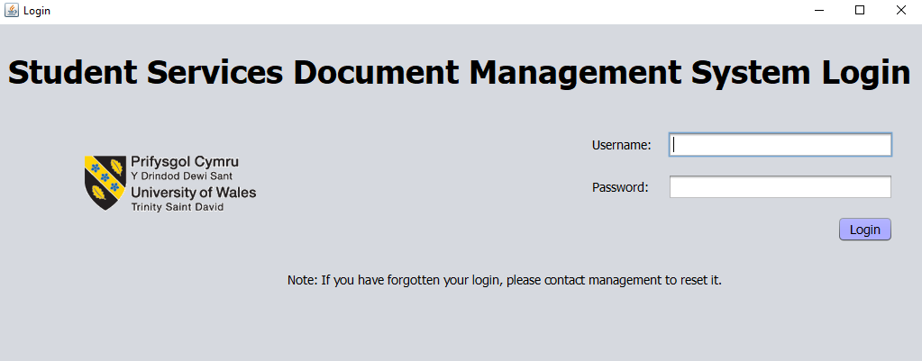
The login page is the first page the user will see upon loading the application. The user will need to enter their login details (Staff number and password) in the input boxes and press the login button. If they have forgotten their password, see section below.
Note: Credentials are case sensitive.

Password Resets
A user can change their own password after login by clicking on the staff profile button on the main menu.
In case of management passwords being forgotten, they can login using the credentials below, and changing their password using the edit staff option on the main menu.
(Username: ManagementAdminReset Password: ManagementReset1234)
In case of staff, login to the system as a manager, and change the staff password using the edit staff option on the main menu.

Main Menu
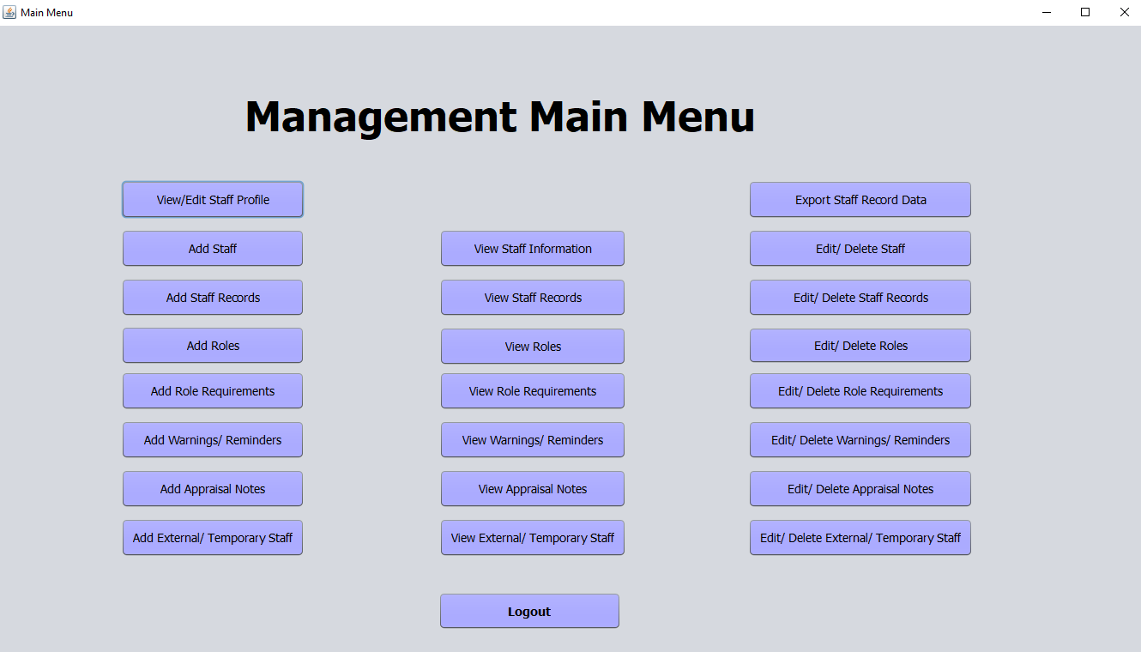
Once the user has logged in, they will see a view that is unique to their access level. The user will need to click on one of the buttons shown to complete a task.
To logout, click on the logout button at the bottom of the main menu page.

Staff Profile
To view the user staff profile, click on the staff profile button on the main menu. Here, the user can change their password, email address and personal information. Click the save button to update the stored information. The user can return to the main menu by clicking on the Back to Main Menu button.

Exporting Staff Record Data
To export staff record data to CSV file format, click on the export staff record data button from the main menu. The manager will then be prompted to select the export location for this data. The data will then be exported to this location. This can then be amended/ exported to another file format as required.

Staff/ Users

Add Staff/ User
This option is only available to manager level users. To add an additional user, click on the add staff member button from the main menu, and the above page will display. The manager is required to enter all the information required above, and select a role based upon their job, using the prompts and drop-down boxes to assist. If the role is not listed, this information will need to be added to the system first. Enter a temporary password for the user, which they should change when they login to the system, and assign a manager, of which they are notified upon their records expiring.
Click on the save button to save the details in the database.
The user can return to the main menu by clicking on the Back to Main Menu button.

View Staff/ User
This option is only available to manager level users. To view staff information, click on the view staff information button from the main menu, and the above page will display. This can allow managers to either view all or individual members of staff, using the staff drop-down list. The user can return to the main menu by clicking on the Back to Main Menu button.

Edit/ Delete Staff/ User
This option is only available to manager level users. To edit or delete staff or users, click on the edit/ delete staff button from the main menu, and the above page will display. The manager can then select the member of staff from the staff drop-down list. They can either edit the stored information, or delete the staff member.
To edit staff information, ensure that the correct member of staff is selected, and then type over the existing information, using the text boxes and drop-down lists to assist. Click on the save button to update the details in the database.
To delete staff, ensure that the correct member of staff is selected, and then click on the delete button to remove the member of staff from the database system.
The user can return to the main menu by clicking on the Back to Main Menu button.

Staff Records

Add Staff Records
To add staff records (trainings, qualifications, professional memberships etc.), click on the add staff records button from the main menu, and the above page will display. Here, the system user can select the staff member and the warning name (trainings, qualifications, professional memberships etc.) from the drop-down lists. If they are not listed, then this information needs to be added into the system first. Use the date pickers to select the start date (this can be the training date), and the expiry date (if applicable). You can attach a file by clicking on the attach file button, and selecting the file. Click on the save button to save this information in the database.
The user can return to the main menu by clicking on the Back to Main Menu button.

View Staff Records
To view staff records, click on the view staff records button on the main menu. This can allow users to either view all the stored records of individual members of staff by using the staff drop-down list. The user can return to the main menu by clicking on the Back to Main Menu button.

Edit/ Delete Staff Record
To edit or delete staff records, click on the button from the main menu, and the above page will display. Use the staff member drop-down list to select the member of staff, then select the training/ qualification/ professional membership etc. from the list provided. The text boxes will automatically update with the stored information.
To edit staff records, ensure that the correct member of staff and warning name are selected, and then type over the existing information, using the date picker and file locator tools to assist. Click on the save button to update the details in the database.
To delete staff records, ensure that the correct member of staff and warning list are selected, and then click on the delete button to remove the staff record from the database system.
The user can return to the main menu by clicking on the Back to Main Menu button.

Roles

Add Role
This option is only available to manager level users. To add a role, click on the add role button from the main menu. You will be directed to the above screen, where the user can add in a role and select the level of access required for the system, using the drop-down list. The user can save this information in the database by clicking the save button. The user can return to the main menu by clicking on the Back to Main Menu button.

View Roles
This option is only available to manager level users. To view roles, click on the view roles button on the main menu. This can allow users to view all the stored roles of either management or staff levels by using the level drop-down list. The user can return to the main menu by clicking on the Back to Main Menu button.

Edit/ Delete Role

This option is only available to manager level users. To edit or delete a role, click on the edit/ delete role button from the main menu. You will be directed to the above screen, where the user can select a role using the available drop-down list.
To edit a role, select the role from the drop-down list, then select the level of access required for the system. The user can save this information in the database by clicking the save button.
To delete a role, select the role from the drop-down list, then click on the delete button to remove the role from the database.
The user can return to the main menu by clicking on the Back to Main Menu button.

Role Requirements

Add Role Requirements
This option is only available to manager level users. To add role requirements, click on the add role requirements button from the main menu. You will be directed to the above screen, where the user can select the role using the drop-down list. The user can utilise the available dropdown lists to add in a role and select the level of access required for the system, using the drop-down list. The user can save this information in the database by clicking the save button. The user can return to the main menu by clicking on the Back to Main Menu button.

View Role Requirements
This option is only available to manager level users. To view role requirements, click on the view role requirements button on the main menu. This can allow users to view all the stored requirements of a role by using the role drop-down list. The user can return to the main menu by clicking on the Back to Main Menu button.

Edit/ Delete Role Requirements
This option is only available to manager level users. To edit or delete role requirements, click on the edit/ delete role requirements button from the main menu. You will be directed to the above screen, where the user can select the role, type and requirements using the available drop-down lists.
To edit role requirements, select the role, type and requirements from the drop-down list, then select the status for the role. The user can save this information in the database by clicking the save button.
To delete a role requirement, select the role, type and requirement from the drop-down list, then click on the delete button to remove the requirement from the database.
The user can return to the main menu by clicking on the Back to Main Menu button.

Warnings/ Reminders
These are the trainings, qualifications, professional body memberships, and background checks. These may or may not require warnings or reminders when they expire, as some may not expire.

Add Warnings/ Reminders
To add a warning or reminder to the database, click on the add warnings/ reminders button from the main menu. This will be redirected to the above view. Enter the information above, using the drop-down lists to assist. The user can save this information in the database by clicking the save button. The user can return to the main menu by clicking on the Back to Main Menu button.

View Warnings/ Reminders
To view warnings or reminders, click on the view warnings/ reminders button on the main menu. This can allow users to view all the stored roles of either management or staff levels by using the level drop-down list. The user can return to the main menu by clicking on the Back to Main Menu button.

Edit/ Delete Warnings/ Reminders
To edit or delete a warning or reminder from the database, click on the edit/ delete warnings/ reminders button from the main menu. This will be redirected to the above view. Select the name using the drop-down list provided.
To edit a warning or reminder, select the name, and then edit the desired information, using the drop-down lists to assist. The user can save this information in the database by clicking the save button.
To delete a warning or reminder, select the name, and then click on the delete button to remove the information from the database.
The user can return to the main menu by clicking on the Back to Main Menu button.

Staff Appraisals

Add Staff Appraisals
This option is only available to manager level users. To add staff appraisals, click on the add staff appraisals button from the main menu, and the above page will display. The manager is required to enter all the information required above, using the drop-down boxes and date picker tool to assist. If the staff member is not listed, this information will need to be added to the system first. Click on the save button to save the details in the database. The user can return to the main menu by clicking on the Back to Main Menu button.

View Staff Appraisals
This option is only available to manager level users. To view staff appraisals, click on the view staff appraisals button from the main menu, and the above page will display. This can allow managers to either view all the appraisals for individual members of staff, using the staff drop-down list. The user can return to the main menu by clicking on the Back to Main Menu button.

Edit/ Delete Staff Appraisals
This option is only available to manager level users. To edit or delete staff appraisals from the database, click on the edit/ delete staff appraisals button from the main menu. This will be redirected to the above view. Select the staff member and appraisal date using the drop-down lists provided.
To edit a staff appraisal, select the staff member and date, and then edit the notes. The user can save this information in the database by clicking the save button.
To delete a staff appraisal, select the staff member and date, and then click on the delete button to remove the information from the database.
The user can return to the main menu by clicking on the Back to Main Menu button.

External/ Temporary Staff

Add External/ Temporary Staff
This option is only available to manager level users. To add external/ fractional staff, click on the button from the main menu, and the above page will display. The manager is required to enter all the information required above, using the date picker tool to assist. The user must enter the number of hours in the box provided.
Click on the save button to save the details in the database.
The user can return to the main menu by clicking on the Back to Main Menu button.

View External/ Temporary Staff
This option is only available to manager level users. To view external/ fractional staff, click on the view external/ fractional staff button on the main menu. This can allow users to view all the stored requirements of an external/ fractional staff by using the role drop-down list. The user can return to the main menu by clicking on the Back to Main Menu button.

Edit/ Delete External/ Temporary Staff
This option is only available to manager level users. To edit or delete external/ fractional staff, click on the button from the main menu, and the above page will display. The manager can then select their name from the drop-down list. They can either edit or delete this information.
To edit this information, ensure that the correct member of staff and the month start date are selected, then type over the existing information, using the text boxes to assist. Click on the save button to update the details in the database.
To delete this information, ensure that the correct member of staff and the month start date are selected, then click on the delete button to remove this information is removed from the database system.
The user can return to the main menu by clicking on the Back to Main Menu button.

Appendix 3: Staff User Guide

Student Services Management Information System - Staff User Guide

University of Wales Trinity Saint David – Student Services | April 2019

Table of Contents
Introduction 2
Minimum System Requirements 2
Login Page 3
Password Resets 3
Main Menu 4
Staff Profile 5
Staff Records 6
Add Staff Records 6
View Staff Records 7
Edit/ Delete Staff Record 8
Warnings/ Reminders 9
Add Warnings/ Reminders 9
View Warnings/ Reminders 10
Edit/ Delete Warnings/ Reminders 11

Introduction
This management information system was developed in conjunction with UWTSD’s Student Services. This document is intended to give the user an overview of the capability and potential usefulness of the developed system, and how to use it to its maximum capabilities.
A user-friendly application has been designed and developed with ease of use in mind; simple layout for data entry, and with minimal steps needed to perform any task required. The application uses a database to store the data entered by the users, which can be retrieved for amending or deletion, if required. The application has two user levels, each with their unique main menu:
- General staff – Can add, edit and delete their user profile, and their records.
- Management – Can perform all the staff tasks, in addition to adding, editing and deleting users (staff members), staff appraisals, their roles and role requirements, adding information regarding external staff hours, and exporting staff record data to CSV file format for audits.

Minimum System Requirements
Java 8 is required to use the system, although the latest version is recommended for security. The latest version of java can be installed from the Oracle website, or contact the system administrators to update to the latest version.

Login Page
The login page is the first page the user will see upon loading the application. The user will need to enter their login details (Staff number and password) in the input boxes and press the login button. If they have forgotten their password, see section below.
Note: Credentials are case sensitive.

Password Resets
A user can change their own password after login by clicking on the staff profile button on the main menu.
In case of staff password resets, please contact a manager to reset the password. Login using the password, and then immediately change it by clicking on the staff profile button on the main menu, and changing your stored password.

Main Menu
Once the user has logged in, they will see a view that is unique to their access level. The user will need to click on one of the buttons shown to complete a task.
To logout, click on the logout button at the bottom of the main menu page.

Staff Profile
To view the user staff profile, click on the staff profile button on the main menu. Here, the user can change their password, email address and personal information. Click the save button to update the stored information. The user can return to the main menu by clicking on the Back to Main Menu button.

Staff Records

Add Staff Records
To add staff records (trainings, qualifications, professional memberships etc.), click on the add staff records button from the main menu, and the above page will display. Here, the system user can select the staff member and the warning name (trainings, qualifications, professional memberships etc.) from the drop-down lists. If they are not listed, then this information needs to be added into the system first. Use the date pickers to select the start date (this can be the training date), and the expiry date (if applicable). You can attach a file by clicking on the attach file button, and selecting the file. Click on the save button to save this information in the database.
The user can return to the main menu by clicking on the Back to Main Menu button.

View Staff Records
To view staff records, click on the view staff records button on the main menu. This can allow users to either view all the stored records of individual members of staff by using the staff drop-down list. The user can return to the main menu by clicking on the Back to Main Menu button.

Edit/ Delete Staff Record
To edit or delete staff records, click on the button from the main menu, and the above page will display. Use the staff member drop-down list to select the member of staff, then select the training/ qualification/ professional membership etc. from the list provided. The text boxes will automatically update with the stored information.
To edit staff records, ensure that the correct member of staff and warning name are selected, and then type over the existing information, using the date picker and file locator tools to assist. Click on the save button to update the details in the database.
To delete staff records, ensure that the correct member of staff and warning list are selected, and then click on the delete button to remove the staff record from the database system.
The user can return to the main menu by clicking on the Back to Main Menu button.

Warnings/ Reminders
These are the trainings, qualifications, professional body memberships, and background checks. These may or may not require warnings or reminders when they expire, as some may not expire.

Add Warnings/ Reminders
To add a warning or reminder to the database, click on the add warnings/ reminders button from the main menu. This will be redirected to the above view. Enter the information above, using the drop-down lists to assist. The user can save this information in the database by clicking the save button. The user can return to the main menu by clicking on the Back to Main Menu button.

View Warnings/ Reminders
To view warnings or reminders, click on the view warnings/ reminders button on the main menu. This can allow users to view all the stored roles of either management or staff levels by using the level drop-down list. The user can return to the main menu by clicking on the Back to Main Menu button.

Edit/ Delete Warnings/ Reminders
To edit or delete a warning or reminder from the database, click on the edit/ delete warnings/ reminders button from the main menu. This will be redirected to the above view. Select the name using the drop-down list provided.
To edit a warning or reminder, select the name, and then edit the desired information, using the drop-down lists to assist. The user can save this information in the database by clicking the save button.
To delete a warning or reminder, select the name, and then click on the delete button to remove the information from the database.
The user can return to the main menu by clicking on the Back to Main Menu button.

Appendix 4: Questionnaire
NOTE: Any comments regarding the answers, or additional feedback can go at the end of this questionnaire.
- I think that I would like to use this system frequently.
Strongly agree Agree Neither agree nor disagree Disagree Strongly disagree
- I found the system unnecessarily complex.
Strongly agree Agree Neither agree nor disagree Disagree Strongly disagree
- I thought the system was easy to use.
Strongly agree Agree Neither agree nor disagree Disagree Strongly disagree
- I think that I would need the support of a technical person to be able to use this system.
Strongly agree Agree Neither agree nor disagree Disagree Strongly disagree
- I found the various functions in this system were well integrated.
Strongly agree Agree Neither agree nor disagree Disagree Strongly disagree
- I thought there was too much inconsistency in this system.
Strongly agree Agree Neither agree nor disagree Disagree Strongly disagree
- I would imagine that most people would learn to use this system very quickly.
Strongly agree Agree Neither agree nor disagree Disagree Strongly disagree
- I found the system very cumbersome to use.
Strongly agree Agree Neither agree nor disagree Disagree Strongly disagree
- I felt very confident using the system.
Strongly agree Agree Neither agree nor disagree Disagree Strongly disagree
- I needed to learn a lot of things before I could get going with this system.
Strongly agree Agree Neither agree nor disagree Disagree Strongly disagree
- Can you perform most tasks quickly (under a minute)?
Yes No
- Is there informative feedback when appropriate?
Yes No
- Can you easily correct and recover from mistakes and errors?
Yes No
- Is there sufficient help and documentation to complete tasks (either on-screen or within the user guide)?
Yes No
- Does the system perform tasks the way you would expect it to?
Yes No
- Are the system menus consistent?
Yes No
- Is there sufficient navigation between menus?
Yes No
- Is the menu design simplistic?
Yes No
- Is the menu design aesthetically pleasing?
Yes No
- Do you like the overall system?
Yes No
Any comments or additional feedback?
____________________________________________________________________________________________________________________________________________________________________________________________________________________________________________________________________________________________________________________________________________________________________________________________________________________________________________________________________________________________________________________________________________________________________________________________________________________________________________________________________________________________________________________________________________________________________________________

