
Programme: MSc Public Health and Social Care in Practice
Module: Quality Assurance and Service Improvements
Module code: LCHS7006
Assignment Title: Component 2 Service Improvement Report
Name : Amiben patel
Student ID : 2526924

1. Introduction
1.1 Background and Organisational Context
Maternity services are a highly critical part of any healthcare organisation, such as the UK NHS, to ensure essential medical, nutritional, and emotional support is available for women throughout pregnancy and the postnatal period (Wojcieszek et al., 2023). However, failures in care delivery can lead to serious lifelong consequences for the mothers and their children, which might damage the reputation of the organisation they are admitted to. In the UK, the Shrewsbury and Telford Hospital NHS Trust (SaTH) is a well-established NHS trust, known for its offering of maternity services within the UK (SaTH, 2026).
However, since 1979, the organisation has been accused of poor maternal care, which has caused numerous neonatal deaths (Weaver, 2020). As a consequence, an investigation (Ockenden Review) was started in 2017 and finally concluded in 2022, which revealed a long-term maternity scam from SaTH in the last 20-year period (BBC, 2022). This investigation revealed leadership issues within the NHS trust as well as weak governance, which indicates that the root causes of the Maternity failure extend beyond clinical decisions by involving broader organisational systems (BBC, 2022).
1.2 Identified maternity quality and patient-safety problem
The central quality concern across SaTH NHS Trust, as revealed in the Ockenden review, was the failure to provide safe, evidence-based and responsive maternity care to all women in their perinatal and postnatal condition. Evidence from nearly 1600 investigations by Ockenden reveals the presence of weak clinical governance and accountability within the chosen trust, which resulted in higher rates of unsafe practices, thereby increasing preventable maternal and neonatal harm (BBC, 2022). The investigation further reveals poor communication and coordination between SaTH staff members, including midwives, obstetricians and neonatal professionals, which further increases the risk of avoidable harm and leads to tragic maternal and neonatal morbidity (BBC, 2022). Therefore, these insights clearly highlight systematic failures within the leadership and governance of SaTH, which significantly compromised maternity quality and endangered patient safety. The investigation also reveals that despite the concerns raised by multiple families in the past, the organisation still chose to neglect those concerns to improve care quality, leading to serious unsafe outcomes (Weaver, 2020). This deliberately hinders overall care quality within the NHS trust, resulting in deaths, stillbirths, neonatal deaths and serious birth injuries, requiring implementation of necessary quality improvement procedures to ensure overall service improvement.
1.3 Rationale for service improvement and Report Aim
The scale and persistence of nearly 1600 patient-safety issues within SaTH NHS Trust clearly necessitates a systematic service improvement instead of any intervention targeted for improving any particular clinical procedure (BBC, 2022). Hence, an overall sustainable improvement within the selected trust is essential, which will require strong attention towards governance, leadership, staff competence, clear monitoring and reporting standards. This will not only improve maternity care quality but also strengthen organisational reputation in future.
Therefore, this report aims to critically examine all the underlying causes of maternity service failure within the SaTH NHS trust and propose actionable, evidence-based strategies for mitigating the issues and improving care quality.
2. Main Body
2.1 Nature and complexity of the service-quality failure
The maternity failures at Shrewsbury and Telford Hospital NHS Trust represent a complex quality issue within their care practices from multiple interconnected systemic weaknesses. The Ockenden investigation confirms that over 1,486 families suffer from the leadership negligence of the NHS trust, which caused 201 avoidable infant deaths and approximately 9 maternal deaths in the past (SHBN, 2022). Multiple families, including Rhiannon Davies and Kayleigh Griffiths, raised concerns regarding the poor maternal care quality; the organisational leaders chose to ignore them, indicating persistent service quality failure (Woods, 2022).
Additionally, the maternity care-related effective decision-making is also affected by poor communication among staff members, which escalates the risks of maternal and neonatal harm (BBC, 2022). As a consequence of the leadership negligence, overall clinical governance became ineffective, which hindered the monitoring mechanisms and limited the organisation's ability to identify recurring risks, which consistently jeopardises patient safety. Overall, the case clearly demonstrates that maternity care does not solely depend on the clinical competence of healthcare organisations; instead, it relies on effective leadership, governance, communication among staff members and monitoring systems.
2.2 Root-cause analysis: Application of Fishbone Diagram, 5 Whys and Donabedian Model
Conducting root-cause analysis is essential to identify the key underlying reasons for the maternity scandals within the SaTH NHS Trust. This will help the organisational leaders to pinpoint all the organisational areas that need improvements and encourage leaders to take immediate action to address them (Okes, 2019). However, conventional root cause analysis can often overemphasise individual actions while neglecting broader systemic failures. Therefore, to avoid this issue, multiple academic models of root-cause analysis, including the Fishbone Diagram, 5 Whys and Donabedian Model, are being utilised in this section to highlight the broader organisational issues within SaTH NHS Trust. These models will help in critically examining the interaction between workforce, processes, governance and organisational culture, and highlight key areas of improvement (Zonsius and Milner, 2021).
Application of Fishbone Model
The Fishbone diagram is a structured model which will be highly essential to categorise SaTH NHS Trust's quality issues under four categories, including People, Process, Management and Cultural factors. The critical discussion under these four factors can clearly showcase how the poor maternity care is a result of multiple interacting factors rather than an outcome of any single clinical or individual practice.
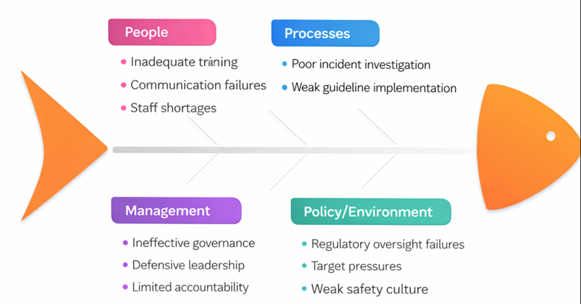
Figure 1: Fishbone Diagram
(Source: Adopted from Component 1)
People
People-related factors highlight that the poor maternal care is the result of inadequate staff training, lack of communication and overall staff shortages in the SaTH NHS trust. The finalisation of the Ockenden investigation disclosed that the trust has significant staffing and training gaps, which have weakened effective departmental communication, and negatively affected the operational running of maternal health services (DHSC, 2022). As a result, Midwives, obstetricians and neonatal professionals failed to deliver high-quality care for the mothers and their infants, leading to deaths of mothers and often stillbirths.
Process
Similarly, the process-related factors highlight poor incident investigation and weak guideline implementation within the chosen Trust. The SaTH Trust was accused multiple times by patient families that their fetal monitoring is inconsistent and the workers lack the ability to follow national clinical guidelines (Weaver, 2020). These process failures ultimately delayed recognition and intensified maternal health risks as well as neonatal harm.
Management
Management-related factors help identify that the trust's governance is weak, leadership is poor and defensive, which limits accountability significantly. The Ockenden review examined past 1600 cases of maternal failures by the SaTH trust, which revealed that clinical governance processes and documentation of maternal issues were inconsistent, and even the governance team of the organisation intentionally downgraded serious illnesses (DHSC, 2022). This confirms weak governance, defensive leadership and overall poor accountability across the trust, which endangered the lives of countless mothers and even led to 9 maternal mortalities.
Policy/environmental
Finally, Policy/environmental factors indicate poor regulatory oversight and the presence of an overall unsafe organisational culture. The Ockenden review clearly reveals that the organisation's management repeatedly failed to address the patient concerns for the last 20 years and consistently ignored and even tried to hide their poor care-related consequences (DHSC, 2022). This further contributed to the continuation of the maternal scandal across the trust.
Overall, the fishbone approach proved to be valuable enough because it prevents the root-cause analysis of the SaTH NHS trust's maternal scandal from becoming overly focused on individual outcomes.
Application of 5 Whys
The 5 Whys technique is another useful approach, which can assist in identifying the underlying reasons for the persistent maternal care failure within the SaTH NHS trust in the UK. The main problem within the trust is found to be repeated unsafe maternity outcomes for the last 20 years, despite allegations and concerns being raised (BBC, 2022). The ‘first why’ in the model suggests identifying the initial reason for which the problem occurred in the first place (Nguyen et al., 2020). Therefore, this Why indicates that the SaTH staff failed to consistently recognise maternal deterioration and communicate the escalation properly, which resulted in poor care quality (DHSC, 2022). The 'second why' encourages identifying further reasons for the problem, such as why the staff failed to manage the maternal risks consistently. In answer to this, it can be recognised that the trust management failed to offer proper training to its staff, while also putting less emphasis on fetal monitoring (DHSC, 2022). This directly reduces the clinical-decision-making ability of the staff members and makes the communication inconsistent, which continuously deteriorates maternal care quality.
Then the 'third why' again encourages identifying further underlying reasons for the failure of the Trust management in maintaining proper training and clinical oversight. This helps in disclosing that the trust lacked effective clinical governance and monitoring mechanisms, which prevented the leaders from arranging training for staff and failed to monitor the maternal risk escalations (Weaver, 2020). Afterwards, the ‘fourth why’ encourages recognising the final reason behind the trust’s failure in correcting all these identified weaknesses. This helps in disclosing that the governance and leadership systems in the SaTH trust did not adhere to the National Institute of Health and Clinical Excellence (NICE) guidelines (DHSC, 2022). As a consequence, the trust failed to properly implement the required patient-safety standards in the last 20 years, which jeopardised maternal health and risked infant lives. Finally, the ‘fifth why’ encourages pinpointing the causes behind the trust leaders' failure in producing sustained improvement even after concerns were raised. This fifth stage helps in revealing the overall poor safety culture within the SaTH NHS trust, which requires effective organisational action and accountability.
The complete 5 whys analysis helps in disclosing the presence of governance system-level failure in SaTH, along with poor accountability and risk monitoring, which contributed to the maternal failure.
Application of Donabedian Model
The structure-process-outcome model of Donabedian can be crucial to link the identified systematic weaknesses of the SaTH NHS trust to its delivery and consequences in maternal care (Moayed et al., 2022).
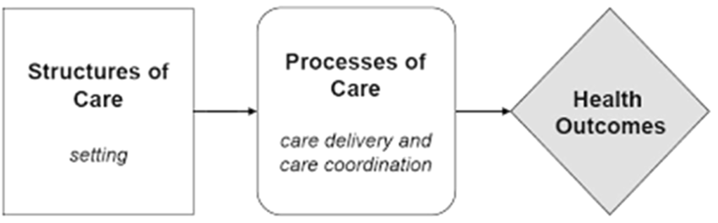
Figure 2: Donabedian Model
(Source: McCullough et al., 2023)
The ‘structure’ dimension in the model assists in identifying inconsistencies in the Trust’s care setting and resources (Tossaint-Schoenmakers et al., 2021). The Ockenden review disclosed that the SaTH trust lacked qualified obstetric anaesthetists and appropriate monitoring and review mechanisms, which led to unsafe maternity services (DHSC, 2022). Next, the 'Process' dimension helps in identifying the actual delivery of maternal care across the trust, which consists of poor fetal monitoring and escalation identification, which delayed treatment and hindered communication with patients and their families (BBC, 2022). Thus, the failures in the care delivery process indicate structural weakness that the organisation consistently failed to address. Lastly, the 'Outcome’ dimension indicates the final effect of the weaknesses in SaTH Trust’s organisational structure and process, which compromised maternal care delivery process quality and contributed to maternal mortality, stillbirths and neonatal deaths (BBC, 2022).
Overall, the combined application of three root-cause analysis approaches highlighted the contributing factors and deeper systematic weaknesses within the SaTH Trust, while connecting those weaknesses with the main maternal failure-related issue within the trust.
2.3 Strategic Planning analysis using SWOT
The SWOT framework is an essential tool for identifying internal strengths, weaknesses, possible opportunities and threats of the SaTH NHS Trust in future (Rahman et al., 2021). This will help in building realistic goals to address the identified problems and seize the opportunities.
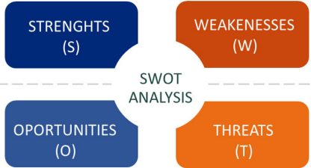
Figure 3: SWOT Matrix
(Source: Cañizares and Bourotte, 2021)
The key strengths of the trust include its established multidisciplinary workforce of around 7,000 staff and access to NHS clinical guidelines, which is essential for delivering consistent better care (SaTH, 2026a). However, weaknesses such as poor leadership accountability and clinical governance within the trust are limiting staff training and clinical monitoring, which is reducing maternal care quality (BBC, 2020).
In terms of opportunities, the NHS Maternity Transformation Programme (MTP) can enable SaTH NHS Trust to harness digital tools and strengthen digital patient-safety monitoring under data-driven maternity surveillance (NHS England, 2026). This can help the Trust in speeding up risk identification, recording information, and supporting evidence-based decision-making (Katapalli and Ibrahim, 2023). Finally, threats such as consistent staff shortages and monitoring resource constraints can hinder public confidence and trust in the Trust's maternity care, which can lower hospital admissions in future and financially strain the organisation in the long term (Alam et al., 2025).
References
Alam, C. E., Abou-Abbas, L., Ramadan, M. S., and Asmar, M. K. (2025). Exploring the barriers to accessing antenatal care at the primary health care centre level of a tertiary hospital in Lebanon: a qualitative study. BMC Health Services Research, 25(1), 304. https://link.springer.com/content/pdf/10.1186/s12913-025-12444-y.pdf
BBC. (2020). 'Failing leadership' at Shrewsbury and Telford Hospital Trust. Available at: https://www.bbc.com/news/uk-england-shropshire-53764432 (Accessed: 03 August 2026).
BBC. (2022). Shrewsbury maternity scandal: Repeated failures led to deaths. Available at: https://www.bbc.com/news/uk-england-shropshire-60925959 (Accessed: 03 August 2026).
Cañizares, A. D., and Bourotte, C. L. M. (2021). Strategic diagnosis of geocommunication using SWOT analysis in the Varvite Geological Park, São Paulo, Brazil. Journal of the Geological Survey of Brazil, 4(SI1). https://jgsb.sgb.gov.br/index.php/journal/article/download/118/9
DHSC. (2022). Ockenden review: summary of findings, conclusions and essential actions. Available at: https://www.gov.uk/government/publications/final-report-of-the-ockenden-review/ockenden-review-summary-of-findings-conclusions-and-essential-actions (Accessed: 03 August 2026).
Katapally, T. R., and Ibrahim, S. T. (2023). Digital health dashboards for decision-making to enable rapid responses during public health crises: replicable and scalable methodology. JMIR Research Protocols, 12(1), e46810. https://www.researchprotocols.org/2023/1/e46810/
McCullough, K., Andrew, L., Genoni, A., Dunham, M., Whitehead, L., and Porock, D. (2023). An examination of primary health care nursing service evaluation using the Donabedian model: A systematic review. Research in nursing & health, 46(1), 159-176. https://onlinelibrary.wiley.com/doi/pdfdirect/10.1002/nur.22291
Moayed, M. S., Khalili, R., Ebadi, A., and Parandeh, A. (2022). Factors determining the quality of health services provided to COVID-19 patients from the perspective of healthcare providers: Based on the Donabedian model. Frontiers in Public Health, 10, 967431. https://www.frontiersin.org/journals/public-health/articles/10.3389/fpubh.2022.967431/full
Nguyen, V., Nguyen, N., Schumacher, B., and Tran, T. (2020). Practical application of plan–do–check–act cycle for quality improvement of sustainable packaging: a case study. Applied Sciences, 10(18), 6332. https://www.mdpi.com/2076-3417/10/18/6332
NHS England. (2026). Maternity Transformation Programme (MTP): Harnessing Digital Technology. Available at: https://www.england.nhs.uk/mat-transformation/harnessing-digital-technology/ (Accessed: 03 August 2026).
Okes, D. (2019). Root cause analysis: The core of problem solving and corrective action. Quality Press. https://books.google.com/books
Rahman, M., Mousa, M. M., and Elwalda, A. (2021). SWOT analysis applications: An integrative literature review. Journal of Global Business Insights, 6(1), 55-73. https://www.academia.edu/download/97055247/SWOT_analysis_applications_An_integrative_literature_review.pdf
SaTH. (2026). Maternity – SaTH. Available at: https://www.sath.nhs.uk/wards-services/az-services/maternity/ (Accessed: 03 August 2026).
SaTH. (2026a). Working with us – SaTH. Available at: https://www.sath.nhs.uk/working-with-us/ (Accessed: 03 August 2026).
SHBN. (2022). Summary – Ockenden Report. Available at: https://shbn.org.uk/summary-ockenden-report/ (Accessed: 03 August 2026).
Tossaint-Schoenmakers, R., Versluis, A., Chavannes, N., Talboom-Kamp, E., and Kasteleyn, M. (2021). The challenge of integrating eHealth into health care: systematic literature review of the Donabedian model of structure, process, and outcome. Journal of medical Internet research, 23(5), e27180. https://www.jmir.org/2021/5/e27180/
Weaver, M. (2020). 'I was told, just shrug it off': Shropshire's baby death scandal started decades earlier, mother reveals. Available at: https://www.theguardian.com/society/2020/oct/16/i-was-told-just-shrug-it-off-shropshires-baby-death-scandal-started-decades-earlier-mother-reveals (Accessed: 03 August 2026).
Wojcieszek, A. M., Bonet, M., Portela, A., Althabe, F., Bahl, R., Chowdhary, N., ... & Oladapo, O. T. (2023). WHO recommendations on maternal and newborn care for a positive postnatal experience: strengthening the maternal and newborn care continuum. BMJ global health, 8(Suppl 2). https://gh.bmj.com/content/bmjgh/8/Suppl_2/e010992.full.pdf
Woods, R. (2022). Shrewsbury maternity scandal: 'We've had to fight all the way for this'. Available at: https://www.bbc.com/news/uk-england-shropshire-60926390 (Accessed: 03 August 2026).
Zonsius, M. C., and Milner, K. A. (2021). Continuous quality improvement. Research for advanced practice nurses: from evidence to practice. 4th ed. New York: Springer Publishing Company, 71-90. https://books.google.com/books

