Certificate in higher education business skills for the workplace

LCLM4006 Enterprise and Entrepreneurship

Task 1: individual business plan

Lecturer Name: Deji Olagboye

Student Name: Alisha Mahmood

Student ID: 2236493



Executive summary
The proposed business is an intergenerational care facility that combines a residential care home for elderly people with a nursery for young children. The aim is to reduce loneliness among older people while providing children with opportunities to develop social skills, empathy and meaningful relationships with another generation.
The facility will operate in separate areas, with qualified carers supporting elderly residents and nursery practitioners caring for the children. Dedicated staff will organise shared activities, including arts and crafts, storytelling, music and gardening, to encourage positive interaction in a safe and welcoming environment.
The business will generate income through residential care fees and nursery fees. Its marketing strategy will include social media, a professional website, local advertising and partnerships with community organisations. The business will also need to comply with relevant care home and childcare regulations, safeguarding requirements and health and safety legislation.
Overall, the business aims to provide high-quality care and childcare while creating social benefits for both generations. Through effective management, financial planning and community engagement, the facility intends to establish a sustainable business that promotes companionship, inclusion and well-being.

Table of contents

Contents Page
Title 1
Executive summary 2
Table of contents 3
Overview of the business 4
management structure
Legal format 5
Market research PESTEL framework 6
Marketing communications 7
Financials 8
Reference list 9

Overview of the Business Idea
The proposed business aims to establish an intergenerational care facility that combines a residential care home for elderly individuals with a dedicated nursery and daycare setting for young children. The premises would be divided into two separate areas to ensure that the specific care, safety and developmental needs of both age groups are met. Qualified nursery practitioners would be responsible for the care and development of the children, while trained care staff would provide support and assistance to the elderly residents. In addition, dedicated activity coordinators would organise structured activities and social events to encourage positive interaction between the two generations. This will also help out working parents who work late as the company will open 5am until 10pm and there will be staff who are able to do waking nights if parents of children have a emergency at work and if families of the elderly need a few days to go out and enjoy themselves as a lot of young children’s day nurseries close at 6:30pm and a lot of care homes don’t have many activities or opportunities for the elderly to do, or get active.
The idea for this business has been developed through the founder’s previous experience working with both children and elderly individuals. This experience has highlighted the importance of social interaction, companionship and emotional well-being, particularly among older people who may experience loneliness or social isolation due to limited family contact or a lack of regular social interaction. By bringing children and elderly individuals together in a supportive and carefully managed environment, the business aims to promote meaningful relationships, reduce feelings of isolation and improve the overall quality of life for elderly residents. Furthermore, the children would have opportunities to develop their communication and social skills, learn from older generations and develop greater empathy and understanding. The overall objective is to create an inclusive, nurturing and supportive environment that benefits both age groups through intergenerational engagement, companionship and shared experiences.
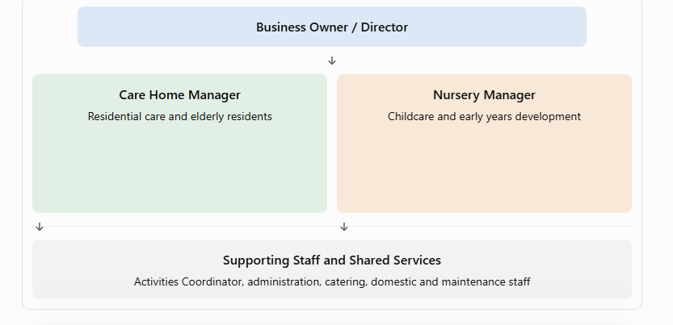

Management structure:
The proposed intergenerational care facility would operate under a clear management structure to ensure the effective running of both the residential care home for elderly individuals and the nursery for young children. Each department would have its own dedicated management team and qualified staff to ensure that the specific needs of both age groups are met. The management structure would promote effective communication, staff accountability, safeguarding and the delivery of high-quality care.
At the top of the structure would be the Business Owner/Director, who would have overall responsibility for the business, including financial management, business development, recruitment and ensuring that the facility operates in accordance with relevant legislation and regulatory requirements.
Reporting to the Business Owner/Director would be the Care Home Manager and the Nursery Manager. The Care Home Manager would oversee the daily operations of the residential care home, supervise care staff, manage residents’ care plans and ensure that residents receive appropriate support. The Nursery Manager would oversee the daycare provision, supervise nursery practitioners, monitor children's learning and development, and ensure that appropriate safeguarding and early years standards are maintained.
The Care Home Manager would supervise the Senior Carers and Care Assistants, who would provide personal care, emotional support and assistance with residents’ daily activities. Similarly, the Nursery Manager would supervise the Senior Nursery Practitioners and Nursery Practitioners, who would support children's learning, development, safety and well-being. The business would also employ an Activities Coordinator to plan and organise suitable activities for both age groups. These activities would encourage social interaction, companionship and the development of meaningful relationships between elderly residents and young children.
Overall, this management structure would establish clear lines of responsibility and communication, allowing each department to operate effectively while working towards the shared aim of providing a safe, welcoming and supportive intergenerational environment.

Legal format:
- Business legal structure
- Care home registration and legislation
- Nursery registration and legislation
- Safeguarding and protection
- Employment law and staff responsibilities
- Health and safety regulations
- Disclosure and barring services (DBS)
- Data protection and confidentiality
- Insurance and financial responsibilities
- Legal requirements for shared activities

Market Research Using PESTEL Analysis

The proposed business combines a residential care home for elderly people with nursery for young children. A PESTEL analysis identifies external factors that could affect the business's success.
1. Political
Government policies on adult social care and funded childcare could influence the business. Partnerships with local councils may create opportunities for support and referrals.
2. Economic
High staffing costs, energy bills, property expenses and equipment costs could affect profitability. Income from both services may help cover shared operating costs.
3. Social
An ageing population and concerns about loneliness among elderly people create potential demand. Intergenerational activities could benefit older residents and help children develop social skills and empathy.
4. Technological
Digital care records, nursery communication apps and security systems could improve safety, organisation and communication with families.
5. Environmental
Energy-efficient equipment, waste reduction and accessible outdoor spaces could reduce costs and create a healthier environment for children and elderly residents.
6. Legal
The business must comply with relevant care home and childcare registration requirements, safeguarding rules, employment law, health and safety legislation and data protection regulations in England.

Marketing Communications and Strategy
The business will use social media, a professional website, local advertising and community partnerships to promote its services. Open days and positive customer reviews will help build trust with families and attract potential customers. The aim is to raise awareness, develop a good reputation and highlight the benefits of bringing children and elderly people together.

Financials

 | MONTH
Cash in | 1
Loan- start up capital | £50,000
Sales (total sales of product and/or services) | £45,000
Other | £0
Total cash in-flows (A) | £95,000
 | MONTH
Cash out-expenses | 1
Rent or premises costs | £5,000
Business rates for your business premises | £1,000
Utilities (gas, electricity, water) | £1,500
Insurance | £500
Telephone and internet | £150
Marketing and advertising expenses | £300
Vehicle running costs | £400
Equipment purchase or leasing | £1,000
Postage, printing, stationery | £100
Transport and delivery | £200
Professional fees (legal, accounting etc.) | £500
Cost of sales (Cost of product) | £3,000
Wages your own | £2,000
Staff wages | £25,000
Any other | £500
Any other | £1,000
Total cash out-flows (B) | £42,150
Your net cash flow (A-B) | £52,850

Reference List

Care Quality Commission (2026) Register as a provider. Available at: https://www.cqc.org.uk/guidance-regulation/registration/register-provider (Accessed: 23 October 2026).
Department for Education (2026) Early years foundation stage statutory framework. Available at: https://www.gov.uk/government/publications/early-years-foundation-stage-framework--2 (Accessed: 23 October 2026).
Department for Education (2026) Evidence of early years providers’ finances from a 2025 survey. Available at: https://www.gov.uk/government/publications/evidence-of-early-years-providers-finances-from-a-2025-survey (Accessed: 23 October 2026).
Information Commissioner’s Office (n.d.) Guide to data protection. Available at: https://ico.org.uk/for-organisations/uk-gdpr-guidance-and-resources/ (Accessed: 23 October 2026).
Office for National Statistics (2026) Estimates of the very old, including centenarians, UK: 2002 to 2025. Available at: https://www.ons.gov.uk/peoplepopulationandcommunity/birthsdeathsandmarriages/ageing/bulletins/estimatesoftheveryoldincludingcentenarians/latest (Accessed: 23 October 2026).
UK Government (n.d.) Register a company. Available at: https://www.gov.uk/limited-company-formation (Accessed: 23 October 2026).
UK Government (n.d.) Health and safety at work. Available at: https://www.gov.uk/browse/employing-people/health-safety (Accessed: 23 October 2026).

