

Assessment 2

Student name:​ Winnie Nzaramba
Student ID: ​2014619
Module name: Mental Disorders and Psychopathology​
Module code: BMHP6006
Lecturer name: Bianca Sanfilippo ​
Date: 05/01/2023

Table of Contents
Introduction 4
Main body 5
General Anxiety Disorder 5
Classification of GAD within ICD-10 5
GAD data in the UK 5
Cause of Anxiety 6
Symptoms and signs 6
Diagnosis of GAD 7
Treatments 7
Measurement of rehabilitation 7
Recommendations for improvement 8
Principle of care for people with GAD 8
Schizophrenia 8
Classification 9
Cause 9
Signs/symptoms 9
Diagnosis 9
Current treatments 9
Measurement of rehabilitation 10
Guidance and principle of care 10
Recommendations for improvements 10
Autism 10
Data related percentage 11
Cause of autism 11
Signs and symptoms 11
Diagnosis 12
Current treatments 12
Measurement of rehabilitation 12
Recommendations for improvement 12
Conclusion 12
References and Bibliography 13

Introduction

This study is based on mental disorders and psychopathology where issues related to general anxiety, schizophrenia and autism will be scrutinised from the ICD-10. To carry out critical analysis hitherto, the field of study will examine the classification, diagnosis, treatment and measurement of rehabilitation based on each health-related issue will be executed. Data related percentages and causes, sign and symptoms, next step to get support will be discussed within the report followed by recommendations on each segment to ensure further improvements. All the data gathered here hence will be supported by adequate reference to avoid collusion.

Main body

General Anxiety Disorder

As per NHS (2021) General Anxiety Disorder (GAD) consider as an issue of feeling constant stress, extreme fear and panic that could have detrimental impact over an individual’s daily life, affecting mental and physical wellbeing. Further, GAD is a long-term condition which cause individual anxious about numerous situation instead of one event. Individual with GAD feel anxious most of the time and struggle to remember the last time they are being peaceful (NHS, 2018).

Classification of GAD within ICD-10

GAD is classified within F40-F48 Neurotic, stress related and somatoform disorder also F41.1 is billable ICD-10-CM which can be used to suggest diagnosis for reimbursement purpose. GAD is under F41.1 and the 2023 edition of ICD-10-CM, F41.1 was effective on October 1, 2022 (ICD10DATA.com, 2022). More women in compare to men are impacted by it and GAD condition is common in people aged 35-55 (Rokach, 2021).

GAD data in the UK

5.9% of overall adult within the UK experienced GAD and 6 out of 100 people diagnosed with GAD and currently over 8m people within the UK experiencing it. unfortunately, less than half of it can access treatment (Rokach, 2021).

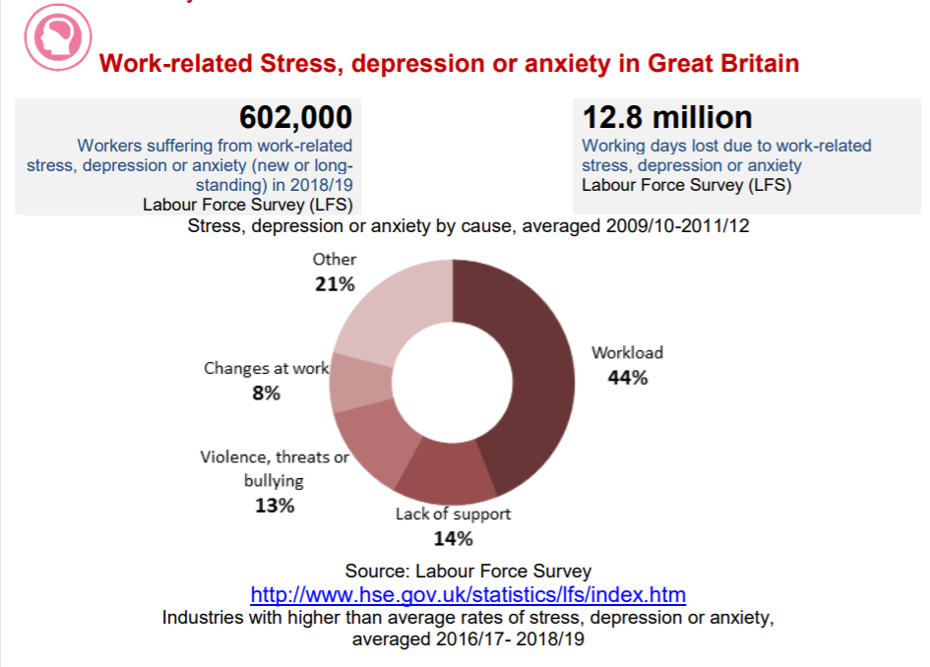
Source: Anxiety in UK percentage 2020 by LFS

An estimated 602,00 employees are affected by GAD each year and as per the Workplace Health Report (2022) 585 employees experience anxiety, 34% of them aged 25-34 and 625 of it are female where only 9% overall seek mental health support (Pinder, 2022).

Cause of Anxiety

There are several cause and risk factor GSD which incorporates genetic and environmental aspects simultaneously such as, family history, prolonged or recent exposure towards stressful situation including family and personal illness, high use of tobacco and caffeine, bullying or child abuse, particulate health related condition such as heart arrhythmias or thyroid problem. As per the evidence, GAD can be triggered via experiencing certain activation within the area of the brain lined with mental activities and introspective thought while an individual encounter situation that cause them to worry (Carey, 2021).

Symptoms and signs

As per NHS (2021) GAD can impact an individual both mentally and physically however, how severe GAD could be varying individual to individual, some may encounter less while some may encounter higher. When it comes to the psychological symptoms it can change the behaviour of an individual in regard to how they feel and think about surroundings such as restlessness, sense of fear, feeling constantly on edge, difficulties concentrating, irritability which may result in sign like one to withdraw from social contact, losing interest of VFF, finding it hard to go to work, taking time off sick, increased poor self-esteem. On the other hand, when it comes to physical symptom of GAD its incorporate tiredness, dizziness, irregular heartbeat, tension, muscle aches, shaking, trembling, sweating, breath shortness, stomach ache, headache, difficulty falling in sleep (NHS, 2021).

Diagnosis of GAD

GAD is something that could be hard to diagnosis and in some case, it can also be difficult to distinguish if individual hold other mental condition like depression. More likely an individual can be diagnosed of GAD if they hold the symptoms for 6 months or more. To help one with the diagnosis, GP might carry out physical examination or blood test in order to rule out different condition which cause one these symptoms like, anaemia, hyperthyroidism. Further to ease the process set of question can be filled by patients (NHS, 2018).

Treatments

If one have GAD, then it is advisable to take psychological treatment in prior to prescribed medication. Further individual also get psychological therapies such as CBT as well as applied relaxation in NHS. Individual can also be referred to NHS psychological therapies services without having referral from a GP, further, a self-help can also be allocated as part of the treatment where patients can help themselves through CBT work book/computer, fill up workbook with the help of therapist and can engage in group course with similar patients to meet the therapist in weekly basis to learn how to tackle the GAD. Another form of treatment is applied relaxation, which focuses on the muscle in a specific way during situation which cause anxiety, here the process required to taught via a therapist which includes, how to relax muscle, how to relax muscle during the situation which makes patient anxious. Along with CBT, applied relation therapy is treatment that need patient to meet therapist with 1 hour session each week for 3-4 months. As part of the treatment medication is also effective where to treat the GAD different medication can be given. Medication usually relied on the length of treatment, possible side effect and whether its suitable for you or not. Medication can be taken every 2-4 weeks for first 3 months (NHS, 2021).

Measurement of rehabilitation

To assess the overall effectiveness of treatment of GAD, it’s important to know the measurement of the rehabilitation. Reason being, if treatment is not appropriate, then it could be changed. One of the effective rehabilitation process of GAD is Anxiety Disorder Questionnaire which is consider as a tool that measure the anxiety level over period of two weeks. The score based GAD questionnaire includes question about anxiety, controlling the anxiety, worrying on things, trouble relaxing, restlessness, feeling afraid and so on. This set of questions used as a screening tool as well as severity measure for an individual. Later, the score is calculated via assigning scores of 0,1,2,3 within response categories on not at all, more than half the days, several days and nearly every day (Patient, 2019).

Recommendations for improvement

GAD can be treated and improved through lots of alternative treatments such as massage and body work, yoga, medication and relaxation strategies, aromatherapy, acupuncture, herbs supplements, diet changes, spiritual practices and so on. These all form of therapies consider as complimentary therapy specially yoga was on to minimize the anxiety in women (Rokach, 2021).

Principle of care for people with GAD

Principle of care towards people of GAD include, build relationship, engaging, explore treatment options, ensure discussion, offer information, ensure comprehensive written information, offer independent interpreters, follow stepped care model which ensure focus on the intervention and nature of the intervention (NICE, 2020).

Schizophrenia

Schizophrenia is a mental disorder that characterised via hallucinations, delusions, disorganised thought process speech as well as behaviour. It also considers as long term mental health condition (Pollock, 2022). Schizophrenia affects approx. 24m people worldwide which is almost 1 in every 300 people globally and the rate is 1 in every 222 people among adults (WHO, 2022). When it comes to the data related to Schizophrenia within the UK one in every 100 people go through Schizophrenia and approx. 220,000 individual has been treated by Schizophrenia in the UK by NHS. It strikes people in early twenties and late teens and it caused by adversity in childhood. Around 25% of Schizophrenia patient recover fully where modern medication is highly effective (NHS, 2021).

Classification

Schizophrenia within the ICD 10 is classified as Schizotypal as well as delusional disorder F20-F29 which indicates it is a characteristic thinking distortions and perception (ICD, 2021).

Cause

When it comes to the cause of Schizophrenia there are several aspects which contributes to it however, the real cause of it is not fully understood. Some of the identified cause of it is brain chemistry which includes, abnormal functioning of neurotransmitters, heredity; which took place due to genetic reason, abnormality in brain such as shrinkage and circuitry dysfunction and finally complications in birth and pregnancy (NHS, 2021).

Signs/symptoms

As per the signs and symptoms Schizophrenia can change how a person behaves and thinks and this overall condition take place very slowly where the first sign is hard to identify at young age. The classification of symptoms classified into positive and negative where positive symptom includes changes if thoughts such as delusions or hallucination whereas negative symptoms is the situation where an individual withdraw from the surroundings as well as take no interests in daily interactions and seems flat and emotionless (NHS, 2021).

Diagnosis

There is no single test for Schizophrenia and it can be diagnosed via the specialist team within mental health department. The specialist team in GP first assess the situation to identify the cause later community mental health team will get involve based on bipolar disorder and schizoaffective disorder (NHS, 2021).

Current treatments

Schizophrenia can be treated with tailored combination of medicine and talking therapy and most of the patient treated via CMHTS who come up with assessment, care plan, key carer appointed and reviews. For serious patients, acute episode is required and for home treatment CRT is needed. Moreover, antipsychotics is something that are usually recommended as part of the initial treatment for acute Schizophrenia episode. As part of the psychological treatment individual may get CBT, family therapy, arts therapy (NHS, 2019).

Measurement of rehabilitation

With the condition of Schizophrenia, measure of the quality care and treatment is highly effective to manage and control complication life suicide and self-harm, drug abuse, self-neglect. With the help of quality indicator rehabilitation care quality care for Schizophrenia can be ensured and managed the condition (Quirc, 2022).

Guidance and principle of care

When it comes to the guidance and principle of care, as per NICE (2022) it ensured managing and recognising psychosis in adults, improved care via early treatment and recognition, focus on long term recovery, checking the co-existing health problems.

Recommendations for improvements

New recommendations for improvements on Schizophrenia includes, care across all phases, preventing the psychosis, first episode of psychosis, subsequent acute episode of schizophrenia, referral in crisis, promoting recovery as well as ensure future care (NICE, 2022).

Autism

Autism consider as a neurodevelopmental condition of variables severity with the lifelong impacts which can be recognised through the early stage of childhood as well as briefly secretaries via difficulties with social communication and interaction as well as via repetitive and restricted pattern of behaviour and thought (Francis et al, 2022). The classification of autism is, F80-F89 disorder of psychological development in ICD, 2010.

Data related percentage

As per the data, one in every 100 people globally has autism, the estimation illustrates the average figure (WHO, 2022). Within the UK, 1% of adult population holds autism spectrum disorders (Autism Society, 2022).

Cause of autism

As per the evidence, the cause of autism is genetic where multiple genes are responsible however it is something that not caused via emotional deprivations (Autism Society, 2022).

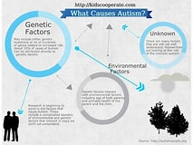

Source: (Autism Society, 2022).

Signs and symptoms

When it comes to the sign and symptom of autism in children it includes, not responding to names, not smiling, not responding, getting highly upset, not talking, repeating same phase etc. and when it comes to adult it includes getting very anxious, struggling to make friends, seeming blunt, taking things literally, failing to understand the social rules, having keen interest, noticing small details etc. (NHS, 2019).

Diagnosis

As far as diagnosis is concern, after identifying the sign, next stage is to talk to specialist regarding it such as GP or health visitor as well as other health professionals to carry out the autism assessment. Autism assessment is effective where a specialist will be delegated to identify whether the individual is autistic or not. Through the assessment how the individual or child interact will be scrutinised as well as specialist will also be get in touch with friends and family member of that individual to dig more information. This assessment is varies based on age of the individual where different professional get involved. For child assessment team may look into, child’s development, interections etc. for adult “the authism diagnostic interview” will be carried out (NHS, 2019).

Current treatments

When it comes to the treatment it includes, behavioural management therapy, CBT, early intervention, school based therapies, medication treatments, occupation therapies etc (NHS, 2019).

Measurement of rehabilitation

Measurement of rehabilitation for autism for children include childhood autism rating scale and observation which is also known as ADOS- autism diagnostic observation schedule that focus on social communication deficit (NHS, 2019).

Recommendations for improvement

Complementary therapy is highly effective such as yoga that helps autistic individual behavioural changes (NHS, 2019).

Conclusion

This study was based on mental disorders and psychopathology where issues related to general anxiety, schizophrenia and autism has been scrutinised from the ICD-10 with the help of various data and discussion. To carry out critical analysis hitherto, the field of study has examined the classification, diagnosis, treatment and measurement of rehabilitation based on each health-related issue will be executed. Data related percentages and causes, sign and symptoms, next step to get support has also been discussed within the report followed by recommendations on each segment to ensure further improvements.

References and Bibliography

Autism Society. (2022). Facts and Statistics. [online] Available at: https://www.autism-society.org/what-is/facts-and-statistics/#:~:text=1%20percent%20of%20the%20adult%20population%20of%20the. Accessed 01/01/2023.

Carey, E. (2021). Generalized Anxiety Disorder (GAD): Symptoms and More. [online] Healthline. Available at: https://www.healthline.com/health/anxiety/generalized-anxiety-disorder#causes-and-risk-factors. Accessed 01/01/2023.

Francis, G., Deniz, E., Torgerson, C. and Toseeb, U. (2022). Play-based interventions for mental health: A systematic review and meta-analysis focused on children and adolescents with autism spectrum disorder and developmental language disorder. Autism & Developmental Language Impairments, 7, p.239694152110731.

NHS (2018). Overview - Generalised Anxiety Disorder in Adults. [online] nhs.uk. Available at: https://www.nhs.uk/mental-health/conditions/generalised-anxiety-disorder/overview/. Accessed 01/01/2023.

www.icd10data.com. (n.d.). 2023 ICD-10-CM Diagnosis Code F41.1: Generalized anxiety disorder. [online] Available at: https://www.icd10data.com/ICD10CM/Codes/F01-F99/F40-F48/F41/F41.1#:~:text=Generalized%20anxiety%20disorder%201%20F41.1%20is%20a%20billable%2Fspecific. Accessed 01/01/2023.

Pindar, J. (2022). Anxiety Statistics UK | 2022 Data. [online] Champion Health. Available at: https://championhealth.co.uk/insights/anxiety-statistics/. Accessed 01/01/2023.

patient (2019). GAD7 Anxiety Test Questionnaire. [online] Patient.info. Available at: https://patient.info/doctor/generalised-anxiety-disorder-assessment-gad-7. Accessed 01/01/2023.

Pollock, M. (2022). Every case of bipolar disorder is different. Mental Health Weekly, 32(16), pp.5–6. doi:10.1002/mhw.33194.

Rokach, A. (2021). Mental health and psychopathology. London: Routledge.

NHS (2021). Symptoms - Generalised anxiety disorder in adults. [online] nhs.uk. Available at: https://www.nhs.uk/mental-health/conditions/generalised-anxiety-disorder/symptoms/. Accessed 01/01/2023.

NHS (2018). Treatment - Generalised anxiety disorder in adults. [online] nhs.uk. Available at: https://www.nhs.uk/mental-health/conditions/generalised-anxiety-disorder/treatment/. Accessed 01/01/2023.

NICE (2020). Recommendations | Generalised anxiety disorder and panic disorder in adults: management | Guidance | NICE. [online] www.nice.org.uk. Available at: https://www.nice.org.uk/guidance/cg113/chapter/Recommendations#principles-of-care-for-people-with-generalised-anxiety-disorder-gad. Accessed 01/01/2023.

NHS (2019). Overview - Schizophrenia. [online] nhs.uk. Available at: https://www.nhs.uk/mental-health/conditions/schizophrenia/overview/. Accessed 02/01/2023.

NHS (2019). Treatment - Schizophrenia. [online] nhs.uk. Available at: https://www.nhs.uk/mental-health/conditions/schizophrenia/treatment/. Accessed 02/01/2023.

NICE (2014). Overview | Psychosis and schizophrenia in adults: prevention and management | Guidance | NICE. [online] Nice.org.uk. Available at: https://www.nice.org.uk/guidance/cg178. Accessed 02/01/2023.

NHS (2019). What Is autism? [online] NHS. Available at: https://www.nhs.uk/conditions/autism/what-is-autism/. Accessed 02/01/2023.

quirc.eu. (n.d.). UCL : QUIRC-SA. [online] Available at: https://quirc.eu/quirc-sa/. Accessed 02/01/2023.

World Health Organization (2022). Schizophrenia. [online] Who.int. Available at: https://www.who.int/news-room/fact-sheets/detail/schizophrenia. Accessed 02/01/2023.

World Health Organization (2022). Autism spectrum disorders. [online] Who.int. Available at: https://www.who.int/news-room/fact-sheets/detail/autism-spectrum-disorders. Accessed 02/01/2023.
Wojtynkiewicz, E. and Sekowski, M. (2022). Relations between attachment, identity and borderline personality disorder symptom severity in male inpatients with alcohol use disorder. Personality and Mental Health.

World Health Organization and World Health Organization. Mental Health Evidence And Research Team (2018). Mental health atlas 2017. Geneva, Switzerland: World Health Organization.

