

Module: Project Management
Module code: LCLM5003

Student Name : Namita Yadav
Student ID:2313042
Table of Contents
Part A: Project Proposal Poster 3
Background / Context 3
Aim and Objective 4
Project Scope 4
Methodology 4
Timeline and Milestones 5
Budget and Resources 5
Expected Outcomes 5
References 7
Part B: Reflection 8
Part C: Project Management Plan 10
Introduction 10
Project Description 10
Project Scope 12
Work Breakdown Structure (WBS) 13
Quad Chart 15
Gantt Chart 16
Stakeholders’ Involvement 17
Allocation of Resources 18
Risk Analysis 18
Conclusion 19
References 21

Part A: Project Proposal Poster
Project Title
“Rebuilding the Principal Transportation Corridor in British Columbia after the 2022 Flooding Disaster”
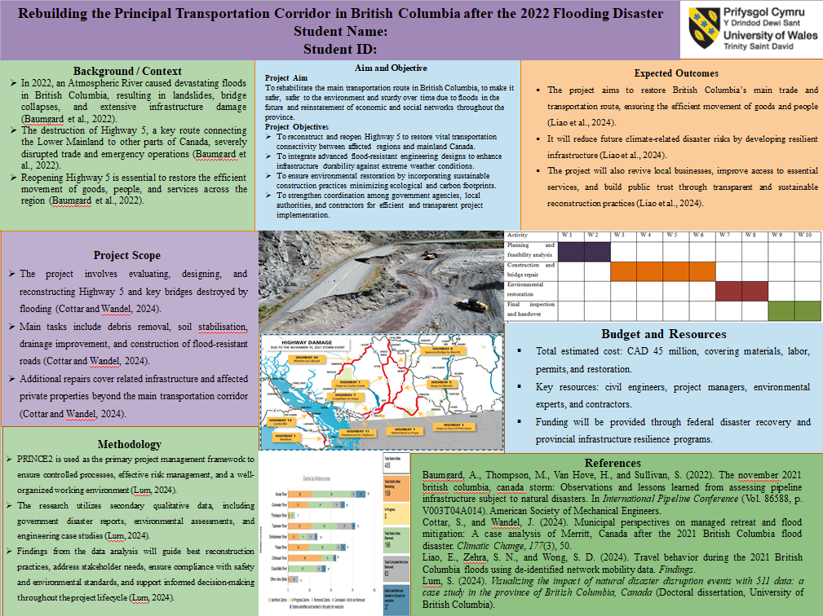

Background / Context
Atmospheric River also caused a devastating flood in 2022 in British Columbia, which occurred, triggering landslides, bridge collapses and radically damaged infrastructures. The event destroyed Highway 5, which was significant as a transportation boundary of the Lower Mainland to other parts of Canada. The catastrophic event stalled commerce and emergency response, and subjected the nearby population to economic and social destitution (Baumgard et al., 2022). It will be critical to open this major highway that will boost the movement of goods, people and services.

Aim and Objective
Project Aim
To rehabilitate the main transportation route in British Columbia, to make it safer, safer to the environment and sturdy over time due to floods in the future and reinstatement of economic and social networks throughout the province.
Project Objectives
- To reconstruct and reopen Highway 5 to restore vital transportation connectivity between affected regions and mainland Canada.
- To integrate advanced flood-resistant engineering designs to enhance infrastructure durability against extreme weather conditions.
- To ensure environmental restoration by incorporating sustainable construction practices minimizing ecological and carbon footprints.
- To strengthen coordination among government agencies, local authorities, and contractors for efficient and transparent project implementation.

Project Scope
The project is the evaluation and design, as well as the reconstruction of Highway 5 and the basic bridges that were destroyed by the flooding. It includes clearing of debris, soil stabilisation, improving drainage and building of roads that are flood resistant (Cottar and Wandel, 2024). Included in the project are not unrelated repairs of the infrastructure and other miscellaneous private property located beyond the project transportation corridor.

Methodology
In this project, PRINCE2 becomes the project management tool of choice, with its focus to ensure that the project has steps that are tightly controlled; a well-managed working environment and risk management is well handled (Lum, 2024). The research has applied the secondary qualitative data, which includes the government disaster reports, environmental assessment, and engineering case study. The results of the data analysis will be used to determine the optimum practices in reconstruction, measure the needs of the stakeholders, and comply with the regulations of safety and environmental consideration. The results will be used in making informed choices during the lifecycle of the project.

Timeline and Milestones
Duration: 10 weeks
Activity | W 1 | W 2 | W 3 | W 4 | W 5 | W 6 | W 7 | W 8 | W 9 | W 10
Planning and feasibility analysis
Construction and bridge repair
Environmental restoration
Final inspection and handover
Weeks 1–2: Project planning, feasibility analysis, and environmental assessment
Weeks 3–6: Construction, bridge repair, and infrastructure testing
Weeks 7–8: Environmental restoration and safety audits
Weeks 9–10: Final inspection, stakeholder evaluation, and project handover

Budget and Resources
Total estimated cost: CAD 45 million, covering materials, labor, permits, and restoration.
Key resources: civil engineers, project managers, environmental experts, and contractors.
Funding will be provided through federal disaster recovery and provincial infrastructure resilience programs.

Expected Outcomes
It is projected that the project will reinstate the principal trade and transportation route of British Columbia, thus providing the smooth flow of goods and people (Liao et al., 2024). It will ensure reduced exposure to disasters caused by changes in climate in the future by creating infrastructure resilient to the changes, revive the local business environment by enhancing access to basic amenities, and enhance trust among people in the reconstruction process due to its transparency and sustainable nature.

References
Baumgard, A., Thompson, M., Van Hove, H., and Sullivan, S. (2022). The november 2021 british columbia, canada storm: Observations and lessons learned from assessing pipeline infrastructure subject to natural disasters. In International Pipeline Conference (Vol. 86588, p. V003T04A014). American Society of Mechanical Engineers.
Cottar, S., and Wandel, J. (2024). Municipal perspectives on managed retreat and flood mitigation: A case analysis of Merritt, Canada after the 2021 British Columbia flood disaster. Climatic Change, 177(3), 50.
Liao, E., Zehra, S. N., and Wong, S. D. (2024). Travel behavior during the 2021 British Columbia floods using de-identified network mobility data. Findings.
Lum, S. (2024). Visualizing the impact of natural disaster disruption events with 511 data: a case study in the province of British Columbia, Canada (Doctoral dissertation, University of British Columbia).

Part B: Reflection
When I finally offered my poster, the tutor and my peers provided positive feedback regarding my project plan of restoring the principal transportation path in British Columbia following the floods in 2022. It should be mentioned that the feedback provided me with very useful information regarding the strong aspects of my proposal and the aspects which need to be corrected to make the final version of the project plan sound, feasible and easy to understand.
There was also one area in my proposal where I scored well; that is, the situation with clarity of the project aim and objectives. My tutor even commended the very clear and measurable objectives since they aligned well with my overarching objective of restoring the connectivity and developing resiliency to the environment (Muhaimin et al., 2021). The systematic method of the PRINCE2 methodology also received a positive reception since it demonstrated a systematic professional model of the handling of the complex reconstruction process. Peers also highlighted and noted the sustainability and climate resilience measures as measures taken in the long-term awareness of social and environmental awareness. Additionally, the deadlines and milestones were praised to be realistic and concise, and they provided a clear list of the activities which are to be achieved during the 10 weeks.
Nevertheless, there were also some areas which the feedback identified as places where improvements can be made. My tutor suggested the expansion of the risk management plan and discussion of some risks, such as delay in the process of funding, weather disruptions, and supply shortage, followed by the mitigation measures (Abokifa and Moustafa, 2021). Certain pieces of advice that colleagues provided included the need to further elaborate on the stakeholder engagement, particularly how to interact with the government bodies, the local communities and the contractors in the process of implementing the project. Another area that was found to be refined is budget justification. The overall cost would have been factored in, though there was a need to subdivide the resource allocation on a finer basis to improve transparency and accountability.
I intend to make a number of improvements to the final project plan based on this feedback. In order to strengthen the risk assessment section, it will be possible to develop a detailed risk register that will identify, assess, and rank the possible threats and response strategies (Yao et al., 2024). The section on stakeholder management will be extended to describe the communication techniques, feedback, and collaboration styles to allow inclusivity and accountability during the project. The budget part will be polished, and it will be in the form of cost estimates with an itemised cost justification being given to all the expenditures. Lastly, the monitoring and evaluation system will be enhanced with the identification of the key performance indicators (KPIs), helping to understand the progress of the project and the degree of success.
On the whole, the process of feedback proved to be immensely helpful in both pointing out the strong and weak sides (Muhaimin et al., 2021). It has helped me to approach a more detailed, realistic and balanced final project plan, which I know will be in accordance with the academic standards but will be reflective of professional project management practices.

Part C: Project Management Plan

Introduction
British Columbia had a major flood in 2022 due to a river of air in the atmosphere, causing severe damage to infrastructure, including the demolition of Highway 5. This is a major transport route that links the lower mainland to central areas and is vital in the transport of goods, emergency services and day-to-day transport. The floods caused the slipping of land, the collapse of bridges and the epic destruction of roads, thus isolating people, destroying trade routes, supply lines, and access to basic services such as hospitals, schools and government buildings.
This Project Management Plan (PMP) forms a roadmap to the project of reconstructing Highway 5, the project objectives, the project scope, the project schedule, the project resources that will be mobilised, the project risks and deliverables of the project. It also forms one of the references as regards tracking the progress, accountability and communication among the stakeholders. The project focuses on staged management, roles and responsibilities, mitigation of risks, and stakeholder engagement with the help of the PRINCE2 methodology. Indeed, through the incorporation of resilient and sustainable building methods, the project will rehabilitate the corridor effectively and minimise susceptibility to eventual catastrophic weather events. The PMP exhibits professionalism, sustainability, and cooperation in the provision of long-term gain to the affected communities.

Project Description
Project Overview
The project, which is called Rebuilding the Principal Transportation Corridor in British Columbia Post-2022 Flooding, concentrates on the reconstruction of Highway 5, along with bridges, embankments, drainage systems, and other infrastructure located around the highway (Deep et al., 2022). The corridor is essential in commercial transportation, emergency response, and community transportation. By reconnecting the corridors, the project will also expand the resilience of the corridors to future floods and other natural calamities caused by climate change.
Project Aim
To repair the main transportation path in British Columbia with an advantage of future safety, environmental sustainability, and overall resilience to future floods and also to repair the damaged economic and social connectivity in the Province.
Project Objectives
- To rebuild and reconnect Highway 5, which was destroyed when the earthquake occurred, to regain essential transportation links between areas and mainland Canada.
- To incorporate high-end resistant infrastructural engineering designs to promote infrastructure against harsh weather events.
- To guarantee that the environment is restored using sustainable building techniques that reduce the ecological and carbon footprint.
- To enhance effective coordination between government bodies, local government, and contractors to develop an efficient and transparent project implementation.
Rationale
The damage to Highway 5 interfered with the trading system, emergency services, and mobility within the community. This is a necessary phase in rebuilding this corridor to obtain economic recovery, social welfare, and disaster resistance. The project conforms to provincial and federal plans of recovery, as sustainable and resilient infrastructure stock is significant (Dhakal et al., 2023). The project itself will be reflected in the introduction of contemporary solutions in the engineering world and the attention to the involvement of stakeholders, which will contribute to addressing short-term recovery problems and long-term recovery measures.
Key Deliverables
- Rebuilding of roads and better structural road bridges.
- Drainage systems that are resistant to flooding can help avoid future destruction.
- Restoration of the environment, such as reforestation and soil.
- Project progress, stakeholder involvement monitoring and reporting.
Assumptions and Constraints
- Assumptions: In good time provision of funds, access to skilled labour and collaboration among the local communities.
- Constraints: None of the restrictions is 10-week project schedule, disruption of the supply chain, uncontrollable weather conditions, and budget constraints.

Project Scope
Inclusions
The project scope will incorporate all the activities required to take Highway 5 to its full functionality following the floods in 2022. These entail conducting massive tests on assessments and viability to ascertain the extent of damage on bridges, embankments and road segments, after which the most appropriate way to suit the reconstruction strategies, is established (Rogers and Enright, 2023). The project will involve the rebuilding of critical infrastructure, which includes bridges, embankments, and sections of the roads, as they will take into consideration a different standard of the structure and the new standards of the engineering requirements. The project will also include the installation of flood-resistant drainage and erosion control to make it more resilient to future events related to climate and reduce the chances of additional damage to infrastructure. As well, such environmental restoration exercises, as reforestation, soil stabilisation, and ecosystem recovery, will be conducted in the impacted regions in order to reduce the ecological impacts and ensure sustainability (Subramanya et al., 2022). The key will be the active participation of stakeholders, communication, and monitoring of the projects at all stages to achieve the transparency of actions, inclusiveness, and accountability.
Exclusions
The repair or reconstruction of personal property that falls outside the Highway 5 project is not covered under the project. It does not extend to infrastructure gains that may be developed outside the specified corridor and other long-term maintenance efforts that will be undertaken after the project is handed over, which will now be the mandate of local authorities (Meharie et al., 2022).
Boundaries
The geographical scope of the project is Highway 5 and other related bridges and embankments. The project has operationally the planning, design, reconstruction, environmental restoration and handover, with any activities outside of these divisions being considered out of scope.
Expected Benefits
The project will rehabilitate a critical transportation pathway, stem potential exposure to subsequent climate-related disasters, revitalise the local economy, enhance the availability of vital services and ensure robust confidence among the people because of the transparent, sustainable reconstruction efforts (Deep et al., 2022).

Work Breakdown Structure (WBS)
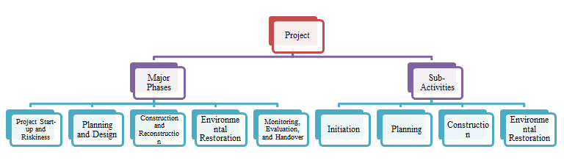
Figure 1: Work Breakdown Structure (WBS)
Source: Self Made
Work Breakdown Structure (WBS) is also an essential project management tool, which offers a hierarchical breakdown of the project into manageable, well-defined tasks (Ganesdhi et al., 2023). The WBS allows planning, resource allocation, monitoring and control to be effective by establishing small and measurable units of the project that will see to it that no aspects of the project are overlooked and that everything is accomplished within the required time and budget constraints.
Level 1 - Major Phases
Project Start-up and Riskiness: Setting up of the project foundation, including preliminary evaluations and clearances.
Planning and Design: Coming up with more detailed designs, schedules and resource plans to direct construction (Saleh et al., 2025).
Construction and Reconstruction: Implementation of all the structural works, such as bridges, embankments and road sections.
Environmental Restoration: Sustainability measures implemented to restore the affected regions.
Monitoring, Evaluation, and Handover: it involves quality compliance, final assessment, and the official transfer to the authorities (Sukmono, 2023).
Level 2 - Sub-Activities
Initiation: Define project charter, derive and involve stakeholders, and conduct feasibility and risk assessment.
Planning: Make comprehensive plans, assign resources including human and materials, seek clearance approvals and come up with schedules (Kussumardianadewi et al., 2024).
Construction: Restore bridges, rebuild parts of the roads, create drainage structures that would not be affected by floods, and perform regular quality control inspections.
Environmental Restoration: Conduct reforestation, soil stabilisation, erosion control and environmental audits to put ecological balance back in place.
Monitoring & Handover
Carry out a thorough inspection, learn the lessons learned, ensure that standards have been met and formally deliver the corridor to authorities (Datola et al., 2025).
The WBS guarantees company responsibility, deliverables, and reporting order. The WBS allows better coordination, eliminates delays, and provides efficient monitoring and project control, which aids the successful reconstruction of Highway 5 by integrating tasks with resources, timeframes, and results (Nugroho and Latife, 2021).

Quad Chart
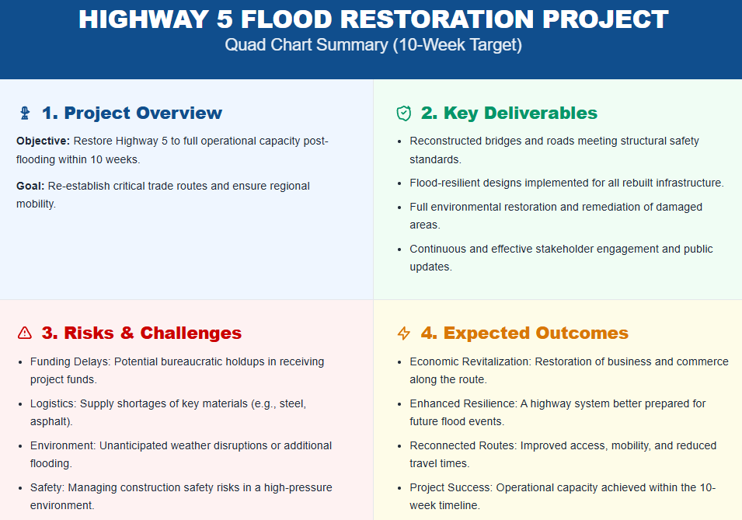
Figure 2: Quad Chart
Source: Self Made
The Quad Chart is a brief high-level graphic, giving a visual representation of the vital project data to the stakeholders so that they can easily interpret the objectives, scope, risks and expected results of projects (Radzi et al., 2023). It is a useful decision-making, prioritisation and progress monitoring tool, particularly in complex infrastructure projects like the rebuilding of Highway 5 after the 2022 floods.
Project Overview
The main goal of the project is to put Highway 5 on full operational capacity within 10 weeks. It is a strategic transport passageway that is vital to trade, emergency services, and the movement of people in the community, which was seriously compromised because of the damage caused by the flooding (Muhit et al., 2024). The project will not simply involve the reconstruction of critical infrastructures alone, but it will also be accompanied by the aspect of flood-resistant designs, which can be of long life and operation.
Key Deliverables
It is going to deliver reconstructed bridges, street sections, and embankment, and install drainage that will withstand floods (Shehadeh et al., 2024). The other deliverables would be the environmental restoration initiatives, such as the reforestation and soil stabilisation, and formal stakeholder engagement and communication plans to introduce transparency and inclusiveness.
Risks & Challenges
The threats will probably be the risk of funding delay, unfavourable weather, supply chain issues and safety accidents throughout the construction. They will have mitigation procedures such as contingency planning, flexible schedule and stringent safety precautions that would minimise disruptions.
Expected Outcomes
Successful closing will result in the achievement of recovered trade and transportation systems, more infrastructure resilience, recovery of the economy of the impacted areas, more access to the required services, and increased confidence in the population regarding the disaster recovery efforts (Radzi et al., 2023).

Gantt Chart
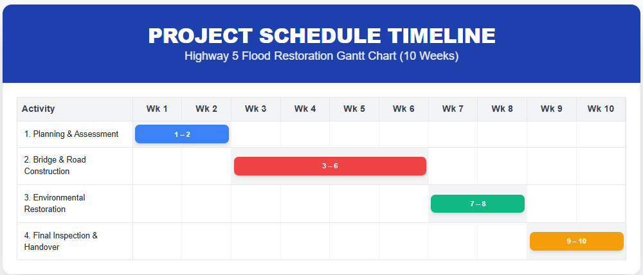
Figure 3: Gantt Chart
Source: Self Made
The Gantt Chart outlines the sequence of project activities and ensures timely delivery.
Duration: 10 Weeks
- Weeks 1–2: Planning, feasibility, and environmental assessment.
- Weeks 3–6: Construction of bridges, road segments, and drainage systems.
- Weeks 7–8: Environmental restoration, reforestation, and safety audits.
- Weeks 9–10: Final inspection, stakeholder evaluation, and project handover.

Stakeholders’ Involvement
The proper stakeholder engagement is a necessary condition of a successful Highway 5 rebuilding, which fosters transparency, responsibility, and cooperation, along with matching the aims of the project with the community demands. Based on the influence and the involvement of the stakeholders, they are divided into primary and secondary.
The main stakeholders would be the British Columbia ministry of transportation, who would be in charge of regulatory compliance, project approvals, federal disaster recovery agencies responsible in funding and monitoring progress, the local municipalities, who would facilitate access to the site and community consultation on the project, the contractors, who would carry out the pieces of reconstruction work and environmental agencies, which would ensure the sustainability and restoration of the ecosystem (Grill, 2021).
The secondary stakeholders involve the local community and residents who use the highway in their commuting and economic studies, and also the logistics and transport companies who are concerned with the accessibility of the corridors (Mazza and Azzali, 2025).
There is a clear definition of roles: the government agencies fund and exercise oversight, contractors offer construction services, environmental experts carry out practices to monitor sustainability, and communities give feedback and influence the decision-making. Weekly progress reports, public consultations, and target feedback sessions during key milestones are engagement strategies (Mazza and Azzali, 2025). These approaches to conflict control are negotiation, formal agreements and escalation procedures.
Early involvement of stakeholders makes sure that project deliverables are in line with the community needs, whilst enabling teamwork, trust and responsibility among them in the reconstruction.

Allocation of Resources
Resource allocation is a critical aspect of project management, ensuring that human, financial, material, and time resources are efficiently utilized to achieve project objectives.
Human Resources: A Project Manager will head the project and coordinate the report as well as handle the risk. The construction quality and safety will be provided by giving technical advice to the civil Engineers. Environmental Specialists will enforce sustainable practices and compliance with regulations. Construction Workers will perform physical reconstruction work, which will consist of bridges and road segments, the installation of drainage, etc. (Dhakal et al., 2023). The Administrative Staff will be dealing with documentation, contacting and scheduling of the stakeholders.
Financial Resources: The complete budget will amount to CAD 45 million, including 15% on planning and design, 55% on construction, 10% on environmental restoration, and 20% on contingency and monitoring (Subramanya et al., 2022). This guarantees that major construction projects get most of the funds, as it is flexible enough to accommodate the unexpected risks.
Material Resources: Some of the crucial materials include concrete, steel, heavy equipment, drainage, and safety gear. The supply chain risks will be mitigated with the help of multiple suppliers.
Time Resources: The project has been planned to be developed in 10 weeks, and the sequencing of tasks and dependencies was recorded in a Gantt chart. The activities related to the critical path are placed first in order to make sure the milestones are achieved within the time frame.
Justification: Distribution of a resource is done according to the criticality of the tasks, the complexity involved in a phase and the priorities of the project in order to maximise efficiency, quality and delivery of a product on time (Dhakal et al., 2023).

Risk Analysis
Purpose
Risk analysis is meant to protect the objectives of the project, such as meeting the timeline, staying within the budget, ensuring quality assurance, and stakeholder satisfaction. Risk management is important to make sure the challenges are being anticipated and addressed systematically.
Risk Identification and Assessment
Funding Delays: Granted fair probability, great impact. Construction may be stopped due to delays. Mitigation: seek approvals and have back-ups.
Weather Disruptions: Floods or rainfall may impede work and have a high likelihood and high impact. Mitigation: flexibility, defence and live surveillance (Nugroho and Latife, 2021).
Supply Shortages: Medium impact and medium likelihood. Material inconvenience may lead to delays. Mitigation: enter into contracts with diverse suppliers, emphasise domestic sourcing and maintain stockpiles.
Safety Incidents: Low likelihood, high impact. Accidents may happen, hence leading to delays or injury to the personnel (Datola et al., 2025). Mitigation: high safety, training and compliance with health measures.
Monitoring and Review
Risks will be monitored weekly, with key indicators reported to stakeholders during progress meetings (Datola et al., 2025).

Conclusion
Thanks to a clear path forward laid out by the PMO, work is underway to restore Highway 5 in British Columbia, which was hard-hit during the 2022 floods. The PRINCE2 method, good risk management and engineering with sustainability will ensure that the project will be executed safely, on time and within budget. Bringing this road back into commission will facilitate convenient travel for people, movement of goods and accessibility for emergency services. The infrastructure will be made to resist floods and other extreme weather conditions that may arise in the future.
A key part of the project is stakeholder engagement. The decision-making process, progress monitoring, and problem-solving involve government agencies, contractors, environmental experts, local communities, and businesses. This approach ensures transparency and collaboration. Planning and supervision of resources are made to concentrate on the main construction activities and retain flexibility for unforeseen events. The plan to deliver the goods on time and on budget helps a government service or public project. The project will replace vital infrastructure, support the local economy, boost public confidence and set an example for best practices in disaster recovery planning for sustainable and effective outcomes.

References
Abokifa, M., and Moustafa, M. A. (2021). Mechanical characterization and material variability effects of emerging non-proprietary UHPC mixes for accelerated bridge construction field joints. Construction and Building Materials, 308, 125064.
Datola, G., Ghisoni, A., Dell'Ovo, M., and Oppio, A. (2025). The feasibility of Nature-Based Solution (NBS) interventions: estimating the cost using the Work Breakdown Structure (WBS). VALORI E VALUTAZIONI, 37, 183-208.
Deep, S., Banerjee, S., Dixit, S., and Vatin, N. I. (2022). Critical factors influencing the performance of highway projects: an empirical evaluation. Buildings, 12(6), 849.
Dhakal, D., Abdi, S. O., Singh, K., and Sharma, A. (2023). Applications of GIS and remote sensing in highway project: a review. Journal of Mining and Environment, 14(2), 375-388.
Ganesdhi, G. A., Latief, Y., and Nugroho, D. B. (2023). Development Of Risk-Based Work Breakdown Structure (WBS) Standards For Integrated Design And Construction Phase On Design-Build Method Of Architectural Works Of High-Rise Building To Improve Construction Safety Performance. International Journal of Science, Technology and Management, 4(4), 792-801.
Grill, C. (2021). Involving stakeholders in research priority setting: a scoping review. Research involvement and engagement, 7(1), 75.
Kussumardianadewi, B. D., Latief, Y., Trigunarsyah, B., Rarasati, A. D., and Widiani, W. (2024). Development of Work Breakdown Structure (WBS) in High-Rise Office Buildings using Green Retrofitting based on GBCI and Minister of PUPR Regulation No. 21 of 2021 to Improve the Quality of Resource Planning. Civil Engineering and Architecture, 12(2), 740-753.
Mazza, T., and Azzali, S. (2025). Stakeholders’ involvement in economics and management programs quality assurance. Quality Assurance in Education, 33(1), 47-61.
Meharie, M. G., Mengesha, W. J., Gariy, Z. A., and Mutuku, R. N. (2022). Application of stacking ensemble machine learning algorithm in predicting the cost of highway construction projects. Engineering, Construction and Architectural Management, 29(7), 2836-2853.
Muhaimin, A. M. M., Zhang, L., Dhakal, S., Lv, X., Pradhananga, N., Kalasapudi, V. S., and Azizinamini, A. (2021). Identification and analysis of factors affecting the future of bridge design, construction, and operation. Journal of Management in Engineering, 37(5), 04021049.
Muhit, I. B., Omairey, E. L., and Pashakolaie, V. G. (2024). A holistic sustainability overview of hemp as building and highway construction materials. Building and Environment, 256, 111470.
Nugroho, D. B., and Latife, Y. (2021). Development of Work Breakdown Structure (WBS) for Safety Planning on Tunneling Work Projects Based on Risk. In Journal of Physics: Conference Series (Vol. 1858, No. 1, p. 012076). IOP Publishing.
Radzi, A. R., Rahman, R. A., and Doh, S. I. (2023). Decision making in highway construction: A systematic review and future directions. Journal of engineering, design and technology, 21(4), 1083-1106.
Rogers, M., and Enright, B. (2023). Highway engineering. John Wiley and Sons.
Saleh, T., Latief, Y., Fitria, D. R., and Atlan, A. D. (2025). Utilization of Work Breakdown Structure (WBS) and Building Information Modeling (BIM) for Dam Maintenance in Indonesia: A Literature Study. OPSearch: American Journal of Open Research, 4(1), 352-363.
Shehadeh, A., Alshboul, O., Al-Shboul, K. F., and Tatari, O. (2024). An expert system for highway construction: Multi-objective optimization using enhanced particle swarm for optimal equipment management. Expert Systems with Applications, 249, 123621.
Subramanya, K., Kermanshachi, S., and Patel, R. K. (2022). The future of highway and bridge construction: Digital project delivery using integrated advanced technologies. In International Conference on Transportation and Development 2022 (pp. 14-25).
Sukmono, C. (2023). Enhancing Project Management Efficiency in PERTAMINA through Work Breakdown Structure (WBS) and Cost Breakdown Structure (CBS) Integration. Structure (CBS), 1(2).
Yao, B., Wang, L., Gao, H., and Ren, L. (2024). Bridge construction risk assessment based on variable weight theory and cloud model. Buildings, 14(3), 576.

