INTRODUCTION TO BUSINESS

Student Name: Eduard Scripcariu
Student ID: 2313339

Table of Contents
Introduction 3
Discussion 3
Conclusion 7
Reference list 8

Introduction
Organizational goals and missions have to be aligned with the organisational culture and environment so that the business can grow in the business industry. In this regard, the essay is going to focus on assessing the effects of Tesco’s key functions on its business processes. Tesco is a public limited company that operates in the retail industry globally (Tesco Plc, 2023a). The mission and goal of this organization is to provide better services to its customers, planet, and communities every day (Tesco Plc, 2023b). This brand sells retail products such as clothing, books, furniture, electronics, toys, and others. Therefore, selection of this brand is justified as it will give an opportunity to assess how key functions influence business operations of a market-leading brand.
Thesis statement: The research aims to evaluate the impact of organizational culture and other aspects like HRM, marketing, accounting, and financing of Tesco on its business operations.

Discussion
Importance of key functions in running the business

Accounting and finance
Effective accounting and financial practices play an important role in order to track and store accurate and transparent financial records of the company (Forbes, 2023). Along with that, with the help of effective accounting and financing techniques, an organisation can ensure the implementation of informed decision-making to make the business process smoother. In the scenario of Tesco, proper financing and accounting practices have been supporting it in developing an accurate annual report, which demonstrates management statements, and financial highlights. For example, annual report 2022 of Tesco states the company has achieved gross sales of £54.8bn in FY2021 (Tesco Plc, 2023d).

Marketing
The international business environment has become complex in the digitalized era, which has made it complicated for brands in the international market to attract customers (Katsikeas et al. 2020). According to Morgan et al. (2019), selecting an appropriate marketing strategy is considered one of the core aspects for businesses to attract customers through the promotion of their products or services. Kingsnorth (2022) supported this by stating that digital marketing strategy has become one of the growing and most effective methods to make customers aware of the brand’s presence and launch of its new products in the market. Tesco has been using a digital marketing strategy to make people aware of its services and products, especially, the new arrivals (Tesco PLC, 2023a). The use of various social media platforms such as Instagram, Facebook, and Twitter have been observed to enhance digital marketing strategy. For example, the total number of followers of Tesco on its Twitter page, which has been created for promotional purposes, has a total of 657.6k followers (Tesco Plc, 2023c). Therefore, based on the analysis, it can be inferred that the use of digital marketing strategy has been supportive of Tesco to attract such a huge number of customers, which led to organizational success.

Human resource management
Human resource management practices are a crucial part of improving employee satisfaction and motivation so that employees can perform effectively to achieve organisational success without any frustration (Azizi et al. 2021). As stated by Stone et al. (2020), HR management practices aim to enhance the management of employer relationships and employee engagement. In this context, it has been observed that the HR management practices in Tesco involve the development of a flexible working environment, ensuring that each employee is treated equally, and skill development programs for improving employee motivation (Chartered Institute of Personnel and
Development, 2023). For example, Tesco’s ROI people director stated that employees who have engaged with “People Development Partnership programs”, were encouraged to perform better and experience better opportunities (Chartered Institute of Personnel and Development, 2023). Therefore, it can be inferred that HR management practices in Tesco are sufficient to improve business operations.
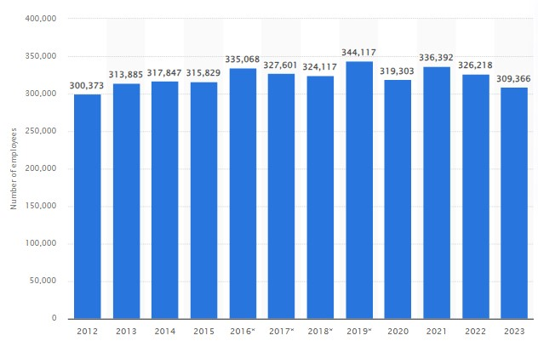

Figure 1: Total employee number of Tesco

(Source: Bedford, 2023)
The company has been serving its services to its customers with the core efforts of nearly 326,000 employees and their efforts have helped the retail brand to become one of the successful retail giants by the end of the fiscal year 2023 (Bedford, 2023) [Refer to figure 1]. Therefore, the skill development programs and employee retention strategy have been supporting the organization to contribute towards its organizational success as it achieved nearly 9.1 billion U.S. dollars in FY2022 (Statista, 2023). “Expectancy theory” of motivation sheds light on justification for the practices of performance management along with factors that reduce the capabilities of an organization to improve employee motivation (Lee, 2019). Stewart and Brown (2019) argued that HR management practices have to be based on leadership approaches, which is helpful in developing loyal shoulders (employees). Pattanayak (2020) stated that high trust culture plays an important role in improving employee satisfaction and motivation. The initiatives of Tesco to organise skill development partnership programs have been helping Tesco improve the motivation of 326,000 employees, which is justified towards smoother operations management (Bedford, 2023). Therefore, it can be inferred that implementation of this theory was justified as it helped in identifying the factors that have potential to improve employee motivation.
Influence of organizational culture on organisational environment
The business environment and culture of Tesco are employee-focused as the leaders and managers pay attention to strategies that can be helpful to maximize employee satisfaction (Ullash, 2023). The flexible working culture and open communication practices in Tesco are supportive of meeting employee needs so that employee potential can boosted and encouraged.
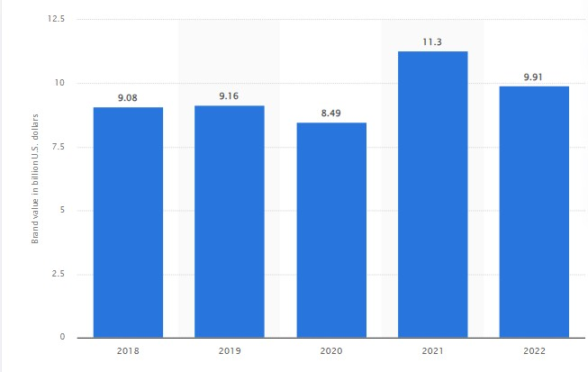

Figure 2: Brand value of Tesco

(Source: Statista, 2023)
Employee motivation is one of the conditions, which ensures workers ensure sustainable performance (Wolor et al. 2020). As per supportive statements of Setiyani et al. (2019), working culture influences the fulfillment of physical, social, and psychological needs of employees which are required to improve the business environment. Effective workplace culture has improved the organizational environment, which boosted employee satisfaction to such a level that their performance led to achieving 9.91 billion U.S. dollars in FY2022 (Statista, 2023). Therefore, it can be inferred that working culture of Tesco has positive effects on its organizational environment.

Conclusion
It can be concluded that Tesco has established a strong brand value in the market with its core services. Accounting and financing practices have helped the company to keep records of each financial statement, which is required to evaluate financial performance every year. Digital marketing helps to connect with a huge number of customers, whereas, HR management approaches are supportive towards employee skill development. Organizational culture is supportive to developing a flexible working environment to promote employee satisfaction. The effective record tracking and people management have helped it to increase its brand value and annual profit.

Reference list
Azizi, M.R., Atlasi, R., Ziapour, A., Abbas, J. and Naemi, R. (2021) ‘Innovative human resource management strategies during the COVID-19 pandemic: A systematic narrative review approach’, Heliyon, 7(6). Available at: https://doi.org/10.1016/j.heliyon.2021.e07233
Bedford, E. (2023) Average number of employees at Tesco in the United Kingdom (UK)* from 2012 to 2023. Available at: https://www.statista.com/statistics/490882/tesco-groupunited-kingdom-uk-number-ofemployees/#:~:text=From%202012%20to%202022%2C%20the,in%202023%20to%20a round%20309%2C300. [Accessed: 17 October 2023]
Chartered Institute of Personnel and Development [CIPD] (2023) Case study: Building HR capability at Tesco. Available at: https://www.cipd.org/en/organisations/peopledevelopment-partners/tesco-hr-capability/ [Accessed: 17 October 2023]
Forbes (2023) 19 Effective Accounting Tips For Business Success. Available at: https://www.forbes.com/sites/forbesfinancecouncil/2023/07/13/19-effective-accountingtips-for-business-success/?sh=584b7ec2410e [Accessed: 17 October 2023]
Katsikeas, C., Leonidou, L. and Zeriti, A. (2020) ‘Revisiting international marketing strategy in a digital era: Opportunities, challenges, and research directions’, International
Marketing Review, 37(3), pp.405-424. Available at: https://doi.org/10.1108/IMR-02-20190080
Kingsnorth, S. (2022) Digital marketing strategy: an integrated approach to online marketing. 3rd edn. Kogan Page Publishers.
Lee, H.W. (2019) ‘Moderators of the motivational effects of performance management: A comprehensive exploration based on expectancy theory’, Public Personnel Management,
48(1), pp.27-55. Available at: https://doi.org/10.1177/0091026018783003
Morgan, N.A., Whitler, K.A., Feng, H. and Chari, S. (2019) ‘Research in marketing strategy’, Journal of the Academy of Marketing Science, 47, pp.4-29. Available at:
https://doi.org/10.1007/s11747-018-0598-1
Pattanayak, B. (2020) Human resource management. 6th edn. PHI Learning Pvt. Ltd..
Setiyani, A., Djumarno, D., Riyanto, S. and Nawangsari, L. (2019) ‘The effect of work environment on flexible working hours, employee engagement and employee motivation’, International Review of Management and Marketing, 9(3), pp.112-116. Available at:
https://doi.org/10.32479/irmm.8114
Statista (2023) Brand value of Tesco worldwide from 2018 to 2022. Available at: https://www.statista.com/statistics/1337228/tesco-brandvalue/#:~:text=The%20brand%20value%20of%20Tesco,overall%20value%20of%20a% 20corporation. [Accessed: 17 October 2023]
Stewart, G.L. and Brown, K.G. (2019) Human resource management. 4th edn. John Wiley & Sons.
Stone, R.J., Cox, A. and Gavin, M. (2020) Human resource management. 10th edn. John Wiley & Sons.
Tesco Plc (2023a) About Tesco Plc. Available at: https://www.tescoplc.com/about/
[Accessed: 17 October 2023]
Tesco Plc (2023b) Core Purpose and Values. Available at:
https://www.tescoplc.com/about/how-we-do-business/core-purpose-and-values/ [Accessed: 17 October 2023]
Tesco Plc (2023c) Twitter page of Tesco Plc. Available at:
https://twitter.com/Tesco?ref_src=twsrc%5Egoogle%7Ctwcamp%5Eserp%7Ctwgr%5Ea uthor [Accessed: 17 October 2023]
Tesco Plc (2023d) Annual report of Tesco Plc 2022. Available at: https://www.tescoplc.com/media/759057/tesco-annual-report-2022.pdf [Accessed: 17 October 2023]
Ullash, S., S. (2023) Organizational Theory and Practice of Tesco PLC. Available at:
https://www.linkedin.com/pulse/organizational-theory-practice-tesco-plc-sanadiuleshorif-
ullash#:~:text=Tesco's%20business%20environment%20is%20employee,function%20a t%20their%20best%20potential. [Accessed: 17 October 2023]
Wolor, C.W., Supriyati, Y. and Purwana, D. (2020) Effect of organizational justice, conflict management, compensation, work stress, work motivation on employee performance sales people. SSRN.

