Name: Peter Scott
Student Number: 2307123
Leading Digital and Strategic Change BMSW7003
Title
Leading the reshaping of the strategic direction in the context of digital change

‘L&D digital transformation for the future public value in policing’

19th April 2024

Table of contents
Contents

Executive Summary 1
List of figures and tables 1
1 Introduction 3
1.1 Context 3
2. Main Findings 6
2.1 Positive Outcomes for communities 6
2.2 Attrition rates of officers in England and Wales 8
2.3 Public sector relevance to value 9
2.4 TVP Current Digital Strategy 10
2.5 Current TVP Learning and Development environment. 10
2.6 PESTEL Analysis 14
2.7 Porters Value Chain 16
2.8 Stake holders. 17
2.9 Leadership 18
2.10 Transformational Leadership theory 18
2.11 Complexity Leadership theory 20
2.12 Cultural Web 22
2.13 SWOT analysis 24
3. Conclusions 25
4. Recommendations 27
Risks and Threats 30
References 31
Appendices 34

Executive Summary
This report has sought to analysis a key function area within Thames Valley Police (TVP), the chosen organisation to evaluate and provide options for a digital transformation solution to ensure a resilient future that can sustain a competitive advantage. The report identifies the challenges facing the police service, including TVP. Utilising the PESTEL analysis and the Value chain and a SWOT analysis, it has been possible to identify challenges from the significant Police Uplift Programme (PUP) Introducing newly qualified police officers into the service, whilst at the same time dealing with the highest attrition rates experienced. The position of Public Value from the police is scrutinised, police outcomes are at there lowest levels, together with public confidence in policing. Together these elements have highlighted the attention now required to radically change how Learning and Development can, upskill, and mobilise the workforce in order that knowledge, skill, and talent can be used to maximum benefit. The digital transformation required will examine the solution of adopting a Matrix structure to manage the transformation through a three-horizon strategy with key stakeholders, harnessing the benefits of transformational leadership to deliver digital solutions to eliminate existing silo processes. The delivery of new ways to market talent and create a system to support a dynamic learning culture for everyone, the recommendations seek to support a workforce in combating the complexities and challenges of the future whilst identifying the real threat of not digitally transforming at all.

List of figures and tables

Figure 1 Outcome percentages for police officers in England and Wales, March 2015-March 2022. 5
Figure 2 Chart displaying TVP charge Volumes. 6
Figure 3 TVP Public satisfaction rates for Investigations. 6
Figure 4 Number of leavers, excluding transfers in policing, England & Wales 2009-2023. 7
Figure 5 Police officer leaver rate, excluding transfers 31 March 2010 - 2023 in England and Wales. (Home Office, 2023) 7
Figure 6 AI assessment concept of finding best learning style. Varsha T, et al ‘Thinking Skills and Creativity’. 12
Figure 7 Porters Value Chain, TVP created by author. 16
Figure 8 Stake Holders Influence and impact map for TVP. 17
Figure 9 Matrix Structure created for TVP digital transformation implementation. 31
Figure 10 Three Horizon Strategy for Thames Valley Police. 32
Figure 11 Risk Matrix for Probability and Impact of not implementing the digital transformation. 33

1 Introduction

1.1 Context

Thames Valley Police (TVP) is one of 43 police forces in England and Wales. It is the second biggest force outside of the Metropolitan, serving three counties in England, with a diverse population of 2,34 million people (Thames Valley Police, 2024) In March 2023, 5034 warranted officers, including an exceeded target of 175 officers from Police Uplift Programme (PUP) serve in TVP. The government set an overall national target for the Police Uplift of 20’000 officers (Home Office, 2023b) The implementation of the (PUP) has been claimed as a success by the Government, achieving its goal in 2023 (House of Commons, 2022) However, the consequences of a rapid induction of new police officers into the service in a short time frame has contributed to an increasingly inexperienced work force, (Office National Statistics, 2022)
Positive outcomes and confidence in investigations in TVP, have been declining, (Home Office, 2023c) (PCC Thames Valley Police, 2024)The critical focus on how public value can be achieved and sustained through knowledge and skills development is now paramount, and therefore the digital transformation of the traditional Learning and Development (L&D) strategy within Thames Valley police is required in line with national police guidance L&D objectives(Harding et al., 2023).
This report will provide considered options and recommendations of how digital transformation within learning and development can be harnessed through an efficient change programme, reshaping the current traditional strategic position. TVP is a public sector organisation, its vision statement seeks excellence, and trust by its communities.(Thames Valley Police, 2024) The business of policing must remain resilient and maintain a sustained competitive advantage. In this sense, a public sector, nonprofit organisation, seeks value through trust, confidence, and efficiency. This position is firmly represented in the Policing Vison 2030 Strategic plan. (NPCC, 2023) This Strategic direction provides a clear road map for all forty-three police forces within England and Wales.
This Policing Vision 2030 strategy provides the context of complexity and scope in achieving vision success. It is however the intention of this paper to isolate a specific strategic function of business where value through digital transformation can be achieved. This strategic function area is L&D, structured under the People directorate (See Appendix B) The critical importance and strategic positioning of L&D within the organisation can provide the correct mechanisms and culture through leadership to catapult performance and innovation (Vey et al., 2017).
Modern digital developments will be discussed, including Artificial Intelligence, machine learning, cloud computing and how these modern breakthroughs can assist organisations such as the police and other profit and nonprofit businesses, and how these developments can be successfully integrated through a digital transformation change programme.
The recommendations from this report will be found utilising the ‘The exploring strategy framework’ as a handrail(Whittington, 2020). This framework allows evaluation of the current strategic position within TVP and considered strategic choices and strategy in action. The report will utilise a PESTEL analysis for external horizon changes, and a SWOT analysis for internal assessment. Porters Value Chain will analyse the integral value chain of the organisation (Porter, 2011) A considered approach examining what a competitive environment within the public sector looks like, and how this compares when viewing ‘value’ through the lens against monetary profit.
The position of the organisational structure and culture and how this can affect any change programme will be reviewed, considering a matrix structure solution to enable the transformation journey of L&D, together with the consideration of two different Leadership solutions: transformational leadership and complexity leadership theories. The effects on stakeholders and interested parties through presented recommendations will be borne through to provide a holistic picture and highlighting realistic threats of not enabling digital transformation.
Workforce skills, knowledge and personal development through L&D create the culture for an agile learning organisation (Vey et al., 2017) that in turn provides the modern platform to inform the positive values expected from policing communities.

2. Main Findings

2.1 Positive Outcomes for communities
Assessment of policing in England and Wales, (2022) report highlights the challenges that the PUP has contributed towards, and brings attention to declining investigation standards, attributed to an increasing inexperienced workforce and supervisors, also captured in a (House of Commons, 2022) that suggests some of these recruited officers would make an impact on crime, however, experience would have to be achieved by the majority over a longer period of time.
The graphical depiction in Figure 1 shows the overall outcome rates by polices officers in E&W, bringing offences to justice, (this means charging offenders cautioning, or out of court disposals). The data displays a declining picture of positive police outcomes. (Home Office, 2023a)
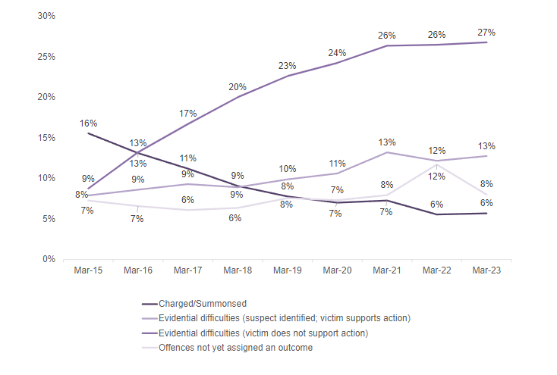
Figure 1 Outcome percentages for police officers in England and Wales, March 2015-March 2023.

TVP charge volumes provided from (PCC Thames Valley Police, 2024) in figure 2.

Figure 2 Chart displaying TVP charge Volumes.
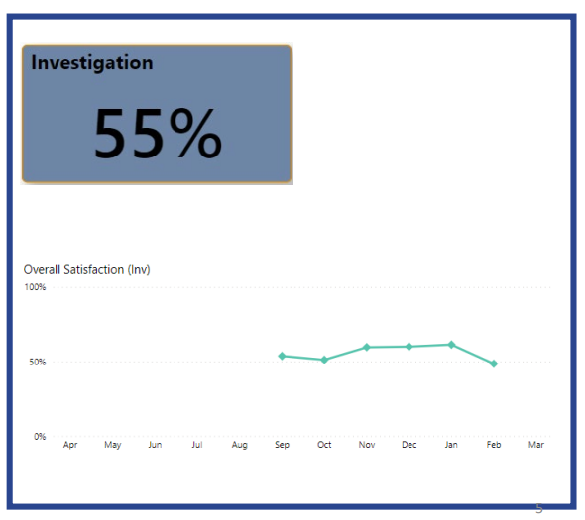
Figure 3 TVP Public satisfaction rates for Investigations.
Satisfaction rates for TVP investigations are at 55% (Fig 3) and declining. Public loss of confidence dropped from 42% of ‘very satisfied’ with the police in 2014, down to 32% in 2020. (PCC Thames Valley Police, 2024).

2.2 Attrition rates of officers in England and Wales
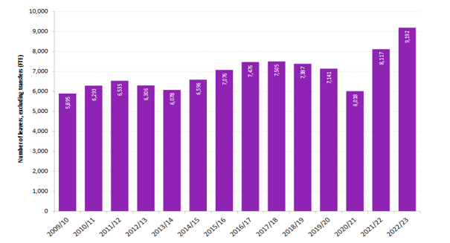
Figure 4 Number of leavers, excluding transfers in policing, England & Wales 2009-2023.

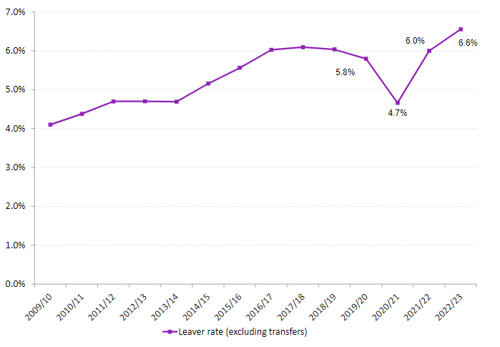
Figure 5 Police officer leaver rate, excluding transfers 31 March 2010 - 2023 in England and Wales. (Home Office, 2023)

According to the (Home Office, 2024), there were 9’192 officers exiting from the English and Welsh forces a year, 6.6% of all employed officers in early 2023, an increase of 13.2% from 2022. (Andrews, 2024) suggests the percentage rates for TVP leavers are approximately 6.8% per year.

2.3 Public sector relevance to value
The Objective of policing since its formation is established on the Peelian principles. (Davis and Silvestri, 2020) capture the aspect of ‘citizens in uniform’, and the established concept of ‘the police are the public and the public are the police’.
According to (Oster, 1995) Value in the Government sector can be exhibited through the clarity of the prescribed mission set through political direction and its mandates, and whether its communities were fulfilled by its aspirations.
Utilising ‘The Public sector Strategic Triangle’ (Moore, 1997) The key aspects of three critical areas can be seen to interact with each other fully. Value, Legitimacy & Support, Operational Capacity.
Value is guided on what focus the organisation is accounting for, its outline and direction – a claim for the organisation to say, the value comes because we were involved operationally. (Heyman, 1987)
Legitimacy & Support – This is where the support contributes to deliver value. Heyman, (1987)
Operational Capacity according to (Bryson, 1995) will acknowledge a skilled workforce, with abilities to use data, and have enough resources and deal with change and innovation.

2.4 TVP Current Digital Strategy

The digital strategy (TVP, 2023) suggests that in dealing with crime, personnel have the challenge of meeting the complexity of evolving crime types, increasing environment of policy and new IT systems that staff need to achieve competence. It provides a clear solution in meeting the national challenge of reducing budgets and increase in savings through focus on efficiencies that can contribute to value. One example that highlights demand complexity is the additional time that one standard investigation file increases by an additional seventeen hours compared to 2018/19. (TVP,2023)
The workforce according to TVP (2023) often left to figure out what technology they want to use based on their personal skill set. Training is referenced as a key reason for challenges, together with complexities.
It is also suggested by TVP (2023) that most of the technical training is online and generic, the one size fits all are not productive or efficient, supporting that the workforce needs to ensure the correct skills as well as technology. Better considered use of CPD and PDRs to support changing technology and processes would assist efficiencies, but to also create target monitoring to deliver performance in key areas in the force. TVP (2023). Demand challenges suggested from TVP (2023) highlight Demand Volume increasing year by year and average time of investigations and case files increasing.

2.5 Current TVP Learning and Development environment.

The current integral systems that operate in Thames Valley Police that support a workforce member can be seen operating in silo systems.
On joining the TVP police service, the recruitment application and onboarding process is a wholly isolated section. Details of an individual, skills and experience would not be identified at this stage and not transmitted to the next progression step, for example initial training, of a new joiner police officer.
The second stage is for the officer to be provided initial start details for the Initial foundation training stage. This lasts 20-24 weeks depending on entry pathway chosen by the individual. (Thames Valley Police, 2023)
The individual officers compete initial training, there is no system or platform that tracks or caters to the individual preferences/learning styles/aspirations or internal development requirements. This is due to no PDR or similar system being in place.
The officer will move from Initial training to a tutor constable period of coached patrol completing a portfolio that is specified by the College of Policing.
When finishing the Tutorship period and assessed on completion of the portfolio, the officer is signed of as Fully Operationally Competent (FOC) (College of Policing, 2020).
The officer at this time will have access and expectations to complete E Learning through the platform Moodle (to complete mandatory training set by the organisation, this is a standalone system)
The officers when through FOC are expected to open and maintain a PDR (Professional Development Review) This sits separate to any E learning/learning platform. (College of Policing, 2020).
The systems identified (Moodle, PDR, E-Learning) have no modern or technological link to the organisation, other than individual integration. Information collated by the organisation (TVP) only collects rates of completion for mandatory training. There is no feedback loop.
The college of policing operate a learning environment separate to TVP, this is a national access platform, but is not web based, has no personal tracking or feedback loop. It is another separate system for individuals to navigate. (College of Policing, 2024)
The (NPCC, 2022) states “By 2025 policing will be a profession with a more representative workforce that will align the right skills, powers, and experience to meet challenging requirements.”
To recognise this direction from the NPCC, it is useful to consider the specific guidance and direction provided in the recent ‘Police Learning & Development 2025 destination report’. (Harding et al., 2023) suggests the report projects L&D as a key function in the organisation and supports the position of its leadership to deliver value externally to the ‘publics’ focusing on developing a skilled and knowledgeable workforce but recognises that value also includes the individuals within the organisation.
Future digital development opportunities (options) for L&D within TVP:
New developments in AI based learning solutions are being examined and explored to assess students learning styles, this according to (Varsha and Prakash J., 2024) can assist organisations to recognise bespoke methods of delivery and what students need and can direct the type of resources required. There are also advantages that can be beneficial to diverse students with learning challenges (Varsha and Prakash J., 2024)
Development of a proposed model from (Varsha and Prakash J., 2024) Suggest a model that uses AI to evaluate a student’s reactions to learning, scrutiny to Attention, Medication, Cognitive workload, facial expressions, emotional state, with an output suggesting through this analysis that the best learning style for a student is Visual, Aural, Read write or Kinaesthetic.
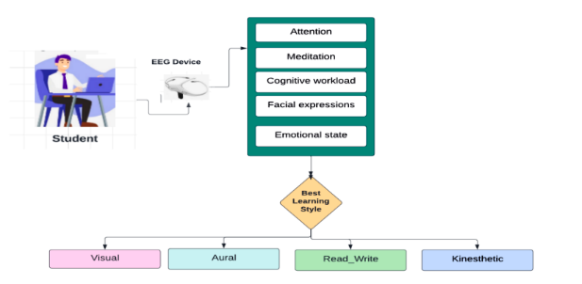
Figure 6 AI assessment concept of finding best learning style. Varsha T, et al ‘Thinking Skills and Creativity’.

Implementation of an advanced DLMS ‘Digital Learning Management System.
According to (Babic, 2012) – The effectiveness and efficiencies of functioning DLMS is to have cemented data links that can be integrated by search engines, and web technology.
Creating an environment of learning analytics through collection of information regarding activities and behaviours. Seek to visualise alternative approaches to the use of this data should be pursued further according to (Fischer,et al, 2023)
(Sousa and Rocha, 2019b)suggests that the empowerment of learners and the elevation of the learning process can be enhanced when methods of learning such as Collaborative Communities; cooperative learning, collaborative learning, and network participation are used. Some concepts of this learning. According to (Sousa and Rocha, 2019a) are Learning Management Systems, e-learning, mobile learning Moodle MOOC. Using methods such as Project based learning, active learning, Gamification, and Simulation.
The ability to link both police initial entry assessment from AI, with a linked system of Advanced DLMS with one system incorporating the PDR system may support the views held by (Vey et al., 2017)that L&D should be assessing critically the existing training frameworks and evaluate they correctly reflect the organisation, questioning whether the organisation is modern or a different approach to knowledge is required.

2.6 PESTEL Analysis

Political | Political funding and budget constraints  Legislation and Regulation frameworks  Political drive to tackle emerging crimes (digital/fraud).  New general election Nov 2024, potential change of government.  Police and Crime Commissioners directive to police chief constables.  Drive for better police performance in communities.
Economical | Reducing horizon budgets for policing.  Inflation remains high.  Mortgage / housing renting remains expensive, pay gap in public sector.  Competitive workforce market.  Quality skills attraction remains challenging.
Sociological | Difference in expectations of younger generation (Gen z) towards organisation workplace environments.  Increased expectations of work life balance (work from home etc)  Digital literacy expectations and capabilities.  Increase in aging workforce – different skills support requirements.  Increasing social demands on policing, mental health, and missing people.  Differing expectations on learning and development for newer generations.
Technology | Emerging digital technologies and systems, pace of change.  Expectations for efficiencies and effectiveness utilising digital technologies.  Training and skills requirement for digital workforce.  Emerging and changing crimes reflecting more digitally enabled crime.  Digital development to maintain competitive advantage.
Ecological | Increasing effects of climate change and global consequences, including extreme weather, floods, heatwaves.  Increase in awareness of ecological sustainability conditions for public sector organisations as well as private businesses.  Increasing protests resulting in more policing duties for public order
Legal | Introduction of new legislation that impacts on police demand.  Regulation of AI and data management constraints for public services such as the police  Changes in legislation for workforce employees.

2.7 Porters Value Chain

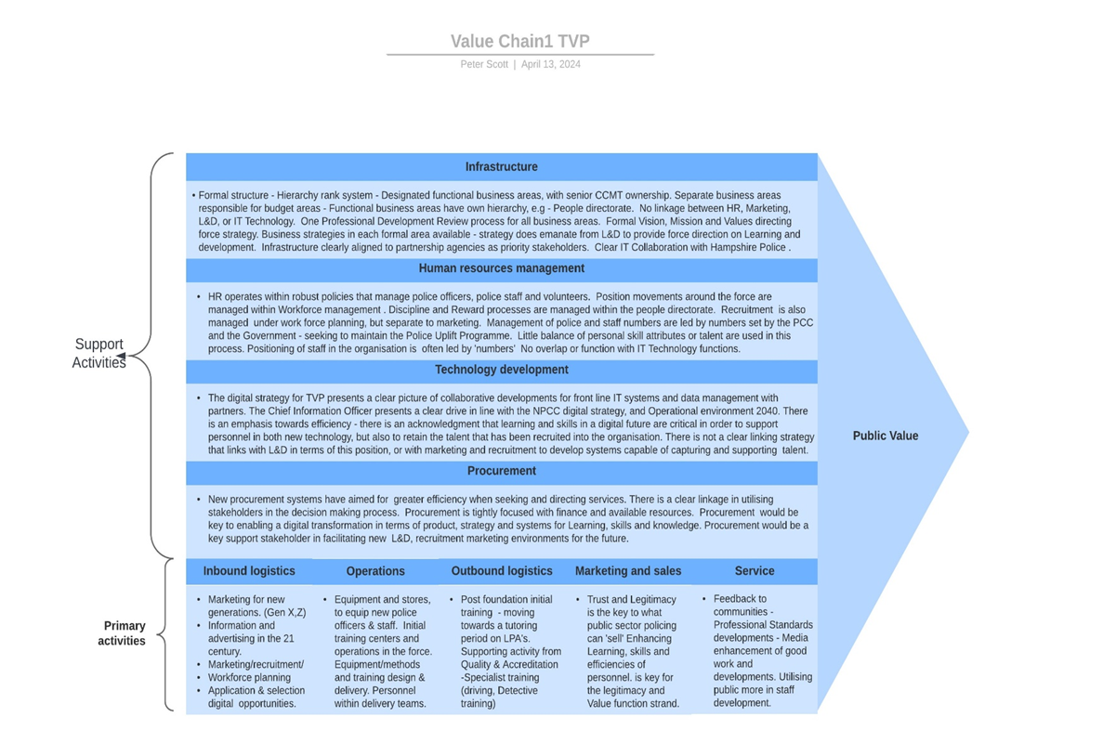
Figure 7 ‘Porters Value Chain’, adapted by author for TVP.

2.8 Stake holders.

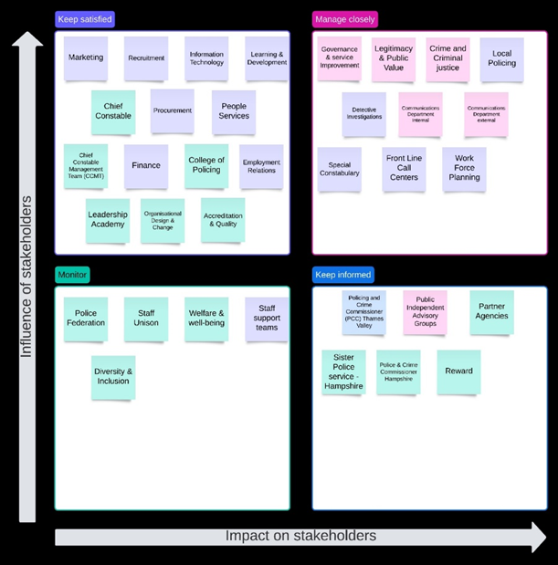
Figure 8 Stake Holders Influence and impact map for TVP.

2.9 Leadership
The transformational change proposal in this report must of course take account of the potential and considered leadership approach to achieve delivery of anticipated value returns.

2.10 Transformational Leadership theory
The study of Police Leadership is wide and varied. However, (Panzarella, 2003; Herrington & Colvin 2016) cited by (Davis and Silvestri, 2020) provide an opening context by suggesting that for the police to be able to deal with the demands of contemporary policing, there needs to be a different approach utilising non-hierarchical pathways in Leadership. (Silvestri, Tong and Brown, 2013) adds that a difference is required to fulfil the demands on contemporary policing, seeking a wider scope of skills and capabilities within police Leadership. Whilst considering the ‘professionalisation’ of the police (Silvestri, 2018) suggests that the Values identified by the Police are of Diversity, and ethical transparent delivery, these sit in contrast to the perceived traditional values of a solidarity and macho culture. This culture within policing has a strong persuasion on the nature and practice of ingrained assumptions within Leadership. The Police service has been actively trying to move away from the traditional transactional leadership style, to adopt a Transformational style in efforts to support reform (Davis and Silvestri, 2020)Studies have supported the effectiveness of a transformational style in policing delivery in the UK (Dobby et al, 2004) Further, (Villers, 2003) is cited by (Davis and Silvestri, 2020) suggesting the Transformational style can tackle the ‘quasi-militaristic’ and transactional command directed approaches in police leadership.
This report seeks to scrutinise Transformational leadership in policing as one proposed style of leadership delivery within this Digital transformational programme. (Siebel, 2019) suggests that successful digital transformation should be lead with leaders that are comfortable in managing risk, have a confidence to speak out and challenge, can move with a mindset of experimentation whilst being secure with technology. To address these perceived attributes a comparison is made between the definitions of (Bass, 1998; Bass & Riggio, 2006) in reference to transformational leadership. The Idealised influence attempts to promote the concept of a clear role model for the leaders’ followers, operating in a moral and ethical way in which followers would want to mirror their traits, it suggests that these leaders are willing to take necessary risks. of (Bass, 1998; Bass & Riggio, 2006) Inspirational motivation captures the concepts of providing a shared vison, with driven focus towards goals, the leaders would be displaying excellent communication skills to motivate and address challenges, supporting the ‘why’ concept. of (Bass, 1998; Bass & Riggio, 2006) Intellectual Stimulation Creates focus around doing things differently and not following the norm, seeking to infuse followers to be creative and innovative, seeking new ideas and creating an environment that does not publicly punish mistakes, or ideas outside that of the leader’s position.
Individualised considerations support the followers in their development, seeking to progress them through a mentorship and coaching approach through good listening skills, and engaged bidirectional communication, creating, and supporting new opportunities for learning.
According to (Kang, 2015) approximately 70% of change efforts that are implemented in organisations are failures due to a lack of guidance and leadership being identified.
It is suggested by (Kerse, G 2021) that top management and leadership are essential for the delivery of change, the leaders’ attributes of being fully committed being able to persuade a workforce with a vison and promote the change through reassurance and support of the workforce throughout. Eisenbach et al, (1999) suggests that the aspects that present transformational leadership are those that forge progress in change and transformation, the leaders being effective in creating a vison for followers to be a part of and demonstrating Charisma and make up of the ‘4I’s’ are in their possession. Transformational leadership presents another perspective from authors, Currie &Lockett’s (2007) view that transformational leadership has flaws and doubts when being approached by a public sector organisation, its applicability is questioned considering the leaders sphere of influence to ‘transform’ operations, due to the considerable Government oversite and political domination. Cockcroft (2014) supports this position and argues that Transformational influence conflicts with the contextual setup of a policing organisation and structure in terms of innovation, collaboration, and participation. Cockcroft (2014) continues to state that the discrepancy between public and private sector working practices and working environments provides the resistance encountered to transformational leadership. Criticism is invited as transformational leadership concentrates to enhance the individuality of the leader according to Jackson and Parry, (2011).

2.11 Complexity Leadership theory
An alternative and newer Leadership Theory for consideration is that of complexity Leadership Theory (CLT). (Drucker,P 1998) states that a great deal of working assumptions within management are over fifty years old and not suitable for the advancement in an economy where knowledge is prime. (Manville, Ober, 2003) also suggest that our systems and governance including management are reminiscent of an industrial period, suggesting a more modernised approach is required for the twenty first centuries. (Bettis, Hitt, 1995) highlights that there is an increasing competitive horizon where advancement in technology and global influence are transformative, and that knowledge is now the power. The creation of an initiative approaches is now crucial for the progression of any organisation. This framework to leadership according to (Marien,Mhi-Bien, 2001) deals with advancement of volatility and speed within a knowledge transformational space. (Heifetz, 1994) suggests that the model extends a horizon beyond bureaucracy, focusing on a science of complex behaviours, it uses a Complex Adaptive System (CAS) to promote leadership as an interactive dynamic moving away from the place of authority. It’s concentration on new operating solutions and different behaviour patterns, sought within network interactions. CAS creates the strong links of common objectives, horizon, and needs. The structure can be achieved with multiple hierarchy overreaching with each other, linking individuals in dynamic networks. (Hedlund, 1994) CAS creates the adaption to learn and problem solve in a creative mode. (Carley and Hill, 2001)
Complexity Leadership Theory contains three core elements in the framework, (Marion and Uhl-Bien, 2001)suggest; Administrative, Adaptive and Enabling leadership, the model provides a distinguished separation of a leader and leadership. Complexity Leadership emerges when confronted with Adaptive Challenges, this being associated to modern knowledge era challenge, compared to a technical challenge linked with an industrial era challenge(Heifetz, 1994) CLT is associated towards a modern knowledge producing organisation, making several assumptions, but one of these assumptions according to, (Uhl-Bien, Marion and McKelvey, 2007) is that Leadership exists as a function of interaction. It assumes that it operates within a bureaucratic organisation, presuming a hierarchical structure environment with open systems. According to (Uhl-Bien, Marion and McKelvey, 2007)CLT requires being able to operate with a greater flexibility and trust aspect, thereby releasing overall control from that associated with traditional hierarchical and top-down structures, they suggest that too much strict rigidity hampers creative flare, but also that two much chaos can prevent adaption being effective.

2.12 Cultural Web
Police culture is inherently resistance to change. (Skogan, 2008).
Core beliefs reflected in stories of police can be found to link to time served and experience as being important to competence and progression particularly when considering this within the context of police leadership. (Silvestri, 2006)
Beliefs in relation to the organisation being attached to the “ideal” worker and “heroic male” in its culture (Davis and Silvestri, 2020)
In attempts to professionalise policing, evidenced based practice (EBP) has been raised on the police agenda. According to (Sherman, 1999) one of the most powerful agents for change in policing practice is EBP. Using evidence to shape best practices. (Kalyal, 2020) EBP challenges the status quo of policing knowing best through centralising research in policing practice.
(Lum, 2009) suggests that the traditional structure in policing, reflecting cultural militaristic and traditional traits are the challenges and blockers to true adoption of evidence-based policing. This has been seen as a challenge in adopting academia within policing. (Davis and Silvestri, 2020) suggests that academia adoption like EBP has overlooked the practitioners’ interests and invested values, needs and identity, this follows suggestions from (Hallenberg and Cockcroft, 2017) that there will be cultural resistance experienced if a movement from experience in number of years served, to a paradigm focused on knowledge.
There is evidence of a conscious departure of initial learning at police training centres, students being re-taught the aspects of real on the street policing, this dynamic can often be working against best taught practices and behaviours. (Adlam, 2002)states that there is a clash of knowledge when considering the practical aspects of policing, and knowledge through operational exposure, against that of academia, education, and knowledge. (Schein, 1990) states that “A pattern of shared basic assumptions that was learned by a group as it solved its problems of external adaptation and internal integration, that has worked well enough to be considered valid and, therefore, to be taught to new members as the correct way to perceive, think, and feel in relation to those problems”.
These aspects directly relate to the challenges of influencing digital transformation towards a learning organisation approach.

2.13 SWOT analysis

SWOT analysis of L&D environment in TVP in context of digital transformation. Source: Stewart J, Rogers P (2017) ‘studying learning and development’

SWOT | Helpful | Harmful
Internal | Strength  Concise digital force strategy, led with a Chief Information Officer and collaborative digital partnership with Hampshire constabulary (TVP digital).  Strong direction with engaged Vision, Mission, Values mandate (TVP).  Implementation of forward digital concepts involving AI and Robotics  Good history of establishing effective change in face of reducing budgets and increasing demand. | Weaknesses  Increase in inexperience and supervision.  Sustained attrition rates from policing.  Antiquated Workplace systems operating in silo environments.  Disjointed PDR, talent management, and learning platforms.  Challenging data management to capture feedback from learning that can be used to inform organisation learning.  Unfocused management of individual learning CPD, or skills gaps in organisation.
External | Opportunities  Engage with established strategies from policing Vison 2030, Digital strategy 2030.  Pursuing and engaging with academia and private sector in supporting digital transformation change programmes.  Better engage younger generations in policing, providing thoughtful support and learning growth opportunities. Supported by modern digital technology solutions. | Threats  Not adapting or responding to global technology changes and preparing our workforce with the skills and knowledge required to engage modern challenges in both society and policing.  Trust and Legitimacy in policing is broken further due to poor value return in policing through lack of skills, knowledge, and poor technological competence to engage a modern society.  Technology crime will outstrip traditional crime trends, enabling greater criminal networks and increasing vulnerability for our communities.

3. Conclusions
The active transition of any organisation to achieve a digital transformation requires the careful analysis of its environments, both internally and externally, to execute a considered strategy of transformation whilst ensuring that a competent style of leadership can influence and support the change implementation. Thames Valley Police, a public sector business suffers no escape from the demands for value and efficiency. The focus of this report isolated the fundamental driver for skills and knowledge in a learning organisation, L&D. Analysis of this environment identified the critical need for recommendations to implement digital change of its existing traditional silo systems.
Political demand for an urgent police uplift of 20’000 officers in 2019 alongside a period of high attrition from the police ranks has contributed to establishing a police service with dwindling experience levels. Societal generational changes have also moved the expectations of new recruited police constables. TVP is no exception. The evidence of decreasing value for the community can be observed in decreasing outcome rates of reported crime. Trust and legitimacy for a police service is critically important, this also remains low. The challenges of complex digital crime and evolving technologies requires the fundamental focus on operational capacity through the enhancement of skills, knowledge, and talent, generating a seismic transformational change.
Translating the current digital TVP strategy, provides direction by focusing on efficiencies that can create value. The report identifies that significant changes using artificial intelligence and big data at recruitment and marketing stages can harness the talent and skills required from community pools. One such area examines how learning styles and preferences of initial workforce staff can be used to influence their future learning methods and adaptions. This early technological intervention would be bolstered by a single advanced Digital Learning Management system, capable of harnessing multiple learning channels and platforms. The Advanced DLMS will be capable of contributing to the individual’s professional development portfolio, with suggestive AI. The future ability for the organisation to interrogate analytics from the system will be capable of intelligently providing skills and talent data for selected alignment depending on where the demand exists.
The considered leadership theories of both transformation leadership and complexity leadership theory were examined to determine the likeness of the best style to successfully implement this transformation. Whilst complexity leadership theory offered a less transactional approach and invited a wider range of contribution and free flow of innovation and creativity. When compared to how the policing organisation is structured, and still exists in a traditional top-down hierarchy, the recommendation is that a transformational leader is better suited. Firstly, as this is a better traditional fit within policing (as a preferred style) and a more robust style to engage followers organised contributions. This style will also compliment the direction required within the recommended Matrix structure of key stakeholders.
In order not to be left behind in a rapidly evolving digital world, the organisation must be agile and bold to meet the future challenges, to retain a competitive advantage through recognised value. The ultimate value contribution is that of our people, through their skill, knowledge, and talent development.

4. Recommendations

Leadership
The leadership theory that is recommended is that a strong digital transformation leader, that is equipped with the relevant knowledge and digital literacy skills to support the matrix structure.
Digital transformation solution
The digital transformation solution recommended is that the development and engagement of one advanced DLMS system that can be incorporated at the Marketing and recruitment gateway, utilising digital AI, to assess, manage and select desired and appropriate talent from the general workforce pool, including intelligent directed marketing using AI, big data.
The advanced DLMS can complete initial assessments on successful candidates to establish learning styles through AI and enable the best suggested teaching and learning methods and solutions for the future.
Development of a force system that utilises big data to re organise how the organisation views and counts its workforce members – new direction on knowing where skills are better placed and utilised, moving away from all skills verses all positions position.
Development of a skills, talent management platform that harnesses known skills from inception to the organisation, utilising the same initial platform that is capable of both tracking and supporting individual workforce members towards desired aspirations, with the platform being able to both recognise aspirations, as well as identify opportunities for workforce members in accordance with skill and talent demonstrated.
The dedicated advanced DLMS system should include the development of a personal PDR system that exists within this holistic system. The advanced DLMS system should communicate and feed from the aspirations of the PDR. The ambition is that there are no separate siloed systems required to be accessed by individuals, thereby reducing barriers, increasing efficiencies of software management, reducing workforce personnel required for input data processing.
The advanced DLMS platform should be able to accommodate future visons of operational officers and staff having feedback from their workplace actions, suggesting feedback and workable development opportunities to support forward efficient and quality productivity within our communities.
Structure
The recommended structure is that the force adopts a long term, flexible matrix structure (figure 9) to accommodate the significant stake holder contribution required in establishing processes that are captured at marketing and recruitment stages, through to established operational officers and staff. This structure benefits from bringing closer alignment of relevant digital expertise with each project stage, aligning with specialist learning and development requirements and expectations.

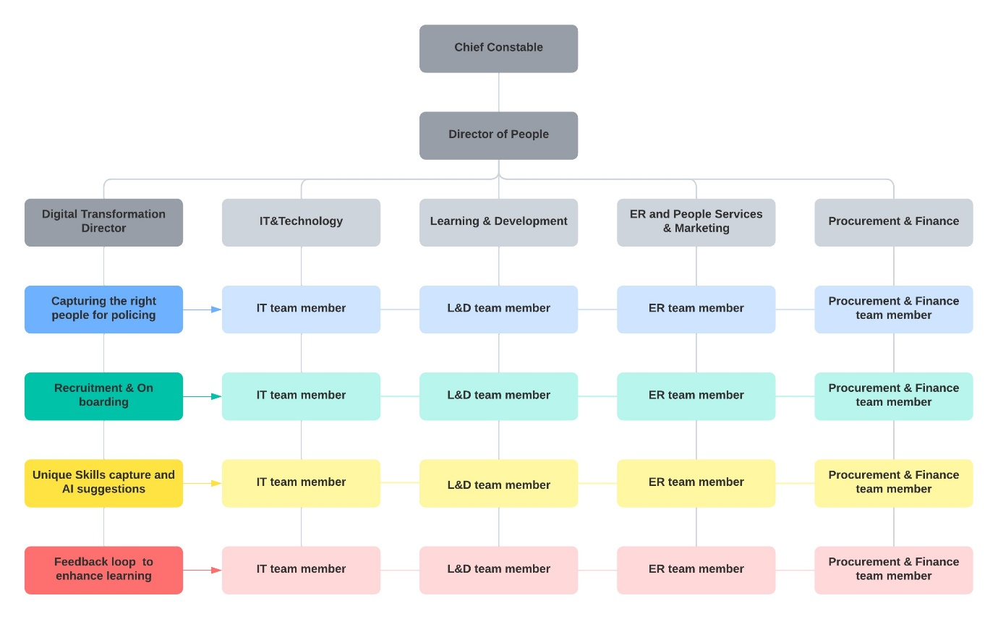
Figure 9 Matrix Structure created for TVP digital transformation implementation.

Timeline strategy utilising three horizon strategy.
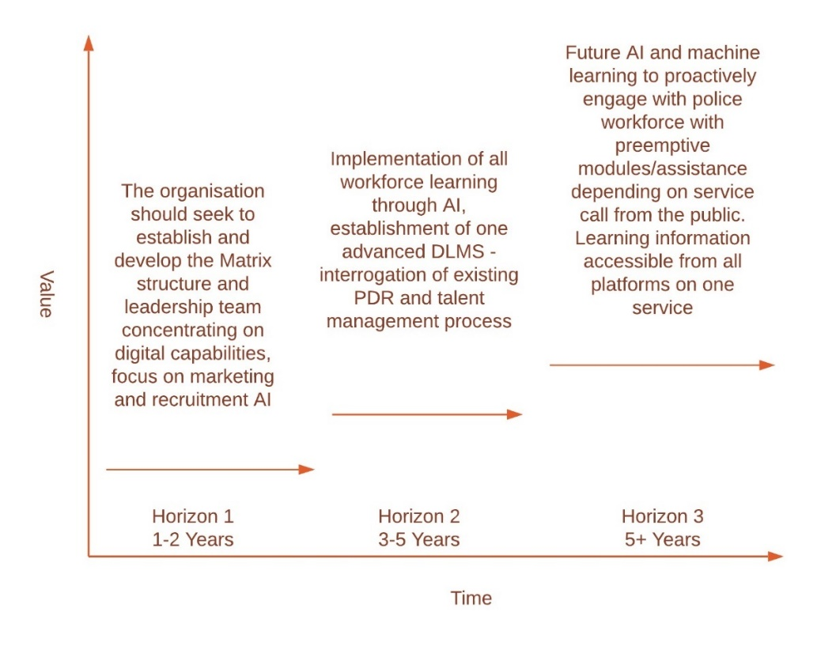
Figure 10 Three Horizon Strategy for Thames Valley Police

Risks and Threats
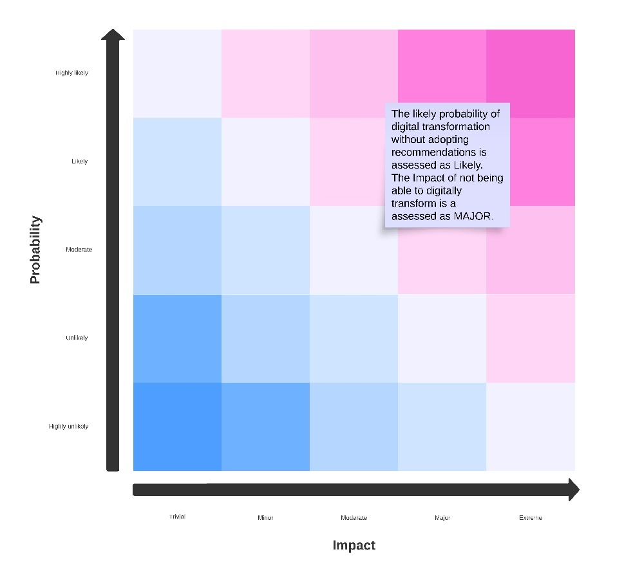
Figure 11 Risk Matrix for Probability and Impact of not implementing the digital transformation.

References
House of Commons (2022) The Police Uplift Programme Fifteenth Report of Session 2022-23 Report, Available at: www.parliament.uk.
Adlam, R. (2002) ‘Governmental rationalities in police leadership: An essay exploring some of the “deep structure” in police leadership praxis’, Policing and Society, 12(1), pp. 15–36. Available at: https://doi.org/10.1080/10439460290006655.
Andrews, C. (2024) ‘Fifth of Thames Valley Police planning to quit’ BBC News. Available at: https://www.bbc.co.uk/news/uk-england-berkshire-68782272 (Accessed: 19 April 2024).
Bryson, J. (1995) ‘Strategic planning for public and non-public organisations’.
Carley, K. and Hill, V. (2001) ‘structural change’.
College of Policing (2020) ‘PDR Principles and process expectations.
College of Policing (2024) ‘Working together College of Policing’. Available at: https://www.college.police.uk/ (Accessed: 19 April 2024).
Davis, C. and Silvestri, M. (2020) Critical perspectives on police leadership. . 1st edn. Bristol: Policy Press.
Dobby, L. et al (2004) Police Leadership: Expectations and Impact, Home office Online Report. London.
Fischer, G., Lundin, J. and Lindberg, J.O. (2023) ‘Rethinking and reinventing learning, education and collaboration in the digital age-from creating technologies to transforming cultures. Available at: https://doi.org/10.1108/IJILT-04-2020-0051.
Hallenberg, K.M. and Cockcroft, T. (2017) ‘From indifference to hostility: Police officers, organizational responses and the symbolic value of “in-service” higher education in policing’, Policing (Oxford), 11(3), pp. 273–288. Available at: https://doi.org/10.1093/police/paw055.
Harding, R. et al. (2023) Police Learning & Development.
Heifetz, R. (1994) ‘Leadership Without_Easy_Answer’.
Home Office (2023a) Crime outcomes in England and Wales 2022 to 2023 - GOV.UK. Available at: https://www.gov.uk/government/statistics/crime-outcomes-in-england-and-wales-2022-to-2023/crime-outcomes-in-england-and-wales-2022-to-2023 (Accessed: 19 April 2024).
Home Office (2023b) Police officer uplift, England and Wales, quarterly update to 31 March 2023 - GOV.UK. Available at: https://www.gov.uk/government/statistics/police-officer-uplift-quarterly-update-to-march-2023/police-officer-uplift-england-and-wales-quarterly-update-to-31-march-2023 (Accessed: 19 April 2024).
Home Office (2023c) Policing Productivity Review (accessible) - GOV.UK. Available at: https://www.gov.uk/government/publications/policing-productivity-review/policing-productivity-review-accessible (Accessed: 19 April 2024).
Home Office (2024) Police workforce, England and Wales: 31 March 2023 (second edition) - GOV.UK. Available at: https://www.gov.uk/government/statistics/police-workforce-england-and-wales-31-march-2023/police-workforce-england-and-wales-31-march-2023 (Accessed: 17 April 2024).
Kalyal, H. (2020) ‘“One Person’s Evidence Is Another Person’s Nonsense”: Why Police Organizations Resist Evidence-Based Practices’, Policing (Oxford), 14(4), pp. 1151–1165. Available at: https://doi.org/10.1093/police/pay106.
Lum, C. (2009) Ideas in American Policing Translating Police Research into Practice. Available at: http://www.policefoundation.org/docs/library.html.
Marion, R. and Uhl-Bien, M. (2001) ‘Leadership in Complex Organisations’.
Moore, M. (1997) Creating Public Value - Google Books. Available at: https://www.google.co.uk/books/edition/Creating_Public_Value/itAuEAAAQBAJ?hl=en&gbpv=1&pg=PR11&printsec=frontcover (Accessed: 17 April 2024).
NPCC (2022) Policing Vision 2025.
NPCC (2023) POLICING VISION 2030 Strategic Policing Partnership Board.
Office National Statistics (2022) The Police Uplift Programme Home Office.
Oster, S. (1995) ‘Strategic management for non profit organisations’.
PCC Thames Valley Police (2024) Performance and Accountability.
Porter, M. (2011) Competitive: Advantage The Value Chain and Your P&L.
Schein, E.H. (1990) Organizational Culture.
Sherman, L.W. (1999) ‘ Evidence-based policing: Ideas in American Policing’.
Siebel, T. (2019) Digital Transformation : Survive and Thrive in an Era of Mass Extinction. New York: RosettaBooks.
Silvestri, M. (2006) ‘Doing time’: Becoming a police leader.
Silvestri, M. (2018) Disrupting the “Heroic” Male Within Policing: A Case of Direct Entry. Available at: https://journals-sagepub-com.ezproxy.uwtsd.ac.uk/doi/epub/10.1177/1557085118763737 (Accessed: 19 April 2024).
Silvestri, M., Tong, S. and Brown, J. (2013) ‘Gender and Police Leadership: Time for a Paradigm Shift?’, International Journal of Police Science and Management, 15(1), pp. 61–73. Available at: https://doi.org/10.1350/IJPS.2013.15.1.303.
Skogan, W.G. (2008) ‘Why reforms fail’, Policing and Society, 18(1), pp. 23–34. Available at: https://doi.org/10.1080/10439460701718534.
Sousa, M.J. and Rocha, Á. (2019a) ‘Digital learning: Developing skills for digital transformation of organizations’, Future Generation Computer Systems, 91, pp. 327–334. Available at: https://doi.org/10.1016/j.future.2018.08.048.
Sousa, M.J. and Rocha, Á. (2019b) ‘Skills for disruptive digital business’, Journal of Business Research, 94, pp. 257–263. Available at: https://doi.org/10.1016/j.jbusres.2017.12.051.
Thames Valley Police (2023) Home - TVP Careers, Thames Valley Police. Available at: https://tvpcareers.co.uk/ (Accessed: 17 April 2024).
Thames Valley Police (2024) About Thames Valley Police | Thames Valley Police. Available at: https://www.thamesvalley.police.uk/police-forces/thames-valley-police/areas/au/about-us/about-thames-valley-police/ (Accessed: 19 April 2024).
Uhl-Bien, M., Marion, R. and McKelvey, B. (2007) ‘Complexity Leadership Theory: Shifting leadership from the industrial age to the knowledge era’, Leadership Quarterly, 18(4), pp. 298–318. Available at: https://doi.org/10.1016/j.leaqua.2007.04.002.
Valley Police, T. (2024) Thames Valley Police Strategic Plan 2024-25.
Varsha, T. and Prakash J. (2024) ‘An AI-based learning style prediction model for personalized and effective learning’, Thinking Skills and Creativity, 51. Available at: https://doi.org/10.1016/j.tsc.2023.101421.
Vey, K. et al. (2017) ‘Learning & Development in Times of Digital Transformation: Facilitating a Culture of Change and Innovation’, International Journal of Advanced Corporate Learning (iJAC), 10(1), p. 22. Available at: https://doi.org/10.3991/ijac.v10i1.6334.
Villers, P. (2003) ‘Some Core Beliefs ’, Philosophy, Doctrine and Leadership, pp. 15–33.
Whittington, R. et al (2020) Exploring strategy: text and cases. . Twelfth Edition. Harlow: Pearson.

Appendices

Appendix A - Vison, Mission and Values of Thames Valley Police.
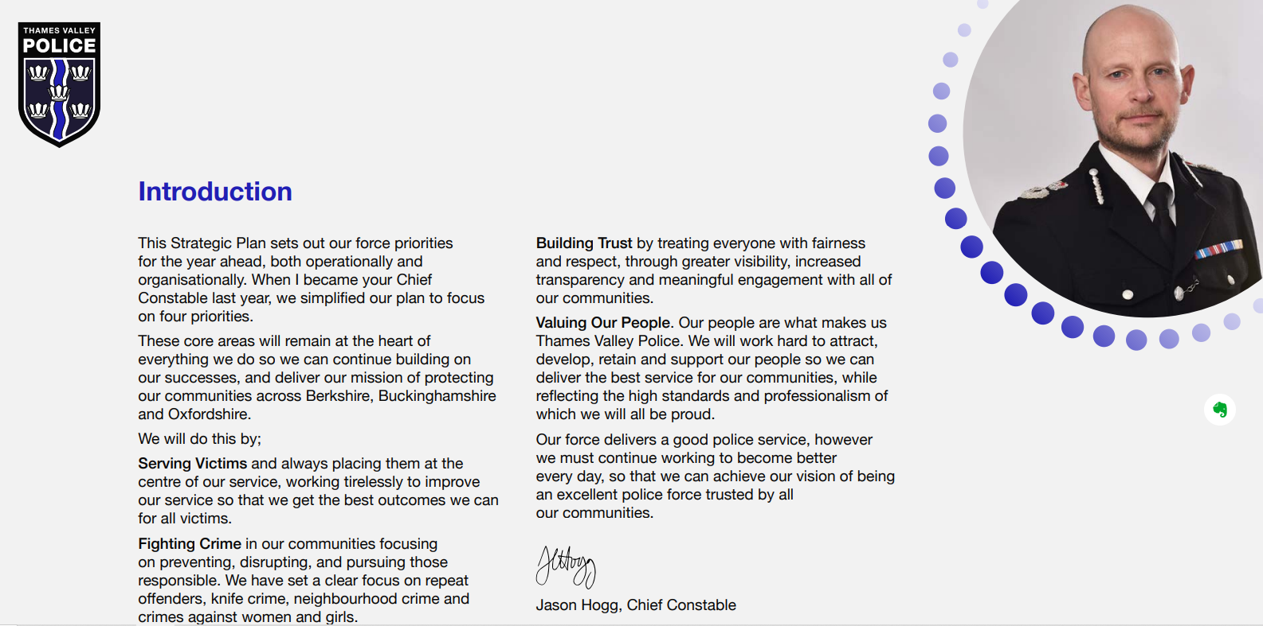

Appendix B – Organisation structure of the people directorate TVP – Source: TVP organisational structure.
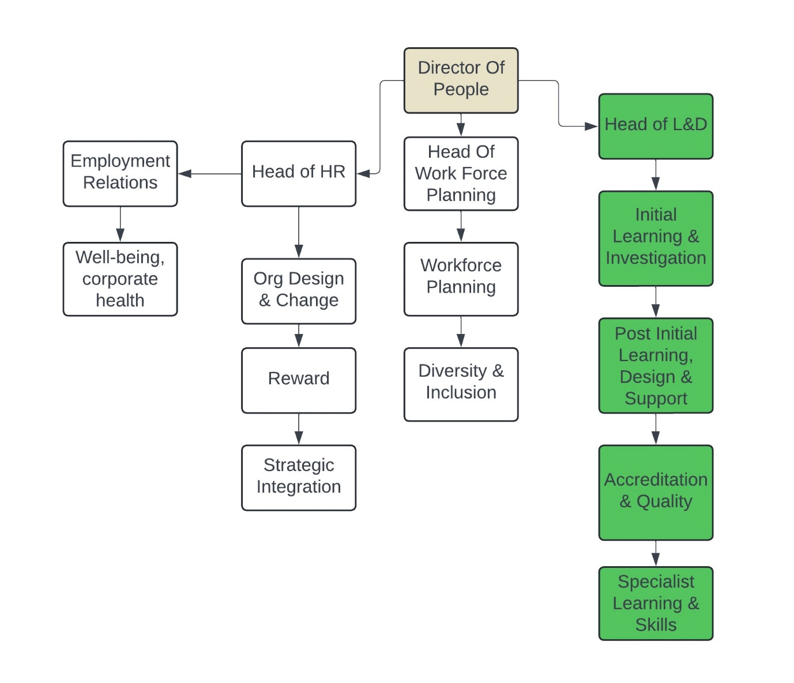

Appendix C Main Chief Constable Management Team structure: Source: Thames Valley Police.


