LCLM4002_BIRM Digital Skills Task 3
Website Evaluation

Student Number | 2423590 | Student Name |  | Edina Bernardo
Website Chosen | Website of The High Field
Insert hyperlink to website | https://www.highfieldedgbaston.co.uk/
Evaluation
Respond to each question
Section 1 – Usability

Question 1a - How quickly and easily does the website load?

Answer: The website of High Field Town Field Hotel loaded quickly, and the leading speed and ease of access of the website play a crucial role in improving user experiences. It has been observed that the site generally loads quickly with a response time within the acceptable limit for modern web standards (Highfieldedgbaston, 2025). In terms of ease of navigation, the website of High Field has been designed with user-friendliness and features a layout menu structure, which allows users to find information quickly without any delays.

Question 1b - Does the website contain many sub-pages? How does a prospective customer navigate these?

Answer: The websites for Highfield Edgbaston help feature well-structed layout with multiple sub-pages that cater various aspects of the services efforts and using a user-friendly menu on the top of the homepage improve the navigation process as the menu offer clear categories including “Our Menu,” “Stay with us,” “Service,” “Gift Vouchers” and “Sign Up.” Each section of the webpage is designed to be intuitive and help inform users quickly, with the “Service” tab offering a detailed description of the offering to the users.

Question 1c - Can a customer make a booking via the webpage?

Answer: 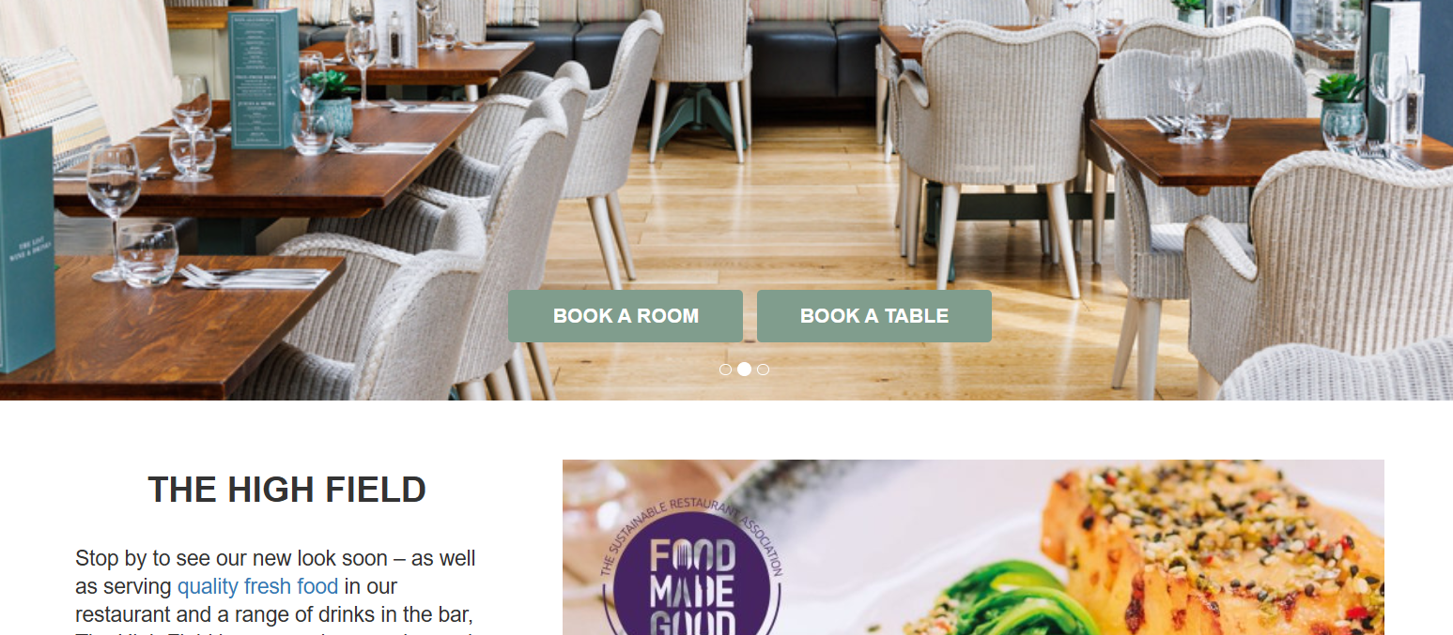
Q1c. Yes, customers can easily book rooms and tables by simply clicking on the “Book Room” or “Book Table” icons on the home page of the website. The website of Highfield offers a user-friendly interface, which allows page visitors to check availability of the rooms and tables based on their desired date and complete the booking process online and for further assistance, they can also contact the managing professional directly through the website.

Question 1d - What improvements could be made to the usability of the website?

Answer: High Field should ensure that the website is fully responsive and optimised for mobile services, as the majority of the customers in the UK use their pocket phones for booking instant travel options (Yin et. al., 2021). It includes resizing images and adjusting layouts, and ensuring that the buttons are easily clickable, which improves overall user experiences. Furthermore, increasing the loading speed may help reduce user bounce rates and assist in boosting website traffic.

Section 2 – Pleasure – Customer Experience

Question 2a – How pleasant does the webpage look? Are there any differences in appearance on a mobile phone versus a computer?

Answer: The webpage of Highfield is visually appealing with clean layouts and harmonious colour schemes, which is pleasant to the eyes of the users and high-quality images are used to make the page attractive and welcoming for the visitors. When viewed on a mobile phone, the website adapts well to the smaller screen (Sammut et. al., 2021). However, some differences between the mobile and computer views have been noted, as some elements are not properly rearranged and resized to the mobile format.

Question 2b - How does the website use imagery, video and colour?

Answer: The website uses colourful images of delicious food courses and dishes, which are mouthwatering and grab the attention of the users. High-quality images and videos have been used to showcase the menu, facilities, events and atmosphere, which help create a visually appealing website to attract potential clients and reflect the sophistication along with elegance associated with the brand (Deng et. al., 2023). Additionally, the colour palette used on the website with the brand identity helps employ a combination of elegant tones that help create a feeling of professionalism and luxury.

Question 2c – Has the website made use of an online chat tool on the website? How effective is this to enquire about the product or service?

Answer: Yes, the website of High Field incorporates online chat tools, which are displayed on the home page and are easily accessible for the visitors and feature immediate communication channels, which allow users to inquire about the services and products in real-time. Additionally, the online chat offers immediate responses to quick queries and helps reduce the time taken in obtaining information compared to the traditional methods such as phone calls and emails.

Question 2d – How effective are the social media links on the website?

Answer: Social media links on the website are fruitful in assessing several factors such as improving user engagement, minimising customer queries and improving brand visibility for High field and enhancing interactions with the audiences to promote offerings (Sammut et. al., 2021). Furthermore, social media links play a significant role in increasing website traffic and improving “ROI or Return on Investment,” which ensures effective content sharing and visitor engagement.

Section 3 – Perceived Value

Question 3a - How are the services offered by the company made clear to customers?

Answer:
The Highfield Town House Hotel website clearly presents its services to customers through prominently displayed options such as “Our Menu”, “Wine and Drinks List”, “Peach Club”, “Order to Table” “Events”, “Outdoor Space”, “Celebrations and Private Dining”, and “Stay With Us”. The website also provides direct links to “Book a Table” and “Book a Room”, along with a “Sign Up” option, likely for a newsletter, ensuring customers are well-informed about the hotel's offerings and updates.
Question 3b - How are customer reviews made available? Are these up to date?

Answer:
Based on the information available on external platforms such as Expedia, Booking.com, KAYAK, and Agoda customer reviews for the Highfield Town House Hotel are generally very positive, with recent feedback within the last year consistently praising aspects like cleanliness, staff service, location, and the quality of the breakfast served at the adjoining pub with 9 points score out of 10 (Maruf and Özdemir, 2024). Therefore, while not on the hotel's website, up-to-date customer reviews are readily accessible on these widely used travel and hotel review platforms.

Question 3c – How is the service presented as high quality? For what reasons would you use the company’s service or recommend to a friend or family member?

Answer:
The Highfield Town House Hotel presents its service as high quality through several indicators evident on its website and on external review platforms. The website showcases stylish and well-appointed rooms, emphasises attention to detail, and highlights offerings like the “Peach Club” and curated dining experiences, suggesting a focus on guest comfort and satisfaction (Tavitiyaman et. al., 2024). I would consider using their service or recommending it to someone seeking a comfortable, well-located stay with attentive service, especially given the positive feedback regarding cleanliness and staff, and the added convenience of dining options and a pleasant atmosphere.
Question 3d - Are prices made clear to customers? If yes, do the prices reflect the quality of service shown? If no, why do you think the company has chosen not to include prices?

Answer:
Yes, the prices for the Highfield Town House Hotel are made clear to customers through various online platforms. While the hotel's website encourages direct booking by stating they offer the “best rates”, it doesn't explicitly list all room prices. However, external booking sites display a range of prices for different room types and dates. These prices generally reflect the high quality of service indicated by the consistently positive customer reviews, which praise the stylish rooms, cleanliness, comfortable amenities, and attentive staff. The slightly higher average room rate compared to the city average, as noted on Agoda, also suggests a pricing strategy aligned with a higher perceived value and quality of the boutique hotel experience.
Section 4 – Searchability

Question 4a - What three words would you type into Google to find this type of service? |  |  | House-Hotel
 |  |  | Birmingham
 |  |  | High Filed
Question 4b - When you type these words into google, does the company’s website appear in the top ten websites?

Answer: No, when I search those words on Google, the company website does not appear in the top ten websites, which indicates poor searchability of the websites of High Field.

Section 5 – Reflection and conclusion
Question 5a - Do you feel that websites still have relevance in modern UK business? Explain your answer.
Answer:
Yes, the Highfield Town House Hotel website still holds significant relevance in modern UK business. In the current digital environment, the hotel website serves as an important early contact for potential guests. It effectively emphasises the proposal, atmosphere and establishment location through an attractive image and comprehensive explanation that contributes to early interest and trust. In addition, this website can contribute to direct reservations and bypass the commission fee imposed by online tourism agencies to increase the profit of the hotel (Yao et. al., 2024). This allows the hotel to form a history and show certain advertising promotions or packages, and provide important details such as location, contact information, and often questions to improve customer service quality in the first request. The external viewing platform plays an important role, but the hotel website provides the opportunity to manage the story, emphasises unique sales points such as “PEACH CLUB” or “Special Offer”, and ultimately stimulates the business and deploys it as an important resource for modern hospitality companies in the UK.
Question 5b - If you were to make one recommendation about how to improve the website of your chosen company, what would it be? Why have you suggested this improvement?

Answer:
The primary recommendation for improving the Highfield Town House Hotel the website Highfield Town House Hotel is to create a specific section for guests and reviews of the site itself (Król et. al., 2024). The external platform can increase immediate trust and trust for potential customers, but the social evidence offered on its own site improves the verification of the services mentioned in the website. This strategy can increase direct reservations to show the positive reviews of the previous guests.

Reference List
Deng, X., Gu, Y., Zheng, B., Chen, S., Stevens, S., Wang, B., Sun, H. and Su, Y., (2023). Mind2web: Towards a generalist agent for the web. Advances in Neural Information Processing Systems, 36, pp.28091-28114.
Highfieldedgbaston, (2025) High Field restaurants [online] Available at: https://www.highfieldedgbaston.co.uk/ [Accessed on 18th April 2025]
Król, K., Zdonek, D. and Sroka, W., (2024). Functionality assessment checklist for evaluating geoportals useful in planning sustainable tourism. Sustainability, 16(12), p.5242.
Maruf, M. and Özdemir, K., (2024). Ranking of Tourism Web Sites According to Service Performance Criteria with CRITIC and MAIRCA Methods: The Case of Turkey. Uluslararası Yönetim Akademisi Dergisi, 6(4), pp.1108-1117.
Sammut, R., Griscti, O. and Norman, I.J., (2021). Strategies to improve response rates to web surveys: a literature review. International journal of nursing studies, 123, p.104058.
Tavitiyaman, P., Zhang, X., Xu, J. and Tsui, B., (2024). Impact of smart tourism technology attributes on perceived usefulness, service experience evaluation, and business performance: A perspective of hotel employees. Journal of Quality Assurance in Hospitality & Tourism, pp.1-26.
Yao, Y., Han, T.Y. and Bi, J.W., (2024). The role of employee loyalty in online reputation: evidence from tourism and hospitality sector. International Journal of Contemporary Hospitality Management, 36(7), pp.2406-2442.
Yin, Q., Liu, Z., Li, Q., Wang, T., Wang, Q., Shen, C. and Xu, Y., (2021). An automated multi-tab website fingerprinting attack. IEEE Transactions on Dependable and Secure Computing, 19(6), pp.3656-3670.

