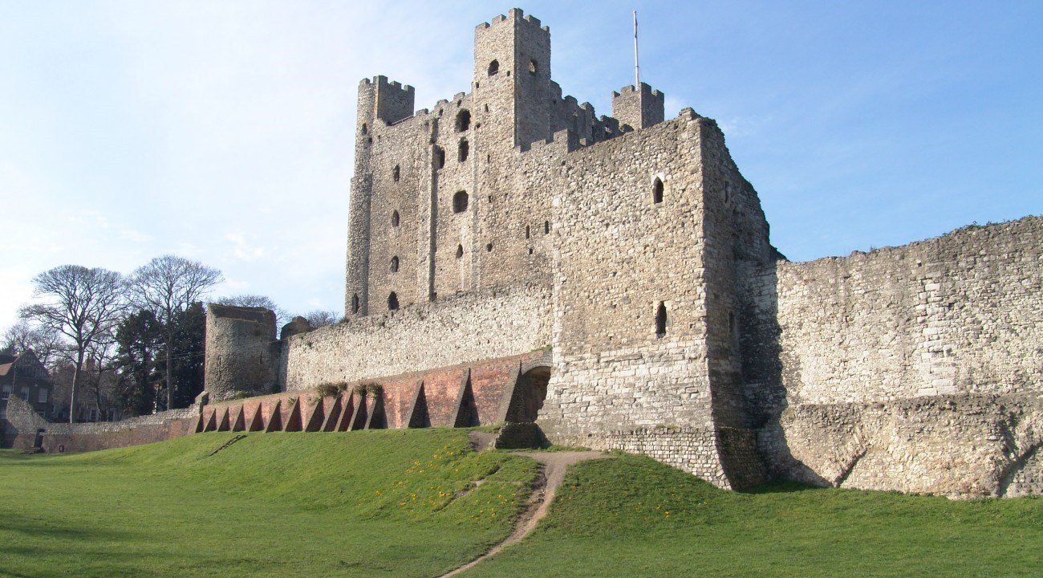
Rochester Castle
The word castle derives from the medieval Latin word ‘castellum’ and from the classical Latin word ‘castra’ meaning camp. A castle is a large building or set of buildings, fortified for defence against an enemy. Castles are the most visible sign of Norman conquest and settlement in England. Churches and castles have been essential in forming our vision of what the middle ages looked like, and castles built by the Normans have been essential in forming our view of the political and social state of Europe after their expansion. Castles were an essential part of feudal society, they were created for a variety of crucial reasons. Every castle performed the same two primary functions: they were the private homes for the nobility and royalty but more crucially for the Normans in their first immediate expansion into England, they were fortifications. Some castles were more military than home such is the case of Rochester Castle. The first castle built at Rochester was founded in the aftermath of the Norman conquest. Rochester served as a strategically important royal castle. During the late medieval period it helped protect England’s south-east coast from invasion.
On the outside of a castle, we expect to see drawbridges and battlements and other military based weapons. We also have expectations of what we will see on the inside of a castle. We expect to see evidence of great luxury and creature comforts. There are great halls for banqueting, huge kitchens, bedroom, chambers and chapels that at one point were all sumptuously decorated. Therefore, a castle might be a fortress but it is also crucially, a home. A definition famously offered by Professor R. Allen Brown in his book English Castles. A castle “is basically a fortified residence, or a residential fortress.” A castle was first and foremost a home to its aristocratic owner and their households. Down to the end of the 13th century and slightly later in wales and Scotland, these noble residences were also strong, defensible buildings that can be reasonably described as ‘fortresses’.
The city of Rochester lies on the north coast of Kent at the mouth of the river Medway. The building that dominates the city’s skyline was built almost nine centuries ago. The tower of Rochester castle dwarfs everything for miles around, including the Norman cathedral that now stands in its shadow. Construction of Rochester castle began in the early 12th century, what emerged was not a brand-new castle but a new type of building that had never been seen before. Rochester’s size was unparalleled at the time of its resurrection. Measuring 125 feet from its base to the top of it turrets, it takes prize for being the tallest great tower in the country. Built from 1127, it is also one of the earliest examples of its type and was the property of the Archbishop of Canterbury, then one of the most powerful lords in the kingdom. Construction of this scale had not been witnessed in Britain since the time of the Romans. The Normans were well aware of this, and seem to have deliberately styled themselves as new Romans, a new conquering in imperial style. William of Poitiers, the conquerors biographer, regularly compares his ruler to Julius Caesar, and suggests that the kings leading men were equivalent in wisdom and power to the Roman senate.
Like most castle sites in England, Rochester was established during the reign of William the Conqueror, the first documentary reference to it comes in 1086; when it is mentioned in passing in the Domesday Book. Given its location a foundation date closer to 1066 is highly likely. The town of Rochester sits on the roman road from Dover to London- Watling street- at the point where it crosses the Medway river. Watling street is likely to have been the route taken by William the Conqueror as he advanced on London in the autumn of 1066. Rochester would have been a strategically essential place for the Normans to protect from an early date. The first chronicle reference to the castle reveals that in 1088 it was in the hands of William’s half-brother, Odo of Bayeux. Odo had been placed in charge of Kent as early as the start of 1067, and in the same year according to the Anglo-Saxon Chronicle “built castles far and wide, throughout the land, oppressing the unhappy people.”
Little remains of the 11th century castle, as one would expect, given that most early Norman castles were constructed from wood. There is one section of wall on the west side of the bailey of an early date, which suggests that at some point soon after its foundation the whole circuit was rebuilt in stone. The obvious date for this rebuilding is immediately after the death of William the Conqueror in 1087, at which point Odo of Bayeux rebelled against the newly crowned king William Rufus, his nephew, with the result that Rochester was besieged and Odo was driven into exile. When it comes to the great tower we are on much firmer ground. A royal charter of 1127 shows that Rufus’ successor, Henry I, struck a deal with the Archbishop of Canterbury, William of Corbeil, granting him joint custody of the castle, and at the same time obliging him to build a tower there. The chronicler Gervase of Canterbury, writing later in the century, confirms that the archbishop built a ‘noble tower of outstanding size'.
William the Conqueror built a network of vast stone castles, encasing England in an iron grip. These were not places of refuge, but instruments of power that stamped Norman authority and identity on the landscape. The political importance of castles was inseparable from their social and economic importance. It was often the reference to castle-building that chroniclers marked out the advancement of certain individuals. It was often through castles that royals made a show of superiority to his fellow countrymen.

Bibliography
R. Liddiard, Anglo-Norman Castles (Suffolk: Boydell Press, 2003).
M. Morris, Castle: A History of the Buildings that Shaped Medieval Britain (London: Random House, 2012).
R. D. Ingleton, Fortress Kent (Yorkshire: Pen & Sword Books Ltd , 2012).
J. A Davies, A. Riley, J. M Levesque, C. Lapiche, Castles and the Anglo-Norman World (United Kingdom: Oxbow Books, 2016).
R. A. Brown. The Normans, (Suffolk: Boydell Press, 1984).
P. F. Purton, A History of the Early Medieval Siege, C. 450-1220 (Suffolk: Boydell Press, 2009).
L. Hull, Understanding the Castle Ruins of England and Wales: How to Interpret the History and Meaning of Masonry and Earthworks (North Carolina: McFarland & Company Inc Publishers, 2009).

M. Morris, Castle: A History of the Buildings that Shaped Medieval Britain (London: Random House, 2012).
R. Liddiard, Anglo-Norman Castles (Suffolk: Boydell Press, 2003).
Ibid p.4
R. D. Ingleton, Fortress Kent (Yorkshire: Pen & Sword Books Ltd , 2012).
Morris, Castle: A History of the Buildings that Shaped Medieval Britain, p 2-4.
Ibid p 2-4
Ibid p 50
Ibid p 50
Ibid p 50
Ibid p 50
Ibid p 54
J. A Davies, A. Riley, J. M Levesque, C. Lapiche, Castles and the Anglo-Norman World (United Kingdom: Oxbow Books, 2016).
Ibid p. 69
Ibid p. 70-72
Ibid p. 70-72
Ibid p. 70-72
Ibid p. 70-72
Ibid p. 70-72
R. Liddiard, Anglo-Norman Castles (Suffolk: Boydell Press, 2003).
Ibid p. 4

