

Ryan Boardman
(2203353)
Vehicle / motorsport technology
ACHA4012
Engine dyno test assignment

Contents
1 – Introduction 3
2- Equipment used 3
2.1 - The dynamometer being used in this experiment: 3
Figure 1 – W230 dynamometer 3
2.2 – Specimen engine used in the test 4
Figure 2 - Example of the Honda 1.6L VTEC engine used in the test. 5
3.0 – Methodology 5
4.0 – Raw and calculated data tables 6
Table 1 – Raw and calculated results table 6
5.0 – Graphs of results 7
Figure 3 – Graph showing Torque Vs Engine speed 7
Figure 4 – Graph showing SFC vs Engine speed 7
Figure 5 – Graph showing Brake power vs Engine speed 8
6.0 – Conclusion 8
7.0 Evaluation 8
8.0 – References list 9

1 – Introduction
This assignment report is designed to display the data and the resulting findings from completing an engine dyno test. For this experiment a Honda 1.6L VTEC engine was set up and tested on the dynamometer. The aims of this assignment is to show the understanding of engine performance. These aims will be achieved through the use of data gathering. The data being gathered and calculated will be the following, corrected Power, Torque, BMEP, SFC, and Overall Thermal Efficiency. The graphs within this report will display SFC against engine speed, Torque against engine speed and Brake power against engine speed. Expanding on this calculated data, a discussion and examination of the data plotted into graphs will be concluded. Data of this assignment has been carried out during the process of undertaking the practical, this data has then been implemented into an excel spreadsheet.

2- Equipment used
This section of the report will list and cover the main equipment needed that is used to undertake this experiment, furthermore it will also describe their intended purpose. It will also explain in a brief, yet informative way on how these featured necessary pieces of test equipment work. The main pieces of test equipment will proceed to be listed in the report.

2.1 - The dynamometer being used in this experiment:
A technical specification Eddy-Current dynamometer W series (W230), was used for the test. Used for testing passenger car engines at high speeds, measuring power outputs and torque outputs of the specimen engine being tested. The dynamometer equipment serves as a load unit for the engine that gets attached to it. This kind of equipment is used for a multitude of things, these include the following, development, quality control, running endurance tests and fuel and or lubricant tests for any passenger vehicle engine of different variations of power. This dynamometer in particular that had been used in the undergoing of the personal engine dyno test was controlled through computers and the control panel rig located in a separate room within the workshop.
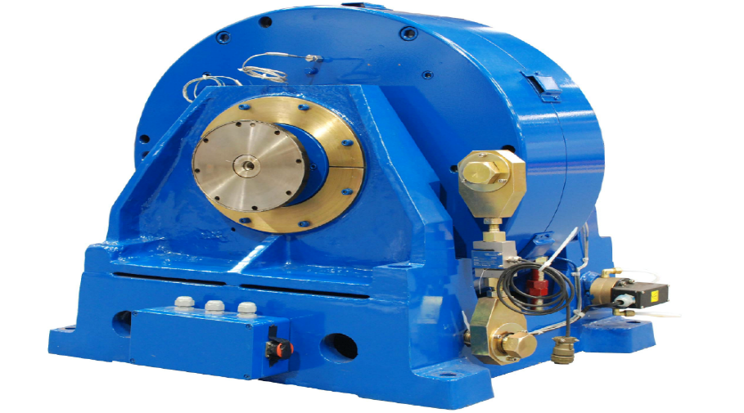

Figure 1 – W230 dynamometer
https://dynamometer-world.com/index.php/horiba-schenck-ds750/10-reconditioned-dynamometers.html
How it works :
This dynamometer model works on the principle of electromagnetic induction whilst being driven by the test specimen (attached engine). When conductive material moves through the magnetic field, eddy currents are then induced into the material. These eddy currents and the magnetic field combine to generate forces that subsequently oppose the motion in the material. The dynamometer has two main components. The first is the stator, within this stator is a series of electromagnets that are organised in a circular pattern. Secondly is the rotor, made from a conductive material, this is the part that is connected by the engine and then is driven. The engine drives the rotor that then moves through the magnetic field that has been created by the stator as it rotates. This movement of the components induce eddy currents within the rotor. These eddy currents create a magnetic field of their own that reacts with the stators magnetic field, this then results in a braking force or torque that is applied to the rotor. The torque, braking forces and overall power output can all be controlled from a separate control panel and computer software using live monitoring.
Using this live monitoring on the computer software, this is how during the test data such as the following was gathered.
The raw data includes:
- Dynamometer load
- Dynamometer speed
- Dynamometer diameter

2.2 – Specimen engine used in the test
For the test an engine was connected to the dynamometer. To be specific the engine that was used was a Honda 1.6L VTEC from a ‘Honda Civic coupe CRX’, from 1990-1991. This particular engine being of either the D15 or D16 variant, is an inline 4-cylinder transverse engine layout. Also, the engine features variable valve timing. The engine itself is weighs around 107-113kg (236-249lbs). The Honda engine has a power of around 148bhp (110kW) at 7600 rpm, also capable of producing 144 Nm of torque at 7100 rpm. When the engine is in the car it is capable of making speeds of up to 129 mph or 208 kph. These kinds of statistics make for an interesting test specimen as it is a fairly powerful engine given its size and weight. This engine that had been used on the dyno for the test, as stated in the earlier section ‘2.1’ it is used to drive the rotor of the dynamometer. By connecting it to the dynamometer and the rotor to be specific, this is how it is possible that data can be gathered from the engine.
Raw data gathered from the engine performance on the rig setup
- Fuel flow rate
- Lambda
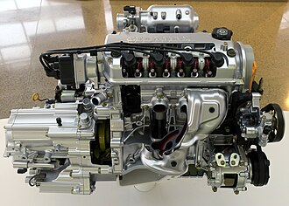

Figure 2 - Example of the Honda 1.6L VTEC engine used in the test.
https://en.wikipedia.org/wiki/Honda_D_engine

3.0 – Methodology
This section of the report will run through the brief methodology and explanation of the process to undergo the engine dyno test.
Firstly it is imperative to the rules around the workshop areas that health and safety protocols are followed properly at all times. This includes steel toe boots, also when around the engine dyno ear defenders are supplied and to be used when necessary.
To begin with make sure everything on the rig is to standard ad that the engine is properly secured to the dynamometer. Once a check has been complete, then move to the separate dyno control room. From this room, using the computer software that is connected to the dyno, turn on the ignition of the engine rig and all corresponding buttons that are required for the engine to run at optimum. Once done shift the dials to achieve the desired settings step by step, taking down the raw data readings as it goes. The gathered data should then be put into an excel spreadsheet where extra calculations will be made.
These calculations include:
- corrected power
- Torque
- BMEP
- SFC
- Thermal efficiency

4.0 – Raw and calculated data tables
This section will show the raw data that was recorded from the test itself. Also within the section and amongst these tables will be the calculated sections (corrected power, torque, BMEP, SFC and thermal efficiency). Selected data will later be put displayed into certain graphs.

Table 1 – Raw and calculated results table

Load | dyno speed | fuel flow rate | Lambda
Newtons | rpm | l/min | Lambda
102.275 | 1000 | 0.0704 | 1.2658
102.756 | 1050 | 0.0724 | 1.26783
103.689 | 1100 | 0.0737 | 1.27344
104.209 | 1150 | 0.0728 | 1.28476
105.811 | 1200 | 0.0744 | 1.29181
107.51 | 1250 | 0.07895 | 1.29729
109.488 | 1300 | 0.079 | 1.29895
111.797 | 1350 | 0.0796 | 1.29469
114.268 | 1400 | 0.0835 | 1.2855
115.783 | 1450 | 0.0847 | 1.27818
116.985 | 1500 | 0.08865 | 1.2795
117.788 | 1550 | 0.0932 | 1.27766
118.471 | 1600 | 0.0959 | 1.28235
118.772 | 1650 | 0.09875 | 1.29028
118.656 | 1700 | 0.10005 | 1.29942
118.861 | 1750 | 0.10305 | 1.31053
119.584 | 1800 | 0.1093 | 1.3149
119.934 | 1850 | 0.11415 | 1.31849
120.176 | 1900 | 0.11745 | 1.31892
120.948 | 1950 | 0.12055 | 1.31484
122.157 | 2000 | 0.12555 | 1.31653
122.845 | 2050 | 0.12785 | 1.32098
123.796 | 2100 | 0.1309 | 1.32287
124.794 | 2150 | 0.13435 | 1.32164
125.137 | 2200 | 0.1377 | 1.31652
126.028 | 2250 | 0.14105 | 1.30465
126.66 | 2300 | 0.14495 | 1.29646
126.822 | 2350 | 0.14985 | 1.28229
126.69 | 2400 | 0.1537 | 1.27304
126.552 | 2450 | 0.15565 | 1.26984
126.438 | 2500 | 0.1596 | 1.27446
126.239 | 2550 | 0.1626 | 1.27876
126.161 | 2600 | 0.16805 | 1.27634
125.847 | 2650 | 0.17145 | 1.28027
124.911 | 2700 | 0.17465 | 1.28371
123.927 | 2750 | 0.1784 | 1.2812
123.689 | 2800 | 0.18005 | 1.27448
123.389 | 2850 | 0.1831 | 1.26036
122.519 | 2900 | 0.1879 | 1.2531
121.837 | 2950 | 0.19255 | 1.23943
121.709 | 3000 | 0.199 | 1.22735
121.123 | 3050 | 0.20605 | 1.2193
121.124 | 3100 | 0.21005 | 1.20692
120.851 | 3150 | 0.21605 | 1.19274
120.596 | 3200 | 0.21795 | 1.18481
120.84 | 3250 | 0.22305 | 1.17378
121.633 | 3300 | 0.2255 | 1.16118
122.181 | 3350 | 0.2285 | 1.15104
122.933 | 3400 | 0.2342 | 1.14117
123.475 | 3450 | 0.23605 | 1.12669
123.428 | 3500 | 0.24195 | 1.11975
124.205 | 3550 | 0.24545 | 1.10622
124.066 | 3600 | 0.25505 | 1.09697
123.967 | 3650 | 0.25755 | 1.09401
123.815 | 3700 | 0.26445 | 1.09659
123.767 | 3750 | 0.2651 | 1.09808
123.509 | 3800 | 0.2693 | 1.09907
122.672 | 3850 | 0.27375 | 1.10533
122.157 | 3900 | 0.2759 | 1.11704
121.184 | 3950 | 0.28285 | 1.12259
120.004 | 4000 | 0.28455 | 1.12461
118.734 | 4050 | 0.2871 | 1.1222
117.442 | 4100 | 0.28895 | 1.12394
116.5 | 4150 | 0.29305 | 1.12233
115.931 | 4200 | 0.2949 | 1.12179
115.034 | 4250 | 0.29715 | 1.12456
114.391 | 4300 | 0.3022 | 1.12278
114.016 | 4350 | 0.30605 | 1.11943
113.871 | 4400 | 0.3092 | 1.11986
113.985 | 4450 | 0.3099 | 1.11873
113.306 | 4500 | 0.31445 | 1.11563
113.074 | 4550 | 0.3171 | 1.10953
112.195 | 4600 | 0.3194 | 1.10569
111.061 | 4650 | 0.32055 | 1.09782
109.973 | 4700 | 0.3207 | 1.09558
108.654 | 4750 | 0.32485 | 1.08827
107.076 | 4800 | 0.32455 | 1.08396
105.24 | 4850 | 0.3257 | 1.08221
103.632 | 4900 | 0.3277 | 1.0846
102.335 | 4950 | 0.32845 | 1.08823
101.106 | 5000 | 0.3287 | 1.08687
99.3149 | 5050 | 0.32985 | 1.0891
97.5815 | 5100 | 0.3297 | 1.09185
95.8486 | 5150 | 0.33095 | 1.09407
94.8033 | 5200 | 0.3338 | 1.09346
93.0976 | 5250 | 0.3313 | 1.08804
91.7886 | 5300 | 0.3324 | 1.08339
90.5938 | 5350 | 0.3308 | 1.08007
89.6374 | 5400 | 0.3388 | 1.07895
88.9256 | 5450 | 0.3438 | 1.07923
88.6474 | 5500 | 0.3488 | 1.08366

5.0 – Graphs of results

Figure 3 – Graph showing Torque Vs Engine speed

From this graph we can see a variation pattern in torque to engine speed. This could be for a few reasons to do with the philosophy of the engine, such as the following, combustion process, the valve timing (due to the VVT), pressures or the likes of friction in the engine at the higher speeds.

Figure 4 – Graph showing SFC vs Engine speed

The variation between the two variables may be due to the engines combustion efficiency, where at the lower end speeds the SFC may be less efficient compared to maybe other points of the cycle. Also could be due to the thermal efficiency and how at low speeds the engine may show characteristics of heat loss which causes the SFC to be higher as more fuel needs to be burned.

Figure 5 – Graph showing Brake power vs Engine speed

In this graph a very similar trendline can be seen compared to the torque vs engine speed graph. The varying results could be related to such characteristics like the thermal efficiency, much like the SFC where this could affect due to the fact there is heat loss at lower speeds. It may also be due to the torque as these two factors tend to go hand in hand with each other, due to this the torque curve can determine how the brake power varies with the engine speed.

6.0 – Conclusion
To conclude the equipment for this test was up to good standard for the assignment. The results that had been gathered were as accurate as they could be given the fact that the software to display the dynamometer data was of a trusting and good quality, also the method used to go about the test was done well and precise to allow for these results. The aim of the experiment has been achieved through all of these factors.

7.0 Evaluation
To evaluate the task from a personal experience I believe it was done to the best of my ability, this is because the rules and instructions were followed. One improvement that could’ve been made personally was to take more time when looking at the live performance data from the rig. One improvement that could be made to the experiment could be that given more time it can be done again to enhance the accuracy of results. Also another way that is given a larger budget that this could be done on a larger scale, such as doing the test on two or more engines at once to achieve a similar effect.

8.0 – References list
Info of dynamometer - Administrator (no date) Www.dynamometer-world.com, Eddy Current Dynamometer Information. Available at: https://dynamometer-world.com/index.php/dynamometer-sales-info/eddy-current-dynamometer-info.html (Accessed: 13 March 2024).
Info of engine - Honda Civic 1.6 VTEC (EE9) 150 hp - specs & performance (2022) ZePerfs . Available at: https://zeperfs.com/en/fiche1305-honda-civic-1-6-vtec.htm (Accessed: 13 March 2024).
Rentar (2018) How efficient are engines: Thermodynamics and Combustion Efficiency, Fuel Catalyst. Available at: https://rentar.com/efficient-engines-thermodynamics-combustion-efficiency/#:~:text=The%20greater%20the%20difference%20in,the%20greater%20the%20energy%20loss. (Accessed: 13 March 2024).
Specific fuel consumption (2021) Specific Fuel Consumption - an overview | ScienceDirect Topics. Available at: https://www.sciencedirect.com/topics/engineering/specific-fuel-consumption#:~:text=We%20then%20define%20specific%20fuel,engine%20converts%20fuel%20into%20power. (Accessed: 13 March 2024).
(Any references for figures has been given underneath figure descriptions where necessary)

