Student: Jack Holland (P149473)

Lecturer: Dr Nik Whitehead

User Experience Design
Assignment 1

Contents
1. Introduction to Pokémon Go and Ingress 2
1.1 Ingress 2
1.2 Pokémon Go 2
1.3 Similarities between Ingress and Pokémon Go 3
2. Target user groups per game 5
3. Elements of each game 7
3.1 Psychology 7
3.2 Usability 8
3.3 Design 10
4. Things wrong with Ingress and Pokémon Go 11
5. Impact of Ingress and Pokémon Go 13
6. References 14

Introduction to Ingress and Pokémon Go
Niantic is a software development company founded in 2010. The company is best known for creating augmented reality games Pokémon Go and Ingress. The company was originally formed as a Google start up but became independent in 2015.

Ingress
Ingress is an augmented reality, location-based game created by Niantic. It was originally published on the Google Play store in December 2013. Support for iOS came in July 2014. Ingress is a science fiction themed game with a continuous open narrative throughout the game.
The plot of Ingress is that a unknown force called Exotic Matter has been discovered by a group of scientists at CERN in Switzerland[1]. Players of Ingress must then choose a faction. There are two factions, the Resistance Faction or the Enlightened Faction. The Resistance Faction are represented in blue and the Enlightened Faction are represented in green.
Around the world are portals, they can occur at points of interests in areas[1]. Portals are known to appear at parks, tourist attractions and historical sites[1]. Portals can be controlled by a faction by deploying resonators on the portals. To make a portal stronger, up to eight resonators can be added to it.
The aim of Ingress is to have greater control of the world than the rival faction. To get more control players have to create links between portals, once a triangle is created the area inside of the triangle (known as mind units[1]) contributes to the teams overall score.
In November 2018, Ingress received a revamp called Ingress Prime. The update intended to make the game less complex and more user-friendly, using lessons Niantic learned with the success of Pokémon Go [2].

Pokémon Go
Similar to Ingress, Pokémon Go is an Augmented Reality (AR), location-based game. The objective of Pokémon Go is to travel around the world completing Pokédex’s. The game was created by Niantic and is a part of the Pokémon franchise. Pokémon Go was released on the 6th July 2016.
Pokémon Go allows its players to travel around the world, collecting Pokémon from generations the first four generations. Players can collect items from various gyms and Pokéstops around the world.
The game is constantly updated to keep players interested, new features to Pokémon Go are a buddy system which allows players to gain Pokémon candy for walking a certain distance, the amount depends per level of Pokémon[3].
Other new features Pokémon Go is a raid battles, which allow many Pokémon Go players to gather together and take on a strong boss Pokémon. Once the boss Pokémon has been defeated, players have the chance to capture that Pokémon for their Pokédex. [4]

Similarities between Ingress and Pokémon Go
As Ingress and Pokémon Go are created by the same developer, there are similarities between the two games.
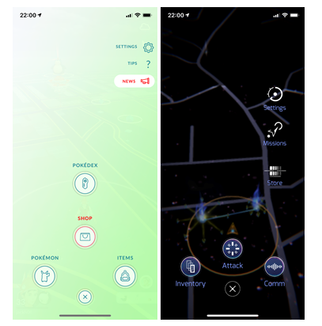
Figure 1 Menu of Pokémon Go and Ingress
Interfaces
The graphical user interfaces (GUI) of Ingress and Pokémon are similiar, this is because it helps users feel familiar. For example, if one player switched from Ingress to Pokémon Go. They would feel familiar as the interface for the game menu is similar.
This is known as a design pattern; user experience designers often include design patterns in their interfaces as the user does not have the time and patience to learn a new interface unless it is necessary.
Design patterns aren’t only in interfaces, some other examples are [5]:
- Road Signs: Important road signs like the Stop sign is always a red octagon with white text, no matter what the language. This gives drivers an indication that it is a stop sign no matter where in the world.

Figure 2 Stop sign in English and Chinese to showing the pattern
- Car Pedals: The pedals for gas, brake and clutch are always in the same position in a car. This is so drivers don’t get confused similar to the road signs mentioned above.
- Websites: Design patterns are used on websites, for example the shopping cart will almost always appear in the top right of the page or navigation bar. This is so that user is always sure of where it is and how to access it.

Push Notifications
Ingress and Pokémon Go both provide notifications to the player when either an event is happening or their gym/portal is being attacked.
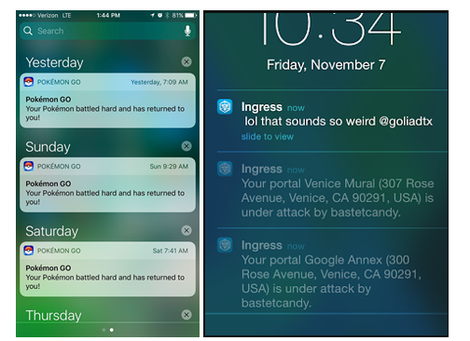
Figure 3 Push notifications from Pokémon Go and Ingress
Ingress will send notifications when:
- A portal is under attack
- A portal is neutralised
Pokémon Go will send notifications when:
- Pokémon’s return from a Gym
- Friend requests are accepted or received
- Gifts received from a friend
- Adventure sync updated
- Events, offers and updates
By sending push notifications to the user’s device, it is a constant reminder for the user to be playing either Ingress or Pokémon Go.

In Figure 3, Niantic are using bad user experience practices. The push notifications sent can be irrelevant as Ingress sent a chat message. The applications both sent multiple push notifications instead of grouping them together which is recommended by the Nielsen Norman Group[6].

Target user groups per game
Although Ingress and Pokémon Go are similar in some ways, the target groups for each game are different.
Ingress
Ingress is science fiction themed, this means that the game will appeal more towards older people.
In a survey done by Beth Wingegarner of Medium.com, the pie chart below shows the ages of people playing Ingress[7]. The survey was taken in 2015 and around 1,250 players were surveyed.
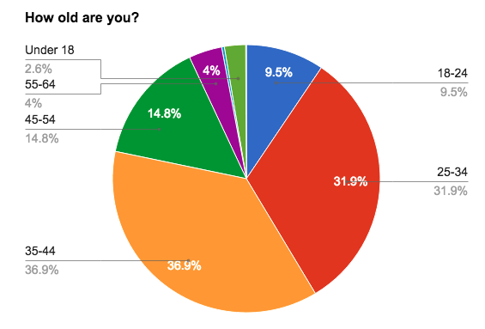
Figure 4 Pie chart representing target audience of Ingress[7]
The chart shows that the majority of Ingress players are 35-44, with the second highest age range being 25-34. This shows that Ingress’ audience are mostly adults.

Pokémon Go
As Pokémon Go is based off Pokémon, the game appeals to a much younger audience. In 2016 Medium.com also ran a survey on the audience of Pokémon Go[8]. The amount of people surveyed was not mentioned.
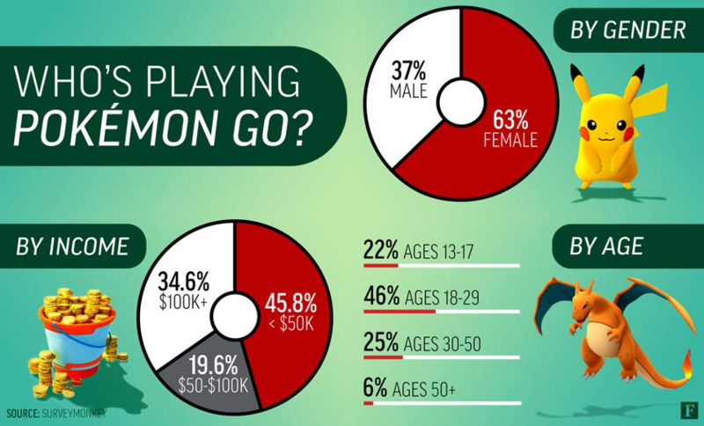
Figure 5 Infographic on who is playing Pokémon Go[8]
Even though Pokémon Go is appealing to a young audience, the most popular age group is 18-29, this is followed by ages 30-50.
The reason why might be because young kids don’t have access to a smart phone, which is required to play Pokémon Go.
Potential Overlap
As the age group between both games are similar, there is potential for players to be playing both Ingress and Pokémon Go. As both games are similar, just the content of each game is different.
When there are special events on, for example Pokémon Go’s community day. It might be tempting for a player who plays Ingress to play Pokémon Go instead so they can get the limited time rewards.

Elements of each game

Psychology
Psychology is used in user experience design as a way control the user’s emotions. In Ingress and Pokémon Go, many psychology tricks are used to control how the player feels.
There 12 universal motivations for a user, they are: Avoiding death, avoiding pain, fuel, homeostasis, sleep, sex, love, protection of children, affiliation, status, justice and understanding. Many of these motivations occur in Ingress and Pokémon Go.
Ingress
The motivation for people to play Ingress is to have fun and to control portals for their team. If a player is controlling portals, they are most likely happy. But if they run out of items or their portals are defeated by the other faction, the player is likely to be sad.
The tutorial of Ingress teaches the player everything they need to know about the game, therefore they shouldn’t be confused when playing the game. If they forget how to play, they can re-do the tutorial in the game settings.
Two of the 12 universal motivations effect players in Ingress, they are:
Avoiding Death
When loading Ingress, the game gives a warning message to its players saying “Remain alert and aware of your surroundings at all times”. This is reminding the players of Ingress to avoid getting themselves into dangerous situations.
Affiliation
Ingress gives the players of the game the feeling of affiliation as players are required to join a team. The game is then centred around capturing and linking portals which represent your team. When a team has more control over an area it shows affiliation.
Pokémon Go
Like Ingress, the motivation to play Pokémon Go is to have fun. Another motivation is to capture as many Pokémon to complete a Pokédex. Pokémon Go players can have many different feelings, when they capture rare Pokémon. Players can feel excitement and happiness. But when they fail to capture a Pokémon, run out of items or lose a position on a gym they can feel sadness or feel annoyed.
Pokémon Go players get given a tutorial similar to Ingress, this teaches them how to play the game and what to do. Players are also eased into the game by Professor Willow, who gives new players tasks to do.
If a player captures a Pokémon for 7 days in a row, the player gets a gift. This is Niantic rewarding players for their good behaivor.
Three of the 12 universal motivations effect players in Ingress, they are:
Status
Players in Pokémon Go can achieve status by collecting as many Pokémon as they can. Medals can also be collected for completing achievements, for example hatching 10 eggs will give the player a bronze medal called “Breeder”.

Fuel
By travelling to Pokéstops, players keep their inventory fuelled by collecting Poké balls, razz berries and other essential items used to play Pokémon Go.
Avoiding Pain
When defending a gym, players will often use their best Pokémon to avoid the pain of their gym being defeated. They will also monitor the gym and apply razz berries to their Pokémon to keep them at maximum health.
Players will also use higher tiered Poké Balls to ensure they have the best rate of capturing a Pokémon.

Usability
Ingress
Before Ingress Prime, Ingress had poor usability and was hard to use the application. But Niantic have used a similar UI which Pokémon Go uses.
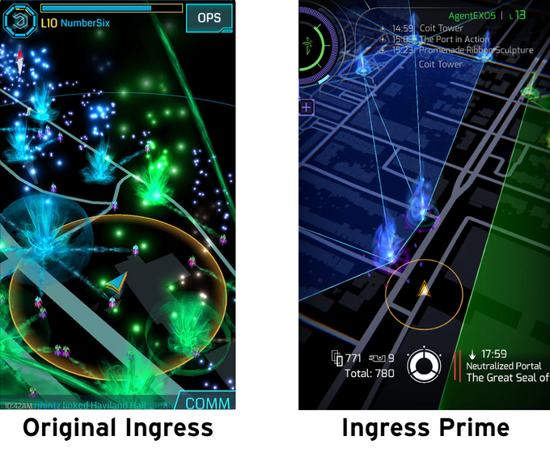
Figure 6 Comparison of Ingress and Ingress Prime[9]
The UI changes made to Ingress improve the usability of the game greatly, Niantic have added shortcuts which allow players to access notable things quickly.
The game received a navigation button similar to Pokémon Go, this means that players can quickly get to points of interest like the inventory, attack screen and game settings easier.
The buttons of the game have also been given icons and better descriptions, this helps players understand the game better.
The game also uses the same map system as Pokemón Go, which is detailed better and includes most rivers and roads. This is an improvement from the old Ingress map system which lacked some roads and rivers.

Pokémon Go
Pokémon Go is a game with good usability, the controls of the game are straight forward and easy to understand. The buttons and menus are clearly described with text and icons.
The game includes messages and reminders from Professor Willow, guiding players through the game. Especially during the first five levels, when the players are often new and unsure of what to do. The professor also gives users tasks to do, ensuring that the users are on the right track of playing the game. It also allows players to get rewards early in the game.
There is also a tips section of the game where a mini-tutorial is displayed to the user, allowing them to refresh themselves on the game if they haven’t played in a while.
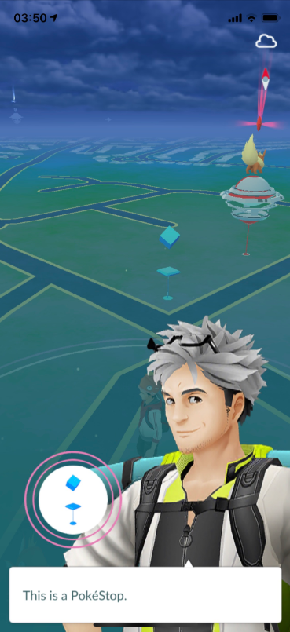
Figure 7 Pokémon Go's Tips menu

Design
Ingress
Ingress is designed well, the design of the game looks well-made and not tacky. It uses a user interface design which is familiar to other games, making the user more likely to trust Ingress. The main screen of Ingress communicates important information to the players by telling them what portals they control and if any are being attacked. In the bottom left corner is information about the amount of portal keys and items in their inventory.
The design of Ingress is consistent throughout the game, when a player is near a portal it begins glowing making the player aware they are in close proximity of it. The colours of Ingress help the users playing the app, if a button can be clicked. The text of it is often purple.
A bad design of the Ingress app is that almost everything on the main screen is clickable, this means that players can often miss menus that are hidden.
Pokémon Go
The design of Pokémon Go is good, as the game uses graphics from the original Pokémon series players feel a sense of familiarisation and trust the game more. The game communicates with its players effectively by using overlay messages, character bubbles and pop up boxes.
The representation of Pokémon Go and Pokémon is consistent through the application by using a colour scheme and UI that matches the original Pokémon series. The design of the application leads the user to important places, when a player approaches a Pokéstop it displays an animation and gets larger. When Professor Willow has a message for the player, the button displays an orange ring around it grabbing the user’s attention.

Things wrong with Ingress and Pokémon Go
Activities & Chat (Ingress)
The activities section of Ingress gives a lot of irrelevant information, by default it gets information from 100 km (62 miles). The chat section of Ingress could also potentially expose younger players to swearing. There is also a cross-faction which allows multiple factions to speak which potentially could cause arguments.
Rural Communities
In rural communities Ingress and Pokémon Go there are limited points of interest for players to use. This is because these areas aren’t mapped like major cities.
The two pictures below show central London and Underwood, a small village near Newport. The orange triangles are gyms and the blue cubes are Pokéstops.
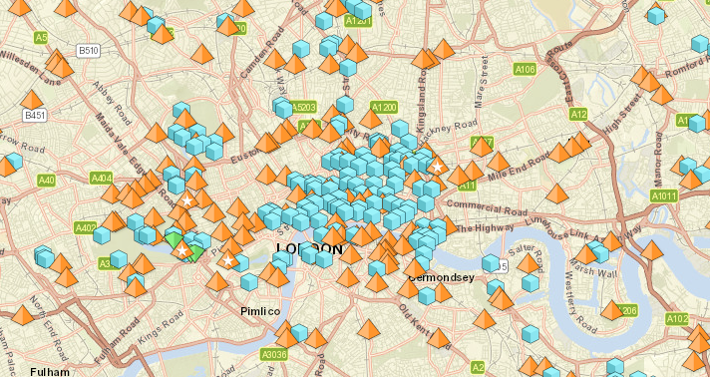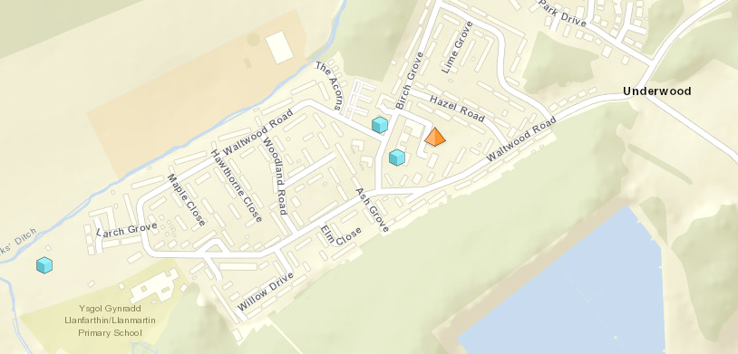
Although the map is not 100% accurate, it shows the major difference in Pokéstop and gyms.

Device Compatibility
Ingress and Pokémon Go both require iOS 10.0 or later to work for iPhones. Not every iPhone will be able to play Pokémon Go. Ingress and Pokémon Go also require mobile Internet to work, which means that players with low allowance won’t be able to play as much as somebody with higher data allowance.
Trespassing & Jaywalking
In December 2018, Niantic settled a court case with a group of homeowners in America over Pokémon Go players trespassing into their properties[10]. This is a problem for Pokémon Go and Ingress players as if they entered a property without permission, the property owner will most likely cause distress to them by asking them to leave and potentially calling the police.
There was also a case in July 2016, where a Pokémon Go player in America got hit by a car whilst playing the game[11]. The player survived, but getting hit by a vehicle would have caused major distress for the victim and their family.

Impact of Ingress and Pokémon Go
Ingress and Pokémon Go are two successful mobile games. Pokémon Go is a more popular game but the reasoning for that is because it is part of the Pokémon franchise.
User numbers
Ingress was one of the first mobile game to feature augmented reality and location features. The game had a slow start, with the game having 2 million users in 2014[12].
When Pokémon Go first launched, it because a massive success. In the summer of 2016, the game had nearly 45 million users playing. In summer 2018, it was reported that Pokémon Go has 147 million players[13].
Length of use
The usage of Pokémon Go is high for a mobile application. In 2016, the game beat Twitter, Netflix and Spotify for length of use on Android devices[14].
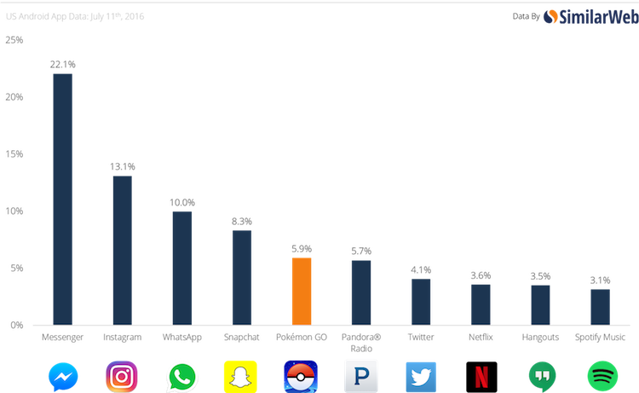
The game also has a high user retention rate. Compared to the gaming average around 25%, Pokémon Go has around 70% retention rate[14].
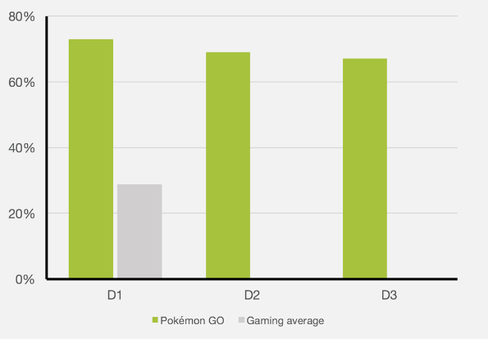
Social familiarity
In summer 2016, Pokémon Go had 45 million players a day. This meant that players often gathered at places of interest to catch Pokémon at lured Pokéstops. That would mean that it would be common to see people playing Pokémon Go.
In July 2018, Niantic held a Pokémon Go festival in Chicago. Players could attend the event where players could socialise with other players and get special rewards.
Acceptance of AR features
With the success of Pokémon Go and Ingress, other companies decided to create augmented reality games. In 2018, a company called Ludia released a game called Jurassic World Alive. The game is similar to Ingress and Pokémon Go where players can explore a virtual world and capture dinosaurs.

References
[1] “Initial Briefing,” Ingress Help Center. [Online]. Available: http://support.ingress.com/hc/en-us/articles/360002045068-Initial-Briefing. [Accessed: 09-Jan-2019].
[2] T. Phillips, “Ingress’ Prime relaunch paves way for new features in Pokémon Go,” Eurogamer, 06-Nov-2018. [Online]. Available: https://www.eurogamer.net/articles/2018-11-06-ingress-prime-relaunch-paves-way-for-new-features-in-pokemon-go. [Accessed: 10-Jan-2019].
[3] “Buddy System - Pokemon GO Wiki Guide - IGN.” [Online]. Available: https://uk.ign.com/wikis/pokemon-go/Buddy_System. [Accessed: 10-Jan-2019].
[4] “Raids - Pokemon GO Wiki Guide - IGN.” [Online]. Available: https://www.ign.com/wikis/pokemon-go/Raids. [Accessed: 10-Jan-2019].
[5] Don’t make me think, revisited: a common sense approach to Web usability, vol. 51. 2014.
[6] “Five Mistakes in Designing Mobile Push Notifications,” Nielsen Norman Group.
[7] B. Winegarner, “The 2015 Ingress demographic survey,” Beth Winegarner, 18-Sep-2015. .
[8] S. Intelligence, “Pokémon GO demographics: The evolving player mix of a smash-hit game,” Medium, 07-Dec-2016. .
[9] “side-by-side.png (680×555).” [Online]. Available: https://techcrunch.com/wp-content/uploads/2018/11/side-by-side.png?resize=680,555. [Accessed: 13-Jan-2019].
[10] “Pokemon Go ‘trespass’ legal action settled,” 03-Dec-2018.
[11] “Pennsylvania Teenager Hit By Car While Playing Pokémon Go,” Time. [Online]. Available: http://time.com/4405221/pokemon-go-teen-hit-by-car/. [Accessed: 14-Jan-2019].
[12] “Google Niantic’s Ingress aims to make gamers thinner and more social in the real world (interview),” VentureBeat, 09-Feb-2014. .
[13] T. Phillips, “Pokémon Go active player count highest since 2016 summer launch,” Eurogamer, 27-Jun-2018. .
[14] “Pokémon GO Revenue and Usage Statistics (2017),” Business of Apps. .

