Project Management Plan
Student Name:Ion Alexandru Circiu
Student Number:1807495
Module Title:PROJECT MANAGEMENT
Module code: LCBB5005
Lecturer’s Name:Joy Botu

Table of Contents
Introduction 3
Schedule 3
Scope 4
Requirements 4
Deliverables 4
Cost 5
Time 5
Human Resources 6
Risk 7
Quality Control 7
Communication 8
Conclusion 8
Reference 9

Introduction
According to Pinto, (2018), a project management plan is a process of making a blueprint of the total work related to the project and every organization is following a procedure to make this thing. Now a day’s making of software is going to be very famous among the corporate people as well as general people. They believe that software can make their life better and handy. By the help of software, people can lead life easily and they can make everything done by using the software. That is why the tendency of making software is increasing. Scientist and researcher trying to develop new software for human welfare. Everyday new idea generation competition has been arranged and students are submitting new ideas so that engineer can builder software. By reading this report, the reader will get a clear knowledge about project management plan and will know how to conduct such type of project (Spinner and Spinner, 2016). Through this report, it will be shown how to make voice command software for a laptop by applying PRINCE2.

Schedule
Before making and software organiser have to generate a schedule so that employee can maintain (Chapman and Ward, 2016). Without a proper schedule, the employee will not be able to finish the work in time. For making a voice command software for laptop company have decided to take 5 employees as a team and one will be the leader.
Resource collection | 1st week
Financial distribution | 2nd week
Employee communication | Every week
Project monitoring | 4th week
Testing | 5th week
Implementation | 6th week
Error finding and development | 7th and 8th week
Product launching | 9th week

Scope
Each and every giant technology best company are trying to make software for a laptop by which the user can control it through voice command (Ceschi et al., 2015). But they have failed several times so show by creating software for a laptop will be a huge thing. A successful software can make huge revenue and the company will get different order from different and company (Mcdonald and Smithers, 2018). So, this software will be a big invention if the organisation can successfully do that. The scope is huge.

Requirements
For making software the team need some necessary things and for purchasing those things company have to give a proper budget (Tam, 2017). The team need for things basically. Those are user, hardware, software, and communication.
User: for making and testing a software user is needed because when anyone wants to generator software then he has to access in the different website as a single user. And again, after making a successful software it needs to be tested. So different user has to use this software differently otherwise engineer cannot find any problem. So, the company have to give the team total access.
Hardware: they need different laptops, desktops, microphones, headphones, recording system, voice identifying technology, internet connection, communication web and so on. Without that hardware, it is not possible to conduct such type of product.
Software: for making the software that team have to take the help from other software, for example, they need voice recording software, data transfer software, voice commanding system, recording software, Windows and so on (Boehm, 2019). After making a combination of hardware and software the team will be able to conduct research about making the software.
Communications: For communication that team need a high-speed internet connection with mobile networks because without high-speed net data cannot be transferred easily. The leader has to contact with superior regularly.
Security: Security is another important thing because before publishing the software any employee can sell the idea to another company. So, the organisation has to choose loyal employ for this project. After making it they will follow the copy right law and patient so that no one can steal the idea of the software.

Deliverables
Deliverables are the process by which a company can distribute the product among the customers. This process is different for the software because selling software through a retailer is not possible. The software can be distributed by website, built-in software with windows or iOS, CD and online market place. This product will bring a huge success definitely so the company is going to sell that product in the market. This product will be available with different Windows including Windows 10 and iOS (McAlister, 2016). User can download it from the official page of the organisation. Home delivery facilities with CD through Amazon.com will be available for the user also. So, this software is going to be deliverable easily.

Cost
It is not possible to generate accurate cost at the time of planning so if the fictitious cost has been given below so that a proper budget can be generated (Khadka and Khanal, 2015). Through this budget, the organisation can estimate its usual cost. The budget has been given below. At the time of implementation, the moral-less cost will be needed.
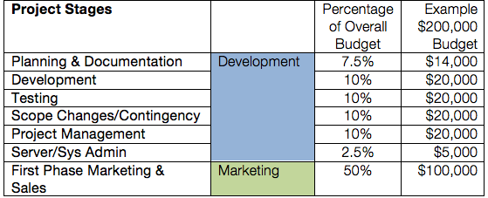

Time
The whole project has been divided among three-phase and the project will be started from January 5, 2020. And it is estimated that the work will be done in May. More or less time will be needed because sometimes software may make some problems.
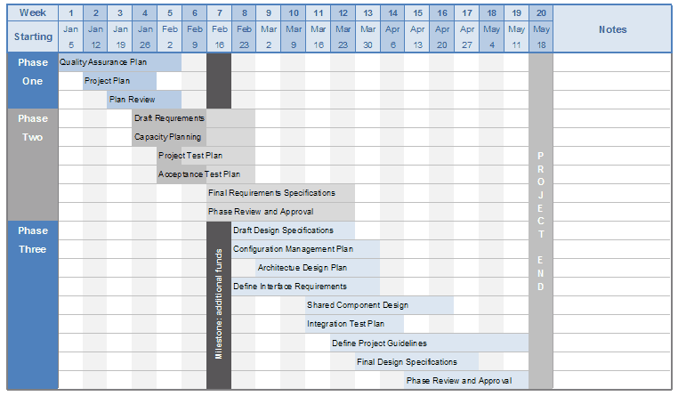

Human Resources
For this work, a team is needed because creating such type of software is not possible by one man. Organisation has decided to give this project among 5 members who will be work together. Among the five one will be the leader and the higher authority will communicate directly with him. The employee will get benefit according to the Maslow's hierarchy of needs (Newton, 2016). The extra money will be given if anyone will work what time. Organisation will follow a proper chain which has been given below.

Risk
Risk is the probability of occurring any harm, damage or loss. There is a lot of risk for this project because a huge investment of money is needed for this work (Boehm, 2019). And there is a possibility of damaging the software. An employee can betray with the company by selling the product with another company before launching. And there is another risk and that is an employee cannot make the software properly (Kerzner, 2017). By considering all the risk the company have selected the best five engineers of the company so that they can do something. Before launching the product, the company is going to arrange everything for them in the organisation including food, cloth, and other facilities. The mobile phone and cameras will be taken away for a long time. If the five employees cannot make the software then the company will recruit a new member with them so that they can do something.

Quality Control
Quality control is the process of identifying the accurate quality of the product which has been promised by the company. Product quality will be insured if the product can perform better than other software (Rice et al., 2018). Through this project, voice command software is going to be generated. For ensuring the quality the authorities have decided that after making the software properly every employee of the organisation will install it and use it. If they will face any problem, they will arrange for the development process. After that, they will launch in the market. Quality control team of 3 members will ensure everything. They will monitor continuously.

Communication
Communication is the process of sharing working updates with higher authority and getting orders from them and giving orders to the subordinates. For better communication, a leader has been selected and higher authority will communicate with him. This process will reduce data biasness. Quality control team will communicate with them continuously and reporting to the higher authority. A continuous monitoring process will be running for this project.

Conclusion
By maintaining all the process anyone can complete a project. For making such type of project a huge budget is needed and organisation have to recruit more employee. Only three-month time is not enough for such type of project because after making the software they need to check it and recheck it again and again. Testing is an important task for software. Before launching a product, proper testing is needed otherwise if the software doesn't work properly then and it will create a bad reputation about the organisation. So, more time is needed for this project. This project management plan has been conducted on the basis of prince2. Now the reader can make a decision about making a project and project plan

Reference
- Boehm, B., 2019, September. Software risk management. In European Software Engineering Conference (pp. 1-19). Springer, Berlin, Heidelberg.
- Boehm, B.W., 2019. Software risk management: principles and practices. IEEE software, 8(1), pp.32-41.
- Ceschi, M., Sillitti, A., Succi, G. and De Panfilis, S., 2015. Project management in plan-based and agile companies. IEEE software, 22(3), pp.21-27.
- Chapman, C. and Ward, S., 2016. Project risk management: processes, techniques and insights. John Wiley.
- Kerzner, H., 2017. Strategic planning for project management using a project management maturity model. John Wiley & Sons.
- Khadka, R.B. and Khanal, A.B., 2015. Environmental management plan (EMP) for Melamchi water supply project, Nepal. Environmental monitoring and assessment, 146(1-3), pp.225-234.
- McAlister, D.T., 2016. The project management plan: Improving team process and performance. Marketing Education Review, 16(1), pp.97-103.
- Mcdonald, B. and Smithers, M., 2018. Implementing a waste management plan during the construction phase of a project: a case study. Construction Management & Economics, 16(1), pp.71-78.
- Newton, R., 2016. Project management step by step: how to plan and manage a highly successful project. Pearson UK.
- Pinto, J.K., 2018. Project management: achieving competitive advantage (No. s 57). Upper Saddle River, NJ: Pearson.
- Rice, M.P., OConnor, G.C. and Pierantozzi, R., 2018. Implementing a learning plan to counter project uncertainty. MIT Sloan Management Review, 49(2), p.54.
- Spinner, M. and Spinner, M., 2016. elements of Project Management: Plan, schedule, and control. Prentice Hall.
- Tam, V.W., 2017. On the effectiveness in implementing a waste-management-plan method in construction. Waste management, 28(6), pp.1072-1080.

