The Global Business Environment, Environment Analysis of Automobile industry

Table of Contents
Introduction 3
Major forces that are affecting the automobile industry 4
Swot analysis of automobile industry 4
Strengths 5
Weaknesses 5
Opportunities 5
Threats 6
PESTEL analysis of automobile industry 7
Political factors 7
Economic factors 7
Social factors 8
Technological factors 8
Environmental factors 8
Legal factors 8
Porter’s five forces analysis of the automobile industry 9
Rivalry 9
the threats of new entrants 9
Threats of substitutes 10
Bargaining power of buyers 10
Supplier bargaining power 10
Conclusion 11
References 12

Introduction
Environmental analysis refers to the set of tools that examines all the elements of internal and external forces of a business that have an impact on the performance of the organisation. Each organisation is affected significantly by the factors of the external and internal business environment. In the automobile industry, there are many factors and among them, some are internal and some are external. In the business environment analysis of the Automobile industry, after examining the factors, it will get adequate information and then provide the information to the strategic planners to conduct the information and forecasting trends for the future and set up the organizational goal. This report will work with Jaguar a well-placed automobile industry in the UK. It will collect information about Jaguar then examines its internal and external factors. Then it will analyse the industries strengths, weaknesses, opportunities and threats through SWOT analysis, then it will analyse Porter’s five forces of automobile analysis (Wetherly and Otter, 2014).

Major forces that are affecting the automobile industry
The automobile industry is not a single company that make final products by its self on the other hand it’s coagulation of different company or organisations that make different parts and then assemble all the parts and then the final products. The automobile industry is involved in the shape, design, and development of motor vehicles. Then it collects all the parts of the automobile then get the final products. In the United Kingdom, several automobile companies are operating their businesses. For operating their business automobile industry must consider some rules and regulations and maintain all business standards as well as follow laws in terms of Export and import. Many factors affect the industry some are Favourable for operating their activities and others are unfavourable. So factors work as an invisible Hand (Black et al., 2010).

Swot analysis of automobile industry
SWOT analysis is a mould of the set, which is used to assess the industries strengths, weaknesses, opportunities and threats. The swot analysis will examine the internal and external factors and set up a standard and then evaluate the current state of the industry. in the UK there are many automobile industries are operating their business. In operating their business they face many problems and threats. Some are internal and some external in the course of operating their activities they analyse the industries internal and external factors. The SWOT analysis of the automobile industry is given below-

Figure: SWOT analysis (Zhikang, 2017)

Strengths
There are many factors available that affect the operating activities of the automobile industry. in the United Kingdom, several automobile companies are operating their business. Jaguar is a well-established industry in the United Kingdom. Jaguar has some strengths which help them to operate their business and help to achieve their goal. The main strengths of Jaguar are –popularity, workforce, barriers to market entry, brand value. Jaguar’s popularity is one of the biggest for them to achieve their target easily. Jaguar workforce has a highly skilled workforce for this reason they can assure highly services to its consumers. Moreover, Jaguar has created another level of brand value for this; new entrants can’t enter into the market easily and compete with Jaguar. All the above-mentioned factors are favourable to Jaguar and help the industry to achieve its target goal (Davis, 2019).

Weaknesses
Weaknesses are the factors that make the operation complex and flinch then the industry must find out the weaknesses and take necessary steps to alleviate the weaknesses and grow up the industry. Though many factors are in favour of the automobile industry to operate their business, some internal factors are adverse for the automobile industry. Jaguar has many factors which are unfavourable which creates many challenges to the industry to achieve their targets. Jaguar’s main weaknesses are – product range, popularity, dependency on few models. Though Jaguar is a well-established automobile industry in the United Kingdom it has a few ranges of automobiles that’s why Jaguar cannot meet up the consumer needs properly. Moreover, Jaguar is popular in the UK but not that popular in other countries. Another weakness of jaguar is a dependency on a few models.

Opportunities
In the business environment, some factors are internal and some are external factors. An industry cannot control the external factors and external factors affect the industry indirectly. Moreover, external factors can create opportunities as well as threats. In the automobile industry technologies are developing day by day moreover many new markets are emerging and the increasing income of the people (Hashim, 2021). Jaguar should rely on new technologies to attract the target market and jaguar has a new market because in India and china the demand for jaguar’s automobiles is increasing rapidly. That’s why Jaguar should grab the opportunity to meet up the new market demand. Jaguar has only a few models that are why cannot meet up all consumers need Jaguar should work on developing new brand models (Lucky and Takim, 2015).

Threats
External factors can create both opportunities and threats, industry cannot control the external factors. Threats are the factors that are unfavourable and affect indirectly. In the United Kingdom, the automobile industry also faces many threats. In the UK, the automobile industry is developing rapidly and adapting to new technologies. As a result, it creates many new threats as well. Competition, changing government and environmental policies, increasing raw materials cost. Their many competitors of jaguar are such as Aston Martin, Bentley Motors, Audi etc. All the above-mentioned automobile industry operates their business in the same market with the same target consumers. All the industry is developing their services to retain their market as well as attract new consumers. Another threat is the increasing cost of raw materials.

PESTEL analysis of automobile industry
PESTEL analysis provides a better and much comprehensive view of the external factors that affect the operation of an industry indirectly. The below Pestel analysis will provide information about Pestel’s automobile industry.

Political factors
Political factors are very important in every sphere of business. Jaguar’s many operating activities are greatly affected by political factors. Whether the jaguar wants to expand their car manufacturing factories and also the tax rate on automobiles affect the decision of Jaguar. And many others government rules and regulations affect the activity of the automobile industry.
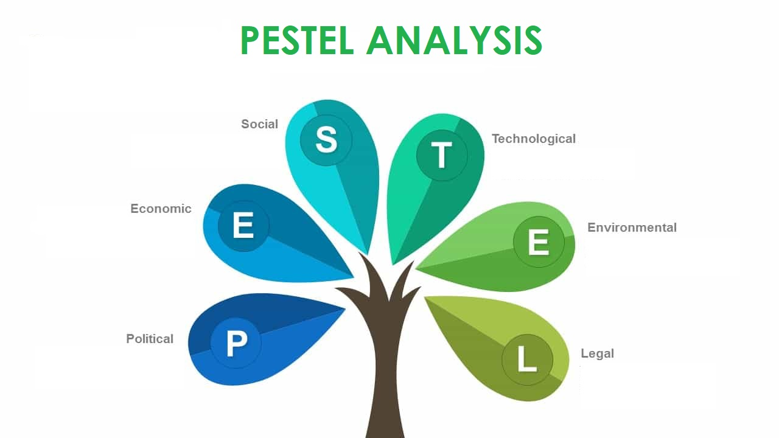
Figure: Pestel analysis (Yüksel, 2012)

Economic factors
In the automobile industry, the economic factors affect the most. In the United Kingdom, the government also invest capital in the automobile industry. the amount of capital invested by the government affect the automobile industry any increase or decrease in the invested capital affects the activities of the automobile industry. Another factor inflation which affects the most inflation force the industry to increase the price of the automobile.

Social factors
Social factors affect many decisions of the industry as well as the decision of consumers. Society trends are ever-changing to retain the market companies like Jaguar should find out the change and make the decision according to the changing situations. Jaguar also considers the religious value and beliefs of the people working in the industry as well as the consumers (Mani, 2010).

Technological factors
In the automobile industry, all the activities rely on technology and technology is developing and changing life. Consumers always want to buy or purchase the best product. Jaguar developing their technology and is always ready to adopt new technology to improve the automobile. Nowadays Jaguar is providing lightweight cars and also working on technology to lessen driving errors and safe journeys.

Environmental factors
Jaguar operates its all activities considering the environmental factors such as minimum emission and wastage, fuel-efficient car and focusing on the use of renewable energy. Jaguar creates a standard of factors that must be considered in operating their activities first all Jaguar work on assuring minimum emission and wastage and also developing their technologies to use renewable energy resources.

Legal factors
To operate a business it must fulfil the laws and rules and regulations which are associated with the business. In the United Kingdom, the automobile industries have to maintain the laws and other trade laws and many others things to carry out their business. Jaguar has to follow all rules of trade and other foreign exporting and importing rules and workforces related laws and regulations etc (Takim, 2015).

Porter’s five forces analysis of the automobile industry
Porter’s five forces will provide a better view of the operating environment of a competition of a business.
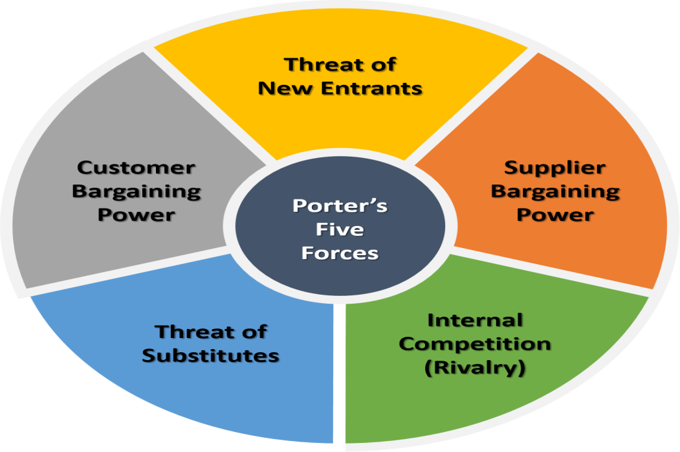
Figure: Porter’s five forces (Rawlinson, 2016)

Rivalry
Rivalry measures the state of competition with the same objectives with the same target market. Rivalry with the current industry of Jaguar with competitors is high in the automobile industry in the United Kingdom. Jaguar’s competitors are- Audi, Mercedes Benz, Bentley, Lamborghini etc. All the above-mentioned industry are operating their activities in the same market for the same target customers with almost the same kind of quality products. Jaguar should always consider the competitors offering and take decisions according to the change to retain its market. And jaguar faces high competitive rivalry (Yu and Jiang, 2020).

the threats of new entrants
The automobile industry requires a lot of capital and other resources to operate its activities. Comparatively the threat of new entrants to Jaguar is very low. Jaguar is a well-established automobile industry in the UK. For a new entrant, it’s very hard to manage huge capital and compete with the well-established automobile industry. The threat of new entrants to Jaguar is very low (Yüksel, 2012).

Threats of substitutes
The threats of substitutes are very high for Jaguar. Jaguar is one of the most renowned automobile industries in the United Kingdom for its rich and luxurious automobile. In the UK there are many automobile industries are operating their businesses in the same market with the same target customers. Such as Bentley, Audi, Ford etc. So there are many substitutes are exist for the consumers. So the threats of substitutes are very high for jaguar (Ramanathan et al., 2010).

Bargaining power of buyers
Bentley, Audi, Lamborghini, BMW, Porsche are competing in the same market as Jaguar. All of the above-mentioned automobile industries in the UK are manufacture high-quality products and offer the products to the same market target customers. When the buyer wants to buy a different manufacturing companies product then the bargaining power is very high but if the buyer wants to buy the same product from a different dealer then the bargaining power of the buyer is relatively low.

Supplier bargaining power
Jaguar automobile industry collects its different parts from different suppliers and Jaguar has to import some parts from china. So here the bargaining power jaguar is relatively for the parts that come from china. And the other parts are produced in the UK here the bargaining power of the supplier is low because Jaguar can change the supplier at any time. Overall the bargaining power of suppliers is average (Wetherly and Otter, 2014).

Conclusion
Technologies are developing with the development of technology automobile industry also developing. In the UK the automobile industry works as a whole achieving its goal to build a sustainable automobile industry. Considering the environmental factors Uk government set a target from 2030 selling diesel or petrol will be illegal. Jaguar continues its activities by strictly maintaining all the factors as well as developing its technologies to achieve long term goals and build a sustainable automobile industry. By analysing the data of Jaguar through SWOT, Pestel and Porter’s five factors we found that almost all of the factors are in favour of Jaguar. Jaguar is in a good position in the automobile industry in the UK. Jaguar should focus on developing technology and adopt new technology to build up a sustainable automobile industry.

References
Davis, S., (2019). Council Post: How Can Adapt To An Environment Of Change. [online] Forbes. Available at: <https://www.forbes.com/sites/forbesagencycouncil/2017/10/12/how-can-adapt-to-an-environment-of-change/> [Accessed 11 December 2019]
Lucky, B.O. and Takim, S., (2015). Manufacturing defects in the automobile industry, a case study of the remote causes and effects of transmission malfunctions in cars. International Journal of Production Management, 2(8), p.257854.
Ramanathan, R., Black, A., Nath, P. and Muyldermans, L., (2010). Impact of environmental regulations on innovation and performance in the UK industrial sector. Management Decision.
Rawlinson, M. and Wells, P., (2016). The new European automobile industry. Springer.
Sathasivam, K., Hashim, R.C. and Bakar, R.A., (2021). Automobile industry managers' views on their roles in environmental sustainability: a qualitative study. Management of Environmental Quality: An International Journal.
Wetherly, P. and Otter, D., (2014). The business environment: themes and issues in a globalizing world. Oxford University Press.
Yu, Y. and Jiang, J., (2020). Analysis on the impact of new energy automobile industry support policy on the regional economy. IOP Conference Series: Journal of European Business Research, 467(1), p.012209.
Yüksel, I., (2012). Developing a multi-criteria decision-making model for PESTEL analysis. International Journal of Business and Management, 7(24), p.52.
Zhikang, L., (2017). Research on the development strategy of automobiles based on SWOT analysis. Procedia Engineering, 174, pp.324-330.

