UWTSD

TITLE:
Write an appropriately structured academic report where you reflect on your learning in this module, using a recognised model of reflection (one). Discuss 3-4 topics from those covered during the term (listed below) and reflect on how useful they have been to you, taking into consideration what you already knew and any learning you undertook outside of the classroom. You will need to explain the chosen model of reflection and apply it to each topic. You will also need to analyse published literature relating to the specific topics you discuss and use the feedback you received on all in-class activities.

Dayami Dos Santos (2022551)
Academic and employability skills
bMSW4001
Lecture’S NAME: SHAO-LAN YUEN

Content
- Introduction …………………………………………………………………………..p 2
- Time Management …………………………………………………………………..p 3
- Referencing …………………………………………………………………………..p 5
- Plagiarism …..…………………………………………………………………………p 6
- Conclusion …………………………………………………………………………….p 8
- References…………………………………………………………………………….p 9

Introduction

When I was told about this assignment at first a felt lost, not knowing where to start, at the time my lecturer introduced me to various methods of reflection but after going through each one of them, I identify myself the most with the one created by an American educational theorist named Kolb in 1984, referred to as an Experiential Learning.
A model of refection helps us understand our own thinking and learning strategies, as well as compare new knowledge to our previous understanding (Kolb,1984). On this report, I will be using the model of reflection created by Kolb, to explain my learning process and I will also be discussing about how learning about time management, referencing and plagiarism has been useful to me to, while applying the above-mentioned model of reflection on each topic.
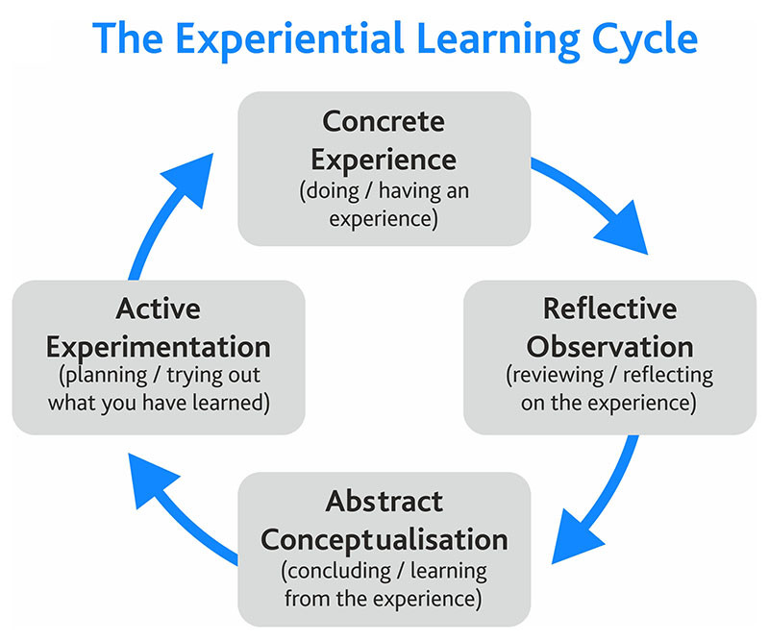

Model of Reflection by Kolb,1984

Time management

When talking about time management, my mindset was turned to the simple affirmation that for many years was part of my life, there is never enough time to do everything you have to do and this affirmation drove me many times into asking myself, how can I be more strict and rigid with time management without procrastinating and having things done by the time they are supposed to? But I never put effort towards solving this matter because my mindset was as described by expert Dweck, 2017 a fixed mindset, thinking that I could not change in any meaningful way.
Since starting with my ACE classes, I had the chance to learn new methods that at first seem to be very basic but when applied with commitment, they turned to be real life changing.
One of them is the Eisenhower Matrix, as a result of this lecturer, I learned to prioritise my activities based on urgency and importance. I started to prioritise my time by doing more important things first, planning my daily activities in advance or as taught by Tracy, 2010 on the book Eat That Frog, set the table and eat a live frog first thing in the morning, so that is what I did.
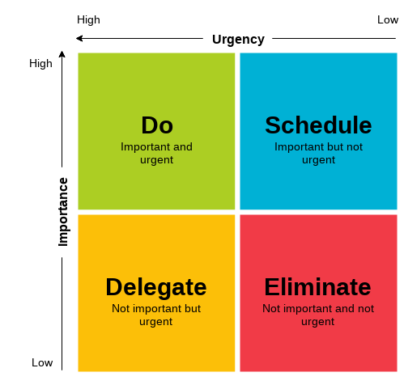
Eisenhower Matrix by Dwight David

At the time one of my biggest difficulties was to do some physical exercises in the morning instead of spending an entire hour on Instagram, so after learning this method I started by ‘eating that frog’, I now exercise at least 3 times a week, and this has been causing a huge impact into my daily routine as well as changing the way I think. I no longer consider myself as a person with a fixed mindset but as someone who is open to improvements, constantly training myself through repetition and practice to overcome procrastination and get my most important tasks completed quickly.
While writing this report, I had the chance to combine the Eisenhower Matrix with the model of reflection created by Kolb and I was amazed with the results.
When told about this report, I was certain that it would be a challenging experience, because I have never written an academic report before, that is when I identified the stage I was (concrete experience). I work full time and having to write 2000 words report, would require a lot of time and effort. I needed to act, find a way to organize my time and ensure that all my activities worked in harmony. So, I started for the first time in my life to plan my daily activities in advance, so that I could have at least 2 hours per day dedicated into doing some research, looking for ways of improving my existing skills (Reflective Observation).
One of the things I learnt with Kolb,1984 when presenting his model of reflection is that it is important to ask yourself questions regularly when seeking for improvement and I totally agree with this argument.
The more I planned my activities in advance, the more I started asking myself questions reflecting on what has worked on the previous day, what needed to be changed, was there anything I could do to make my daily planner work in a more efficient way, how do I write an academic report by only using two hours of my day, where do I start, etc…
Those questions lead me into a new stage, where I started to do numerous researches. After consulting friends that have once found themselves into the same situation as me, I have started watching Ted talks, reading books and spoke to my lecturer who assisted and explained me exactly what I was supposed to do, making this process less scary (Abstract Conceptualisation).
The time came where I needed to put all the gathered information during the first few steps into practice and as expected, I started to see a lot of improvements, by taking 2 hours of each day, my report started to gain form and there was harmony between my academic responsibilities and work.
I followed my daily plan as I should and ironically started to identify gaps in between my time such as the one hour I spend on the train on my way to work, as a chance to read a book that will contribute into my personal self-development and academic reports (Active Experimentation).

Referencing

Before this class I knew very little about referencing, the importance of it or even the purpose of using it (Concrete Experience). I knew that it was necessary for me to invest time to do some research, as referencing is something that I will need to use many times in my academic life. After this lesson, I had the chance to learn that referencing is a way to acknowledge the contribution of writers or researchers in our own work, by referencing we recognise the work of experts that for many times spend years of their lives dedicated to research about a specific subject (Reflective Observation).
On the other hand, I have also learnt that referencing needs to always be accurate, in order to allow our readers to trace the sources of information consulted while writing an assignment. It helps us to build a web of ideas, support our voice in academic writing, validate arguments, spread knowledge and it also helps to avoid plagiarism, Neville (2010).
Something that I did not know, and I was very surprised is that referencing does not only apply to books or videos, but we can also reference any idea coming from sources such as journals, articles, personal interview, emails, letters, etc...
Before, I found it difficult to reference from videos, for not knowing how to properly do the referencing at the end, for many times I ended up not using any information coming from videos even though it had very important facts that could be of use to my work, because I was afraid of committing plagiarism. Now, after consulting my lecturer, I know how to do it in the right way and whenever I need to use any information coming from a video, I will do it with confidence (Abstract Conceptualization).
According to Neville (2010), referencing is a part of a societal value system that vigorously support the idea of intellectual property rights of others, I strongly agree with this affirmation, it is important to recognise other people researches and I see it as a way of appreciating their time and effort. I feel much more confident when it comes to referencing and ready to use it without limitations in my future academic assignments (Active Experimentation).

Plagiarism

Plagiarism is certainly a term that I was always familiar with but never truly understood the meaning of it (Concrete Experience).
When I started this course my understanding of writing a report was very little, I knew that I would have to do it, but I was not aware of the responsibility that comes with it, the rules that need to be followed. After going through some classes in this module with my lecturer, I started to realise that it would be a challenging experience, and when I was truly introduced to the concept of plagiarism, I confess that I was scared.
I did not know if I would be able to do it, I started doubting myself, I realised that I would need to put more effort into doing my assignments and reports as thought before, but I knew that with the right mindset and effort I would be able to overcome any obstacle, not commit plagiarism and get a great grade.
After doing some research, I learned that plagiarism is when we use someone else’s ideas or words as one’s own, by intentionally incorporate into our own work without full acknowledge the work of others Neville,2010.
Plagiarism is also known as academic dishonesty and it can lead to serious consequences. As a new student I found it extremely important to be fully aware of the consequences we can encounter when committing plagiarism, the types of plagiarism and the rules that need to be followed in order to avoid committing it (Reflective Observation).
Neville,2010 says that many of the frustrations and insecurities presented by students are due to the fact of being accused of plagiarism. Over the past decade, discussions about plagiarism have been a dominant concern in higher education and it seems that many students have learned about it, however, it has also limited others when it comes to express their point of view in assignments, due to the fact of being scared to commit plagiarism.
As millennials, I believe that plagiarism will continue to be a matter that universities and colleges will never stop discussing, we live in a technological world, future generations are being controlled and limited by it, it is easier and more tempting to look up at something on the internet than read a book and this eventually will become a ritualized behaviour.
Among all the existing reasons to plagiarism, I believe that pour time management has proven to be the main one, starting too late and eventually run out of time, can cause a huge amount of stress, the fear of getting a bad grade will lead us into cooping our work from the internet (Abstract Conceptualization).
Tracy, 2010 says that a person who develops the habit of setting clear priorities and getting important tasks completed quickly will run circles around a genius who makes wonderful plans but who gets very little done.
By setting clear priorities, I started to learn more about summarising, referencing and paraphrasing in order to avoid plagiarism. Therefore, I feel much more confident after going through all this learning process, by applying these concepts in the right way I will be able to success in my academic life. The fear of failing still exist, but I also believe that there is no limits to what you can accomplish.

Conclusion

Writing this report has given me the chance to improve and widen my learning methods, Kolb’s model of refection has increased my self-awareness, creative thinking and encouraged me into always look for different possibilities. This repost has changed the way I think and who I was, I see myself now as a risk taker, more confident and with an open mindset. Changes can be tough, but always worthy.
2002 words

References

Tracy, B. (2010) Eat That Frog: get more of the important things done today. Hodder and Stoughton, An Hachette UK Company, Great Britain
Dweck, C. (2017) Mindset: changing the way you think to fulfil your potential. Robinson, New York
Neville, C. (2010) The Complete Guide to Referencing and Avoiding Plagiarism. MC Graw Hill Open University press, New York
Kolb, DA. (1984) Model of reflection https://www.simplypsychology.org/learning-kolb.html (accessed on the 28/03/2021)
Scribbr, (2020) what is plagiarism? https://youtu.be/Uk1pq8sb-eo
https://www.scribbr.com/category/plagiarism/?utm_source=youtube&utm_medium=description&utm_campaign=plagiarism (accessed on the 28/03/2021)
Einsenhower matrix imagine https://www.eisenhower.me/eisenhower-matrix/ ( accessed on the 27/03/2021)

