
How to promote understanding of the importance of effective communication for young children’s learning and development during transitions, for key workers in early year’s settings.

Context page.
Introduction. p 3

The role of the adult p 4

The needs of the child p 6

Partnerships p 8

Interventions p 9

Proposed outcomes p 10

Reference list p 11

Introduction.

This handbook is aimed for Early Years Practitioners to help with a smooth transition for the child in your care and provision. The purpose of this handbook is to promote and understand the importance of effective communication for young children’s learning and development during transitions from different settings and homes to the nursery school setting for the age of 3-4 years old. Having a smooth transition can help the child feel more secure and feel in control of the situation, with the help from the child’s parents and practitioners. Supporting the child’s needs from the very beginning will help to progress the child’s outcomes.

Transition
A number of transition occurs throughout a child’s life. The term transition means the process of movement from one place to another. This may require adjusting to a new peer group, new adults, new environment and new expectation. When starting a new setting children face new experiences including developing contact with unknown people and the environment. The practitioners plays a key role in maintaining the child’s self-esteem, experiences and well-being when they are making the transition to the setting from a different setting e.g. private nursery, creche, flying start, home, by tailoring the transition to the needs of the child. Practitioners need to have a clear understanding of the impact transition has on children’s experiences and how it can have on their future progress and development. Kelman and Lauchian, (2010). Settings need to have a good communication with the child’s parents and with other partnership to maintain a positive relationship and to construct a platform for a secure development for the child. A young child is totally dependent on the person who matters to them most and the comfort they provide, the child will value themselves only if they know they have the unconditional love of a parent or carer Dowling, (2014). A smooth transition can make a positive impact for the child in these areas cognitive, social and emotional development and there are lots of theories that support this.

Sourced quizlet.com
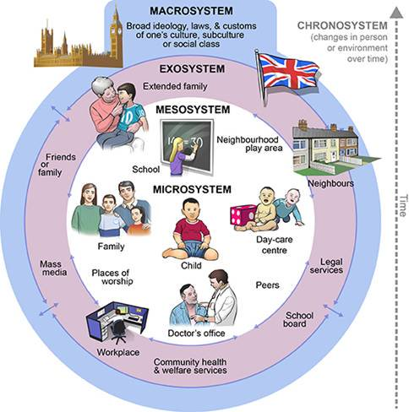
Urie Bronfenbrenner’s theory expresses that a child’s development is affected by everything in their surrounding environment. Children’s development is affected in complex and profound ways by the culture in which they grow up. (Doherty and Hughes, 2009).
The microsystem: Refers to the system closest to the individual; this included people whom they have direct contact.
The Mesosystem: Refers to the interactions which are a result of an extension of their microsystem
The Exosystem: Refers to the setting a person is in.
The Macrosystem: Refers to the larger society- its values, laws, conventions and traditions
Understanding the influences and different circumstances in which children live and how they are brought up are important on how children develop. Stability and home location are factors that influence the experience the child has. As practitioners giving the child a stability in routine and building a good communication with their microsystem can provide an understanding of the individual needs of the child.

Role of the adult.

Practitioners need to build a good relationship with the child, and their parents during a transition it can be very stressful for the child and their parents to make these changes however making the child comfortable, finding out what the child’s interest, likes and dislikes can build the child’s self-esteem and feel secure. Parents are the child’s first and most important educators and should therefore be involved in their early years learning experiences, this can be done by informing the parents with their progress or their work and by celebrating their achievements. According to Doherty and Hughes, (2009) the children of parents who show love and care are secure in themselves and know how to return affection. Harsh parents are confusing for children and make the learning of socially accepted norms difficult.

Practitioners need to spend time with the children who feel insecure in a new setting and emotionally dependent on an adult. According to Dowling,(2014) a key person is helpful for the child to reassure that they are never on their own, this reassures and prevents anxiety, also the child feels in control of their feeling when he gets to know the pattern of the day. Children develop in different rates, this requires them to allow to develop at their own pace. Practitioners need to plan according to the child’s needs and skills for the child to become a confident learner. The child’s experiences when they enter the setting need to be recognized and considered this can be done by observing and recording the child and then evaluating the outcomes. Practitioners gain greater understanding the needs of the child when conducting observations. Children’s individual needs can be met by recognising their differences and acknowledging that they have the right to be treated with respect Leech, (2008).
Children need to have access to a variety of media to express themselves and opportunities to apply their imagination in a purposeful way. WAG, 2008. As children learn new skills they should be given the opportunities to practice them in different situation reflect and evaluate their work, children’s work should be respected, valued and celebrated. Vygotsky’s concept of scaffolding is closely related to the concept of the zone of proximal development. Scaffolding refers to the temporary support given to a child by More Knowledgeable Others, usually parents or teachers, that enable the child to perform a task until such time that the child can already perform the task independently, (Psychology notes 2018).

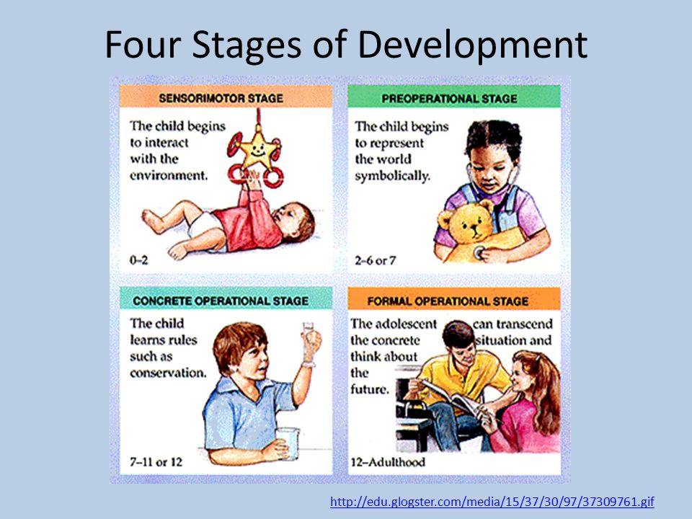
Historically Jean Piaget’s theory believed that children learn by observing, experimenting and interacting with the world around them. They add new knowledge, build upon existing knowledge and adapt their previous knowledge to accommodate new information. (Cherry, 2018). Piaget theory of cognitive development suggest that children move through four different stages of mental development. Piaget also argued that a child does not start out as a thinker, but through developing schemes/schemas which are organized ways of making sense of an experience. As children grow older they develop new schemes and build on existing ones and become better at developing and refining. Doherty and Hughes, (2009).
The United Convention of the Rights of the Child (UNCRC) state in article 12 that ‘children have the right to say what they think should happen, when adults are making decisions that affect them, and have their opinions taken into account,.’ Welsh Gov,(2015). Children’s voice should be respected and included in the planning. A well planned curriculum gives children the opportunity to make choices be challenged and progress in their development. WAG (2008).
The environment helps children to develop physically and be independent. A well-organized setting can increase opportunities for children to use their imitative, Dowling, (2014) .
Dowling, (2014) emphasizes on Reggio Emilia that the environment is the third teacher, it plans the setting to promote independence and thinks about the layout of the setting. The quality of children’s self -chosen play is influenced by the quality and range of continuous provision.
Montessori settings also encourage children to select apparatus for themselves rather than have it readily available on the table.
Steiner settings emphasize children developing their own ideas through using open ended and natural materials.
Children should be encouraged to use the environment and make decision with whom they like to play and also determine what they do with their time. Bilton, (2010) suggests having objects and resources which can be adapted to the need of the child, where there are loose materials and equipment’s children have to be involved in more sustained play this impacts on the level of learning.
With the new curriculum Donaldson reviews that practitioners should have more control of what and how they teach. The report suggests teaching and learning that focuses on:
- The purposes of curriculum.
- Challenging children to be the best they can be.
- Giving opportunities for problem solving, creativity and critical thinking.
- Setting tasks and resources that build on knowledge and skills.
- Creating real-life opportunities for learning.
- Encouraging children to take responsibility for their own learning.
The high expectations embedded in the Progression Step will only be realized through effective teaching that engages children’s curiosity and enthusiasm through a blend of teaching and learning approaches. (Gov.Wales,2018).
Sourcedpinterest.com
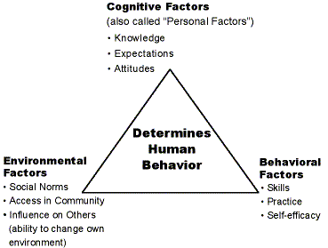
Bandura’s social learning theory emphasizes that people learn from one another, via observation, imitation and modelling. Children are surrounded by many influential models such as parents, family, media, friends and teachers. These models provide examples of behavior to observe and imitate. Bandura’s experiment with Bobo dolls concluded that the children were motivated to imitate what they believed were valued ways of behaving. These findings are powerful reminder of the need to show children the positive behavior and loving relationship. Dowling, (2014). Practitioners need to value every child and respect their personal and cultural identity and develop methods that support ethnical and cultural identities of all children. Children need to be engaged in arrange of knowledge to prepare them for life as global citizens. WAG (2008)

The needs of the child.

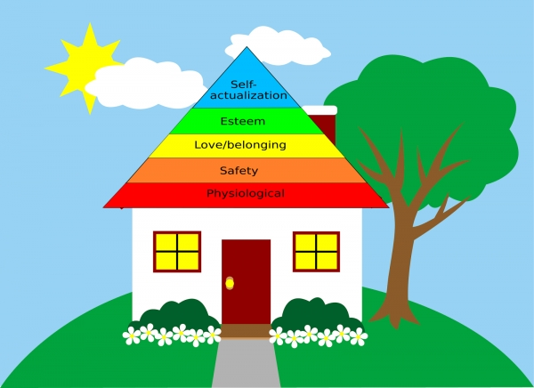
Maslow hierarchy of needs represents the individual where needs, need to be satisfied before they can attend to needs higher up. The child’s needs to fulfill the physiological needs before their cognitive needs can be met. The child needs to feel physically and emotionally safe and be accepted to progress and reach to their full potential. Motivation to achieve basic needs for physical survival will motivate the behavior and fulfill the next level up. Maslow looks at the complete physical, emotional, social and intellectual qualities of an individual and how they impact on learning. McLeod, (2018).

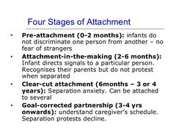
Bowlby attachment emphasizes the importance of a secure and trusting mother-child bond on development and wellbeing. The quality of attachment has an effect on development and has been linked to various aspects of postive functioning, such as psychological well-being. Bowlby believed that children have an natural need to develop a close relationship with one main figure, usually the mother. When this does not occur , it has an negative impact on the development, causing a decline in intelligence, depression, aggression, behaviour and effetionless. McLeod, (2007). Children thrive on familarity and predictability and these involve ensuring a continuity of attention through a key person developing a personal realationship with the child, this forms a special association with both the child and his parents. A key person approach ensures consistency, a postive attachment will experience a close, effectionate and reliable relationship and the child are helped to feel unique and special. Dowling,(2014).
Sourced Pinterest.

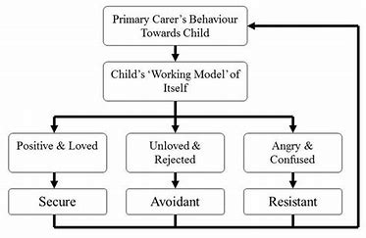
This internal working model is a cognitive framework made up of mental representations for understanding the world, self and others. A persons interaction with others is guided by memories and expectations from their internal model which influence and help evaluate their contacts with others. According to Bowlby, once an attachment to another person has been established the child re-creates, in each new relationship, the pattern with which he is familiar. McLeod, (2018).
Sourced pinterest.com

Play provides the conditions for developing confidence, generates critical thinking and increases self-belief. One way to developing confidence is to encourage children to play in situations where there is no right or wrong ,they can learn to explore, think about solving problems and interact with peers and adults Moyles (2010). Each area of learning must be planned and provide purposeful play that also include skilled teaching, establishing a context to engage children in learning as this way children can develop and improve their language and improve their communication skills. Rodger,(2016) suggests that activities should be designed to build on regular, accurate assessment of children’s learning, knowledge and skills. Activities need to be adjusted to meet the needs of individual children and groups who need support in learning.

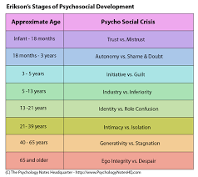
Erikson’s stages of Psychosocial development emphasizes that personality develops in a predetermined order through eight stages of psychosocial development, from infancy to adulthood. During each stages the person experiences crises that could have a positive or a negative outcome for personality development. Successful completion of each stage results in a healthy personality and strengthens characteristic, whereas failure to complete a stage can result in failure in ability to complete further stages this can impact on the
lack of personality development. However these stages can be resolved successfully at a later stage. (McLeod, 2007). This highlight’s that children in a nursery should explore freely trialing and making mistakes and learn without practitioners criticizing there mistakes. As children play, their brain develops, their muscles grow strong and they develop good social and life skills such as sharing, taking turns, making choices and understanding the feeling of others.
Sourced pinterest.com
The play policy in Wales state that play is the elemental learning process by which humankind has developed. Children exhibit a behavioral imperative and instinctive desire to play. children use play in the natural environment to learn of the world they inhabit with others. It is the very process of learning and growth, and as such all that is learnt through it is of benefit to the child. Wales Gov,( 2018)
According to Dowling,(2014) a physically independent child is likely to adapt more easily to the setting, whereas a more dependent child needs time and encouragement. Physical and functional independence allows children to feel more in control of their own life and gives them self-respect, with close support and encouragement from the practitioners this can be achieved by teaching the child in little steps and then gradually stepping back when the child is more competent.

Partnerships.

Supporting children in transition also implies the need to work with parents. When parents choose to send their child to the nursey, the are demonstrating a great act of faith in the people who will be taking care of their child. Good communication between the parent and the practitioner can help practitioners to form a rapid and meaningful bond with each child. Such details can highlight children’s behavior in different situations. According to Dowling, (2014) staff and parents need time together in order to encourage parents to respond to the request. Parents will respond if they are convinced that their knowledge is not only valuable for staff, but also important in helping their child to settle happily, feel known and make progress.

Practitioners need to respond to real questions, concerns and communicate ways in which staff bond with the child, get to know them support their behavior and help them develop good relationship Dowling, (2014). Practitioners need to have good communication in the setting with other practitioners this can support the child by acknowledging and sharing information regarding the child’s health for example if there is any allergies, developmental delays, physical needs.

Partnership working provides opportunities for needs to be met collectively as well as individually so that the needs of families can be address in a unifies way ( Gasper,2010). Education, Health and Social Services work together with families by listening and organizing, planning, undertaking and reflecting on the needs. When working in partnership with different agencies practitioners can gather information on the background of the child and their families, needs can be dealt with holistically and with regards to the whole family where necessary, get support from the professionals and the child’s developmental needs can be highlighted before the child comes to the setting giving the practitioners knowledge of the child.

Interventions.



Home visits.
Practitioners can have an insight of the background the child is coming from. Practitioners can work with parents and share the upbringing of their child during the early years. Practitioners need to communicate by exchanging information with families, work together to understand children’s development and respect and support families. According to Dowling,(2014) having this direct contact with the parents can make parents feel supported to bring up their child. Parents need to be given information about policies and daily procedures, this can be done with a welcome pack with details and photo’s of staff and ways parents can help their child with the transition.

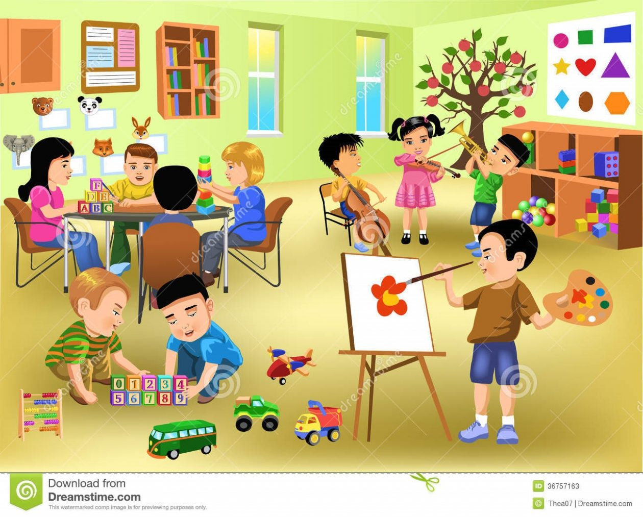
Open Day.
This gives the child to become familiar with the environment at the setting. Visiting the setting and meeting the staff can reassure the child and build up their self-esteem. Dowling, (2014) suggests that the key person should be available to talk informally, in this way parents will get to know the qualities of the key person, they can observe how the key person relates to their child and see how they can make the attachment.
Sourced Glowblogs.com

Sourced biblioottawalibrary

Stay and play.
This gives the parent’s an insight of the daily routine that their child follows during their time in the nursery. Parents can get the opportunities to watch and play with their child this can help with the development of their child by communicating and understanding the importance of play for children to develop in all arears of development. Stay and play gives the opportunity for communication between the child, parent and practitioners to discuss any concerns that they may have. Moyles,(2010) states actively involving families in order to share understanding of children’s lives, providing relevant, challenging, playful learning opportunities.

Proposed Outcomes.

A successful transition for a child is understanding that every child is unique. Preparing and understanding the importance of children’s experiences can make the children feel secure and settle into the new setting .Emotions that comes with change can be handled when the setting has a clear welcoming procedure. Children cope better with transition when the environment is similar, communication is clear and understanding that the process of change takes place gradually over time.

All families are important and different they should be welcomed and valued in setting and be involved in their child’s learning and development. Positive relationship can ease transition by planning, sharing information and listening with the parents throughout the process. Offering a range of opportunities for parents to access information about the transition process and by working together to provide a clear understanding of an effective transition.

Provision for children should be holistic with the child at the heart of any planning, practitioners need to promote positive attitudes and equal opportunities and encourage participation in all areas of the setting. The Foundation Phase curriculum promotes a holistic development of children, building on their experiences, knowledge and skills. First hand experiences to develop the children’s understanding of themselves and the world they live. Building the child’s self-image, self-worth and self-esteem. The curriculum meets the diverse needs of the child and focusses on the stage of learning rather than age related outcomes. WAG,( 2008).

Commitment from all professionals involved to promote a smooth transition by developing communication links in order to promote continuity for all the children experiencing transition between settings, it is important that there is a shared approach between all those professionals involved.

Practitioners must ensure that children learn and develop well and are kept healthy and safe. In early years setting children should have consistency and good quality teaching and learning, equality of opportunities and anti-discriminatory practice ensuring that every child is included and supported and makes good progress. Promoting effective communication and language in the early years is vital. When planning and guiding children’s activities, practitioners need to understand the different ways children learn and reflect these in their practice. Rodger,(2016).

Reference List.

Bee H. & Boyd, D.G. (2013) The Developing Child (13th edition) Essex: Pearson Education Limited.
Bilton, H. (2010) Outdoor learning in the early years: Management and innovation (3rd ed). London: David Fulton eBook.
Doherty, J. & Hughes, M. (2009) Child Development Theory and Practice 0-11. Essex: Pearson Education Limited.
Dowling, M. (2014) Young Children’s Personal, Social and Emotional development (4th Edition). London: Sage Publications Limited.
Jones, P., Moss, D., Tomlinson, P. & Welch, S. (2008) Childhood Services and Provision for Children. Essex: Pearson Education Limited.
Leech, S. R. (2008) How to observe children. 2nd ed. Essex: Heinemann.​
​
McLeod, S. (2007). Bowlby’s Attachment Theory. Available at: https://www.simplypsychology.org/bowlby.html (accessed 20th Nov 2018)

McLeod, S. A. (2008) Maslow’s hierarchy of needs. Available at; https://www.simplypsychology.org/maslow.html (Accessed: 18th October 2018).​

McLeod, S. (2016). Bandura- Social Learning Theory. Available at: https://www.simplypsychology.org/bandura.html (accessed 19th Nov 2018)

McLeod, S. A. (2018). Erik Erikson's stages of psychosocial development. Available at: https://www.simplypsychology.org/Erik-Erikson.html (accessed 21th Nov 2018)

Moyles, J. (ed) (2010) The Excellence of Play (3rd Ed). Maidenhead: Open University Press.
Moyles, J. (ed) (2010) Thinking about play: Developing a reflective approach. Maidenhead: Open University Press.
Oswalt, A. (2018) Urie Bronfenbrenner And Child Development. Available at: https://www.mentalhelp.net/articles/urie-bronfenbrenner-and-child-development/ (accessed 25th Nov 2018).
Play Wales, (2018). Play Policy. Available at: http://www.playwales.org.uk/eng/playpolicy (accessed 21th Nov 2018)

Psychology notes HQ. (2018). Vygotsky Sociocultural Theory of Cognitive Development. Available at: https://www.psychologynoteshq.com/vygotsky-theory/ (accessed 20th Nov 2018)

Rodger, R. (2016) Planning an appropriate curriculum in the early years: A guide for early years practitioners and leaders, students and parents. (4th ed). London: Routledge.

Sarrah. (2015). The importance of Bronfenbrenners’s theory in relation to developing positive relationship. Available at: https://sja1blog.wordpress.com/2015/10/13/the-importance-of-bronfenbrenners-theory-in-relation-to-developing-positive-relationships/ (accessed 21st Nov 2018).

WAG, (2008). Foundation Phase: Framework for Children’s Learning for 3 to 7-year-olds in Wales. Wales: Crown

Welsh Gov, (2015). Successful Futures. Available at: https://beta.gov.wales/sites/default/files/publications/2018-03/succesful-futures-a-summary-of-professor-graham-donaldsons-report.pdf (accessed 18th Nov 2018)

Welsh Government. (2015) A summary of the United Nations Convention on the Rights of the Child. Wales: Crown.

