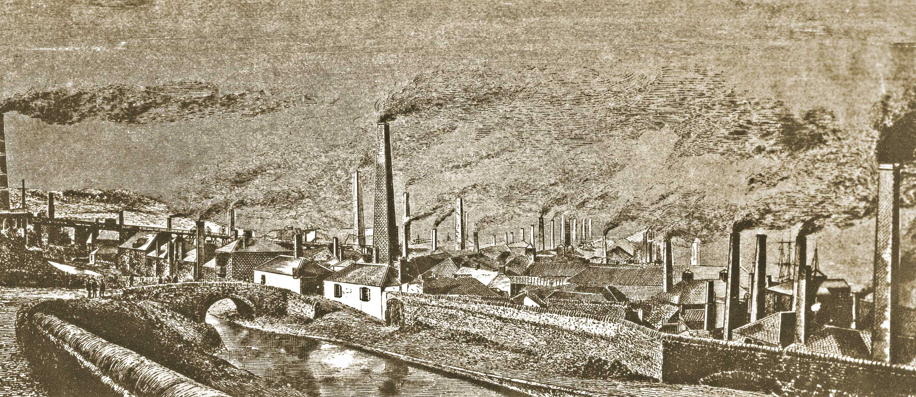

Assessment 1
In this assessment I am going to be talking about the distinctiveness of the lower Swansea valley and how it was a part of the era of the industrial revolution, and everything that led to it. The industrial revolution, now mainly known as the first industrial revolution was the transition too new manufacturing processes in Britain, Europe and the united states.
The industrial revolution led to a huge rise in Swansea’s local economy. It brought wealth to the people of Swansea. This then eventually led to the transformation of landscape and a quick and huge rise in population in Swansea.
The industrial revolution began in the 18th century. It first began in Britain but later spread throughout the whole of Europe and north America. Some aspects that historians do believe were causes for the industrial revolution were the emergence of capitalism, European imperialism, the efforts to mine coaling and the effects of agricultural revolution. (history crunch writers 2017)
The lower Swansea valley was well placed, on the coast of south wales coalfield with also remarkably good access to copper ores. Copper ore was first founded in Cornwell, and Anglsey bit from the early 1800’s it became available in a lot of other parts of the world. Glamorgan conquered the British production of copper and the world centre for copper smelting. The copper in the area was first began in Neath this was in the early 1500’s. this was when the first copper smelter was established. The first establishment in the Swansea valley was the Llangyfelach works in Landore in the early 1700’s. This was eventually followed by the Cambrian works. White rock copperworks was founded on the east bank of the tawe in 1737.
During the industrial revolution era, the lower Swansea valley did have some environmental issues. At the time of the industrial revolution there was almost no environmental rules or controls legally in place, this caused a huge contamination in water and on land caused by toxic and severely dangerous pollutants. Before this the river Tawe had already previously been polluted by the coal mining industry and it suffered tremendously. The factories also cause a huge amount of air pollution.
During the time of the industrial revolution working conditions were poor and dangerous for the workers. The lighting was not the best in the factories, making it awfully hard for the workers to be able to see what they were doing. Many of the factories were filled with dust, this made it hard for the workers to breathe, and unlike today they did not have the options to wear the appropriate gear like a mask and goggles. The dust pollution also increased the risk of the workers developing diseases such as cancer, so they most definitely put their lifes at risk during this time. A lot of workers were working 12-hour shifts, 6 days a week. They worked extremely hard. A lot of the time they did not get any days off or any paid holidays unlike today where people are entitled to these days off.
During the time of the industrial revolution technology was not as advanced as it is today, technology has an extreme amount since then. At the start of the industrial revolution power was made by using natural power sources such as water and wind, but as the years went on new ways to make power were founded, these were steam power and electricity. Electricity is now a huge part of everyday life today, but it played a huge role in allowing the industrial revolution to grow.
The industrial revolution started an enormous deal of change in the society. It marked a dramatic change for women as this is when many of them decided to enter the work force for the very first time. Unfortunately female factory workers made one third less than men. This then led to women wanting this to change, as it was very sexist. Eventually in doing this women demanded the right to vote which thankfully was later granted.
The industrial revolution brought a huge increase in population, it also created a new working class. The new class of industry workers included all men, women and children. As we discussed previously the women had a low paying wage, but the low paying wage also applied for the children too. No matter where they were working or what the working conditions were children and women were paid less. But for many during the industrial revolution there was a huge increase in wealth, the production of goods and the standard living. People had better access to healthier diets, better housing, cheaper goods. Education also increased during the industrial revolution. (lcps 2014)

References
www.lcps.org
www.histroycrunchwriters.com

