Emerging IS/IT in Health and Social Care Settings (International Context)
Introduction
To address evolving challenges across health and social care settings, there is an active global demand to implement modern, innovative digital technologies. Two distinct themes contributing to this challenge are an ageing population and chronic disease prevalence, which can affect both workforce capacity and efficiency, and rather than asserting more of the same resource, meaningful digital transformation is needed. (Wolf, H.F., 2025)
The rise and exploitation of Artificial Intelligence (AI) within the medical field has been fuelled by the growth of clinical data capture, and breakthroughs in deep learning (DL) and machine learning (ML), which has seen improvements in accuracy and efficiency when supporting clinical decision making (Meca A, Ali M, 2024).
Digital health advocates believe Remote Patient Monitoring (RPM) has the potential to transform disease management, health outcomes, and patient care, especially for individuals with multiple chronic conditions who lack convenient access to providers (Future of Remote Patient Monitoring (2024). Bipartisan Policy Center).
Both AI and RPM have a proven potential to enhance health outcomes by improving medical diagnosis and data-based treatment decisions as well self-management of care and person-centred care (Global strategy on digital health 2020-2025). This essay will provide explore both technologies and provide insight, analysis and comparison, whilst considering their strength, value and limitation within the global health and social care setting
No generative AI was used to produce content within this document.

Methods
Provide a brief description of how evidence was identified and selected. Include:
- RPM study used - Mayo Clinic USA, delivered over three main campuses (Minnesota; Arizona; and Florida). This was selected as a strong example, as there was an established integration of RPM medical devices prior to the COVID-19 healthcare crisis and the requirement to rapidly respond to the pandemic.
- Exploration through PubMed and Google Scholar
- UWTSD digital resources library

Review of emerging technology 1 - Remote Patient Monitoring (RPM), or Telemonitoring
The aim of RPM or telemonitoring is to improve patient care through digitally transmitted health-related data, which support early detection of disease decompensation and intervention, increased patient education and improves patient–physician relationship (Farias, F.A.C. de et al. 2020).
The history of RPM can be traced back to a key milestone event during May 1961, when NASA successfully tracked an astronaut’s biological data via electrocardiogram (EKG) in real time from the ground. Over the following decades, RPM experienced a slow-but-steady growth, but it was the COVID-19 pandemic which propelled this technology to the forefront of medical revolution (Hegde, S. and Eid, N.S. 2021).
In address to the pandemic the Mayo Clinic Centre for Digital Health, USA (the largest integrated, not-for-profit medical group practice in the world), in partnership with a multidisciplinary team of COVID-19 physicians, created a strategy to leverage existing products (including RPM technology) to rapidly support clinical management of patients with Acute COVID-19. The expected goals included a reduction in healthcare resource utilisation, greater fostering of self-management, and reductions in the cost of care (Haddad, T. C. et. al., 2021).
Two distinct Clinical workflows were established to address patients established as either high-risk or low-risk for contracting severe COVID-19 (see Fig. 1). Those aligned to the former and were identified as having one or more of the following: over 65 years of age, smoker status, BMI over 40, or some form of an immunocompromised state.
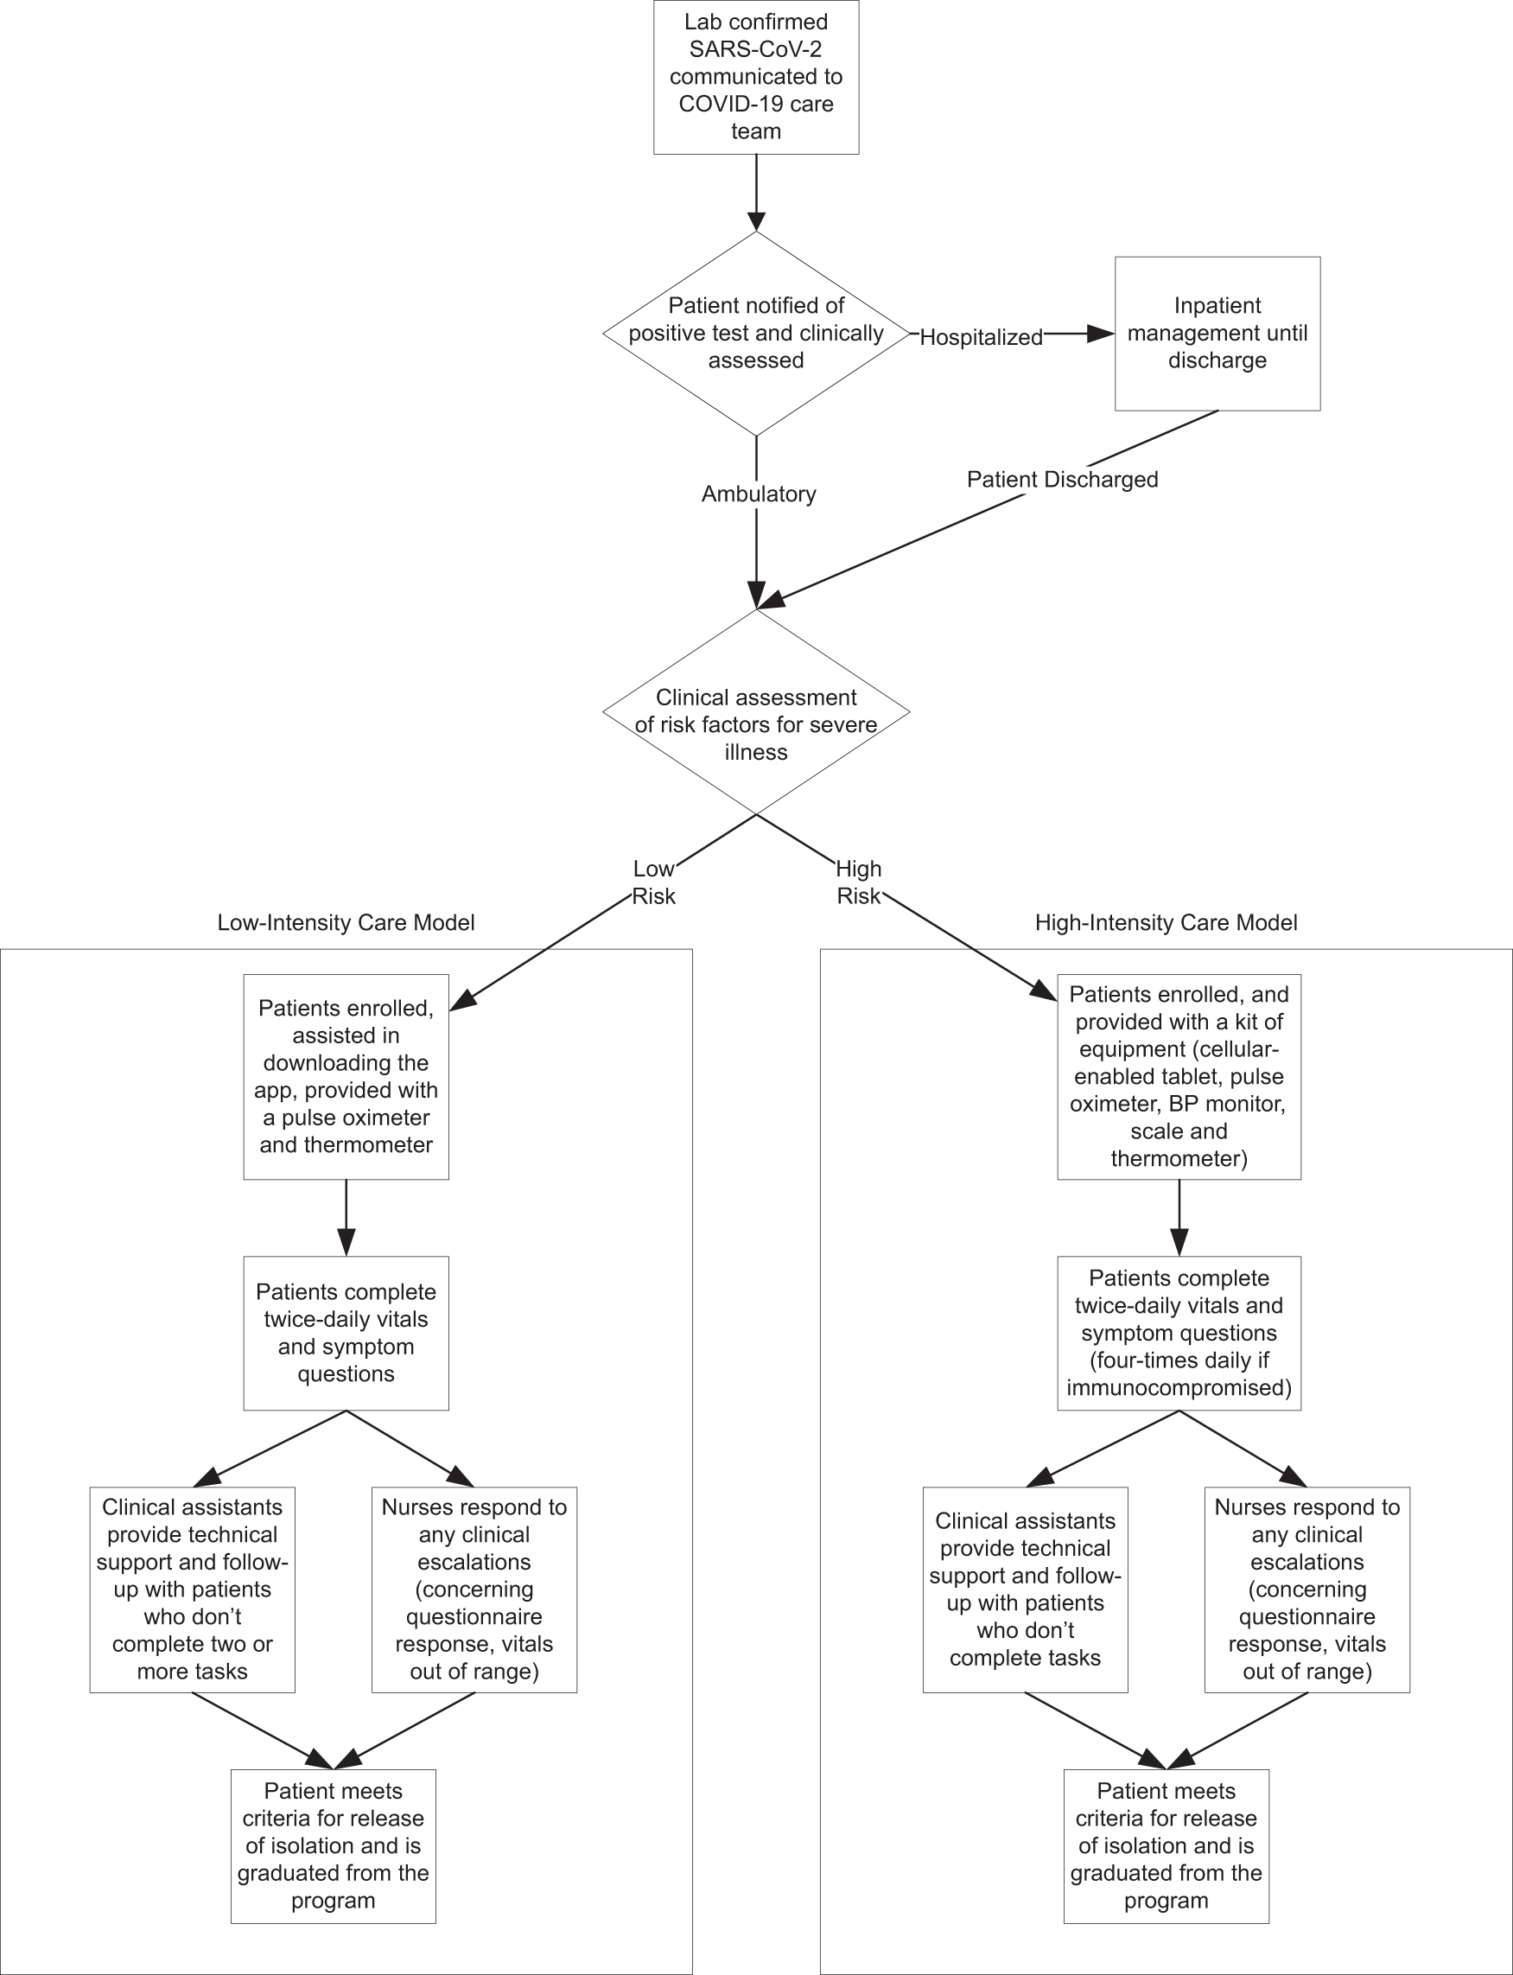
(Fig. 1) (Coffey, J.D. et al. (2021)
Dictated by their clinical assessment outcome, patients would receive care-model appropriate home-based RPM devices, including pulse oximeters, thermometers and blood-pressure monitors. Utilising these devices, patients were required to report symptom assessments twice daily, with initial clinical assessments in response to these managed by the RPM registered nurses, who validated abnormal physiologic data, evaluated concerning symptoms, and provided supportive care recommendations when appropriate. This nurse-led care model resulted in only 9-18% of alerts requiring escalation to the small core team of physicians (Haddad, T. C. et. al., 2021).
The Mayo Clinic reported successes aligned to their RPM program strategy, in which the ability to leverage existing technology as well as RPM registered nurses allowed for improved scalability across service users and the ability to review and validate incoming patient monitoring data more efficiently. A feedback statement from an Emergency Medicine physician, monitored through RPM following COVID-19 diagnosis, posted on the Mayo Clinic Health System website …
“I reported my symptoms twice a day to the RPM team. It gave [me] a tremendous sense of comfort to know that there was someone watching [my] symptoms, vital signs and knowing when to escalate care" (Remote patient monitoring: Home care - Mayo Clinic Health System)
Whilst there has been rapid improvement and adoption of RPM during and since COVID-19, potential barriers to successful implementation and integration still remain.
A systematic review of RPM showed that intervention can reduce Acute care use when incorporating elements such as timely response to alerts, personalised patient parameters, and a focus on enhancing patient self-management, there were variations in its effectiveness. Acknowledging that technology which can accurately detect a decline in health is important, the generated alerts must trigger actionable and timely responses by staff, to realise the benefits RPM can introduce. Change is required to the model of care rather than just technological implementation (Thomas EE, Taylor ML, Banbury A, et al, 2021).
In addition to the changes required within the care model and ways of working referenced above, service user needs must be considered to realise the value of RPM.
A study to examine patient experience with at-home RPM devices resulted in the identification of numerous barriers to successful adoption. Identified service users reported recurring concerns relating to…
- Access to reliable internet connection to transmit data
- Incorporating RPM into a busy lifestyle; introducing inconsistencies in data due to work schedules and/or individual forgetfulness
- Resistance to adoption over fear of losing human contact with care professionals
(Chu, F. et al. 2024)
The integration of RPM, accelerated during the global health crisis of COVID-19, is continuing to create value with the realisation of benefits to both patients and clinicians; however, there are still improvements required to achieve the maximum potential. Care providers should be given resource capacity and be adequately trained to manage incoming patient data transmission. Considerable effort should be made when managing patient resistance to change adoption, ensuring users are supported to feel empowered and possess suitable levels digital literacy to manage the at-home devices. Patients should be encouraged to provide insight into their experience, to enable the removal of potential adoption barriers and inform options for future change.

Review of emerging technology 2 – Clinical Decision Support Systems (CDSS) with AI
- Description of the technology: describe the technology including:
  - its purpose and intended application within health and social care (for example, is it a single product, a type of technology, small or large scale, a new kind of functionality or way of working supported by digital or data?)
  - its origins (is it commercial, based on academic research, developed by a health or care provider or a standards organisation?)
- Evidence from the literature: summarise and synthesise evidence relating to:
- Benefits and opportunities
- Impact on patients, professionals, and organisations
- Reported outcomes and effectiveness
- Include a brief evaluation of how strong is the evidence, how much data is available about outcomes, how reliable is the evaluation and how consistent are the findings?
- Challenges and limitations: discuss
- Barriers to implementation
- Risks, limitations or unintended consequences
- Gaps or weaknesses in the evidence base

Both technologies introduce benefits to clinician’s and service users, but are dependent upon effective change management, high adoption rate and availability to perform.

References
Wolf, H.F. (2025) ‘Global Healthcare Enters a Transformative Era of Accelerating Technology’, Frontiers of Health Services Management, 41(4), pp. 34–39. Available at: https://doi.org/10.1097/HAP.0000000000000219.
Meça, A. and Ali, M. (2024) ‘A Comparative Analysis of Startups Applying AI in Clinical Oncology’, 2024 International Conference on Computing, Networking, Telecommunications &amp; Engineering Sciences Applications (CoNTESA). IEEE, pp. 37–45. Available at: https://doi.org/10.1109/CoNTESA64738.2024.10891291.
Center, B.P. (2024) Executive Summary, The Future of Remote Patient Monitoring. Bipartisan Policy Center. Available at: http://www.jstor.org.uwtsd.idm.oclc.org/stable/resrep56945.3.
Farias FAC de, Dagostini CM, Bicca Y de A, Falavigna VF, Falavigna A. Remote Patient Monitoring: A Systematic Review. Telemedicine and e-Health. 2020;26(5):576-583. doi:10.1089/tmj.2019.0066
Farias, F.A.C. de et al. (2020) ‘Remote Patient Monitoring: A Systematic Review’, Telemedicine and e-Health, 26(5), pp. 576–583. Available at: https://doi.org/10.1089/tmj.2019.0066.
Global strategy on digital health 2020-2025. Geneva: World Health Organization; 2021. Licence: CC BY-NC-SA 3.0 IGO. gs4dhdaa2a9f352b0445bafbc79ca799dce4d.pdf
Hegde, S. and Eid, N.S. (2021) ‘Telehealth and Remote Patient Monitoring After the COVID Pandemic’, Pediatric Allergy, Immunology, and Pulmonology, 34(4), pp. 130–131. Available at: https://doi.org/10.1089/ped.2021.0162.
Haddad, T. C. et. al. Scalable Framework for Telehealth – the Mayo Clinic Center for Connected Care Response to the COVID-19 Pandemic (2021)
Coffey, J.D. et al. (2021) ‘Implementation of a multisite, interdisciplinary remote patient monitoring program for ambulatory management of patients with COVID-19’, npj Digital Medicine, 4(1), p. 123. Available at: https://doi.org/10.1038/s41746-021-00490-9.
Thomas, E.E. et al. (2021) ‘Factors influencing the effectiveness of remote patient monitoring interventions: a realist review’, BMJ Open, 11(8), p. e051844. Available at: https://doi.org/10.1136/bmjopen-2021-051844.
Hailu, R. et al. (2024) ‘Challenges and Facilitators in Implementing Remote Patient Monitoring Programs in Primary Care’, Journal of General Internal Medicine, 39(13), pp. 2471–2477. Available at: https://doi.org/10.1007/s11606-023-08557-x.
Thomas, E.E. et al. (2022) ‘Building on the momentum: Sustaining telehealth beyond COVID-19’, Journal of Telemedicine and Telecare, 28(4), pp. 301–308. Available at: https://doi.org/10.1177/1357633X20960638.
Hailu, R. et al. (2024) ‘Challenges and Facilitators in Implementing Remote Patient Monitoring Programs in Primary Care’, Journal of General Internal Medicine, 39(13), pp. 2471–2477. Available at: https://doi.org/10.1007/s11606-023-08557-x.
Chu, F. et al. (2024) ‘Patient Experience in a Remote Patient Monitoring Program for Hypertension: A Qualitative Study’, American Journal of Hypertension, 37(11), pp. 861–867. Available at: https://doi.org/10.1093/ajh/hpae086.

