
Module Code:(LCBB6006)
Module Name: Academic Skills

Topic: Benefits of Time Management
Student name: Farida Ahmed
Student ID: 2123556

Table of content

I. Introduction 3
II. MAIN BODY 3
A. Key insights from the chapter "Time Management as a Student" 3
B. Challenges faced by students in managing their time 4
C. Strategies and tools suggested for effective time management 4
III. Evaluation of the Skills 5
A. Importance of time management skills for academic and professional success 5
B. Academic benefits of effective time management 5
C. Tips and techniques for better time management 5
IV. Conclusion 6
Reference 8

I. Introduction
Time management is an essential skill for productivity and efficiency. Effective time management techniques can help individuals priorities tasks, meet deadlines an reduce stress. Several strategies have been suggested by researcher and experts in the field. The importance of time management for students and individuals and its effect on productive study are the main topics of this research.

II. Main Body

A. "Time Management as a student’’
The subject matter places a strong emphasis on the need for students to acquire time awareness, comprehend how they presently use their time, and identify areas where they may make changes. Students who are aware of their time-making use may make thoughtful choices and efficiently prioritize their assignments. Training to order jobs according to significance and urgency is a vital skill for time management(Daugule, Kapeniak, and Timsans, 2022). Students may effectively manage their time to concentrate on their academic objectives by differentiating between important tasks and less important activities. Clear, realistic goals must be established in order to effectively manage your time. By defining their goals, kids may remain motivated and feel purposeful, which improves time management. Students are prioritising their tasks, homework, study and many more aspects to become more organised. A well-planned timetable enables students to successfully manage their time and guarantee enough study time. Utilizing time-blocking strategies, students may set up certain time blocks to concentrate on particular topics.

B. Challenges faced by students in managing their time
Numerous demands: Students must juggle their academic obligations with part-time employment, their families, their social lives, their extracurricular activities, and their personal interests. Due to the variety
Procrastination: Procrastination may prevent students from making the most of their time, resulting in hurried work and lower output.
Time Under Pressure: It might be challenging to maintain a balanced study schedule and allocate time wisely in such situation. This may lead to an unbalanced study strategy and degrade performance as a whole(Ashton-Hay, and Doncaster, 2021). Additionally, when many assignments or projects are due simultaneously, student should adopt tactics including making a study timetable, reducing things into small portions, and engaging in self-care to manage time under pressure. During stressful time setting reasonable objectives and asking for help from peers or instructors may also reduce stress and improve time management. In the end, retaining productivity and succeeding academically depends on the ability to stay organized and calm under stress. Time management is the best solution for managing assignments during exam time.

C. Strategies and tools suggested for effective time management
Participants are urged to keep track of their time use in order to spot trends, possible growth areas, and time wasters(Ahmad Uzir, et al., 2020). Teaching students how to organize their workload according to priority and due dates enables them to use their time wisely and concentrate first on the most important tasks. Setting goals that are specific, measurable, motivating and achievable can help you manage your time well. Making regular or recurring to-do lists may help you stay organized and focused(Tohara, 2021). Making a study timetable that takes into account all obligations enable students to allot specific study time and prevents last-minute cramming. The Pomodoro Technique and the two-minute rule are two effective procrastination-reduction techniques. Controlling tasks, keeping track of time, and creating reminders may all be done more effectively by using productivity applications or tools.
A popular time management technique is the “ pomodoro technique’’ developed by Francesco Cirillo(2006). This method involves breaking work in to 25 minutes interval called “Pomodoro’s’’ separated by short breaks. After completing four \Pomodoro’s, a longer break of about 15-30 minutes is taken. The pomodoro Technique has been shown to enhance focus and productivity (Cirillo, 2006). In addition to these techniques , various other approaches , such as Eisenhower Matrix (Eisenhower & D.Eisenhower, 1954) and the Pareto principle ( also known as the 80/20 rule), can be helpful in managing time effectively. These strategies provide frameworks for prioritization and decision making to ensure that time is allocated efficiently.

III. Evaluation of the Skills

A. Importance of time management skills for academic and professional success
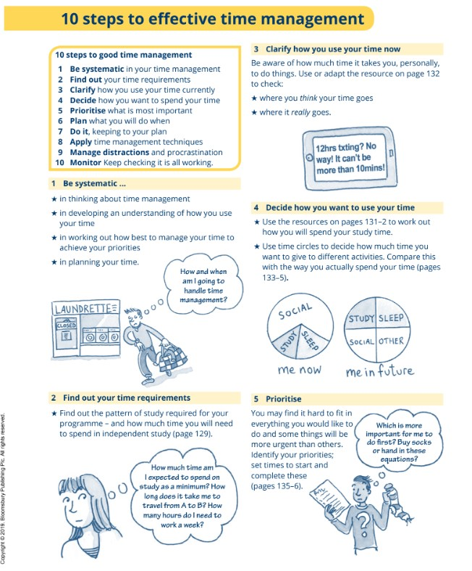
(source-Cottrell, Stella, 2019)
Time management becomes even more important in the workplace. Meeting deadlines at work displays dependability and professionalism, which improves image as a capable and responsible worker, can handle various jobs, prioritize projects, and keep attention on key goals.

B. Academic benefits of effective time management
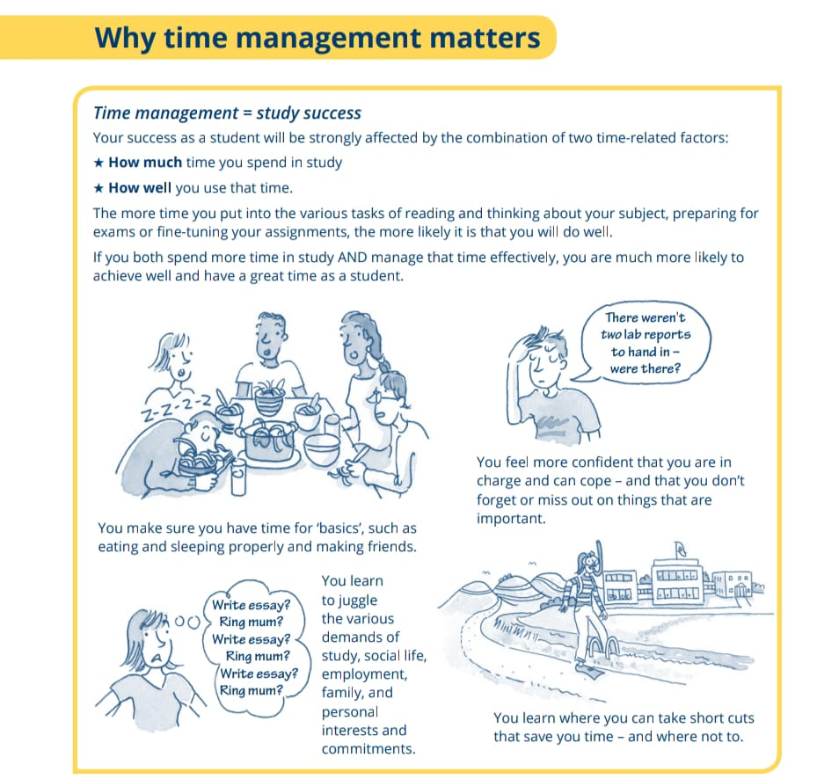
(source-Cottrell, Stella, 2019)

Efficient time management, Prioritizing projects according to their urgency and significance allows to devote more time to difficult topics or assignments, resulting in a better knowledge of difficult concepts(Kremser, and Blagoev, 2021). Time management will enhance the ability and skills of students and make them efficient in the upcoming years.

C. Tips and techniques for better time management
Task Prioritization: In order to concentrate first on the most important things, select an urgent and important activities.
Making a Study Calendar: By making a weekly study calendar which takes courses, assignments, and personal obligations into account.
Setting Specific Objectives: To ensure success, establish a specific, attainable academic objectives. Long-term goals may be divided into smaller milestones to help feel accomplished and keep on target(Baptiste, 2019).
Using time-blocking techniques: Time-blocking aids in enhancing attention and reducing task overlap by allowing to set up distinct time intervals for various projects.
Reviewing and adjusting frequently: This adaptable strategy enables consistently improve the output and adjust to new conditions(Lozada, and Croft, 2021).

IV. Conclusion
Time management is a crucial skill that affects performance in both study and work place. Students who are good in time management can reconcile their academic goals with other facets of their life. Students may make the most of their study time and enhance their academic achievement by prioritizing their work and being time conscious. Effective time management helps students learn topics more thoroughly, complete projects on time, and experience less stress during test time.

Reference
Ahmad Uzir, N.A., Gašević, D., Matcha, W., Jovanović, J. and Pardo, A., 2020. Analytics of time management strategies in a flipped classroom. Journal of Computer Assisted Learning, 36(1), pp.70-88.
Ashton-Hay, S.A. and Doncaster, N., 2021. Student success and retention: What’s academic skills got to do with it?. Journal of Academic Language and Learning, 15(1), pp.102-116.
Ashton-Hay, S.A. and Doncaster, N., 2021. Student success and retention: What’s academic skills got to do with it?. Journal of Academic Language and Learning, 15(1), pp.102-116.
Daugule, I., Kapenieks, A. and Timsans, Z., 2022. Use of Knowledge Acquisition Surface to Monitor and Assess Students’ Success. International Journal of Emerging Technologies in Learning (Online), 17(14), p.109.
Kremser, W. and Blagoev, B., 2021. The dynamics of prioritizing: How actors temporally pattern complex role–routine ecologies. Administrative Science Quarterly, 66(2), pp.339-379.
Einstein, A., 2023. Teaching students how to learn. Educational Utopias, p.227.

Eisenhower, D.&eisenhower, D.(1954). The Eisenhower Matrix: a guide to prioritizing your tasks. Retrieved from

https://www.eisenhower.me/eisenhower-matrix

/.Jdaitawi, M., 2019. The effect of flipped classroom strategy on students learning outcomes. International Journal of Instruction, 12(3), pp.665-680.
Tohara, A.J.T., 2021. Exploring digital literacy strategies for students with special educational needs in the digital age. Turkish Journal of Computer and Mathematics Education (TURNCOAT), 12(9), pp.3345-3358.
Cottrell, Stella, 2019,<i> The Skills Handbook</i>, London: Bloomsbury Publishing Ptc. Accessed july 21, 2023. ProQuest EbookCentral. Created from trinity on 2023-07-21 09.30.09.

