
FESTO Cyber-Physical Production System – Goods Dispatch Process Automation Development
James Holliman 1901805

ACMA5002
Manufacturing Design & Technology
University of Wales Trinity St David’s

Contents Page
Page 1 Introduction
Page 2 Design to Manufacture
Page 5 Design Ideas
Page 6 Design for Assembly
Page 7 Design Evolution
Page 10 Analysis
Page 11 Summary
Page 11 References

Introduction:
This report describes the redesign of a robot gripper and effector for a mobile phone using Design for Assembly (DFA) and Design for Manufacture (DFM) principles.
According to Dong, H. et al. (2018), grippers are devices used to hold objects and enable robots to move them. Grippers are often combined with collaborative robots. These are called Cobots and are also sometimes known as robotic cells. According to Gultekin, H., Dalgic, O and Akturk, M.S. (2017), they are often used in industries to avoid human touch that could damage the object (a mobile phone in this scenario) during transit or construction. Also, Nguyen, D.N et al. (2022) have stated that Cobots can also be used in environments outside of manufacturing industry such as agriculture or electrics where they can pick delicate or handle potentially dangerous materials.
Universal Robots (2022) and Cobot Interface (2022) state that there are multiple types of grippers that can be used in industry such as:
Vacuum grippers that use a plunger type sucker on the end of the arm and high pressure to move objects. The advantage of this type is that there are fewer mechanical parts required in manufacture and maintenance and thus these are cheaper than some other types. However, the disadvantage is that the air flow cannot be interrupted, or the object will drop and possibly break.
Pneumatic grippers use pistons and compressed air to open and close the prongs (jaws). This type of gripper is usually has either 2 prong or 3 prong configurations to hold the object. This type is useful because it is cheap (similar to the vacuum gripper) while also being able to operate in small spaces. But these are best with single simple parts because the gripper provides limited force and position control, which when handling a mobile phone, as in this project, could be problematic.
Hydraulic grippers are similar to pneumatic grippers but use hydraulic fluid instead of compressed gas. This gives the gripper more force which makes this gripper best for dealing heavier loads than other grippers. However, it does have a higher maintenance requirement then the other grippers because, to generate the extra force, the hydraulic fluid does operate at high pressure.
Electric motor-driven grippers are the most common gripper for Cobot machines. This gripper has a higher operating speed than the other grippers while still maintaining a light to moderate gripping force. Similar to the pneumatic grippers, it often comes in a 2-prong or 3-prong configuration. The advantage of this type of gripper is that it is easier to control compared to other types but can be more expensive as well. Because control is important to handle mobile phones, this is the gripper type that will be used in this report.
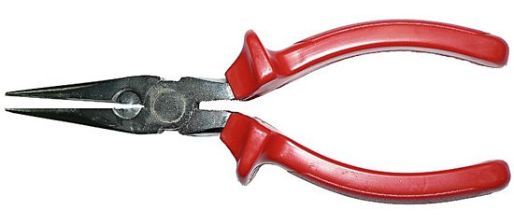
Figure 1: Image of manual pliers showing two-prongs on the left, a central pivot and two red handles on the right (as found in https://www.britannica.com/technology/pliers)
Grippers can be made in many different forms and sizes depending on what end use is required. The simplest way of showing this is through a pair of pliers as shown in Figure 1 where only one arm needs to move to make a gap between the 2-prong jaws. This principal is what the mobile phone claw design in this report will be based on.
Shim, M. and Kim, J.H. (2018) and Long, Z., et al. (2020) have reported that, when considering the design of different types of claws the claw for a gripper, flexible fingers enable a higher level of precision then other prong attachments, but they are more complex and harder to maintain. Another type they considered is a three-pronged grip, which has a secure grip but can be difficult to control with precision. The final type that was considered by these workers and for this project was the two-pronged grip as it is the simplest design, but it can still hold the phone without any issues. This type is also the cheapest and the easiest to maintain. Because of this, the two-pronged grip will be used for this project.
As described above, this report is about the redesign of a robot gripper and effector for a mobile phone using Design for Assembly (DFA) and Design for Manufacture (DFM) principles.
According to O’Driscoll, M. (2002), Design for Manufacturing is a procedure during the design process that is meant to reduce the manufacturing time and cost of materials and manufacturing by making sure the design is as simple as possible. As the gripper will be mass produced, a simple and cheap manufacturing method, is required while still being reliable and efficient.
Parmentier, D.D., Van Acker, B.B., Detand, J. and Saldien, J. (2020), states that Design for Assembly is an evaluation tool that is used to reduce the number of parts required for assembly as well as the labour and time that is required for assembly. This method can also make maintenance easier when done correctly while also lowering the during the manufacturing process.

Design to Manufacture (DFM)
The first Design to Manufacture (DFM) concept that has been used for the robot gripper is that it is important to use the fewest number of parts, and so the gripper uses two identical gripper arms with inbuilt cog driver units. These arms are placed the opposite way around in the gripper housing in the final design. This DFM concept makes the manufacturing process simpler because only one type of gripper arm needs to be made. It also means that these parts have multiple functions because the left and right-hard arms can be swapped around. Also following the DFM approach, during the manufacturing process, the gripper arms are placed onto fixed axel pins inside a single housing unit. The driver motor is then positioned to drive one of the gripper arms. This means that the finished design is modular, which makes maintenance and recycling much easier because everything can easily be taken apart and replaced or easily recycled. Standard components (e.g., driver motor) have been used where possible while the gripper arms can be recycled into new gripper units or used in new products (e.g., pliers) or can be re-melted into new products.
The design for the housing unit for the gripper arms has two parts. The base will contain pins for the gripper arms to be placed on whilst the top is a single clear box top for simplicity.
When building any Cobot, it is vital to consider what it is being used for and how long the Cobot needs to work for. As the part is dealing with phone transportation, the gripper does not need to have an high tolerance. Thus, materials such as carbon fibre and titanium can be removed as these are too expensive for what is needed. Another factor to consider is whether to make different part of the gripper out of different materials. Due to the different requirements of different pieces (e.g., strength in the claws but some flexibility not to damage the phone), the design will include different materials in different parts of the claw.
Recycled plastic, wood-plastic composite, aluminium and steel have all been considered as raw materials for the gripper arms. Recycled plastic according to Metteb, Z.W., (2020), has the advantage that it is a cheap material which prevents waste. It can also be 3-D printed or moulded. However, it is not as strong as aluminium or steel and so the parts would not last as long in operation. Wood-plastic composite according to Bhaskar, K., et al (2021), is also light and can be milled to the correct shape. But again, it is not as strong as aluminium or steel when used in a repetitive and continuous process like manufacturing. Aluminium according to Tisza, M. and Imre, C. (2018), is also light and can be recycled but it is not as strong as steel unless it is made into an alloy which makes it more difficult to recycle.
So, steel has been chosen as the material for the gripper arms. This is because the high strength to weight ration of steel means that a smaller amount of material can be used which reduces costs and the carbon footprint of the final product. Material Properties (2022), state steel can also be easily recycled by remelting in an electric arc furnace. For the gripper cogs, there needs to be balance of the number of teeth on the outside of the cog wheel. More teeth means that there is more control on the final position of the gripper arms, whereas fewer teeth mean there is more tolerance allowed on the parts which means less waste during the manufacturing process.
The base of the housing for the gripper will be made from steel to make it strong and also compatible with the gripper arms. But to make it easier to maintain the gripper mechanism a different and transparent material will be used for the top of the housing such as plastic or glass. Plastic according to Miller, B. (2020) and Byju (2022), is useful because plastic has a long-life span and can be reused multiple times and is affordable and has a higher scratch resistance and is not as brittle as glass while still being see through. So, the design for the top of the housing is to make it from clear plastic.
For the end of the gripper arms that will be the part that actually holds the phone, rubber has been chosen as the best material as CEA (2012) and Export Development Board (2021) have both stated that it has a high resistance to wear and tear and high tensile strength so will last a long time while still being inexpensive. Rubber also has a high elasticity so will not damage the phone when the claw is gripping it. Rubber is also biodegradable so will not pollute the environment when the lifespan on it has run out.
When choosing a manufacturing method for the parts, CNC milling, machining, 3-D printing and casting have all been considered for the gripper arms. According to Rizwan, H.M. (2022), CNC (Computer Numerical Control) milling and machining have the advantages that they both can start with a block of material (steel for the gripper arms). However, these manufacturing processes remove material from the block to make the shape. This creates a lot of waste, and every part has to be made individually as well as being high maintenance and costly. 3-D printing of steel is also possible. Pîrjan, A. and Petroşanu, D.M. (2013) have stated that this creates minimal waste while still making the desired shape. However, it uses a lot of energy to melt the metal powder and the part may not be as strong as it could be. So, casting has been chosen because this uses the minimum amount of raw material, and the mould can be used repeatedly.
D W Plastics LTD (2022) states that plastic also has different manufacturing methods such as plastic extrusion where the plastic is fed into a extrusion machine and heated till it is molten, then pushed through a metal die to give the plastic the desired shape. But because this the process can only do standard shapes (e.g., pipes) it will not work for this project. Injection moulding is similar to plastic extrusion but uses a mould to create the shape of the product so can make more complex structure than plastic extrusion. Moulding can be used to manufacture a large number of parts in a short amount of time. Extrusion and injection blow moulding is the same as the other two but has an added air pressure to create hollow shapes but as the top is not hollow this is unnecessary. Plastic rotational moulding is another method to create hollow products by placing the heated plastic into a mould and the mould into a furnace and rotating it making the molten plastic stick to the edge of the mould. Much like extrusion and injection blow moulding, this manufacturing process is not the right type for what is being manufactured. Vacuum casting is best used making small parts in low volumes using a vacuum to pull the material into the two-part mold and then placed in an oven to cure. This type is useful when air cannot be trapped in the product but, as this is not a requirement for these parts, this type shall not be used. Thermoforming takes an already extruded piece of plastic and heats it until it is mouldable, then shapes it over a mould. This can produce high numbers of parts but, as this is more complex and used mainly in the food and medical industry, this method will not be used. Compression moulding is where pre-heated plastic is fed into a open mould that is then equally heated and pressurized on all points until the plastic has hardened and the mould removed. After considering each of these manufacturing types and the requirements of the product and the volume that will be made, injection moulding has been chosen to manufacture the top of the base.
Rubber Molding (2022), states that rubber can be manufactured in six ways. One is extruding the rubber but as the part design is not flat or cylindrical, this process will not work without other processes afterwards making this manufacturing process unnecessarily complicated. The second method is to use injection moulding which melts the rubber before depositing it into the mould and letting it cool and set before removing the mould. This process is the most common for rubber as it yields the greatest production rate and the products are made with the best accuracy. Also, the mould can be reused multiple times saving time as a new one does not need to be made. Liquid injection moulding is similar to injection moulding but starts with liquid rubber instead of melting it down first the pouring into the mould and heating to solidify it. This process is faster than injection moulding but requires higher pressure. Insert moulding is where the rubber is moulded around a non-rubber part (i.e., an insert) to make the part. However, as this process is the slowest and has to be manually done, this process will not be used. Compression moulding is the same as injection moulding but all the stack and moulds are pre-measured and pre-weighed so no material is wasted. But this does mean that this process takes longer and also means sometimes the results are not accurate if there is an error in the measurements. Blow moulding can also be used to make hollow rubber products by placing a tube in the mould after pouring the rubber in and blowing compressed air to mould the rubber round the tube and fit the mould, and then heat the rubber to set it. After considering each of these processes, injection moulding was chosen due to the high production rate.

Design ideas:
Figure 2: Claw with one moving component
Design idea 1, as shown through Figure 2, is a design with only one moving claw while the other claw is stationary. The advantage of this design is that it is simpler to make and requires less maintenance than other design ideas. However, due to the single gear principle used, one claw will have more pressure than the other which could cause cracking or breakage in the phone screen.
Figure 3: Claw with two moving arms
Design idea 2 shows two moving arms with a four-cog configuration as shown in Figure 3. This removes the pressure problem that the last design had as the pressure is equal on both sides. But, this does make the design more complicated with a larger error margin as well as being more expensive then the last design.
Figure 4: Three-pronged claw design
Figure 4 shows idea 3 has a three-pronged claw that can give greater grip with there being three points of contact on the phone instead of two. But this means that this is the most complex of the models as well as the most expensive of the ideas.
Figure 5: Deign for gripper using forklift styled holder
Design idea 4 which Figure 5 illustrates is a design with a forklift principal to lift the phone instead of gripping the phone. This idea is good as it removes the need for a grip making the design simple but has the disadvantage of if the Cobot hits an uneven surface there is nothing to stop the phone sliding off the prongs and smashing on the floor.

Design for Assembly
The gripper mechanism has also been designed for easy assembly and recycling. To do this, the minimum number of parts have been used (housing base and top, two gripper arms and driver motor). Another thing to consider according to Lei, P. and Zheng, L. (2017), when looking at the assembly is the alignment of every piece so that it assembly accurately and with as little an error margin as possible. So in the chosen design, the housing base has been designed with two pins to easily align the gripper arm cogs and a locator for the motor. To make assembly simple, all these parts can be inserted from the top and placed directly into position without needing any tools.

Table 1: Design for assembly chart for Cobot
 | First design | New design | Improvement (%)
Metal casting time (min) | 20 | 18 | 10
Assembly time (min) | 3 | 1.5 | 50
Number of parts | 10 | 6 | 40
Number of operations | 13 | 9 | 31
Weight (g) | 6460.51 | 6271.15 | 2.93

Table 1 shows that Design for Assembly principles give largest improvements in assembly time and number of parts in the final design compared to the first design.

Design evolution:
The first draft of the final design is based of design 2 and design 4 with two less cogs to save space and two prongs for the phone to rest on while being transported. Four screws have been used to attach one half of the base to the other as shown in Figure 6.
Figure 6: First draft of final design
From this design, the principles of design for manufacture and design for assembly and similar principals from Hassan, A. and Abomoharam, M. (2017) were applied to create the final design shown in Figure 7. The design principals that Hassan and Abomoharam state are about cutting unnecessary components from the process to create the optimum part. This final design has retained the 2-cog configuration but has had the 4 screws removed and replaced with a clip-on snap attachment shown in Figure 8 to join the bottom and the top of the gripper box along with the two prongs in the bottom of the box as the claw should be strong enough to hold the phone without the assistance. Figure 9 and 10 show the engineering drawings that shows the dimensions of the final design.
Figure 7: CAD model of final design

Figure 8: CAD model from top

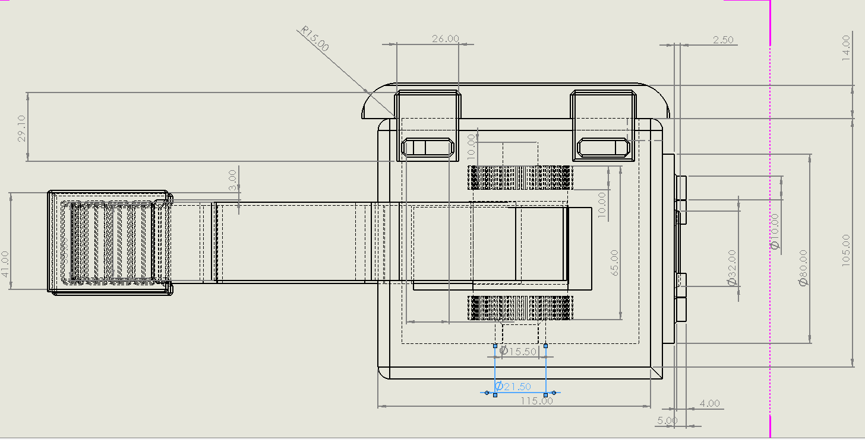
Figure 9: Dimention drawing of design (side view)

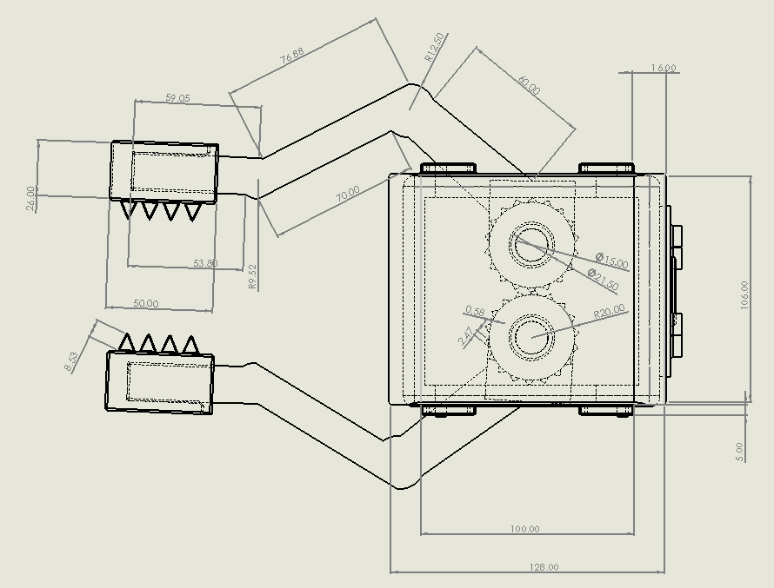
Figure 10: Dimension drawing of design from top view

Analysis:

Failure Mode and Effects Analysis (FMEA) chart:
According to Suresh, R., Sathyanathan, M., Visagavel, K. and Rajesh, Kumar, M.R. (2014), a Failure Mode and Effects Analysis (FMEA) chart is used to show possible problems and rate them according to severity (with 1 being no effect and 10 being a hazardous effect without warning), occurrence (how often it occurs in a system) and detection (with 1 being almost certain to detect the problem before it occurs and 10 being unable to detect the problem). Then using these terms, it is possible to calculate the Risk Priority Number to rate what needs to be addressed.
Table 2: Failure Mode and Effects Analysis (FMEA) chart for Cobot
Part | Problem | Severity | Occurrence | Detection | Risk Priority Number (RPN)
Wheels | Sensors malfunctioning Running over workers | 7 | 2 | 7 | 98
Arm | Motor malfunctioning Knocking objects off benches | 4 | 4 | 5 | 80
Claw | Cogs slipping possible damage to phone | 6 | 2 | 3 | 36

Table 2 shows the greatest risks are the Cobot running over workers or knocking objects off benches. The best way to prevent these problems is to do routine maintenance checks on the Cobot before and after the workday. Another solution would be to mark off the route that the Cobot is taking so that no one is in the way when the Cobot is moving the phone from one location to another.

Summary:
This report set out to design and analyse a collaborative robot gripper meant to hold a mobile phone using design for manufacture and design for assembly principles. First, the type of gripper that would be used was considered with an electric motor-driven gripper being chosen. After this, the material for the gripper was considered with steel chosen for the base and arms for material strength and plastic chosen for the roof to help maintenance by showing any possible issues that may occur in the gripper mechanism. Both of these materials were also chosen due to their durability and recyclability when the operational lifespan has finished. The material for the end of the grippers was than considered as steel was thought to be too stiff and smooth to hold the phone correctly. So, rubber was chosen to cover the gripper jaws as it can hold the phone without breaking or dropping it. Once the materials were chosen the manufacturing processes for each component had to be decided. For the plastic and rubber parts, injection moulding has been chosen as it yields the highest production rate while, for the steel components, casting has been chosen as it creates the least waste material. After this, different design ideas were considered with a first draft for the final design being drawn. This design then had the design for assembly principles applied to it to make the final design that was drawn using computer aided design software. After this, a Failure Mode and Effects Analysis (FMEA) chart has been applied to show some of the possible problems that could occur from the Cobot and some possible solutions to combat them.

References
O’Driscoll, M. (2002) 'Design for manufacture', Journal of Materials Processing Technology, 122(), pp. 318–321 [Online]. Available at: file:///C:/Users/Student/Downloads/1-s2.0-S0924013601011323-main.pdf (Accessed: 9th June 2022).
Pîrjan, A. and Petroşanu, D.M. (2013) 'THE IMPACT OF 3D PRINTING TECHNOLOGY ON THE SOCIETY AND ECONOMY', JOURNAL OF INFORMATION SYSTEMS & OPERATIONS MANAGEMEN, 07(2), pp. 360-370 [Online]. Available at: https://www.researchgate.net/profile/Mircea-Cirnu/publication/260424967_Circular_convolution_and_discrete_Fourier_transform/links/0deec533f63683a136000000/Circular-convolution-and-discrete-Fourier-transform.pdf#page=156 (Accessed: 11th June 2022).
Bhaskar, K., Jayabalakrishnan, D., Kumar, M.V., Sendilvelan, S. and Prabhahar, M. (2021) 'Analysis on mechanical properties of wood plastic composite', Materials Today: Proceedings, 45(), pp. 5886-5891 [Online]. Available at: https://reader.elsevier.com/reader/sd/pii/S221478532036452X?token=C522DEADFC86D678220DB14156E23745BCBCF2BEC57E7E1AF9EE6EB3C663DE0408ED4E84BC3896DF527718956F9EA9A0&originRegion=eu-west-1&originCreation=20220618123419 (Accessed: 13th June 2022).
BYJU (2022) Advantages and Disadvantages of Plastic, Available at: https://byjus.com/chemistry/advantages-and-disadvantages-of-plastic/ (Accessed: 12th June 2022).
CEA (2012) Materials Part 3, Available at: https://ccea.org.uk/downloads/docs/Support/AS%201%20Support/2019/Section%20D%3A%20Fact%20Files%20-%20Materials%20Part%203.pdf (Accessed: 13th June 2022).
Cobot Interface (2022) Types of robotic grippers from collaborative robots companies, Available at: https://cobotintel.com/techman-ca/types-of-robotic-grippers-from-collaborative-robots-companies/ (Accessed: 9th June 2022).
D W Plastics LTD (2022) WHAT ARE THE MANUFACTURING PROCESSES FOR PLASTICS?, Available at: https://www.dwplastics.co.uk/manufacturing-processes-for-plastics/ (Accessed: 2nd June 2022).
Dong, H., Asadi, E., Qiu, C., Dai, J. and Chen, I.M. (2018) 'Geometric design optimization of an under-actuated tendon-driven robotic gripper', Robotics and Computer–Integrated Manufacturing, 50(), pp. 80-89 [Online]. Available at: file:///C:/Users/Student/OneDrive%20-%20University%20of%20Wales%20Trinity%20Saint%20David/year%202/manufacturing/Robot/Robot[12].pdf (Accessed: 8th June 2022).
Dynacast (2022) ABOUT DIE CASTING, Available at: https://www.dynacast.com/en-gb/specialty-die-casting/about-die-casting#:~:text=Die%20casting%20is%20a%20manufacturing,created%20with%20accuracy%20and%20repeatability. (Accessed: 3rd June 2022).
Export Development Board (2021) USES & ADVANTAGES OF NATURAL RUBBER, Available at: https://www.srilankabusiness.com/blog/uses-advantages-of-natural-rubber.html (Accessed: 13th June 2022).
Gultekin, H., Dalgic, O and Akturk, M.S. (2017) 'Pure cycles in two-machine dual-gripper robotic cells', Robotics and Computer–Integrated Manufacturing, 48(), pp. 121-131 [Online]. Available at: file:///C:/Users/Student/OneDrive%20-%20University%20of%20Wales%20Trinity%20Saint%20David/year%202/manufacturing/Robot/Robot[4].pdf (Accessed: 6th June 2022).
Hassan, A. and Abomoharam, M. (2017) 'Modeling and design optimization of a robot gripper mechanism', Robotics and Computer–Integrated Manufacturing, 46(), pp. 94-103 [Online]. Available at: file:///C:/Users/Student/OneDrive%20-%20University%20of%20Wales%20Trinity%20Saint%20David/year%202/manufacturing/Robot/Robot[1].pdf (Accessed: 05th June 2022).
Lei, P. and Zheng, L. (2017) 'An automated in-situ alignment approach for finish machining assembly interfaces of large-scale components', Robotics and Computer–Integrated Manufacturing, 46(), pp. 130-143 [Online]. Available at: file:///C:/Users/Student/OneDrive%20-%20University%20of%20Wales%20Trinity%20Saint%20David/year%202/manufacturing/Robot/Robot[3].pdf (Accessed: 6th June 2022).
Long, Z., Jiang, Q., Shuai, T., Wen, F. and Liang, C. (2020) 'A Systematic Review and Meta-analysis of Robotic Gripper', OP Conference Series: Materials Science and Engineering, 782(), pp. 42-55 [Online]. Available at: doi:10.1088/1757-899X/782/4/042055 (Accessed: 8th June 2022).
Material Properties (2022) Mild Steel – Density – Strength – Hardness – Melting Point, Available at: https://material-properties.org/mild-steel-density-strength-hardness-melting-point/ (Accessed: 11th June 2022).
Metteb, Z.W., Abdalla, F.A and Ameen, E.A. (2020) 'Mechanical properties of recycled plastic waste with the polyester', AIP Conference Proceedings, 2213(), pp. 20-67 [Online]. Available at: https://doi.org/10.1063/5.0000281 (Accessed: 13th June 2022).
Miller, B. (2020) 17 Biggest Advantages and Disadvantages of Plastics, Available at: https://greengarageblog.org/17-biggest-advantages-and-disadvantages-of-plastics (Accessed: 12th June 2022).
Nguyen, D.N., Dang, P.M., Nguyen, T.T. and Dao, T.P. (2022) 'Intelligent computation modeling and analysis of a gripper for advanced manufacturing application', International Journal on Interactive Design and Manufacturing, (), pp. [Online]. Available at: https://doi.org/10.1007/s12008-022-00885-2 (Accessed: 7th June 2022).
Parmentier, D.D., Van Acker, B.B., Detand, J. and Saldien, J. (2020) 'Design for assembly meaning: a framework for designers to design products that support operator cognition during the assembly process', Cognition, Technology & Work, 22(), pp. 615-632 [Online]. Available at: https://link.springer.com/content/pdf/10.1007/s10111-019-00588-x.pdf (Accessed: 10th June 2022).
Rizwan, H.M. (2022) CNC MACHINES, Available at: https://physlab.org/wp-content/uploads/2016/04/CNCPRESENTATION.pdf (Accessed: 11th June 2022).
Rubber Molding (2022) Rubber Molding, Available at: https://www.rubbermolding.org/ (Accessed: 10th June 2022).
Shim, M. and Kim, J.H. (2018) 'Design and optimization of a robotic gripper for the FEM assembly process of vehicles', Mechanism and Machine Theory, 129(), pp. 1-16 [Online]. Available at: file:///C:/Users/Student/OneDrive%20-%20University%20of%20Wales%20Trinity%20Saint%20David/year%202/manufacturing/Robot/Robot[11].pdf (Accessed: 8th June 2022).
Suresh, R., Sathyanathan, M., Visagavel, K. and Rajesh, Kumar, M.R. (2014) 'Risk Assessment For Blast Furnace Using FMEA', International Journal of Research in Engineering and Technology, 03(11), pp. 2319-1163 [Online]. Available at: https://citeseerx.ist.psu.edu/viewdoc/download?doi=10.1.1.679.8583&rep=rep1&type=pdf (Accessed 13 June 2022
Tisza, M. and Imre, C. (2018) 'Comparative Study of the Application of Steels and Aluminium in Lightweight Production of Automotive Parts', International Journal of Lightweight Materials and Manufacture, 1(), pp. 229-238 [Online]. Available at: file:///C:/Users/Student/OneDrive%20-%20University%20of%20Wales%20Trinity%20Saint%20David/year%202/manufacturing/Robot/Al%20versus%20steel.pdf (Accessed: 12th June 2022).
Universal Robots (2022) TYPES OF GRIPPERS USED IN MANUFACTURING, Available at: https://www.universal-robots.com/blog/types-of-grippers-used-in-manufacturing/#:~:text=In%20the%20simplest%20terms%2C%20grippers,pick%20%26%20place%20and%20machine%20tending. (Accessed: 9th June 2022).

