Developing relationships and workplace achievement

Name: Sara Al Hashidi
Student ID: 1919947
Name of university: University Of Wales Trinity Saint David
Name of lecturer: Sujeewa Herath
Module code: BMSW5102
Module name: Developing relationships and workplace achievement
Assignment title: Developing relationships and workplace achievement

Table of content
Introduction………….……………………………………………............…………….…………..1
Discussion about the chosen organisation ………………………………………….….….2
Explain the concept of motivation, engagement and commitment………….…3
Discuss on the different motivation factors for organisations to develop…..4
Evaluate the role and the importance of employee motivation in
performance enhancement……………………………………………………………………….5
Evaluation on the role and the importance of employee engagement……….6
Evaluate the strategies of training and development based on the
Organisation………………………………………………………………………………………………7
Discuss effectiveness of the organisation when supporting employee
satisfaction and business performance…………………………………………………..…8
Personal development plan……………………………………………………………..……….9
Conclusion……………………………………………………………………………………………….10
Reference list……………………………………………………………………………………………11

Introduction
Developing the relationship in the workplace is very important factor that enhance the progress and achievement for an organisation. Every individual efforts contributes to the success and achievements of an organisation. Therefore, being able to perform high standards of commitments shows how motivated the individual is and what builds the organisation efficiency and productivity. Business targets can be achieved when the company convince and pursue a high performance of its workers and direct approach to employee recruitment, trainings, development and motivation. This works towards helping and promoting employee commitment which lead to ongoing improvement and grow of the company. However, in this report I will aim to demonstrate the key motivational factors that can be used to develop organisation, and evaluate the role and the importance of employee engagement. I will also concentrate towards the development of training strategies and how they can influence on employee satisfaction and business performance effectively. To support my writing I will use relevant theories and models to discuss different motivational aspects.



Argos overview
Argos is an organisation trading operated in the united kingdom and Ireland but it has started in Canada and grew further to larger exporters . Argos company was established at 1972. It is a supplier that provides direct and indirect manufacturing capabilities (2021). It has two main business that it operates , the first business focus on dealing with productions and allocations of its own products. There are several factories that perform and conduct all of the Argos equipment which are their own products manufactured separately (2021). The second business operation aim to provide the ability to work with other businesses. However, Argos work collaboratively to promote business growth, strive to create value for its stakeholders, maintain and build a strong relationships with suppliers, distributers and customers as well as meeting their needs. The company promote and strive to the most of its ability to make significant improvement to the quality of its products and services (2021). Argos also aim to build high performance of its employees, enhance motivation and personal development towards helping it achieve its goals of high standards, effectiveness and productivity.

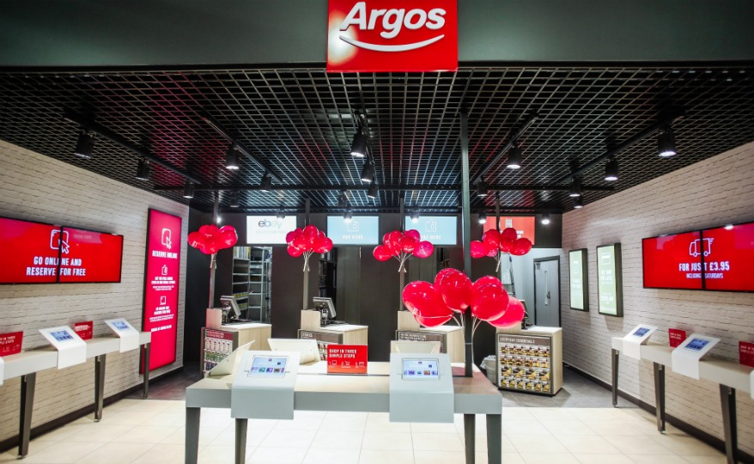

The concept of motivation, engagement and commitment
Motivation: is the process that initiates, guides and maintains goal oriented behaviour. it direct us to act and make some movements to our internal desire, with the ability to accomplish important tasks we aim to meet to fulfil our needs (Tutorialspoint,2021). Motivation is always essential part of business functioning which produce satisfaction to the individual and to the work itself. Being able to work motivated towards the workplace and within the environment helps to increase high level of engagement, efficiency and overall process of the company towards achieving its goals and success (Tutorialspoint, 2021).

Engagement; employee engagement is a human resource concept that describe the level of dedication and enthusiasm towards the workplace (2021). Employees that are engaged feels more about the difference of their effort that they produce to the company and increase their quality of work performance (2021). Employee engagement in the workplace helps to promote individuals self confidence, feeling more valued, respected and heard from others. It reduce the impact of discrimination and develops relationships within the workplace.

Commitment; is the employee connection towards its organisation and workplace. It is a bond that combines the individual to a specific goal and motivate the employee to work hard to aim for achieving targets. Being committed to the workplace helps to increase success and productivity of the organisation (Commitment,2021). It also shows the way of providing enthusiasm and support to become more satisfied and valued towards the work and other colleagues. This promotes the business efficiency and contributes to the company progression and profitability (Commitment,2021).

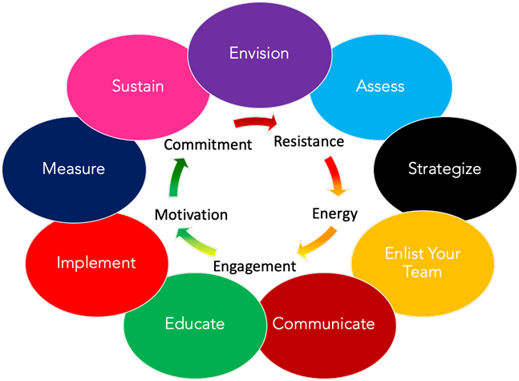

Different motivation factors for organisations to develop
Organisation process and function well more successfully when they maintain motivational factors which increase the quality and the performance of the company. However, factors of motivation are strategies and elements that increase employees overall motivation to perform their duties at work and performing at their best. There are different factors that can be implemented to increase productivity and satisfaction (2021). Motivation is a very important element for the organisation to develop and improve on the company system. There are theories that will be demonstrated in this report which explain motivation process in the workplace and the different factors that leads to job satisfaction (2021).
Maslow’s Hierarchy Theory Of Motivation: Maslow’s hierarchy of needs is a theory that explain human motivation based on the pursuit of different level of needs. This involves hierarchical order which considers the basic needs and moves up to the fifth level which is more advanced needs to reach goals. However, Maslow’s theory consist of five main levels that describe motivation (Maslow’s Hierarchy Of Needs,2021).
Physiological needs; this involves the basic needs that individuals need to survive with such as shelter, food, water, health and rest.
Safety needs; this second level of hierarchy needs talks about the security and safety of violence, physical safety and other protection to individual (Maslow’s Hierarchy Of Needs,2021).
Love and belonging needs; this third level considers the needs of family, friends and love. This is an important need that provides the feeling of value and attention.
Esteem needs; this fourth level of Maslow’s hierarchy needs describes the importance of esteem needs , being able to feel recognised, respected, freedom and dignity.
Self-actualization needs; this is the final level which can only be achieved when the other four is met. Self-actualization outlines all the motivational factors as it relates to the individual’s own potential and were every human strive to educate himself to the best of his knowledge, obtaining skills, continue education, utilize skills, knowledge and personal talent, seeking happiness and pursuing future dreams and goals (Maslow’s Hierarchy Of Needs,2021).
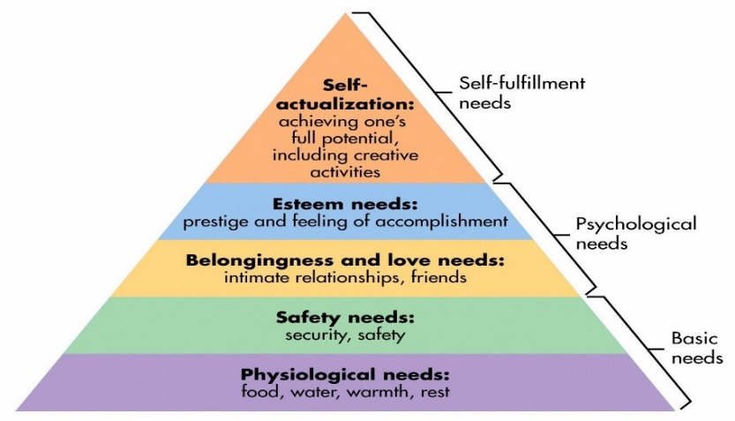
The role and the importance of employee motivation in performance enhancement
Employee motivation is imperative for organisation’s growth and development. Motivation helps to establish a successful career for an organisation and it initiates positive changes in the workplace environment. Motivation is very essential for the organisation to build high standard of performance, products and services. Employee motivation can increase productivity, it promote and drive employees to work to the best of their capabilities, it shows the efforts of individuals and the different skills they have (Tutorialspoint,2021). It facilitates directions, it implements specific plans and strategies for the business, contributes to the organisation’s main goals, it creates enthusiasm in employees and help improve and innovate the company (GraduateWay,2021). Motivation has a huge impact on promoting loyalty among the employees, well motivated workforce helps to increase sense of loyalty towards the company, higher levels of morale, commitment. It ensures employees adapt to dynamic changes in the workplace, it also reduce the resistance to difficult organisational decisions. It foster organisation to become more efficient and productive (GraduateWay,2021).

However, there are both positive and negative motivators which can be used by the organisations. Positive motivators involves benefit for employee such as , bonuses, profit sharing and different types of rewards (Tutorialspoint,2021). There are two types of motivation extrinsic and intrinsic that employees can be engaged with. Intrinsic motivation is provided by the work itself and is associated with the concept of engagement such as, power, acceptance, social status and independence (GraduateWay,2021). Extrinsic motivation can be provided to the people to become motivated or increase employee motivation such as, organised activities, promotion, bonuses increased pay and benefit package. Despite, negative motivators can include, suspensions, verbal and written warnings, and bad performance review. Employers provide a variety of methods to motivate employees to increase performance (Tutorialspoint,2021). Organisations that treat their employees well and maintain a high standard of support and motivation to engage them, helps employees to feel valued and trusted within the field (2021). Therefore, this contributes the organisation to become successful and achieve its goal and impact on employees positively to spend more effort aiming for organisation satisfaction and increased profitability and a high level of performance enhancement (GraduateWay,2021).

The role and the importance of employee engagement
Employee engagement is very important because it affects every aspects of the business. Employee engagement is a key for business success and it is when the employees feels invested, more motivated and committed to perform at their best and contributes to the organisations’ goals (2021). There are many benefits of employee engagement that leads to achieved goals and success of the company (Employee Engagement,2021).
Commitment to the work; employees that are engaged to their organisation provide a high value and time to the company, they make the most to the satisfaction of the organisation as well as meeting their responsibilities and commitments towards the workplace (Commitment,2021).
Quality of work; when employees of an organisation is engaged, it increase the level of quality of their work in addition to effort that is put by employees. It also helps to enhance productivity and efficiency in employees and desirable business outcomes which strive to met costumers needs (2021).
Value to company goals; engaged employees helps to improve business quality and performance and maintain to create the foundation for the organisation’s success. They strive for the benefits of the company mission and profits (2021).

However, Argos ensure to engage and communicate more effectively with employees to engage them within the environment to enhance motivation and build a sense of engagement for the workplace (2021). Is order to improve engagement of employees and initiate better atmosphere for them to enjoy working conditions, they assigned integrity to help deign new branding for most areas within employees work places and rest areas to provide healthy and satisfaction for employees (Employee Engagement,2021). Argos make sure to maintain and support key strategies that met each and everyone’s needs to enhance their abilities to perform at their best, feel valued and provide high standard product and services (2021).


The strategies of training and development based on the organisation
In any organisation, it is important to implement powerful training and development strategies to maintain a successful company process and align the business goals of the organisation. Organisation strategies aim to contribute to incorporate changes, serving guidance and make improvement for the company (2021). However , Argos company performed strategies that involves, product, price, place, promotion which demonstrates market strategies of Argos (2021). There are several marketing strategies that Argos company have benefited from and contributed to support and help the brand grow. Marketing strategies like promotion planning, pricing approach, product innovation has lead Argos company to success and helped the market to produce more effectively (MBA Skool,2021).

Argos product strategy; aimed to provide pictures of the products with its description that explain benefits of the item, pricing with offers , and catalogue number. Argos have been adding a huge number of new products in sale as part of its marketing mixture of products portfolio (Thousandisland.co.uk.2021). It developed the number of new products advertisement compared to the previous years within a high quality of its products. The initiative of its products that is maintained has increased the number of customers and sales. Argos market promotes the customers satisfaction and service provision (2021). It changed the logo to more colourful and served a wide range of different products in different perspectives to meet customers needs. With an addition to its own brands (Thousandisland.co.uk.2021) .
Argos pricing strategy; the main goal of this strategy is to provide low price. Argos maintain and build a relationship with suppliers in order to benefit from its lowest price of products of its low selling costs (2021).
Argos place, distribution strategy; is providing a high standards of performance to meet customers needs and preference of ways in which they like to shop. Argos market is available both online and at the store (2021). The quality of service provide more than one option to choose from a variety of stores around the local destinations, in addition to collection and delivery at the same day for customers. The market company also provide several ways of payment methods of instalments involving the desired months for customers to meet their affordability which is also free from interests (Thousandisland.co.uk.2021) . All these strategies benefit both customers and the company that adds up as an advantage of the market to buy from (2021).
Argos promotion strategy; this strategy ensure to allow customers to be aware of new offers and deals. Therefore, there could be more products that is sold out from customers that is new and satisfied when meeting their choice of products (2021).

Effectiveness of the organisation when supporting employee satisfaction and business performance
Argos business retail market aim to focus on the importance of motivation in the workplace and the different ways to help set the organisation at a high level of performance and increase the satisfaction of employees (2021). However, human resource management deals with the employment relationship with decisions, actions and issues that relates to the organisational overall function. Human resource management is also a legal implementation between the organisation itself and the employees (HRM, case study of argos,2021). Human resource management discuss about the use of organisational planning, improve the employee under human resource functions, ensure the business apply government policies, ensure to make a safe and fairness environment for employees, work with team performance, discretion and business ethics etc (HRM, case study of argos,2021). The purpose of Argos human resource management identifies the organisational legal policy and regulation, make good labour relations, enhance employees role system, improve management skills, ensure safety and fairness for every employee, satisfaction of every individual in the workplace, promote employee training and development, implement personal cost planning and time management (2021).
However, maintaining Argos strategies of training and development enables the organisation to effectively support employee satisfaction and ways in which they work as well as the performance of the company. Promoting these strategies effectively involves giving the employees responsibilities to decide what needs to be done differently (Tousandisland.co.uk,2021). There will be an increase in employee engagement and greater commitment to the workplace service. To effectively support employee satisfaction it is important to make training available for employees to develop and improve on their quality of performance and service, Argos company believe that by offering training to employees, it help mangers to realise and be aware of required education employees look for as well as certain task they lack of (2021). The company set clear goals and offer words of encouragement, this helps employees to feel more motivated to perform to the best of their ability (2021). Argos company enhance employees to work smart rather than working hard because, when employees work efficiently and with high level of motivation this then contributes to the success of the business. Therefore, it is important that managers promote and maintain employers rights in an appropriate way to meet their need and develop their quality of work through dedication and engagement (Tousandisland.co.uk,2021).


Personal development plan
Development area | What I need to do | Resources | Measure |  | Time
Become more motivated to my workplace | Engage with other employees and identify specific weaknesses of the organisation, perform at the best of my ability, get involved with activities of the organisation to improve my motivational factors. Become more committed to my own responsibilities. | Feedback,  Advice, employee support, motivational theories, customers survey | Outline strategies learnt, adjust negative feedback to become more positive, outline poor quality conducts, maintain a high quality of performance of my own role, develop my skills by providing the best of my ability and set a target to increase motivation and engagement. |  | Aim to achieve this goal by duration of 3 to 5 months
Encourage more with other employees | Start to get more in contact with other employees and maintain closer friendship with everyone to benefit from each others knowledge and previous experiences. | Self confidence,  Create friendly team, support from manager, help and guidance, different task for employees to join, manager provide equal opportunities for all employees | Develop team working skills, behave respectfully, enhance and improve others skills, develop communication skills, work with others effectively, accept each others different perspectives, maintain safe and encouraging environment for individuals to work productively. |  | Aim to achieve this goal by the time of today and further on in my workplace.
Stay positive and provide good quality of work | Learn to follow organisational policy and procedures. Develop work conditions and look forward for customers needs to be met. Forget about my social life and try to focus just on the workplace environment. Provide high quality of service. Aim to conduct customers issues and look after their needs and specifications. | Gain rewards from the manager to promote my quality of performance, rules and regulations to be identified clearly, get training opportunities, manager produce innovation and different tasks, mix the role fairly by the manager, perfect area to work on. | Develop my own skills and previous experience to be put in practice within the workplace. Increase the level of commitment and become more knowledgeable. Help others and support with the quality of the organisation input, create happiness whithin the employees and myself by staying the whole time positive. Make adjustments effectively to aim for customer satisfaction, meet their needs. |  | Aim to achieve this goal by the end of this year 2021.
Develop and enhance communication skills and workplace activities | Communicate with employees effectively, understand their point of views, accept their perspectives, support each other with the work content, improve on the personal strength of each individual to aim for the same goal and strive for the overall benefit of the organisation, prefer work content and customers satisfaction more than profitability. | Manager provide sufficient time for employee discussion regarding the work content, use a variety of organisational strategies that is set by the company to develop workplace activities, create plan for the team to identify strength and weaknesses. | Work with honesty and love towards the workplace, make the most the my ability to provide for my own job to develop more effectively, communicate with employees, managers and customers to create a good relationship within the workplace. Provide feedback for employees to utilities from inappropriate tasks to determine what needs to be admitted for the future. Take an advantage of the previous performance to improve it for future actions. |  | Aim to be achieved by 6 months period.
Manage the time effectively | I need to make sure to manage the time effectively to be able to respond to customers as soon as they expect. I will get the potential task done firstly to meet the standard of employee expectations and responsibilities. | Set out a timeline and deadline for specific duties to be handles as soon as possible. | Develop time management skills and share the job duties reasonably between the employees to get it done. Manage the time effectively to be able to produce at the best of employee ability. | Aim to achieve by 6 months period.
Provide the best service for customers | I will strive to promote customers choice of needs and maintain the best service to satisfy customers. I have to listen to customers different point of view in regards of products to serve for better performance of our availability. | New products, different advertisement, deals and discounts, a variety of choice. | Customers needs must be identified to meet their needs, provide good quality of products and nice service team to deal with customers. Aim to gain customers satisfaction by increasing the product types and get everyone’s preference to be met. | Aim to achieve this goal by the end of this year 2021.
Conclusion
For any organisation to progress and become more highly known by customers, it is important to know the strategies that is implemented by the company. Therefore, it is also important for the company to effectively support employee satisfaction, provide training strategies for employees, enhance employee engagement, develop and promote motivation in employees to be able to create the best for them (2021). This help employees to produce more for the company and encourage their abilities to improve work process, the quality of the work that is done, and to maintain a high standard of performance within the workplace. However, Argos ensure to provide the best organised role and work progress for each employee to develop their skills and experience further to achieve organisational goals (2021). The organisation maintain different motivational factors for the company to become successful and increase the product innovation to support the market sale. Therefore, when any organisation provide great service and support, good quality of products and produce offers and deals for customers. This helps the organisation to obtain positive feedback from customers, promote and develop the relationships and workplace achievements, increase profitability, gain more customer satisfaction and meet customers needs and preference (2021).
However, organisation such as Argos reach the most repetition from customers which counts as the positive feedbacks and review from customers (2021). The main purpose of their success is that they provide same day delivery service unlike most of the other organisations. In addition to the same day collection and pay by instalments without interests. All these aspects increase customer satisfaction and meets their perspectives and needs. The more the company provides for their customers the more satisfied customers will be which then lead up to an increase of sale, profit, and achievements (2021). The manager responsibility is to enhance employee engagement and motivate them to become more committed to their workplace. This helps to produce the best quality for customers and support the organisational strategies effectively and productively. Developing relationships with customers and create a high standard of job performance.


Reference list
- Argos for Business. 2021. 5 Tips to Help Motivate Your Employees - Argos For Business. [online] Available at: <https://argosforbusiness.co.uk/blog/tips-to-help-motivate-your-employees/> [Accessed 28 July 2021].

- commitment?, W., 2021. What is employee commitment?. [online] Effectory - Listen. Learn. Lead. Available at: <https://www.effectory.com/knowledge/what-is-employee-commitment/> [Accessed 28 July 2021].

- Corporate Finance Institute. 2021. Maslow's Hierarchy of Needs - Overview, Explanation, and Examples. [online] Available at: <https://corporatefinanceinstitute.com/resources/knowledge/other/maslows-hierarchy-of-needs/> [Accessed 29 July 2021].

- Economy, B. and organisation?, W., 2021. Importance of motivation in managing an organisation. [online] Lsbf.org.uk. Available at: <https://www.lsbf.org.uk/blog/news/business-economy/what-role-does-motivation-play-in-managing-an-organisation> [Accessed 28 July 2021].

- EdApp Microlearning Blog. 2021. Training and Development Strategy | EdApp Microlearning. [online] Available at: <https://www.edapp.com/blog/training-and-development-strategy/> [Accessed 28 July 2021].

- GraduateWay. 2021. The relationship between employee motivation and performance Example | GraduateWay. [online] Available at: <https://graduateway.com/the-relationship-between-employee-motivation-and-performance/> [Accessed 28 July 2021].

- Investopedia. 2021. Employee Engagement. [online] Available at: <https://www.investopedia.com/terms/e/employee-engagement.asp> [Accessed 28 July 2021].

- Mbaskool.com. 2021. MBA Skool - Business & Strategy Knowledge Resource for Management Students, Aspirants & Professionals. [online] Available at: <https://www.mbaskool.com/> [Accessed 28 July 2021].

- Nain, B., 2013. Nain's Porous Hierarchy of Needs: An Alternative to Maslow's Hierarchy/Theory of Needs. SSRN Electronic Journal,.

- Ryba, K., 2021. What is Employee Engagement? What, Why, and How to Improve It. [online] Quantumworkplace.com. Available at: <https://www.quantumworkplace.com/future-of-work/what-is-employee-engagement-definition> [Accessed 28 July 2021].

- SnackNation. 2021. 23 Reasons Why Employee Engagement Is Important In 2021. [online] Available at: <https://snacknation.com/blog/importance-of-employee-engagement/> [Accessed 28 July 2021].

- ThoughtCo. 2021. Maslow's Hierarchy of Needs Explained. [online] Available at: <https://www.thoughtco.com/maslows-hierarchy-of-needs-4582571> [Accessed 29 July 2021].

- Thousandislands.co.uk. 2021. How Argos works with suppliers. [online] Available at: <https://thousandislands.co.uk/wp-content/incs/?how_argos_works_with_suppliers.html> [Accessed 28 July 2021].

- Tutorialspoint.com. 2021. Motivation in the Business World - Tutorialspoint. [online] Available at: <https://www.tutorialspoint.com/motivating_skills/motivating_skills_in_business_world.htm> [Accessed 28 July 2021].

- UKEssays.com. 2021. Human Resource Management: Case Study of Argos. [online] Available at: <https://www.ukessays.com/essays/business/importance-of-human-resource-management-business-essay.php> [Accessed 28 July 2021].

- Verywell Mind. 2021. How Maslow's Famous Hierarchy of Needs Explains Human Motivation. [online] Available at: <https://www.verywellmind.com/what-is-maslows-hierarchy-of-needs-4136760> [Accessed 29 July 2021].

- 2021. [online] Available at: <https://www.linkedin.com/in/eldenerosenwinkel> [Accessed 29 July 2021].

- 2021. [online] Available at: <https://www.wbcsd.org/Programs/Redefining-Value_/Business-Decision-Making/Assess-and-Manage-Performance/Measuring-and-valuing-impact-business-examples/Argos-Assessment-enhances-decision-making-risk-management-and-transparency> [Accessed 28 July 2021].

