

Student name: KATARZYNA GLUBA
Student ID: 2316845

Module name: Empowering the Older Person
Module code:BMHP6027
Lecturer’s name: Dr. Laila Surani

EMPOWERMENT THE CARE AND SUPPORT NEEDS OF OLDER PEOPLE
(www.youtube.com, n.d.)

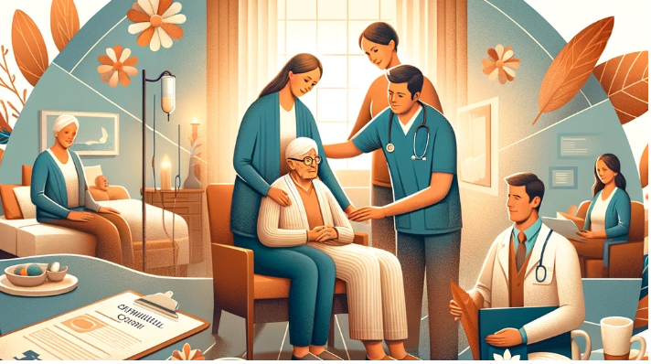 |  |  |  | Maintaining functional ability, independence, freedom and choice. (World Health Organization, 2015)  Preserving an older person's functional ability—that is, their ability to carry out necessary daily tasks—is a key objective in their care.  Maintaining functional ability is crucial because it directly impacts an individual’s independence—the ability to live without undue reliance on others.  Promoting independence empowers older adults to make decisions about their own lives, contributing to their sense of freedom and choice. (D.B and D.H, 2017)  EFFECTIVENESS – BENEFIT – UK POLICIES – THEORY  Person - centered care focuses on respecting and responding to the individual preferences, needs, and values of older adults.  Technologies such as personal alarms, mobility aids, and smart home devices enable older people to perform daily activities safely and independently.  POLICIES  - The Care Act 2014 (Legislation.gov.uk, 2014)  This landmark legislation promotes well-being and emphasizes prevention, early intervention, and person-centered care.  - The National Health Service (NHS) Long Term Plan (2019) (NHS England, 2019)  The plan prioritizes integrated care, personalized support, and community-based services to improve outcomes for older adults with complex health needs.  - The Ageing Society Grand Challenge (part of the UK Government’s Industrial Strategy)  Aims to ensure that people can enjoy at least five extra healthy, independent years of life by 2035 through innovation in healthcare, social care, and technology.  THEORIES  . The Activity Theory of Ageing  This theory suggests that staying mentally and physically active leads to higher satisfaction and better quality of life in older age. (Havighurst, R. J. (1961). Successful aging. The Gerontologist, 1(1), 8-13.)  The Person-Environment Fit Theory  This theory highlights the interaction between an individual’s abilities and their environment. (Lawton and Nahemow, 1973)  CONCLUSION  Supporting and empowering older adults to maintain their independence and functional ability is essential for promoting their well-being, dignity, and quality of life. Current UK policies, such as the Care Act 2014 and the NHS Long Term Plan, emphasize person-centered, integrated, and community-based approaches that are effective in addressing the diverse needs of older people. Implementing strategies that promote self-management, utilize assistive technology, and foster social engagement can significantly enhance their autonomy. |  |  | 
Introduction  As the global population ages, the evaluation of care and support needs for older adults has become increasingly critical. Older people often experience a range of physical, cognitive, and social changes that necessitate tailored support to ensure their well-being and quality of life.  Global Aging Trends:  According to the World Health Organization (WHO), the number of people aged 60 years and older is projected to reach 2.1 billion by 2050. (World Health Organization, 2024)  Increased Care Needs:  A study published in The Lancet found that approximately 40% of older adults require some form of long-term care, whether at home or in residential facilities, due to chronic illnesses, disabilities, or cognitive impairments. (M et al., 2015) |  |  |  |  |  |  | CHALLENGES (National Institute of Aging, 2020)  Physical Health Decline  - Aging commonly brings about chronic conditions such as arthritis, osteoporosis, cardiovascular diseases, and sensory impairments (e.g., vision and hearing loss).  Cognitive Decline  - Conditions like dementia and Alzheimer’s disease affect memory, problem-solving, and decision-making abilities.  Mental Health Issues  - Depression, anxiety, and social isolation are frequent among older adults, often exacerbated by loss of loved ones or reduced social interaction.  Environmental Barriers  - Many older people live in housing that is not adapted to their changing needs—lacking features such as ramps, grab bars, or adequate lighting. (Centers for Disease Control and Prevention, 2020)  - Access to healthcare, rehabilitation, assistive technologies, and community support  - Financial Constraints  - Fixed or limited incomes can restrict the ability to afford medications, home modifications, assistive devices, or paid caregiving, all of which are important for sustaining independence.  Social expectations, stigma, or family dynamics may influence the willingness or ability of older adults to seek or accept help.  RECOMMENDATION AND CONCLUSION  Based on current evidence and best practices, the following recommendations are proposed:  - Promote Person-Centered and Holistic Care  - Services should be tailored to individual needs, preferences, and values. This involves actively engaging older adults in decision-making processes, respecting their autonomy, and providing care that considers their physical, mental, and social well-being.  - Community-based services, including home care, social activities, and support groups, help maintain independence and reduce feelings of loneliness or isolation.  .

References
Reference list
Abdi, S., Spann, A., Borilovic, J., de Witte, L. and Hawley, M. (2019). Understanding the Care and Support Needs of Older people: a Scoping Review and Categorisation Using the WHO International Classification of functioning, Disability and Health Framework (ICF). BMC Geriatrics, [online] 19(1). https://doi.org/10.1186/s12877-019-1189-9.
Apa.org. (2026). Available at: https://www.apa.org/pi/aging/resources/guides/mental-health. [Accessed 4 Mar. 2026].
Centers for Disease Control and Prevention (2020). Older Adult Falls. [online] www.cdc.gov. Available at: https://www.cdc.gov/falls/index.html.
D.B, R. and D.H, S. (2017). Courses and Conferences. Journal of the American Geriatrics Society, 65(11), pp.2550–2550. https://doi.org/10.1111/jgs.14648.
Department of Health (2001). Older People National Service Framework Modern Standards and Service Models National Service Framework for Older People. [online] Available at: https://assets.publishing.service.gov.uk/media/5a7b4f16e5274a34770ead1c/National_Service_Framework_for_Older_People.pdf .
HAVIGHURST, R.J. (1961). Successful aging. The Gerontologist.
Lawton, M.P. and Nahemow, L. (1973). Ecology and the aging process. The psychology of adult development and aging., pp.619–674. https://doi.org/10.1037/10044-020.
Legislation.gov.uk (2014). Care Act 2014. [online] Legislation.gov.uk. Available at: https://www.legislation.gov.uk/ukpga/2014/23/contents/enacted.
M, P., A, W., M, G., G-C, A., Y.-T, W. and M, P. (2015). ADI - World Alzheimer Report 2015. [online] World Alzheimer Report 2015: The Global Impact of Dementia. Alzheimer’s Disease International. Available at: https://www.alzint.org/resource/world-alzheimer-report-2015/.
National Institute of Aging (2020). Cognitive health and older adults. [online] National Institute on Aging. Available at: https://www.nia.nih.gov/health/cognitive-health-and-older-adults.
NHS England (2019). The NHS Long Term Plan. [online] NHS. Available at: https://www.longtermplan.nhs.uk/publication/nhs-long-term-plan/ .
NICE (2015). Overview | Older people with social care needs and multiple long-term conditions | Guidance | NICE. [online] Nice.org.uk. Available at: https://www.nice.org.uk/guidance/ng22.
Policy Press. (2024). Partnership working in health and social care. [online] Available at: https://policy.bristoluniversitypress.co.uk/partnership-working-in-health-and-social-care.
UNITED NATION (2020). United Nations. (2020). Policy Brief: the Impact of COVID-19 on Older persons. [online] Available at: https://www.un.org/development/desa/ageing/wp-content/uploads/sites/24/2020/05/PB_68.pdf [Accessed 4 Mar. 2026].
World Health Organization (2015). World report on ageing and health. [online] World Health Organization. Available at: https://www.who.int/publications/i/item/9789241565042.
World Health Organization (2024). Ageing and health. [online] World Health Organization. Available at: https://www.who.int/news-room/fact-sheets/detail/ageing-and-health.
www.youtube.com. (n.d.). Nora’s Story, depicting an integrated care for older people. [online] Available at: https://www.youtube.com/watch?v=UIvnJJWyUuQ.

