

University of Wales Trinity Saint David

School of Engineering

Engineering Design and Materials

ACHA4001

Material Properties, Selection, and Manufacturing Processes of a Piston.

19th March 2023

Word Count: (2170 Words)

Ross Burnside

Motorsport Engineering

2110614
Contents:

Introduction:

The application of a Piston.
Functional parts of a Compression Chamber.
Compression Cut-outs & Valve Relief.

Page 3

Material Properties:

Forged Pistons vs. Cast Pistons.
Available Materials.
Heat/Environmental coating Considerations.

Pages 4, 5

Material Selection:

Impacts of Environment.
Research Analysis.
Research Conclusion.

Pages 6, 7

Manufacturing Processes:

Acceptable Manufacturing Processes.

Page 8

Conclusion:

Page 9

Reference List:

Pages 10, 11
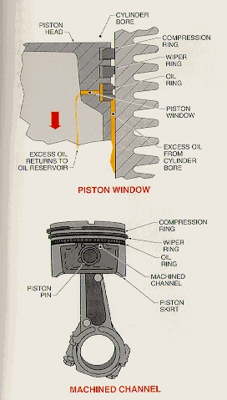
Introduction:

The University of Windsor (2023) state that a Piston is a “cylindrical engine component that slides back and forth in the cylinder bore by forces produced during the combustion process [acting as a] movable end of the combustion chamber”.

Pistons are used for a variety of applications such as vehicle propulsion, machinery functions, and generators; and have around 8 to 10 fixed and concentric parts in order to create a sealed combustion chamber. Figure 1 allows for a visual inspection of the primary functional parts, housed within the cylinder, in order to create a combustion chamber, holding compressional capability.

The ‘Crown’ of the piston, or top-most surface, is sealed by Piston Rings. In order to maintain a sealed cylinder/combustion chamber, a compression ring (see fig. 1) is positioned first, beneath the piston crown/head. On cylinder ignition and combustion, “pressurised gases travel through the gap between the cylinder wall and the piston and into the piston ring groove”, creating a seal between the Compression Ring and cylinder wall, creating a pressure on the ring “approximately proportional to the combustion gas pressure”.
Figure 1; A labelled Piston diagram showing parts and names. – University of Windsor, 2023.

Compressed gases able to escape the seal created by the compression ring are “stopped by the wiper ring […] located between the compression ring and oil ring” (University of Windsor – 2023).

In addition to assisting in sealing the combustion chamber, the Wiper Ring also disperses, or ‘wipes’ the cylinder wall; using a tapered face (see fig. 1) to “clean off excess oil”, returning it to the reservoir through the corrugated slots in the oil ring, and supply hole located behind. (University of Windsor – 2023).

The size of a Piston is also directly proportional to the Cubic Capacity (cc) of the engine block. Because of this it is not uncommon to see various sizes and styles of Piston; each with differences in compressional, and dimensional features, alongside alterations in ring location and number. These include dished pistons for increased cylinder volume/Detonation avoidance for Turbo and Supercharged engines, or Crown cut-outs for valve relief at Top Dead Centre (TDC) of the 720° cycle. A piston’s make-up is also comprised of Connecting Rod, Gudgeon Pin, and big-end bearing Cap.
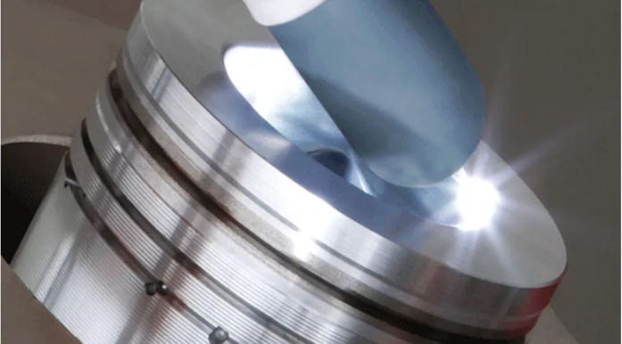
Material Properties:

A Piston needs to be manufactured to have a “minimum weight to minimize the inertia forces [whilst still maintaining] rigid construction to endure thermal, mechanical distortion” alongside “sufficient area to avoid undue wear” (Ahmed, A – 2016).

Pistons are made from a variety of materials dependent on their application and environment. One consideration required by automotive parts manufacturers is heat dissipation, due to the fact that “increasing […] specific power output produces higher mechanical loads and temperatures, making a piston’s heat dissipation as important as its strength” (Brooks, R. – 2012).
Figure 2; Energy Input inputted around the rim of a piston volume dome to re-melt the alloy to create a more rapid cooling effect than in initial solidification, “producing silicon particles that are a fraction of their original size […] enhancing the strength and durability of the alloy” (Brooks, R. – 2012).

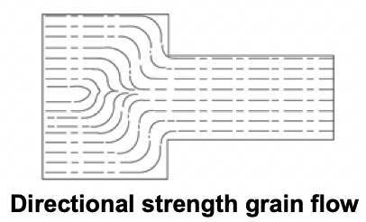
Increased temperatures can lead to augmented fatigue and deformation of pistons, making Forged piston manufacturing more desirable to engine platforms subject to amplified working conditions. “Aluminium alloy has good conductivity” (Kumar, A. – 2022), and due to the increase in thermal expansion, resistance wear is decreased/improved alongside increased longevity under higher engine speeds and temperatures. Forged pistons can also go through additional heat treatment (fig. 2) after initial solidification. What makes Forged manufacturing more desirable than Cast alternatives is the resultant material grain pattern post-development.

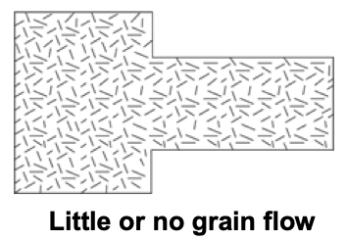
Forged pistons begin as a solid block of Aluminium Alloys or Steel, and are ‘stamped’ into shape, as opposed to material removal. This forces the material into compaction, creating a directional grain (fig. 3) “conforming to the shape of the part”; this highlights a major advantage of forging, showing a strength increase through “uniformity of composition and structure resulting in metallurgical recrystallisation and grain refinement as a result of the thermal cycle and deformation process”, eliminating the possibility of “impurities […] trapped below the surface” alongside “vapor bubbles and micro fractures” (Interstate McBee – 2019).
Figure 3; Example showing directional grain flow from the ‘stamping’ process of forging causing an increase in strength, aiding the piston to resist deformation under actions of an external load/temperature. (Interstate McBee – 2019).

Cast pistons can be advantageous when used in the correct environment; in example, Iron pistons are featured in older, classic generations of cars, low-speed engines, alongside cheap manufacturing applications due to the “synergetic […] engine platform design” with that of an Iron engine block (SAE International. – 2018) and excess of cheap material availability.
Figure 4; Example showing a loss of directional grain flow caused by casting. With the casting process being pre-shaped moulds, the metal is poured into the cast and rapidly cooled, creating little grain flow on re-solidification. (Interstate McBee – 2019).
Despite this, it is still common for “aluminium alloy pistons [to be] used in engines where the piston speed is high” (Kumar, A. – 2022) due to their affordability, as with in manufacturing. Cast pistons are lighter weight in comparison to forged pistons, alongside higher-grade materials being sufficient in strength, thermal conductivity, and fatigue preventative for the automotive industry and majority of motorsport-enthusiast engine developments found.
However, in both Aluminium and Steel examples, “additional treatment” is required “after they are cast, such as custom finishing or thermal treatment” (Brooks, R. – 2012).
This is because “the process does not prevent formation of certain metallurgical defects” whilst also eliminating the advantages of “grain flow [and] directional strength” (Interstate McBee. – 2019). This loss of grain flow (fig. 4) can create fatigue-caused brittleness, creep, and a decrease in strength/longevity.
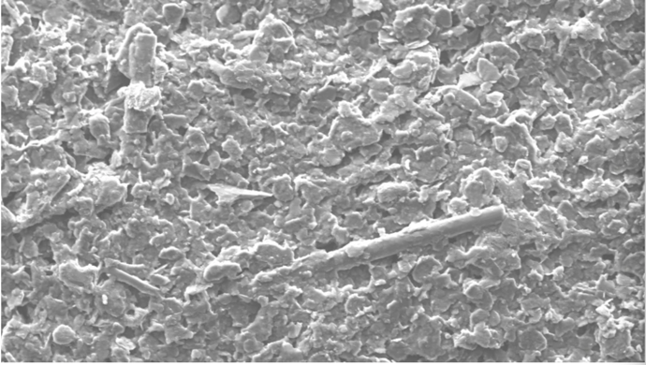
Pistons can also feature temperature-based coatings.
One example could be pistons with an ‘EcoTough’ coating (fig. 5), developed “tests showed that [experiments on] EcoTough coated diesel pistons reduced friction by up to 13% for a single cylinder engine, compared with pistons coated in conventional graphite material” and that the coating also featured a “high wear resistance that can reduce friction and fuel consumption without compromising noise and vibration standards, or the engine’s durability” (Brooks, R. – 2012).
Figure 5; “A scanning electron microscope image of the new EcoTough coating” – (OEM Off-Highway, 2012).

Super-high-Silicon-content-alloy pistons have “higher fatigue limits and excellent wear resistance” due to them “having a silicon content of higher than 11.8%”. These aluminium alloys are referred to as “hypereutectic” and known for creating a higher melting point than that of the constituents individually; alongside having “good strength characteristics” under increased load and temperature environment settings (Horváth, R. – 2003).

“The difference between maximum and minimum temperature around the bowl rim circumference can exceed 40°C”, as can be seen in Figure 6; resulting in “Piston Fatigue Strength […], Plastic Deformation [causing] ring sticking, [and] Radial Deformation of the piston [affecting] noise, frictional losses, and clearances between the piston and other components” alongside Fatigue Resistance Loss being “as high as 80% compared to room temperature properties” (Jääskeläinen, H. – 2017).

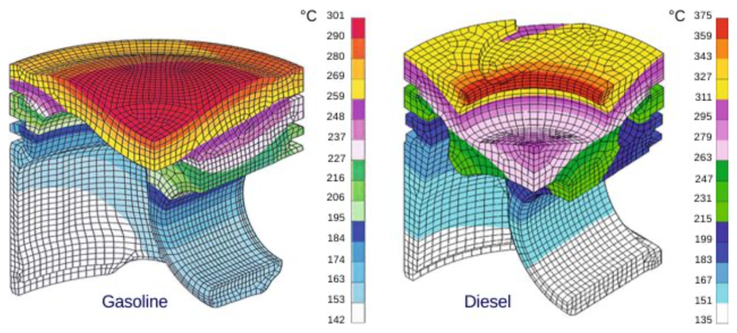
Key areas of the piston exposed to maximum temperature (such as the crown, bowl, and rim) require control to “prevent premature wear and failure of the piston and subsequent engine damage” (Jääskeläinen, H. – 2017).

Figure 6; “Maximum temperature distribution in a [Petroleum] and oil cooled Diesel piston” (Jääskeläinen, H. – 2017).

Material Selection:

In order to decide on the best available material for a performance/track-build application, it is important to note the endurance needed to resist fatigue and creep; considering stresses the piston is subjected to, such as “full throttle and 6000rpm”, when a “piston in a [Petroleum] engine is subjected to nearly 10 tons of force every 0.02 seconds”.

This, alongside “piston operating temperatures [reaching] 120 degrees”, creating “peak cylinder pressures [of] 1500psi to 2200” requires a robust material with high thermal conductivity and hardness (Tingwall, E. – 2014). To help consider material stress and heat requirements, Figure 7 shows a temperature distribution graph over multiple sections of the piston crown, pin bore, and piston skirt:
Figure 7; A Chart to show the mean temperature range (˚C) of key areas of a piston. (Burnside, R. – 2023).
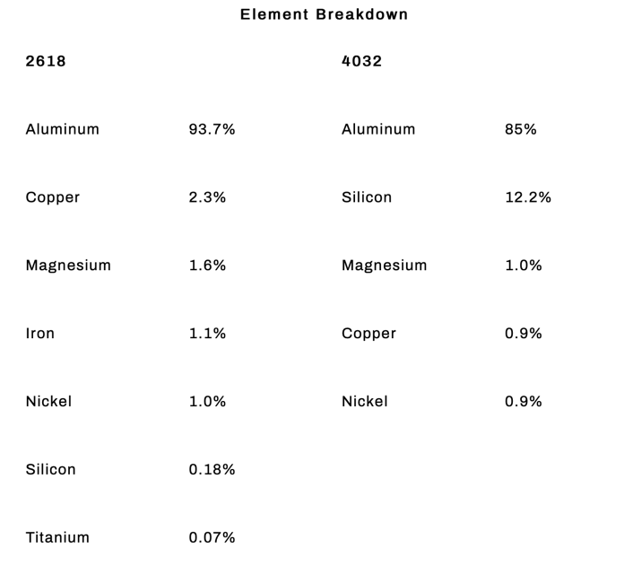
Included; Data for calculations collected from (Jääskelänen, H – 2017) via https://dieselnet.com/tech/.
Considering a high-performance, race application for the Material Selection, pre-tested and explored options favour a choice between 2618 and 4032 aluminium alloy. With temperature resistance being a key property of high-grade piston success, an element breakdown (fig. 8 – Smith, J.) can be used to evaluate differences between the two selected compound options.
4032 aluminium alloy is not only lighter, but also has a “high silicon content - a full 12%” (or more commonly 12.2%). The “addition of silicon greatly reduces aluminium’s expansion rate” allowing the piston to “run with tighter cold clearances” (Smith, J. – 2017) due to the fact that “a 4032 piston will maintain the proper ring groove clearance and seal for more miles travelled” because of its high-grade nature and hardness (Smith, J. – 2017).
Figure 8; Data sheet collected from (Smith, J – 2017) to show an element breakdown of 2618 and 4032 aluminium alloy compounds. (JE Pistons. – 2017).
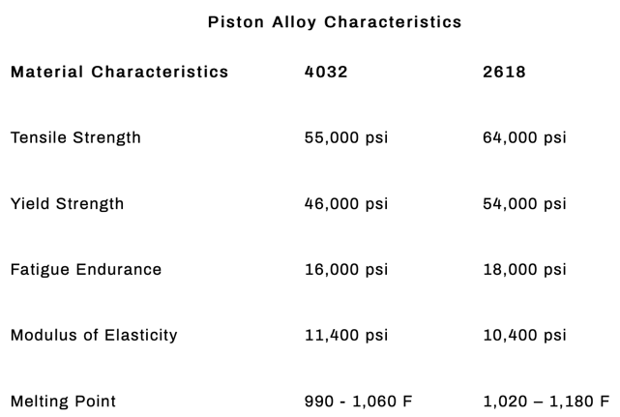
Despite this, 4032’s “reduced ductility” and hardness “does make the alloy less resistant to cracking with extreme impact loads such as detonation or unforeseen physical contact” when compared to 2618 (Smith, J. – 2017).

The main advantage of a 2618 compound piston, alongside being “renowned for its excellent high-temperature strength”, is its “very low silicon content” of 0.23% offering a “much more malleable” platform, proving advantageous under “high-load [and] high-stress applications” from additional power increase attempts; such as “superchargers, turbochargers, or nitrous oxide” and ability to handle more cylinder pressure (Smith, J. – 2017).
Figure 9; Data sheet collected from (Smith, J. – 2017) to show different piston alloy characteristics when considering 2618 and 4032 alloys. (JE Pistons. – 2017).

However, the low silicon content in turn causes the piston to have an increased linear expansion rate. This “must be compensated for with greater ambient piston-to-wall clearances”, known for expanding “15% more than a 4032 version”. These increased clearances when using a 2618 platform will also cause the engine to run “slightly noisier when cold as opposed to a comparable 4032 forging” due to its increased heat expansion at optimum working temperature (Smith, J. – 2017).

Considering a performance motorsport vehicle application, 2618 aluminium alloy reflects the desired quality and material characteristics discussed as needed.
Despite 4032’s comparative lightness and higher silicon content, the vehicle in question would be raced over a series of events, with engine quantity and/or repair restrictions.
This requires a longer lasting piston able to deal with high-stress applications, such as coping with only ever being driven flat-out with maximum throttle, speed, and engine breaking in turn. Because of its stress-capable longevity and increased fatigue endurance (fig. 9 – Smith, J. – 2017), alongside the ability to better cope with additional power components (turbo/superchargers/$N_{2}O$), 2618 is considered the best material for the given application.

Manufacturing Processes:

The forging process is defined as the “controlled deformation of metal into a desired shape by [application of repeated] compressive force” resulting in “stronger and more durable” metalwork products (Gearhart, M. – 2018). Alongside the “changing [of] internal grain structure of the metal” it is necessary to remember that, before cutting the material to begin forging, “pistons do require additional room temperature clearance”; especially that of 2618, with a slightly higher thermal expansion than 4032. However, the silicon content present in the aluminium alloy “controls the expansion to nearly the same as a […] silicon cast piston” (Fussner, D. – 2018).

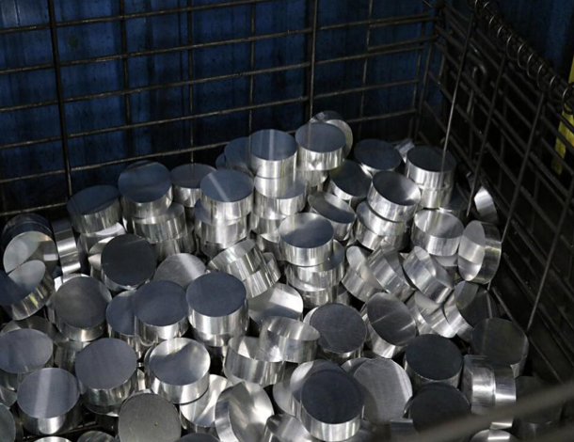
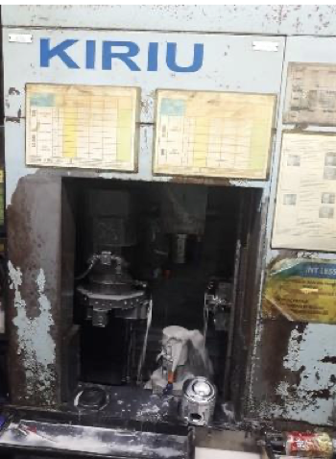
Considering the chosen material for our application, the forged piston manufacturing begins with a “solid aluminium rod type 2618”, which is heated between “100˚C [and] 150˚C” and cut into ‘slugs’ (fig. 10, IOP Conference Series). The forging punch (fig. 11, IOP Conference Series) is purpose-heated to “426˚C and applies 2000 tons of pressure onto the slug” (IOP Conference Series. – 2020).
Figure 10; “Slugs after cutting”, pre-forging process. (IOP Conference Series. – 2020).
Figure 11; “KIRIU Machine setup”. (IOP Conference Series. – 2020).
Following this, a “grinding process” is then carried out to “give the crown the shape required according to the design” before final machining using a “techno automation system which has high accuracy and increases actual production” of the final product (IOP Conference Series. – 2020).

Despite the inherent benefits of the final piston product, the forging process is “expensive” (IOP Conference Series. – 2020), with a mean market price of £1,399.00 for a Porsche 997, 6-cylinder performance MAHLE piston layout (4032 piston, used in a cast iron cylinder liner – MARMotorsport – 2023), with the actual material production “not maximum” due to a “complicated” process of Computer Numerically Controlled (CNC) removed material post forging, requiring significantly more time and effort in manufacturing with excessive waste and huge thermal capacity needed (IOP Conference Series. – 2020).

Conclusion:

In conclusion, previous studies by Ahmed et al. (2016) have suggest that forged aluminium alloy may offer minimum weight whilst maintaining a rigid construction, and potentially when involved in a high-stress application, such as performance motorsport. Ahmed et al. (2016) also implies that this is due to the hypereutectic combination of base materials resulting in fatigue wear longevity and strength, alongside a significantly increased melting point.

Given the selection of forged aluminium, consideration was then made for the hypereutectic mix. Work published by Smith (2017) indicates that a desired ductility should be considered in relation to specific piston applications. In this current study, 2618 aluminium alloy was selected as the chosen material. Moreover, Smith (2017) highlights that, despite an increased heat expansion percentage and rate, 2618 features a better “high temperature strength” in conjunction with a lower silicon content, proving advantageous under high-load/high-stress conditions due to being more malleable in comparison to the alternative performance option of 4032, which is more prone to cracking under increased pressures and combustion.

Notwithstanding the 15% increased piston-to-wall clearances required for 2618 alloy pistons, their ability to undergo intense stress from issues such as sudden detonation and maintained tolerance capacity over more miles travelled is more suited to a racing series; where maintaining the engine’s performance over multiple stages is prioritised over a minimal hours optimum-use window.

Although expensive, the “controlled deformation of metal” through forging allows for increased strength and durability in final production from the adaptation of material internal grain flow (Gearhart, M. – 2018). The additional costs and manufacturing time caused by the repeated necessary thermal expansion of the product to allow for ‘room temperature clearance’ and general cutting/stamping of the material in forging is outweighed by the “metallurgical recrystallisation and grain refinement” created by the additional treatment and repeated thermal cycles the material is subjected to throughout the process (Interstate McBee – 2019).

Reference List:

University of Windsor. – 2023.
Piston and Piston Rings:
https://courses.washington.edu/engr100/Section_Wei/engine/UofWindsorManual/Piston%20and%20Piston%20Rings.htm
Accessed 19th February 2023.

Ahmed, A. / Wahab, M.S. / Raus, A. A. / Kamarudin, K. / Bakhsh, Q. – 2016.
Mechanical Properties, Material and Design of the Automobile Piston: An Ample Review:
https://sciresol.s3.us-east-2.amazonaws.com/IJST/Articles/2016/Issue-36/Article115.pdf
Accessed 19th February 2023.

Summit Racing Equipment. – 2019.
Piston Styles: A Basic Overview:
https://help.summitracing.com/app/answers/detail/a_id/5017/~/piston-styles
Accessed 19th February 2023.

Acosta, G. – 2021.
Enginelabs.com: Modern Piston Materials, Manufacturing, and Coatings with UEM:
https://www.enginelabs.com/news/modern-piston-materials-manufacturing-and-coatings-with-uem/
Accessed 20th February 2023.

Brooks, R. – 2012.
Handling the Heat, and the Pressure, of New Product Development:
https://www.foundrymag.com/molds-cores/article/21927637/handling-the-heat-and-the-pressure-of-new-product-development
Accessed 20th February 2023.

Kumar, A. – 2022.
Automobile Engineering: Definition, Components or Parts, Types, Material, Function, and Property:
https://themechanicalengineering.com/piston/
Accessed 2nd March 2023.

SAE International. – 2018.
Nodular cast iron pistons for Medium Duty Applications:
https://www.sae.org/publications/technical-papers/content/2018-01-1275/
Accessed 2nd March 2023.

Interstate McBee. – 2019.
Technical Partsgram - #56: Steel Pistons – Forged vs. Cast:
https://interstate-mcbee.com/wp-content/uploads/2019/03/forged-v-cast-lr.pdf
Accessed 2nd March 2023.

OEM Off-Highway. – 2012.
EcoTough Coated Diesel Pistons: Federal-Mogul Powertrain:
https://www.oemoffhighway.com/engines/engine-components/product/10781941/federalmogul-powertrain-ecotough-coated-diesel-pistons
Accessed 6th March 2023.

Jääskeläinen, H. – 2017.
Piston Cooling: Piston Temperature:
https://dieselnet.com/tech/combustion_piston-cool.php
Accessed 8th March 2023.

Tingwall, E. – 2014.
Car and Driver: Everything you ever wanted to know about modern pistons:
https://www.caranddriver.com/features/a15109982/everything-you-ever-wanted-to-know-about-pistons-feature/
Accessed 9th March 2023.

Horváth, R. – 2003.
Machinability of high silicon content aluminium alloys:
https://www.forgacsolaskutatas.hu/innovacio/microCAD_Delphi_ENG/
Accessed 10th March 2023.

Smith, J. – 2017.
JE Pistons: 2618 vs. 4032 Piston Material Differences:
https://auto.jepistons.com/blog/2618-vs.-4032-material-differences
Accessed 10th March 2023.

Gearhart, M. – 2018.
Including quote from (Fussner, D. – 2018)
Motortrend: How a forged piston is produced:
https://www.motortrend.com/how-to/1803-how-a-forged-piston-is-produced/
Accessed 11th March 2023.

IOP Conference Series. – 2020.
Materials Science and Engineering: Aluminium Alloy Piston Fabrication Technology:
https://iopscience.iop.org/article/10.1088/1757-899X/924/1/012001/pdf
Accessed 14th March 2023.

MARMotorsport. – 2023.
4032 pistons, used in a cast iron cylinder liner:
https://marmotorsport.com/shop/forged-piston-set-porsche-997-3-8l-for-cast-iron-liner-100mm-bore/
Accessed 14th March 2023.

