University of Wales Trinity St David
School of Engineering
Turbo Charger Analysis
Iwan Thomas
P147756
BSc Motorsport Engineering
Powertrain Design & Efficiency M5X02200

Contents

1.0 Principles of Turbocharging
1.1 What is turbocharging? Page 3
1.2 Flow of air and exhaust gasses Page 4
2.0 Turbo Strip Down Page 5
3.0 Turbocharger Installation
3.1 Turbocharger Calculations Page 6
3.2 Intercooler Calculations Page 8
3.3 Turbo Selection Page 9
3.4 Installation Considerations Page 11
4.0 References Page 12

1.0 Principles of Turbocharging
1.1 What is Turbocharging?
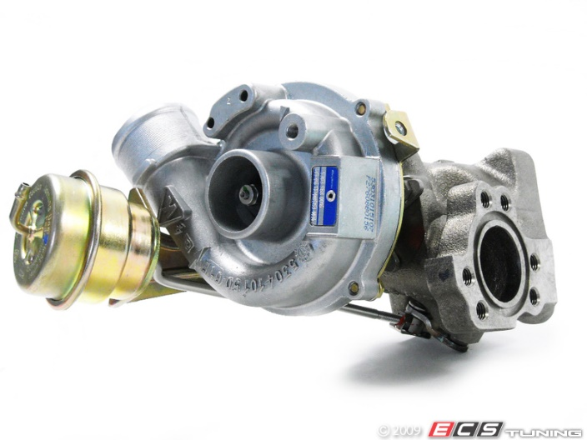
A turbocharger is a more sophisticated air pump, primarily used to supply the engine with more air than a standard air filter during the intake stroke. The air is supplied by harnessing the wasted energy in the exhaust. The exhaust gasses drive a turbine and shaft which in turn rotates the compressor turbine. Once the exhaust turbine turns the compressor wheel, high pressure cold air is forced into the engine and injected into the combustion chamber, consequently allowing more fuel to be injected, increasing the size of the combustion. As stated by turbo one (2005), the high concentration of oxygen forced into the combustion chamber along with the optimum air/fuel ratio, creating a cleaner and more complete combustion. Benefits of turbocharging including the increase of engine performance in terms of power and torque. Turbocharging lowers diesel fuel consumption and reduces the harmful emissions excreted by the engine. Manufacturers lately have been downsizing their engines and adding a turbocharger to increase fuel consumption and power simultaneously. According to BorgWarner Turbos (2002-18), there are two main types of turbine types; axial and radial flow. Axial flow allows the air to flow only in the axial direction. Radial flow turbochargers are a centripetal flow. A centripetal flow allows the air to flow in a radial direction from the outside of the turbo inwards whilst the gas outflow in an axial direction. A standard turbocharger compressor consists of three essential components; turbine, diffuser and housing according to BorgWarner Turbos (2002-18). The rotational speed of the turbine draws the air in axially, accelerated to a high velocity within the housing and then expelled in a radial direction. The behaviour of the compressor is defined by maps demonstrating the relationship between pressure ratio and mass flow rate. The majority of turbos incorporate a sleeve bearing which is a shaft that turns without friction due to an oil film in the sleeve. The oil supply for this sleeve comes from the engine oil circuit. The bearings rotate at about half shaft speed, situated between the rotating shaft within the turbo and the stationary centre housing.

1.2 Flow of air and exhaust gasses
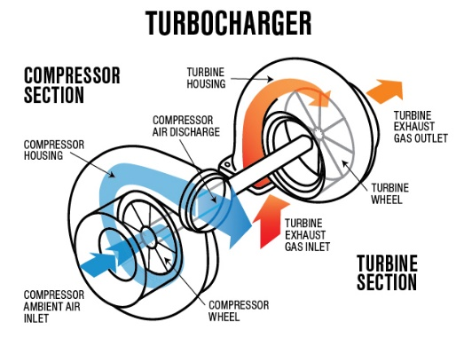
Starting the engine will begin the process of air entering the compressor side of the turbocharger where the already rotating exhaust turbine allows the compressor wheel to draw in the air. The air will be recirculated back into an intercooler which cools the air before returning to be compressed in the turbo. Choosing the correct intercooler is key; it will determine how quick and how efficiently the air will be cooled. Applying the throttle will increase the pressure of the compressed air; the more throttle applied the quicker the air will enter the engine. No matter how much pressure is applied to the throttle, the air flow path won’t change. Exhaust gasses will leave the engine via the exhaust manifold in turn spinning the wheel in the turbine housing. The turbine is connected to the compressor wheel via a shaft therefore the quicker exhaust gasses leave the engine, the quicker clean air will be able to enter.

2.0 Turbocharger Strip down

- Be sure to wear dust coats and protective steel toecap boots for safety reasons. Keep anything removed from the turbocharger in a safe place as everything will be needed for reinstallation. Do not drop the turbo as it’s been balanced precisely to run at speeds of up to 150,000 rpm.
- Remove the wastegate or vacuum actuator attached to the turbo housing. This will be done by removing two bolts found underneath the actuator. Be sure to keep these bolts in a safe place for reinstallation. Disconnect the actuator arm by removing the C shape clip holding it to the housing.
- Use an 8mm spanner to remove the bolts in the back of the compressor housing. The bolts will be rather tight; undo opposites in order and remove each bolt equal amounts. After all the bolts are removed the housing should release relatively easily; depending on the condition of the turbo.
- Once the compressor housing has been fully removed, inspect the quality of all the parts. Check the compressor wheel for any fin damage. Do not replace the compressor wheel if there’s damage to the fins; these are accurately balanced and cant be damaged by any foreign objects. Also, check for play in the compressor shaft. If there’s excessive amounts of play, new bearings or a new shaft will be needed for the turbo. Finally, check the compressor housing for any damage.
- Moving onto the turbine side of the turbo, remove the 10mm bolts in the back to separate the turbine housing from the centre hub in the same way the compressor housing was done. Inspect the exhaust turbine for any damage as well as checking the housing. Check the bearing to see if the turbine wheel spins freely. Mark the location of the nut with the compressor wheel; when it’s put back together, the marks should meet up.
- Inspect and clean all parts before reassembling the turbocharger. Add some thread lock to the bolts along with replacing all gaskets found.

3.0 Turbocharger Installation
3.1 Turbocharger Calculations
8 cylinders | V = Volumetric Flow
Bore: 0.095m | v = Total Engine Displacement
Stroke: 0.08m | n = Volumetric Efficiency
RPM Redline: 9500 | N = Engine Speed
N/A Efficiency: 85% | L = Stroke
Boost Pressure: 12psi
Intercooler Efficiency: 60%
Ambient Temperature: 27ºC

Total Engine Displacement = Volume of each Cylinder x Number of Cylinders
= πr² x L
= π x 0.0475² x 0.08
= 5.67x10⁻⁴ x 8
= 4.54x10⁻³

V = v x n x N
2 x 60
V = 4.54x10⁻³ x 0.85 x 9500
2 x 60
V = 0.31 m³/s

PR = Total Absolute Pressure
Atmospheric Pressure
PR = (12 + 14.7)
14.7
PR = 1.82

Vt = PR x v x n x N
2 x 60
Vt = 1.82 x 0.31
Vt = 0.56 m³/s

0.56 x 2119 = 1186.64 cfm
100% | 83.06 | PR 1.82
50% | 41.53 | PR 1.82
20% | 16.61 | PR

1186.64 x 0.07 = 83.06 lb/min

Temp Out = PR^{0.28} x Temp in
= 1.82^{0.28} x 27
= 31.93ºC

3.2 Intercooler Calculations
Temp Out = Compressor Out Temp - Intercooler Efficiency
Compressor Out Temp - Ambient Temp
= 31.93 - 0.6
31.93 - 27
= 6.35 ºC
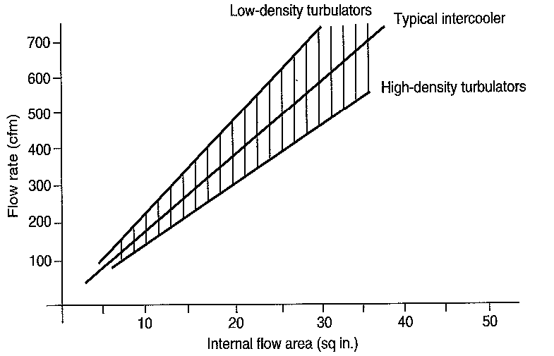
As suggested by Richard, our lecturer, I will calculate the size of intercooler using this graph. The CFM calculated doesn’t fit on this graph, therefore I will half the CFM in order for it to fit the graph and then double the internal flow area to calculate the size of intercooler needed. The calculations can be seen below.

Half CFM = 593.32

As seen on the graph, half the CFM needs an internal flow area of 29.5in² meaning that the total CFM will need a minimum internal flow area of 59in² for enough air to be cooled to feed the turbo charger.
3.3 Turbo Selection
After completing the equations above. The math can be used to choose a suitable compressor by plotting the results on the graphs provided. The turbo with the highest efficiency throughout the spool will be the compressor selected.
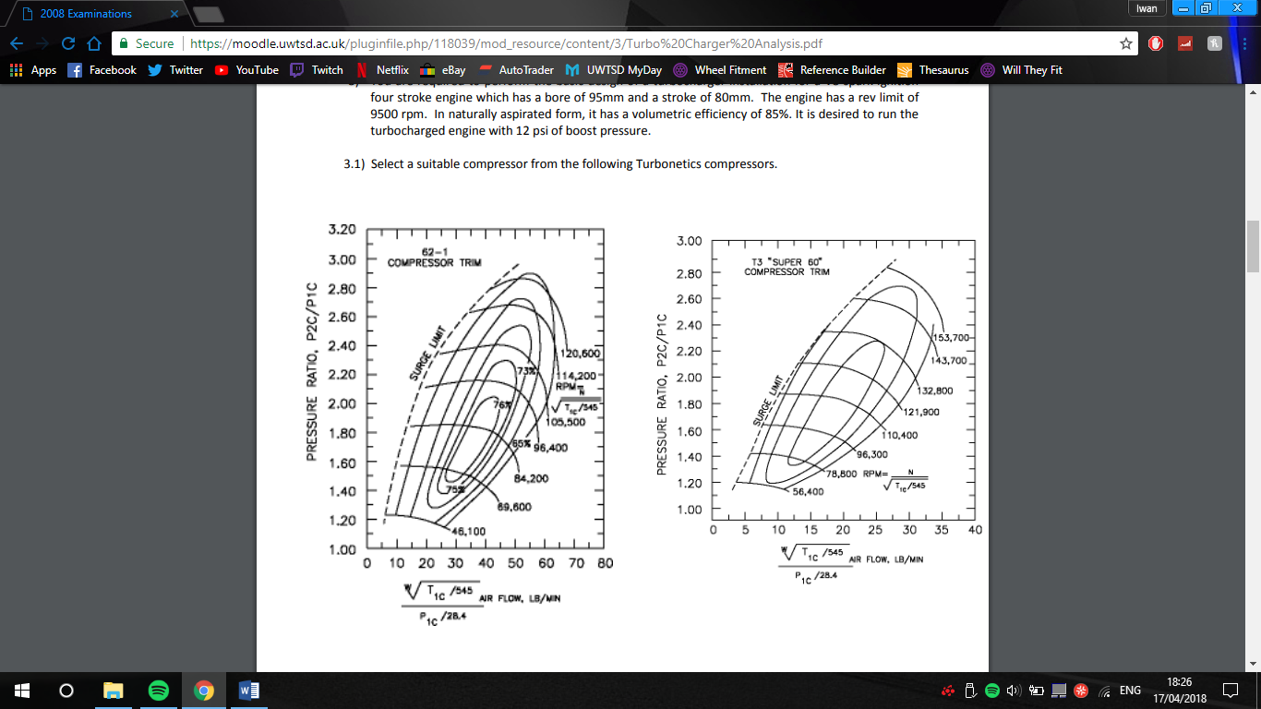
After completing the equations, I worked out that the Pressure ratio for the turbo’s was 1.82 at 100%. The air flow at 100% is 83.06 lb/min which doesn’t fit on this graph. Therefore, at 100% air flow, this turbo can not handle the amount of air flow that the engine needs. At 50%, I have calculated that the air flow needed is 41.53 and this 62-1 compressor will be 76% efficient and spooling at approximately 84,200rpm. This compressor will be suitable for everyday driving but wont be suitable for use on a race car.

The second compressor which goes by the name of “T3 Super 60” cannot handle the turbo at the air flow of 100%, 83.06 lb/min and it cannot perform at 50% air flow either. The T3 will be able to perform at 20% of the desired air flow, spooling at approximately 78,800rpm. This compressor wont be suitable for everyday driving nor will it be suitable for race purposes.

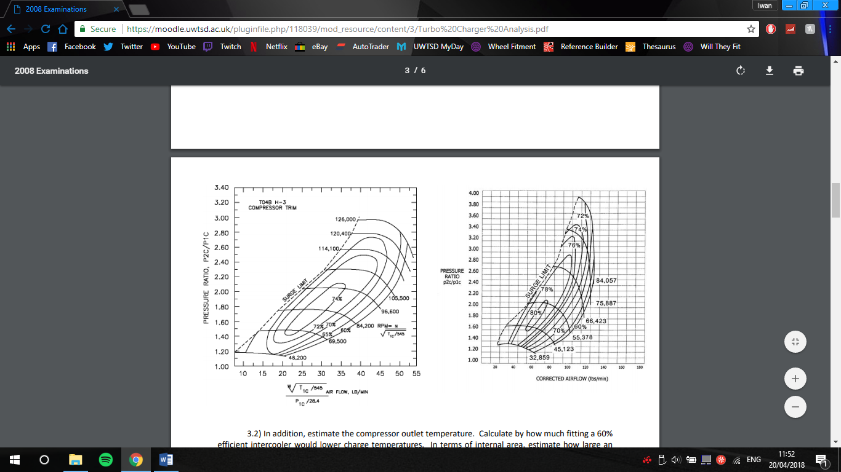
The T048 compressor isn’t large enough for the 100% air flow that I’ve calculated above. The 83.06 calculated doesn’t fit on this graph. 50% of the compressors spool calculated above will be able to fit on this graph resulting in a 70% efficient spool at approximately 55,000rpm. This T048 compressor wont be suitable for the application on a race car but would be suitable for a vehicle being used every day.

This compressor housing is the perfect size for the collected results. At 100% air flow this compressor housing will be 74% efficient and spool at approximately 60,000rpm. At 50% corrected air flow, this compressor housing will be on the surge limit. This compressor wont be suitable for everyday driving but it would be perfect for a vehicle primarily used on a race track as the maximum power produced will be high up the rev range.
3.3 Installation Considerations

Choosing the correct turbo for your desire is the most important part of turbocharging a vehicle. A target horsepower must be chosen by not losing sight of what the car will be used for. A very large turbo may look good but isn’t practical in terms of traction and whether the engine and driveline will be able to handle the increase in power and torque. A smaller, quicker spooling turbo is often best for every day use compared to a larger turbo that needs 4500rpm to start spooling. Consider engine internals may need to be upgraded to handle the increase in power also. A larger turbo will generate more heat than a smaller turbo no matter the boost pressure. Increasing air flow and horsepower should be the largest consideration not boost pressure according to A Bonk from super street (2016). When deciding on compressor and turbine housings, choose ones that remove the most exhaust gases and ones that can pump the most air into the engine without increasing heat more than necessary.
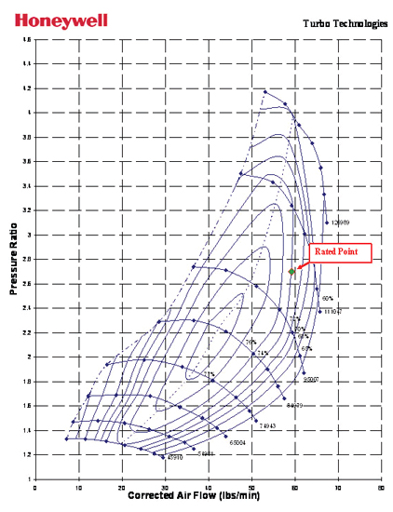
Compressor maps are the easiest way to reveal a given turbo’s efficiency, surge limit and boost potential. A turbo that has a great efficiency throughout the spool and a higher boost potential should be chosen. A larger turbo will have a later surge limit meaning the turbo might not be efficient until redline says super street (2016). As the size of the turbo increases the efficiency will drop and heat produced will rise. According to Turbo by Garrett (2018), a daily driver turbo has the capability to increase stock horsepower by 150hp whilst keeping the reliability, performance and drivability. For example, a 2.0 engine tested by Garrett would have a GT3788R turbo. This turbo includes a tip with a diameter of 88mm and a 52mm compressor wheel, also including a 64.45mm inducer. This turbo would be adequate for this car by looking at the graph, the point falls very nicely on the map with additional room for increased performance in terms of boost and horsepower targets.
Once a turbo has been installed, the space for an intercooler needs to be considered. The major limiting factor in choosing an intercooler is constraints between the radiator and the front bumper, it may prove to be difficult to install an intercooler of an efficient size to work with the turbo. Usually, if there’s not enough room for an adequate sized intercooler, a water to air intercooler is used to maximise the cooling ability of the intercooler’s core surface area according to Turbo by Garrett (2018). Choosing an intercooler with a core that’s too small, it’s possible to starve the turbo of adequately cooled charged air.

4.0 References
Principles of turbocharging
Anon (n.d.). Tech Fundamentals. [online] Available at: http://www.turbo.com.sg/tech_fundamentals.htm [Accessed 1 May 2018].
Anon (n.d.). Design and Function of a Turbocharger - Turbine | BorgWarner Turbo Systems. [online] Turbos.bwauto.com. Available at: http://www.turbos.bwauto.com/products/turbochargerTurbine.aspx [Accessed 1 May 2018].
Image 1: Borg Warner Turbo. (2018). [image] Available at: https://c1552172.ssl.cf0.rackcdn.com/22668_x800.jpg [Accessed 1 May 2018].
Turbo air flow
Honeywell Garrett. (n.d.). Turbo Tech Expert: Mass Flow Rate. [online] Available at: https://www.turbobygarrett.com/turbobygarrett/mass_flow_rate [Accessed 1 May 2018].
Turbodynamics.co.uk. (n.d.). How Does A Turbocharger Work? | Turbo Dynamics. [online] Available at: https://www.turbodynamics.co.uk/technical/understanding-turbochargers/ [Accessed 1 May 2018].
Bonk, A. (2016). How to Pick the Right Turbocharger. [online] SuperStreetOnline. Available at: http://www.superstreetonline.com/how-to/engine/1602-how-to-pick-the-right-turbocharger/ [Accessed 1 May 2018].
Image 2: Quora. (2015). How is the motion of the exhaust air at the outlet of a turbocharger? Is there any swirling motion created due to the turbocharger?. [online] Available at: https://www.quora.com/How-is-the-motion-of-the-exhaust-air-at-the-outlet-of-a-turbocharger-Is-there-any-swirling-motion-created-due-to-the-turbocharger [Accessed 1 May 2018].
Turbo Selection
Image 3: Turbo Charger Analysis. (n.d.). [image] Available at: https://moodle.uwtsd.ac.uk/pluginfile.php/118039/mod_resource/content/3/Turbo%20Charger%20Analysis.pdf [Accessed 1 May 2018].
Installation Considerations
Bonk, A. (2016). How to Pick the Right Turbocharger. [online] SuperStreetOnline. Available at: http://www.superstreetonline.com/how-to/engine/1602-how-to-pick-the-right-turbocharger/ [Accessed 1
Honeywell Garrett. (n.d.). Choosing a Turbo. [online] Available at: https://www.turbobygarrett.com/turbobygarrett/choosing_turbo [Accessed 1 May 2018].
Image 4: Honeywell Garrett (2018). Turbo Technologies. [image] Available at: https://www.turbobygarrett.com/turbobygarrett/sites/default/files/turboTech/turboTechDieselTech/diesel-map-01.jpg [Accessed 1 May 2018].
Honeywell Garrett. (n.d.). How do I select the proper intercooler core size?. [online] Available at: https://www.turbobygarrett.com/turbobygarrett/core-size [Accessed 1 May 2018].

