Enterprise Network Security Practical Evidence Report
Student Name: | Riddhi Damjibhai Mendpara
Student ID: | 2518862
Module: | ACCA7032 Enterprise Network Security
Lecturer: | Munyaradzi Murira
Submission Date: | 27th July 2026

1. Practical Implementation Overview
The implementation and setup of a Check Point enterprise network security environment are detailed in this practical evidence report. Gaia installation and initial configuration, Security Gateway and Security Management Server operation, Smart Console management, network object generation, Network address translation (NAT), Access Control Policy configuration, policy installation and audit verification are all covered by the evidence. The corresponding screenshot from the practical work should be positioned alongside each figure.

2. Gaia, Gateway and Management Deployment
2.1 Check Point Gaia OS Installation
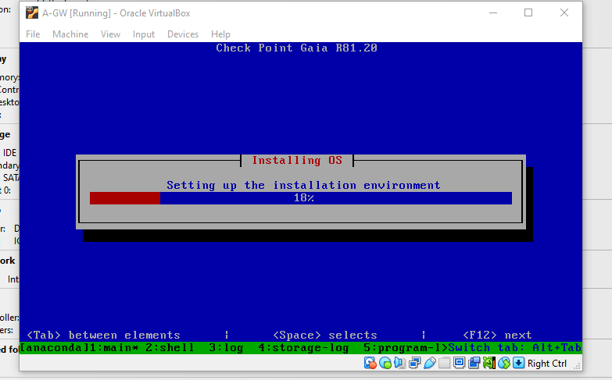
The installation of Check Point Gaia R81.20 on the Security Gateway virtual machine is shown in this screenshot. The Check Point gateway's operating system, Gaia, serves as the foundation for the firewall and other security features. Before network interfaces, management connectivity, and security rules can be configured, the foundational system must be established. Because it verifies that the actual environment was constructed from the operating-system level rather than merely customising pre-existing Smart Console objects the installation proof is crucial. The gateway is ready for integration with the Security Management Server and may be accessed via the Gaia Portal once the installation is finished. Thus, this phase serves as the basis for the corporate security implementation seen in the screenshots that follow.

2.2 Gaia Portal Login
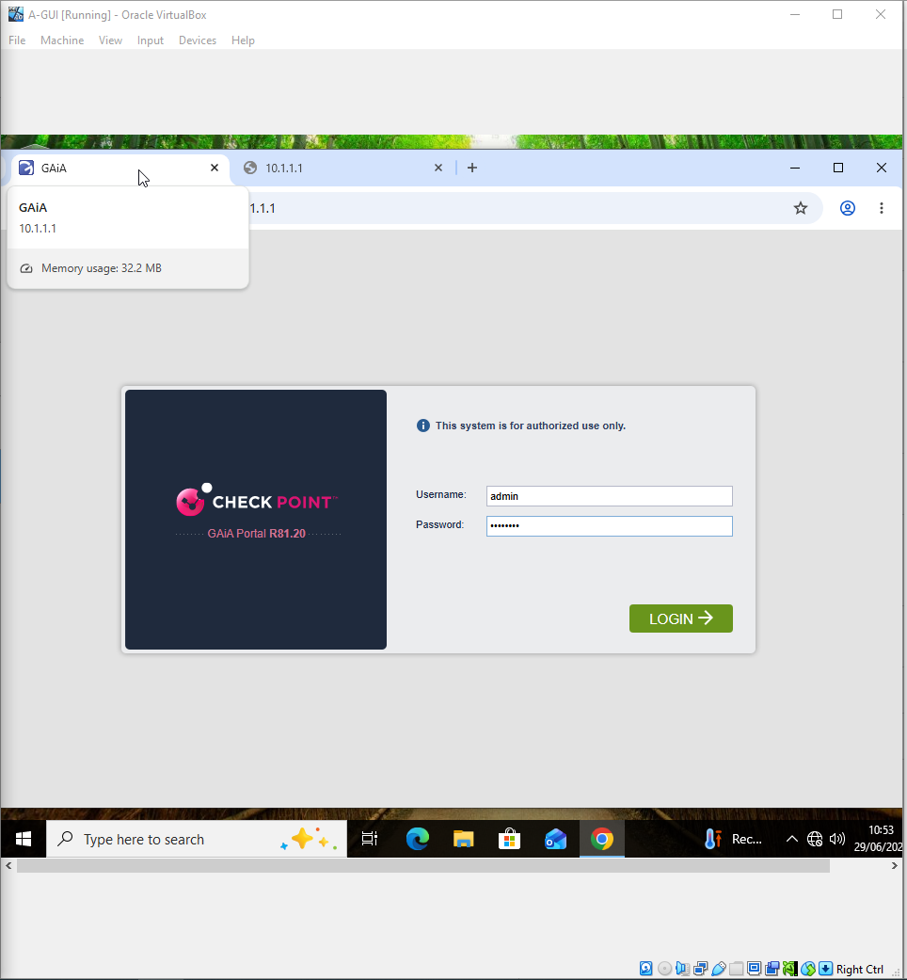
This screenshot demonstrates how to use the Security Gateway management address to access the Check Point Gaia Portal. A browser-based administration interface for setting up and keeping an eye on the gateway operating system is offered via the Gaia Portal. In order to limit infrastructure management to authorised users, administrator authentication is necessary before system parameters may be altered. After installation, accessing the portal verifies that the gateway is operating properly and that the management interface is reachable. Settings including interfaces, routes, system data, and administrative configuration can be examined from this interface. Successful portal access indicates that the gateway has advanced from installation to an operational state and is prepared for the First Time Configuration Wizard and subsequent enterprise network configuration, which makes it an important stage in the practical sequence.

2.3 First Time Configuration Wizard
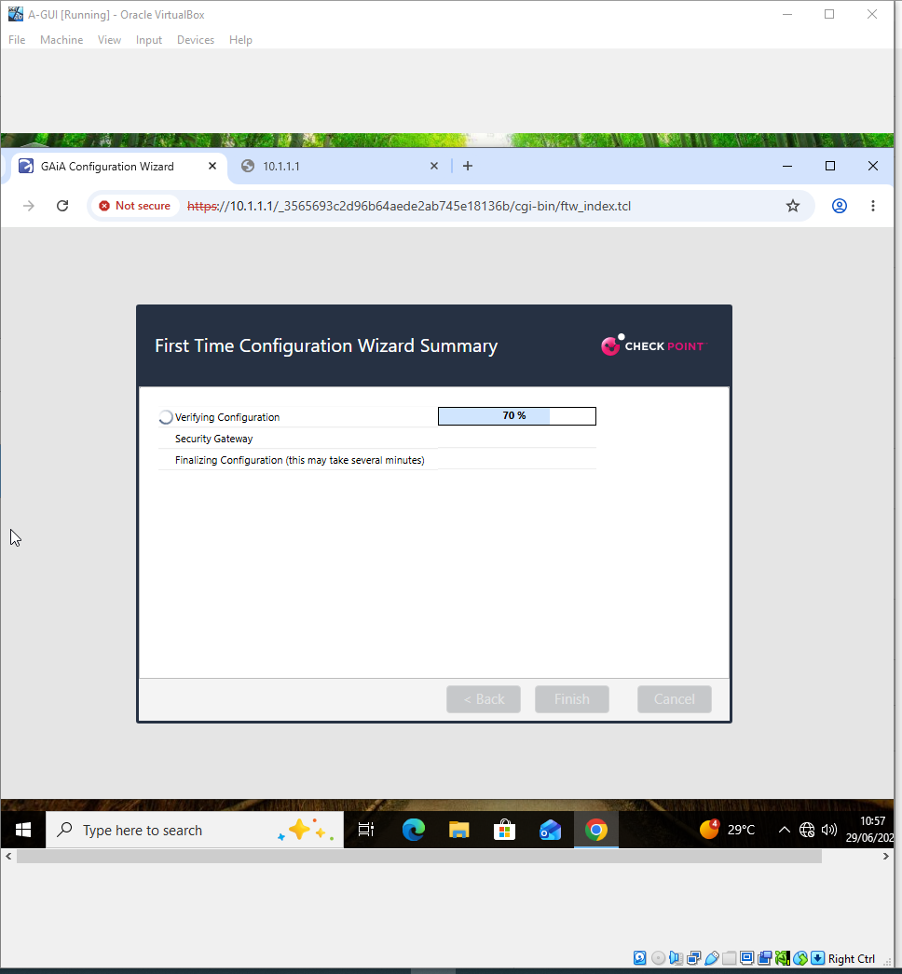The Check Point First Time Configuration Wizard, which is used to finish the Security Gateway's first configuration, is seen in the screenshot. Before the gateway may take part in the managed environment, this wizard applies the necessary system and security setup. By allowing the chosen configuration to be examined prior to commit, the verification stage lowers the possibility of using the wrong initial settings. After it is finished, the gateway can be ready for policy enforcement and communication with the Security Management Server. This step is crucial because before Smart Console can be used to handle its security objects and policies, a firewall gateway needs to be properly initialised. As a result, the screenshot shows the change from a freshly installed Gaia system to a configured Check Point Security Gateway appropriate for the business lab.

2.4 Gateway System Overview 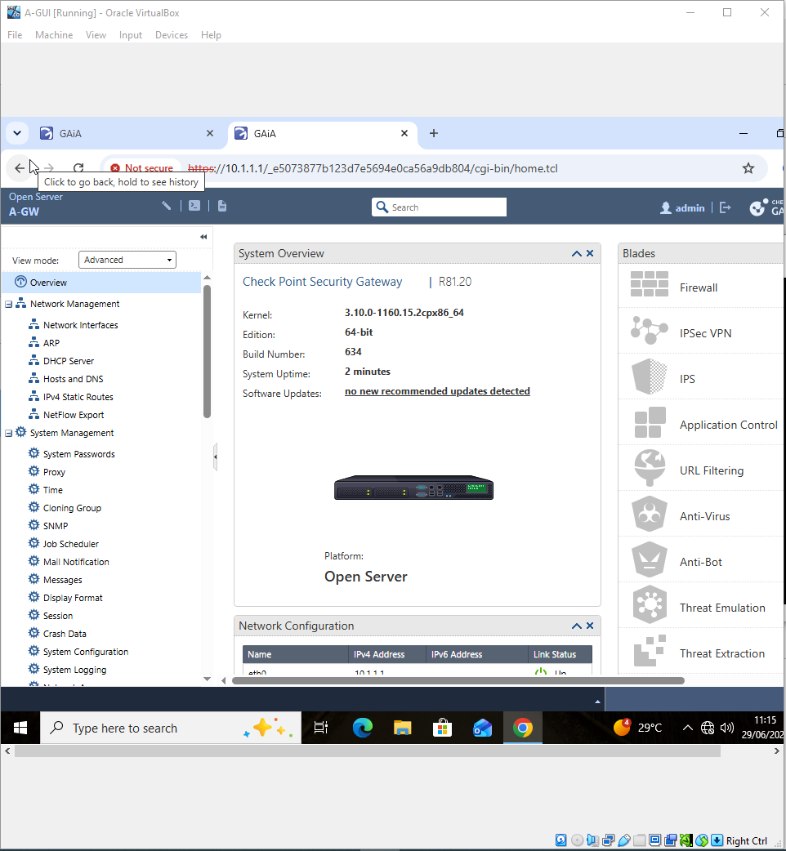
This screenshot verifies that the Alpha Security Gateway is up and running on Check Point R81.20 and displays the Gaia System Overview for A-GW. The overview offers a core synopsis of the gateway platform and the state of the system at the moment. It is helpful to validate that the administrator is in charge of the intended gateway and that the required Check Point version is operating after the initial configuration. Access Control and NAT policies that are later specified in Smart Console are finally deployed on this machine since A-GW serves as an enforcement point inside the practical topology. As a result, this screenshot is more than just a system-information screen; it shows that the gateway needed for the Alpha site is present and accessible prior to the demonstration of network objects, firewall rules, and policy installation.

2.5 Gateway Network Interface
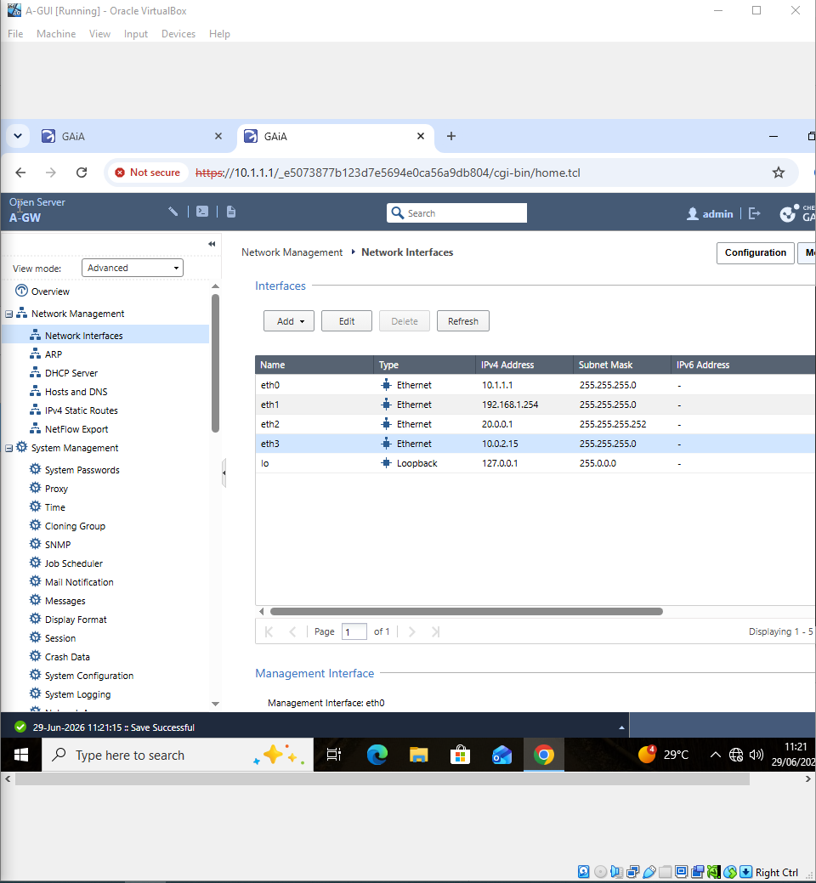
The interface configuration that A-GW uses to link the various components of the enterprise topology is shown on the Network Interfaces screen. Every specified interface connects to a specific network or security zone, enabling the gateway to monitor and regulate traffic as it travels between them. Because firewall rules and NAT setup rely on the gateway's ability to recognise and route traffic between the management, internal, DMZ, and external networks depicted in the illustration, proper interface addressing is crucial. As a result, the snapshot confirms the underlying network connectivity needed for subsequent security-policy testing. Because communication between zones can be forced through the Security Gateway, where the defined Access Control policy can be enforced, using gateway interfaces to separate networks also facilitates segmentation.

2.6 Security Management Server Console
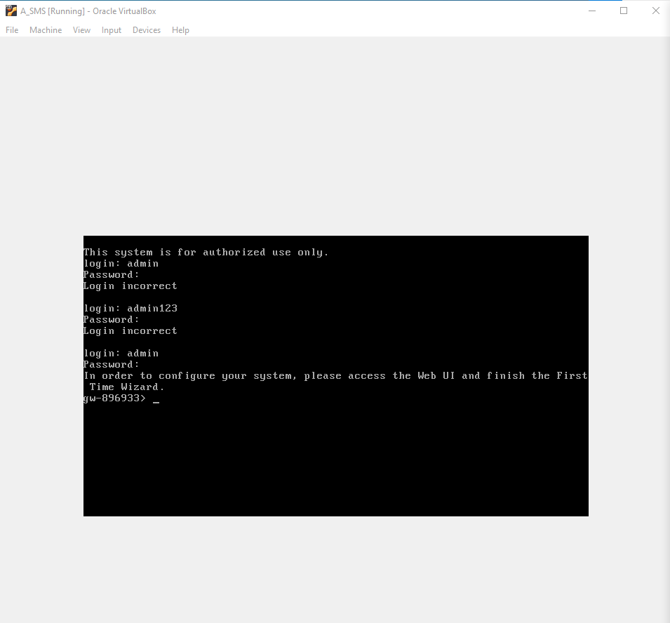
The A-SMS Security Management Server's console is accessible to administrators, as seen in this screenshot. Because security objects, policy packages, gateway settings, logs, and administrative updates are all controlled centrally via the management server, it is an essential part of the Check Point environment. Before Smart Console is linked, successful console access verifies that A-SMS is operational and accessible. While A-GW and other gateways handle traffic enforcement, the practical architecture's separation of management from the enforcement gateway enables rules to be developed and managed centrally. As a result, the screenshot shows that the environment's management component has been successfully deployed and is prepared to enable the following development of network objects, gateway objects, NAT settings, and access control rules.

2.7 Security Management Server Gaia Portal
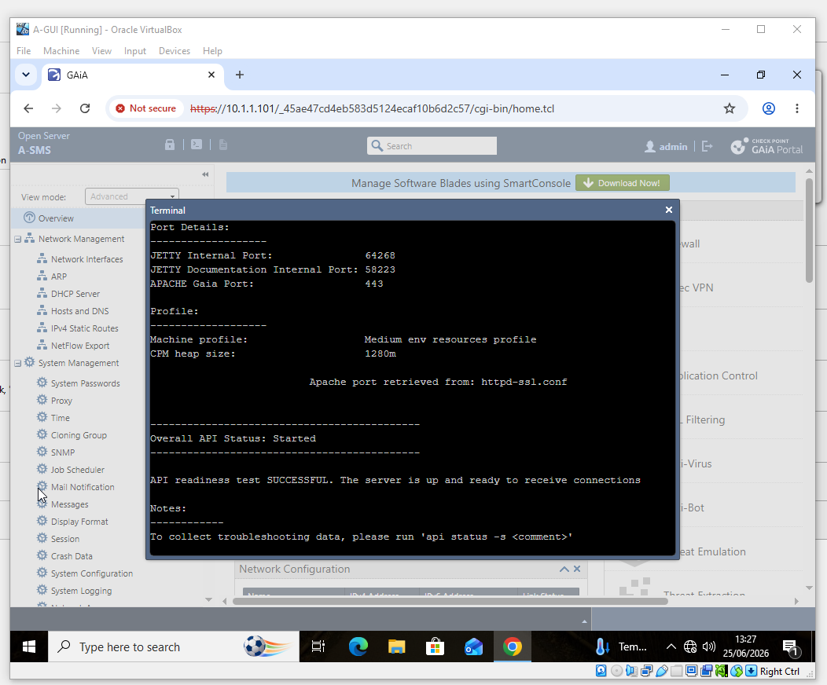
Through its web-based management interface, the Security Management Server's functionality is confirmed by the A-SMS Gaia Portal screenshot. The server services needed for administration are available, according to the management/API readiness information that is shown. This is significant because Smart Console depends on the management server to store and disseminate configuration data, such as logs, policy packages, network objects, and gateway definitions. Verifying the server status before proceeding lessens the likelihood that an incomplete management-server configuration will be the source of subsequent Smart Console connectivity issues. This screenshot serves as confirmation that A-SMS has advanced from installation and console access to a working management platform that can support centralised administration of the Alpha and Bravo security environments within the practical sequence.

2.8 Smart Console Management Server Status
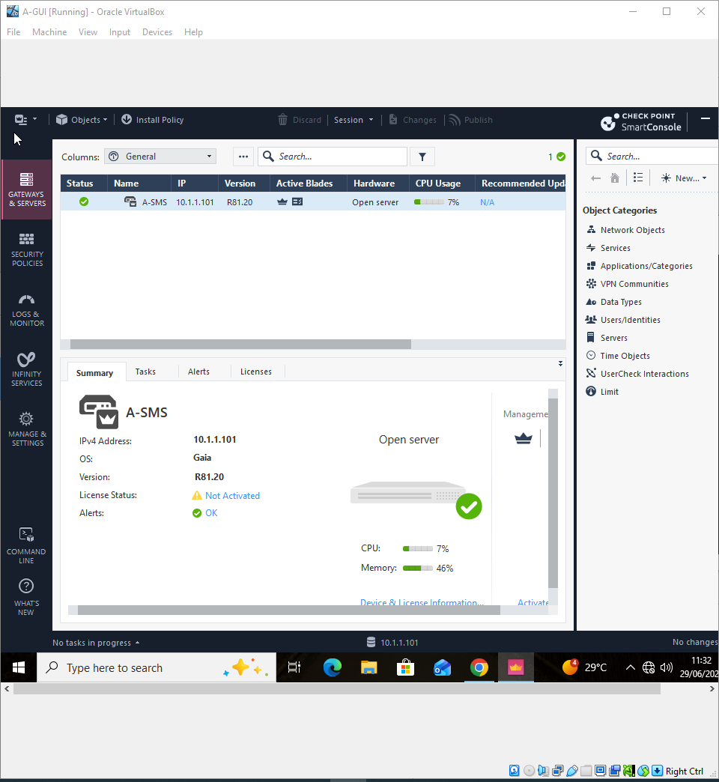

This screenshot shows how to successfully control A-SMS using Check Point Smart Console. The server's management address and R81.20 software version are shown, verifying that the Security Management Server and the administrator workstation are communicating. Throughout the practical, Smart Console serves as the primary interface for creating network and host objects, configuring NAT, creating Access Control rules, defining gateway objects, installing policies, and reviewing logs. Thus, establishing this connection is a crucial step in the implementation process. It offers the administrative platform needed for all ensuing security settings and verifies that the management architecture is operational. Additionally, the screenshot illustrates centralised management, which allows for the administration of numerous gateways and network resources from a single security-management environment.

2.9 VirtualBox Enterprise Lab
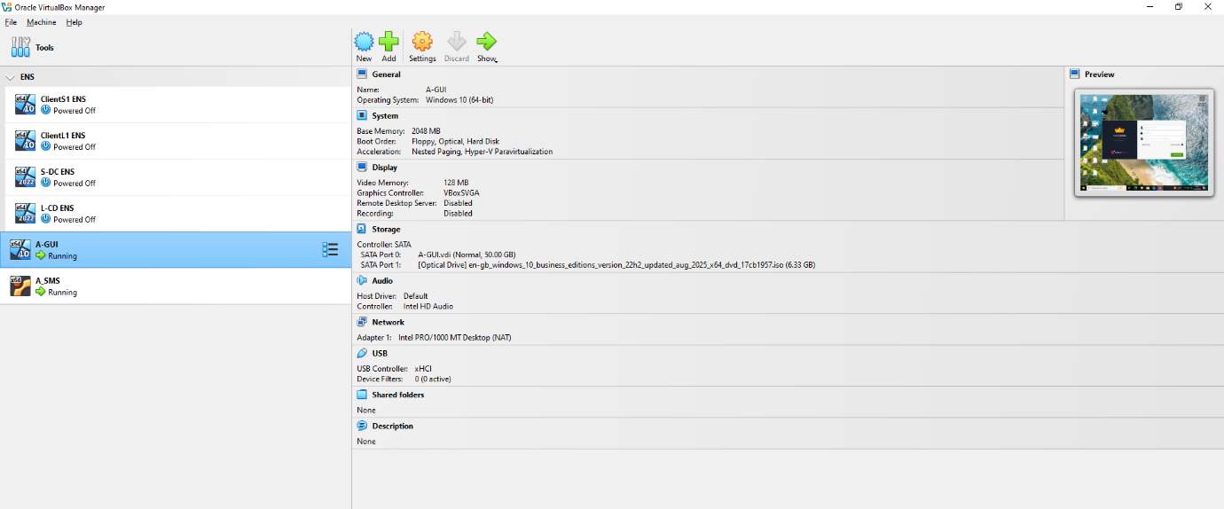

The Oracle VirtualBox environment used to host the systems needed for the enterprise network security practical is depicted in this screenshot. The administrator workstation, Check Point Security Management Server, and other security components can function in the virtual machines' isolated laboratory without interfering with a production network. Because distinct systems and network parts may be built and tested in a controlled environment, a virtualised topology is helpful for illustrating enterprise security concepts. By demonstrating that the real implementation is based on operational virtual systems rather than merely theoretical policy design, the screenshot sets the scene for the rest of the report. The management, setup, and testing tasks shown in the subsequent Smart Console and Gaia pictures are supported by these virtual machines.

3. Gateway and NAT Preparation
3.1 Alpha Policy Installation Target
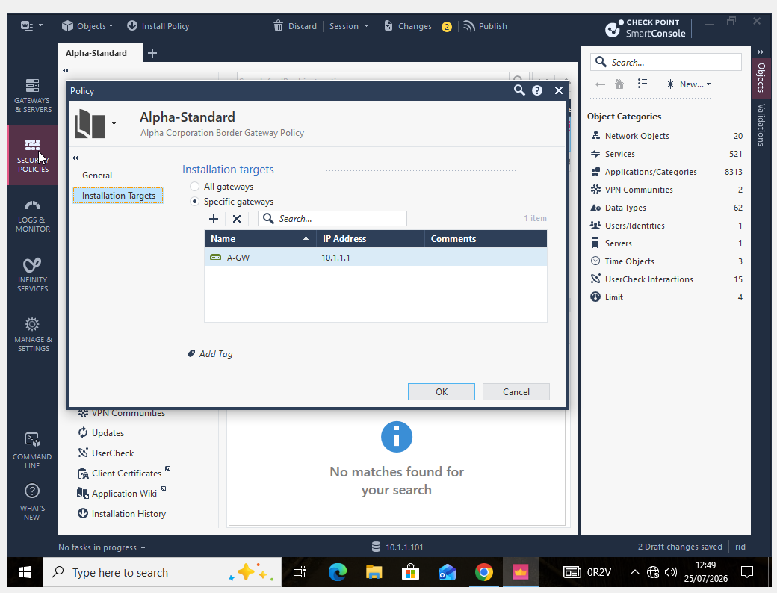The setup of A-GW as the installation target for the Alpha-Standard policy package is shown in this screenshot. The Security Gateway that receives and enforces the policy specified in Smart Console depends on the installation target that is selected. In this instance, linking Alpha-Standard to A-GW guarantees that the rules intended for the Alpha site are not inadvertently applied to another gateway. Because each site may need various network objects and security rules, this becomes especially crucial when the environment has several gateways, such as A-GW and B-GW. As a result, the structure facilitates site separation and regulated policy management. Additionally, it sets up the conditions for the explicit deployment of Alpha-Standard to A-GW in the later policy-installation evidence.

3.2 A-SMS Static NAT
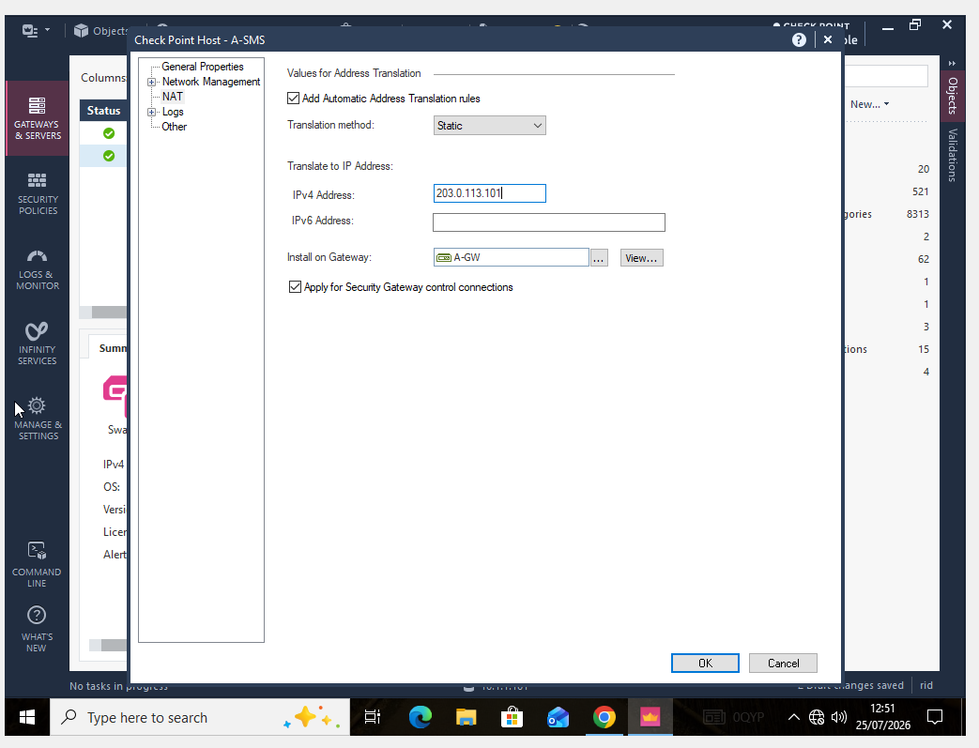
The A-SMS Security Management Server's NAT configuration is seen in this screenshot. The administration server is represented by the translated IPv4 address 203.0.113.101 through A-GW since Automatic Static NAT is enabled. When a specific internal system requires a predictable translated address, static NAT generates a constant one-to-one translation for the host. By setting up the translation at the object level, Smart Console can also automatically create the corresponding NAT rule, which minimises the need for human rule generation. The screenshot is important because it shows how regulated connectivity can be maintained while private corporate addressing and translated addressing are kept apart. This object-level setting resulted in an enforceable translation rule, as confirmed by the final NAT rule-base screenshot later in the report.

3.3 Bravo Gateway object
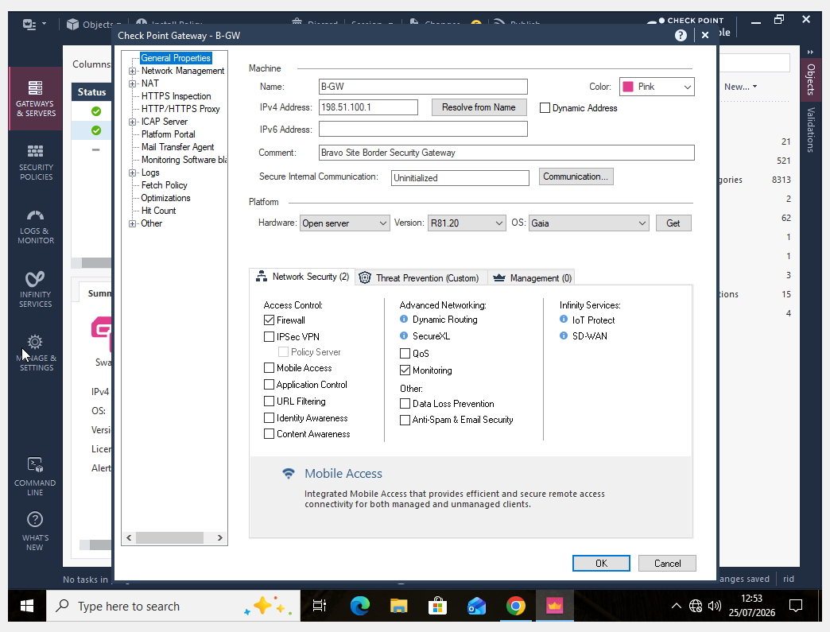
The screenshot shows how the Bravo Site Border Security Gateway, or B-GW, was created. The Bravo gateway IPv4 address and Check Point Gaia R81.20 are configured on the object, and the Firewall capability is chosen for Access Control enforcement. The Security Management Server can represent the Bravo enforcement point and link site-specific configuration to it by defining the gateway in Smart Console. Additionally, the integration of B-GW shows how centralised management can accommodate many company sites and extends the practical beyond a single-gateway topology. Because those controls must be linked to the appropriate site, this is crucial for the later Bravo Standard policy and B-INT-NET NAT configuration. As a result, the snapshot creates the management object needed for the Bravo security configuration that is displayed later in the report.

3.4 Gateway object Verification

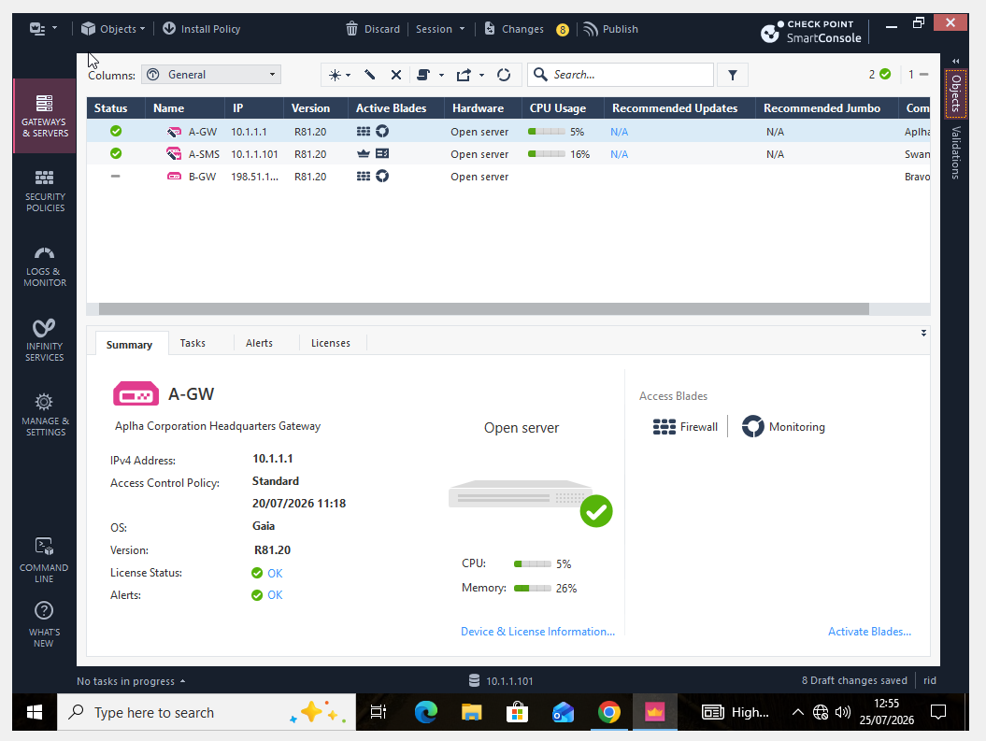
The primary gateway and server objects utilised in the practical, such as A-GW, A-SMS, and B-GW, are shown in this Smart Console view. After the infrastructure elements are created, the screen offers a central point of verification. The Alpha enforcement gateway is represented by A-GW, the Bravo site gateway by B-GW, and central security management is provided by A-SMS. The relationship between central management and several enforcement points can be seen when these items are viewed collectively. Additionally, it verifies that the administrator can oversee the enterprise security infrastructure from a single Smart Console environment. Because it confirms that the necessary gateway objects exist and can then be chosen for NAT settings, policy targets, and security-rule setup, this verification is helpful prior to developing site-specific rules.

4. Network objects and Address Translation
4.1 Alpha Management Network
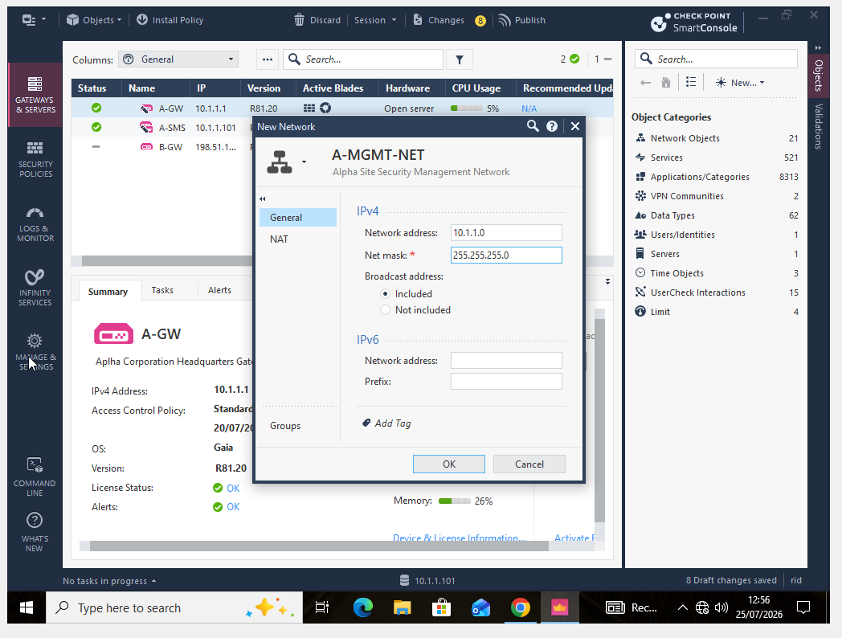
The construction of the A-MGMT-NET network object for the Alpha management subnet 10.1.1.0/24 is shown in this screenshot. Because administrative communication with gateways and management systems needs to be separated from regular user traffic, a dedicated management network is crucial. Instead of repeatedly typing individual addresses, the subnet can be directly referenced in Access Control rules by representing it as a Smart Console object. This increases uniformity and facilitates comprehension and upkeep of the rule foundation. The management object may be used as an approved source for administrative services under the later firewall policy, but other sources are still prohibited. Thus, the screenshot shows how to create objects as well as the practical basis for implementing least-privilege limits on security-management traffic.

4.2 Alpha Internal Network
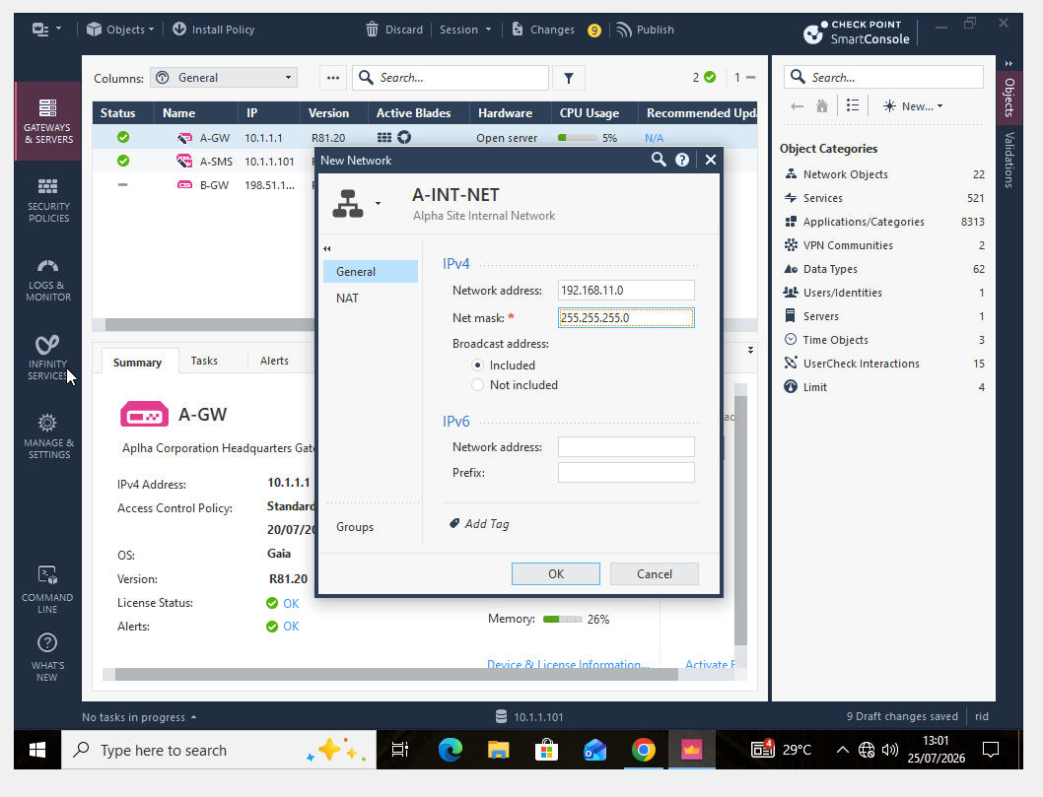
A-INT-NET creation for the Alpha internal subnet 192.168.11.0/24 is shown in the screenshot. The administrator can consistently refer to the trusted Alpha user network in Access Control and NAT settings by defining the entire internal subnet as a network object. This lessens the possibility of inconsistent addressing across many rules and is easier to handle than declaring every internal device separately. Because the internal network is represented independently of the management network and DMZ, the object also aids in network segmentation. Because of this, various security measures can be implemented based on the source and destination zones. The same centrally defined object can take part in several aspects of the Check Point security policy, as demonstrated by the use of the A-INT-NET object for Hide NAT.

4.3Alha internal Network Hide NAT
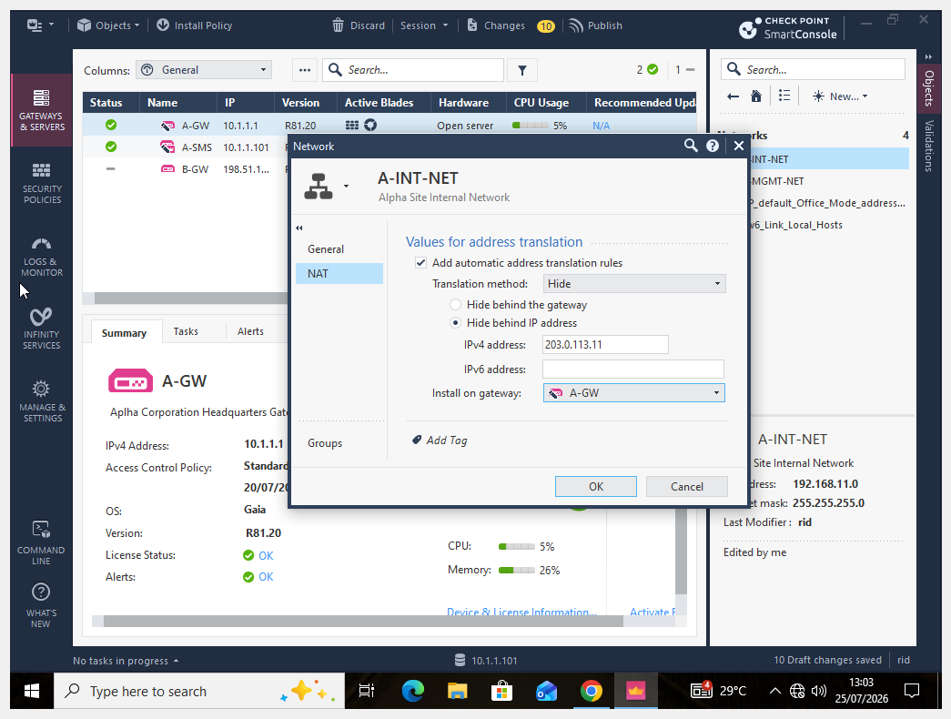
Automatic Hide NAT is set up for A-INT-NET in this screenshot. While the NAT configuration converts outgoing traffic to 203.0.113.11 via A-GW, the internal Alpha subnet uses private addressing. Multiple private hosts can interact using a translated address without disclosing their unique internal addresses thanks to hide NAT. This allows for regulated communication outside of the internal network while maintaining the private addressing structure from a security and administrative standpoint. Additionally, Smart Console may automatically create the required translation rule by configuring NAT directly on the A-INT-NET object. The resulting policy entry is confirmed by the subsequent NAT rule-base screenshot. Thus, this screenshot shows that address translation was actively configured for the Alpha internal network in addition to being discussed theoretically.

4.4 Alpha DMZ web server
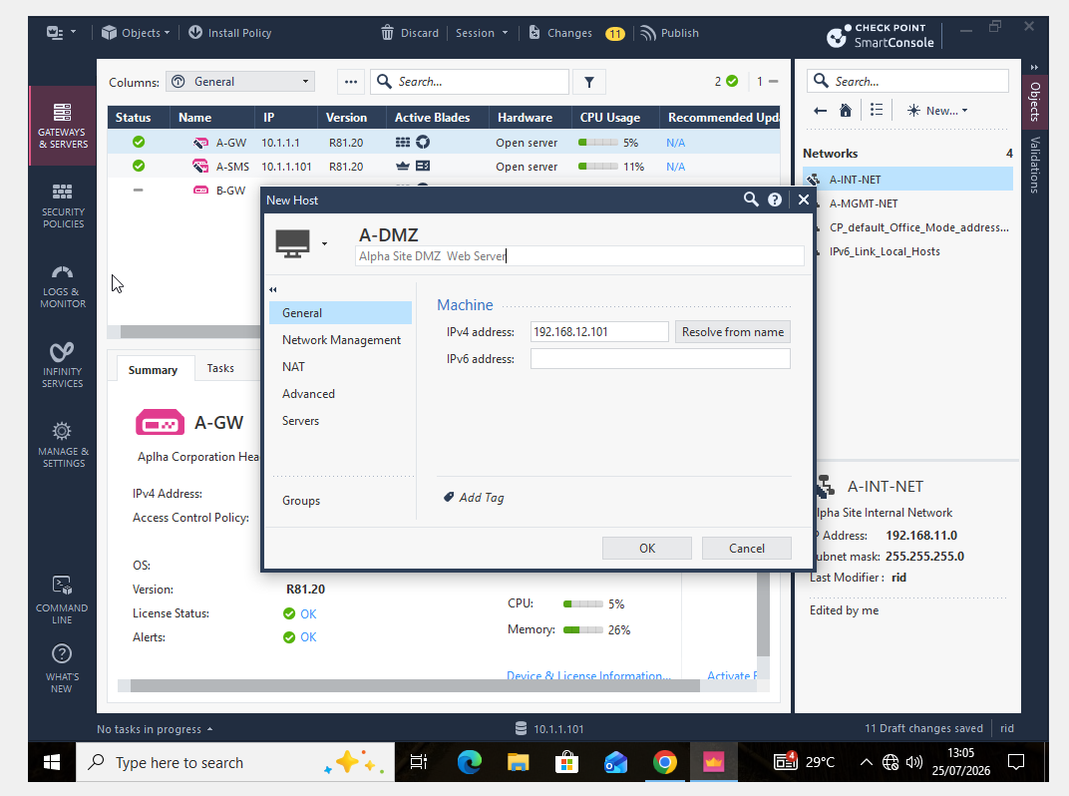

The construction of the A-DMZ host object, which represents the Alpha Site DMZ web server at 192.168.12.101, is seen in this screenshot. Systems that could require different connectivity requirements are kept apart from the secured internal user network via a DMZ. Compared to using a broad network object alone, creating the web server as a specific host object allows for more accurate firewall and NAT policy selections. For instance, when regulating authorised services or translated communication, rules may expressly mention this server. Because the descriptive object name specifies the host's function rather than depending solely on an IP address, the setup also facilitates clearer policy documentation. Thus, this screenshot shows how a structured and segmented corporate topology can be implemented using Check Point objects.

4.5 Alpha Network group
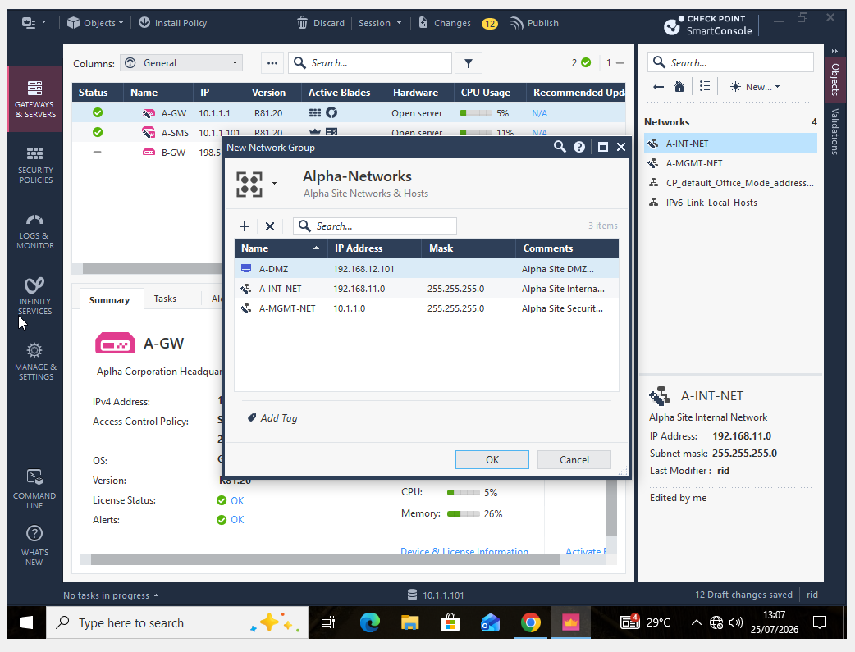
The DMZ, internal, and management networks are among the pertinent Alpha site objects that are combined in the Alpha-Networks group displayed in this screenshot. By enabling several related items to be referred through a single logical group where a policy demands the same treatment for every member, object groups streamline administration. This can make the policy easier to read and cut down on redundancy in a rule base. When different treatment is needed, the individual network objects are still available for more stringent regulations. The graphic illustrates a crucial policy-management strategy: rationally organising network resources prior to creating intricate firewall rules. As the company topology grows or more network objects are added, this increases scalability and lowers configuration effort.

4.6 Alpha DMZ NAT
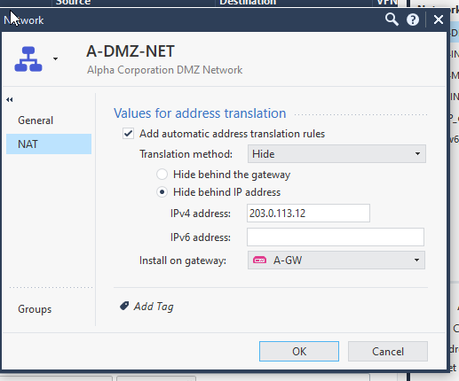
The Alpha DMZ network's Automatic Hide NAT configuration is seen in this screenshot. 203.0.113.12 is used to translate the private DMZ addresses using A-GW. The DMZ can be distinguished from the Alpha internal network, which has its own NAT configuration, by using a different translated address. Because distinct network zones can be recognised and independently handled, this is helpful in a divided enterprise design. Smart Console can generate the necessary automated NAT rule by configuring the translation on the network object. As a result, the configuration complements the distinct A-DMZ host object used to represent the web server within that zone and offers tangible proof of address translation for the DMZ.

4.7 Bravo Internal Network NAT
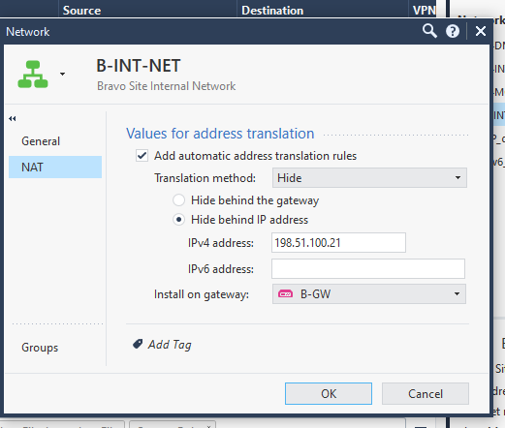
Automatic Hide NAT for B-INT-NET, the Bravo internal network, is seen in this screenshot. B-GW translates the private Bravo addresses to 198.51.100.21. While maintaining the two sites' logical separation, the configuration mimics the NAT strategy employed for the Alpha internal network. Instead of using the Alpha gateway, using B-GW as the applicable gateway guarantees that Bravo traffic is translated at the proper enforcement point. Because each location may maintain its unique addressing and security-policy needs while still being centrally managed by Smart Console, this is especially crucial in a multi-site setting. As a result, the screenshot shows that the realistic environment supports many enterprise network locations and offers proof of site-specific NAT implementation.

4.8 Automatic NAT Rule Base
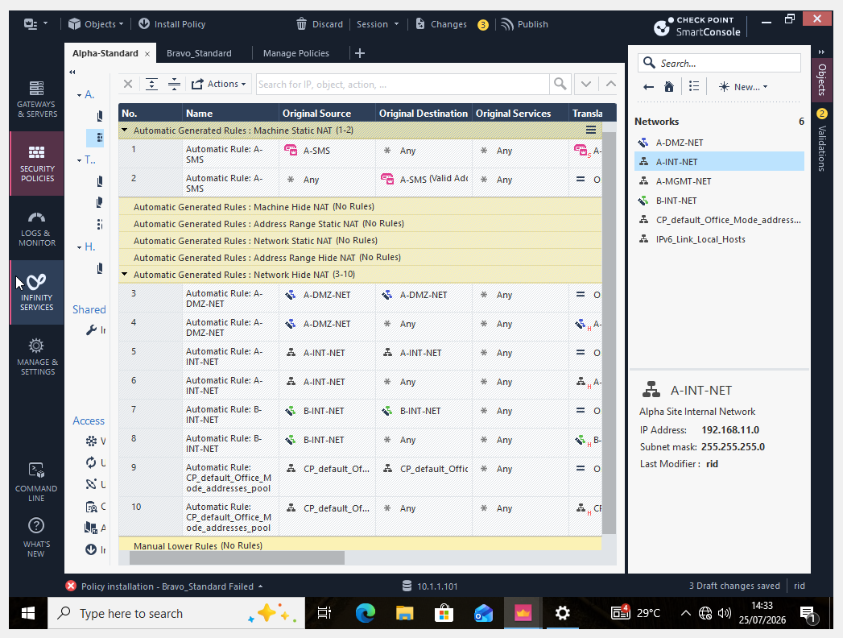
Consolidated verification of the previously defined automatic translations at the object level is provided by the NAT rule-base screenshot. For resources like A-SMS, the Alpha internal/DMZ networks, and the Bravo internal network, Smart Console shows created NAT entries. This is a crucial verification step because it shows that the NAT attributes allocated to specific objects were converted into real policy rules that the appropriate gateways could enforce. The administrator can verify the original and translated source or destination information and determine the gateway on which translation is anticipated by looking over the rule base. As a result, the screenshot offers solid practical proof of the finished address-translation setup and connects the various NAT configuration panels to the final, enforceable NAT policy.

5. Access Control Policy Configuration
5.1 Alpha Access Control Rule Base
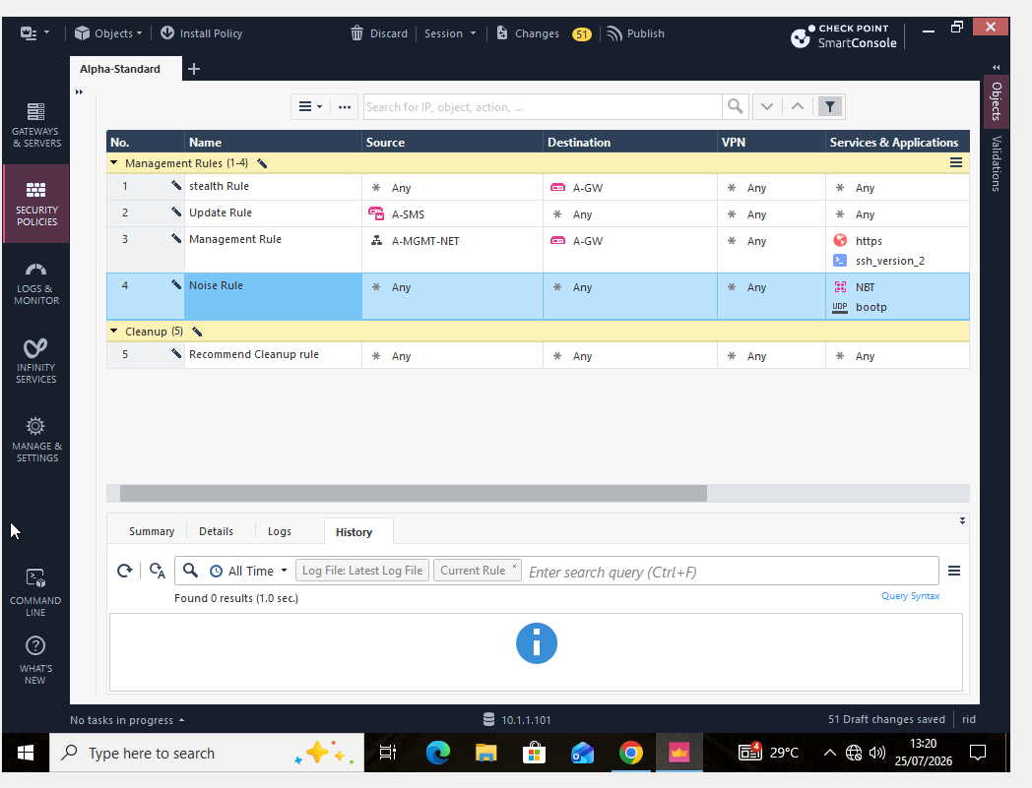
The Alpha-Standard Access Control rule base, which regulates traffic at the Alpha site, is shown in this snapshot. By limiting administrative services to authorized management sources, a management rule can minimize needless security infrastructure exposure. The Cleanup rule offers defined processing for traffic that reaches the end of the rule base without matching an earlier rule, whereas the Stealth rule is meant to shield the gateway itself from access that has not been specifically permitted. Because Check Point compares traffic to the policy sequentially, the order of firewall rules is crucial. Therefore, rather than depending on a single general accept or deny rule, this screenshot illustrates how several restrictions are merged into a structured policy.

5.2 Updated Alpha Inbound and management rules
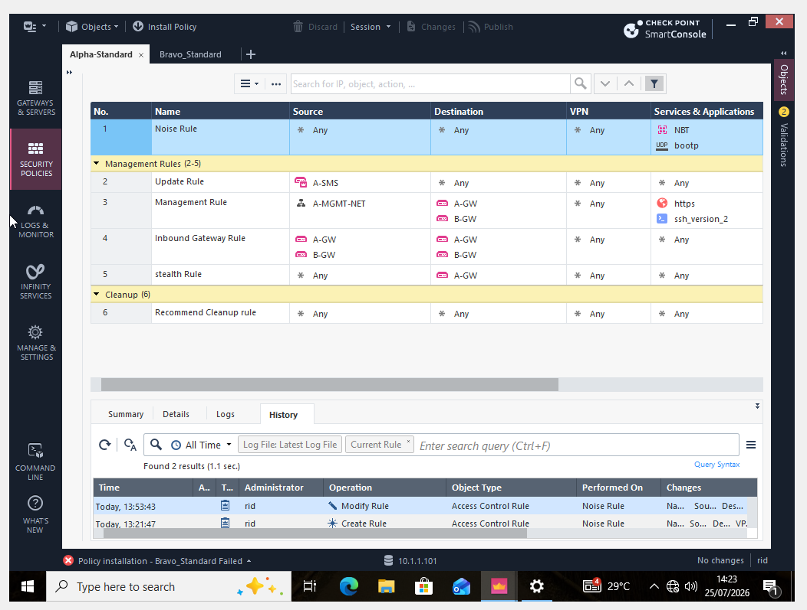
After further gateway and administration controls were added, the enlarged Alpha-Standard policy is displayed in this snapshot. Noise, update/management communication, inbound gateway access, stealth protection, and final cleanup behaviour are among the categories of traffic that are separated by the rule base. The security policy is easier to audit when explicit rules are created for various traffic objectives since the rule structure makes it clear why communication is allowed or prohibited. By permitting only the necessary sources, destinations, and services rather than employing unduly broad access, it also promotes the establishment of least-privilege policies. The final Cleanup rule guarantees a clear action for traffic that was not purposefully allowed by earlier rules. All things considered, this screenshot shows that the Alpha firewall policy is better organised and security-focused.

5.3 Bravo Policy Package
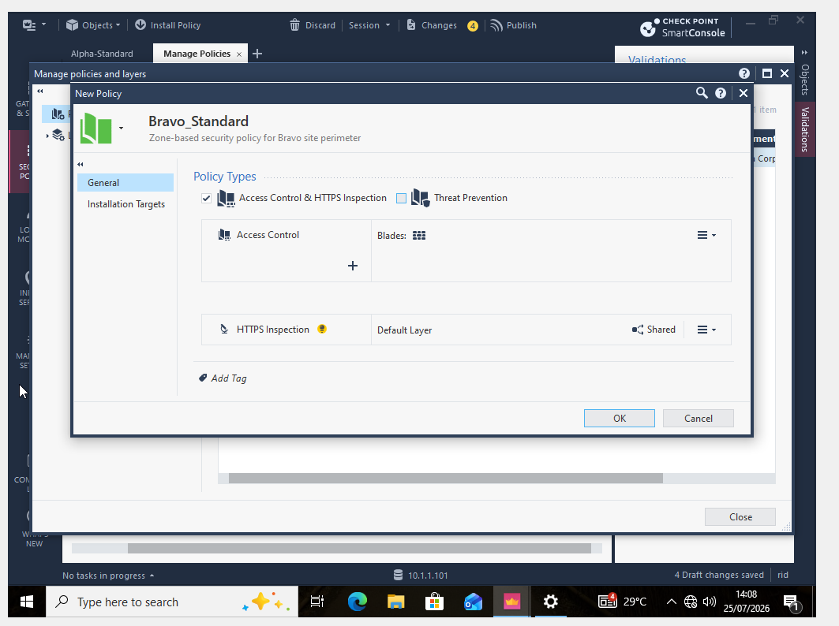
The construction of the Bravo Standard policy package for the Bravo site is shown in this screenshot. While both environments are centrally managed using the same Security Management Server, security rules for B-GW can be written separately from the Alpha policy using a different policy package. Because separate locations may have different network objects, translated addresses, and permissible traffic requirements, this strategy is helpful in a multi-site organization. The presented inspection components and Access Control are included in the policy package, which serves as the container for managing the Bravo rule base. As a result, the screenshot illustrates policy separation and sets up the environment for the Management, Stealth, Outbound, and Cleanup rules unique to Bravo, which are displayed in the following evidence.

5.4 Bravo Access Control Rules
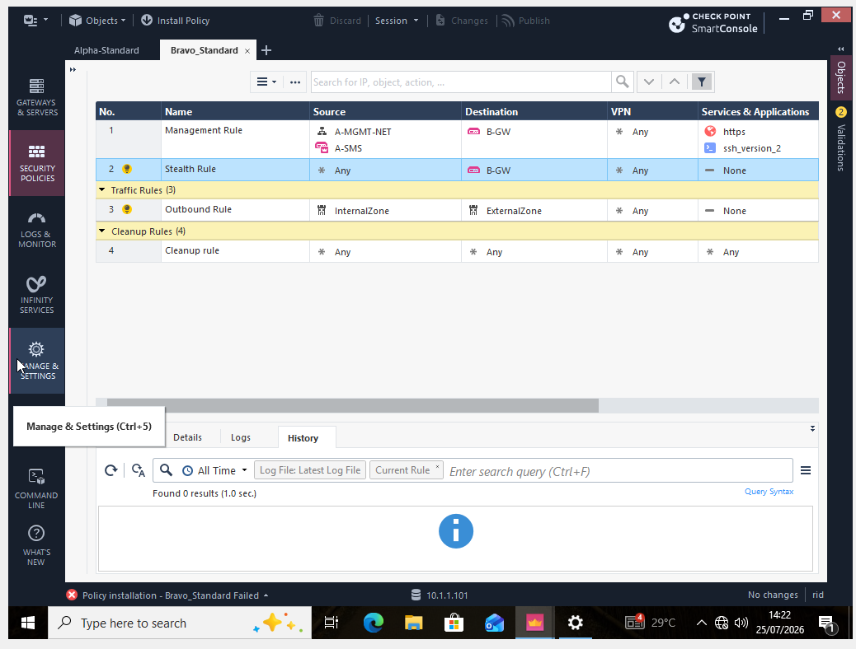
The Access Control rules made for the Bravo site are shown in the Bravo Standard rule-base screenshot. Each of the policy's four rules—Management, Stealth, Outbound, and Cleanup—serves a distinct security function. Administrative communication is limited by the Management Rule to the specified management sources and necessary services. While the Outbound Rule regulates communication started from the Bravo internal environment, the Stealth Rule shields the gateway from traffic that is not specifically authorized. Lastly, at the conclusion of the policy, the Cleanup Rule offers a specified action for unmatched traffic. This tiered structure illustrates a regulated approach to firewall setting, whereby unneeded or unauthorized traffic is limited while necessary business communication is allowed by clear rules.

6. Policy Installation and Verification
6.1 Alpha Policy Installation
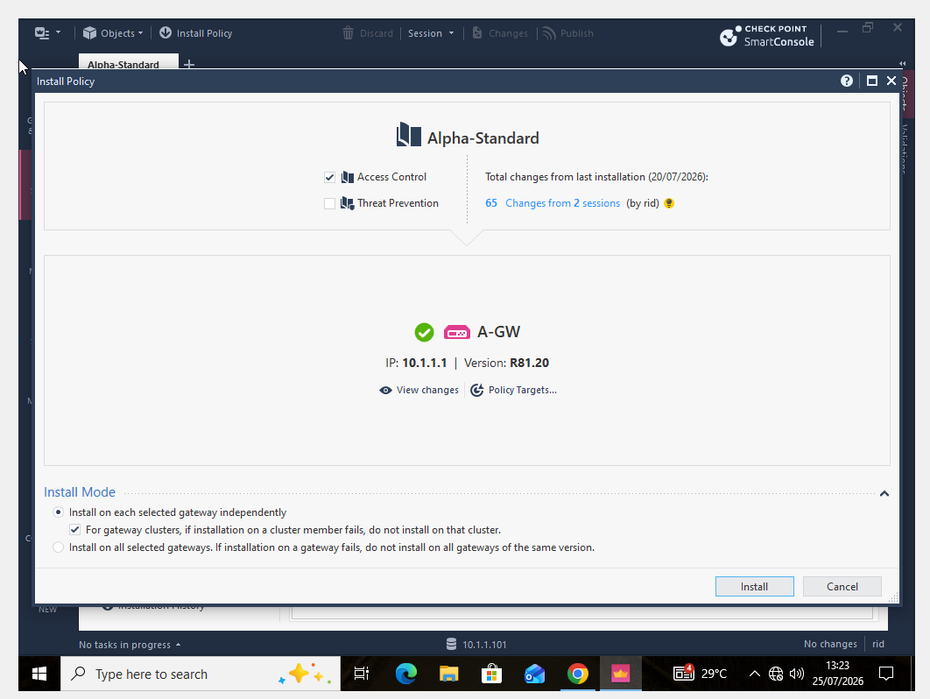
The Alpha-Standard Access Control policy installation stage is seen in this screenshot. In order to guarantee that the Alpha policy is implemented at the appropriate enforcement point, A-GW is chosen as the target gateway. The policy must be deployed before the gateway can enforce the modified configuration; simply creating rules in Smart Console does not indicate that they are active on the gateway. Before sending the pertinent configuration to A-GW, the management environment validates and prepares the policy during installation. Thus, policy design and operational enforcement are linked at this level. Because it depicts the administrator purposefully choosing the Access Control policy and intended gateway prior to deployment rather than just showing an uninstalled rule base, the screenshot is especially significant practical proof.

6.2 successful Policy Installation
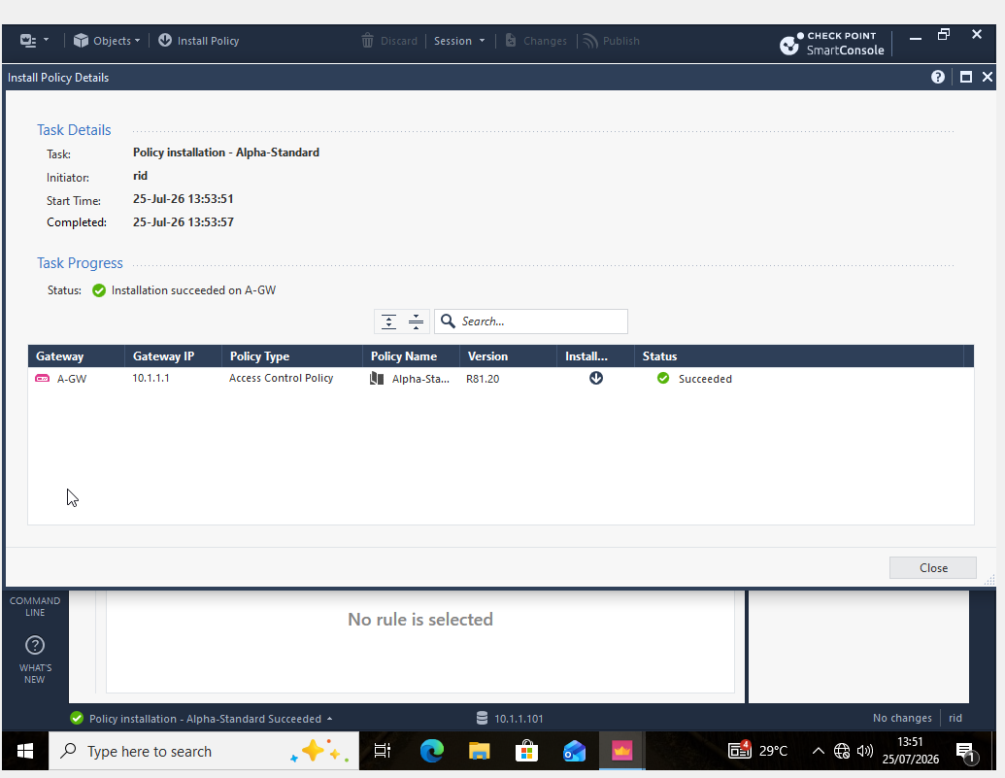
This screenshot attests to the successful installation of the Alpha-Standard policy on A-GW. A successful outcome shows that there was no installation issue when the Security Management Server processed the policy and deployed it to the chosen Security Gateway. Because it verifies that the configured Access Control policy advanced to the enforcement stage, this offers more robust implementation evidence than the rule-based screenshots alone. After installation, A-GW can assess network traffic based on the order and configured actions of the modified rules. Additionally, connectivity between Smart Console, the Security Management Server, and A-GW is demonstrated by the installation's success. As one of the important verification numbers in the practical report, this screenshot ought to be kept.

6.3 Policy Installation Audit Log
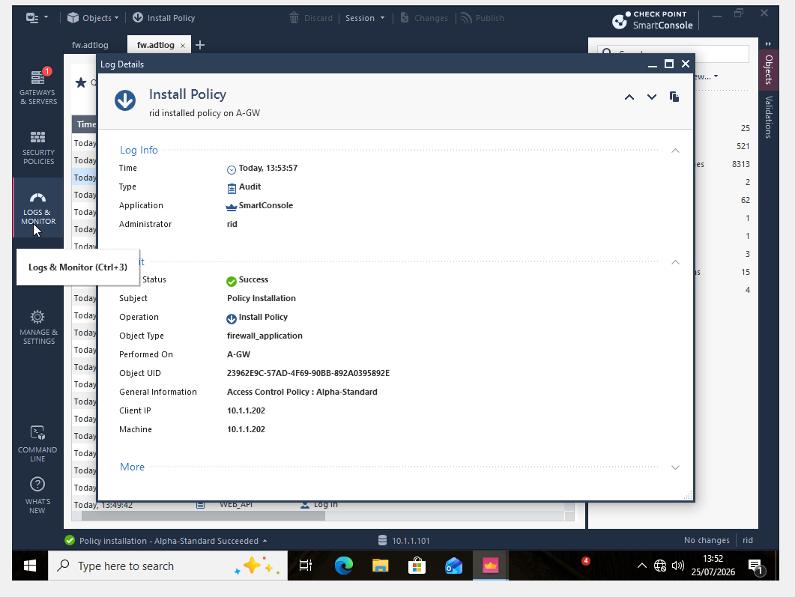
The policy installation process is documented in the audit-log snapshot, which also shows administrative traceability. The administrator, target gateway, and Alpha-Standard Access Control policy are among the details linked to the successful Install Policy activity that are identified in the log. Because administrators must ascertain who made a configuration modification, what action was taken, and whether it was effective, audit information is crucial to organizational security. This facilitates both troubleshooting and accountability for changes to security policies. In this practical, the audit record serves as an additional source of confirmation that Alpha-Standard was deployed to A-GW, complementing the successful policy-installation screen. When taken as a whole, these screenshots show the change's technical deployment as well as its management logging.

7. Additional setup, SIC, publishing and Licensing Evidence
7.1 A-SMS Virtual Machine Setup
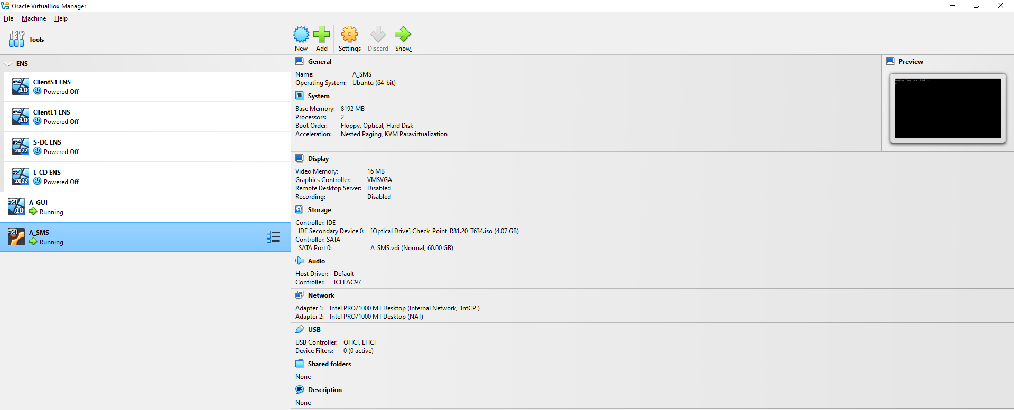

The Oracle VirtualBox setup for the A-SMS virtual machine is displayed in this screenshot. The centralised management architecture employed throughout the practical is supported by hosting the Security Management Server as an independent virtual machine. While the Security Gateways carry out traffic enforcement, A-SMS stores and maintains gateway objects, network objects, policies, and administrative data. Thus, prior to the installation and configuration of the Gaia management platform, the screenshot records the underlying laboratory architecture. Instead of starting merely at the Smart Console configuration step, this evidence helps illustrate the entire practical workflow from virtual-machine preparation to policy deployment.

7.2 A-SMS Gaia Installation
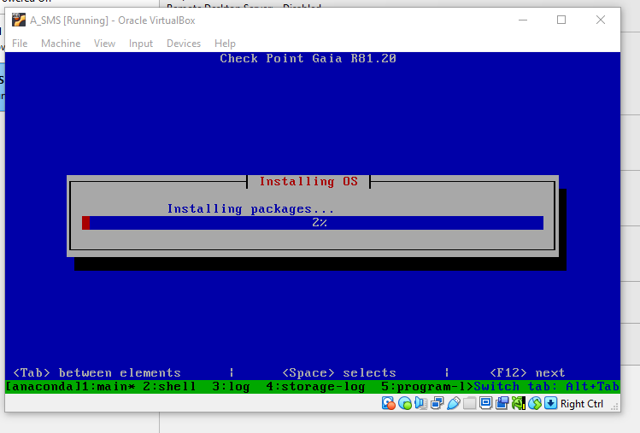
The installation of Check Point Gaia R81.20 for the A-SMS system is shown in this screenshot. The operating system and administration components needed for the Security administration Server are set up during the package-installation phase. This proof demonstrates that the central management platform was set up as part of the real-world environment prior to the configuration of its network settings and management role. The system can be initialised using the First Time Configuration Wizard after the installation is finished. The A-SMS deployment sequence, which includes management addressing, wizard completion, Gaia verification, and Smart Console administration, is therefore initiated by the screenshot.

7.3 A-SMS Management Connection
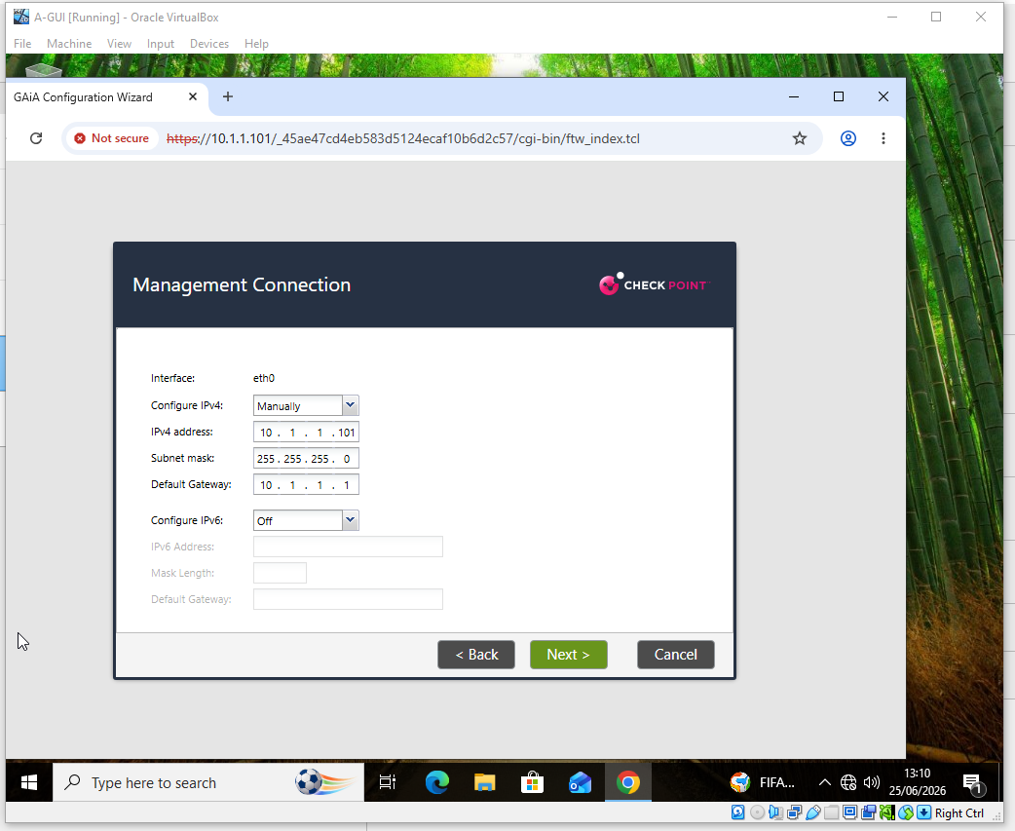
This screenshot displays the A-SMS management-network configuration, which includes the default gateway 10.1.1.1 and eth0 IPv4 address 10.1.1.101/24. Because A-SMS needs to connect with both the managed Security Gateway and the administrator workstation, proper management addressing is crucial. The central management server is connected to the larger laboratory topology by the configured default gateway, which on the management network corresponds to A-GW. As a result, this screenshot offers concrete proof of the network setup necessary before Smart Console can establish secure management contact with the gateway and connect to A-SMS.

7.4 A-SMS First Time Configuration Progress
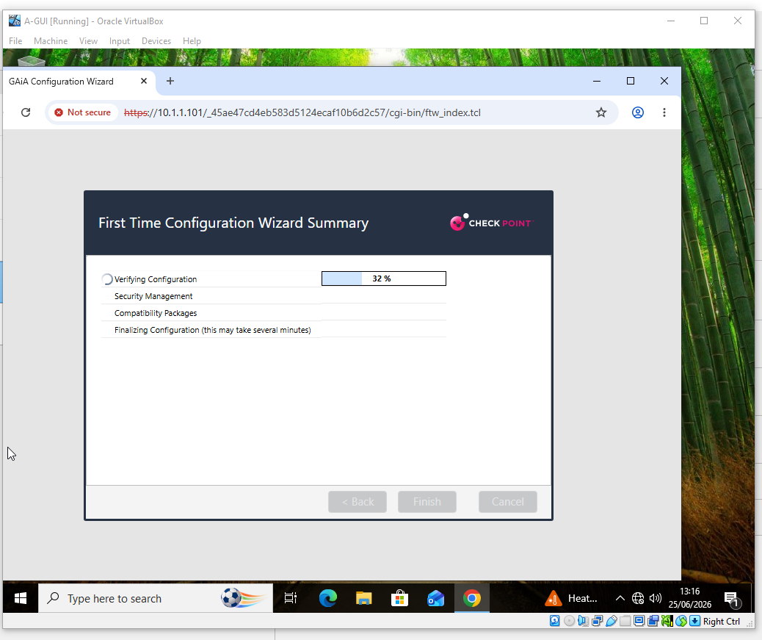

While the chosen management-server settings are being implemented, this screenshot captures the A-SMS First Time Configuration Wizard. The freshly installed Gaia system is set up for its Check Point management function by the wizard. Implementation evidence between the initial management-network configuration and the finished server setup is provided by displaying the progress stage. This is helpful because, instead of just showing the management environment's final configuration, it shows that it was actively configured. The server may offer the central management services needed for gateway administration, security-policy management, and Smart Console connectivity once the wizard is finished.

7.5 A-SMS First Time Configuration Completed
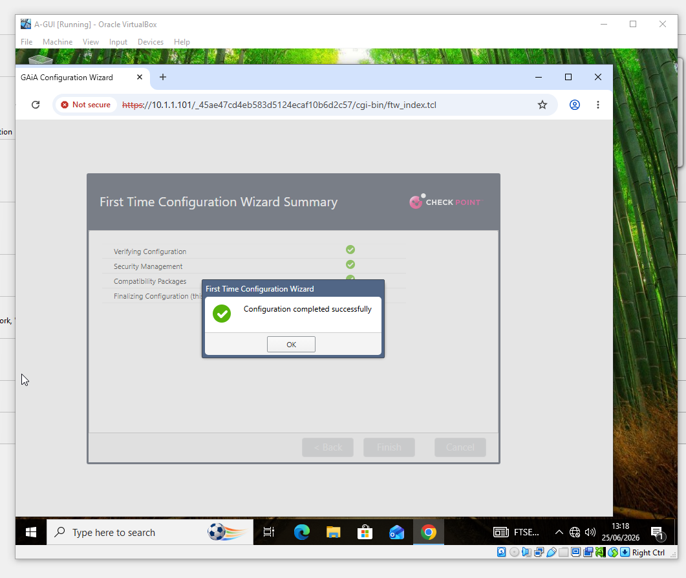

This screenshot attests to the A-SMS First Time Configuration Wizard's successful completion. The successful outcome shows that the initial configuration procedure was carried out correctly and that the chosen management-server parameters were approved. Before the administrator moves on to the Gaia System Overview and Smart Console administration stages, this offers a crucial point of verification. The screenshot shows how A-SMS advanced from installation and network configuration to an operating Security Management Server in the overall practical process. The gateway objects, NAT configuration, Access Control policies, publishing, licensing, and audit operations that are described elsewhere in the report are subsequently supported by this central server.

7.6 A-SMS Gaia System Overview
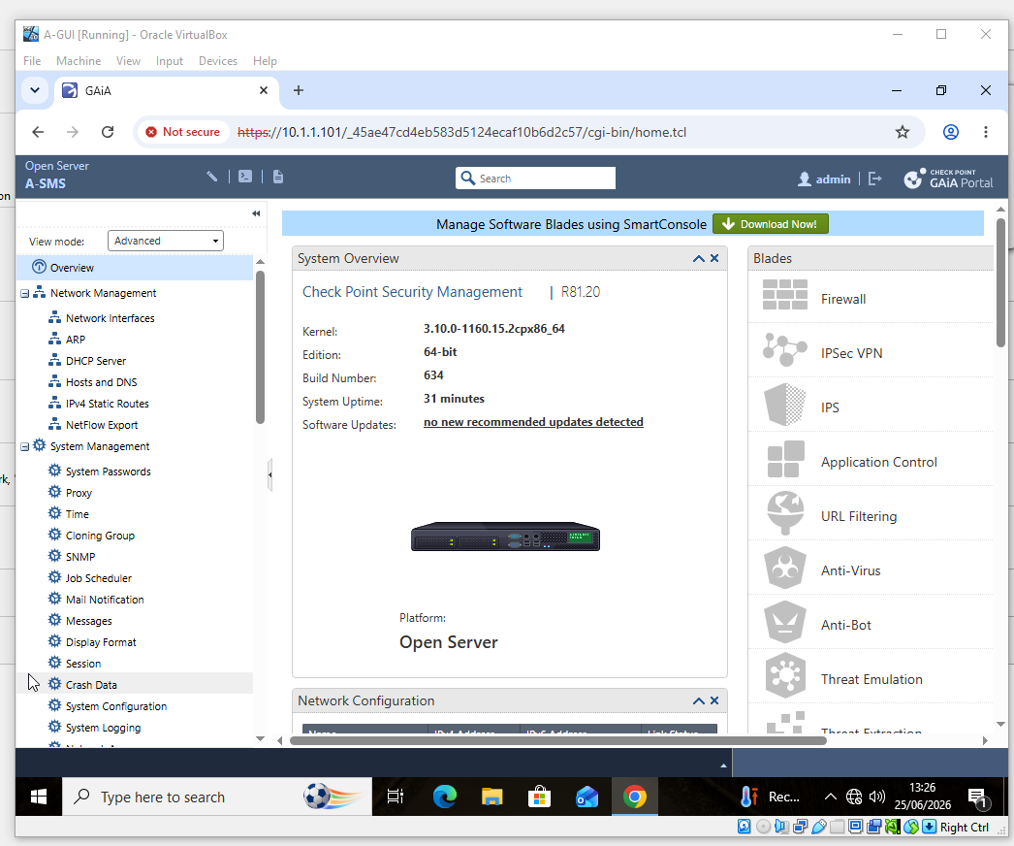
The Gaia System Overview for the A-SMS Security Management Server running Check Point R81.20 is displayed in this screenshot. After the initial setting is finished, the screen confirms that the management platform is working. Before connecting using Smart Console, it is helpful to confirm the software version and system role to make sure the administrator is in charge of the intended server. The primary platform for managing A-GW and B-GW, network objects, NAT settings, and security policies is provided by A-SMS. Therefore, before the report enters graphical policy administration, the screenshot offers system-level verification of the management server.

7.7 Smart Console Installation – Initial Progress
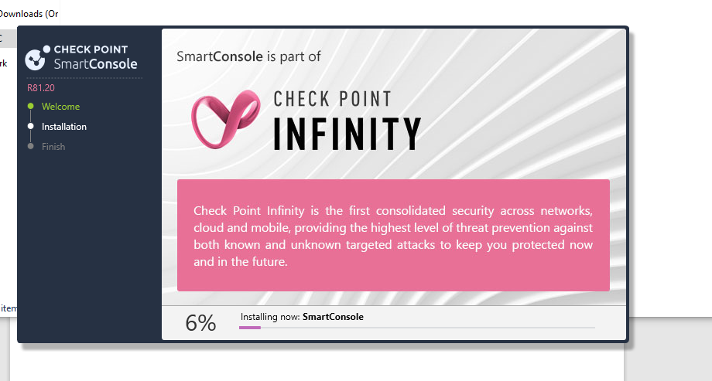
The early stages of the Check Point Smart Console R81.20 installation on the Windows administration workstation are shown in this screenshot. The graphical user interface for gateway objects, NAT, Access Control, publishing, policy installation, and logging is provided by Smart Console, which is necessary for managing the Security Management Server. Before any security policy setting was carried out, the administration environment was set up, as documented by the installation proof. Thus, this screenshot links the subsequently functional Smart Console login and management interfaces with the Windows virtual-machine configuration.

7.8 Smart Console Installation – Further Progress
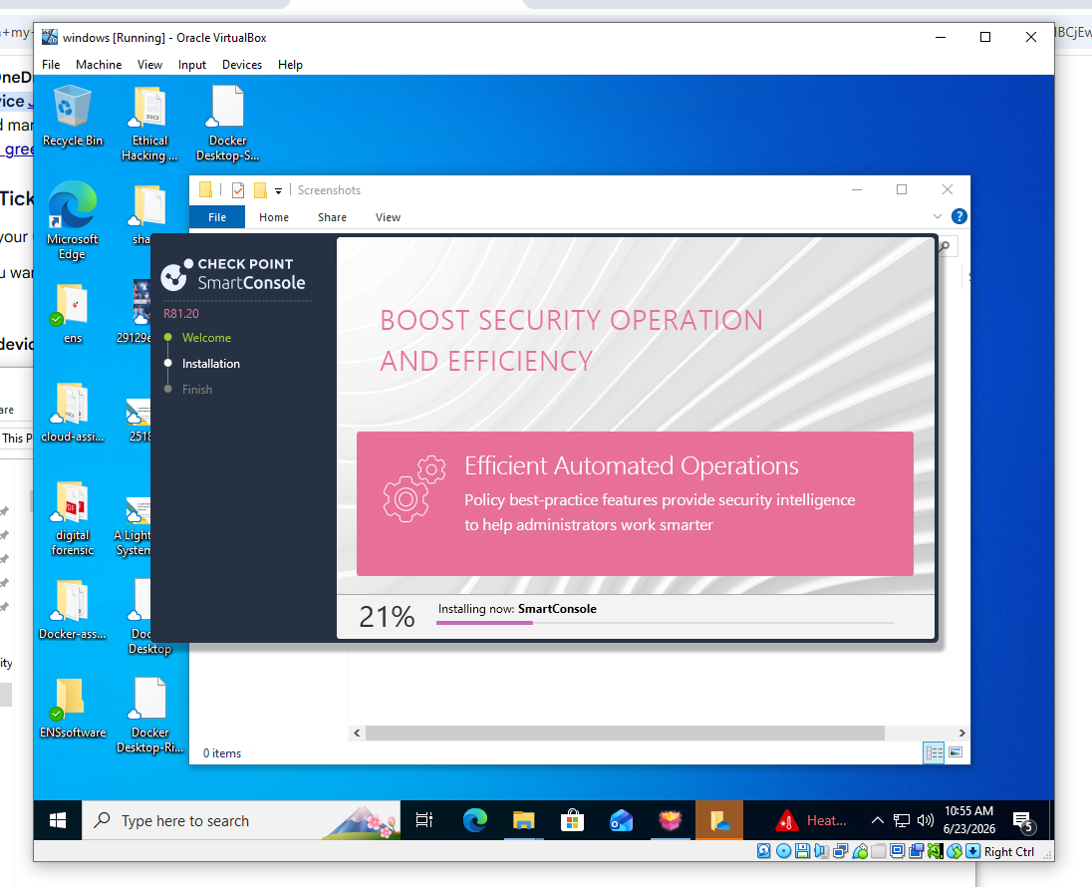
As more program components are installed, this screenshot offers more proof of the Smart Console R81.20 installation procedure. It records the development of the management-client deployment along with the previous installation screen. Even though the main installation procedure is depicted in both screenshots, keeping this figure offers a more comprehensive practical record where the assessment anticipates detailed proof. After installation, Smart Console takes over as the main administration tool, therefore finishing this step successfully is required before creating and managing the gateway, NAT, and firewall configurations that are presented later.

7.9 Smart Console Login after Installation
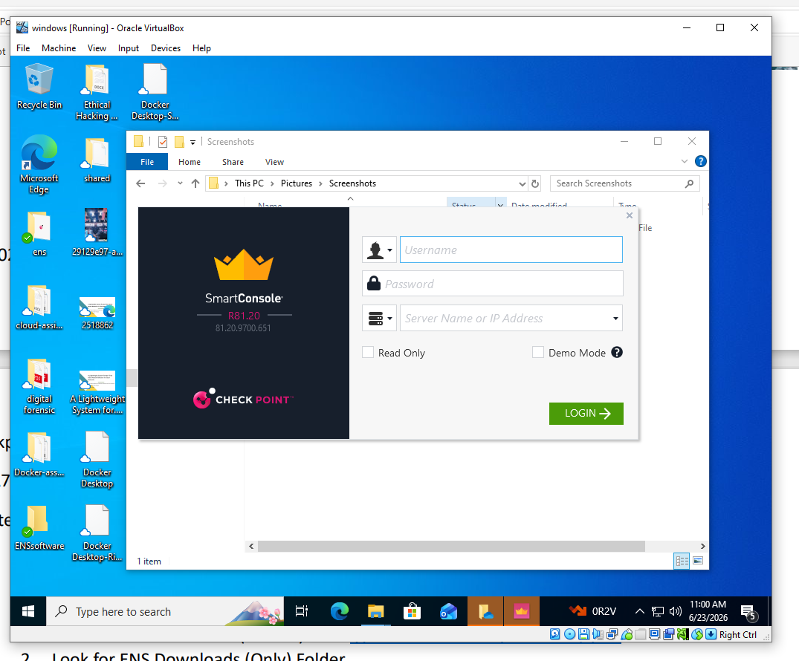
After installation, the Smart Console R81.20 login interface is displayed in this screenshot. The management client was successfully installed and is prepared to connect to the Security Management Server when it reaches the login screen. After that, the administrator can control the Check Point environment centrally and authenticate to A-SMS. Thus, this screenshot illustrates the change from installing management software to administering active security. The gateway, network-object, NAT, and access control configurations made with this client are shown in the Smart Console evidence that follows.

7.10 Gateway Installation Wizard Completion
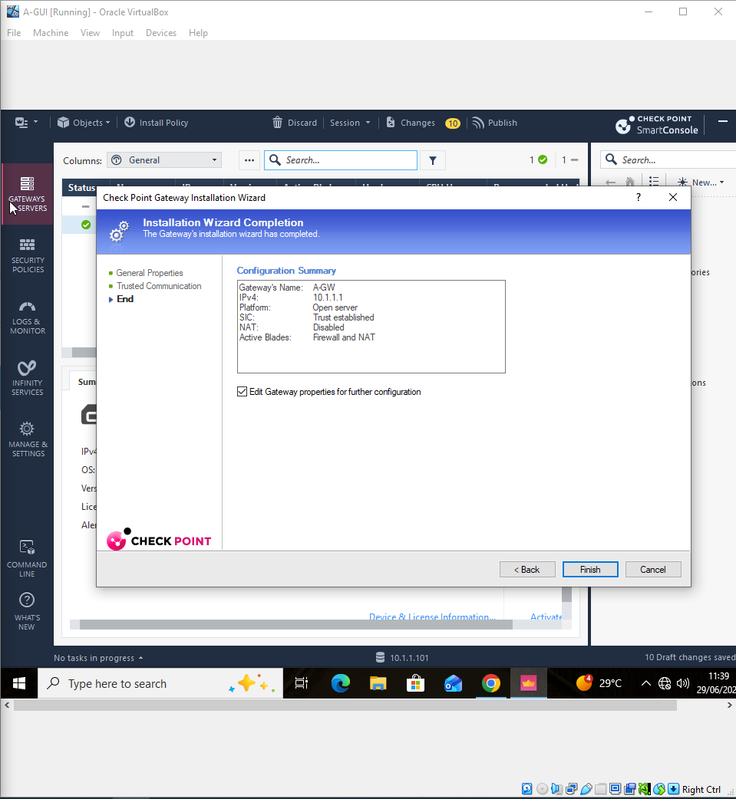The Gateway Installation Wizard for A-GW is completed in this screenshot. Important gateway details, such as its IPv4 address, platform, and active security capabilities, are indicated in the report, which also shows that SIC trust has been established. This offers compelling proof that the centrally administered Check Point environment successfully incorporated A-GW. The finished wizard sets up the gateway for the deployment of security policies and connects the system-level Gaia configuration with Smart Console administration. Prior to the specific SIC status and policy-installation evidence that are later supplied, the information displayed also serves as a helpful point of verification.

7.11 SIC Trust Verification
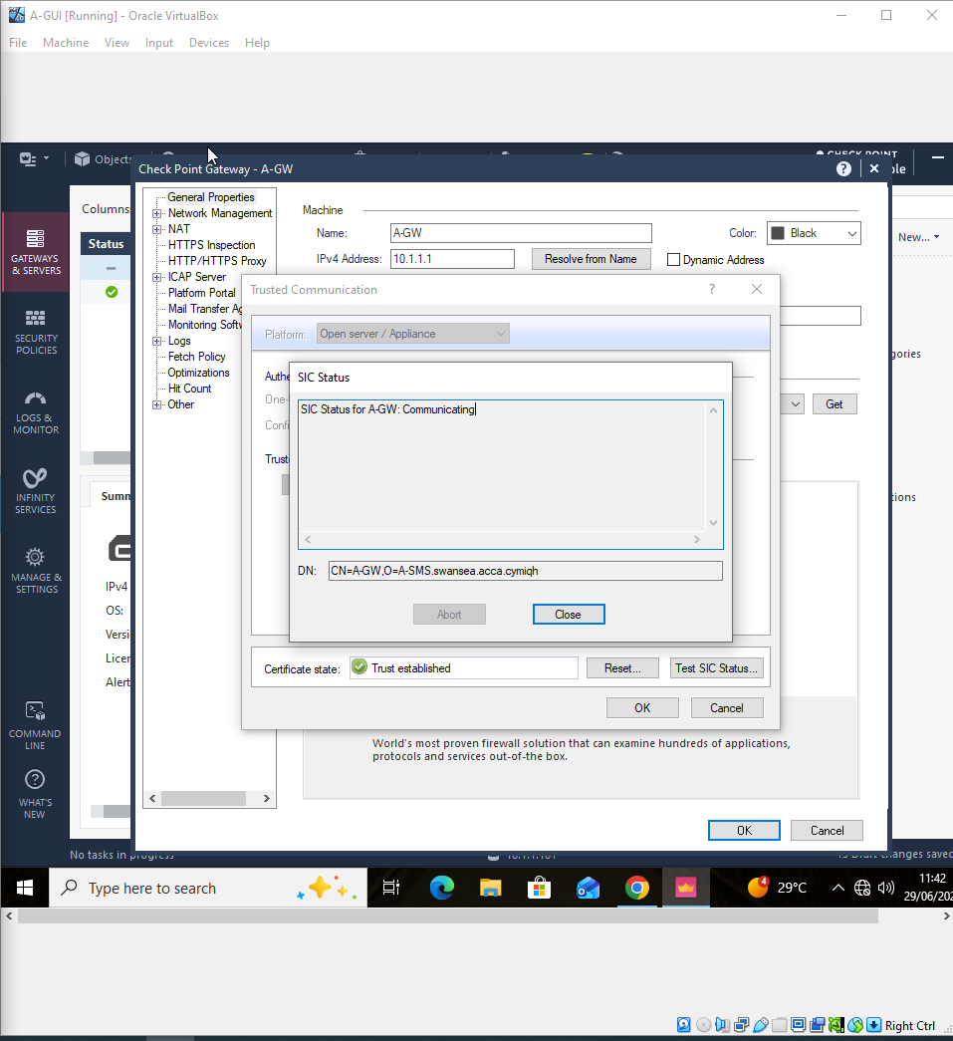
Secure Internal Communication (SIC) between A-GW and the Security Management Server is confirmed by this screenshot. The management server and gateway have established the trusted connection necessary for secure management operations, as evidenced by the communication and trust-established status that are presented. Because policy installation and other management communications rely on the gateway's recognition and confidence by the management environment, SIC is especially crucial. Therefore, the screenshot offers concrete proof of the safe integration of the management and enforcement components. This facilitates the Alpha-Standard policy's subsequent effective transition from A-SMS to A-GW.

7.12 Publishing Smart Console Changes
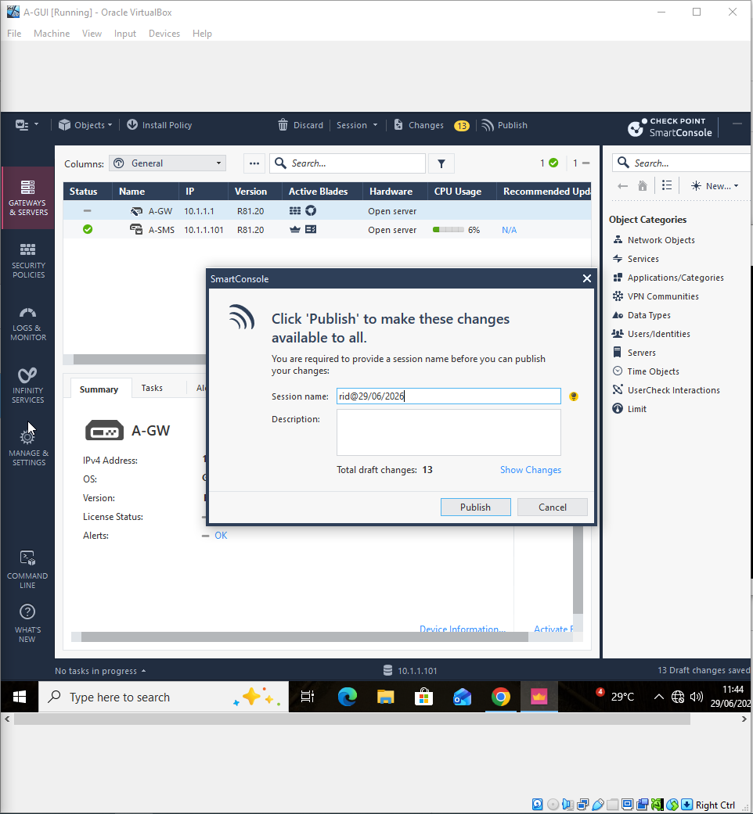
The posting of configuration changes in Smart Console is depicted in this screenshot. In order for the administrator's modifications to be utilised for later policy activities, publishing saves them to the management database.

7.13 Administrator and Permission Configuration
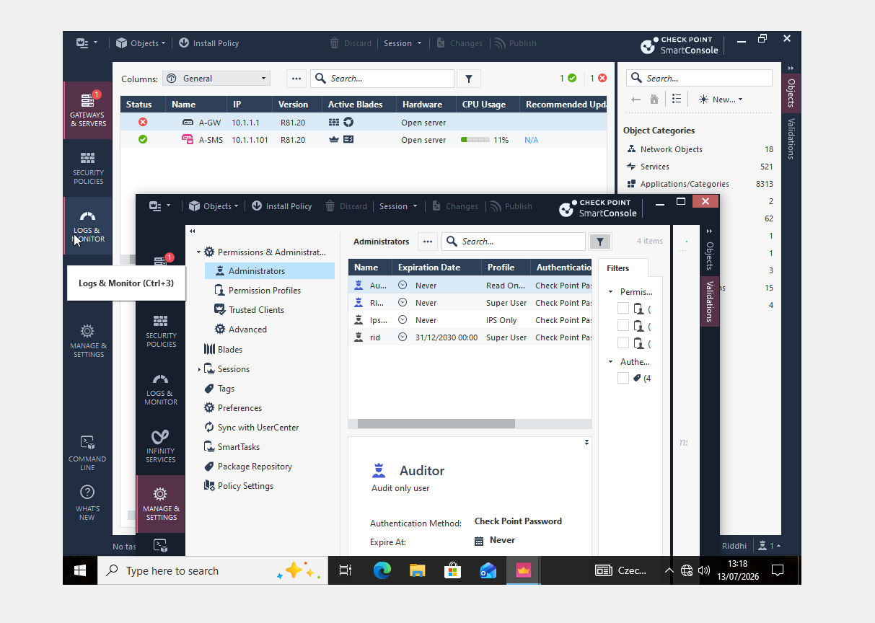
The administrator and permission settings in Smart Console are shown in this screenshot. Only authorised administrators are able to perform security management tasks thanks to these controls.

7.14 Gateway Device and Policy Information
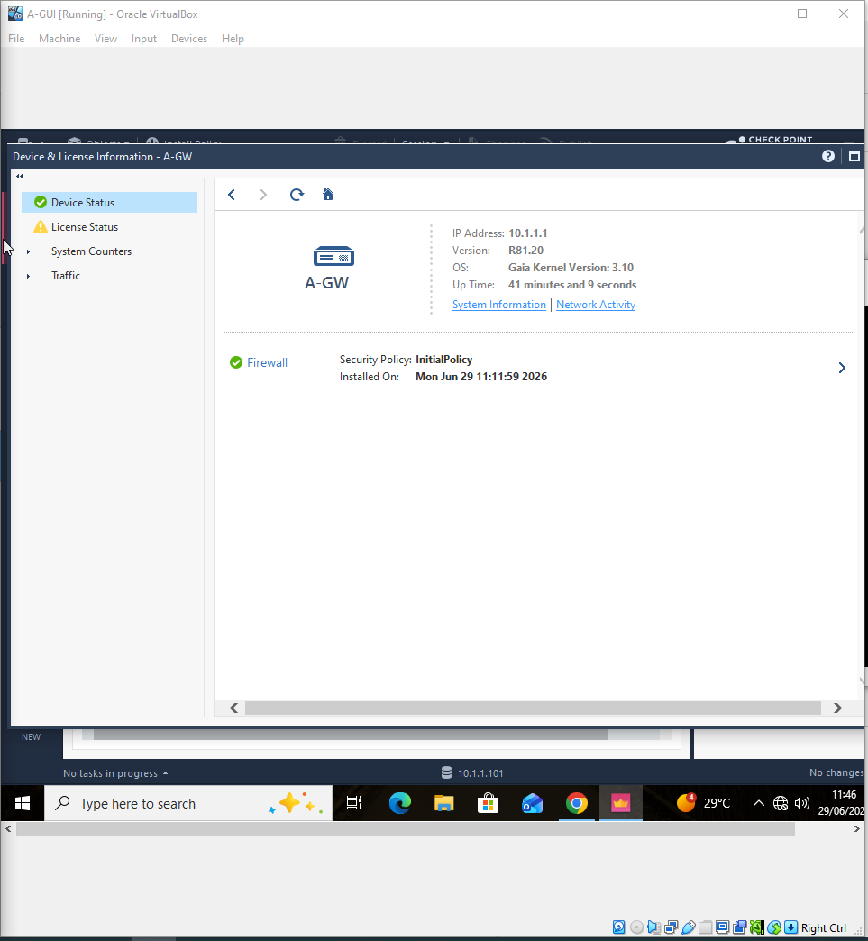
The device, license, and security policy details for A-GW are shown in this snapshot. It confirms that the gateway is identified and controlled by the Check Point system.

7.15 Gateway License Status
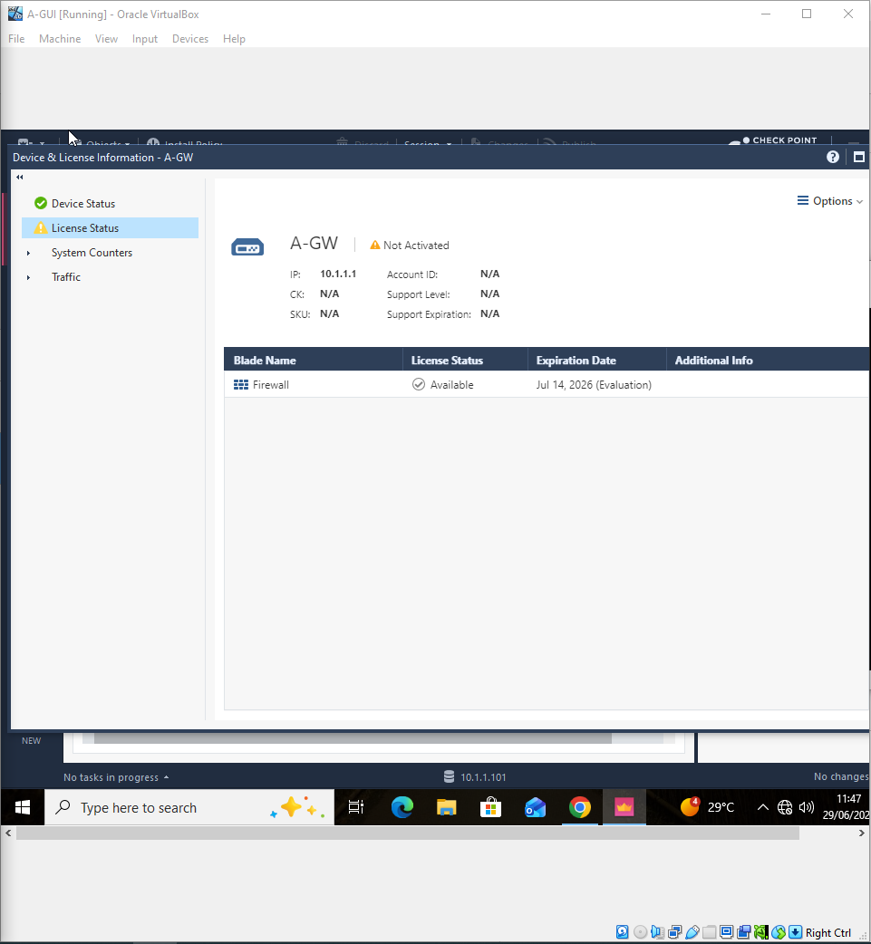
The license status of A-GW and the availability of firewall capability are displayed in this screenshot. It verifies the gateway used in the practical's license status.

7.16 A-GW CLI License Verification
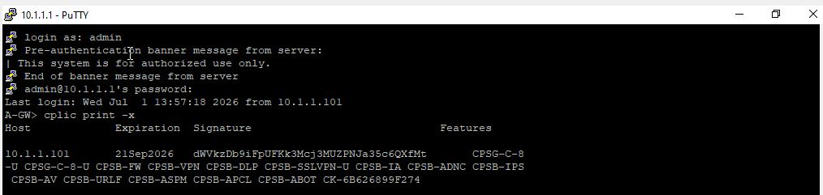
The command-line verification of license and feature information on A-GW is shown in this snapshot. It offers more proof that the gateway license was verified straight from the system.

7.17 A-SMS CLI License Verification → openshellA-SMS.png
The A-SMS command-line interface's license verification is seen in this screenshot. It offers proof of the license data that is accessible on the Security Management Server.

7.18 Contract Coverage Verification
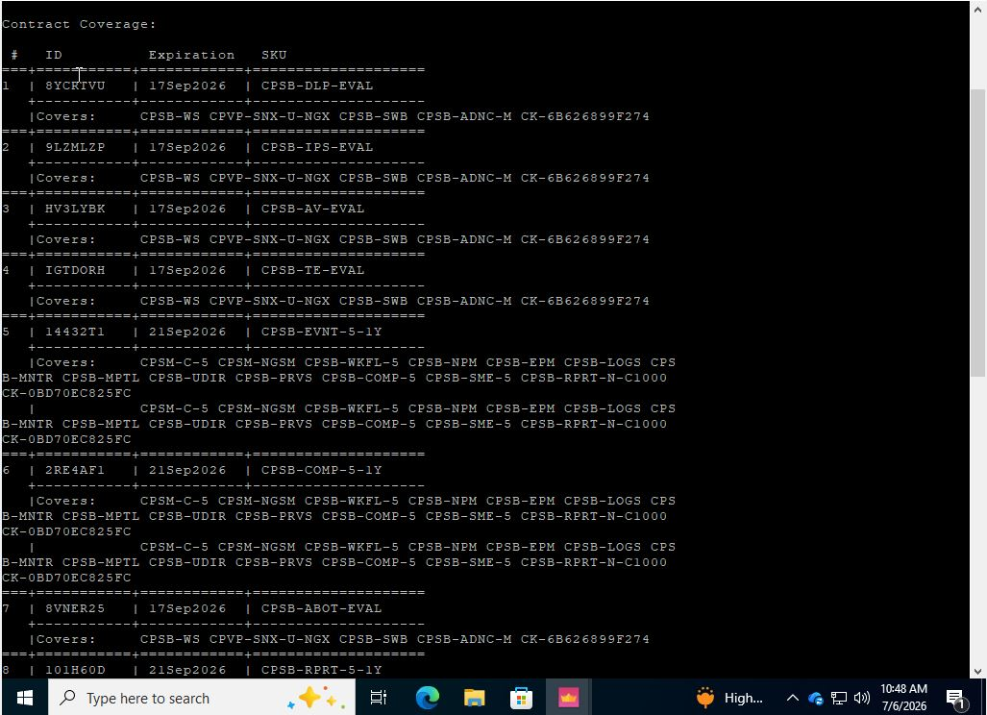
Check Point contract and evaluation coverage details are shown in this screenshot. It aids in confirming the security features that are available and the entitlement data that goes with them.

7.19 Smart Update Licenses and Contracts 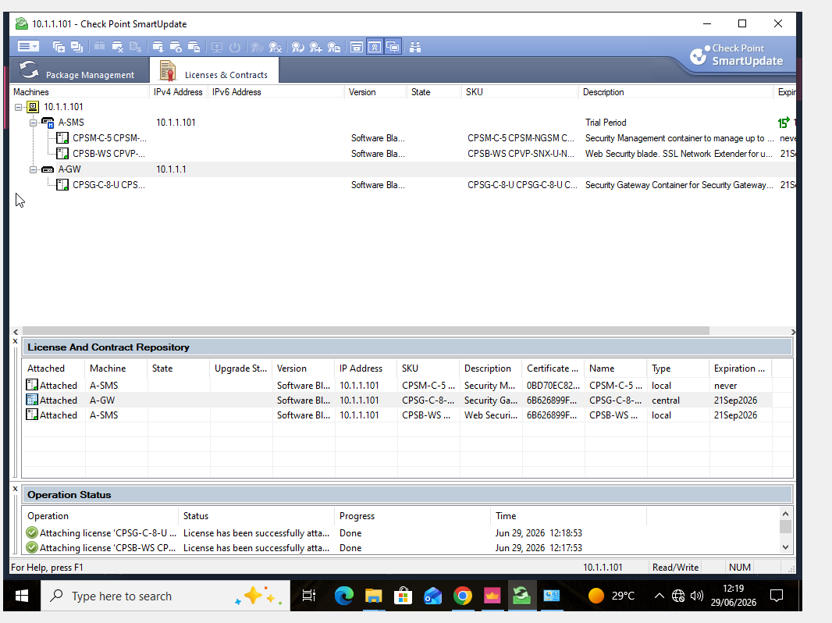
The Licenses & Contracts section of Check Point Smart Update is displayed in this screenshot. It offers central access to license data related to the controlled Check Point systems.

7.20 Successful Licence/Contract Attachment 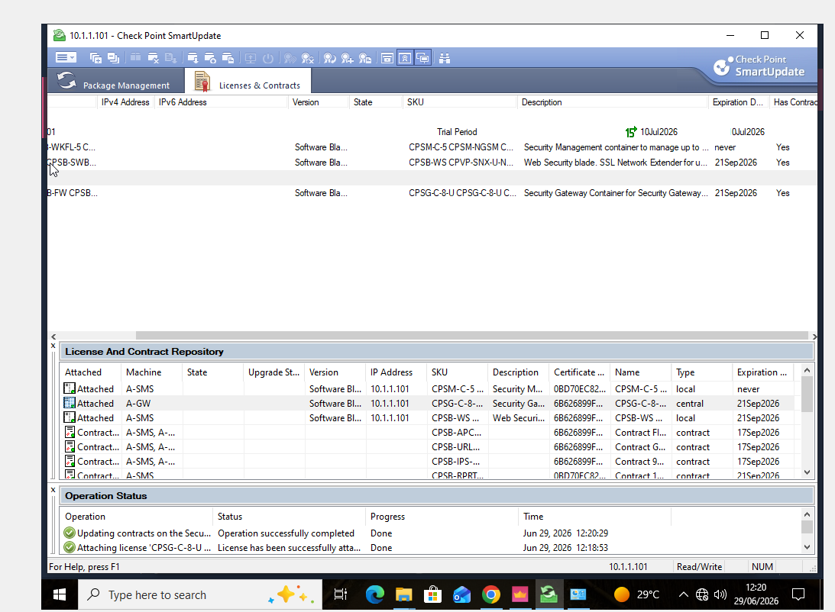
The effective completion of the license and contract procedures is verified by this screenshot. It confirms that the management environment recognises the pertinent entitlement information.

7.21 A-SMS Licence and Contract Information 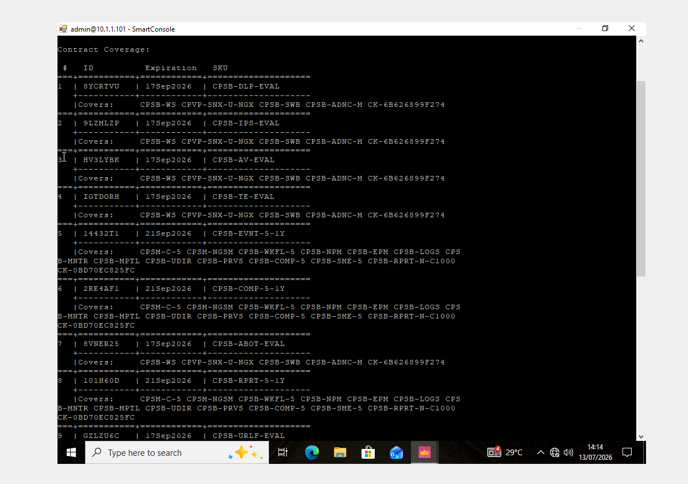
Additional licence and contract details for A-SMS are shown in this screenshot. It facilitates confirmation that the Security Management Server's licensing was examined.

7.22 Additional A-SMS NAT Evidence 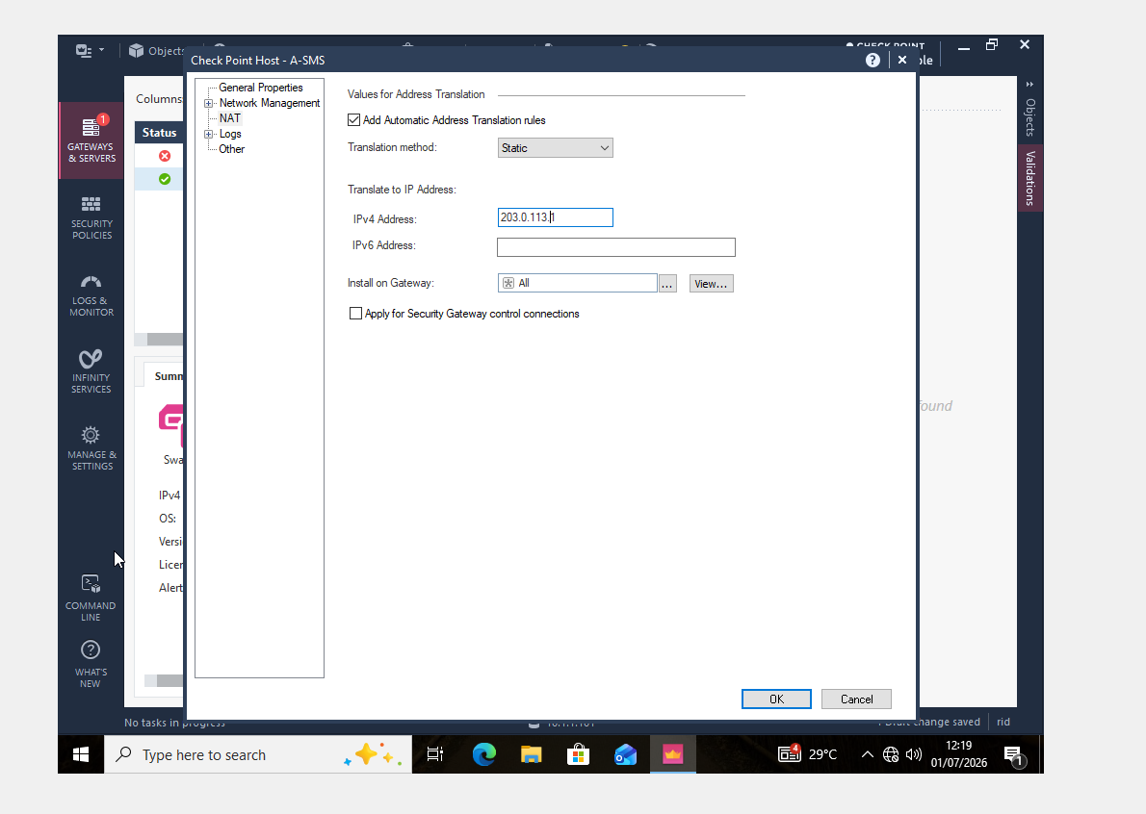
The NAT settings set up for the A-SMS object in Smart Console are seen in this screenshot. It offers more proof of the management server's address-translation setup.

