

FINANCIAL MANAGEMENT (LCMB7002)

NAME: JOEL BINASH
STUDENT ID: 2237045
LECTURER NAME: JIA MIAO
SUBMISSIONDATE: 02/09/2024

Table of contents
Part A: Introduction 3
History of EasyJet Plc 3
Part B: Financial performance review 4
Key Financial Ratios 4
Profitability Ratios 4
Liquidity Ratios 6
Gearing Ratios 7
Efficiency Ratios 8
Comparison of Financial Performance 10
Part C: Investment appraisal 15
1. Investment appraisal techniques evaluation 15
2. Advantages and shortcomings of investment appraisal techniques 19
Non-financial factors of investment decision-making 20
Recommendations 21
Conclusion and Recommendation 21
Reference List 23

Part A: Introduction

History of EasyJet Plc
EasyJet Plc is a UK-based multinational airline business that provides low-cost airline services. EasyJet is a low-cost European airline that has 343 aircraft and operates in 35 countries with 158 airports (EasyJet Plc, 2024). In addition, the company provides flight booking facilities, travel insurance, car rental and airport transfer services and it was established in 1995. Additionally, the business model of EasyJet is focused on providing low-cost airline services to customers by managing service and network differentiation (EasyJet Plc, 2024). The company aims to connect customers and approach the world at lower cost and providing comfortable service is another purpose of the company. In contrast, International Airlines Group and Ryanair are two key competitors of EasyJet.
Leadership style of EasyJet focuses on following positive long-term experience with customers that can help in making differentiation. Thomas Haagensen is the group market director of EasyJet who has been working since 2008 with more than 20 years of experience (EasyJet Plc, 2024). In addition, Johan Lundgren is the chief executive officer of EasyJet who joined in 2017 with more than 30 years of experience. Consistency in directors can be observed in past 5 years that give a high contribution in providing low-cost airline services. In 2019 net profit after tax was earned £349m reduced to £324m in 2023 (EasyJet, 2023). Decreasing net profit is observed for the company that makes a profit warning however, revenue earned in 2019 was £6,385m that increased to £8,171m in 2023. However, issues of punctuality and flight cancellations due to certain weather changes. Moreover, managing environmental regulations is important for EasyJet to avoid legal risks as noise pollution and emissions can create challenges for the company in sustainable business operations. In addition, EasyJet has acquired Air Berlin and GB Airways along with Go Fly (EasyJet Plc, 2024). However, EasyJet uses cost advantage to manage operational efficiency in primary airports in Europe. Strategic priority of the company is based on low-cost airline services that can target large number of travellers. Its significantly affect revenue generation potential of the business that results in increasing revenue earning capacity in last 5 years.

5 MAJOR EVENTS OF EASY JET IN LAST 5 YEAR:

- 2018 - EasyJet welcomes the delivery of its first A321 NEO, the fleet reaches 300 aircraft, with at least 50% being A320, and 28 being NEO.
- 2019 - EasyJet holidays is launched in November 2019, allowing customers to book package holidays directly with EasyJet. A partnership with Airbus is announced; a joint research project on zero-emission aircraft. EasyJet became the first major airline to offset 100% of the carbon emissions from the fuel used for all its flights on behalf of all its customers.
- 2020 - The COVID-19 pandemic severely impacts the airline industry. EasyJet grounds its entire fleet for the first time in its history. EasyJet welcomes the unveiling by its partner Airbus of three new zero-emission, hydrogen fueled commercial aircraft concepts.
- 2021 - EasyJet begins to recover from the pandemic, gradually restoring its flight schedule and launching a Covid-19 Travel Hub on easyjet.com. The new cabin bag policy is introduced and EasyJet launches a new Standard Plus fare bundle.
- 2022 - EasyJet announces its roadmap to achieving net zero by 2050. EasyJet agrees to utilize purchase options of an additional 56 A320neo family aircraft for delivery between FY26 and FY29, as well as converting 18 planned deliveries of A320neo aircraft to 18 A321neo aircraft with a higher gauge.

Part B: Financial performance review

Key Financial Ratios

Profitability Ratios
Particulars (£, million) | Formula | EASYJET PLC
Particulars (£, million) | Formula | 2023 | 2022 | 2021 | 2020 | 2019
"Operating Profits (OP)" | [OP/ S] *100 | 453 | -27 | -910 | -899 | 466
"Total Sales (S)" | [OP/ S] *100 | 8171 | 5769 | 1458 | 3009 | 6385
"Operating Profit Margin" | [OP/ S] *100 | 6% | -0.47% | -62% | -30% | 7%
"Net Profits (NP)" | [NP/ S] *100 | 324 | -169 | -858 | -1079 | 349
"Total Sales (S)" | [NP/ S] *100 | 8171 | 5769 | 1458 | 3009 | 6385
"Net Profit Margin" | [NP/ S] *100 | 4% | -3% | -59% | -36% | 5%
Table 1: Profitability Ratios of EasyJet Plc during past 5 years
(Source: Self-developed)

Operating Profit Margin
The operating profit margin is evaluated to interpret the proportion of funds retained after complying with direct and indirect expenses of the company during an accounting period. The operating margin is computed by evaluating total operating profits for the period by total sales generated during the year. It is obtained as a percentage to emulate the net funds available before complying with financial and taxation expenses. The operating margin of EasyJet Plc had massively declined during 2020 and 2021. Increasing proportion of direct and indirect expenses during both years evolved operating losses. It has been observed that sales had considerably declined due to the restriction in air travel due to Covid-19. Sales during 2020 and 2021 had declined by nearly 50% margin. Contrastingly, during 2022, sales of EasyJet Plc significantly increased to £5769 million from £1458 million (EasyJet, 2022). Resultantly, the operating losses declined during 2022. Further during 2023, sales increased to £8171 million causing the operating profits to escalate by significant margins. Effective growth in sales during the period leverages the growth in operating profits. It has been observed that EasyJet Plc significantly recovered during the past two years with considerable growth in sales and operating profits. Thus, the operating profit margin of the company has significantly improved during the recent years.
Net Profit Margin
Net profit margin is computed to understand the total amount of funds retained after having complied with all organisational expenses during the period. The net profit margin is computed by evaluating the net income during the period by total sales generated (Nariswari and Nugraha, 2020). This outcome is obtained as a percentage to reflect net retention against the sales generated during a period. The net profit margin of EasyJet Plc had significantly declined during the 2020 and 2021 due to the massive growth in operational expenses and severe downfall in sales. The overall sales margin during 2020 had reduced more than 50% since 2019. Similarly, sales during 2021 reduced by 50% margin. Such reduction in sales were caused due to the evolution of Covid-19 which barred air travel for lengthy periods. Resultantly, EasyJet Plc suffered significant losses during both 2020 and 2021. The losses generated during 2020 was the highest, amounting to £1079 million (EasyJet, 2020). However, the net income improved with effective growth in total sales during 2022 and 2023. The net losses reduced to £169 million during 2022 while reflected profits during 2023. The financial performance of EasyJet Plc improved with effective growth in net income during the recent years. Thus, the net profit margin of the company significantly improved during the past two years.

Liquidity Ratios
Particulars (£, million) | Formula | EASYJET PLC
Particulars (£, million) | Formula | 2023 | 2022 | 2021 | 2020 | 2019
"Current Assets (CA)" | [CA/ CL] | 4130 | 4929 | 4165 | 2163 | 2119
"Current Liabilities (CL)" | [CA/ CL] | 4144 | 3678 | 2677 | 3826 | 2668
"Current Ratio" | [CA/ CL] | 1.00 | 1.34 | 1.56 | 0.57 | 0.79
"Cash and cash equivalents (Cash)" | [Cash/ CL] | 2925 | 3514 | 3536 | 2284 | 1285
"Current Liabilities (CL)" | [Cash/ CL] | 4144 | 3678 | 2677 | 3826 | 2668
"Cash Ratio" | [Cash/ CL] | 0.71 | 0.96 | 1.32 | 0.60 | 0.48
Table 2: Liquidity Ratios of EasyJet Plc during past 5 years
(Source: Self-developed)
Current Ratio
The current ratio of an organisation is computed to evaluate the liquidity position of an organisation during relevant periods. The current ratio is computed by evaluating availability of current assets against current liabilities during the end of an accounting period (Chairunisa, Digdowiseiso and Karyatun, 2023). This value is obtained as a ratio to interpret whether current assets are adequate for managing different current liabilities during the year. It has been observed that the current ratio of EasyJet Plc was considerably low during 2019 and 2020. The amount of current assets during 2019 and 2020 were significantly lesser than current liabilities of the period. Resultantly, the short-term financial adequacy was considerably low. However, the current assets steadily increased during 2021 and 2022. It helped the company evolve its current ratio thereby improving the liquidity position. Extensive amount of credit flexibility offered to the customers led the debtors to rise by considerable proportions. Current liabilities on another hand marginally reduced during 2021 and 2022 (EasyJet, 2022). Resultantly, the liquidity position of EasyJet Plc significantly escalated during both years. During 2023 there was a significant decline in current assets while current liabilities escalated causing the current assets and liabilities come at par (EasyJet, 2023). Thus, the liquidity position of EasyJet Plc consistently improved until 2022 but fluctuated marginally during 2023.
Cash Ratio
Cash ratio is computed to estimate the adequacy of cash funds for managing the short-term liabilities of an organisation during the end of an accounting period. The cash ratio is computed by evaluating the availability of cash equivalent funds by the current liabilities of the period. A higher cash ratio emulates increased availability of cash for meeting current liabilities (Seth, Chadha and Sharma, 2021). The overall cash holdings of EasyJet Plc have consistently fluctuated during the past 5 years. The cash ratio consistently increased until 2021 but significantly reduced post that year. Increased cash funds during 2021 caused the liquidity position to escalate for this company. However, cash holdings reduced during 2022 and 2023 in comparison to 2021. This emulated a significant scope for reduction in the cash funds for EasyJet Plc. The cash funds were reduced to £2925 million from £3514 million during 2023 (EasyJet, 2023). Based on the recent decline in cash funds, the adequacy of cash equivalents for current liabilities have reduced for EasyJet Plc. Thus, the liquidity position of EasyJet Plc has considerably reduced during the recent years due to effective decline in cash funds.

Gearing Ratios
Particulars (£, million) | Formula | EASYJET PLC
Particulars (£, million) | Formula | 2023 | 2022 | 2021 | 2020 | 2019
"Total Debts (D)" | [D/ E] | 7054 | 7921 | 7134 | 6574 | 6574
"Total Equity (E)" | [D/ E] | 2787 | 2533 | 2639 | 1899 | 2985
"Debt to Equity Margin" | [D/ E] | 2.53 | 3.13 | 2.70 | 3.46 | 2.20
"Operating Profits (OP)" | [OP/ Int] | 453 | -27 | -910 | -899 | 466
"Interest (Int)" | [OP/ Int] | 180 | 143 | 209 | 491 | 60
"Interest Coverage Ratio" | [OP/ Int] | 2.52 | -0.19 | -4.35 | -1.83 | 7.77
Table 3: Gearing Ratios of EasyJet Plc during past 5 years
(Source: Self-developed)

Debt to Equity Margin
Debt to equity margin is computed to estimate the proportion of debt and equity funds existing in the capital structure of an organisation. The debt-to-equity margin is computed by evaluating the amount of debt against the value of equity at the end of an accounting period. The outcome is obtained as a ratio to reflect the existence of debts in comparison to equity capital. The debt proportion in EasyJet Plc has consistently increased during each year until 2023. There has been a significant reduction in debts during 2023 due to massive debt repayment. It has been observed that equity capital kept fluctuating during each year though. The growth of equity funds along with reduction in debt funds during 2023 emulated that the company is using a lesser amount of leverage since previous years (EasyJet, 2023). The debt-to-equity margin was highest during 2020 and 2022 due to high amounts of debt capital. Effective reduction in total debts also indicate significant minimisation of financial interests paid by the company. It has been observed that debt capital was maximum during 2022 with 37961 million (EasyJet, 2022). Thus, a reducing debt and increasing equity margin caused gearing ratios reduced during the recent years

Interest Coverage Ratio
Interest coverage ratio is computed to emulate the adequacy of operating profits for paying out the financial interests arising during an accounting period. The interest coverage ratio is computed to evaluate the efficiency of operating profits for acknowledging the interest expenses of a firm (Hussain et al., 2020). A higher interest coverage ratio emulates that the firm has a significant amount of funds for meeting the financial liabilities during the year. It has been observed that repetitive operating losses during the 2020 to 2022 period has reflected negative adequacy of operating profits. EasyJet Plc had significantly faced operating losses due to the severity of Covid-19 upon air travel across the globe. The overall expenses had increased while the revenue margin significantly reduced. Contrastingly, the debts collected levied enormous amounts of interest during the 2020 to 2022 period. It has been observed that sufficient operating profits during 2023 enabled EasyJet Plc to pay out the interests successfully during the period (EasyJet, 2023). The amount of financial interests was also lower during the past two years in comparison to 2021 and 2020. Thus, it had facilitated EasyJet Plc to improve their gearing margin by totalling a higher amount of operating profits during the year.

Efficiency Ratios
Particulars (£, million) | Formula | EASYJET PLC
Particulars (£, million) | Formula | 2023 | 2022 | 2021 | 2020 | 2019
"Trade Receivables (TR)" | [TR/ S] *365 | 343 | 367 | 291 | 193 | 302
"Total Sales (S)" | [TR/ S] *365 | 8171 | 5769 | 1458 | 3009 | 6385
"Trade Receivable Days" | [TR/ S] *365 | 15 | 23 | 73 | 23 | 17
"Total Sales (S)" | [S/ TA] | 8171 | 5769 | 1458 | 3009 | 6385
"Total Assets (TA)" | [S/ TA] | 9841 | 10454 | 9773 | 8473 | 8163
"Asset Turnover Ratio" | [S/ TA] | 0.83 | 0.55 | 0.15 | 0.36 | 0.78
Table 4: Efficiency Ratios of EasyJet Plc during past 5 years
(Source: Self-developed)
Trade Receivable Days
Trade receivable days is an efficiency ratio used for evaluating the number of days taken by a customer to pay back an organisation. The trade receivable days are computed by evaluating the debtors balance against the total credit sales and multiplying 365 days. This outcome is obtained in a number of days to understand the amount of time the company is expected to take for liquidating its account receivables. A lesser number of trade receivable days emulate faster collection of debtor’s balance during the year (Zimon et al., 2022). The growth in trade debtors is comparatively lesser than the hike in total credit sales during recent years. The overall debtor’s proportion minimising during the recent years have implied that the firm secures earlier payment from its debtors. It has been observed that trade receivable days of EasyJet Plc have considerably minimised during 2022 and 2023 (EasyJet, 2023). Previously the proportion of debtors against sales was comparatively higher. The enormous growth in sales during recent years with controlled escalation in total debtors led to the minimisation of receivable periods. It has been observed that trade receivable days massively escalated during 2021 post which it kept declining. Thus, the efficiency margin of the company increased during recent years with successful recovery of credit sales.

Asset Turnover Ratio
The asset turnover ratio is computed to estimate how efficiently the total assets are being used for generating sales revenue of an organisation. The asset turnover ratio is computed by evaluating total sales by total assets during an accounting period. A higher asset turnover ratio implies that the firm has efficiently utilised its assets for enhancing the sales of the company. The asset turnover ratio of EasyJet Plc has significantly increased during the recent years. It has been observed that total sales of the company have significantly increased during the recent years. Contrastingly, the growth in total assets has been lesser in comparison to the growth of total sales. Resultantly, the asset turnover ratio has increased during the recent years. The reduced proportion sales during 2020 and 2021 has massively reduced this ratio. The sales growth during 2022 and 2023 was considerably high (EasyJet, 2023). This rate of growth in total sales accelerated the asset turnover ratio by considerable proportions. It has been observed that total assets of EasyJet Plc increased during 2022 but had significantly minimised during 2023. Reduced amount of total assets during the year with massive escalation in sales indicates better utility of total assets since previous years. Thus, improvement in asset turnover ratio indicates better efficiency margin for the company during recent years.

Comparison of Financial Performance

Profitability Ratios
Particulars (£, million) | Formula | INTERNATIONAL AIRLINES GROUP
Particulars (£, million) | Formula | 2023 | 2022 | 2021 | 2020 | 2019
"Operating Profits (OP)" | [OP/ S] *100 | 528 | -348 | -2765 | -7451 | 2613
"Total Sales (S)" | [OP/ S] *100 | 6716 | 4443 | 8455 | 7806 | 25506
"Operating Profit Margin" | [OP/ S] *100 | 8% | -8% | -33% | -95% | 10%
"Net Profits (NP)" | [NP/ S] *100 | 458 | -361 | -2933 | -6935 | 1715
"Total Sales (S)" | [NP/ S] *100 | 6716 | 4443 | 8455 | 7806 | 25506
"Net Profit Margin" | [NP/ S] *100 | 7% | -8% | -35% | -89% | 7%

Table 5: Profitability Ratios of IAG during past 5 years
(Source: Self-developed)
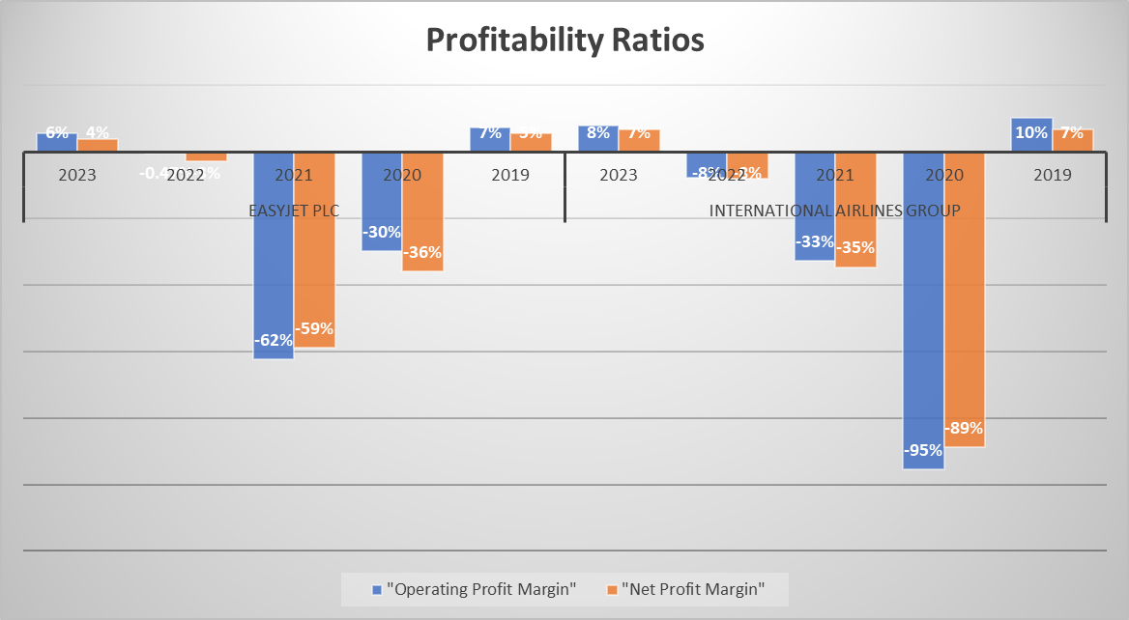
Figure 1: Comparative profitability position
(Source: Self-developed)
The performance of EasyJet Plc is comparatively better than IAG during the past 5 years. During 2023 the amount of profitability for IAG was higher but with low saleability (Iairgroup, 2023). It has been observed that IAG faced increasing amounts of losses during the previous years. Significant sales growth of EasyJet Plc during the recent years has implied the increased scope of profitability. It implies that IAG succeeded in generating increased rates of profitability than EasyJet Plc. Resultantly, the performance of EasyJet Plc is better than its competitor during recent years due to minimum losses and high profits.
Liquidity Ratios
Particulars (£, million) | Formula | INTERNATIONAL AIRLINES GROUP
Particulars (£, million) | Formula | 2023 | 2022 | 2021 | 2020 | 2019
"Current Assets (CA)" | [CA/ CL] | 5698 | 4438 | 10551 | 7840 | 11327
"Current Liabilities (CL)" | [CA/ CL] | 10134 | 8208 | 13278 | 11516 | 12748
"Current Ratio" | [CA/ CL] | 0.56 | 0.54 | 0.79 | 0.68 | 0.89
"Cash and cash equivalents (Cash)" | [Cash/ CL] | 3573 | 2376 | 7892 | 5774 | 4062
"Current Liabilities (CL)" | [Cash/ CL] | 10134 | 8208 | 13278 | 11516 | 12748
"Cash Ratio" | [Cash/ CL] | 0.35 | 0.29 | 0.59 | 0.50 | 0.32
Table 6: Liquidity Ratios of IAG during past 5 years
(Source: Self-developed)
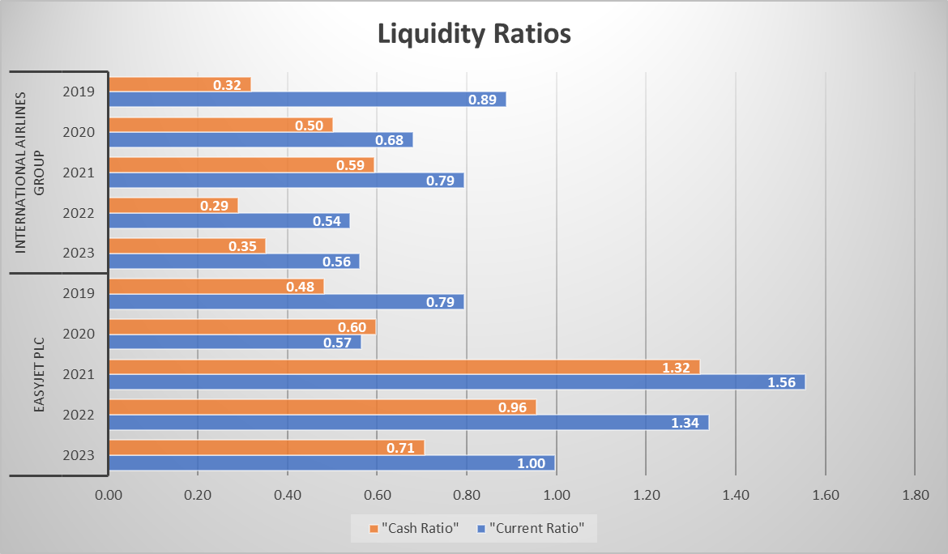
Figure 2: Comparative liquidity position
(Source: Self-developed)
The liquidity position of EasyJet Plc is comparatively better than IAG during the past 5 years. The current liabilities of IAG has been consistently high in comparison to EasyJet Plc. It has been observed that current liabilities of EasyJet Plc are considerably low and is lesser than its current assets. Current liabilities of IAG were maximum during 2021 and 2020 (Iairgroup, 2021). Alongside, cash equivalents of EasyJet Plc is also leveraging higher proportions of its current liabilities. Based on these metrics, it can be stated that the liquidity position of EasyJet Plc is considerably better than its competitors during the recent years.

Gearing Ratios
Particulars (£, million) | Formula | INTERNATIONAL AIRLINES GROUP
Particulars (£, million) | Formula | 2023 | 2022 | 2021 | 2020 | 2019
"Total Debts (D)" | [D/ E] | 19771 | 18326 | 33560 | 28706 | 28622
"Total Equity (E)" | [D/ E] | 2323 | 2483 | 846 | 1610 | 6829
"Debt to Equity Margin" | [D/ E] | 8.51 | 7.38 | 39.67 | 17.83 | 4.19
"Operating Profits (OP)" | [OP/ Int] | 528 | -348 | -2765 | -7451 | 2613
"Interest (Int)" | [OP/ Int] | 309 | 230 | 830 | 670 | 611
"Interest Coverage Ratio" | [OP/ Int] | 1.71 | -1.51 | -3.33 | -11.12 | 4.28
Table 7: Gearing Ratios of IAG during past 5 years
(Source: Self-developed)

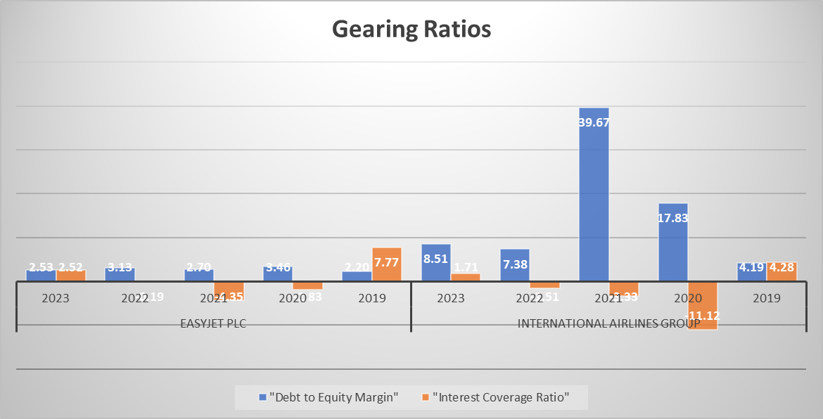

Figure 3: Comparative gearing ratios
(Source: Self-developed)
The gearing ratios of EasyJet Plc is better in comparison to IAG during the past 5 years. It has been observed that total operating losses of IAG is higher than EasyJet’s. Alongside, the debt margin in IAG is also very high compared to EasyJet (Iairgroup, 2023). Existence of high debt margin also proposes the financial expenses of IAG to remain higher. This type of capital structure has been massively reducing the financial sustainability of IAG. Resultantly, it has been observed that EasyJet Plc has a more balanced capital structure along with optimum financial stability during the past 5 years.

Efficiency Ratios
Particulars (£, million) | Formula | INTERNATIONAL AIRLINES GROUP
Particulars (£, million) | Formula | 2023 | 2022 | 2021 | 2020 | 2019
"Trade Receivables (TR)" | [TR/ S] *365 | 2323 | 2483 | 846 | 1610 | 7120
"Total Sales (S)" | [TR/ S] *365 | 6716 | 4443 | 8455 | 7806 | 25506
"Trade Receivable Days" | [TR/ S] *365 | 126 | 204 | 37 | 75 | 102
"Total Sales (S)" | [S/ TA] | 6716 | 4443 | 8455 | 7806 | 25506
"Total Assets (TA)" | [S/ TA] | 22094 | 20809 | 34406 | 30316 | 35668
"Asset Turnover Ratio" | [S/ TA] | 0.30 | 0.21 | 0.25 | 0.26 | 0.72
Table 8: Efficiency Ratios of IAG during past 5 years
(Source: Self-developed)
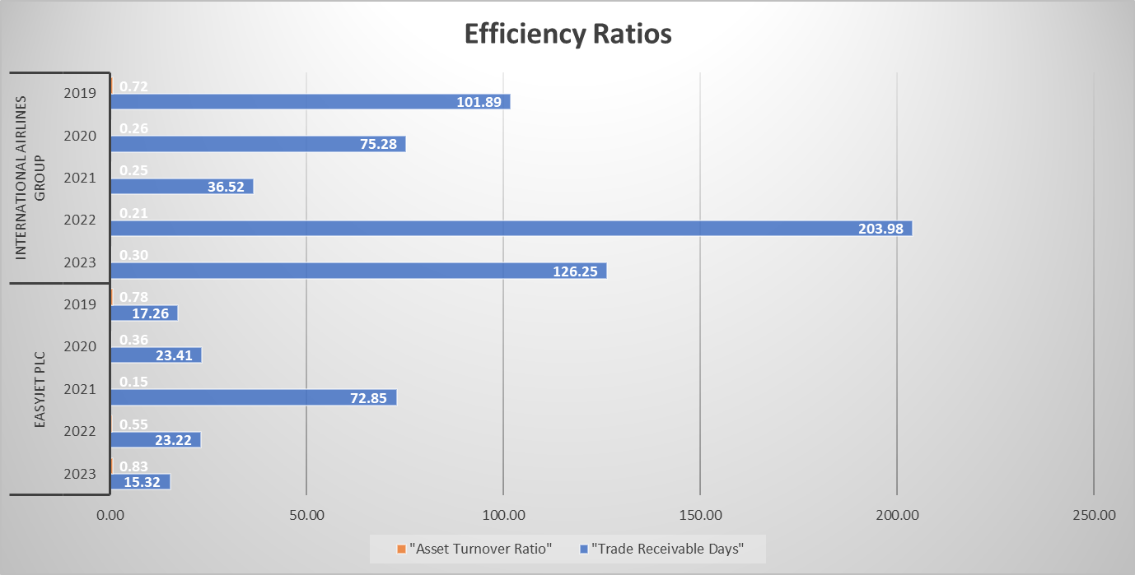
Figure 4: Comparative efficiency ratios
(Source: Self-developed)
The efficiency performance of EasyJet Plc is considerably better than that of IAG during the past 5 years. The trade receivable days of EasyJet Plc is comparatively lesser than IAG during the majority of the years. Alongside, the asset turnover ratio of EasyJet Plc is also higher than IAG during each year. Both these outcomes imply that EasyJet is recovering its trade receivables faster and maximising sales in comparison to the amount of total assets held. The total assets of IAG were maximum during 2021 and 2019 (Iairgroup, 2021). Thus, EasyJet Plc has a better efficiency margin in comparison to IAG during recent years.

Part C: Investment appraisal

1. Investment appraisal techniques evaluation
Investment appraisal means evaluating attractiveness of a project or investment and it is a part of capital budgeting techniques. “Net present value (NPV), payback period (PBP), accounting rate of return (ARR) and internal rate of return (IRR)” are part of capital budgeting techniques (Siziba and Hall, 2021). Investment appraisal techniques are important to evaluate whether Project A or B is suitable for EasyJet Plc.
Calculation of Payback Period (PBP)
Payback period (PBP) calculations
Year | A (£m) | Cumulative cash flow balance | B (£m) | Cumulative cash flow balance
0 | -80 |  | -75
1 | 25 | 25 | 50 | 50
2 | 25 | 50 | 20 | 70
3 | 20 | 70 | 20 | 90
4 | 55 | 125 | 20 | 110
Payback period (Years)
Formula: "Payback period based on cumulative balance +[Initial investment-Nearest year cumulative balance/ cash flow]"
Payback period (Years) | A |  | B
Payback period (Years) | 3+((80-70)/20) |  | 2+((75-70)/20)
Payback period (Years) | 3.5 Year |  | 2.25 Year
Table 9: PBP
(Source: Spreadsheet)
PBP is an investment appraisal technique that evaluates time required to recover the initial investment of a project. Lower value of payback period is preferred for a company that reflects faster recovery of cost of investment. PBP of Project A is calculated as 3.5 years which is higher than Project B’s 2.25 years. Hence, a lower value of PBP is observed for project B that EasyJet Plc can get a faster recovery of its initial investment by investing in the project.
Accounting Rate of Return (ARR) evaluation
Accounting Rate of Return (ARR)
Year | A (£m) | B (£m)
0 | -80 | -75
1 | 25 | 50
2 | 25 | 20
3 | 20 | 20
4 | 55 | 20
Average annual profit | 31.25 | 27.5
ARR
Formula: "Average net profit/initial investment" | 39% | 37%
Table 10: ARR
(Source: Spreadsheet)
ARR is an investment appraisal technique that is used for capital budgeting decision-making. Average net income of an investment is divided by its cost and multiplied by 100 to calculate the accounting rate of return (Danielson, 2024). ARR of Project A is computed as 39% which is higher than Project B’s 37%. Higher value of ARR is observed for project A and the company can get better profit by investing in this project.
Net Present Value (NPV) analysis
Net present value (NPV)
Year | A (£m) | B (£m)
0 | -80 | -75
1 | 25 | 50
2 | 25 | 20
3 | 20 | 20
4 | 55 | 20
Cost of capital | 9.75% | 9.75%
Formula: "FV1/(1+r)1+FV2/(1+r)2+FV3/(1+r)3+FV4/(1+r)4-I0"
"FV= Future value of investment, n= Number of years, r= rate of return and I0= initial investment"
NPV (£m) | 25/(1+0.0975)^1 + 25/(1+0.0975)^2+20/(1+0.0975)^3+55/(1+0.0975)^4-80 | 50/(1+0.0975)^1 + 20/(1+0.0975)^2+20/(1+0.0975)^3+20/(1+0.0975)^4-75
NPV (£m) | £16.57m | £16.08m
Table 11: NPV
(Source: Spreadsheet)
NPV determine difference between cash inflow and cash outflow of a project in present value is a part of investment appraisal technique. In addition, NPV determines both an investment in today's discounted price (Martínez-Ruiz et al. 2021). NPV of project A is calculated as £16.57m which is higher than project B's £16.08m. Hence, higher value of NPV is expected from a company that reflects investment in project A can be beneficial for the business.
Recommendation for project
Investment appraisal techniques indicate that PBP is being effectively maintained by Project B as it is lower. However, better NPV and ARR are maintained by project A reflecting it has greater profitability than the other project. It is suggested that EasyJet PLC invest in project A as it has a higher value of ARR and NPV which is important for profit maximisation. Differences PBP is quite low which seems investment in project A can provide better profitability to the company.

2. Advantages and shortcomings of investment appraisal techniques
PBP
Advantages: Evaluation of PBP is simple and can easily be calculated which is important to capital decision-making. According to Olaniyi and Prause (2020), payback period is easy to calculate and quickly determine the time required to recover initial capital for an investment. Hence, PBP is beneficial to know about time required to recovery of initial investment and it can be also used in measuring risk of a project. For instance, liquidity risks of a project can be understood from PBP calculation that is significant for capital budgeting decision-making. However, it focuses on short-term decision-making by expecting faster recovery of project’s initial capital cost. Hence, evaluation of PBP is important for capital budgeting as it induces an investor’s decision-making process by determining length of time for investment return.
Shortcomings: Time value of money gets ignored in PBP calculation and makes difficulties in capital budgeting decision-making process. However, time value of money is important to make better financial decisions as it affects financial return (Dragotă, 2022). Hence, not considering time value of money makes a limitation of PBP and it only focuses on short-term comings. Hence, only short-term earnings only prioritised in this method that is a limitation of the techniques due to not considering long-term impact.
ARR
Advantages: ARR determines rate of return that would be received by an investor, and it is beneficial to determine profitability of a project. Accounting rate of return is effective in calculating profitability of an investment that considers net income and initial cost of investment in calculation. Evaluation of ARR can help in comparing profitability of different projects that are effective for investors to decide about suitability of investment. Project benchmarking can be possible by calculating ARR and it is also simple to evaluate multiple projects. Use of income statements can be observed in ARR as it considers net income of an investment in calculation rather than cash flows and it increases its accuracy in determining profitability of projects.
Shortcomings: ARR ignores time value of money which makes a limitation of the technique. Ignoring time value of money can give inaccurate results for project evaluation in terms of profitability (Shahriar et al. 2021). Non-cash items are not considered in evaluation of ARR such as depreciation is not considered in calculation which is a limitation of ARR in determining the accurate value of assets. Moreover, long-term value creation by a project is not considered in ARR evaluation which makes a limitation of the technique by only focusing on short-term out coming.
NPV
Advantages: Evaluation of NPV is important for an investor as it focuses on time value of money that gives accurate results for present value of future investment. Discounted cash flows are considered in net present value calculations that provide better results for cash flow determination (Peymankar et al. 2021). Evaluation of NPV in investment appraisal techniques is beneficial and it helps in objective-based decision-making. NPV analyse cash flows based on discount rates that suggest negative values mean loss of investors. However, cash flows are considered in this technique making it more reliable for investment decision-making.
Shortcomings: Calculation of NPV is quite complicated by considering time value of money which is a limitation of the technique. In addition, NPV is time-consuming to calculate as it requires discount rate evaluation, and cash flow determination and also needs a deep concept of accounting. However, projected cash flows determine accuracy of net present value calculation. It makes a limitation of the technique as inaccurate cash flow projection can result in wrong NPV evaluation. As a result, inaccurate decision-making by investors can be observed in case of inaccurate cash flow projections for NPV calculation.

Non-financial factors of investment decision-making
Investment decision-making is influenced by different non-financial factors such as environmental impact. However, managing sustainability is essential for a business for effective resource allocation and utilisation by minimising negative impact on environment. Companies have to impact an investment in environment which is important to prevent environmental pollution. For instance, carbon emissions produced from a project need to be considered before its acceptance as it directly influences environmental sustainability. In addition, wastage produced from a project needs to be also considered before investment as it affects environmental sustainability (Ikram et al. 2021). Considering environmental impacts such as carbon emission and waste generation is important for a company before investment as it influences environmental sustainability. However, regulatory constraints are also essential to consider before any investment as it determines legal risk and reputation associated with a project. For instance, UK offers a business-friendly environment to trade and invest by focusing on climate change (U.S Department of State, 2023). EasyJet PLC needs to consider acts associated with climate change before choosing a project as it can minimise legal risk and chances of penalties.
Evaluation of societal impact is also important for a company before choosing an investment as it determines labour rights. Human rights and labour rights are protected to deal with unjust and inappropriate working conditions (International Labour Organisation, 2023). Determining social impact of an investment is an important non-financial factor as it influences the community and families of a nation. Moreover, cultural factors need to be also considered before investment such as ensuring diversity and equity is important for an organisation before considering an investment. It can influence inclusion of an integrated and diversified workplace in EasyJet PLC as it influences availability of skilled labour in a project. Hence, considering environmental factors, societal factors, regulatory constraints and cultural factors can minimise risk of an investment by adjusting adequate strategies.

Recommendations
- EasyJet Plc is required to minimise the debt proportion in its capital structure for minimising the financial interests to be paid during the year. The reduction in net interest pay out shall also escalate the annual profitability during following years (Aulia and Saputri, 2021).
- EasyJet Plc is required to escalate their sales during the following years by attracting a larger number of air passengers by offering discounts. This approach is expected to leverage increased scope for profitability along with a larger market share. There shall be increased sales and profits with access to a higher number of customers.

Conclusion and Recommendation
Overall performance of EasyJet Plc has been considerably better than IAG during the past 5 years. It can be concluded that EasyJet Plc has efficiently managed its financial health in comparison with International Airlines Group thereby determining the H1 hypothesis as true. The profitability and efficiency margin of EasyJet has been considerably better due to increased saleability during the period. It has been observed that liquidity composition of EasyJet is also being efficiently managed by sustaining a low scope of current liabilities.
It is recommended that Project A is feasible for investment due to increasing scope of profitability. EasyJet Plc shall leverage increased earnings by investing in this project by securing comparatively quicker returns.

Reference List
Chairunisa, S.S., Digdowiseiso, K. and Karyatun, S., (2023). The Effect of Total Assets Turnover, Debt to Assets Ratio, Cash Ratio and Current Ratio on Financial Performance of Companies The Hotel, Restaurant and Tourism Subsector in IDX for The Period 2016-2020. Jurnal Syntax Admiration, 4(3), pp.548-558.
Danielson, M.G., (2024). A robust model to estimate a firm’s average economic return. Journal of Contemporary Accounting & Economics, 20(1), p.100400.
Dragotă, V., (2022). How important is the time value of money in decision making? Results of an experiment. Prague Economic Papers, 30(3-4), pp.259-275.
EasyJet Plc, (2024). Business model. Available at: https://corporate.easyjet.com/about/business-model/default.aspx (Accessed 11.08.2024).
EasyJet Plc, (2024). Leadership. Available at: https://corporate.easyjet.com/about/leadership/default.aspx (Accessed 11.08.2024).
EasyJet Plc, (2024). Our journey. Available at: https://corporate.easyjet.com/about/our-journey/default.aspx (Accessed 11.08.2024).
EasyJet Plc, (2024). What we do. Available at: https://corporate.easyjet.com/about/what-we-do/default.aspx (Accessed 11.08.2024).
EasyJet, (2020). Annual Reports 2020. Available at: https://s203.q4cdn.com/522538739/files/doc_financials/2020/ar/annual-report-2020.pdf (Accessed 10.8.24)
EasyJet, (2022). Annual Reports 2022. Available at: https://s203.q4cdn.com/522538739/files/shareholder_docs/2023/annual-report-2022.pdf (Accessed 10.8.24)
EasyJet, (2023). Annual Reports 2023. Available at: https://s203.q4cdn.com/522538739/files/doc_financials/2023/ar/43627_easyJet_Annual-Report_Web.pdf (Accessed 10.8.24)
IAG (2021). IAG CNMV Annual Financial Report 2021. Retrieved August 10, 2024, from https://www.iairgroup.com/media/mgepukn4/iag-cnmv-annual-finanical-report-2021-en.pdf.

IAG (2023). Annual Report 2023. Retrieved August 10, 2024, from
https://www.iairgroup.com/investors-and-shareholders/financial-reporting/annual-reports/.
Ikram, M., Ferasso, M., Sroufe, R. and Zhang, Q., (2021). Assessing green technology indicators for cleaner production and sustainable investments in a developing country context. Journal of Cleaner Production, 322, p.129090.
Martínez-Ruiz, Y., Manotas-Duque, D.F. and Ramírez-Malule, H., (2021). Evaluation of investment projects in photovoltaic solar energy using the DNPV methodology. International Journal of Energy Economics and Policy, 11(1), pp.180-185.
Nariswari, T.N. and Nugraha, N.M., (2020). Profit growth: impact of net profit margin, gross profit margin and total assests turnover. International Journal of Finance & Banking Studies (2147-4486), 9(4), pp.87-96.
Olaniyi, E.O. and Prause, G., (2020). Investment analysis of waste heat recovery system installations on ships’ engines. Journal of Marine Science and Engineering, 8(10), p.811.
Peymankar, M., Davari, M. and Ranjbar, M., (2021). Maximizing the expected net present value in a project with uncertain cash flows. European Journal of Operational Research, 294(2), pp.442-452.
Seth, H., Chadha, S. and Sharma, S., (2021). Benchmarking the efficiency model for working capital management: data envelopment analysis approach. International Journal of Productivity and Performance Management, 70(7), pp.1528-1560.
Shahriar, M.S., Hasan, K.B.M.R., Hossain, T., Beg, T.H., Islam, K.A. and Zayed, N.M., (2021). Financial decision making and forecasting techniques on project evaluation: a planning, development and entrepreneurial perspective. Academy of Entrepreneurship Journal, 27(4), pp.1-7.
Siziba, S. and Hall, J.H., (2021). The evolution of the application of capital budgeting techniques in enterprises. Global finance journal, 47, p.100504.
Zimon, G., Tarighi, H., Salehi, M. and Sadowski, A., (2022). Assessment of financial security of SMEs operating in the renewable energy industry during COVID-19 pandemic. Energies, 15(24), p.9627.

