
Management Accounting
Assessment 1
Student Name:Yanitsa Gospodinova
Student ID:1907707
Lecture Name:Winifred Soribe

Table of Contents
Introduction 2
Management Accounting Principles 2
Cost Structures and Allocation in Businesses 3
Overview 3
Types 3
The importance of cost structures and allocation 4
Contextual Investigation of Harriot Hotel 5
Conclusion 5
References 6

Introduction
The purpose of this report is to analyse management accounting principles and link them within the contextual reference of Harriot Hotel where cost structures, types of costs and the way in which profit and cost affect businesses is being explained and appropriately applied. Furthermore, the report will have an overview of management accounting and will extend to explain cost structures and types of costs as well as effect which can be positive or negative in the presence of specific values are figures in a business organisation. Finally, it is important to outline that a conclusion consisting of several recommendations is also provided at the end.

Management Accounting Principles
Management accountings the act of recognizing, evaluating, dissecting, deciphering and transmitting monetary data to the supervisory authorities in search of the goals of the association (Drury, 2018). It is changing from cash accounting in light of the fact that the planned motivation behind administrative accounting is to help clients internalize the organization by adhering to many educated business choices (Chinasak Suwanachariya, Nacha Kwanmanee and Kalasom Latae, 2019).
This type of accounting includes numerous accounting features aimed at improving the nature of the data transmitted on board for business activity measurements (Drury, 2018). Administrative accountants use data identifying the revenues and transactions of products and enterprises created by the organization (Shahab, Clinch and O’Neill, 2018). Cost accounting is a huge subset of administrative accounting that explicitly concentrates on capturing the overall costs of setting up an organization by examining the variable costs for each progression of creation, just like fixed costs. It allows organizations to recognize and reduce unnecessary costs and increase benefits.
The vital distinction between administrative accounting and monetary accounting is identified with the proposed data clients (Seal et al., 2019). Administrative accounting data is aimed at helping association bosses to adhere to highly educated business choices, while monetary accounting is aimed at providing monetary data to parties outside the association.
Financial, or monetary accounting must adapt to specific rules, such as the correct accounting rules (GAAP). All freely held organizations are required to complete their GAAP fiscal summaries as a prerequisite for maintaining those traded in open market status. Most of the various organizations in the United States are adapting to GAAP to fulfil the mandatory contracts regularly required by monetary organizations offering credit extensions (Seal et al., 2019).

Cost Structures and Allocation in Businesses

Overview
The cost structure is referred to as the different types of costs that a business incurs and usually consists of fixed and variable costs (Bjørnenak, 2000). Fixed costs are costs that remain unchanged, with little attention paid to measuring the profitability that the organization produces, while variable costs change with the volume of creation (Bjørnenak, 2000).
Working in a business must lead to some kind of cost, whether it is retail or a specialized organization. Expenditure structures contrast between retailers and specialized organizations, thus business books shown in a fiscal summary rely on expenditure items such as item, administration, task, customer, or business movement. In fact, even within an organization, cost designs can change between offering products, units, or special units because of the unambiguous types of exercises they perform.

Types
Fixed costs
Fixed costs are consistent and are unlikely to change in the long run. Cases of fixed costs are overheads such as leasing, interest costs, local fees and depreciation of fixed resources (Serpeninova, Makarenko and Linska, 2019). An outstanding illustration of a fixed cost is the immediate labour costs. While direct labour costs will generally vary, as indicated by the number of hours the agent works, they will actually be moderately stable and could therefore be considered as fixed costs, despite the fact that this is even more commonly referred to as variable cost when it comes to hourly workers.
Variable costs
Variable costs will be costs that vary depending on yield. Examples of variable costs include direct operating costs, direct material costs, utilities, rewards, and commissions and demonstration costs (Serpeninova, Makarenko and Linska, 2019). Variable costs will generally be different from fixed costs. For organizations that sell items, variable costs may include direct materials, commissions, and piece compensation. For specialized organizations, variable costs are made from salaries, wages and travel expenses. For project-based organizations, costs, such as compensation and other risk costs, depend on the number of hours invested in each of the activities (Mizikovskiy and Mizikovskiy, n.d.).
Cost section
Cost allocation is the way to recognize the costs incurred and their subsequent accumulation and distribution to the correct cost objects (eg product proposals, administrative lines, projects, divisions, special units, customers) in some quantifiable premises. The indication of costs is used for appropriate costs between different cost objects to calculate the benefit of, for example, extraordinary product offerings (Rounaghi, 2019).
Pool costs
Pool costs are the collection of individual costs, from which later cost allocations are made. Overheads, maintenance costs and other fixed costs are normal cases of pool costs. The organization typically uses a single cost component, such as working time or machine time, to allocate costs from cost pools to specified cost items.
An organization with a pool of costs for assembling overhead costs uses direct working time as a prerequisite for its cost (Dean et al., 2020). Initially, the organization accumulates its overheads over a period of time, say one year, and then divides the absolute overheads by the full number of working hours to find the overhead costs "every working hour" (the degree of distribution). Finally, the organization duplicates the hourly costs with the number of hours worked to make an element to decide the overhead costs for the specific product offering.
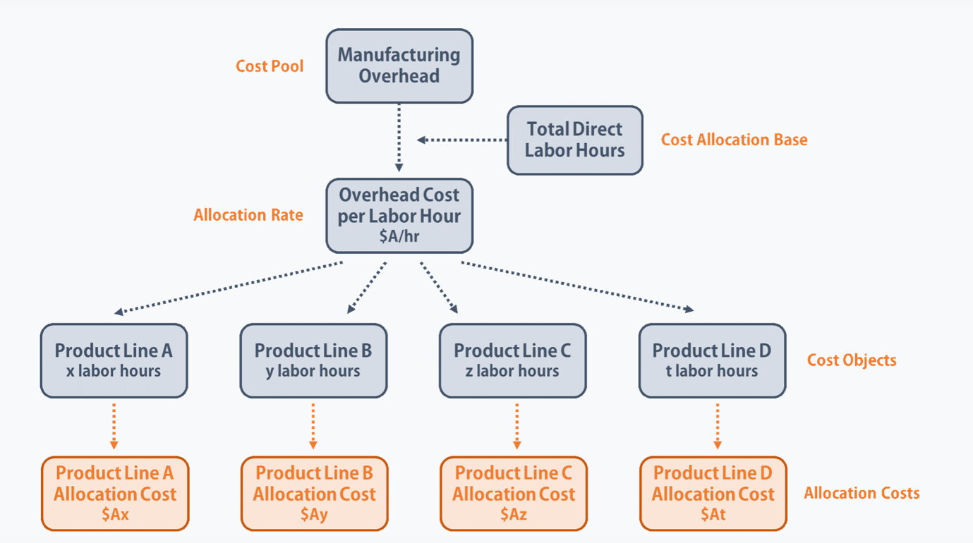
Source: Corporate Finance Institute (2021)

The importance of cost structures and allocation
To maximize benefits, organizations should follow every possible cost-limiting method. Although some fixed costs are necessary to maintain the business, the monetary expert must perform an ongoing audit of fiscal summaries to recognize perhaps excessive costs that do not offer any additional benefit to the center's business exercises (Collins, 2011).
Once the expert understands the overall cost structure of an organization, he / she can distinguish acceptable cost reduction techniques without affecting the nature of the items sold or the administration provided to customers (Collins, 2011). The monetary investigator must also pay attention to the cost model to ensure a stable income and to avoid unexpected cost spikes.
Therefore, cost allocation is an important cycle for a business, because if we assume that the costs are incorrectly distributed, at this point the business may be found in the wrong choice, such as overvaluation / undervaluation of an item or investing excess assets in useless positions (Collins, 2011). It is the job of the monetary investigator to ensure that the costs are accurately attributed to the expenditure objects assigned and that the appropriate bases for designating the costs are selected.
In other words, the cost allocation allows the researcher to calculate the unit costs for different products, special units or offices and subsequently discover the unit advantages. With this data, the monetary expert can provide particles of knowledge to improve the usefulness of specific elements, replace the most useless elements or implement various methodologies to reduce costs.

Contextual Investigation of Harriot Hotel
There are three recommendations in total for the issues which Harriot Hotel is currently facing. The primary aim of the organisation is to be able to cut costs and minimise additional expenses for the maintenance and management of the hotel facilities. COVID-19 has had a severe impact on the level of interest in the tourism industry in a negative way, whereby individuals are not willing to pay for visits and the hospitality industry therefore loses a lot of money since 2020. The minimisation of costs can occur in the following way:
- Reduction of employee wages in accordance to the current revenue, or making employees of specific positions redundant where the owners or managers can take on more workload.
- Minimisation of advertising expenses at 10% can be achieved in the year 2021 by the organisation. The costs here are fixed and are not dependent at all on any generated revenue by the company.
- Loan – this is a variable cost for the business organisation, interest decreases based on the loan principle and outstanding sum for its full return to the bank. This should be a focal point for Harriot Hotel to reduce or compensate.

Conclusion
This concludes the essay on management accounting as well as the contextual reference to Harriot Hotel which experiences predominant difficulties with decreased revenue and increased costs.

References
Bjørnenak, T. (2000). Understanding cost differences in the public sector—a cost drivers approach. Management Accounting Research, 11(2), pp.193–211.
Chinasak Suwanachariya, Nacha Kwanmanee and Kalasom Latae (2019). Way to Reduce Transaction Costs by Accounting. [online] eLibrary.ru. Available at: https://elibrary.ru/item.asp?id=41536404 [Accessed 25 Mar. 2021].
Collins, D. (2011). A General Matrix Model Of Support Department Cost Allocation Methods. Journal of Applied Business Research (JABR), 19(2).
Dean, E., Elardo, J., Green, M., Wilson, B. and Berger, S. (2020). Explicit and Implicit Costs, and Accounting and Economic Profit. [online] openoregon.pressbooks.pub. Available at: https://openoregon.pressbooks.pub/socialprovisioning2/chapter/10-1-explicit-and-implicit-costs-and-accounting-and-economic-profit/ [Accessed 25 Mar. 2021].
Drury, C. (2018). Management and cost accounting. 10th ed. Andover: Cengage Learning.
Mizikovskiy, E. and Mizikovskiy, I. (n.d.). Preparing accounting information on costs for manufactured crop production Polikarpova. Preparing accounting information on costs for manufactured crop production.
Rounaghi, M.M. (2019). Economic analysis of using green accounting and environmental accounting to identify environmental costs and sustainability indicators. International Journal of Ethics and Systems, 35(4), pp.504–512.
Seal, W.B., Rohde, C., Garrison, R.H. and Noreen, E.W. (2019). Management accounting. London: Mcgraw-Hill Education.
Serpeninova, Y., Makarenko, I. and Linska, A. (2019). Logistics costs accounting: challenges for identification in Ukrainian accounting practice. Accounting and Financial Control, 2(1), pp.47–53.
Shahab, S., Clinch, J.P. and O’Neill, E. (2018). Accounting for transaction costs in planning policy evaluation. Land Use Policy, 70, pp.263–272.

