Dylan Pugh
GDI Design Ltd
5 Upper Mill
SA15 3RY
Mr. John Smith
Carmarthenshire County Council
County Hall
Carmarthen
SA31 1JP
Project Number: 5010
Project Title: Ysgol Glangwili

Dear Mr Smith,

I’ll to discuss and inform you about the requirements for BIM maturity and the management of the project through the use of a BIM Execution Plan (BEP). The concept behind BIM maturity is the criteria that’s required to be considered BIM compliant. It’s the process from the drawing board to the computer and into the digital era. The process is defined into the form of levels which range from 0 to 3.

- Level 0 is the basic form of information being the form of unmanaged data and 2D drawings paper or electronic copies traded.
- Level 1 is organized and managed CAD in 2D or 3D formats within a community device providing consistent information. With a regulative approach to information structure and positions.
- Level 2 is a managed 3D environment that’s held in separate guidelines of BIM tools with data attached to it.
- Level 3 is a single source of all information that’s created and can be accessed by all the projects staff via SharePoint, the cloud or intranets. This allows data to be transferred between construction, management and allowing open communication and the buildings lifecycle management. With Level 3 there’s 4 sub categories that fall under it that work on different parts of BIM Process. This level allows information to be transferable through different departments to enable full collaboration and access to all forms of information.
Figure 1: BIM Maturity Levels (Carradori, 2022)

BIM isn’t 3D modelling, BIM is about information and date management. It’s a collective of varies and mutliply forms of information that is used at all levels, stages and people within that project. Its to allow everyone involved in the project to have the same shared information from start, middle and end to prevent miscommunication and errors in the information given to diffferent parties.

If a project is emplmenting BIM, it must start the BIM Process at the very start of the project. With the most qualified personnel who can manage and have their roles defined on what they must provide and maintain. See below, Figure 2: The Information Delievery Cycle.
Figure 2: The Information Delivery Cycle (Carradori, 2022)

The standards that are used for BIM is BSI ISO 19650 which is the current standard for BIM. This standard is an international standard, not just a UK based standard. Which is used for managing the information of the life cycle of a building using BIM and Naming Conventions which is to be able to transfer information between people and applications as well. Also, you have PAS 1192-2: 2013 and CIC BIM Protocol which is a standard created by the Construction Industry Council to outline the obligations, liabilities and limitations of the models. This standard is related to BIM Level 2 with the requirements of creating a managed 3D environment.

PAS 1192-2: 2013 is the framework standard that deals with the construction stage of the project. Also, specifying the requirements needed for Level 2 Maturity. This particularly standard identifies the roles and responsibilities for collaborative BIM working and linking into the Common Data Environment (CDE). In Figure 2 it shows the cycle of information through the BIM Process. The process starts in the Procurement stage where the client will need to do the Employers Information Requirements (EIR) then the BEP is developed as well. The EIR is Then contract is awarded and forms the Master Information Delivery Plan (MIDP). In the figure, the central green boxes show the CDE. This is the area which different forms of information are stored, these information are Documentation, Non-Graphical Data and Graphical Model (Naming conventions will come into this as each one will stand for different information such as revision, designer, discipline and status). The level of information increase throughout the progression of the project from the Brief all the way to the Operation. The reason for this is the use for the information as the earlier stages only certain information is required whereas the more your progress the more detail is needed especially in the construction phase as this is where your constructing the project and installing doors, windows and roofing. As you’ll need to know sizes, positions and quantities in this stage where in stages 1 to 4 you’ll only want to know where doorways are, can we get access or got enough light from the windows.

The BIM Execution Plan is the document that is used to manage information on a BIM Project. Linking back to PAS 1192-2: 2013 it defines it as a “plan prepared by the suppliers to explain how the information modelling aspects of a project will be carried out”. The BEP is developed during both the pre and post contract phases. Its made in response to the EIR. As the EIR is a document produced in the Brief stage of the project. This document is created as early as possible as it sets out the information to be delivered, the standards and process that suppliers should adopt within the project delivery stage. Then it enables suppliers to produce their BEP. The level of information with in the BEP differs with the BIM Level as at 1 its less complex and much lighter document whereas in Level 2 it’s more in depth and detailed. Within the document it should include the agreed upon roles and responsibilities in relation to CDM, the strategy of key deliverables which all contractors are expected to be able to produce such as CDE, 3D Data and Plans of work. Lastly, out line key stages within the project that must be met in terms of deadlines, milestones and how these will affect the projects timeline and sequence of work.

In the project, other contractors will have their own BEP’s but they all will tie into and link up with the main BEP produced from the start of the project and made by the main contractor.

Yours Sincerely,
Dylan Pugh

The level of Information Need

RIBA Plan of Work

The RIBA Plan of works is to organise the “process of briefing, designing, constructing and operating building projects” (Architecture, 2021). The plan is spilt into 8 different stages which all act together to achieve the purpose of the plan. Each stage explains the outcomes, purpose of tasks and the exchanging of information between the various stages. Every stage of the plan works off the success of the previous as the information is transferred across.

Stages of RIBA Plan of Work

The RIBA Plan of Work has stages range that from 0 to 7. See Appendix 1 – RIBA Plan of Work 2020. These stages make up the Plan and all has set goals, tasks and methodology they must complete and meet for the next stage to continue.
The stages of the plan take place at different points of the project in the pre-construction all the way to the post construction. With stages 0 to 4 being in the Procurement and Tendering stages. Stage 0 is about determining the best way to achieve the clients requirements. This is to focus on making the right choices in a business case such as anything that could affect the budget, pros and cons. Once this has been achieved Stage 1 will begin. In stage 1 its taking the client requirements and turning that information into a Design Brief which is suitable for Stage 2. Its proving that all the requirements set by the client can be achieved with the means that it can be accommodated on site. Design is the next step after the feasibility stage as its taking the information gathered from the Project Brief and studies to create a design concept which meets the requirements specified previously and improving the level of information to be able to work off. The concept must be approved by the client and allow input from specialised in terms of services, cost and structural. After Stage 2, the concept is tested to make sure that the information that’s past on is ready for manufacturing. Stage 3 is about checking and verifying the information given will be “Spatially Coordinated” (RIBA, 2020). This is checking against all the reports and strategies set in place and planning. As if any information is missing it’ll be past back to stage 2 before being issued out to stage 4.
Once, proven that the design can be spatially coordinated. It moves to developing the information from the design team and specialists to be able to provide the required information to manufacture and construct the project. This can be related back to the level of BIM as the quality of information with specifications, manuals and Building Regulations. Regardless of the Procurement route whether be Construction Management or Design and Build. All follow the same plan.
Stage 5 is when the client hands over to the contractor. takes place in the construction phase of the project with constructing the building. The level of information needed for this stage for the contractor is drawings, design models, bill of quantities, specification, Construction phase plan and various other documents which the client will provide or the contractor will form off the tendering stage. This stage will then pass on all surveys, testing, defects and Health and Safety file created in stage 6.
Stage 6 is the in between of construction and post as its the handover from contractor to client. The contractor would carry out an As-Built survey of everything constructed, certificate of completion and sign off of all works and testing. Also, feedback about the building itself in regards to maintenance and if there was any variations in design which then be used to update the plans. Then it will be opened up for use after everything been signed off.
Stage 7 is the post construction phase which includes the use of the building but monitoring and when the building reaches its life cycle. As the information received in this stage will be Health and Safety file and updated drawings of the building. In this stage, it’ll look at the possibility of restarting the cycle with repairs, maintenance or refurbishment so it’ll gather the necessary information to start stage 0.
The stages of the RIBA Plan of Work 2020 is similar to the BIM Process and Levels of Information. As the levels of information needed increase over the different stages to meet the needs for that stage like in the BIM Delivery Information cycle as at the start the brief outlines the clients requirements and proves if they can go ahead with it. Then goes onto determine the purposed design based off the requirements that’s set by the client and if they can do it. Both processes follow the same need to improve the quality of information as the stages progress along the project and after the project in record keeping to improve future development and information.
The Employer’s Information Requirements and Stages 0 and 1 are the same they set what the clients wants to do and achieve. The information required for this can be an objective or wanting to meet the supply and demand such build an infant school. Then its expanding on it saying how many pupils you want to facilitate and what facilities to include and services you want to offer. Both use a baseline that’s the Clients Requirements or EIR to then expand and determine the levels of information required to continue to though the stages.
For example see Appendix – Copy of EIR for Barmouth Metallic Viaduct. (Pryor, 2021). The document outlines the purpose of the plan to the project and the level of information they required with the EIR. The project is to construct a Metallic Viaduct in Barmouth for Network Rail. Network Rail gave out their EIR for contractors to tender and those requirements outline what they want to achieve. In so doing so Alun Griffiths produced a BEP using their requirements listing the level BIM, CDE and in regards to CDM with Roles and Responsibilities.
Furthermore, see Appendix 4 – Copy of Network Rails Employer’s Requirements (Rail, 2022). This is the EIR issued by Network Rail to all there departments and out for tender as this is their company standard which follows the current BIM standards of PAS 1192-2: 2013 AND ISO 19650. This document highlights what they expect in contractors BIM Execution Plans when tendering or been awarded the contractors. It shows the level of information they will provide out to the contractor for them to make the BEP and what they require in return of BIM Maturity, Information and Quality.

References
Architecture, R. (2021, November 9). RIBA Plan of Work. Retrieved from RIBA Architecture : https://www.architecture.com/knowledge-and-resources/resources-landing-page/riba-plan-of-work#available-resources
BSI. (2023, January 11). What is ISO 19650? Retrieved from BSI: https://www.bsigroup.com/en-GB/iso-19650-BIM/
Carradori, M. (2022, April 23). THE ROAD TO IBIM: BIM IN THE UK. Retrieved from BIS Lab: https://www.bis-lab.eu/2017/04/23/the-road-to-ibim-il-bim-nel-regno-unito/
McPartland, R. (2017, February 28). What is a BIM Execution Plan (BEP)? Retrieved from NBS: https://www.thenbs.com/knowledge/what-is-a-bim-execution-plan-bep
McPartland, R. (2017, September 11). What is the PAS 1192 framework? Retrieved from NBS: https://www.thenbs.com/knowledge/what-is-the-pas-1192-framework#:~:text=PAS%201192-2%3A%202013%2C%20which%20deals%20with%20the%20construction,the%20scope%20of%20the%20Common%20Data%20Environment%20%28CDE%29.
Pryor, C. (2021). Barmouth Metallic Viaduct BIM Execution Plan . Barmouth: Alun Griffiths Contractor Ltd.
Rail, N. (2022). Employers Requirements. London: Network Rail.
RIBA. (2020). RIBA Plan of Work 2020 Overview. London: RIBA.
Trust, S. F. (2023, January 10). BIM Level 1 Approach. Retrieved from Scottish Futures Trust: https://bimportal.scottishfuturestrust.org.uk/level2/stage/1/task/57/create-employers-information-requirements#:~:text=Employer%E2%80%99s%20information%20requirements%20usually%20include%3A%20Standard,or%20appointment%3B%20Information-related%20roles%20an

Appendices

Appendix 1 – RIBA Plan of Work 2020 (Architecture, 2021)
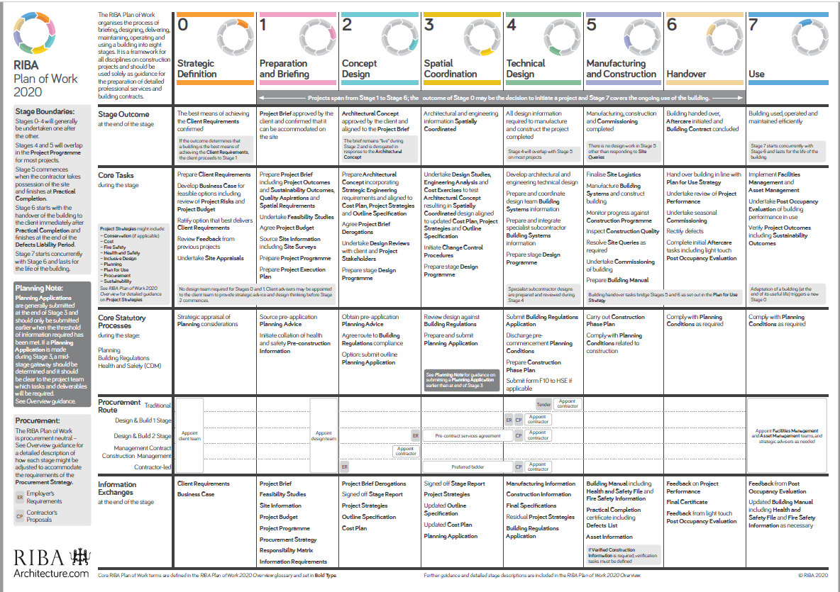

Appendix 2 – Copy of EIR for Barmouth Metallic Viaduct. (Pryor, 2021)
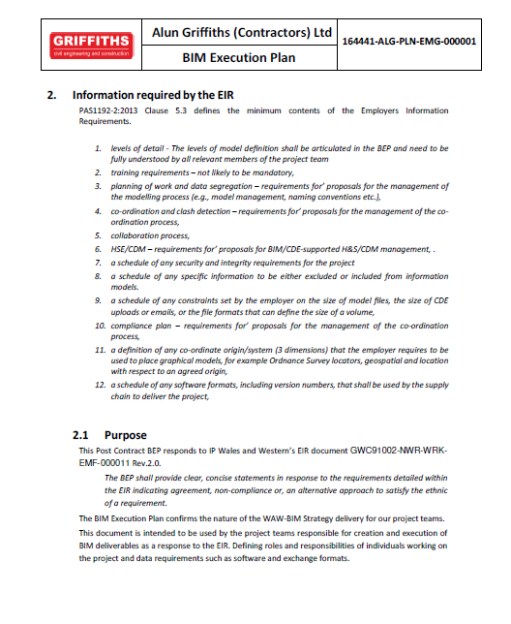

Appendix 3 – Copy of Alun Griffiths Contractors Abbreviations Explained in BEP (Pryor, 2021)
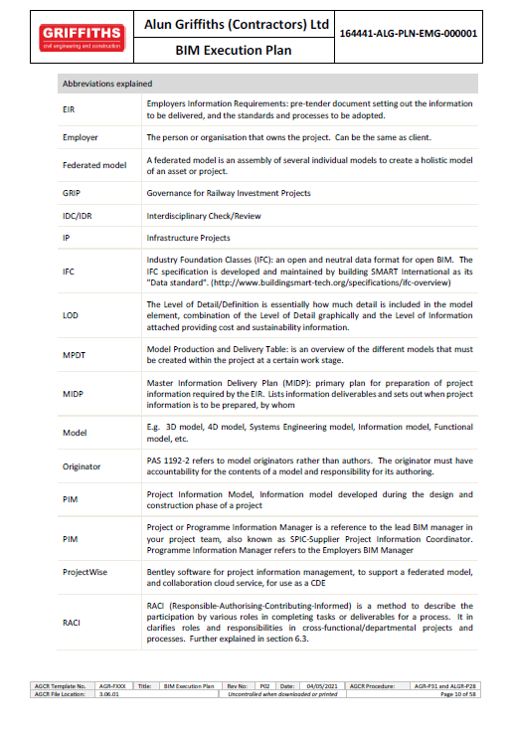

Appendix 4 – Copy of Network Rails Employer’s Requirements (Rail, 2022)
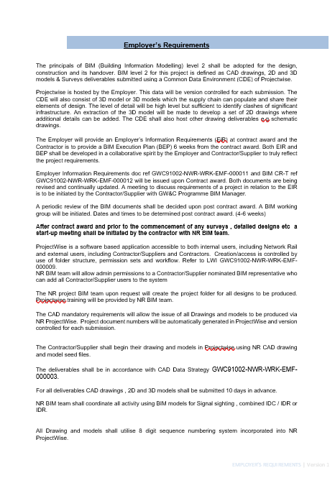
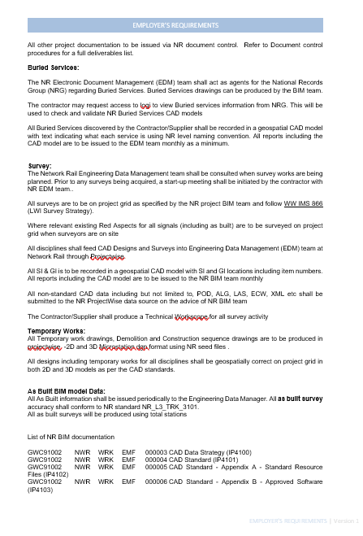
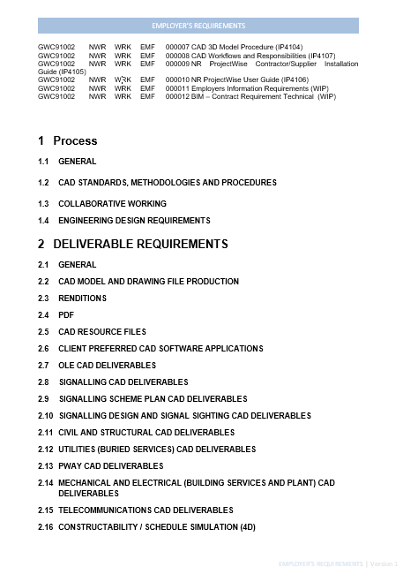


Appendix 5 – Alun Griffiths Contractors Ltd Naming Conventions (Pryor, 2021)


