Recommendation Of A Sentiment
Analysis ML Model

Table of Contents

Abstract ...................................................................................................................... 3
1. Introduction ............................................................................................................4
2. Related work in the literature .................................................................................4
3. Workflow methodology ..........................................................................................5
4. Discussion and recommendations.......................................................................... 8
5. Conclusion ........................................................................................................... 12
References List ........................................................................................................ 13

Abstract
This report offers an entire consultation of a marketing firm that would need a low cost and resource efficient sentiment analysis solution that utilizes conventional machine learning and not deep learning. The report initializes the context of the problem and constraints followed by synthesizing the literature of importance at an introductory level in order to position classical text classification methods to sentiment analysis. It suggests a sparse end to end workflow that focuses on readiness of data, strong feature engineering using bag of words and n grams, meticulous model selection and calibration and clear evaluation using understandable measures. A simple regularization, probability calibration and lightweight dimensionality control with simple regularization on TF IDF weighted word and character n grams is recommended to support this model is simple. The pipeline is meant to work based on small infrastructure based on a CPU only basis with ease of replication and to be aligned to good practice in data preprocessing and assurance. The implementation road map likely benefits and constraints and the particular measures to be employed to demonstrate efficacy without undermining simplicity or interpretability are briefly illustrated in closing the report.

1. Introduction
The marketing company needs a sentiment analysis tool that would categorize the reviews of the shoppers as positive, negative or neutral whilst operating with under provisioned compute resources with minimal maintenance cost. This is aimed at suggesting a classic machine learning algorithm and a workflow that support providing an effective, reliable and precise classifier at low training and execution costs. The short specifically requests to not use neural networks and deep learning, which implies that the space of solutions is based on proven algorithms like linear support machine, logistic regression and multinomial naive Bayes based on sparse vectors representation. These methods are competitive in terms of many short text and review analysis problems since they combine well with bag of words and n gram capabilities, they also train fast on CPU and are also easy to calibrate and monitor. The report thus focuses on classical models of text classification, preprocessing models that drive it and the evaluation practice needed to prove that the model recommended addresses the notion of accuracy and efficiency criteria on a realistic set of shopper reviews. The report scope is feasible. It does not give a model but stipulates in detail how to do it, starting with ingesting the data, extracting the features, training them, evaluating them and analyzing the errors, with the exact metrics that need to be given out to the stakeholders. It further elucidates the limits and dangers that are consequential to a young organization, including constraining memory utilization, preventing the concealed complexity in the customization of the preprocessing stage, counteracting label noise and alleviating the interchange of information among educating and assessment groups. It focuses on an easily reasonable, reproducible and iteratively improvable pipeline in case new data comes in.
2. Related work in the literature
Initial surveys on the text classification and sentiment analysis provide a helpful background in the design of a conventional workflow. Text classification Survey Text classification methods and their effectiveness on sparse representations How to make the most of linear classifiers on sparse representations: Use of word and character n grams and frequent trade offs in accuracy, complexity and interpretability especially when small groups of people are under compute requirements [3]. Sentiment analysis survey papers offer a general map of solutions, data and assessment models, such as conventional methods of lexicon based systems and supervised learners constructed on bag of words attributes that are still very competitive in review polarity classification when weighed against cost and simplicity [6]. In general reviews raising the subject of efficient processing of language tasks, it is stated that when runtime and memory are extremely limited, compact representations and linear decision functions should be preferred, which is consistent with the design goals of a lightweight pipeline of shopper reviews [7]. The introductory material on evaluation metrics provides the reasons as to why a simple accuracy is not enough when classes have unequal distribution or positives and negatives have varying business implications. Precision, recall and F1 per class, macro averaged F1 to eliminate bias on the majority class, a complementary ranking metric are also often reported in cases where probabilistic outputs are generated, not necessarily to provide information on the quality of hard classification alone in the same report [5]. Data preprocessing reviews highlight cleaning and standardization as first class in practice in analytics because small, highly motivated preprocessing steps tend to represent larger increment in classics models than complex modeling substitutes, as long as they are diligently adhered to and recorded [2]. Lastly, initial summaries of dimensionality reduction offer a lexicon of choices in controlling sparsity and feature explosion as well as remind the practitioner that with bag of words models, feature selection or truncated SVD is preferable to dense transforms which would nullify the benefits of sparsity [9]. The common themes across these surveys include that bag of words pipelines continue to remain competitive on review data, linear models form good baseline and are often the best practical option, and that evaluation must be transparent and multi-faceted, in order to help make operational decisions.
3. Workflow methodology
The workflow represents a series of audits of modular steps, which can be deployed with the use of typical open source libraries and run on off-the-shelf CPU hardware. Data definition and scoping, data collection and partitioning, text normalization and tokenization, feature extraction using TF IDF n grams, optional feature control by hashing or selection, model training using a linear support vector machine and probability calibration, evaluation using interpretable metrics and error analysis to detect systematic weaknesses are the steps. The choice of each of these steps is to reduce the computational load and cognitive load on the engineering staff and to maximise the clarity of the assumptions and traceability of the result. The initial stage will be data definition and scoping. The team is to choose the policy of label set and annotation. In the case of shopper reviews, three labels are normally adequate to use in initial deployment such as, positive, negative and neutral. In case the company wants to be binary in a first release, one can map neutral to the nearest polarity according to thresholds of ratings or go through them to make sure that neutral does not take control of the decision limits. The data source must be specified specifically, i.e. reviews posted on the platform of the company within a specific time frame with specific guidelines to include or exclude. This also involves making specifications on the text fields to be included. In case of a minimal viable pipeline, the review body and review title are adequate, and they are joined together in the form of one text. When there are ratings, then these should not be used as features in addition to deriving labels as this would also leak information of labels to the model. The team too must announce policy on handling non English contents in case it is present. The easiest thing to do is to narrow down to English with a language identification heuristic that is lightweight and queue other languages to a future upgrade. The choices establish a firm basis of the repeatable experiments and reliable assessment. The second step is partitioning and collection of data. The data are to be divided into one training, one validation and one test partition according to a stratified scheme that maintains the distribution of the labels. A typical divide of a small to medium data set is 80 percent of examples, which are used to train and validate using cross validation and 20 percent that remain in a held out test set. In the event that the dataset is large enough, one can use 70, 15 and 15 percent. A temporal split can be viewed as an alleviation to optimistic performance estimates as a result of time leakage when the reviews are distributed over extended periods of time, however in the first release a stratified random split is usually okay and provides enough examples per class. The test set is not supposed to be changed, it needs to be fixed and never be used to tune features or hyperparameters. The count, proportion of classes and an average length of review as well as existence of outliers should be captured in the lightweight data card, that assists in future audit and provides the stakeholders with immediate intuition regarding class balance and sample sizes [2]. Normalizing and tokenizing of text is the third step. The pipeline must reduce the cases, normalize usual punctuations, standardized spacing and eliminated unnecessary markups or HTML features. The emojis can be retained or erased based on the volume and significance in the field, although in the beginning, it is better to keep them and leave the character n grams absorb their meaning. Numbers also can be memorized, since they tend to have a special meaning, when associated with counts or prices. Removal of stopwords with n grams should not be done initially, since a linear model using the TF IDF weighting method can be trained to ignore uninformative words and removal of stopwords may disrupt the useful phrases. Stemming or lemmatization is sometimes not required and is not always necessary to review polarity with n grams, because such features as was bad and is bad already have stems and the classifier can generalize using tense and aspect based on context. The tokenization must be easy, and basic word tokenizer combined with character n grams in order to contain misspellings and informal words [2]. The fourth process is feature extraction. TF IDF weighted n gram features should be used as their core representation. With words, unigrams and bigrams, possibly trigrams should be used in case the dataset is large enough to justify them. On the part of characters, n grams of length 3 to 5 should be used, this length is likely to pick out subword patterns, long words, run of exclamations and emoticons, which in many cases are indicators of sentiment. Memory can be controlled by capping the vocabularies to maximum sizes. A combined feature space of several hundred thousand dimensions is feasible only with a small machine since the representation is sparse. In order to further reduce the memory and build time, the feature hashing may be applied with a fixed number of dimensions. The use of hashing can be particularly useful when the raw space is increasing at a fast rate (character n grams). Sublinear term frequency scaling should be used and idf should be scaled to smooth rare features in the TF IDF transform. In case dimensionality reduction is required, chi square feature selection can be applied to select the most discriminative features across classes, or truncated SVD can be applied to sparse matrix to obtain a low rank approximation and be computationally feasible. Experiments that make a trade off between performance and runtime and memory in the target environment should drive the choice between feature selection and truncated SVD [9]. The fifth step is selecting and training of algorithms. The best model suggested is a linear support vector machine using a hinge loss or squared hinge loss using TF IDF features as inputs. Linear SVMs are powerful when using high dimensional sparse text, single dominant hyperparameter to control regularization and also they can be trained quickly by stochastic or coordinate descent. Since certain end- consumer users might require calibrated probabilities instead of hard margins, the SVM must be enclosed in a calibration phase of probabilities like Platt scaling on a validation fold. The L2 regularized logistic regression is an appropriate runner up and usually comparable to the SVM in accuracy although it does not give calibrated and direct probabilities. The value of Multinomial naive Bayes is a rich secondary baseline, as it is lightning-fast, can surprisingly well on short texts with word counts, and is able to provide an interpretable view of the feature likelihood, however, it may also perform poorly on subtle phrasing. Class weighting should be employed in the training process in order to account the imbalance that may exist and the hyperparameter selection must be based on stratified k fold cross validation. Regularization strength C and word and character n gram choice and size as well as the vocabulary caps are the hyperparameters to be tuned. The training must not be overly complex in ensembling to keep runtime and guarantee simplicity. The sixth step is evaluation. The evaluation protocol must state general accuracy, macro averaged precision, recall and F 1, per class F 1 of positive, negative, and neutral, and the area under the curve of precision recall should there be probabilities available. Macro averaging also makes sure there is no dominance of majority class in the evaluation which is essential in case of neutral comments. Simple bootstrapping can be used to estimate confidence intervals of important metrics to provide the stakeholders with a feeling of statistical stability. Paired tests can be used to compare models statistically across cross validation folds in order to ascertain whether the observed variation is significant to help in avoiding overfitting of small deltas [5]. Reviewing of confusion matrices is necessary to detect systematic confusions, e.g. neutral versus slightly positive, and this may indicate targeted data augmentation or threshold change. The evaluation section is to be provided with a brief narrative relating metrics to business results, i.e., why greater recall of negative classification issues to customer service triage. The seventh step is error iteration and analysis. The artificially misclassified examples should be sampled and analyzed in order to classify the types of errors, i.e. sarcasm, domain specific jargon, mixed sentiment and out of vocabulary slang. These types guide lightweight-level refinements such as the addition of character n grams when word only used features were pruned, the vocabulary limit was increased, or simplistic text normalization rules are added where repeat artifacts occur. In the case of a high level of label noise in the dataset caused by heuristic labelling by star ratings, a limited human audit can minimise the noise in the validation and test subsets to enhance the quality of performance estimates. These iterations are cheap and they can help in measurably improving them without altering the foundational model, holding the simplicity requirement. The eighth process is documentation and assurance. A short model card and data card where the concise description of the dataset, features, algorithm, metrics, calibration procedure and known limitations are given should be documented on the pipeline. Snapshot Data The snapshots of data are versioned, features and model artifacts are traceable, and repeatable. Such simple practices of governance like a checklist on data quality, a data of metric definitions and thresholds and a change log on updating the model minimises operational risk and promotes stakeholder trust [1]. A decommissioning program should also be documented detailing how the team will revert to a previous model in the event that monitoring shows that the team has run off track or that there is undue change in performance that they did not anticipate.
4. Discussion and recommendations
The way to make the central design choice is to select the classifier within the mentioned constraints. A linear support vector machine with TF IDF n gram word and character characterizers provide a great tradeoff between accuracy, stability, speed and simplicity in the case of shopper reviews written in regular language. It is highly dimensional and sparse data, and only minimal hyperparameter optimization and can be trained in a short time on a laptop class CPU. Linear kernel does not need the computational cost of the nonlinear kernels which would not be suitable in the resource constrained environment. Since SVM maximizes margins, it is generally resistant to correlated features and can be effectively used to deal with the redundancy that occurs in n gram space naturally. Probability calibration enables the model to generate scores which may be used to generate risk based processes like labeling likely negatives as subject to human attention, without alterating the boundary of decision making. In the event that only one model is to be maintained then the linear SVM with calibrated probabilities is to be used. The second best suggestion is the L2 regularised logistic regression on the same features. The benefit of logistic regression is that the optimization of the log loss is directly optimized and that the resulting probabilities are calibrated without needing an additional step and it routinely outperforms the linear SVM by a fraction of a point in the review classification domain. In case the individual team members are comfortable with the conceptual simplicity of using logistic regression and its native probability outputs, it can be used with little modification to the rest of the pipeline. The multinomial naive Bayes has to remain as a control in testing and as a potential backup when datasets are extremely small or runtime constraints are extremely strict as it can be trained and put into practice with almost no resources. Nevertheless, when the company is able to afford the low extra expense of linear SVM or logistic regression, the models will typically perform better in terms of macro F1 and more consistent across domains. The other decision is the feature representation. Word unigrams and bigrams together with character n grams that are between 3 to 5 in length should also be used. The capture semantic content in short spans e.g. not good or do not buy whereas the character features capture misspellings, stylized emphasis e.g. gooood and emoticons and punctuation runs that typically indicate high emotion. The effect of common tokens is reduced through TF IDF weighting, and discriminative terms are upweighted without any supervised target information needed in the feature transform. Vocabulary limits The memory footprint is limited by vocabulary limits. When memory constraints are at risk due to the space growth of features, then the hashing trick offers a sparse representation of fixed dimensionality at a zero training cost and with little effect on accuracy at moderate dimensions. Assuming that the team wants to select features by their explanatory power, chi square selection may keep a fixed number of features with the most correlation to class labels and keep the sparse structure that is helpful to linear models [9]. The workflow does not employ any stopword removal, aggressive stemming, and complicated text normalization. Such operations are not often of steady profit to the polarity classification of linear models and may have the effect of just eliminating informative patterns or moving token delimitations so as to diminish the utility of character n grams. Using n grams and TF IDF, the pipeline leaves the processing of common function words and morphological variants to the model and thus leaves the preprocessing code much simpler, and the maintenance overhead smaller. The remaining normalization is the normalization to basic high leverage normalization like lowercasing, whitespace normalization, and light punctuation normalization, which results in the same tokenization without costly language specific handling [2].
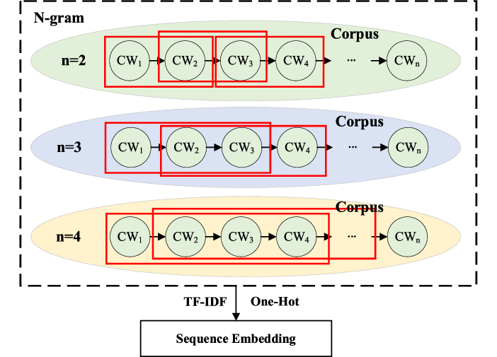
Figure 1 - researchgate.net/figure/The-flow-of-TF-IDF-N-gram-embedding_fig1_369787057
The evaluation plan will focus on the metrics of providing a balanced picture of the performance between classes. Total accuracy can be understood readily though has to be accompanied by macro averaged precision, recall and F1 to ensure that minority classes are given the appropriate weight. According to the feature F1 by class, the number of negative reviews that are being overlooked or the number of neutral and positive that are mixed can be used to make focused data or feature improvements. In case probabilities do exist, area under the precision recall curve is better than ROC AUC in class imbalanced environments since it captures the performance in high precision or high recall areas that are of importance to the business. Cross validation folds are moderated by statistical tests that guarantee against over interpreting small deltas so that any switch between SVM and logistic regression or a change in n gram ranges has strong support [5]. These metrics need to be linked to the operational decisions in the evaluation narrative, e.g. stating that negative class recall in excess of a threshold is needed to initiate automatic customer service processes [1][8].
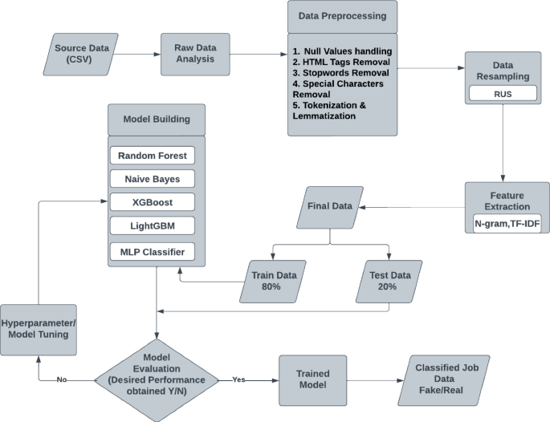
Figure 2 - https://link.springer.com/chapter/10.1007/978-3-031-66694-0_9
The report also recognizes the fact that the modern literature also talks about highly accurate deep learning methods that make use of large pretrained language models. Although such means can be performed well, it brings with it complexity and cost, which is not in tandem with the constraints of the company. They have special hardware requirements to perform training and inference effectively, include more complicated preprocessing and deployment options and are harder to maintain and update safely by a small team. The effective language processing literature emphasizes that, in conditions of resource scarcity, classical methods can be an appealing baseline that can be adequate, particularly in combination with good data hygiene, right features and fair assessment [4][7]. The proposed pipeline therefore remains under the conventional machine learning at the same time providing a viable solution to the needs of the company.

5. Conclusion
The need of the company is apparent. It must have a sentiment analysis feature that is analytical enough on customer experience processes and marketing insights, and easy enough to develop, describe, implement and maintain on low-resource bases. As demonstrated in the analysis in this report, the requirements can be met by the use of a classic machine learning model that involves a linear support machine trained on the TF IDF word and character n grams. It is a workflow that is proposed and focuses on clean definition of data, uniform and minimal preprocessing, strong sparse features, disciplined cross validated training and transparent evaluation with macro averaged metrics and probabilities that are calibrated. The pipeline is computationally efficient, simple to recreate and track and congruent with reasonable governance and assurance practices to a professional environment. It is a cautious strategy to minimize risk and operational cost, though still leaving a way of making continuous improvements with improved data, small feature additions and, should there be need, simple algorithm options like logistic regression.

The pragmatic follow-up steps of the company are to compile the labeled corpus of the shopper reviews with clearly defined inclusion criteria, deploy the pipeline with the well-supported open source libraries, perform the baseline performance of the linear SVM with the calibrated probabilities, and establish monitoring thresholds that would relate the model measures with business activities. With these in place, the company will end up with a strong and effective classifier that achieves its fundamental purpose without the complexity and the high cost of the modern deep learning networks. The suggestion is thus that the proposed pipeline and model must be taken, it should be documented, and it should be pledged to go through the pipeline lightly and once a time as new data flows in and the business is changing.

References List

[1] F. A. Batarseh, L. Freeman, and C.-H. Huang, “A survey on artificial intelligence assurance,” Journal of Big Data, vol. 8, no. 1, p. 60, Apr. 2021, doi: 10.1186/s40537-021-00445-7.
[2] C. Fan, M. Chen, X. Wang, J. Wang, and B. Huang, “A Review on Data Preprocessing Techniques Toward Efficient and Reliable Knowledge Discovery From Building Operational Data,” Front. Energy Res., vol. 9, Mar. 2021, doi: 10.3389/fenrg.2021.652801.
[3] A. Gasparetto, M. Marcuzzo, A. Zangari, and A. Albarelli, “A Survey on Text Classification Algorithms: From Text to Predictions,” Information, vol. 13, no. 2, p. 83, Feb. 2022, doi: 10.3390/info13020083.
[4] N. Patwardhan, S. Marrone, and C. Sansone, “Transformers in the Real World: A Survey on NLP Applications,” Information, vol. 14, no. 4, p. 242, Apr. 2023, doi: 10.3390/info14040242.
[5] O. Rainio, J. Teuho, and R. Klén, “Evaluation metrics and statistical tests for machine learning,” Sci Rep, vol. 14, no. 1, p. 6086, Mar. 2024, doi: 10.1038/s41598-024-56706-x.
[6] K. L. Tan, C. P. Lee, and K. M. Lim, “A Survey of Sentiment Analysis: Approaches, Datasets, and Future Research,” Applied Sciences, vol. 13, no. 7, p. 4550, Jan. 2023, doi: 10.3390/app13074550.
[7] M. Treviso et al., “Efficient Methods for Natural Language Processing: A Survey,” Transactions of the Association for Computational Linguistics, vol. 11, pp. 826–860, July 2023, doi: 10.1162/tacl_a_00577.
[8] R. van de Schoot et al., “An open source machine learning framework for efficient and transparent systematic reviews,” Nat Mach Intell, vol. 3, no. 2, pp. 125–133, Feb. 2021, doi: 10.1038/s42256-020-00287-7.
[9] A. A. Wani, “Comprehensive review of dimensionality reduction algorithms: challenges, limitations, and innovative solutions,” PeerJ Comput. Sci., vol. 11, p. e3025, July 2025, doi: 10.7717/peerj-cs.3025.

